 |  | E
 | 
  TG/336/1
  ORIGINAL: English
  DATE: 2020-12-17
INTERNATIONAL UNION FOR THE PROTECTION OF NEW VARIETIES OF PLANTS
 | Geneva
  COREOPSIS
  UPOV Code(s):
  COREO
  Coreopsis L.
  *
GUIDELINES
FOR THE CONDUCT OF TESTS
FOR DISTINCTNESS, UNIFORMITY AND STABILITY

Alternative names:*

Botanical name | English | French | German | Spanish
  Coreopsis L.
  Coreopsis, Tickseed
  Coréopsis
  Mädchenauge
  Coreopsis

The purpose of these guidelines (“Test Guidelines”) is to elaborate the principles contained in the General Introduction (document TG/1/3), and its associated TGP documents, into detailed practical guidance for the harmonized examination of distinctness, uniformity and stability (DUS) and, in particular, to identify appropriate characteristics for the examination of DUS and production of harmonized variety descriptions.
ASSOCIATED DOCUMENTS
These Test Guidelines should be read in conjunction with the General Introduction and its associated TGP documents.

TABLE OF CONTENTS | PAGE
1. | SUBJECT OF THESE TEST GUIDELINES.......................................................................................................... | 3
2. | MATERIAL REQUIRED......................................................................................................................................... | 3
3. | METHOD OF EXAMINATION................................................................................................................................ | 3
3.1 | Number of Growing Cycles........................................................................................................................ | 3
3.2 | Testing Place............................................................................................................................................. | 3
3.3 | Conditions for Conducting the Examination............................................................................................... | 3
3.4 | Test Design................................................................................................................................................ | 3
3.5 | Additional Tests......................................................................................................................................... | 4

4. | ASSESSMENT OF DISTINCTNESS, UNIFORMITY AND STABILITY................................................................. | 4
4.1 | Distinctness............................................................................................................................................... | 4
4.2 | Uniformity.................................................................................................................................................. | 5
4.3 | Stability...................................................................................................................................................... | 5

5. | GROUPING OF VARIETIES AND ORGANIZATION OF THE GROWING TRIAL................................................ | 6
6. | INTRODUCTION TO THE TABLE OF CHARACTERISTICS................................................................................ | 6
6.1 | Categories of Characteristics..................................................................................................................... | 6
6.2 | States of Expression and Corresponding Notes........................................................................................ | 7
6.3 | Types of Expression.................................................................................................................................. | 7
6.4 | Example Varieties...................................................................................................................................... | 7
6.5 | Legend....................................................................................................................................................... | 7

7. | TABLE OF CHARACTERISTICS/TABLEAU DES CARACTÈRES/MERKMALSTABELLE/TABLA DE CARACTERES...................................................................................................................................................... | 8
8. | EXPLANATIONS ON THE TABLE OF CHARACTERISTICS............................................................................... | 21
8.1 | Explanations covering several characteristics........................................................................................... | 21
 | Explanations for individual characteristics................................................................................................. | 22
  8.2

9. | LITERATURE......................................................................................................................................................... | 30
10. | TECHNICAL QUESTIONNAIRE............................................................................................................................ | 31

1. | Subject of these Test Guidelines
  These Test Guidelines apply to all varieties of Coreopsis L..

2. | Material Required
2.1
  The competent authorities decide on the quantity and quality of the plant material required for testing the variety and when and where it is to be delivered. Applicants submitting material from a State other than that in which the testing takes place must ensure that all customs formalities and phytosanitary requirements are complied with.
2.2
  The material is to be supplied in the form of young plants or seed.
2.3
  The minimum quantity of plant material, to be supplied by the applicant, should be:
Vegetatively propagated varieties: 10 plants
Seed propagated varieties: sufficient seed to produce 40 plants

 | In the case of seed, the seed should meet the minimum requirements for germination, species and analytical purity, health and moisture content, specified by the competent authority.
2.4
  The plant material supplied should be visibly healthy, not lacking in vigor, nor affected by any important pest or disease.
2.5
  The plant material should not have undergone any treatment which would affect the expression of the characteristics of the variety, unless the competent authorities allow or request such treatment. If it has been treated, full details of the treatment must be given.

3. | Method of Examination
3.1 | Number of Growing Cycles
3.1.1 | The minimum duration of tests should normally be a single growing cycle.
3.1.2 | The testing of a variety may be concluded when the competent authority can determine with certainty the outcome of the test.
3.2 | Testing Place
 | Tests are normally conducted at one place. In the case of tests conducted at more than one place, guidance is provided in TGP/9 “Examining Distinctness”.
3.3 | Conditions for Conducting the Examination
 | The tests should be carried out under conditions ensuring satisfactory growth for the expression of the relevant characteristics of the variety and for the conduct of the examination.
  3.3.1
 | Because daylight varies, color determinations made against a color chart should be made either in a suitable cabinet providing artificial daylight or in the middle of the day in a room without direct sunlight. The spectral distribution of the illuminant for artificial daylight should conform with the CIE Standard of Preferred Daylight D 6500 and should fall within the tolerances set out in the British Standard 950, Part I. These determinations should be made with the plant part placed against a white background. The color chart and version used should be specified in the variety description.
  3.3.2
3.4 | Test Design
  3.4.1
  In the case of vegetatively propagated varieties, each test should be designed to result in a total of at least 10 plants.
  3.4.2
  In the case of seed-propagated varieties, each test should be designed to result in a total of at least 40 plants.

  3.4.3
  The design of the tests should be such that plants or parts of plants may be removed for measurement or counting without prejudice to the observations which must be made up to the end of the growing cycle.
3.5 | Additional Tests
 | Additional tests, for examining relevant characteristics, may be established.

4. | Assessment of Distinctness, Uniformity and Stability
4.1 | Distinctness
4.1.1 | General Recommendations
 | It is of particular importance for users of these Test Guidelines to consult the General Introduction prior to making decisions regarding distinctness. However, the following points are provided for elaboration or emphasis in these Test Guidelines.
4.1.2 | Consistent Differences
 | The differences observed between varieties may be so clear that more than one growing cycle is not necessary. In addition, in some circumstances, the influence of the environment is not such that more than a single growing cycle is required to provide assurance that the differences observed between varieties are sufficiently consistent. One means of ensuring that a difference in a characteristic, observed in a growing trial, is sufficiently consistent is to examine the characteristic in at least two independent growing cycles.
4.1.3 | Clear Differences
 | Determining whether a difference between two varieties is clear depends on many factors, and should consider, in particular, the type of expression of the characteristic being examined, i.e. whether it is expressed in a qualitative, quantitative, or pseudo-qualitative manner. Therefore, it is important that users of these Test Guidelines are familiar with the recommendations contained in the General Introduction prior to making decisions regarding distinctness.
4.1.4
  Number of Plants or Parts of Plants to be Examined
In the case of vegetatively propagated varieties, unless otherwise indicated, for the purposes of distinctness, all observations on single plants should be made on 9 plants or parts taken from each of 9 plants and any other observation made on all plants in the test, disregarding any off-type plants.

In the case of seed-propagated varieties, unless otherwise indicated, for the purposes of distinctness, all observations on single plants should be made on 20 plants or parts taken from each of 20 plants and any other observation made on all plants in the test, disregarding any off-type plants.

4.1.5 | Method of Observation
 | The recommended method of observing the characteristic for the purposes of distinctness is indicated by the following key in the Table of Characteristics (see document TGP/9 “Examining Distinctness”, Section 4 “Observation of characteristics”):
MG: single measurement of a group of plants or parts of plants
MS: measurement of a number of individual plants or parts of plants
VG: visual assessment by a single observation of a group of plants or parts of plants
VS: visual assessment by observation of individual plants or parts of plants

 | Type of observation: visual (V) or measurement (M)

 | “Visual” observation (V) is an observation made on the basis of the expert’s judgment. For the purposes of this document, “visual” observation refers to the sensory observations of the experts and, therefore, also includes smell, taste and touch. Visual observation includes observations where the expert uses reference points (e.g. diagrams, example varieties, side-by-side comparison) or non-linear charts (e.g. color charts). Measurement (M) is an objective observation against a calibrated, linear scale e.g. using a ruler, weighing scales, colorimeter, dates, counts, etc.
  Type of record: for a group of plants (G) or for single, individual plants (S)
  For the purposes of distinctness, observations may be recorded as a single record for a group of plants or parts of plants (G), or may be recorded as records for a number of single, individual plants or parts of plants (S). In most cases, “G” provides a single record per variety and it is not possible or necessary to apply statistical methods in a plant-by-plant analysis for the assessment of distinctness.
 | In cases where more than one method of observing the characteristic is indicated in the Table of Characteristics (e.g. VG/MG), guidance on selecting an appropriate method is provided in document TGP/9, Section 4.2.
4.2 | Uniformity
4.2.1 | It is of particular importance for users of these Test Guidelines to consult the General Introduction prior to making decisions regarding uniformity. However, the following points are provided for elaboration or emphasis in these Test Guidelines:
4.2.2 | These Test Guidelines have been developed for the examination of self-pollinated seed-propagated and vegetatively propagated varieties. For varieties with other types of propagation the recommendation in the General Introduction and document TGP/13 "Guidance for new types and species". Section 4.5 Testing Uniformity should be followed.
4.2.3
  For the assessment of uniformity of vegetatively propagated, a population standard of 1% and an acceptance probability of at least 95% should be applied. In the case of a sample size of 10 plants, 1 off-type is allowed.
4.2.4
  For the assessment of uniformity of self-pollinated seed propagated varieties, a population standard of 1% and an acceptance probability of at least 95% should be applied. In the case of a sample size of 40 plants, 2 off-types are allowed.
4.3 | Stability
4.3.1 | In practice, it is not usual to perform tests of stability that produce results as certain as those of the testing of distinctness and uniformity. However, experience has demonstrated that, for many types of variety, when a variety has been shown to be uniform, it can also be considered to be stable.
4.3.2 | Where appropriate, or in cases of doubt, stability may be further examined by testing a new seed or plant stock to ensure that it exhibits the same characteristics as those shown by the initial material supplied.

5. | Grouping of Varieties and Organization of the Growing Trial
5.1 | The selection of varieties of common knowledge to be grown in the trial with the candidate varieties and the way in which these varieties are divided into groups to facilitate the assessment of distinctness are aided by the use of grouping characteristics.
5.2 | Grouping characteristics are those in which the documented states of expression, even where produced at different locations, can be used, either individually or in combination with other such characteristics: (a) to select varieties of common knowledge that can be excluded from the growing trial used for examination of distinctness; and (b) to organize the growing trial so that similar varieties are grouped together.
5.3 | The following have been agreed as useful grouping characteristics:
  (a)
  Divided leaf: width of terminal lobe (characteristic 13)
(b) |  | Leaf: distribution of secondary color (characteristic 16)
  (c)
  Flower head: type (characteristic 21)
  (d)
  Ray floret: main color (characteristic 28) with the following groups:
  Gr. 1: white
  Gr. 2: yellow
  Gr. 3: orange
  Gr. 4: pink
  Gr. 5: red
  Gr. 6: purple

  (e)
  Ray floret: secondary color (characteristic 31) with the following groups:
  Gr. 1: white
  Gr. 2: yellow
  Gr. 3: orange
  Gr. 4: pink
  Gr. 5: red
  Gr. 6: purple
  (f)
  Ray floret: length of corolla tube (characteristic 38)
  (g)
  Only varieties with flower head: type: single and semi-double: Disc: color before anthesis (characteristic 44)

5.4 | Guidance for the use of grouping characteristics, in the process of examining distinctness, is provided through the General Introduction and document TGP/9 “Examining Distinctness”.

6. | Introduction to the Table of Characteristics
6.1 | Categories of Characteristics
6.1.1 | Standard Test Guidelines Characteristics
 | Standard Test Guidelines characteristics are those which are approved by UPOV for examination of DUS and from which members of the Union can select those suitable for their particular circumstances.
6.1.2 | Asterisked Characteristics
 | Asterisked characteristics (denoted by *) are those included in the Test Guidelines which are important for the international harmonization of variety descriptions and should always be examined for DUS and included in the variety description by all members of the Union, except when the state of expression of a preceding characteristic or regional environmental conditions render this inappropriate.

6.2 | States of Expression and Corresponding Notes
6.2.1 | States of expression are given for each characteristic to define the characteristic and to harmonize descriptions. Each state of expression is allocated a corresponding numerical note for ease of recording of data and for the production and exchange of the description.
6.2.2 | All relevant states of expression are presented in the characteristic.
6.2.3 | Further explanation of the presentation of states of expression and notes is provided in document TGP/7 “Development of Test Guidelines”.
6.3 | Types of Expression
 | An explanation of the types of expression of characteristics (qualitative, quantitative and pseudo-qualitative) is provided in the General Introduction.
6.4 | Example Varieties
 | Where appropriate, example varieties are provided to clarify the states of expression of each characteristic.

6.5 | Legend
 |  | English |  | français |  | deutsch | español | Example Varieties  Exemples  Beispielssorten  Variedades ejemplo | Note/  Nota
  1
  2
  3
  4
  5
  6
  7
  Name of characteristics in English
  Nom du caractère en français
  Name des Merkmals auf Deutsch
  Nombre del carácter en español
  states of expression
  types d’expression
  Ausprägungsstufen
  tipos de expresión

1 | Characteristic number
2 | (*) | Asterisked characteristic | – see Chapter 6.1.2
3 | Type of expression
 | QL | Qualitative characteristic | – see Chapter 6.3
 | QN | Quantitative characteristic | – see Chapter 6.3
 | PQ | Pseudo-qualitative characteristic | – see Chapter 6.3
4 | Method of observation (and type of plot, if applicable)
 | MG, MS, VG, VS |  | – see Chapter 4.1.5
5
  (+)
  See Explanations on the Table of Characteristics in Chapter 8.2
6
  (a)-(f)
  See Explanations on the Table of Characteristics in Chapter 8.1
7
  Not applicable

 | 7. |  | Table of Characteristics/Tableau des caractères/Merkmalstabelle/Tabla de caracteres
 |  |  |  | English |  | français |  | deutsch | español | Example Varieties  Exemples  Beispielssorten  Variedades ejemplo |  | Note/  Nota
1. |  | (*) |  | QN | VG | (+)
  Plant: growth habit
  Plante : port
  Pflanze: Wuchsform
  Planta: hábito de crecimiento
 |  |  |  | upright |  | dressé |  | aufrecht | erecto | Garnet |  | 1
 |  |  |  | semi-upright |  | demi-dressé |  | halbaufrecht | semierecto | VIZCOR 609 |  | 2
 |  |  |  | semi-spreading |  | demi-étalé |  | halbbreitwüchsig | semiextendido | URITW02 |  | 3
 |  |  |  | spreading |  | étalé |  | breitwüchsig | extendido | Mercury Rising |  | 4
2. |  |  |  | QN | MG/MS/VG
  Plant: height
  Plante : hauteur
  Pflanze: Höhe
  Planta: altura
 |  |  |  | very short |  | très courte |  | sehr niedrig | muy baja |  |  | 1
 |  |  |  | very short to short |  | très courte à courte |  | sehr niedrig bis niedrig | muy baja a baja |  |  | 2
 |  |  |  | short |  | courte |  | niedrig | baja | Mercury Rising |  | 3
 |  |  |  | short to medium |  | courte à moyenne |  | niedrig bis mittel | baja a media |  |  | 4
 |  |  |  | medium |  | moyenne |  | mittel | media | Redshift |  | 5
 |  |  |  | medium to tall |  | moyenne à haute |  | mittel bis hoch | media a alta |  |  | 6
 |  |  |  | tall |  | haute |  | hoch | alta |  |  | 7
 |  |  |  | tall to very tall |  | haute à très haute |  | hoch bis sehr hoch | alta a muy alta |  |  | 8
 |  |  |  | very tall |  | très haute |  | sehr hoch | muy alta |  |  | 9
3. |  |  |  | QN | MG/MS/VG
  Plant: width
  Plante : largeur
  Pflanze: Breite
  Planta: anchura
 |  |  |  | very narrow |  | très étroite |  | sehr schmal | muy estrecha |  |  | 1
 |  |  |  | very narrow to narrow |  | très étroite à étroite |  | sehr schmal bis schmal | muy estrecha a estrecha |  |  | 2
 |  |  |  | narrow |  | étroite |  | schmal | estrecha | CSGZ0002 |  | 3
 |  |  |  | narrow to medium |  | étroite à moyenne |  | schmal bis mittel | estrecha a media |  |  | 4
 |  |  |  | medium |  | moyenne |  | mittel | media | Charlize |  | 5
 |  |  |  | medium to broad |  | moyenne à large |  | mittel bis breit | media a ancha |  |  | 6
 |  |  |  | broad |  | large |  | breit | ancha | Mercury Rising |  | 7
 |  |  |  | broad to very broad |  | large à très large |  | breit bis sehr breit | ancha muy ancha |  |  | 8
 |  |  |  | very broad |  | très large |  | sehr breit | muy ancha |  |  | 9
4. |  | (*) |  | QN | VG | (+)
  Plant: density
  Plante : densité
  Pflanze: Dichte
  Planta: densidad
 |  |  |  | very sparse |  | très faible |  | sehr locker | muy laxa |  |  | 1
 |  |  |  | sparse |  | faible |  | locker | laxa |  |  | 2
 |  |  |  | medium |  | moyenne |  | mittel | media | VIZCOR 609 |  | 3
 |  |  |  | dense |  | forte |  | dicht | densa |  |  | 4
 |  |  |  | very dense |  | très forte |  | sehr dicht | muy densa | Uritwo02 |  | 5

 |  |  |  |  |  |  | English |  |  |  | français |  |  |  | deutsch | español | Example Varieties  Exemples  Beispielssorten  Variedades ejemplo | Note/  Nota
5. |  |  | (*) |  |  | QL |  |  | VG |  | (+) |  | (a)
  Leaf: type
  Feuille : type
  Blatt: Typ
  Hoja: tipo
 |  |  |  |  |  | simple |  |  |  |  | simple |  |  |  | einfach | simple |  | 1
 |  |  |  |  |  | simple and divided |  |  |  |  | simple et découpé |  |  |  | einfach und gelappt | simple y dividido |  | 2
 |  |  |  |  |  | divided |  |  |  |  | découpé |  |  |  | gelappt | dividido |  | 3
 |  | 6. |  |  | (*) |  |  | QN |  | MG/MS/VG |  |  |  | (a), (b)
  Simple leaf: length
  Feuille simple : longueur
  Einfaches Blatt: Länge
  Hoja simple: longitud
 |  |  |  |  |  |  |  | very short |  |  |  | très courte |  |  | sehr kurz | muy corta |  | 1
 |  |  |  |  |  |  |  | very short to short |  |  |  | très courte à courte |  |  | sehr kurz bis kurz | muy corta a corta |  | 2
 |  |  |  |  |  |  |  | short |  |  |  | courte |  |  | kurz | corta | Charlize | 3
 |  |  |  |  |  |  |  | short to medium |  |  |  | courte à moyenne |  |  | kurz bis mittel | corta a media |  | 4
 |  |  |  |  |  |  |  | medium |  |  |  | moyenne |  |  | mittel | media | Mercury Rising | 5
 |  |  |  |  |  |  |  | medium to long |  |  |  | moyenne à longue |  |  | mittel bis lang | media a larga |  | 6
 |  |  |  |  |  |  |  | long |  |  |  | longue |  |  | lang | larga | CSGZ0002 | 7
 |  |  |  |  |  |  |  | long to very long |  |  |  | longue à très longue |  |  | lang bis sehr lang | larga a muy larga |  | 8
 |  |  |  |  |  |  |  | very long |  |  |  | très longue |  |  | sehr lang | muy larga |  | 9
 |  | 7. |  |  | (*) |  |  | QN |  | MG/MS/VG |  |  |  | (a), (b)
  Simple leaf: width
  Feuille simple : largeur
  Einfaches Blatt: Breite
  Hoja simple: anchura
 |  |  |  |  |  |  |  | very narrow |  |  |  | très étroite |  |  | sehr schmal | muy estrecha |  | 1
 |  |  |  |  |  |  |  | very narrow to narrow |  |  |  | très étroite à étroite |  |  | sehr schmal bis schmal | muy estrecha a estrecha |  | 2
 |  |  |  |  |  |  |  | narrow |  |  |  | étroite |  |  | schmal | estrecha | Mercury Rising | 3
 |  |  |  |  |  |  |  | narrow to medium |  |  |  | étroite à moyenne |  |  | schmal bis mittel | estrecha a media |  | 4
 |  |  |  |  |  |  |  | medium |  |  |  | moyenne |  |  | mittel | media | Baluptgonz | 5
 |  |  |  |  |  |  |  | medium to broad |  |  |  | moyenne à large |  |  | mittel bis breit | media a ancha |  | 6
 |  |  |  |  |  |  |  | broad |  |  |  | large |  |  | breit | ancha | Charlize | 7
 |  |  |  |  |  |  |  | broad to very broad |  |  |  | large à très large |  |  | breit bis sehr breit | ancha muy ancha |  | 8
 |  |  |  |  |  |  |  | very broad |  |  |  | très large |  |  | sehr breit | muy ancha |  | 9
 |  | 8. |  |  | (*) |  |  | QN |  | MG/MS/VG |  | (+) |  | (a), (b)
  Simple leaf: length/width ratio
  Feuille simple : rapport longueur/largeur
  Einfaches Blatt: Verhältnis Länge/Breite
  Hoja simple: relación longitud/anchura
 |  |  |  |  |  |  |  | very low |  |  |  | très bas |  |  | sehr klein | muy baja |  | 1
 |  |  |  |  |  |  |  | very low to low |  |  |  | très bas à bas |  |  | sehr klein bis klein | muy baja a baja |  | 2
 |  |  |  |  |  |  |  | low |  |  |  | bas |  |  | klein | baja | Charlize | 3
 |  |  |  |  |  |  |  | low to medium |  |  |  | bas à moyen |  |  | klein bis mittel | baja a media |  | 4
 |  |  |  |  |  |  |  | medium |  |  |  | moyen |  |  | mittel | media |  | 5
 |  |  |  |  |  |  |  | medium to high |  |  |  | moyen à élevé |  |  | mittel bis groß | media a alta |  | 6
 |  |  |  |  |  |  |  | high |  |  |  | élevé |  |  | groß | alta | Mercury Rising | 7
 |  |  |  |  |  |  |  | high to very high |  |  |  | élevé à très élevé |  |  | groß bis sehr groß | alta a muy alta |  | 8
 |  |  |  |  |  |  |  | very high |  |  |  | très élevé |  |  | sehr groß | muy alta |  | 9
 |  | 9. |  |  |  |  |  | QN |  | MG/MS/VG |  |  |  | (a), (b), (c)
  Divided leaf: length
  Feuille découpée : longueur
  Gelapptes Blatt: Länge
  Hoja dividida: longitud
 |  |  |  |  |  |  |  | very short |  |  |  | très courte |  |  | sehr kurz | muy corta |  | 1
 |  |  |  |  |  |  |  | very short to short |  |  |  | très courte à courte |  |  | sehr kurz bis kurz | muy corta a corta |  | 2
 |  |  |  |  |  |  |  | short |  |  |  | courte |  |  | kurz | corta | Buttermilk | 3
 |  |  |  |  |  |  |  | short to medium |  |  |  | courte à moyenne |  |  | kurz bis mittel | corta a media |  | 4
 |  |  |  |  |  |  |  | medium |  |  |  | moyenne |  |  | mittel | media | VIZCOR 609 | 5
 |  |  |  |  |  |  |  | medium to long |  |  |  | moyenne à longue |  |  | mittel bis lang | media a larga |  | 6
 |  |  |  |  |  |  |  | long |  |  |  | longue |  |  | lang | larga | PRO538 | 7
 |  |  |  |  |  |  |  | long to very long |  |  |  | longue à très longue |  |  | lang bis sehr lang | larga a muy larga |  | 8
 |  |  |  |  |  |  |  | very long |  |  |  | très longue |  |  | sehr lang | muy larga |  | 9
 |  | 10. |  |  |  |  |  | QN |  | MG/MS/VG |  |  |  | (a), (b), (c)
  Divided leaf: width
  Feuille découpée : largeur
  Gelapptes Blatt: Breite
  Hoja dividida: anchura
 |  |  |  |  |  |  |  | very narrow |  |  |  | très étroite |  |  | sehr schmal | muy estrecha |  | 1
 |  |  |  |  |  |  |  | very narrow to narrow |  |  |  | très étroite à étroite |  |  | sehr schmal bis schmal | muy estrecha a estrecha |  | 2
 |  |  |  |  |  |  |  | narrow |  |  |  | étroite |  |  | schmal | estrecha | Charlize | 3
 |  |  |  |  |  |  |  | narrow to medium |  |  |  | étroite à moyenne |  |  | schmal bis mittel | estrecha a media |  | 4
 |  |  |  |  |  |  |  | medium |  |  |  | moyenne |  |  | mittel | media | Buttermilk | 5
 |  |  |  |  |  |  |  | medium to broad |  |  |  | moyenne à large |  |  | mittel bis breit | media a ancha |  | 6
 |  |  |  |  |  |  |  | broad |  |  |  | large |  |  | breit | ancha | VIZCOR 609 | 7
 |  |  |  |  |  |  |  | broad to very broad |  |  |  | large à très large |  |  | breit bis sehr breit | ancha muy ancha |  | 8
 |  |  |  |  |  |  |  | very broad |  |  |  | très large |  |  | sehr breit | muy ancha |  | 9
 |  | 11. |  |  |  |  |  | QN |  | MG/MS/VG |  | (+) |  | (a), (b)
  Divided leaf: length/width ratio
  Feuille découpée : rapport longueur/largeur
  Gelapptes Blatt: Verhältnis Länge/Breite
  Hoja dividida: relación longitud/anchura
 |  |  |  |  |  |  |  | very low |  |  |  | très bas |  |  | sehr klein | muy baja |  | 1
 |  |  |  |  |  |  |  | very low to low |  |  |  | très bas à bas |  |  | sehr klein bis klein | muy baja a baja |  | 2
 |  |  |  |  |  |  |  | low |  |  |  | bas |  |  | klein | baja |  | 3
 |  |  |  |  |  |  |  | low to medium |  |  |  | bas à moyen |  |  | klein bis mittel | baja a media |  | 4
 |  |  |  |  |  |  |  | medium |  |  |  | moyen |  |  | mittel | media |  | 5
 |  |  |  |  |  |  |  | medium to high |  |  |  | moyen à élevé |  |  | mittel bis groß | media a alta |  | 6
 |  |  |  |  |  |  |  | high |  |  |  | élevé |  |  | groß | alta |  | 7
 |  |  |  |  |  |  |  | high to very high |  |  |  | élevé à très élevé |  |  | groß bis sehr groß | alta a muy alta |  | 8
 |  |  |  |  |  |  |  | very high |  |  |  | très élevé |  |  | sehr groß | muy alta |  | 9
 |  | 12. |  |  | (*) |  |  | QN |  | MG/MS/VG |  |  |  | (a), (b), (c)
  Divided leaf: length of terminal lobe
  Feuille découpée : longueur du lobe terminal
  Gelapptes Blatt: Länge des Terminallappens
  Hoja dividida: longitud del lóbulo terminal
 |  |  |  |  |  |  |  | very short |  |  |  | très courte |  |  | sehr kurz | muy corta |  | 1
 |  |  |  |  |  |  |  | very short to short |  |  |  | très courte à courte |  |  | sehr kurz bis kurz | muy corta a corta |  | 2
 |  |  |  |  |  |  |  | short |  |  |  | courte |  |  | kurz | corta | Buttermilk | 3
 |  |  |  |  |  |  |  | short to medium |  |  |  | courte à moyenne |  |  | kurz bis mittel | corta a media |  | 4
 |  |  |  |  |  |  |  | medium |  |  |  | moyenne |  |  | mittel | media | Enchanted Eve | 5
 |  |  |  |  |  |  |  | medium to long |  |  |  | moyenne à longue |  |  | mittel bis lang | media a larga |  | 6
 |  |  |  |  |  |  |  | long |  |  |  | longue |  |  | lang | larga | Balupteam | 7
 |  |  |  |  |  |  |  | long to very long |  |  |  | longue à très longue |  |  | lang bis sehr lang | larga a muy larga |  | 8
 |  |  |  |  |  |  |  | very long |  |  |  | très longue |  |  | sehr lang | muy larga |  | 9
 |  | 13. |  |  | (*) |  |  | QN |  | MG/MS/VG |  |  |  | (a), (b), (c)
  Divided leaf: width of terminal lobe
  Feuille découpée : largeur du lobe terminal
  Gelapptes Blatt: Breite des Terminallappens
  Hoja dividida: anchura del lóbulo terminal
 |  |  |  |  |  |  |  | very narrow |  |  |  | très étroite |  |  | sehr schmal | muy estrecha |  | 1
 |  |  |  |  |  |  |  | very narrow to narrow |  |  |  | très étroite à étroite |  |  | sehr schmal bis schmal | muy estrecha a estrecha |  | 2
 |  |  |  |  |  |  |  | narrow |  |  |  | étroite |  |  | schmal | estrecha | VIZCOR 609 | 3
 |  |  |  |  |  |  |  | narrow to medium |  |  |  | étroite à moyenne |  |  | schmal bis mittel | estrecha a media |  | 4
 |  |  |  |  |  |  |  | medium |  |  |  | moyenne |  |  | mittel | media | Enchanted Eve | 5
 |  |  |  |  |  |  |  | medium to broad |  |  |  | moyenne à large |  |  | mittel bis breit | media a ancha |  | 6
 |  |  |  |  |  |  |  | broad |  |  |  | large |  |  | breit | ancha | Sophia | 7
 |  |  |  |  |  |  |  | broad to very broad |  |  |  | large à très large |  |  | breit bis sehr breit | ancha muy ancha |  | 8
 |  |  |  |  |  |  |  | very broad |  |  |  | très large |  |  | sehr breit | muy ancha |  | 9
 |  | 14. |  |  | (*) |  |  | QN |  | MG/MS/VG |  | (+) |  | (a), (b)
  Divided leaf: length/width ratio of terminal lobe
  Feuille découpée : rapport longueur/largeur du lobe terminal
  Gelapptes Blatt: Verhältnis Länge/Breite des Terminallappens
  Hoja dividida: relación longitud/anchura del lóbulo terminal
 |  |  |  |  |  |  |  | very low |  |  |  | très bas |  |  | sehr klein | muy baja |  | 1
 |  |  |  |  |  |  |  | very low to low |  |  |  | très bas à bas |  |  | sehr klein bis klein | muy baja a baja |  | 2
 |  |  |  |  |  |  |  | low |  |  |  | bas |  |  | klein | baja | PRO538 | 3
 |  |  |  |  |  |  |  | low to medium |  |  |  | bas à moyen |  |  | klein bis mittel | baja a media |  | 4
 |  |  |  |  |  |  |  | medium |  |  |  | moyen |  |  | mittel | media | Buttermilk | 5
 |  |  |  |  |  |  |  | medium to high |  |  |  | moyen à élevé |  |  | mittel bis groß | media a alta |  | 6
 |  |  |  |  |  |  |  | high |  |  |  | élevé |  |  | groß | alta | URITW02 | 7
 |  |  |  |  |  |  |  | high to very high |  |  |  | élevé à très élevé |  |  | groß bis sehr groß | alta a muy alta |  | 8
 |  |  |  |  |  |  |  | very high |  |  |  | très élevé |  |  | sehr groß | muy alta |  | 9
15. |  |  | (*) |  |  | PQ |  |  | VG |  |  |  | (a)
  Leaf: main color
  Feuille : couleur principale
  Blatt: Hauptfarbe
  Hoja: color principal
 |  |  |  |  |  | yellow green |  |  |  |  | vert jaune |  |  |  | gelbgrün | verde amarillento |  | 1
 |  |  |  |  |  | light green |  |  |  |  | vert clair |  |  |  | hellgrün | verde claro |  | 2
 |  |  |  |  |  | medium green |  |  |  |  | vert moyen |  |  |  | mittelgrün | verde medio | Balupteam | 3
 |  |  |  |  |  | dark green |  |  |  |  | vert foncé |  |  |  | dunkelgrün | verde oscuro | VIZCOR 609 | 4
16. |  |  | (*) |  |  | PQ |  |  | VG |  | (+) |  | (a)
  Leaf: distribution of secondary color
  Feuille : distribution de la couleur secondaire
  Blatt: Verteilung der Sekundärfarbe
  Hoja: distribución del color secundario
 |  |  |  |  |  | none |  |  |  |  | aucune |  |  |  | keine | ausente |  | 1
 |  |  |  |  |  | on margin |  |  |  |  | au bord |  |  |  | am Rand | en el borde |  | 2
 |  |  |  |  |  | marginal zone |  |  |  |  | zone marginale |  |  |  | im Randbereich | en la zona del borde | Tequila Sunrise | 3
 |  |  |  |  |  | irregular |  |  |  |  | irrégulière |  |  |  | unregelmäßig | irregular |  | 4
17. |  |  |  |  |  | PQ |  |  | VG |  |  |  | (a)
  Leaf: secondary color
  Feuille : couleur secondaire
  Blatt: Sekundärfarbe
  Hoja: color secundario
 |  |  |  |  |  | whitish |  |  |  |  | blanchâtre |  |  |  | weißlich | blanquecino |  | 1
 |  |  |  |  |  | light yellow |  |  |  |  | jaune clair |  |  |  | hellgelb | amarillo claro | Tequila Sunrise | 2
 |  |  |  |  |  | medium yellow |  |  |  |  | jaune moyen |  |  |  | mittelgelb | amarillo medio |  | 3
 |  |  |  |  |  | yellow green |  |  |  |  | vert jaune |  |  |  | gelbgrün | verde amarillento |  | 4
 |  | 18. |  |  |  |  |  | QN |  | VG |  |  |  | (a)
  Leaf: glossiness
  Feuille : brillance
  Blatt: Glanz
  Hoja: brillo
 |  |  |  |  |  |  |  | absent or very weak |  |  |  | nulle ou très faible |  |  | fehlend oder sehr gering | ausente o muy débil | Sophia | 1
 |  |  |  |  |  |  |  | weak |  |  |  | faible |  |  | gering | débil |  | 2
 |  |  |  |  |  |  |  | medium |  |  |  | moyenne |  |  | mittel | medio | Buttermilk | 3
 |  |  |  |  |  |  |  | strong |  |  |  | forte |  |  | stark | fuerte | Tweety | 4
 |  |  |  |  |  |  |  | very strong |  |  |  | très forte |  |  | sehr stark | muy fuerte |  | 5
 |  | 19. |  |  | (*) |  |  | QN |  | VG
  Peduncle: length
  Pédoncule : longueur
  Blütenstiel: Länge
  Pedúnculo: longitud
 |  |  |  |  |  |  |  | very short |  |  |  | très courte |  |  | sehr kurz | muy corta |  | 1
 |  |  |  |  |  |  |  | very short to short |  |  |  | très courte à courte |  |  | sehr kurz bis kurz | muy corta a corta |  | 2
 |  |  |  |  |  |  |  | short |  |  |  | courte |  |  | kurz | corta | Charlize | 3
 |  |  |  |  |  |  |  | short to medium |  |  |  | courte à moyenne |  |  | kurz bis mittel | corta a media |  | 4
 |  |  |  |  |  |  |  | medium |  |  |  | moyenne |  |  | mittel | media | Red Elf | 5
 |  |  |  |  |  |  |  | medium to long |  |  |  | moyenne à longue |  |  | mittel bis lang | media a larga |  | 6
 |  |  |  |  |  |  |  | long |  |  |  | longue |  |  | lang | larga | PRO538 | 7
 |  |  |  |  |  |  |  | long to very long |  |  |  | longue à très longue |  |  | lang bis sehr lang | larga a muy larga |  | 8
 |  |  |  |  |  |  |  | very long |  |  |  | très longue |  |  | sehr lang | muy larga |  | 9
 |  | 20. |  |  | (*) |  |  | QN |  | VG |  | (+) |  | (d)
  Flower head: position relative to foliage
  Capitule : position par rapport au feuillage
  Blütenstand: Position im Verhältnis zum Laub
  Capítulo: posición con respecto a follaje
 |  |  |  |  |  |  |  | below or same level |  |  |  | en dessous ou au même niveau |  |  | unterhalb oder auf gleicher Höhe | por debajo o al mismo nivel | VIZCOR 609 | 1
 |  |  |  |  |  |  |  | slightly above |  |  |  | juste au-dessus |  |  | etwas oberhalb | ligeramente por encima | Enchanted Eve | 2
 |  |  |  |  |  |  |  | moderately above |  |  |  | modérément au-dessus |  |  | mäßig oberhalb | moderadamente por encima | PRO538 | 3
 |  |  |  |  |  |  |  | far above |  |  |  | bien au-dessus |  |  | weit oberhalb | muy por encima |  | 4
 |  | 21. |  |  | (*) |  |  | PQ |  | VG |  | (+) |  | (d)
  Flower head: type
  Capitule : type
  Blütenstand: Typ
  Capítulo: tipo
 |  |  |  |  |  |  |  | single |  |  |  | simple |  |  | einfach | simple | Cosmic Eye | 1
 |  |  |  |  |  |  |  | semi-double |  |  |  | semi-double |  |  | halbgefüllt | semidoble | Baluptowed | 2
 |  |  |  |  |  |  |  | double |  |  |  | double |  |  | gefüllt | doble | DCOREO16 | 3
 |  | 22. |  |  | (*) |  |  | QN |  | MG/MS/VG |  |  |  | (d)
  Flower head: diameter
  Capitule : diamètre
  Blütenstand: Durchmesser
  Capítulo: diámetro
 |  |  |  |  |  |  |  | very small |  |  |  | très petit |  |  | sehr klein | muy pequenõ |  | 1
 |  |  |  |  |  |  |  | very small to small |  |  |  | très petit à petit |  |  | sehr klein bis klein | muy pequenõ a pequenõ |  | 2
 |  |  |  |  |  |  |  | small |  |  |  | petit |  |  | klein | pequenõ | Tweety | 3
 |  |  |  |  |  |  |  | small to medium |  |  |  | petit à moyen |  |  | klein bis mittel | pequenõ a medio |  | 4
 |  |  |  |  |  |  |  | medium |  |  |  | moyen |  |  | mittel | medio | Red Elf | 5
 |  |  |  |  |  |  |  | medium to large |  |  |  | moyen à grand |  |  | mittel bis groß | medio a grande |  | 6
 |  |  |  |  |  |  |  | large |  |  |  | grand |  |  | groß | grande | Baluptgonz | 7
 |  |  |  |  |  |  |  | large to very large |  |  |  | grand à très grand |  |  | groß bis sehr groß | grande a muy grande |  | 8
 |  |  |  |  |  |  |  | very large |  |  |  | très grand |  |  | sehr groß | muy grande |  | 9
 |  | 23. |  |  | (*) |  |  | QN |  | MG/MS/VG |  |  |  | (d)
  Only varieties with flower head: type: single or semi-double: Flower head: number of ray florets
  Seulement les variétés avec capitule : type : simple ou semi-double : Capitule : nombre de fleurs ligulées
  Nur Sorten mit Blütenstand: Typ: einfach oder halbgefüllt: Blütenstand: Anzahl der Zungenblüten
  Solo variedades con capítulo: tipo: simple o semidoble: Capítulo: número de flores liguladas
 |  |  |  |  |  |  |  | very few |  |  |  | très faible |  |  | sehr gering | muy bajo | Buttermilk | 1
 |  |  |  |  |  |  |  | few |  |  |  | faible |  |  | gering | bajo | Enchanted Eve | 2
 |  |  |  |  |  |  |  | medium |  |  |  | moyen |  |  | mittel | medio | Baluptowed | 3
 |  |  |  |  |  |  |  | many |  |  |  | élevé |  |  | groß | alto |  | 4
 |  |  |  |  |  |  |  | very many |  |  |  | très élevé |  |  | sehr groß | muy alto |  | 5
 |  | 24. |  |  | (*) |  |  | QN |  | VG |  | (+) |  | (d), (e)
  Ray floret: attitude of basal part
  Fleur ligulée : port de la partie basale
  Zungenblüte: Haltung des basalen Teils
  Flor ligulada: porte de la parte basal
 |  |  |  |  |  |  |  | strongly ascending |  |  |  | fortement ascendant |  |  | stark nach oben | muy ascendente |  | 1
 |  |  |  |  |  |  |  | moderately ascending |  |  |  | modérément ascendant |  |  | mäßig nach oben | moderadamente ascendente |  | 2
 |  |  |  |  |  |  |  | weakly ascending |  |  |  | faiblement ascendant |  |  | leicht nach oben | ligeramente ascendente | Sophia | 3
 |  |  |  |  |  |  |  | horizontal |  |  |  | horizontal |  |  | waagerecht | horizontal | Enchanted Eve | 4
 |  |  |  |  |  |  |  | weakly descending |  |  |  | faiblement descendant |  |  | leicht nach unten | ligeramente descendente | URITW02 | 5
 |  |  |  |  |  |  |  | moderately descending |  |  |  | modérément descendant |  |  | mäßig nach unten | moderadamente descendente | Pineapple Pie | 6
 |  |  |  |  |  |  |  | strongly descending |  |  |  | fortement descendant |  |  | stark nach unten | muy descendente |  | 7
 |  | 25. |  |  | (*) |  |  | QN |  | MG/MS/VG |  |  |  | (d), (e)
  Ray floret: length
  Fleur ligulée : longueur
  Zungenblüte: Länge
  Flor ligulada: longitud
 |  |  |  |  |  |  |  | very short |  |  |  | très courte |  |  | sehr kurz | muy corta |  | 1
 |  |  |  |  |  |  |  | very short to short |  |  |  | très courte à courte |  |  | sehr kurz bis kurz | muy corta a corta |  | 2
 |  |  |  |  |  |  |  | short |  |  |  | courte |  |  | kurz | corta | Solar Dance | 3
 |  |  |  |  |  |  |  | short to medium |  |  |  | courte à moyenne |  |  | kurz bis mittel | corta a media |  | 4
 |  |  |  |  |  |  |  | medium |  |  |  | moyenne |  |  | mittel | media | Red Elf | 5
 |  |  |  |  |  |  |  | medium to long |  |  |  | moyenne à longue |  |  | mittel bis lang | media a larga |  | 6
 |  |  |  |  |  |  |  | long |  |  |  | longue |  |  | lang | larga | Baluptgonz | 7
 |  |  |  |  |  |  |  | long to very long |  |  |  | longue à très longue |  |  | lang bis sehr lang | larga a muy larga |  | 8
 |  |  |  |  |  |  |  | very long |  |  |  | très longue |  |  | sehr lang | muy larga |  | 9
 |  | 26. |  |  | (*) |  |  | QN |  | MG/MS/VG |  |  |  | (d), (e)
  Ray floret: width
  Fleur ligulée : largeur
  Zungenblüte: Breite
  Flor ligulada: anchura
 |  |  |  |  |  |  |  | very narrow |  |  |  | très étroite |  |  | sehr schmal | muy estrecha |  | 1
 |  |  |  |  |  |  |  | very narrow to narrow |  |  |  | très étroite à étroite |  |  | sehr schmal bis schmal | muy estrecha a estrecha |  | 2
 |  |  |  |  |  |  |  | narrow |  |  |  | étroite |  |  | schmal | estrecha | VIZCOR 609 | 3
 |  |  |  |  |  |  |  | narrow to medium |  |  |  | étroite à moyenne |  |  | schmal bis mittel | estrecha a media |  | 4
 |  |  |  |  |  |  |  | medium |  |  |  | moyenne |  |  | mittel | media | Redshift | 5
 |  |  |  |  |  |  |  | medium to broad |  |  |  | moyenne à large |  |  | mittel bis breit | media a ancha |  | 6
 |  |  |  |  |  |  |  | broad |  |  |  | large |  |  | breit | ancha | CSGZ0002 | 7
 |  |  |  |  |  |  |  | broad to very broad |  |  |  | large à très large |  |  | breit bis sehr breit | ancha muy ancha |  | 8
 |  |  |  |  |  |  |  | very broad |  |  |  | très large |  |  | sehr breit | muy ancha |  | 9
 |  | 27. |  |  | (*) |  |  | QN |  | MG/MS/VG |  | (+) |  | (d), (e)
  Ray floret: length/width ratio
  Fleur ligulée : rapport longueur/largeur
  Zugenblüte: Verhältnis Länge/Breite
  Flor ligulada: relación longitud/anchura
 |  |  |  |  |  |  |  | very low |  |  |  | très bas |  |  | sehr klein | muy baja |  | 1
 |  |  |  |  |  |  |  | very low to low |  |  |  | très bas à bas |  |  | sehr klein bis klein | muy baja a baja |  | 2
 |  |  |  |  |  |  |  | low |  |  |  | bas |  |  | klein | baja | PRO538 | 3
 |  |  |  |  |  |  |  | low to medium |  |  |  | bas à moyen |  |  | klein bis mittel | baja a media |  | 4
 |  |  |  |  |  |  |  | medium |  |  |  | moyen |  |  | mittel | media | Starlight | 5
 |  |  |  |  |  |  |  | medium to high |  |  |  | moyen à élevé |  |  | mittel bis groß | media a alta |  | 6
 |  |  |  |  |  |  |  | high |  |  |  | élevé |  |  | groß | alta | Tweety | 7
 |  |  |  |  |  |  |  | high to very high |  |  |  | élevé à très élevé |  |  | groß bis sehr groß | alta a muy alta |  | 8
 |  |  |  |  |  |  |  | very high |  |  |  | très élevé |  |  | sehr groß | muy alta |  | 9
 |  | 28. |  |  | (*) |  |  | PQ |  | VG |  |  |  | (d), (e), (f)
  Ray floret: main color
  Fleur ligulée : couleur principale
  Zungenblüte: Hauptfarbe
  Flor ligulada: color principal
 |  |  |  |  |  |  |  | RHS colour chart (indicate reference number) |  |  |  | Code RHS des couleurs (indiquer le numéro de référence) |  |  | RHS-Farbkarte (Nummer angeben) | Carta de colores RHS (indíquese el número de referencia)
 |  | 29. |  |  | (*) |  |  | PQ |  | VG |  | (+) |  | (d), (e), (f)
  Ray floret: distribution of main color
  Fleur ligulée : distribution de la couleur principale
  Zungenblüte: Verteilung der Hauptfarbe
  Flor ligulada: distribución del color principal
 |  |  |  |  |  |  |  | basal half |  |  |  | moitié basale |  |  | in basaler Hälfte | en la mitad basal |  | 1
 |  |  |  |  |  |  |  | basal half and margins |  |  |  | moitié basale et bords |  |  | in basaler Hälfte und am Rand | en la mitad basal y los bordes |  | 2
 |  |  |  |  |  |  |  | basal three quarters |  |  |  | trois quarts basaux |  |  | in basalen drei Vierteln | en los tres cuartos basales |  | 3
 |  |  |  |  |  |  |  | basal three quarters and margins |  |  |  | trois quarts basaux et bords |  |  | in basalen drei Vierteln und am Rand | en los tres cuartos basales y los bordes |  | 4
 |  |  |  |  |  |  |  | distal three quarters |  |  |  | trois quarts distaux |  |  | in distalen drei Vierteln | en los tres cuartos distales | Balupteamed | 5
 |  |  |  |  |  |  |  | distal half |  |  |  | moitié distale |  |  | in distaler Hälfte | en la mitad distal | Cosmic Eye | 6
 |  |  |  |  |  |  |  | throughout |  |  |  | sur la totalité |  |  | überall | en la totalidad | Charlize | 7
 |  | 30. |  |  | (*) |  |  | PQ |  | VG |  | (+) |  | (d), (e), (f)
  Ray floret: distribution of secondary color
  Fleur ligulée : distribution de la couleur secondaire
  Zungenblüte: Verteilung der Sekundärfarbe
  Flor ligulada: distribución del color secundario
 |  |  |  |  |  |  |  | none |  |  |  | aucune |  |  | keine | ausente | Charlize | 1
 |  |  |  |  |  |  |  | base |  |  |  | base |  |  | an Basis | en la base | Balupteamed | 2
 |  |  |  |  |  |  |  | base and margins |  |  |  | base et bords |  |  | an Basis und am Rand | en la base y los bordes |  | 3
 |  |  |  |  |  |  |  | basal quarter |  |  |  | quart basal |  |  | im basalen Viertel | en el cuarto basal | Baluptowed | 4
 |  |  |  |  |  |  |  | basal quarter and margins |  |  |  | quart basal et bords |  |  | im basalen Viertel und am Rand | en el cuarto basal y los bordes |  | 5
 |  |  |  |  |  |  |  | basal half |  |  |  | moitié basale |  |  | in basaler Hälfte | en la mitad basal |  | 6
 |  |  |  |  |  |  |  | basal half and margins |  |  |  | moitié basale et bords |  |  | in basaler Hälfte und am Rand | en la mitad basal y los bordes |  | 7
 |  |  |  |  |  |  |  | basal three quarters |  |  |  | trois quarts basaux |  |  | in basalen drei Vierteln | en los tres cuartos basales |  | 8
 |  |  |  |  |  |  |  | basal three quarters and margins |  |  |  | trois quarts basaux et bords |  |  | in basalen drei Vierteln und am Rand | en los tres cuartos basales y los bordes |  | 9
 |  |  |  |  |  |  |  | distal three quarters |  |  |  | trois quarts distaux |  |  | in distalen drei Vierteln | en los tres cuartos distales |  | 10
 |  |  |  |  |  |  |  | distal half |  |  |  | moitié distale |  |  | in distaler Hälfte | en la mitad distal |  | 11
 |  |  |  |  |  |  |  | distal quarter |  |  |  | quart distal |  |  | im distalen Viertel | en el cuarto distal | Enchanted Eve | 12
 |  |  |  |  |  |  |  | tip |  |  |  | extrémité |  |  | an Spitze | en la punta |  | 13
 |  |  |  |  |  |  |  | margins |  |  |  | bords |  |  | am Rand | en los bordes |  | 14
 |  |  |  |  |  |  |  | throughout |  |  |  | sur la totalité |  |  | überall | en la totalidad |  | 15
 |  | 31. |  |  | (*) |  |  | PQ |  | VG |  |  |  | (d), (e), (f)
  Ray floret: secondary color
  Fleur ligulée : couleur secondaire
  Zungenblüte: Sekundärfarbe
  Flor ligulada: color secundario
 |  |  |  |  |  |  |  | RHS Colour Chart (indicate reference number) |  |  |  | Code RHS des couleurs (indiquer le numéro de référence) |  |  | RHS-Farbkarte (Nummer angeben) | Carta de colores RHS (indíquese el número de referencia)
 |  | 32. |  |  | (*) |  |  | PQ |  | VG |  | (+) |  | (d), (e), (f)
  Ray floret: pattern of secondary color
  Fleur ligulée : répartition de la couleur secondaire
  Zungenblüte: Muster der Sekundärfarbe
  Flor ligulada: pauta de distribución del color secundario
 |  |  |  |  |  |  |  | solid |  |  |  | uniforme |  |  | durchgefärbt | uniforme |  | 1
 |  |  |  |  |  |  |  | solid and flushed |  |  |  | uniforme et diffuse |  |  | durchgefärbt und verschwommen | uniforme y difuso |  | 2
 |  |  |  |  |  |  |  | flushed |  |  |  | diffuse |  |  | verschwommen | difuso |  | 3
 |  | 33. |  |  | (*) |  |  | PQ |  | VG |  | (+) |  | (d), (e), (f)
  Ray floret: distribution of tertiary color
  Fleur ligulée : distribution de la couleur tertiaire
  Zungenblüte: Verteilung der Tertiärfarbe
  Flor ligulada: distribución del color terciario
 |  |  |  |  |  |  |  | none |  |  |  | aucune |  |  | keine | ausente |  | 1
 |  |  |  |  |  |  |  | base |  |  |  | base |  |  | an Basis | en la base |  | 2
 |  |  |  |  |  |  |  | base and margins |  |  |  | base et bords |  |  | an Basis und am Rand | en la base y los bordes |  | 3
 |  |  |  |  |  |  |  | basal quarter |  |  |  | quart basal |  |  | im basalen Viertel | en el cuarto basal |  | 4
 |  |  |  |  |  |  |  | basal quarter and margins |  |  |  | quart basal et bords |  |  | im basalen Viertel und am Rand | en el cuarto basal y los bordes |  | 5
 |  |  |  |  |  |  |  | basal half |  |  |  | moitié basale |  |  | in basaler Hälfte | en la mitad basal |  | 6
 |  |  |  |  |  |  |  | distal half |  |  |  | moitié distale |  |  | in distaler Hälfte | en la mitad distal |  | 7
 |  |  |  |  |  |  |  | distal quarter |  |  |  | quart distal |  |  | im distalen Viertel | en el cuarto distal |  | 8
 |  |  |  |  |  |  |  | tip |  |  |  | extrémité |  |  | an Spitze | en la punta |  | 9
 |  |  |  |  |  |  |  | margins |  |  |  | bords |  |  | am Rand | en los bordes |  | 10
 |  | 34. |  |  |  |  |  | PQ |  | VG |  |  |  | (d), (e), (f)
  Ray floret: tertiary color
  Fleur ligulée : couleur tertiaire
  Zungenblüte: Tertiärfarbe
  Flor ligulada: color terciario
 |  |  |  |  |  |  |  | RHS Colour Chart (indicate reference number) |  |  |  | Code RHS des couleurs (indiquer le numéro de référence) |  |  | RHS-Farbkarte (Nummer angeben) | Carta de colores RHS (indíquese el número de referencia)
 |  | 35. |  |  | (*) |  |  | PQ |  | VG |  | (+) |  | (d), (e), (f)
  Ray floret: pattern of tertiary color
  Fleur ligulée : répartition de la couleur tertiaire
  Zungenblüte: Muster der Tertiärfarbe
  Flor ligulada: pauta de distribución del color terciario
 |  |  |  |  |  |  |  | solid |  |  |  | uniforme |  |  | durchgefärbt | uniforme |  | 1
 |  |  |  |  |  |  |  | solid and flushed |  |  |  | uniforme et diffuse |  |  | durchgefärbt und verschwommen | uniforme y difuso |  | 2
 |  |  |  |  |  |  |  | flushed |  |  |  | diffuse |  |  | verschwommen | difuso |  | 3
 |  | 36. |  |  |  |  |  | QL |  | VG |  | (+)
  Ray floret: color of outer side compared to inner side
  Fleur ligulée : couleur de la face externe par rapport à la face interne
  Zungenblüte: Farbe der Außenseite im Vergleich zur Innenseite
  Flor ligulada: color de la cara externa en comparación con la cara interna
 |  |  |  |  |  |  |  | similar |  |  |  | identique |  |  | ähnlich | semejante |  | 1
 |  |  |  |  |  |  |  | markedly different |  |  |  | nettement différente |  |  | deutlich unterschiedlich | marcadamente diferente |  | 2
 |  | 37. |  |  |  |  |  | PQ |  | VG
  Only varieties with Ray floret: color of outer side compared to inner side: markedly different: Ray floret: color of outer side
  Seulement les variétés avec fleur ligulée : couleur de la face externe par rapport à la face interne : nettement différente: Fleur ligulée : couleur de la face externe
  Nur Sorten mit Zungenblüte: Farbe der Außenseite im Vergleich zur Innenseite: deutlich unterschiedlich: Zungenblüte: Farbe der Außenseite
  Solo variedades con flor ligulada: color de la cara externa en comparación con la cara interna: muy diferente: Flor ligulada: color de la cara externa
 |  |  |  |  |  |  |  | RHS colour chart (indicate reference number) |  |  |  | Code RHS des couleurs (indiquer le numéro de référence) |  |  | RHS-Farbkarte (Nummer angeben) | Carta de colores RHS (indíquese el número de referencia)
 |  | 38. |  |  | (*) |  |  | QN |  | VG |  | (+) |  | (d), (e)
  Ray floret: length of corolla tube
  Fleur ligulée : longueur du tube de la corolle
  Zungenblüte: Länge der Kronröhre
  Flor ligulada: longitud del tubo de la corola
 |  |  |  |  |  |  |  | absent or very short |  |  |  | absente ou très courte |  |  | fehlend oder sehr kurz | ausente o muy corta | Cosmic Eye | 1
 |  |  |  |  |  |  |  | short |  |  |  | courte |  |  | kurz | corta |  | 2
 |  |  |  |  |  |  |  | medium |  |  |  | moyenne |  |  | mittel | media | Jethro Tull | 3
 |  |  |  |  |  |  |  | long |  |  |  | longue |  |  | lang | larga |  | 4
 |  |  |  |  |  |  |  | very long |  |  |  | très longue |  |  | sehr lang | muy larga | DCOREO16 | 5
 |  | 39. |  |  | (*) |  |  | QN |  | VG |  | (+) |  | (d), (e)
  Ray floret: longitudinal axis
  Fleur ligulée : axe longitudinal
  Zungenblüte: Längsachse
  Flor ligulada: eje longitudinal
 |  |  |  |  |  |  |  | strongly incurving |  |  |  | fortement incurvé |  |  | stark aufgebogen | fuertemente incurvado |  | 1
 |  |  |  |  |  |  |  | moderately incurving |  |  |  | modérément incurvé |  |  | mäßig aufgebogen | moderadamente incurvado | Ladybird | 2
 |  |  |  |  |  |  |  | weakly incurving |  |  |  | faiblement incurvé |  |  | leicht aufgebogen | débilmente incurvado | URITW02 | 3
 |  |  |  |  |  |  |  | straight |  |  |  | droit |  |  | gerade | recto | Balupteamed | 4
 |  |  |  |  |  |  |  | weakly reflexing |  |  |  | faiblement courbé |  |  | leicht zurückgebogen | débilmente reflexo | Buttermilk | 5
 |  |  |  |  |  |  |  | moderately reflexing |  |  |  | modérément courbé |  |  | mäßig zurückgebogen | moderadamente reflexo |  | 6
 |  |  |  |  |  |  |  | strongly reflexing |  |  |  | fortement courbé |  |  | stark zurückgebogen | fuertemente reflexo |  | 7
 |  | 40. |  |  | (*) |  |  | QN |  | VG |  | (+) |  | (d), (e)
  Ray floret: profile in cross section
  Fleur ligulée : profil en section transversale
  Zungenblüte: Profil im Querschnitt
  Flor ligulada: perfil de la sección transversal
 |  |  |  |  |  |  |  | strongly concave |  |  |  | fortement concave |  |  | stark konkav | fuertemente cóncavo | DCOREO16 | 1
 |  |  |  |  |  |  |  | moderately concave |  |  |  | modérément concave |  |  | mäßig konkav | moderadamente cóncavo | Enchanted Eve | 2
 |  |  |  |  |  |  |  | weakly concave |  |  |  | faiblement concave |  |  | leicht konkav | débilmente cóncavo | URITW02 | 3
 |  |  |  |  |  |  |  | flat |  |  |  | plat |  |  | gerade | plano | Cosmic Eye | 4
 |  |  |  |  |  |  |  | weakly convex |  |  |  | faiblement convexe |  |  | leicht konvex | débilmente convexo | PRO538 | 5
 |  |  |  |  |  |  |  | moderately convex |  |  |  | modérément convexe |  |  | mäßig konvex | moderadamente convexo | VIZCOR 609 | 6
 |  |  |  |  |  |  |  | strongly convex |  |  |  | fortement convexe |  |  | stark konvex | fuertemente convexo |  | 7
 |  | 41. |  |  | (*) |  |  | QN |  | VG |  | (+) |  | (d), (e)
  Ray floret: number of indentations at tip
  Fleur ligulée : nombre de denticulations du sommet
  Zungenblüte: Anzahl Randeinschnitte an der Spitze
  Flor ligulada: número de indentaciones en la punta
 |  |  |  |  |  |  |  | absent or very few |  |  |  | nul ou très petit |  |  | fehlend oder sehr gering | ausente o muy bajo | Bengal Tiger | 1
 |  |  |  |  |  |  |  | few |  |  |  | petit |  |  | gering | bajo | Starlight | 2
 |  |  |  |  |  |  |  | medium |  |  |  | moyen |  |  | mittel | medio | Buttermilk | 3
 |  |  |  |  |  |  |  | many |  |  |  | élevé |  |  | hoch | alto | Enchanted Eve | 4
 |  |  |  |  |  |  |  | very many |  |  |  | très élevé |  |  | sehr hoch | muy alto | VIZCOR 609 | 5
 |  | 42. |  |  | (*) |  |  | QN |  | VG |  | (+) |  | (d), (e)
  Ray floret: depth of indentations at tip
  Fleur ligulée : profondeur des denticulations du sommet
  Zungenblüte: Tiefe der Randeinschnitte an der Spitze
  Flor ligulada: profundidad de indentaciones de la punta
 |  |  |  |  |  |  |  | very shallow |  |  |  | très peu profonde |  |  | sehr flach | muy poco profunda | Buttermilk | 1
 |  |  |  |  |  |  |  | shallow |  |  |  | peu profonde |  |  | flach | poco profunda | URIT02 | 2
 |  |  |  |  |  |  |  | medium |  |  |  | moyenne |  |  | mittel | media | PRO538 | 3
 |  |  |  |  |  |  |  | deep |  |  |  | profonde |  |  | tief | profunda | Enchanted Eve | 4
 |  |  |  |  |  |  |  | very deep |  |  |  | très profonde |  |  | sehr tief | muy profunda |  | 5
 |  | 43. |  |  | (*) |  |  | QN |  | MG/MS/VG |  |  |  | (d)
  Only varieties with flower head: type: single or semi-double: Disc: diameter
  Seulement les variétés avec capitule : type : simple ou semi-double : Disque : diamètre
  Nur Sorten mit Blütenstand: Typ: einfach oder halbgefüllt: Scheibe: Durchmesser
  Solo variedades con capítulo: tipo: simple o semidoble: Disco: diámetro
 |  |  |  |  |  |  |  | very small |  |  |  | très petit |  |  | sehr klein | muy pequeño |  | 1
 |  |  |  |  |  |  |  | small |  |  |  | petit |  |  | klein | pequeño | Buttermilk | 2
 |  |  |  |  |  |  |  | medium |  |  |  | moyen |  |  | mittel | medio | CSGZ0002 | 3
 |  |  |  |  |  |  |  | large |  |  |  | grand |  |  | groß | grande | Cosmic Eye | 4
 |  |  |  |  |  |  |  | very large |  |  |  | très grand |  |  | sehr groß | muy grande |  | 5
 |  | 44. |  |  | (*) |  |  | PQ |  | VG |  |  |  | (d)
  Only varieties with flower head: type: single and semi-double: Disc: color before anthesis
  Seulement les variétés avec capitule : type : simple et semi-double : Disque : couleur avant anthèse
  Nur Sorten mit Blütenstand: Typ: einfach oder halbgefüllt: Scheibe: Farbe vor der Blüte
  Solo variedades con capítulo: tipo: simple y semidoble: Disco: color antes de la antesis
 |  |  |  |  |  |  |  | yellow green |  |  |  | vert jaune |  |  | gelbgrün | verde amarillento | PRO538 | 1
 |  |  |  |  |  |  |  | yellow |  |  |  | jaune |  |  | gelb | amarillo | CSGZ0002 | 2
 |  |  |  |  |  |  |  | orange |  |  |  | orange |  |  | orange | naranja | Enchanted Eve | 3
 |  |  |  |  |  |  |  | reddish brown |  |  |  | brun rougeâtre |  |  | rötlichbraun | marrón rojizo | Buttermilk | 4
 |  |  |  |  |  |  |  | blackish purple |  |  |  | pourpre noirâtre |  |  | schwärzlichpurpurn | púrpura negruzco | Peach Sparkle | 5

8. | Explanations on the Table of Characteristics
8.1 | Explanations covering several characteristics
  All characteristics should be observed at the time of full flowering.
 | Characteristics containing the following key in the Table of Characteristics should be examined as indicated below:
  (a)
  Observations should be made on fully developed leaves from the middle part of the stem.
  (b)
  Observations should only be made in relation to the predominant leaf type according to Characteristic 5. Where no predominance is observed for Characteristic 5, i.e. both simple and divided leaf type occur in similar amounts, observations should be made on both types of leaf.
(c) | a = Length of terminal lobe  b = Width of terminal lobe  c = Leaf length  d = Leaf width
  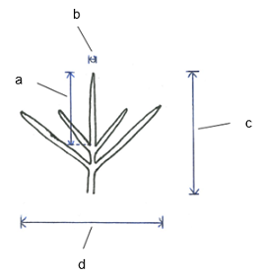 | 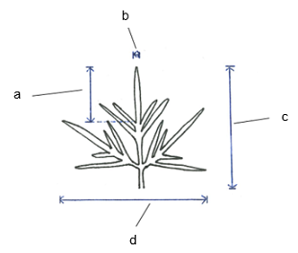
  (d)
  Observations should be made on fully open flowers just after anther dehiscence has started.
  (e)
  Observations should be made on the inner surface of the outer whorl of florets.
  (f)
  The main color is the color with the largest surface area. The color with the second largest area is the secondary color. The color with the third largest area is the tertiary color. In cases where the areas of the colors are too similar to reliably decide which color has the largest area, the darker color is considered to be the main color.

 | Explanations for individual characteristics
  8.2
Ad. 1: Plant: growth habit

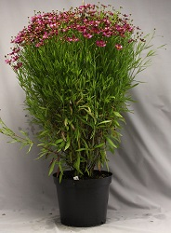 | 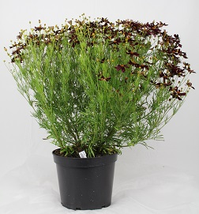 | 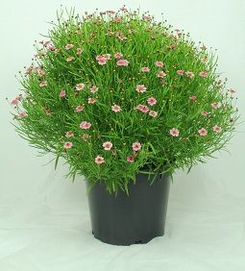 | 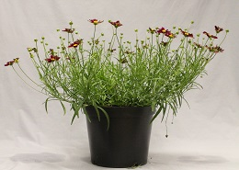
1 | 2 | 3 | 4
upright | semi-upright | semi-spreading | spreading

Ad. 4: Plant: density

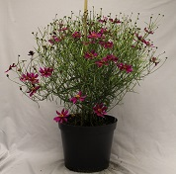
2 | 3 | 4
sparse | medium | dense

Ad. 5: Leaf: type

Some varieties have both types of leaves. The predominant leaf type should be assessed. The state “simple and divided” should be used where there is no predominant type and the variety has a similar amount of both types of leaves.

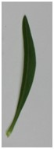 | 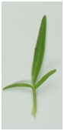
1 | 3
simple | divided

Ad. 8: Simple leaf: length/width ratio

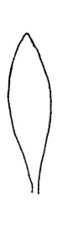 | 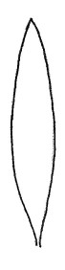 | 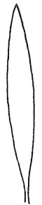
3 | 5 | 7
low | medium | high

Ad. 11: Divided leaf: length/width ratio

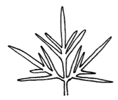 | 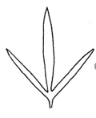 | 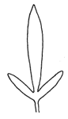
3 | 5 | 7
low | medium | high

Ad. 14: Divided leaf: length/width ratio of terminal lobe

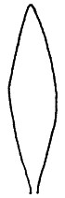 | 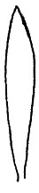 | 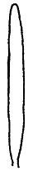
3 | 5 | 7
low | medium | high

Ad. 16: Leaf: distribution of secondary color

The secondary color is the part on the diagram that is not shaded.

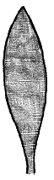 | 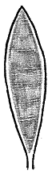 | 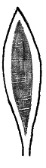 | 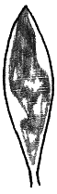
1 | 2 | 3 | 4
none | on margin | marginal zone | irregular

Ad. 20: Flower head: position relative to foliage

 | 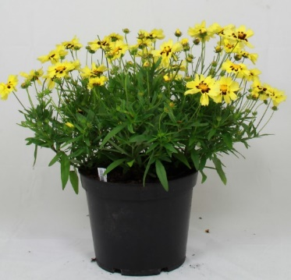 | 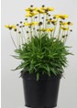
1 | 2 | 3
below or same level | slightly above | moderately above

Ad. 21: Flower head: type

1. Only one row of ray florets
2. More than one row of ray florets, but a clearly defined disc present.
3. Multiple rows of ray florets with no clearly defined disc.

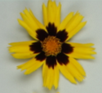 | 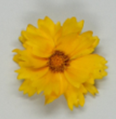 | 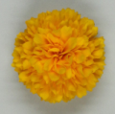
1 | 2 | 3
single | semi-double | double

Ad. 24: Ray floret: attitude of basal part

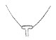 | 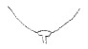 | 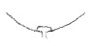 | 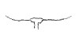
1 | 2 | 3 | 4
strongly  ascending | moderately ascending | weakly  ascending | horizontal

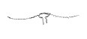 | 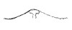 | 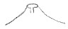
5 | 6 | 7
weakly  descending | moderately descending | strongly descending

Ad. 27: Ray floret: length/width ratio

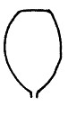 | 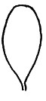 | 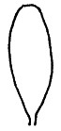
3 | 5 | 7
low | medium | high

Ad. 29: Ray floret: distribution of main color

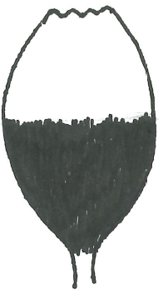 | 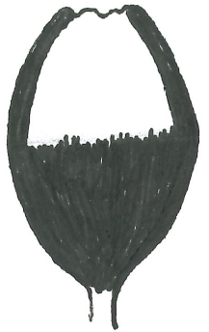 | 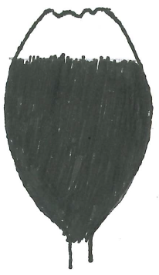 | 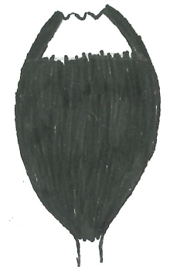
1 | 2 | 3 | 4
basal half | basal half and margins | basal three quarters | basal three quarters and margins
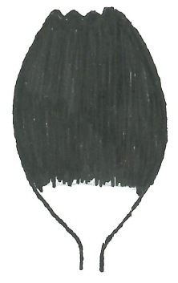 | 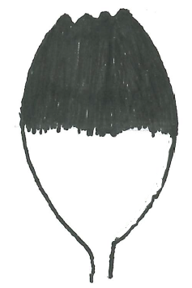 | 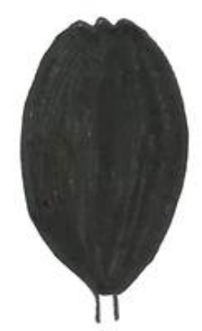
5 | 6 | 7
distal three quarters | distal half | throughout

Ad. 30: Ray floret: distribution of secondary color

If the secondary color is not solid, it may be distributed on more than half of the ray floret and the total area is still less than the main color.

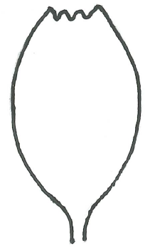 | 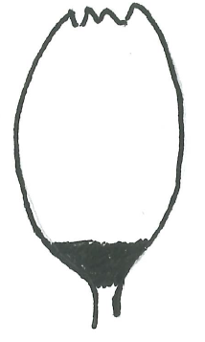 | 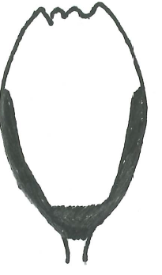 | 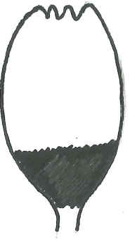 | 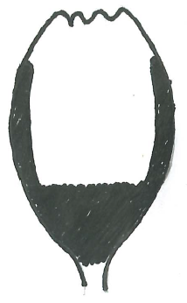
1 | 2 | 3 | 4 | 5
none | base | base and margins | basal quarter | basal quarter and margins
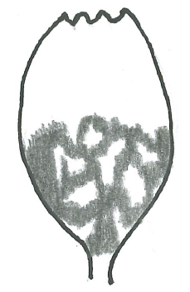 | 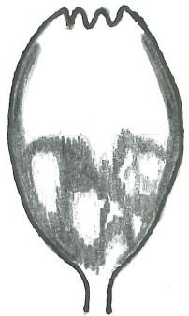 | 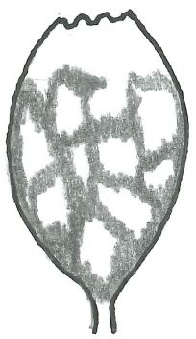 | 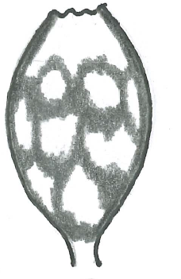 | 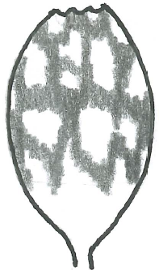
6 | 7 | 8 | 9 | 10
basal half | basal half and margins | basal three quarters | basal three quarters and margin | distal three quarters
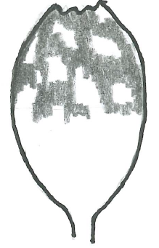 | 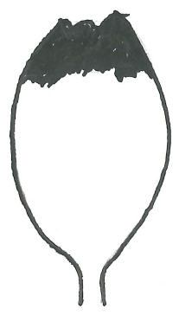 | 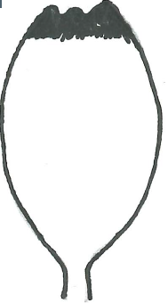 | 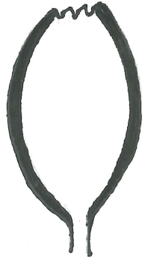 | 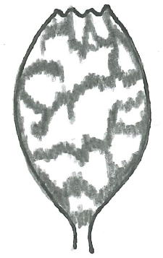
11 | 12 | 13 | 14 | 15
distal half | distal quarter | tip | margins | throughout

Ad. 32: Ray floret: pattern of secondary color

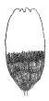 | 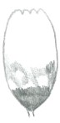 | 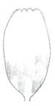
1 | 2 | 3
solid | solid and flushed | flushed

Ad. 33: Ray floret: distribution of tertiary color

If the tertiary color is not solid, it may be distributed in up to half of the ray floret and the total area is still less than the secondary color.

 |  |  | 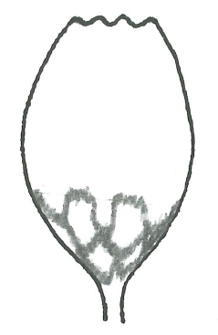 | 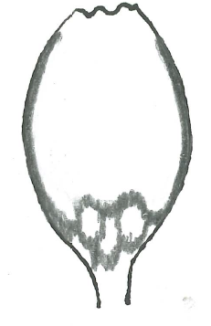
1 | 2 | 3 | 4 | 5
none | base | base and margins | basal quarter | basal quarter and margins
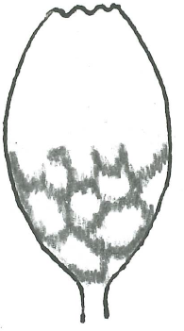 | 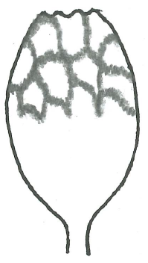 | 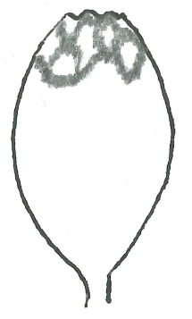
6 | 7 | 8 | 9 | 10
basal half | distal half | distal quarter | tip | margins

Ad. 35: Ray floret: pattern of tertiary color

See Ad. 32

Ad. 36: Ray floret: color of outer side compared to inner side

Markedly different means a different color, not a difference in intensity of one color.

Ad. 38: Ray floret: length of corolla tube
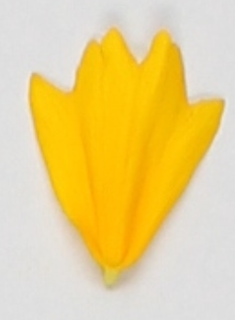 | 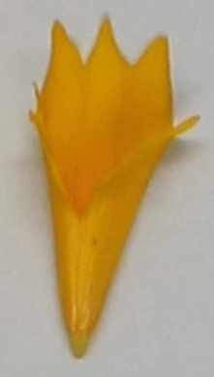 | 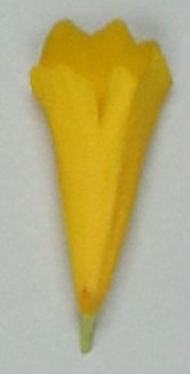
1 | 3 | 5
absent or very short | medium | very long

Ad. 39: Ray floret: longitudinal axis

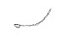 | 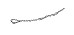 | 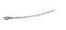 | 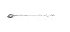 | 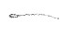 | 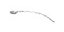 | 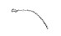
1 | 2 | 3 | 4 | 5 | 6 | 7
strongly incurving | moderately incurving | weakly incurving | straight | weakly reflexing | moderately reflexing | strongly reflexing

Ad. 40: Ray floret: profile in cross section

The cross section should be observed at the mid point along the floret.

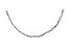 | 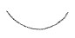 | 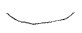 |  |  | 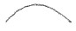 | 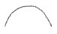
1 | 2 | 3 | 4 | 5 | 6 | 7
strongly concave | moderately concave | weakly concave | flat | weakly convex | moderately convex | strongly convex

Ad. 41: Ray floret: number of indentations at tip

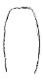 | 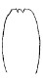 | 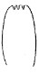 | 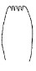 | 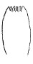
1 | 2 | 3 | 4 | 5
absent or very few | few | medium | many | very many

Ad. 42: Ray floret: depth of indentations at tip

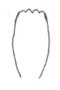 | 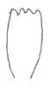 | 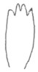 | 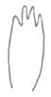 | 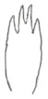
1 | 2 | 3 | 4 | 5
very shallow | shallow | medium | deep | very deep

9. | Literature

Rice, G. (ed)., 2006: Royal Horticultural Society Encyclopedia of Perennials. Dorling Kindersley Ltd.. London, GB pp. 133-135

Brickell, C. (ed)., 2016: Royal Horticultural Society A - Z Encyclopedia of Garden Plants. Dorling Kindersley Ltd.. London, GB pp. 283-284

10. | Technical Questionnaire

TECHNICAL QUESTIONNAIRE | Page {x} of {y} | Reference Number:

Application date:
(not to be filled in by the applicant)
TECHNICAL QUESTIONNAIRE
to be completed in connection with an application for plant breeders' rights

1. | Subject of the Technical Questionnaire
 |  | Botanical name
  1.1
  Coreopsis L.
 |  | Common name
  1.2
  Coreopsis, Tickseed
 | 1.3 | Species:

2. | Applicant
 | Name
 | Address
 | Telephone No.
 | Fax No.
 | E-mail address
 | Breeder (if different from
 | applicant)

3. | Proposed denomination and breeder's reference
 | Proposed denomination
 | (if available)
 | Breeder's reference

TECHNICAL QUESTIONNAIRE |  |  | Page {x} of {y} | Reference Number:
#4. | Information on the breeding scheme and propagation of the variety
 | 4.1 | Breeding scheme
 | Variety resulting from:
  4.1.1
  Crossing
 |  | [ ]
  (a)
  controlled cross
  (please state parent varieties)
(…………………..……………..…) x (……………..…………………..…)

female parent male parent

 |  | [ ]
  (b)
  partially known cross
  (please state known parent variety(ies))
(…………………..……………..…) x (……………..…………………..…)

female parent male parent

 |  | [ ]
  (c)
  unknown cross
 |  | [ ]
  4.1.2
  Mutation
  (please state parent variety)
 |  | [ ]
  4.1.3
  Discovery and development
  (please state where and when discovered and how developed)
 | Other  (Please provide details) | [ ]
  4.1.4

TECHNICAL QUESTIONNAIRE | Page {x} of {y} | Reference Number:

 | 4.2 | Method of propagating the variety
  4.2.1
  Seed-propagated varieties
 |  | [ ]
  (a)
  Self-pollination
 |  | [ ]
  (b)
  Cross-pollination
 |  | [ ]
  (c)
  Hybrid
 |  | [ ]
  (d)
  Other (please provide details)
  4.2.2
  Vegetative propagation
 |  | [ ]
  (a)
  Cuttings
 |  | [ ]
  (b)
  In vitro propagation
 |  | [ ]
  (c)
  Other (state method)
 | Other  (Please provide details) | [ ]
  4.2.3

TECHNICAL QUESTIONNAIRE | Page {x} of {y} | Reference Number:

5. | Characteristics of the variety to be indicated (the number in brackets refers to the corresponding characteristic in Test Guidelines; please mark the note which best corresponds).

 | Characteristics | Example Varieties | Note
  5.1
  (2)
  Plant: height
  very short
  1 [ ]
  very short to short
  2 [ ]
  short
  Mercury Rising
  3 [ ]
  short to medium
  4 [ ]
  medium
  Redshift
  5 [ ]
  medium to tall
  6 [ ]
  tall
  7 [ ]
  tall to very tall
  8 [ ]
  very tall
  9 [ ]
  5.2
  (15)
  Leaf: main color
  yellow green
  1 [ ]
  light green
  2 [ ]
  medium green
  Balupteam
  3 [ ]
  dark green
  VIZCOR 609
  4 [ ]
  5.3
  (16)
  Leaf: distribution of secondary color
  none
  1 [ ]
  on margin
  2 [ ]
  marginal zone
  Tequila Sunrise
  3 [ ]
  irregular
  4 [ ]
  5.4
  (21)
  Flower head: type
  single
  Cosmic Eye
  1 [ ]
  semi-double
  Baluptowed
  2 [ ]
  double
  DCOREO16
  3 [ ]

TECHNICAL QUESTIONNAIRE | Page {x} of {y} | Reference Number:

 |  | Characteristics | Example Varieties | Note
  5.5
  (22)
  Flower head: diameter
  very small
  1 [ ]
  very small to small
  2 [ ]
  small
  Tweety
  3 [ ]
  small to medium
  4 [ ]
  medium
  Red Elf
  5 [ ]
  medium to large
  6 [ ]
  large
  Baluptgonz
  7 [ ]
  large to very large
  8 [ ]
  very large
  9 [ ]
  5.6(i)
  (28)
  Ray floret: main color
  RHS colour chart (indicate reference number)
  5.6(ii)
  (28)
  Ray floret: main color
  white
  1 [ ]
  yellow
  Balupteamed
  2 [ ]
  orange
  Sweet Marmalade
  3 [ ]
  pink
  URITW02
  4 [ ]
  red
  Mercury Rising
  5 [ ]
  purple
  Starstruck
  6 [ ]
  5.7(i)
  (31)
  Ray floret: secondary color
  RHS Colour Chart (indicate reference number)
  5.7(ii)
  (31)
  Ray floret: secondary color
  white
  1 [ ]
  yellow
  Enchanted Eve
  2 [ ]
  orange
  3 [ ]
  pink
  4 [ ]
  red
  Balupteamed
  5 [ ]
  purple
  6 [ ]
  5.8
  (38)
  Ray floret: length of corolla tube
  absent or very short
  Cosmic Eye
  1 [ ]
  short
  2 [ ]
  medium
  Jethro Tull
  3 [ ]
  long
  4 [ ]
  very long
  DCOREO16
  5 [ ]

TECHNICAL QUESTIONNAIRE | Page {x} of {y} | Reference Number:

 |  | Characteristics | Example Varieties | Note
  5.9
  (44)
  Only varieties with flower head: type: single and semi-double: Disc: color before anthesis
  yellow green
  PRO538
  1 [ ]
  yellow
  CSGZ0002
  2 [ ]
  orange
  Enchanted Eve
  3 [ ]
  reddish brown
  Buttermilk
  4 [ ]
  blackish purple
  Peach Sparkle
  5 [ ]

TECHNICAL QUESTIONNAIRE | Page {x} of {y} | Reference Number:

6. | Similar varieties and differences from these varieties
Please use the following table and box for comments to provide information on how your candidate variety differs from the variety (or varieties) which, to the best of your knowledge, is (or are) most similar. This information may help the examination authority to conduct its examination of distinctness in a more efficient way.

  Denomination(s) of variety(ies) similar to your candidate variety
  Characteristic(s) in which your candidate variety differs from the similar variety(ies)
  Describe the expression of the characteristic(s) for the similar variety(ies)
  Describe the expression of the characteristic(s) for your candidate variety

Example
  Flower head: diameter
  small
  medium

 | Comments:

TECHNICAL QUESTIONNAIRE | Page {x} of {y} | Reference Number:

#7. | Additional information which may help in the examination of the variety
7.1 | In addition to the information provided in sections 5 and 6, are there any additional characteristics which may help to distinguish the variety?
 | Yes | [ ] | No | [ ]
 | (If yes, please provide details)
7.2 | Are there any special conditions for growing the variety or conducting the examination?
 | Yes | [ ] | No | [ ]
 | (If yes, please provide details)
7.3 | Other information
A representative color photograph of the variety displaying its main distinguishing feature(s), should accompany the Technical Questionnaire. The photograph will provide a visual illustration of the candidate variety which supplements the information provided in the Technical Questionnaire.
The key points to consider when taking a photograph of the candidate variety are:
• Indication of the date and geographic location
• Correct labeling (breeder’s reference)
• Good quality printed photograph (minimum 10 cm x 15 cm) and/or sufficient resolution electronic format version (minimum 960 x 1280 pixels)”
Further guidance on providing photographs with the Technical Questionnaire is available in document TGP/7 "Development of Test Guidelines", Guidance Note 35 (http://www.upov.int/tgp/en/).
[The link provided may be deleted by members of the Union when developing authorities’ own test guidelines.]

TECHNICAL QUESTIONNAIRE | Page {x} of {y} | Reference Number:

8. | Authorization for release
 | (a) | Does the variety require prior authorization for release under legislation concerning the protection of the environment, human and animal health?
 |  | Yes | [ ] | No | [ ]
 | (b) | Has such authorization been obtained?
 |  | Yes | [ ] | No | [ ]
 | If the answer to (b) is yes, please attach a copy of the authorization.

9. Information on plant material to be examined or submitted for examination

9.1 The expression of a characteristic or several characteristics of a variety may be affected by factors, such as pests and disease, chemical treatment (e.g. growth retardants or pesticides), effects of tissue culture, different rootstocks, scions taken from different growth phases of a tree, etc.
9.2 The plant material should not have undergone any treatment which would affect the expression of the characteristics of the variety, unless the competent authorities allow or request such treatment. If the plant material has undergone such treatment, full details of the treatment must be given. In this respect, please indicate below, to the best of your knowledge, if the plant material to be examined has been subjected to:

 | (a) | Microorganisms (e.g. virus, bacteria, phytoplasma) | Yes [ ] | No [ ]
 | (b) | Chemical treatment (e.g. growth retardant, pesticide) | Yes [ ] | No [ ]
 | (c) | Tissue culture | Yes [ ] | No [ ]
 | (d) | Other factors | Yes [ ] | No [ ]
 | Please provide details for where you have indicated “yes”.

10. | I hereby declare that, to the best of my knowledge, the information provided in this form is correct:
 | Applicant’s name
 | Signature |  | Date

[End of document]

