E
TG/322/1 Corr.
ORIGINAL: English
DATE: 2017-04-05 + 2019-10-03
INTERNATIONAL UNION FOR THE PROTECTION OF NEW VARIETIES OF PLANTS
Geneva

 | UROCHLOA  UPOV Code: UROCH_BRI; UROCH_DEC; UROCH_DIC; UROCH_HUM; UROCH_RBR; UROCH_RDB, UROCH_RUZ  Urochloa brizantha (Hochst. ex A. Rich.) R. D. Webster;  Urochloa decumbens (Stapf) R. D. Webster;  Urochloa dictyoneura (Fig. & De Not.) Veldkamp;  Urochloa humidicola (Rendle) Morrone & Zuloaga;  Urochloa ruziziensis (R. Germ. & C. M. Evrard) Crins x U. brizantha (Hochst. ex A. Rich.) R. D. Webster;  Urochloa ruziziensis x Urochloa decumbens x Urochloa brizantha;  Urochloa ruziziensis (R. Germ. & C. M. Evrard) Crins | *

GUIDELINES
FOR THE CONDUCT OF TESTS
FOR DISTINCTNESS, UNIFORMITY AND STABILITY

Alternative Names:*

Botanical name | English | French | German | Spanish
Urochloa brizantha (Hochst. ex A. Rich.) R. D. Webster, Brachiaria brizantha (Hochst. ex A. Rich.) Stapf, Panicum brizanthum Hochst. ex A. Rich. | Bread Grass, Palisade grass, Palisade signal grass, Signal Grass |  | Palisadengras | Pasto alambre, Pasto señal, Zacate señal, Zacate signal, Brachiaria
Urochloa decumbens (Stapf) R. D. Webster, Brachiaria decumbens Stapf | Basilisk signal grass, Signal grass, Spreading liverseed grass, Surinam grass |  | Surinamgras | Zacate Surinam, Pasto chontalpo, Pasto de la palizada, Pasto de las orillas, Pasto peludo, Pasto prodigio, Zacate prodigio, Brachiaria
Urochloa dictyoneura (Fig. & De Not.) Veldkamp, Brachiaria dictyoneura (Fig. & De Not.) Stapf, Panicum dictyoneurum Fig. & De Not. | Koronivia grass
Urochloa humidicola (Rendle) Morrone & Zuloaga, Brachiaria humidicola (Rendle) Schweick.; Panicum humidicola Rendle | Creeping signal grass, Koronivia grass | Koronivia |  | Braquiaria dulce, Kikuyu de la Amazonía, Pasto humidícola, Pasto humidícola dulce
Urochloa ruziziensis (R. Germ. & C. M. Evrard) Crins x U. brizantha (Hochst. ex A. Rich.) R. D. Webster, Brachiaria ruziziensis R. Germ. & C. M. Evrard x B. brizantha (Hochst. ex A. Rich.) Stapf
Urochloa ruziziensis x Urochloa decumbens x Urochloa brizantha, Brachiaria ruziziensis x Brachiaria decumbens x Brachiaria brizantha
Urochloa ruziziensis (R. Germ. & C. M. Evrard) Crins, Brachiaria ruziziensis R. Germ. & C. M. Evrard | Congo grass, Congo signal grass, Ruzi grass |  |  | Congo señal, Gambutera, Kenia, Pasto Congo, Pasto ruzi, Brachiaria

The purpose of these guidelines (“Test Guidelines”) is to elaborate the principles contained in the General Introduction (document TG/1/3), and its associated TGP documents, into detailed practical guidance for the harmonized examination of distinctness, uniformity and stability (DUS) and, in particular, to identify appropriate characteristics for the examination of DUS and production of harmonized variety descriptions.

ASSOCIATED DOCUMENTS
These Test Guidelines should be read in conjunction with the General Introduction and its associated TGP documents.
TABLE OF CONTENTS PAGE

1. Subject of these Test Guidelines 4
2. Material Required 4
3. Method of Examination 4
3.1 Number of Growing Cycles 4
3.2 Testing Place 4
3.3 Conditions for Conducting the Examination 4
3.4 Test Design 4
3.5 Additional Tests 5
4. Assessment of Distinctness, Uniformity and Stability 5
4.1 Distinctness 5
4.2 Uniformity 6
4.3 Stability 6
5. Grouping of Varieties and Organization of the Growing Trial 6
6. Introduction to the Table of Characteristics 7
6.1 Categories of Characteristics 7
6.2 States of Expression and Corresponding Notes 7
6.3 Types of Expression 7
6.4 Example Varieties 7
6.5 Legend 8
7. Table of Characteristics/Tableau des caractères/Merkmalstabelle/Tabla de caracteres 9
8. Explanations on the Table of Characteristics 12
8.1 Explanations covering several characteristics 12
8.2 Explanations for individual characteristics 12
9. Literature 15
10. Technical Questionnaire 16

Subject of these Test Guidelines

These Test Guidelines apply to all varieties of Urochloa brizantha (Hochst. ex A. Rich.) R. D. Webster, Urochloa decumbens (Stapf) R. D. Webster, Urochloa dictyoneura (Fig. & De Not.) Veldkamp, Urochloa humidicola (Rendle) Morrone & Zuloaga, Urochloa ruziziensis (R. Germ. & C. M. Evrard) Crins x U. brizantha (Hochst. ex A. Rich.) R. D. Webster, Urochloa ruziziensis x Urochloa decumbens x Urochloa brizantha, Urochloa ruziziensis (R. Germ. & C. M. Evrard) Crins.

Material Required

2.1 The competent authorities decide on the quantity and quality of the plant material required for testing the variety and when and where it is to be delivered. Applicants submitting material from a State other than that in which the testing takes place must ensure that all customs formalities and phytosanitary requirements are complied with.

2.2 The material is to be supplied in the form of seed.

2.3 The minimum quantity of plant material, to be supplied by the applicant, should be:

500 g of seed.

The seed should meet the minimum requirements for germination, species and analytical purity, health and moisture content, specified by the competent authority. In cases where the seed is to be stored, the germination capacity should be as high as possible and should, be stated by the applicant.

2.4 The plant material supplied should be visibly healthy, not lacking in vigor, nor affected by any important pest or disease.

2.5 The plant material should not have undergone any treatment which would affect the expression of the characteristics of the variety, unless the competent authorities allow or request such treatment. If it has been treated, full details of the treatment must be given.

Method of Examination

3.1 Number of Growing Cycles

3.1.1 The minimum duration of tests should normally be two independent growing cycles.

3.1.2 The two independent growing cycles should be in the form of two separate plantings.

3.2 Testing Place

Tests are normally conducted at one place. In the case of tests conducted at more than one place, guidance is provided in TGP/9 “Examining Distinctness”.

3.3 Conditions for Conducting the Examination

The tests should be carried out under conditions ensuring satisfactory growth for the expression of the relevant characteristics of the variety and for the conduct of the examination.

3.4 Test Design

3.4.1 For apomictic varieties, each test should be designed to result in a total of at least 40 spaced plants which should be divided between at least 2 replicates.

3.4.2 For cross-pollinated varieties, each test should be designed to result in a total of at least 60 spaced plants which should be divided between at least 3 replicates.

3.4.3 The design of the tests should be such that plants or parts of plants may be removed for measurement or counting without prejudice to the observations which must be made up to the end of the growing cycle.

3.5 Additional Tests

Additional tests, for examining relevant characteristics, may be established.

Assessment of Distinctness, Uniformity and Stability

4.1 Distinctness

4.1.1 General Recommendations

It is of particular importance for users of these Test Guidelines to consult the General Introduction prior to making decisions regarding distinctness. However, the following points are provided for elaboration or emphasis in these Test Guidelines.

4.1.2 Consistent Differences

The differences observed between varieties may be so clear that more than one growing cycle is not necessary. In addition, in some circumstances, the influence of the environment is not such that more than a single growing cycle is required to provide assurance that the differences observed between varieties are sufficiently consistent. One means of ensuring that a difference in a characteristic, observed in a growing trial, is sufficiently consistent is to examine the characteristic in at least two independent growing cycles.

4.1.3 Clear Differences

Determining whether a difference between two varieties is clear depends on many factors, and should consider, in particular, the type of expression of the characteristic being examined, i.e. whether it is expressed in a qualitative, quantitative, or pseudo-qualitative manner. Therefore, it is important that users of these Test Guidelines are familiar with the recommendations contained in the General Introduction prior to making decisions regarding distinctness.

4.1.4 Number of Plants / Parts of Plants to be Examined

In the case of apomictic varieties, unless otherwise indicated, for the purposes of distinctness, all observations on single plants should be made on 20 plants or parts taken from each of 20 plants and any other observations made on all plants in the test, disregarding any off-type plants.

In the case of cross-pollinated varieties, unless otherwise indicated, for the purposes of distinctness, all observations on single plants should be made on 60 plants or parts taken from each of 60 plants and any other observations made on all plants in the test, disregarding any off-type plants.

4.1.5 Method of Observation

The recommended method of observing the characteristic for the purposes of distinctness is indicated by the following key in the Table of Characteristics (see document TGP/9 “Examining Distinctness”, Section 4 “Observation of characteristics”):

MG: single measurement of a group of plants or parts of plants
MS: measurement of a number of individual plants or parts of plants
VG: visual assessment by a single observation of a group of plants or parts of plants
VS: visual assessment by observation of individual plants or parts of plants

Type of observation: visual (V) or measurement (M)

“Visual” observation (V) is an observation made on the basis of the expert’s judgment. For the purposes of this document, “visual” observation refers to the sensory observations of the experts and, therefore, also includes smell, taste and touch. Visual observation includes observations where the expert uses reference points (e.g. diagrams, example varieties, side-by-side comparison) or non-linear charts (e.g. color charts). Measurement (M) is an objective observation against a calibrated, linear scale e.g. using a ruler, weighing scales, colorimeter, dates, counts, etc.

Type of record: for a group of plants (G) or for single, individual plants (S)

For the purposes of distinctness, observations may be recorded as a single record for a group of plants or parts of plants (G), or may be recorded as records for a number of single, individual plants or parts of plants (S). In most cases, “G” provides a single record per variety and it is not possible or necessary to apply statistical methods in a plant-by-plant analysis for the assessment of distinctness.

In cases where more than one method of observing the characteristic is indicated in the Table of Characteristics (e.g. VG/MG), guidance on selecting an appropriate method is provided in document TGP/9, Section 4.2.

4.2 Uniformity

4.2.1 It is of particular importance for users of these Test Guidelines to consult the General Introduction prior to making decisions regarding uniformity. However, the following points are provided for elaboration or emphasis in these Test Guidelines:

4.2.2 These Test Guidelines have been developed for the examination of apomictic and cross-pollinated varieties. For varieties with other types of propagation the recommendations in the General Introduction and document TGP/13 “Guidance for new types and species”, Section 4.5 “Testing Uniformity” should be followed.

4.2.3 The assessment of uniformity for cross-pollinated varieties should be according to the recommendations for cross-pollinated varieties in the General Introduction.

4.2.4 For the assessment of uniformity of apomictic varieties, a population standard of 2% and an acceptance probability of at least 95 % should be applied. In the case of a sample size of 40 plants, 2 off-types are allowed.

4.3 Stability

4.3.1 In practice, it is not usual to perform tests of stability that produce results as certain as those of the testing of distinctness and uniformity. However, experience has demonstrated that, for many types of variety, when a variety has been shown to be uniform, it can also be considered to be stable.

4.3.2 Where appropriate, or in cases of doubt, stability may be further examined by testing a new seed stock to ensure that it exhibits the same characteristics as those shown by the initial material supplied.

Grouping of Varieties and Organization of the Growing Trial

5.1 The selection of varieties of common knowledge to be grown in the trial with the candidate varieties and the way in which these varieties are divided into groups to facilitate the assessment of distinctness are aided by the use of grouping characteristics.

5.2 Grouping characteristics are those in which the documented states of expression, even where produced at different locations, can be used, either individually or in combination with other such characteristics: (a) to select varieties of common knowledge that can be excluded from the growing trial used for examination of distinctness; and (b) to organize the growing trial so that similar varieties are grouped together.

5.3 The following have been agreed as useful grouping characteristics:

(a) Leaf blade: hairs (characteristic 11)
(b) Inflorescence: shape of rachis in cross section (characteristic 15)
(c) Flower: stigma color (characteristic 19)

5.4 Guidance for the use of grouping characteristics, in the process of examining distinctness, is provided through the General Introduction and document TGP/9 “Examining Distinctness”.

Introduction to the Table of Characteristics

6.1 Categories of Characteristics

6.1.1 Standard Test Guidelines Characteristics

Standard Test Guidelines characteristics are those which are approved by UPOV for examination of DUS and from which members of the Union can select those suitable for their particular circumstances.

6.1.2 Asterisked Characteristics

Asterisked characteristics (denoted by *) are those included in the Test Guidelines which are important for the international harmonization of variety descriptions and should always be examined for DUS and included in the variety description by all members of the Union, except when the state of expression of a preceding characteristic or regional environmental conditions render this inappropriate.

6.2 States of Expression and Corresponding Notes

6.2.1 States of expression are given for each characteristic to define the characteristic and to harmonize descriptions. Each state of expression is allocated a corresponding numerical note for ease of recording of data and for the production and exchange of the description.

6.2.2 In the case of qualitative and pseudo-qualitative characteristics (see Chapter 6.3), all relevant states of expression are presented in the characteristic. However, in the case of quantitative characteristics with 5 or more states, an abbreviated scale may be used to minimize the size of the Table of Characteristics. For example, in the case of a quantitative characteristic with 9 states, the presentation of states of expression in the Test Guidelines may be abbreviated as follows:

State | Note
small | 3
medium | 5
large | 7

However, it should be noted that all of the following 9 states of expression exist to describe varieties and should be used as appropriate:

State | Note
very small | 1
very small to small | 2
small | 3
small to medium | 4
medium | 5
medium to large | 6
large | 7
large to very large | 8
very large | 9

6.2.3 Further explanation of the presentation of states of expression and notes is provided in document TGP/7 “Development of Test Guidelines”.

6.3 Types of Expression

An explanation of the types of expression of characteristics (qualitative, quantitative and pseudo-qualitative) is provided in the General Introduction.

6.4 Example Varieties

Where appropriate, example varieties are provided to clarify the states of expression of each characteristic.

6.5 Legend

(*) Asterisked characteristic – see Chapter 6.1.2

QL Qualitative characteristic – see Chapter 6.3
QN Quantitative characteristic – see Chapter 6.3
PQ Pseudo-qualitative characteristic – see Chapter 6.3

MG, MS, VG, VS – see Chapter 4.1.5

(a)-(b) See Explanations on the Table of Characteristics in Chapter 8.

(+) See Explanations on the Table of Characteristics in Chapter 8.

Table of Characteristics/Tableau des caractères/Merkmalstabelle/Tabla de caracteres

 |  | English | français | deutsch | español | Example Varieties  Exemples  Beispielssorten  Variedades ejemplo | Note/  Nota
(*)  (+) | VG | Plant: growth habit | Plante : port | Pflanze: Wuchsform | Planta: porte
QN |  | erect | dressé | aufrecht | erecto | BRS Piatã, CIAT BR02/1718 | 1
 |  | semi erect | demi-dressé | halbaufrecht | semierecto | BRS Tupi, Llanero | 3
 |  | semi prostate | demi-étalé | halbliegend | semipostrado | MIXE LN 45, Mulato II | 5
 |  | prostrate | étalé | liegend | postrado | Humidícola comum | 7
(*)  (+) | MS | Plant: height | Plante : hauteur | Pflanze: Höhe | Planta: altura
QN | (a) | short | basse | niedrig | corta | BRS Tupi | 3
 |  | medium | moyenne | mittel | media | BRS Piatã, MIXE LN 45, Mulato II | 5
 |  | tall | haute | hoch | alta | CIAT BR02/1718, Xaraés | 7
(*) | MS | Stolon: length of internode | Stolon : longueur de l’entre-nœud | Ausläufer: Internodienlänge | Estolón: longitud del entrenudo
QN |  | absent or very short | absent ou très court | fehlend oder sehr kurz | ausente o muy corto | BRS Piatã | 1
 |  | short | court | kurz | corto | Mulato II | 3
 |  | medium | moyen | mittel | medio | Humidícola comum | 5
 |  | long | long | lang | largo | BRS Tupi | 7
(*)  (+) | MS | Culm: length of internode | Tige : longueur de l’entre-nœud | Halm: Internodienlänge | Macollo: longitud del entrenudo
QN |  | short | court | kurz | corto | BRS Tupi | 3
 |  | medium | moyen | mittel | medio | MIXE LN 45 | 5
 |  | long | long | lang | largo | Xaraés | 7
(+) | MS | Culm: diameter | Tige : diamètre | Halm: Durchmesser | Macollo: diámetro
QN |  | small | petit | klein | pequeño |  | 1
 |  | medium | moyen | mittel | medio | MIXE LN 45, Mulato II | 2
 |  | large | grand | groß | grande |  | 3
(*)  (+) | VG | Flag leaf: curvature | Dernière feuille : courbure | Fahnenblatt: Biegung | Última hoja: curvatura
QN |  | absent or weak | absente ou faible | fehlend oder gering | ausente o débil |  | 1
 |  | medium | moyenne | mittel | media |  | 2
 |  | strong | forte | stark | fuerte |  | 3
(*)  (+) | VG | Flag leaf: width | Dernière feuille : largeur | Fahnenblatt: Breite | Última hoja: anchura
QN |  | narrow | étroite | schmal | estrecha | BRS Piatã | 1
 |  | medium | moyenne | mittel | media | MIXE LN 45, Mulato II | 2
 |  | broad | large | breit | ancha |  | 3
(*) | VG | Flag leaf: distribution of hairs on sheath | Dernière feuille : répartition des poils sur la gaine | Fahnenblatt: Verteilung der Haare an der Blattscheide | Última hoja: distribución de los pelos en la vaina
PQ |  | at base | à la base | an der Basis | en la base |  | 1
 |  | at apex | au sommet | an der Spitze | en el ápice | MIXE LN 45 | 2
 |  | on margins | en bordure | an den Rändern | en los márgenes |  | 3
 |  | throughout | partout | überall | en la totalidad | BRS Piatã, Mulato II | 4
 | MS | Leaf blade: length | Limbe : longueur | Blattspreite: Länge | Limbo: longitud
QN | (b) | short | court | kurz | corto | Basilisk, Humidícola comum | 3
 |  | medium | moyen | mittel | medio | MIXE LN 45 | 5
 |  | long | long | lang | largo | BRS Piatã, Mulato II | 7
(*) | MS | Leaf blade: width | Limbe : largeur | Blattspreite: Breite | Limbo: anchura
QN | (b) | narrow | étroit | schmal | estrechas | BRS Piatã | 3
 |  | medium | moyen | mittel | medio | MIXE LN 45 | 5
 |  | broad | large | breit | anchas | Mulato II | 7
(*) | VG | Leaf blade: hairs | Limbe : poils | Blattspreite: Haare | Limbo: pelos
QL | (b) | absent | absente | fehlend | ausente | BRS Piatã | 1
 |  | present | présente | vorhanden | presente | Mulato II | 9
(*) | VG | Leaf blade: distribution of hairs | Limbe : répartition des poils | Blattspreite: Verteilung der Haare | Limbo: distribución de los pelos
PQ | (b) | on upper surface only | uniquement sur la face supérieure | nur an der Oberseite | solo en el haz | BRS Tupi, Llanero | 1
 |  | on lower surface only | uniquement sur la face inférieure | nur an der Unterseite | solo en el envés | MIXE LN 45 | 2
 |  | on margins only | uniquement en bordure | nur an den Rändern | solo en los márgenes | Marandú, Xaraés | 3
 |  | on both surfaces | sur les deux faces | auf beiden Seiten | en ambas superficies | Mulato II, Basilisk | 4
(*) | VG | Leaf sheath: density of hairs | Gaine de la feuille: densité de la pilosité | Blattscheide: Dichte der Behaarung | Vaina de la hoja: densidad de la vellosidad
QN | (b) | absent or sparse | absente ou éparse | fehlend oder locker | ausente o escasa | BRS Piatã | 1
 |  | medium | moyenne | mittel | media |  | 2
 |  | dense | dense | dicht | densa | Mulato II | 3
(+) | MS | Inflorescence: length of rachis | Inflorescence : longueur du rachis | Blütenstand: Länge der Spindeln | Inflorescencia: longitud del raquis
QN | (a) | short | court | kurz | corto | Mulato II | 3
 |  | medium | moyen | mittel | medio | Llanero | 5
 |  | long | long | lang | largo | Marandú | 7
(*)  (+) | VG | Inflorescence: shape of rachis in cross section | Inflorescence : forme du rachis en section transversale | Blütenstand: Form der Spindeln im Querschnitt | Inflorescencia: forma del raquis en sección transversal
PQ | (a) | triangular | triangulaire | dreieckig | triangular | MIXE LN 45 | 1
 |  | winged | ailée | geflügelt | alado | Mulato II | 2
 |  | crescent | en croissant | halbmondförmig | lunular | BRS Piatã | 3
(+) | MS | Inflorescence: length of basal racemes | Inflorescence : longueur des racèmes de la base | Blütenstand: Länge der basalen Blütentrauben | Inflorescencia: longitud de los racimos basales
QN | (a) | short | courts | kurz | cortos | BRS Tupi, Humidícola comum | 3
 |  | medium | moyens | mittel | medios | MIXE LN 45, Mulato II | 5
 |  | long | longs | lang | largos | Marandú | 7
(*)  (+) | MS | Inflorescence: length of peduncle | Inflorescence : longueur du pédoncule | Blütenstand: Länge des Blütenstandsstiels | Inflorescencia: longitud del pedúnculo
QN | (a) | short | court | kurz | corto |  | 3
 |  | medium | moyen | mittel | medio | Mulato II | 5
 |  | long | long | lang | largo | BRS Piatã, MIXE LN 45 | 7
(*) | VG | Spikelet: pubescence | Épillet : pubescence | Ährchen: Behaarung | Espiguilla: pubescencia
QN | (a) | absent or very sparse | absente ou très éparse | fehlend oder sehr locker | ausente o muy escasa | BRS Piatã | 1
 |  | sparse | éparse | locker | escasa | Humidícola comum | 3
 |  | medium | moyenne | mittel | media | Mulato II, Xaraés | 5
 |  | dense | dense | dicht | densa | BRS Tupi, Llanero | 7
(*) | VG | Flower: stigma color | Fleur : couleur des stigmates | Blüte: Farbe der Narbe | Flor: color del estigma
PQ |  | white | blanc | weiß | blanco | Mulato II | 1
 |  | light purple | violet clair | hellpurpurn | púrpura claro | Llanero | 2
 |  | medium purple | violet moyen | mittelpurpurn | púrpura medio | BRS Piatã, MIXE LN 45 | 3
 |  | dark purple | violet foncé | dunkelpurpurn | púrpura oscuro | Marandú, Toledo | 4
 | VG | Glume: anthocyanin coloration | Glume : pigmentation anthocyanique | Hüllspelze: Anthocyanfärbung | Gluma: pigmentación antociánica
QN | (a) | absent or very weak | absente ou très faible | fehlend oder sehr gering | ausente o muy débil | BRS Piatã | 1
 |  | weak | absente | gering | débil | Basilisk | 3
 |  | medium | moyenne | mittel | media | Marandú | 5
 |  | strong | forte | stark | fuerte | Llanero | 7
(*)  (+) | MG | Time of inflorescence emergence | Époque d’épiaison | Zeitpunkt des Erscheinens der Blütenstände | Época de la emergencia de las inflorescencias
QN |  | early | précoce | früh | temprana | BRS Piatã, Basilisk, Llanero | 3
 |  | medium | moyenne | mittel | media | Marandú | 5
 |  | late | tardive | spät | tardía | Xaraés | 7

Explanations on the Table of Characteristics

8.1 Explanations covering several characteristics

Characteristics containing the following key should be examined as indicated below:

(a) Observations should be made at the time of beginning of flowering.

(b) Observations on fully developed leaves should be made on the penultimate leaf of the main culm.

8.2 Explanations for individual characteristics

Ad. 1: Plant: growth habit
1 erect
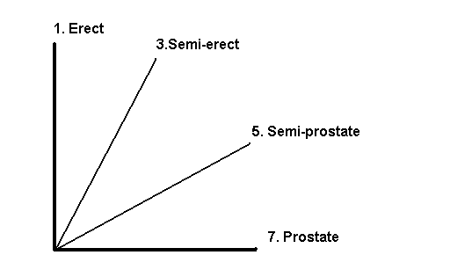
7 prostrate
3 semi erect
5 semi prostrate

Ad. 2: Plant: height

The height of the plant should be measured in the center of the plant, from the first leaf below the flag leaf to the ground level, excluding the inflorescence.

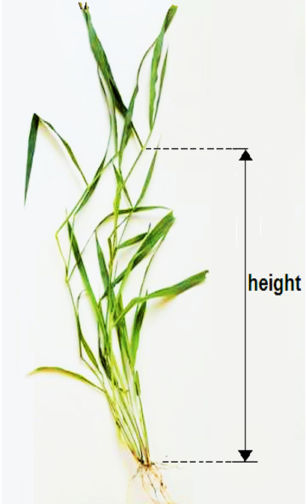

Ad. 4: Culm: length of internode
Ad. 5: Culm: diameter

The assessment of the length of internode should be made in the middle third of plant; it does not refer to floral culm.

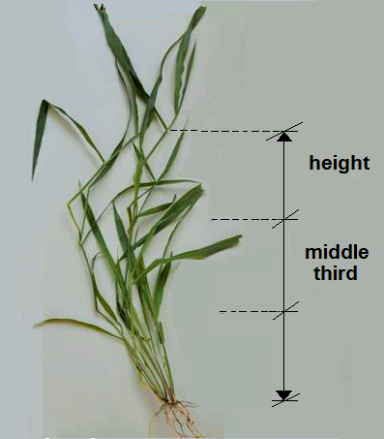

Ad. 6: Flag leaf: curvature

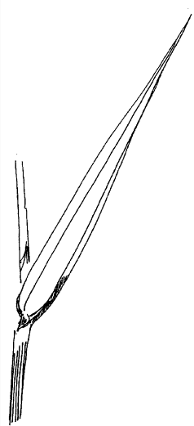 | 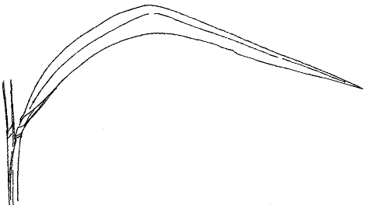 | 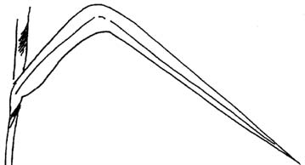
1 | 2 | 3
absent or weak | medium | strong

Ad. 7: Flag leaf: width

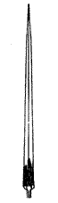 | 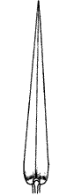 | 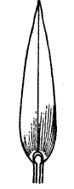
1 | 2 | 3
narrow | medium | broad

Ad. 14: Inflorescence: length of rachis
Ad. 16: Inflorescence: length of basal racemes
Ad. 17: Inflorescence: length of peduncle
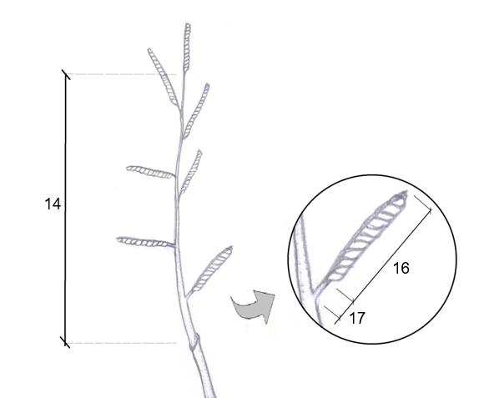

Ad. 15: Inflorescence: shape of rachis in cross section

1 | 2 | 3
triangular | winged | crescent

Ad. 21: Time of inflorescence emergence

The time of inflorescence emergence is reached when 50% of the plants have at least one inflorescence fully emerged.

Literature

Assis, G.M.L. de, Euclydes, R.F., Cruz, C.D. and Valle, C. B. do. 2003: Discriminação de Espécies de Brachiaria Baseada em Diferentes Grupos de Caracteres Morfológicos. R. Bras. Zootec., v.32, n.3, pp.576-584

Miles, J. W., Maass, B. L. and Valle, C. B. do. eds., 1996: Brachiaria: Biology, Agronomy, and Improvement. CIAT Publication No. 259

Technical Questionnaire

 | TECHNICAL QUESTIONNAIRE |  |  |  |  | Page {x} of {y} |  | Reference Number:
 |  |  |  |  |  |  |  | Application date:
 |  |  |  |  |  |  |  | (not to be filled in by the applicant)
TECHNICAL QUESTIONNAIRE
to be completed in connection with an application for plant breeders’ rights

 | 1. Subject of the Technical Questionnaire
 | 1.1.1 Botanical name |  |  | Urochloa brizantha (Hochst. ex A. Rich.) R. D. Webster |  |  |  |  |  |  |  | [ ]
 | 1.1.2 Common name |  |  | Bread Grass, Palisade grass, Palisade signal grass, Signal Grass
 | 1.2.1 Botanical name |  |  | Urochloa decumbens (Stapf) R. D. Webster |  |  |  |  |  |  | [ ]
 | 1.2.2 Common name |  |  | Basilisk signal grass, Signal grass, Spreading liverseed grass, Surinam grass
 | 1.3.1 Botanical name |  |  | Urochloa dictyoneura (Fig. & De Not.) Veldkamp |  |  |  |  |  |  | [ ]
 | 1.3.2 Common name |  |  | Koronivia grass
 | 1.4.1 Botanical name |  |  | Urochloa humidicola (Rendle) Morrone & Zuloaga |  |  |  |  |  |  | [ ]
 | 1.4.2 Common name |  |  | Creeping signal grass, Koronivia grass
 | 1.5.1 Botanical name |  |  | Urochloa ruziziensis (R. Germ. & C. M. Evrard) Crins x U. brizantha (Hochst. ex A. Rich.) R. D. Webster |  |  |  |  |  |  | [ ]
 | 1.5.2 Common name
 | 1.6.1 Botanical name |  |  | Urochloa ruziziensis x Urochloa decumbens x Urochloa brizantha |  |  |  |  |  |  | [ ]
 | 1.6.2 Common name
 | 1.7.1 Botanical name |  |  | Urochloa ruziziensis (R. Germ. & C. M. Evrard) Crins |  |  |  |  |  |  | [ ]
 | 1.7.2 Common name |  |  | Congo grass, Congo signal grass, Ruzi grass
 | 2. Applicant
 | Name
 | Address
 | Telephone No.
 | Fax No.
 | E-mail address
 | Breeder (if different from applicant)
 | 3. Proposed denomination and breeder’s reference
 | Proposed denomination
 | (if available)
 | Breeder’s reference
#4. Information on the breeding scheme and propagation of the variety

4.1 Breeding scheme

Variety resulting from:

4.1.1 Crossing

(a) controlled cross [ ]
(please state parent varieties)

(…………………..…………………………) x (……………..…………..………………..…)
female parent male parent

(b) partially known cross [ ]
(please state known parent variety(ies))

(…………………..……………………....…) x (……………..………………..…………..…)
female parent male parent

(c) unknown cross [ ]

4.1.2 Mutation [ ]
(please state parent variety)

4.1.3 Discovery and development [ ]
(please state where and when discovered and how developed)

4.1.4 Other [ ]
(please provide details)

4.2 Method of propagating the variety

4.2.1 Seed-propagated varieties

(a) apomictic [ ]
(b) non-apomictic [ ]
(c) Other [ ]
(please provide details)

4.2.2 Other
(please provide details) [...]

 | 5. Characteristics of the variety to be indicated (the number in brackets refers to the corresponding characteristic in Test Guidelines; please mark the note which best corresponds).
 |  | Characteristics |  |  |  |  |  |  | Example Varieties |  |  |  |  | Note
 | 5.1  (11) | Leaf blade: hairs
 |  | absent |  |  |  |  |  |  | BRS Piatã |  |  |  |  | 1 [ ]
 |  | present |  |  |  |  |  |  | Mulato II |  |  |  |  | 9 [ ]
 | 5.2  (15) | Inflorescence: shape of rachis in cross section
 |  | triangular |  |  |  |  |  |  | MIXE LN 45 |  |  |  |  | 1 [ ]
 |  | winged |  |  |  |  |  |  | Mulato II |  |  |  |  | 2 [ ]
 |  | crescent |  |  |  |  |  |  | BRS Piatã |  |  |  |  | 3 [ ]
 | 5.3  (19) | Flower: stigma color
 |  | white |  |  |  |  |  |  | Mulato II |  |  |  |  | 1 [ ]
 |  | light purple |  |  |  |  |  |  | Llanero |  |  |  |  | 2 [ ]
 |  | medium purple |  |  |  |  |  |  | BRS Piatã, MIXE LN 45 |  |  |  |  | 3 [ ]
 |  | dark purple |  |  |  |  |  |  | Marandú, Toledo |  |  |  |  | 4 [ ]
6. Similar varieties and differences from these varieties

Please use the following table and box for comments to provide information on how your candidate variety differs from the variety (or varieties) which, to the best of your knowledge, is (or are) most similar. This information may help the examination authority to conduct its examination of distinctness in a more efficient way.

Denomination(s) of variety(ies) similar to your candidate variety |  |  | Characteristic(s) in which your candidate variety differs from the similar variety(ies) |  |  |  | Describe the expression of the characteristic(s) for the similar variety(ies) |  |  | Describe the expression of the characteristic(s) for your candidate variety
Example |  |  | Flower: stigma color |  |  |  | dark purple |  |  | light purple
Comments:

#7. Additional information which may help in the examination of the variety

7.1 In addition to the information provided in sections 5 and 6, are there any additional characteristics which may help to distinguish the variety?

Yes [ ] No [ ]

(If yes, please provide details)

7.2 Are there any special conditions for growing the variety or conducting the examination?

Yes [ ] No [ ]

(If yes, please provide details)

7.3 Other information

Ploidy [ ]

8. Authorization for release

(a) Does the variety require prior authorization for release under legislation concerning the protection of the environment, human and animal health?

Yes [ ] No [ ]

(b) Has such authorization been obtained?

Yes [ ] No [ ]

If the answer to (b) is yes, please attach a copy of the authorization.

9. Information on plant material to be examined or submitted for examination

9.1 The expression of a characteristic or several characteristics of a variety may be affected by factors, such as pests and disease, chemical treatment (e.g. growth retardants or pesticides), effects of tissue culture, different rootstocks, scions taken from different growth phases of a tree, etc.

9.2 The plant material should not have undergone any treatment which would affect the expression of the characteristics of the variety, unless the competent authorities allow or request such treatment. If the plant material has undergone such treatment, full details of the treatment must be given. In this respect, please indicate below, to the best of your knowledge, if the plant material to be examined has been subjected to:

(a) Microorganisms (e.g. virus, bacteria, phytoplasma) Yes [ ] No [ ]

(b) Chemical treatment (e.g. growth retardant, pesticide) Yes [ ] No [ ]

(c) Tissue culture Yes [ ] No [ ]

(d) Other factors Yes [ ] No [ ]

Please provide details for where you have indicated “yes”.

10. I hereby declare that, to the best of my knowledge, the information provided in this form is correct:

Applicant’s name

Signature Date

[End of document]

* These names were correct at the time of the introduction of these Test Guidelines but may be revised or updated. [Readers are advised to consult the UPOV Code, which can be found on the UPOV Website (www.upov.int), for the latest information.]
# Authorities may allow certain of this information to be provided in a confidential section of the Technical Questionnaire.
# Authorities may allow certain of this information to be provided in a confidential section of the Technical Questionnaire.

