E
TG/315/1
ORIGINAL: English
DATE: 2016-03-16
INTERNATIONAL UNION FOR THE PROTECTION OF NEW VARIETIES OF PLANTS
Geneva

 | PLECTRANTHUS  UPOV Code: PLECT  Plectranthus L’Hér.  excluding P. scutellarioides | *

GUIDELINES
FOR THE CONDUCT OF TESTS
FOR DISTINCTNESS, UNIFORMITY AND STABILITY

Alternative Names:*

Botanical name | English | French | German | Spanish
Plectranthus L’Hér., Coleus Lour., Plectranthus L’Herit. | Plectranthus, Spurflower | Plectranthe | Harfenstrauch | Plectranthus

The purpose of these guidelines (“Test Guidelines”) is to elaborate the principles contained in the General Introduction (document TG/1/3), and its associated TGP documents, into detailed practical guidance for the harmonized examination of distinctness, uniformity and stability (DUS) and, in particular, to identify appropriate characteristics for the examination of DUS and production of harmonized variety descriptions.

ASSOCIATED DOCUMENTS
These Test Guidelines should be read in conjunction with the General Introduction and its associated TGP documents.
TABLE OF CONTENTS PAGE

1. Subject of these Test Guidelines 3
2. Material Required 3
3. Method of Examination 3
3.1 Number of Growing Cycles 3
3.2 Testing Place 3
3.3 Conditions for Conducting the Examination 3
3.4 Test Design 3
3.5 Additional Tests 3
4. Assessment of Distinctness, Uniformity and Stability 4
4.1 Distinctness 4
4.2 Uniformity 5
4.3 Stability 5
5. Grouping of Varieties and Organization of the Growing Trial 5
6. Introduction to the Table of Characteristics 5
6.1 Categories of Characteristics 5
6.2 States of Expression and Corresponding Notes 6
6.3 Types of Expression 6
6.4 Example Varieties 6
6.5 Legend 7
7. Table of Characteristics/Tableau des caractères/Merkmalstabelle/Tabla de caracteres 8
8. Explanations on the Table of Characteristics 14
8.1 Explanations covering several characteristics 14
8.2 Explanations for individual characteristics 14
9. Literature 18
10. Technical Questionnaire 19

Subject of these Test Guidelines

These Test Guidelines apply to all varieties of Plectranthus L’Hér. excluding P. scutellarioides.

Material Required

2.1 The competent authorities decide on the quantity and quality of the plant material required for testing the variety and when and where it is to be delivered. Applicants submitting material from a State other than that in which the testing takes place must ensure that all customs formalities and phytosanitary requirements are complied with.

  - The material is to be supplied in the form of plants capable of expressing all relevant characteristics of the variety during the first growing cycle.

2.3 The minimum quantity of plant material, to be supplied by the applicant, should be:

10 plants.

2.4 The plant material supplied should be visibly healthy, not lacking in vigor, nor affected by any important pest or disease.

2.5 The plant material should not have undergone any treatment which would affect the expression of the characteristics of the variety, unless the competent authorities allow or request such treatment. If it has been treated, full details of the treatment must be given.

Method of Examination

3.1 Number of Growing Cycles

The minimum duration of tests should normally be a single growing cycle.

3.2 Testing Place

Tests are normally conducted at one place. In the case of tests conducted at more than one place, guidance is provided in TGP/9 “Examining Distinctness”.

3.3 Conditions for Conducting the Examination

3.3.1 The tests should be carried out under conditions ensuring satisfactory growth for the expression of the relevant characteristics of the variety and for the conduct of the examination.

3.3.2 Because daylight varies, color determinations made against a color chart should be made either in a suitable cabinet providing artificial daylight or in the middle of the day in a room without direct sunlight. The spectral distribution of the illuminant for artificial daylight should conform with the CIE Standard of Preferred Daylight D 6500 and should fall within the tolerances set out in the British Standard 950, Part I. These determinations should be made with the plant part placed against a white background. The color chart and version used should be specified in the variety description.

3.4 Test Design

3.4.1 Each test should be designed to result in a total of at least 10 plants.

3.4.2 The design of the tests should be such that plants or parts of plants may be removed for measurement or counting without prejudice to the observations which must be made up to the end of the growing cycle.

3.5 Additional Tests

Additional tests, for examining relevant characteristics, may be established.

Assessment of Distinctness, Uniformity and Stability

4.1 Distinctness

4.1.1 General Recommendations

It is of particular importance for users of these Test Guidelines to consult the General Introduction prior to making decisions regarding distinctness. However, the following points are provided for elaboration or emphasis in these Test Guidelines.

4.1.2 Consistent Differences

The differences observed between varieties may be so clear that more than one growing cycle is not necessary. In addition, in some circumstances, the influence of the environment is not such that more than a single growing cycle is required to provide assurance that the differences observed between varieties are sufficiently consistent. One means of ensuring that a difference in a characteristic, observed in a growing trial, is sufficiently consistent is to examine the characteristic in at least two independent growing cycles.

4.1.3 Clear Differences

Determining whether a difference between two varieties is clear depends on many factors, and should consider, in particular, the type of expression of the characteristic being examined, i.e. whether it is expressed in a qualitative, quantitative, or pseudo-qualitative manner. Therefore, it is important that users of these Test Guidelines are familiar with the recommendations contained in the General Introduction prior to making decisions regarding distinctness.

4.1.4 Number of Plants / Parts of Plants to be Examined

Unless otherwise indicated, for the purposes of distinctness, all observations on single plants should be made on 5 plants or parts taken from each of 5 plants and any other observations made on all plants in the test, disregarding any off-type plants. In the case of observations of parts taken from single plants, the number of parts to be taken from each of the plants should be 1.

4.1.5 Method of Observation

The recommended method of observing the characteristic for the purposes of distinctness is indicated by the following key in the second column of the Table of Characteristics (see document TGP/9 “Examining Distinctness”, Section 4 “Observation of characteristics”):

MG: single measurement of a group of plants or parts of plants
MS: measurement of a number of individual plants or parts of plants
VG: visual assessment by a single observation of a group of plants or parts of plants
VS: visual assessment by observation of individual plants or parts of plants

Type of observation: visual (V) or measurement (M)

“Visual” observation (V) is an observation made on the basis of the expert’s judgment. For the purposes of this document, “visual” observation refers to the sensory observations of the experts and, therefore, also includes smell, taste and touch. Visual observation includes observations where the expert uses reference points (e.g. diagrams, example varieties, side-by-side comparison) or non-linear charts (e.g. color charts). Measurement (M) is an objective observation against a calibrated, linear scale e.g. using a ruler, weighing scales, colorimeter, dates, counts, etc.

Type of record: for a group of plants (G) or for single, individual plants (S)

For the purposes of distinctness, observations may be recorded as a single record for a group of plants or parts of plants (G), or may be recorded as records for a number of single, individual plants or parts of plants (S). In most cases, “G” provides a single record per variety and it is not possible or necessary to apply statistical methods in a plant-by-plant analysis for the assessment of distinctness.

In cases where more than one method of observing the characteristic is indicated in the Table of Characteristics (e.g. VG/MG), guidance on selecting an appropriate method is provided in document TGP/9, Section 4.2.

4.2 Uniformity

    - It is of particular importance for users of these Test Guidelines to consult the General Introduction prior to making decisions regarding uniformity. However, the following points are provided for elaboration or emphasis in these Test Guidelines:

4.2.2 For the assessment of uniformity, a population standard of 1% and an acceptance probability of at least 95% should be applied. In the case of a sample size of 10 plants, 1 off-type is allowed.

4.3 Stability

4.3.1 In practice, it is not usual to perform tests of stability that produce results as certain as those of the testing of distinctness and uniformity. However, experience has demonstrated that, for many types of variety, when a variety has been shown to be uniform, it can also be considered to be stable.

4.3.2 Where appropriate, or in cases of doubt, stability may be further examined by testing a new plant stock to ensure that it exhibits the same characteristics as those shown by the initial material supplied.

Grouping of Varieties and Organization of the Growing Trial

5.1 The selection of varieties of common knowledge to be grown in the trial with the candidate varieties and the way in which these varieties are divided into groups to facilitate the assessment of distinctness are aided by the use of grouping characteristics.

5.2 Grouping characteristics are those in which the documented states of expression, even where produced at different locations, can be used, either individually or in combination with other such characteristics: (a) to select varieties of common knowledge that can be excluded from the growing trial used for examination of distinctness; and (b) to organize the growing trial so that similar varieties are grouped together.

5.3 The following have been agreed as useful grouping characteristics:

(a) Plant: height (characteristic 2)
(b) Leaf blade: variegation (characteristic 12)
(c) Leaf blade: anthocyanin coloration of lower side (characteristic 15)
(d) Flower: main color (characteristic 24) with the following groups:
Gr. 1: white
Gr. 2: pink
Gr. 3: reddish purple
Gr. 4: purple
Gr. 5: violet
Gr. 6: violet blue

5.4 Guidance for the use of grouping characteristics, in the process of examining distinctness, is provided through the General Introduction and document TGP/9 “Examining Distinctness”.

Introduction to the Table of Characteristics

6.1 Categories of Characteristics

6.1.1 Standard Test Guidelines Characteristics

Standard Test Guidelines characteristics are those which are approved by UPOV for examination of DUS and from which members of the Union can select those suitable for their particular circumstances.

6.1.2 Asterisked Characteristics

Asterisked characteristics (denoted by *) are those included in the Test Guidelines which are important for the international harmonization of variety descriptions and should always be examined for DUS and included in the variety description by all members of the Union, except when the state of expression of a preceding characteristic or regional environmental conditions render this inappropriate.

6.2 States of Expression and Corresponding Notes

6.2.1 States of expression are given for each characteristic to define the characteristic and to harmonize descriptions. Each state of expression is allocated a corresponding numerical note for ease of recording of data and for the production and exchange of the description.

6.2.2 In the case of qualitative and pseudo-qualitative characteristics (see Chapter 6.3), all relevant states of expression are presented in the characteristic. However, in the case of quantitative characteristics with 5 or more states, an abbreviated scale may be used to minimize the size of the Table of Characteristics. For example, in the case of a quantitative characteristic with 9 states, the presentation of states of expression in the Test Guidelines may be abbreviated as follows:

State | Note
small | 3
medium | 5
large | 7

However, it should be noted that all of the following 9 states of expression exist to describe varieties and should be used as appropriate:

State | Note
very small | 1
very small to small | 2
small | 3
small to medium | 4
medium | 5
medium to large | 6
large | 7
large to very large | 8
very large | 9

6.2.3 Further explanation of the presentation of states of expression and notes is provided in document TGP/7 “Development of Test Guidelines”.

6.3 Types of Expression

An explanation of the types of expression of characteristics (qualitative, quantitative and pseudo-qualitative) is provided in the General Introduction.

6.4 Example Varieties

Where appropriate, example varieties are provided to clarify the states of expression of each characteristic.

6.5 Legend

(*) Asterisked characteristic – see Chapter 6.1.2

QL Qualitative characteristic – see Chapter 6.3
QN Quantitative characteristic – see Chapter 6.3
PQ Pseudo-qualitative characteristic – see Chapter 6.3

MG, MS, VG, VS – see Chapter 4.1.5

(a)-(d) See Explanations on the Table of Characteristics in Chapter 8.1

(+) See Explanations on the Table of Characteristics in Chapter 8.2

Table of Characteristics/Tableau des caractères/Merkmalstabelle/Tabla de caracteres

 |  | English | français | deutsch | español | Example Varieties  Exemples  Beispielssorten  Variedades ejemplo | Note/  Nota
(+) | VG | Plant: growth habit | Plante : port | Pflanze: Wuchsform | Planta: porte
QN |  | upright | dressé | aufrecht | erguido | Erma | 1
 |  | semi-upright | demi-dressé | halbaufrecht | semierguido | Cloud Nine | 3
 |  | spreading | étalé | breitwüchsig | extendida | Amanda, Verandah Jacaranda | 5
 |  | semi-trailing | semi-rampant | halbhängend | semirastrera |  | 7
 |  | trailing | rampant | hängend | rastrera | Variegated Cape GC | 9
(*)  (+) | MS/VG | Plant: height | Plante : hauteur | Pflanze: Höhe | Planta: altura
QN |  | short | basse | niedrig | baja | Hadi Variegated | 3
 |  | medium | moyenne | mittel | media | Chimanimani | 5
 |  | tall | haute | hoch | alta | Erma | 7
 | MS/VG | Plant: width | Plante : largeur | Pflanze: Breite | Planta: anchura
QN |  | narrow | étroite | schmal | estrecha | Hadi Variegated | 3
 |  | medium | moyenne | mittel | media | Chimanimani | 5
 |  | broad | large | breit | ancha | Variegated Cape GC | 7
 | MS/VG | Petiole: length | Pétiole : longueur | Blattstiel: Länge | Pecíolo: longitud
QN | (a) | short | court | kurz | corto | Jazz Pink | 1
 |  | medium | moyen | mittel | medio | Variegated Cape GC | 2
 |  | long | long | lang | largo | Verandah Jacaranda | 3
(*) | MS/VG | Leaf blade: length | Limbe : longueur | Blattspreite: Länge | Limbo: longitud
QN | (a) | short | court | kurz | corto | Chimanimani | 3
 |  | medium | moyen | mittel | medio | Jaws | 5
 |  | long | long | lang | largo | Erma, Trish | 7
(*) | MS/VG | Leaf blade: width | Limbe : largeur | Blattspreite: Breite | Limbo: anchura
QN | (a) | very narrow | très étroit | sehr schmal | muy estrecho |  | 1
 |  | narrow | étroit | schmal | estrecho | Chimanimani | 3
 |  | medium | moyen | mittel | medio | Jazz Purple | 5
 |  | broad | large | breit | ancho | Erma | 7
 |  | very broad | très large | sehr breit | muy ancho | Trish | 9
(+) | VG | Leaf blade: ratio length/width | Limbe : rapport longueur/largeur | Blattspreite: Verhältnis Länge/Breite | Limbo: relación longitud/anchura
QN | (a) | low | bas | klein | baja | Chimanimani | 1
 |  | medium | moyen | mittel | media | Jazz Purple | 2
 |  | high | élevé | groß | alta | Tommy White | 3
 | VG | Leaf blade: thickness | Limbe : épaisseur | Blattspreite: Dicke | Limbo: grosor
QN | (a) | thin | fin | dünn | delgado | Erma | 1
 |  | medium | moyen | mittel | medio | Jazz White | 2
 |  | thick | épais | dick | grueso | Verandah Jacaranda | 3
(*)  (+) | VG | Leaf blade: shape of base | Limbe : forme de la base | Blattspreite: Form der Basis | Limbo: forma de la base
PQ | (a) | acute | pointue | spitz | aguda | Amanda, Erma | 1
 |  | obtuse | obtuse | stumpf | obtusa | Plepalila | 2
 |  | rounded | arrondie | abgerundet | redondeada | Cloud Nine, Jazz Purple | 3
 |  | truncate | tronquée | gerade | truncada | Coral Cloud, Jaws | 4
(*)  (+) | VG | Leaf blade: shape of apex | Limbe : forme du sommet | Blattspreite: Form der Spitze | Limbo: forma del ápice
PQ | (a) | acute | pointu | spitz | agudo | Guru's Choice | 1
 |  | obtuse | obtus | stumpf | obtuso | Coral Cloud | 2
 |  | rounded | arrondi | abgerundet | redondeado | Amanda, Trish | 3
 | VG | Leaf blade: position of broadest part | Limbe : position de la partie la plus large | Blattspreite: Position der breitesten Stelle | Limbo: posición de la parte más ancha
QN | (a) | at middle | au milieu | in der Mitte | en el medio | P 00 06 07 | 1
 |  | slightly towards base | légèrement vers la base | leicht zur Basis hin | ligeramente hacia la base | Jazz Purple | 2
 |  | moderately towards base | modérément vers la base | mäßig zur Basis hin | moderadamente hacia la base | Variegated Cape GC | 3
(*) | VG | Leaf blade: variegation | Limbe : panachure | Blattspreite: Panaschierung | Limbo: variegación
QL | (a) | absent | absente | fehlend | ausente | Jaws, Jazz Purple | 1
 |  | present | présente | vorhanden | presente | Variegated Cape GC | 9
(*)  (+) | VG | Leaf blade: intensity of green color of upper side | Limbe : intensité de la couleur verte de la face supérieure | Blattspreite: Intensität der Grünfärbung der Oberseite | Limbo: intensidad del color verde del haz
QN | (a) | light | claire | hell | claro | Easy Gold, Jaws | 1
 |  | medium | moyenne | mittel | medio | Amanda | 2
 |  | dark | foncée | dunkel | oscuro | Erma | 3
 | VG | Leaf blade: anthocyanin coloration of upper side | Limbe : pigmentation anthocyanique de la face supérieure | Blattspreite: Anthocyanfärbung der Oberseite | Limbo: pigmentación antociánica del haz
QN | (a) | absent or weak | absente ou faible | fehlend oder schwach | ausente o débil |  | 1
 |  | medium | moyenne | mittel | media |  | 2
 |  | strong | forte | stark | fuerte |  | 3
(*) | VG | Leaf blade: anthocyanin coloration of lower side | Limbe : pigmentation anthocyanique de la face inférieure | Blattspreite: Anthocyanfärbung der Unterseite | Limbo: pigmentación antociánica del envés
QN | (a) | absent or very weak | absente ou très faible | fehlend oder sehr gering | ausente o muy débil | Cloud Nine | 1
 |  | weak | faible | gering | débil | Tommy White | 3
 |  | medium | moyenne | mittel | media | Jazz Blush Pink | 5
 |  | strong | forte | stark | fuerte | Jazz Purple | 7
 |  | very strong | très forte | sehr stark | muy fuerte |  | 9
(*) | VG | Leaf blade: distribution of anthocyanin coloration of lower side | Limbe : répartition de la pigmentation anthocyanique de la face inférieure | Blattspreite: Verteilung der Anthocyanfärbung der Unterseite | Limbo: distribución de la pigmentación antociánica del envés
PQ | (a) | between veins | entre les nervures | zwischen den Adern | entre los nervios | Verandah Jacaranda | 1
 |  | on veins only | sur les nervures seulement | nur auf den Adern | solo en los nervios | Coral Cloud | 2
 |  | throughout | partout | überall | por todo | Amanda, P 00 06 07 | 3
(*)  (+) | VG | Leaf blade: type of incisions of margin | Limbe : type d'incisions du bord | Blattspreite: Art der Randeinschnitte | Limbo: tipo de incisiones del borde
PQ | (a) | biserrate | bidenticulé | doppelt gesägt | biserradas | Tommy White | 1
 |  | serrate | denticulé | gesägt | serradas | Erma | 2
 |  | serrate to dentate | denticulé à denté | gesägt bis gezähnt | de serradas a dentadas | Jazz Blush Pink | 3
 |  | dentate | denté | gezähnt | dentadas | Variegated Cape GC | 4
 |  | dentate to crenate | denté à crénelé | gezähnt bis gekerbt | de dentadas a crenadas | Amanda | 5
 |  | crenate | crénelé | gekerbt | crenadas | Cloud Nine | 6
(*)  (+) | VG | Leaf blade: depth of incisions of margin | Limbe : profondeur des incisions du bord | Blattspreite: Tiefe der Randeinschnitte | Limbo: profundidad de las incisiones del borde
QN | (a) | very shallow | très peu profondes | sehr flach | muy poco profundas | Hadi Variegated | 1
 |  | shallow | peu profondes | flach | poco profundas | Erma | 2
 |  | medium | moyennes | mittel | medias | Variegated Cape GC | 3
 |  | deep | profondes | tief | profundas | Tommy White | 4
 |  | very deep | très profondes | sehr tief | muy profundas | Jaws | 5
 | VG | Leaf blade: blistering | Limbe : cloqûre | Blattspreite: Blasigkeit | Limbo: abullonado
QN | (a) | weak | faible | gering | débil | Coral Cloud | 1
 |  | medium | moyenne | mittel | medio | Amanda | 2
 |  | strong | forte | stark | fuerte | Jazz Purple | 3
(*) | VG | Leaf blade: pubescence | Limbe : pilosité | Blattspreite: Behaarung | Limbo: pubescencia
QN | (a) | absent or very sparse | absente ou très faible | fehlend oder sehr gering | ausente o muy laxa | Erma | 1
 |  | sparse | faible | gering | laxa | P 00 06 07 | 2
 |  | medium | moyenne | mittel | media | Tommy White | 3
 |  | dense | forte | dicht | densa | Plepalila | 4
 |  | very dense | très forte | sehr dicht | muy densa | Jaws | 5
 | VG | Flowering branch: density of flowers | Branche florifère : densité des fleurs | Blühender Trieb: Dichte der Blüten | Rama floral: densidad de flores
QN | (b) | very sparse | très faible | sehr locker | muy laxa | Jazz Pink | 1
 |  | sparse | faible | locker | laxa | Jazz Purple | 3
 |  | medium | moyenne | mittel | media | Jazz Variegated White | 5
 |  | dense | forte | dicht | densa | Chimanimani | 7
 |  | very dense | très forte | sehr dicht | muy densa |  | 9
(*) | VG | Flowering branch: pubescence | Branche florifère : pilosité | Blühender Trieb: Behaarung | Rama floral: pubescencia
QN | (b) | absent or very sparse | absente ou très faible | fehlend oder sehr locker | ausente o muy laxa | Jazz Purple | 1
 |  | sparse | faible | locker | laxa | Chimanimani | 2
 |  | medium | moyenne | mittel | media | Variegated Cape GC | 3
 |  | dense | forte | dicht | densa |  | 4
 |  | very dense | très forte | sehr dicht | muy densa | Jaws | 5
 | VG | Flowering branch: anthocyanin coloration | Branche florifère : pigmentation anthocyanique | Blühender Trieb: Anthocyanfärbung | Rama floral: pigmentación antociánica
QN | (b) | absent or very weak | absente ou très faible | fehlend oder sehr gering | ausente o muy débil | Guru's Choice | 1
 |  | weak | faible | gering | débil |  | 2
 |  | medium | moyenne | mittel | media | Coral Cloud | 3
 |  | strong | forte | stark | fuerte |  | 4
 |  | very strong | très forte | sehr stark | muy fuerte | Amanda | 5
(*)  (+) | VG | Flower: main color | Fleur : couleur principale | Blüte: Hauptfarbe | Flor: color principal
PQ | (c) | white | blanc | weiß | blanco | Jazz Variegated White | 1
 | (d) | pink | rose | rosa | rosa | Jazz Blush Pink | 2
 |  | reddish purple | pourpre rougeâtre | rötlichpurpurn | púrpura rojizo | P 00 06 07 | 3
 |  | purple | pourpre | purpurn | púrpura | Amanda | 4
 |  | violet | violet | violett | violeta | Jazz Purple | 5
 |  | violet blue | bleu-violet | violettblau | azul violáceo | Hadi Variegated | 6
(*)  (+) | MS/VG | Corolla: length | Corolle : longueur | Krone: Länge | Corola: longitud
QN | (d) | very short | très courte | sehr kurz | muy corta | Chimanimani | 1
 |  | short | courte | kurz | corta | Jazz Variegated White | 3
 |  | medium | moyenne | mittel | media | Jazz Blush Pink | 5
 |  | long | longue | lang | larga | Jazz Purple | 7
 |  | very long | très longue | sehr lang | muy larga |  | 9
(+) | MS/VG | Corolla: height | Corolle : hauteur | Krone: Höhe | Corola: altura
QN | (d) | low | basse | niedrig | pequeña |  | 1
 |  | medium | moyenne | mittel | media |  | 3
 |  | high | haute | hoch | alta |  | 5
(*)  (+) | MS/VG | Corolla tube: length | Tube de la corolle : longueur | Kronröhre: Länge | Tubo de la corola: longitud
QN | (d) | very short | très court | sehr kurz | muy corto | Coral Cloud | 1
 |  | short | court | kurz | corto | Amanda | 3
 |  | medium | moyen | mittel | medio | Guru's Choice | 5
 |  | long | long | lang | largo | Cloud Nine | 7
 |  | very long | très long | sehr lang | muy largo |  | 9
(*)  (+) | MS/VG | Corolla tube: height | Tube de la corolle : hauteur | Kronröhre: Höhe | Tubo de la corola: altura
QN | (d) | very low | très bas | sehr niedrig | muy bajo | Chimanimani | 1
 |  | low | bas | niedrig | bajo | Coral Cloud, Jazz Variegated White | 3
 |  | medium | moyen | mittel | medio | Jazz Pink | 5
 |  | high | haut | hoch | alto | Guru's Choice | 7
 |  | very high | très haut | sehr hoch | muy alto |  | 9
(*)  (+) | VG | Corolla tube: ratio length/height | Tube de la corolle : rapport longueur/hauteur | Kronröhre: Verhältnis Länge/Höhe | Tubo de la corola: relación longitud/altura
QN | (d) | low | bas | klein | baja |  | 1
 |  | medium | moyen | mittel | media |  | 2
 |  | high | élevé | groß | alta |  | 3
(+) | VG | Corolla tube: longitudinal curving | Tube de la corolle : courbure longitudinale | Kronröhre: Längskrümmung | Tubo de la corola: curvatura longitudinal
QN | (d) | absent or weak | absente ou faible | fehlend oder gering | ausente o débil | Cloud Nine | 1
 |  | medium | moyenne | mittel | media | Variegated Cape GC | 2
 |  | strong | forte | stark | fuerte | Guru's Choice | 3
(*) | VG | Corolla tube: main color of outer side | Tube de la corolle : couleur principale de la face externe | Kronröhre: Hauptfarbe der Außenseite | Tubo de la corola: color principal de la cara externa
PQ | (c)  (d) | RHS Colour Chart (indicate reference number) | Code RHS des couleurs (indiquer le numéro de référence) | RHS-Farbkarte (Nummer angeben) | Carta de colores RHS (indíquese el número de referencia)
(*)  (+) | VG | Upper corolla lobe: main color of outer side | Lobe supérieur de la corolle : couleur principale de la face externe | Oberer Kronlappen: Hauptfarbe der Außenseite | Lóbulo superior de la corola: color principal de la cara externa
PQ | (c)  (d) | RHS Colour Chart (indicate reference number) | Code RHS des couleurs (indiquer le numéro de référence) | RHS-Farbkarte (Nummer angeben) | Carta de colores RHS (indíquese el número de referencia)
(*)  (+) | VG | Upper corolla lobe: main color of inner side | Lobe supérieur de la corolle : couleur principale de la face interne | Oberer Kronlappen: Hauptfarbe der Innenseite | Lóbulo superior de la corola: color principal de la cara interna
PQ | (c)  (d) | RHS Colour Chart (indicate reference number) | Code RHS des couleurs (indiquer le numéro de référence) | RHS-Farbkarte (Nummer angeben) | Carta de colores RHS (indíquese el número de referencia)
(*)  (+) | VG | Upper corolla lobe: prominence of purple spots or markings | Lobe supérieur de la corolle : importance des taches ou marques pourpres | Oberer Kronlappen: Ausprägung von purpurnen Flecken oder Zeichnungen | Lóbulo superior de la corola: prominencia de lunares o marcas púrpura
QN | (d) | absent or weak | nulle ou faible | fehlend oder schwach | ausente o débil | Jazz Blush Pink | 1
 |  | medium | moyenne | mittel | media | Tommy White | 2
 |  | strong | forte | stark | fuerte | P 00 06 07 | 3
(*)  (+) | VG | Lower corolla lobe: main color of outer side | Lobe inférieur de la corolle : couleur principale de la face externe | Unterer Kronlappen: Hauptfarbe der Außenseite | Lóbulo inferior de la corola: color principal de la cara externa
PQ | (c) | white | blanc | weiß | blanco | Guru's Choice | 1
 | (d) | pink | rose | rosa | rosa | Jazz Blush Pink | 2
 |  | reddish purple | pourpre rougeâtre | rötlichpurpurn | púrpura rojizo | P 00 06 07 | 3
 |  | purple | pourpre | purpurn | púrpura | Amanda | 4
 |  | violet | violet | violett | violeta | Coral Cloud, Jazz Purple | 5
 |  | violet blue | bleu-violet | violettblau | azul violáceo | Hadi Variegated | 6
(+) | MG | Time of beginning of flowering | Époque de début de floraison | Zeitpunkt des Blühbeginns | Época de comienzo de la floración
QN |  | early | précoce | früh | temprana |  | 3
 |  | medium | moyenne | mittel | media |  | 5
 |  | late | tardive | spät | tardía |  | 7

Explanations on the Table of Characteristics

8.1 Explanations covering several characteristics

Unless otherwise indicated, observations should be made at the time of full flowering.

Characteristics containing the following key in the second column of the Table of Characteristics should be examined as indicated below:

(a) Observations on the leaf should be made on fully developed leaves from the middle part of the plant.

(b) Observations on the flowering branch should be made on the highest flowering branch. Pubescence and anthocyanin coloration of the flowering branch should be assessed on the middle third of the rachis.

(c) The main color is the color with the largest surface area. In cases where the areas of the main and secondary color are too similar to reliably decide which color has the largest area, the darker color is considered to be the main color.

(d) Observations on the flower and flower parts should be made on fresh, fully open flowers.

8.2 Explanations for individual characteristics

Ad. 1: Plant: growth habit

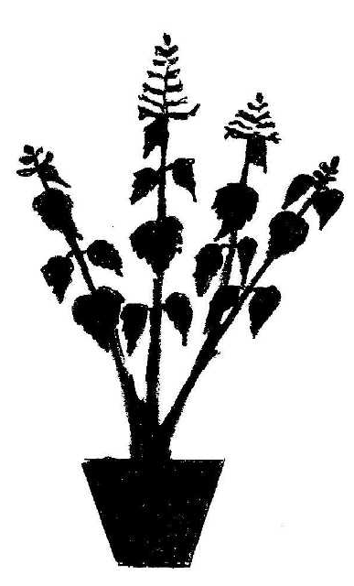 | 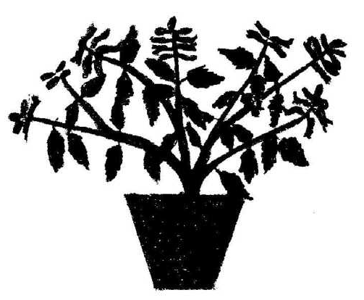 | 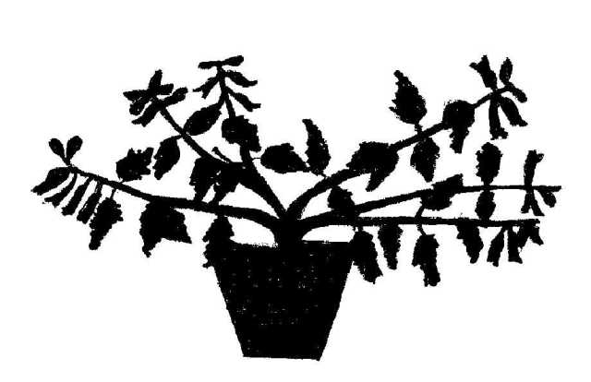 | 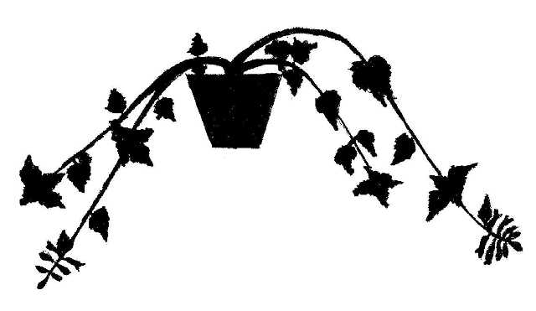
1 | 3 | 5 | 9
upright | semi-upright | spreading | trailing

Ad. 2: Plant: height

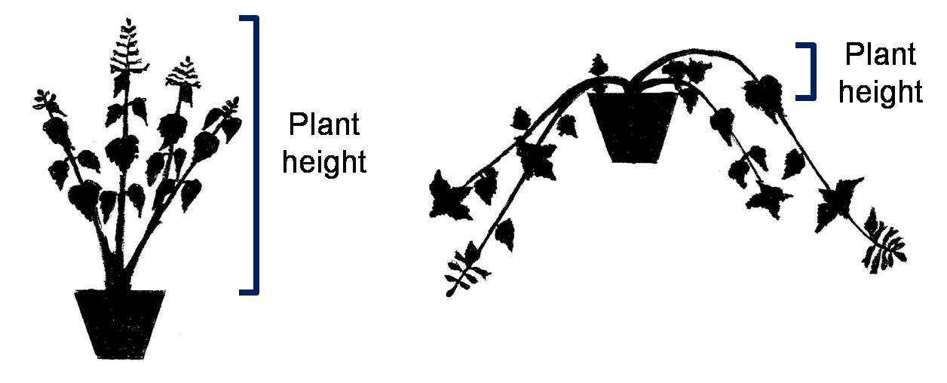
Plant height
Plant height

Ad. 7: Leaf blade: ratio length/width

1 | 2 | 3
low | medium | high

Ad. 9: Leaf blade: shape of base

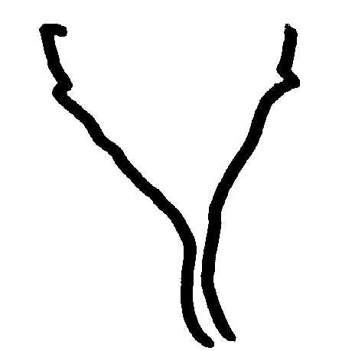 | 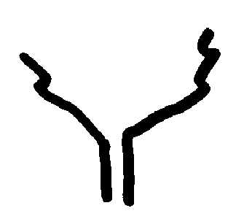 | 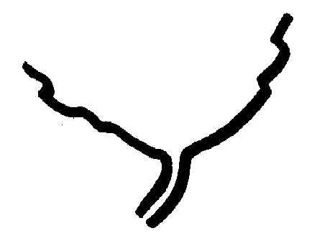 | 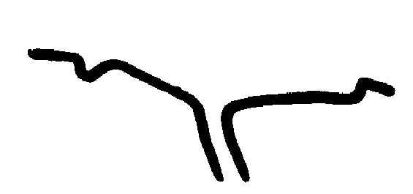
1 | 2 | 3 | 4
acute | obtuse | rounded | truncate

Ad. 10: Leaf blade: shape of apex

1 | 2 | 3
acute | obtuse | rounded

Ad. 13: Leaf blade: intensity of green color of upper side

To be observed excluding variegation.

Ad. 17: Leaf blade: type of incisions of margin

 |  | 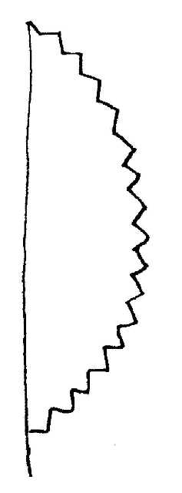
1 | 2 | 4 | 6
biserrate | serrate | dentate | crenate

Ad. 18: Leaf blade: depth of incisions of margin

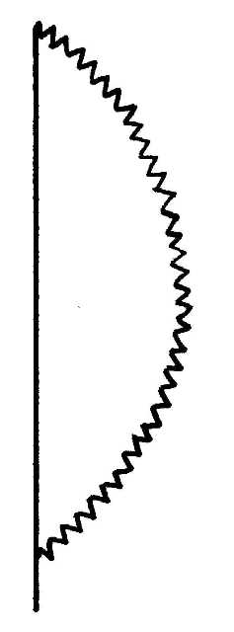 | 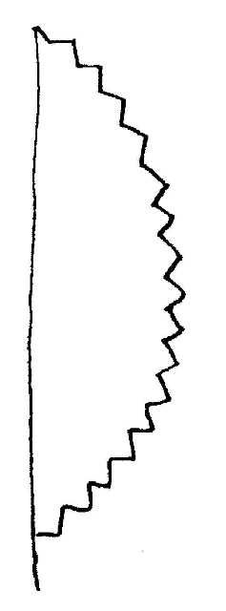 | 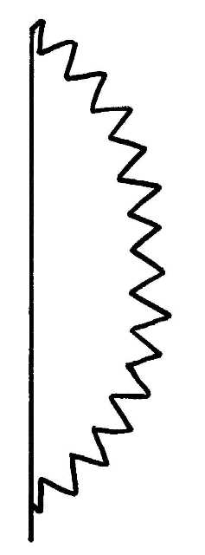
2 | 3 | 4
shallow | medium | deep

Ad. 24: Flower: main color

This characteristic refers to the general color impression of the flowers, and should be observed while standing one or two steps away from the plants.

Ad. 25: Corolla: length
Ad. 26: Corolla: height

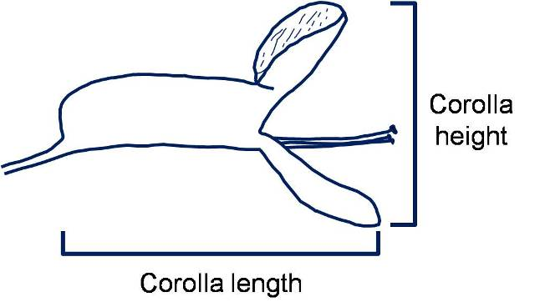
Corolla length
Corolla height

Ad. 27: Corolla tube: length
Ad. 28: Corolla tube: height

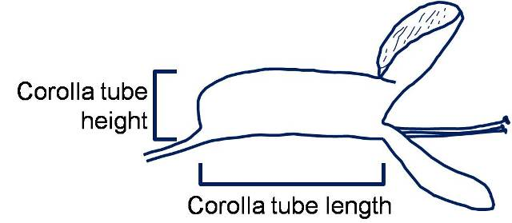
Corolla tube length
Corolla tube height

Ad. 29: Corolla tube: ratio length/height

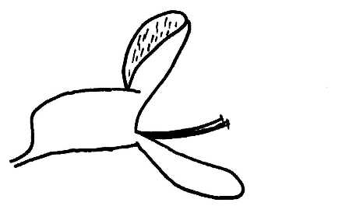 | 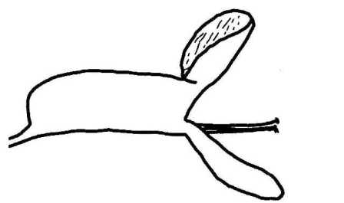 | 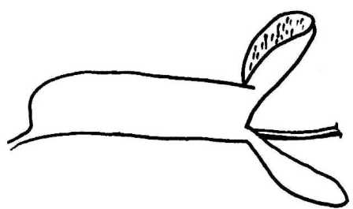
1 | 2 | 3
low | medium | high

Ad. 30: Corolla tube: longitudinal curving

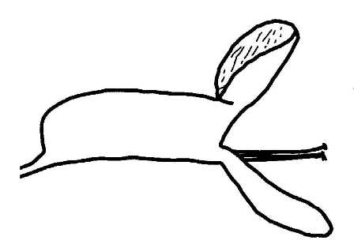 | 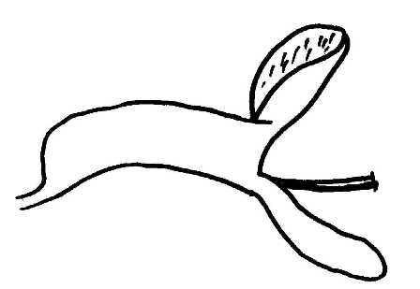 | 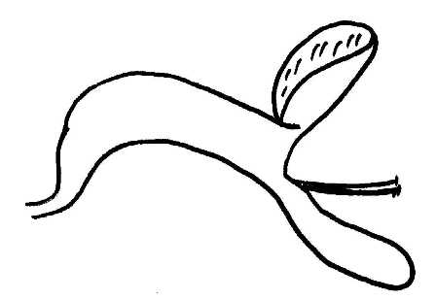
1 | 2 | 3
absent or weak | medium | strong

Ad. 32: Upper corolla lobe: main color of outer side
Ad. 33: Upper corolla lobe: main color of inner side
Ad. 35: Lower corolla lobe: main color of outer side

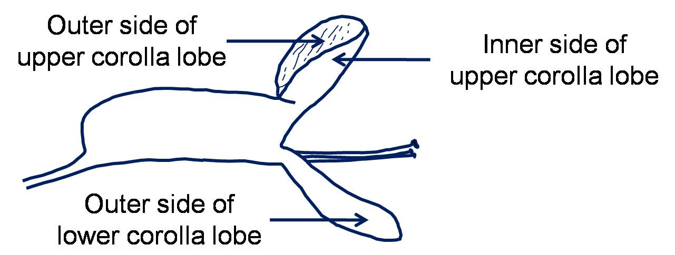
Inner side of upper corolla lobe
Outer side of lower corolla lobe
Outer side of upper corolla lobe

Ad. 34: Upper corolla lobe: prominence of purple spots or markings

The prominence is determined by the color contrast.

Ad. 36: Time of beginning of flowering

The time of beginning of flowering is when all plants have at least one open flower.

Literature

Blake, S.T., 1971: A Revision of Plectranthus (Labiatae) in Australasia. Contributions from the Queensland Herbarium No. 9. Brisbane, Queensland, AU.

Codd, L.E., 1975: Plectranthus (Labiatae) and allied genera in Southern Africa. Bothalia, vol. 11. Pretoria, ZA, pp. 371 to 442.

Van Jaarsveld, E.J., 1981: The S.A. Plectranthus species as Garden Plants. National Botanic Gardens of South Africa. Cape Town, ZA, 9 pp.

Van Jaarsveld, E.J., 1988: The Plectranthus Handbook. National Botanic Gardens of South Africa. Cape Town, ZA, 21 pp.

Van Jaarsveld, E.J., Edwards, T.J., 1997: Notes on Plectranthus (Lamiaceae) from southern Africa. Bothalia, vol. 27. Pretoria, ZA, pp. 1 to 6.

Technical Questionnaire

TECHNICAL QUESTIONNAIRE |  |  |  | Page {x} of {y} |  | Reference Number:
 |  |  |  |  |  | Application date:
 |  |  |  |  |  | (not to be filled in by the applicant)
TECHNICAL QUESTIONNAIRE
to be completed in connection with an application for plant breeders’ rights

1. Subject of the Technical Questionnaire

1.1 Genus |  |  | Plectranthus L’Hér
1.2 Species |  |  |  |  |  |  |  |  | [ ]
(please complete)
1.3 Hybrid |  |  |  |  |  |  |  |  | [ ]
Species
(please complete)

2. Applicant
Name
Address
Telephone No.
Fax No.
E-mail address
Breeder (if different from applicant)
3. Proposed denomination and breeder’s reference
Proposed denomination
(if available)

Breeder’s reference
#4. Information on the breeding scheme and propagation of the variety

4.1 Breeding scheme

Variety resulting from:

4.1.1 Crossing

(a) controlled cross [ ]
(please state parent varieties)

(…………………..……………..…) x (……………..…………………..…)
female parent male parent

(b) partially known cross [ ]
(please state known parent variety(ies))

(…………………..……………..…) x (……………..…………………..…)
female parent male parent

(c) unknown cross [ ]

4.1.2 Mutation [ ]
(please state parent variety)

4.1.3 Discovery and development [ ]
(please state where and when discovered and how developed)

4.1.4 Other [ ]
(please provide details)

4.2 Method of propagating the variety

4.2.1 Vegetative propagation

(a) cuttings [ ]

(b) in vitro propagation [ ]

(c) other (state method) [ ]

4.2.3 Other [ ]
(please provide details)

5. Characteristics of the variety to be indicated (the number in brackets refers to the corresponding characteristic in Test Guidelines; please mark the note which best corresponds).

 | Characteristics |  |  |  |  |  | Example Varieties |  |  | Note
5.1  (2) | Plant: height
 | very short |  |  |  |  |  |  |  |  | 1[ ]
 | very short to short |  |  |  |  |  |  |  |  | 2[ ]
 | short |  |  |  |  |  | Hadi Variegated |  |  | 3[ ]
 | short to medium |  |  |  |  |  |  |  |  | 4[ ]
 | medium |  |  |  |  |  | Chimanimani |  |  | 5[ ]
 | medium to tall |  |  |  |  |  |  |  |  | 6[ ]
 | tall |  |  |  |  |  | Erma |  |  | 7[ ]
 | tall to very tall |  |  |  |  |  |  |  |  | 8[ ]
 | very tall |  |  |  |  |  |  |  |  | 9[ ]
5.2  (12) | Leaf blade: variegation
 | absent |  |  |  |  |  | Jaws, Jazz Purple |  |  | 1[ ]
 | present |  |  |  |  |  | Variegated Cape GC |  |  | 9[ ]
5.3  (15) | Leaf blade: anthocyanin coloration of lower side
 | absent or very weak |  |  |  |  |  | Cloud Nine |  |  | 1[ ]
 | very weak to weak |  |  |  |  |  |  |  |  | 2[ ]
 | weak |  |  |  |  |  | Tommy White |  |  | 3[ ]
 | weak to medium |  |  |  |  |  |  |  |  | 4[ ]
 | medium |  |  |  |  |  | Jazz Blush Pink |  |  | 5[ ]
 | medium to strong |  |  |  |  |  |  |  |  | 6[ ]
 | strong |  |  |  |  |  | Jazz Purple |  |  | 7[ ]
 | strong to very strong |  |  |  |  |  |  |  |  | 8[ ]
 | very strong |  |  |  |  |  |  |  |  | 9[ ]
5.4  (24) | Flower: main color
 | white |  |  |  |  |  | Jazz Variegated White |  |  | 1[ ]
 | pink |  |  |  |  |  | Jazz Blush Pink |  |  | 2[ ]
 | reddish purple |  |  |  |  |  | P 00 06 07 |  |  | 3[ ]
 | purple |  |  |  |  |  | Amanda |  |  | 4[ ]
 | violet |  |  |  |  |  | Jazz Purple |  |  | 5[ ]
 | violet blue |  |  |  |  |  | Hadi Variegated |  |  | 6[ ]
6. Similar varieties and differences from these varieties

Please use the following table and box for comments to provide information on how your candidate variety differs from the variety (or varieties) which, to the best of your knowledge, is (or are) most similar. This information may help the examination authority to conduct its examination of distinctness in a more efficient way.

Denomination(s) of variety(ies) similar to your candidate variety |  | Characteristic(s) in which your candidate variety differs from the similar variety(ies) |  |  | Describe the expression of the characteristic(s) for the similar variety(ies) |  |  | Describe the expression of the characteristic(s) for your candidate variety
Example |  | Leaf blade: variegation |  |  | absent |  |  | present
Comments:

#7. Additional information which may help in the examination of the variety

7.1 In addition to the information provided in sections 5 and 6, are there any additional characteristics which may help to distinguish the variety?

Yes [ ] No [ ]

(If yes, please provide details)

7.2 Are there any special conditions for growing the variety or conducting the examination?

Yes [ ] No [ ]

(If yes, please provide details)

7.3 Other information

Main use
(a) garden plant [ ]
(b) pot plant [ ]
(c) other [ ]
(please provide details)

7.4 A representative color photograph of the variety displaying its main distinguishing feature(s), should accompany the Technical Questionnaire. The photograph will provide a visual illustration of the candidate variety which supplements the information provided in the Technical Questionnaire.

The key points to consider when taking a photograph of the candidate variety are:

- Indication of the date and geographic location
- Correct labeling (breeder’s reference)
- Good quality printed photograph (minimum 10 cm x 15 cm) and/or sufficient resolution electronic format version (minimum 960 x 1280 pixels)

Further guidance on providing photographs with the Technical Questionnaire is available in document TGP/7 “Development of Test Guidelines”, Guidance Note 35 (http://www.upov.int/tgp/en/).

[The link provided may be deleted by members of the Union when developing authorities’ own test guidelines.]

8. Authorization for release

(a) Does the variety require prior authorization for release under legislation concerning the protection of the environment, human and animal health?

Yes [ ] No [ ]

(b) Has such authorization been obtained?

Yes [ ] No [ ]

If the answer to (b) is yes, please attach a copy of the authorization.

9. Information on plant material to be examined or submitted for examination.

9.1 The expression of a characteristic or several characteristics of a variety may be affected by factors, such as pests and disease, chemical treatment (e.g. growth retardants or pesticides), effects of tissue culture, different rootstocks, scions taken from different growth phases of a tree, etc.

9.2 The plant material should not have undergone any treatment which would affect the expression of the characteristics of the variety, unless the competent authorities allow or request such treatment. If the plant material has undergone such treatment, full details of the treatment must be given. In this respect, please indicate below, to the best of your knowledge, if the plant material to be examined has been subjected to:

(a) Microorganisms (e.g. virus, bacteria, phytoplasma) Yes [ ] No [ ]

(b) Chemical treatment (e.g. growth retardant, pesticide) Yes [ ] No [ ]

(c) Tissue culture Yes [ ] No [ ]

(d) Other factors Yes [ ] No [ ]

Please provide details for where you have indicated “yes”.

……………………………………………………………

9.3 Has the plant material to be examined been tested for the presence of virus or other pathogens?

Yes [ ]

(please provide details as specified by the Authority)

No [ ]

10. I hereby declare that, to the best of my knowledge, the information provided in this form is correct:

Applicant’s name

Signature Date

[End of document]

* These names were correct at the time of the introduction of these Test Guidelines but may be revised or updated. [Readers are advised to consult the UPOV Code, which can be found on the UPOV Website (www.upov.int), for the latest information.]
# Authorities may allow certain of this information to be provided in a confidential section of the Technical Questionnaire.
# Authorities may allow certain of this information to be provided in a confidential section of the Technical Questionnaire.

