E
TG/301/1
ORIGINAL: English
DATE: 2014-04-09
INTERNATIONAL UNION FOR THE PROTECTION OF NEW VARIETIES OF PLANTS
Geneva

 | LILAC  UPOV Code: SYRIN  Syringa L. | *

GUIDELINES

FOR THE CONDUCT OF TESTS

FOR DISTINCTNESS, UNIFORMITY AND STABILITY

Alternative Names:*

Botanical name | English | French | German | Spanish
Syringa L. | Lilac | Lilas | Flieder | Lila

The purpose of these guidelines (“Test Guidelines”) is to elaborate the principles contained in the General Introduction (document TG/1/3), and its associated TGP documents, into detailed practical guidance for the harmonized examination of distinctness, uniformity and stability (DUS) and, in particular, to identify appropriate characteristics for the examination of DUS and production of harmonized variety descriptions.

ASSOCIATED DOCUMENTS
These Test Guidelines should be read in conjunction with the General Introduction and its associated TGP documents.
TABLE OF CONTENTS PAGE

1. Subject of these Test Guidelines 3
2. Material Required 3
3. Method of Examination 3
3.1 Number of Growing Cycles 3
3.2 Testing Place 3
3.3 Conditions for Conducting the Examination 3
3.4 Test Design 3
3.5 Additional Tests 3
4. Assessment of Distinctness, Uniformity and Stability 4
4.1 Distinctness 4
4.2 Uniformity 5
4.3 Stability 5
5. Grouping of Varieties and Organization of the Growing Trial 5
6. Introduction to the Table of Characteristics 5
6.1 Categories of Characteristics 5
6.2 States of Expression and Corresponding Notes 6
6.3 Types of Expression 6
6.4 Example Varieties 6
6.5 Legend 7
7. Table of Characteristics/Tableau des caractères/Merkmalstabelle/Tabla de caracteres 8
8. Explanations on the Table of Characteristics 135
8.1 Explanations covering several characteristics 15
8.2 Explanations for individual characteristics 135
9. Literature 23
10. Technical Questionnaire 24

Subject of these Test Guidelines

These Test Guidelines apply to all varieties of Syringa L..

Material Required

2.1 The competent authorities decide on the quantity and quality of the plant material required for testing the variety and when and where it is to be delivered. Applicants submitting material from a State other than that in which the testing takes place must ensure that all customs formalities and phytosanitary requirements are complied with.

2.2 The material is to be supplied in the form of plants, capable of flowering and expressing all relevant characteristics of the variety during the first growing cycle.

2.3 The minimum quantity of plant material, to be supplied by the applicant, should be:

9 plants.

2.4 The plant material supplied should be visibly healthy, not lacking in vigor, nor affected by any important pest or disease.

2.5 The plant material should not have undergone any treatment which would affect the expression of the characteristics of the variety, unless the competent authorities allow or request such treatment. If it has been treated, full details of the treatment must be given.

Method of Examination

3.1 Number of Growing Cycles

The minimum duration of tests should normally be a single growing cycle.

3.2 Testing Place

Tests are normally conducted at one place. In the case of tests conducted at more than one place, guidance is provided in TGP/9 “Examining Distinctness”.

3.3 Conditions for Conducting the Examination

3.3.1 The tests should be carried out under conditions ensuring satisfactory growth for the expression of the relevant characteristics of the variety and for the conduct of the examination.

3.3.2 Because daylight varies, color determinations made against a color chart should be made either in a suitable cabinet providing artificial daylight or in the middle of the day in a room without direct sunlight. The spectral distribution of the illuminant for artificial daylight should conform with the CIE Standard of Preferred Daylight D 6500 and should fall within the tolerances set out in the British Standard 950, Part I. These determinations should be made with the plant part placed against a white background. The color chart and version used should be specified in the variety description.

3.4 Test Design

3.4.1 Each test should be designed to result in a total of at least 9 plants.

3.4.2 The design of the tests should be such that plants or parts of plants may be removed for measurement or counting without prejudice to the observations which must be made up to the end of the growing cycle.

3.5 Additional Tests

Additional tests, for examining relevant characteristics, may be established.

Assessment of Distinctness, Uniformity and Stability

4.1 Distinctness

4.1.1 General Recommendations

It is of particular importance for users of these Test Guidelines to consult the General Introduction prior to making decisions regarding distinctness. However, the following points are provided for elaboration or emphasis in these Test Guidelines.

4.1.2 Consistent Differences

The differences observed between varieties may be so clear that more than one growing cycle is not necessary. In addition, in some circumstances, the influence of the environment is not such that more than a single growing cycle is required to provide assurance that the differences observed between varieties are sufficiently consistent. One means of ensuring that a difference in a characteristic, observed in a growing trial, is sufficiently consistent is to examine the characteristic in at least two independent growing cycles.

4.1.3 Clear Differences

Determining whether a difference between two varieties is clear depends on many factors, and should consider, in particular, the type of expression of the characteristic being examined, i.e. whether it is expressed in a qualitative, quantitative, or pseudo-qualitative manner. Therefore, it is important that users of these Test Guidelines are familiar with the recommendations contained in the General Introduction prior to making decisions regarding distinctness.

4.1.4 Number of Plants / Parts of Plants to be Examined

Unless otherwise indicated, for the purposes of distinctness, all observations on single plants should be made on 5 plants or parts taken from each of 5 plants and any other observations made on all plants in the test, disregarding any off-type plants.

4.1.5 Method of Observation

The recommended method of observing the characteristic for the purposes of distinctness is indicated by the following key in the second column of the Table of Characteristics (see document TGP/9 “Examining Distinctness”, Section 4 “Observation of characteristics”):

MG: single measurement of a group of plants or parts of plants
MS: measurement of a number of individual plants or parts of plants
VG: visual assessment by a single observation of a group of plants or parts of plants
VS: visual assessment by observation of individual plants or parts of plants

Type of observation: visual (V) or measurement (M)

“Visual” observation (V) is an observation made on the basis of the expert’s judgment. For the purposes of this document, “visual” observation refers to the sensory observations of the experts and, therefore, also includes smell, taste and touch. Visual observation includes observations where the expert uses reference points (e.g. diagrams, example varieties, side-by-side comparison) or non-linear charts (e.g. color charts). Measurement (M) is an objective observation against a calibrated, linear scale e.g. using a ruler, weighing scales, colorimeter, dates, counts, etc.

Type of record: for a group of plants (G) or for single, individual plants (S)

For the purposes of distinctness, observations may be recorded as a single record for a group of plants or parts of plants (G), or may be recorded as records for a number of single, individual plants or parts of plants (S). In most cases, “G” provides a single record per variety and it is not possible or necessary to apply statistical methods in a plant-by-plant analysis for the assessment of distinctness.

In cases where more than one method of observing the characteristic is indicated in the Table of Characteristics (e.g. VG/MG), guidance on selecting an appropriate method is provided in document TGP/9, Section 4.2.

4.2 Uniformity

4.2.1 It is of particular importance for users of these Test Guidelines to consult the General Introduction prior to making decisions regarding uniformity. However, the following points are provided for elaboration or emphasis in these Test Guidelines:

4.2.2 For the assessment of uniformity, a population standard of 1% and an acceptance probability of at least 95% should be applied. In the case of a sample size of 9 plants, 1 off-type is allowed.

4.3 Stability

4.3.1 In practice, it is not usual to perform tests of stability that produce results as certain as those of the testing of distinctness and uniformity. However, experience has demonstrated that, for many types of variety, when a variety has been shown to be uniform, it can also be considered to be stable.

4.3.2 Where appropriate, or in cases of doubt, stability may be further examined by testing a new plant stock to ensure that it exhibits the same characteristics as those shown by the initial material supplied.

Grouping of Varieties and Organization of the Growing Trial

5.1 The selection of varieties of common knowledge to be grown in the trial with the candidate varieties and the way in which these varieties are divided into groups to facilitate the assessment of distinctness are aided by the use of grouping characteristics.

5.2 Grouping characteristics are those in which the documented states of expression, even where produced at different locations, can be used, either individually or in combination with other such characteristics: (a) to select varieties of common knowledge that can be excluded from the growing trial used for examination of distinctness; and (b) to organize the growing trial so that similar varieties are grouped together.

5.3 The following have been agreed as useful grouping characteristics:

(a) Leaf: shape (characteristic 9)
(b) Flower: type (characteristic 19)
(c) Corolla lobe: main color of inner side (characteristic 28)
Gr. 1: white
Gr. 2: yellow
Gr. 3: pink
Gr. 4: purple
Gr. 5: violet

5.4 Guidance for the use of grouping characteristics, in the process of examining distinctness, is provided through the General Introduction and document TGP/9 “Examining Distinctness”.

Introduction to the Table of Characteristics

6.1 Categories of Characteristics

6.1.1 Standard Test Guidelines Characteristics

Standard Test Guidelines characteristics are those which are approved by UPOV for examination of DUS and from which members of the Union can select those suitable for their particular circumstances.

6.1.2 Asterisked Characteristics

Asterisked characteristics (denoted by *) are those included in the Test Guidelines which are important for the international harmonization of variety descriptions and should always be examined for DUS and included in the variety description by all members of the Union, except when the state of expression of a preceding characteristic or regional environmental conditions render this inappropriate.

6.2 States of Expression and Corresponding Notes

6.2.1 States of expression are given for each characteristic to define the characteristic and to harmonize descriptions. Each state of expression is allocated a corresponding numerical note for ease of recording of data and for the production and exchange of the description.

6.2.2 In the case of qualitative and pseudo-qualitative characteristics (see Chapter 6.3), all relevant states of expression are presented in the characteristic. However, in the case of quantitative characteristics with 5 or more states, an abbreviated scale may be used to minimize the size of the Table of Characteristics. For example, in the case of a quantitative characteristic with 9 states, the presentation of states of expression in the Test Guidelines may be abbreviated as follows:

State | Note
small | 3
medium | 5
large | 7

However, it should be noted that all of the following 9 states of expression exist to describe varieties and should be used as appropriate:

State | Note
very small | 1
very small to small | 2
small | 3
small to medium | 4
medium | 5
medium to large | 6
large | 7
large to very large | 8
very large | 9

6.2.3 Further explanation of the presentation of states of expression and notes is provided in document TGP/7 “Development of Test Guidelines”.

6.3 Types of Expression

An explanation of the types of expression of characteristics (qualitative, quantitative and pseudo-qualitative) is provided in the General Introduction.

6.4 Example Varieties

Where appropriate, example varieties are provided to clarify the states of expression of each characteristic.

6.5 Legend

(*) Asterisked characteristic – see Chapter 6.1.2

QL Qualitative characteristic – see Chapter 6.3
QN Quantitative characteristic – see Chapter 6.3
PQ Pseudo-qualitative characteristic – see Chapter 6.3

MG, MS, VG, VS – see Chapter 4.1.5

(a)-(b) See Explanations on the Table of Characteristics in Chapter 8.1

(+) See Explanations on the Table of Characteristics in Chapter 8.2.

Table of Characteristics/Tableau des caractères/Merkmalstabelle/Tabla de caracteres

 |  | English | français | deutsch | español | Example Varieties  Exemples  Beispielssorten  Variedades ejemplo | Note/  Nota
(+) | VG | Plant: growth habit | Plante : port | Pflanze: Wuchsform | Planta: hábito de crecimiento
QN |  | upright | dressé | aufrecht | erguido |  | 1
 |  | upright to spreading | dressé à étalé | aufrecht bis breitwüchsig | erguido a extendido |  | 2
 |  | spreading | étalé | breitwüchsig | extendido |  | 3
 | VG | Plant: height | Plante : hauteur | Pflanze: Höhe | Planta: altura
QN |  | short | basse | niedrig | baja | Palibin | 3
 |  | medium | moyenne | mittel | media | Excellens, Xiang Xue | 5
 |  | tall | haute | hoch | alta | Luo Lan Zi | 7
(+) | VG | Plant: density of branches | Plante : densité des ramifications | Pflanze: Dichte der Zweige | Planta: densidad de las ramas
QN |  | sparse | lâche | locker | laxa |  | 1
 |  | medium | moyenne | mittel | media |  | 3
 |  | dense | dense | dicht | densa |  | 5
 | VG | Plant: number of inflorescences | Plante : nombre d’inflorescences | Pflanze: Anzahl Blütenstände | Planta: número de inflorescencias
QN |  | few | petit | gering | bajo | Chang Tong Bai, Zi Yun | 3
 |  | medium | moyen | mittel | medio | Luo Lan Zi | 5
 |  | many | grand | hoch | alto | Si Ji Lan | 7
 | VG | One-year-old shoot: color | Rameau d’un an : couleur | Einjähriger Trieb: Farbe | Rama de un año: color
PQ |  | grey brown | brun grisâtre | graubraun | marrón grisáceo | Ami Schott | 1
 |  | light brown | brun clair | hellbraun | marrón claro | Maiden's Blush | 2
 |  | medium brown | brun moyen | mittelbraun | marrón medio | Fantasy | 3
 |  | red brown | brun rougeâtre | rotbraun | marrón rojizo | Agnes Smith | 4
(*)  (+) | VG | Leaf: type | Feuille : type | Blatt: Typ | Hoja: tipo
QL | (a) | simple | simple | einfach | simple | Luo Lan Zi | 1
 |  | compound | composée | zusammengesetzt | compuesta |  | 2
(+) | VG | Only varieties with leaf type: simple: Leaf: depth of sinus | Seulement variétés avec type de feuille : simple : Feuille : profondeur du sinus | Nur Sorten mit Blattyp: einfach: Blatt: Tiefe der Einbuchtungen | Solo variedades con tipo de hoja: simple: Hoja: profundidad de los senos
QN | (a) | absent or very shallow | absent ou très peu profond | fehlend oder sehr flach | ausentes o muy poco profundos | Luo Lan Zi | 1
 |  | shallow | peu profond | flach | poco profundos | Alba-plena | 2
 |  | medium | moyen | mittel | medios |  | 3
 |  | deep | profond | tief | profundos | Kabul | 4
(+) | VG | Only varieties with leaf type: simple: Leaf: number of sinuses | Seulement variétés avec type de feuille : simple : Feuille : nombre de sinus | Nur Sorten mit Blattyp: einfach: Blatt: Anzahl Einbuchtungen | Solo variedades con tipo de hoja: simple: Hoja: número de senos
PQ | (a) | none | aucun | keine | ausentes |  | 1
 |  | one | un | eine | uno |  | 2
 |  | two | deux | zwei | dos |  | 3
 |  | more than two | plus de deux | mehr als zwei | más de dos |  | 4
(*)  (+) | VG | Leaf: shape | Feuille : forme | Blatt: Form | Hoja: forma
PQ | (a) | broad ovate | ovale large | breit eiförmig | oval ancha |  | 1
 |  | medium ovate | ovale moyenne | mittel eiförmig | oval media |  | 2
 |  | narrow ovate | ovale étroite | schmal eiförmig | oval estrecha |  | 3
 |  | medium elliptic | elliptique moyenne | mittel elliptisch | elíptica media |  | 4
 |  | narrow elliptic | elliptique étroite | schmal elliptisch | elíptica estrecha |  | 5
 |  | obovate | obovale | verkehrt eiförmig | oboval |  | 6
(+) | VG | Leaf: shape of base | Feuille : forme de la base | Blatt: Form der Basis | Limbo: forma de la base
PQ | (a) | cuneate | cunéiforme | keilförmig | cuneada |  | 1
 |  | truncate | tronquée | abgestumpft | truncada |  | 2
 |  | cordate | cordiforme | herzförmig | cordiforme |  | 3
(*)  (+) | VG | Leaf: main color of upper side | Feuille : couleur principale de la face supérieure | Blatt: Hauptfarbe der Oberseite | Hoja: color principal del haz
PQ | (a) | yellow | jaune | gelb | amarillo | Aurea, Lutens | 1
 |  | yellowish green | vert jaunâtre | gelblich grün | verde amarillento | Beauty of Heaven | 2
 |  | light green | vert clair | hellgrün | verde claro |  | 3
 |  | medium green | vert moyen | mittelgrün | verde medio | Marengo, Martha | 4
 |  | dark green | vert foncé | dunkelgrün | verde oscuro |  | 5
(*)  (+) | VG | Leaf: secondary color of upper side | Feuille : couleur secondaire de la face supérieure | Blatt: Sekundärfarbe der Oberseite | Hoja: color secundario del haz
PQ | (a) | none | aucune | keine | ninguna |  | 1
 |  | white | blanc | weiß | blanco | Chantilly Lace | 2
 |  | yellow | jaune | gelb | amarillo | Golden Eclipse | 3
 |  | light green | vert clair | hellgrün | verde claro |  | 4
(+) | - VG | Flower bud: color | Bourgeon floral : couleur | Blütenknospe: Farbe | Botón floral: color
PQ | (b) | RHS Colour Chart  (indicate reference number) | Code RHS des couleurs (indiquer le numéro de référence) | RHS-Farbkarte  (Nummer angeben) | Carta de colores RHS  (indíquese el número de referencia)
(+) | VG | Inflorescence: attitude | Inflorescence : port | Blütenstand: Haltung | Inflorescencia: porte
PQ | (b) | upright | dressé | aufrecht | erecto | Prince Notger | 1
 |  | semi-upright | demi-dressé | halbaufrecht | semierecto | Marie Frances | 2
 |  | drooping | retombant | hängend | colgante | Nodding | 3
(*)  (+) | VG/  MG | Inflorescence: length | Inflorescence : longueur | Blütenstand: Länge | Inflorescencia: longitud
QN | (b) | short | courte | kurz | pequeña | Si Ji Lan | 1
 |  | medium | moyenne | mittel | media | Ethiopia, Xiang Xue | 3
 |  | long | longue | lang | larga |  | 5
(*)  (+) | VG | Inflorescence: shape | Inflorescence : forme | Blütenstand: Form | Inflorescencia: forma
QN | (b) | conic | conique | kegelförmig | cónica | Chang Tong Bai, Erzherzog Johann | 1
 |  | conic to cylindric | conique à cylindrique | kegelförmig bis zylindrisch | cónica a cilíndrico |  | 2
 |  | cylindric | cylindrique | zylindrisch | cilíndrico | Night | 3
(*)  (+) | VG | Inflorescence: density of flowers | Inflorescence : densité de fleurs | Blütenstand: Dichte der Blüten | Inflorescencia: densidad de flores
QN | (b) | very sparse | très lâche | sehr locker | muy laxa |  | 1
 |  | sparse | lâche | locker | laxa | Bretschneiden,  Chang Tong Bai | 3
 |  | medium | moyenne | mittel | media | Olive May Cummings | 5
 |  | dense | dense | dicht | densa | Buffon | 7
 |  | very dense | très dense | sehr dicht | muy densa | Dawn | 9
 | VG | Flower: fragrance | Fleur : parfum | Blüte: Duft | Flor: fragancia
QN | (b) | absent or weak | absent ou faible | fehlend oder schwach | ausente o débil | Luo Lan Zi | 1
 |  | moderate | modéré | mäßig | moderada | Chang Tong Bai | 2
 |  | strong | fort | stark | fuerte | Xiang Xue | 3
(*)  (+) | VG | Flower: type | Fleur : type | Blüte: Typ | Flor: tipo
QL | (b) | single | simple | einfach | simple | Chang Tong Bai,  Edith Braun | 1
 |  | double | double | gefüllt | doble | Magellan | 2
 | VG | Flower: diameter of corolla | Fleur : diamètre de la corolle | Blüte: Durchmesser der Krone | Flor: diámetro de la corola
QN | (b) | small | petit | klein | pequeño | Si Ji Lan | 1
 |  | medium | moyen | mittel | medio | Wan Hua Zi | 3
 |  | large | grand | groß | grande | Agincourt Beauty | 5
(*)  (+) | VG | Only varieties with flower type: double: Flower: number of corolla lobes | Seulement variétés avec type de fleur : double : Fleur : nombre de lobes de corolle | Nur Sorten mit Blütentyp: gefüllt: Blüte: Anzahl Kronlappen | Solo variedades con tipo de flor: doble: Flor: número de lóbulos de la corola
QN | (b) | few | petit | gering | bajo | Magellan | 1
 |  | medium | moyen | mittel | medio | Fritz | 3
 |  | many | grand | hoch | alto | Leon Gambetta  Luo Lan Zi | 5
(*)  (+) | VG | Only varieties with flower type: double: Flower: distance between whorls | Seulement variétés avec type de fleur : double : Fleur : distance entre verticilles | Nur Sorten mit Blütentyp: gefüllt: Blüte: Abstand zwischen den Wirteln | Solo variedades con tipo de flor: doble: Flor: distancia entre verticilos
QN | (b) | short | courte | klein | corta | Jewel, Luo Lan Zi | 1
 |  | medium | moyenne | mittel | media |  | 2
 |  | long | longue | groß | larga | Anne Tighe | 3
(*)  (+) | VG | Corolla lobe: attitude | Lobe de la corolle : port | Kronlappen: Haltung | Lóbulo de la corola: porte
PQ | (b) | semi-erect | demi-dressé | halbaufrecht | semierecto | Minuet | 1
 |  | horizontal | horizontal | horizontal | horizontal | Excel | 2
 |  | recurved | recourbé | zurückgebogen | recurvado | Fraser | 3
(+) | VG | Corolla lobe: shape | Lobe de la corolle : forme | Kronlappen: Form | Lóbulo de la corola: forma
PQ | (b) | broad elliptic | elliptique large | breit elliptisch | elíptica ancha |  | 1
 |  | narrow elliptic | elliptique étroit | schmal elliptisch | elíptica estrecha |  | 2
 |  | obovate | obovale | verkehrt eiförmig | oboval |  | 3
(*)  (+) | VG | Corolla lobe: undulation | Lobe de la corolle : ondulation | Kronlappen: Wellung | Lóbulo de la corola: ondulación
QN | (b) | absent or weak | absente ou faible | fehlend oder schwach | ausente o débil | Heather, Alba Grandiflora | 1
 |  | medium | moyenne | mittel | media |  | 2
 |  | strong | forte | stark | fuerte | Edith Braun, Wan Hua Zi | 3
(*)  (+) | VG | Corolla lobe: incurving of margin | Lobe de la corolle : courbure du bord | Kronlappen: Einrollen des Randes | Lóbulo de la corola: curvado del borde hacia arriba
QN | (b) | absent or very weak | absente ou très faible | fehlend oder sehr gering | ausente o muy débil | Helena Agathe Keessen | 1
 |  | weak | faible | gering | débil | Carley | 2
 |  | medium | moyenne | mittel | medio | Edith Braun,  Frank Paterson | 3
 |  | strong | forte | stark | fuerte | Bailbelle | 4
(+) | VG | Corolla lobe: shape of apex | Lobe de la corolle : forme du sommet | Kronlappen: Form der Spitze | Lóbulo de la corola: forma del ápice
PQ | (b) | acuminate | acuminé | zugespitzt | acuminado |  | 1
 |  | acute | pointu | spitz | agudo |  | 2
 |  | rounded | arrondi | abgerundet | redondeado |  | 3
 |  | emarginate | émarginé | eingekerbt | emarginado |  | 4
(*)  (+) | VG | Corolla lobe: main color of inner side | Lobe de la corolle : couleur principale de la face interne | Kronlappen: Hauptfarbe der Innenseite | Lóbulo de la corola: color principal de la cara interna
PQ | (b) | RHS Colour Chart  (indicate reference number) | Code RHS des couleurs (indiquer le numéro de référence) | RHS-Farbkarte  (Nummer angeben) | Carta de colores RHS  (indíquese el número de referencia)
(+) | VG | Corolla lobe: secondary color of inner side | Lobe de la corolle : couleur secondaire de la face interne | Kronlappen: Sekundärfarbe der Innenseite | Lóbulo de la corola: color secundario de la cara interna
PQ | (b) | RHS Colour Chart  (indicate reference number) | Code RHS des couleurs (indiquer le numéro de référence) | RHS-Farbkarte  (Nummer angeben) | Carta de colores RHS  (indíquese el número de referencia)
 | VG | Corolla tube: color of outer side | Tube de la corolle : couleur de la face externe | Kronröhre: Farbe der Außenseite | Tubo de la corola: color de la cara externa
PQ | (b) | RHS Colour Chart  (indicate reference number) | Code RHS des couleurs (indiquer le numéro de référence) | RHS-Farbkarte  (Nummer angeben) | Carta de colores RHS  (indíquese el número de referencia)
(*) | VG | Anther: color | Anthère : couleur | Anthere: Farbe | Antera: color
QL | (b) | yellow | jaune | gelb | amarilla | Audrey, Wan Hua Zi | 1
 |  | purple | pourpre | purpurn | púrpura | Si Ji Lan | 2
(+) | MG | Time of beginning of flowering | Époque de début de la floraison | Zeitpunkt des Blühbeginns | Época de comienzo de la floración
QN |  | early | précoce | früh | temprana | Chang Tong Bai | 3
 |  | medium | moyenne | mittel | media | Leonore | 5
 |  | late | tardive | spät | tardía | Ivory Silk | 7

Explanations on the Table of Characteristics

8.1 Explanations covering several characteristics

Characteristics containing the following key in the second column of the Table of Characteristics should be examined as indicated below:

(a) Observations on the leaf should be made on leaves from the middle part of the shoot on the current year’s growth.

(b) Observations on the inflorescence should be made on inflorescences from the middle to the upper part of the shoots when 50% of the inflorescences have all flowers open. Observations on the flower should be made on flowers from the middle part of the inflorescence. Observations on the corolla lobe of double flowers should be made on the lobes of the second whorl from the top of the flower.

8.2 Explanations for individual characteristics

Ad. 1: Plant: growth habit

1 | 2 | 3
upright | upright to spreading | spreading

Ad. 3: Plant: density of branches

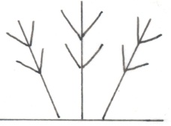 | 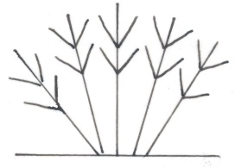 | 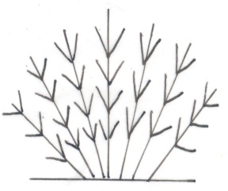
1 | 3 | 5
sparse | medium | dense

Ad. 6: Leaf: type

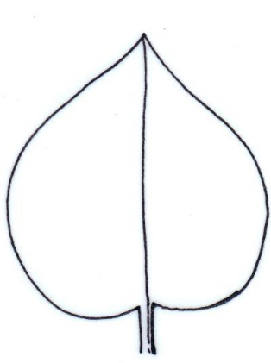 | 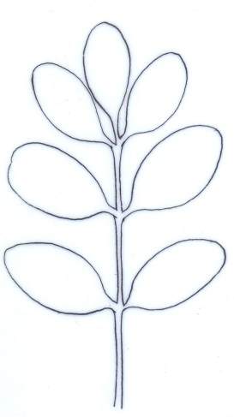
1 | 2
simple | compound
Ad. 7: Only varieties with leaf type: simple: Leaf: depth of sinus

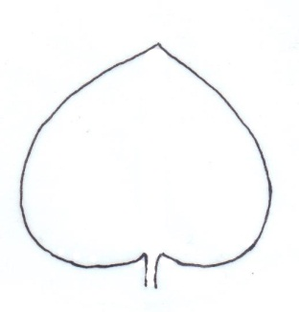 | 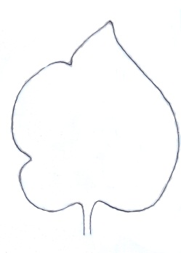 | 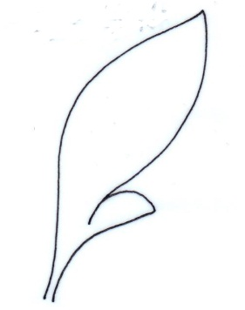 | 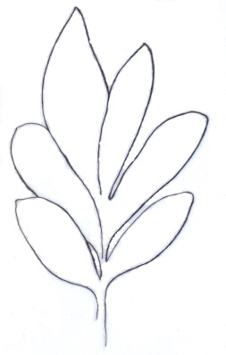
1 | 2 | 3 | 4
absent or very shallow | shallow | medium | deep

Ad. 8: Only varieties with leaf type: simple: Leaf: number of sinuses

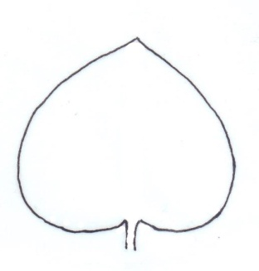 | 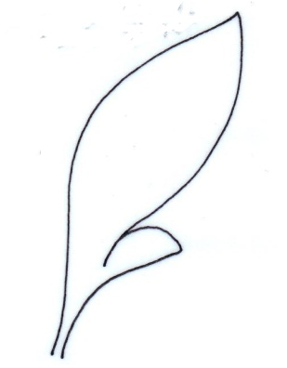 | 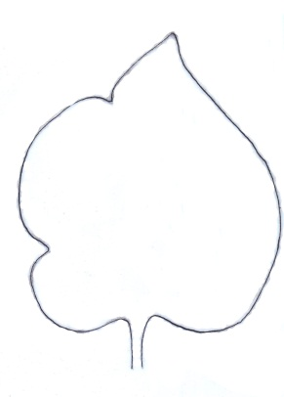 | 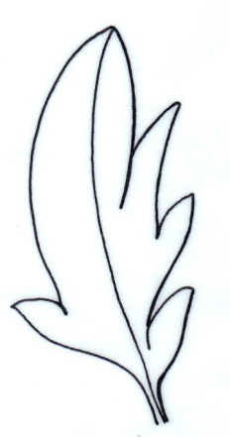
1 | 2 | 3 | 4
none | one | two | more than two

Ad. 9: Leaf: shape

For compound leaves, the imaginary outline should be observed.

 | broadest part
 | below middle | at middle | above middle
broad (low) width (ratio length/width) narrow (high) | 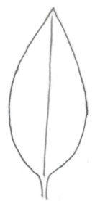 | 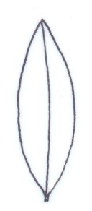
 | 3 | 5
 | narrow ovate | narrow elliptic
 | 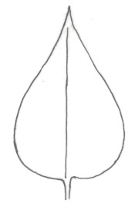 | 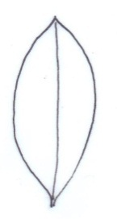 | 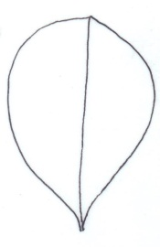
 | 2 | 4 | 6
 | medium ovate | medium elliptic | obovate
 | 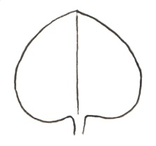
 | 1
 | broad ovate

Ad. 10: Leaf: shape of base

For compound leaves, the terminal leaflet should be observed.

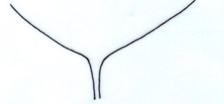 | 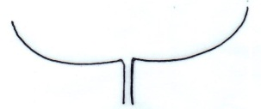 | 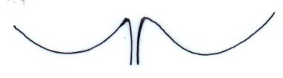
1 | 2 | 3
cuneate | truncate | cordate

Ad. 11: Leaf: main color of upper side
Ad. 12: Leaf: secondary color of upper side

The main color is the color with the largest surface area. The secondary color (if present) is the color with the second largest surface area. In cases where the areas of the main and secondary color are too similar to reliably decide which color has the largest area, the darker color is considered to be the main color.

Ad. 13: Flower bud: color

Observation on the flower bud should be made before opening.

Ad. 14: Inflorescence: attitude

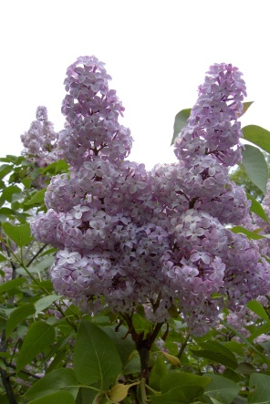 | 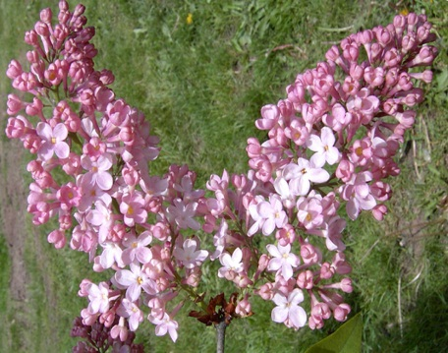 | 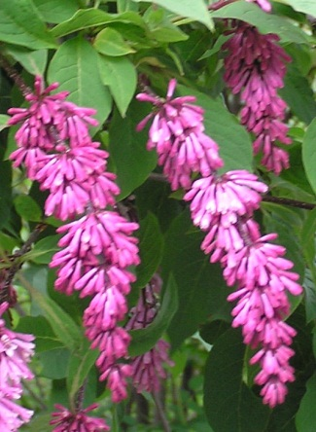
1 | 2 | 3
upright | semi-upright | drooping

Ad. 15: Inflorescence: length

The natural length of an inflorescence should be observed from the lowest hanging flower to the top flower when the inflorescence is in full bloom.

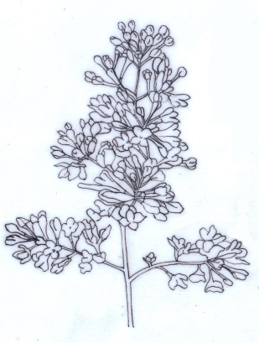
Length

Ad. 16: Inflorescence: shape

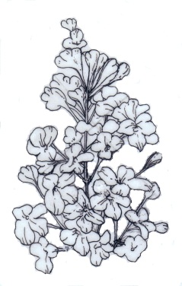 | 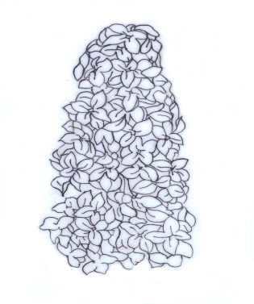 | 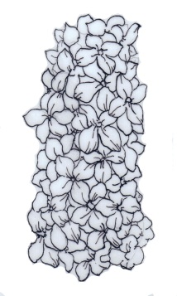
1 | 2 | 3
conic | conic to cylindric | cylindric

Ad. 17: Inflorescence: density of flowers

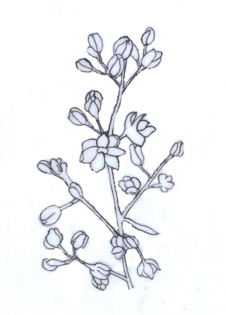 | 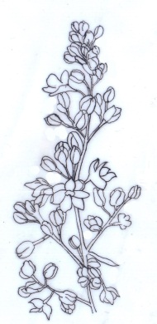 | 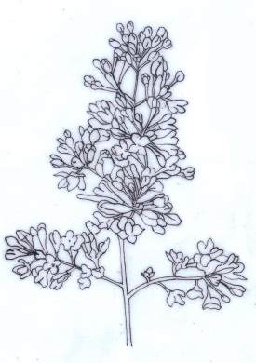 | 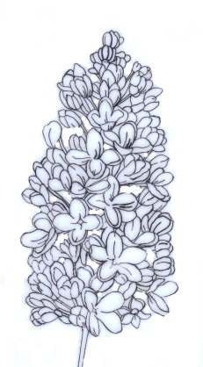 | 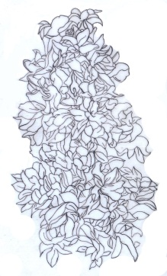
1 | 3 | 5 | 7 | 9
very sparse | sparse | medium | dense | very dense

Ad. 19: Flower: type

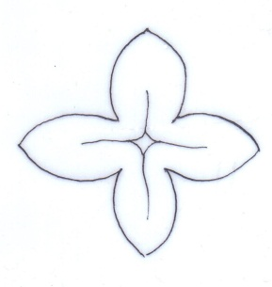 | 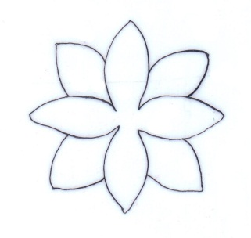
1 | 2
single | double

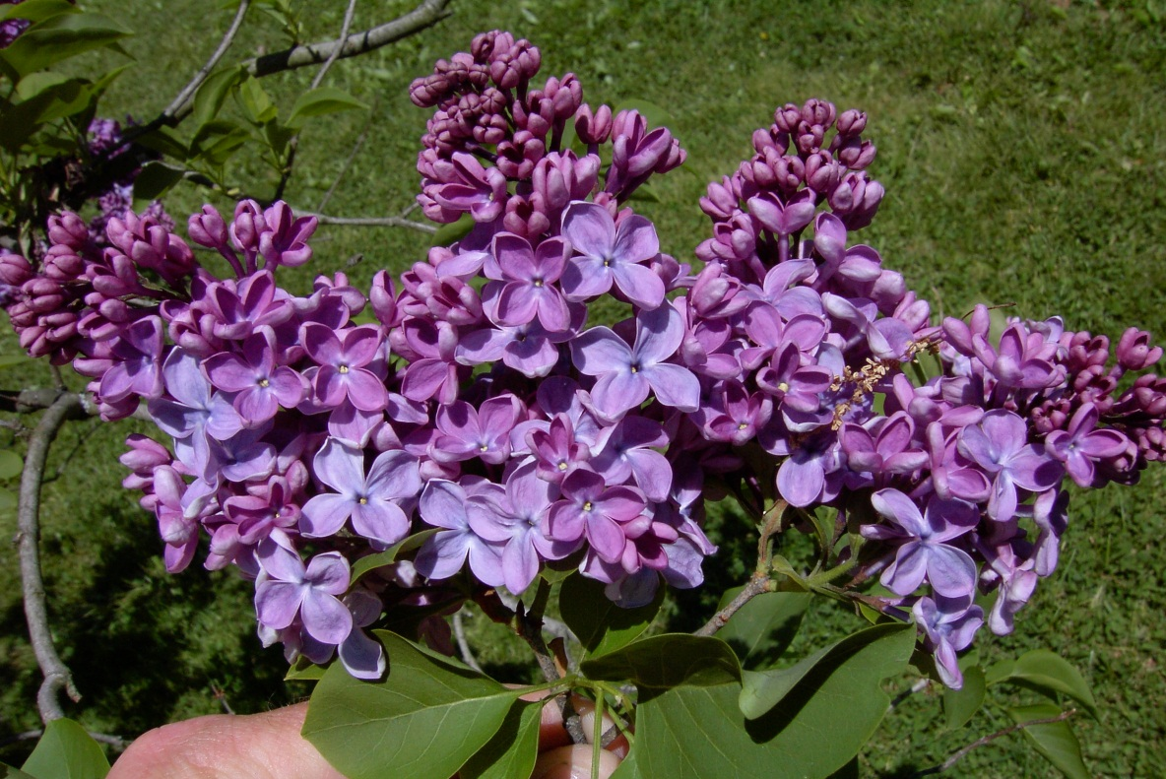

Ad. 21: Only varieties with flower type: double: Flower: number of corolla lobes

In state 1 “few”, the inner lobes are not completely unfolded.

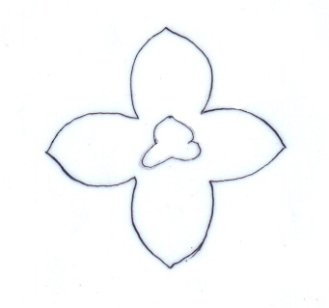 | 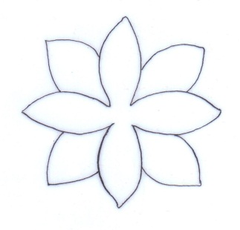 | 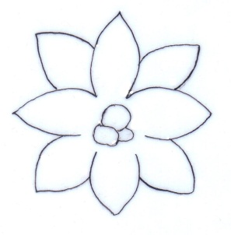
1 | 3 | 5
few | medium | many
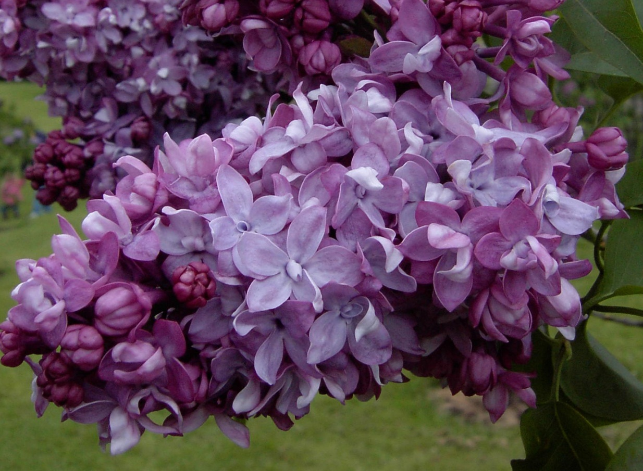

Ad. 22: Only varieties with flower type: double: Flower: distance between whorls
Distance between whorls

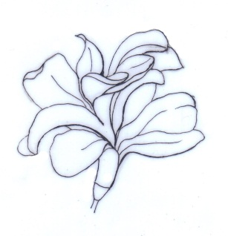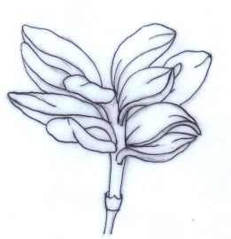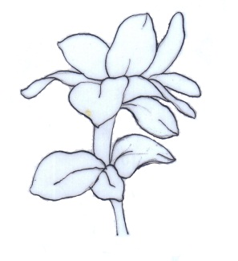

1 | 2 | 3
short | medium | long

Ad. 23: Corolla lobe: attitude

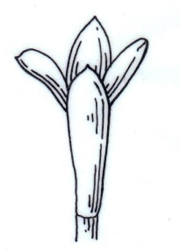 | 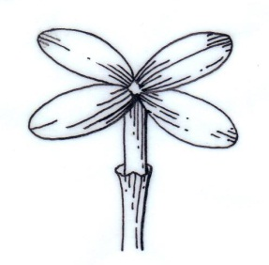 | 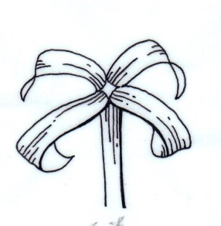
1 | 2 | 3
semi-erect | horizontal | recurved

Ad. 24: Corolla lobe: shape

 | broadest part
 | at middle | above middle
broad (low)  width (ratio length/width)  narrow (high) | 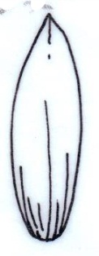
 | 2
 | narrow elliptic
 | 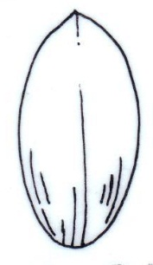 | 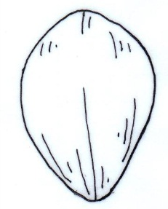
 | 1 | 3
 | broad elliptic | obovate

Ad. 25: Corolla lobe: undulation

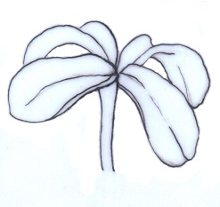 | 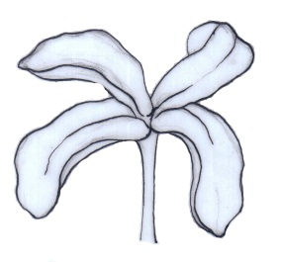 | 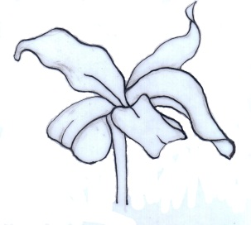
1 | 2 | 3
absent or weak | medium | strong

Ad. 26: Corolla lobe: incurving of margin

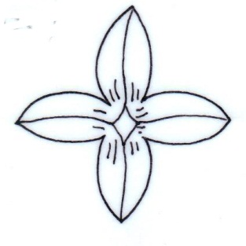 | 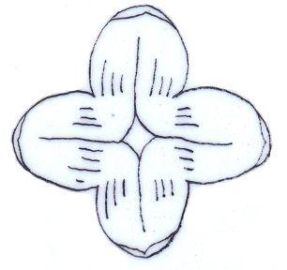 | 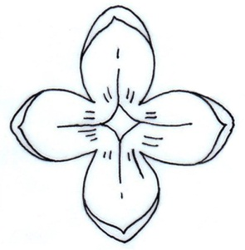 | 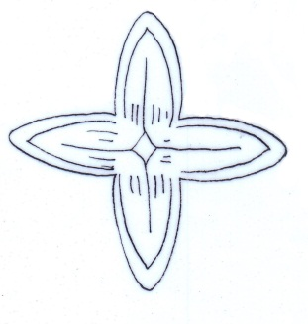
1 | 2 | 3 | 4
absent or very weak | weak | medium | strong

Ad. 27: Corolla lobe: shape of apex

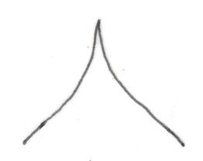 | 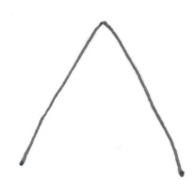 | 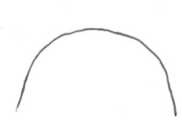 | 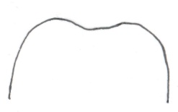
1 | 2 | 3 | 4
acuminate | acute | rounded | emarginate

Ad. 28: Corolla lobe: main color of inner side
Ad. 29: Corolla lobe: secondary color of inner side

The main color is the color with the largest surface area. The secondary color (if present) is the color with the second largest surface area. In cases where the areas of the main and secondary color are too similar to reliably decide which color has the largest area, the darker color is considered to be the main color.

Ad. 32: Time of beginning of flowering

The time of beginning of flowering is when 5% of flowers on all plants are open.

Literature

Jone, FR., Fiala, L., 1988: Lilacs- The Genus Syringa. Timber Press, Inc. Oregon, US

Harris, J. F., Woolf Harris, M., 1994: Plant identification terminology: An Illustrated Glossary. Spring Lake Publishing. Payson, Arizona, US

Borzan, Ž., Holetich, C.D., Borkovic, S. (Editor), 2014: Lilacs photograph library [DVD]. HR, W.S.P.d.o.o.

Technical Questionnaire

TECHNICAL QUESTIONNAIRE |  |  |  | Page {x} of {y} |  | Reference Number:
 |  |  |  |  |  | Application date:
 |  |  |  |  |  | (not to be filled in by the applicant)
TECHNICAL QUESTIONNAIRE
to be completed in connection with an application for plant breeders’ rights

1. Subject of the Technical Questionnaire
1.1 Genus
1.1.1 Botanical name |  |  | Syringa L.
1.1.2 Common name |  |  | Lilac
1.2 Species
1.2.1 Botanical name
(please complete)
1.2.2 Common name
2. Applicant
Name
Address
Telephone No.
Fax No.
E-mail address
Breeder (if different from applicant)
3. Proposed denomination and breeder’s reference
Proposed denomination
(if available)

Breeder’s reference
#4. Information on the breeding scheme and propagation of the variety

4.1 Breeding scheme

Variety resulting from:

4.1.1 Crossing

(a) controlled cross [ ]
(please state parent varieties)

(…………………..……………..…) x (……………..…………………..…)
female parent male parent

(b) partially known cross [ ]
(please state known parent variety(ies))

(…………………..……………..…) x (……………..…………………..…)
female parent male parent

(c) unknown cross [ ]

4.1.2 Mutation [ ]
(please state parent variety)

4.1.3 Discovery and development [ ]
(please state where and when discovered and how developed)

4.1.4 Other [ ]
(please provide details)

4.2 Method of propagating the variety

4.2.1 Vegetative propagation

(a) cuttings [ ]

(b) in vitro propagation [ ]

(c) other (state method) [ ]

4.2.2 Other [ ]
(please provide details)

5. Characteristics of the variety to be indicated (the number in brackets refers to the corresponding characteristic in Test Guidelines; please mark the note which best corresponds).

 | Characteristics |  |  |  |  |  | Example Varieties |  |  | Note
5.1  (4) | Plant: number of inflorescences
 | very few |  |  |  |  |  |  |  |  | 1[ ]
 | very few to few |  |  |  |  |  |  |  |  | 2[ ]
 | few |  |  |  |  |  | Chang Tong Bai, Zi Yun |  |  | 3[ ]
 | few to medium |  |  |  |  |  |  |  |  | 4[ ]
 | medium |  |  |  |  |  | Luo Lan Zi |  |  | 5[ ]
 | medium to many |  |  |  |  |  |  |  |  | 6[ ]
 | many |  |  |  |  |  | Si Ji Lan |  |  | 7[ ]
 | many to very many |  |  |  |  |  |  |  |  | 8[ ]
 | very many |  |  |  |  |  |  |  |  | 9[ ]
5.2  (9) | Leaf: shape
 | broad ovate |  |  |  |  |  |  |  |  | 1[ ]
 | medium ovate |  |  |  |  |  |  |  |  | 2[ ]
 | narrow ovate |  |  |  |  |  |  |  |  | 3[ ]
 | medium elliptic |  |  |  |  |  |  |  |  | 4[ ]
 | narrow elliptic |  |  |  |  |  |  |  |  | 5[ ]
 | obovate |  |  |  |  |  |  |  |  | 6[ ]
5.3  (15) | Inflorescence: length
 | short |  |  |  |  |  | Si Ji Lan |  |  | 1[ ]
 | short to medium |  |  |  |  |  |  |  |  | 2[ ]
 | medium |  |  |  |  |  | Ethiopia, Xiang Xue |  |  | 3[ ]
 | medium to long |  |  |  |  |  |  |  |  | 4[ ]
 | long |  |  |  |  |  |  |  |  | 5[ ]
 | Characteristics |  |  |  |  |  | Example Varieties |  |  | Note
5.4  (16) | Inflorescence: shape
 | conic |  |  |  |  |  | Chang Tong Bai, Erzherzog Johann |  |  | 1[ ]
 | conic to cylindric |  |  |  |  |  |  |  |  | 2[ ]
 | cylindric |  |  |  |  |  | Night |  |  | 3[ ]
5.5  (17) | Inflorescence: density of flowers
 | very sparse |  |  |  |  |  |  |  |  | 1[ ]
 | very sparse to sparse |  |  |  |  |  |  |  |  | 2[ ]
 | sparse |  |  |  |  |  | Bretschneiden, Chang Tong Bai |  |  | 3[ ]
 | sparse to medium |  |  |  |  |  |  |  |  | 4[ ]
 | medium |  |  |  |  |  | Olive May Cummings |  |  | 5[ ]
 | medium to dense |  |  |  |  |  |  |  |  | 6[ ]
 | dense |  |  |  |  |  | Buffon |  |  | 7[ ]
 | dense to very dense |  |  |  |  |  |  |  |  | 8[ ]
 | very dense |  |  |  |  |  | Dawn |  |  | 9[ ]
5.6  (19) | Flower: type
 | single |  |  |  |  |  | Chang Tong Bai, Edith Braun |  |  | 1[ ]
 | double |  |  |  |  |  | Magellan |  |  | 2[ ]
5.7  (26) | Corolla lobe: incurving of margin
 | absent or very weak |  |  |  |  |  | Helena Agathe Keessen |  |  | 1[ ]
 | weak |  |  |  |  |  | Carley |  |  | 2[ ]
 | medium |  |  |  |  |  | Edith Braun, Frank Paterson |  |  | 3[ ]
 | strong |  |  |  |  |  | Bailbelle |  |  | 4[ ]
 | Characteristics |  |  |  |  |  | Example Varieties |  |  | Note
5.8 i  (28) | Corolla lobe: main color of inner side
 | RHS Colour Chart (indicate reference number)
5.8 ii  (28) | Corolla lobe: main color of inner side
 | white |  |  |  |  |  |  |  |  | 1[ ]
 | yellow |  |  |  |  |  |  |  |  | 2[ ]
 | pink |  |  |  |  |  |  |  |  | 3[ ]
 | purple |  |  |  |  |  |  |  |  | 4[ ]
 | violet |  |  |  |  |  |  |  |  | 5[ ]
5.9 i  (29) | Corolla lobe: secondary color of inner side
 | RHS Colour Chart (indicate reference number)
5.9 ii  (29) | Corolla lobe: secondary color of inner side
 | white |  |  |  |  |  |  |  |  | 1[ ]
 | yellow |  |  |  |  |  |  |  |  | 2[ ]
 | pink |  |  |  |  |  |  |  |  | 3[ ]
 | purple |  |  |  |  |  |  |  |  | 4[ ]
 | violet |  |  |  |  |  |  |  |  | 5[ ]
6. Similar varieties and differences from these varieties

Please use the following table and box for comments to provide information on how your candidate variety differs from the variety (or varieties) which, to the best of your knowledge, is (or are) most similar. This information may help the examination authority to conduct its examination of distinctness in a more efficient way.

Denomination(s) of variety(ies) similar to your candidate variety |  | Characteristic(s) in which your candidate variety differs from the similar variety(ies) |  |  | Describe the expression of the characteristic(s) for the similar variety(ies) |  |  | Describe the expression of the characteristic(s) for your candidate variety
Example |  | Corolla lobe: main color of inner side |  |  | purple |  |  | pink
Comments:

#7. Additional information which may help in the examination of the variety

7.1 In addition to the information provided in sections 5 and 6, are there any additional characteristics which may help to distinguish the variety?

Yes [ ] No [ ]

(If yes, please provide details)

7.2 Are there any special conditions for growing the variety or conducting the examination?

Yes [ ] No [ ]

(If yes, please provide details)

7.3 Other information

7.3.1 Main use

(a) garden plant [ ]
(b) pot plant [ ]
(c) cut-flower [ ]
(d) other [ ]
(please provide details)

7.3.2 A representative color image of the variety should accompany the Technical Questionnaire.

8. Authorization for release

(a) Does the variety require prior authorization for release under legislation concerning the protection of the environment, human and animal health?

Yes [ ] No [ ]

(b) Has such authorization been obtained?

Yes [ ] No [ ]

If the answer to (b) is yes, please attach a copy of the authorization.

9. Information on plant material to be examined or submitted for examination.

9.1 The expression of a characteristic or several characteristics of a variety may be affected by factors, such as pests and disease, chemical treatment (e.g. growth retardants or pesticides), effects of tissue culture, different rootstocks, scions taken from different growth phases of a tree, etc.

9.2 The plant material should not have undergone any treatment which would affect the expression of the characteristics of the variety, unless the competent authorities allow or request such treatment. If the plant material has undergone such treatment, full details of the treatment must be given. In this respect, please indicate below, to the best of your knowledge, if the plant material to be examined has been subjected to:

(a) Microorganisms (e.g. virus, bacteria, phytoplasma) Yes [ ] No [ ]

(b) Chemical treatment (e.g. growth retardant, pesticide) Yes [ ] No [ ]

(c) Tissue culture Yes [ ] No [ ]

(d) Other factors Yes [ ] No [ ]

Please provide details for where you have indicated “yes”.

……………………………………………………………

10. I hereby declare that, to the best of my knowledge, the information provided in this form is correct:

Applicant’s name

Signature Date

[End of document]

* These names were correct at the time of the introduction of these Test Guidelines but may be revised or updated. [Readers are advised to consult the UPOV Code, which can be found on the UPOV Website (www.upov.int), for the latest information.]
# Authorities may allow certain of this information to be provided in a confidential section of the Technical Questionnaire.
# Authorities may allow certain of this information to be provided in a confidential section of the Technical Questionnaire.

