E
TG/297/1
ORIGINAL: English
DATE: 2013-03-20
INTERNATIONAL UNION FOR THE PROTECTION OF NEW VARIETIES OF PLANTS
Geneva

 | TREE PEONY  UPOV Codes: PAEON_DEL; PAEON_JIS; PAEON_LUD; PAEON_OST;  PAEON_QIU; PAEON_ROC; PAEON_SUF  Paeonia delavayi Franch.; Paeonia jishanensis T. Hong & W. Z. Zhao; Paeonia ludlowii (Stern & Taylor) D. Y. Hong;  Paeonia ostii T. Hong & J. X. Zhang; Paeonia qiui Y. L. Pei & D. Y. Hong;  Paeonia rockii (S. G. Haw & Lauener) T. Hong & J. J. Li ex D. Y. Hong;  Paeonia suffruticosa Andrews | *

GUIDELINES

FOR THE CONDUCT OF TESTS

FOR DISTINCTNESS, UNIFORMITY AND STABILITY

Alternative Names:*

Botanical name | English | French | German | Spanish
Paeonia delavayi Franch. | Tree Peony,  Yellow Tree Peony | Pivoine arbustive | Delavays Strauch-pfingstrose, Gelbe Pfingstrose
Paeonia jishanensis T. Hong & W. Z. Zhao
Paeonia ludlowii (Stern & Taylor) D. Y. Hong
Paeonia ostii T. Hong & J. X. Zhang
Paeonia qiui Y. L. Pei & D. Y. Hong
Paeonia rockii (S. G. Haw & Lauener) T. Hong & J. J. Li ex D. Y. Hong |  |  | Gefleckte Strauch-pfingstrose
Paeonia suffruticosa Andrews, Paeonia moutan Sims | Tree Peony,  Moutan Peony | Pivoine arbustive | Strauchpäonie | Peonia

The purpose of these guidelines (“Test Guidelines”) is to elaborate the principles contained in the General Introduction (document TG/1/3), and its associated TGP documents, into detailed practical guidance for the harmonized examination of distinctness, uniformity and stability (DUS) and, in particular, to identify appropriate characteristics for the examination of DUS and production of harmonized variety descriptions.

ASSOCIATED DOCUMENTS
These Test Guidelines should be read in conjunction with the General Introduction and its associated TGP documents.
TABLE OF CONTENTS PAGE

1. Subject of these Test Guidelines 3
2. Material Required 3
3. Method of Examination 3
3.1 Number of Growing Cycles 3
3.2 Testing Place 3
3.3 Conditions for Conducting the Examination 3
3.4 Test Design 3
3.5 Additional Tests 4
4. Assessment of Distinctness, Uniformity and Stability 4
4.1 Distinctness 4
4.2 Uniformity 5
4.3 Stability 5
5. Grouping of Varieties and Organization of the Growing Trial 5
6. Introduction to the Table of Characteristics 6
6.1 Categories of Characteristics 6
6.2 States of Expression and Corresponding Notes 6
6.3 Types of Expression 6
6.4 Example Varieties 6
6.5 Legend 7
7. Table of Characteristics/Tableau des caractères/Merkmalstabelle/Tabla de caracteres 8
8. Explanations on the Table of Characteristics 17
8.1 Explanations covering several characteristics 17
8.2 Explanations for individual characteristics 17
9. Literature 31
10. Technical Questionnaire 32

Subject of these Test Guidelines

These Test Guidelines apply to all varieties of Paeonia suffruticosa Andrews, Paeonia jishanensis T. Hong & W. Z. Zhao, Paeonia ostii T. Hong & J. X. Zhang, Paeonia rockii (S. G. Haw & Lauener) T. Hong & J. J. Li ex D. Y. Hong, Paeonia delavayi Franch., Paeonia qiui Y. L. Pei & D. Y. Hong and Paeonia ludlowii (Stern & Taylor) D. Y. Hong.

Material Required

2.1 The competent authorities decide on the quantity and quality of the plant material required for testing the variety and when and where it is to be delivered. Applicants submitting material from a State other than that in which the testing takes place must ensure that all customs formalities and phytosanitary requirements are complied with.

2.2 The material is to be supplied in the form of one-year-old plants grafted on a rootstock.

2.3 The minimum quantity of plant material, to be supplied by the applicant, should be:

5 plants.

2.4 The plant material supplied should be visibly healthy, not lacking in vigor, nor affected by any important pest or disease. The rootstock should be named when the plant material is supplied. The competent authorities may prescribe the rootstock on which the variety should be grafted.

2.5 The plant material should not have undergone any treatment which would affect the expression of the characteristics of the variety, unless the competent authorities allow or request such treatment. If it has been treated, full details of the treatment must be given.

Method of Examination

3.1 Number of Growing Cycles

The minimum duration of tests should normally be a single growing cycle.

3.2 Testing Place

Tests are normally conducted at one place. In the case of tests conducted at more than one place, guidance is provided in TGP/9 “Examining Distinctness”.

3.3 Conditions for Conducting the Examination

3.3.1 The tests should be carried out under conditions ensuring satisfactory growth for the expression of the relevant characteristics of the variety and for the conduct of the examination.

3.3.2 Because daylight varies, color determinations made against a color chart should be made either in a suitable cabinet providing artificial daylight or in the middle of the day in a room without direct sunlight. The spectral distribution of the illuminant for artificial daylight should conform with the CIE Standard of Preferred Daylight D 6500 and should fall within the tolerances set out in the British Standard 950, Part I. These determinations should be made with the plant part placed against a white background. The color chart and version used should be specified in the variety description.

3.4 Test Design

3.4.1 Each test should be designed to result in a total of at least 5 plants.

3.4.2 The design of the tests should be such that plants or parts of plants may be removed for measurement or counting without prejudice to the observations which must be made up to the end of the growing cycle.

3.5 Additional Tests

Additional tests, for examining relevant characteristics, may be established.

Assessment of Distinctness, Uniformity and Stability

4.1 Distinctness

4.1.1 General Recommendations

It is of particular importance for users of these Test Guidelines to consult the General Introduction prior to making decisions regarding distinctness. However, the following points are provided for elaboration or emphasis in these Test Guidelines.

4.1.2 Consistent Differences

The differences observed between varieties may be so clear that more than one growing cycle is not necessary. In addition, in some circumstances, the influence of the environment is not such that more than a single growing cycle is required to provide assurance that the differences observed between varieties are sufficiently consistent. One means of ensuring that a difference in a characteristic, observed in a growing trial, is sufficiently consistent is to examine the characteristic in at least two independent growing cycles.

4.1.3 Clear Differences

Determining whether a difference between two varieties is clear depends on many factors, and should consider, in particular, the type of expression of the characteristic being examined, i.e. whether it is expressed in a qualitative, quantitative, or pseudo-qualitative manner. Therefore, it is important that users of these Test Guidelines are familiar with the recommendations contained in the General Introduction prior to making decisions regarding distinctness.

4.1.4 Number of Plants / Parts of Plants to be Examined

Unless otherwise indicated, for the purposes of distinctness, all observations should be made on 5 plants or parts taken from each of 5 plants. In the case of observations of parts taken from single plants, the number of parts to be taken from each of the plants should be 2.

4.1.5 Method of Observation

The recommended method of observing the characteristic for the purposes of distinctness is indicated by the following key in the second column of the Table of Characteristics (see document TGP/9 “Examining Distinctness”, Section 4 “Observation of characteristics”):

MG: single measurement of a group of plants or parts of plants
MS: measurement of a number of individual plants or parts of plants
VG: visual assessment by a single observation of a group of plants or parts of plants
VS: visual assessment by observation of individual plants or parts of plants

Type of observation: visual (V) or measurement (M)

“Visual” observation (V) is an observation made on the basis of the expert’s judgment. For the purposes of this document, “visual” observation refers to the sensory observations of the experts and, therefore, also includes smell, taste and touch. Visual observation includes observations where the expert uses reference points (e.g. diagrams, example varieties, side-by-side comparison) or non-linear charts (e.g. color charts). Measurement (M) is an objective observation against a calibrated, linear scale e.g. using a ruler, weighing scales, colorimeter, dates, counts, etc.

Type of record: for a group of plants (G) or for single, individual plants (S)

For the purposes of distinctness, observations may be recorded as a single record for a group of plants or parts of plants (G), or may be recorded as records for a number of single, individual plants or parts of plants (S). In most cases, “G” provides a single record per variety and it is not possible or necessary to apply statistical methods in a plant-by-plant analysis for the assessment of distinctness.

In cases where more than one method of observing the characteristic is indicated in the Table of Characteristics (e.g. VG/MG), guidance on selecting an appropriate method is provided in document TGP/9, Section 4.2.

4.2 Uniformity

4.2.1 It is of particular importance for users of these Test Guidelines to consult the General Introduction prior to making decisions regarding uniformity. However, the following points are provided for elaboration or emphasis in these Test Guidelines:

4.2.2 For the assessment of uniformity, a population standard of 1% and an acceptance probability of at least 95% should be applied. In the case of a sample size of 5 plants, no off-type is allowed.

4.3 Stability

4.3.1 In practice, it is not usual to perform tests of stability that produce results as certain as those of the testing of distinctness and uniformity. However, experience has demonstrated that, for many types of variety, when a variety has been shown to be uniform, it can also be considered to be stable.

4.3.2 Where appropriate, or in cases of doubt, stability may be further examined by testing a new plant stock to ensure that it exhibits the same characteristics as those shown by the initial material supplied.

Grouping of Varieties and Organization of the Growing Trial

5.1 The selection of varieties of common knowledge to be grown in the trial with the candidate varieties and the way in which these varieties are divided into groups to facilitate the assessment of distinctness are aided by the use of grouping characteristics.

5.2 Grouping characteristics are those in which the documented states of expression, even where produced at different locations, can be used, either individually or in combination with other such characteristics: (a) to select varieties of common knowledge that can be excluded from the growing trial used for examination of distinctness; and (b) to organize the growing trial so that similar varieties are grouped together.

5.3 The following have been agreed as useful grouping characteristics:

(a) Plant: growth habit (characteristic 1)
(b) Plant: height (characteristic 6)
(c) Leaf: type (characteristic 9)
(d) Lateral leaflets: depth of sinus (characteristic 16)
(e) Flower: form (characteristic 22)
(f) Flower: main color (characteristic 23) with the following groups:
Gr.1: white
Gr.2: green
Gr.3: yellow
Gr.4: orange
Gr.5: pink
Gr.6: red
Gr.7: purple
Gr.8: dark red purple
(g) Petal: blotch (characteristic 28)
(h) Petal: length of blotch (characteristic 29)
(i) Time of beginning of flowering (characteristic 49)

5.4 Guidance for the use of grouping characteristics, in the process of examining distinctness, is provided through the General Introduction and document TGP/9 “Examining Distinctness”.

Introduction to the Table of Characteristics

6.1 Categories of Characteristics

6.1.1 Standard Test Guidelines Characteristics

Standard Test Guidelines characteristics are those which are approved by UPOV for examination of DUS and from which members of the Union can select those suitable for their particular circumstances.

6.1.2 Asterisked Characteristics

Asterisked characteristics (denoted by *) are those included in the Test Guidelines which are important for the international harmonization of variety descriptions and should always be examined for DUS and included in the variety description by all members of the Union, except when the state of expression of a preceding characteristic or regional environmental conditions render this inappropriate.

6.2 States of Expression and Corresponding Notes

6.2.1 States of expression are given for each characteristic to define the characteristic and to harmonize descriptions. Each state of expression is allocated a corresponding numerical note for ease of recording of data and for the production and exchange of the description.

6.2.2 In the case of qualitative and pseudo-qualitative characteristics (see Chapter 6.3), all relevant states of expression are presented in the characteristic. However, in the case of quantitative characteristics with 5 or more states, an abbreviated scale may be used to minimize the size of the Table of Characteristics. For example, in the case of a quantitative characteristic with 9 states, the presentation of states of expression in the Test Guidelines may be abbreviated as follows:

State | Note
small | 3
medium | 5
large | 7

However, it should be noted that all of the following 9 states of expression exist to describe varieties and should be used as appropriate:

State | Note
very small | 1
very small to small | 2
small | 3
small to medium | 4
medium | 5
medium to large | 6
large | 7
large to very large | 8
very large | 9

6.2.3 Further explanation of the presentation of states of expression and notes is provided in document TGP/7 “Development of Test Guidelines”.

6.3 Types of Expression

An explanation of the types of expression of characteristics (qualitative, quantitative and pseudo-qualitative) is provided in the General Introduction.

6.4 Example Varieties

Where appropriate, example varieties are provided to clarify the states of expression of each characteristic.

6.5 Legend

(*) Asterisked characteristic – see Chapter 6.1.2

QL Qualitative characteristic – see Chapter 6.3
QN Quantitative characteristic – see Chapter 6.3
PQ Pseudo-qualitative characteristic – see Chapter 6.3

MG, MS, VG, VS – see Chapter 4.1.5

(a)-(d) See Explanations on the Table of Characteristics in Chapter 8.1

(+) See Explanations on the Table of Characteristics in Chapter 8.2.

Table of Characteristics/Tableau des caractères/Merkmalstabelle/Tabla de caracteres

 |  | English | français | deutsch | español | Example Varieties  Exemples  Beispielssorten  Variedades ejemplo | Note/  Nota
(*)  (+) | VG | Plant: growth habit | Plante : port | Pflanze: Wuchsform | Planta: hábito de crecimiento
QN |  | upright | dressé | aufrecht | erguido | Kao, Shichifukujin | 1
 |  | semi-upright | demi-dressé | halbaufrecht | semierguido | Wu Long Peng Sheng | 2
 |  | spreading | étalé | breitwüchsig | extendido | Zhao Fen | 3
(*)  (+) | VG/  MG | One-year-old branch: length | Rameau vieux d’un an : longueur | Einjähriger Trieb: Länge | Rama de un año: longitud
QN |  | short | court | kurz | corta | Shan Hu Tai, Ying Luo Bao Zhu | 3
 |  | medium | moyen | mittel | media | Luo Yang Hong,  Zhao Fen | 5
 |  | long | long | lang | larga | Tian Xiang Zhan Lu, Zi Die Ying Feng | 7
(+) | VG | Mixed bud: shape in lateral view | Bourgeon mixte : forme en vue latérale | Gemischte Knospe: Form in Seitenansicht | Yema mixta: forma en vista lateral
QN | (a) | narrow ovate | ovale étroit | schmal eiförmig | oval estrecha | Qing Long Wo MO Chi,  Rou Fu Rong | 1
 |  | medium ovate | ovale moyen | mittel eiförmig | oval media | LuoYang Hong | 3
 |  | broad ovate | ovale large | breit eiförmig | oval ancha | Cai Xia, Cong zhong xiao | 5
 | VG | Mixed bud: color | Bourgeon mixte : couleur | Gemischte Knospe: Farbe | Yema mixta: color
PQ | (a) | yellow brown | brun jaunâtre | gelbbraun | marrón amarillo | Yang Huang | 1
 |  | green | vert | grün | verde | Cui Ye Zi, Zhi Hong, | 2
 |  | red | rouge | rot | rojo | Hu Hong, Zhu Sha Lei | 3
 |  | purple | pourpre | purpurn | púrpura | Kao | 4
(*) | VG | Two-year-old branch: number of flowering branches | Rameau vieux de deux ans : nombre de rameaux florifères | Zweijähriger Trieb: Anzahl Blütentriebe | Rama de dos años: número de ramas en floración
QN |  | one | un | einer | una | Shou An Hong | 1
 |  | two | deux | zwei | dos | Hanakisoi, Zhu Sha Lei | 2
 |  | more than two | plus de deux | mehr als zwei | más de dos | Taiyo | 3
(*)  (+) | VG/  MS | Plant: height | Plante : hauteur | Pflanze: Höhe | Planta: altura
QN |  | short | basse | niedrig | baja | Shan Hu Tai | 3
 |  | medium | moyenne | mittel | media | Kao, Luo Yang Hong | 5
 |  | tall | haute | hoch | alta | Hanakisoi | 7
(+) | VG | Very young shoot: color | Très jeune pousse : couleur | Sehr junger Trieb: Farbe | Brote muy joven: color
PQ |  | yellow green | vert jaunâtre | gelbgrün | verde amarillo | San Qing Bai | 1
 |  | medium green | vert moyen | mittelgrün | verde medio | Bai Hua Du, Shin-jitsugetu | 2
 |  | pink | rose | rosa | rosa | Lu He Hong | 3
 |  | purple red | rouge pourpre | purpurrot | rojo púrpura | Si He Lian | 4
 |  | brown red | rouge brun | braunrot | rojo marrón | Shou An Hong | 5
(+) | VG | Leaf: attitude in relation to the stem | Feuille : port par rapport à la tige | Blatt: Stellung im Verhältnis zum Stamm | Hoja: porte en relación con el tallo
QN | (b) | erect | dressé | aufrecht | erecto | Kinkaku | 1
 |  | semi-erect | demi-dressé | halbaufrecht | semierecto | Cang Zhi Hong,  Shou An Hong | 2
 |  | horizontal | horizontal | horizontal | horizontal | Dou Lv, Zi Hong Zheng Yan | 3
(*)  (+) | VG | Leaf: type | Feuille : type | Blatt: Typ | Hoja: tipo
QL | (b) | pinnate | pennée | gefiedert | pinnada |  | 1
 |  | bipinnate | bipennée | doppelt gefiedert | bipinnada |  | 2
 |  | tripinnate | tripennée | dreifach gefiedert | tripinnada |  | 3
(*)  (+) | MS | Leaf: length | Feuille : longueur | Blatt: Länge | Hoja: longitud
QN | (b) | short | courte | kurz | corta | Mei Ren Hong | 3
 |  | medium | moyenne | mittel | media | Luo Yang Hong | 5
 |  | long | longue | lang | larga | Rou Fu Rong | 7
(*)  (+) | MS | Leaf: width | Feuille : largeur | Blatt: Breite | Hoja: anchura
QN | (b) | narrow | étroite | schmal | estrecha | Yin Hong Qiao Dui | 3
 |  | medium | moyenne | mittel | media | Luo Yang Hong | 5
 |  | broad | large | breit | ancha | Rou Fu Rong | 7
(+) | VG | Leaf: color of upper side | Feuille : couleur de la face supérieure | Blatt: Farbe der Oberseite | Hoja: color del haz
PQ |  | yellow green | jaune vert | gelbgrün | verde amarillento | Zhao Fen | 1
 |  | medium green | vert moyen | mittelgrün | verde medio | Dou Lv | 2
 |  | dark green | vert foncé | dunkelgrün | verde oscuro | Guan Shi Mo Yu,  Zhuang Yuan Hong | 3
 |  | grey green | vert gris | graugrün | verde grisaceo | Mo Kui | 4
 | VG | Leaf: anthocyanin coloration on upper side | Feuille : pigmentation anthocyanique sur la face supérieure | Blatt: Anthocyanfärbung der Oberseite | Hoja: pigmentación antociánica del haz
QN | (b) | absent or weak | absente ou faible | fehlend oder gering | ausente o débil | Bai Hua Du | 1
 |  | medium | moyenne | mittel | media | Hu Hong | 2
 |  | strong | forte | stark | fuerte | Dan Lu Yan | 3
(*) | VG | Leaf: pubescence on lower side | Feuille : pubescence sur la face inférieure | Blatt: Behaarung der Unterseite | Hoja: pubescencia del envés
QN | (b) | absent or weak | absente ou faible | fehlend oder gering | ausente o débil | Yin Fen Jin Lin | 1
 |  | medium | moyenne | mittel | media |  | 2
 |  | strong | forte | stark | fuerte | Dou Lv | 3
(*)  (+) | VG | Lateral leaflets: shape | Folioles latérales : forme | Seitliche Blattfiedern: Form | Foliolos laterales: forma
PQ | (b) | lanceolate | lancéolées | lanzettlich | lanceolada |  | 1
 |  | narrow ovate | ovales étroites | schmal eiförmig | ovada estrecha |  | 2
 |  | narrow elliptic | elliptiques étroites | schmal elliptisch | elíptica estrecha |  | 3
 |  | broad elliptic | elliptiques larges | breit elliptisch | elíptica ancha |  | 4
 |  | broad ovate | ovales larges | breit eiförmig | oval ancha |  | 5
(*)  (+) | VG | Lateral leaflets: depth of sinus | Folioles latérales : profondeur du sinus | Seitliche Blattfiedern: Tiefe der Buchten | Foliolos laterales: profundidad del seno
QN | (b) | absent or very shallow | absente ou très peu profonde | fehlend oder sehr flach | ausente o muy poco profundo |  | 1
 |  | shallow | peu profonde | flach | poco profundo |  | 3
 |  | medium | moyenne | mittel | medio |  | 5
 |  | deep | profonde | tief | profundo |  | 7
 |  | very deep | très profonde | sehr tief | muy profundo |  | 9
(*)  (+) | VG/  MS | Petiole: length | Pétiole : longueur | Blattstiel: Länge | Peciolo: longitud
QN | (b) | short | court | kurz | corto | Mei Ren Hong,  Yi Pin Zhu Yi | 3
 |  | medium | moyen | mittel | medio | Luo Yang Hong | 5
 |  | long | long | lang | largo | Yu Ji Yan Zhuang | 7
(*)  (+) | VG | Flower bud: shape in lateral view | Bourgeon floral : forme en vue latérale | Blütenknospe: Form in Seitenansicht | Botón floral: forma en vista lateral
PQ | (c) | narrow ovate | ovale étroit | schmal eiförmig | oval estrecha | Yu Mian Tao Hua | 1
 |  | broad ovate | ovale large | breit eiförmig | oval ancha | Zhu Sha Lei | 2
 |  | circular | circulaire | kreisförmig | circular | Shan Hu TAi | 3
 |  | oblate | aplati | breitrund | achatada | Shou An Hong | 4
(*)  (+) | VG | Plant: attitude of flowers | Plante : port des fleurs | Pflanze: Haltung der Blüten | Planta: porte de los flores
QN | (c) | erect | dressé | aufrecht | erecto | Kao | 1
 |  | horizontal | horizontal | waagerecht | horizontal | Rou Fu Rong | 2
 |  | drooping | retombant | hängend | colgante | Dou Lv | 3
(*)  (+) | MG | Only varieties with flower form: Crown, Globular or Proliferate form: Flower: height of petaloid stamens (in relation to petals) | Seulement variétés avec forme de fleur : en forme de couronne, en forme circulaire ou en forme de prolifération : Fleur : hauteur des étamines pétaloïdes (par rapport aux pétales) | Nur Sorten mit Blütenform: Kronenform, Kugelform oder gefüllte Form: Blüte: Höhe der petaloiden Staubblätter (im Vergleich zu den Blütenblättern) | Únicamente variedades con forma de la flor: corona, globular o en forma de floración: Flor: altura de los estambres petaloideos (en relación con los pétalos)
QN | (c) | short | courte | niedrig | baja | Dou Lv | 1
 |  | medium | moyenne | mittel | media | Shou An Hong | 2
 |  | tall | haute | hoch | alta | Zi Rong Qiu | 3
(*) | VG/  MS | Flower: diameter | Fleur : diamètre | Blüte: Durchmesser | Flor: diámetro
QN | (c) | small | petit | klein | pequeño | Pan Zhong Qu Guo | 3
 |  | medium | moyen | mittel | medio | Luo Yang Hong | 5
 |  | large | large | groß | grande | Bai He Liang Chi,  Xian Tao | 7
(*)  (+) | VG | Flower: form | Fleur : forme | Blüte: Form | Flor: forma
PQ | (c) | single form | en forme unique | einfache Form | forma simple | Shu Sheng Peng Mo | 1
 |  | golden stamen form | en forme d’étamine dorée | goldene Staubblattform | forma de estambre dorado | Yao Huang | 2
 |  | anemone form | en forme d’anémone | Anemonenform | forma de anémona | Yin Si Guan Ding | 3
 |  | lotus form | en forme de lotus | Lotusform | forma de loto | Yu Ban Bai | 4
 |  | chrysanthemum form | en forme de chrysanthème | Chrysanthemenform | forma de crisantemo | Cong Zhong Xiao, Ru Hua Si Yu | 5
 |  | rose form | en forme de rose | Rosenform | forma de rosa | Luo Yang Hong | 6
 |  | golden circle form | en forme de cercle doré | goldene Kreisform | forma de círculo dorado | Fen Mian Tao Hua | 7
 |  | crown form | en forme de couronne | Kronenform | forma de corona | Shou An Hong | 8
 |  | globular form | en forme circulaire | Kugelform | forma globular | Fen Yu Qiu | 9
 |  | proliferate form | en forme de prolifération | gefüllte Form | en forma de floración | Jun Yan Hong, Xian Tao | 10
(*)  (+) | VG | Flower: main color | Fleur : couleur principale | Blüte: Hauptfarbe | Flor: color principal
PQ |  | RHS Colour Chart (indicate reference number) | Code RHS des couleurs (indiquer le numéro de référence) | RHS-Farbkarte (Nummer angeben) | Carta de colores RHS (indíquese el número de referencia)
(*)  (+) | VG | Flower: secondary color | Fleur : couleur secondaire | Blüte: Sekundärfarbe | Flor: color secundario
PQ |  | RHS Colour Chart (indicate reference number) | Code RHS des couleurs (indiquer le numéro de référence) | RHS-Farbkarte (Nummer angeben) | Carta de colores RHS (indíquese el número de referencia)
(*)  (+) | VG | Flower: distribution of secondary color | Fleur : distribution de la couleur secondaire | Blüte: Verteilung der Sekundärfarbe | Flor: distribución del color secundario
PQ | (c) | none | aucune | keine | ninguno | Luo Yang Hong | 1
 |  | stripes | en bandes | Streifen | en rayas | He Pin Hua Er Qiao | 2
 |  | blocks | en blocs | Blöcke | en bloques | Hua Er Qiao | 3
 |  | at center | au centre | in der Mitte | en el centro | Yuan Yang Pu | 4
 |  | ring | en anneau | Ring | en anillo | Tao Yang Jin | 5
 |  | at edge | au bord | am Rand | en el borde |  | 6
(+) | VG | Petal: shape (excluding petaloid) | Pétale : forme (à l’exclusion du pétaloïde) | Blütenblatt: Form (ohne Petaloide) | Pétalo: forma (excluidos los petaloideos)
PQ | (c) | elliptic | elliptique | elliptisch | elíptica |  | 1
 |  | circular | circulaire | kreisförmig | circular |  | 2
 |  | oblate | aplatie | breitrund | achatada |  | 3
(+) | VG | Petal: incision of apex (excluding petaloid) | Pétale : incision du sommet (à l’exclusion du pétaloïde) | Blütenblatt: Einschnitt der Spitze (ohne Petaloide) | Pétalo: incisión del ápice (excluidos los petaloideos)
QN | (c) | absent or very weak | absente ou très faible | fehlend oder sehr gering | ausente o muy débil | Cong Zhong Xiao | 1
 |  | medium | moyenne | mittel | media | Luo Yang Hong | 3
 |  | very strong | très forte | sehr stark | muy fuerte | Zi Rong Jian Rong | 5
(*)  (+) | VG | Petal: blotch | Pétale : tache | Blütenblatt: Fleck | Pétalo: mancha
QL | (c) | absent | absente | fehlend | ausente | Zhao Fen | 1
 | (d) | present | présente | vorhanden | presente | Luo Yang Hong | 9
(*)  (+) | VG | Petal: length of blotch | Pétale : longueur de la tache | Blütenblatt: Länge des Flecks | Pétalo: longitud de la mancha
QN | (d) | very short | très courte | sehr kurz | muy corta | Hu Hong | 1
 |  | short | courte | kurz | corta | Luo Yang Hong | 2
 |  | medium | moyenne | mittel | media | Cong Zhong Xiao | 3
 |  | long | longue | lang | larga | Shu Sheng Peng Mo | 4
 |  | very long | très longue | sehr lang | muy larga | Zhong Ban Bai | 5
(*)  (+) | VG | Petal: width of blotch | Pétale : largeur de la tache | Blütenblatt: Breite des Flecks | Pétalo: anchura de la mancha
PQ | (d) | very narrow | très étroite | sehr schmal | muy estrecha | Chi Tang Xiao Yue | 1
 |  | narrow | étroite | schmal | estrecha | Lan Hai Bi Bo | 2
 |  | medium | moyenne | mittel | media | Cong Zhong Xiao | 3
 |  | broad | large | breit | ancha | Shu Sheng Peng Mo | 4
 |  | very broad | très large | sehr breit | muy ancha | Zhong Ban Bai | 5
(*) | VG | Petal: color of blotch | Pétale : couleur de la tache | Blütenblatt: Farbe des Fleckes | Pétalo: color de la mancha
PQ | (d) | white | blanc | weiß | blanco | Zheng Chun | 1
 |  | red | rouge | rot | rojo | High Noon | 2
 |  | purple red | rouge pourpre | purpurrot | rojo púrpura | Xue Hai Dan Xin | 3
 |  | red brown | brun rouge | rotbraun | marrón rojizo | Xue Hai Yin Zhen | 4
 |  | dark purple or black | pourpre foncé ou noir | dunkelpurpurn oder schwarz | púrpura oscuro o negro | Zi Die Ying Feng | 5
(+) | VG | Petal: white line in the center of the blotch | Pétale : ligne blanche au centre de la tache | Blütenblatt: weiße Linie in der Mitte des Fleckes | Pétalo: línea blanca en el centro de la mancha
QN | (d) | absent or very inconspicuous | absente ou très peu nette | fehlend oder sehr undeutlich | ausente o muy poco visible |  | 1
 |  | moderately conspicuous | modérément nette | mäßig deutlich | moderadamente visible |  | 2
 |  | very conspicuous | très nette | sehr deutlich | muy visible |  | 3
(*) | MG/  VG | Flower: petaloid stamens | Fleur : étamines pétaloïdes | Blüte: petaloide Staubblätter | Flor: estambres petaloideos
QN | (c) | none or very few | aucune ou très rares | fehlend oder sehr wenige | ninguno o muy pocos | Renkaku | 1
 |  | few | rares | wenige | pocos | Yu Ban Bai | 2
 |  | medium | moyennes | mittel | medio | Luo Yang Hong | 3
 |  | many | nombreuses | viele | abundantes | Kun Shan Ye Guang | 4
 |  | very many | très nombreuses | sehr viele | muy abundantes | Tao Hong Xian Mei | 5
 | VG | Stamen: color of filaments | Étamine : couleur des filaments | Staubblatt: Farbe der Staubfäden | Estambre: color de los filamentos
PQ | (c) | white | blanche | weiß | blanco | Renkaku | 1
 |  | light yellow | jaune clair | hellgelb | amarillo claro | Xue Lian | 2
 |  | pink | rose | rosa | rosa | Zhao Fen | 3
 |  | light purple | violet clair | hellpurpurn | púrpura claro | Luo Yang Hong | 4
 |  | dark purple | pourpre foncé | dunkelpurpurn | púrpura oscuro | Yan Long Zi Zhu Pan | 5
(*)  (+) | VG | Only varieties with petaloid stamens: Petaloid stamen: type | Seulement variétés avec étamine pétaloïde : Étamine pétaloïde : type | Nur Sorten mit petaloiden Staubblättern: Petaloides Staubblatt: Typ | Únicamente variedades con estambres petaloideos: Estambre petaloideo: tipo
QL | (c) | stamen-like | en form d’étamine | staubblattähnlich | en forma de estambre |  | 1
 |  | petal-like | en forme de pétale | blütenblattähnlich | en forma de pétalo |  | 2
(+) | VG | Only varieties with petaloid stamens: Flower: conspicuousness of anthers | Seulement variétés avec étamines pétaloïdes : Fleur : netteté des anthères | Nur Sorten mit petaloiden Staubblättern: Blüte: Ausprägung der Antheren | Únicamente variedades con estambres petaloideos: Flor: visibilidad de las anteras
QN | (c) | inconspicuous | peu nette | undeutlich | poco visibles |  | 1
 |  | moderately conspicuous | modérément nette | mäßig deutlich | moderadamente visibles |  | 2
 |  | very conspicuous | très nette | sehr deutlich | muy visibles |  | 3
 | MG | Pistil: number | Pistil : nombre | Stempel: Anzahl | Pistilo: número
QN | (c) | few | rare | wenig | pequeño | Shou An Hong | 1
 |  | medium | moyen | mittel | medio | Zi Die Ying Feng | 2
 |  | many | élevé | viele | grande | Luo Yang Hong | 3
(*) | VG | Pistil: color of stigma | Pistil : couleur du stigmate | Stempel: Farbe der Narbe | Pistilo: color del estigma
PQ | (c) | light yellow | jaune clair | hellgelb | amarillo claro | Renkaku, Yu Ban Bai | 1
 |  | pink | rose | rosa | rosa | Zhao Fen | 2
 |  | red | rouge | rot | rojo | Guo Qi Hong | 3
 |  | purple red | rouge pourpre | purpurrot | rojo púrpura | Luo Yang Hong | 4
 |  | purplish black | noir violacé | purpurschwarz | negro púrpura | Ye Guang Bei | 5
 |  | black | noir | schwarz | negro | Yan Long Zi Zhu Pan | 6
(*)  (+) | VG | Pistil: openness of disc | Pistil : ouverture du disque | Stempel: Öffnung der Scheibe | Pistilo: apertura del disco
QN | (c) | closed | fermé | geschlossen | cerrado |  | 1
 |  | partly open | en partie ouvert | teilweise geöffnet | parcialmente abierto |  | 2
 |  | fully open | complètement ouvert | vollständig geöffnet | totalmente abierto |  | 3
(*) | VG | Pistil: pubescence of carpels | Pistil : pubescence des carpelles | Stempel: Behaarung der Fruchtblätter | Pistilo: pubescencia de los cárpelos
QN | (c) | absent or sparse | absente ou lâche | fehlend oder gering | ausente o escasa | Hua Xia Hong | 1
 |  | medium | moyenne | mittel | media | High Noon | 2
 |  | dense | dense | stark | densa | Luo Yang Hong | 3
(+) | VG | Fleshiness of disc | État charnu du disque | Fleischigkeit der Scheibe | Carnosidad del disco
PQ | (c) | weak | faible | schwach | débil | Luo Yang Hong | 1
 |  | medium | moyen | mittel | media | Hua Xia Yi Pin Huang | 2
 |  | strong | fort | stark | fuerte | Hua Xia Hong | 3
(*) | VG | Pistil: color of disc | Pistil : couleur du disque | Stempel: Farbe der Scheibe | Pistilo: color del disco
PQ | (c) | yellowish white | blanc jaunâtre | gelblich weiß | blanco amarillento | Renkaku, Xue Lian | 1
 |  | yellow | jaune | gelb | amarillo | Hua Xia Yi Pin Huang | 2
 |  | pink | rose | rosa | rosa | Zhao Fen | 3
 |  | purple red | rouge pourpre | purpurrot | rojo púrpura | Xue Hai Dan Xin | 4
 |  | dark purple | pourpre foncé | dunkelpurpurn | púrpura oscuro | Yan Long Zi Zhu Pan | 5
(*)  (+) | VG | Petaloid pistil | Pistil pétaloïde | Petaloider Stempel | Pistilo petaloideo
QL | (c) | absent | absent | fehlend | ausente |  | 1
 |  | present | présent | vorhanden | presente |  | 9
(*)  (+) | VG | Petaloid pistil: type | Pistil pétaloïde : type | Petaloider Stempel: Typ | Pistilo petaloideo: tipo
PQ | (c) | only stigma | stigmate seulement | nur Narbe | únicamente el estigma |  | 1
 |  | partly petaloid | en partie pétaloïde | teilweise petaloid | parcialmente petaloideo |  | 2
 |  | completely petaloid | complètement pétaloïde | vollständig petaloid | completamente petaloideo |  | 3
(*) | VG | Petaloid pistil: color | Pistil pétaloïde : couleur | Petaloider Stempel: Farbe | Pistilo petaloideo: color
PQ | (c) | white only | blanch seulement | nur weiß | únicamente blanco | Zhi Hong Zheng Yan | 1
 |  | green and white | vert et blanc | grün und weiß | verde y blanco | Yan Zhi Dian Cui | 2
 |  | green only | vert seulement | nur grün | únicamente verde | Kun Shan Ye Guang | 3
 |  | green and red | vert et rouge | grün und rot | verde y rojo | Wu Long Peng Sheng | 4
(*) | VG | Flower: fragrance | Fleur : parfum | Blüte: Duft | Flor: aroma
QN | (c) | weak | faible | gering | débil | Yu Ban Bai | 1
 |  | medium | moyen | mittel | medio | Luo Yang Hong | 2
 |  | strong | fort | stark | fuerte | Guan Qun Fang | 3
(*) | VG | Flowering stem: lateral flowers | Tige florifère : fleurs latérales | Blütenstengel: lateraler Blüten | Tallo floral: flores laterales
QN | (c) | none | aucune | keine | ninguna | Luo Yang Hong | 1
 |  | one or two | une ou deux | eine oder zwei | una o dos | Zi Mei You Chun | 2
 |  | more than two | plus de deux | mehr als zwei | más de dos | High Noon | 3
(*)  (+) | VG | Plant: position of flower in relation to foliage | Plante : position de la fleur par rapport au feuillage | Pflanze: Position der Blüte im Verhältnis zum Laub | Planta: posición de la flor en relación con las hojas
QN | (c) | within | à l’intérieur | innerhalb | dentro | Cang Zhi Hong | 1
 |  | same level or nearly same level | au même niveau ou quasiment au même niveau | auf gleicher oder fast gleicher Höhe | al mismo nivel o casi al mismo nivel | Cong Zhong xiao | 3
 |  | above | au-dessus | oberhalb | encima | Kao | 5
(*)  (+) | MG | Time of beginning of flowering | Époque de début de floraison | Zeitpunkt des Blühbeginns | Época de inicio de la floración
QN |  | early | précoce | früh | temprana | Huo Lian Jin Dan | 3
 |  | medium | moyenne | mittel | media | Luo Yang Hong | 5
 |  | late | tardive | spät | tardía | High Noon | 7

Explanations on the Table of Characteristics

8.1 Explanations covering several characteristics

- Observations on the mixed bud shape and color should be made on the first lateral bud from the apex on a current year branch after leaf fall in the autumn.

- Except for leaf color, observations on the petiole, leaf and leaflet should be made on the third and fourth fully developed leaves from the base on current year’s branch in flower.

- Observations on flower, petal, stamen and pistil should be made on the terminal flower on a primary flowering branch. Observations on the petal should be made when the flower is fully open. Observations on the flower form should be made on the flowers with most complex form.

- Observations on the blotch should be made on the first and second inner petal whorl when the flower is fully open. The blotch is an irregularly shaped and sized spot at the base of the inner side of the petal.

8.2 Explanations for individual characteristics

Ad. 1: Plant: growth habit

Observed after leaf fall in the winter.

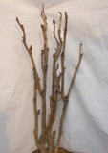 | 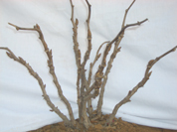 | 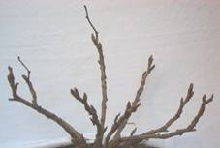
1 | 2 | 3
upright | semi-upright | spreading

Ad. 2: One-year-old branch: length

Observed after leaf fall on current year branches, excluding basal shoots.

Ad. 3: Mixed bud: shape in lateral view

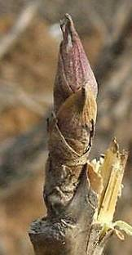 | 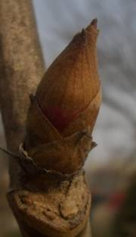 | 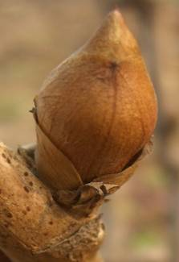
1 | 3 | 5
narrow ovate | medium ovate | broad ovate

Ad. 6: Plant: height

Observed when plants are in flower.

Ad. 7: Very young shoot: color

Very young shoots are less than 10 cm in length. The color of very young shoots excludes that of flower buds.

Ad. 8: Leaf: attitude in relation to the stem

1 | 2 | 3
erect | semi-erect | horizontal

Ad. 9: Leaf: type

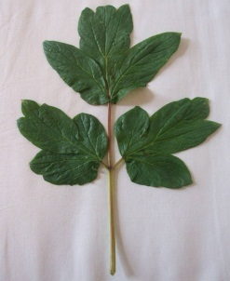 | 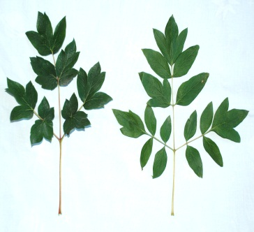
1 | 2 | 3
pinnate | bipinnate | tripinnate

Ad. 10: Leaf: length
Ad. 11: Leaf: width
Ad. 17: Petiole: length

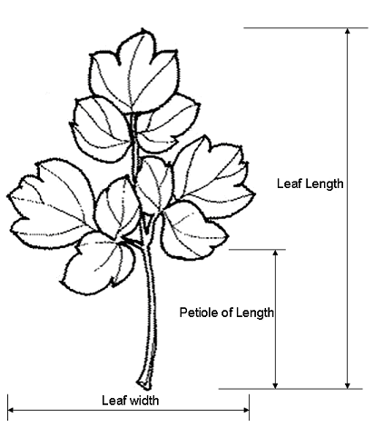

Ad. 12: Leaf: color of upper side

Observed at the beginning of flowering.

Ad. 15: Lateral leaflets: shape
Ad. 16: Lateral leaflets: depth of sinus

The outline shape of the leaflet should be observed.

position of observed lateral leaflet

Ad. 15: Lateral leaflets: shape

 |  | broadest part
 |  | (below middle) | at middle

broad (compressed) width (ratio length/width) narrow (elongated) |  | 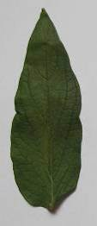  1  lanceolate | 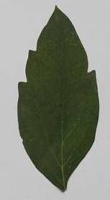  3  narrow elliptic
 |  | 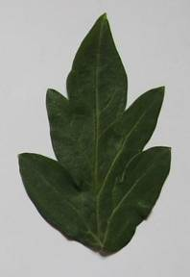  2  narrow ovate | 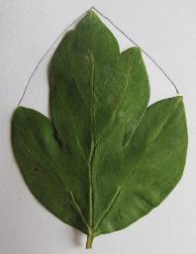  4  broad elliptic
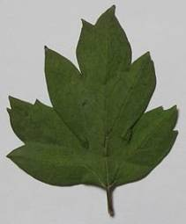
5
broad ovate

Ad. 16: Lateral leaflets: depth of sinus

The sinus is an indent in the leaflet. The sinus may extend to the midrib, creating a lobe. To avoid confusion: a leaflet has a petiolule, but a lobe does not have a petiolule.

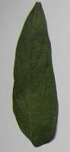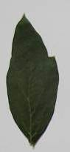 | 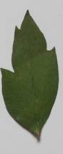 | 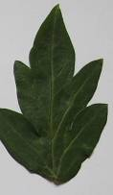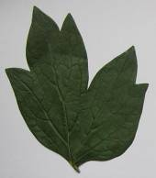 | 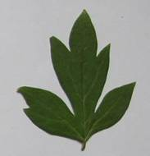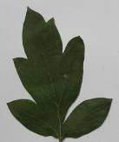 | 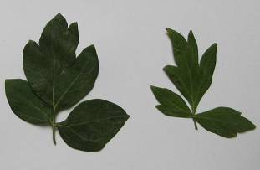
1 | 3 | 5 | 7 | 9
absent or very shallow | shallow | medium | deep | very deep

Ad. 18: Flower bud: shape in lateral view

Observations on the shape of flower bud should be made when the bud is well developed but before it is beginning to show the color.

 |  | broadest part
 |  | (below middle) | at middle
broad (low) width (ratio length/width) narrow (high) |  | 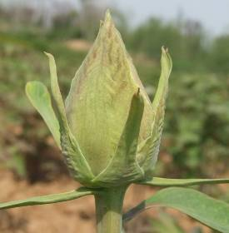
 |  | 1
 |  | narrow ovate
 |  | 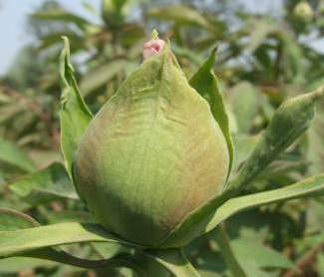 | 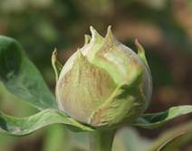
 |  | 2 | 3
 |  | broad ovate | circular
 |  |  | 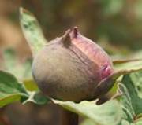
 |  |  | 4
 |  |  | oblate

Ad. 19: Plant: attitude of flowers

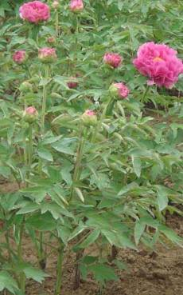 | 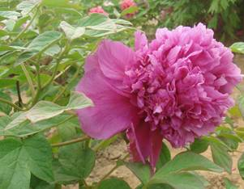 | 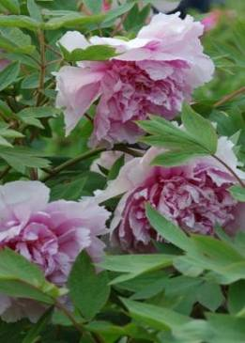
1 | 2 | 3
erect | horizontal | drooping

Ad. 20: Only varieties with flower form: Crown, Globular or Proliferate form: Flower: height of petaloid stamens (in relation to petals)

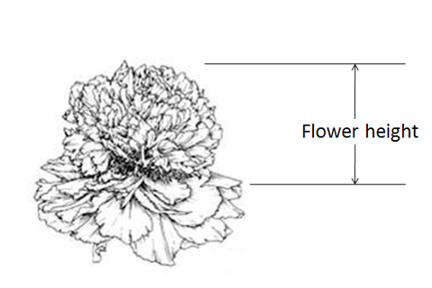

Ad. 22: Flower: form

The most complex form is the flower with the greatest number of petals and/or petaloids.

Flower type | Note | Number of whorls | Petaloid stamens | Petaloid pistils | Illustration
Single form | 1 | 1~3 | None | None | 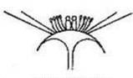
Golden stamen form | 2 | 2~3 | None but stamens very bright and large in center, larger anthers and flat filaments. | None | 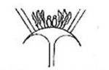
Anemone form | 3 | 2~3 | Almost all, visibly smaller than normal petals. | None or reduced | 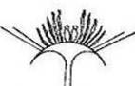
Lotus form | 4 | 4~5 | None | None | 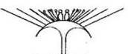
Chrysanthemum form | 5 | 6, petals gradually smaller towards the center. | A few, in flower center. | None | 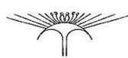
Rose form | 6 | More than 6, petals becoming smaller from outside to flower center | Few, many stamens disappeared. | None or a few or reduced | 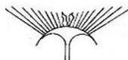
Golden circle form | 7 | 2~3 layers | Many, a whole of normal stamen remains as a yellow circle between interior and outer petals. | None or a few or reduced | 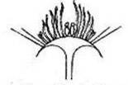
Crown form | 8 | 1~3 | Many, and completely petaloid, larger from outside to inside, mixed with some incompletely petaloid. High flower center, crown- shaped. | A few, reduced or disappeared. | 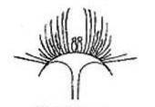
Globular form | 9 | 1~3 | All, and completely petaloid, similar to normal petals. Ball-shaped | All. reduced or disappeared | 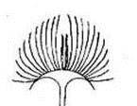
Proliferate form | 10 | 1~3/4/5/6 | None, many or all | None, many, completely petaloid, or disappeared | 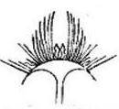

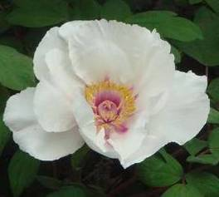 | 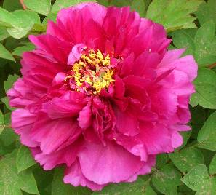
1 | 6
single form | rose form
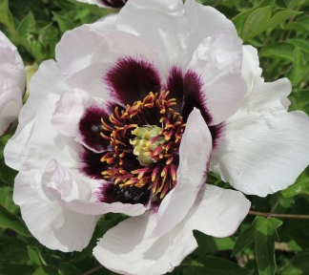 | 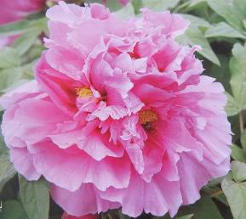
2 | 7
golden stamen form | golden circle form
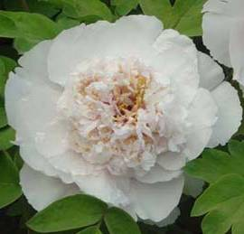 | 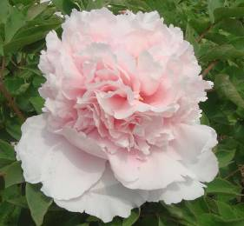
3 | 8
anemone form | crown form
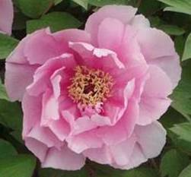 | 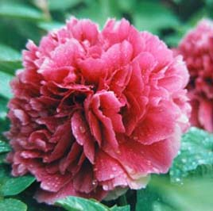
4 | 9
lotus form | globular form
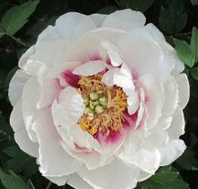 | 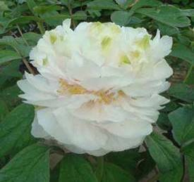
5 | 10
chrysanthemum form | proliferate form

Ad. 23: Flower: main color
Ad. 24: Flower: secondary color

The main color is the color with the largest surface area. The secondary color is the color with the second largest surface area. In cases where the areas of the main and secondary color are too similar to reliably decide which color has the largest area, the darkest color is considered to be the main color.

The main color and secondary color exclude the blotch and basal color.

Ad. 25: Flower: distribution of secondary color

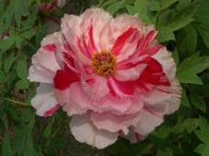 | 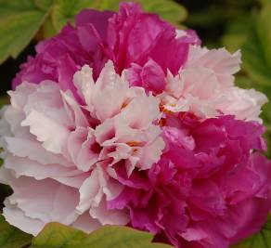 | 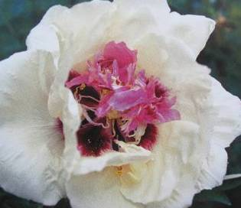
2 | 3 | 4
stripes | blocks | at center

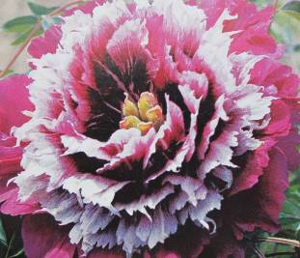 | 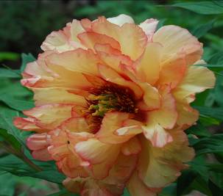
5 | 6
ring | at edge

2: stripes (Secondary color relates to the petaloid stamens. Stripes present from base to apex)
3: blocks
4: at center
5: ring (on most whorls excluding outer whorls, giving a circular appearance)
6: at edge

Ad. 26: Petal: shape (excluding petaloid)

 |  | broadest part
 |  | at middle
broad (low) width (ratio length/width) narrow (high) |  | 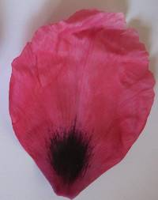  1  elliptic
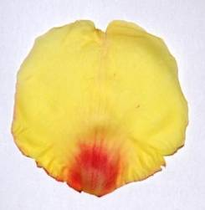
2
circular

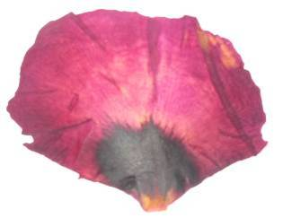
3
oblate

Ad. 27: Petal: incision of apex (excluding petaloid)

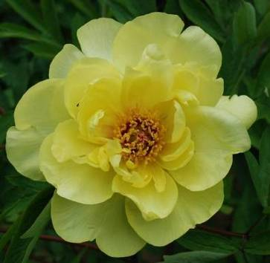 | 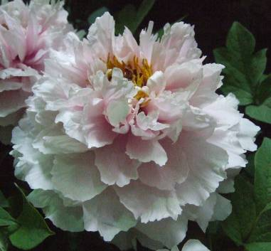 | 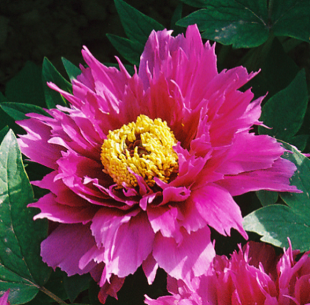
1 | 3 | 5
absent or very weak | medium | very strong

Ad. 28: Petal: blotch
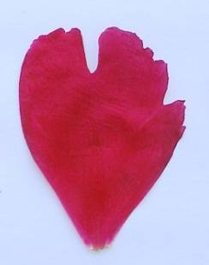 | 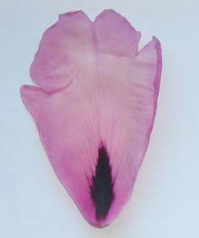
1 | 9
absent | present

Ad. 29: Petal: length of blotch

very short (1) less than 1/8 of the length of petal

short (2) 1/8 to 1/4 of the length of petal

medium (3) 1/4 to 3/8 of the length of petal

long (4) 3/8 to 1/2 of the length of petal

very long (5) more than 1/2 of the length of petal

Ad. 30: Petal: width of blotch

Width of blotch means the widest part of a blotch.

Ad. 32: Petal: white line in the center of the blotch

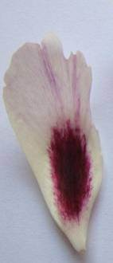 | 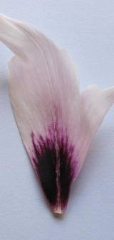 | 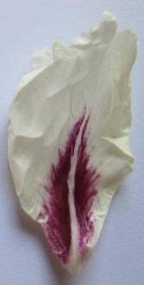
1 | 2 | 3
absent or very inconspicuous | moderately conspicuous | very conspicuous

Ad. 35: Only varieties with petaloid stamens: Petaloid stamen: type

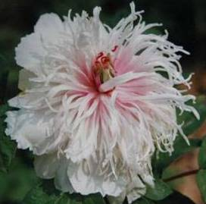 | 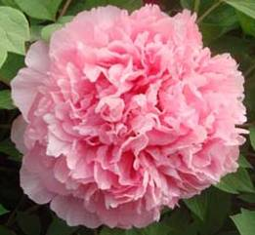
1 | 2
stamen-like | petal-like

Ad. 36: Only varieties with petaloid stamens: Flower: conspicuousness of anthers

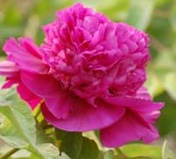 | 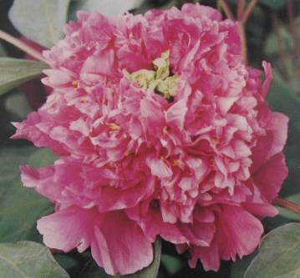 | 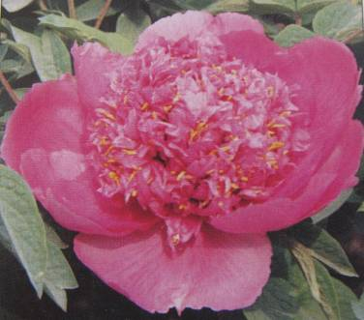
1 | 2 | 3
inconspicuous | moderately conspicuous | very conspicuous

Ad. 39: Pistil: openness of disc

The openness of the disc is assessed by the visibility of the carpels.

Closed: the carpels are enclosed completely by disc and not visible.
Partly open: the carpels are partly enclosed by disc and partially visible.
Fully open: the carpels are enclosed by disc only at base and fully exposed.

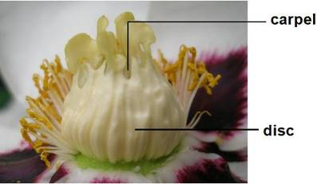 | 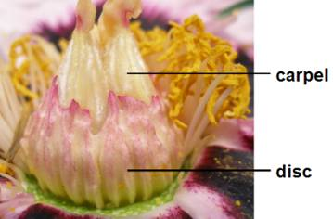 | 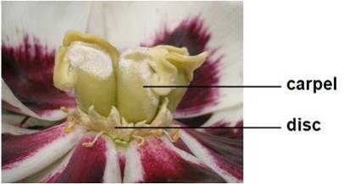
1 | 2 | 3
closed | partly open | fully open

Ad. 41: Fleshiness of disc

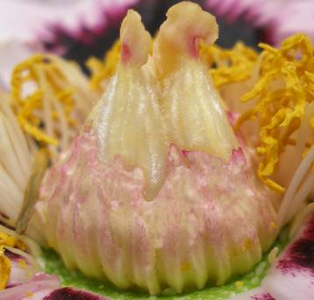 | 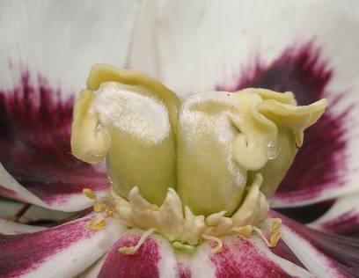 | 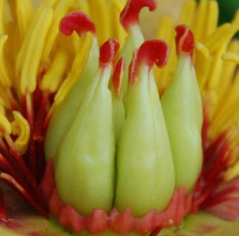
1 | 2 | 3
weak | medium | strong

Ad. 43: Petaloid pistil

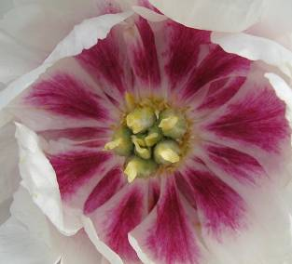 | 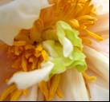
1 | 9
absent | present

Ad. 44: Petaloid pistil: type

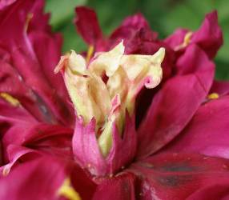 | 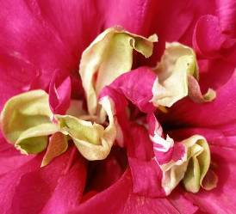 | 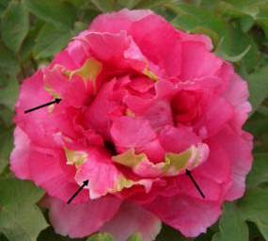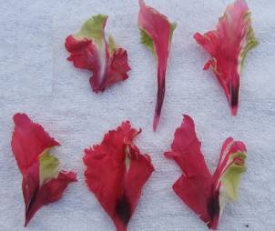
1 | 2 | 3
only stigma | partly petaloid | completely petaloid

Ad. 48: Plant: position of flower in relation to foliage

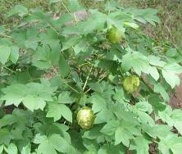 | 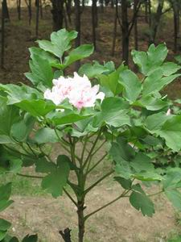 | 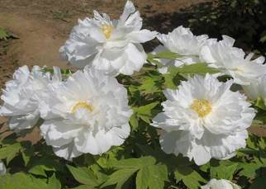
1 | 3 | 5
within | same level or nearly same level | above

- Ad. 49: Time of beginning of flowering

The beginning of flowering is determined when 10% of all flower buds have opened in the first flowering period.

Literature

Brickell, C., Editor-in Chief, 2003: A-Z Encyclopedia of Garden Plants. The Horticulture Society.

Harding, A., 1993: The Peony. Sagapress/Timber press.

Li Jia -jue, Zhang,Xi-fang, Zhao Xiao-qing, 2011: Tree peony in China. Chinese Encyclopedia Publishing House.

Rogers, A., 1995: Peonies. Timber Press.

Wang Lian-ying, 1997: Pictorial Record of Chinese Tree Peony Varieties. Chinese Forestry Publishing House.

Technical Questionnaire

TECHNICAL QUESTIONNAIRE |  |  |  | Page {x} of {y} |  | Reference Number:
 |  |  |  |  |  | Application date:
 |  |  |  |  |  | (not to be filled in by the applicant)
TECHNICAL QUESTIONNAIRE
to be completed in connection with an application for plant breeders’ rights

1. Subject of the Technical Questionnaire
1.1 Botanical name |  |  | Paeonia delavayi Franch. |  |  |  |  |  |  | [ ]
1.2 Common name |  |  | Tree Peony
2.1 Botanical name |  |  | Paeonia jishanensis T. Hong & W. Z. Zhao |  |  |  |  |  | [ ]
2.2 Common name
3.1 Botanical name |  |  | Paeonia ludlowii (Stern & Taylor) D. Y. Hong |  |  |  |  |  | [ ]
3.2 Common name
4.1 Botanical name |  |  | Paeonia ostii T. Hong & J. X. Zhang |  |  |  |  |  | [ ]
4.2 Common name
5.1 Botanical name |  |  | Paeonia qiui Y. L. Pei & D. Y. Hong |  |  |  |  |  | [ ]
5.2 Common name
6.1 Botanical name |  |  | Paeonia rockii (S. G. Haw & Lauener) T. Hong & J. J. Li ex D. Y. Hong |  |  |  |  |  | [ ]
6.2 Common name
7.1 Botanical name |  |  | Paeonia suffruticosa Andrews |  |  |  |  |  | [ ]
7.2 Common name |  |  | Tree Peony
2. Applicant
Name
Address
Telephone No.
Fax No.
E-mail address
Breeder (if different from
applicant)
3. Proposed denomination and breeder’s reference
Proposed denomination
(if available)
Breeder’s reference
#4. Information on the breeding scheme and propagation of the variety

4.1 Breeding scheme
Variety resulting from:

4.1.1 Crossing

(a) controlled cross [ ]
(please state parent varieties)

(…………………..…………………………) x (……………..…………..………………..…)
female parent male parent

(b) partially known cross [ ]
(please state known parent variety(ies))

(…………………..……………………....…) x (……………..………………..…………..…)
female parent male parent

(c) unknown cross [ ]
4.1.2 Mutation [ ]
(please state parent variety)

4.1.3 Discovery and development [ ]
(please state where and when discovered and how developed)

4.1.4 Other [ ]
(please provide details)

4.2 Method of propagating the variety

4.2.1 Vegetatively propagated varieties [ ]

4.2.2 Other [ ]
(please provide details)

5. Characteristics of the variety to be indicated (the number in brackets refers to the corresponding characteristic in Test Guidelines; please mark the note which best corresponds).

 | Characteristics |  |  |  |  |  | Example Varieties |  |  |  | Note
5.1  (1) | Plant: growth habit
 | upright |  |  |  |  |  | Kao, Shichifukujin |  |  |  | 1[ ]
 | semi-upright |  |  |  |  |  | Wu Long Peng Sheng |  |  |  | 2[ ]
 | spreading |  |  |  |  |  | Zhao Fen |  |  |  | 3[ ]
5.2  (6) | Plant: height
 | very short |  |  |  |  |  |  |  |  |  | 1[ ]
 | very short to short |  |  |  |  |  |  |  |  |  | 2[ ]
 | short |  |  |  |  |  | Shan Hu Tai |  |  |  | 3[ ]
 | short to medium |  |  |  |  |  |  |  |  |  | 4[ ]
 | medium |  |  |  |  |  | Kao, Luo Yang Hong |  |  |  | 5[ ]
 | medium to tall |  |  |  |  |  |  |  |  |  | 6[ ]
 | tall |  |  |  |  |  | Hanakisoi |  |  |  | 7[ ]
 | tall to very tall |  |  |  |  |  |  |  |  |  | 8[ ]
 | very tall |  |  |  |  |  |  |  |  |  | 9[ ]
5.3  (9) | Leaf: type
 | pinnate |  |  |  |  |  |  |  |  |  | 1[ ]
 | bipinnate |  |  |  |  |  |  |  |  |  | 2[ ]
 | tripinnate |  |  |  |  |  |  |  |  |  | 3[ ]
5.4  (16) | Lateral leaflets: depth of sinus
 | absent or very shallow |  |  |  |  |  |  |  |  |  | 1[ ]
 | very shallow to shallow |  |  |  |  |  |  |  |  |  | 2[ ]
 | shallow |  |  |  |  |  |  |  |  |  | 3[ ]
 | shallow to medium |  |  |  |  |  |  |  |  |  | 4[ ]
 | medium |  |  |  |  |  |  |  |  |  | 5[ ]
 | medium to deep |  |  |  |  |  |  |  |  |  | 6[ ]
 | deep |  |  |  |  |  |  |  |  |  | 7[ ]
 | deep to very deep |  |  |  |  |  |  |  |  |  | 8[ ]
 | very deep |  |  |  |  |  |  |  |  |  | 9[ ]
 | Characteristics |  |  |  |  |  | Example Varieties |  |  |  | Note
5.5  (22) | Flower: form
 | single form |  |  |  |  |  | Shu Sheng Peng Mo |  |  |  | 1[ ]
 | golden stamen form |  |  |  |  |  | Yao Huang |  |  |  | 2[ ]
 | anemone form |  |  |  |  |  | Yin Si Guan Ding |  |  |  | 3[ ]
 | lotus form |  |  |  |  |  | Yu Ban Bai |  |  |  | 4[ ]
 | chrysanthemum form |  |  |  |  |  | Cong Zhong Xiao, Ru Hua Si Yu |  |  |  | 5[ ]
 | rose form |  |  |  |  |  | Luo Yang Hong |  |  |  | 6[ ]
 | golden circle form |  |  |  |  |  | Fen Mian Tao Hua |  |  |  | 7[ ]
 | crown form |  |  |  |  |  | Shou An Hong |  |  |  | 8[ ]
 | globular form |  |  |  |  |  | Fen Yu Qiu |  |  |  | 9[ ]
 | proliferate form |  |  |  |  |  | Jun Yan Hong, Xian Tao |  |  |  | 10[ ]
5.6 i  (23) | Flower: main color
 | RHS Colour Chart (indicate reference number)
5.6 ii  (23) | Flower: main color
 | white |  |  |  |  |  |  |  |  |  | 1[ ]
 | green |  |  |  |  |  |  |  |  |  | 2[ ]
 | yellow |  |  |  |  |  |  |  |  |  | 3[ ]
 | orange |  |  |  |  |  |  |  |  |  | 4[ ]
 | pink |  |  |  |  |  |  |  |  |  | 5[ ]
 | red |  |  |  |  |  |  |  |  |  | 6[ ]
 | purple |  |  |  |  |  |  |  |  |  | 7[ ]
 | dark red purple |  |  |  |  |  |  |  |  |  | 8[ ]
5.7  (28) | Petal: blotch
 | absent |  |  |  |  |  | Zhao Fen |  |  |  | 1[ ]
 | present |  |  |  |  |  | Luo Yang Hong |  |  |  | 9[ ]
 | Characteristics |  |  |  |  |  | Example Varieties |  |  |  | Note
5.8  (29) | Petal: length of blotch
 | very short |  |  |  |  |  | Hu Hong |  |  |  | 1[ ]
 | short |  |  |  |  |  | Luo Yang Hong |  |  |  | 2[ ]
 | medium |  |  |  |  |  | Cong Zhong Xiao |  |  |  | 3[ ]
 | long |  |  |  |  |  | Shu Sheng Peng Mo |  |  |  | 4[ ]
 | very long |  |  |  |  |  | Zhong Ban Bai |  |  |  | 5[ ]
5.9  (49) | Time of beginning of flowering
 | very early |  |  |  |  |  |  |  |  |  | 1[ ]
 | very early to early |  |  |  |  |  |  |  |  |  | 2[ ]
 | early |  |  |  |  |  | Huo Lian Jin Dan |  |  |  | 3[ ]
 | early to medium |  |  |  |  |  |  |  |  |  | 4[ ]
 | medium |  |  |  |  |  | Luo Yang Hong |  |  |  | 5[ ]
 | medium to late |  |  |  |  |  |  |  |  |  | 6[ ]
 | late |  |  |  |  |  | High Noon |  |  |  | 7[ ]
 | late to very late |  |  |  |  |  |  |  |  |  | 8[ ]
 | very late |  |  |  |  |  |  |  |  |  | 9[ ]
6. Similar varieties and differences from these varieties

Please use the following table and box for comments to provide information on how your candidate variety differs from the variety (or varieties) which, to the best of your knowledge, is (or are) most similar. This information may help the examination authority to conduct its examination of distinctness in a more efficient way.

Denomination(s) of variety(ies) similar to your candidate variety |  | Characteristic(s) in which your candidate variety differs from the similar variety(ies) |  |  | Describe the expression of the characteristic(s) for the similar variety(ies) |  |  | Describe the expression of the characteristic(s) for your candidate variety
Example |  | Plant: height |  |  | medium |  |  | short
Comments:

#7. Additional information which may help in the examination of the variety

7.1 In addition to the information provided in sections 5 and 6, are there any additional characteristics which may help to distinguish the variety?

Yes [ ] No [ ]

(If yes, please provide details)

7.2 Are there any special conditions for growing the variety or conducting the examination?

Yes [ ] No [ ]

(If yes, please provide details)

7.3 Other information

7.3.1 Main use

(a) garden plant [ ]
(b) pot plant [ ]
(c) cut-flower [ ]
(d) other [ ]
(please provide details)

7.3.2 A representative color photograph of the variety should accompany the Technical Questionnaire.

8. Authorization for release

(a) Does the variety require prior authorization for release under legislation concerning the protection of the environment, human and animal health?

Yes [ ] No [ ]

(b) Has such authorization been obtained?

Yes [ ] No [ ]

If the answer to (b) is yes, please attach a copy of the authorization.

9. Information on plant material to be examined or submitted for examination

9.1 The expression of a characteristic or several characteristics of a variety may be affected by factors, such as pests and disease, chemical treatment (e.g. growth retardants or pesticides), effects of tissue culture, different rootstocks, scions taken from different growth phases of a tree, etc.

9.2 The plant material should not have undergone any treatment which would affect the expression of the characteristics of the variety, unless the competent authorities allow or request such treatment. If the plant material has undergone such treatment, full details of the treatment must be given. In this respect, please indicate below, to the best of your knowledge, if the plant material to be examined has been subjected to:

(a) Microorganisms (e.g. virus, bacteria, phytoplasma) Yes [ ] No [ ]

(b) Chemical treatment (e.g. growth retardant, pesticide) Yes [ ] No [ ]

(c) Tissue culture Yes [ ] No [ ]

(d) Other factors Yes [ ] No [ ]

Please provide details for where you have indicated “yes”.

10. I hereby declare that, to the best of my knowledge, the information provided in this form is correct:

Applicant’s name

Signature Date

[End of document]

* These names were correct at the time of the introduction of these Test Guidelines but may be revised or updated. [Readers are advised to consult the UPOV Code, which can be found on the UPOV Website (www.upov.int), for the latest information.]
# Authorities may allow certain of this information to be provided in a confidential section of the Technical Questionnaire.
# Authorities may allow certain of this information to be provided in a confidential section of the Technical Questionnaire.

