 |  | E  TG/290/1  ORIGINAL: English  DATE: 2013-03-20
INTERNATIONAL UNION FOR THE PROTECTION OF NEW VARIETIES OF PLANTS
Geneva

 | KUMQUAT  UPOV Code: FORTU  Fortunella Swingle | *

GUIDELINES

FOR THE CONDUCT OF TESTS

FOR DISTINCTNESS, UNIFORMITY AND STABILITY

Alternative Names:*

Botanical name |  | English |  | French |  | German |  | Spanish
Fortunella Swingle | Kumquat |  | Kumquat |  | Kumquat |  | Kumquat

The purpose of these guidelines (“Test Guidelines”) is to elaborate the principles contained in the General Introduction (document TG/1/3), and its associated TGP documents, into detailed practical guidance for the harmonized examination of distinctness, uniformity and stability (DUS) and, in particular, to identify appropriate characteristics for the examination of DUS and production of harmonized variety descriptions.

ASSOCIATED DOCUMENTS
These Test Guidelines should be read in conjunction with the General Introduction and its associated TGP documents.
TABLE OF CONTENTS PAGE

1. Subject of these Test Guidelines 3
2. Material Required 3
3. Method of Examination 3
3.1 Number of Growing Cycles 3
3.2 Testing Place 3
3.3 Conditions for Conducting the Examination 3
3.4 Test Design 3
3.5 Additional Tests 4
4. Assessment of Distinctness, Uniformity and Stability 4
4.1 Distinctness 4
4.2 Uniformity 5
4.3 Stability 5
5. Grouping of Varieties and Organization of the Growing Trial 5
6. Introduction to the Table of Characteristics 5
6.1 Categories of Characteristics 5
6.2 States of Expression and Corresponding Notes 6
6.3 Types of Expression 6
6.4 Example Varieties 6
6.5 Legend 7
7. Table of Characteristics/Tableau des caractères/Merkmalstabelle/Tabla de caracteres 8
8. Explanations on the Table of Characteristics 12
8.1 Explanations covering several characteristics 12
8.2 Explanations for individual characteristics 12
9. Literature 17
10. Technical Questionnaire 18

Subject of these Test Guidelines

These Test Guidelines apply to all varieties of Fortunella Swingle.

Material Required

2.1 The competent authorities decide on the quantity and quality of the plant material required for testing the variety and when and where it is to be delivered. Applicants submitting material from a State other than that in which the testing takes place must ensure that all customs formalities and phytosanitary requirements are complied with.

2.2 The material is to be supplied in the form of budsticks with sufficient buds to propagate 5 trees (to be sent at budding time), dormant shoots grafted on a rootstock selected by the testing authority or one-year-old trees grafted on a rootstock selected by the testing authority.

2.3 The minimum quantity of plant material, to be supplied by the applicant, should be:

5 budsticks, or
5 dormant shoots, or
5 one-year-old trees.

2.4 The plant material supplied should be visibly healthy, not lacking in vigor, nor affected by any important pest or disease.

2.5 The plant material should not have undergone any treatment which would affect the expression of the characteristics of the variety, unless the competent authorities allow or request such treatment. If it has been treated, full details of the treatment must be given.

Method of Examination

3.1 Number of Growing Cycles

3.1.1 The minimum duration of tests should normally be two independent growing cycles.

3.1.2 In particular, it is essential that the trees produce a satisfactory crop of fruit in each of the two growing cycles.

3.1.3 The growing cycle is considered to be the duration of a single growing season, beginning with bud burst, flowering and fruit harvest and concluding when the following dormant period ends with the swelling of new season buds.

3.2 Testing Place

Tests are normally conducted at one place. In the case of tests conducted at more than one place, guidance is provided in TGP/9 “Examining Distinctness”.

3.3 Conditions for Conducting the Examination

The tests should be carried out under conditions ensuring satisfactory growth for the expression of the relevant characteristics of the variety and for the conduct of the examination.

3.4 Test Design

3.4.1 Each test should be designed to result in a total of at least 5 trees.

3.4.2 The design of the tests should be such that plants or parts of plants may be removed for measurement or counting without prejudice to the observations which must be made up to the end of the growing cycle.

3.5 Additional Tests

Additional tests, for examining relevant characteristics, may be established.

Assessment of Distinctness, Uniformity and Stability

4.1 Distinctness

4.1.1 General Recommendations

It is of particular importance for users of these Test Guidelines to consult the General Introduction prior to making decisions regarding distinctness. However, the following points are provided for elaboration or emphasis in these Test Guidelines.

4.1.2 Consistent Differences

The differences observed between varieties may be so clear that more than one growing cycle is not necessary. In addition, in some circumstances, the influence of the environment is not such that more than a single growing cycle is required to provide assurance that the differences observed between varieties are sufficiently consistent. One means of ensuring that a difference in a characteristic, observed in a growing trial, is sufficiently consistent is to examine the characteristic in at least two independent growing cycles.

4.1.3 Clear Differences

Determining whether a difference between two varieties is clear depends on many factors, and should consider, in particular, the type of expression of the characteristic being examined, i.e. whether it is expressed in a qualitative, quantitative, or pseudo-qualitative manner. Therefore, it is important that users of these Test Guidelines are familiar with the recommendations contained in the General Introduction prior to making decisions regarding distinctness.

4.1.4 Number of Plants / Parts of Plants to be Examined

Unless otherwise indicated, for the purposes of distinctness, all observations on single plants should be made on 5 plants or parts taken from each of 5 plants and any other observations made on all plants in the test. In the case of observations of parts taken from single plants, the number of parts to be taken from each of the plants should be 2.

4.1.5 Method of Observation

The recommended method of observing the characteristic for the purposes of distinctness is indicated by the following key in the second column of the Table of Characteristics (see document TGP/9 “Examining Distinctness”, Section 4 “Observation of characteristics”):

MG: single measurement of a group of plants or parts of plants
MS: measurement of a number of individual plants or parts of plants
VG: visual assessment by a single observation of a group of plants or parts of plants
VS: visual assessment by observation of individual plants or parts of plants

Type of observation: visual (V) or measurement (M)

“Visual” observation (V) is an observation made on the basis of the expert’s judgment. For the purposes of this document, “visual” observation refers to the sensory observations of the experts and, therefore, also includes smell, taste and touch. Visual observation includes observations where the expert uses reference points (e.g. diagrams, example varieties, side-by-side comparison) or non-linear charts (e.g. color charts). Measurement (M) is an objective observation against a calibrated, linear scale e.g. using a ruler, weighing scales, colorimeter, dates, counts, etc.

Type of record: for a group of plants (G) or for single, individual plants (S)

For the purposes of distinctness, observations may be recorded as a single record for a group of plants or parts of plants (G), or may be recorded as records for a number of single, individual plants or parts of plants (S). In most cases, “G” provides a single record per variety and it is not possible or necessary to apply statistical methods in a plant-by-plant analysis for the assessment of distinctness.

In cases where more than one method of observing the characteristic is indicated in the Table of Characteristics (e.g. VG/MG), guidance on selecting an appropriate method is provided in document TGP/9, Section 4.2.

4.2 Uniformity

    - It is of particular importance for users of these Test Guidelines to consult the General Introduction prior to making decisions regarding uniformity. However, the following points are provided for elaboration or emphasis in these Test Guidelines:

4.2.2 For the assessment of uniformity, a population standard of 1% and an acceptance probability of at least 95% should be applied. In the case of a sample size of 5 plants, no off-types are allowed.

4.3 Stability

4.3.1 In practice, it is not usual to perform tests of stability that produce results as certain as those of the testing of distinctness and uniformity. However, experience has demonstrated that, for many types of variety, when a variety has been shown to be uniform, it can also be considered to be stable.

4.3.2 Where appropriate, or in cases of doubt, stability may be further examined by testing a new plant stock to ensure that it exhibits the same characteristics as those shown by the initial material supplied.”

Grouping of Varieties and Organization of the Growing Trial

5.1 The selection of varieties of common knowledge to be grown in the trial with the candidate varieties and the way in which these varieties are divided into groups to facilitate the assessment of distinctness are aided by the use of grouping characteristics.

5.2 Grouping characteristics are those in which the documented states of expression, even where produced at different locations, can be used, either individually or in combination with other such characteristics: (a) to select varieties of common knowledge that can be excluded from the growing trial used for examination of distinctness; and (b) to organize the growing trial so that similar varieties are grouped together.

5.3 The following have been agreed as useful grouping characteristics:

(a) Fruit: weight (characteristic 18)
(b) Fruit: shape (characteristic 19)
(c) Fruit: color of skin (characteristic 20)
(d) Time of beginning of fruit ripening (characteristic 29)

5.4 Guidance for the use of grouping characteristics, in the process of examining distinctness, is provided through the General Introduction and document TGP/9 “Examining Distinctness”.

Introduction to the Table of Characteristics

6.1 Categories of Characteristics

6.1.1 Standard Test Guidelines Characteristics

Standard Test Guidelines characteristics are those which are approved by UPOV for examination of DUS and from which members of the Union can select those suitable for their particular circumstances.

6.1.2 Asterisked Characteristics

Asterisked characteristics (denoted by *) are those included in the Test Guidelines which are important for the international harmonization of variety descriptions and should always be examined for DUS and included in the variety description by all members of the Union, except when the state of expression of a preceding characteristic or regional environmental conditions render this inappropriate.

6.2 States of Expression and Corresponding Notes

6.2.1 States of expression are given for each characteristic to define the characteristic and to harmonize descriptions. Each state of expression is allocated a corresponding numerical note for ease of recording of data and for the production and exchange of the description.

6.2.2 In the case of qualitative and pseudo-qualitative characteristics (see Chapter 6.3), all relevant states of expression are presented in the characteristic. However, in the case of quantitative characteristics with 5 or more states, an abbreviated scale may be used to minimize the size of the Table of Characteristics. For example, in the case of a quantitative characteristic with 9 states, the presentation of states of expression in the Test Guidelines may be abbreviated as follows:

State | Note
small | 3
medium | 5
large | 7

However, it should be noted that all of the following 9 states of expression exist to describe varieties and should be used as appropriate:

State | Note
very small | 1
very small to small | 2
small | 3
small to medium | 4
medium | 5
medium to large | 6
large | 7
large to very large | 8
very large | 9

6.2.3 Further explanation of the presentation of states of expression and notes is provided in document TGP/7 “Development of Test Guidelines”.

6.3 Types of Expression

An explanation of the types of expression of characteristics (qualitative, quantitative and pseudo-qualitative) is provided in the General Introduction.

6.4 Example Varieties

Where appropriate, example varieties are provided to clarify the states of expression of each characteristic.

6.5 Legend

(*) Asterisked characteristic – see Chapter 6.1.2

QL Qualitative characteristic – see Chapter 6.3
QN Quantitative characteristic – see Chapter 6.3
PQ Pseudo-qualitative characteristic – see Chapter 6.3

MG, MS, VG, VS – see Chapter 4.1.5

(a)-(e) See Explanations on the Table of Characteristics in Chapter 8.1

(+) See Explanations on the Table of Characteristics in Chapter 8.2.

Table of Characteristics/Tableau des caractères/Merkmalstabelle/Tabla de caracteres

 |  | English | français | deutsch | español | Example Varieties  Exemples  Beispielssorten  Variedades ejemplo | Note/  Nota
1  (*)  (+) | VG | Plant: growth habit | Plante : port | Pflanze: Wuchsform | Planta: porte
QN | (a) | upright | dressé | aufrecht | erguido | Nagami | 1
 |  | semi upright | demi-dressé | halbaufrecht | semierguido | Meiwa | 2
 |  | spreading | étalé | breitwüchsig | extendido | Fukushu | 3
2  (*)  (+) | VG | Plant: density of branches | Plante : densité des branches | Pflanze: Dichte der Verzweigung | Planta: densidad de las ramas
QN | (a) | sparse | lâche | locker | laxa | Tetraploid-Meiwa | 3
 |  | medium | moyenne | mittel | media | Meiwa | 5
 |  | dense | dense | dicht | densa | Marumi | 7
3  (*) | VG/MS | One-year-old shoot: length | Rameau d’un an : longueur | Einjähriger Trieb: Länge | Rama de un año: longitud
QN | (b) | short | court | kurz | corta | Nagami | 3
 |  | medium | moyen | mittel | media | Meiwa | 5
 |  | long | long | lang | larga | Tetraploid-Meiwa | 7
4  (*) | VG/MS | One-year-old shoot: thickness | Rameau d’un an : épaisseur | Einjähriger Trieb: Dicke | Rama de un año: grosor
QN | (b) | thin | mince | dünn | delgada | Marumi | 1
 |  | medium | moyen | mittel | media | Nagami | 3
 |  | thick | épais | dick | gruesa | Meiwa | 5
5  (*) | VG/MS | One-year-old shoot: length of internode | Rameau d’un an : longueur de l’entre-nœud | Einjähriger Trieb: Länge des Internodiums | Rama de un año: longitud del entrenudo
QN | (b) | short | court | kurz | corta | Nagami | 3
 |  | medium | moyen | mittel | media | Meiwa | 5
 |  | long | long | lang | larga | Tetraploid-Meiwa | 7
6  (*) | VG | One-year-old shoot: number of spines | Rameau d’un an : nombre d’épines | Einjähriger Trieb: Anzahl Stacheln | Rama de un año: número de espinas
QN | (b) | none or very few | aucun ou très petit | keine oder sehr wenige | ausente o muy pocas | Nagami, Fukushu | 1
 |  | few | petit | wenige | pocas | Marumi | 3
 |  | medium | moyen | mittel | media | Meiwa | 5
 |  | many | grand | viele | abundantes | Tetraploid-Meiwa | 7
7  (*) | VG/MS | Leaf blade: length | Limbe : longueur | Blattspreite: Länge | Limbo: longitud
QN | (b) | short | court | kurz | corto | Meiwa | 3
 |  | medium | moyen | mittel | medio | Tetraploid-Meiwa | 5
 |  | long | long | lang | largo | Nagami | 7
8  (*) | VG/MS | Leaf blade: width | Limbe : largeur | Blattspreite: Breite | Limbo: anchura
QN | (c) | narrow | étroit | schmal | estrecho | Meiwa | 1
 |  | medium | moyen | mittel | medio | Tetraploid-Meiwa | 3
 |  | broad | large | breit | ancho | Fukushu | 5
9  (*)  (+) | VG | Leaf blade: shape | Limbe : forme | Blattspreite: Form | Limbo: forma
PQ | (c) | lanceolate | lancéolé | lanzettlich | lanceolado | Nagami | 1
 |  | narrow elliptic | elliptique étroit | schmall elliptisch | elíptico estrecho | Meiwa | 2
 |  | broad elliptic | elliptique large | breit elliptisch | elíptico ancho | Fukushu | 3
10  (*)  (+) | VG | Leaf blade: shape of apex | Limbe : forme du sommet | Blattspreite: Form der Spitze | Limbo: forma del ápice
PQ | (c) | obtuse | obtus | stumpf | obtuso | Fukushu | 1
 |  | acute | aigu | spitz | agudo |  | 2
 |  | acuminate | acuminé | mit aufgesetzter Spitze | acuminado | Meiwa | 3
11  (*)  (+) | VG | Leaf blade: shape of base | Limbe : forme de la base | Blattspreite: Form der Basis | Limbo: forma de la base
QN | (c) | acute | aigue | spitz | agudo | Nagami | 1
 |  | right angled | droit | rechtwinklig | en ángulo recto | Meiwa | 2
 |  | obtuse | obtuse | stumpf | obtuso | Fukushu | 3
12  (*) | VG | Leaf blade: undulation of margin | Limbe : ondulation du bord | Blattspreite: Wellung des Randes | Limbo: ondulación del borde
QN | (c) | weak | faible | gering | débil | Marumi | 1
 |  | medium | moyenne | mittel | media | Meiwa | 2
 |  | strong | forte | stark | fuerte | Nagami | 3
13  (*) | VG/MS | Leaf: length of petiole | Feuille : longueur du pétiole | Blatt: Länge des Blattstiels | Hoja: longitud del peciolo
QN | (c) | short | court | kurz | corto | Fukushu | 1
 |  | medium | moyen | mittel | medio | Marumi | 3
 |  | long | long | lang | largo | Nagami | 5
14  (*)  (+) | VG/MS | Flower: diameter | Fleur : diamètre | Blüte: Durchmesser | Flor: diámetro
QN | (d) | small | petit | klein | pequeño | Meiwa | 1
 |  | medium | moyen | mittel | medio |  | 3
 |  | large | grand | groß | grande | Tetraploid-Meiwa | 5
15  (*) | VG | Flower: number of filaments | Fleur : nombre de filaments | Blüte: Anzahl der Staubfäden | Flor: número de filamentos
QN | (d) | few | petit | wenige | bajo | Tetraploid-Meiwa | 1
 |  | medium | moyen | mittel | medio | Nagami | 3
 |  | many | grand | viele | alto | Meiwa | 5
16  (*) | VG/MS | Fruit: length | Fruit : longueur | Frucht: Länge | Fruto: longitud
QN | (e) | short | court | kurz | corto | Marumi | 1
 |  | medium | moyen | mittel | medio | Meiwa | 3
 |  | long | long | lang | largo | Nagami | 5
17  (*) | VG/MS | Fruit: diameter | Fruit : diamètre | Frucht: Durchmesser | Fruto: diámetro
QN | (e) | small | petit | klein | pequeño | Marumi | 1
 |  | medium | moyen | mittel | medio | Meiwa | 3
 |  | large | grand | groß | grande | Fukushu | 5
18  (*)  (+) | MG | Fruit: weight | Fruit : poids | Frucht: Gewicht | Fruto: peso
QN | (e) | low | petit | niedrig | pequeño | Nagami | 3
 |  | medium | moyen | mittel | medio | Tetraploid-Meiwa | 5
 |  | high | grand | hoch | grande | Fukushu | 7
19  (*)  (+) | VG | Fruit: shape | Fruit : forme | Frucht: Form | Fruto: forma
PQ | (e) | circular | circulaire | kreisförmig | circular | Marumi | 1
 |  | elliptic | elliptique | elliptisch | elíptico | Meiwa | 2
 |  | obovate | obovale | verkehrt eiförmig | obovado | Fukushu, Nagami | 3
20  (*) | VG | Fruit: color of skin | Fruit : couleur de l’épiderme | Frucht: Farbe der Schale | Fruto: color de la piel
PQ | (e) | yellowish orange | orange jaunâtre | gelblich orange | naranja amarillento | Nagami | 1
 |  | medium orange | orange moyen | mittelorange | naranja medio | Meiwa | 2
 |  | dark orange | orange foncé | dunkelorange | naranja oscuro |  | 3
21  (*)  (+) | VG/MS | Fruit: thickness of skin | Fruit : épaisseur de l’épiderme | Frucht: Dicke der Schale | Fruto: grosor de la piel
QN | (e) | thin | mince | dünn | delgada | Marumi | 1
 |  | medium | moyen | mittel | media | Meiwa | 3
 |  | thick | épais | dick | gruesa | Tetraploid-Meiwa | 5
22  (*)  (+) | MG | Fruit: sweetness of flesh | Fruit : goût sucré de la chair | Frucht: Süße des Fleisches | Fruto: dulzura de la pulpa
QN | (e) | low | faible | gering | baja | Nagami | 3
 |  | medium | moyen | mittel | media | Meiwa | 5
 |  | high | fort | hoch | alta | Tetraploid-Meiwa | 7
23  (*)  (+) | MG | Fruit: acidity of flesh | Fruit : acidité de la chair | Frucht: Säure des Fleisches | Fruto: acidez de la pulpa
QN | (e) | low | faible | gering | baja | Tetraploid-Meiwa | 3
 |  | medium | moyenne | mittel | media | Meiwa | 5
 |  | high | forte | hoch | alta | Nagami | 7
24  (*)  (+) | MG | Fruit: sweetness of skin | Fruit : goût sucré de l’épiderme | Frucht: Süße der Schale | Fruto: dulzura de la piel
QN | (e) | low | faible | gering | baja | Nagami | 3
 |  | medium | moyen | mittel | media | Meiwa | 5
 |  | high | fort | hoch | alta | Tetraploid-Meiwa | 7
25  (*)  (+) | VG | Fruit: juiciness | Fruit : jutosité | Frucht: Saftigkeit des Fleisches | Fruto: suculencia
QN | (e) | low | faible | gering | baja | Marumi | 3
 |  | medium | moyenne | mittel | media | Meiwa | 5
 |  | high | forte | hoch | alta | Fukushu | 7
26  (*) | MS | Fruit: number of fully developed seeds | Fruit : nombre de graines complètement développées | Frucht: Anzahl vollentwickelter Samen | Fruto: número de semillas completamente desarrolladas
QN | (e) | none or few | nul ou petit | keine oder wenige | ninguna o bajo | Nagami | 1
 |  | medium | moyen | mittel | medio | Marumi | 2
 |  | many | grand | viele | alto | Meiwa | 3
27  (*)  (+) | VG | Seed: embryony | Pépin : embryonie | Samen: Embryonie | Semilla: embrionía
QL | (e) | monoembryonic | monoembryonique | monoembryonisch | monoembriónico | Nagami | 1
 |  | polyembryonic | polyembryonique | polyembryonisch | poliembriónico | Meiwa | 2
28  (+) | MG | Time of beginning of flowering | Époque du début de floraison | Zeitpunkt des Blühbeginns | Época del inicio de la floración
QN | (d) | early | précoce | früh | temprana |  | 3
 |  | medium | moyenne | mittel | media |  | 5
 |  | late | tardive | spät | tardía |  | 7
29  (*)  (+) | MG | Time of beginning of fruit ripening | Époque du début de maturation des fruits | Zeitpunkt des Beginns der Fruchtreife | Época de inicio de maduración del fruto
QN | (e) | early | précoce | früh | temprana | Fukushu | 3
 |  | medium | moyenne | mittel | media | Meiwa | 5
 |  | late | tardive | spät | tardía | Nagami | 7

Explanations on the Table of Characteristics

8.1 Explanations covering several characteristics

Characteristics containing the following key in the second column of the Table of Characteristics should be examined as indicated below:

- Plant: Observations on the plant should be made in the winter season
- One-year-old shoot: Observations on the one-year-old shoot should be made on well developed shoots (excluding water shoots) at the equatorial part of outer side of the plant.
- Leaf blade: Observations on the leaf blade should be made on fully developed leaves. Leaves should be taken from the middle third of one-year-old shoots.
(d) Flower: Observations on the flower should be made on the primary flowers.
(e) Fruit: Observations on the fruit should be made on the first fruit, which has reached maturity and is ready for consumption.

8.2 Explanations for individual characteristics

Ad. 1: Plant: growth habit

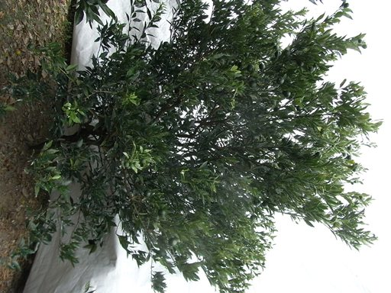 | 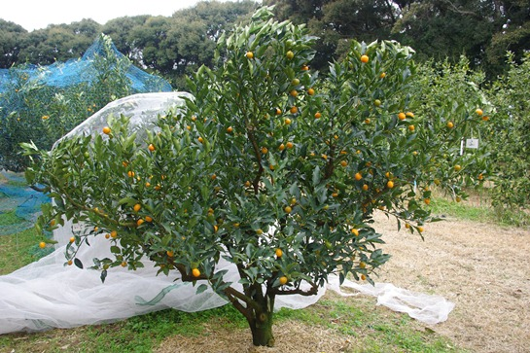 | 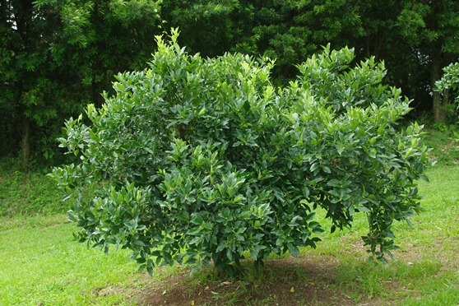
1 | 2 | 3
upright | semi upright | spreading

Ad. 2: Plant: density of branches

Trees should only be pruned in the year of planting to ensure good branch formation.

Ad. 9: Leaf blade: shape

broad ← width → narrow |  | ← broadest part →
broad ← width → narrow |  | (below middle) | at middle
broad ← width → narrow |  | 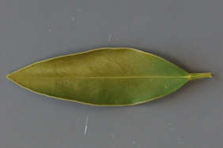
broad ← width → narrow |  | 1
broad ← width → narrow |  | lanceolate
broad ← width → narrow |  |  | 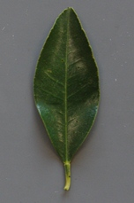
broad ← width → narrow |  |  | 2
broad ← width → narrow |  |  | narrow elliptic
broad ← width → narrow |  |  | 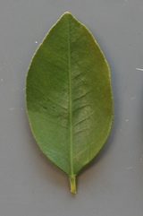
broad ← width → narrow |  |  | 3
broad ← width → narrow |  |  | broad elliptic

Ad. 10: Leaf blade: shape of apex

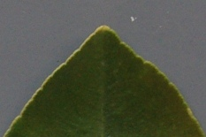 | 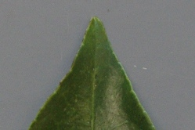 | 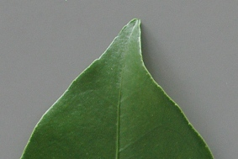
1 | 2 | 3
obtuse | acute | acuminate

Ad. 11: Leaf blade: shape of base

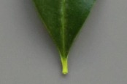 | 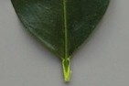 | 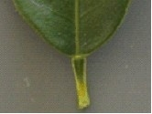
1 | 2 | 3
acute | right angled | obtuse

Ad. 14: Flower: diameter

The flower diameter is the broadest part of the primary flower at full flowering time.

diameter
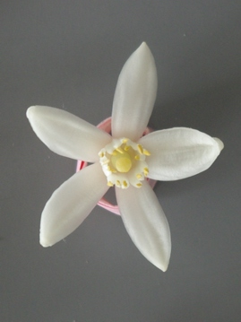

Ad. 18: Fruit: weight

The weight of 10 fruits should be observed.

Ad. 19: Fruit: shape

towards top ← broadest part → at middle |  | shape
towards top ← broadest part → at middle |  | compressed ↔ elongated
towards top ← broadest part → at middle |  | 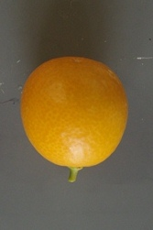 | 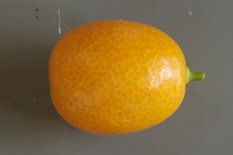
towards top ← broadest part → at middle |  | 1 | 2
towards top ← broadest part → at middle |  | circular | elliptic
towards top ← broadest part → at middle |  |  | 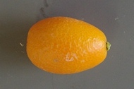
towards top ← broadest part → at middle |  |  | 3
towards top ← broadest part → at middle |  |  | obovate

Ad. 21: Fruit: thickness of skin

thickness
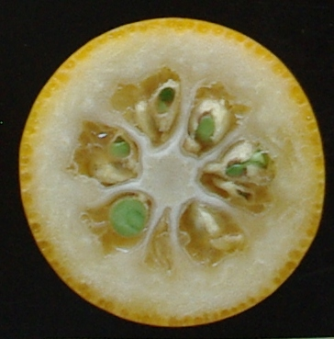

Ad. 22: Fruit: sweetness of flesh

The sweetness is considered as the total soluble solids content, and is determined with a refractometer.

Ad. 23: Fruit: acidity of flesh

The acidity is considered as free acids content, and is determined by titration.

Ad. 24: Fruit: sweetness of skin

The sweetness is considered as the total soluble solids content of juice from peeled skin at the middle part of fruit determined with a refractometer.

Ad. 25: Fruit: juiciness

The juiciness should be determined by observation of juice content by squeezing fruit which is cut at the middle part of cross section.

Ad. 27: Seed: embryony

Seed embryony should be determined after removing seed coat.

Ad. 28: Time of beginning of flowering

The beginning of flowering is considered as the time when 10% of the flowers are fully open.

Ad. 29: Time of beginning of fruit ripening

The beginning of fruit ripening is considered as the time when 10% of the fruits are ready for consumption.

Literature

Alexander, D. McE., 1983: Some Citrus Species and Varieties in Australia, Commonwealth Scientific and Industrial Research Organization, AU, pp. 44-47.

Hatano, H. et al., 1999: Kumquat, The Encyclopedia of Fruit Horticulture, Nosangyoson Bunka Kyokai, v.7, JP.

Iwahori, S., et al.. 1999: The Introduction to Citrus, Yokendo Ltd., JP, pp. 197-199.

Iwamasa, M., 1976: The Varieties of Citrus, Sizuoka Prefecture Citrus Agricultural Cooperative, JP, pp. 243-245.

Kawase, K., 2007: Kumquat, Nosangyoson Bunka Kyokai, JP, p. 204.

Kozaki, I., et al., 1996: The Fruit in Japan, Yokendo Ltd., JP, pp. 382-383.

Reuther, W., Webber, H.J., Batchelor, L. D., (Editors), 1967: The Citrus Industry, Volume 1, University of California, Division of Agricultural Sciences, pp. 329-335, pp. 580-583.

Saunt, J., 2000: Citrus Varieties of the World: An Illustrated Guide, Sinclair International Ltd., Norwich, GB, pp. 134-137.

Technical Questionnaire

TECHNICAL QUESTIONNAIRE |  |  |  | Page {x} of {y} |  | Reference Number:
 |  |  |  |  |  | Application date:
 |  |  |  |  |  | (not to be filled in by the applicant)
TECHNICAL QUESTIONNAIRE
to be completed in connection with an application for plant breeders’ rights

1. Subject of the Technical Questionnaire
1.1 Botanical name |  |  | Fortunella Swingle
1.2 Common name |  |  | Kumquat
2. Applicant
Name
Address
Telephone No.
Fax No.
E-mail address
Breeder (if different from applicant)
3. Proposed denomination and breeder’s reference
Proposed denomination
(if available)

Breeder’s reference
#4. Information on the breeding scheme and propagation of the variety

4.1 Breeding scheme

Variety resulting from:

4.1.1 Crossing

(a) controlled cross [ ]
(please state parent varieties)

(…………………..……………..…) x (……………..…………………..…)
female parent male parent

(b) partially known cross [ ]
(please state known parent variety(ies))

(…………………..……………..…) x (……………..…………………..…)
female parent male parent

(c) unknown cross [ ]

4.1.2 Mutation [ ]
(please state parent variety)

4.1.3 Discovery and development [ ]
(please state where and when discovered and how developed)

4.1.4 Other [ ]
(please provide details)

4.2 Method of propagating the variety

4.2.1 Vegetative propagation

(a) cuttings [ ]

(b) in vitro propagation [ ]

(c) other (state method) [ ]

4.2.2 Seed [ ]

4.2.3 Other [ ]
(please provide details)

5. Characteristics of the variety to be indicated (the number in brackets refers to the corresponding characteristic in Test Guidelines; please mark the note which best corresponds).

 | Characteristics |  |  |  |  |  | Example Varieties |  |  | Note
5.1  (18) | Fruit: weight
 | very low |  |  |  |  |  |  |  |  | 1[ ]
 | very low to low |  |  |  |  |  |  |  |  | 2[ ]
 | low |  |  |  |  |  | Nagami |  |  | 3[ ]
 | low to medium |  |  |  |  |  |  |  |  | 4[ ]
 | medium |  |  |  |  |  | Tetraploid-Meiwa |  |  | 5[ ]
 | medium to high |  |  |  |  |  |  |  |  | 6[ ]
 | high |  |  |  |  |  | Fukushu |  |  | 7[ ]
 | high to very high |  |  |  |  |  |  |  |  | 8[ ]
 | very high |  |  |  |  |  |  |  |  | 9[ ]
5.2  (19) | Fruit: shape
 | circular |  |  |  |  |  | Marumi |  |  | 1[ ]
 | elliptic |  |  |  |  |  | Meiwa |  |  | 2[ ]
 | obovate |  |  |  |  |  | Fukushu, Nagami |  |  | 3[ ]
5.3  (20) | Fruit: color of skin
 | yellowish orange |  |  |  |  |  | Nagami |  |  | 1[ ]
 | medium orange |  |  |  |  |  | Meiwa |  |  | 2[ ]
 | dark orange |  |  |  |  |  |  |  |  | 3[ ]
5.4  (29) | Time of beginning of fruit ripening
 | very early |  |  |  |  |  |  |  |  | 1[ ]
 | very early to early |  |  |  |  |  |  |  |  | 2[ ]
 | early |  |  |  |  |  | Fukushu |  |  | 3[ ]
 | early to medium |  |  |  |  |  |  |  |  | 4[ ]
 | medium |  |  |  |  |  | Meiwa |  |  | 5[ ]
 | medium to late |  |  |  |  |  |  |  |  | 6[ ]
 | late |  |  |  |  |  | Nagami |  |  | 7[ ]
 | late to very late |  |  |  |  |  |  |  |  | 8[ ]
 | very late |  |  |  |  |  |  |  |  | 9[ ]
6. Similar varieties and differences from these varieties

Please use the following table and box for comments to provide information on how your candidate variety differs from the variety (or varieties) which, to the best of your knowledge, is (or are) most similar. This information may help the examination authority to conduct its examination of distinctness in a more efficient way.

Denomination(s) of variety(ies) similar to your candidate variety |  | Characteristic(s) in which your candidate variety differs from the similar variety(ies) |  |  | Describe the expression of the characteristic(s) for the similar variety(ies) |  |  | Describe the expression of the characteristic(s) for your candidate variety
Example |  | Fruit: color of skin |  |  | yellowish orange |  |  | medium orange
Comments:

#7. Additional information which may help in the examination of the variety

7.1 In addition to the information provided in sections 5 and 6, are there any additional characteristics which may help to distinguish the variety?

Yes [ ] No [ ]

(If yes, please provide details)

7.2 Are there any special conditions for growing the variety or conducting the examination?

Yes [ ] No [ ]

(If yes, please provide details)

  - Other information

What is this variety used for?

Fruit [ ] Ornamental [ ]

A representative color image of the variety should accompany the Technical Questionnaire.

8. Authorization for release

(a) Does the variety require prior authorization for release under legislation concerning the protection of the environment, human and animal health?

Yes [ ] No [ ]

(b) Has such authorization been obtained?

Yes [ ] No [ ]

If the answer to (b) is yes, please attach a copy of the authorization.

9. Information on plant material to be examined or submitted for examination.

9.1 The expression of a characteristic or several characteristics of a variety may be affected by factors, such as pests and disease, chemical treatment (e.g. growth retardants or pesticides), effects of tissue culture, different rootstocks, scions taken from different growth phases of a tree, etc.

9.2 The plant material should not have undergone any treatment which would affect the expression of the characteristics of the variety, unless the competent authorities allow or request such treatment. If the plant material has undergone such treatment, full details of the treatment must be given. In this respect, please indicate below, to the best of your knowledge, if the plant material to be examined has been subjected to:

(a) Microorganisms (e.g. virus, bacteria, phytoplasma) Yes [ ] No [ ]

(b) Chemical treatment (e.g. growth retardant, pesticide) Yes [ ] No [ ]

(c) Tissue culture Yes [ ] No [ ]

(d) Other factors Yes [ ] No [ ]

Please provide details for where you have indicated “yes”.

……………………………………………………………

10. I hereby declare that, to the best of my knowledge, the information provided in this form is correct:

Applicant’s name

Signature Date

[End of document]

* These names were correct at the time of the introduction of these Test Guidelines but may be revised or updated. [Readers are advised to consult the UPOV Code, which can be found on the UPOV Website (www.upov.int), for the latest information.]
# Authorities may allow certain of this information to be provided in a confidential section of the Technical Questionnaire.
# Authorities may allow certain of this information to be provided in a confidential section of the Technical Questionnaire.

