 |  | E  TG/274/1  ORIGINAL: English  DATE: 2011-10-20
INTERNATIONAL UNION FOR THE PROTECTION OF NEW VARIETIES OF PLANTS
GENEVA

 | ROSE OF SHARON  UPOV Code: HIBIS_SYR  Hibiscus syriacus L. | *

GUIDELINES

FOR THE CONDUCT OF TESTS

FOR DISTINCTNESS, UNIFORMITY AND STABILITY

Alternative Names:*

Botanical name | English | French | German | Spanish
Hibiscus syriacus L. | Rose of Sharon,  Shrub Althea | Hibiscus de Syrie | Hibiskus,  Echter Roseneibisch | Alteia-Arbustiva, Hibisco Colunar, Hibisco da Siria,  Rosa de Sharao

The purpose of these guidelines (“Test Guidelines”) is to elaborate the principles contained in the General Introduction (document TG/1/3), and its associated TGP documents, into detailed practical guidance for the harmonized examination of distinctness, uniformity and stability (DUS) and, in particular, to identify appropriate characteristics for the examination of DUS and production of harmonized variety descriptions.

ASSOCIATED DOCUMENTS

These Test Guidelines should be read in conjunction with the General Introduction and its associated TGP documents.
TABLE OF CONTENTS PAGE

1. Subject of these Test Guidelines 3
2. Material Required 3
3. Method of Examination 3
3.1 Number of Growing Cycles 3
3.2 Testing Place 3
3.3 Conditions for Conducting the Examination 3
3.4 Test Design 4
3.5 Additional Tests 4
4. Assessment of Distinctness, Uniformity and Stability 4
4.1 Distinctness 4
4.2 Uniformity 5
4.3 Stability 6
5. Grouping of Varieties and Organization of the Growing Trial 6
6. Introduction to the Table of Characteristics 6
6.1 Categories of Characteristics 6
6.2 States of Expression and Corresponding Notes 7
6.3 Types of Expression 8
6.4 Example Varieties 8
6.5 Legend 8
7. Table of Characteristics/Tableau des caractères/Merkmalstabelle/Tabla de caracteres 9
8. Explanations on the Table of Characteristics 17
8.1 Explanations covering several characteristics 17
8.2 Explanations for individual characteristics 17
9. Literature 25
10. Technical Questionnaire 26

Subject of these Test Guidelines
These Test Guidelines apply to all varieties of Hibiscus syriacus L..

Material Required
2.1 The competent authorities decide on the quantity and quality of the plant material required for testing the variety and when and where it is to be delivered. Applicants submitting material from a State other than that in which the testing takes place must ensure that all customs formalities and phytosanitary requirements are complied with.

2.2 The material is to be supplied in the form of young plants. Plants should be of sufficient size and maturity to flower and show their other representative characteristics the first year.

2.3 The minimum quantity of plant material, to be supplied by the applicant, should be:

8 plants

2.4 The plant material supplied should be visibly healthy, not lacking in vigor, nor affected by any important pest or disease.

2.5 The plant material should not have undergone any treatment which would affect the expression of the characteristics of the variety, unless the competent authorities allow or request such treatment. If it has been treated, full details of the treatment must be given.

Method of Examination

3.1 Number of Growing Cycles
The minimum duration of tests should normally be a single growing cycle.

3.2 Testing Place
Tests are normally conducted at one place. In the case of tests conducted at more than one place, guidance is provided in TGP/9 “Examining Distinctness”.

3.3 Conditions for Conducting the Examination
3.3.1 The tests should be carried out under conditions ensuring satisfactory growth for the expression of the relevant characteristics of the variety and for the conduct of the examination.

3.3.2 Because daylight varies, color determinations made against a color chart should be made either in a suitable cabinet providing artificial daylight or in the middle of the day in a room without direct sunlight. The spectral distribution of the illuminant for artificial daylight should conform with the CIE Standard of Preferred Daylight D 6500 and should fall within the tolerances set out in the British Standard 950, Part I. These determinations should be made with the plant part placed against a white background. The color chart and version used should be specified in the variety description.

3.4 Test Design
3.4.1 Each test should be designed to result in a total of at least 8 plants.

3.4.2 The design of the tests should be such that plants or parts of plants may be removed for measurement or counting without prejudice to the observations which must be made up to the end of the growing cycle.

3.5 Additional Tests
Additional tests, for examining relevant characteristics, may be established.

Assessment of Distinctness, Uniformity and Stability

4.1 Distinctness
4.1.1 General Recommendations
It is of particular importance for users of these Test Guidelines to consult the General Introduction prior to making decisions regarding distinctness. However, the following points are provided for elaboration or emphasis in these Test Guidelines.

4.1.2 Consistent Differences
The differences observed between varieties may be so clear that more than one growing cycle is not necessary. In addition, in some circumstances, the influence of the environment is not such that more than a single growing cycle is required to provide assurance that the differences observed between varieties are sufficiently consistent. One means of ensuring that a difference in a characteristic, observed in a growing trial, is sufficiently consistent is to examine the characteristic in at least two independent growing cycles.

4.1.3 Clear Differences
Determining whether a difference between two varieties is clear depends on many factors, and should consider, in particular, the type of expression of the characteristic being examined, i.e. whether it is expressed in a qualitative, quantitative, or pseudo-qualitative manner. Therefore, it is important that users of these Test Guidelines are familiar with the recommendations contained in the General Introduction prior to making decisions regarding distinctness.

4.1.4 Number of Plants / Parts of Plants to be Examined
Unless otherwise indicated, for the purposes of distinctness, all observations on single plants should be made on 6 plants or parts taken from each of 6 plants and any other observations made on all plants in the test, disregarding any off-type plants.
    - Method of Observation

The recommended method of observing the characteristic for the purposes of distinctness is indicated by the following key in the second column of the Table of Characteristics (see document TGP/9 “Examining Distinctness”, Section 4 “Observation of characteristics”):

MG: single measurement of a group of plants or parts of plants
MS: measurement of a number of individual plants or parts of plants
VG: visual assessment by a single observation of a group of plants or parts of plants
VS: visual assessment by observation of individual plants or parts of plants

Type of observation: visual (V) or measurement (M)

“Visual” observation (V) is an observation made on the basis of the expert’s judgment. For the purposes of this document, “visual” observation refers to the sensory observations of the experts and, therefore, also includes smell, taste and touch. Visual observation includes observations where the expert uses reference points (e.g. diagrams, example varieties, side-by-side comparison) or non-linear charts (e.g. color charts). Measurement (M) is an objective observation against a calibrated, linear scale e.g. using a ruler, weighing scales, colorimeter, dates, counts, etc.

Type of record: for a group of plants (G) or for single, individual plants (S)

For the purposes of distinctness, observations may be recorded as a single record for a group of plants or parts of plants (G), or may be recorded as records for a number of single, individual plants or parts of plants (S). In most cases, “G” provides a single record per variety and it is not possible or necessary to apply statistical methods in a plant-by-plant analysis for the assessment of distinctness.

In cases where more than one method of observing the characteristic is indicated in the Table of Characteristics (e.g. VG/MG), guidance on selecting an appropriate method is provided in document TGP/9, Section 4.2.

4.2 Uniformity
4.2.1 It is of particular importance for users of these Test Guidelines to consult the General Introduction prior to making decisions regarding uniformity. However, the following points are provided for elaboration or emphasis in these Test Guidelines:

4.2.2 For the assessment of uniformity, a population standard of 95% and an acceptance probability of at least 1% should be applied. In the case of a sample size of 8 plants, 1 off-type is allowed.
4.3 Stability

4.3.1 In practice, it is not usual to perform tests of stability that produce results as certain as those of the testing of distinctness and uniformity. However, experience has demonstrated that, for many types of variety, when a variety has been shown to be uniform, it can also be considered to be stable.

    - Where appropriate, or in cases of doubt, stability may be further examined by testing a new plant stock to ensure that it exhibits the same characteristics as those shown by the initial material supplied.

Grouping of Varieties and Organization of the Growing Trial
5.1 The selection of varieties of common knowledge to be grown in the trial with the candidate varieties and the way in which these varieties are divided into groups to facilitate the assessment of distinctness are aided by the use of grouping characteristics.

5.2 Grouping characteristics are those in which the documented states of expression, even where produced at different locations, can be used, either individually or in combination with other such characteristics: (a) to select varieties of common knowledge that can be excluded from the growing trial used for examination of distinctness; and (b) to organize the growing trial so that similar varieties are grouped together.

5.3 The following have been agreed as useful grouping characteristics:

(a) Plant: growth habit (characteristic 1)
(b) Leaf blade: variegation (characteristic 14)
(c) Flower: type (characteristic 17)
(d) Flower: eye zone (characteristic 22)
(e) Petal: main color on inner side (eye zone and extensions excluded) (characteristic 29)

5.4 Guidance for the use of grouping characteristics, in the process of examining distinctness, is provided through the General Introduction and document TGP/9 “Examining Distinctness”.

Introduction to the Table of Characteristics

6.1 Categories of Characteristics
6.1.1 Standard Test Guidelines Characteristics

Standard Test Guidelines characteristics are those which are approved by UPOV for examination of DUS and from which members of the Union can select those suitable for their particular circumstances.

6.1.2 Asterisked Characteristics

Asterisked characteristics (denoted by *) are those included in the Test Guidelines which are important for the international harmonization of variety descriptions and should always be examined for DUS and included in the variety description by all members of the Union, except when the state of expression of a preceding characteristic or regional environmental conditions render this inappropriate.

6.2 States of Expression and Corresponding Notes
6.2.1 States of expression are given for each characteristic to define the characteristic and to harmonize descriptions. Each state of expression is allocated a corresponding numerical note for ease of recording of data and for the production and exchange of the description.

6.2.2 In the case of qualitative and pseudo-qualitative characteristics (see Chapter 6.3), all relevant states of expression are presented in the characteristic. However, in the case of quantitative characteristics with 5 or more states, an abbreviated scale may be used to minimize the size of the Table of Characteristics. For example, in the case of a quantitative characteristic with 9 states, the presentation of states of expression in the Test Guidelines may be abbreviated as follows:

State | Note
small | 3
medium | 5
large | 7

However, it should be noted that all of the following 9 states of expression exist to describe varieties and should be used as appropriate:

State | Note
very small | 1
very small to small | 2
small | 3
small to medium | 4
medium | 5
medium to large | 6
large | 7
large to very large | 8
very large | 9

6.2.3 Further explanation of the presentation of states of expression and notes is provided in document TGP/7 “Development of Test Guidelines”.

6.3 Types of Expression
An explanation of the types of expression of characteristics (qualitative, quantitative and pseudo-qualitative) is provided in the General Introduction.

6.4 Example Varieties
Where appropriate, example varieties are provided to clarify the states of expression of each characteristic.

6.5 Legend
(*) Asterisked characteristic – see Chapter 6.1.2

QL Qualitative characteristic – see Chapter 6.3
QN Quantitative characteristic – see Chapter 6.3
PQ Pseudo-qualitative characteristic – see Chapter 6.3

MG, MS, VG, VS – see Chapter 4.1.5

(a)-(b) See Explanations on the Table of Characteristics in Chapter 8.1

(+) See Explanations on the Table of Characteristics in Chapter 8.2

Table of Characteristics/Tableau des caractères/Merkmalstabelle/Tabla de caracteres
 |  | English | français | deutsch | español | Example Varieties/  Exemples/  Beispielssorten/  Variedades ejemplo | Note/  Nota
1.  (*)  (+) | VG | Plant: growth habit | Plante : port | Pflanze: Wuchsform | Planta: porte
PQ |  | upright | dressé | aufrecht | erecto | Jeonyeongnol | 1
 |  | semi upright | demi-dressé | halbaufrecht | semierecto | Shichisai | 2
 |  | spreading | étalé | breitwüchsig | abierto | Yeonmin | 3
 |  | drooping | retombant | überhängend | colgante | Jina | 4
2.  (*) | MG/  MS | Plant: height | Plante : hauteur | Pflanze: Höhe | Planta: altura
QN |  | short | basse | niedrig | baja | Antong | 3
 |  | medium | moyenne | mittel | media | Paektanshim | 5
 |  | tall | haute | hoch | alta | Shichisai | 7
3. | VG | Plant: density of branching | Plante : densité des ramifications | Pflanze: Dichte der Verzweigung | Planta: densidad de la ramificación
QN |  | sparse | faible | locker | escasa | Yeonmin | 3
 |  | medium | moyenne | mittel | media | Shichisai | 5
 |  | dense | forte | dicht | densa | Antong, Sukim | 7
4.  (+) | VG | Current-year branch: color | Rameau de l’année en cours : couleur | Jahrestrieb: Farbe | Rama del año actual: color
PQ |  | greenish | verdâtre | grünlich | verdoso | Byunghwa | 1
 |  | brownish | brunâtre | bräunlich | marronáceo | Chilbo, Shichisai | 2
 |  | purplish | pourpre | purpurn | purpúreo | Samchulli | 3
5. | VG | Petiole: length | Pétiole : longueur | Blattstiel: Länge | Pecíolo: longitud
QN | (a) | short | court | kurz | corto |  | 3
 |  | medium | moyen | mittel | medio |  | 5
 |  | long | long | lang | largo |  | 7
6.  (*) | VG/  MS | Leaf blade: length | Limbe : longueur | Blattspreite: Länge | Limbo: longitud
QN | (a) | short | court | kurz | corto | Antong | 3
 |  | medium | moyen | mittel | medio | Chilbo | 5
 |  | long | long | lang | largo | Shichisai | 7
7.  (*) | VG/  MS | Leaf blade: width | Limbe : largeur | Blattspreite: Breite | Limbo: anchura
QN | (a) | narrow | étroit | schmal | estrecho | Chilbo | 3
 |  | medium | moyen | mittel | medio |  | 5
 |  | broad | large | breit | ancho | Shichisai | 7
8.  (*)  (+) | VG | Leaf blade: ratio length/width | Limbe : rapport longueur/largeur | Blattspreite: Verhältnis Länge/Breite | Limbo: relación longitud/anchura
QN | (a) | slightly elongated | légèrement allongé | leicht langgezogen | ligeramente elongado | Happykim | 1
 |  | moderately elongated | modérément allongé | mäßig langgezogen | moderadamente elongado | Paektanshim | 2
 |  | very elongated | très allongé | stark langgezogen | muy elongado | Chilbo | 3
9.  (*)  (+) | VG | Leaf blade: shape of base | Limbe : forme de la base | Blattspreite: Form der Basis | Limbo: forma de la base
PQ | (a) | acute | aiguë | spitz | aguda | Yeonmin | 1
 |  | obtuse | obtuse | stumpf | obtusa | Gwangmyeong | 2
 |  | rounded | arrondie | abgerundet | redondeada | Shichisai | 3
10.  (*) | VG | Leaf blade: intensity of green color | Limbe : intensité de la couleur verte | Blattspreite: Intensität der Grünfärbung | Limbo: intensidad del color verde
QN | (a) | light | claire | hell | claro |  | 3
 |  | medium | moyenne | mittel | medio | Samchulli | 5
 |  | dark | foncée | dunkel | oscuro | Chilbo | 7
11.  (*)  (+) | VG | Leaf blade: lobing | Limbe : découpure du bord | Blattspreite: Lappung | Limbo: lobulado
QN | (a) | absent or very shallow | absente ou très peu profonde | fehlend oder sehr flach | ausente o muy poco profundo | Asadal | 1
 |  | shallow | peu profonde | flach | poco profundo | Jeonyeongnol | 3
 |  | medium | moyenne | mittel | medio | Gwangmyeong | 5
 |  | deep | profonde | tief | profundo | Sukim | 7
12.  (+) | VG | Leaf blade: undulation | Limbe : ondulation | Blattspreite: Wellung | Limbo: ondulación
QN | (a) | absent or weak | absente ou faible | fehlend oder gering | ausente o débil | Antong | 1
 |  | medium | moyenne | mittel | media |  | 2
 |  | strong | forte | stark | fuerte | Gwangmyeong | 3
13.  (*)  (+) | VG | Leaf blade: incisions of margin | Limbe : incisions du bord | Blattspreite: Randeinschnitte | Limbo: número de incisiones del borde
QN | (a) | few | peu nombreuses | wenige | bajo | Chilbo | 3
 |  | medium | moyennes | mittel | medio | Paektanshim | 5
 |  | many | nombreuses | viele | alto |  | 7
14.  (*)  (+) | VG | Leaf blade: variegation | Limbe : panachure | Blattspreite: Panaschierung | Limbo: variegación
QL | (a) | absent | absente | fehlend | ausente | Asadal | 1
 |  | present | présente | vorhanden | presente | Purpureus | 9
15.  (*) | VG | Leaf blade: color of variegation | Limbe : couleur de la panachure | Blattspreite: Farbe der Panaschierung | Limbo: color de la variegación
PQ | (a) | white | blanche | weiß | blanco |  | 1
 |  | white and yellow | blanche et jaune | weiß und gelb | blanco y amarillo |  | 2
 |  | yellow | jaune | gelb | amarillo |  | 3
 |  | yellow and green | jaune et verte | gelb und grün | amarillo y verde |  | 4
16. | VG | Flower: Pedicel: length | Fleur : Pédicelle : longueur | Blüte: Blütenstiel: Länge | Flor: Pedicelo: longitud
QN | (b) | short | court | kurz | corto |  | 1
 |  | medium | moyen | mittel | medio |  | 2
 |  | long | long | lang | largo |  | 3
17.  (*)  (+) | VG | Flower: type | Fleur : type | Blüte: Typ | Flor: tipo
QL | (b) | single | unique | einfach | simple | Asadal | 1
 |  | semi-double | semi-double | halbgefüllt | semidoble | Aka-hanagasa | 2
 |  | double | double | gefüllt | doble | Pompon Rouge | 3
18.  (*) | MG | Excluding varieties with flower type: single: Flower: number of petaloid stamens | À l’exclusion des variétés à type de fleur : unique : Fleur : nombre d’étamines pétaloïdes | Ohne Sorten mit Blüte: Typ: einfach: Blüte: Anzahl Nebenkronen | Excluidas las variedades con tipo de flor: simple: Flor: número de estambres petaloides
QN | (b) | few | faible | gering | bajo | Lady Stanley | 3
 |  | medium | moyen | mittel | medio | Aka-hanagasa | 5
 |  | many | grand | groß | alto | Pompon Rouge | 7
19.  (*)  (+) | VG | Flower: attitude of outermost petals | Fleur : port des pétales externes | Blüte: Haltung der äußersten Blütenblätter | Flor: porte de los pétalos exteriores
QN | (b) | strongly ascending | fortement ascendants | stark nach oben stehend | muy ascendente | Hwarang | 1
 |  | moderately ascending | modérément ascendants | mäßig nach oben stehend | moderadamente ascendente | Sooni | 3
 |  | horizontal | horizontaux | waagerecht | horizontal | Samchulli | 5
20.  (*)  (+) | VG | Excluding varieties with flower type: double: Flower: arrangement of outermost petals | À l’exclusion des variétés à type de fleur : double : Fleur : disposition des pétales externes | Ohne Sorten mit Blüte: Typ: gefüllt: Blüte: Anordnung der äußersten Blütenblätter | Excluidas las variedades con tipo de flor: doble: Flor: disposición de los pétalos exteriores
QN | (b) | strongly apart | nettement séparés | stark auseinanderstehend | muy separados | Antong | 1
 |  | slightly apart | légèrement séparés | leicht auseinanderstehend | ligeramente separados |  | 2
 |  | touching or slightly overlapping | tangents ou légèrement chevauchants | sich berührend oder  leicht überlappend | en contacto o ligeramente solapados | Lady Stanley | 3
 |  | moderately overlapping | modérément chevauchants | mäßig überlappend | moderadamente solapados |  | 4
 |  | strongly overlapping | fortement chevauchants | stark überlappend | muy solapados | Jongmoo, Yousoon | 5
21.  (*) | VG/  MS | Flower: diameter | Fleur : diamètre | Blüte: Durchmesser | Flor: diámetro
QN | (b) | small | petit | klein | pequeño | Asadal | 3
 |  | medium | moyen | mittel | mediano | Chilbo | 5
 |  | large | grand | groß | grande | Shichisai | 7
22.  (*)  (+) | VG | Flower: eye zone | Fleur : œil | Blüte: Augenzone | Flor: zona del ojo
QL | (b) | absent | absent | fehlend | ausente | Paedal | 1
 |  | present | présent | vorhanden | presente | Paektanshim | 9
23.  (*)  (+) | VG | Petal: size of eye zone relative to petal (extensions excluded) | Pétale : taille de l’œil par rapport au pétale (extensions exclues) | Blütenblatt: Größe der Augenzone im Vergleich zum Blütenblatt (ohne streifenförmige Ausdehnungen) | Pétalo: tamaño de la zona del ojo en relación con el pétalo (excluidas las extensiones)
QN | (b) | small | petit | klein | pequeño | Samchulli | 3
 |  | medium | moyen | mittel | mediano | Chilbo | 5
 |  | large | grand | groß | grande | Sooni | 7
24.  (*)  (+) | VG | Eye zone: length of extensions | Œil : longueur des extensions | Augenzone: Länge der streifenförmigen Ausdehnungen | Zona del ojo: longitud de las extensiones
QN | (b) | absent or very short | absentes ou très courtes | fehlend oder sehr kurz | ausente o muy cortas | Samchulli | 1
 |  | short | courtes | kurz | cortas | Antong | 2
 |  | medium | moyennes | mittel | longitud media | Shichisai | 3
 |  | long | longues | lang | largas | Chilbo | 4
25.  (*)  (+) | VG | Eye zone: main color | Œil : couleur principale | Augenzone: Hauptfarbe | Zona del ojo: color principal
PQ | (b) | RHS Colour Chart  (indicate reference number) | Code RHS des couleurs (indiquer le numéro de référence) | RHS-Farbkarte (Nummer angeben) | Carta de colores RHS  (indíquese el número de referencia)
26.  (*) | VG/  MS | Petal: length | Pétale : longueur | Blütenblatt: Länge | Pétalo: longitud
QN | (b) | short | court | kurz | corto | Asadal | 3
 |  | medium | moyen | mittel | mediano | Chilbo | 5
 |  | long | long | lang | largo | Shichisai | 7
27.  (*) | VG/  MS | Petal: width | Pétale : largeur | Blütenblatt: Breite | Pétalo: anchura
QN | (b) | narrow | étroit | schmal | estrecho | Asadal | 3
 |  | medium | moyen | mittel | medio | Chilbo | 5
 |  | broad | large | breit | ancho | Shichisai | 7
28.  (*)  (+) | VG | Petal: shape | Pétale : forme | Blütenblatt: Form | Pétalo: forma
QN | (b) | slightly elongated | légèrement allongé | leicht langgezogen | ligeramente elongado |  | 1
 |  | moderately elongated | modérément allongé | mäßig langgezogen | moderadamente elongado |  | 2
 |  | very elongated | très allongé | stark langgezogen | muy elongado |  | 3
29.  (*)  (+) | VG | Petal: main color on inner side (eye zone and extensions excluded) | Pétale : couleur principale de la face interne (œil et extensions exclus) | Blütenblatt: Hauptfarbe der Innenseite (ohne Augenzone und streifenförmige Ausdehnungen) | Pétalo: color principal de la cara interna (excluida la zona del ojo y las extensiones)
PQ | (b) | RHS Colour Chart (indicate reference number) | Code RHS des couleurs (indiquer le numéro de référence) | RHS-Farbkarte (Nummer angeben) | Carta de colores RHS (indíquese el número de referencia)
30.  (*)  (+) | VG | Petal: secondary color on inner side (eye zone and extensions excluded) | Pétale : couleur secondaire de la face interne (œil et extensions exclus) | Blütenblatt: Sekundärfarbe der Innenseite (ohne Augenzone und streifenförmige Ausdehnungen) | Pétalo: color secundario de la cara interna (excluidas la zona del ojo y las extensiones)
PQ | (b) | RHS Colour Chart (indicate reference number) | Code RHS des couleurs (indiquer le numéro de référence) | RHS-Farbkarte (Nummer angeben) | Carta de colores RHS (indíquese el número de referencia)
31.  (*)  (+) | VG | Petal: distribution of secondary color (eye zone and extensions excluded) | Pétale : distribution de la couleur secondaire (œil et extensions exclus) | Blütenblatt: Verteilung der Sekundärfarbe (ohne Augenzone und streifenförmige Ausdehnungen) | Pétalo: distribución del color secundario (excluidas la zona del ojo y las extensiones)
PQ | (b) | none | aucune | keine | ninguna |  | 1
 |  | lateral zone | zone latérale | seitlicher Rand | zona lateral | Asadal, Lady Stanley | 2
 |  | distal half | moitié distale | obere Hälfte | parte media distal | Seonnyo | 3
 |  | throughout | sur la totalité du pétale | durchgehend | en todo el pétalo |  | 4
32.  (*)  (+) | VG | Petal: incisions | Pétale : incisions | Blütenblatt: Einschnitte | Pétalo: incisiones
QN | (b) | absent or weak | absentes ou faibles | fehlend oder gering | ausente o poco profundas | Yeonmin | 1
 |  | medium | moyennes | mittel | medianas | Yousoon | 2
 |  | strong | fortes | stark | muy profundas | Saeachim | 3
33.  (*)  (+) | VG | Petal: undulation | Pétale : ondulation | Blütenblatt: Wellung | Pétalo: ondulación
QN | (b) | absent or very weak | absente ou très faible | fehlend oder sehr gering | ausente o muy débil |  | 1
 |  | weak | faible | gering | débil | Sooni | 3
 |  | medium | moyenne | mittel | mediana | Dudungsil | 5
 |  | strong | forte | stark | fuerte | Hayypkim | 7
34.  (+) | VG | Excluding varieties with flower type: double: Staminal column: length | À l’exclusion des variétés à type de fleur : double : Colonne staminale : longueur | Ohne Sorten mit Blüte: Typ: gefüllt: Columna: Länge | Excluidas las variedades con tipo de flor: doble: Columna estaminal: longitud
QN | (b) | short | courte | kurz | corta | Asadal | 1
 |  | medium | moyenne | mittel | mediana | Chilbo | 2
 |  | long | longue | lang | larga | Shichisai, Sukim | 3

Explanations on the Table of Characteristics

8.1 Explanations covering several characteristics
Characteristics containing the following key in the second column of the Table of Characteristics should be examined as indicated below:

(a) Observations on the leaves should be made on fully developed leaves in the middle third of the current year branch.
(b) Observations on the flower and flower parts should be made on a fully opened flower of the current year branch.

8.2 Explanations for individual characteristics
Ad. 1: Plant: growth habit

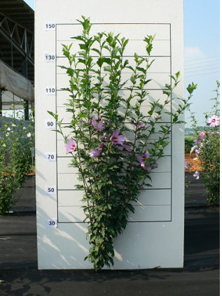 | 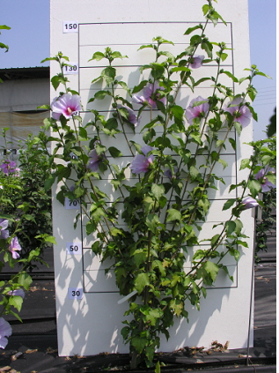 | 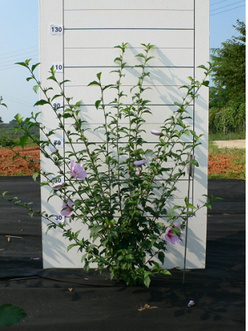 | 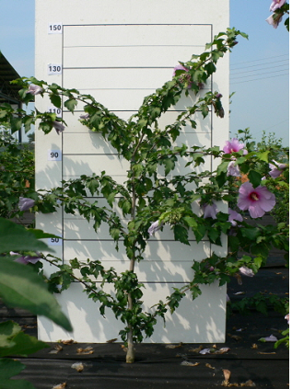
1 | 2 | 3 | 4
upright | semi upright | spreading | drooping

Ad. 4: Current-year branch: color

The color should be observed one month after the first flower has fully opened on the middle third of the current-year branch.

Ad. 8: Leaf blade: ratio length/width

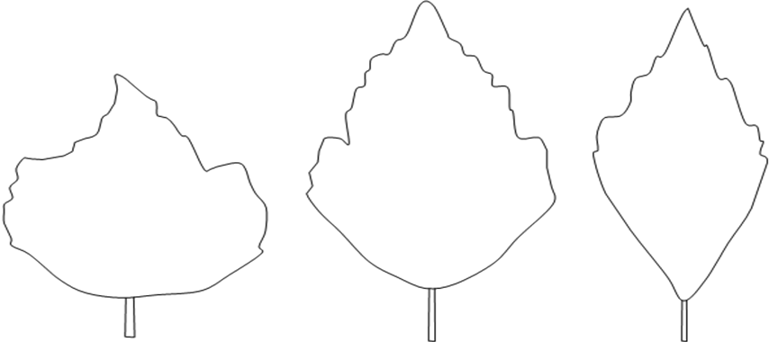
1 | 2 | 3
slightly elongated | moderately elongated | very elongated

Ad. 9: Leaf blade: shape of base

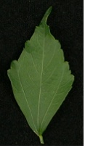 | 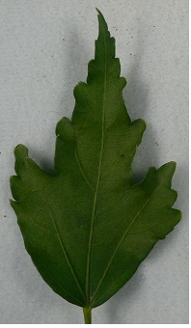 | 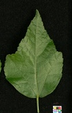
1 | 2 | 3
acute | obtuse | rounded

Ad. 11: Leaf blade: lobing

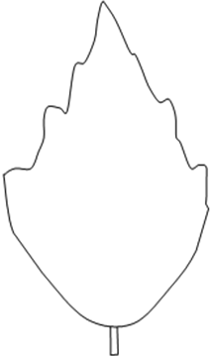 | 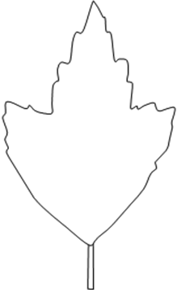 | 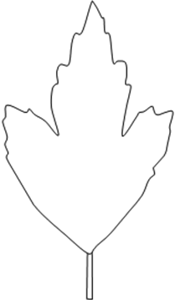 | 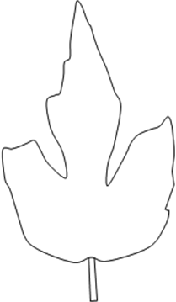
1 | 3 | 5 | 7
absent or  very shallow | shallow | medium | deep

Ad. 12: Leaf blade: undulation

1 | 2 | 3
absent or weak | medium | strong

Ad. 13: Leaf blade: incisions of margins

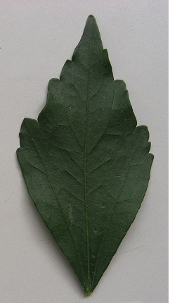 | 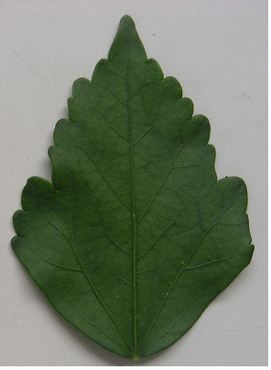 | 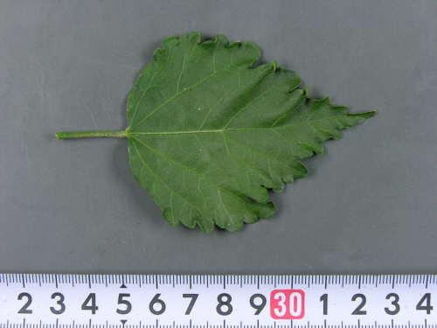
3 | 5 | 7
few | medium | many

Ad. 14: Leaf blade: variegation

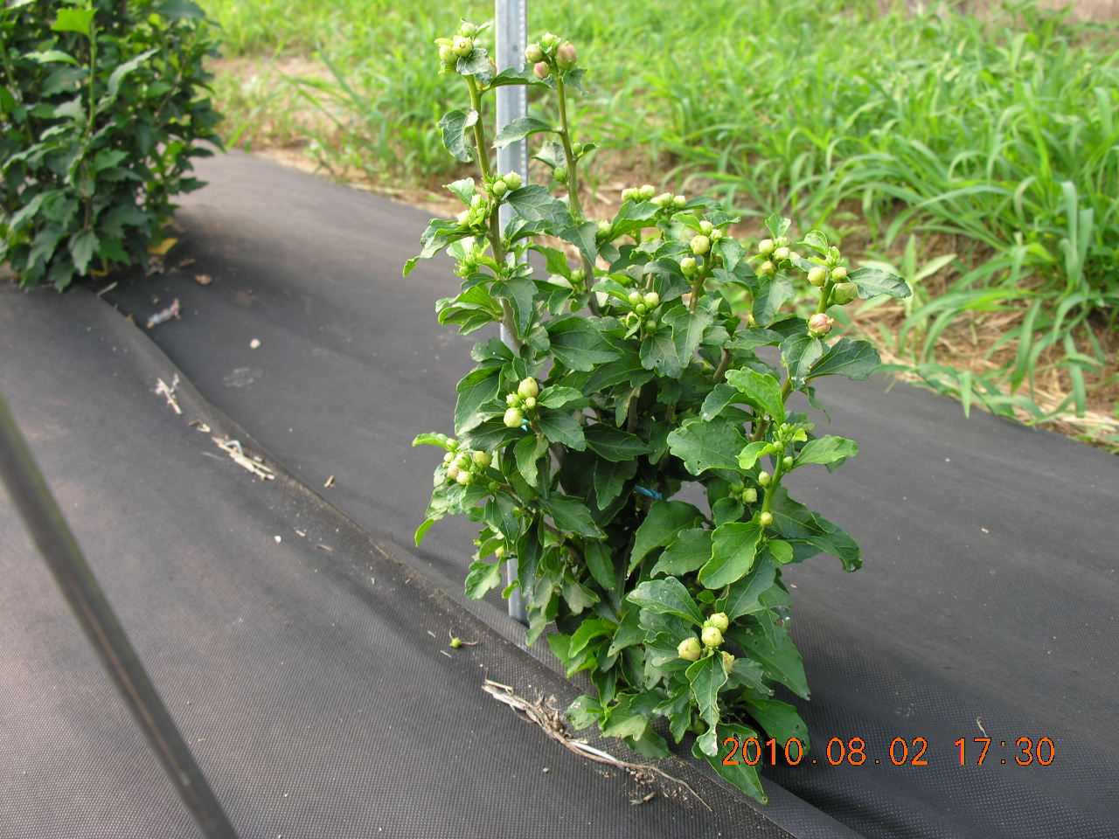 | 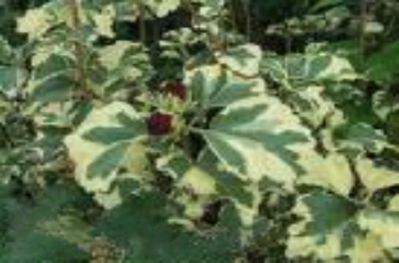
1 | 9
absent | present

Ad. 17: Flower: type

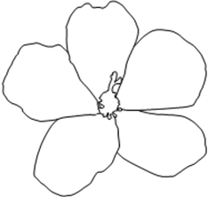 | 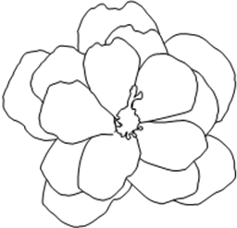 | 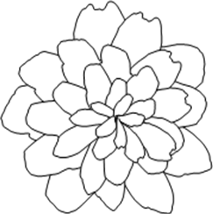
1 | 2 | 3
single | semi-double | double
Single: only 5 petals
Semi-double: some petaloid stamens present
Double: no stamens and no pistil

Ad. 19: Flower: attitude of outermost petals

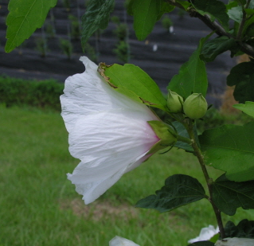 | 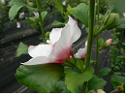 | 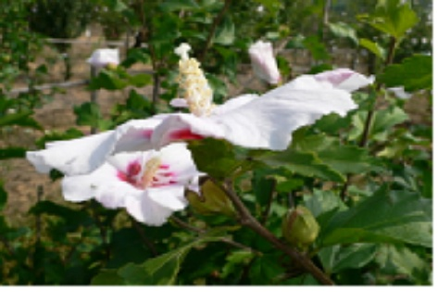
1 | 3 | 5
strongly ascending | moderately ascending | horizontal
Ad. 20: Excluding varieties with flower type: double: Flower: arrangement of outermost petals

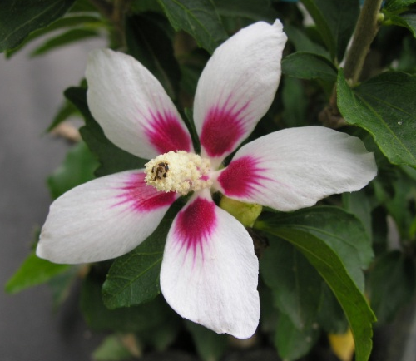 | 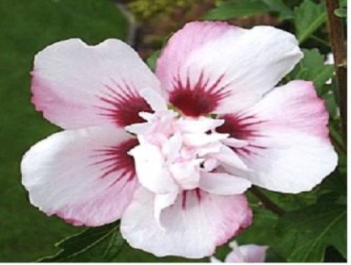 | 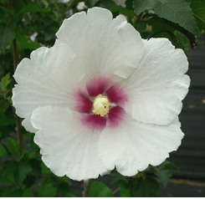
1 | 3 | 5
strongly apart | touching or  slightly overlapping | strongly overlapping

Ad. 22: Flower: eye zone

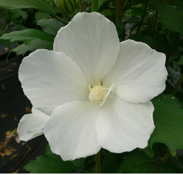 | 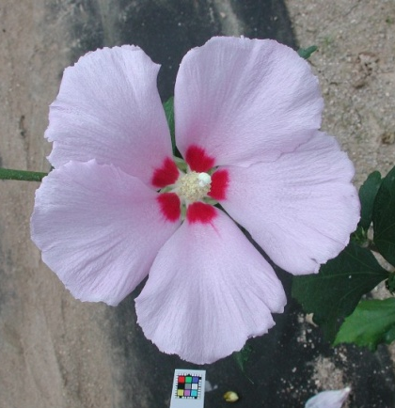
1 | 9
absent | present

Ad. 23: Petal: size of eye zone relative to petal (extensions excluded)

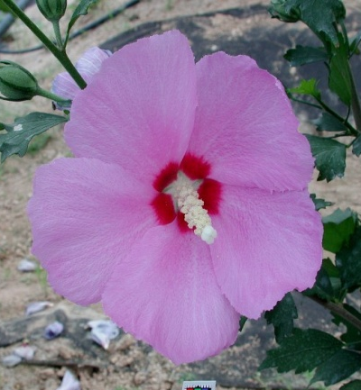 | 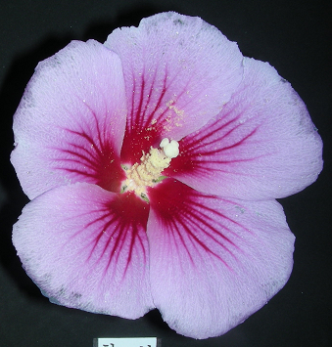 | 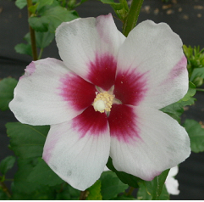
3 | 5 | 7
small | medium | large
Ad. 24: Eye zone: length of extensions
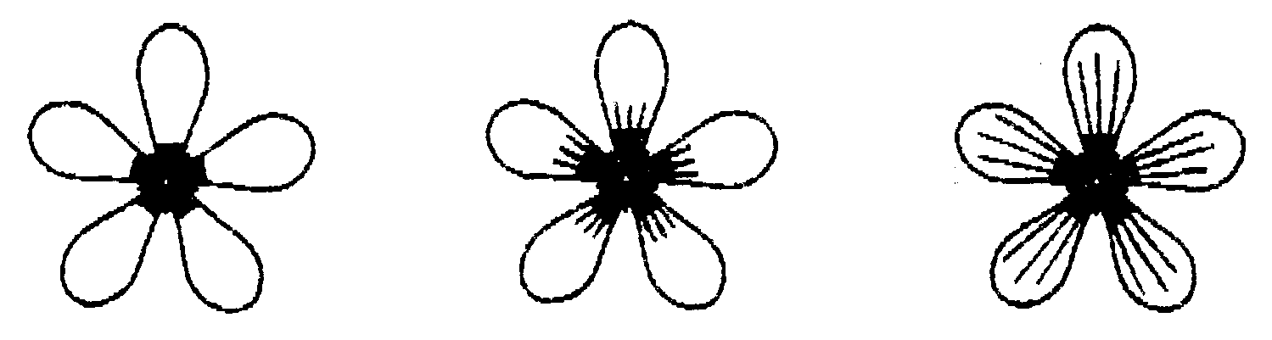
1 | 2 | 4
absent or very short | short | long

Ad. 25: Eye zone: main color

The main color is the color with the largest surface area.

Ad. 28: Petal: shape

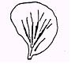
1 | 2 | 3
slightly elongated | moderately elongated | very elongated

Ad. 29: Petal: main color on inner side (eye zone and extensions excluded)
Ad. 30: Petal: secondary color on inner side (eye zone and extensions excluded)

The main color is the color with the largest total surface area the secondary color is the color with the second largest total surface area. If the area of the colors is nearly half and half, the lighter color is the main color.

Ad. 31: Petal: distribution of secondary color (eye zone and extensions excluded)

 | 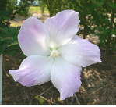 | 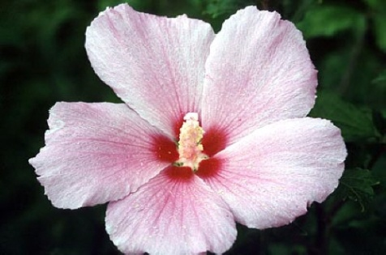
2 | 3 | 4
lateral zone | distal half | throughout

Ad. 32: Petal: incisions

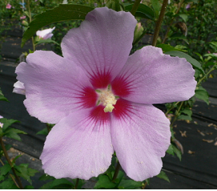 | 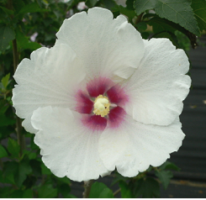 | 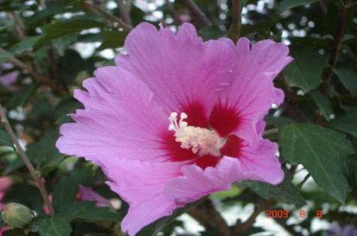
1 | 2 | 3
absent or weak | medium | strong

Ad. 33: Petal: undulation

 | 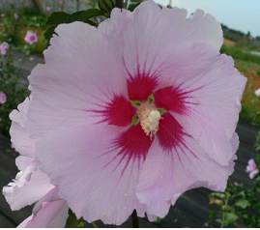 | 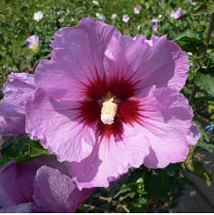
3 | 5 | 7
weak | medium | strong

Ad. 34: Excluding varieties with flower type: double: Staminal column: length

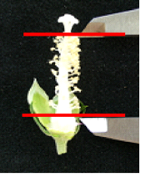

Literature

Hillier, J. and Coombes, A. 2002 The Hillier Manual of Trees and Shrubs. David and Charles, Newton Abbot, UK.

Lawton, B.P. 2004 Hibiscus. Timber Press, Portland, US

Ryu D. Y. 1987: 나라꽃 무궁화, Hakwonsa, Seoul, KR, pp. 177 to 261.

Song W.S. 2004: Hibiscus, Semyoungbook, Seoul, KR, ISBN 89-89097-21-5

Hogan S. 2003: Flora, A Gardener’s Encyclopedia, Vol. 1, Timber Press, Inc., Oregon, US, ISBN 0-88192-538-1, p. 704.

Technical Questionnaire
TECHNICAL QUESTIONNAIRE |  | Page {x} of {y} | Reference Number:
 |  |  | Application date:
 |  |  | (not to be filled in by the applicant)
TECHNICAL QUESTIONNAIRE
to be completed in connection with an application for plant breeders’ rights

1. Subject of the Technical Questionnaire
1.1 Botanical name | Hibiscus syriacus L.
1.2 Common name | Rose of Sharon
2. Applicant
Name
Address
Telephone No.
Fax No.
E-mail address
Breeder (if different from applicant)
3. Proposed denomination and breeder’s reference
Proposed denomination
(if available)

Breeder’s reference
#4. Information on the breeding scheme and propagation of the variety

4.1 Breeding scheme

Variety resulting from:

4.1.1 Crossing

(a) controlled cross [ ]
(please state parent varieties)

(…………………..……………..…) x (……………..…………………..…)
female parent male parent

(b) partially known cross [ ]
(please state known parent variety(ies))

(…………………..……………..…) x (……………..…………………..…)
female parent male parent

(c) unknown cross [ ]

4.1.2 Mutation [ ]
(please state parent variety)

4.1.3 Discovery and development [ ]
(please state where and when discovered and how developed)

4.1.4 Other [ ]
(please provide details)

4.2 Method of propagating the variety

4.2.1 Vegetative propagation

(a) cuttings [ ]

(b) in vitro propagation [ ]

(c) other (state method) [ ]

4.2.2 Seed [ ]

4.2.3 Other [ ]
(please provide details)

(please provide details)”

TECHNICAL QUESTIONNAIRE |  |  | Page {x} of {y} |  | Reference Number:
5. Characteristics of the variety to be indicated (the number in brackets refers to the corresponding characteristic in Test Guidelines; please mark the note which best corresponds).

 | Characteristics |  |  |  |  | Example Varieties |  | Note
5.1  (1) | Plant: growth habit
 | upright |  |  |  |  | Jeonyeongnol |  | 1[ ]
 | semi upright |  |  |  |  | Shichisai |  | 2[ ]
 | spreading |  |  |  |  | Yeonmin |  | 3[ ]
 | drooping |  |  |  |  | Jina |  | 4[ ]
5.2  (2) | Plant: height
 | very short |  |  |  |  |  |  | 1[ ]
 | very short to short |  |  |  |  |  |  | 2[ ]
 | short |  |  |  |  | Antong |  | 3[ ]
 | short to medium |  |  |  |  |  |  | 4[ ]
 | medium |  |  |  |  | Paektanshim |  | 5[ ]
 | medium to tall |  |  |  |  |  |  | 6[ ]
 | tall |  |  |  |  | Shichisai |  | 7[ ]
 | tall to very tall |  |  |  |  |  |  | 8[ ]
 | very tall |  |  |  |  |  |  | 9[ ]
5.3  (14) | Leaf blade: variegation
 | absent |  |  |  |  | Asadal |  | 1[ ]
 | present |  |  |  |  | Purpureus |  | 9[ ]
 | Characteristics |  |  |  |  | Example Varieties |  | Note
5.4  (17) | Flower: type
 | single |  |  |  |  | Asadal |  | 1[ ]
 | semi-double |  |  |  |  | Aka-hanagasa |  | 2[ ]
 | double |  |  |  |  | Pompon Rouge |  | 3[ ]
5.5  (22) | Flower: eye zone
 | absent |  |  |  |  | Paedal |  | 1[ ]
 | present |  |  |  |  | Paektanshim |  | 9[ ]
5.6i  (29) | Petal: main color on inner side (eye zone and extensions excluded)
 | RHS Colour Chart (indicate reference number)
5.6ii  (29) | Petal: main color on inner side (eye zone and extensions excluded)
 | white or whitish |  |  |  |  |  |  | 1[ ]
 | pink |  |  |  |  |  |  | 2[ ]
 | red |  |  |  |  |  |  | 3[ ]
 | purple |  |  |  |  |  |  | 4[ ]
 | violet blue |  |  |  |  |  |  | 5[ ]
 | other |  |  |  |  |  |  | 6[ ]
6. Similar varieties and differences from these varieties

Please use the following table and box for comments to provide information on how your candidate variety differs from the variety (or varieties) which, to the best of your knowledge, is (or are) most similar. This information may help the examination authority to conduct its examination of distinctness in a more efficient way.

Denomination(s) of variety(ies) similar to your candidate variety |  | Characteristic(s) in which your candidate variety differs from the similar variety(ies) |  | Describe the expression of the characteristic(s) for the similar variety(ies) |  |  | Describe the expression of the characteristic(s) for your candidate variety
Example |  | Plant: growth habit |  | upright |  |  | semi upright
Comments:

#7. Additional information which may help in the examination of the variety

7.1 In addition to the information provided in sections 5 and 6, are there any additional characteristics which may help to distinguish the variety?

Yes [ ] No [ ]

(If yes, please provide details)

7.2 Are there any special conditions for growing the variety or conducting the examination?

Yes [ ] No [ ]

(If yes, please provide details)

7.3 Other information

A representative color image of the variety should accompany the Technical Questionnaire.

8. Authorization for release

(a) Does the variety require prior authorization for release under legislation concerning the protection of the environment, human and animal health?

Yes [ ] No [ ]

(b) Has such authorization been obtained?

Yes [ ] No [ ]

If the answer to (b) is yes, please attach a copy of the authorization.

9. Information on plant material to be examined or submitted for examination.

9.1 The expression of a characteristic or several characteristics of a variety may be affected by factors, such as pests and disease, chemical treatment (e.g. growth retardants or pesticides), effects of tissue culture, different rootstocks, scions taken from different growth phases of a tree, etc.

9.2 The plant material should not have undergone any treatment which would affect the expression of the characteristics of the variety, unless the competent authorities allow or request such treatment. If the plant material has undergone such treatment, full details of the treatment must be given. In this respect, please indicate below, to the best of your knowledge, if the plant material to be examined has been subjected to:

(a) Microorganisms (e.g. virus, bacteria, phytoplasma) Yes [ ] No [ ]

(b) Chemical treatment (e.g. growth retardant, pesticide) Yes [ ] No [ ]

(c) Tissue culture Yes [ ] No [ ]

(d) Other factors Yes [ ] No [ ]

Please provide details for where you have indicated “yes”.

……………………………………………………………

10. I hereby declare that, to the best of my knowledge, the information provided in this form is correct:

Applicant’s name

Signature Date

[End of document]

* These names were correct at the time of the introduction of these Test Guidelines but may be revised or updated. [Readers are advised to consult the UPOV Code, which can be found on the UPOV Website (www.upov.int), for the latest information.]
# Authorities may allow certain of this information to be provided in a confidential section of the Technical Questionnaire.
# Authorities may allow certain of this information to be provided in a confidential section of the Technical Questionnaire.

