 |  | E  TG/273/1  ORIGINAL: English  DATE: 2011-10-20
INTERNATIONAL UNION FOR THE PROTECTION OF NEW VARIETIES OF PLANTS
GENEVA

 | ACEROLA  UPOV Code: MALPI_EMA  Malpighia emarginata DC. | *

GUIDELINES

FOR THE CONDUCT OF TESTS

FOR DISTINCTNESS, UNIFORMITY AND STABILITY

^{Alternative Names:}*
Botanical name | English | French | German | Spanish
Malpighia emarginata DC., Malpighia punicifolia auct. non L. | Acerola, Barbados cherry, West Indian-cherry | Cerise de Cayenne, Cerisier de Barbade, Cerisier des Antilles | Barbadoskirsche, Westindische Kirsche | Acerola,  Semeruco

The purpose of these guidelines (“Test Guidelines”) is to elaborate the principles contained in the General Introduction (document TG/1/3), and its associated TGP documents, into detailed practical guidance for the harmonized examination of distinctness, uniformity and stability (DUS) and, in particular, to identify appropriate characteristics for the examination of DUS and production of harmonized variety descriptions.

ASSOCIATED DOCUMENTS

These Test Guidelines should be read in conjunction with the General Introduction and its associated TGP documents.
TABLE OF CONTENTS PAGE

1. Subject of these Test Guidelines 3
2. Material Required 3
3. Method of Examination 3
3.1 Number of Growing Cycles 3
3.2 Testing Place 3
3.3 Conditions for Conducting the Examination 3
3.4 Test Design 4
3.5 Additional Tests 4
4. Assessment of Distinctness, Uniformity and Stability 4
4.1 Distinctness 4
4.2 Uniformity 5
4.3 Stability 5
5. Grouping of Varieties and Organization of the Growing Trial 6
6. Introduction to the Table of Characteristics 6
6.1 Categories of Characteristics 6
6.2 States of Expression and Corresponding Notes 7
6.3 Types of Expression 7
6.4 Example Varieties 7
6.5 Legend 8
7. Table of Characteristics/Tableau des caractères/Merkmalstabelle/Tabla de caracteres 9
8. Explanations on the Table of Characteristics 16
8.1 Explanations covering several characteristics 16
8.2 Explanations for individual characteristics 16
9. Literature 22
10. Technical Questionnaire 23

Subject of these Test Guidelines
These Test Guidelines apply to all varieties of Malpighia emarginata DC..

Material Required
2.1 The competent authorities decide on the quantity and quality of the plant material required for testing the variety and when and where it is to be delivered. Applicants submitting material from a State other than that in which the testing takes place must ensure that all customs formalities and phytosanitary requirements are complied with.

2.2 The material is to be supplied in the form of budsticks with sufficient buds to propagate 5 trees (to be sent at budding time), dormant shoots grafted on a rootstock selected by the testing authority or one-year-old trees grafted on a rootstock selected by the testing authority.

2.3 The minimum quantity of plant material, to be supplied by the applicant, should be:

- 5 budsticks or
- 5 dormant shoots or
- 5 one-year-old trees

2.4 The plant material supplied should be visibly healthy, not lacking in vigor, nor affected by any important pest or disease.

2.5 The plant material should not have undergone any treatment which would affect the expression of the characteristics of the variety, unless the competent authorities allow or request such treatment. If it has been treated, full details of the treatment must be given.

Method of Examination

3.1 Number of Growing Cycles
3.1.1 The minimum duration of tests should normally be two independent growing cycles. In particular, it is essential that the trees produce a satisfactory crop of fruit in each of the two growing cycles.

3.1.2 The growing cycle is considered to be the duration of a single growing season, beginning with bud burst, flowering and fruit harvest and concluding when the following dormant period ends with the swelling of new season buds.

3.2 Testing Place
Tests are normally conducted at one place. In the case of tests conducted at more than one place, guidance is provided in TGP/9 “Examining Distinctness”.

3.3 Conditions for Conducting the Examination
The tests should be carried out under conditions ensuring satisfactory growth for the expression of the relevant characteristics of the variety and for the conduct of the examination. Trees should only be pruned in the year of planting to ensure good branch formation.

3.4 Test Design
3.4.1 Each test should be designed to result in a total of at least 5 trees.

3.4.2 The design of the tests should be such that plants or parts of plants may be removed for measurement or counting without prejudice to the observations which must be made up to the end of the growing cycle.

3.5 Additional Tests
Additional tests, for examining relevant characteristics, may be established.

Assessment of Distinctness, Uniformity and Stability

4.1 Distinctness

4.1.1 General Recommendations
It is of particular importance for users of these Test Guidelines to consult the General Introduction prior to making decisions regarding distinctness. However, the following points are provided for elaboration or emphasis in these Test Guidelines.

4.1.2 Consistent Differences
The differences observed between varieties may be so clear that more than one growing cycle is not necessary. In addition, in some circumstances, the influence of the environment is not such that more than a single growing cycle is required to provide assurance that the differences observed between varieties are sufficiently consistent. One means of ensuring that a difference in a characteristic, observed in a growing trial, is sufficiently consistent is to examine the characteristic in at least two independent growing cycles.

4.1.3 Clear Differences
Determining whether a difference between two varieties is clear depends on many factors, and should consider, in particular, the type of expression of the characteristic being examined, i.e. whether it is expressed in a qualitative, quantitative, or pseudo-qualitative manner. Therefore, it is important that users of these Test Guidelines are familiar with the recommendations contained in the General Introduction prior to making decisions regarding distinctness.

4.1.4 Number of Plants / Parts of Plants to be Examined
Unless otherwise indicated, for the purposes of distinctness, all observations on single plants should be made on 5 plants or parts taken from each of 5 plants and any other observations made on all plants in the test, disregarding any off-type plants. In the case of observations of parts taken from single plants, the number of parts to be taken from each of the plants should be 2.

4.1.5 Method of Observation
The recommended method of observing the characteristic for the purposes of distinctness is indicated by the following key in the second column of the Table of Characteristics (see document TGP/9 “Examining Distinctness”, Section 4 “Observation of characteristics”):

MG: single measurement of a group of plants or parts of plants
MS: measurement of a number of individual plants or parts of plants
VG: visual assessment by a single observation of a group of plants or parts of plants
VS: visual assessment by observation of individual plants or parts of plants

Type of observation: visual (V) or measurement (M)

“Visual” observation (V) is an observation made on the basis of the expert’s judgment. For the purposes of this document, “visual” observation refers to the sensory observations of the experts and, therefore, also includes smell, taste and touch. Visual observation includes observations where the expert uses reference points (e.g. diagrams, example varieties, side-by-side comparison) or non-linear charts (e.g. color charts). Measurement (M) is an objective observation against a calibrated, linear scale e.g. using a ruler, weighing scales, colorimeter, dates, counts, etc.

Type of record: for a group of plants (G) or for single, individual plants (S)

For the purposes of distinctness, observations may be recorded as a single record for a group of plants or parts of plants (G), or may be recorded as records for a number of single, individual plants or parts of plants (S). In most cases, “G” provides a single record per variety and it is not possible or necessary to apply statistical methods in a plant-by-plant analysis for the assessment of distinctness.

In cases where more than one method of observing the characteristic is indicated in the Table of Characteristics (e.g. VG/MG), guidance on selecting an appropriate method is provided in document TGP/9, Section 4.2.

4.2 Uniformity
4.2.1 It is of particular importance for users of these Test Guidelines to consult the General Introduction prior to making decisions regarding uniformity. However, the following points are provided for elaboration or emphasis in these Test Guidelines:

4.2.2 For the assessment of uniformity, a population standard of 1% and an acceptance probability of at least 95% should be applied. In the case of a sample size of 5 plants, no off-types are allowed.

4.3 Stability
4.3.1 In practice, it is not usual to perform tests of stability that produce results as certain as those of the testing of distinctness and uniformity. However, experience has demonstrated that, for many types of variety, when a variety has been shown to be uniform, it can also be considered to be stable.

4.3.2 Where appropriate, or in cases of doubt, stability may be further examined by testing a new plant stock to ensure that it exhibits the same characteristics as those shown by the initial material supplied.

Grouping of Varieties and Organization of the Growing Trial
5.1 The selection of varieties of common knowledge to be grown in the trial with the candidate varieties and the way in which these varieties are divided into groups to facilitate the assessment of distinctness are aided by the use of grouping characteristics.

5.2 Grouping characteristics are those in which the documented states of expression, even where produced at different locations, can be used, either individually or in combination with other such characteristics: (a) to select varieties of common knowledge that can be excluded from the growing trial used for examination of distinctness; and (b) to organize the growing trial so that similar varieties are grouped together.

5.3 The following have been agreed as useful grouping characteristics:

(a) Leaf blade: ratio length/width (characteristic 8)
(b) Petal: intensity of pink color (characteristic 16)
(c) Fruit: ratio length/diameter (characteristic 19)
(d) Fruit: weight (characteristic 20)
(e) Fruit: acidity (characteristic 30)

5.4 Guidance for the use of grouping characteristics, in the process of examining distinctness, is provided through the General Introduction and document TGP/9 “Examining Distinctness”.

Introduction to the Table of Characteristics

6.1 Categories of Characteristics
6.1.1 Standard Test Guidelines Characteristics

Standard Test Guidelines characteristics are those which are approved by UPOV for examination of DUS and from which members of the Union can select those suitable for their particular circumstances.

6.1.2 Asterisked Characteristics

Asterisked characteristics (denoted by *) are those included in the Test Guidelines which are important for the international harmonization of variety descriptions and should always be examined for DUS and included in the variety description by all members of the Union, except when the state of expression of a preceding characteristic or regional environmental conditions render this inappropriate.

6.2 States of Expression and Corresponding Notes
6.2.1 States of expression are given for each characteristic to define the characteristic and to harmonize descriptions. Each state of expression is allocated a corresponding numerical note for ease of recording of data and for the production and exchange of the description.

6.2.2 In the case of qualitative and pseudo-qualitative characteristics (see Chapter 6.3), all relevant states of expression are presented in the characteristic. However, in the case of quantitative characteristics with 5 or more states, an abbreviated scale may be used to minimize the size of the Table of Characteristics. For example, in the case of a quantitative characteristic with 9 states, the presentation of states of expression in the Test Guidelines may be abbreviated as follows:

State | Note
small | 3
medium | 5
large | 7

However, it should be noted that all of the following 9 states of expression exist to describe varieties and should be used as appropriate:

State | Note
very small | 1
very small to small | 2
small | 3
small to medium | 4
medium | 5
medium to large | 6
large | 7
large to very large | 8
very large | 9

6.2.3 Further explanation of the presentation of states of expression and notes is provided in document TGP/7 “Development of Test Guidelines”.

6.3 Types of Expression
An explanation of the types of expression of characteristics (qualitative, quantitative and pseudo-qualitative) is provided in the General Introduction.

6.4 Example Varieties
Where appropriate, example varieties are provided to clarify the states of expression of each characteristic.

6.5 Legend

(*) Asterisked characteristic – see Chapter 6.1.2

QL Qualitative characteristic – see Chapter 6.3
QN Quantitative characteristic – see Chapter 6.3
PQ Pseudo-qualitative characteristic – see Chapter 6.3

MG, MS, VG, VS – see Chapter 4.1.5

(a)-(d) See Explanations on the Table of Characteristics in Chapter 8.1
(+) See Explanations on the Table of Characteristics in Chapter 8.2

Table of Characteristics/Tableau des caractères/Merkmalstabelle/Tabla de caracteres
 |  | English | français | deutsch | español | Example Varieties/  Exemples/  Beispielssorten/  Variedades ejemplo | Note/  Nota
1.  (*)  (+) | VG | Plant: growth habit | Plante : port | Pflanze: Wuchsform | Planta: porte
PQ | (a) | upright | dressé | aufrecht | erguido | Maunawili | 1
 |  | spreading | étalé | breitwüchsig | extendido | Hawaiian Queen, Rubra | 2
 |  | drooping | retombant | überhängend | colgante | Cabocla, Sertaneja | 3
2.  (+) | VG | Plant: vigor | Plante : vigueur | Pflanze: Wuchsstärke | Planta: vigor
QN | (a) | weak | faible | gering | débil |  | 3
 |  | medium | moyenne | mittel | medio | Tropical Ruby | 5
 |  | strong | forte | stark | fuerte | Maunawili | 7
3.  (*) | VG | Plant: density of branches | Plante : densité des ramifications | Pflanze: Dichte der Verzweigung | Planta: densidad de las ramas
QN | (a) | sparse | lâche | locker | baja |  | 3
 |  | medium | moyenne | mittel | media | Cabocla, Maunawili, Rubra | 5
 |  | dense | dense | dicht | alta | Tropical ruby | 7
4.  (*) | MS/VG | One-year-old shoot: length of internode | Rameau d’un an : longueur de l’entre-noeud | Einjähriger Trieb: Länge des Internodiums | Rama de un año: longitud del internudo
QN | (a) | short | court | kurz | corto | Tropical ruby | 3
 |  | medium | moyen | mittel | mediano | Maunawili | 5
 |  | long | long | lang | largo |  | 7
5.  (*) | MS/VG | One-year-old shoot: thickness | Rameau d’un an : épaisseur | Einjähriger Trieb: Dicke | Rama de un año: grosor
QN | (a) | thin | mince | dünn | delgado | Hawaiian Queen | 3
 |  | medium | moyen | mittel | medio | Maunawili | 5
 |  | thick | épais | dick | grueso | Tropical ruby | 7
6. | VG | Young shoot: pubescence | Jeune rameau : pilosité | Jungtrieb: Behaarung | Rama joven: pubescencia
QN | (a) | sparse | faible | locker | dispersa | Maunawili | 1
 |  | medium | moyenne | mittel | media | Hawaiian Queen | 2
 |  | dense | forte | dicht | densa |  | 3
7.  (*)  (+) | MS/VG | Leaf blade: length | Limbe : longueur | Blattspreite: Länge | Limbo: longitud
QN | (b) | short | court | kurz | corto |  | 3
 |  | medium | moyen | mittel | mediano | Tropical Ruby | 5
 |  | long | long | lang | largo | Maunawili | 7
8.  (*)  (+) | MS/VG | Leaf blade: ratio length/width | Limbe : rapport longueur/largeur | Blattspreite: Verhältnis Länge/Breite | Limbo: relación longitud/anchura
QN | (b) | moderately elongated | modérément allongé | mäßig langgezogen | moderadamente alargado | Maunawili | 3
 |  | medium | moyen | mittel | medio | Hawaiian Queen | 5
 |  | moderately compressed | modérément compressé | mäßig zusammengedrückt | moderadamente comprimido |  | 7
9.  (*)  (+) | VG | Leaf blade: position of broadest part | Limbe : position de la partie la plus large | Blattspreite: Position der breitesten Stelle | Limbo: posición de la parte más ancha
QN | (b) | toward base | vers la base | zur Basis hin | hacia la base |  | 1
 |  | at middle | au milieu | in der Mitte | en el medio | Maunawili | 2
 |  | toward apex | vers le sommet | zur Spitze hin | hacia el ápice |  | 3
10.  (*)  (+) | VG | Leaf blade: undulation of margin | Limbe : ondulation du bord | Blattspreite: Randwellung | Limbo: ondulación del margen
QN | (b) | weak | faible | gering | débil | Okinawa | 1
 |  | medium | moyenne | mittel | media | Cabocla, Sertaneja | 3
 |  | strong | forte | stark | fuerte |  | 5
11.  (+) | VG | Leaf blade: shape of apex | Limbe : forme du sommet | Blattspreite: Form der Spitze | Limbo: forma del ápice
PQ | (b) | acute | aigu | spitz | agudo | Maunawili | 1
 |  | obtuse | obtus | stumpf | obtuso | Hawaiian Queen | 2
 |  | rounded | arrondi | abgerunded | redondeado |  | 3
12.  (*) | VG | Leaf blade: intensity of green color on upper side | Limbe : intensité de la couleur verte sur la face supérieure | Blattspreite: Intensität der Grünfärbung der Oberseite | Limbo: intensidad del color verde de la cara superior
QN | (b) | light | claire | hell | claro | Flor Branca | 1
 |  | medium | moyenne | mittel | medio | Cabocla | 3
 |  | dark | foncée | dunkel | oscuro | Maunawili, Rubra | 5
13.  (*) | VG | Flower: position of stigma in relation to anthers | Fleur : position du stigmate par rapport aux étamines | Blüte: Stellung der Narbe im Vergleich zu den Antheren | Flor: posición del estigma en relación con las anteras
QN | (c) | below | au-dessous | unterhalb | por debajo |  | 1
 |  | same level | au même niveau | auf gleicher Höhe | al mismo nivel | Cabocla, Rubra | 2
 |  | above | au-dessus | oberhalb | por encima |  | 3
14.  (+) | VG | Flower: curvature of style | Fleur : courbure du style | Blüte: Biegung des Griffels | Flor: curvatura del estilo
QN | (c) | straight | nulle | gerade | recto | Sanmi-kei | 1
 |  | slightly curved | légère | schwach gebogen | ligeramente curvado | Okinawa | 2
 |  | strongly curved | forte | stark gebogen | muy curvado | NRA309 | 3
15.  (+) | VG | Petal: undulation of margin | Pétale : ondulation du bord | Blütenblatt: Randwellung | Pétalo: ondulación del margen
QN | (c) | weak | faible | gering | débil |  | 1
 |  | medium | moyenne | mittel | media |  | 3
 |  | strong | forte | stark | fuerte | Hawaiian Queen | 5
16.  (*) | VG | Petal: intensity of pink color | Pétale : intensité de la couleur rose | Blütenblatt: Intensität der Rosafärbung | Pétalo: intensidad del color rosa
QN | (c) | light | claire | hell | claro |  | 1
 |  | medium | moyenne | mittel | medio | Manuawili | 2
 |  | dark | foncée | dunkel | oscuro | Hawaiian Queen | 3
17.  (*)  (+) | MS/VG | Fruit: length | Fruit : longueur | Frucht: Länge | Fruto: longitud
QN | (a) | short | court | kurz | corto | Flor blanca | 3
 |  | medium | moyen | mittel | medio | Hawaiian Queen | 5
 |  | long | long | lang | largo | Red Jumbo | 7
18.  (*)  (+) | MS/VG | Fruit: diameter | Fruit : diamètre | Frucht: Durchmesser | Fruto: diámetro
QN | (a) | small | petit | klein | pequeño | Sertaneja | 3
 |  | medium | moyen | mittel | mediano | Rubra | 5
 |  | large | grand | groß | grande | Cabocla | 7
19.  (*)  (+) | MS/VG | Fruit: ratio length/diameter | Fruit : rapport longueur/diamètre | Frucht: Verhältnis Länge/Durchmesser | Fruto: relación longitud/diámetro
QN | (a) | elongated | allongé | langgezogen | alargado | Maunawili | 1
 |  | medium | moyen | mittel | medio |  | 2
 |  | compressed | compressé | zusammengedrückt | comprimido |  | 3
20.  (*)  (+) | MG | Fruit: weight | Fruit : poids | Frucht: Gewicht | Fruto: peso
QN | (a) | low | petit | gering | ligero | Maunawili, Sertaneja | 3
 |  | medium | moyen | mittel | medio | Hawaiian Queen, Rubra | 5
 |  | high | élevé | hoch | pesado | Cabocla, C.F.Rehnborg | 7
21.  (*)  (+) | VG | Fruit: shape | Fruit : forme | Frucht: Form | Fruto: forma
PQ | (a) | oblong | oblong | rechteckig | oblonga |  | 1
 |  | circular | rond | kreisförmig | circular | Maunawili | 2
 |  | oblate | aplati | breitrund | achatada | Hawaiian Queen | 3
 |  | ovate | ovale | eiförmig | ovado | Tropical Ruby | 4
22.  (*)  (+) | VG | Fruit: depth of grooves | Fruit : profondeur des cannelures | Frucht: Tiefe der Furchen | Fruto: profundidad de los surcos
QN | (a) | shallow | peu profondes | flach | poco profundos | Maunawili, Rubra | 1
 |  | medium | moyennement profondes | mittel | media | Cereja, Olivier | 2
 |  | deep | profondes | tief | profundos | Cabocla | 3
23.  (*)  (+) | VG | Fruit: depth of basin | Fruit : profondeur de la cuvette | Frucht: Tiefe der Grube | Fruto: profundidad de la cavidad
QN | (a) | shallow | peu profonde | flach | poco profunda | Maunawili | 1
 |  | medium | moyennement profonde | mittel | media | Tropical Ruby | 2
 |  | deep | profonde | tief | profunda |  | 3
24.  (*)  (+) | VG | Fruit: width of basin | Fruit : largeur de la cuvette | Frucht: Breite der Grube | Fruto: anchura de la cavidad
QN | (a) | narrow | étroite | schmal | estrecha | Maunawili | 1
 |  | medium | moyenne | mittel | media | Tropical Ruby | 2
 |  | broad | large | breit | ancha | Hawaiian Queen | 3
25.  (*)  (+) | VG | Fruit: depth of stalk cavity | Fruit : profondeur de la dépression pédonculaire | Frucht: Tiefe der Stielhöhle | Fruto: profundidad de la cavidad peduncular
QN | (a) | shallow | peu profonde | flach | poco profunda | Maunawili | 1
 |  | medium | moyennement profonde | mittel | media |  | 2
 |  | deep | profonde | tief | profunda | Hawaiian Queen | 3
26.  (*)  (+) | MS/VG | Fruit: length of stalk | Fruit : longueur du pédoncule | Frucht: Länge des Stiels | Fruto: longitud del pedúnculo
QN | (a) | short | court | kurz | corto | Maunawili | 3
 |  | medium | moyen | mittel | medio | Hawaiian Queen | 5
 |  | long | long | lang | largo | Red Jumbo | 7
27.  (*)  (+) | VG | Fruit: width of stalk cavity | Fruit : largeur de la dépression pédonculaire | Frucht: Breite der Stielhöhle | Fruto: anchura de la cavidad peduncular
QN | (a) | narrow | étroite | schmal | estrecha |  | 3
 |  | medium | moyenne | mittel | media | Maunawili | 5
 |  | broad | large | breit | ancha | Hawaiian Queen | 7
28.  (*) | VG | Fruit: main color of skin | Fruit : couleur principale de la peau | Frucht: Hauptfarbe der Schale | Fruto: color principal de la piel
PQ | (a) | yellow | jaune | gelb | amarillo | CMF025 | 1
 |  | light red | rouge clair | hellrot | rojo claro |  | 2
 |  | medium red | rouge moyen | mittelrot | rojo medio | Cabocla, Rubra | 3
 |  | dark red | rouge foncé | dunkelrot | rojo oscuro | Maunawili | 4
29.  (*) | VG | Fruit: color of flesh | Fruit : couleur de la chair | Frucht: Farbe des Fleisches | Fruto: color de la pulpa
PQ | (a) | yellow | jaune | gelb | amarillo | Red Jumbo | 1
 |  | orange | orange | orange | anaranjado | Cabocla | 2
 |  | pink | rose | rosa | rosa | Maunawili | 3
 |  | red | rouge | rot | rojo | C.F.Rehnborg | 4
30.  (*)  (+) | MG | Fruit: acidity | Fruit : acidité | Frucht: Säure | Fruto: acidez
QN | (a) | low | faible | gering | baja | Rubra | 3
 |  | medium | moyenne | mittel | media | Cabocla, Maunawili | 5
 |  | high | forte | hoch | alta | Sertaneja | 7
31.  (*) | VG | Fruit: juiciness | Fruit : succulence | Frucht: Saftigkeit | Fruto: jugosidad
QN | (a) | low | faible | gering | baja | Florida Sweet, Red Jumbo | 1
 |  | medium | moyenne | mittel | media | Maunawili | 3
 |  | high | forte | hoch | alta | Cabocla | 5
32.  (*) | VG | Stone: size | Noyau :taille | Stein: Größe | Hueso: tamaño
QN | (a) | small | petit | klein | pequeño | Sertaneja | 1
 |  | medium | moyen | mittel | medio | Cabocla, Okinawa | 3
 |  | large | gros | groß | grande | Rubra | 5
37. | VG | Stone: intensity of brown color | Noyau : intensité de la couleur brune | Stein: Intensität der Braunfärbung | Hueso: intensidad del color marrón
QN | (a) | light | claire | hell | claro | Maunawili | 1
 |  | medium | moyenne | mittel | medio | Tropical Ruby | 2
 |  | dark | foncée | dunkel | oscuro |  | 3

Explanations on the Table of Characteristics

8.1 Explanations covering several characteristics
Characteristics containing the following key in the second column of the Table of Characteristics should be examined as indicated below:

(a) Observations should be made at physiological ripeness, when the color change of the fruit is complete.
(b) Leaf blade: All observations on the leaf blade should be made on fully developed leaves. Leaves should be taken from the middle third of one-year-old shoot.
(c) Flower: All observations on the flower should be made within the day its flower bloomed.

8.2 Explanations for individual characteristics

Ad. 1: Plant: growth habit

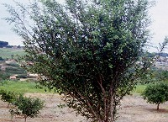 | 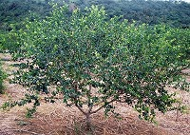 | 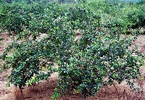
1 | 2 | 3
upright | spreading | drooping

Ad. 2: Plant: vigor

The vigor of the plant should be considered as the overall abundance of vegetative growth.

Ad. 7: Leaf blade: length
Ad. 8: Leaf blade: ratio length/width

length
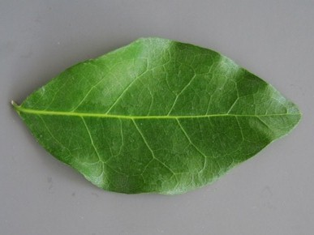
width

Ad. 8: Leaf blade: ratio length/width

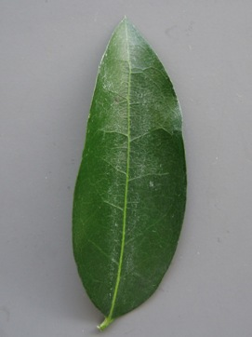 | 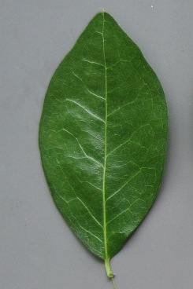 | 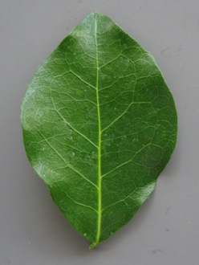
3 | 5 | 7
moderately elongated | medium | moderately compressed

Ad. 9: Leaf blade: position of broadest part

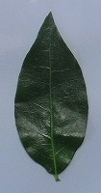 | 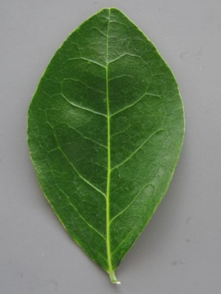 | 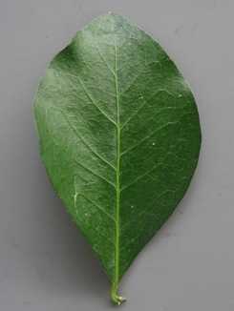
1 | 2 | 3
toward base | at middle | toward apex

Ad. 10: Leaf blade: undulation of margin

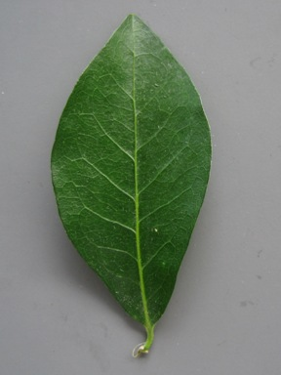 | 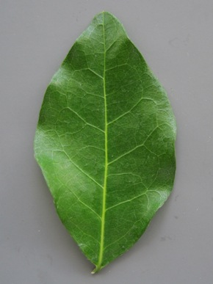 | 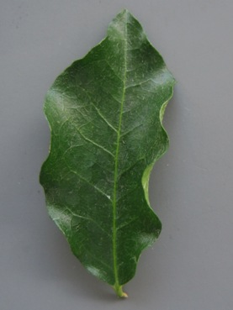
1 | 3 | 5
weak | medium | strong

Ad. 11: Leaf blade: shape of apex

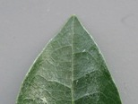 | 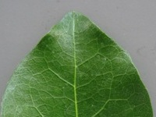 | 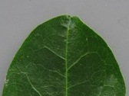
1 | 2 | 3
acute | obtuse | rounded

Ad. 14: Flower: curvature of style

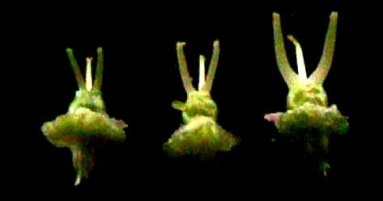
1 | 2 | 3
straight | slightly curved | strongly curved

Ad. 15: Petal: undulation of margin

The largest petal should be excluded from the observation of the undulation of margin: the largest petal is circled in the following images.

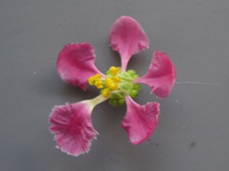 | 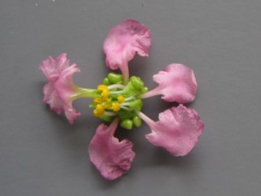 | 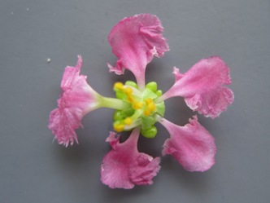
1 | 3 | 5
weak | medium | strong

Ad. 17: Fruit: length
Ad. 18: Fruit: diameter

diameter
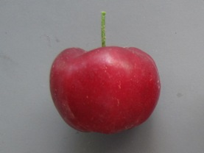 length

Ad. 19: Fruit: ratio length/diameter

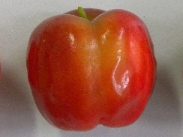 | 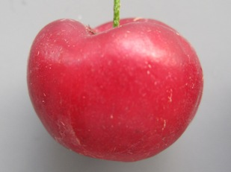 | 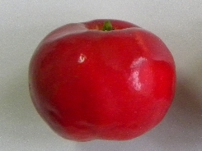
1 | 2 | 3
elongated | medium | compressed

Ad. 20: Fruit: weight

The weight of 10 fruits should be observed.

Ad. 21: Fruit: shape

 |  | ← broadest part →
 |  | (below middle) | at middle

broad (compressed) ← width (ratio length/width) → narrow (elongated) |  | 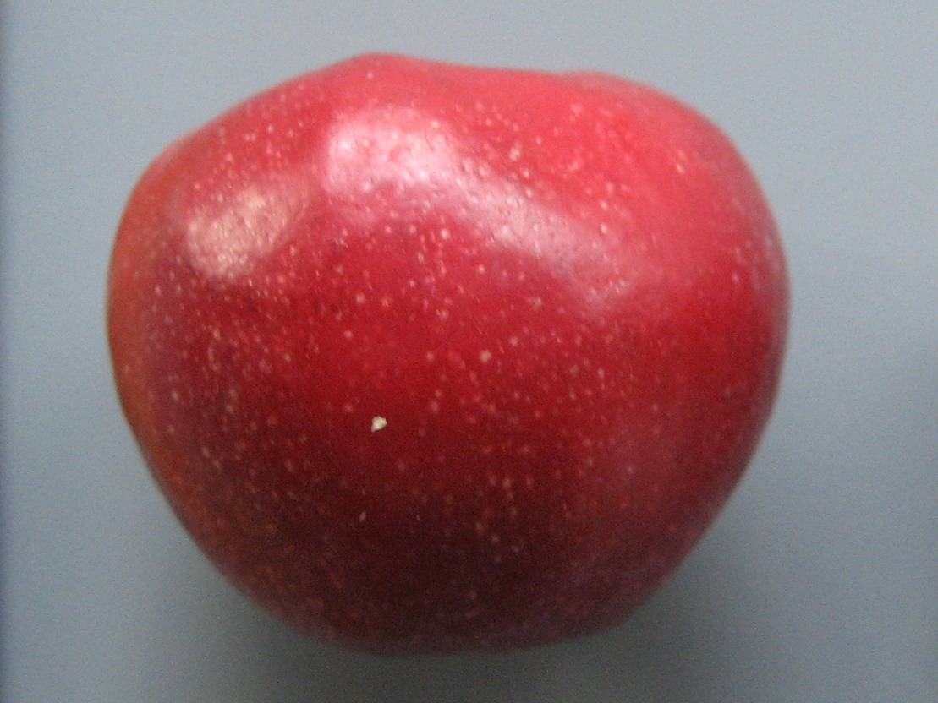  4  ovate | 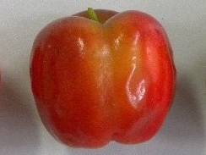  1  oblong  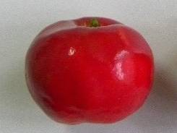  3  oblate | 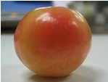  2  circular

* The base is the end nearest to the stalk: however, the photographs were taken with the stalk (base) uppermost.

Ad. 22: Fruit: depth of grooves

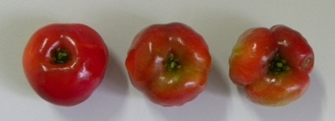

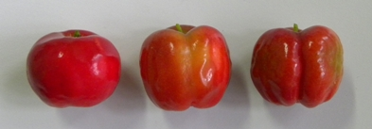
1 | 2 | 3
shallow | medium | deep
Ad. 23: Fruit: depth of basin
Ad. 24: Fruit: width of basin
Ad. 25: Fruit: depth of stalk cavity
Ad. 26: Fruit: length of stalk
Ad. 27: Fruit: width of stalk cavity

width of stalk cavity

depth of stalk cavity length of stalk
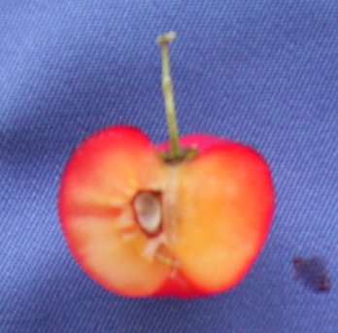 depth of basin

width of basin

Ad. 30: Fruit: acidity

The acidity should be measured with a pH meter.

Literature
Asenjo, C.F., 1980: Tropical and subtropical fruits. Eds. Nagay, S., and P. E. Shaw. AVI publishing. Connecticut, US, pp. 341 to 374

Munsell, H. E. et al., 1950: Composition of food plants of Central America. III. Guatemala. Food Res. 15: 34-52.

Chowdhury, A. K., Yonemoto, Y., Kato, H., Malid Macha, M. M., 2005: Classification of some acerola (Malpighia glabra Linn.) cultivars using morphometric descriptors and RAPD markers. J. Trop. Agr. 49: 255-263.

Nakasone, H. Y., Paul, R. E., 1998: Acerola. Tropical Fruits. CAB International l. pp. 377 to 378

Vivaldi, J. L., 1984: New taxa of Malpighia from Mexico and West Indies

Silva de Freitas, C. A. et al., 2006: Acerola: Production, Composition, Nutritional Aspext and Products. R. Bras. Agrociencia, 12(4): 395-400.

Ishihata, Kiyotake et al., 2000: Acerola, Tropical fruit, The enciclopedia of fruit horticulture, v.17, JP, pp.1 to 15

Ishihata, K. 2001: The new production technique of tropical and sub-tropical fruits: 18, 19, 20, Agriculture and Horticulture, v. 76: Yokendo Ltd., JP, pp. 715 to 721, pp. 829 to 831, pp. 933 to 934

Technical Questionnaire
TECHNICAL QUESTIONNAIRE |  |  |  | Page {x} of {y} |  | Reference Number:
 |  |  |  |  |  | Application date:
 |  |  |  |  |  | (not to be filled in by the applicant)
TECHNICAL QUESTIONNAIRE
to be completed in connection with an application for plant breeders’ rights

1. Subject of the Technical Questionnaire
1.1 Botanical name |  |  | Malpighia emarginata DC.
1.2 Common name |  |  | Acerola
2. Applicant
Name
Address
Telephone No.
Fax No.
E-mail address
Breeder (if different from applicant)
3. Proposed denomination and breeder’s reference
Proposed denomination
(if available)

Breeder’s reference
#4. Information on the breeding scheme and propagation of the variety

4.1 Breeding scheme

Variety resulting from:

4.1.1 Crossing

(a) controlled cross [ ]
(please state parent varieties)

(…………………..……………..…) x (……………..…………………..…)
female parent male parent

(b) partially known cross [ ]
(please state known parent variety(ies))

(…………………..……………..…) x (……………..…………………..…)
female parent male parent

4.1.2 Mutation [ ]
(please state parent variety)

4.1.3 Discovery and development [ ]
(please state where and when discovered and how developed)

4.1.4 Other [ ]
(please provide details)

4.2 Method of propagating the variety

4.2.1 Vegetative propagation

(a) cuttings [ ]

(b) in vitro propagation [ ]

(c) other (state method) [ ]

4.2.2 Seed [ ]

4.2.3 Other [ ]
(please provide details)

5. Characteristics of the variety to be indicated (the number in brackets refers to the corresponding characteristic in Test Guidelines; please mark the note which best corresponds).

 | Characteristics |  |  |  |  |  | Example Varieties |  |  | Note
5.1  (8) | Leaf blade: ratio length/width
 | very elongated |  |  |  |  |  |  |  |  | 1[ ]
 | very elongated to moderately elongated |  |  |  |  |  |  |  |  | 2[ ]
 | moderately elongated |  |  |  |  |  | Maunawili |  |  | 3[ ]
 | moderately elongated to medium |  |  |  |  |  |  |  |  | 4[ ]
 | medium |  |  |  |  |  | Hawaiian Queen |  |  | 5[ ]
 | medium to moderately compressed |  |  |  |  |  |  |  |  | 6[ ]
 | moderately compressed |  |  |  |  |  |  |  |  | 7[ ]
 | moderately compressed to very compressed |  |  |  |  |  |  |  |  | 8[ ]
 | very compressed |  |  |  |  |  |  |  |  | 9[ ]
5.2  (16) | Petal: intensity of pink color
 | light |  |  |  |  |  |  |  |  | 1[ ]
 | medium |  |  |  |  |  | Manuawili |  |  | 2[ ]
 | dark |  |  |  |  |  | Hawaiian Queen |  |  | 3[ ]
5.3  (19) | Fruit: ratio length/diameter
 | elongated |  |  |  |  |  | Maunawili |  |  | 1[ ]
 | medium |  |  |  |  |  |  |  |  | 2[ ]
 | compressed |  |  |  |  |  |  |  |  | 3[ ]
 | Characteristics |  |  |  |  |  | Example Varieties |  |  | Note
5.4  (20) | Fruit: weight
 | very low |  |  |  |  |  |  |  |  | 1[ ]
 | very low to low |  |  |  |  |  |  |  |  | 2[ ]
 | low |  |  |  |  |  | Maunawili, Sertaneja |  |  | 3[ ]
 | low to medium |  |  |  |  |  |  |  |  | 4[ ]
 | medium |  |  |  |  |  | Hawaiian Queen, Rubra |  |  | 5[ ]
 | medium to high |  |  |  |  |  |  |  |  | 6[ ]
 | high |  |  |  |  |  | Cabocla, C.F.Rehnborg |  |  | 7[ ]
 | high to very high |  |  |  |  |  |  |  |  | 8[ ]
 | very high |  |  |  |  |  |  |  |  | 9[ ]
5.5  (30) | Fruit: acidity
 | very low |  |  |  |  |  |  |  |  | 1[ ]
 | very low to low |  |  |  |  |  |  |  |  | 2[ ]
 | low |  |  |  |  |  | Rubra |  |  | 3[ ]
 | low to medium |  |  |  |  |  |  |  |  | 4[ ]
 | medium |  |  |  |  |  | Cabocla, Maunawili |  |  | 5[ ]
 | medium to high |  |  |  |  |  |  |  |  | 6[ ]
 | high |  |  |  |  |  | Sertaneja |  |  | 7[ ]
 | high to very high |  |  |  |  |  |  |  |  | 8[ ]
 | very high |  |  |  |  |  |  |  |  | 9[ ]
6. Similar varieties and differences from these varieties

Please use the following table and box for comments to provide information on how your candidate variety differs from the variety (or varieties) which, to the best of your knowledge, is (or are) most similar. This information may help the examination authority to conduct its examination of distinctness in a more efficient way.

Denomination(s) of variety(ies) similar to your candidate variety |  | Characteristic(s) in which your candidate variety differs from the similar variety(ies) |  |  | Describe the expression of the characteristic(s) for the similar variety(ies) |  |  | Describe the expression of the characteristic(s) for your candidate variety
Example |  | Fruit color |  |  | light red |  |  | medium red
Comments:

#7. Additional information which may help in the examination of the variety

7.1 In addition to the information provided in sections 5 and 6, are there any additional characteristics which may help to distinguish the variety?

Yes [ ] No [ ]

(If yes, please provide details)

7.2 Are there any special conditions for growing the variety or conducting the examination?

Yes [ ] No [ ]

(If yes, please provide details)

7.3 What is this variety used for?

Fruit [ ] Ornamental [ ]

7.4 Other information

A representative color image of the variety should accompany the Technical Questionnaire.

8. Authorization for release

(a) Does the variety require prior authorization for release under legislation concerning the protection of the environment, human and animal health?

Yes [ ] No [ ]

(b) Has such authorization been obtained?

Yes [ ] No [ ]

If the answer to (b) is yes, please attach a copy of the authorization.

9. Information on plant material to be examined or submitted for examination.

9.1 The expression of a characteristic or several characteristics of a variety may be affected by factors, such as pests and disease, chemical treatment (e.g. growth retardants or pesticides), effects of tissue culture, different rootstocks, scions taken from different growth phases of a tree, etc.

9.2 The plant material should not have undergone any treatment which would affect the expression of the characteristics of the variety, unless the competent authorities allow or request such treatment. If the plant material has undergone such treatment, full details of the treatment must be given. In this respect, please indicate below, to the best of your knowledge, if the plant material to be examined has been subjected to:

(a) Microorganisms (e.g. virus, bacteria, phytoplasma) Yes [ ] No [ ]

(b) Chemical treatment (e.g. growth retardant, pesticide) Yes [ ] No [ ]

(c) Tissue culture Yes [ ] No [ ]

(d) Other factors Yes [ ] No [ ]

Please provide details for where you have indicated “yes”.

……………………………………………………………

10. I hereby declare that, to the best of my knowledge, the information provided in this form is correct:

Applicant’s name

Signature Date

[End of document]

* These names were correct at the time of the introduction of these Test Guidelines but may be revised or updated. [Readers are advised to consult the UPOV Code, which can be found on the UPOV Website (www.upov.int), for the latest information.]
# Authorities may allow certain of this information to be provided in a confidential section of the Technical Questionnaire.
# Authorities may allow certain of this information to be provided in a confidential section of the Technical Questionnaire.

