 |  | E  TG/272/1  ORIGINAL: English  DATE: 2011-10-20
INTERNATIONAL UNION FOR THE PROTECTION OF NEW VARIETIES OF PLANTS
GENEVA

 | TORENIA  UPOV Code: TOREN  Torenia L. | *

GUIDELINES

FOR THE CONDUCT OF TESTS

FOR DISTINCTNESS, UNIFORMITY AND STABILITY

Alternative Names:*

Botanical name | English | French | German | Spanish
Torenia L. | Torenia, Bluewings,  Wishbone-flower | Torenia | Torenie | Torenia,  Legazpia blanco

The purpose of these guidelines (“Test Guidelines”) is to elaborate the principles contained in the General Introduction (document TG/1/3), and its associated TGP documents, into detailed practical guidance for the harmonized examination of distinctness, uniformity and stability (DUS) and, in particular, to identify appropriate characteristics for the examination of DUS and production of harmonized variety descriptions.

ASSOCIATED DOCUMENTS

These Test Guidelines should be read in conjunction with the General Introduction and its associated TGP documents.

TABLE OF CONTENTS PAGE

1. Subject of these Test Guidelines 3
2. Material Required 3
3. Method of Examination 3
3.1 Number of Growing Cycles 3
3.2 Testing Place 3
3.3 Conditions for Conducting the Examination 3
3.4 Test Design 4
3.5 Additional Tests 4
4. Assessment of Distinctness, Uniformity and Stability 4
4.1 Distinctness 4
4.2 Uniformity 5
4.3 Stability 6
5. Grouping of Varieties and Organization of the Growing Trial 6
6. Introduction to the Table of Characteristics 7
6.1 Categories of Characteristics 7
6.2 States of Expression and Corresponding Notes 8
6.3 Types of Expression 8
6.4 Example Varieties 8
6.5 Legend 9
7. Table of Characteristics/Tableau des Caractères/Merkmalstabelle/ Tabla de caracteres 10
8. Explanations on the Table of Characteristics 15
8.1 Explanations covering several characteristics 15
8.2 Explanations for individual characteristics 15
9. Literature 20
10. Technical Questionnaire 21

Subject of these Test Guidelines
These Test Guidelines apply to all varieties of Torenia L.

Material Required
2.1 The competent authorities decide on the quantity and quality of the plant material required for testing the variety and when and where it is to be delivered. Applicants submitting material from a State other than that in which the testing takes place must ensure that all customs formalities and phytosanitary requirements are complied with.

2.2 The material is to be supplied in the form of seed or rooted cuttings.

2.3 The minimum quantity of plant material, to be supplied by the applicant, should be:

Vegetatively propagated varieties: 10 rooted cuttings
Seed-propagated varieties: sufficient seed to produce 20 plants

In the case of seed, the seed should meet the minimum requirements for germination, species and analytical purity, health and moisture content, specified by the competent authority. In cases where the seed is to be stored, the germination capacity should be as high as possible and should be stated by the applicant.

2.4 The plant material supplied should be visibly healthy, not lacking in vigor, nor affected by any important pest or disease.

2.5 The plant material should not have undergone any treatment which would affect the expression of the characteristics of the variety, unless the competent authorities allow or request such treatment. If it has been treated, full details of the treatment must be given.

Method of Examination

3.1 Number of Growing Cycles
The minimum duration of tests should normally be a single growing cycle.

3.2 Testing Place
Tests are normally conducted at one place. In the case of tests conducted at more than one place, guidance is provided in TGP/9 “Examining Distinctness”.

3.3 Conditions for Conducting the Examination

3.3.1 The tests should be carried out under conditions ensuring satisfactory growth for the expression of the relevant characteristics of the variety and for the conduct of the examination.

    - Observation of color by eye

Because daylight varies, color determinations made against a color chart should be made either in a suitable cabinet providing artificial daylight or in the middle of the day in a room without direct sunlight. The spectral distribution of the illuminant for artificial daylight should conform with the CIE Standard of Preferred Daylight D 6500 and should fall within the tolerances set out in the British Standard 950, Part I. These determinations should be made with the plant part placed against a white background. The color chart and version used should be specified in the variety description.

3.4 Test Design
3.4.1 Each test should be designed to result in a total of at least 10 plants for vegetatively propagated varieties or 20 plants for seed propagated varieties.

3.4.2 The design of the tests should be such that plants or parts of plants may be removed for measurement or counting without prejudice to the observations which must be made up to the end of the growing cycle.

3.5 Additional Tests
Additional tests, for examining relevant characteristics, may be established.

Assessment of Distinctness, Uniformity and Stability

4.1 Distinctness
4.1.1 General Recommendations
It is of particular importance for users of these Test Guidelines to consult the General Introduction prior to making decisions regarding distinctness. However, the following points are provided for elaboration or emphasis in these Test Guidelines.

4.1.2 Consistent Differences
The differences observed between varieties may be so clear that more than one growing cycle is not necessary. In addition, in some circumstances, the influence of the environment is not such that more than a single growing cycle is required to provide assurance that the differences observed between varieties are sufficiently consistent. One means of ensuring that a difference in a characteristic, observed in a growing trial, is sufficiently consistent is to examine the characteristic in at least two independent growing cycles.

4.1.3 Clear Differences
Determining whether a difference between two varieties is clear depends on many factors, and should consider, in particular, the type of expression of the characteristic being examined, i.e. whether it is expressed in a qualitative, quantitative, or pseudo-qualitative manner. Therefore, it is important that users of these Test Guidelines are familiar with the recommendations contained in the General Introduction prior to making decisions regarding distinctness.

4.1.4 Number of Plants / Parts of Plants to be Examined
Unless otherwise indicated, for the purposes of distinctness, all observations on single plants should be made on 9 plants or parts taken from each of 9 plants for vegetatively propagated varieties, or 19 plants or parts of plants taken from 19 plants for seedpropagated varieties, and any other observations made on all plants in the test, disregarding any off-type plants.

4.1.5 Method of Observation
The recommended method of observing the characteristic for the purposes of distinctness is indicated by the following key in the second column of the Table of Characteristics (see document TGP/9 “Examining Distinctness”, Section 4 “Observation of characteristics”):

MG: single measurement of a group of plants or parts of plants
MS: measurement of a number of individual plants or parts of plants
VG: visual assessment by a single observation of a group of plants or parts of plants
VS: visual assessment by observation of individual plants or parts of plants

Type of observation: visual (V) or measurement (M)

“Visual” observation (V) is an observation made on the basis of the expert’s judgment. For the purposes of this document, “visual” observation refers to the sensory observations of the experts and, therefore, also includes smell, taste and touch. Visual observation includes observations where the expert uses reference points (e.g. diagrams, example varieties, side-by-side comparison) or non-linear charts (e.g. color charts). Measurement (M) is an objective observation against a calibrated, linear scale e.g. using a ruler, weighing scales, colorimeter, dates, counts, etc.

Type of record: for a group of plants (G) or for single, individual plants (S)

For the purposes of distinctness, observations may be recorded as a single record for a group of plants or parts of plants (G), or may be recorded as records for a number of single, individual plants or parts of plants (S). In most cases, “G” provides a single record per variety and it is not possible or necessary to apply statistical methods in a plant-by-plant analysis for the assessment of distinctness.

In cases where more than one method of observing the characteristic is indicated in the Table of Characteristics (e.g. VG/MG), guidance on selecting an appropriate method is provided in document TGP/9, Section 4.2.

4.2 Uniformity
4.2.1 It is of particular importance for users of these Test Guidelines to consult the General Introduction prior to making decisions regarding uniformity. However, the following points are provided for elaboration or emphasis in these Test Guidelines:
4.2.2 For the assessment of uniformity of vegetatively propagated varieties, a population standard of 1% and an acceptance probability of at least 95 % should be applied. In the case of a sample size of 10 plants, one off-type is allowed.

4.2.3 For the assessment of uniformity of seed-propagated varieties which are self-pollinated, a population standard of 1% and an acceptance probability of at least 95% should be applied. In the case of a sample size of 20 plants, one off-type is allowed.

4.2.4 The assessment of uniformity for hybrid varieties depends on the type of hybrid and should be according to the recommendations for hybrid varieties in the General Introduction.

4.3 Stability
4.3.1 In practice, it is not usual to perform tests of stability that produce results as certain as those of the testing of distinctness and uniformity. However, experience has demonstrated that, for many types of variety, when a variety has been shown to be uniform, it can also be considered to be stable.

4.3.2 Where appropriate, or in cases of doubt, stability may be further examined by testing a new seed or plant stock to ensure that it exhibits the same characteristics as those shown by the initial material supplied.

Grouping of Varieties and Organization of the Growing Trial
5.1 The selection of varieties of common knowledge to be grown in the trial with the candidate varieties and the way in which these varieties are divided into groups to facilitate the assessment of distinctness are aided by the use of grouping characteristics.

5.2 Grouping characteristics are those in which the documented states of expression, even where produced at different locations, can be used, either individually or in combination with other such characteristics: (a) to select varieties of common knowledge that can be excluded from the growing trial used for examination of distinctness; and (b) to organize the growing trial so that similar varieties are grouped together.
  - The following have been agreed as useful grouping characteristics:

- Plant: growth habit (characteristic 1)
- Upper corolla lobe: color of basal part (characteristic 19) with the following groups:
Gr.1: white
Gr.2: yellow
Gr.3: orange
Gr.4: red
Gr.5: pink
Gr.6: purple
Gr.7: violet
- Upper corolla lobe: color of distal part (characteristic 20) with the following groups:
Gr.1: white
Gr.2: yellow
Gr.3: orange
Gr.4: red
Gr.5: pink
Gr.6: purple
Gr.7: violet
- Lateral corolla lobe: color of central part (characteristic 21) with the following groups:
Gr.1: white
Gr.3: yellow
Gr.4: orange
Gr.5: red
Gr.2: pink
Gr.6: purple
Gr.7: violet
- Lower corolla lobe: conspicuousness of blotch (characteristic 24)

Guidance for the use of grouping characteristics, in the process of examining distinctness, is provided through the General Introduction and document TGP/9 “Examining Distinctness”.

6. Introduction to the Table of Characteristics

6.1 Categories of Characteristics
6.1.1 Standard Test Guidelines Characteristics

Standard Test Guidelines characteristics are those which are approved by UPOV for examination of DUS and from which members of the Union can select those suitable for their particular circumstances.

6.1.2 Asterisked Characteristics

Asterisked characteristics (denoted by *) are those included in the Test Guidelines which are important for the international harmonization of variety descriptions and should always be examined for DUS and included in the variety description by all members of the Union, except when the state of expression of a preceding characteristic or regional environmental conditions render this inappropriate.

6.2 States of Expression and Corresponding Notes
6.2.1 States of expression are given for each characteristic to define the characteristic and to harmonize descriptions. Each state of expression is allocated a corresponding numerical note for ease of recording of data and for the production and exchange of the description.

6.2.2 In the case of qualitative and pseudo-qualitative characteristics (see Chapter 6.3), all relevant states of expression are presented in the characteristic. However, in the case of quantitative characteristics with 5 or more states, an abbreviated scale may be used to minimize the size of the Table of Characteristics. For example, in the case of a quantitative characteristic with 9 states, the presentation of states of expression in the Test Guidelines may be abbreviated as follows:

State | Note
small | 3
medium | 5
large | 7

However, it should be noted that all of the following 9 states of expression exist to describe varieties and should be used as appropriate:

State | Note
very small | 1
very small to small | 2
small | 3
small to medium | 4
medium | 5
medium to large | 6
large | 7
large to very large | 8
very large | 9

6.2.3 Further explanation of the presentation of states of expression and notes is provided in document TGP/7 “Development of Test Guidelines”.

6.3 Types of Expression
An explanation of the types of expression of characteristics (qualitative, quantitative and pseudo-qualitative) is provided in the General Introduction.

6.4 Example Varieties
Where appropriate, example varieties are provided to clarify the states of expression of each characteristic.

6.5 Legend
(*) Asterisked characteristic – see Chapter 6.1.2

QL Qualitative characteristic – see Chapter 6.3
QN Quantitative characteristic – see Chapter 6.3
PQ Pseudo-qualitative characteristic – see Chapter 6.3

MG, MS, VG, VS – see Chapter 4.1.5

(a) See Explanations on the Table of Characteristics in Chapter 8.1
(+) See Explanations on the Table of Characteristics in Chapter 8.2

7. Table of Characteristics/Tableau des caractères/Merkmalstabelle/Tabla de caracteres
 |  | English | français | deutsch | español | Example Varieties  Exemples  Beispielssorten  Variedades ejemplo | Note/  Nota
1.  (*)  (+) | VG | Plant: growth habit | Plante : port | Pflanze: Wuchsform | Planta: porte
PQ |  | upright | dressé | aufrecht | erguido | Clown Blue | 1
 |  | upright to semi upright | dressé à demi-dressé | aufrecht bis halbaufrecht | erguido a semierecto |  | 2
 |  | semi upright | demi-dressé | halbaufrecht | semierecto | Dantopuremon | 3
 |  | semi upright to horizontal | demi-dressé à horizontal | halbaufrecht bis waagerecht | semierecto a horizontal |  | 4
 |  | horizontal | horizontal | waagerecht | horizontal | Danmoon20 | 5
 |  | drooping | retombant | überhängend | colgante | Hato-04-05 | 6
2.  (+) | VG/MS | Plant: height | Plante : hauteur | Pflanze: Höhe | Planta: altura
QN |  | short | basse | niedrig | baja | Danmoon20 | 3
 |  | medium | moyenne | mittel | media | Clown Blue | 5
 |  | tall | haute | hoch | alta |  | 7
3.  (*)  (+) | VG/MS | Plant: width | Plante : largeur | Pflanze: Breite | Planta: anchura
QN |  | narrow | étroite | schmal | estrecha | Clown Blue | 3
 |  | medium | moyenne | mittel | media |  | 5
 |  | broad | large | breit | ancha | Danmoon15 | 7
4.  (+) | VG/MS | Petiole: length | Pétiole : longueur | Blattstiel: Länge | Peciolo: longitud
QN | (a) | short | court | kurz | bajo |  | 1
 |  | medium | moyen | mittel | medio | Danmoon20 | 2
 |  | long | long | lang | grande | Clown Blue | 3
5.  (*)  (+) | VG/MS | Leaf blade: length | Limbe : longueur | Blattspreite: Länge | Limbo: longitud
QN | (a) | short | court | kurz | bajo |  | 3
 |  | medium | moyen | mittel | medio | Hato-04-05 | 5
 |  | long | long | lang | grande | Clown Blue | 7
6.  (*)  (+) | VG/MS | Leaf blade: width | Limbe : largeur | Blattspreite: Breite | Limbo: anchura
QN | (a) | narrow | étroit | schmal | estrecho |  | 3
 |  | medium | moyen | mittel | medio | Hato-04-05 | 5
 |  | broad | large | breit | ancha | Clown Blue | 7
7.  (+) | VG | Leaf blade: incisions of margin | Limbe : type d’incisions du bord | Blattspreite: Randeinschnitte | Limbo: incisiones del borde
PQ | (a) | dentate | dentelé | gezähnt | dentado | Danmoon20 | 1
 |  | dentate to crenate | dentelé à crénelé | gezähnt bis gekerbt | dentado a crenado |  | 2
 |  | crenate | crénelé | gekerbt | crenado | Hato-04-05 | 3
8. | VG | Leaf blade: depth of incisions of margin | Limbe : profondeur des incisions du bord | Blattspreite: Tiefe der Randeinschnitte | Limbo: profundidad de las incisiones del borde
 | (a) | very shallow | très peu profondes | sehr flach | muy poco profunda |  | 1
 |  | shallow | peu profondes | flach | poco profunda | Hato-04-05 | 2
 |  | medium | moyennes | mittel | media |  | 3
 |  | deep | profondes | tief | profunda | Danmoon20 | 4
 |  | very deep | très profondes | sehr tief | muy profunda |  | 5
9.  (*)  (+) | VG | Inflorescence: axillary flower | Inflorescence : bourgeon axillaire | Blütenstand: achselständige Blüte | Inflorescencia: flor axilar
QL |  | absent | absent | fehlend | ausente | Clown Blue | 1
 |  | present | présent | vorhanden | presente | Danmoon20 | 9
10.  (*)  (+) | MG | Calyx: number of lobes | Calice : nombre de lobes | Kelch: Anzahl der Lappen | Cáliz: número de lóbulos
QL |  | two | deux | zwei | dos | Clown Blue | 1
 |  | five | cinq | fünf | cinco | Danmoon20 | 2
11.  (*)  (+) | VG/MS | Flower: length in front view | Fleur : longueur vue de face | Blüte: Länge in Frontansicht | Flor: longitud en la vista frontal
QN |  | short | courte | kurz | baja |  | 3
 |  | medium | moyenne | mittel | media | Clown Blue | 5
 |  | long | longue | lang | grande | Dantopur | 7
12.  (*)  (+) | VG/MS | Flower: width in front view | Fleur : largeur vue de face | Blüte: Breite in Frontansicht | Flor: anchura en la vista frontal
QN |  | narrow | étroite | schmal | estrecha |  | 3
 |  | medium | moyenne | mittel | media | Clown Blue | 5
 |  | broad | large | breit | ancha | Dantopur | 7
13.  (*)  (+) | VG/MS | Corolla tube: length | Tube de la corolle : longueur | Kronröhre: Länge | Tubo de la corola: longitud
QN |  | short | court | kurz | baja |  | 3
 |  | medium | moyen | mittel | media | Danmoon20 | 5
 |  | long | long | lang | grande | Danmoon18 | 7
14.  (*)  (+) | VG | Corolla tube: color of outer side | Tube de la corolle : couleur de la face externe | Kronröhre: Farbe der Außenseite | Tubo de la corola: color de la cara externa
PQ |  | RHS Colour Chart (indicate reference number) | Code RHS des couleurs (indiquer le numéro de référence) | RHS-Farbkarte (Nummer angeben) | Carta de colores RHS (indíquese el número de referencia)
15.  (+) | VG | Corolla tube: vertical lines on inner side | Tube de la corolle : lignes verticales sur la face interne | Kronröhre: vertikale Linien an der Innenseite | Tubo de la corola: rayas verticales en la parte interna
QN |  | absent or weak | absentes ou faibles | fehlend oder gering | ausente o débil | Clown Blue | 1
 |  | medium | moyennes | mittel | media |  | 2
 |  | strong | prononcées | stark | fuerte | Dantomoon10 | 3
16.  (+) | VG | Corolla tube: color of inner side at basal part | Tube de la corolle : couleur de la face interne au niveau de la partie basale | Kronröhre: Farbe des basalen Teils der Innenseite | Tubo de la corola: color de la parte interna en la parte basal
PQ |  | RHS Colour Chart (indicate reference number) | Code RHS des couleurs (indiquer le numéro de référence) | RHS-Farbkarte (Nummer angeben) | Carta de colores RHS (indíquese el número de referencia)
17.  (*)  (+) | VG | Corolla lobe:  incisions of margin | Lobe de la corolle : incisions du bord | Kronlappen: Randeinschnitte | Lóbulo de la corola: incisiones del borde
QN |  | absent or weak | absentes ou faibles | fehlend oder gering | ausente o débil | Danmoon20 | 1
 |  | medium | moyennes | mittel | media |  | 2
 |  | strong | prononcées | stark | fuerte | Danmoon15 | 3
18.  (+) | VG | Upper corolla lobe: undulation | Lobe supérieur de la corolle : ondulation | Oberer Kronlappen: Wellung | Lóbulo superior de la corola: ondulación
QN |  | absent or weak | absente ou faible | fehlend oder gering | ausente o débil | Danmoon20 | 1
 |  | medium | moyenne | mittel | media |  | 2
 |  | strong | prononcée | stark | fuerte | Clown Blue | 3
19.  (*)  (+) | VG | Upper corolla lobe: color of basal part | Lobe supérieur de la corolle : couleur de la partie basale | Oberer Kronlappen: Farbe des basalen Teils | Lóbulo superior de la corola: color de la parte basal
PQ |  | RHS Colour Chart (indicate reference number) | Code RHS des couleurs (indiquer le numéro de référence) | RHS-Farbkarte (Nummer angeben) | Carta de colores RHS (indíquese el número de referencia)
20.  (*)  (+) | VG | Upper corolla lobe: color of distal part | Lobe supérieur de la corolle : couleur de la partie distale | Oberer Kronlappen: Farbe des distalen Teils | Lóbulo superior de la corola: color de la parte distal
PQ |  | RHS Colour Chart (indicate reference number) | Code RHS des couleurs (indiquer le numéro de référence) | RHS-Farbkarte (Nummer angeben) | Carta de colores RHS (indíquese el número de referencia)
21.  (*)  (+) | VG | Lateral corolla lobe: color of central part | Lobe latéral de la corolle : couleur de la partie centrale | Seitlicher Kronlappen: Farbe des mittleren Teils | Lóbulo lateral de la corola: color de la parte central
PQ |  | RHS Colour Chart (indicate reference number) | Code RHS des couleurs (indiquer le numéro de référence) | RHS-Farbkarte (Nummer angeben) | Carta de colores RHS (indíquese el número de referencia)
22.  (*)  (+) | VG | Lateral corolla lobe: color of marginal part | Lobe latéral de la corolle : couleur de la partie marginale | Seitlicher Kronlappen: Farbe des Randes | Lóbulo lateral de la corola: color de la parte marginal
PQ |  | RHS Colour Chart (indicate reference number) | Code RHS des couleurs (indiquer le numéro de référence) | RHS-Farbkarte (Nummer angeben) | Carta de colores RHS (indíquese el número de referencia)
23.  (*)  (+) | VG | Lower corolla lobe: color of distal part | Lobe inférieur de la corolle : couleur de la partie distale | Unterer Kronlappen: Farbe des distalen Teils | Lóbulo inferior de la corola: color de la parte distal
PQ |  | RHS Colour Chart (indicate reference number) | Code RHS des couleurs (indiquer le numéro de référence) | RHS-Farbkarte (Nummer angeben) | Carta de colores RHS (indíquese el número de referencia)
24.  (*)  (+) | VG | Lower corolla lobe: conspicuousness of blotch | Lobe inférieur de la corolle : netteté de la tache | Unterer Kronlappen: Ausprägung des Flecks | Lóbulo inferior de la corola: visibilidad de la mancha
QN |  | absent or weak | absente ou faible | fehlend oder gering | ausente o débil | Hato-04-05 | 1
 |  | medium | moyenne | mittel | media |  | 2
 |  | strong | prononcée | stark | fuerte | Clown Blue | 3

Explanations on the Table of Characteristics

8.1 Explanations covering several characteristics
Unless otherwise indicated, all characteristics should be observed at the time of full flowering.

Characteristics containing the following key in the second column of the Table of Characteristics should be examined as indicated below:

- Observations on the leaf should be made on fully expanded leaves from the middle third of the shoot.

8.2 Explanations for individual characteristics
Ad. 1: Plant: growth habit

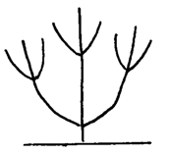 | 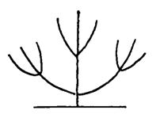 | 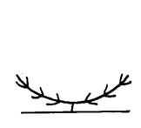
1 | 3 | 5 | 6
upright | semi upright | horizontal | drooping

Ad. 2: Plant: height
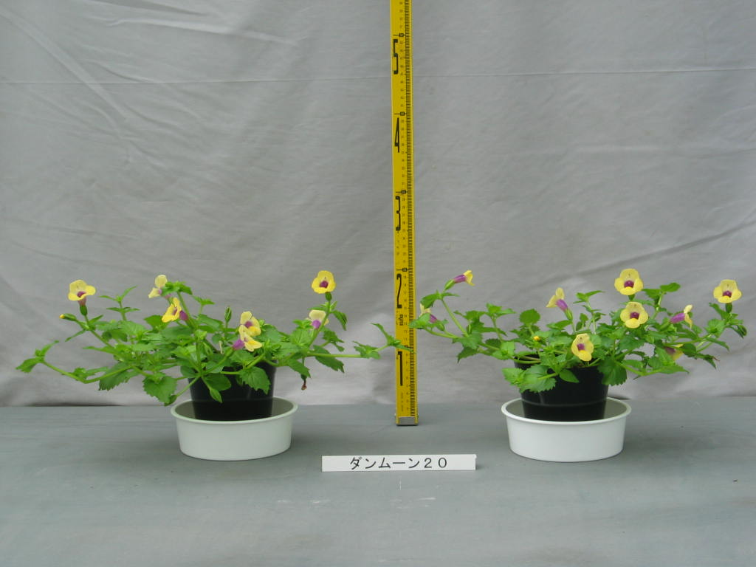
Ad. 3: Plant: width
height
width
height
width

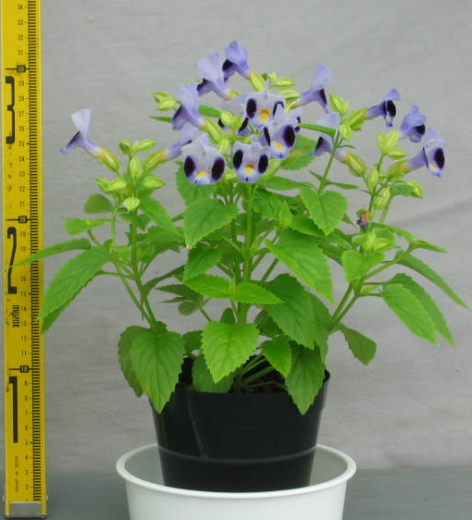

Ad. 4: Petiole: length
Ad. 5: Leaf blade: length
Ad. 6: Leaf blade: width

Leaf blade: length

Petiole: length

Leaf blade: width

Ad. 7: Leaf blade: incisions of margin
1 | 3
dentate | crenate

Ad. 9: Inflorescence: axillary flower
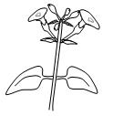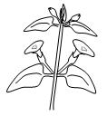
axillary flower
1 | 9
absent | present
Ad. 10: Calyx: number of lobes
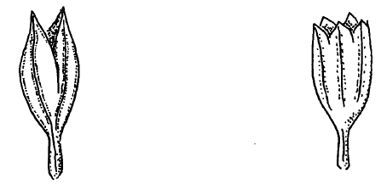
1 | 2
two | five

Ad. 11: Flower: length in front view
Ad. 12: Flower: width in front view

length in front view

width in front view

Ad. 13: Corolla tube: length
Ad. 14: Corolla tube: color of outer side
length
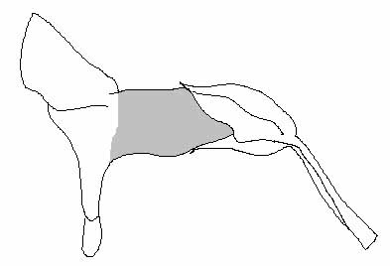
color of outer side

Ad. 15: Corolla tube: vertical lines on inner side

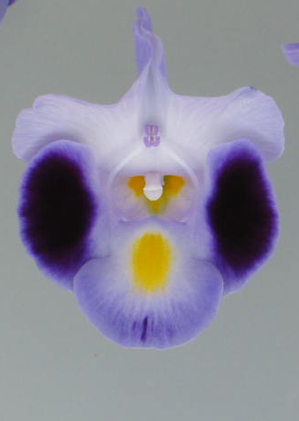 | 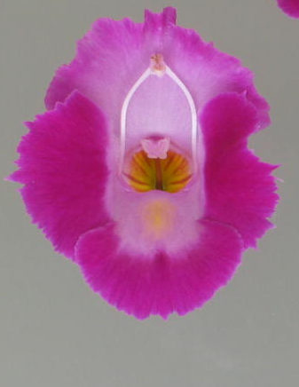 | 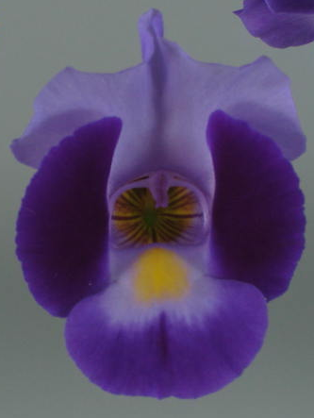
1 | 2 | 3
absent or weak | medium | strong

Ad. 16: Corolla tube: color of inner side at basal part
Ad. 19: Upper corolla lobe: color of basal part
Ad. 20: Upper corolla lobe: color of distal part
Ad. 21: Lateral corolla lobe: color of central part
Ad. 22: Lateral corolla lobe: color of marginal part
Ad. 23: Lower corolla lobe: color of distal part

Upper corolla lobe: color of distal part
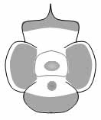
Upper corolla lobe: color of basal part

Corolla tube: color of inner side at basal part

Lateral corolla lobe: color of marginal part

Lateral corolla lobe: color of central part
Lower corolla lobe: color of distal part

Ad. 17: Corolla lobe: incisions of margin

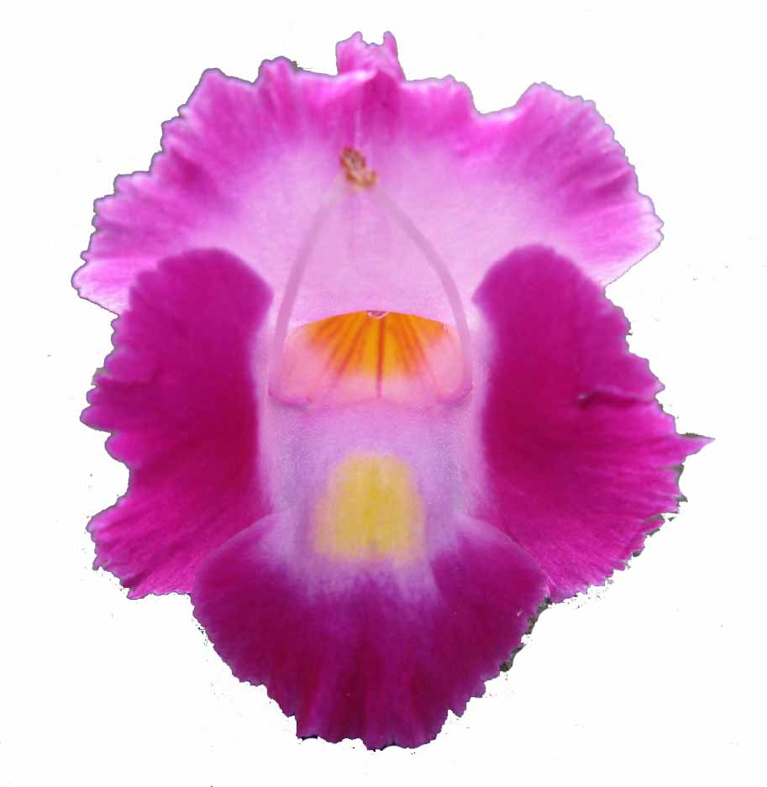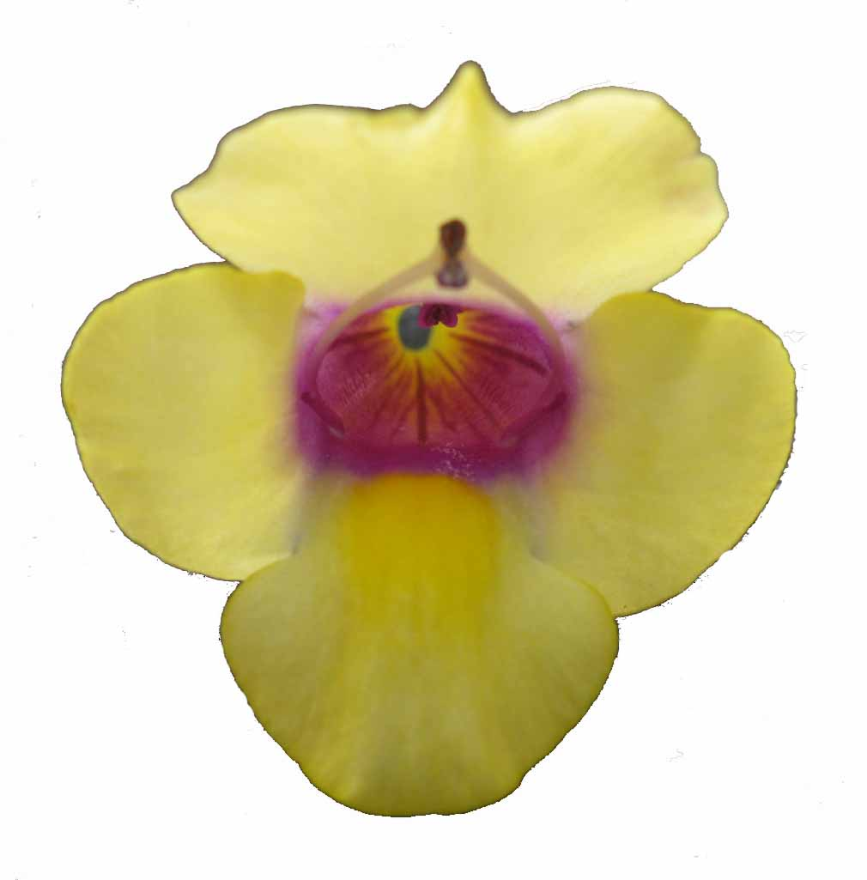
1 | 3
absent or weak | strong

Ad. 18: Upper corolla lobe: undulation

1 | 2 | 3
absent or weak | medium | strong

Ad. 24: Lower corolla lobe: conspicuousness of blotch

The conspicuousness of the blotch is determined by the color contrast with the color of the lower corolla lobe.

Literature
Inoue,Y, et al., 1982: Encyclopedia of Horticulture. Seibundoshinkosya. Tokyo, JP, vol.11, pp.161-162

Tsukamoto,Y., 1994: The Grand Dictionary of Horticulture. Shogakukan. Tokyo, JP, pp.1638-1639

Technical Questionnaire
TECHNICAL QUESTIONNAIRE |  | Page {x} of {y} | Reference Number:
 |  |  | Application date:
 |  |  | (not to be filled in by the applicant)
TECHNICAL QUESTIONNAIRE
to be completed in connection with an application for plant breeders’ rights

1. Subject of the Technical Questionnaire
1.1 Botanical name | Torenia L.
1.2 Common name | Torenia, Bluewings, Wishbone-flower
2. Applicant
Name
Address
Telephone No.
Fax No.
E-mail address
Breeder (if different from applicant)
3. Proposed denomination and breeder’s reference
Proposed denomination
(if available)

Breeder’s reference

TECHNICAL QUESTIONNAIRE | Page {x} of {y} | Reference Number:
#4. Information on the breeding scheme and propagation of the variety

4.1 Breeding scheme

Variety resulting from:

4.1.1 Crossing

(a) controlled cross [ ]
(please state parent varieties)

(…………………..……………..…) x (……………..…………………..…)
female parent male parent

(b) partially known cross [ ]
(please state known parent variety(ies))

(…………………..……………..…) x (……………..…………………..…)
female parent male parent

(c) unknown cross [ ]

4.1.2 Mutation [ ]
(please state parent variety)

4.1.3 Discovery and development [ ]
(please state where and when discovered and how developed)

4.1.4 Other [ ]
(please provide details)

4.2 Method of propagating the variety

4.2.1 Vegetative propagation

(a) cuttings [ ]

(b) in vitro propagation [ ]

(c) other (state method) [ ]

4.2.2 Seed [ ]

4.2.3 Other (please provide details) [ ]

(please provide details)”

TECHNICAL QUESTIONNAIRE |  |  | Page {x} of {y} |  | Reference Number:
5. Characteristics of the variety to be indicated (the number in brackets refers to the corresponding characteristic in Test Guidelines; please mark the note which best corresponds).

 | Characteristics |  |  |  |  | Example Varieties |  | Note
5.1  (1) | Plant: growth habit
 | upright |  |  |  |  | Clown Blue |  | 1[ ]
 | upright to semi upright |  |  |  |  |  |  | 2[ ]
 | semi upright |  |  |  |  | Dantopuremon |  | 3[ ]
 | semi upright to horizontal |  |  |  |  |  |  | 4[ ]
 | horizontal |  |  |  |  | Danmoon20 |  | 5[ ]
 | drooping |  |  |  |  | Hato-04-05 |  | 6[ ]
5.2(i)  (19) | Upper corolla lobe: color of basal part
 | RHS Colour Chart (indicate reference number)
5.2(ii)  (19) | Upper corolla lobe: color of basal part
 | white |  |  |  |  |  |  | 1[ ]
 | yellow |  |  |  |  |  |  | 2[ ]
 | orange |  |  |  |  |  |  | 3[ ]
 | red |  |  |  |  |  |  | 4[ ]
 | pink |  |  |  |  |  |  | 5[ ]
 | purple |  |  |  |  |  |  | 6[ ]
 | violet |  |  |  |  |  |  | 7[ ]
 | other (indicate color) ……………………………………............................
5.3(i)  (20) | Upper corolla lobe: color of distal part
 | RHS Colour Chart (indicate reference number)
 | Characteristics |  |  |  |  | Example Varieties |  | Note
5.3(ii)  (20) | Upper corolla lobe: color of distal part
 | white |  |  |  |  |  |  | 1[ ]
 | yellow |  |  |  |  |  |  | 2[ ]
 | orange |  |  |  |  |  |  | 3[ ]
 | red |  |  |  |  |  |  | 4[ ]
 | pink |  |  |  |  |  |  | 5[ ]
 | purple |  |  |  |  |  |  | 6[ ]
 | violet |  |  |  |  |  |  | 7[ ]
 | other (indicate color) ……………………………………............................
5.4(i)  (21) | Lateral corolla lobe: color of central part
 | RHS Colour Chart (indicate reference number)
5.4(ii)  (21) | Lateral corolla lobe: color of central part
 | white |  |  |  |  |  |  | 1[ ]
 | yellow |  |  |  |  |  |  | 2[ ]
 | orange |  |  |  |  |  |  | 3[ ]
 | red |  |  |  |  |  |  | 4[ ]
 | pink |  |  |  |  |  |  | 5[ ]
 | purple |  |  |  |  |  |  | 6[ ]
 | violet |  |  |  |  |  |  | 7[ ]
 | other (indicate color) ……………………………………............................
5.5  (24) | Lower corolla lobe: conspicuousness of blotch
 | absent or weak |  |  |  |  | Hato-04-05 |  | 1[ ]
 | medium |  |  |  |  |  |  | 2[ ]
 | strong |  |  |  |  | Clown Blue |  | 3[ ]
6. Similar varieties and differences from these varieties

Please use the following table and box for comments to provide information on how your candidate variety differs from the variety (or varieties) which, to the best of your knowledge, is (or are) most similar. This information may help the examination authority to conduct its examination of distinctness in a more efficient way.

Denomination(s) of variety(ies) similar to your candidate variety |  | Characteristic(s) in which your candidate variety differs from the similar variety(ies) |  | Describe the expression of the characteristic(s) for the similar variety(ies) |  |  | Describe the expression of the characteristic(s) for your candidate variety
Example |  | Plant: height |  | short |  |  | medium
Comments:

#7. Additional information which may help in the examination of the variety

7.1 In addition to the information provided in sections 5 and 6, are there any additional characteristics which may help to distinguish the variety?

Yes [ ] No [ ]

(If yes, please provide details)

7.2 Are there any special conditions for growing the variety or conducting the examination?

Yes [ ] No [ ]

(If yes, please provide details)

7.3 Other information

A representative color image of the variety should accompany the Technical Questionnaire.

8. Authorization for release

(a) Does the variety require prior authorization for release under legislation concerning the protection of the environment, human and animal health?

Yes [ ] No [ ]

(b) Has such authorization been obtained?

Yes [ ] No [ ]

If the answer to (b) is yes, please attach a copy of the authorization.

9. Information on plant material to be examined or submitted for examination.

9.1 The expression of a characteristic or several characteristics of a variety may be affected by factors, such as pests and disease, chemical treatment (e.g. growth retardants or pesticides), effects of tissue culture, different rootstocks, scions taken from different growth phases of a tree, etc.

9.2 The plant material should not have undergone any treatment which would affect the expression of the characteristics of the variety, unless the competent authorities allow or request such treatment. If the plant material has undergone such treatment, full details of the treatment must be given. In this respect, please indicate below, to the best of your knowledge, if the plant material to be examined has been subjected to:

(a) Microorganisms (e.g. virus, bacteria, phytoplasma) Yes [ ] No [ ]

(b) Chemical treatment (e.g. growth retardant, pesticide) Yes [ ] No [ ]

(c) Tissue culture Yes [ ] No [ ]

(d) Other factors Yes [ ] No [ ]

Please provide details for where you have indicated “yes”.

……………………………………………………………

10. I hereby declare that, to the best of my knowledge, the information provided in this form is correct:

Applicant’s name

Signature Date

[End of document]

* These names were correct at the time of the introduction of these Test Guidelines but may be revised or updated. [Readers are advised to consult the UPOV Code, which can be found on the UPOV Website (www.upov.int), for the latest information.]
# Authorities may allow certain of this information to be provided in a confidential section of the Technical Questionnaire.
# Authorities may allow certain of this information to be provided in a confidential section of the Technical Questionnaire.

