 |  | E  TG/257/1  ORIGINAL: English  DATE: 2009-04-01
INTERNATIONAL UNION FOR THE PROTECTION OF NEW VARIETIES OF PLANTS
GENEVA

 | PHLOX  UPOV Code: PHLOX_PAN  Phlox paniculata L. | *

GUIDELINES

FOR THE CONDUCT OF TESTS

FOR DISTINCTNESS, UNIFORMITY AND STABILITY

Alternative Names:*

Botanical name | English | French | German | Spanish
Phlox paniculata. L. | Fall phlox, Fall pink, Garden phlox, Panicled phlox, Perennial phlox, Perennial pink, Summer phlox, Sweet William | Phlox | Staudenphlox | Flox paniculada

The purpose of these guidelines (“Test Guidelines”) is to elaborate the principles contained in the General Introduction (document TG/1/3), and its associated TGP documents, into detailed practical guidance for the harmonized examination of distinctness, uniformity and stability (DUS) and, in particular, to identify appropriate characteristics for the examination of DUS and production of harmonized variety descriptions.

ASSOCIATED DOCUMENTS

These Test Guidelines should be read in conjunction with the General Introduction and its associated TGP documents.

TABLE OF CONTENTS PAGE

1. Subject of these Test Guidelines 3
2. Material Required 3
3. Method of Examination 3
3.1 Number of Growing Cycles 3
3.2 Testing Place 3
3.3 Conditions for Conducting the Examination 3
3.4 Test Design 4
3.5 Number of Plants / Parts of Plants to be Examined 4
3.6 Additional Tests 4
4. Assessment of Distinctness, Uniformity and Stability 4
4.1 Distinctness 4
4.2 Uniformity 5
4.3 Stability 5
5. Grouping of Varieties and Organization of the Growing Trial 5
6. Introduction to the Table of Characteristics 6
6.1 Categories of Characteristics 6
6.2 States of Expression and Corresponding Notes 6
6.3 Types of Expression 6
6.4 Example Varieties 6
6.5 Legend 6
7. Table of Characteristics/Tableau des caractères/Merkmalstabelle/Tabla de caracteres 7
8. Explanations on the Table of Characteristics 13
8.1 Explanations covering several characteristics 13
8.2 Explanations for individual characteristics 13
9. Literature 17
10. Technical Questionnaire 18

Subject of these Test Guidelines
These Test Guidelines apply to all varieties of Phlox paniculata L. of the family Polemoniaceae.

Material Required
2.1 The competent authorities decide on the quantity and quality of the plant material required for testing the variety and when and where it is to be delivered. Applicants submitting material from a State other than that in which the testing takes place must ensure that all customs formalities and phytosanitary requirements are complied with.

2.2 The material is to be supplied in the form of young plants capable of expressing all relevant characteristics of the variety during the first growing cycle.

2.3 The minimum quantity of plant material, to be supplied by the applicant, should be:

20 young plants.

2.4 The plant material supplied should be visibly healthy, not lacking in vigor, nor affected by any important pest or disease.

2.5 The plant material should not have undergone any treatment which would affect the expression of the characteristics of the variety, unless the competent authorities allow or request such treatment. If it has been treated, full details of the treatment must be given.

Method of Examination

3.1 Number of Growing Cycles
The minimum duration of tests should normally be a single growing cycle.

3.2 Testing Place
Tests are normally conducted at one place. In the case of tests conducted at more than one place, guidance is provided in TGP/9 “Examining Distinctness”.

3.3 Conditions for Conducting the Examination
3.3.1 The tests should be carried out under conditions ensuring satisfactory growth for the expression of the relevant characteristics of the variety and for the conduct of the examination.

3.3.2 Unless otherwise stated, all observations should be made at the time of full flowering.

3.3.3 Because daylight varies, color determinations made against a color chart should be made either in a suitable cabinet providing artificial daylight or in the middle of the day in a room without direct sunlight. The spectral distribution of the illuminant for artificial daylight should conform with the CIE Standard of Preferred Daylight D 6500 and should fall within the tolerances set out in the British Standard 950, Part I. These determinations should be made with the plant part placed against a white background.

3.4 Test Design
3.4.1 Each test should be designed to result in a total of at least 20 plants

3.4.2 The design of the tests should be such that plants or parts of plants may be removed for measurement or counting without prejudice to the observations which must be made up to the end of the growing cycle.

3.5 Number of Plants / Parts of Plants to be Examined
Unless otherwise indicated, all observations should be made on 10 plants or parts taken from each of 10 plants.

3.6 Additional Tests
Additional tests, for examining relevant characteristics, may be established.

Assessment of Distinctness, Uniformity and Stability

4.1 Distinctness

4.1.1 General Recommendations

It is of particular importance for users of these Test Guidelines to consult the General Introduction prior to making decisions regarding distinctness. However, the following points are provided for elaboration or emphasis in these Test Guidelines.

4.1.2 Consistent Differences

The differences observed between varieties may be so clear that more than one growing cycle is not necessary. In addition, in some circumstances, the influence of the environment is not such that more than a single growing cycle is required to provide assurance that the differences observed between varieties are sufficiently consistent. One means of ensuring that a difference in a characteristic, observed in a growing trial, is sufficiently consistent is to examine the characteristic in at least two independent growing cycles.

4.1.3 Clear Differences

Determining whether a difference between two varieties is clear depends on many factors, and should consider, in particular, the type of expression of the characteristic being examined, i.e. whether it is expressed in a qualitative, quantitative, or pseudo-qualitative manner. Therefore, it is important that users of these Test Guidelines are familiar with the recommendations contained in the General Introduction prior to making decisions regarding distinctness.

4.2 Uniformity
4.2.1 It is of particular importance for users of these Test Guidelines to consult the General Introduction prior to making decisions regarding uniformity. However, the following points are provided for elaboration or emphasis in these Test Guidelines:

4.2.2 For the assessment of uniformity, a population standard of 1% and an acceptance probability of at least 95% should be applied. In the case of a sample size of 20 plants, 1 off-type is allowed.

4.3 Stability
4.3.1 In practice, it is not usual to perform tests of stability that produce results as certain as those of the testing of distinctness and uniformity. However, experience has demonstrated that, for many types of variety, when a variety has been shown to be uniform, it can also be considered to be stable.

4.3.2 Where appropriate, or in cases of doubt, the stability may be tested, either by growing a further generation, or by testing a new plant stock to ensure that it exhibits the same characteristics as those shown by the previous material supplied.

Grouping of Varieties and Organization of the Growing Trial
5.1 The selection of varieties of common knowledge to be grown in the trial with the candidate varieties and the way in which these varieties are divided into groups to facilitate the assessment of distinctness are aided by the use of grouping characteristics.

5.2 Grouping characteristics are those in which the documented states of expression, even where produced at different locations, can be used, either individually or in combination with other such characteristics: (a) to select varieties of common knowledge that can be excluded from the growing trial used for examination of distinctness; and (b) to organize the growing trial so that similar varieties are grouped together.

5.3 The following have been agreed as useful grouping characteristics:

(a) Plant: height (characteristic 1)
(b) Leaf: variegation (characteristic 11)
(c) Corolla lobe: main color of upper side (excluding eye) (characteristic 27) with the following groups:
Gr. 1: white
Gr. 2: pink
Gr. 3: red
Gr. 4: violet
Gr. 5: purple red
Gr. 6: purple
Gr. 7: blue
(d) Corolla: eye (characteristic 29)

5.4 Guidance for the use of grouping characteristics, in the process of examining distinctness, is provided through the General Introduction.

Introduction to the Table of Characteristics

6.1 Categories of Characteristics
6.1.1 Standard Test Guidelines Characteristics

Standard Test Guidelines characteristics are those which are approved by UPOV for examination of DUS and from which members of the Union can select those suitable for their particular circumstances.

6.1.2 Asterisked Characteristics

Asterisked characteristics (denoted by *) are those included in the Test Guidelines which are important for the international harmonization of variety descriptions and should always be examined for DUS and included in the variety description by all members of the Union, except when the state of expression of a preceding characteristic or regional environmental conditions render this inappropriate.

6.2 States of Expression and Corresponding Notes
States of expression are given for each characteristic to define the characteristic and to harmonize descriptions. Each state of expression is allocated a corresponding numerical note for ease of recording of data and for the production and exchange of the description.

6.3 Types of Expression
An explanation of the types of expression of characteristics (qualitative, quantitative and pseudo-qualitative) is provided in the General Introduction.

6.4 Example Varieties
Where appropriate, example varieties are provided to clarify the states of expression of each characteristic.

6.5 Legend
(*) Asterisked characteristic – see Chapter 6.1.2

QL: Qualitative characteristic – see Chapter 6.3
QN: Quantitative characteristic – see Chapter 6.3
PQ: Pseudo-qualitative characteristic – see Chapter 6.3

(a)-(c) See Explanations on the Table of Characteristics in Chapter 8.1

(+) See Explanations on the Table of Characteristics in Chapter 8.2

Table of Characteristics/Tableau des caractères/Merkmalstabelle/Tabla de caracteres
 |  |  |  | English | français |  | deutsch |  | español |  |  | Example Varieties  Exemples  Beispielssorten  Variedades ejemplo |  | Note/  Nota
1.  (*)  (+) |  |  |  | Plant: height | Plante: hauteur |  | Pflanze: Höhe |  | Planta: altura
QN |  | (a) |  | short | courte |  | niedrig |  | baja |  |  | Barfourteen |  | 3
 |  |  |  | medium | moyenne |  | mittel |  | media |  |  | Barnine |  | 5
 |  |  |  | tall | haute |  | hoch |  | alta |  |  | Landhochzeit |  | 7
2. |  |  |  | Stem: thickness at middle third | Tige: épaisseur au tiers central |  | Stiel: Dicke im mittleren Drittel |  | Tallo: grosor del tercio central
QN |  | (a) |  | thin | fine |  | dünn |  | fino |  |  | Becky Towe |  | 1
 |  |  |  | medium | moyenne |  | mittel |  | medio |  |  | Elisabeth |  | 2
 |  |  |  | thick | épaisse |  | dick |  | grueso |  |  | Bareleven |  | 3
3.  (*) |  |  |  | Stem: anthocyanin coloration | Tige: pigmentation anthocyanique |  | Stiel: Anthocyanfärbung |  | Tallo: pigmentación antociánica
QN |  | (a) |  | absent or very weak | absente ou très faible |  | fehlend oder sehr gering |  | ausente o muy débil |  |  | Becky Towe |  | 1
 |  |  |  | weak | faible |  | gering |  | débil |  |  | Red Feelings |  | 3
 |  |  |  | medium | moyenne |  | mittel |  | media |  |  | Bartwentyeight |  | 5
 |  |  |  | strong | forte |  | stark |  | fuerte |  |  | Lizzy |  | 7
4. |  |  |  | Stem: length of internode at middle third | Tige: longueur de l’entre-noeud au tiers central |  | Stiel: Länge des Internodiums im mittleren Drittel |  | Tallo: longitud de los entrenudos en el tercio central
QN |  | (a) |  | short | courte |  | kurz |  | corta |  |  |  |  | 3
 |  |  |  | medium | moyenne |  | mittel |  | media |  |  |  |  | 5
 |  |  |  | long | longue |  | lang |  | larga |  |  |  |  | 7
5. |  |  | Leaf: length |  |  | Feuille: longueur |  | Blatt: Länge |  | Hoja: longitud
QN | (b) |  | short |  |  | courte |  | kurz |  | corta | Elisabeth |  | 3
 |  |  | medium |  |  | moyenne |  | mittel |  | media | Bareleven |  | 5
 |  |  | long |  |  | longue |  | lang |  | larga | Barthirtyfive |  | 7
6. |  |  | Leaf: width |  |  | Feuille: largeur |  | Blatt: Breite |  | Hoja: anchura
QN | (b) |  | narrow |  |  | étroite |  | schmal |  | estrecha | Junior Surprise |  | 3
 |  |  | medium |  |  | moyenne |  | mittel |  | media | Becky Towe |  | 5
 |  |  | broad |  |  | large |  | breit |  | ancha | Barthirtyfour |  | 7
7.  (*) |  |  | Leaf: ratio length/ width |  |  | Feuille: rapport longueur/largeur |  | Blatt: Verhältnis Länge/Breite |  | Hoja: relación longitud/anchura
QN | (b) |  | moderately elongated |  |  | modérément allongé |  | mäßig länglich |  | moderadamente alargada | Barfive, Rubymine |  | 3
 |  |  | medium |  |  | moyen |  | mittel |  | media | Barfourteen, Goldmine |  | 5
 |  |  | moderately compressed |  |  | modérément comprimé |  | mäßig zusammengedrückt |  | moderadamente comprimida | Barthirtyfour |  | 7
8.  (+) |  |  | Leaf: position of broadest part |  |  | Feuille: position de la partie la plus large |  | Blatt: Position der breitesten Stelle |  | Hoja: posición de la parte más ancha
QN | (b) |  | towards apex |  |  | vers le sommet |  | zur Spitze hin |  | hacia el ápice | Esm Zeus |  | 1
 |  |  | at middle |  |  | au milieu |  | in der Mitte |  | en el medio | Bartwentyeight |  | 2
 |  |  | towards base |  |  | vers la base |  | zur Basis hin |  | hacia la base | Becky Towe |  | 3
9. |  |  | Leaf: shape in cross section |  |  | Feuille: forme en section transversale |  | Blatt: Form im Querschnitt |  | Hoja: forma en sección transversal
QN | (b) |  | concave |  |  | concave |  | konkav |  | cóncava |  |  | 1
 |  |  | flat |  |  | plate |  | flach |  | plana |  |  | 2
 |  |  | convex |  |  | convexe |  | konvex |  | convexa |  |  | 3
10.  (+) |  |  | Leaf: shape of apex |  |  | Feuille: forme du sommet |  | Blatt: Form der Spitze |  | Hoja: forma del ápice
PQ | (b) |  | acuminate |  |  | acuminé |  | zugespitzt |  | acuminado | Bartwentyeight |  | 1
 |  |  | acuminate to acute |  |  | acuminé à aigu |  | zugespitzt bis spitz |  | acuminado a agudo |  |  | 2
 |  |  | acute |  |  | aigu |  | spitz |  | agudo | Becky Towe |  | 3
11.  (*) |  |  | Leaf: variegation |  |  | Feuille: panachure |  | Blatt: Panaschierung |  | Hoja: variegación
QL | (b) |  | absent |  |  | absente |  | fehlend |  | ausente | Bartwentyeight, Lizzy |  | 1
 |  |  | present |  |  | présente |  | vorhanden |  | presente | Becky Towe, Elisabeth |  | 9
12.  (*) |  |  | Leaf: anthocyanin coloration on upper side |  |  | Feuille: pigmentation anthocyanique de la face supérieure |  | Blatt: Anthocyan-färbung der Oberseite |  | Hoja: ondulación del margen
QN | (b) |  | absent or weak |  |  | absente ou faible |  | fehlend oder gering |  | ausente o débil | Becky Towe |  | 1
 |  |  | medium |  |  | moyenne |  | mittel |  | media |  |  | 2
 |  |  | strong |  |  | forte |  | stark |  | fuerte | Empty feelings, Rubymine |  | 3
13. |  |  | Leaf: undulation of margin |  |  | Feuille: ondulation du bord |  | Blatt: Wellung des Randes |  | Hoja: ondulación del margen
QN | (b) |  | absent or weak |  |  | nulle ou faible |  | fehlend oder gering |  | ausente o débil | Barfourteen, Lizzy |  | 1
 |  |  | medium |  |  | moyenne |  | mittel |  | media | Elisabeth, Rubymine |  | 2
 |  |  | strong |  |  | forte |  | stark |  | fuerte |  |  | 3
14.  (*) |  |  | Inflorescence: number of flowers |  |  | Inflorescence: nombre de fleurs |  | Blütenstand: Anzahl Blüten |  | Inflorescencia: cantidad de flores
QN | (c) |  | few |  |  | faible |  | gering |  | débil | Barfive, Junior Surprise |  | 3
 |  |  | medium |  |  | moyen |  | mittel |  | media | Barforty, Delilah |  | 5
 |  |  | many |  |  | élevé |  | gross |  | elevada | Bareleven, Barnine |  | 7
15. |  |  | Pedicel: length |  |  | Pédoncule: longueur |  | Blütenstiel: Länge |  | Pedicelo: longitud
QN | (c) |  | short |  |  | courte |  | kurz |  | corto | Barfourteen |  | 3
 |  |  | medium |  |  | moyenne |  | mittel |  | medio | Becky Towe, Red Feelings |  | 5
 |  |  | long |  |  | longue |  | lang |  | largo | Barnine, Goldmine |  | 7
16. |  |  | Pedicel: anthocyanin coloration |  |  | Pédoncule: pigmentation anthocyanique |  | Blütenstiel: Anthocyanfärbung |  | Pedicelo: pigmentación antociánica
QN | (c) |  | absent or weak |  |  | absente ou faible |  | fehlend oder gering |  | ausente o débil | Elisabeth, Esm Indigo |  | 1
 |  |  | medium |  |  | moyenne |  | mittel |  | media | Esm Zeus |  | 2
 |  |  | strong |  |  | forte |  | stark |  | fuerte | Barthirtyfive,  Esm Egeo |  | 3
17. |  |  | Calyx: length |  |  | Calice: longueur |  | Kelch: Länge |  | Cáliz: longitud
QN | (c) |  | short |  |  | courte |  | kurz |  | corta | Elisabeth |  | 1
 |  |  | medium |  |  | moyenne |  | mittel |  | media | Junior Surprise |  | 2
 |  |  | long |  |  | longue |  | lang |  | larga | Barthirtyfive |  | 3
18.  (*) |  |  | Calyx: anthocyanin coloration |  |  | Calice: pigmentation anthocyanique |  | Kelch: Anthocyan-färbung |  | Cáliz: pigmentación antociánica
QN | (c) |  | absent or weak |  |  | absente ou faible |  | fehlend oder gering |  | ausente o débil | Barthirtysix, Elisabeth |  | 1
 |  |  | medium |  |  | moyenne |  | mittel |  | media | VBL26 |  | 2
 |  |  | strong |  |  | forte |  | stark |  | fuerte | Esm Indigo |  | 3
19.  (*) |  |  | Flower: diameter |  |  | Fleur: diamètre |  | Blüte: Durchmesser |  | Flor: diámetro
QN | (c) |  | small |  |  | petit |  | klein |  | pequeño | Red Feelings |  | 3
 |  |  | medium |  |  | moyen |  | mittel |  | medio | Elisabeth, Vebablu |  | 5
 |  |  | large |  |  | élevé |  | groß |  | grande | Goldmine, Lizzy |  | 7
20.  (*)  (+) |  |  | Flower: perianth |  |  | Fleur : périanthe |  | Blüte: Blütenhülle |  | Flor: perianto
QL | (c) |  | absent |  |  | absent |  | fehlend |  | ausente | Empty Feelings |  | 1
 |  |  | present |  |  | présent |  | vorhanden |  | presente | Elisabeth |  | 9
21.  (+) |  |  | Corolla tube: length |  |  | Tube de la corolle: longueur |  | Kronröhre: Länge |  | Tubo de la corola: longitud
QN | (c) |  | short |  |  | courte |  | kurz |  | corta | Junior Surprise |  | 3
 |  |  | medium |  |  | moyenne |  | mittel |  | media | Esm Indigo |  | 5
 |  |  | long |  |  | longue |  | lang |  | larga | Elisabeth |  | 7
22.  (+) |  |  | Corolla tube: diameter just below lobes |  |  | Tube de la corolle: diamètre juste en dessous des lobes |  | Kronröhre: Durchmesser unmittelbar unter den Lappen |  | Tubo de la corola: diámetro justo por debajo de los lóbulos
QN | (c) |  | small |  |  | petit |  | klein |  | pequeño | Esm Egeo, Rubymine |  | 1
 |  |  | medium |  |  | moyen |  | mittel |  | medio | Delilah, Vebablu |  | 2
 |  |  | large |  |  | élevé |  | groß |  | grande | Esm Indigo |  | 3
23.  (+) |  |  | Corolla tube: color |  |  | Tube de la corolle: couleur |  | Kronröhre: Farbe |  | Tubo de la corola: color
PQ | (c) |  | RHS Colour Chart (indicate reference number) |  |  | Code RHS des couleurs (indiquer le numéro de référence) |  | RHS-Farbkarte (Nummer angeben) |  | Carta de colores RHS (indíquese el número de referencia)
24.  (+) |  |  | Corolla lobe: length |  |  | Lobe de la corolle: longueur |  | Kronlappen: Länge |  | Lóbulo de la corola: longitud
QN | (c) |  | short |  |  | courte |  | kurz |  | corta | Bartwentynine |  | 3
 |  |  | medium |  |  | moyenne |  | mittel |  | media | Becky Towe, Rubymine |  | 5
 |  |  | long |  |  | longue |  | lang |  | larga | Bartwentyeight, Lizzy |  | 7
25.  (+) |  |  | Corolla lobe: width |  |  | Lobe de la corolle: largeur |  | Kronlappen: Breite |  | Lóbulo de la corola: anchura
QN | (c) |  | narrow |  |  | étroite |  | schmal |  | estrecha | Barthirtytwo |  | 3
 |  |  | medium |  |  | moyenne |  | mittel |  | media | Junior Dream |  | 5
 |  |  | broad |  |  | large |  | breit |  | ancha | Esm Indigo |  | 7
26.  (*)  (+) |  |  | Corolla lobe: shape |  |  | Lobe de la corolle: forme |  | Kronlappen: Form |  | Lóbulo de la corola: forma
PQ | (c) |  | elliptic |  |  | elliptique |  | elliptisch |  | elíptico |  |  | 1
 |  |  | oblate |  |  | oblong |  | breitrund |  | achatado | Lizzy |  | 2
 |  |  | obovate |  |  | obovale |  | verkehrt eiförmig |  | oboval | Bartwentynine |  | 3
 |  |  | obdeltate |  |  | obdeltoïde |  | verkehrt deltaförmig |  | obdeltado | Bartwentyeight |  | 4
27.  (*)  (+) |  |  | Corolla lobe: main color of upper side (excluding eye) |  |  | Lobe de la corolle: couleur principale de la face supérieure (oeil exclu) |  | Kronlappen: Hauptfarbe der Oberseite  (ohne Auge) |  | Lóbulo de la corola: color principal del haz (excluido el ojo)
PQ | (c) |  | RHS Colour Chart (indicate reference number) |  |  | Code RHS des couleurs (indiquer le numéro de référence) |  | RHS-Farbkarte (Nummer angeben) |  | Carta de colores RHS (indíquese el número de referencia)
28. |  |  | Corolla lobe: secondary color of upper side  (excluding eye) |  |  | Lobe de la corolle : couleur secondaire de la face supérieure (œil exclu) |  | Kronlappen: Sekundärfarbe der Oberseite (ohne Auge) |  | Lóbulo de la corola: color secundario del haz (excluido el ojo)
PQ | (c) |  | RHS Colour Chart (indicate reference number) |  |  | Code RHS des couleurs (indiquer le numéro de référence) |  | RHS-Farbkarte (Nummer angeben) |  | Carta de colores RHS (indíquese el número de referencia)
29.  (*)  (+) |  |  | Corolla: eye |  |  | Corolle: oeil |  | Krone: Auge |  | Corola: ojo
QL | (c) |  | absent |  |  | absent |  | fehlend |  | ausente | Barthirtynine, Elisabeth |  | 1
 |  |  | present |  |  | présent |  | vorhanden |  | presente | Becky Towe, Rubymine |  | 9
30.  (*)  (+) |  |  | Corolla: color of eye |  |  | Corolle: couleur de l’oeil |  | Krone: Farbe des Auges |  | Corola: color del ojo
PQ | (c) |  | RHS Colour Chart (indicate reference number) |  |  | Code RHS des couleurs (indiquer le numéro de référence) |  | RHS-Farbkarte (Nummer angeben) |  | Carta de colores RHS (indíquese el número de referencia)
31. |  |  | Anther: color |  |  | Anthère: couleur |  | Anthere: Farbe |  | Antera: color
PQ | (c) |  | white |  |  | blanche |  | weiss |  | blanco | Barthirtysix, Elisabeth |  | 1
 |  |  | light yellow |  |  | jaune clair |  | hellgelb |  | amarillo claro | Esm Egeo |  | 2
 |  |  | light green |  |  | verte clair |  | hellgrün |  | verde claro |  |  | 3
32. |  |  | Style: color |  |  | Style : couleur |  | Griffel: Farbe |  | Estilo: color
PQ | (c) |  | white |  |  | blanc |  | weiss |  | blanco |  |  | 1
 |  |  | light yellow |  |  | jaune clair |  | hellgelb |  | amarillo claro | Becky Towe |  | 2
 |  |  | light green |  |  | vert clair |  | hellgrün |  | verde claro | Ruby Mine |  | 3
 |  |  | purple red |  |  | pourpre rouge |  | purpurn |  | rojo púrpura | Goldmine, Lizzy |  | 4

Explanations on the Table of Characteristics

8.1 Explanations covering several characteristics
Characteristics containing the following key in the second column of the Table of Characteristics should be examined as indicated below:

(a) Observations on plant and stem should be made when 50% of flowers have opened on the first panicle.
(b) Observations on leaves should be made on fully expanded leaves taken from the middle third of the flowering stem.
(c) Observations on flowers should be made on fully expanded flowers when 50% of flowers have opened.

8.2 Explanations for individual characteristics
Ad. 1: Plant: height

Plant height should be measured from soil level to the top of the plant including the flowers.

Ad. 8: Leaf: position of broadest part

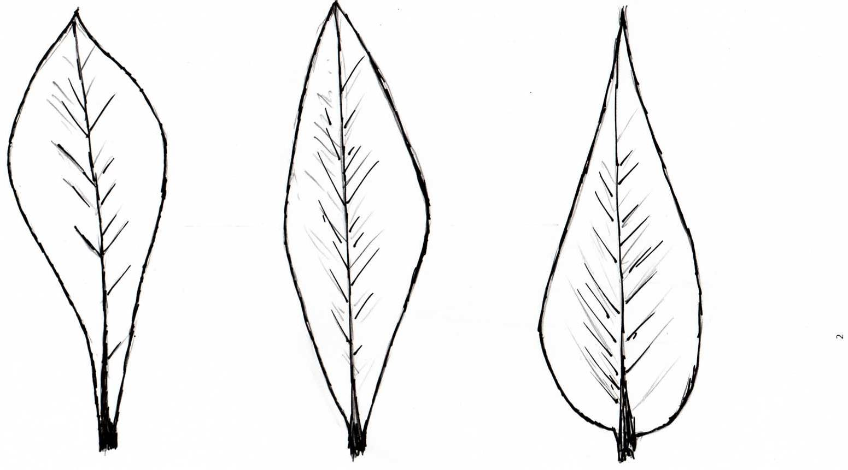

1 | 2 | 3
towards apex | at middle | towards base

Ad. 10: Leaf: shape of apex

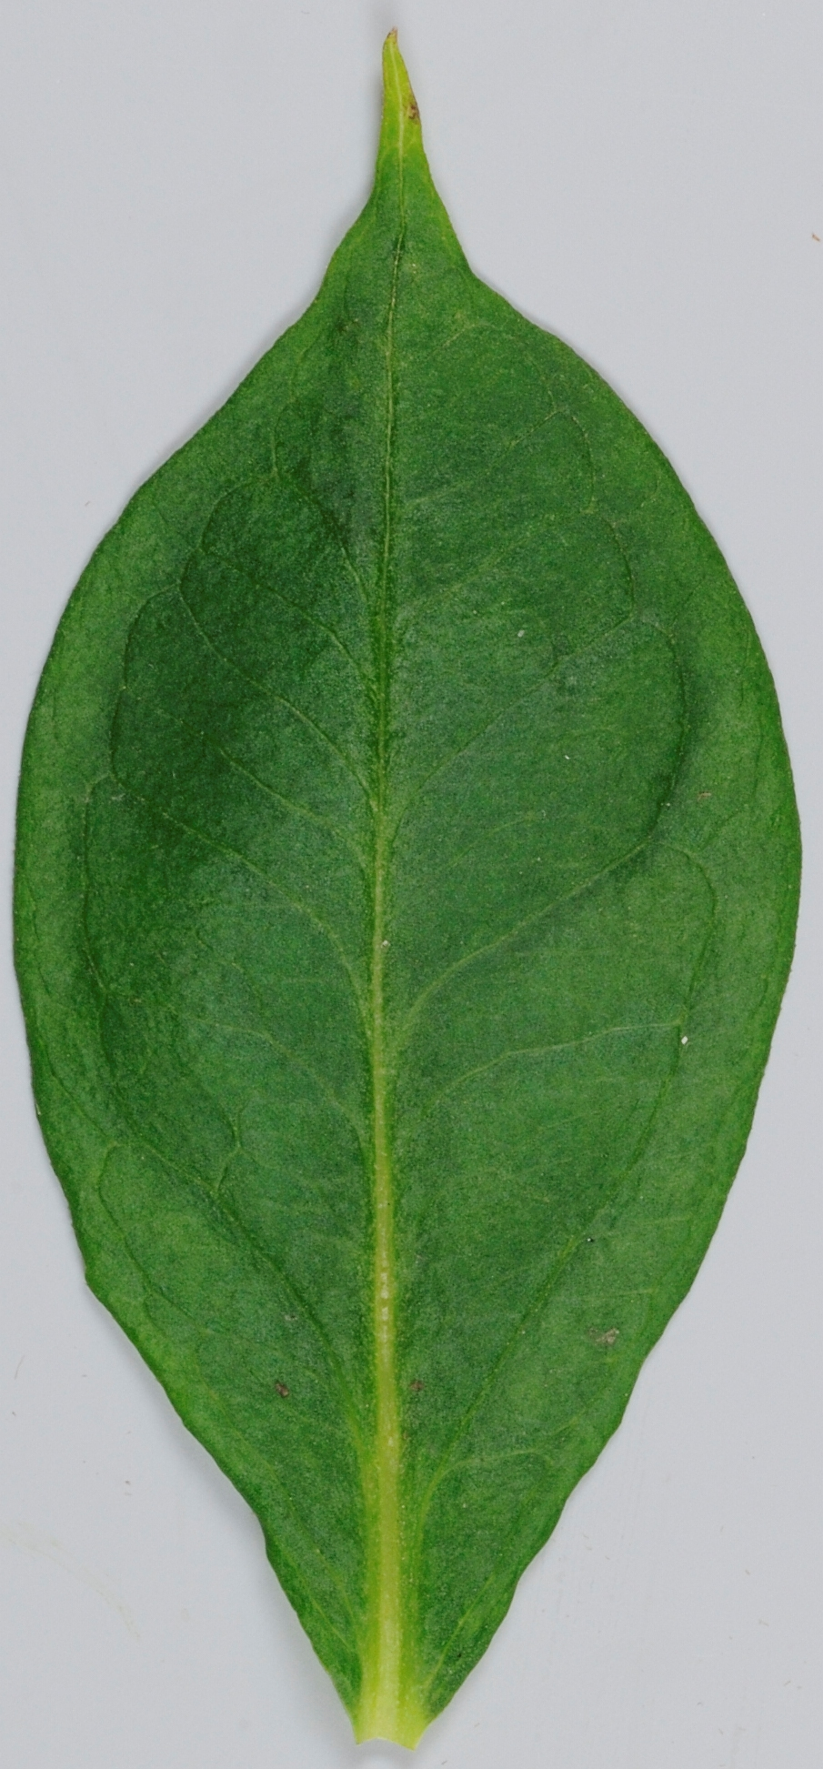 | 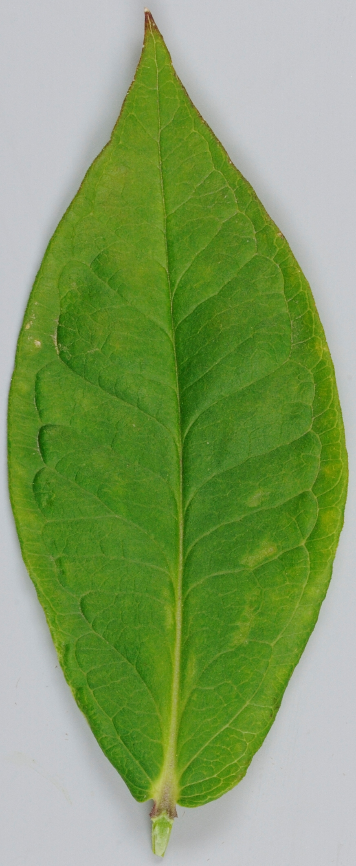 | 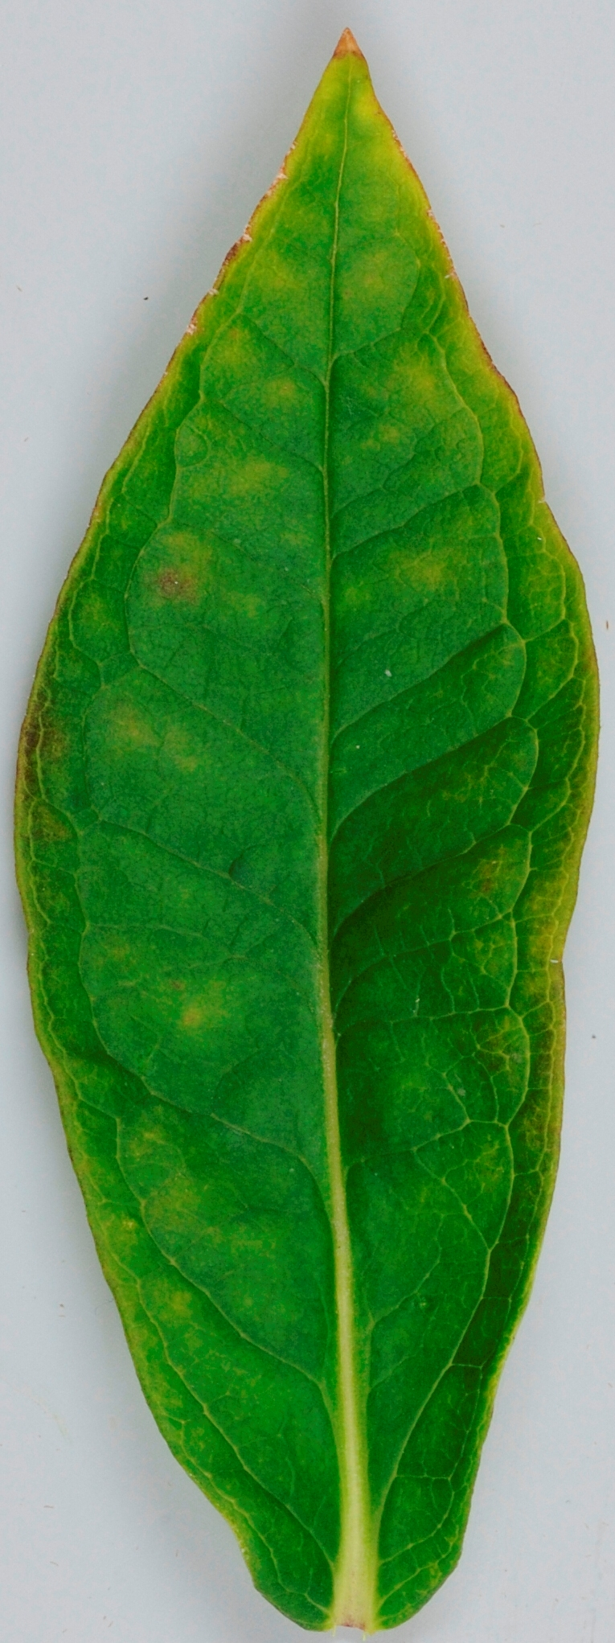
1 | 2 | 3
acuminate | acuminate to acute | acute

Ad. 20: Flower: perianth

Varieties with perianth “absent” may have a vestigial perianth.

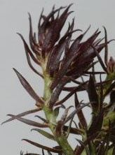 | 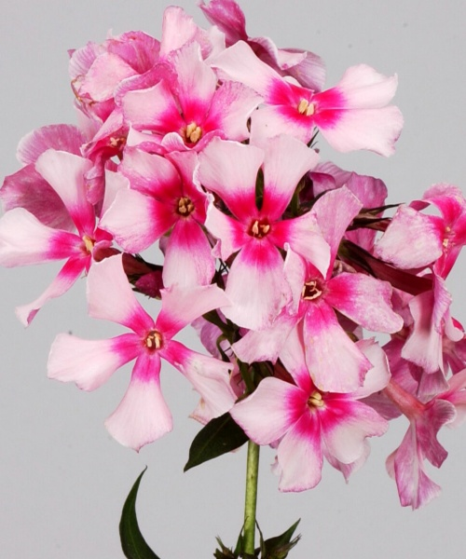
1 | 9
absent | present

Ad. 21: Corolla tube: length
Ad. 22: Corolla tube: diameter just below lobes
Ad. 23: Corolla tube: color
Ad. 24: Corolla lobe: length
Ad. 25: Corolla lobe: width
Ad. 26: Corolla lobe: shape
Ad. 27: Corolla lobe: main color of upper side (excluding eye)

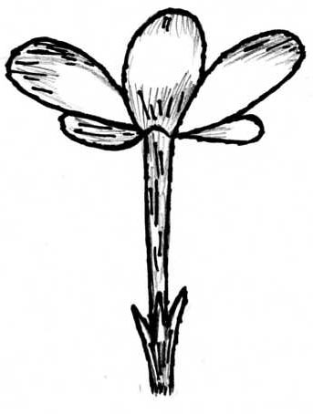
Corolla lobe: width

Corolla lobe: lobes
length

Corolla tube:
length

Corolla tube:
diameter

The color of the corolla tube should be observed on the outer side.

Ad. 26: Corolla lobe: shape

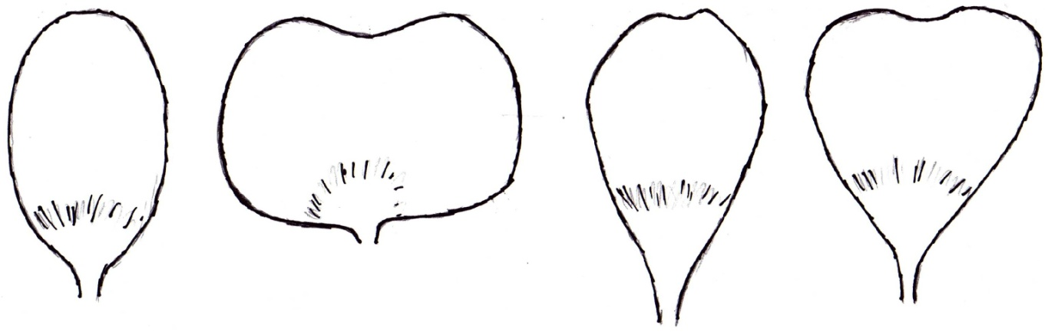

1 | 2 | 3 | 4
elliptic | oblate | obovate | obdeltate

Ad. 27: Corolla lobe: main color of upper side (excluding eye)

The main color is the color with the largest surface area.

Ad. 29: Corolla: eye
Ad. 30: Corolla: color of eye

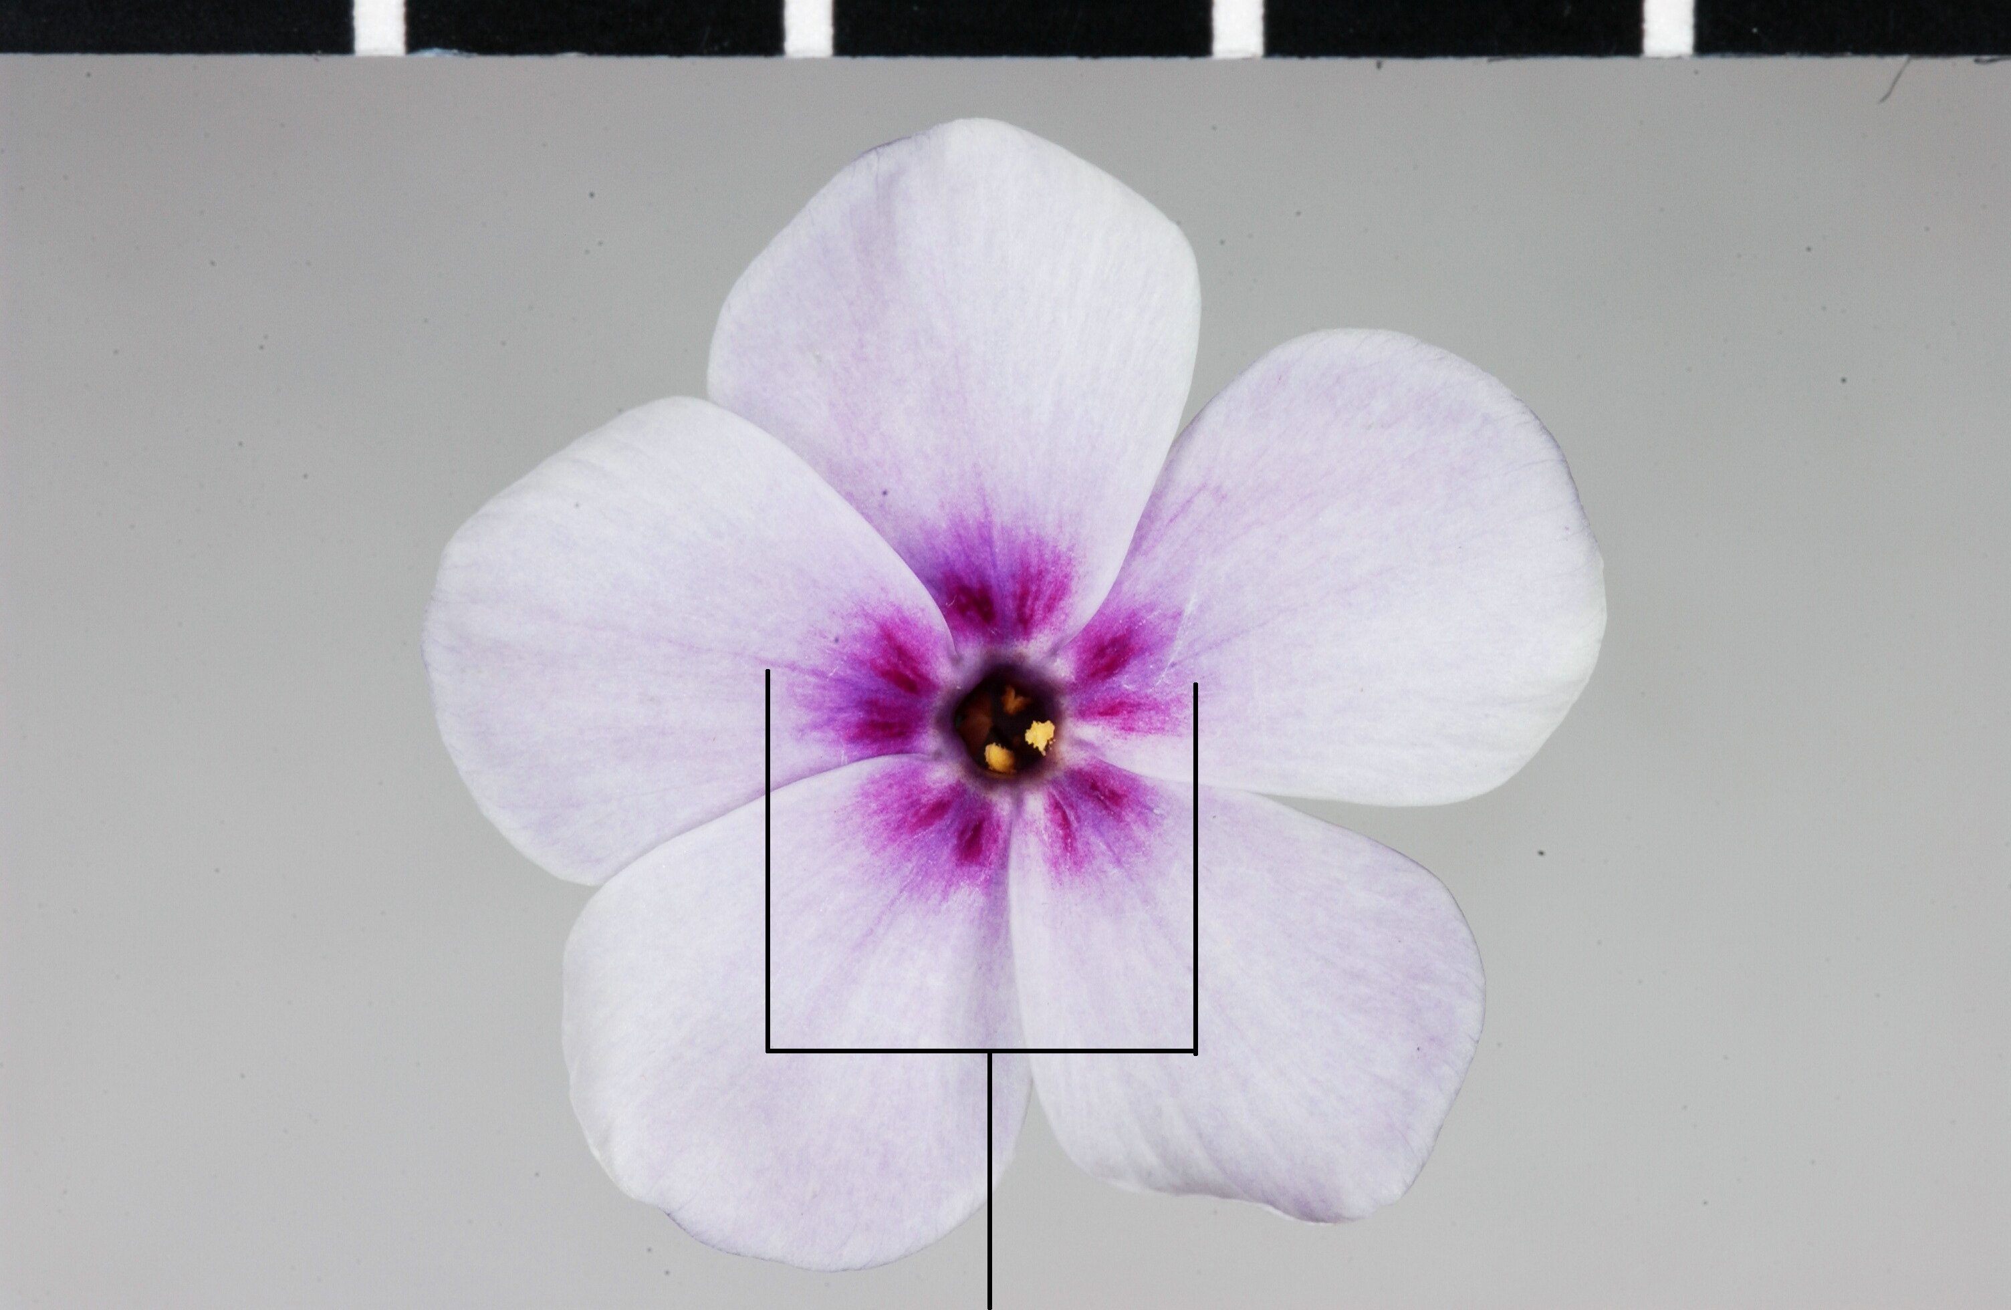 | 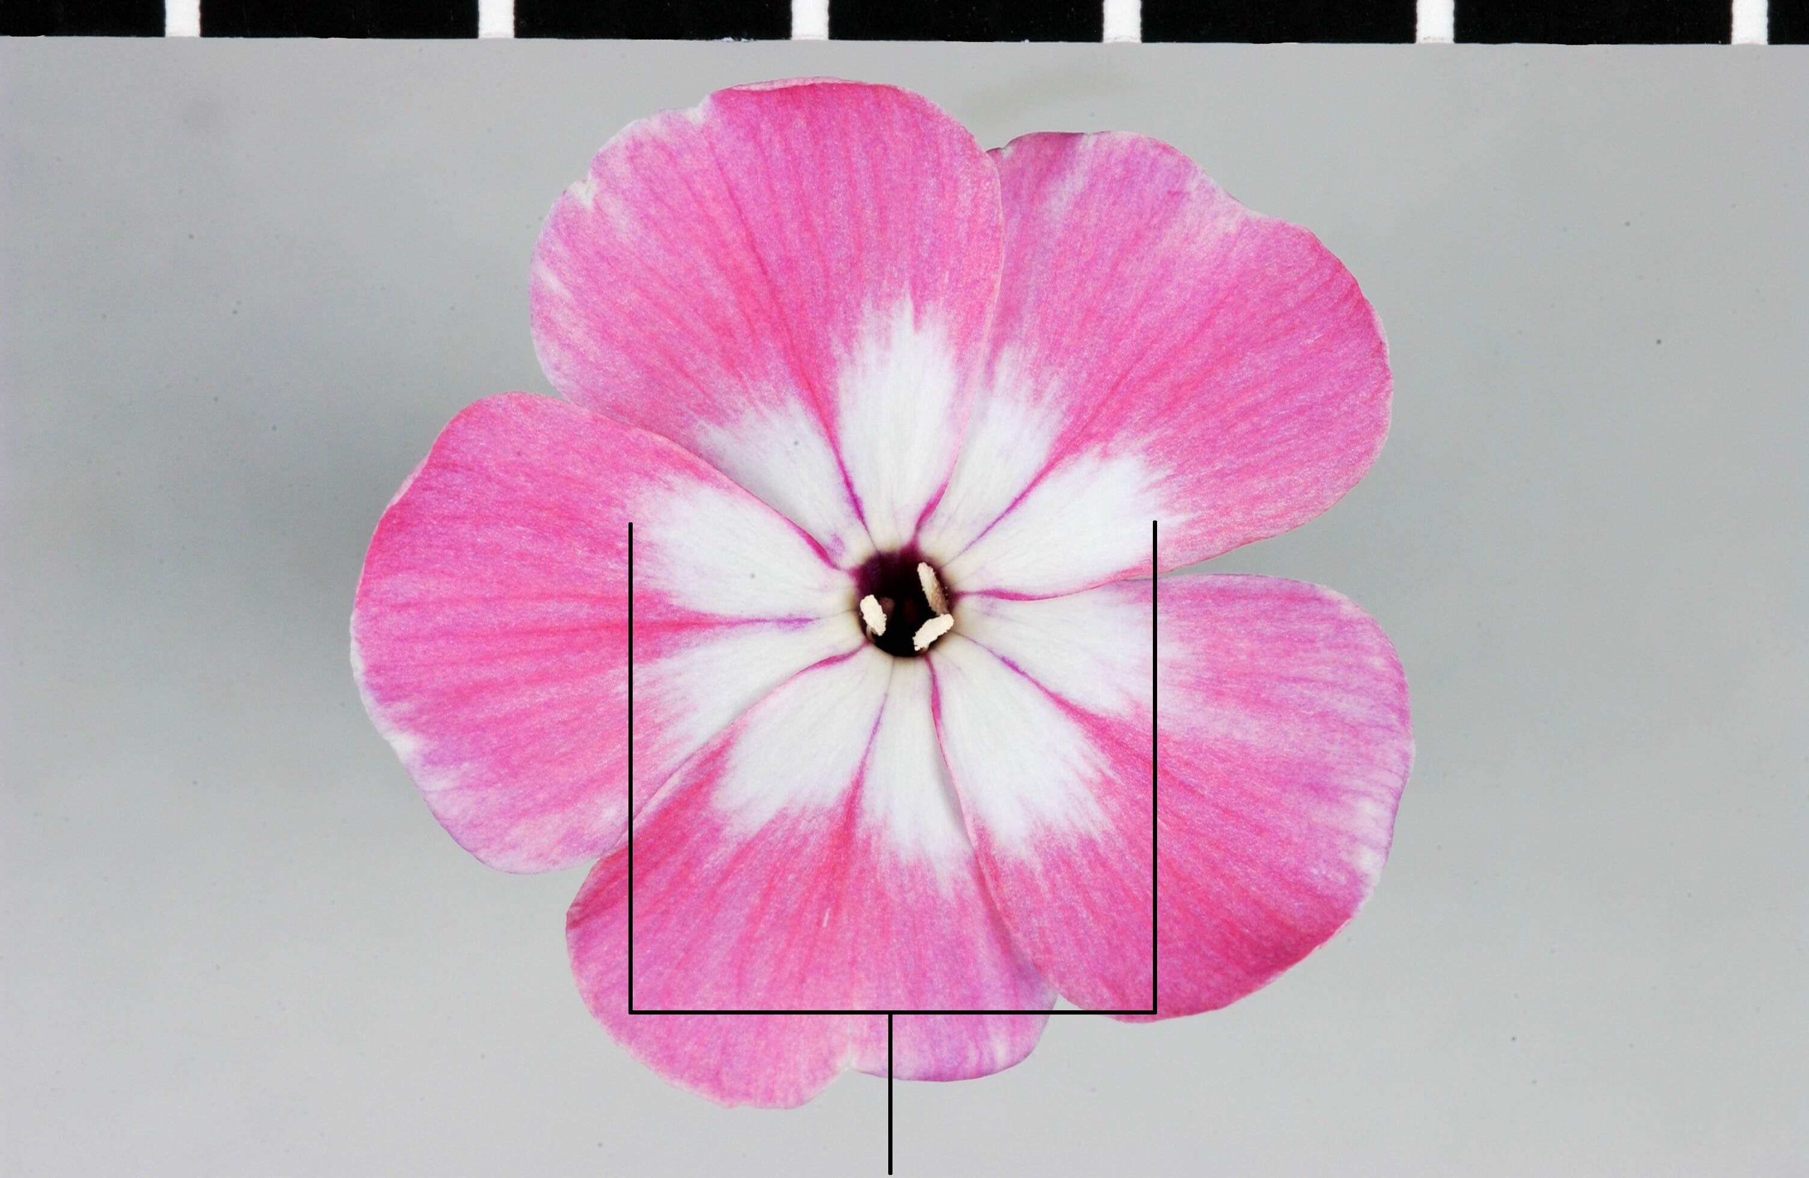
eye

Literature
Cheers, G., 2004: The Encyclopedia of Garden Flowers. Global Book Publishing Pty Ltd.

Fuchs, H., 1994: Phlox, Stauden- und Polsterphloxe. Eugen Ulmer Verlag. Stuttgart, DE.

Technical Questionnaire
TECHNICAL QUESTIONNAIRE |  |  |  | Page {x} of {y} |  | Reference Number:
 |  |  |  |  |  | Application date:
 |  |  |  |  |  | (not to be filled in by the applicant)
TECHNICAL QUESTIONNAIRE
to be completed in connection with an application for plant breeders’ rights

1. Subject of the Technical Questionnaire
1.1 Botanical name |  |  | Phlox paniculata L.
1.2 Common name |  |  | Phlox
2. Applicant
Name
Address
Telephone No.
Fax No.
E-mail address
Breeder (if different from applicant)
3. Proposed denomination and breeder’s reference
Proposed denomination
(if available)

Breeder’s reference
#4. Information on the breeding scheme and propagation of the variety

4.1 Breeding scheme

Variety resulting from:

4.1.1 Crossing

(a) controlled cross [ ]
(please state parent varieties)
(b) partially known cross [ ]
(please state known parent variety(ies))
(c) unknown cross [ ]

4.1.2 Mutation [ ]
(please state parent variety)

4.1.3 Discovery and development [ ]
(please state where and when discovered
and how developed)

4.1.4 Other [ ]
(please provide details)

4.2 Method of propagating the variety

4.2.1 Vegetative propagation

(a) cuttings [ ]
(b) in vitro propagation [ ]
(c) other (state method) [ ]

4.2.2 Other [ ]
(please provide details)

5. Characteristics of the variety to be indicated (the number in brackets refers to the corresponding characteristic in Test Guidelines; please mark the note which best corresponds).

 | Characteristics |  |  |  |  |  | Example Varieties |  |  | Note
5.1  (1) | Plant: height
 | short |  |  |  |  |  | Barfourteen |  |  | 3[ ]
 | medium |  |  |  |  |  | Barnine |  |  | 5[ ]
 | tall |  |  |  |  |  | Landhochzeit |  |  | 7[ ]
5.2  (11) | Leaf: variegation
 | absent |  |  |  |  |  | Bartwentyeight, Lizzy |  |  | 1[ ]
 | present |  |  |  |  |  | Becky Towe, Elisabeth |  |  | 9[ ]
5.3  (27) | Corolla lobe: main color of upper side (excluding eye)
 | white |  |  |  |  |  |  |  |  | 1[ ]
 | pink |  |  |  |  |  |  |  |  | 2[ ]
 | red |  |  |  |  |  |  |  |  | 3[ ]
 | violet |  |  |  |  |  |  |  |  | 4[ ]
 | purple red |  |  |  |  |  |  |  |  | 5[ ]
 | purple |  |  |  |  |  |  |  |  | 6[ ]
 | blue |  |  |  |  |  |  |  |  | 7[ ]
5.4  (29) | Corolla: eye
 | absent |  |  |  |  |  | Barthirtynine, Elisabeth |  |  | 1[ ]
 | present |  |  |  |  |  | Becky Towe, Rubymine |  |  | 9[ ]
6. Similar varieties and differences from these varieties

Please use the following table and box for comments to provide information on how your candidate variety differs from the variety (or varieties) which, to the best of your knowledge, is (or are) most similar. This information may help the examination authority to conduct its examination of distinctness in a more efficient way.

Denomination(s) of variety(ies) similar to your candidate variety |  | Characteristic(s) in which your candidate variety differs from the similar variety(ies) |  |  | Describe the expression of the characteristic(s) for the similar variety(ies) |  |  | Describe the expression of the characteristic(s) for your candidate variety
Example |  | Plant: height |  |  | short |  |  | tall
Comments:

#7. Additional information which may help in the examination of the variety

7.1 In addition to the information provided in sections 5 and 6, are there any additional characteristics which may help to distinguish the variety?

Yes [ ] No [ ]

(If yes, please provide details)

7.2 Are there any special conditions for growing the variety or conducting the examination?

Yes [ ] No [ ]

(If yes, please provide details)

7.3 Other information

7.3.1 Main use

(a) garden plant [ ]
(b) pot plant [ ]
(c) cut-flower [ ]
(d) other [ ]
(please provide details)

7.3.2 A representative color photograph of the variety should accompany the Technical Questionnaire.

8. Authorization for release

(a) Does the variety require prior authorization for release under legislation concerning the protection of the environment, human and animal health?

Yes [ ] No [ ]

(b) Has such authorization been obtained?

Yes [ ] No [ ]

If the answer to (b) is yes, please attach a copy of the authorization.

9. Information on plant material to be examined or submitted for examination.

9.1 The expression of a characteristic or several characteristics of a variety may be affected by factors, such as pests and disease, chemical treatment (e.g. growth retardants or pesticides), effects of tissue culture, different rootstocks, scions taken from different growth phases of a tree, etc.

9.2 The plant material should not have undergone any treatment which would affect the expression of the characteristics of the variety, unless the competent authorities allow or request such treatment. If the plant material has undergone such treatment, full details of the treatment must be given. In this respect, please indicate below, to the best of your knowledge, if the plant material to be examined has been subjected to:

(a) Microorganisms (e.g. virus, bacteria, phytoplasma) Yes [ ] No [ ]

(b) Chemical treatment (e.g. growth retardant, pesticide) Yes [ ] No [ ]

(c) Tissue culture Yes [ ] No [ ]

(d) Other factors Yes [ ] No [ ]

Please provide details for where you have indicated “yes”.

……………………………………………………………

10. I hereby declare that, to the best of my knowledge, the information provided in this form is correct:

Applicant’s name

Signature Date

[End of document]

* These names were correct at the time of the introduction of these Test Guidelines but may be revised or updated. [Readers are advised to consult the UPOV Code, which can be found on the UPOV Website (www.upov.int), for the latest information.]
# Authorities may allow certain of this information to be provided in a confidential section of the Technical Questionnaire.
# Authorities may allow certain of this information to be provided in a confidential section of the Technical Questionnaire.

