 |  | E  TG/254/1  ORIGINAL: English  DATE: 2009-04-01
INTERNATIONAL UNION FOR THE PROTECTION OF NEW VARIETIES OF PLANTS
GENEVA

 | RUBBER  UPOV Code: HEVEA  Hevea Aubl. | *

GUIDELINES

FOR THE CONDUCT OF TESTS

FOR DISTINCTNESS, UNIFORMITY AND STABILITY

Alternative Names:*

Botanical name | English | French | German | Spanish
Hevea Aubl. | Rubber | Hevea | Parakautschukbaum | Árbol del caucho, Hule

The purpose of these guidelines (“Test Guidelines”) is to elaborate the principles contained in the General Introduction (document TG/1/3), and its associated TGP documents, into detailed practical guidance for the harmonized examination of distinctness, uniformity and stability (DUS) and, in particular, to identify appropriate characteristics for the examination of DUS and production of harmonized variety descriptions.

ASSOCIATED DOCUMENTS

These Test Guidelines should be read in conjunction with the General Introduction and its associated TGP documents.

TABLE OF CONTENTS PAGE

1. Subject of these Test Guidelines 3
2. Material Required 3
3. Method of Examination 3
3.1 Number of Growing Cycles 3
3.2 Testing Place 3
3.3 Conditions for Conducting the Examination 3
3.4 Test Design 4
3.5 Number of Plants / Parts of Plants to be Examined 4
3.6 Additional Tests 4
4. Assessment of Distinctness, Uniformity and Stability 4
4.1 Distinctness 4
4.2 Uniformity 5
4.3 Stability 5
5. Grouping of Varieties and Organization of the Growing Trial 5
6. Introduction to the Table of Characteristics 6
6.1 Categories of Characteristics 6
6.2 States of Expression and Corresponding Notes 6
6.3 Types of Expression 6
6.4 Example Varieties 6
6.5 Legend 6
7. Table of Characteristics/Tableau des caractères/Merkmalstabelle/Tabla de caracteres 7
8. Explanations on the Table of Characteristics 13
8.1 Explanations covering several characteristics 13
8.2 Explanations for individual characteristics 13
9. Literature 19
10. Technical Questionnaire 20

Subject of these Test Guidelines
These Test Guidelines apply to all varieties of Hevea Aubl.

Material Required
2.1 The competent authorities decide on the quantity and quality of the plant material required for testing the variety and when and where it is to be delivered. Applicants submitting material from a State other than that in which the testing takes place must ensure that all customs formalities and phytosanitary requirements are complied with.

2.2 The material is to be supplied in the form of a brown dormant bud grafted on a rootstock to be specified by the authority.

2.3 The minimum quantity of plant material, to be supplied by the applicant, should be:

10 plants.

2.4 The plant material supplied should be visibly healthy, not lacking in vigor, nor affected by any important pest or disease.

2.5 The plant material should not have undergone any treatment which would affect the expression of the characteristics of the variety, unless the competent authorities allow or request such treatment. If it has been treated, full details of the treatment must be given.

Method of Examination

Number of Growing Cycles
    - The minimum duration of tests should normally be a single growing cycle.

    - The growing cycle is considered to be the period ranging from the beginning of active vegetative growth, continuing through active vegetative growth and concluding with seed maturity. The growing cycle will be at least 5 years.

3.2 Testing Place
Tests are normally conducted at one place. In the case of tests conducted at more than one place, guidance is provided in TGP/9 “Examining Distinctness”.

3.3 Conditions for Conducting the Examination
3.3.1 The tests should be carried out under conditions ensuring satisfactory growth for the expression of the relevant characteristics of the variety and for the conduct of the examination.

3.3.2 The optimum stage of development for the assessment of each characteristic is indicated by a letter in the second column of the Table of Characteristics. The stages of development denoted by each letter are described in Chapter 8.1.

3.3.3 The recommended method of observing the characteristic is indicated by the following key in the second column of the Table of Characteristics:

MG: single measurement of a group of plants or parts of plants
MS: measurement of a number of individual plants or parts of plants
VG: visual assessment by a single observation of a group of plants or parts of plants
VS: visual assessment by observation of individual plants or parts of plants

3.4 Test Design
3.4.1. Each test should be designed to result in a total of at least 7 plants.

3.4.2. The design of the tests should be such that plants or parts of plants may be removed for measurement or counting without prejudice to the observations which must be made up to the end of the growing cycle.

3.5 Number of Plants / Parts of Plants to be Examined
Unless otherwise indicated, all observations on single plants should be made on 5 plants or parts taken from each of 5 plants and any other observations made on all plants in the test. In the case of observations of parts taken from single plants, the number of parts to be taken from each of the plants should be 3.

3.6 Additional Tests
Additional tests, for examining relevant characteristics, may be established.

Assessment of Distinctness, Uniformity and Stability

4.1 Distinctness

4.1.1 General Recommendations

It is of particular importance for users of these Test Guidelines to consult the General Introduction prior to making decisions regarding distinctness. However, the following points are provided for elaboration or emphasis in these Test Guidelines.

4.1.2 Consistent Differences

The differences observed between varieties may be so clear that more than one growing cycle is not necessary. In addition, in some circumstances, the influence of the environment is not such that more than a single growing cycle is required to provide assurance that the differences observed between varieties are sufficiently consistent. One means of ensuring that a difference in a characteristic, observed in a growing trial, is sufficiently consistent is to examine the characteristic in at least two independent growing cycles.

4.1.3 Clear Differences

Determining whether a difference between two varieties is clear depends on many factors, and should consider, in particular, the type of expression of the characteristic being examined, i.e. whether it is expressed in a qualitative, quantitative, or pseudo-qualitative manner. Therefore, it is important that users of these Test Guidelines are familiar with the recommendations contained in the General Introduction prior to making decisions regarding distinctness.

4.2 Uniformity
4.2.1. It is of particular importance for users of these Test Guidelines to consult the General Introduction prior to making decisions regarding uniformity. However, the following points are provided for elaboration or emphasis in these Test Guidelines:

4.2.2. For the assessment of uniformity of vegetatively propagated varieties, a population standard of 95% and an acceptance probability of at least 1% should be applied. In the case of a sample size of 7 plants, 1 off-type is allowed.

4.3 Stability
4.3.1 In practice, it is not usual to perform tests of stability that produce results as certain as those of the testing of distinctness and uniformity. However, experience has demonstrated that, for many types of variety, when a variety has been shown to be uniform, it can also be considered to be stable.

4.3.2 Where appropriate, or in cases of doubt, stability may be tested, either by growing a further generation, or by testing a new plant stock to ensure that it exhibits the same characteristics as those shown by the previous material supplied.

Grouping of Varieties and Organization of the Growing Trial
5.1 The selection of varieties of common knowledge to be grown in the trial with the candidate varieties and the way in which these varieties are divided into groups to facilitate the assessment of distinctness are aided by the use of grouping characteristics.

5.2 Grouping characteristics are those in which the documented states of expression, even where produced at different locations, can be used, either individually or in combination with other such characteristics: (a) to select varieties of common knowledge that can be excluded from the growing trial used for examination of distinctness; and (b) to organize the growing trial so that similar varieties are grouped together.

5.3 The following have been agreed as useful grouping characteristics:

(a) Trunk: curvature of axis (characteristic 15)
(b) Trunk: diameter (characteristic 16)
(c) Tree: beginning of winter leaf shed (characteristic 23)

5.4 Guidance for the use of grouping characteristics, in the process of examining distinctness, is provided through the General Introduction.

Introduction to the Table of Characteristics

6.1 Categories of Characteristics
6.1.1 Standard Test Guidelines Characteristics

Standard Test Guidelines characteristics are those which are approved by UPOV for examination of DUS and from which members of the Union can select those suitable for their particular circumstances.

6.1.2 Asterisked Characteristics

Asterisked characteristics (denoted by *) are those included in the Test Guidelines which are important for the international harmonization of variety descriptions and should always be examined for DUS and included in the variety description by all members of the Union, except when the state of expression of a preceding characteristic or regional environmental conditions render this inappropriate.

6.2 States of Expression and Corresponding Notes
States of expression are given for each characteristic to define the characteristic and to harmonize descriptions. Each state of expression is allocated a corresponding numerical note for ease of recording of data and for the production and exchange of the description.

6.3 Types of Expression
An explanation of the types of expression of characteristics (qualitative, quantitative and pseudo-qualitative) is provided in the General Introduction.

6.4 Example Varieties
Where appropriate, example varieties are provided to clarify the states of expression of each characteristic.

6.5 Legend
(*) Asterisked characteristic – see Chapter 6.1.2

QL: Qualitative characteristic – see Chapter 6.3
QN: Quantitative characteristic – see Chapter 6.3
PQ: Pseudo-qualitative characteristic – see Chapter 6.3

MG, MS, VG, VS: See Chapter 3.3.3.

(a)-(c) See Explanations on the Table of Characteristics in Chapter 8.1
(+) See Explanations on the Table of Characteristics in Chapter 8.2

Table of Characteristics/Tableau des caractères/Merkmalstabelle/Tabla de caracteres
 |  | English | français | Deutsch | español | Example Varieties  Exemples  Beispielssorten  Variedades ejemplo | Note/  Nota
1.  (*)  (+) | VG | Leaf cluster: shape of top | Touffe de feuilles : forme du sommet | Blattbüschel: Form der Spitze | Racimo de hojas: forma de la parte superior
PQ | (a) | acute | aiguë | spitz | aguda | RRIC 102, RRIM 600, PB 235 | 1
 |  | obtuse | obtuse | stumpf | obtusa | IAN 717, TP 749 | 2
 |  | round | ronde | rund | redondeada | RRIC 100 | 3
 |  | flattened | étalée | abgeflacht | achatada | GT1 | 4
2.  (*) | VG | Leaf: central leaflet shape compared to laterals | Feuille : forme de la foliole médiane par rapport aux folioles latérales | Blatt: Form des mittleren Fiederblatts im Vergleich zu den Seitenfiedern | Hoja: forma del foliolo central comparado con los laterales
QN | (a) | same or slightly different | identique ou légèrement différente | gleich oder etwas verschieden | similar o ligeramente diferente | GT1 | 1
 |  | moderately different | peu différente | mäßig verschieden | moderadamente diferente | PB 260 | 2
 |  | very different | très différente | sehr verschieden | muy diferente | F 4512, FDR 5953 | 3
3.  (*) | VG | Leaf: intensity of green color of upper side | Feuille : intensité de la couleur verte de la face supérieure | Blatt: Intensität der Grünfärbung der Oberseite | Hoja: intensidad del color verde del haz
QN | (a) | light | claire | hell | claro | BPM 1, PB 235, RRIM 600 | 3
 |  | medium | moyenne | mittel | medio | BPM 24 | 5
 |  | dark | foncée | dunkel | oscuro | GT1 | 7
4.  (*) | VG | Leaf: glossiness of upper side | Feuille : brillance de la face supérieure | Blatt: Glanz der Oberseite | Hoja: brillo del haz
QN | (a) | absent or weak | absente ou faible | fehlend oder gering | ausente o débil | BPM 24 | 1
 |  | medium | moyenne | mittel | medio | GT1, RRIM 600 | 2
 |  | strong | forte | stark | fuerte | PA 31 | 3
5.  (*) | VG | Leaf: surface texture of upper side | Feuille : texture de la surface de la face supérieure | Blatt: Textur der Oberfläche der Oberseite | Hoja: textura del superficie del haz
QN | (a) | smooth or slightly rough | lisse ou légèrement rugueuse | glatt oder leicht rauh | lisa o ligeramente rugosa | PB 235, PB 260 | 1
 |  | moderately rough | peu rugueuse | mäßig rauh | moderadamente rugosa | GT1, RRIM 600 | 2
 |  | very rough | très rugueuse | sehr rauh | muy rugosa | RRIC 101 | 3
6. | VG | Leaf: pubescence on veins on lower side | Feuille : pubescence sur les nervures de la face inférieure | Blatt: Behaarung an den Adern an der Unterseite | Hoja: pubescencia en las venas del envés
QL | (a) | absent | absente | fehlend | ausente | PB 235, RRIM 600 | 1
 | (b) | present | présente | vorhanden | presente | F 4542, RRIC 101 | 9
7.  (+) | VG | Leaflet blade: attitude in relation to petiole | Limbe de la foliole : port par rapport au pétiole | Fiederblattspreite: Haltung im Verhältnis zum Blattstiel | Limbo del foliolo: actitud en relación con el pecíolo
QN | (a) | semi-erect | demi-dressé | halbaufrecht | semierecto | FDR 5788 | 1
 | (b) | horizontal | horizontal | waagerecht | horizontal | RRIC 100 | 2
 |  | semi-drooping | demi-retombant | halbhängend | semicolgante | IRCA 41, PA31 | 3
8. | VG | Leaflet blade: length | Limbe de la foliole : longueur | Fiederblattspreite: Länge | Limbo del foliolo: longitud
QN | (a) | short | courte | kurz | corto | FDR 4151 | 3
 | (b) | medium | moyenne | mittel | medio | GT1, PB 217, PB 235, RRIM 600 | 5
 |  | long | longue | lang | largo | RRIC 100 | 7
9.  (*)  (+) | VG | Leaflet blade: position of broadest part | Limbe de la foliole : position de la partie la plus large | Fiederblattspreite: Position des breitesten Teils | Limbo del foliolo: posición de la parte más ancha
QN | (a) | towards base | vers la base | zur Basis hin | hacia la base |  | 1
 | (b) | at middle | au milieu | in der Mitte | en el medio | PB 217, RRIM 703 | 2
 |  | towards apex | vers le sommet | zur Spitze hin | hacia el ápice | RRIM 600 | 3
10.  (*)  (+) | VG | Leaflet blade: axis in longitudinal section | Limbe de la foliole : axe en section longitudinale | Fiederblattspreite: Achse im Längsschnitt | Limbo del foliolo: eje en la sección longitudinal
PQ | (a) | straight | droit | gerade | recto | BPM1 | 1
 | (b) | convex | convexe | konvex | convexo | GT1 | 2
 |  | sigmoid | sigmoïde | S-förmig | sigmoideo | PB 260 | 3
11.  (*)  (+) | VG | Leaflet blade: undulation of margin | Limbe de la foliole : ondulation du bord | Fiederblattspreite: Randwellung | Limbo del foliolo: ondulación del borde
QN | (a) | absent or weak | absente ou faible | fehlend oder gering | ausente o débil | BPM 24, PB 235, RRIM 600 | 1
 | (b) | medium | moyenne | mittel | media | GT1, PB 260, RRIC 100 | 2
 |  | strong | forte | stark | fuerte | RRII5, RRII118, RRIM701 | 3
12.  (+) | VG | Leaflet blade: shape of base | Limbe de la foliole : forme de la base | Fiederblattspreite: Form der Basis | Limbo del foliolo: forma de la base
PQ | (a) | attenuate | effilée | verjüngt | afilada |  | 1
 | (b) | cuneate | cunéiforme | keilförmig | cuneiforme |  | 2
 |  | obtuse | obtuse | stumpf | obtusa |  | 3
13.  (+) | VG | Leaflet blade: shape of apex excluding tip | Limbe de la foliole : forme du sommet (pointe exclue) | Fiederblattspreite: Form der Spitze ohne aufgesetzte Spitze | Limbo del foliolo: forma del ápice, excluida la punta
PQ | (a) | acute | aiguë | spitz | aguda | FDR 5332, F 4512, PB 235, RRII105 | 1
 | (b) | obtuse | obtuse | stumpf | obtusa | FDR 5203, PB 260, RRIM 600 | 2
 |  | rounded | arrondie | abgerundet | redondeada | FDR 5731 | 3
14.  (*)  (+) | VG | Petiole: attitude | Pétiole : port | Blattstiel: Haltung | Pecíolo: porte
QN |  | semi-erect | demi-dressé | halbaufrecht | semierecto | CDC 25, GT1, RRIC 100, RRIM 600, RRIM 703 | 1
 |  | horizontal | horizontal | waagerecht | horizontal | CDC 343, PB 235, PB 260 | 2
 |  | semi-drooping | demi-retombant | halbhängend | semicolgante | MDX 571 | 3
15.  (*)  (+) | VG | Trunk: curvature of axis | Tronc : courbure de l’axe | Stamm: Biegung der Achse | Tronco: curvatura del eje
QN |  | straight or slightly curved | droit ou légèrement courbé | gerade oder leicht gebogen | recto o ligeramente curvado | CDC 312, FDR 5788, GT1, RRIM 600 | 1
 |  | moderately curved | peu courbé | mäßig gebogen | moderadamente curvado | RRII5 | 2
 |  | strongly curved | très courbé | stark gebogen | fuertemente curvado | TP 875 | 3
16.  (*)  (+) | MS | Trunk: diameter | Tronc : diamètre | Stamm: Durchmesser | Tronco: diámetro
QN | (c) | small | petit | klein | pequeño | PR 107 | 3
 |  | medium | moyen | mittel | medio | GT1, RRIM 600 | 5
 |  | large | grand | groß | grande | CDC 312, PB 235, PB 260 | 7
17.  (+) | VG | Trunk: main color of bark | Tronc : couleur principale de l’écorce | Stamm: Hauptfarbe der Rinde | Tronco: color principal de la corteza
PQ | (c) | reddish brown | brun rougeâtre | rötlichbraun | marrón rojizo | PB 314 | 1
 |  | brown | brune | braun | marrón | PB 217, PB 312, RRIM 600 | 2
 |  | grey | grise | grau | gris | PB 235 | 3
18. | VG | Trunk: texture of bark | Tronc : texture de l’écorce | Stamm: Textur der Rinde | Tronco: textura de la corteza
QN | (c) | smooth or slightly rough | lisse ou légèrement rugueuse | glatt oder leicht rauh | lisa o ligeramente rugosa | FDR 5788, PB 235 | 1
 |  | moderately rough | peu rugueuse | mäßig rauh | moderadamente rugosa | GT1 | 2
 |  | very rough | très rugueuse | sehr rauh | muy rugosa | CDC 308 | 3
19.  (+) | VG | Tree: shape | Arbre : forme | Baum: Form | Árbol: forma
PQ | (c) | triangular | triangulaire | dreieckig | triangular | PB 217, PB 235, PB 260 | 1
 |  | ovate | ovale | eiförmig | ovada |  | 2
 |  | circular | circulaire | kreisförmig | circular | PB 314 | 3
 |  | oblate | aplatie | breitrund | achatada | RRIM 600 | 4
20.  (*) | VG | Tree: density of foliage | Arbre : densité du feuillage | Baum: Dichte des Laubes | Árbol: densidad del follaje
QN | (c) | sparse | faible | locker | ralo | FDR 5788, PR 261 | 3
 |  | medium | moyenne | mittel | medio | PB 260 | 5
 |  | dense | forte | dicht | denso | PA 31, PB 217, PB 314 | 7
21.  (*)  (+) | VG | Coagulum: color of surface | Coagulum : couleur de la surface | Coagulum: Farbe der Oberfläche | Coágulo: color de la superficie
PQ | (c) | white | blanc | weiß | blanco | GT1, PB 217, RRIM 600 | 1
 |  | light yellow | jaune clair | hellgelb | amarillo claro | PB260 | 2
 |  | medium yellow | jaune moyen | mittelgelb | amarillo medio |  | 3
 |  | dark grey | gris foncé | dunkelgrau | gris oscuro | IAN 3156, RRII 203 | 4
22.  (*)  (+) | VG | Tree: winter leaf shed | Arbre : défoliation hivernale | Baum: Laubfall im Winter | Árbol: defoliación invernal
QN |  | absent | absent | fehlend | ausente | PA 31 | 1
 |  | partial | partiel | partiell | parcial | F 4512, GT1 | 2
 |  | full | total | vollständig | total | PB 260, RRIM 600 | 3
23.  (*) | MG | Tree: beginning of winter leaf shed | Arbre : début de la défoliation hivernale | Baum: Beginn des Laubfalls im Winter | Árbol: comienzo de la defoliación invernal
QN | (c) | early | précoce | früh | temprana | BPM 1, PB 260 | 3
 |  | medium | moyen | mittel | media | PB 235 | 5
 |  | late | tardif | spät | tardía | GT1, RRIM 600 | 7
24.  (*)  (+) | MS | Seed: length | Graine : longueur | Samen: Länge | Semilla: longitud
QN | (c) | short | courte | kurz | corta | GT1 | 3
 |  | medium | moyenne | mittel | media | RRIM 600 | 5
 |  | long | longue | lang | larga | CDC 312, RRIC 100 | 7
25.  (*)  (+) | MS | Seed: width | Graine : largeur | Samen: Breite | Semilla: anchura
QN | (c) | narrow | étroite | schmal | estrecha | GT1 | 1
 |  | medium | moyenne | mittel | media | RRIM 600 | 2
 |  | broad | large | breit | ancha | RRIC 100 | 3
26.  (*)  (+) | MS | Seed: thickness | Graine : épaisseur | Samen: Dicke | Semilla: grosor
QN | (c) | thin | mince | dünn | delgada | PB 260, RRIM 600 | 1
 |  | medium | moyenne | mittel | media | IRCA 317, PB 235, PB 280 | 2
 |  | thick | épaisse | dick | gruesa | CDC 312, RRIC 100 | 3
27.  (*)  (+) | VG | Seed: shape in dorsal view | Graine : forme en vue dorsale | Samen: Form in Rückenansicht | Semilla: forma en vista dorsal
PQ | (c) | elliptic | elliptique | elliptisch | elíptica | FDR 233, PB 235 | 1
 |  | circular | circulaire | rund | circular | IRCA 339, RRIM 600 | 2
 |  | oblong | oblongue | länglich | oblonga | FDR 18, RRII 105 | 3
 |  | obovate | obovale | verkehrt eiförmig | obovada | IRCA 621, RRIM 623 | 4

Explanations on the Table of Characteristics

8.1 Explanations covering several characteristics

Characteristics containing the following key in the second column of the Table of Characteristics should be examined as indicated below:

(a) observations should be made on young plants, approximately 18 months old (last flush of mature leaves)
(b) observation should be made on the central leaflet
(c) observations should be made on mature trees with a fully developed trunk, at least 5 years old

8.2 Explanations for individual characteristics
Ad. 1: Leaf cluster: shape of top

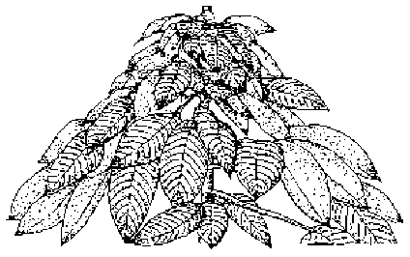 | 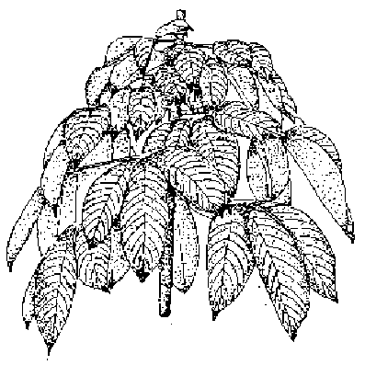
1 | 2
acute | obtuse

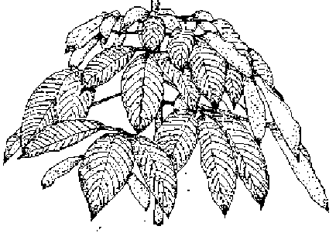 | 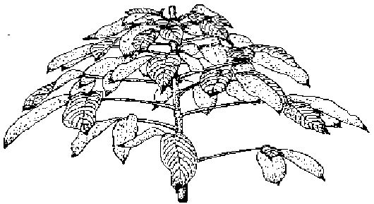
3 | 4
round | flattened

Ad. 7: Leaflet blade: attitude in relation to petiole

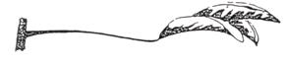 | 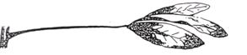
1 | 2
semi-erect | horizontal

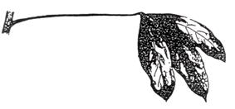
3
semi-drooping

Ad. 9: Leaflet blade: position of broadest part

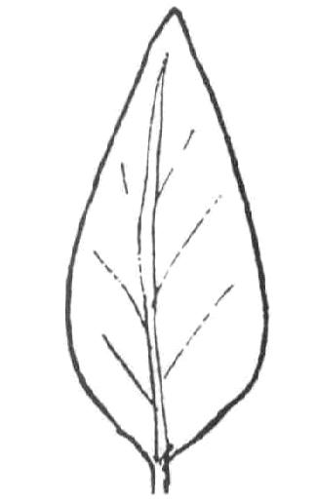 | 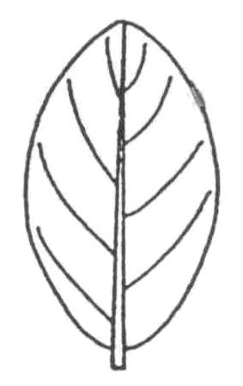 | 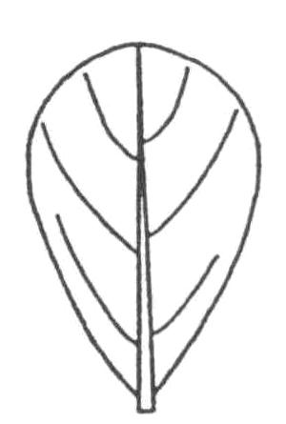
1 | 2 | 3
towards base | at middle | towards apex

Ad. 10: Leaflet blade: axis in longitudinal section

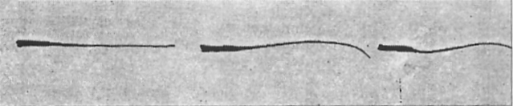
1 | 2 | 3
straight | convex | sigmoid

Ad. 11: Leaflet blade: undulation of margin

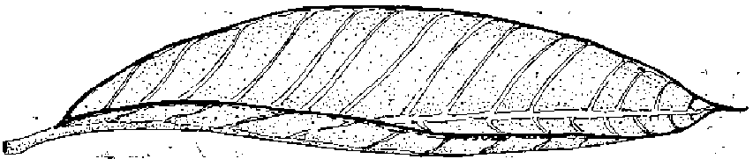 | 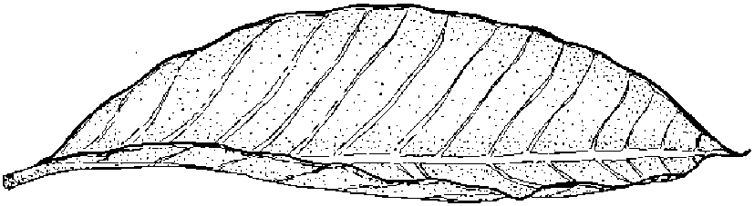 | 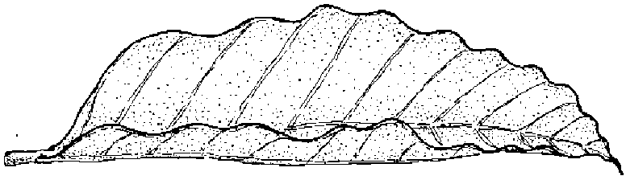
1 | 2 | 3
absent or weak | medium | strong

Ad. 12: Leaflet blade: shape of base

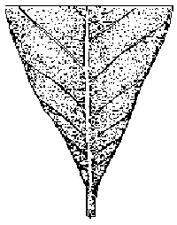 | 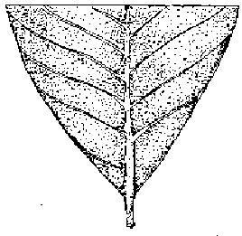 | 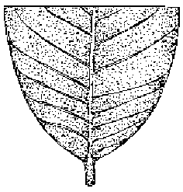
1 | 2 | 3
attenuate | cuneate | obtuse

Ad. 13: Leaflet blade: shape of apex excluding tip

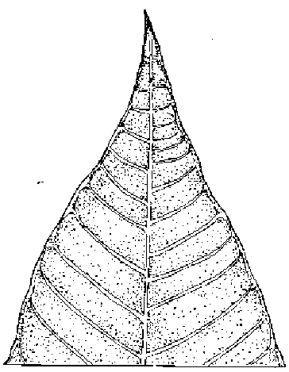 | 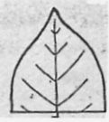 | 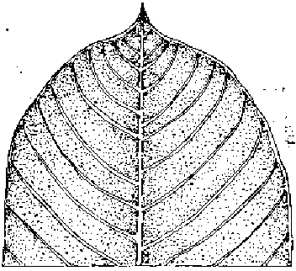
1 | 2 | 3
acute | obtuse | rounded

Ad. 14: Petiole: attitude

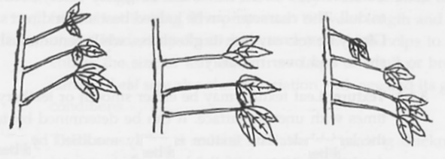
1 | 2 | 3
semi-erect | horizontal | semi-drooping

Ad. 15: Trunk: curvature of axis

1 | 2 | 3
straight or slightly curved | moderately curved | strongly curved

Ad. 16: Trunk: diameter

The diameter of the trunk should be observed at 1 meter above the ground.

Ad. 17: Trunk: main color of bark

The main color is the color with the largest surface area.

Ad. 19: Tree: shape

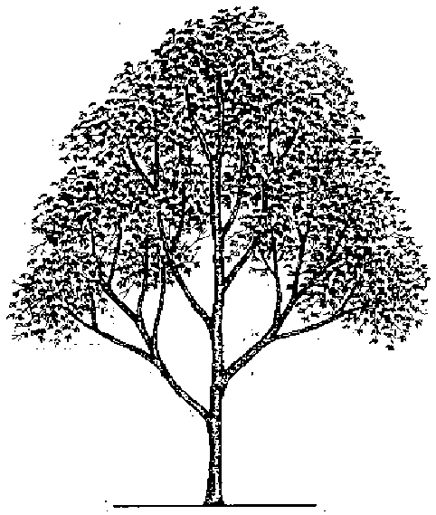 | 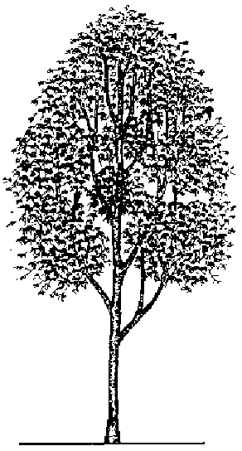
1  triangular | 2  ovate
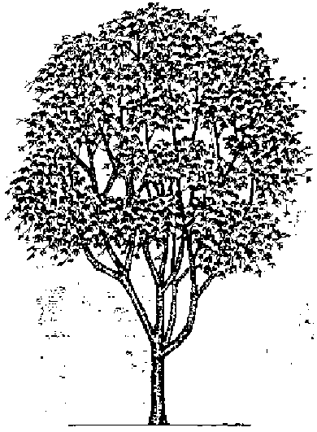 | 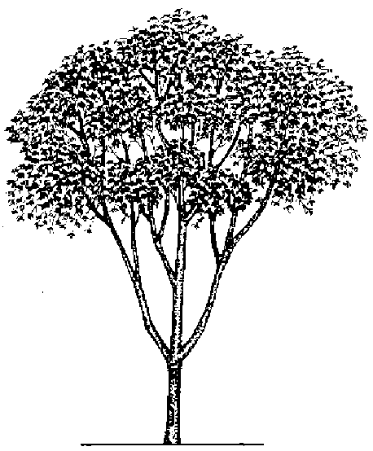
3  circular | 4  oblate

Ad. 21: Coagulum: color of surface

Observation of color is made on 5 ml of latex collected in a plastic cup from a tree tapped in half-spirale from at least one month. The coagulum color is evaluated on the surface exposed to the air, 48 hours after tapping.

Ad. 22: Tree: winter leaf shed

Absent: no leaves fall
Partial: some leaves fall
Full: all leaves fall from the tree

Ad. 24: Seed: length
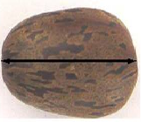

Ad. 25: Seed: width

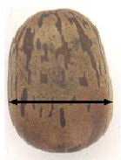

Ad. 26: Seed: thickness

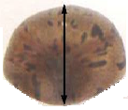

Ad. 27: Seed: shape in dorsal view

 |  | 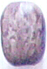 | 
1 | 2 | 3 | 4
elliptic | circular | oblong | obovate

(Point of attachment is at the base in these illustrations)

Literature
Bobilioff, W., 1931: Colour reactions of latex as a mark of identification of Hevea clones. Archives of Rubber Cultivation, 15: pp. 289-309.

Department of Agriculture, 2002: Plant Germoplasm Database: Para rubber. Department of Agriculture. Bangkok, TH, 114 pp.

Dijkman, M.J.,1939: Identificatiekenmerken van de voornaamste in de praktijk aageplante Hevea cloonen. Buitenzorg Central Proefstations Vereeniging Archipel Drukkerij. 263pp.

Dijkman, M.J., 1951: Hevea: Thirty years of research in the Far East. University of Miami Press, Florida, US, pp. 155-177.

Mercykutty, V.C., Marattukalam, J.G., Saraswathyamma, C.K., Meenakumari, T., 2002: Identification of Hevea clones. A manual. Rubber Research Institute of India. 103 pp.

Mercykutty, V.C., (1998) Clone identification I. Rubber, 386: 21-25.

Mercykutty V.C., (1998) Clone identfication II. Rubber, 387: pp. 15-18.

Mercykutty, V.C., Varghese, Y., Licy, J., Panikkar, A.O.N., 1991: Juvenile characters and seed morphology of certain modern Hevea clones. Indian Journal of Natural Rubber Research, 4(1): pp. 16-25.

Thomas V., Mercykutty, V.C. and Saraswathyamma, C.K., 1996: Seed morphology of the rubber tree (Hevea brasiliensis, Muell. Arg. Euphorbiaceae): A review. Phytomorphology; 46(4): pp. 335-342.

Technical Questionnaire
TECHNICAL QUESTIONNAIRE |  |  |  | Page {x} of {y} |  | Reference Number:
 |  |  |  |  |  | Application date:
 |  |  |  |  |  | (not to be filled in by the applicant)
TECHNICAL QUESTIONNAIRE
to be completed in connection with an application for plant breeders’ rights

1. Subject of the Technical Questionnaire
1.1 Genus
1.1.1 Botanical name |  |  | Hevea Aubl.
1.1.2 Common name |  |  | Rubber
1.2 Species
(please complete)
2. Applicant
Name
Address
Telephone No.
Fax No.
E-mail address
Breeder (if different from applicant)
3. Proposed denomination and breeder’s reference
Proposed denomination
(if available)

Breeder’s reference
#4. Information on the breeding scheme and propagation of the variety

4.1 Breeding scheme

Variety resulting from:

4.1.1 Crossing

(a) controlled cross [ ]
(please state parent varieties)
(b) partially known cross [ ]
(please state known parent variety(ies))
(c) unknown cross [ ]

4.1.2 Mutation [ ]
(please state parent variety)

4.1.3 Discovery and development [ ]
(please state where and when discovered
and how developed)

4.1.4 Other [ ]
(please provide details)

4.2 Method of propagating the variety

4.2.1 Vegetative propagation

(a) bud grafting [ ]

(b) cuttings [ ]

(c) in vitro propagation [ ]

(d) other (state method) [ ]

4.2.2 Other [ ]
(please provide details)

5. Characteristics of the variety to be indicated (the number in brackets refers to the corresponding characteristic in Test Guidelines; please mark the note which best corresponds).

 | Characteristics |  |  |  |  |  | Example Varieties |  |  |  | Note
5.1  (15) | Trunk: curvature of axis
 | straight or slightly curved |  |  |  |  |  | CDC 312, FDR 5788, GT1, RRIM 600 |  |  |  | 1[ ]
 | moderately curved |  |  |  |  |  | RRII5 |  |  |  | 2[ ]
 | strongly curved |  |  |  |  |  | TP 875 |  |  |  | 3[ ]
5.2  (16) | Trunk: diameter
 | small |  |  |  |  |  | PR 107 |  |  |  | 3[ ]
 | medium |  |  |  |  |  | GT1, RRIM 600 |  |  |  | 5[ ]
 | large |  |  |  |  |  | CDC 312, PB 235, PB 260 |  |  |  | 7[ ]
5.3  (23) | Tree: beginning of winter leaf shed
 | early |  |  |  |  |  | BPM 1, PB 260 |  |  |  | 3[ ]
 | medium |  |  |  |  |  | PB 235 |  |  |  | 5[ ]
 | late |  |  |  |  |  | GT1, RRIM 600 |  |  |  | 7[ ]
6. Similar varieties and differences from these varieties

Please use the following table and box for comments to provide information on how your candidate variety differs from the variety (or varieties) which, to the best of your knowledge, is (or are) most similar. This information may help the examination authority to conduct its examination of distinctness in a more efficient way.

Denomination(s) of variety(ies) similar to your candidate variety |  | Characteristic(s) in which your candidate variety differs from the similar variety(ies) |  |  | Describe the expression of the characteristic(s) for the similar variety(ies) |  |  | Describe the expression of the characteristic(s) for your candidate variety
Example |  | Trunk: diameter |  |  | medium |  |  | large
Comments:

#7. Additional information which may help in the examination of the variety

7.1 In addition to the information provided in sections 5 and 6, are there any additional characteristics which may help to distinguish the variety?

Yes [ ] No [ ]

(If yes, please provide details)

7.2 Are there any special conditions for growing the variety or conducting the examination?

Yes [ ] No [ ]

(If yes, please provide details)

7.3 Other information

8. Authorization for release

(a) Does the variety require prior authorization for release under legislation concerning the protection of the environment, human and animal health?

Yes [ ] No [ ]

(b) Has such authorization been obtained?

Yes [ ] No [ ]

If the answer to (b) is yes, please attach a copy of the authorization.

9. Information on plant material to be examined or submitted for examination.

9.1 The expression of a characteristic or several characteristics of a variety may be affected by factors, such as pests and disease, chemical treatment (e.g. growth retardants or pesticides), effects of tissue culture, different rootstocks, scions taken from different growth phases of a tree, etc.

9.2 The plant material should not have undergone any treatment which would affect the expression of the characteristics of the variety, unless the competent authorities allow or request such treatment. If the plant material has undergone such treatment, full details of the treatment must be given. In this respect, please indicate below, to the best of your knowledge, if the plant material to be examined has been subjected to:

(a) Microorganisms (e.g. virus, bacteria, phytoplasma) Yes [ ] No [ ]

(b) Chemical treatment (e.g. growth retardant, pesticide) Yes [ ] No [ ]

(c) Tissue culture Yes [ ] No [ ]

(d) Other factors Yes [ ] No [ ]

Please provide details for where you have indicated “yes”.

……………………………………………………………

10. I hereby declare that, to the best of my knowledge, the information provided in this form is correct:

Applicant’s name

Signature Date

[End of document]

* These names were correct at the time of the introduction of these Test Guidelines but may be revised or updated. [Readers are advised to consult the UPOV Code, which can be found on the UPOV Website (www.upov.int), for the latest information.]
# Authorities may allow certain of this information to be provided in a confidential section of the Technical Questionnaire.
# Authorities may allow certain of this information to be provided in a confidential section of the Technical Questionnaire.

