 |  | E  TG/249/1  ORIGINAL: English  DATE: 2008-04-09
INTERNATIONAL UNION FOR THE PROTECTION OF NEW VARIETIES OF PLANTS
GENEVA

 | COFFEE  UPOV Codes:  COFFE_ARA; COFFE_CAN; COFFE_ACA  Coffea arabica L.; C. canephora Pierre ex A. Froehner;  C. arabica × C. canephora hybrids | *

GUIDELINES

FOR THE CONDUCT OF TESTS

FOR DISTINCTNESS, UNIFORMITY AND STABILITY

Alternative Names:*

Botanical name | English | French | German | Spanish
Coffea arabica L. | Coffee | Caféier | Kaffee | Cafeto
Coffea canephora Pierre ex A. Froehner | Coffee | Caféier | Kaffee | Cafeto

The purpose of these guidelines (“Test Guidelines”) is to elaborate the principles contained in the General Introduction (document TG/1/3), and its associated TGP documents, into detailed practical guidance for the harmonized examination of distinctness, uniformity and stability (DUS) and, in particular, to identify appropriate characteristics for the examination of DUS and production of harmonized variety descriptions.

ASSOCIATED DOCUMENTS
These Test Guidelines should be read in conjunction with the General Introduction and its associated TGP documents.
TABLE OF CONTENTS PAGE

1. Subject of these Test Guidelines 3
2. Material Required 3
3. Method of Examination 3
3.1 Number of Growing Cycles 3
3.2 Testing Place 3
3.3 Conditions for Conducting the Examination 4
3.4 Test Design 4
3.5 Number of Plants / Parts of Plants to be Examined 4
3.6 Additional Tests 4
4. Assessment of Distinctness, Uniformity and Stability 4
4.1 Distinctness 4
4.2 Uniformity 5
4.3 Stability 5
5. Grouping of Varieties and Organization of the Growing Trial 5
6. Introduction to the Table of Characteristics 6
6.1 Categories of Characteristics 6
6.2 States of Expression and Corresponding Notes 6
6.3 Types of Expression 6
6.4 Example Varieties 6
6.5 Legend 6
7. Table of Characteristics/Tableau des caractères/Merkmalstabelle/Tabla de caracteres 7
8. Explanations on the Table of Characteristics 14
8.1 Explanations covering several characteristics 14
8.2 Explanations for individual characteristics 14
9. Literature 19
10. Technical Questionnaire 20

Subject of these Test Guidelines
These Test Guidelines apply to all varieties of Coffea arabica L. (Arabica type), Coffea canephora Pierre ex A. Froehner (Robusta type) and hybrids between C. arabica L. and C. canephora L..

Material Required
2.1 The competent authorities decide on the quantity and quality of the plant material required for testing the variety and when and where it is to be delivered. Applicants submitting material from a State other than that in which the testing takes place must ensure that all customs formalities and phytosanitary requirements are complied with.

2.2 The material is to be supplied in the form of
(a) six-month- to one-year-old plants on their own roots;
(b) scions grafted on a rootstock to be specified by the competent authority;
(c) budwood to produce grafted plants;
(d) cuttings to produce plants on their own roots; or
(e) seed

2.3 The minimum quantity of plant material, to be supplied by the applicant, should be:

Vegetatively propagated varieties: 8 one-year-old plants, or budwood or cuttings sufficient to produce 8 plants
Seed-propagated varieties: 50 seeds.

2.4 The plant material supplied should be visibly healthy, not lacking in vigor, nor affected by any important pest or disease.

2.5 The plant material should not have undergone any treatment which would affect the expression of the characteristics of the variety, unless the competent authorities allow or request such treatment. If it has been treated, full details of the treatment must be given.

Method of Examination

3.1 Number of Growing Cycles
3.1.1 The minimum duration of tests should normally be two independent growing cycles.

3.1.2 The growing cycle is considered to be the duration of a single growing season, beginning with vegetative growth, followed by flowering and fruit harvest.

3.2 Testing Place
Tests are normally conducted at one place. In the case of tests conducted at more than one place, guidance is provided in TGP/9 “Examining Distinctness”.

3.3 Conditions for Conducting the Examination
The tests should be carried out under conditions ensuring satisfactory growth for the expression of the relevant characteristics of the variety and for the conduct of the examination. In particular, it is essential that the plants produce a satisfactory crop of fruit in each of the two growing cycles.

3.4 Test Design
3.4.1 For seed-propagated varieties: each test should be designed to result in a total of at least 20 plants.

3.4.2 For vegetatively propagated varieties: each test should be designed to result in a total of at least 5 plants.

3.5 Number of Plants / Parts of Plants to be Examined
Unless otherwise indicated, all observations should be made on 5 plants or parts taken from each of 5 plants for vegetatively propagated varieties and 20 plants or parts taken from each of 20 plants for seed-propagated varieties.

3.6 Additional Tests
Additional tests, for examining relevant characteristics, may be established.

Assessment of Distinctness, Uniformity and Stability

4.1 Distinctness
4.1.1 General Recommendations

It is of particular importance for users of these Test Guidelines to consult the General Introduction prior to making decisions regarding distinctness. However, the following points are provided for elaboration or emphasis in these Test Guidelines.

4.1.2 Consistent Differences

The differences observed between varieties may be so clear that more than one growing cycle is not necessary. In addition, in some circumstances, the influence of the environment is not such that more than a single growing cycle is required to provide assurance that the differences observed between varieties are sufficiently consistent. One means of ensuring that a difference in a characteristic, observed in a growing trial, is sufficiently consistent is to examine the characteristic in at least two independent growing cycles.

4.1.3 Clear Differences

Determining whether a difference between two varieties is clear depends on many factors, and should consider, in particular, the type of expression of the characteristic being examined, i.e. whether it is expressed in a qualitative, quantitative, or pseudo-qualitative manner. Therefore, it is important that users of these Test Guidelines are familiar with the recommendations contained in the General Introduction prior to making decisions regarding distinctness.

4.2 Uniformity
4.2.1 It is of particular importance for users of these Test Guidelines to consult the General Introduction prior to making decisions regarding uniformity. However, the following points are provided for elaboration or emphasis in these Test Guidelines:

4.2.2 The assessment of uniformity for seed-propagated varieties should be according to the recommendations for cross-pollinated varieties in the General Introduction.

4.2.3 For the assessment of uniformity of vegetatively propagated varieties, a population standard of 1% and an acceptance probability of at least 95% should be applied. In the case of a sample size of 5 plants, no off-types are allowed.

4.3 Stability
4.3.1 In practice, it is not usual to perform tests of stability that produce results as certain as those of the testing of distinctness and uniformity. However, experience has demonstrated that, for many types of variety, when a variety has been shown to be uniform, it can also be considered to be stable.

4.3.2 Where appropriate, or in cases of doubt, stability may be tested, either by growing a further generation, or by testing a new seed or plant stock to ensure that it exhibits the same characteristics as those shown by the previous material supplied.

Grouping of Varieties and Organization of the Growing Trial
5.1 The selection of varieties of common knowledge to be grown in the trial with the candidate varieties and the way in which these varieties are divided into groups to facilitate the assessment of distinctness are aided by the use of grouping characteristics.

5.2 Grouping characteristics are those in which the documented states of expression, even where produced at different locations, can be used, either individually or in combination with other such characteristics: (a) to select varieties of common knowledge that can be excluded from the growing trial used for examination of distinctness; and (b) to organize the growing trial so that similar varieties are grouped together.

5.3 The following have been agreed as useful grouping characteristics:

(a) Plant: height (characteristic 2)
(b) Fruit: color (characteristic 16).

5.4 Guidance for the use of grouping characteristics, in the process of examining distinctness, is provided through the General Introduction.

Introduction to the Table of Characteristics

6.1 Categories of Characteristics
6.1.1 Standard Test Guidelines Characteristics

Standard Test Guidelines characteristics are those which are approved by UPOV for examination of DUS and from which members of the Union can select those suitable for their particular circumstances.

6.1.2 Asterisked Characteristics

Asterisked characteristics (denoted by *) are those included in the Test Guidelines which are important for the international harmonization of variety descriptions and should always be examined for DUS and included in the variety description by all members of the Union, except when the state of expression of a preceding characteristic or regional environmental conditions render this inappropriate.

6.2 States of Expression and Corresponding Notes
States of expression are given for each characteristic to define the characteristic and to harmonize descriptions. Each state of expression is allocated a corresponding numerical note for ease of recording of data and for the production and exchange of the description.

6.3 Types of Expression
An explanation of the types of expression of characteristics (qualitative, quantitative and pseudo-qualitative) is provided in the General Introduction.

6.4 Example Varieties
Where appropriate, example varieties are provided to clarify the states of expression of each characteristic.

6.5 Legend
(*) Asterisked characteristic – see Chapter 6.1.2

QL Qualitative characteristic – see Chapter 6.3
QN Quantitative characteristic – see Chapter 6.3
PQ Pseudo-qualitative characteristic – see Chapter 6.3

(a)–(d) See Explanations on the Table of Characteristics in Chapter 8.1
(+) See Explanations on the Table of Characteristics in Chapter 8.2

Table of Characteristics/Tableau des caractères/Merkmalstabelle/Tabla de caracteres
Char.  No. |  | English | français | Deutsch |  | español | Example Varieties/  Exemples/  Beispielssorten/  Variedades ejemplo | Note/  Nota
1.  (*)  (+) |  | Plant: shape | Plante: forme | Pflanze: Form |  | Planta: forma
PQ | (a) | conical | conique | kegelförmig |  | cónica | Acaia, Laurina | 1
 |  | ellipsoid | ellipsoïde | ellipsoid |  | elipsoide | Blue Mountain, Granica, Pluma Hidalgo, Tipica | 2
 |  | cylindrical | cylindrique | zylindrisch |  | cilíndrica | Catuaí | 3
2.  (*) |  | Plant: height | Plante: hauteur | Pflanze: Höhe |  | Planta: altura
QN | (a) | very short | très courte | sehr niedrig |  | muy corta | San Ramón, Vila Lobos | 1
 |  | short | courte | niedrig |  | corta | Caturra, IAPAR 59 | 3
 |  | medium | moyenne | mittel |  | media | Catuaí, Rubi, Topázio | 5
 |  | tall | haute | hoch |  | larga | Bourbon | 7
 |  | very tall | très haute | sehr hoch |  | muy larga | Acaia, Mundo Novo | 9
3.  (+) |  | Plant: diameter of canopy | Plante: diamètre du bouquet foliaire | Pflanze: Durch-messer des Laubes |  | Planta: diámetro de la cobertura foliar
QN | (a) | very small | très petit | sehr klein |  | muy pequeño | Vila Lobos | 1
 |  | small | petit | klein |  | pequeño | IAPAR 59 | 3
 |  | medium | moyen | mittel |  | medio | Catuaí, Rubi, Topázio | 5
 |  | large | grand | groß |  | grande | Obatã | 7
 |  | very large | très grand | sehr groß |  | muy grande | Mundo Novo IAC 388-17 | 9
4.  (*)  (+) |  | Plagiotropic primary branch: length of internode | Branche primaire plagiotrope : longueur de l’entre-nœud | Plagiotroper Zweig erster Ordnung: Länge des Internodiums |  | Rama primaria plagiotropa: longitud del entrenudo
QN |  | short | courte | kurz |  | corta | Caturra, IAPAR 59, Típica | 3
 |  | medium | moyenne | mittel |  | media | Catuaí, Rubi, Topázio | 5
 |  | long | longue | lang |  | larga | Mundo Novo | 7
5. |  | Plagiotropic primary branch: intensity of ramification | Branche primaire plagiotrope : intensité de la ramification | Plagiotroper Zweig erster Ordnung: Stärke der Verzweigung | Rama primaria plagiotropa: intensidad de la ramificación
QN |  | very weak | très faible | sehr gering |  | muy débil | Bourbon | 1
 |  | weak | faible | gering |  | débil | Acaia | 3
 |  | medium | moyenne | mittel |  | media | Mundo Novo | 5
 |  | strong | forte | stark |  | fuerte | Catuaí, Rubi, Topázio | 7
 |  | very strong | très forte | sehr stark |  | muy fuerte | San Ramón | 9
6. |  | Leaf: length | Feuille: longueur | Blatt: Länge |  | Hoja: longitud
QN | (b) | very short | très courte | sehr kurz |  | muy corta | Laurina | 1
 |  | short | courte | kurz |  | corta | Bourbon, San Ramón | 3
 |  | medium | moyenne | mittel |  | media | Caturra, Mundo Novo | 5
 |  | long | longue | lang |  | larga | Obatã | 7
 |  | very long | très longue | sehr lang |  | muy large | Maragogipe | 9
7. |  | Leaf: width | Feuille: largeur | Blatt: Breite |  | Hoja: anchura
QN | (b) | very narrow | très étroite | sehr schmal |  | muy estrecha | Laurina | 1
 |  | narrow | étroite | schmal |  | estrecha | Bourbon | 3
 |  | medium | moyenne | mittel |  | media | Caturra, Mundo Novo | 5
 |  | broad | large | breit |  | ancha | Obatã | 7
 |  | very broad | très large | sehr breit |  | muy ancha | Maragogipe | 9
8.  (+) |  | Leaf: shape | Feuille: forme | Blatt: Form |  | Hoja: forma
PQ | (b) | lanceolate | lancéolée | lanzettlich |  | lanceolada |  | 1
 |  | ovate | ovale | eiförmig |  | oval | Maragogipe | 2
 |  | elliptic | elliptique | elliptisch |  | elíptica | San Ramón, Típica | 3
9. |  | Young leaf: anthocyanin coloration | Jeune rameau: pigmentation anthocyanique | Junges Blatt: Anthocyanfärbung |  | Hoja joven: pigmentación antociánica
QN | (b) | absent or weak | absente ou faible | fehlend oder gering |  | ausente o débil | Catuaí, Caturra,  Mundo Novo IAC 376-4 | 1
 |  | medium | moyenne | mittel |  | media | Mundo Novo IAC 379-19 | 2
 |  | strong | forte | stark |  | fuerte | Purpuracens | 3
10. |  | Leaf: undulation of margin | Feuille: ondulation du bord | Blatt: Wellung des Randes |  | Hoja externa: ondulación del borde
QN | (b) | very weak | très faible | sehr gering |  | muy débil |  | 1
 |  | weak | faible | gering |  | débil | Laurina | 3
 |  | medium | moyenne | mittel |  | media | Catuaí, Caturra,  Mundo Novo | 5
 |  | strong | forte | stark |  | fuerte | Típica | 7
11. |  | Leaf: depth of secondary veins | Feuille : profondeur des nervures secondaires | Blatt: Tiefe der Adern zweiter Ordnung |  | Hoja: profundidad de los nervios secundarios
QN | (b) | shallow | peu profond | flach |  | poco profunda | Laurina | 3
 |  | medium | moyen | mittel |  | media | Catuaí, Mundo Novo | 5
 |  | deep | profond | tief |  | profunda |  | 7
12.  (+) |  | Leaf: domatia | Feuille : domaties | Blatt: Domatia |  | Hoja: domacios
QL | (b) | absent | absentes | fehlend |  | ausentes |  | 1
 |  | present | présentes | vorhanden |  | presentes | Típica | 9
13.  (*)  (+) |  | Inflorescence: number of flowers | Inflorescence: nombre de fleurs | Blütenstand: Anzahl Blüten |  | Inflorescencia: número de flores
QN |  | few | faible | gering |  | bajo | Típica | 3
 |  | medium | moyen | mittel |  | medio | Bourbon, Caturra | 5
 |  | many | élevé | groß |  | alto | Catuaí, Rubi, Topázio | 7
14. |  | Fruit: size | Fruit: taille | Frucht: Größe |  | Fruto: tamaño
QN | (c) | very small | très petite | sehr klein |  | muy pequeño | Ibairi | 1
 |  | small | petite | klein |  | pequeño | Bourbon Rojo,  Bourbon Salvadoreño,  Bourbon Amarelo | 3
 |  | medium | moyenne | mittel |  | medio | Caturra Amarelo,  Caturra Rojo,  Catuai Vermelho,  Catuai Amarelo,  Granica, Mundo Novo | 5
 |  | large | grande | groß |  | grande | Acaia, Colômbia,  Costa Rica,  Pluma Hidalgo | 7
 |  | very large | très grande | sehr groß |  | muy grande | Maracatu, Maragogipe, Pacamara, | 9
15.  (*)  (+) |  | Fruit: shape | Fruit: forme | Frucht: Form |  | Fruto: forma
PQ | (c) | elliptic | elliptique | elliptisch |  | elíptica | Laurina IAC 870 | 1
 |  | circular | circulaire | kreisförmig |  | circular | Ibairi | 2
 |  | oblong | oblong | rechteckig |  | oblonga | Mundo Novo | 3
16.  (*) |  | Fruit: color | Fruit: couleur | Frucht: Farbe |  | Fruto: color
PQ | (c) | yellow | jaune | gelb |  | amarillo | Bourbon Amarelo,  Caturra Amarelo, Topázio | 1
 |  | orange | orange | orange |  | naranja |  | 2
 |  | light red | rouge clair | hellrot |  | rojo claro | Mundo Novo,  Oro Azteca, Rubi | 3
17. |  | Fruit: adherence to branch | Fruit: adhérence à la ramification | Frucht: Anhaften am Zweig |  | Fruto: adherencia a la rama
QN | (c) | weak | faible | gering |  | débil | Mundo Novo | 1
 |  | medium | moyenne | mittel |  | media | Catuaí | 2
 |  | strong | forte | stark |  | fuerte | Icatu Amarelo IAC 29-44 | 3
18.  (+) |  | Fruit: dry weight of 100 fruits | Fruit: poids sec de 100 fruits | Frucht: Trocken-gewicht von 100 Früchten |  | Fruto: peso seco de 100 frutos
QN | (c)  (d) | low | petit | niedrig |  | pequeño | Ibairi | 3
 |  | medium | moyen | mittel |  | medio | Catuaí | 5
 |  | high | grand | hoch |  | grande | Maragogipe | 7
19.  (*)  (+) |  | Seed: length | Pépin: longueur | Samen: Länge |  | Semilla: longitud
QN | (d)  (e) | very short | très courte | sehr kurz |  | muy corta | Ibairi | 1
 |  | short | courte | kurz |  | corta | Bourbon | 3
 |  | medium | moyenne | mittel |  | media | Catuaí, Caturra,  Mundo Novo | 5
 |  | long | longue | lang |  | larga | Acaia, Típica | 7
 |  | very long | très longue | sehr lang |  | muy larga | Maragogipe | 9
20.  (+) |  | Seed: width | Pépin: largeur | Samen: Breite |  | Semilla: anchura
QN | (d)  (e) | narrow | étroite | schmal |  | estrecha | Acaiá | 3
 |  | medium | moyenne | mittel |  | media | Mundo Novo | 5
 |  | broad | large | breit |  | ancha | Catuaí | 7
21.  (+) |  | Seed: length/width ratio | Pépin: rapport longueur/largeur | Samen: Verhältnis Länge/Breite |  | Semilla: relación longitud/anchura
QN | (d)  (e) | small | petit | klein |  | pequeña | Ibairi | 3
 |  | medium | moyen | mittel |  | media | Bourbon, Típica | 5
 |  | large | grand | groß |  | grande | Laurina, Maragogipe | 7
22.  (+) |  | Seed: thickness | Pépin: épaisseur | Samen: Dicke |  | Semilla: grosor
QN | (d)  (e) | thin | fin | dünn |  | delgada | Ibairi | 3
 |  | medium | moyen | mittel |  | media | Mundo Novo | 5
 |  | thick | épais | dick |  | gruesa | Maragogipe | 7
23.  (+) |  | Seed: weight of 100 seeds | Pépin: poids de  100 grains | Samen: Gewicht von 100 Samen |  | Semilla: peso de  100 semillas
QN |  | very low | très petit | sehr niedrig |  | muy pequeño | Ibairi | 1
 |  | low | petit | niedrig |  | pequeño | Laurina | 3
 |  | medium | moyen | mittel |  | medio | Catuaí | 5
 |  | high | grand | hoch |  | grande | Acaia | 7
 |  | very high | très grand | sehr hoch |  | muy grande | Maragogipe | 9
24.  (*)  (+) |  | Period between flowering and harvesting | Période entre floraison et récolte | Zeitraum zwischen Blüte und Ernte |  | Período entre floración y cosecha
QN |  | very short | très courte | sehr kurz |  | muy corto | IAPAR 59 | 1
 |  | short | courte | kurz |  | corto | Bourbon | 3
 |  | medium | moyenne | mittel |  | medio | Mundo Novo | 5
 |  | long | longue | lang |  | largo | Catuaí | 7
 |  | very long | très longue | sehr lang |  | muy largo | Obatã | 9
25.  (+) |  | Seed: caffeine content | Teneur en caféine | Koffeingehalt |  | Contenido de cafeína
QN |  | low | faible | gering |  | bajo | Laurina | 1
 |  | medium | moyenne | mittel |  | mediano | Catuaí, Mundo Novo | 2
 |  | high | élevée | hoch |  | alto |  | 3
26.  (+) |  | Seed: sucrose content | Pépin : teneur en saccharose | Samen: Saccharosegehalt |  | Semilla: contenido de sacarosa:
QN |  | low | faible | gering |  | bajo |  | 1
 |  | medium | moyenne | mittel |  | medio |  | 2
 |  | high | élevée | hoch |  | alto |  | 3
27.  (+) |  | Seed: total chlorogenic acid content | Pépin : teneur totale en acide chlorogénique | Samen: Gesamtgehalt an Chlorogensäure |  | Semilla: contenido total de ácido clorogénico:
QN |  | low | faible | gering |  | bajo |  | 1
 |  | medium | moyenne | mittel |  | medio |  | 2
 |  | high | élevée | hoch |  | alto |  | 3

Explanations on the Table of Characteristics

8.1 Explanations covering several characteristics
Characteristics containing the following key in the second column of the Table of Characteristics should be examined as indicated below:

(a) After the second yield from the third harvest on, assessed on one main stem.
(b) Observations should be made in summer on fully developed leaves from the middle third of a well-developed current season shoot.
(c) Observations should be made at the time of harvest on ripe fruits unless otherwise stated.
(d) To be observed on non-floating fruits only.
(e) To be measured from a sample of 20 seeds.

8.2 Explanations for individual characteristics
Ad. 1: Plant: shape
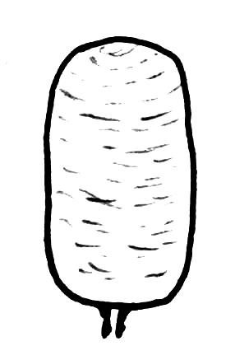
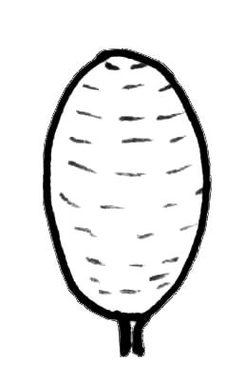
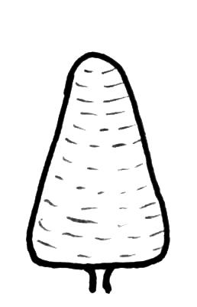

1 | 2 | 3
conical | ellipsoid | cylindrical

Ad. 3: Plant: diameter of canopy

The observation should correspond to the maximum diameter.

Ad. 4: Plagiotropic primary branch: length of internode

The length of the internodes should be observed in the middle third of the branch.

Plagiotropic: mode of growth of lateral branches, growing horizontally away from the leading shoot and maintaining a different morphology

Orthotropic: mode of growth of vertical branches or leading shoots, where lateral (plagiotropic) branches may have different morphology

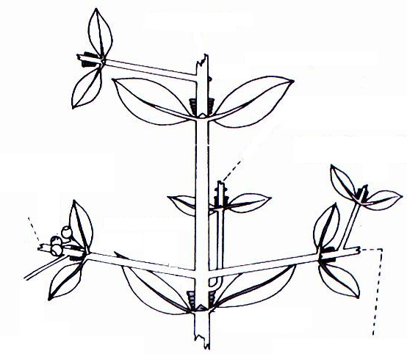
orthotropic branch
plagiotropic branch
plagiotropic branch

Ad. 8: Leaf: shape

 |  | 
1 | 2 | 3
lanceolate | ovate | elliptic

Ad. 12: Leaf: domatia

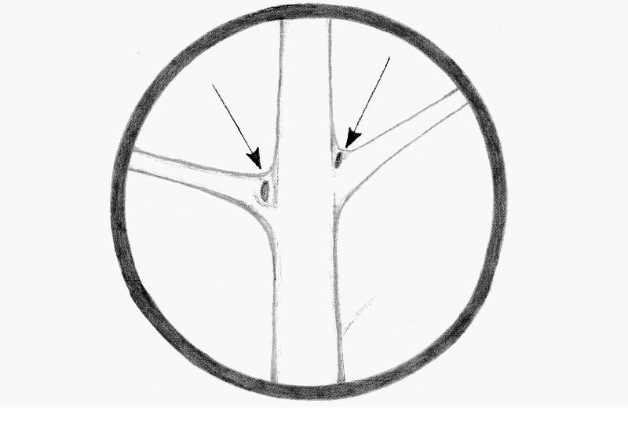
Leaf domatia are small raised structures found on the lower surface of the leaves, partly enclosed by leaf tissue or hairs, located in the axils of the veins of Coffea arabica L., C. canephora and other plants of Rubiaceae family.

Ad. 13: Inflorescence: number of flowers

The number of flowers per axil should be observed on the middle third of the plant on the flower bud, before anthesis.

Ad. 15: Fruit: shape

 |  | 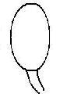
1 | 2 | 3
elliptic | circular | oblong

Ad. 18: Fruit: dry weight of 100 fruits

Only non-floating fruits at 12% of moisture content should be used for the observation of this characteristic.
Ad. 19: Seed length
Ad. 20: Seed width
Ad. 21: Seed length/width ratio
Ad. 22: Seed thickness

length
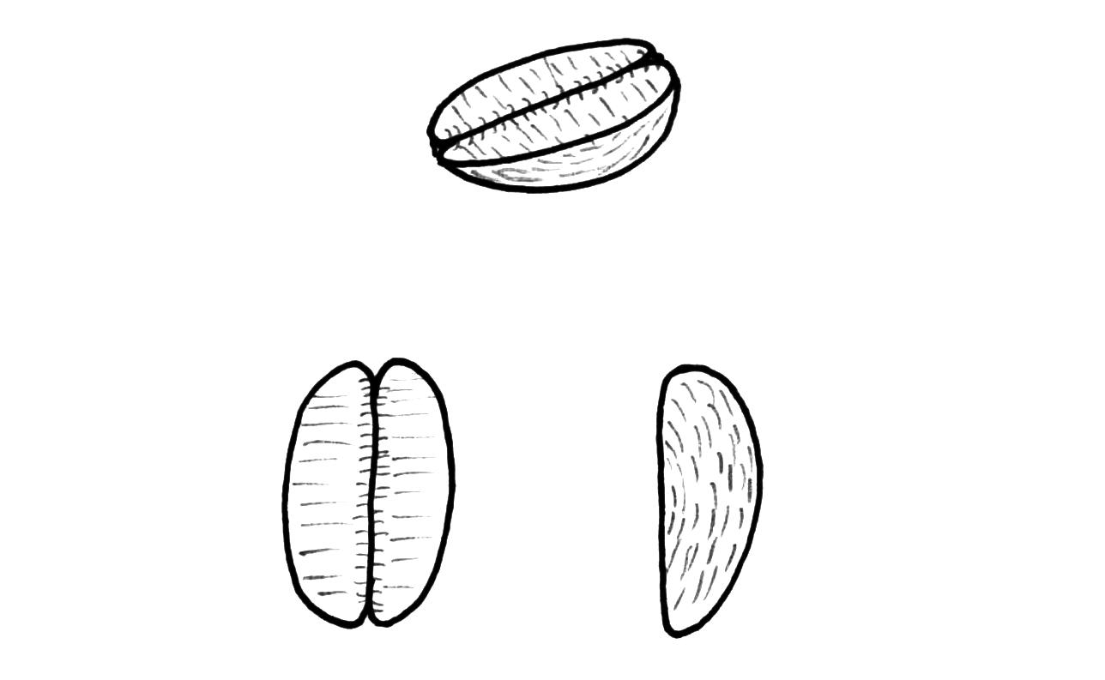

thickness

width
width
thickness

length

Ad. 22: Seed: thickness

The measurement should be made on flat-type seeds.

Ad. 23: Seed: weight of 100 seeds

Only non-floating fruits and flat-type seeds, excluding pea-berry seeds, should be observed. The seeds should be at 12% moisture.

Ad. 24: Period between flowering and harvesting

The time of flowering is when the greatest number of flowers are at anthesis (the main flush). The time of harvesting is when 50% of the berries from the main flush have reached mature color.

Ad. 25: Seed: caffeine content
Ad. 26: Seed: sucrose content
Ad. 27: Seed: total chlorogenic acid content

The following methods should be used:

- Caffeine content and total chlorogenic acid content:

Clifford, M.N.; Ohiokpehai, O.; Menezes, H. C., 1985: 11th International Scientific Colloquium on Coffee-ASIC. Vol. 1, pp. 252-262.

- Sucrose content:

Rogers, W. J.; Michaux, S., Bastin, M.; Bucheli, P., 1999: Changes to the content of sugars, sugar alcohols, myo-inositol, carboxilic acids and inorganic anions in developing grains from different varieties of Robusta (Coffea canephora) and Arabica (Coffea arabica) coffees. Plant Science, 149: 115-123.

The states of expression are determined as follows:

Varieties of Coffea arabica |  | % of dry weight
 | Characteristic | low | medium | high
Char. 25 | Caffeine content | <0,9 | 0,9-1,2 | >1,2
Char. 26 | Sucrose content | <7,0 | 7,0-9,0 | >9,0
Char. 27 | Total Chlorogenic Acid content | <4,5 | 4,5-6,5 | >6,5

Varieties of Coffea canephora |  | % of dry weight
 | Characteristic | low | medium | high
Char. 25 | Caffeine content | <1,8 | 1,8-2,5 | >2,5
Char. 26 | Sucrose content | <4,5 | 4,5-7,0 | >7,0
Char. 27 | Total Chlorogenic Acid content | <7,0 | 7,0-8,0 | >8,0

Literature
Analysis of Carbohydrates by High Performance Anion Exchange, Chromatography with Pulsed Amperometric Detection (HPAE-PAD). Technical Note n° 20 edited by Dionex. 1993 Dionex Corporation. 1228 Titan Way, P.O Box 3603. Sunnyvale, CA 94088-3603.

Carvalho, A., Medina Filho, H.P., Fazuoli, L.C., Guerreiro Filho, O., Lima, M.M.A., 1991: Aspectos genéticos do cafeeiro. Revista Brasileira de Genética, BR, v. 14, n.1, pp. 135-183.

Carvalho, A., 1958: Advances in coffee production technology. Recent advances in our knowledge of coffee trees. 2 - Genetics Coffee and Tea Industries and the Flavor Field, BR, v. 81, pp. 30-36.

Clifford, M.N.; Ohiokpehai, O.; Menezes, H. C., 1985: 11th International Scientific Colloquium on Coffee-ASIC. Vol. 1, pp. 252-262.

Fazuoli, L.C., Silvarolla, M.B., Camargo, C.E. de O., Pommer, C.V., Chiavegato, E.J., Dall’orto, F.A. C., Nagai, H., Godoy, I.J., Veiga, R.F. de A., 1994: Descritores mínimos para o registro institucional de cultivares: Café. Campinas: Instituto Agronômico, Documentos IAC 46, BR.

Krug, C.A., Carvalho, A., 1951: The genetics of Coffea. Advances in Genetics, 4:127-158.

Krug, C.A., Mendes, J.E.T.&Carvalho, A., 1939: Taxonomia de Coffea arabica L. Descrição das variedades e formas encontradas no Estado de São Paulo. Campinas, Instituto Agronômico, Boletim técnico 62, 57 pp.

Mondolot L., La Fisca P., Buatois B., Talansier E., de Kochko A., Campa C., 2006: Evolution in caffeoylquinic acid content and histolocalization during Coffea canephora leaf development. Ann. Bot, London, GB, 98(1):33-40.

Rena, A.B., Maestri, M., 1984: Fisiologia do cafeeiro. In: Rena, A.B., Malavolta, E., Yamada, T. (Ed.). Cultura do cafeeiro: fatores que afetam a produtividade. Piracicaba: Potafs, pp. 3-85.

Rogers, W. J.; Michaux, S., Bastin, M.; Bucheli, P., 1999: Changes to the content of sugars, sugar alcohols, myo-inositol, carboxilic acids and inorganic anions in developing grains from different varieties of Robusta (Coffea canephora) and Arabica (Coffea arabica) coffees. Plant Science, 149: 115-123.

Zamarripa Colmanero, A., Escamilla Prado, E., 2002: Variedades de café en México, origen, características y pespectivas. Centro Nacional de Investigación para el Desarrollo de Regiones Cafetaleras-Centro Regional Universitario Oriente (CRUO). Universidad Autónoma Chapingo. Huatusco, Veracruz, MX, 39 p.

Technical Questionnaire
TECHNICAL QUESTIONNAIRE |  |  |  |  | Page {x} of {y} | Reference Number:
 |  |  |  |  |  | Application date:
 |  |  |  |  |  | (not to be filled in by the applicant)
TECHNICAL QUESTIONNAIRE
to be completed in connection with an application for plant breeders’ rights

1. Subject of the Technical Questionnaire
1.1.1 Botanical name |  | Coffea arabica L.
1.1.2 Common name |  | Arabica Type Coffee
1.2.1 Botanical name |  | Coffea canephora Pierre ex A. Froehner
1.2.2 Common name |  | Robusta Type Coffee
1.3.1 Botanical name |  | Coffea arabica × C. canephora
1.3.2 Common name |  | Interspecific Hybrid
2. Applicant
Name
Address
Telephone No.
Fax No.
E-mail address
Breeder (if different from applicant)
3. Proposed denomination and breeder’s reference
Proposed denomination
(if available)
Breeder’s reference
#4. Information on the breeding scheme and propagation of the variety

4.1 Breeding scheme

Variety resulting from:

4.1.1 Crossing

(a) controlled cross [ ]
(please state parent varieties)
(b) partially known cross [ ]
(please state known parent variety(ies))
(c) unknown cross [ ]

4.1.2 Mutation [ ]
(please state parent variety)

4.1.3 Discovery and development [ ]
(please state where and when discovered
and how developed)

4.1.4 Other [ ]
(please provide details)

4.2 Method of propagating of the variety

TECHNICAL QUESTIONNAIRE |  |  | Page {x} of {y} |  |  | Reference Number:
5. Characteristics of the variety to be indicated (the number in brackets refers to the corre-sponding characteristic in Test Guidelines; please mark the note which best corresponds)
 | Characteristics |  |  |  |  | Example Varieties | Note
5.1  (1) | Plant: shape
 | conical |  |  |  |  | Acaia, Laurina | 1[ ]
 | ellipsoid |  |  |  |  | Blue Mountain, Granica,  Pluma Hidalgo, Tipica | 2[ ]
 | cylindrical |  |  |  |  | Catuaí | 3[ ]
5.2  (2) | Plant: height
 | very short |  |  |  |  | San Ramón, Vila Lobos | 1[ ]
 | short |  |  |  |  | IAPAR 59, Caturra | 3[ ]
 | medium |  |  |  |  | Catuaí, Rubi, Topázio | 5[ ]
 | tall |  |  |  |  | Bourbon | 7[ ]
 | very tall |  |  |  |  | Acaia, Mundo Novo | 9[ ]
5.3  (16) | Fruit: color
 | yellow |  |  |  |  | Bourbon Amarelo,  Caturra Amarelo, Topázio | 1[ ]
 | orange |  |  |  |  |  | 2[ ]
 | light red |  |  |  |  | Mundo Novo, Oro Azteca, Rubi | 3[ ]
5.4  (24) | Period between flowering and harvesting
 | very short |  |  |  |  | IAPAR 59 | 1[ ]
 | short |  |  |  |  | Bourbon | 3[ ]
 | medium |  |  |  |  | Mundo Novo | 5[ ]
 | long |  |  |  |  | Catuaí | 7[ ]
 | very long |  |  |  |  | Obatã | 9[ ]
TECHNICAL QUESTIONNAIRE |  |  | Page {x} of {y} |  | Reference Number:

6. Similar varieties and differences from these varieties

Please use the table, and space provided for comments, below to provide information on how your candidate variety differs from the variety (or varieties) which, to the best of your knowledge, is (or are) most similar. This information may help the examination authority to conduct its examination of distinctness in a more efficient way.

Denomination(s) of variety(ies) similar to your candidate variety | Characteristic(s) in which your candidate variety differs from the similar variety(ies) | Describe the expression of the characteristic(s) for the similar variety(ies) | Describe the expression of the characteristic(s) for your candidate variety
Example | Plant: diameter of canopy | small | medium
Comments:

TECHNICAL QUESTIONNAIRE | Page {x} of {y} | Reference Number:
#7. Additional information which may help in the examination of the variety

7.1 In addition to the information provided in sections 5 and 6, are there any additional characteristics, which may help to distinguish the variety?

Yes [ ] No [ ]

(If yes, please provide details)

7.2 Are there any special conditions for growing the variety or conducting the examination?

Yes [ ] No [ ]

(If yes, please provide details)

8. Authorization for release

(a) Does the variety require prior authorization for release under legislation concerning the protection of the environment, human and animal health?

Yes [ ] No [ ]

(b) Has such authorization been obtained?

Yes [ ] No [ ]

If the answer to (b) is yes, please attach a copy of the authorization.

TECHNICAL QUESTIONNAIRE | Page {x} of {y} | Reference Number:

9. Information on plant material to be examined or submitted for examination.

9.1 The expression of a characteristic or several characteristics of a variety may be affected by factors, such as pests and disease, chemical treatment (e.g. growth retardants or pesticides), effects of tissue culture, different rootstocks, scions taken from different growth phases of a tree, etc.

9.2 The plant material should not have undergone any treatment which would affect the expression of the characteristics of the variety, unless the competent authorities allow or request such treatment. If the plant material has undergone such treatment, full details of the treatment must be given. In this respect, please indicate below, to the best of your knowledge, if the plant material to be examined has been subjected to:

(a) Microorganisms (e.g. virus, bacteria, phytoplasma) Yes [ ] No [ ]

(b) Chemical treatment (e.g. growth retardant, pesticide) Yes [ ] No [ ]

(c) Tissue culture Yes [ ] No [ ]

(d) Other factors Yes [ ] No [ ]

Please provide details for where you have indicated “yes”.

……………………………………………………………

10. I hereby declare that, to the best of my knowledge, the information provided in this form is correct:

Applicant’s name

Signature Date

[End of document]

* These names were correct at the time of the introduction of these Test Guidelines but may be revised or updated. [Readers are advised to consult the UPOV Code, which can be found on the UPOV Website (www.upov.int), for the latest information.]
# Authorities may allow certain of this information to be provided in a confidential section of the Technical Questionnaire.
# Authorities may allow certain of this information to be provided in a confidential section of the Technical Questionnaire.

