 |  | E  TG/248/1  ORIGINAL: English  DATE: 2007-03-28
INTERNATIONAL UNION FOR THE PROTECTION OF NEW VARIETIES OF PLANTS
GENEVA

 | COMMON MILLET  UPOV Code: PANIC_MIL  Panicum miliaceum L. | *

GUIDELINES

FOR THE CONDUCT OF TESTS

FOR DISTINCTNESS, UNIFORMITY AND STABILITY

Alternative Names:*

Botanical name | English | French | German | Spanish
Panicum miliaceum L. | Common Millet | Millet commun, Panic millet,  Panic faux millet | Rispenhirse | Mijo común

The purpose of these guidelines (“Test Guidelines”) is to elaborate the principles contained in the General Introduction (document TG/1/3), and its associated TGP documents, into detailed practical guidance for the harmonized examination of distinctness, uniformity and stability (DUS) and, in particular, to identify appropriate characteristics for the examination of DUS and production of harmonized variety descriptions.

ASSOCIATED DOCUMENTS

These guidelines (“Test Guidelines”) should be read in conjunction with document TG/1/3, “General Introduction to the Examination of Distinctness, Uniformity and Stability and the Development of Harmonized Descriptions of New Varieties of Plants” (hereinafter referred to as the “General Introduction”) and its associated “TGP” documents.

TABLE OF CONTENTS PAGE

1. Subject of these Test Guidelines 3
2. Material Required 3
3. Method of Examination 3
3.1 Number of Growing Cycles 3
3.2 Testing Place 3
3.3 Conditions for Conducting the Examination 3
3.4 Test Design 4
3.5 Number of Plants / Parts of Plants to be Examined 4
3.6 Additional Tests 4
4. Assessment of Distinctness, Uniformity and Stability 4
4.1 Distinctness 4
4.2 Uniformity 5
4.3 Stability 5
5. Grouping of Varieties and Organization of the Growing Trial 5
6. Introduction to the Table of Characteristics 6
6.1 Categories of Characteristics 6
6.2 States of Expression and Corresponding Notes 6
6.3 Types of Expression 6
6.4 Example Varieties 6
6.5 Legend 7
7. Table of Characteristics/Tableau des caractères/Merkmalstabelle/Tabla de caracteres 8
8. Explanations on the Table of Characteristics 18
8.1 Explanations covering several characteristics 18
8.2 Explanations for individual characteristics 18
8.3 Decimal Code for the Growth Stages of Cereals 25
9. Literature 28
10. Technical Questionnaire 29

Subject of these Test Guidelines
These Test Guidelines apply to all varieties of Panicum miliaceum L. of the family Poaceae.

Material Required
2.1 The competent authorities decide on the quantity and quality of the plant material required for testing the variety and when and where it is to be delivered. Applicants submitting material from a State other than that in which the testing takes place must ensure that all customs formalities and phyto-sanitary requirements are complied with.

2.2 The material is to be supplied in the form of seeds and, if requested by the competent authority, panicles should also be submitted.

2.3 The minimum quantity of plant material, to be supplied by the applicant, should be:

seed: 1 kg; and
panicles (if requested): 100.

2.4 The seed should meet the minimum requirements for germination, species and analytical purity, health and moisture content, specified by the competent authority. In cases where the seed is to be stored, the germination capacity should be as high as possible and should, be stated by the applicant. Panicles should contain a sufficient number of viable seeds to establish a satisfactory row of plants for observation.

2.5 The plant material supplied should be visibly healthy, not lacking in vigor, nor affected by any important pest or disease.

2.6 The plant material should not have undergone any treatment which would affect the expression of the characteristics of the variety, unless the competent authorities allow or request such treatment. If it has been treated, full details of the treatment must be given.

Method of Examination

3.1 Number of Growing Cycles
The minimum duration of tests should normally be two independent growing cycles.

3.2 Testing Place
Tests are normally conducted at one place. In the case of tests conducted at more than one place, guidance is provided in TGP/9 “Examining Distinctness”.

3.3 Conditions for Conducting the Examination
3.3.1 The tests should be carried out under conditions ensuring satisfactory growth for the expression of the relevant characteristics of the variety and for the conduct of the examination.
3.3.2 The optimum stage of development for the assessment of each characteristic is indicated by a number in the second column of the Table of Characteristics. The stages of development denoted by each number are described at the end of Chapter 8.3.

3.3.3 The recommended method of observing the characteristic is indicated by the following key in the second column of the Table of Characteristics:

MG: single measurement of a group of plants or parts of plants
MS: measurement of a number of individual plants or parts of plants
VG: visual assessment by a single observation of a group of plants or parts of plants
VS: visual assessment by observation of individual plants or parts of plants

3.4 Test Design
3.4.1 The design of the tests should be such that plants or parts of plants may be removed for measurement or counting without prejudice to the observations which must be made up to the end of the growing cycle.

3.4.2 Each test should be designed to result in a total of at least 1,000 plants, which should be divided between two or more replicates.

3.4.3 Single panicle-rows: if tests on panicle-rows are conducted, at least 100 panicle-rows should be observed.

3.5 Number of Plants / Parts of Plants to be Examined
Unless otherwise indicated, all observations on single plants should be made on 20 plants or parts taken from each of 20 plants and any other observations should be made on all plants in the test.

3.6 Additional Tests
Additional tests, for examining relevant characteristics, may be established.

Assessment of Distinctness, Uniformity and Stability

4.1 Distinctness
4.1.1 General Recommendations

It is of particular importance for users of these Test Guidelines to consult the General Introduction prior to making decisions regarding distinctness. However, the following points are provided for elaboration or emphasis in these Test Guidelines.

4.1.2 Consistent Differences

The differences observed between varieties may be so clear that more than one growing cycle is not necessary. In addition, in some circumstances, the influence of the environment is not such that more than a single growing cycle is required to provide assurance that the differences observed between varieties are sufficiently consistent. One means of ensuring that a difference in a characteristic, observed in a growing trial, is sufficiently consistent is to examine the characteristic in at least two independent growing cycles.

4.1.3 Clear Differences

Determining whether a difference between two varieties is clear depends on many factors, and should consider, in particular, the type of expression of the characteristic being examined, i.e. whether it is expressed in a qualitative, quantitative, or pseudo-qualitative manner. Therefore, it is important that users of these Test Guidelines are familiar with the recommendations contained in the General Introduction prior to making decisions regarding distinctness.

4.2 Uniformity
4.2.1 It is of particular importance for users of these Test Guidelines to consult the General Introduction prior to making decisions regarding uniformity. However, the following points are provided for elaboration or emphasis in these Test Guidelines:

4.2.2 Row plots: For the assessment of uniformity on row plots, a population standard of 0.1% and an acceptance probability of at least 95% should be applied. In the case of a sample size of 1,000 plants, 3 off-types are allowed.

4.2.3 Single panicle rows: For the assessment of uniformity on single panicle rows, a population standard of 1% and an acceptance probability of at least 95% should be applied. In the case of a sample size of 100 panicle rows, 3 off-type rows are allowed.

4.3 Stability
4.3.1 In practice, it is not usual to perform tests of stability that produce results as certain as those of the testing of distinctness and uniformity. However, experience has demonstrated that, for many types of variety, when a variety has been shown to be uniform, it can also be considered to be stable.

4.3.2 Where appropriate, or in cases of doubt, stability may be tested, either by growing a further generation, or by testing a new seed stock to ensure that it exhibits the same characteristics as those shown by the previous material supplied.

Grouping of Varieties and Organization of the Growing Trial
5.1 The selection of varieties of common knowledge to be grown in the trial with the candidate varieties and the way in which these varieties are divided into groups to facilitate the assessment of distinctness are aided by the use of grouping characteristics.

5.2 Grouping characteristics are those in which the documented states of expression, even where produced at different locations, can be used, either individually or in combination with other such characteristics: (a) to select varieties of common knowledge that can be excluded from the growing trial used for examination of distinctness; and (b) to organize the growing trial so that similar varieties are grouped together.
5.3 The following have been agreed as useful grouping characteristics:

(a) Time of panicle emergence (characteristic 9)
(b) Plant: natural height (characteristic 10)
(c) Panicle: angle of branches (characteristic 11)
(d) Glume: anthocyanin coloration (characteristic 21)
(e) Grain: color (characteristic 25)

5.4 Guidance for the use of grouping characteristics, in the process of examining distinctness, is provided through the General Introduction.

Introduction to the Table of Characteristics

6.1 Categories of Characteristics
6.1.1 Standard Test Guidelines Characteristics

Standard Test Guidelines characteristics are those which are approved by UPOV for examination of DUS and from which members of the Union can select those suitable for their particular circumstances.

6.1.2 Asterisked Characteristics

Asterisked characteristics (denoted by *) are those included in the Test Guidelines which are important for the international harmonization of variety descriptions and should always be examined for DUS and included in the variety description by all members of the Union, except when the state of expression of a preceding characteristic or regional environmental conditions render this inappropriate.

6.2 States of Expression and Corresponding Notes
States of expression are given for each characteristic to define the characteristic and to harmonize descriptions. Each state of expression is allocated a corresponding numerical note for ease of recording of data and for the production and exchange of the description.

6.3 Types of Expression
An explanation of the types of expression of characteristics (qualitative, quantitative and pseudo-qualitative) is provided in the General Introduction.

6.4 Example Varieties
Where appropriate, example varieties are provided to clarify the states of expression of each characteristic.

6.5 Legend
(*) Asterisked characteristic – see Chapter 6.1.2

QL Qualitative characteristic – see Chapter 6.3
QN Quantitative characteristic – see Chapter 6.3
PQ Pseudo-qualitative characteristic – see Chapter 6.3

MG, MS, VG, VS: See Chapter 3.3.3

(a) See Explanations on the Table of Characteristics in Chapter 8.1

(+) See Explanations on the Table of Characteristics in Chapter 8.2

56-92 See Explanations on the Table of Characteristics in Chapter 8.3

Table of Characteristics/Tableau des caractères/Merkmalstabelle/Tabla de caracteres
 |  | English | français | Deutsch | español | Example Varieties/  Exemples/  Beispielssorten/  Variedades ejemplo | Note/  Nota
1.  (+) | 56-59  VG | Flag leaf: attitude of blade | Dernière feuille : port du limbe | Oberstes Blatt: Haltung der Blattspreite | Hoja bandera: porte del limbo
PQ |  | erect | dressé | aufrecht | erecto | Saratovske 8 | 1
 |  | semi-erect | demi-dressé | halbaufrecht | semierecto | Kyivske 87, Veselopodilske 16 | 3
 |  | horizontal | horizontal | waagerecht | horizontal | Kyivske 96,  Myronivske 51 | 5
 |  | semi-drooping | demi-retombant | halbüberhängend | semidescendente | Voronizke 899 | 7
2.  (*) | 56-59  VG | Flag leaf: anthocyanin coloration | Dernière feuille : pigmentation anthocyanique | Oberstes Blatt: Anthocyanfärbung | Hoja bandera: coloración antociánica
QL |  | absent | absente | fehlend | ausente | Sonyachne | 1
 |  | present | présente | vorhanden | presente | Lilove | 9
3.  (*) | 56-59  VG | Flag leaf: intensity of anthocyanin coloration | Dernière feuille : intensité de la pigmentation anthocyanique | Oberstes Blatt: Intensität der Anthocyanfärbung | Hoja bandera: intensidad de la coloración antociánica
QN |  | weak | faible | gering | débil | Lilove, Veselopodolyanske 305 | 3
 |  | medium | moyenne | mittel | media | Veselopodolyanske 403 | 5
 |  | strong | forte | stark | fuerte | Irtyshske 201 | 7
4. | 56-59  MS | Flag leaf: length | Dernière feuille : longueur | Oberstes Blatt: Länge | Hoja bandera: longitud
QN |  | short | courte | kurz | corta | Charivne,  Veselopodilske 16, | 3
 |  | medium | moyenne | mittel | media | Kyivske 87,  Myronivske 51 | 5
 |  | long | longue | lang | larga | Kharkivske 71 | 7
5. | 56-59  MS | Flag leaf: width | Dernière feuille : largeur | Oberstes Blatt: Breite | Hoja bandera: anchura
QN |  | narrow | étroite | schmal | estrecha | Kharkivske 10,  Omske 9 | 3
 |  | medium | moyenne | mittel | media | Novo Kyivske 01, Veselopodolyanske 16 | 5
 |  | broad | large | breit | ancha | Kharkivske 86, Omriyane | 7
6. | 70-79  MS | Stem: number of nodes | Tige : nombre de noeuds | Halm: Anzahl Knoten | Tallo: número de nudos
QN |  | very few | très petit | sehr gering | muy bajo | Omske 9 | 1
 |  | few | petit | gering | bajo | Kyivske 96,  Myronivske 51 | 3
 |  | medium | moyen | mittel | medio | Kharkivske 86,  Novo Kyivske 01 Veselopodilske 16 | 5
 |  | many | grand | groß | alto | Kharkivske kormove | 7
7.  (*)  (+) | 70-79  VG/MS | Stem: length of upper internode | Tige : longueur de l’entre-nœud supérieur | Halm: Länge des oberen Internodiums | Tallo: longitud del entrenudo superior
QN |  | short | court | kurz | corto | Veselopodolyanske 534 | 3
 |  | medium | moyen | mittel | medio | Myronivske 51,  Novo Kyivske 01, Slobozhanske | 5
 |  | long | long | lang | medio | Charivne,  Kharkivske 72 | 7
8.  (+) | 70-79  VG/MS | Stem: thickness of internode | Tige : épaisseur de l’entre-nœud | Halm: Dicke des Internodiums | Tallo: grosor del entrenudo
QN |  | thin | mince | dünn | delgado | Omske | 3
 |  | medium | moyenne | mittel | medio | Veselopodolyanske 632 | 5
 |  | thick | épaisse | dick | grueso | Myronivske 94, Veselopodilske 16 | 7
9.  (*)  (+) | MG | Time of panicle emergence | Époque de l’apparition de la panicule | Zeitpunkt des Rispenschiebens | Época de emergencia de la panícula
QN |  | very early | très précoce | sehr früh | muy temprana | Omske 9 | 1
 |  | early | précoce | früh | temprana | Kyivske 96 | 3
 |  | medium | moyenne | mittel | media | Kharkivske 56 | 5
 |  | late | tardive | spät | tardía | Kharkivske kormove | 7
 |  | very late | très tardive | sehr spät | muy tardía | Illichovske | 9
10.  (*)  (+) | 81-92  MG | Plant: natural height | Plante : hauteur naturelle | Pflanze: natürliche Höhe | Planta: altura
QN |  | short | basse | niedrig | baja | Karlik 305,  Orlovskiy karlik | 3
 |  | medium | moyenne | mittel | media | Kharkivske 86,  Kyivske 96 | 5
 |  | long | haute | hoch | alta | Kharkivske 57, Veselopodilske 16 | 7
11.  (*) (+) | 65-69  VG | Panicle: angle of branches | Panicule : angle des ramifications | Rispe: Winkel der Seitenäste | Panícula: ángulo de las ramas
QN |  | very acute | très aigu | sehr spitz | muy agudo | Pikulovytske | 1
 |  | moderately acute | moyennement aigu | mäßig spitz | moderadamente agudo |  | 2
 |  | right angle | angle droit | rechtwinklig | recto | Chornomorske | 3
 |  | moderately obtuse | moyennement obtus | mäßig stumpf | moderadamente obtuso | Kyivske 87,  Veselopodilske 16 | 4
 |  | very obtuse | très obtus | sehr stumpf | muy obtuso | Omske 9 | 5
12.  (*)  (+) | 65-69  VG | Panicle: attitude | Panicule : port | Rispe: Haltung | Panícula: porte
PQ |  | erect | dressé | aufrecht | erecta | Omske 9 | 1
 |  | semi-erect | demi-dressé | halbaufrecht | semierecta | Charivne, Veselopodolyanske  305-54 | 2
 |  | moderately drooping | moyennement retombant | leicht überhängend | moderadamente colgante | Kyivske 96 | 3
 |  | strongly drooping | fortement retombant | stark überhängend | fuertemente colgante | Kharkivske 57 | 4
13.  (+) | 65-69  MS | Panicle: length (excluding peduncle) | Panicule : longueur (pédoncule non compris) | Rispe: Länge (ohne Blütenstandsstiel | Panícula: longitud (excluido el pedúnculo)
QN |  | very short | très courte | sehr kurz | muy corta | Pikulovytske | 1
 |  | short | courte | kurz | corta | Charivne | 3
 |  | medium | moyenne | mittel | media | Kyivske 96 | 5
 |  | long | longue | lang | larga | Myronivske 94, Novokyivske 01 | 7
 |  | very long | très longue | sehr lang | muy larga | Kyivske 87, Veselopodolyanske 176 | 9
14.  (+) | 65-69  MS | Panicle: width | Panicule : largeur | Rispe: Breite | Panícula: anchura
QN |  | narrow | étroite | schmal | estrecha | Kharkivske 57, Novokyivske 01 | 3
 |  | medium | moyenne | mittel | media | Myronivske 94, Slobozhanske | 5
 |  | broad | large | breit | ancha | Kyivske 87, Veselopodolyanske  305-54 | 7
15.  (*)  (+) | 65-69  VG | Panicle: density | Panicule : densité | Rispe: Dichte | Panícula: densidad
QN |  | lax | lâche | locker | laxa | Myronivske 51 | 3
 |  | medium | demi-lâche | mittel | media | Charivne | 5
 |  | dense | dense | dicht | densa | Pikulovytske | 7
16.  (+) | 65-69  VG | Panicle: degree of curvature of lateral branches | Panicule : degré de courbure des ramifications latérales | Rispe: Grad der Krümmung der Seitenäste | Panícula: grado de curvatura de las ramas laterales
QN |  | absent or very weak | nul ou très faible | fehlend oder sehr gering | ausente o muy débil | Charivne | 1
 |  | weak | faible | gering | débil | Raduha, Kharkivske 71 | 3
 |  | medium | moyen | mittel | media | Novokyivske 01, Slobozhanske | 5
 |  | strong | fort | stark | fuerte | Kharkivske 31,  Myronivske 51 | 7
 |  | very strong | très fort | sehr stark | muy fuerte | Veselopodolyanske 38 | 9
17.  (+) | 65-69  VG | Panicle: number of pillows | Panicule : nombre de coussins | Rispe: Anzahl Kissen | Panícula: número de almohadillas
QN |  | none or very few | aucun ou très peu | fehlend oder sehr gering | nulo o muy bajo | Charivne, Omriyane | 1
 |  | few | peu | gering | bajo | Myronivske 51, Novokyivske 01 | 3
 |  | medium | moyennement nombreux | mittel | medio | Sredneruske | 5
 |  | many | nombreux | groß | alto | Imunne 366,  Zoryane | 7
 |  | very many | très nombreux | sehr groß | muy alto | Syayvo,  Veselopodolyanske 632 | 9
18.  (+) | 65-69  VG | Panicle: length of primary branches | Panicule : longueur des ramifications principales | Rispe: Länge der Äste erster Ordnung | Panícula: longitud de las ramas primarias
QN |  | very short | très courtes | sehr kurz | muy cortas | Pikulovytske | 1
 |  | short | courtes | kurz | cortas | Charivne,  Kharkivske 86 | 3
 |  | medium | moyennes | mittel | medias | Myronivske 51, Veselopodilske 16 | 5
 |  | long | longues | lang | largas | Slobozhanske, Veselopodolyanske 176 | 7
 |  | very long | très longues | sehr lang | muy largas | Voronizhske 884 | 9
19.  (*)  (+) | 81-92  VG | Spikelet: shape | Épillet : forme | Ährchen: Form | Espiguilla: forma
QN |  | narrow elliptic | elliptique étroite | schmal elliptisch | elíptica estrecha | Sonyachne | 1
 |  | broad elliptic | elliptique large | breit elliptisch | elíptica ancha | Lilove,  Veselopodolyanske 176 | 2
 |  | circular | circulaire | kreisförmig | circular | Charivne | 3
20. | 80-92  VG | Spikelet: intensity of yellow color | Épillet : intensité de la couleur jaune | Ährchen: Intensität der Gelbfärbung | Espiguilla: intensidad del color amarillo
QN |  | light | claire | hell | claro | Raduha | 3
 |  | medium | moyenne | mittel | medio | Sonyachne | 5
 |  | dark | foncée | dunkel | oscuro | Kyivske 96 | 7
21.  (*) | 70-79  VG | Glume: anthocyanin coloration | Glume : pigmentation anthocyanique | Hüllspelze: Anthocyanfärbung | Gluma: coloración antociánica
QN |  | absent or very weak | absente ou très faible | fehlend oder sehr gering | ausente o muy ausente | Myronivske 51 | 1
 |  | weak | faible | gering | débil | Veselopodolyanske 403 | 3
 |  | medium | moyenne | mittel | media | Podolyanske 24/273 | 5
 |  | strong | forte | stark | fuerte | Lilove | 7
22. | 60-65  VG | Stigma: color | Stigmate : couleur | Narbe: Farbe | Estigma: color
QL |  | light pink | rose clair | hellrosa | rosa claro | Kharkivske 31,  Kyivske 96 | 1
 |  | violet | violet | violett | violeta | Lilove | 2
23.  (*)  (+) | 90-92  MS | Grain: size | Grain : taille | Korn: Größe | Grano: tamaño
QN |  | small | petite | klein | pequeño | Omske 9 | 3
 |  | medium | moyenne | mittel | medio | Myronivske 51, Syayvo | 5
 |  | large | grande | groß | grande | Kyivske 96, Veselopodolyanske 176 | 7
 |  | very large | très grande | sehr groß | muy grande | Horlinka | 9
24.  (*)  (+) | 90-92  VG | Grain: shape | Grain : forme | Korn: Form | Grano: forma
QN |  | narrow elliptic | elliptique étroite | schmal elliptisch | elíptica estrecha | Kostiantynivske | 1
 |  | broad elliptic | elliptique large | breit elliptisch | elíptica ancha | Kyivske 87,  Kyivske 96,  Myronivske 51,  Myronivske 94 | 2
 |  | circular | circulaire | kreisförmig | circular | Charivne,  Novokyivske,  Veselopodolyanske 63201 | 3
25.  (*) | 90-92  VG | Grain: color | Grain : couleur | Korn: Farbe | Grano: color
PQ |  | white | blanc | weiß | blanco | Tonkoplivchaste 048 | 1
 |  | whitish | blanchâtre | weißlich | blanquecino | Novokyivske 01 | 2
 |  | light yellow | jaune clair | hellgelb | amarillo claro | Veselopodolyanske 38 | 3
 |  | medium yellow | jaune moyen | mittelgelb | amarillo medio | Myronivske 51 | 4
 |  | dark yellow | jaune foncé | dunkelgelb | amarillo oscuro | Saratovske 2 | 5
 |  | golden | doré | goldfarben | dorado | Zolotyste | 6
 |  | light red | rouge clair | hellrot | rojo claro | Tavriyske | 7
 |  | medium red | rouge moyen | mittelrot | rojo medio | Lilove | 8
 |  | dark red | rouge foncé | dunkelrot | rojo oscuro | Veselopodolyanske  305-54 | 9
 |  | red brown | rouge-brun | rotbraun | marrón rojizo | Chornosimyanne 1 | 10
 |  | brown | brun | braun | marrón | Amurske mistseve | 11
 |  | black | noir | schwarz | negro | Hexiaoyingmizi | 12
26. | 90-92  VG | Grain: presence of spotting | Grain : taches | Korn: Vorhandensein von Flecken | Grano: presencia de manchas
QL |  | absent | absentes | fehlend | ausentes | Denkivske, Lana | 1
 |  | present | présentes | vorhanden | presentes | Charivne | 9
27. | 90-92  VG | Grain: size of spots | Grain : taille des taches | Korn: Größe der Flecken | Grano: tamaño de las manchas
QN |  | small | petites | klein | pequeño | Skhidne | 3
 |  | medium | moyennes | mittel | medio | Omriane, Zolushka | 5
 |  | large | grandes | groß | grande | Charivne | 7
28.  (*) | 90-92  MG | Weight per 1000 grains | Grain : poids de 1000 grains | Tausendkorn-  gewicht | Peso de 1.000 granos
QN |  | very low | très petit | sehr niedrig | muy pequeño | Tonkoplivchaste 048 | 1
 |  | low | petit | niedrig | pequeño | Ostrohovske 9 | 3
 |  | medium | moyen | mittel | medio | Sonyachne | 5
 |  | high | grand | hoch | grande | Kharkivske 86,  Myronivske 51, | 7
 |  | very high | très grand | sehr hoch | muy grande | Kyivske 96,  Veselopodilske 16 | 9
29.  (*) | 90-92  VG | Kernel (not polished): color | Cerneau (non poli) : couleur | Nacktes Korn (nicht poliert): Farbe | Cariópside (sin pulir): color
QN | (a) | whitish | blanchâtre | weißlich | blanquecino | Veselopodolyanske 176 | 1
 |  | light yellow | jaune clair | hellgelb | amarillo claro | Kyivske 96 | 2
 |  | medium yellow | jaune moyen | mittelgelb | amarillo medio | Omriyane | 3
30.  (+) | 92  VG | Kernel: intensity of brown color of hilum | Cerneau : intensité de la couleur brune du hile | Nacktes Korn: Intensität der Braunfärbung des Nabels | Cariópside: intensidad del color marrón del hilo
QN | (a) | light | claire | hell | claro | Sonyachne | 3
 |  | medium | moyenne | mittel | medio | Myronivske 51 | 5
 |  | dark | foncée | dunkel | oscuro | Novokyivske 01 | 7
31.  (+) | 92  VG | Kernel: type of endosperm | Cerneau : type d’endosperme | Nacktes Korn: Typ des Endosperms | Cariopse: tipo de endosperma
QL | (a) | waxy | cireux | wachsig | ceroso |  | 1
 |  | non waxy | non cireux | nicht wachsig | no ceroso |  | 2
32. | 57-59  VS | Resistance to smut (Sporisorium destruens: Yank) | Résistance au charbon (Sporisorium destruens) | Resistenz gegen Brand (Sporisorium destruens: Brand an Rispenhirse) | Resistencia al hongo (Sporisorium destruens: Yank)
32.1 |  | Race 1 | Race 1 | Pathotyp 1 | Raza 1
QN |  | susceptible | sensible | anfällig | sensible | Raduha | 1
 |  | moderately resistant | modérément résistant | mäßig resistent | moderadamente resistente |  | 2
 |  | highly resistant | très résistent | hoch resistent | muy resistente | Myronivske 51 | 3
 |  | -------------------------- | -------------------------- | -------------------------- | -------------------------- | -------------------------- | -------
32.2 |  | Race 2 | Race 2 | Pathotyp 2 | Raza 2
QN |  | susceptible | sensible | anfällig | sensible | Novokyivske 01 | 1
 |  | moderately resistant | modérément résistant | mäßig resistent | moderadamente resistente |  | 2
 |  | highly resistant | très résistent | hoch resistent | muy resistente | Myronivske 51 | 3
 |  | -------------------------- | -------------------------- | -------------------------- | -------------------------- | -------------------------- | -------
32.3 |  | Race 3 | Race 3 | Pathotyp 3 | Raza 3
QN |  | susceptible | sensible | anfällig | sensible | Kharkivske 56 | 1
 |  | moderately resistant | modérément résistant | mäßig resistent | moderadamente resistente |  | 2
 |  | highly resistant | très résistent | hoch resistent | muy resistente | Myronivske 51 | 3
 |  | -------------------------- | -------------------------- | -------------------------- | -------------------------- | -------------------------- | -------
32.4 |  | Race 4 | Race 4 | Pathotyp 4 | Raza 4
QN |  | susceptible | sensible | anfällig | sensible | Kyivske 87 | 1
 |  | moderately resistant | modérément résistant | mäßig resistent | moderadamente resistente |  | 2
 |  | highly resistant | très résistent | hoch resistent | muy resistente | Myronivske 51 | 3
 |  | -------------------------- | -------------------------- | -------------------------- | -------------------------- | -------------------------- | -------
32.5 |  | Race 5 | Race 5 | Pathotyp 5 | Raza 5
QN |  | susceptible | sensible | anfällig | sensible | Kyivske 87 | 1
 |  | moderately resistant | modérément résistant | mäßig resistent | moderadamente resistente |  | 2
 |  | highly resistant | très résistent | hoch resistent | muy resistente | Myronivske 51 | 3
32.6 |  | Race 6 | Race 6 | Pathotyp 6 | Raza 6
QN |  | susceptible | sensible | anfällig | sensible | Kyivske 87 | 1
 |  | moderately resistant | modérément résistant | mäßig resistent | moderadamente resistente |  | 2
 |  | highly resistant | très résistent | hoch resistent | muy resistente | Myronivske 51 | 3

Explanations on the Table of Characteristics

8.1 Explanations covering several characteristics
(a) to be observed on dehusked grain without polishing.

8.2 Explanations for individual characteristics

Ad. 1: Flag leaf: attitude of blade

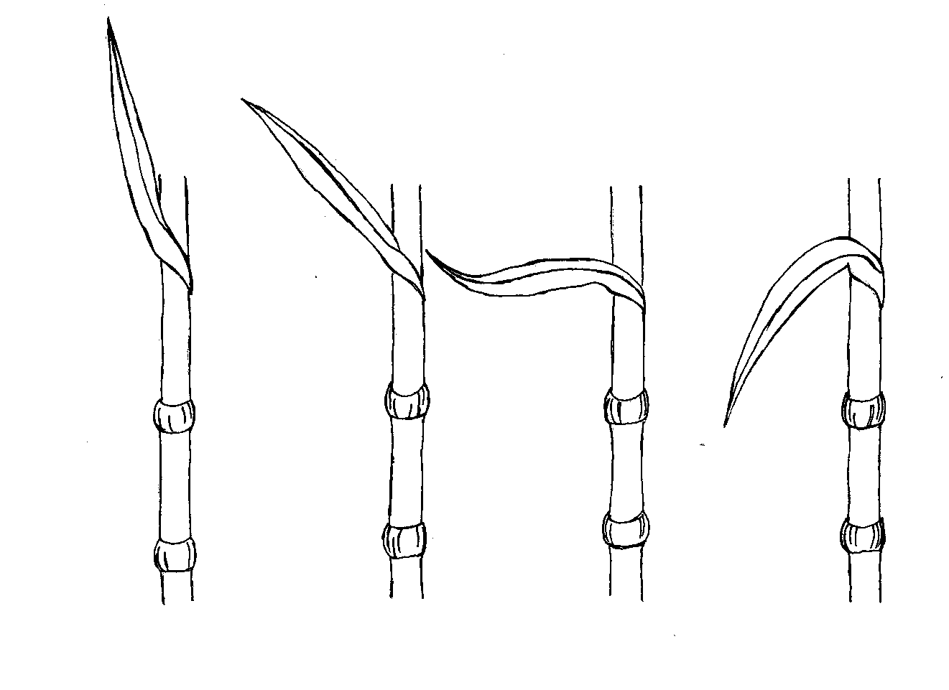
1 | 3 | 5 | 7
erect | semi-erect | horizontal | semi-drooping

Ad. 7: Stem: length of upper internode

upper internode
Ad. 8: Stem: thickness of internode

To be observed on the middle third of the plant.
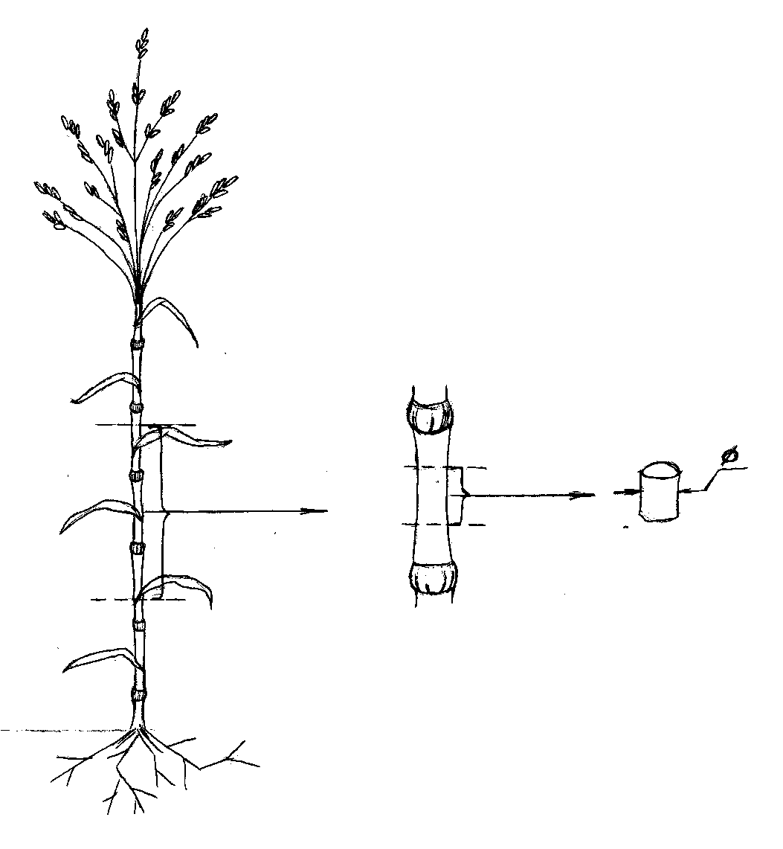

Ad. 9: Time of panicle emergence

The time of panicle emergence is when the first spikelet is visible in 50% of the plants.

Ad. 10: Plant: natural height

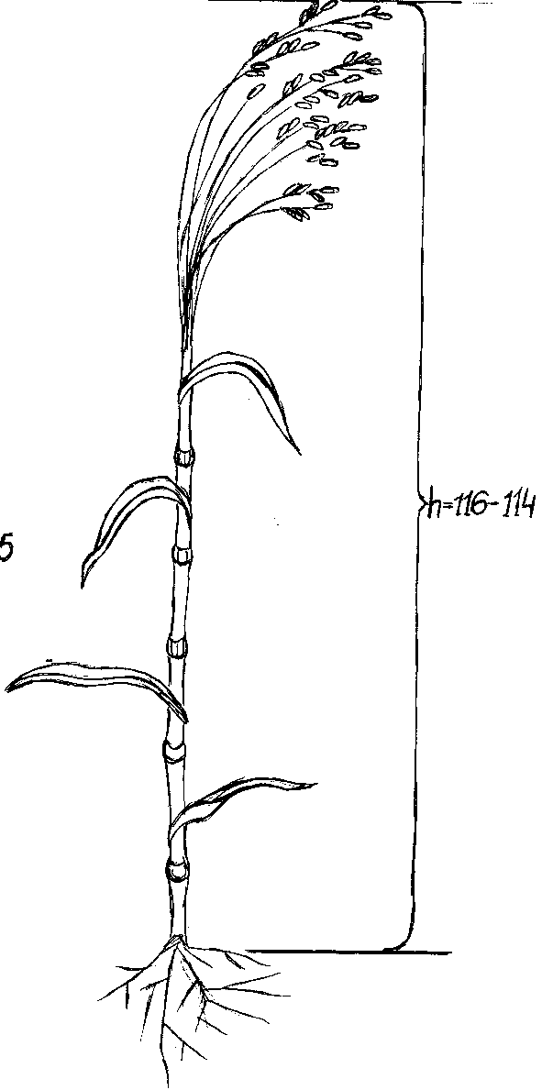

natural height
Ad. 11: Panicle: angle of branches

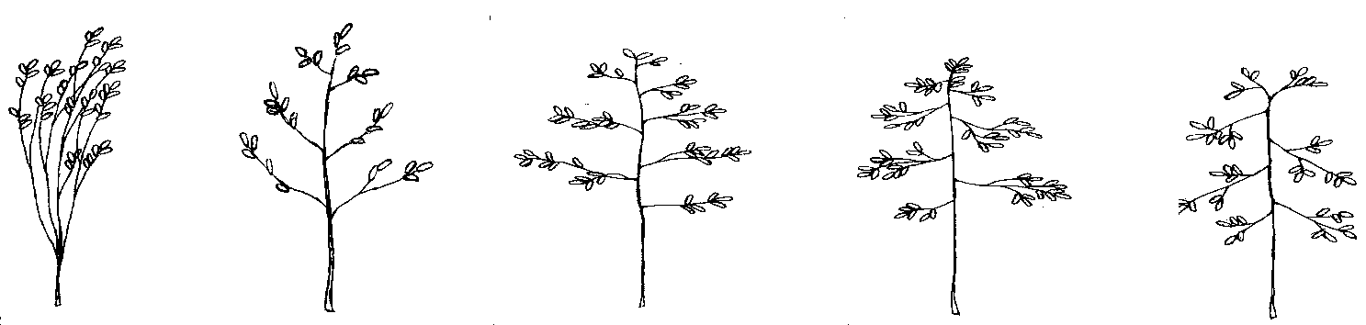
1 | 2 | 3 | 4 | 5
very acute | moderately acute | right angle | moderately obtuse | very obtuse

Ad. 12: Panicle: attitude

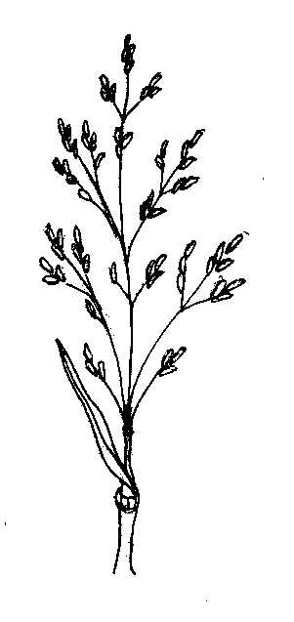 | 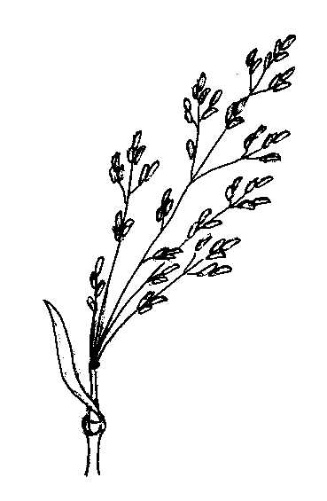 | 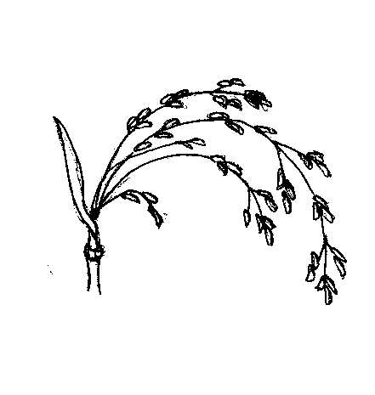 | 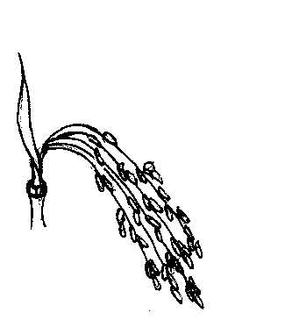
1 | 2 | 3 | 4
erect | semi-erect | moderately drooping | strongly drooping

Ad. 13: Panicle: length (excluding peduncle)

Ad. 14: Panicle: width

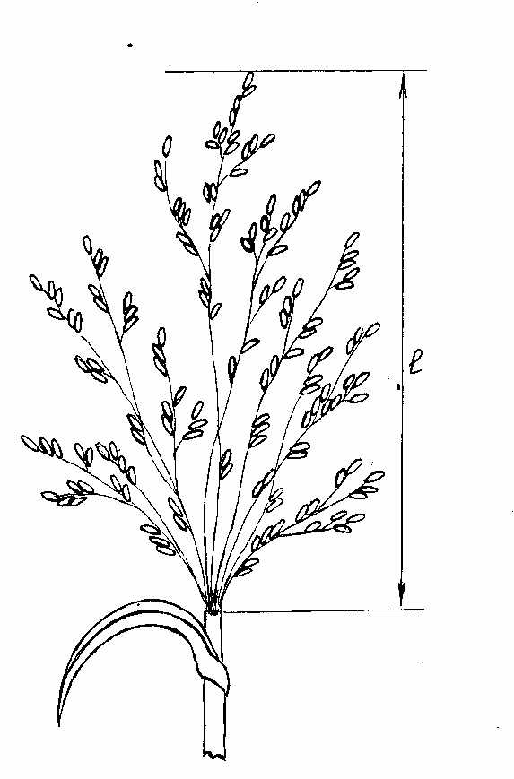 | 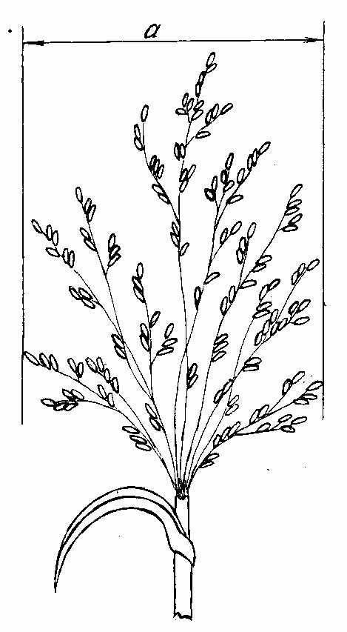

To be observed on 20 harvested panicles on a table.

Ad. 15: Panicle: density

The density of the panicle is determined by the division of the number of primary branches into the length of a principal axis of panicle.

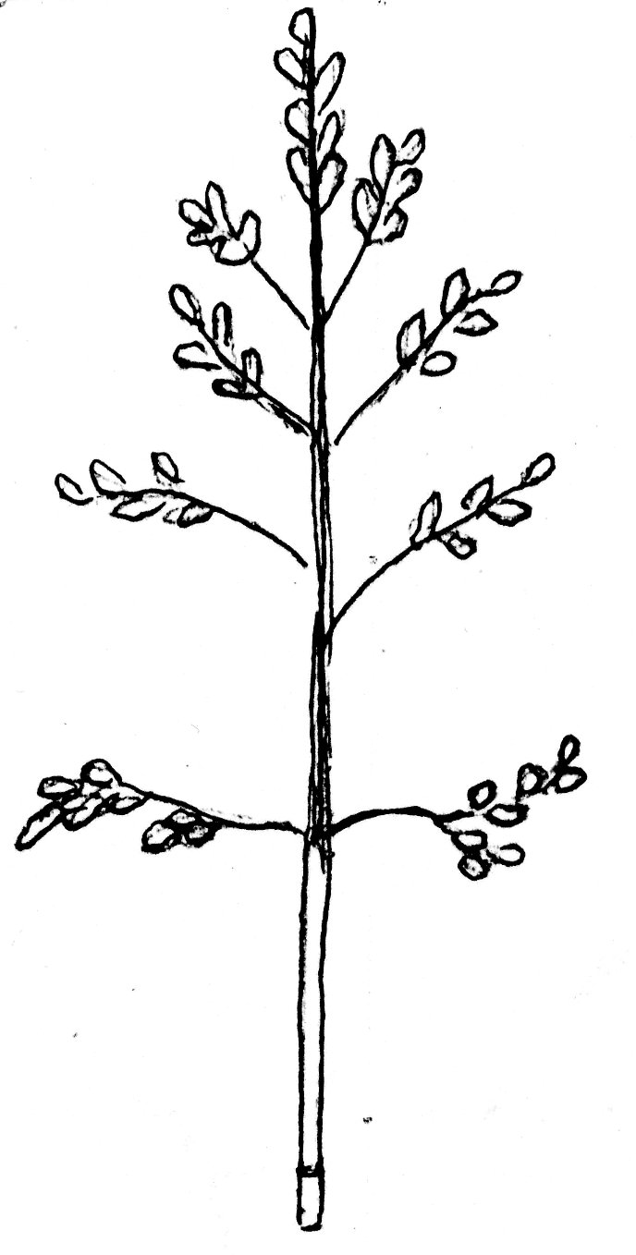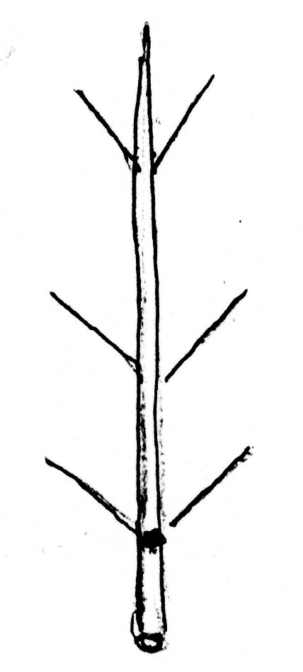 | 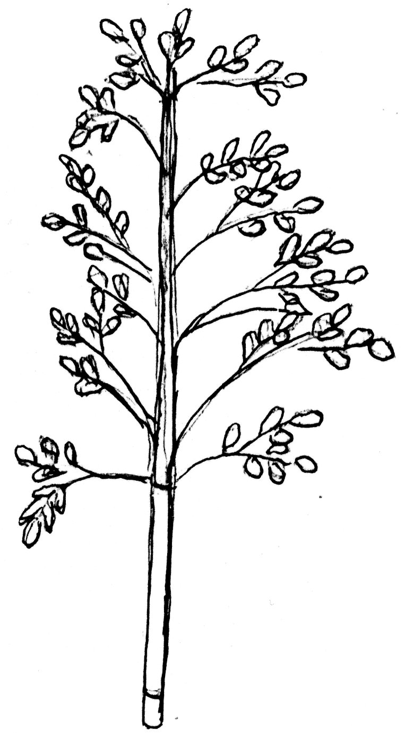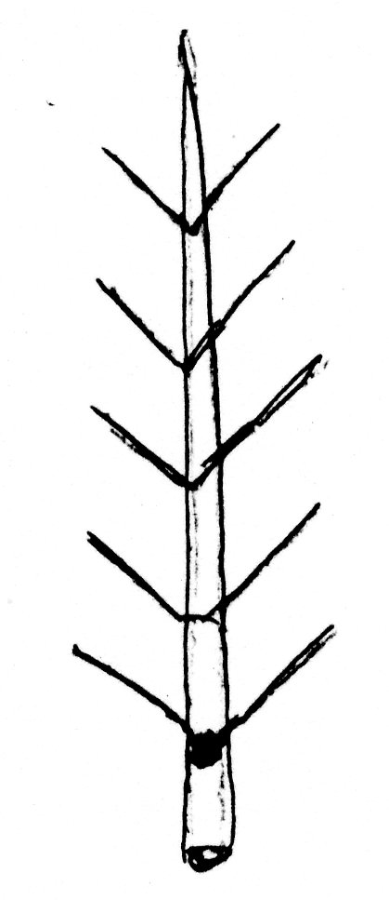 | 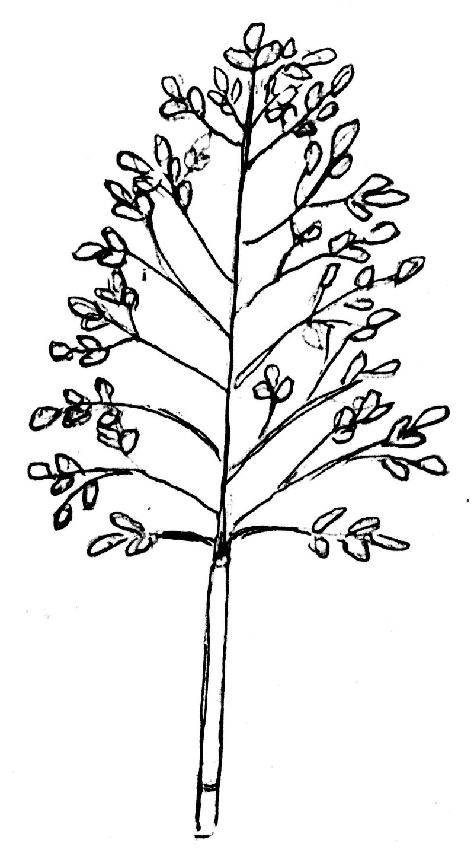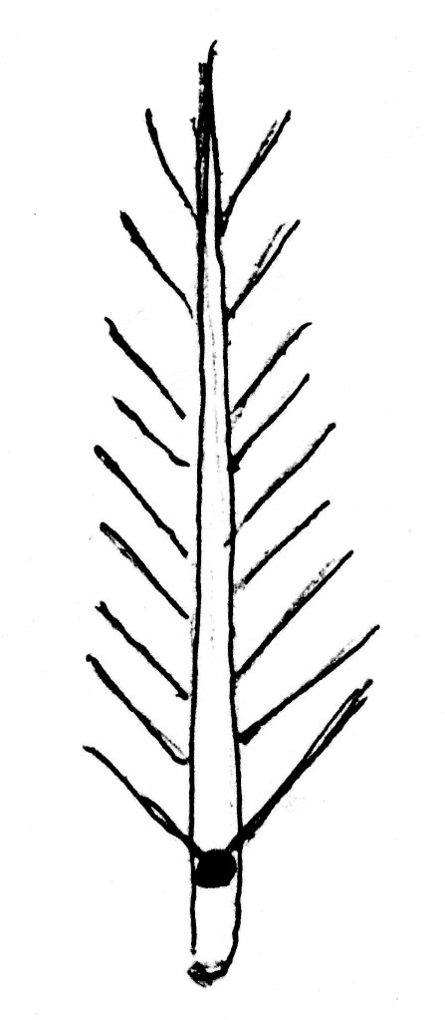
3 | 5 | 7
lax | medium | dense

Ad. 16: Panicle: degree of curvature of lateral branches
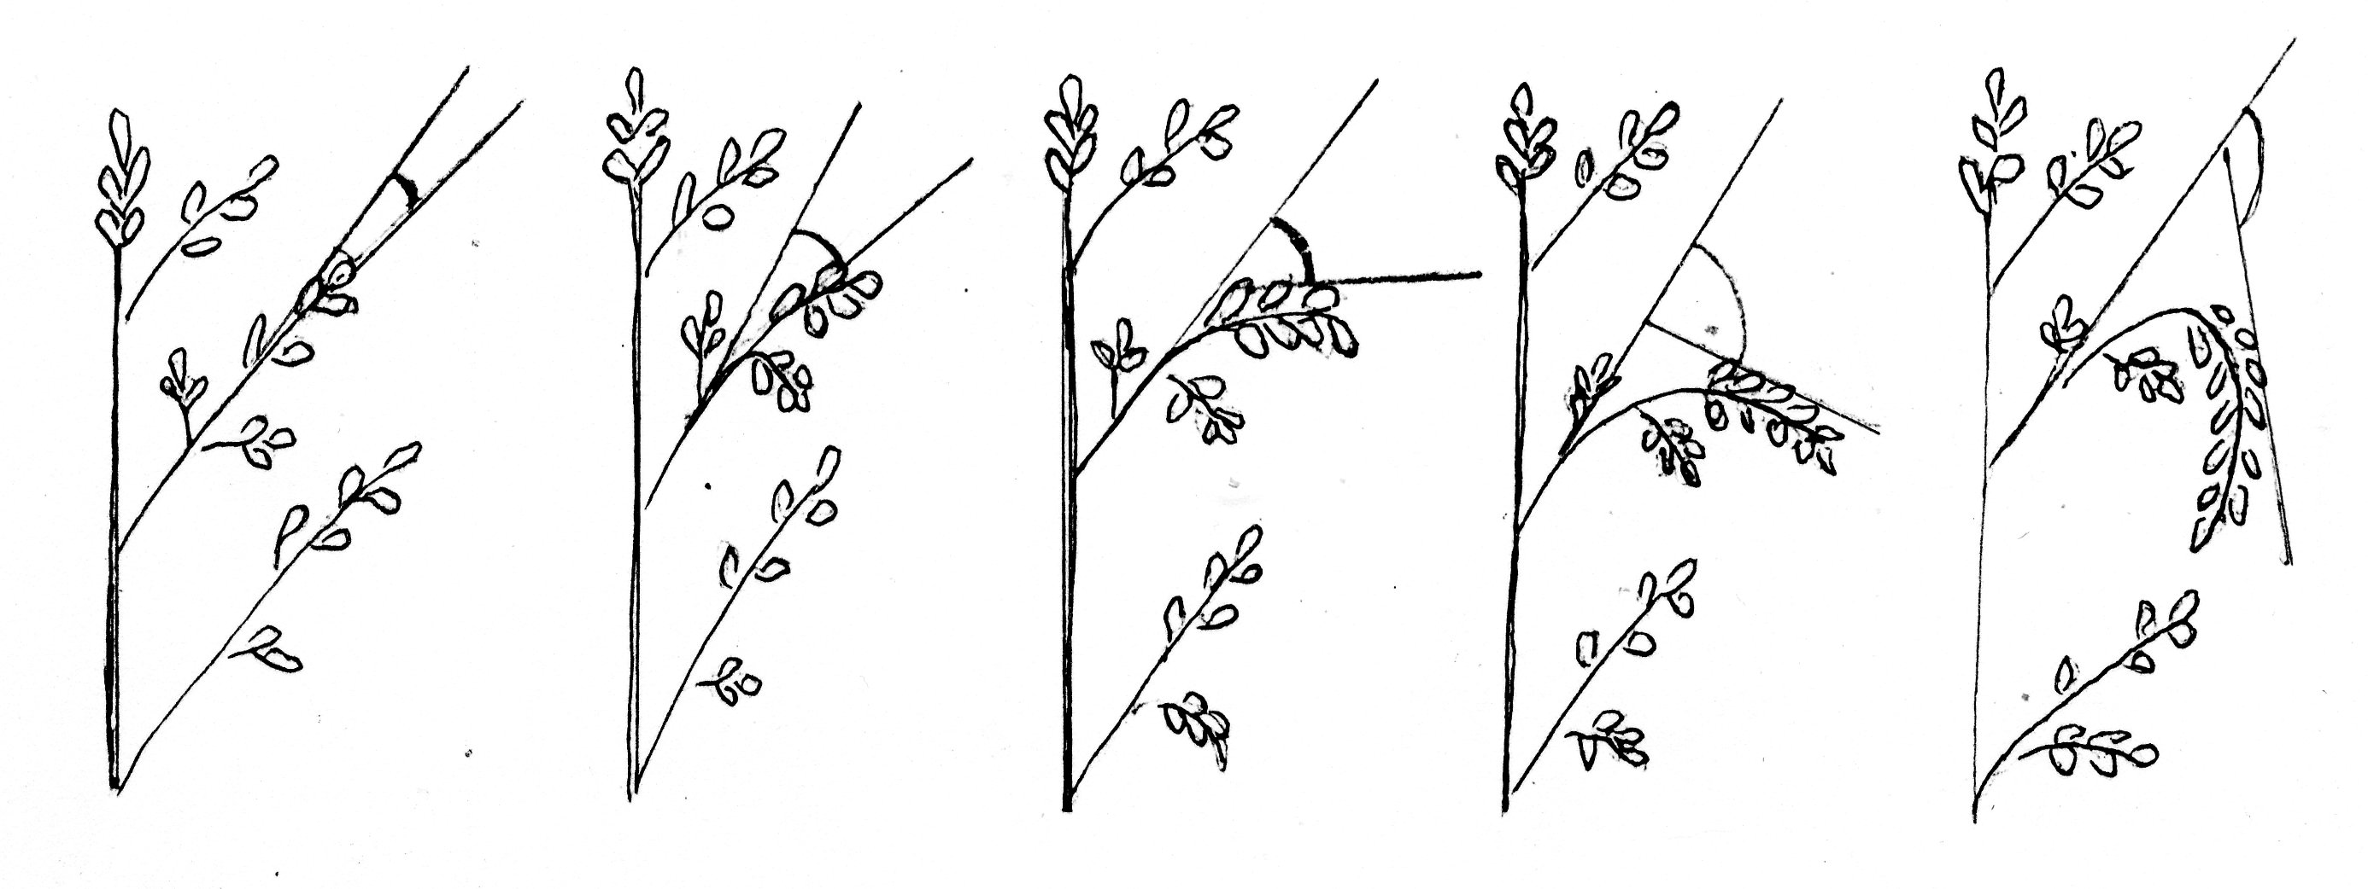
1 | 3 | 5 | 7 | 9
absent or very weak | weak | medium | strong | very strong

Ad. 17: Panicle: number of pillows

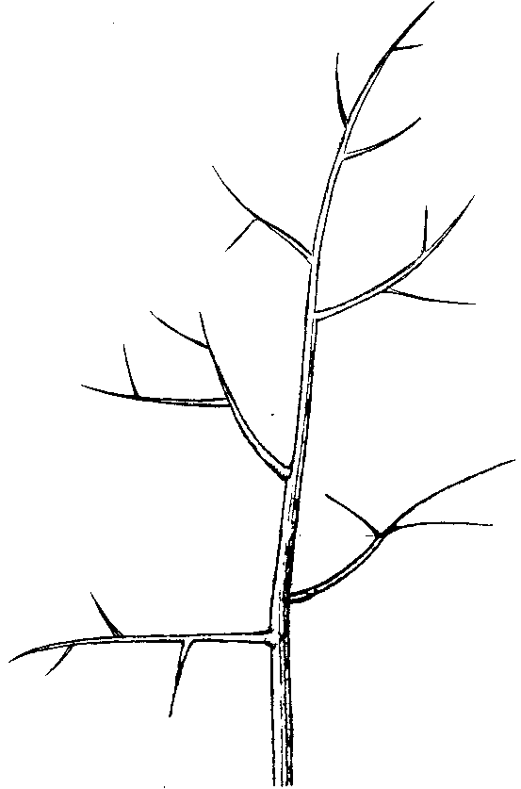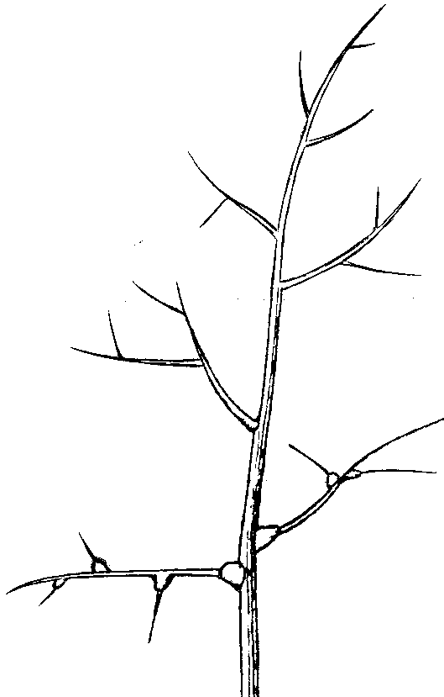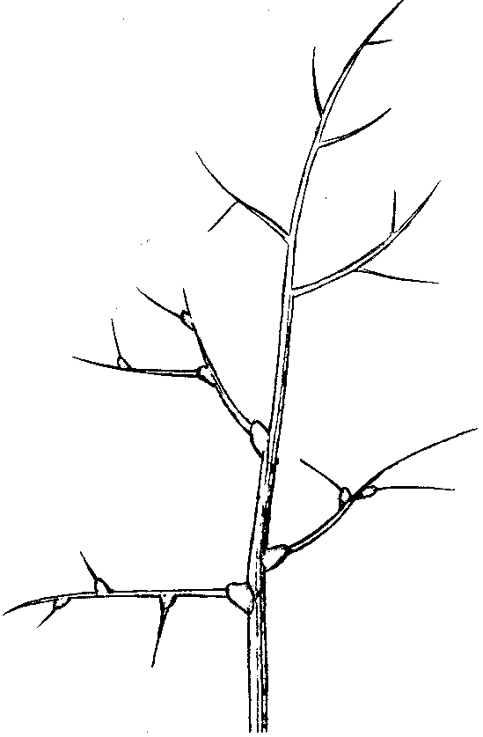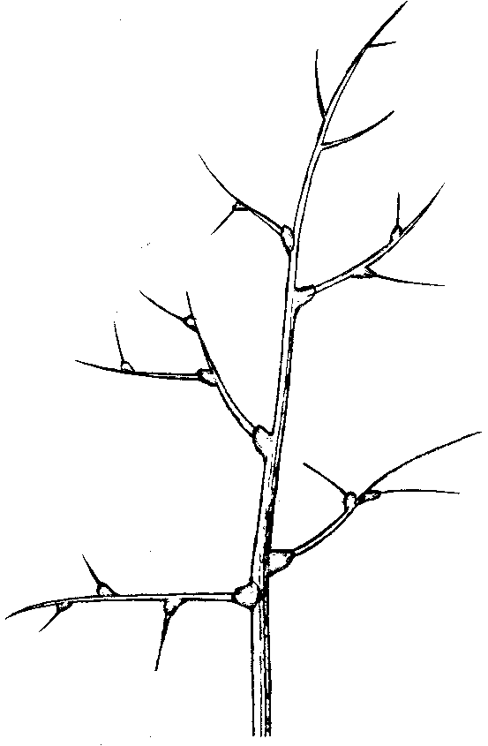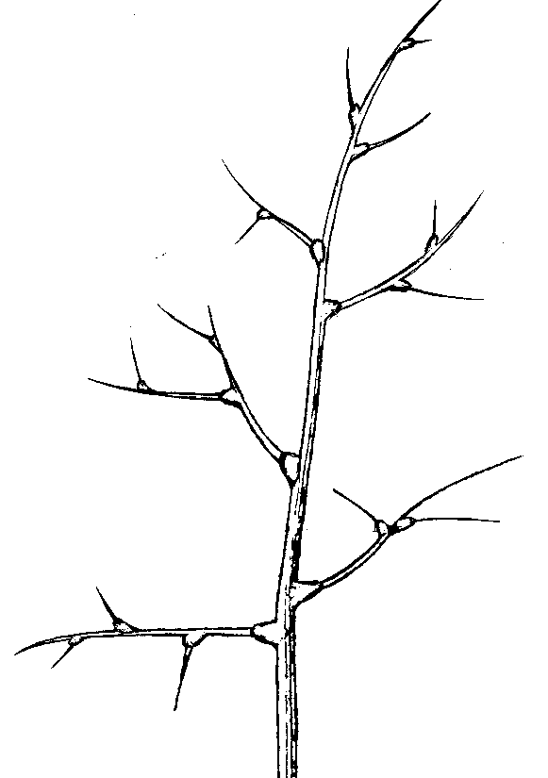

1 | 3 | 5 | 7 | 9
none or very few | few | medium | many | very many

Ad. 18: Panicle: length of primary branches

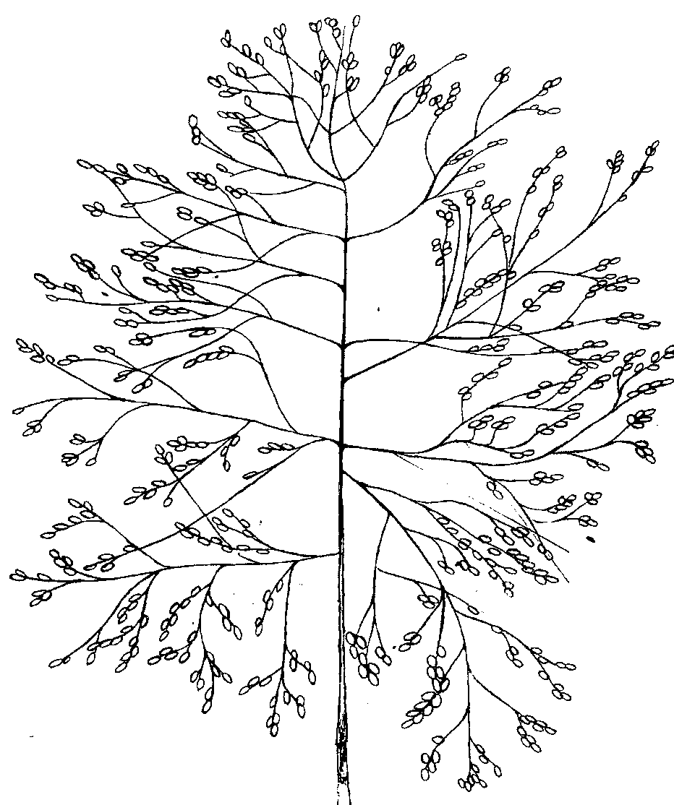
to be observed in the middle third of the panicle

Ad. 19: Spikelet: shape

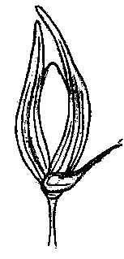 | 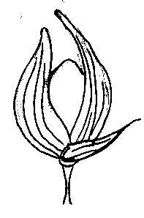 | 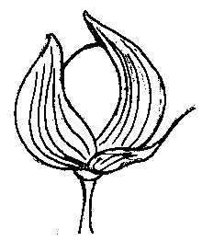
1 | 2 | 3
narrow elliptic | broad elliptic | circular

Ad. 23: Grain: size

The grain size should be measured in millimeters.

Ad. 24: Grain: shape

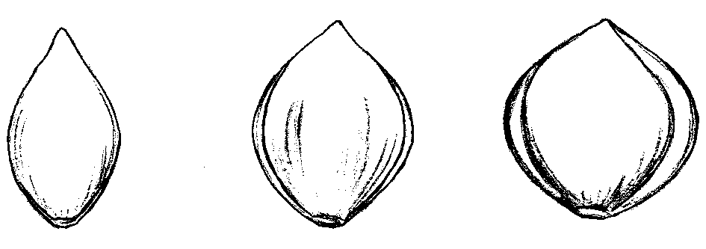
1 | 2 | 3
narrow elliptic | broad elliptic | circular

Ad. 30: Kernel: intensity of brown color of hilum

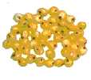 | 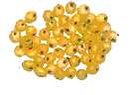 | 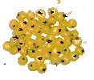
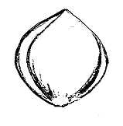 | 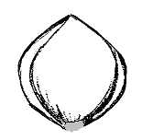 | 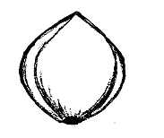
3 | 5 | 7
light | medium | dark

Ad. 31: Kernel: type of endosperm

The characteristic is observed by reaction to Potassium Iodide solution: waxy type endosperm is stained reddish purple; non-waxy type endosperm is stained blue purple.

Ad. 32.1 - 32.6: Resistance to smut (Sporisorium destruens: Yank)

Method for determination of resistance to infection by smut races:

Inoculum: | The spores must be viable and ripe. Each race (1, 2, 3, 4, 5, 6) to be used separately.
Method of inoculation: | Before sowing, grains and smut spores are mixed carefully by shaking thoroughly. 100 seeds are infected with each race.
Infection load: | 0,2% spores in relation to seed weight
Place of growing: | Field
Observations: | Observations should be made on healthy plants when inflorescences are fully emerged. For each variety, the number of affected plants is observed. The response of the variety to a specific smut race is described as follows:  Note 1 – susceptible (>50% affected plants)  Note 2 – moderately resistant (5-50% affected plants)  Note 3 – highly resistant (<5% affected plants)
Remark: | It is possible to obtain races for testing from the Institute of Agriculture (Chabany, Kyevo-Svyatoshynskyi district, Kyiv region 08162, Ukraine).

8.3 Decimal Code for the Growth Stages of Cereals
2-digit Code (Zadoks Scale) | General Description | Feekes Scale
1 | 2
Germination
00 | Dry seed
01 | Start of imbibition
02
03 | Imbibition complete
04
05 | Radicle emerged from caryopsis
06
07 | Coleoptile emerged from caryopsis
08
09 | Leaf just at coleoptile tip
Seedling growth
10 | First leaf through coleoptile | 1
11 | First leaf unfolded | 1
12 | 2 leaves unfolded
13 | 3 leaves unfolded
14 | 4 leaves unfolded
15 | 5 leaves unfolded
16 | 6 leaves unfolded
17 | 7 leaves unfolded
18 | 8 leaves unfolded
19 | 9 or more leaves unfolded
Tillering
20 | Main shoot only
21 | Main shoot and 1 tiller
22 | Main shoot and 2 tillers
23 | Main shoot and 3 tillers | 3
24 | Main shoot and 4 tillers | 3
25 | Main shoot and 5 tillers | 3
26 | Main shoot and 6 tillers | 3
27 | Main shoot and 7 tillers | 3
28 | Main shoot and 8 tillers | 3
29 | Main shoot and 9 or more tillers
Stem elongation
30 | Pseudo stem erection (2) | 4-5
31 | 1st node detectable | 6
32 | 2nd node detectable | 7
33 | 3rd node detectable
34 | 4th node detectable
35 | 5th node detectable
36 | 6th node detectable
37 | Flag leaf just visible | 8
38
2-digit Code (Zadoks Scale) | General Description | Feekes Scale
39 | Flag leaf/collar just visible | 9
Booting
40
41 | Flag leaf sheath extending
42
43 | Boots just visible swollen | 10
44 |  | 10
45 | Boots swollen | 10
46
47 | Flag leaf sheath | 10.1
48 |  | -//-
49 | First awns visible | -//-
Inflorescence emergence
50 | First spikelet of inflorescence just visible | -//-
51 | -//- -//- -//- | -//-
52 | 1/4 of inflorescence emerged | 10.2
53 | -//- -//- -//- | -//-
54 | 1/2 of inflorescence emerged | 10.3
55 | -//- -//- -//- | -//-
56 | 3/4 of inflorescence emerged | 10.4
57 | -//- -//- -//- | -//-
58 | Emergence of inflorescence completed | 10.5
59 | -//- -//- -//- | -//-
Anthesis
60 | Beginning of anthesis | 10.51
61 | -//- -//- -//- | -//-
62
63
64 | Anthesis half-way | 10.52
65 | -//- -//- -//- | -//-
66
67
68 | Anthesis complete | 10.53
69 | -//- -//- -//- | -//-
Milk development
70
71 | Caryopsis watery ripe
72
73 | Early milk | 11.1
74
75 | Medium milk | 11.1
76
77 | Late milk | 11.1
78
79
2-digit Code (Zadoks Scale) | General Description | Feekes Scale
Dough development
80
81
82
83 | Early dough | 11.2
84
85 | Soft dough | 11.2
86
87 | Hard dough | 11.2
88
89
 | Ripening
90
91 | Caryopsis hard (difficult to divide by thumbnail) (3) | 11.3
92 | Caryopsis hard (can no longer be dented by thumbnail) (4) | 11.4
93 | Caryopsis loosening in daytime
94 | Over-ripe, straw dead and collapsing
95 | Seed dormant
96 | Viable seed giving 50% germination
97 | Seed not dormant
98 | Secondary dormancy induced
99 | Secondary dormancy lost
T1 | Unrooting of seedlings
T2
T3 | Rooting
T4
T5
T6
T7 | Recovery of shoots
T8
T9 | Resumption of vegetative growth

Literature
Артюшенко З.Т., Федоров А. А. Атлас по описательной морфологии высших растений. – Л.: Наука. -1986. -392с.

Гуляев Г.В., Мальченко В.В. Словарь терминов по генетике, цитологии, селекции, семеноводству и семеноведению.- М.: Россельхозиздат. - 1975.- 215с.

Доспехов Б. А. Методика полевого опыта. М.: Агропромиздат, 1985. - 351с.

Зайцев Г.Н. Математическая статистика в экспериментальной ботанике. - М.: Наука, 1984. - 423с.

Культурная флора СССР. Крупяные культуры. Л.: Колос, 1975.- Т.З. - 7-118c.

Лякин Г.Ф. Биометрия.- М.: Высшая школа, 1990. - 349с.

Словарь ботанических терминов. Под общей редакцией Дудки И.А. - К.: Наукова думка.- 1984.- 308с.

Федоров А.А. , Артюшенко З.Т. Атлас по описательной морфологии высших растений. Соцветие. - Л.: Наука. - 1979. 296с.

Шмидт В. М. Математические методы в ботанике. Издательство Ленинградского университета, 1984.- 285с.

Широкий унифицированный классификатор СЭВ и Международный классификатор СЭВ. Вид Panicum Miliaceum L. - Л., 1982. – 24с.

Zadoks, J.C., Chang T.T. and Konzak C.F., 1974: A decimal code for the growth stages of cereals. Weed Research 14: pp. 415-421.

Technical Questionnaire
TECHNICAL QUESTIONNAIRE |  |  |  | Page {x} of {y} |  | Reference Number:
 |  |  |  |  |  | Application date:
 |  |  |  |  |  | (not to be filled in by the applicant)
TECHNICAL QUESTIONNAIRE
to be completed in connection with an application for plant breeders’ rights

1. Subject of the Technical Questionnaire
1.1 Botanical name |  |  | Panicum miliaceum L.
1.2 Common name |  |  | Common Millet
2. Applicant
Name
Address
Telephone No.
Fax No.
E-mail address
Breeder (if different from applicant)
3. Proposed denomination and breeder’s reference
Proposed denomination
(if available)

Breeder’s reference
#4. Information on the breeding scheme and propagation of the variety

4.1 Breeding scheme

Variety resulting from:

4.1.1 Crossing

(a) controlled cross [ ]
(please state parent varieties)
(b) partially known cross [ ]
(please state known parent variety(ies))
(c) unknown cross [ ]

4.1.2 Mutation [ ]
(please state parent variety)

4.1.3 Discovery and development [ ]
(please state where and when discovered and
how developed)

4.1.4 Other [ ]
(please provide details)
4.2 Method of propagating the variety

5. Characteristics of the variety to be indicated (the number in brackets refers to the corresponding characteristic in Test Guidelines; please mark the note which best corresponds).

 | Characteristics |  |  |  |  |  | Example Varieties |  |  | Note
5.1  (2) | Flag leaf: anthocyanin coloration
 | absent |  |  |  |  |  | Sonyachne |  |  | 1[ ]
 | present |  |  |  |  |  | Lilove |  |  | 9[ ]
5.2  (3) | Flag leaf: intensity of anthocyanin coloration
 | weak |  |  |  |  |  | Lilove, Veselopodolyanske 305 |  |  | 3[ ]
 | medium |  |  |  |  |  | Veselopodolyanske 403 |  |  | 5[ ]
 | strong |  |  |  |  |  | Irtyshske 201 |  |  | 7[ ]
5.3  (7) | Stem: length of upper internode
 | short |  |  |  |  |  | Veselopodolyanske 534 |  |  | 3[ ]
 | medium |  |  |  |  |  | Myronivske 51,  Novo Kyivske 01, Slobozhanske |  |  | 5[ ]
 | long |  |  |  |  |  | Charivne,  Kharkivske 72 |  |  | 7[ ]
5.4  (9) | Time of panicle emergence
 | very early |  |  |  |  |  | Omske 9 |  |  | 1[ ]
 | early |  |  |  |  |  | Kyivske 96 |  |  | 3[ ]
 | medium |  |  |  |  |  | Kharkivske 56 |  |  | 5[ ]
 | late |  |  |  |  |  | Kharkivske kormove |  |  | 7[ ]
 | very late |  |  |  |  |  | Illichovske |  |  | 9[ ]
 | Characteristics |  |  |  |  |  | Example Varieties |  |  | Note
5.5  (10) | Plant: natural height
 | short |  |  |  |  |  | Karlik 305,  Orlovskiy karlik |  |  | 3[ ]
 | medium |  |  |  |  |  | Kharkivske 86,  Kyivske 96 |  |  | 5[ ]
 | long |  |  |  |  |  | Kharkivske 57, Veselopodilske 16 |  |  | 7[ ]
5.6  (11) | Panicle: angle of branches
 | very acute |  |  |  |  |  | Pikulovytske |  |  | 1[ ]
 | moderately acute |  |  |  |  |  |  |  |  | 2[ ]
 | right angle |  |  |  |  |  | Chornomorske |  |  | 3[ ]
 | moderately obtuse |  |  |  |  |  | Kyivske 87,  Veselopodilske 16 |  |  | 4[ ]
 | very obtuse |  |  |  |  |  | Omske 9 |  |  | 5[ ]
5.7  (12) | Panicle: attitude
 | erect |  |  |  |  |  | Omske 9 |  |  | 1[ ]
 | semi-erect |  |  |  |  |  | Charivne, Veselopodolyanske 305-54 |  |  | 2[ ]
 | moderately drooping |  |  |  |  |  | Kyivske 96 |  |  | 3[ ]
 | strongly drooping |  |  |  |  |  | Kharkivske 57 |  |  | 4[ ]
5.8  (15) | Panicle: density
 | lax |  |  |  |  |  | Myronivske 51 |  |  | 3[ ]
 | medium |  |  |  |  |  | Charivne |  |  | 5[ ]
 | dense |  |  |  |  |  | Pikulovytske |  |  | 7[ ]
 | Characteristics |  |  |  |  |  | Example Varieties |  |  | Note
5.9  (19) | Spikelet: shape
 | narrow elliptic |  |  |  |  |  | Sonyachne |  |  | 1[ ]
 | broad elliptic |  |  |  |  |  | Lilove,  Veselopodolyanske 176 |  |  | 2[ ]
 | circular |  |  |  |  |  | Charivne |  |  | 3[ ]
5.10  (21) | Glume: anthocyanin coloration
 | absent or very weak |  |  |  |  |  | Myronivske 51 |  |  | 1[ ]
 | weak |  |  |  |  |  | Veselopodolyanske 403 |  |  | 3[ ]
 | medium |  |  |  |  |  | Podolyanske 24/273 |  |  | 5[ ]
 | strong |  |  |  |  |  | Lilove |  |  | 7[ ]
5.11  (23) | Grain: size
 | small |  |  |  |  |  | Omske 9 |  |  | 3[ ]
 | medium |  |  |  |  |  | Myronivske 51, Syayvo |  |  | 5[ ]
 | large |  |  |  |  |  | Kyivske 96, Veselopodolyanske 176 |  |  | 7[ ]
 | very large |  |  |  |  |  | Horlinka |  |  | 9[ ]
5.12  (24) | Grain: shape
 | narrow elliptic |  |  |  |  |  | Kostiantynivske |  |  | 1[ ]
 | broad elliptic |  |  |  |  |  | Kyivske 87,  Kyivske 96,  Myronivske 51,  Myronivske 94 |  |  | 2[ ]
 | circular |  |  |  |  |  | Charivne,  Novokyivske,  Veselopodolyanske 63201 |  |  | 3[ ]
 | Characteristics |  |  |  |  |  | Example Varieties |  |  | Note
5.13  (25) | Grain: color
 | white |  |  |  |  |  | Tonkoplivchaste 048 |  |  | 1[ ]
 | whitish |  |  |  |  |  | Novokyivske 01 |  |  | 2[ ]
 | light yellow |  |  |  |  |  | Veselopodolyanske 38 |  |  | 3[ ]
 | medium yellow |  |  |  |  |  | Myronivske 51 |  |  | 4[ ]
 | dark yellow |  |  |  |  |  | Saratovske 2 |  |  | 5[ ]
 | golden |  |  |  |  |  | Zolotyste |  |  | 6[ ]
 | light red |  |  |  |  |  | Tavriyske |  |  | 7[ ]
 | medium red |  |  |  |  |  | Lilove |  |  | 8[ ]
 | dark red |  |  |  |  |  | Veselopodolyanske 305-54 |  |  | 9[ ]
 | red brown |  |  |  |  |  | Chornosimyanne 1 |  |  | 10[ ]
 | brown |  |  |  |  |  | Amurske mistseve |  |  | 11[ ]
 | black |  |  |  |  |  | Hexiaoyingmizi |  |  | 12[ ]
5.14  (28) | Weight per 1000 grains
 | very low |  |  |  |  |  | Tonkoplivchaste 048 |  |  | 1[ ]
 | low |  |  |  |  |  | Ostrohovske 9 |  |  | 3[ ]
 | medium |  |  |  |  |  | Sonyachne |  |  | 5[ ]
 | high |  |  |  |  |  | Kharkivske 86,  Myronivske 51 |  |  | 7[ ]
 | very high |  |  |  |  |  | Kyivske 96,  Veselopodilske 16 |  |  | 9[ ]
5.15  (29) | Kernel (not polished): color
 | whitish |  |  |  |  |  | Veselopodolyanske 176 |  |  | 1[ ]
 | light yellow |  |  |  |  |  | Kyivske 96 |  |  | 2[ ]
 | medium yellow |  |  |  |  |  | Omriyane |  |  | 3[ ]
6. Similar varieties and differences from these varieties

Please use the following table and box for comments to provide information on how your candidate variety differs from the variety (or varieties) which, to the best of your knowledge, is (or are) most similar. This information may help the examination authority to conduct its examination of distinctness in a more efficient way.

Denomination(s) of variety(ies) similar to your candidate variety |  | Characteristic(s) in which your candidate variety differs from the similar variety(ies) |  |  | Describe the expression of the characteristic(s) for the similar variety(ies) |  |  | Describe the expression of the characteristic(s) for your candidate variety
Example |  | Panicle: density |  |  | lax |  |  | medium
Comments:

#7. Additional information which may help in the examination of the variety

7.1 In addition to the information provided in sections 5 and 6, are there any additional characteristics which may help to distinguish the variety?

Yes [ ] No [ ]

(If yes, please provide details)

7.2 Are there any special conditions for growing the variety or conducting the examination?

Yes [ ] No [ ]

(If yes, please provide details)

7.3 Other information

8. Authorization for release

(a) Does the variety require prior authorization for release under legislation concerning the protection of the environment, human and animal health?

Yes [ ] No [ ]

(b) Has such authorization been obtained?

Yes [ ] No [ ]

If the answer to (b) is yes, please attach a copy of the authorization.

9. Information on plant material to be examined or submitted for examination.

9.1 The expression of a characteristic or several characteristics of a variety may be affected by factors, such as pests and disease, chemical treatment (e.g. growth retardants or pesticides), effects of tissue culture, different rootstocks, scions taken from different growth phases of a tree, etc.

9.2 The plant material should not have undergone any treatment which would affect the expression of the characteristics of the variety, unless the competent authorities allow or request such treatment. If the plant material has undergone such treatment, full details of the treatment must be given. In this respect, please indicate below, to the best of your knowledge, if the plant material to be examined has been subjected to:

(a) Microorganisms (e.g. virus, bacteria, phytoplasma) Yes [ ] No [ ]

(b) Chemical treatment (e.g. growth retardant, pesticide) Yes [ ] No [ ]

(c) Tissue culture Yes [ ] No [ ]

(d) Other factors Yes [ ] No [ ]

Please provide details for where you have indicated “yes”.

……………………………………………………………

10. I hereby declare that, to the best of my knowledge, the information provided in this form is correct:

Applicant’s name

Signature Date

[End of document]

* These names were correct at the time of the introduction of these Test Guidelines but may be revised or updated. [Readers are advised to consult the UPOV Code, which can be found on the UPOV Website (www.upov.int), for the latest information.]
# Authorities may allow certain of this information to be provided in a confidential section of the Technical Questionnaire.
# Authorities may allow certain of this information to be provided in a confidential section of the Technical Questionnaire.

