 |  | E  TG/245/1 Rev. 2  ORIGINAL: English  DATE: 2008-04-09 + 2021-10-26  + 2022-10-25
INTERNATIONAL UNION FOR THE PROTECTION OF NEW VARIETIES OF PLANTS
GENEVA

 | GARDEN ROCKET  UPOV Code: ERUCA_SAT  Eruca sativa Mill. | *

GUIDELINES

FOR THE CONDUCT OF TESTS

FOR DISTINCTNESS, UNIFORMITY AND STABILITY

Alternative Names:*

Botanical name | English | French | German | Spanish
Eruca sativa Mill. | Arugula,  Cultivated Rocket, Garden Rocket, Rocket-salad, Rugula,  Salad Rocket | Roquette cultivée | Ölrauke, Rauke, Ruke, Rukola, Senfrauke | Oruga común, Roqueta

The purpose of these guidelines (“Test Guidelines”) is to elaborate the principles contained in the General Introduction (document TG/1/3), and its associated TGP documents, into detailed practical guidance for the harmonized examination of distinctness, uniformity and stability (DUS) and, in particular, to identify appropriate characteristics for the examination of DUS and production of harmonized variety descriptions.

ASSOCIATED DOCUMENTS

These Test Guidelines should be read in conjunction with the General Introduction and its associated TGP documents.

Other associated UPOV documents: TG/244/1 Rev. 2: Test Guidelines for Wild Rocket
TABLE OF CONTENTS PAGE

1. Subject of these Test Guidelines 3
2. Material Required 3
3. Method of Examination 3
3.1 Number of Growing Cycles 3
3.2 Testing Place 3
3.3 Conditions for Conducting the Examination 3
3.4 Test Design 4
3.5 Number of Plants / Parts of Plants to be Examined 4
3.6 Additional Tests 4
4. Assessment of Distinctness, Uniformity and Stability 4
4.1 Distinctness 4
4.2 Uniformity 5
4.3 Stability 5
5. Grouping of Varieties and Organization of the Growing Trial 5
6. Introduction to the Table of Characteristics 6
6.1 Categories of Characteristics 6
6.2 States of Expression and Corresponding Notes 6
6.3 Types of Expression 6
6.4 Example Varieties 6
6.5 Legend 6
7. Table of Characteristics/Tableau des caractères/Merkmalstabelle/Tabla de caracteres 7
8. Explanations on the Table of Characteristics 10
8.1 Explanations covering several characteristics 10
8.2 Explanations for individual characteristics 10
9. Literature 12
10. Technical Questionnaire 13

Subject of these Test Guidelines
These Test Guidelines apply to all varieties of Eruca sativa Mill.

Material Required
2.1 The competent authorities decide on the quantity and quality of the plant material required for testing the variety and when and where it is to be delivered. Applicants submitting material from a State other than that in which the testing takes place must ensure that all customs formalities and phytosanitary requirements are complied with.

2.2 The material is to be supplied in the form of seed.

2.3 The minimum quantity of plant material, to be supplied by the applicant, should be:

25 g or 15 000 seeds.

The seed should meet the minimum requirements for germination, species and analytical purity, health and moisture content, specified by the competent authority. In cases where the seed is to be stored, the germination capacity should be as high as possible and should, be stated by the applicant.

2.4 The plant material supplied should be visibly healthy, not lacking in vigor, nor affected by any important pest or disease.

2.5 The plant material should not have undergone any treatment which would affect the expression of the characteristics of the variety, unless the competent authorities allow or request such treatment. If it has been treated, full details of the treatment must be given.

Method of Examination

3.1 Number of Growing Cycles
The minimum duration of tests should normally be two independent growing cycles.

3.2 Testing Place
Tests are normally conducted at one place. In the case of tests conducted at more than one place, guidance is provided in TGP/9 “Examining Distinctness”.

3.3 Conditions for Conducting the Examination
3.3.1 The tests should be carried out under conditions ensuring satisfactory growth for the expression of the relevant characteristics of the variety and for the conduct of the examination.

3.3.2 The recommended method of observing the characteristic is indicated by the following key in the second column of the Table of Characteristics:

MG: single measurement of a group of plants or parts of plants
MS: measurement of a number of individual plants or parts of plants
VG: visual assessment by a single observation of a group of plants or parts of plants
VS: visual assessment by observation of individual plants or parts of plants

3.4 Test Design
3.4.1 Each test should be designed to result in a total of at least 60 plants, which should be divided between two or more replicates.

3.4.2 The design of the tests should be such that plants or parts of plants may be removed for measurement or counting without prejudice to the observations which must be made up to the end of the growing cycle.

3.5 Number of Plants / Parts of Plants to be Examined
Unless otherwise indicated, all observations on single plants should be made on 20 plants or parts taken from each of 20 plants and any other observations made on all plants in the test.”

3.6 Additional Tests
Additional tests, for examining relevant characteristics, may be established.

Assessment of Distinctness, Uniformity and Stability

4.1 Distinctness

4.1.1 General Recommendations

It is of particular importance for users of these Test Guidelines to consult the General Introduction prior to making decisions regarding distinctness. However, the following points are provided for elaboration or emphasis in these Test Guidelines.

4.1.2 Consistent Differences

The differences observed between varieties may be so clear that more than one growing cycle is not necessary. In addition, in some circumstances, the influence of the environment is not such that more than a single growing cycle is required to provide assurance that the differences observed between varieties are sufficiently consistent. One means of ensuring that a difference in a characteristic, observed in a growing trial, is sufficiently consistent is to examine the characteristic in at least two independent growing cycles.

4.1.3 Clear Differences

Determining whether a difference between two varieties is clear depends on many factors, and should consider, in particular, the type of expression of the characteristic being examined, i.e. whether it is expressed in a qualitative, quantitative, or pseudo-qualitative manner. Therefore, it is important that users of these Test Guidelines are familiar with the recommendations contained in the General Introduction prior to making decisions regarding distinctness.

4.2 Uniformity
4.2.1 It is of particular importance for users of these Test Guidelines to consult the General Introduction prior to making decisions regarding uniformity. However, the following points are provided for elaboration or emphasis in these Test Guidelines:

4.2.2 The assessment of uniformity should be according to the recommendations for cross-pollinated varieties in the General Introduction.

4.3 Stability
4.3.1 In practice, it is not usual to perform tests of stability that produce results as certain as those of the testing of distinctness and uniformity. However, experience has demonstrated that, for many types of variety, when a variety has been shown to be uniform, it can also be considered to be stable.

4.3.2 Where appropriate, or in cases of doubt, stability may be tested, either by growing a further generation, or by testing a new seed stock to ensure that it exhibits the same characteristics as those shown by the previous material supplied.

Grouping of Varieties and Organization of the Growing Trial
5.1 The selection of varieties of common knowledge to be grown in the trial with the candidate varieties and the way in which these varieties are divided into groups to facilitate the assessment of distinctness are aided by the use of grouping characteristics.

5.2 Grouping characteristics are those in which the documented states of expression, even where produced at different locations, can be used, either individually or in combination with other such characteristics: (a) to select varieties of common knowledge that can be excluded from the growing trial used for examination of distinctness; and (b) to organize the growing trial so that similar varieties are grouped together.

5.3 The following have been agreed as useful grouping characteristics:

- Leaf: anthocyanin coloration of veins (characteristic 4)
- Leaf: length (characteristic 5)
- Leaf: width (characteristic 6)
- Leaf: division (characteristic 7)
- Leaf: secondary lobing (characteristic 9)
- Flower: color of petals (characteristic 14)

5.4 Guidance for the use of grouping characteristics, in the process of examining distinctness, is provided through the General Introduction.

Introduction to the Table of Characteristics

6.1 Categories of Characteristics
6.1.1 Standard Test Guidelines Characteristics

Standard Test Guidelines characteristics are those which are approved by UPOV for examination of DUS and from which members of the Union can select those suitable for their particular circumstances.

6.1.2 Asterisked Characteristics

Asterisked characteristics (denoted by *) are those included in the Test Guidelines which are important for the international harmonization of variety descriptions and should always be examined for DUS and included in the variety description by all members of the Union, except when the state of expression of a preceding characteristic or regional environmental conditions render this inappropriate.

6.2 States of Expression and Corresponding Notes
States of expression are given for each characteristic to define the characteristic and to harmonize descriptions. Each state of expression is allocated a corresponding numerical note for ease of recording of data and for the production and exchange of the description.

6.3 Types of Expression
An explanation of the types of expression of characteristics (qualitative, quantitative and pseudo-qualitative) is provided in the General Introduction.

6.4 Example Varieties
Where appropriate, example varieties are provided to clarify the states of expression of each characteristic.

6.5 Legend
(*) Asterisked characteristic – see Chapter 6.1.2
QL: Qualitative characteristic – see Chapter 6.3
QN: Quantitative characteristic – see Chapter 6.3
PQ: Pseudo-qualitative characteristic – see Chapter 6.3

MG, MS, VG, VS: See Chapter 3.3.2

(a) See Explanations on the Table of Characteristics in Chapter 8.1

(+) See Explanations on the Table of Characteristics in Chapter 8.2

Table of Characteristics/Tableau des caractères/Merkmalstabelle/Tabla de caracteres
 |  | English | français | Deutsch | español | Example Varieties/  Exemples/  Beispielssorten/  Variedades ejemplo | Note/  Nota
1. | VG | Leaf: attitude | Feuille : port | Blatt: Haltung | Hoja: porte
QN | (a) | erect | dressé | aufrecht | erecto | Runway | 1
 |  | semi erect | demi dressé | halbaufrecht | semi erecto | Apollo, Astro | 3
 |  | horizontal | horizontal | waagerecht | horizontal | Fireworks | 5
2.  (*) | VG | Leaf: color of blade | Feuille : couleur du limbe | Blatt: Farbe der Spreite | Hoja: color del limbo
QL | (a) | yellow green | vert jaune | gelbgrün | verde amarillento | Apollo, Rococo, Runway | 1
 |  | green | vert | grün | verde | Astro | 2
3. | VG | Leaf: intensity of color | Feuile: intensité de la couleur | Blatt: Intensität der Farbe | Hoja: intensidad del color
QN | (a) | light | claire | hell | claro |  | 3
 |  | medium | moyenne | mittel | medio | Astro, Flash, Rococo | 5
 |  | dark | foncée | dunkel | oscuro | Esmee | 7
4.  (*) | VG | Leaf: anthocyanin coloration of veins | Feuille: pigmentation anthocyanique des nervures | Blatt: Anthocyanfärbung der Adern | Hoja: pigmentación antociánica de los nervios
QL | (a) | absent | absente | fehlend | ausente | Astro, Flash, Rococo | 1
 |  | present | présente | vorhanden | presente | Fireworks,  Sweet Intensity, | 9
5.  (*)  (+) | VG/MS | Leaf: length | Feuille: longueur | Blatt: Länge | Hoja: longitud
QN | (a) | short | courte | kurz | corta | Sparkle | 3
 |  | medium | moyenne | mittel | media | Rococo | 5
 |  | long | longue | lang | larga | Runway | 7
6.  (*) | VG/MS | Leaf: width | Feuille: largeur | Blatt: Breite | Hoja: anchura
QN | (a) | narrow | étroit | schmal | estrecha |  | 3
 |  | medium | moyenne | mittel | media | Runway | 5
 |  | broad | large | breit | ancha | Apollo, Rococo | 7
7.  (*)  (+) | VG | Leaf: division | Feuille: découpure | Blatt: Fiederung | Hoja: división
QN | (a) | absent or very weak | absente ou très faible | fehlend oder sehr gering | ausente o muy débil | Apollo | 1
 |  | weak | faible | gering | débil |  | 3
 |  | medium | moyenne | mittel | mediana | Rococo | 5
 |  | strong | forte | stark | fuerte | Flash | 7
 |  | very strong | très forte | sehr stark | muy fuerte | Runway | 9
8.  (+) | VG | Leaf: width of primary lobes | Feuille: largeur des lobes primaires | Blatt: Breite der Lappen erster Ordnung | Hoja: anchura de los lóbulos principales
QN | (a) | narrow | étroits | schmal | estrecha | Runway | 3
 |  | medium | moyens | mittel | media | Astro, Flash | 5
 |  | broad | larges | breit | ancha | Rococo | 7
9.  (*)  (+) | VG | Leaf: secondary lobing | Feuille: découpure secondaire | Blatt: Lappung zweiter Ordnung | Hoja: lobulado secundario
QN | (a) | absent or very weak | absente ou très faible | fehlend oder sehr gering | ausente o muy débil | Apollo | 1
 |  | weak | faible | gering | débil | Tosca | 3
 |  | medium | moyenne | mittel | medio | Rococo | 5
 |  | strong | forte | stark | fuerte | Esmee | 7
 |  | very strong | très forte | sehr stark | muy fuerte | Runway | 9
10. | VG | Leaf: undulation of margin | Feuille: ondulation du bord | Blatt: Randwellung | Hoja: ondulación del borde
QN | (a) | weak | faible | gering | débil | Flash | 3
 |  | medium | moyenne | mittel | media | Rococo | 5
 |  | strong | forte | stark | fuerte |  | 7
11. | VG | Leaf: hairiness | Feuille: pilosité | Blatt: Behaarung | Hoja: vellosidad
QN | (a) | weak | faible | gering | débil | Flash | 3
 |  | medium | moyenne | mittel | media | Apollo | 5
 |  | strong | forte | stark | fuerte | Sweet Intensity | 7
12.  (*)  (+) | MG | Time of flowering | Epoque de floraison | Zeitpunkt der Blüte | Época de floración
QN |  | early | précoce | früh | temprana | Astro | 3
 |  | medium | moyenne | mittel | media | Flash | 5
 |  | late | tardive | spät | tardía | Runway | 7
 |  | very late | très tardive | sehr spät | muy tardía |  | 9
13. | VG | Plant: height at flowering stage | Plante: hauteur au stade floraison | Pflanze: Höhe im Blühstadium | Planta: altura en floración
QN |  | short | courte | niedrig | baja |  | 3
 |  | medium | moyenne | mittel | media | Rococo | 5
 |  | long | longue | hoch | alta | Flash | 7
14.  (*)  (+) | VG | Flower: color of petals | Fleur: couleur des pétales | Blüte: Farbe der Blütenblätter | Flor: color de los pétalos
PQ |  | whitish | blanchâtre | weißlich | blanquecino | Rococo, Tosca | 1
 |  | cream | crème | cremefarben | crema | Astro, Fireworks | 2
 |  | light yellow | jaune pâle | hellgelb | amarillo claro | Flash, Runway | 3
15. | VG | Flower: anthocyanin coloration of veins | Fleur: coloration anthocyanique des nervures | Blüte: Anthocyanfärbung der Adern | Flor: coloración antoaciánica de los nervios
QN |  | absent or weak | absente à faible | fehlend oder gering | ausente o débil | Flash | 1
 |  | medium | moyenne | mittel | media | Astro | 2
 |  | strong | forte | stark | fuerte | Rococo | 3

Explanations on the Table of Characteristics

8.1 Explanations covering several characteristics

Characteristics containing the following key in the second column of the Table of Characteristics should be examined as indicated below:

(a) All observation on the leaf should be made on the rosette before the appearance of the inflorescence.

8.2 Explanations for individual characteristics
Ad. 5: Leaf: length

The leaf length includes the blade and petiole.

Ad. 7: Leaf: division

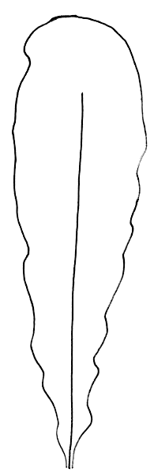 | 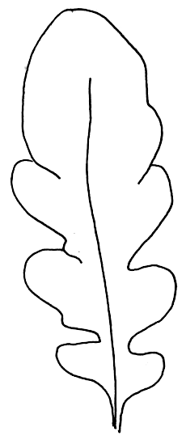 | 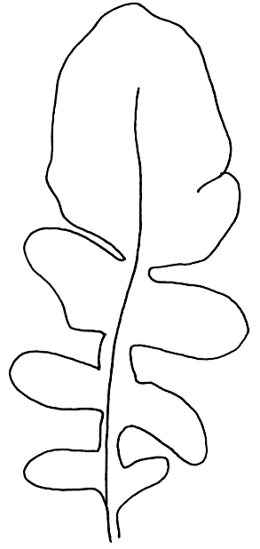 | 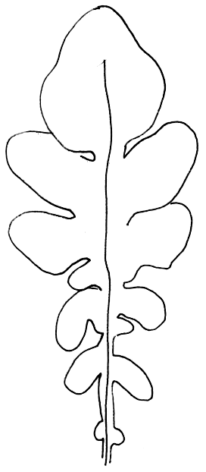 | 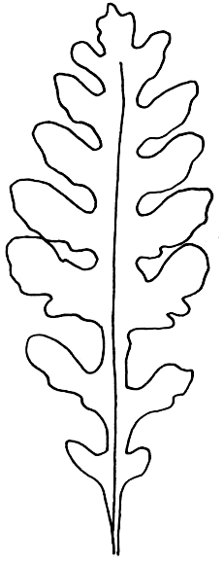
1 | 3 | 5 | 7 | 9
absent or very weak | weak | medium | strong | very strong

The division of the leaf should be observed in the middle third of the leaf.

Ad. 8: Leaf: width of primary lobes

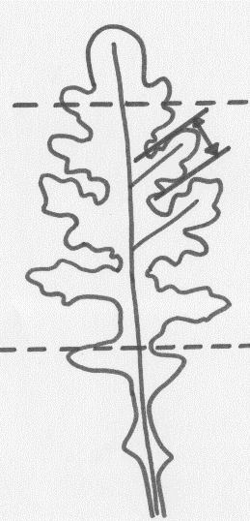

The width of the primary lobes should be observed in the middle part of the leaf.

Ad. 9: Leaf: secondary lobing
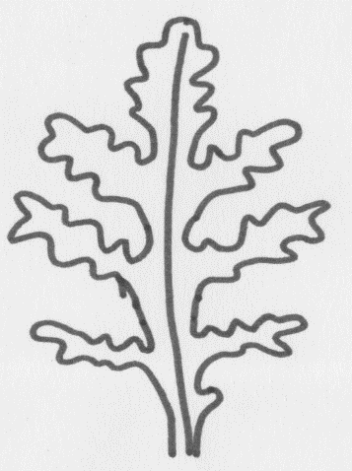
secondary lobe

primary lobe

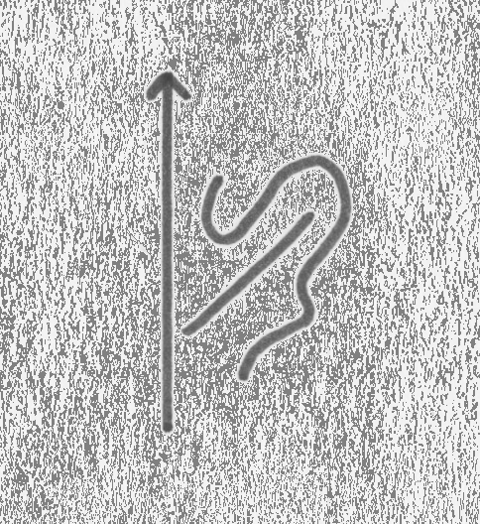
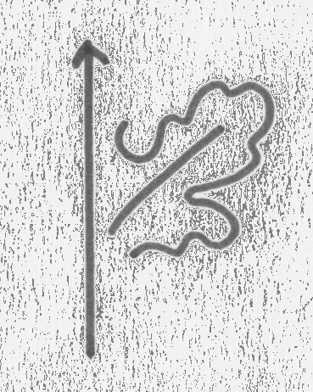
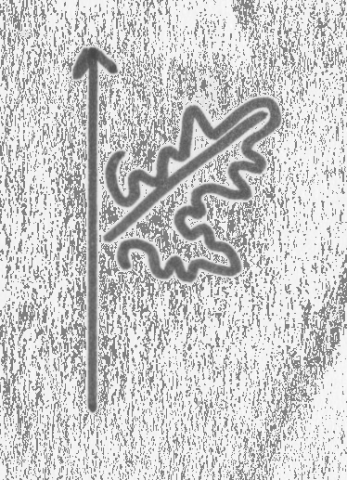

3 | 5 | 7
weak | medium | strong

Ad. 12: Time of flowering

The time of flowering is when 50% of plants have at least one open flower.

Ad. 14: Flower: color of petals

The color of the petals should be observed at the time of flower opening.

Literature
IPGRI, 1999: Descriptors for Rocket (Eruca spp.). International Plant Genetic Resources Institute, Rome, IT, 56 pp.

Padulosi, S., Pignone, D., editors, 1997: Rocket: a Mediterranean crop for the world. Report of a workshop, 13-14 December 1996, Legnaro, IT. International Plant Genetic Resources Institute, Rome, IT, 97 pp.

Technical Questionnaire
TECHNICAL QUESTIONNAIRE |  |  |  | Page {x} of {y} |  |  | Reference Number:
 |  |  |  |  |  |  | Application date:
 |  |  |  |  |  |  | (not to be filled in by the applicant)
TECHNICAL QUESTIONNAIRE

to be completed in connection with an application for plant breeders’ rights

1. Subject of the Technical Questionnaire
1.1 Botanical name |  |  | Eruca sativa Mill.
1.2 Common name |  |  | Garden Rocket
2. Applicant
Name
Address
Telephone No.
Fax No.
E-mail address
Breeder (if different from applicant)
3. Proposed denomination and breeder’s reference
Proposed denomination
(if available)
Breeder’s reference
#4. Information on the breeding scheme and propagation of the variety

4.1 Breeding scheme

Variety resulting from:
4.1.1 Crossing
(a) controlled cross [ ]
(please state parent varieties)

(b) partially known cross [ ]
(please state known parent variety(ies))

(c) unknown cross [ ]

4.1.2 Mutation [ ]
(please state parent variety)

4.1.3 Discovery and development [ ]
(please state where and when discovered
and how developed)

4.1.4 Other [ ]
(please provide details)

4.2 Method of propagating the variety

(a) Cross-pollination
(i) population [ ]
(ii) synthetic variety [ ]

(b) Other [ ]
(please provide details)

5. Characteristics of the variety to be indicated (the number in brackets refers to the corresponding characteristic in Test Guidelines; please mark the note which best corresponds).

 | Characteristics |  |  |  |  |  |  | Example Varieties |  |  |  | Note
5.1  (4) | Leaf: anthocyanin coloration of veins
 | absent |  |  |  |  |  |  | Astro, Flash, Rococo |  |  |  | 1 [ ]
 | present |  |  |  |  |  |  | Fireworks, Sweet Intensity, |  |  |  | 9 [ ]
5.2  (5) | Leaf: length
 | short |  |  |  |  |  |  | Sparkle |  |  |  | 3 [ ]
 | medium |  |  |  |  |  |  | Rococo |  |  |  | 5 [ ]
 | long |  |  |  |  |  |  | Runway |  |  |  | 7 [ ]
5.3  (6) | Leaf: width
 | narrow |  |  |  |  |  |  |  |  |  |  | 3 [ ]
 | medium |  |  |  |  |  |  | Runway |  |  |  | 5 [ ]
 | broad |  |  |  |  |  |  | Apollo, Rococo |  |  |  | 7 [ ]
5.4  (7) | Leaf: division
 | absent or very weak |  |  |  |  |  |  | Apollo |  |  |  | 1 [ ]
 | weak |  |  |  |  |  |  |  |  |  |  | 3 [ ]
 | medium |  |  |  |  |  |  | Rococo |  |  |  | 5 [ ]
 | strong |  |  |  |  |  |  | Flash |  |  |  | 7 [ ]
 | very strong |  |  |  |  |  |  | Runway |  |  |  | 9 [ ]
5.5  (9) | Leaf: secondary lobing
 | absent or very weak |  |  |  |  |  |  | Apollo |  |  |  | 1 [ ]
 | weak |  |  |  |  |  |  | Tosca |  |  |  | 3 [ ]
 | medium |  |  |  |  |  |  | Rococo |  |  |  | 5 [ ]
 | strong |  |  |  |  |  |  | Esmee |  |  |  | 7 [ ]
 | very strong |  |  |  |  |  |  | Runway |  |  |  | 9 [ ]
 | Characteristics |  |  |  |  |  |  | Example Varieties |  |  |  | Note
5.6  (12) | Time of flowering
 | early |  |  |  |  |  |  | Astro |  |  |  | 3 [ ]
 | medium |  |  |  |  |  |  | Flash |  |  |  | 5 [ ]
 | late |  |  |  |  |  |  | Runway |  |  |  | 7 [ ]
 | very late |  |  |  |  |  |  |  |  |  |  | 9 [ ]
5.7  (14) | Flower: color of petals
 | whitish |  |  |  |  |  |  | Rococo, Tosca |  |  |  | 1 [ ]
 | cream |  |  |  |  |  |  | Astro, Fireworks |  |  |  | 2 [ ]
 | light yellow |  |  |  |  |  |  | Flash, Runway |  |  |  | 3 [ ]
6. Similar varieties and differences from these varieties

Please use the following table and box for comments to provide information on how your candidate variety differs from the variety (or varieties) which, to the best of your knowledge, is (or are) most similar. This information may help the examination authority to conduct its examination of distinctness in a more efficient way.

Denomination(s) of variety(ies) similar to your candidate variety |  | Characteristic(s) in which your candidate variety differs from the similar variety(ies) |  |  | Describe the expression of the characteristic(s) for the similar variety(ies) |  |  |  | Describe the expression of the characteristic(s) for your candidate variety
Example |  | Flower: color of petals |  |  |  | whitish |  |  | light yellow
Comments:

#7. Additional information which may help in the examination of the variety

7.1 In addition to the information provided in sections 5 and 6, are there any additional characteristics which may help to distinguish the variety?

Yes [ ] No [ ]

(If yes, please provide details)

7.2 Are there any special conditions for growing the variety or conducting the examination?

Yes [ ] No [ ]

(If yes, please provide details)

8. Authorization for release

(a) Does the variety require prior authorization for release under legislation concerning the protection of the environment, human and animal health?

Yes [ ] No [ ]

(b) Has such authorization been obtained?

Yes [ ] No [ ]

If the answer to (b) is yes, please attach a copy of the authorization.

9. Information on plant material to be examined or submitted for examination.

9.1 The expression of a characteristic or several characteristics of a variety may be affected by factors, such as pests and disease, chemical treatment (e.g. growth retardants or pesticides), effects of tissue culture, different rootstocks, scions taken from different growth phases of a tree, etc.

9.2 The plant material should not have undergone any treatment which would affect the expression of the characteristics of the variety, unless the competent authorities allow or request such treatment. If the plant material has undergone such treatment, full details of the treatment must be given. In this respect, please indicate below, to the best of your knowledge, if the plant material to be examined has been subjected to:

(a) Microorganisms (e.g. virus, bacteria, phytoplasma) Yes [ ] No [ ]

(b) Chemical treatment (e.g. growth retardant, pesticide) Yes [ ] No [ ]

(c) Tissue culture Yes [ ] No [ ]

(d) Other factors Yes [ ] No [ ]

Please provide details for where you have indicated “yes”.

……………………………………………………………

10. I hereby declare that, to the best of my knowledge, the information provided in this form is correct:

Applicant’s name

Signature Date

[End of document]

* These names were correct at the time of the introduction of these Test Guidelines but may be revised or updated. [Readers are advised to consult the UPOV Code, which can be found on the UPOV Website (www.upov.int), for the latest information.]
## Authorities may allow certain of this information to be provided in a confidential section of the Technical Questionnaire.
## Authorities may allow certain of this information to be provided in a confidential section of the Technical Questionnaire.

