 |  | E
 | INCLUDEPICTURE "wordml://75.png" \* MERGEFORMATINET INCLUDEPICTURE "wordml://75.png" \* MERGEFORMATINET INCLUDEPICTURE "wordml://75.png" \* MERGEFORMATINET INCLUDEPICTURE "wordml://75.png" \* MERGEFORMATINET INCLUDEPICTURE "wordml://75.png" \* MERGEFORMATINET INCLUDEPICTURE "wordml://75.png" \* MERGEFORMATINET INCLUDEPICTURE "wordml://75.png" \* MERGEFORMATINET INCLUDEPICTURE "wordml://75.png" \* MERGEFORMATINET 
  TG/242/2
  ORIGINAL: English
  DATE: 2020-05-20
INTERNATIONAL UNION FOR THE PROTECTION OF NEW VARIETIES OF PLANTS
 | Geneva
  PORTULACA
  UPOV Code(s):
  PORTU_GRA;
  PORTU_OLE;
  PORTU_UMB
  Portulaca grandiflora Hook.;
  Portulaca oleracea L.;
  Portulaca umbraticola Kunth
  *
GUIDELINES
FOR THE CONDUCT OF TESTS
FOR DISTINCTNESS, UNIFORMITY AND STABILITY

Alternative names:*

Botanical name | English | French | German | Spanish
Portulaca grandiflora Hook.

  Portulaca oleracea L.
  Portulaca
  Pourpier
  Portulak
  Verdolaga
Portulaca umbraticola Kunth

The purpose of these guidelines (“Test Guidelines”) is to elaborate the principles contained in the General Introduction (document TG/1/3), and its associated TGP documents, into detailed practical guidance for the harmonized examination of distinctness, uniformity and stability (DUS) and, in particular, to identify appropriate characteristics for the examination of DUS and production of harmonized variety descriptions.
ASSOCIATED DOCUMENTS
These Test Guidelines should be read in conjunction with the General Introduction and its associated TGP documents.

TABLE OF CONTENTS | PAGE
1. | SUBJECT OF THESE TEST GUIDELINES.......................................................................................................... | 3
2. | MATERIAL REQUIRED......................................................................................................................................... | 3
3. | METHOD OF EXAMINATION................................................................................................................................ | 3
3.1 | Number of Growing Cycles........................................................................................................................ | 3
3.2 | Testing Place............................................................................................................................................. | 3
3.3 | Conditions for Conducting the Examination............................................................................................... | 3
3.4 | Test Design................................................................................................................................................ | 4
3.5 | Additional Tests......................................................................................................................................... | 4

4. | ASSESSMENT OF DISTINCTNESS, UNIFORMITY AND STABILITY................................................................. | 4
4.1 | Distinctness............................................................................................................................................... | 4
4.2 | Uniformity.................................................................................................................................................. | 5
4.3 | Stability...................................................................................................................................................... | 5

5. | GROUPING OF VARIETIES AND ORGANIZATION OF THE GROWING TRIAL................................................ | 6
6. | INTRODUCTION TO THE TABLE OF CHARACTERISTICS................................................................................ | 7
6.1 | Categories of Characteristics..................................................................................................................... | 7
6.2 | States of Expression and Corresponding Notes........................................................................................ | 7
6.3 | Types of Expression.................................................................................................................................. | 7
6.4 | Example Varieties...................................................................................................................................... | 7
6.5 | Legend....................................................................................................................................................... | 8

7. | TABLE OF CHARACTERISTICS/TABLEAU DES CARACTÈRES/MERKMALSTABELLE/TABLA DE CARACTERES...................................................................................................................................................... | 9
8. | EXPLANATIONS ON THE TABLE OF CHARACTERISTICS............................................................................... | 14
8.1 | Explanations covering several characteristics........................................................................................... | 14
 | Explanations for individual characteristics................................................................................................. | 14
  8.2

9. | LITERATURE......................................................................................................................................................... | 19
10. | TECHNICAL QUESTIONNAIRE............................................................................................................................ | 20

1. | Subject of these Test Guidelines
1.1
  These Test Guidelines apply to all varieties of Portulaca grandiflora Hook., Portulaca oleracea L. and Portulaca umbraticola Kunth.
1.2
  Guidance on the use of Test Guidelines for interspecific hybrids that are not explicitly covered by Test Guidelines is provided in document TGP/13 “Guidance for New Types and Species”.

1.3 | In the case of vegetable varieties, in particular, it may be necessary to use additional characteristics or additional states of expression to those included in the Table of Characteristics in order to examine Distinctness, Uniformity and Stability.
2. | Material Required
2.1
  The competent authorities decide on the quantity and quality of the plant material required for testing the variety and when and where it is to be delivered. Applicants submitting material from a State other than that in which the testing takes place must ensure that all customs formalities and phytosanitary requirements are complied with.
2.2
  The material is to be supplied in the form of rooted cuttings or seeds.
2.3
  The minimum quantity of plant material, to be supplied by the applicant, should be:
vegetatively propagated varieties: 15 rooted cuttings
seed-propagated varieties: a sufficient quantity of seed to produce 40 plants.

 | In the case of seed, the seed should meet the minimum requirements for germination, species and analytical purity, health and moisture content, specified by the competent authority.
2.4
  The plant material supplied should be visibly healthy, not lacking in vigor, nor affected by any important pest or disease.
2.5
  The plant material should not have undergone any treatment which would affect the expression of the characteristics of the variety, unless the competent authorities allow or request such treatment. If it has been treated, full details of the treatment must be given.

3. | Method of Examination
3.1 | Number of Growing Cycles
3.1.1 | The minimum duration of tests should normally be a single growing cycle.
3.1.2 | The testing of a variety may be concluded when the competent authority can determine with certainty the outcome of the test.
3.2 | Testing Place
 | Tests are normally conducted at one place. In the case of tests conducted at more than one place, guidance is provided in TGP/9 “Examining Distinctness”.
3.3 | Conditions for Conducting the Examination
 | The tests should be carried out under conditions ensuring satisfactory growth for the expression of the relevant characteristics of the variety and for the conduct of the examination.
  3.3.1
 | Because daylight varies, color determinations made against a color chart should be made either in a suitable cabinet providing artificial daylight or in the middle of the day in a room without direct sunlight. The spectral distribution of the illuminant for artificial daylight should conform with the CIE Standard of Preferred Daylight D 6500 and should fall within the tolerances set out in the British Standard 950, Part I. These determinations should be made with the plant part placed against a white background. The color chart and version used should be specified in the variety description.
  3.3.2

3.4 | Test Design
  3.4.1
  In the case of vegetatively propagated varieties, each test should be designed to result in a total of at least 15 plants.
  3.4.2
  In the case of seed-propagated varieties, each test should be designed to result in a total of at least 40 plants.

  3.4.3
  The design of the tests should be such that plants or parts of plants may be removed for measurement or counting without prejudice to the observations which must be made up to the end of the growing cycle.
3.5 | Additional Tests
 | Additional tests, for examining relevant characteristics, may be established.

4. | Assessment of Distinctness, Uniformity and Stability
4.1 | Distinctness
4.1.1 | General Recommendations
 | It is of particular importance for users of these Test Guidelines to consult the General Introduction prior to making decisions regarding distinctness. However, the following points are provided for elaboration or emphasis in these Test Guidelines.
4.1.2 | Consistent Differences
 | The differences observed between varieties may be so clear that more than one growing cycle is not necessary. In addition, in some circumstances, the influence of the environment is not such that more than a single growing cycle is required to provide assurance that the differences observed between varieties are sufficiently consistent. One means of ensuring that a difference in a characteristic, observed in a growing trial, is sufficiently consistent is to examine the characteristic in at least two independent growing cycles.
4.1.3 | Clear Differences
 | Determining whether a difference between two varieties is clear depends on many factors, and should consider, in particular, the type of expression of the characteristic being examined, i.e. whether it is expressed in a qualitative, quantitative, or pseudo-qualitative manner. Therefore, it is important that users of these Test Guidelines are familiar with the recommendations contained in the General Introduction prior to making decisions regarding distinctness.
4.1.4
  Number of Plants or Parts of Plants to be Examined
In the case of vegetatively propagated varieties, unless otherwise indicated, for the purposes of distinctness, all observations on single plants should be made on 10 plants or parts taken from each of 10 plants and any other observation made on all plants in the test, disregarding any off-type plants.

In the case of seed-propagated varieties, unless otherwise indicated, for the purposes of distinctness, all observations on single plants should be made on 20 plants or parts taken from each of 20 plants and any other observation made on all plants in the test, disregarding any off-type plants.

4.1.5 | Method of Observation
 | The recommended method of observing the characteristic for the purposes of distinctness is indicated by the following key in the Table of Characteristics (see document TGP/9 “Examining Distinctness”, Section 4 “Observation of characteristics”):
MG: single measurement of a group of plants or parts of plants
MS: measurement of a number of individual plants or parts of plants
VG: visual assessment by a single observation of a group of plants or parts of plants
VS: visual assessment by observation of individual plants or parts of plants

 | Type of observation: visual (V) or measurement (M)

 | “Visual” observation (V) is an observation made on the basis of the expert’s judgment. For the purposes of this document, “visual” observation refers to the sensory observations of the experts and, therefore, also includes smell, taste and touch. Visual observation includes observations where the expert uses reference points (e.g. diagrams, example varieties, side-by-side comparison) or non-linear charts (e.g. color charts). Measurement (M) is an objective observation against a calibrated, linear scale e.g. using a ruler, weighing scales, colorimeter, dates, counts, etc.
  Type of record: for a group of plants (G) or for single, individual plants (S)
  For the purposes of distinctness, observations may be recorded as a single record for a group of plants or parts of plants (G), or may be recorded as records for a number of single, individual plants or parts of plants (S). In most cases, “G” provides a single record per variety and it is not possible or necessary to apply statistical methods in a plant-by-plant analysis for the assessment of distinctness.
 | In cases where more than one method of observing the characteristic is indicated in the Table of Characteristics (e.g. VG/MG), guidance on selecting an appropriate method is provided in document TGP/9, Section 4.2.
4.2 | Uniformity
4.2.1 | It is of particular importance for users of these Test Guidelines to consult the General Introduction prior to making decisions regarding uniformity. However, the following points are provided for elaboration or emphasis in these Test Guidelines:
4.2.2 | These Test Guidelines have been developed for the examination of vegetatively propagated and cross-pollinated seed-propagated varieties. For varieties with other types of propagation the recommendation in the General Introduction and document TGP/13 "Guidance for new types and species". Section 4.5 Testing Uniformity should be followed.
 | For the assessment of uniformity of vegetatively propagated varieties, a population standard of 1% and an acceptance probability of at least 95% should be applied. In the case of a sample size of 15 plants, 1 off-type is allowed.
  4.2.3
4.2.4
  The assessment of uniformity for seed-propagated varieties should be according to the recommendations for cross-pollinated varieties in the General Introduction.
4.3 | Stability
4.3.1 | In practice, it is not usual to perform tests of stability that produce results as certain as those of the testing of distinctness and uniformity. However, experience has demonstrated that, for many types of variety, when a variety has been shown to be uniform, it can also be considered to be stable.
4.3.2 | Where appropriate, or in cases of doubt, stability may be further examined by testing a new seed or plant stock to ensure that it exhibits the same characteristics as those shown by the initial material supplied.

5. | Grouping of Varieties and Organization of the Growing Trial
5.1 | The selection of varieties of common knowledge to be grown in the trial with the candidate varieties and the way in which these varieties are divided into groups to facilitate the assessment of distinctness are aided by the use of grouping characteristics.
5.2 | Grouping characteristics are those in which the documented states of expression, even where produced at different locations, can be used, either individually or in combination with other such characteristics: (a) to select varieties of common knowledge that can be excluded from the growing trial used for examination of distinctness; and (b) to organize the growing trial so that similar varieties are grouped together.
5.3 | The following have been agreed as useful grouping characteristics:
  (a)
  Shoot: attitude (characteristic 2)
  (b)
  Flower: type (characteristic 11)
  (c)
  Flower: diameter (characteristic 13)
  (d)
  Petal: main color (characteristic 17) with the following groups:
  Gr. 1: white
  Gr. 2: yellow
  Gr. 3: yellow orange
  Gr. 4: orange
  Gr. 5: pink
  Gr. 6: red
  Gr. 7: purple
  Gr. 8: violet

(e)
  Petal: secondary color (characteristic 18) with the following groups:
  Gr. 1: white
  Gr. 2: yellow
  Gr. 3: orange
  Gr. 4: orange brown
  Gr. 5: pink
  Gr. 6: red
  Gr. 7: purple
  Gr. 8: violet
  (f)
  Petal: distribution of secondary color (characteristic 19)

5.4 | Guidance for the use of grouping characteristics, in the process of examining distinctness, is provided through the General Introduction and document TGP/9 “Examining Distinctness”.

6. | Introduction to the Table of Characteristics
6.1 | Categories of Characteristics
6.1.1 | Standard Test Guidelines Characteristics
 | Standard Test Guidelines characteristics are those which are approved by UPOV for examination of DUS and from which members of the Union can select those suitable for their particular circumstances.
6.1.2 | Asterisked Characteristics
 | Asterisked characteristics (denoted by *) are those included in the Test Guidelines which are important for the international harmonization of variety descriptions and should always be examined for DUS and included in the variety description by all members of the Union, except when the state of expression of a preceding characteristic or regional environmental conditions render this inappropriate.
6.2 | States of Expression and Corresponding Notes
6.2.1 | States of expression are given for each characteristic to define the characteristic and to harmonize descriptions. Each state of expression is allocated a corresponding numerical note for ease of recording of data and for the production and exchange of the description.
6.2.2 | In the case of qualitative and pseudo-qualitative characteristics (see Chapter 6.3), all relevant states of expression are presented in the characteristic. However, in the case of quantitative characteristics with 5 or more states, an abbreviated scale may be used to minimize the size of the Table of Characteristics. For example, in the case of a quantitative characteristic with 9 states, the presentation of states of expression in the Test Guidelines may be abbreviated as follows:
State | Note
small | 3
medium | 5
large | 7

 | However, it should be noted that all of the following 9 states of expression exist to describe varieties and should be used as appropriate:
State | Note
very small | 1
very small to small | 2
small | 3
small to medium | 4
medium | 5
medium to large | 6
large | 7
large to very large | 8
very large | 9

6.2.3 | Further explanation of the presentation of states of expression and notes is provided in document TGP/7 “Development of Test Guidelines”.
6.3 | Types of Expression
 | An explanation of the types of expression of characteristics (qualitative, quantitative and pseudo-qualitative) is provided in the General Introduction.
6.4 | Example Varieties
 | Where appropriate, example varieties are provided to clarify the states of expression of each characteristic.

6.5 | Legend
 |  | English |  | français |  | deutsch | español | Example Varieties  Exemples  Beispielssorten  Variedades ejemplo | Note/  Nota
  1
  2
  3
  4
  5
  6
  7
  Name of characteristics in English
  Nom du caractère en français
  Name des Merkmals auf Deutsch
  Nombre del carácter en español
  states of expression
  types d’expression
  Ausprägungsstufen
  tipos de expresión

1 | Characteristic number
2 | (*) | Asterisked characteristic | – see Chapter 6.1.2
3 | Type of expression
 | QL | Qualitative characteristic | – see Chapter 6.3
 | QN | Quantitative characteristic | – see Chapter 6.3
 | PQ | Pseudo-qualitative characteristic | – see Chapter 6.3
4 | Method of observation (and type of plot, if applicable)
 | MG, MS, VG, VS |  | – see Chapter 4.1.5
5
  (+)
  See Explanations on the Table of Characteristics in Chapter 8.2
6
  (a)-(c)
  See Explanations on the Table of Characteristics in Chapter 8.1
7
  Not applicable

7. |  | Table of Characteristics/Tableau des caractères/Merkmalstabelle/Tabla de caracteres
 |  |  | English |  | français |  | deutsch | español | Example Varieties  Exemples  Beispielssorten  Variedades ejemplo |  | Note/  Nota
1. | (*) |  | QN | VG
  Plant: number of shoots
  Plante : nombre de ramifications
  Pflanze: Anzahl Triebe
  Planta: número de tallos
 |  |  | few |  | petit |  | gering | bajo | LAZPRT 1502 |  | 3
 |  |  | medium |  | moyen |  | mittel | medio | Cindy |  | 5
 |  |  | many |  | élevé |  | groß | alto | LAZZDU 0807 |  | 7
2. | (*) |  | QN | VG | (+)
  Shoot: attitude
  Ramification : port
  Trieb: Haltung
  Tallo: porte
 |  |  | upright |  | dressé |  | aufrecht | erguido | Sunseeker Orange |  | 1
 |  |  | semi-upright |  | demi-dressé |  | halbaufrecht | semierguido | Pazzaz Deep Pink |  | 3
 |  |  | horizontal |  | horizontal |  | waagerecht | horizontal |  |  | 5
 |  |  | semi-trailing |  | semi-retombant |  | halbhängend | semirastrero | LAZPRT 1703 |  | 7
 |  |  | trailing |  | retombant |  | hängend | rastrero | LAZPRT 1502 |  | 9
3. |  |  | QN | MS/VG
  Shoot: length
  Ramification : longueur
  Trieb: Länge
  Tallo: longitud
 |  |  | short |  | courte |  | kurz | corta | Sunseeker Orange |  | 3
 |  |  | medium |  | moyenne |  | mittel | media |  |  | 5
 |  |  | long |  | longue |  | lang | larga | LAZPRT 1502 |  | 7
4. | (*) |  | PQ | VG
  Shoot: color
  Ramification : couleur
  Trieb: Farbe
  Tallo: color
 |  |  | light green |  | vert clair |  | hellgrün | verde claro | Cindy |  | 1
 |  |  | medium green |  | vert moyen |  | mittelgrün | verde medio |  |  | 2
 |  |  | dark green |  | vert foncé |  | dunkelgrün | verde oscuro |  |  | 3
 |  |  | light reddish brown |  | brun rougeâtre clair |  | hellrötlichbraun | marrón rojizo claro |  |  | 4
 |  |  | medium reddish brown |  | brun rougeâtre moyen |  | mittelrötlichbraun | marrón rojizo medio | Sunseeker Orange |  | 5
 |  |  | dark reddish brown |  | brun rougeâtre foncé |  | dunkelrötlichbraun | marrón rojizo oscuro | LAZZDU 1112 |  | 6
5. |  |  | QN | MS/VG |  | (a)
  Leaf: length
  Feuille : longueur
  Blatt: Länge
  Hoja: longitud
 |  |  | short |  | courte |  | kurz | corta |  |  | 3
 |  |  | medium |  | moyenne |  | mittel | media | LAZZDU 1112 |  | 5
 |  |  | long |  | longue |  | lang | larga | LAZPRT 1507 |  | 7

 |  | English |  | français |  | deutsch | español | Example Varieties  Exemples  Beispielssorten  Variedades ejemplo | Note/  Nota
6. | (*) | QN | MS/VG |  | (a)
  Leaf: width
  Feuille : largeur
  Blatt: Breite
  Hoja: anchura
 |  | very narrow |  | très étroite |  | sehr schmal | muy estrecha | Sunseeker Orange | 1
 |  | narrow |  | étroite |  | schmal | estrecha |  | 3
 |  | medium |  | moyenne |  | mittel | media | LAZPRT 1507 | 5
 |  | broad |  | large |  | breit | ancha | LAZPRT 1502 | 7
 |  | very broad |  | très large |  | sehr breit | muy ancha |  | 9
7. | (*) | QL | VG |  | (a)
  Leaf: variegation
  Feuille : panachure
  Blatt: Panaschierung
  Hoja: variegación
 |  | absent |  | absente |  | fehlend | ausente | LAZPRT 1507 | 1
 |  | present |  | présente |  | vorhanden | presente | Flare Cherry | 9

8. |  | QN | VG |  | (a)
  Leaf: intensity of green color
  Feuille : intensité de la couleur verte
  Blatt: Intensität der Grünfärbung
  Hoja: intensidad del color verde
 |  | light |  | claire |  | hell | clara |  | 1
 |  | medium |  | moyenne |  | mittel | media | LAZZDU 1112 | 2
 |  | dark |  | foncée |  | dunkel | oscura | Pazzaz Deep Pink | 3
9. | (*) | QN | VG | (+) | (a)
  Leaf: width of reddish brown coloration on margin
  Feuille : largeur de la pigmentation brun rougeâtre du bord
  Blatt: Breite der rötlichbraunen Färbung am Rand
  Hoja: anchura de la coloración marrón rojizo del borde
 |  | absent or very narrow |  | absente ou très étroite |  | fehlend oder sehr schmal | ausente o muy estrecha | DPAZORFLAR | 1
 |  | narrow |  | étroite |  | schmal | estrecha |  | 2
 |  | medium |  | moyenne |  | mittel | media | LAZPRT 1507 | 3
 |  | broad |  | large |  | breit | ancha | Pazzaz Deep Pink | 4
 |  | very broad |  | très large |  | sehr breit | muy ancha |  | 5
10. |  | QN | VG |  | (a)
  Leaf: intensity of reddish brown coloration on margin
  Feuille : intensité de la pigmentation brun rougeâtre du bord
  Blatt: Intensität der rötlichbraunen Färbung am Rand
  Hoja: intensidad de la coloración marrón rojizo del borde
 |  | absent or very weak |  | absente ou très faible |  | fehlend oder sehr gering | ausente o muy leve | DPAZORFLAR | 1
 |  | weak |  | faible |  | gering | leve | LAZPRT 1502 | 2
 |  | medium |  | moyenne |  | mittel | media | LAZPRT 1507 | 3
 |  | strong |  | forte |  | stark | intensa | Pazzaz Deep Pink | 4
 |  | very strong |  | très forte |  | sehr stark | muy intensa |  | 5

 |  | English |  | français |  | deutsch | español | Example Varieties  Exemples  Beispielssorten  Variedades ejemplo | Note/  Nota
11. | (*) | QL | VG | (+) | (b)
  Flower: type
  Fleur : type
  Blüte: Typ
  Flor: tipo
 |  | single |  | simple |  | einfach | simple | LAZZDU 1112 | 1
 |  | double |  | double |  | gefüllt | doble | Sunseeker Orange | 2
 |  | with petaloid staminodes |  | avec des staminodes pétaloïdes |  | mit Nebenkronenstaminodien | con estaminodios petaloides | Cindy | 3
12. |  | QN | VG | (+)
  Only varieties with Flower: type: single: Flower: shape in lateral view
  Seulement les variétés avec Fleur : type : simple : Fleur : forme en vue latérale
  Nur Sorten mit Blüte:
  Typ: einfach: Blüte: Form in Seitenansicht
  Solo variedades con Flor: tipo: simple: Flor: forma en vista lateral
 |  | flat or slightly concave |  | plate ou légèrement concave |  | gerade oder leicht konkav | plana o ligeramente cóncava |  | 1
 |  | moderately concave |  | modérément concave |  | mäßig konkav | medianamente cóncava |  | 2
 |  | strongly concave |  | fortement concave |  | stark konkav | muy cóncava |  | 3
13. | (*) | QN | MS/VG |  | (b)
  Flower: diameter
  Fleur : diamètre
  Blüte: Durchmesser
  Flor: diámetro
 |  | small |  | petit |  | klein | pequeño | LAZPRT 1502 | 3
 |  | medium |  | moyen |  | mittel | medio | Pazzaz Deep Pink | 5
 |  | large |  | grand |  | groß | grande | KLEPO 12820 | 7
14. | (*) | QN | VG | (+) | (b)
  Only varieties with Flower: type: single: Flower: overlapping of petals
  Seulement les variétés avec Fleur : type : simple : Fleur : chevauchement des pétales
  Nur Sorten mit Blüte: Typ: einfach: Blüte: Überlappung der Blütenblätter
  Solo variedades con Flor: tipo: simple: Flor: solapamiento de los pétalos
 |  | absent or weak |  | absent ou faible |  | fehlend oder gering | nulo o leve | LAZZDU 1112 | 1
 |  | medium |  | moyen |  | mittel | medio | LAZZDU 0806 | 2
 |  | strong |  | fort |  | stark | marcado | DPAZORFLAR | 3
15. |  | QN | VG | (+) | (b)
  Only varieties with Flower: type: single: Flower: conspicuousness of color at base
  Seulement les variétés avec Fleur : type : simple : Fleur : netteté de la couleur à la base
  Nur Sorten mit Blüte: Typ: einfach: Blüte: Ausprägung der Farbe an der Basis
  Solo variedades con Flor: tipo: simple: Flor: visibilidad del color de la base
 |  | absent or very weak |  | absente ou très faible |  | fehlend oder sehr gering | ausente o muy débil | LAZZDU 1112 | 1
 |  | weak |  | faible |  | gering | debil |  | 2
 |  | medium |  | moyenne |  | mittel | media | DPAZORFLAR | 3
 |  | strong |  | forte |  | stark | fuerte |  | 4
 |  | very strong |  | très forte |  | sehr stark | muy fuerte | LAZPRT 1707 | 5

 |  | English |  | français |  | deutsch | español | Example Varieties  Exemples  Beispielssorten  Variedades ejemplo | Note/  Nota
16. |  | PQ | VG |  | (b)
  Only varieties with Flower: type: single: Flower: color at base
  Seulement les variétés avec Fleur : type : simple: Fleur : couleur à la base
  Nur Sorten mit Blüte: Typ: einfach: Blüte: Farbe an der Basis
  Solo variedades con Flor: tipo: simple: Flor: color de la base
 |  | yellowish |  | jaunâtre |  | gelblich | amarillento |  | 1
 |  | yellowish with dark margin |  | jaunâtre avec bord foncé |  | gelblich mit dunklem Rand | amarillento con borde oscuro |  | 2
 |  | reddish |  | rougeâtre |  | rötlich | rojizo |  | 3
 |  | brownish |  | brunâtre |  | bräunlich | amarronado |  | 4
17. | (*) | PQ | VG | (+) | (c)
  Petal: main color
  Pétale : couleur principale
  Blütenblatt: Hauptfarbe
  Pétalo: color principal
 |  | RHS Colour Chart (indicate reference number) |  | Code RHS des couleurs (indiquer le numéro de référence) |  | RHS-Farbkarte (Nummer angeben) | Carta de colores RHS (indíquese el número de referencia)
18. | (*) | PQ | VG | (+) | (c)
  Petal: secondary color
  Pétale : couleur secondaire
  Blütenblatt: Sekundärfarbe
  Pétalo: color secundario
 |  | RHS Colour Chart (indicate reference number) |  | Code RHS des couleurs (indiquer le numéro de référence) |  | RHS-Farbkarte (Nummer angeben) | Carta de colores RHS (indíquese el número de referencia)
19. | (*) | PQ | VG | (+) | (c)
  Petal: distribution of secondary color
  Pétale : répartition de la couleur secondaire
  Blütenblatt: Verteilung der Sekundärfarbe
  Pétalo: distribución del color secundario
 |  | mainly at apex |  | principalement à l’extrémité |  | überwiegend an der Spitze | principalmente en el ápice |  | 1
 |  | at upper third |  | au tiers supérieur |  | im oberen Drittel | en el tercio superior |  | 2
 |  | irregular along marginal zone |  | irrégulière le long de la zone marginale |  | unregelmäßig entlang der Randzone | irregular en la zona del borde |  | 3
 |  | on lateral marginal zone |  | sur la zone marginale latérale |  | an der seitlichen Randzone | en las zonas laterales del borde |  | 4
 |  | central |  | au centre |  | in der Mitte | central |  | 5
 |  | throughout |  | partout |  | überall | en la totalidad |  | 6
20. |  | PQ | VG | (+) | (c)
  Petal: tertiary color
  Pétale : couleur tertiaire
  Blütenblatt: Tertiärfarbe
  Pétalo: color terciario
 |  | RHS Colour Chart (indicate reference number) |  | Code RHS des couleurs (indiquer le numéro de référence) |  | RHS-Farbkarte (Nummer angeben) | Carta de colores RHS (indíquese el número de referencia)

 |  | English |  | français |  | deutsch | español | Example Varieties  Exemples  Beispielssorten  Variedades ejemplo | Note/  Nota
21. |  | QN | MS/VG |  | (c)
  Petal: length
  Pétale : longueur
  Blütenblatt: Länge
  Pétalo: longitud
 |  | short |  | courte |  | kurz | corta | LAZPRT 1607 | 3
 |  | medium |  | moyenne |  | mittel | media | Pazzaz Deep Pink | 5
 |  | long |  | longue |  | lang | larga | KLEPO 12820 | 7
22. |  | QN | MS/VG |  | (c)
  Petal: width
  Pétale : largeur
  Blütenblatt: Breite
  Pétalo: anchura
 |  | narrow |  | étroite |  | schmal | estrecha | LAZPRT 1502 | 3
 |  | medium |  | moyenne |  | mittel | media | Pazzaz Deep Pink | 5
 |  | broad |  | large |  | breit | ancha | KLEPO 12820 | 7

23. | (*) | QN | VG | (+) | (c)
  Petal: emargination
  Pétale : échancrure
  Blütenblatt: Einkerbung
  Pétalo: emarginación
 |  | absent or shallow |  | absente ou peu profonde |  | fehlend oder flach | nula o poco profunda | DPAZORFLAR | 1
 |  | medium |  | moyenne |  | mittel | medianamente profunda | LAZZDU 0807 | 2
 |  | deep |  | profonde |  | tief | profunda | LAZZDU 0806 | 3
24. | (*) | PQ | VG | (+)
  Petaloid staminodes: color of outer staminodes
  Staminodes pétaloïdes : couleur des staminodes externes
  Nebenkronenstaminodien: Farbe der äußeren Staminodien
  Estaminodios petaloides: color de los estaminodios externos
 |  | RHS Colour Chart (indicate reference number) |  | Code RHS des couleurs (indiquer le numéro de référence) |  | RHS-Farbkarte (Nummer angeben) | Carta de colores RHS (indíquese el número de referencia)
25. |  | PQ | VG | (+)
  Petal staminodes: color of inner staminodes
  Staminodes pétaloïdes : couleur des staminodes internes
  Nebenkronenstaminodien: Farbe der inneren Staminodien
  Estaminodios petaloides: color de los estaminodios internos
 |  | RHS Colour Chart (indicate reference number) |  | Code RHS des couleurs (indiquer le numéro de référence) |  | RHS-Farbkarte (Nummer angeben) | Carta de colores RHS (indíquese el número de referencia)

8.
Explanations on the Table of Characteristics
8.1 | Explanations covering several characteristics
Unless otherwise indicated, observations should be made one month after first flowering.

Characteristics containing the following key in the Table of Characteristics should be examined as indicated below:
  (a)
  Observations should be made on the upper side of fully developed leaves from the middle part of a plant.
  (b)
  Observations should be made on the inner side of a fully open flower.
  (c)
  Observations should be made on the inner side. Unless otherwise indicated, observations on the petal of double flowers should be made on the outermost whorl of petals.

8.2 | Explanations for individual characteristics
Ad. 2: Shoot: attitude

INCLUDEPICTURE "wordml://76.png" \* MERGEFORMATINET INCLUDEPICTURE "wordml://76.png" \* MERGEFORMATINET INCLUDEPICTURE "wordml://76.png" \* MERGEFORMATINET INCLUDEPICTURE "wordml://76.png" \* MERGEFORMATINET INCLUDEPICTURE "wordml://76.png" \* MERGEFORMATINET INCLUDEPICTURE "wordml://76.png" \* MERGEFORMATINET INCLUDEPICTURE "wordml://76.png" \* MERGEFORMATINET INCLUDEPICTURE "wordml://76.png" \* MERGEFORMATINET 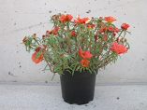 | INCLUDEPICTURE "wordml://77.png" \* MERGEFORMATINET INCLUDEPICTURE "wordml://77.png" \* MERGEFORMATINET INCLUDEPICTURE "wordml://77.png" \* MERGEFORMATINET INCLUDEPICTURE "wordml://77.png" \* MERGEFORMATINET INCLUDEPICTURE "wordml://77.png" \* MERGEFORMATINET INCLUDEPICTURE "wordml://77.png" \* MERGEFORMATINET INCLUDEPICTURE "wordml://77.png" \* MERGEFORMATINET INCLUDEPICTURE "wordml://77.png" \* MERGEFORMATINET 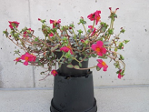 | INCLUDEPICTURE "wordml://78.png" \* MERGEFORMATINET INCLUDEPICTURE "wordml://78.png" \* MERGEFORMATINET INCLUDEPICTURE "wordml://78.png" \* MERGEFORMATINET INCLUDEPICTURE "wordml://78.png" \* MERGEFORMATINET INCLUDEPICTURE "wordml://78.png" \* MERGEFORMATINET INCLUDEPICTURE "wordml://78.png" \* MERGEFORMATINET INCLUDEPICTURE "wordml://78.png" \* MERGEFORMATINET INCLUDEPICTURE "wordml://78.png" \* MERGEFORMATINET 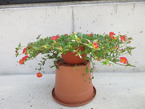
1 | 3 | 5
upright | semi-upright | horizontal

INCLUDEPICTURE "wordml://79.png" \* MERGEFORMATINET INCLUDEPICTURE "wordml://79.png" \* MERGEFORMATINET INCLUDEPICTURE "wordml://79.png" \* MERGEFORMATINET INCLUDEPICTURE "wordml://79.png" \* MERGEFORMATINET INCLUDEPICTURE "wordml://79.png" \* MERGEFORMATINET INCLUDEPICTURE "wordml://79.png" \* MERGEFORMATINET INCLUDEPICTURE "wordml://79.png" \* MERGEFORMATINET INCLUDEPICTURE "wordml://79.png" \* MERGEFORMATINET 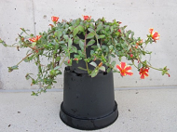 | INCLUDEPICTURE "wordml://80.png" \* MERGEFORMATINET INCLUDEPICTURE "wordml://80.png" \* MERGEFORMATINET INCLUDEPICTURE "wordml://80.png" \* MERGEFORMATINET INCLUDEPICTURE "wordml://80.png" \* MERGEFORMATINET INCLUDEPICTURE "wordml://80.png" \* MERGEFORMATINET INCLUDEPICTURE "wordml://80.png" \* MERGEFORMATINET INCLUDEPICTURE "wordml://80.png" \* MERGEFORMATINET INCLUDEPICTURE "wordml://80.png" \* MERGEFORMATINET 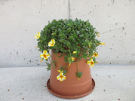
7 | 9
semi-trailing | trailing

Ad. 9: Leaf: width of reddish brown coloration on margin

INCLUDEPICTURE "wordml://81.png" \* MERGEFORMATINET INCLUDEPICTURE "wordml://81.png" \* MERGEFORMATINET INCLUDEPICTURE "wordml://81.png" \* MERGEFORMATINET INCLUDEPICTURE "wordml://81.png" \* MERGEFORMATINET INCLUDEPICTURE "wordml://81.png" \* MERGEFORMATINET INCLUDEPICTURE "wordml://81.png" \* MERGEFORMATINET INCLUDEPICTURE "wordml://81.png" \* MERGEFORMATINET INCLUDEPICTURE "wordml://81.png" \* MERGEFORMATINET 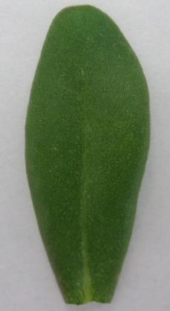 | INCLUDEPICTURE "wordml://82.png" \* MERGEFORMATINET INCLUDEPICTURE "wordml://82.png" \* MERGEFORMATINET INCLUDEPICTURE "wordml://82.png" \* MERGEFORMATINET INCLUDEPICTURE "wordml://82.png" \* MERGEFORMATINET INCLUDEPICTURE "wordml://82.png" \* MERGEFORMATINET INCLUDEPICTURE "wordml://82.png" \* MERGEFORMATINET INCLUDEPICTURE "wordml://82.png" \* MERGEFORMATINET INCLUDEPICTURE "wordml://82.png" \* MERGEFORMATINET 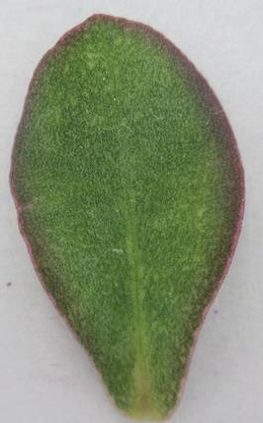 | INCLUDEPICTURE "wordml://83.png" \* MERGEFORMATINET INCLUDEPICTURE "wordml://83.png" \* MERGEFORMATINET INCLUDEPICTURE "wordml://83.png" \* MERGEFORMATINET INCLUDEPICTURE "wordml://83.png" \* MERGEFORMATINET INCLUDEPICTURE "wordml://83.png" \* MERGEFORMATINET INCLUDEPICTURE "wordml://83.png" \* MERGEFORMATINET INCLUDEPICTURE "wordml://83.png" \* MERGEFORMATINET INCLUDEPICTURE "wordml://83.png" \* MERGEFORMATINET 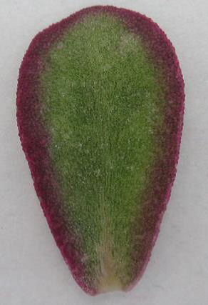
1 | 3 | 4
absent or very narrow | medium | broad

Ad. 11: Flower: type

A single flower has 4 to 6 petals and no petaloid staminodes. A double flower has more than 6 petals and no petaloid staminodes. For flowers with petaloid staminodes the number of petals is irrelevant.

INCLUDEPICTURE "wordml://84.png" \* MERGEFORMATINET INCLUDEPICTURE "wordml://84.png" \* MERGEFORMATINET INCLUDEPICTURE "wordml://84.png" \* MERGEFORMATINET INCLUDEPICTURE "wordml://84.png" \* MERGEFORMATINET INCLUDEPICTURE "wordml://84.png" \* MERGEFORMATINET INCLUDEPICTURE "wordml://84.png" \* MERGEFORMATINET INCLUDEPICTURE "wordml://84.png" \* MERGEFORMATINET INCLUDEPICTURE "wordml://84.png" \* MERGEFORMATINET 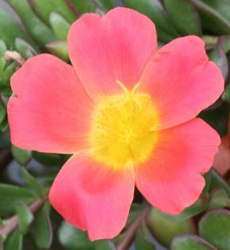 | INCLUDEPICTURE "wordml://85.png" \* MERGEFORMATINET INCLUDEPICTURE "wordml://85.png" \* MERGEFORMATINET INCLUDEPICTURE "wordml://85.png" \* MERGEFORMATINET INCLUDEPICTURE "wordml://85.png" \* MERGEFORMATINET INCLUDEPICTURE "wordml://85.png" \* MERGEFORMATINET INCLUDEPICTURE "wordml://85.png" \* MERGEFORMATINET INCLUDEPICTURE "wordml://85.png" \* MERGEFORMATINET INCLUDEPICTURE "wordml://85.png" \* MERGEFORMATINET 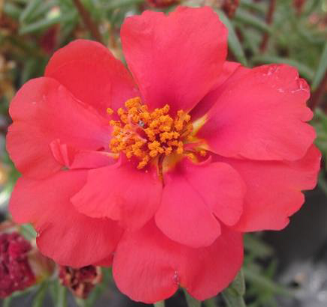 | INCLUDEPICTURE "wordml://86.png" \* MERGEFORMATINET INCLUDEPICTURE "wordml://86.png" \* MERGEFORMATINET INCLUDEPICTURE "wordml://86.png" \* MERGEFORMATINET INCLUDEPICTURE "wordml://86.png" \* MERGEFORMATINET INCLUDEPICTURE "wordml://86.png" \* MERGEFORMATINET INCLUDEPICTURE "wordml://86.png" \* MERGEFORMATINET INCLUDEPICTURE "wordml://86.png" \* MERGEFORMATINET INCLUDEPICTURE "wordml://86.png" \* MERGEFORMATINET 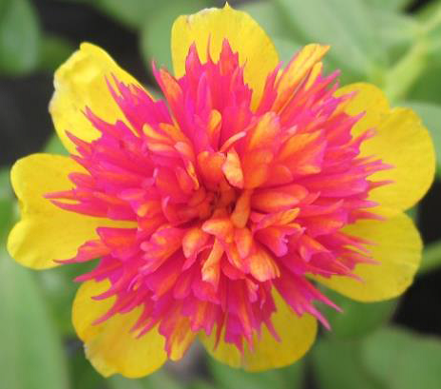
1 | 2 | 3
single | double | with petaloid staminodes

Ad. 12: Only varieties with Flower: type: single: Flower: shape in lateral view
INCLUDEPICTURE "wordml://87.png" \* MERGEFORMATINET INCLUDEPICTURE "wordml://87.png" \* MERGEFORMATINET INCLUDEPICTURE "wordml://87.png" \* MERGEFORMATINET INCLUDEPICTURE "wordml://87.png" \* MERGEFORMATINET INCLUDEPICTURE "wordml://87.png" \* MERGEFORMATINET INCLUDEPICTURE "wordml://87.png" \* MERGEFORMATINET INCLUDEPICTURE "wordml://87.png" \* MERGEFORMATINET INCLUDEPICTURE "wordml://87.png" \* MERGEFORMATINET 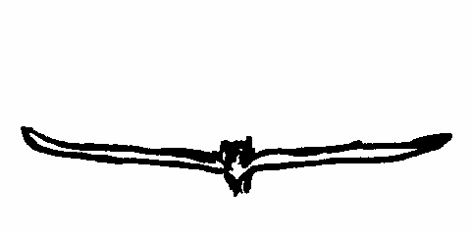 | INCLUDEPICTURE "wordml://88.png" \* MERGEFORMATINET INCLUDEPICTURE "wordml://88.png" \* MERGEFORMATINET INCLUDEPICTURE "wordml://88.png" \* MERGEFORMATINET INCLUDEPICTURE "wordml://88.png" \* MERGEFORMATINET INCLUDEPICTURE "wordml://88.png" \* MERGEFORMATINET INCLUDEPICTURE "wordml://88.png" \* MERGEFORMATINET INCLUDEPICTURE "wordml://88.png" \* MERGEFORMATINET INCLUDEPICTURE "wordml://88.png" \* MERGEFORMATINET 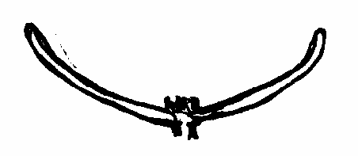 | INCLUDEPICTURE "wordml://89.png" \* MERGEFORMATINET INCLUDEPICTURE "wordml://89.png" \* MERGEFORMATINET INCLUDEPICTURE "wordml://89.png" \* MERGEFORMATINET INCLUDEPICTURE "wordml://89.png" \* MERGEFORMATINET INCLUDEPICTURE "wordml://89.png" \* MERGEFORMATINET INCLUDEPICTURE "wordml://89.png" \* MERGEFORMATINET INCLUDEPICTURE "wordml://89.png" \* MERGEFORMATINET INCLUDEPICTURE "wordml://89.png" \* MERGEFORMATINET 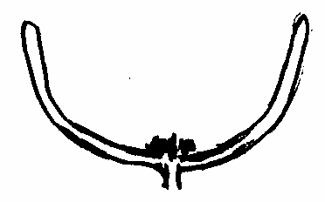
1 | 2 | 3
flat or slightly concave | moderately concave | strongly concave

Ad. 14: Only varieties with Flower: type: single: Flower: overlapping of petals

INCLUDEPICTURE "wordml://90.png" \* MERGEFORMATINET INCLUDEPICTURE "wordml://90.png" \* MERGEFORMATINET INCLUDEPICTURE "wordml://90.png" \* MERGEFORMATINET INCLUDEPICTURE "wordml://90.png" \* MERGEFORMATINET INCLUDEPICTURE "wordml://90.png" \* MERGEFORMATINET INCLUDEPICTURE "wordml://90.png" \* MERGEFORMATINET INCLUDEPICTURE "wordml://90.png" \* MERGEFORMATINET INCLUDEPICTURE "wordml://90.png" \* MERGEFORMATINET 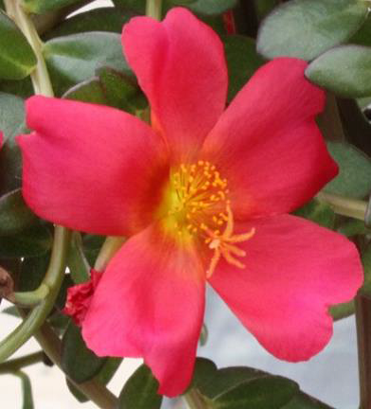 | INCLUDEPICTURE "wordml://91.png" \* MERGEFORMATINET INCLUDEPICTURE "wordml://91.png" \* MERGEFORMATINET INCLUDEPICTURE "wordml://91.png" \* MERGEFORMATINET INCLUDEPICTURE "wordml://91.png" \* MERGEFORMATINET INCLUDEPICTURE "wordml://91.png" \* MERGEFORMATINET INCLUDEPICTURE "wordml://91.png" \* MERGEFORMATINET INCLUDEPICTURE "wordml://91.png" \* MERGEFORMATINET INCLUDEPICTURE "wordml://91.png" \* MERGEFORMATINET 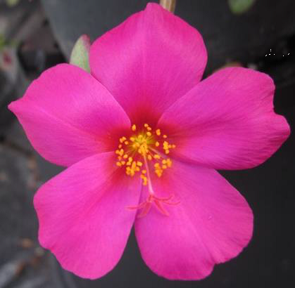 | INCLUDEPICTURE "wordml://92.png" \* MERGEFORMATINET INCLUDEPICTURE "wordml://92.png" \* MERGEFORMATINET INCLUDEPICTURE "wordml://92.png" \* MERGEFORMATINET INCLUDEPICTURE "wordml://92.png" \* MERGEFORMATINET INCLUDEPICTURE "wordml://92.png" \* MERGEFORMATINET INCLUDEPICTURE "wordml://92.png" \* MERGEFORMATINET INCLUDEPICTURE "wordml://92.png" \* MERGEFORMATINET INCLUDEPICTURE "wordml://92.png" \* MERGEFORMATINET 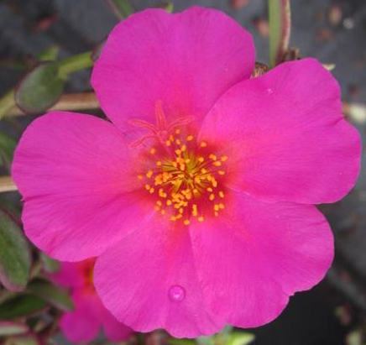
1 | 2 | 3
absent or weak | medium | strong

Ad. 15: Only varieties with Flower: type: single: Flower: conspicuousness of color at base

The conspicuousness is determined by the color contrast and the width of the contrasting ring. The innermost center of the flower is not observed.

 |  | color at base |  | color at base
INCLUDEPICTURE "wordml://93.png" \* MERGEFORMATINET INCLUDEPICTURE "wordml://93.png" \* MERGEFORMATINET INCLUDEPICTURE "wordml://93.png" \* MERGEFORMATINET INCLUDEPICTURE "wordml://93.png" \* MERGEFORMATINET INCLUDEPICTURE "wordml://93.png" \* MERGEFORMATINET INCLUDEPICTURE "wordml://93.png" \* MERGEFORMATINET INCLUDEPICTURE "wordml://93.png" \* MERGEFORMATINET INCLUDEPICTURE "wordml://93.png" \* MERGEFORMATINET 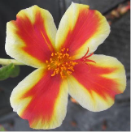 | INCLUDEPICTURE "wordml://94.png" \* MERGEFORMATINET INCLUDEPICTURE "wordml://94.png" \* MERGEFORMATINET INCLUDEPICTURE "wordml://94.png" \* MERGEFORMATINET INCLUDEPICTURE "wordml://94.png" \* MERGEFORMATINET INCLUDEPICTURE "wordml://94.png" \* MERGEFORMATINET INCLUDEPICTURE "wordml://94.png" \* MERGEFORMATINET INCLUDEPICTURE "wordml://94.png" \* MERGEFORMATINET INCLUDEPICTURE "wordml://94.png" \* MERGEFORMATINET 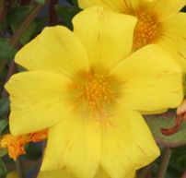 | INCLUDEPICTURE "wordml://95.png" \* MERGEFORMATINET INCLUDEPICTURE "wordml://95.png" \* MERGEFORMATINET INCLUDEPICTURE "wordml://95.png" \* MERGEFORMATINET INCLUDEPICTURE "wordml://95.png" \* MERGEFORMATINET INCLUDEPICTURE "wordml://95.png" \* MERGEFORMATINET INCLUDEPICTURE "wordml://95.png" \* MERGEFORMATINET INCLUDEPICTURE "wordml://95.png" \* MERGEFORMATINET INCLUDEPICTURE "wordml://95.png" \* MERGEFORMATINET 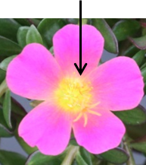 | INCLUDEPICTURE "wordml://96.png" \* MERGEFORMATINET INCLUDEPICTURE "wordml://96.png" \* MERGEFORMATINET INCLUDEPICTURE "wordml://96.png" \* MERGEFORMATINET INCLUDEPICTURE "wordml://96.png" \* MERGEFORMATINET INCLUDEPICTURE "wordml://96.png" \* MERGEFORMATINET INCLUDEPICTURE "wordml://96.png" \* MERGEFORMATINET INCLUDEPICTURE "wordml://96.png" \* MERGEFORMATINET INCLUDEPICTURE "wordml://96.png" \* MERGEFORMATINET 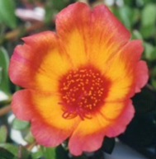 | INCLUDEPICTURE "wordml://97.png" \* MERGEFORMATINET INCLUDEPICTURE "wordml://97.png" \* MERGEFORMATINET INCLUDEPICTURE "wordml://97.png" \* MERGEFORMATINET INCLUDEPICTURE "wordml://97.png" \* MERGEFORMATINET INCLUDEPICTURE "wordml://97.png" \* MERGEFORMATINET INCLUDEPICTURE "wordml://97.png" \* MERGEFORMATINET INCLUDEPICTURE "wordml://97.png" \* MERGEFORMATINET INCLUDEPICTURE "wordml://97.png" \* MERGEFORMATINET 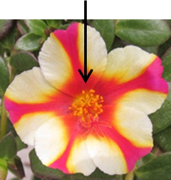
1 | 2 | 3 | 4 | 5
absent or very weak | weak | medium | strong | very strong

Ad. 17: Petal: main color

The main color is the color with the largest surface area excluding the color at base. In cases where the areas of the main and the secondary color are too similar to reliably decide which color has the larger area, the darker color is considered to be the main color. The tertiary color is the color with the third largest area. In cases where the areas of the secondary and the tertiary color are too similar to decide which has the smaller area, the lighter color is considered to be the tertiary color.

Ad. 18: Petal: secondary color

See Ad. 17.

Ad. 19: Petal: distribution of secondary color
In varieties with bi- or multi-colored flowers the proportion of the main and the secondary color can change due to environmental conditions. Those flowers which have the predominant distribution should be described.
Arrow points to the secondary color:

INCLUDEPICTURE "wordml://98.png" \* MERGEFORMATINET INCLUDEPICTURE "wordml://98.png" \* MERGEFORMATINET INCLUDEPICTURE "wordml://98.png" \* MERGEFORMATINET INCLUDEPICTURE "wordml://98.png" \* MERGEFORMATINET INCLUDEPICTURE "wordml://98.png" \* MERGEFORMATINET INCLUDEPICTURE "wordml://98.png" \* MERGEFORMATINET INCLUDEPICTURE "wordml://98.png" \* MERGEFORMATINET INCLUDEPICTURE "wordml://98.png" \* MERGEFORMATINET 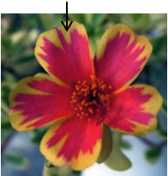 | INCLUDEPICTURE "wordml://99.png" \* MERGEFORMATINET INCLUDEPICTURE "wordml://99.png" \* MERGEFORMATINET INCLUDEPICTURE "wordml://99.png" \* MERGEFORMATINET INCLUDEPICTURE "wordml://99.png" \* MERGEFORMATINET INCLUDEPICTURE "wordml://99.png" \* MERGEFORMATINET INCLUDEPICTURE "wordml://99.png" \* MERGEFORMATINET INCLUDEPICTURE "wordml://99.png" \* MERGEFORMATINET INCLUDEPICTURE "wordml://99.png" \* MERGEFORMATINET 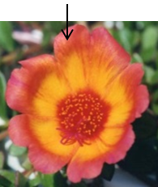 | INCLUDEPICTURE "wordml://100.png" \* MERGEFORMATINET INCLUDEPICTURE "wordml://100.png" \* MERGEFORMATINET INCLUDEPICTURE "wordml://100.png" \* MERGEFORMATINET INCLUDEPICTURE "wordml://100.png" \* MERGEFORMATINET INCLUDEPICTURE "wordml://100.png" \* MERGEFORMATINET INCLUDEPICTURE "wordml://100.png" \* MERGEFORMATINET INCLUDEPICTURE "wordml://100.png" \* MERGEFORMATINET INCLUDEPICTURE "wordml://100.png" \* MERGEFORMATINET 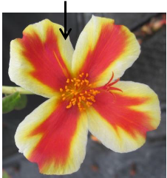
1 | 2 | 3
mainly at apex | at upper third | irregular along marginal zone

INCLUDEPICTURE "wordml://101.png" \* MERGEFORMATINET INCLUDEPICTURE "wordml://101.png" \* MERGEFORMATINET INCLUDEPICTURE "wordml://101.png" \* MERGEFORMATINET INCLUDEPICTURE "wordml://101.png" \* MERGEFORMATINET INCLUDEPICTURE "wordml://101.png" \* MERGEFORMATINET INCLUDEPICTURE "wordml://101.png" \* MERGEFORMATINET INCLUDEPICTURE "wordml://101.png" \* MERGEFORMATINET INCLUDEPICTURE "wordml://101.png" \* MERGEFORMATINET 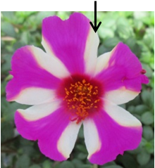 | INCLUDEPICTURE "wordml://102.png" \* MERGEFORMATINET INCLUDEPICTURE "wordml://102.png" \* MERGEFORMATINET INCLUDEPICTURE "wordml://102.png" \* MERGEFORMATINET INCLUDEPICTURE "wordml://102.png" \* MERGEFORMATINET INCLUDEPICTURE "wordml://102.png" \* MERGEFORMATINET INCLUDEPICTURE "wordml://102.png" \* MERGEFORMATINET INCLUDEPICTURE "wordml://102.png" \* MERGEFORMATINET INCLUDEPICTURE "wordml://102.png" \* MERGEFORMATINET 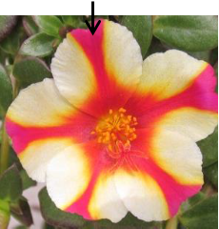 | INCLUDEPICTURE "wordml://103.png" \* MERGEFORMATINET INCLUDEPICTURE "wordml://103.png" \* MERGEFORMATINET INCLUDEPICTURE "wordml://103.png" \* MERGEFORMATINET INCLUDEPICTURE "wordml://103.png" \* MERGEFORMATINET INCLUDEPICTURE "wordml://103.png" \* MERGEFORMATINET INCLUDEPICTURE "wordml://103.png" \* MERGEFORMATINET INCLUDEPICTURE "wordml://103.png" \* MERGEFORMATINET INCLUDEPICTURE "wordml://103.png" \* MERGEFORMATINET 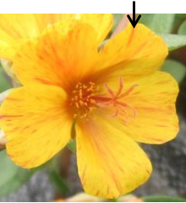
4 | 5 | 6
on lateral marginal zone | central | throughout

Ad. 20: Petal: tertiary color

See Ad. 17.

Ad. 23: Petal: emargination
INCLUDEPICTURE "wordml://104.png" \* MERGEFORMATINET INCLUDEPICTURE "wordml://104.png" \* MERGEFORMATINET INCLUDEPICTURE "wordml://104.png" \* MERGEFORMATINET INCLUDEPICTURE "wordml://104.png" \* MERGEFORMATINET INCLUDEPICTURE "wordml://104.png" \* MERGEFORMATINET INCLUDEPICTURE "wordml://104.png" \* MERGEFORMATINET INCLUDEPICTURE "wordml://104.png" \* MERGEFORMATINET INCLUDEPICTURE "wordml://104.png" \* MERGEFORMATINET 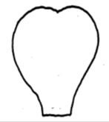 | INCLUDEPICTURE "wordml://105.png" \* MERGEFORMATINET INCLUDEPICTURE "wordml://105.png" \* MERGEFORMATINET INCLUDEPICTURE "wordml://105.png" \* MERGEFORMATINET INCLUDEPICTURE "wordml://105.png" \* MERGEFORMATINET INCLUDEPICTURE "wordml://105.png" \* MERGEFORMATINET INCLUDEPICTURE "wordml://105.png" \* MERGEFORMATINET INCLUDEPICTURE "wordml://105.png" \* MERGEFORMATINET INCLUDEPICTURE "wordml://105.png" \* MERGEFORMATINET 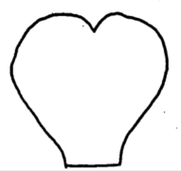 | INCLUDEPICTURE "wordml://106.png" \* MERGEFORMATINET INCLUDEPICTURE "wordml://106.png" \* MERGEFORMATINET INCLUDEPICTURE "wordml://106.png" \* MERGEFORMATINET INCLUDEPICTURE "wordml://106.png" \* MERGEFORMATINET INCLUDEPICTURE "wordml://106.png" \* MERGEFORMATINET INCLUDEPICTURE "wordml://106.png" \* MERGEFORMATINET INCLUDEPICTURE "wordml://106.png" \* MERGEFORMATINET INCLUDEPICTURE "wordml://106.png" \* MERGEFORMATINET 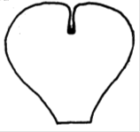
1 | 2 | 3
absent or shallow | medium | deep

Ad. 24: Petaloid staminodes: color of outer staminodes

INCLUDEPICTURE "wordml://107.png" \* MERGEFORMATINET INCLUDEPICTURE "wordml://107.png" \* MERGEFORMATINET INCLUDEPICTURE "wordml://107.png" \* MERGEFORMATINET INCLUDEPICTURE "wordml://107.png" \* MERGEFORMATINET INCLUDEPICTURE "wordml://107.png" \* MERGEFORMATINET INCLUDEPICTURE "wordml://107.png" \* MERGEFORMATINET INCLUDEPICTURE "wordml://107.png" \* MERGEFORMATINET INCLUDEPICTURE "wordml://107.png" \* MERGEFORMATINET 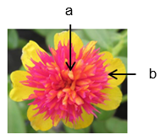 | a = Inner staminodes  b = Outer staminodes

Ad. 25: Petal staminodes: color of inner staminodes

See Ad. 24.

9.
Literature

No specific literature.

10.
Technical Questionnaire

TECHNICAL QUESTIONNAIRE | Page {x} of {y} | Reference Number:

Application date:
(not to be filled in by the applicant)
TECHNICAL QUESTIONNAIRE
to be completed in connection with an application for plant breeders' rights

1. | Subject of the Technical Questionnaire
 |  | Botanical name
  1.1.1
  Portulaca grandiflora Hook.
  [ ]
 |  | Common name
  1.1.2
 |  | Botanical name
  1.2.1
  Portulaca oleracea L.
  [ ]
 |  | Common name
  1.2.2
  Portulaca
 |  | Botanical name
  1.3.1
  Portulaca umbraticola Kunth
  [ ]
 |  | Common name
  1.3.2
 |  | Botanical name
  1.4.1
  [ ]
 |  | Common name
  1.4.2

2. | Applicant
 | Name
 | Address
 | Telephone No.
 | Fax No.
 | E-mail address
 | Breeder (if different from
 | applicant)

3. | Proposed denomination and breeder's reference

Proposed denomination
(if available)
Breeder's reference

TECHNICAL QUESTIONNAIRE |  |  | Page {x} of {y} | Reference Number:
#4. | Information on the breeding scheme and propagation of the variety
 | 4.1 | Breeding scheme
 | Variety resulting from:
  4.1.1
  Crossing
 |  | [ ]
  (a)
  controlled cross
  (please state parent varieties)
(…………………..……………..…) x (……………..…………………..…)

female parent male parent

 |  | [ ]
  (b)
  partially known cross
  (please state known parent variety(ies))
(…………………..……………..…) x (……………..…………………..…)

female parent male parent

 |  | [ ]
  (c)
  unknown cross
 |  | [ ]
  4.1.2
  Mutation
  (please state parent variety)
 |  | [ ]
  4.1.3
  Discovery and development
  (please state where and when discovered and how developed)
 | Other  (Please provide details) | [ ]
  4.1.4

TECHNICAL QUESTIONNAIRE  Page {x} of {y} | Reference Number:

 | 4.2 | Method of propagating the variety
  4.2.1
  Seed-propagated varieties
 |  | [ ]
  (a)
  Self-pollination
 |  | [ ]
  (b)
  Cross-pollination
 |  | [ ]
  (c)
  Hybrid
 |  | [ ]
  (d)
  Other (please provide details)
  4.2.2
  Vegetative propagation
 |  | [ ]
  (a)
  Cuttings
 |  | [ ]
  (b)
  In vitro propagation
 |  | [ ]
  (c)
  Other (state method)
 | Other  (Please provide details) | [ ]
  4.2.3

TECHNICAL QUESTIONNAIRE | Page {x} of {y} | Reference Number:

5. | Characteristics of the variety to be indicated (the number in brackets refers to the corresponding characteristic in Test Guidelines; please mark the note which best corresponds).

 | Characteristics | Example Varieties | Note
  5.1
  (2)
  Shoot: attitude
  upright
  Sunseeker Orange
  1 [ ]
  upright to semi-upright
  2 [ ]
  semi-upright
  Pazzaz Deep Pink
  3 [ ]
  semi-upright to horizontal
  4 [ ]
  horizontal
  5 [ ]
  horizontal to semi-trailing
  6 [ ]
  semi-trailing
  LAZPRT 1703
  7 [ ]
  semi-trailing to trailing
  8 [ ]
  trailing
  LAZPRT 1502
  9 [ ]
  5.2
  (11)
  Flower: type
  single
  LAZZDU 1112
  1 [ ]
  double
  Sunseeker Orange
  2 [ ]
  with petaloid staminodes
  Cindy
  3 [ ]
  5.3
  (13)
  Flower: diameter
  very small
  1 [ ]
  very small to small
  2 [ ]
  small
  LAZPRT 1502
  3 [ ]
  small to medium
  4 [ ]
  medium
  Pazzaz Deep Pink
  5 [ ]
  medium to large
  6 [ ]
  large
  KLEPO 12820
  7 [ ]
  large to very large
  8 [ ]
  very large
  9 [ ]

TECHNICAL QUESTIONNAIRE
Page {x} of {y} | Reference Number:

 | Characteristics | Example Varieties | Note
  5.4(i)
  (17)
  Petal: main color
  RHS Colour Chart (indicate reference number)
  5.4(ii)
  (17)
  Petal: main color
  white
  1 [ ]
  yellow
  2 [ ]
  yellow orange
  3 [ ]
  orange
  4 [ ]
  pink
  5 [ ]
  red
  6 [ ]
  purple
  7 [ ]
  violet
  8 [ ]
  other color (indicate)
  9 [ ]
  5.5(i)
  (18)
  Petal: secondary color
  RHS Colour Chart (indicate reference number)
  5.5(ii)
  (18)
  Petal: secondary color
  white
  1 [ ]
  yellow
  2 [ ]
  orange
  3 [ ]
  orange brown
  4 [ ]
 | pink
  5 [ ]
  red
  6 [ ]
  purple
  7 [ ]
 |  |  | 8 [ ]
  violet
  other color (indicate)
  9 [ ]
  5.6
  (19)
  Petal: distribution of secondary color
  mainly at apex
  1 [ ]
  at upper third
  2 [ ]
  irregular along marginal zone
  3 [ ]
  on lateral marginal zone
  4 [ ]
  central
  5 [ ]
  throughout
  6 [ ]

TECHNICAL QUESTIONNAIRE | Page {x} of {y} | Reference Number:

6. | Similar varieties and differences from these varieties
Please use the following table and box for comments to provide information on how your candidate variety differs from the variety (or varieties) which, to the best of your knowledge, is (or are) most similar. This information may help the examination authority to conduct its examination of distinctness in a more efficient way.

  Denomination(s) of variety(ies) similar to your candidate variety
  Characteristic(s) in which your candidate variety differs from the similar variety(ies)
  Describe the expression of the characteristic(s) for the similar variety(ies)
  Describe the expression of the characteristic(s) for your candidate variety

Example
  Flower: diameter
  small
  medium

 | Comments:

TECHNICAL QUESTIONNAIRE | Page {x} of {y} | Reference Number:

#7. | Additional information which may help in the examination of the variety
7.1 | In addition to the information provided in sections 5 and 6, are there any additional characteristics which may help to distinguish the variety?
 | Yes | [ ] | No | [ ]
 | (If yes, please provide details)
7.2 | Are there any special conditions for growing the variety or conducting the examination?
 | Yes | [ ] | No | [ ]
 | (If yes, please provide details)
7.3 | Other information
A representative color photograph of the variety displaying its main distinguishing feature(s), should accompany the Technical Questionnaire. The photograph will provide a visual illustration of the candidate variety which supplements the information provided in the Technical Questionnaire.
The key points to consider when taking a photograph of the candidate variety are:
• Indication of the date and geographic location
• Correct labeling (breeder’s reference)
• Good quality printed photograph (minimum 10 cm x 15 cm) and/or sufficient resolution electronic format version (minimum 960 x 1280 pixels)”
Further guidance on providing photographs with the Technical Questionnaire is available in document TGP/7 "Development of Test Guidelines", Guidance Note 35 (http://www.upov.int/tgp/en/).
[The link provided may be deleted by members of the Union when developing authorities’ own test guidelines.]

TECHNICAL QUESTIONNAIRE
Page {x} of {y} | Reference Number:

8. | Authorization for release
 | (a) | Does the variety require prior authorization for release under legislation concerning the protection of the environment, human and animal health?
 |  | Yes | [ ] | No | [ ]
 | (b) | Has such authorization been obtained?
 |  | Yes | [ ] | No | [ ]
 | If the answer to (b) is yes, please attach a copy of the authorization.

9. Information on plant material to be examined or submitted for examination

9.1 The expression of a characteristic or several characteristics of a variety may be affected by factors, such as pests and disease, chemical treatment (e.g. growth retardants or pesticides), effects of tissue culture, different rootstocks, scions taken from different growth phases of a tree, etc.
9.2 The plant material should not have undergone any treatment which would affect the expression of the characteristics of the variety, unless the competent authorities allow or request such treatment. If the plant material has undergone such treatment, full details of the treatment must be given. In this respect, please indicate below, to the best of your knowledge, if the plant material to be examined has been subjected to:

 | (a) | Microorganisms (e.g. virus, bacteria, phytoplasma) | Yes [ ] | No [ ]
 | (b) | Chemical treatment (e.g. growth retardant, pesticide) | Yes [ ] | No [ ]
 | (c) | Tissue culture | Yes [ ] | No [ ]
 | (d) | Other factors | Yes [ ] | No [ ]
 | Please provide details for where you have indicated “yes”.

10. | I hereby declare that, to the best of my knowledge, the information provided in this form is correct:
 | Applicant’s name
 | Signature |  | Date

[End of document]

