 |  | E  TG/240/1  ORIGINAL: English  DATE: 2008-04-09
INTERNATIONAL UNION FOR THE PROTECTION OF NEW VARIETIES OF PLANTS
GENEVA

 | COMMON SEA BUCKTHORN  UPOV Code: HIPPH_RHA  Hippophae rhamnoides L. | *

GUIDELINES

FOR THE CONDUCT OF TESTS

FOR DISTINCTNESS, UNIFORMITY AND STABILITY

Alternative Names:*

Botanical name | English | French | German | Spanish
Hippophae rhamnoides L. | Common Sea Buckthorn, Sallowthorn, Sea-buckthorn | Argasse,  Argousier,  Grisset | Sanddorn | Espino amarillo, Espino falso

The purpose of these guidelines (“Test Guidelines”) is to elaborate the principles contained in the General Introduction (document TG/1/3), and its associated TGP documents, into detailed practical guidance for the harmonized examination of distinctness, uniformity and stability (DUS) and, in particular, to identify appropriate characteristics for the examination of DUS and production of harmonized variety descriptions.

ASSOCIATED DOCUMENTS

These Test Guidelines should be read in conjunction with the General Introduction and its associated TGP documents.
TABLE OF CONTENTS PAGE

1. Subject of these Test Guidelines 3
2. Material Required 3
3. Method of Examination 3
3.1 Number of Growing Cycles 3
3.2 Testing Place 3
3.3 Conditions for Conducting the Examination 3
3.4 Test Design 4
3.5 Number of Plants / Parts of Plants to be Examined 4
3.6 Additional Tests 4
4. Assessment of Distinctness, Uniformity and Stability 4
4.1 Distinctness 4
4.2 Uniformity 5
4.3 Stability 5
5. Grouping of Varieties and Organization of the Growing Trial 5
6. Introduction to the Table of Characteristics 6
6.1 Categories of Characteristics 6
6.2 States of Expression and Corresponding Notes 6
6.3 Types of Expression 6
6.4 Example Varieties 6
6.5 Legend 6
7. Table of Characteristics/Tableau des caractères/Merkmalstabelle/Tabla de caracteres 7
8. Explanation on the Table of Characteristics 12
8.1 Explanations covering several characteristics 12
8.2 Explanations for individual characteristics 12
9. Literature 15
10. Technical Questionnaire 16

Subject of these Test Guidelines
These Test Guidelines apply to all varieties of Hippophae rhamnoides L.

Material Required
2.1 The competent authorities decide on the quantity and quality of the plant material required for testing the variety and when and where it is to be delivered. Applicants submitting material from a State other than that in which the testing takes place must ensure that all customs formalities and phytosanitary requirements are complied with.

2.2 The material is to be supplied in the form of one-year-old, well-rooted plants with at least two shoots.

2.3 The minimum quantity of plant material, to be supplied by the applicant, should be:

5 plants.

2.4 The plant material supplied should be visibly healthy, not lacking in vigor, nor affected by any important pest or disease.

2.5 The plant material should not have undergone any treatment which would affect the expression of the characteristics of the variety, unless the competent authorities allow or request such treatment. If it has been treated, full details of the treatment must be given.

Method of Examination

3.1 Number of Growing Cycles
3.1.1 The minimum duration of tests should normally be two independent growing cycles.

3.1.2 The growing cycle is considered to be the duration of a single growing season, beginning with bud burst (flowering and/or vegetative), flowering and fruit harvest and concluding when the following dormant period ends with the swelling of new season buds.”

3.2 Testing Place
Tests are normally conducted at one place. In the case of tests conducted at more than one place, guidance is provided in TGP/9 “Examining Distinctness”.

3.3 Conditions for Conducting the Examination
3.3.1 The tests should be carried out under conditions ensuring satisfactory growth for the expression of the relevant characteristics of the variety and for the conduct of the examination. In particular, it is essential that the plants produce a satisfactory crop of fruit in each of the two growing cycles.

3.3.2 The recommended method of observing the characteristic is indicated by the following key in the second column of the Table of Characteristics:

MG: single measurement of a group of plants or parts of plants
MS: measurement of a number of individual plants or parts of plants
VG: visual assessment by a single observation of a group of plants or parts of plants
VS: visual assessment by observation of individual plants or parts of plants.

3.4 Test Design
3.4.1 Each test should be designed to result in a total of at least 5 plants.

3.4.2 The design of the tests should be such that plants or parts of plants may be removed for measurement or counting without prejudice to the observations which must be made up to the end of the growing cycle.

3.5 Number of Plants / Parts of Plants to be Examined
Unless otherwise indicated, all observations should be made on 5 plants or parts taken from each of 5 plants. In the case of parts of plants, the number to be taken from each of the plants should be 3.

3.6 Additional Tests
Additional tests, for examining relevant characteristics, may be established.

Assessment of Distinctness, Uniformity and Stability

4.1 Distinctness

4.1.1 General Recommendations
It is of particular importance for users of these Test Guidelines to consult the General Introduction prior to making decisions regarding distinctness. However, the following points are provided for elaboration or emphasis in these Test Guidelines.

4.1.2 Consistent Differences
The differences observed between varieties may be so clear that more than one growing cycle is not necessary. In addition, in some circumstances, the influence of the environment is not such that more than a single growing cycle is required to provide assurance that the differences observed between varieties are sufficiently consistent. One means of ensuring that a difference in a characteristic, observed in a growing trial, is sufficiently consistent is to examine the characteristic in at least two independent growing cycles.

4.1.3 Clear Differences
Determining whether a difference between two varieties is clear depends on many factors, and should consider, in particular, the type of expression of the characteristic being examined, i.e. whether it is expressed in a qualitative, quantitative, or pseudo-qualitative manner. Therefore, it is important that users of these Test Guidelines are familiar with the recommendations contained in the General Introduction prior to making decisions regarding distinctness.

4.2 Uniformity
4.2.1 It is of particular importance for users of these Test Guidelines to consult the General Introduction prior to making decisions regarding uniformity. However, the following points are provided for elaboration or emphasis in these Test Guidelines:

4.2.2 For the assessment of uniformity, a population standard of 1% and an acceptance probability of at least 95% should be applied. In the case of a sample size of 5 plants, no off-types are allowed.

4.3 Stability
4.3.1 In practice, it is not usual to perform tests of stability that produce results as certain as those of the testing of distinctness and uniformity. However, experience has demonstrated that, for many types of variety, when a variety has been shown to be uniform, it can also be considered to be stable.

4.3.2 Where appropriate, or in cases of doubt, stability may be tested, either by growing a further generation, or by testing a new plant stock to ensure that it exhibits the same characteristics as those shown by the previous material supplied.

Grouping of Varieties and Organization of the Growing Trial
5.1 The selection of varieties of common knowledge to be grown in the trial with the candidate varieties and the way in which these varieties are divided into groups to facilitate the assessment of distinctness are aided by the use of grouping characteristics.

5.2 Grouping characteristics are those in which the documented states of expression, even where produced at different locations, can be used, either individually or in combination with other such characteristics: (a) to select varieties of common knowledge that can be excluded from the growing trial used for examination of distinctness; and (b) to organize the growing trial so that similar varieties are grouped together.

5.3 The following have been agreed as useful grouping characteristics:

- Plant: sex (characteristic 1)
- Plant: growth type (characteristic 2)
- Plant: attitude of branches (characteristic 3)
- Shoot: number of thorns (from middle part to top) (characteristic 8)

5.4 Guidance for the use of grouping characteristics, in the process of examining distinctness, is provided through the General Introduction.

Introduction to the Table of Characteristics

6.1 Categories of Characteristics

6.1.1 Standard Test Guidelines Characteristics
Standard Test Guidelines characteristics are those which are approved by UPOV for examination of DUS and from which members of the Union can select those suitable for their particular circumstances.

6.1.2 Asterisked Characteristics
Asterisked characteristics (denoted by *) are those included in the Test Guidelines which are important for the international harmonization of variety descriptions and should always be examined for DUS and included in the variety description by all members of the Union, except when the state of expression of a preceding characteristic or regional environmental conditions render this inappropriate.

6.2 States of Expression and Corresponding Notes
States of expression are given for each characteristic to define the characteristic and to harmonize descriptions. Each state of expression is allocated a corresponding numerical note for ease of recording of data and for the production and exchange of the description.

6.3 Types of Expression
An explanation of the types of expression of characteristics (qualitative, quantitative and pseudo-qualitative) is provided in the General Introduction.

6.4 Example Varieties
Where appropriate, example varieties are provided to clarify the states of expression of each characteristic.

6.5 Legend
(*) Asterisked characteristic – see Chapter 6.1.2

QL: Qualitative characteristic – see Chapter 6.3
QN: Quantitative characteristic – see Chapter 6.3
PQ: Pseudo-qualitative characteristic – see Chapter 6.3

MG, MS, VG, VS: See Chapter 3.3.2

(a)-(e) See Explanations on the Table of Characteristics in Chapter 8.1

(+) See Explanations on the Table of Characteristics in Chapter 8.2

Table of Characteristics/Tableau des caractères/Merkmalstabelle/Tabla de caracteres
 |  | English | français | Deutsch | español | Example Varieties/  Exemples/  Beispielssorten/  Variedades ejemplo | Note/  Nota
1.  (*)  (+) | VG | Plant: sex | Plante: sexe | Pflanze: Geschlecht | Planta: sexo
QL | (a) | female | femelle | weiblich | femenina | Bojan, Leikora, Slovan | 1
 |  | male | mâle | männlich | masculina | Pollmix 1 | 2
2.  (*)  (+) | VG | Plant: growth type | Plante: type de croissance | Pflanze: Wuchstyp | Planta: porte
QL | (a) | tree-type | arbre | baumartig | tipo árbol | Maslichnaya, Novost` Altaya, Slovan, Vitaminaya | 1
 |  | bush-type | buissonnant | buschig | tipo arbustivo | Bojan, Dorana, Terhi | 2
3.  (*) | VG | Plant: attitude of branches | Plante: port des ramifications | Pflanze: Stellung der Seitenäste | Planta: porte de las ramificaciones
PQ | (a) | erect | dressé | aufrecht | erecto | Ascola, Frugana | 1
 |  | semi-erect | demi-dressé | halbaufrecht | semierecto | Leikora, Slovan, Vitaminaya | 2
 |  | horizontal | horizontal | waagerecht | horizontal | Bojan, Maslichnaya | 3
 |  | arching | arqué | bogenförmig | arqueada | Hergo | 4
4.  (+) | VG | Plant: vigor | Plante: vigueur | Pflanze: Wuchsstärke | Planta: vigor
QN | (a) | weak | faible | gering | débil | Dorana, Maslichnaya | 3
 |  | medium | moyenne | mittel | medio | Bojan, Hergo | 5
 |  | strong | forte | stark | fuerte | Ascola | 7
 |  | very strong | très forte | sehr stark | muy fuerte | Leikora | 9
5. | VG | Plant: density of shoots | Plante: densité des rameaux | Pflanze: Dichte der Triebe | Planta: densidad de las ramas
QN | (a) | sparse | faible | locker | laxa | Pollmix 3, Vitaminaya | 3
 |  | medium | moyenne | mittel | media | Bojan | 5
 |  | dense | dense | dicht | densa | Maslichnaya, Slovan | 7
6. | VG | Plant: position of inflorescences | Plante : position des inflorescences | Pflanze: Position der Blütenstände | Planta: posición de las inflorescencias
QL | (b) | on one-year-old shoots only | seulement sur les rameaux d’un an | nur an einjährigen Trieben | sólo en ramas de un año | Leikora, Pollmix 1, Pollmix 2 | 1
 |  | both on one-year-old and older shoots | sur les rameaux d’un an et les rameaux plus anciens | an einjährigen und an älteren Trieben | en ramas de un año y en ramas más viejas | Ascola, Dorana, Frugana | 2
7. | VG | One-year-old shoot: thickness | Rameau d’un an : épaisseur | Einjähriger Trieb: Dicke | Rama de un año: grosor
QN | (b) | thin | mince | dünn | delgada |  | 3
 |  | medium | moyenne | mittel | media | Bojan, Slovan | 5
 |  | thick | épaisse | dick | gruesa | Leikora, Maslichnaya | 7
8.  (*) | VG | Shoot: number of thorns (from middle part to top) | Rameau : nombre d’épines (de la partie médiane au sommet) | Trieb: Anzahl Dornen (vom mittleren Teil bis zur Spitze) | Rama: número de espinas (de la parte media hacia arriba)
QN | (b) | absent or very few | nul ou très petit | fehlend oder sehr gering | ausente o muy bajo | Obil´naya, Yantarnaya | 1
 |  | few | faible | gering | bajo | Pollmix 1, Vitaminaya | 3
 |  | medium | moyen | mittel | medio | Slovan | 5
 |  | many | grand | groß | alto | Bojan, Leikora, Pollmix 2 | 7
9.  (+) | VG | Shoot: length of thorns | Rameau : longueur des épines | Trieb: Länge der Dornen | Rama: longitud de las espinas
QN | (b) | short | courtes | kurz | corta | Silvia, Tiberiu | 3
 |  | medium | moyennes | mittel | media | Auras, Victoria | 5
 |  | long | longues | lang | larga | Diana | 7
10.  (*)  (+) | VG | Leaf blade: shape | Limbe: forme | Blattspreite: Form | Limbo: forma
PQ | (c) | very narrow elliptic | très elliptique étroit | sehr schmal elliptisch | muy elíptica estrecha | Bojan, Dorana, Maslichnaya, Vitaminaya | 1
 |  | narrow elliptic | elliptique étroit | schmal elliptisch | elíptica estrecha | Slovan | 2
 |  | narrow ovate | oval étroit | schmal eiförmig | oval estrecha | Frugana | 3
11.  (*) | MG/  VG | Leaf blade: size | Limbe: taille | Blattspreite: Größe | Limbo: tamaño
QN | (c) | small | petit | klein | pequeño | Dorana, Maslichnaya | 3
 |  | medium | moyen | mittel | mediano | Hergo, Slovan | 5
 |  | large | grand | groß | grande | Bojan, Leikora, Vitaminaya | 7
12. | VG | Leaf blade: undulation of margin | Limbe: ondulation du bord | Blattspreite: Randwellung | Limbo: ondulación del borde
QL | (c) | absent | absente | fehlend | ausente | Bojan, Dorana, Maslichnaya, Slovan, Vitaminaya | 1
 |  | present | présente | vorhanden | presente | Frugana | 9
13.  (*) | VG | Leaf blade: color of upper side | Limbe: couleur de la face supérieure | Blattspreite: Farbe der Oberseite | Limbo: color del haz
QL | (c) | green | verte | grün | verde | Dorana, Leikora, Pollmix 1 | 1
 |  | silverish | argentée | silbrig | plateado | Bojan, Maslichnaya, Slovan, Sprite | 2
14.  QN | VG  (c) | Leaf blade: intensity of green color of upper side | Limbe: intensité de la couleur verte de la face supérieure | Blattspreite: Intensität der Grünfärbung der Oberseite | Limbo: intensidad del color verde en la parte superior
 |  | light | légère | hell | claro | Dorana | 1
 |  | medium | moyenne | mittel | medio | Leikora | 2
 |  | dark | foncée | dunkel | oscuro | Pollmix 1 | 3
15.  (*) | VG | Leaf blade: pubescence of lower side | Limbe: pilosité de la face inférieure | Blattspreite : Behaarung der Unterseite | Limbo: pubescencia del envés
QN | (c) | weak | faible | gering | débil | Bojan, Diana, Ovidiu, Slovan, Tiberiu | 3
 | (d) | medium | moyenne | mittel | media | Auras, Serpenta, Victoria | 5
 |  | strong | forte | stark | fuerte | Silvia | 7
16.  (*) | VG | Fruit: size | Fruit: taille | Frucht: Größe | Fruto: tamaño
QN | (e) | small | petit | klein | pequeño | Bojan, Dorana | 3
 |  | medium | moyen | mittel | medio | Hergo, Maslichnaya | 5
 |  | large | gros | groß | grande | Leikora | 7
17.  (*)  (+) | VG | Fruit: shape | Fruit: forme | Frucht: Form | Fruto: forma
PQ | (e) | pear-shaped | piriforme | birnenförmig | piriforme | Dorana | 1
 |  | ovate | ovale | eiförmig | ovada | Leikora, Slovan | 2
 |  | transverse elliptic | elliptique transverse | quer elliptisch | elíptica transversal | Silvia | 3
 |  | circular | circulaire | kreisförmig | circular | Tashkent | 4
 |  | elliptic | elliptique | elliptisch | elíptica | Askola, Bojan, Frugana | 5
 |  | oblong | oblong | rechteckig | oblonga | Hergo, Terhi | 6
18.  (*) | VG | Fruit: color of skin | Fruit: couleur de la peau | Frucht: Farbe der Haut | Fruto: color de la epidermis
PQ | (e) | light yellow | jaune clair | hellgelb | amarillo claro |  | 1
 |  | dark yellow | jaune foncé | dunkelgelb | amarillo oscuro | Terhi, Tytti | 2
 |  | yellow orange | jaune orange | gelborange | anaranjado amarillento | Hergo, Slovan | 3
 |  | orange red | rouge orangé | orangerot | rojo anaranjado | Ascola, Bojan, Leikora | 4
 |  | red | rouge | rot | rojo | L 90/539, Sirola | 5
19. | VG | Fruit: pubescence | Fruit: pilosité | Frucht: Behaarung | Fruto: pubescencia
QN | (d) | weak | faible | gering | débil | Bojan, Frugana, Maslichnaya, Vitaminaya | 3
 | (e) | medium | moyenne | mittel | media | Hergo | 5
 |  | strong | forte | stark | fuerte | Ascola, Slovan | 7
20. | VG | Fruit: length of stalk | Fruit: longueur du pédoncule | Frucht: Länge des Stiels | Fruto: longitud del pedúnculo
QN | (e) | short | court | kurz | corto | Bojan, Hergo | 1
 |  | medium | moyen | mittel | medio | Leikora, Maslichnaya | 2
 |  | long | long | lang | largo | Frugana, Slovan | 3
21.  (+) | MG | Time of beginning of flowering | Époque de début de floraison | Zeitpunkt des Blühbeginns | Época de comienzo de la floración
QN |  | early | précoce | früh | temprana | Terhy, Tytti | 3
 |  | medium | moyenne | mittel | media | Bojan, Dorana,  Hergo, Maslichnaya | 5
 |  | late | tardive | spät | tardía | Leikora, Slovan | 7
22.  (+) | MG | Time of beginning of fruit ripening | Époque du début de la maturation des fruits | Zeitpunkt des Beginns der Fruchtreife | Época de inicio de maduración del fruto
QN |  | very early | très précoce | sehr früh | muy temprana | Terhi, Tytti | 1
 |  | early | précoce | früh | temprana | Frugana | 3
 |  | medium | moyenne | mittel | media | Dorana, Hergo | 5
 |  | late | tardive | spät | tardía | Leikora | 7
 |  | very late | très tardive | sehr spät | muy tardía |  | 9

Explanation on the Table of Characteristics

8.1 Explanations covering several characteristics
Characteristics containing the following key in the second column of the Table of Characteristics should be examined as indicated below:

(a) Plant: Observations should be made during winter dormancy.
(b) Shoot: Observations should be made during active growth.
(c) Leaf blade: Observations should be made on mature leaves taken from the middle third of the current season’s growth in the middle part of plant.
(d) Pubescence: Observations should be made using a magnifying glass.
(e) Fruit: Observations should be made at the time of fruit maturity.

8.2 Explanations for individual characteristics
Ad. 1: Plant: sex

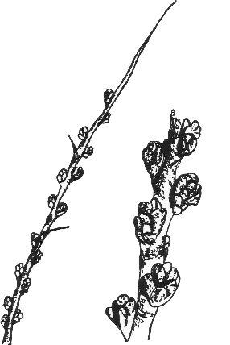 | 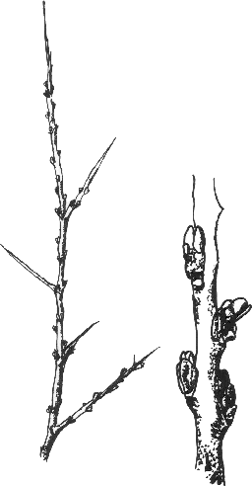
1 | 2
male | female
Ad. 2: Plant: growth type
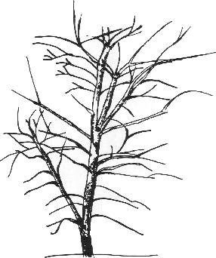 | 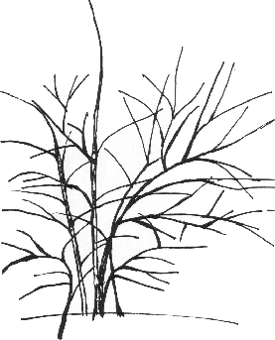
1 | 2
tree-type | bush-type

Ad. 4: Plant: vigor

The vigor of the plant should be considered as the overall abundance of vegetative growth.

Ad. 9: Shoot: length of thorns

Lateral thorns should be assessed exclusively, as the terminal ones (at the tip of the central leading shoots) are longer.

Ad. 10: Leaf blade: shape

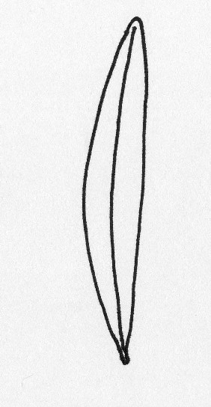 | 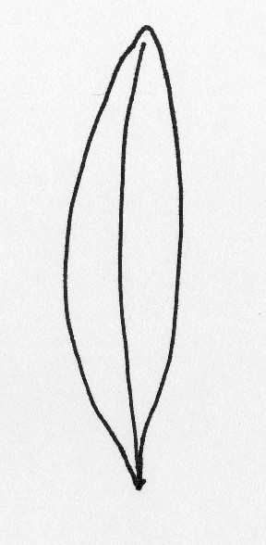 | 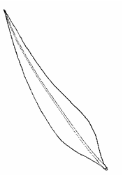
1 | 2 | 3
very narrow elliptic | narrow elliptic | narrow ovate
Ad. 17: Fruit: shape

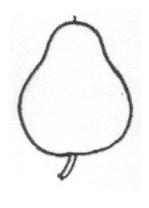 | 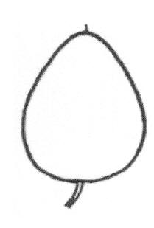 | 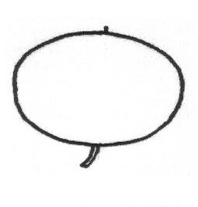
1 | 2 | 3
pear-shaped | ovate | transverse elliptic
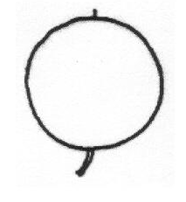 | 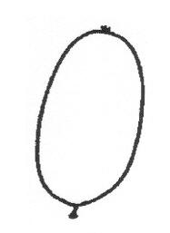 | 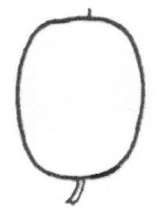
4 | 5 | 6
circular | elliptic | oblong

Ad. 21: Time of beginning of flowering

Time of beginning of flowering is when 10 % of flowers are fully open.

Ad. 22: Time of beginning of fruit ripening

Time of fruit maturity is when at least 90 % of fruits have achieved full color.

Literature
Kutina, J., 1992: Pomologický atlas 2, Zemědělské nakladatelství BRÁZDA, Praha, CZ, 304 pp.

Krüssmann, G., 1968: Die Bäume Europas. Paul Parey, Berlin and Hamburg, DE, 186 pp.

Porpáczy, A., 1987: Ribiszke, áfonya, bodza, fekete berkenye. Mezőgazdasági Kiadó, Budapest, HU, pp. 305-311.

Hričovský, I., 2002: Pomológia, Nezávislosť, Bratislava, SK, pp. 361-363.

Technical Questionnaire
TECHNICAL QUESTIONNAIRE |  |  | Page {x} of {y} | Reference Number:
 |  |  |  | Application date:
 |  |  |  | (not to be filled in by the applicant)
TECHNICAL QUESTIONNAIRE
to be completed in connection with an application for plant breeders’ rights

1. Subject of the Technical Questionnaire
1.1 Botanical name |  | Hippophae rhamnoides L.
1.2 Common name |  | Common Sea Buckthorn
2. Applicant
Name
Address
Telephone No.
Fax No.
E-mail address
Breeder (if different from applicant)
3. Proposed denomination and breeder’s reference
Proposed denomination
(if available)

Breeder’s reference
#4. Information on the breeding scheme and propagation of the variety

4.1 Breeding scheme

Variety resulting from:

4.1.1 Crossing

(a) controlled cross [ ]
(please state parent varieties)
(b) partially known cross [ ]
(please state known parent variety(ies))
(c) unknown cross [ ]

4.1.2 Mutation [ ]
(please state parent variety)

4.1.3 Discovery and development [ ]
(please state where and when discovered
and how developed)

4.1.4 Other [ ]
(please provide details)

4.2 Method of propagating the variety

4.2.1 Vegetative propagation

(a) cuttings [ ]

(b) in vitro propagation [ ]

(c) other (state method) [ ]

4.2.2 Other [ ]
(please provide details)

5. Characteristics of the variety to be indicated (the number in brackets refers to the corresponding characteristic in Test Guidelines; please mark the note which best corresponds).
 | Characteristics |  |  |  | Example Varieties |  |  | Note
5.1  (1) | Plant: sex
 | female |  |  |  | Bojan, Leikora, Slovan |  |  | 1[ ]
 | male |  |  |  | Pollmix 1 |  |  | 2[ ]
5.2  (2) | Plant: growth type
 | tree-type |  |  |  | Maslichnaya, Novost` Altaya, Slovan, Vitaminaya |  |  | 1[ ]
 | bush-type |  |  |  | Bojan, Dorana, Terhi |  |  | 2[ ]
5.3  (3) | Plant: attitude of branches
 | erect |  |  |  | Ascola, Frugana |  |  | 1[ ]
 | semi-erect |  |  |  | Leikora, Slovan, Vitaminaya |  |  | 2[ ]
 | horizontal |  |  |  | Bojan, Maslichnaya |  |  | 3[ ]
 | arching |  |  |  | Hergo |  |  | 4[ ]
5.4  (8) | Shoot: number of thorns (from middle part to top)
 | absent or very few |  |  |  | Obil´naya, Yantarnaya |  |  | 1[ ]
 | few |  |  |  | Pollmix 1, Vitaminaya |  |  | 3[ ]
 | medium |  |  |  | Slovan |  |  | 5[ ]
 | many |  |  |  | Bojan, Leikora, Pollmix 2 |  |  | 7[ ]
 | Characteristics |  |  |  | Example Varieties |  |  | Note
5.5  (17) | Fruit: shape
 | pear-shaped |  |  |  | Dorana |  |  | 1[ ]
 | ovate |  |  |  | Leikora, Slovan |  |  | 2[ ]
 | transverse elliptic |  |  |  | Silvia |  |  | 3[ ]
 | circular |  |  |  | Tashkent |  |  | 4[ ]
 | elliptic |  |  |  | Askola, Bojan, Frugana |  |  | 5[ ]
 | oblong |  |  |  | Hergo, Terhi |  |  | 6[ ]
5.6  (18) | Fruit: color of skin
 | light yellow |  |  |  |  |  |  | 1[ ]
 | dark yellow |  |  |  | Terhi, Tytti |  |  | 2[ ]
 | yellow orange |  |  |  | Hergo, Slovan |  |  | 3[ ]
 | orange red |  |  |  | Ascola, Bojan, Leikora |  |  | 4[ ]
 | red |  |  |  | L 90/539, Sirola |  |  | 5[ ]

TECHNICAL QUESTIONNAIRE | Page {x} of {y} | Reference Number:

6. Similar varieties and differences from these varieties
Please use the following table and box for comments to provide information on how your candidate variety differs from the variety (or varieties) which, to the best of your knowledge, is (or are) most similar. This information may help the examination authority to conduct its examination of distinctness in a more efficient way.

Denomination(s) of variety(ies) similar to your candidate variety | Characteristic(s) in which your candidate variety differs from the similar variety(ies) |  | Describe the expression of the characteristic(s) for the similar variety(ies) |  | Describe the expression of the characteristic(s) for your candidate variety
Example | Leaf: color of upper side |  | green |  | silverish
Comments:

TECHNICAL QUESTIONNAIRE |  | Page {x} of {y} |  | Reference Number:
#7. Additional information which may help in the examination of the variety

7.1 In addition to the information provided in sections 5 and 6, are there any additional characteristics which may help to distinguish the variety?

Yes [ ] No [ ]

(If yes, please provide details)

7.2 Are there any special conditions for growing the variety or conducting the examination?

Yes [ ] No [ ]

(If yes, please provide details)

8. Authorization for release

(a) Does the variety require prior authorization for release under legislation concerning the protection of the environment, human and animal health?

Yes [ ] No [ ]

(b) Has such authorization been obtained?

Yes [ ] No [ ]

If the answer to (b) is yes, please attach a copy of the authorization.

TECHNICAL QUESTIONNAIRE |  | Page {x} of {y} |  | Reference Number:
9. Information on plant material to be examined or submitted for examination.

9.1 The expression of a characteristic or several characteristics of a variety may be affected by factors, such as pests and disease, chemical treatment (e.g. growth retardants or pesticides), effects of tissue culture, different rootstocks, scions taken from different growth phases of a tree, etc.

9.2 The plant material should not have undergone any treatment which would affect the expression of the characteristics of the variety, unless the competent authorities allow or request such treatment. If the plant material has undergone such treatment, full details of the treatment must be given. In this respect, please indicate below, to the best of your knowledge, if the plant material to be examined has been subjected to:

(a) Microorganisms (e.g. virus, bacteria, phytoplasma) Yes [ ] No [ ]

(b) Chemical treatment (e.g. growth retardant, pesticide) Yes [ ] No [ ]

(c) Tissue culture Yes [ ] No [ ]

(d) Other factors Yes [ ] No [ ]

Please provide details for where you have indicated “yes”.

……………………………………………………………

10. I hereby declare that, to the best of my knowledge, the information provided in this form is correct:

Applicant’s name

Signature Date

[End of document]

* These names were correct at the time of the introduction of these Test Guidelines but may be revised or updated. [Readers are advised to consult the UPOV Code, which can be found on the UPOV Website (www.upov.int), for the latest information.]
# Authorities may allow certain of this information to be provided in a confidential section of the Technical Questionnaire.
# Authorities may allow certain of this information to be provided in a confidential section of the Technical Questionnaire.

