 |  | E  TG/239/1  ORIGINAL: English  DATE: 2008-04-09
INTERNATIONAL UNION FOR THE PROTECTION OF NEW VARIETIES OF PLANTS
GENEVA

 | HAWTHORN  UPOV Code: CRATA  Crataegus L. | *

GUIDELINES

FOR THE CONDUCT OF TESTS

FOR DISTINCTNESS, UNIFORMITY AND STABILITY

Alternative Names:*

Botanical name | English | French | German | Spanish
Crataegus L. | Hawthorn | Aubépine | Weißdorn | Espino, Espinero, Manzanilla, Marjoleto, Marzoleto, Tejocote

The purpose of these guidelines (“Test Guidelines”) is to elaborate the principles contained in the General Introduction (document TG/1/3), and its associated TGP documents, into detailed practical guidance for the harmonized examination of distinctness, uniformity and stability (DUS) and, in particular, to identify appropriate characteristics for the examination of DUS and production of harmonized variety descriptions.

ASSOCIATED DOCUMENTS

These Test Guidelines should be read in conjunction with the General Introduction and its associated TGP documents.
TABLE OF CONTENTS PAGE

1. Subject of these Test Guidelines 3
2. Material Required 3
3. Method of Examination 3
3.1 Number of Growing Cycles 3
3.2 Testing Place 3
3.3 Conditions for Conducting the Examination 3
3.4 Test Design 4
3.5 Number of Plants / Parts of Plants to be Examined 4
3.6 Additional Tests 4
4. Assessment of Distinctness, Uniformity and Stability 4
4.1 Distinctness 4
4.2 Uniformity 5
4.3 Stability 5
5. Grouping of Varieties and Organization of the Growing Trial 5
6. Introduction to the Table of Characteristics 6
6.1 Categories of Characteristics 6
6.2 States of Expression and Corresponding Notes 6
6.3 Types of Expression 6
6.4 Example Varieties 6
6.5 Legend 6
7. Table of Characteristics/Tableau des caractères/Merkmalstabelle/Tabla de caracteres 7
8. Explanations on the Table of Characteristics 18
8.1 Explanations covering several characteristics 18
8.2 Explanations for individual characteristics 18
9. Literature 25
10. Technical Questionnaire 26

Subject of these Test Guidelines
These Test Guidelines apply to all varieties of Crataegus L., of the family Rosaceae.

Material Required
2.1 The competent authorities decide on the quantity and quality of the plant material required for testing the variety and when and where it is to be delivered. Applicants submitting material from a State other than that in which the testing takes place must ensure that all customs formalities and phytosanitary requirements are complied with.

2.2 The material is to be supplied in the form of graft sticks, grafted plants or plants on their own roots.

2.3 The minimum quantity of plant material, to be supplied by the applicant, should be:

8 graft sticks or 5 plants.

In the case of grafted plants, the rootstock to be used is specified by the competent authority.

  - The plant material supplied should be visibly healthy, not lacking in vigor, nor affected by any important pest or disease.

2.5 The plant material should not have undergone any treatment which would affect the expression of the characteristics of the variety, unless the competent authorities allow or request such treatment. If it has been treated, full details of the treatment must be given.

Method of Examination

3.1 Number of Growing Cycles
The minimum duration of tests should normally be two independent growing cycles.

The growing cycle is considered to be the duration of a single growing season, beginning with bud burst (flowering and vegetative), growth and fruit harvest and concluding when the following dormant period ends with the swelling of new season buds.

3.2 Testing Place
Tests are normally conducted at one place. In the case of tests conducted at more than one place, guidance is provided in TGP/9 “Examining Distinctness”.

3.3 Conditions for Conducting the Examination
The tests should be carried out under conditions ensuring satisfactory growth for the expression of the relevant characteristics of the variety and for the conduct of the examination. In particular, it is essential that the plants produce a satisfactory crop of fruit in each of the two growing cycles.

3.4 Test Design
3.4.1 Each test should be designed to result in a total of at least five plants.

3.4.2 The design of the tests should be such that plants or parts of plants may be removed for measurement or counting without prejudice to the observations which must be made up to the end of the growing cycle.

3.5 Number of Plants / Parts of Plants to be Examined
Unless otherwise indicated, all observations should be made on 5 plants or parts taken from each of 5 plants. In the case of parts of plants, the number to be taken from each of the plants should be 2.

3.6 Additional Tests
Additional tests, for examining relevant characteristics, may be established.

Assessment of Distinctness, Uniformity and Stability

4.1 Distinctness
4.1.1 General Recommendations

It is of particular importance for users of these Test Guidelines to consult the General Introduction prior to making decisions regarding distinctness. However, the following points are provided for elaboration or emphasis in these Test Guidelines.

4.1.2 Consistent Differences

The differences observed between varieties may be so clear that more than one growing cycle is not necessary. In addition, in some circumstances, the influence of the environment is not such that more than a single growing cycle is required to provide assurance that the differences observed between varieties are sufficiently consistent. One means of ensuring that a difference in a characteristic, observed in a growing trial, is sufficiently consistent is to examine the characteristic in at least two independent growing cycles.

4.1.3 Clear Differences

Determining whether a difference between two varieties is clear depends on many factors, and should consider, in particular, the type of expression of the characteristic being examined, i.e. whether it is expressed in a qualitative, quantitative, or pseudo-qualitative manner. Therefore, it is important that users of these Test Guidelines are familiar with the recommendations contained in the General Introduction prior to making decisions regarding distinctness.

4.2 Uniformity
4.2.1 It is of particular importance for users of these Test Guidelines to consult the General Introduction prior to making decisions regarding uniformity. However, the following points are provided for elaboration or emphasis in these Test Guidelines.

    - For the assessment of uniformity, a population standard of 1% and an acceptance probability of at least 95% should be applied. In the case of a sample size of 5 plants, no off-types are allowed.

4.3 Stability
4.3.1 In practice, it is not usual to perform tests of stability that produce results as certain as those of the testing of distinctness and uniformity. However, experience has demonstrated that, for many types of variety, when a variety has been shown to be uniform, it can also be considered to be stable.

4.3.2 Where appropriate, or in cases of doubt, stability may be tested, either by growing a further generation, or by testing a new plant stock to ensure that it exhibits the same characteristics as those shown by the previous material supplied.

Grouping of Varieties and Organization of the Growing Trial
5.1 The selection of varieties of common knowledge to be grown in the trial with the candidate varieties and the way in which these varieties are divided into groups to facilitate the assessment of distinctness are aided by the use of grouping characteristics.

5.2 Grouping characteristics are those in which the documented states of expression, even where produced at different locations, can be used, either individually or in combination with other such characteristics: (a) to select varieties of common knowledge that can be excluded from the growing trial used for examination of distinctness; and (b) to organize the growing trial so that similar varieties are grouped together.

5.3 The following have been agreed as useful grouping characteristics:

- Plant: growth type (characteristic 1);
- Plant: habit (characteristic 2);
- Shoot: presence of thorns (characteristic 6);
- Leaf blade: lobes (characteristic 15);
- Petiole: length (characteristic 22);
- Fruit: color (characteristic 32).

5.4 Guidance for the use of grouping characteristics, in the process of examining distinctness, is provided through the General Introduction.

Introduction to the Table of Characteristics

6.1 Categories of Characteristics
6.1.1 Standard Test Guidelines Characteristics

Standard Test Guidelines characteristics are those which are approved by UPOV for examination of DUS and from which members of the Union can select those suitable for their particular circumstances.

6.1.2 Asterisked Characteristics

Asterisked characteristics (denoted by *) are those included in the Test Guidelines which are important for the international harmonization of variety descriptions and should always be examined for DUS and included in the variety description by all members of the Union, except when the state of expression of a preceding characteristic or regional environmental conditions render this inappropriate.

6.2 States of Expression and Corresponding Notes
States of expression are given for each characteristic to define the characteristic and to harmonize descriptions. Each state of expression is allocated a corresponding numerical note for ease of recording of data and for the production and exchange of the description.

6.3 Types of Expression
An explanation of the types of expression of characteristics (qualitative, quantitative and pseudo-qualitative) is provided in the General Introduction.

6.4 Example Varieties
Where appropriate, example varieties are provided to clarify the states of expression of each characteristic.

6.5 Legend
(*) Asterisked characteristic – see Chapter 6.1.2

QL Qualitative characteristic – see Chapter 6.3
QN Quantitative characteristic – see Chapter 6.3
PQ Pseudo-qualitative characteristic – see Chapter 6.3

(a) – (e) See Explanations on the Table of Characteristics in Chapter 8.1
(+) See Explanations on the Table of Characteristics in Chapter 8.2

Table of Characteristics/Tableau des caractères/Merkmalstabelle/Tabla de caracteres
 |  | English | français | Deutsch | español | Example Varieties  Exemples  Beispielssorten  Variedades ejemplo | Note/  Nota
1.  (*)  (+) |  | Plant: growth type | Plante: type de croissance | Pflanze: Wuchstyp | Planta: hábito de crecimiento
PQ | (a) | shrub | arbrisseau | Strauch | arbusto | Calpantino, Candelaria, Compacta, Mitzi | 1
 |  | semi-shrub | demi-arbrisseau | Halbstrauch | semiarbusto | Azucena, Paul’s Scarlet | 2
 |  | tree | arbre | Baum | árbol | Calpan Gold, Plena | 3
2. (*) (+) |  | Plant: habit | Plante: port | Pflanze: Wuchsform | Planta: porte
PQ | (a) | fastigiate | très dressé | sehr aufrecht | fastigiado | Ergo, Gaca, Pingo | 1
 |  | upright | dressé | aufrecht | erguido | Azucena, Calpar, Stricta | 2
 |  | spreading | étalé | breitwüchsig | rastrero | Atexcac | 3
 |  | semi drooping | demi-retombant | halbüberhängend | semicolgante | Candelaria, Chico | 4
 |  | drooping | retombant | überhängend | colgante |  | 5
 |  | weeping | pleureur | lang überhängend | llorón | Pendula | 6
3.  (+) |  | Plant: shape | Plante : forme | Pflanze: Form | Planta: forma
PQ | (b) | semi-circular | semi-circulaire | halbrund | semi-circular | Ara | 1
 |  | ovate | ovale | eiförmig | oval | Edgar, Epi, Pingo | 2
 |  | oblong | oblongue | rechteckig | oblonga | Gloria | 3
 |  | circular | circulaire | rund | circular | Erick | 4
 |  | transverse elliptic | elliptique transverse | quer elliptisch | elíptica transversal | Chela, Poblano | 5
 |  | obovate | obovale | verkehrt eiförmig | oboval | Ade | 6
4. |  | Plant: height | Plante: hauteur | Pflanze: Höhe | Planta: altura
QN | (a) | short | courte | niedrig | baja | Belén, Gloria | 3
 |  | medium | moyenne | mittel | media | Epi, Mutabilis, Robelo | 5
 |  | tall | haute | hoch | alta | Compacta, Tequex | 7
5. |  | Plant: density of foliage | Plante: densité du feuillage | Pflanze: Dichte des Laubes | Planta: densidad del follaje
QN | (b) | sparse | faible | locker | escasa | Superior | 3
 |  | medium | moyenne | mittel | media | Epi, Paul’s Scarlet | 5
 |  | dense | dense | dicht | densa | Carrieri | 7
6.  (*) |  | Shoot: presence of thorns | Rameau: présence d’épines | Trieb: Vorhanden-sein von Dornen | Rama: presencia de espinas
QL | (a) | absent | absentes | fehlend | ausente | Compacta, Edgar, Epi | 1
 |  | present | présentes | vorhanden | presente | Chela, Mutabilis, Pingo | 9
7. |  | Shoot: number of thorns | Rameau: nombre d’épines | Trieb: Anzahl Dornen | Rama: número de espinas
QN | (a) | few | petit | gering | pocas | Salicifolia, Tequex | 1
 |  | medium | moyen | mittel | medio | Chela, Mutabilis, Pingo | 2
 |  | many | grand | groß | abundantes | Carrieri, Tempranero | 3
8. |  | Shoot: length of thorns | Rameau: longueur d’épines | Trieb: Länge der Dornen | Rama: longitud de espinas
QN | (a) | short | courtes | kurz | corta | Chapinguero, Gloria | 3
 |  | medium | moyennes | mittel | media | Ara | 5
 |  | long | longues | lang | larga |  | 7
9. |  | Shoot: length | Rameau: longueur | Trieb: Länge | Rama: longitud
QN | (a) | short | court | kurz | corta | Karen | 3
 |  | medium | moyen | mittel | media | Tempranero | 5
 |  | long | long | lang | larga | Elena | 7
10. |  | Shoot: growth type | Rameau: type de croissance | Trieb: Wuchstyp | Rama: tipo de crecimiento
QL | (a) | straight | droit | gerade | recto | Ara, Elena, Stricta | 1
 |  | zig zag | en forme de zigzag | zickzackförmig | en zigzag | Carrierei, Flexuosa | 2
11. |  | Leaf blade: length | Limbe: longueur | Blattspreite: Länge | Limbo: longitud
QN | (c) | short | court | kurz | corta | Belén, Mutabilis | 3
 |  | medium | moyen | mittel | media | Epi | 5
 |  | long | long | lang | larga | Carrierei, Edgar | 7
12. |  | Leaf blade: width | Limbe: largeur | Blattspreite: Breite | Limbo: anchura
QN | (c) | narrow | étroit | schmal | estrecho | Epi, Flexuosa, Mutabilis | 3
 |  | medium | moyen | mittel | medio | Aurora, Edgar,  Paul’s Scarlet | 5
 |  | broad | large | breit | ancho | Wattiana | 7
13.  (*) |  | Leaf blade: ratio length/width | Limbe: rapport longueur/largeur | Blattspreite: Verhältnis Länge/Breite | Limbo: relación longitud/anchura
QN | (c) | small | faible | klein | pequeña | Flexuosa, Toba, Wattiana | 3
 |  | medium | moyen | mittel | media | Azucena, Carrierei | 5
 |  | large | élevé | groß | grande | Poblano, Stipulacea | 7
14.  (+) |  | Leaf blade: margin | Limbe: bord | Blattspreite: Rand | Limbo: borde
PQ | (c) | entire | entier | ganzrandig | entero | Flexuosa | 1
 |  | crenate | crénelé | gekerbt | crenado | Karen | 2
 |  | bicrenate | bicrénelé | doppelt gekerbt | bicrenado | Tempranero | 3
 |  | serrate | dentelé | gesägt | serrado | Compacta, Tzapingo | 4
 |  | biserrate | bidentelé | doppelt gesägt | biserrado | Ade, Pingo, Toba | 5
15. (*) (+) |  | Leaf blade: lobes | Limbe: lobes | Blattspreite: Lappen | Limbo: lóbulos
QL | (c) | absent | absents | fehlend | ausente | Ade, Mago | 1
 |  | present | présents | vorhanden | presente | Compacta, Flexuosa, Stricta | 9
16.  (+) |  | Leaf blade: depth of lobes | Limbe: profondeur des lobes | Blattspreite: Tiefe der Lappen | Limbo: profundidad de los lóbulos
QN | (c) | shallow | peu profonds | flach | poco profunda | Stipulacea | 3
 |  | medium | moyens | mittel | media | Punicea | 5
 |  | deep | profonds | tief | profunda | Major, Toba | 7
17. |  | Leaf blade: variegation | Limbe: panachure | Blattspreite: Panaschierung | Limbo: variegación
QL | (d) | absent | absente | fehlend | ausente | Carrieri | 1
 |  | present | présente | vorhanden | presente | Gireoudii | 9
18. |  | Leaf blade: anthocyanin coloration | Limbe: pigmentation anthocyanique | Blattspreite: Anthocyanfärbung | Limbo: pigmentación antociánica
QN | (c) | absent or weak | absente ou faible | fehlend oder gering | ausente o débil |  | 1
 |  | medium | moyenne | mittel | media |  | 2
 |  | strong | forte | stark | fuerte |  | 3
19. |  | Leaf blade: glossiness | Limbe: brillance | Blattspreite: Glanz | Limbo: brillo
QN | (c) | absent or weak | absente ou faible | fehlend oder gering | ausente o débil | Tzapingo | 1
 |  | medium | moyenne | mittel | medio | Mago, Nitida | 2
 |  | strong | forte | stark | fuerte | Carrierei | 3
20.  (+) |  | Leaf blade: pubescence on upper side | Limbe: pilosité de la face supérieure | Blattspreite: Behaarung der Oberseite | Limbo: pubescencia del lado superior
QL | (c) | absent | absente | fehlend | ausente | Calpantino, Toba | 1
 |  | present | présente | vorhanden | presente | Calpan Gold, Chapeado, Erick (Major) | 9
21. |  | Leaf blade: surface | Limbe: surface | Blattspreite: Oberfläche | Limbo: superficie
QL | (c) | smooth | lisse | glatt | lisa | Aby, Toba | 1
 |  | wrinkled | ridée | runzlig | arrugada | Chela, Flexuosa | 2
22. (*) |  | Petiole: length | Pétiole: longueur | Blattstiel: Länge | Peciolo: longitud
QN | (c) | short | court | kurz | corta | Tzapingo | 3
 |  | medium | moyen | mittel | media | Paul’s Scarlet, Plena | 5
 |  | long | long | lang | larga | Toba, Wattiana | 7
23.  (+) |  | Flower: calyx length | Fleur: longueur  du calice | Blüte: Länge des Kelches | Flor: longitud del cáliz
QN | (d) | short | court | kurz | corta | Alex | 3
 |  | medium | moyen | mittel | media | San José | 5
 |  | long | long | lang | larga | Lupita | 7
24. (*) |  | Flower: pedicel length | Fleur: longueur  du pédoncule | Blüte: Länge des Blütenstiels | Flor: longistud del pedicelo
QN | (d) | short | court | kurz | corta | Alex | 3
 |  | medium | moyen | mittel | media | Cris | 5
 |  | long | long | lang | larga | San José | 7
25.  (+) |  | Flower: type | Fleur: type | Blüte: Typ | Flor: tipo
QL | (d) | single | simple | einfach | simple | Carrieri, Edgar, Gloria, Punicea | 1
 |  | double | double | gefüllt | doble | Masekii, Paul’s Scarlet | 2
26.  (+) |  | Flower: diameter | Fleur: diamètre | Blüte: Durchmesser | Flor: diámetro
QN | (d) | small | petit | klein | pequeño | Aby, Poblano | 3
 |  | medium | moyen | mittel | medio | Chela, Pingo | 5
 |  | large | grand | groß | grande | Superior, Tequex | 7
27. |  | Flower: color of petals | Fleur: couleur des pétales | Blüte: Farbe der Blütenblätter | Flor: color de los pétalos
PQ | (d) | white | blanche | weiß | blanco | Chapeada, Chela, Plena | 1
 |  | light pink | rose clair | hellrosa | rosa claro | Masekii, Toba | 2
 |  | medium pink | rose moyen | mittelrosa | rosa medio | Pink Corkscrew,  Rubra Plena | 3
 |  | dark pink | rose foncée | dunkelrosa | rosa oscuro |  | 4
 |  | red | rouge | rot | rojo | Paul’s Scarlet | 5
28.  (+) |  | Flower: shape of anther | Fleur: forme des anthères | Blüte: Form der Anthere | Flor: forma de la antera
PQ | (d) | circular | rondes | kreisförmig | circular | Betty | 1
 |  | elliptic | elliptiques | elliptisch | elíptica | Aby, San José | 2
 |  | ovate | ovales | eiförmig | oval | Carla | 3
29. |  | Flower: color of base of anther stalks | Fleur: couleur de la base des pédoncules des anthères | Blüte: Farbe des Unterteils der Filamente der Antheren | Flor: color de la base de los filamentos de las anteras
PQ | (d) | green | verte | grün | verde | Poblano, Superior | 1
 |  | yellow | jaune | gelb | amarilla | Edgar, Gloria | 2
 |  | pink | rose | rosa | rosa | Centenario | 3
 |  | red pink | rosée | rotrosa | rosa rojizo | San José | 4
 |  | medium purple | pourpre moyenne | mittelpurpurn | púrpura medio | Chela | 5
 |  | dark purple | pourpre foncé | dunkelpurpurn | púrpura oscuro | San Cristóbal | 6
 |  | brown | brune | braun | marrón | Tempranero, Teques | 7
30.  (+) |  | Flower: attitude of petals | Fleur: port des pétales | Blüte: Haltung der Blütenblätter | Flor: porte de los pétalos
QN | (d) | erect | dressé | aufrecht | erecto | Poblano, Tempranero | 1
 |  | semi erect | demi-dressé | halbaufrecht | semierecto | Chela | 2
 |  | horizontal | horizontal | waagerecht | horizontal | Edgar, Pingo, Superior | 3
31.  (+) |  | Only varieties with flower type: single: Flower: arrangement of petals | Variétés à capitule: simple: Fleur: disposition des pétales | Nur Sorten mit einfachem Blütenstand: Blüte: Anordnung der Blütenblätter | Sólo variedades con capítulo tipo: sencillo: Flor: disposición de los pétalos
QN | (d) | free | ouverts | freistehend | libre | Edgar, Superior | 1
 |  | touching | tangents | sich berührend | en contacto | Natzi | 2
 |  | overlapping | se recouvrant | überlappend | solapados | San Cristóbal | 3
32.  (*) |  | Fruit: color | Fruit: couleur | Frucht: Farbe | Fruto: color
PQ | (e) | light green | vert clair | hellgrün | verde claro | Epi, San Nicolás | 1
 |  | medium green | vert moyen | mittelgrün | verde medio |  | 2
 |  | yellow | jaune | gelb | amarillo | Aurora, Tzapingo | 3
 |  | yellow and orange | jaune et orange | gelb und orange | amarillo y naranja | Alex, Chapeado | 4
 |  | yellow and red | jaune et rouge | gelb und rot | amarillo y rojo | Carrierei, Elena | 5
 |  | orange | orange | orange | naranja | Ade, Huejo | 6
 |  | orange and red | orange et rouge | orange und rot | naranja y rojo | Poblano | 7
 |  | medium red | rouge moyen | mittelrot | rojo medio | Ara | 8
 |  | dark red | rouge foncé | dunkelrot | rojo oscuro | Eli | 9
 |  | purple | pourpre | purpurn | púrpura |  | 10
 |  | black | noir | schwarz | negro |  | 11
33. (*) |  | Fruit: glossiness of skin | Fruit: brillance de la peau | Frucht: Glanz der Haut | Fruto: brillo de la epidermis
QL | (e) | absent | absente | fehlend | ausente | Cas, Eli | 1
 |  | present | présente | vorhanden | presente | Ara | 9
34. |  | Fruit: density of lenticels | Fruit: densité des lenticelles | Frucht: Dichte der Lentizellen | Fruto: densidad de lenticelas
QN | (e) | very sparse | très lâche | sehr locker | muy baja | Robelo | 1
 |  | sparse | lâche | locker | baja | Mago | 3
 |  | medium | moyenne | mittel | media |  | 5
 |  | dense | dense | dicht | alta | Iracema | 7
 |  | very dense | très dense | sehr dicht | muy alta | Paola | 9
35. |  | Fruit: texture of surface | Fruit: texture de la surface | Frucht: Textur der Oberfläche | Fruto: textura de la superficie
QN | (e) | smooth or slightly rough | lisse ou légèrement rugueuse | glatt oder leicht blasig | lisa o ligeramente rugosa | Dany | 1
 |  | moderately rough | modérément rugueuse | mäßig blasig | moderadamente rugosa | San Nicolás | 2
 |  | very rough | très rugueuse | sehr blasig | muy rugosa | Tzingo | 3
36. |  | Fruit: aroma | Fruit: arôme | Frucht: Aroma | Fruto: aroma
QN | (e) | absent or weak | absent ou faible | fehlend oder gering | ausente o débil | Chela | 1
 |  | medium | moyen | mittel | medio | Elvia | 2
 |  | strong | fort | stark | fuerte | Orem | 3
37.  (+) |  | Fruit: general shape | Fruit: forme générale | Frucht: allgemeine Form | Fruto: forma general
PQ | (e) | conical | conique | kegelförmig | cónica | Ela | 1
 |  | elliptic | elliptique | elliptisch | elíptica | Santa Cata | 2
 |  | circular | circulaire | kreisförmig | circular | Pingo | 3
 |  | oblate | aplati | breitrund | achatada | Dany | 4
 |  | obovate | obovale | verkehrt eiförmig | oboval | Erick (Pedillelata) | 5
38.  (+) |  | Fruit: presence of neck | Fruit : présence du collet | Frucht: Vorhandensein eines Halses | Fruto: cuello
QL | (e) | absent | absent | fehlend | ausente | Carla | 1
 |  | present | présent | vorhanden | presente | Lupita | 9
39.  (+) |  | Fruit: length | Fruit: longueur | Frucht: Länge | Fruto: longitud
QN | (e) | short | court | kurz | corta | Dany, Tzapingo | 3
 |  | medium | moyen | mittel | media | Epi | 5
 |  | long | long | lang | larga | Calpan Gold | 7
40. |  | Fruit: width | Fruit: largeur | Frucht: Breite | Fruto: anchura
QN | (e) | narrow | étroit | schmal | estrecha | Yesenia | 3
 |  | medium | moyen | mittel | media | Tequex | 5
 |  | broad | large | breit | ancha | Carla | 7
41.  (*) |  | Fruit: length/width ratio | Fruit: rapport longueur/largeur | Frucht: Verhältnis Länge/Breite | Fruto: relación longitud/anchura
QN | (e) | small | petit | klein | pequeña | Ela | 3
 |  | medium | moyen | mittel | media | Erick, Robelo | 5
 |  | large | grand | groß | grande | Alex, Natzi | 7
42.  (+) |  | Fruit: cavity of eye basin | Fruit : cavité de la cuvette de l’œil | Frucht: Kelchgrube | Fruto: cavidad del ojo
QL | (e) | closed | fermée | geschlossen | cerrada | Dany, Robelo | 1
 |  | open | ouverte | offen | abierta | Karen | 2
43.  (+) |  | Fruit: depth of eye basin | Fruit: profondeur de la cuvette de l’œil | Frucht: Tiefe der Kelchgrube | Fruto: profundidad de la cavidad del ojo
QN | (e) | very shallow | très peu profonde | sehr flach | muy poco profunda | Candelaria, Mago | 1
 |  | shallow | peu profonde | flach | poco profunda | Rob | 3
 |  | medium | moyenne | mittel | media | Gloria | 5
 |  | deep | profonde | tief | profunda | Chapeado | 7
 |  | very deep | très profonde | sehr tief | muy profunda | Elvia | 9
44.  (+) |  | Fruit: main color of flesh | Fruit: couleur principale de la chair | Frucht: Hauptfarbe des Fleisches | Fruto: color principal de la pulpa
PQ | (e) | green | verte | grün | verde | San Nicolás | 1
 |  | white | blanche | weiß | blanco | Epi | 2
 |  | light yellow | jaune clair | hellgelb | amarillo claro | Superior | 3
 |  | medium yellow | jaune moyen | mittelgelb | amarillo medio | Belén | 4
 |  | dark yellow | jaune foncé | dunkelgelb | amarillo oscuro | Azucena | 5
 |  | orange | orange | orange | naranja | Chela, Cris, Poblano | 6
 |  | red | rouge | rot | rojo | Dany | 7
45. |  | Endocarp: number | Endocarpe: nombre | Endokarp: Anzahl | Endocarpo: número
QN | (e) | few | faible | gering | bajo | Natzi, Santa Cata | 1
 |  | medium | moyen | mittel | medio | Edgar | 2
 |  | many | élevé | groß | alto | Centenario | 3
46.  (+) |  | Endocarp: length | Endocarpe: longueur | Endokarp: Länge | Endocarpo: longitud
QN | (e) | short | court | kurz | corta | Pingo | 3
 |  | medium | moyen | mittel | media | Natzi | 5
 |  | long | long | lang | larga | Chela | 7
47.  (+) |  | Endocarp: width | Endocarpe: largeur | Endokarp: Breite | Endocarpo: anchura
QN | (e) | narrow | étroit | schmal | estrecha | Ade | 3
 |  | medium | moyen | mittel | media | San Cristóbal | 5
 |  | broad | large | breit | ancha | Carla | 7
48. (*) |  | Endocarp: width/length ratio | Endocarpe: rapport longueur/largeur | Endokarp: Verhältnis Länge/Breite | Endocarpo: relación longitud/anchura
QN | (e) | small | petit | klein | pequeña | Belén, Lila, Yesenia | 3
 |  | medium | moyen | mittel | media | Calpar, Candelaria, Yash | 5
 |  | large | grand | groß | grande | Ixayoc | 7
49. |  | Time of flowering | Époque de  floraison | Zeitpunkt der Blüte | Época de la floración
QN |  | early | précoce | früh | temprana | Eli | 3
 |  | medium | moyenne | mittel | media | Centenario | 5
 |  | late | tardive | spät | tardía | Chapeado | 7
50. |  | Time of harvest | Époque de récolte | Zeitpunkt der Ernte | Época de cosecha
QN |  | very early | très précoce | sehr früh | muy temprana | Tempranero | 1
 |  | early | précoce | früh | temprana | Adela | 3
 |  | medium | moyenne | mittel | media | Ara, Mago | 5
 |  | late | tardive | spät | tardía | Nati | 7
 |  | very late | très tardive | sehr spät | muy tardía | Mitzi | 9

Explanations on the Table of Characteristics

8.1 Explanations covering several characteristics

Characteristics containing the following key in the second column of the Table of Characteristics should be examined as indicated below:

- Observations on the plant stem and branch which should be made on the vegetative current season’s shoots after growth.
- Observations on the plant which should be made on foliated plants in the spring.
- Leaf: Observations on the leaf should be made on mature leaves from branches on the outside of the tree which are neither bearing fruit nor showing signs of new flush. Leaves should be taken from the middle third of the current season’s growth.
- Flower: Observations on the flower which should be made during the first flower opening, at the start of anther dehiscence.
- Fruit and endocarp: Observations on the fruit and endocarp which should be made on 10 typical fruits taken from each of 5 plants, at the time of fruit ripening.

Explanations for individual characteristics
Ad. 1: Plant: growth type

 | 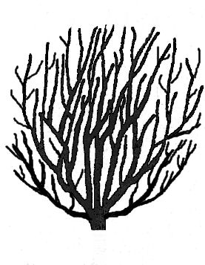 |  | 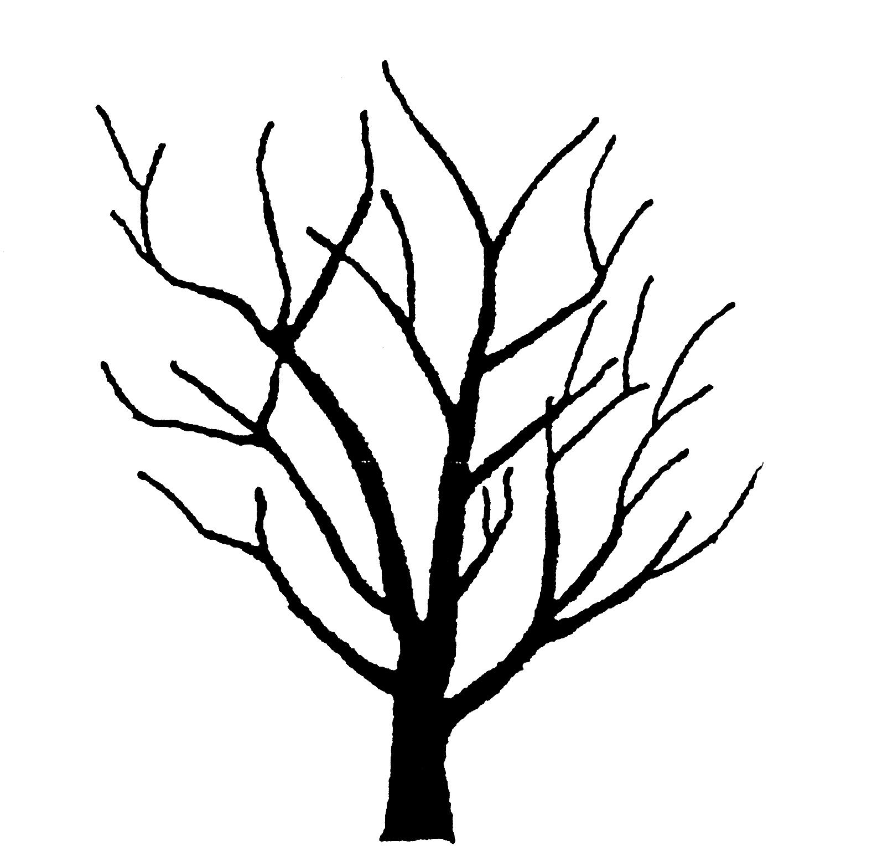
 | 1 | 2 | 3
 | shrub | semi-shrub | tree

Shrub: multiple stems arising close to the grafting point, relatively low height.

Semi-shrub: multiple stems arising generally from the same point but not close to the graft point, with a main stem, not tall.

Tree: having a main trunk, with branches arising from different points and usually a distinct crown.
Ad. 2: Plant: habit

 |  |  |  |  | 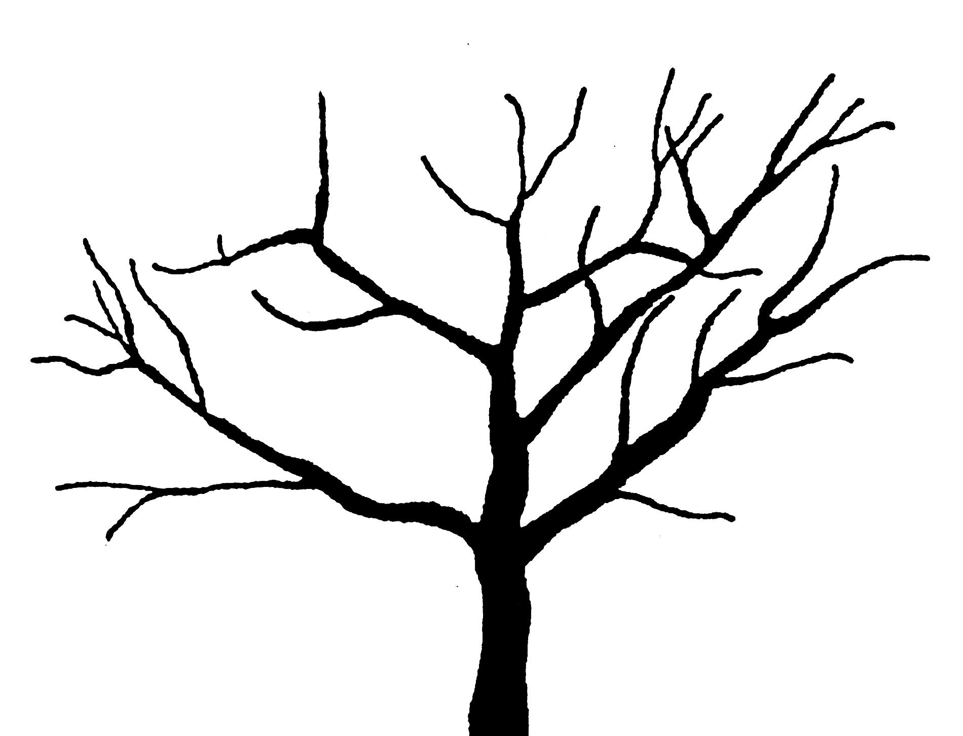
 |  |  | 1 | 2 | 3
 |  |  | fastigiate | upright | spreading
 |  | 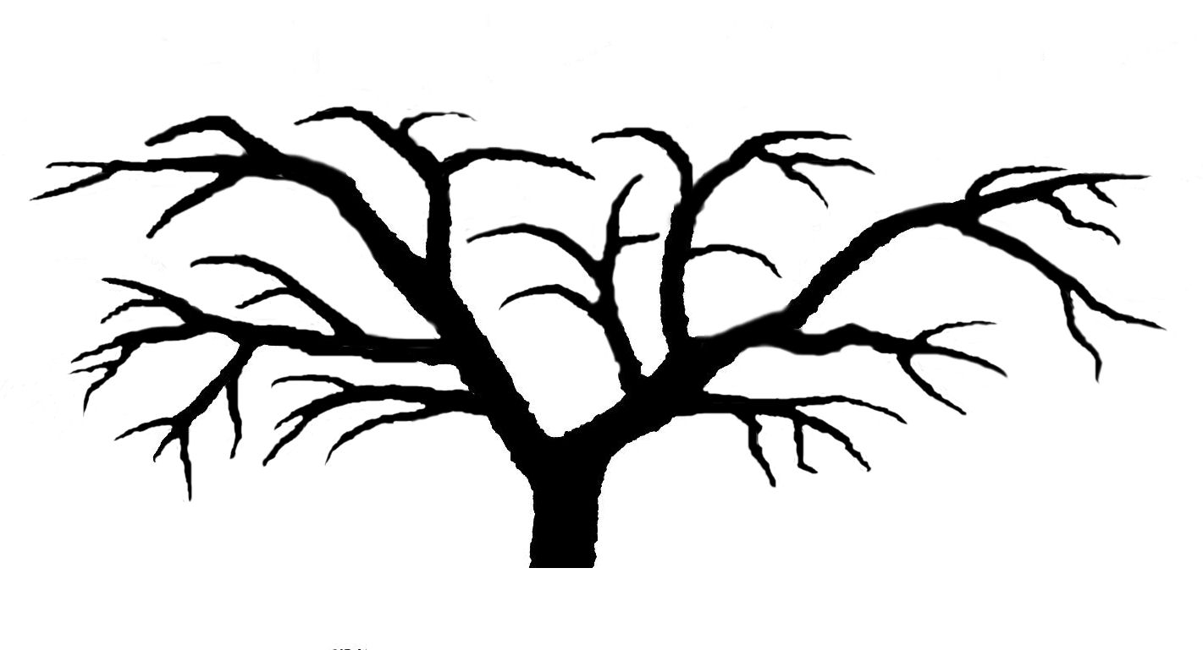 |  | 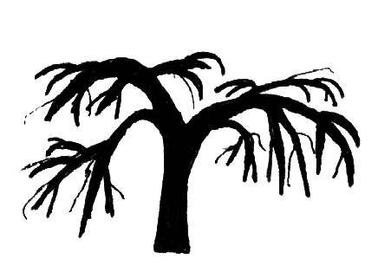 | 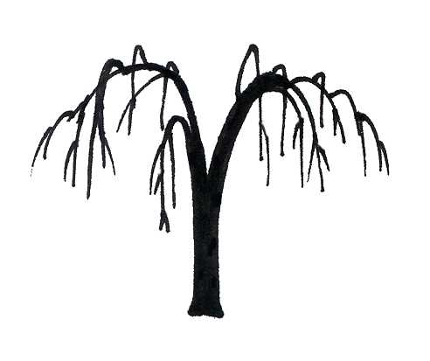
 | 4 |  |  | 5 | 6
 |  | semi drooping |  | drooping | weeping

Ad. 3: Plant: shape
 | 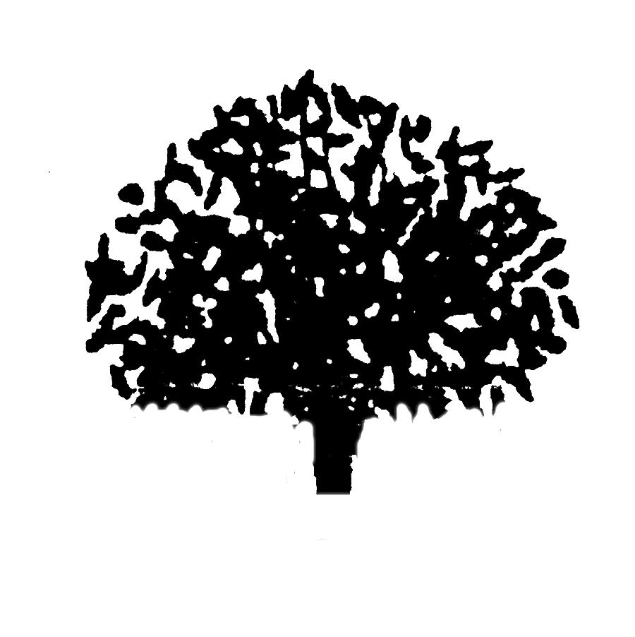 | 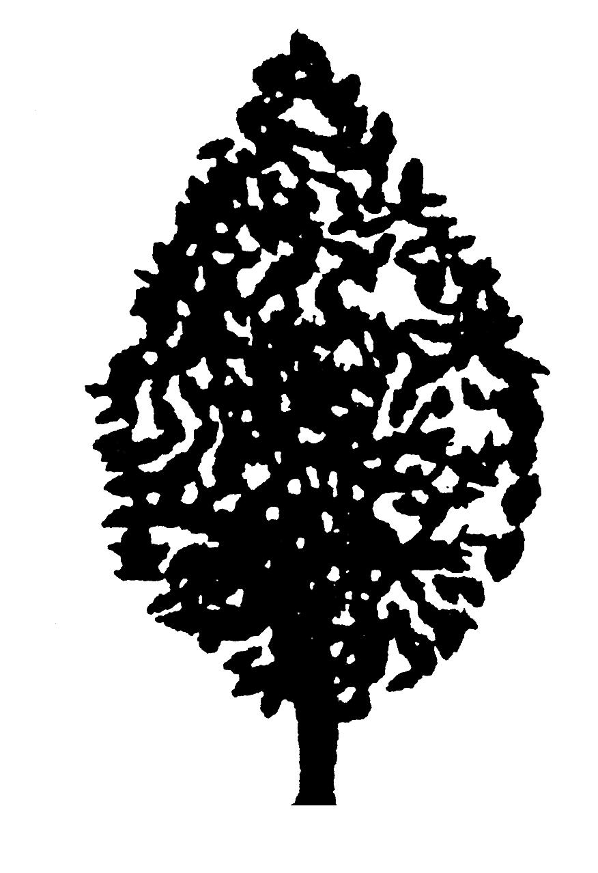 | 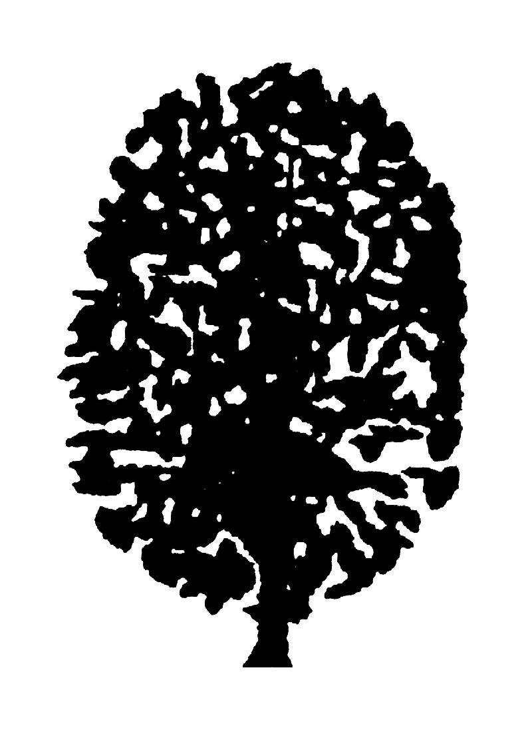
 | 1 | 2 | 3
 | semi-circular | ovate | oblong
 |  |  | 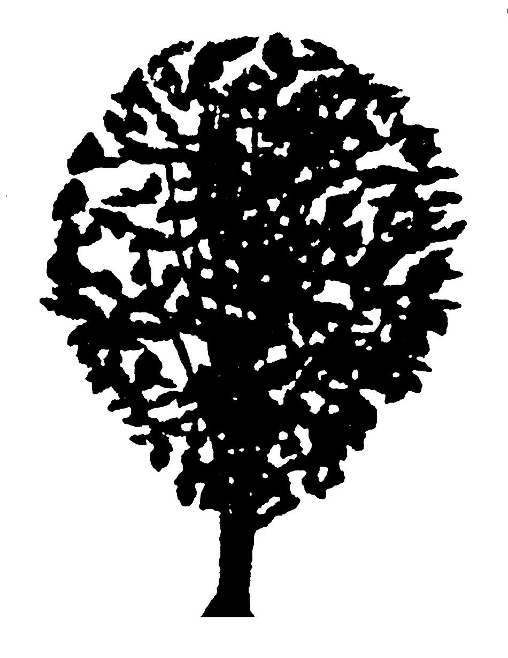
 | 4 | 5 | 6
 | circular | transverse elliptic | obovate

Ad. 14: Leaf blade: margin

 |  |  | 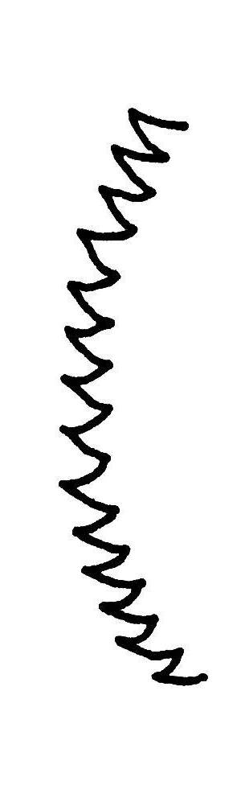 | 
1 | 2 | 3 | 4 | 5
entire | crenate | bicrenate | serrate | biserrate
Ad. 15: Leaf blade: lobes

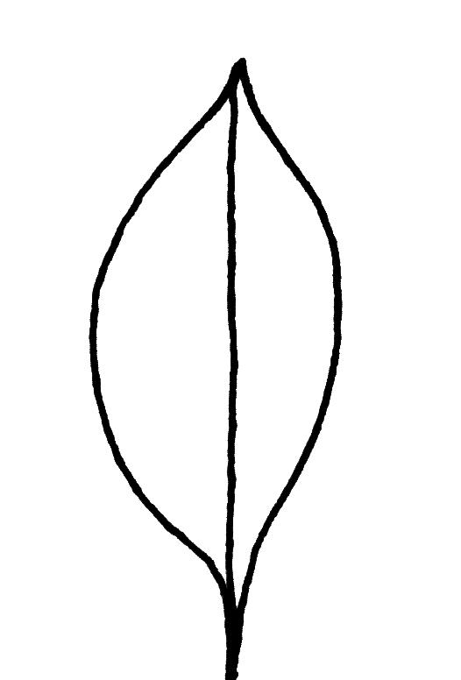 | 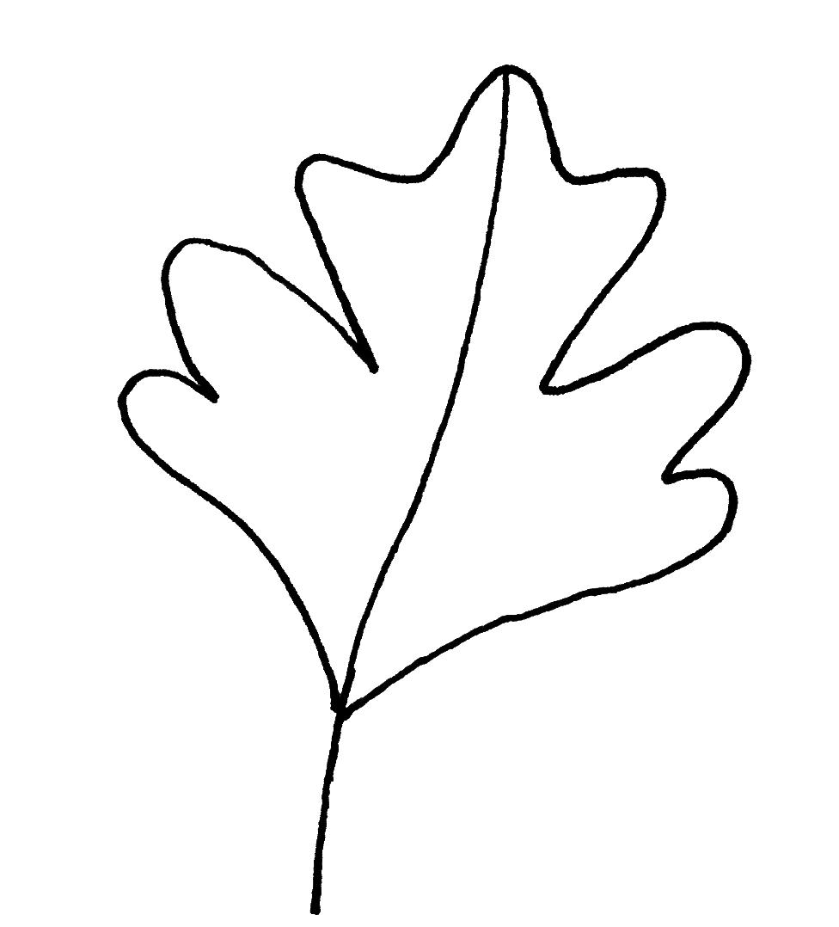
1 | 9
absent | present

Ad. 16: Leaf blade: depth of lobes


depth of lobe

Ad. 20: Leaf blade: pubescence on upper side

Pubescence should be observed with the aid of a magnifying glass.

Ad. 23: Flower: calyx length

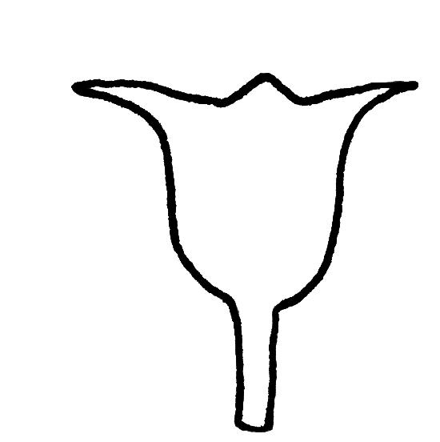
length

Ad. 25: Flower type

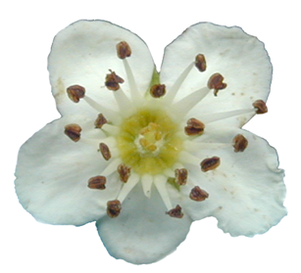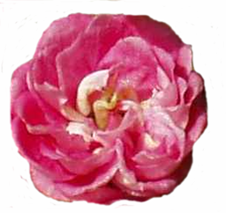

1 | 2
single | double

Ad. 26: Flower: diameter

diameter

The flower diameter should be observed with the petals pressed into a horizontal position.

Ad. 28: Flower: shape of anther

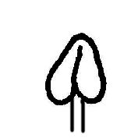

1 | 2 | 3
circular | elliptic | ovate

Ad. 30: Flower: attitude of petals

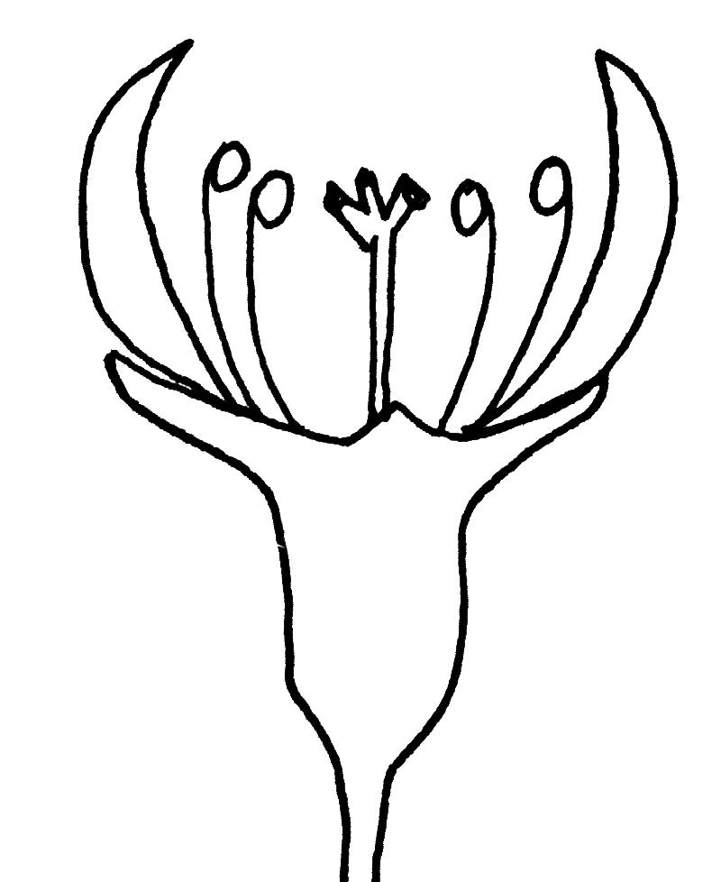 | 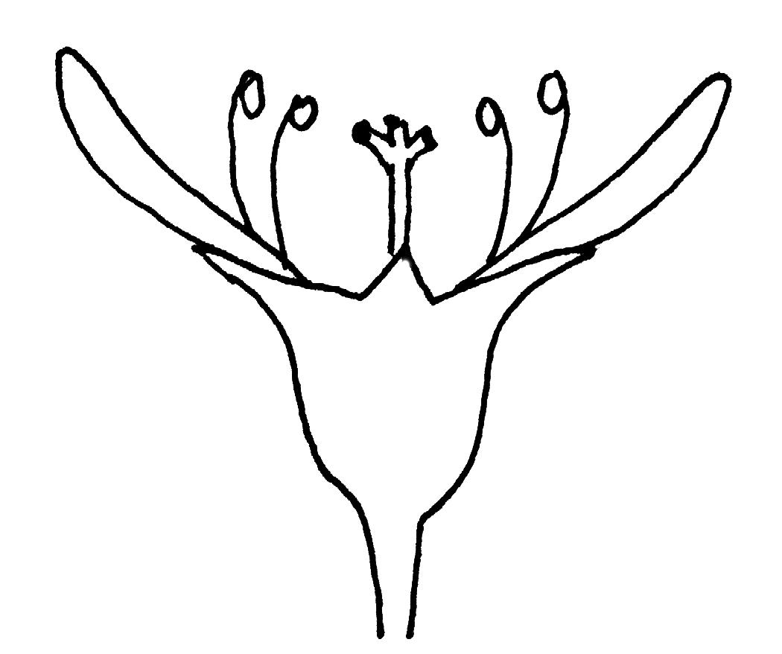 | 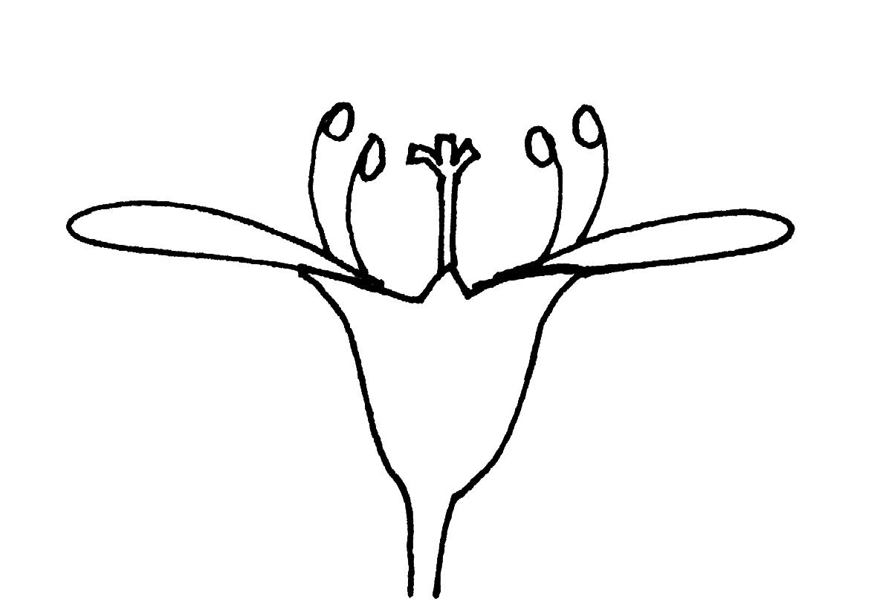
1 | 2 | 3
erect | semi erect | horizontal

Ad. 31: Only varieties with flower type: single: Flower: arrangement of petals

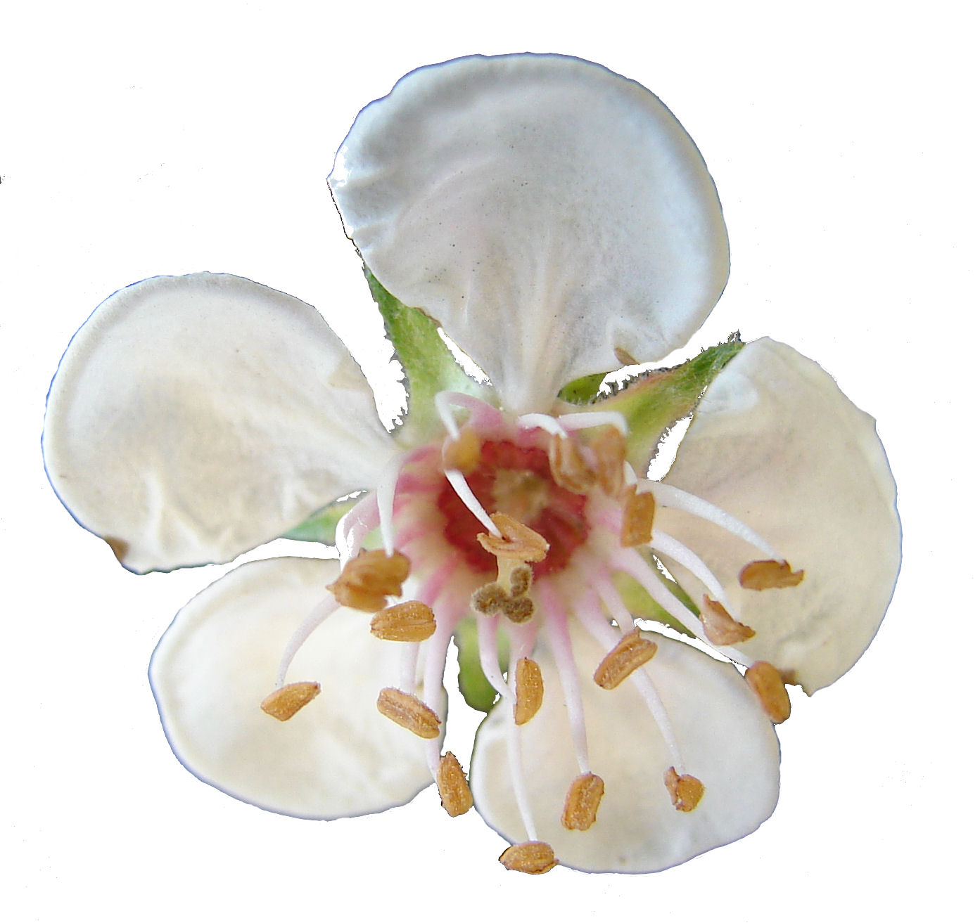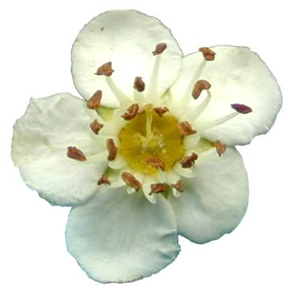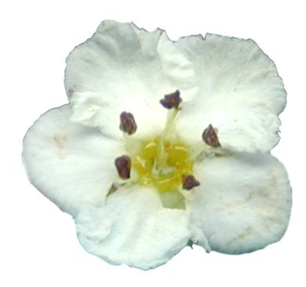

1 | 2 | 3
free | touching | overlapping

Ad. 37: Fruit: general shape

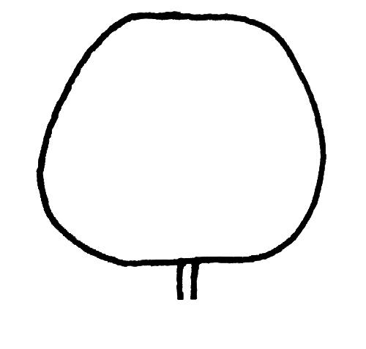 |  |  |  |  | 
1 |  | 2 |  |  | 3
conical |  | elliptic |  |  | circular
 |  |  |  | 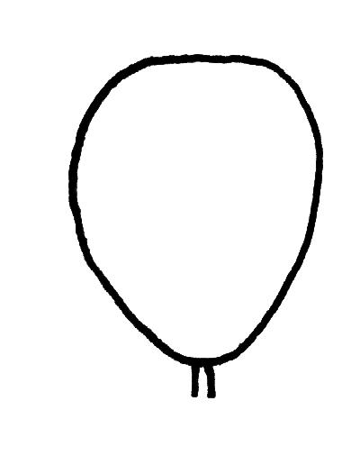
 | 4 |  |  | 5
 | oblate |  |  | obovate

Ad. 38: Fruit: presence of neck

 | 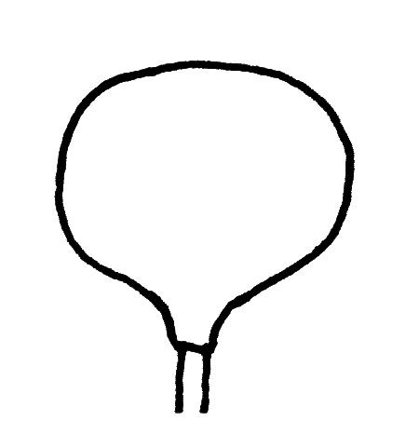
1 | 9
absent | present

Ad. 39: Fruit: length

The length of fruit includes the neck (if present).

Ad. 42: Fruit: cavity of eye basin

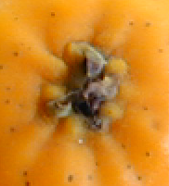
1 |  | 2
closed |  | open

Ad. 43: Fruit: depth of eye basin


depth

Ad. 44: Fruit: main color of flesh

The main color is the color with the largest surface area.

Ad. 46: Endocarp: length
Ad. 47: Endocarp: width

length

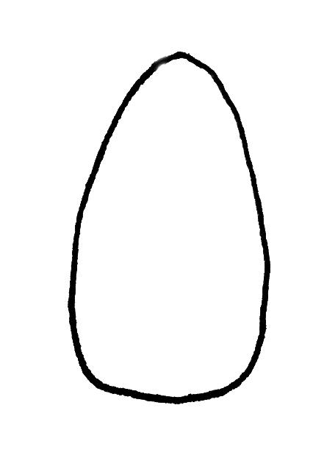

width

Literature
Borys, M. W., Leszczyñska-Borys, H., 1994: Tejocote (Crataegus spp.) – planta para solares, macetas e interiores. Revista Chapingo Serie Horticultura 1(2): 95-107.

Hillier, H.G., 1992: Hillier’s Manual of Trees and Shrubs. 6th ed. Romsey, GB, 575 pp.

Phipps, J.B., 1997: Monography of Northern Mexican Crataegus (Rosaceae, subfam. Maloideae). The University of Western Ontario, Department of Plant Science, London, Ontario, CA, 93 pp.

Technical Questionnaire
TECHNICAL QUESTIONNAIRE |  |  |  | Page {x} of {y} |  | Reference Number:
 |  |  |  |  |  | Application date:
 |  |  |  |  |  | (not to be filled in by the applicant)
TECHNICAL QUESTIONNAIRE
to be completed in connection with an application for plant breeders’ rights

1. Subject of the Technical Questionnaire
1.1 Botanical name |  |  | Crataegus L.
1.2 Common Name |  |  | Hawthorn
 |  |  | Species (please complete)
2. Applicant
Name
Address
Telephone No.
Fax No.
E-mail address
Breeder (if different from applicant)
3. Proposed denomination and breeder’s reference
Proposed denomination
(if available)

Breeder’s reference
#4. Information on the breeding scheme and propagation of the variety

4.1 Breeding Scheme

Variety resulting from:

4.1.1 Crossing

(a) controlled cross [ ]
(please state parent varieties)
(b) partially known cross [ ]
(please state known parent variety(ies))
(c) unknown cross [ ]

4.1.2 Mutation [ ]
(please state parent variety)

4.1.3 Discovery and development [ ]
(please state where and when discovered and how developed)

4.1.4 Other [ ]
(please provide details)

4.2 Method of propagating the variety

4.2.1 Vegetative

(a) grafted [ ]
(b) shoot cuttings [ ]
(c) root cuttings [ ]

5. Characteristics of the variety to be indicated (the number in brackets refers to the corresponding characteristic in Test Guidelines; please mark the note which best corresponds).
 | Characteristics |  |  |  |  |  | Example Varieties |  |  | Note
5.1  (1) | Plant: growth type
 | shrub |  |  |  |  |  | Calpantino, Candelaria, Compacta, Mitzi |  |  | 1[ ]
 | semi-shrub |  |  |  |  |  | Azucena, Paul’s Scarlet |  |  | 2[ ]
 | tree |  |  |  |  |  | Calpan Gold, Plena |  |  | 3[ ]
5.2  (2) | Plant: habit
 | fastigiate |  |  |  |  |  | Ergo, Gaca, Pingo |  |  | 1[ ]
 | upright |  |  |  |  |  | Azucena, Calpar, Stricta |  |  | 2[ ]
 | spreading |  |  |  |  |  | Atexcac |  |  | 3[ ]
 | semi drooping |  |  |  |  |  | Candelaria, Chico |  |  | 4[ ]
 | drooping |  |  |  |  |  |  |  |  | 5[ ]
 | weeping |  |  |  |  |  | Pendula |  |  | 6[ ]
5.3  (6) | Shoot: presence of thorns
 | absent |  |  |  |  |  | Compacta, Edgar, Epi |  |  | 1[ ]
 | present |  |  |  |  |  | Chela, Mutabilis, Pingo |  |  | 9[ ]
5.4  (11) | Leaf blade: length
 | short |  |  |  |  |  | Belén, Mutabilis |  |  | 3[ ]
 | medium |  |  |  |  |  | Epi |  |  | 5[ ]
 | long |  |  |  |  |  | Carrierei, Edgar |  |  | 7[ ]
 | Characteristics |  |  |  |  |  | Example Varieties |  |  | Note
5.5  (22) | Petiole: length
 | short |  |  |  |  |  | Tzapingo |  |  | 3[ ]
 | medium |  |  |  |  |  | Paul’s Scarlet, Plena |  |  | 5[ ]
 | long |  |  |  |  |  | Toba, Wattiana |  |  | 7[ ]
5.6  (32) | Fruit: color
 | light green |  |  |  |  |  | Epi, San Nicolás |  |  | 1[ ]
 | medium green |  |  |  |  |  |  |  |  | 2[ ]
 | yellow |  |  |  |  |  | Aurora, Tzapingo |  |  | 3[ ]
 | yellow and orange |  |  |  |  |  | Alex, Chapeado |  |  | 4[ ]
 | yellow and red |  |  |  |  |  | Carrierei, Elena |  |  | 5[ ]
 | orange |  |  |  |  |  | Ade, Huejo |  |  | 6[ ]
 | orange and red |  |  |  |  |  | Poblano |  |  | 7[ ]
 | medium red |  |  |  |  |  | Ara |  |  | 8[ ]
 | dark red |  |  |  |  |  | Eli |  |  | 9[ ]
 | purple |  |  |  |  |  |  |  |  | 10[ ]
 | black |  |  |  |  |  |  |  |  | 11[ ]
5.7  (41) | Fruit: length/width ratio
 | small |  |  |  |  |  | Ela |  |  | 3[ ]
 | medium |  |  |  |  |  | Erick, Robelo |  |  | 5[ ]
 | large |  |  |  |  |  | Alex, Natzi |  |  | 7[ ]
- Similar varieties and differences from these varieties

Please use the following table and box for comments to provide information on how your candidate variety differs from the variety (or varieties) which, to the best of your knowledge, is (or are) most similar. This information may help the examination authority to conduct its examination of distinctness in a more efficient way.

Denomination(s) of variety(ies) similar to your candidate variety |  | Characteristic(s) in which your candidate variety differs from the similar variety(ies) |  |  | Describe the expression of the characteristic(s) for the similar variety(ies) |  |  | Describe the expression of the characteristic(s) for your candidate variety
Example |  | Leaf blade: lobes |  |  | note 1  absent |  |  | note 9  present

TECHNICAL QUESTIONNAIRE | Page {x} of {y} | Reference Number:
#7. Additional information which may help in the examination of the variety

7.1 In addition to the information provided in sections 5 and 6, are there any additional characteristics, which may help to distinguish the variety?

Yes [ ] No [ ]

(If yes, please provide details)

7.2 Are there any special conditions for growing the variety or conducting the examination?

Yes [ ] No [ ]

(If yes, please provide details)

7.3 Other information

7.3.1 Type

(a) fruit [ ]
(b) ornamental [ ]

7.3.2 A representative color photograph of the variety should accompany the Technical Questionnaire

8. Authorization for release

(a) Does the variety require prior authorization for release under legislation concerning the protection of the environment, human and animal health?

Yes [ ] No [ ]

(b) Has such authorization been obtained?

Yes [ ] No [ ]

If the answer to (b) is yes, please attach a copy of the authorization.

9. Information on plant material to be examined or submitted for examination.

9.1 The expression of a characteristic or several characteristics of a variety may be affected by factors, such as pests and disease, chemical treatment (e.g. growth retardants or pesticides), effects of tissue culture, different rootstocks, scions taken from different growth phases of a tree, etc.

9.2 The plant material should not have undergone any treatment which would affect the expression of the characteristics of the variety, unless the competent authorities allow or request such treatment. If the plant material has undergone such treatment, full details of the treatment must be given. In this respect, please indicate below, to the best of your knowledge, if the plant material to be examined has been subjected to:

(a) Microorganisms (e.g. virus, bacteria, phytoplasma) Yes [ ] No [ ]

(b) Chemical treatment (e.g. growth retardant, pesticide) Yes [ ] No [ ]

(c) Tissue culture Yes [ ] No [ ]

(d) Other factors Yes [ ] No [ ]

Please provide details for where you have indicated “yes”.

……………………………………………………………

10. I hereby declare that, to the best of my knowledge, the information provided in this form is correct:

Applicant’s name

Signature Date

[End of document]

* These names were correct at the time of the introduction of these Test Guidelines but may be revised or updated. [Readers are advised to consult the UPOV Code, which can be found on the UPOV Website (www.upov.int), for the latest information.]
# Authorities may allow certain of this information to be provided in a confidential section of the Technical Questionnaire.
# Authorities may allow certain of this information to be provided in a confidential section of the Technical Questionnaire.

