 |  | E  TG/237/1  ORIGINAL: English  DATE: 2007-03-28
INTERNATIONAL UNION FOR THE PROTECTION OF NEW VARIETIES OF PLANTS
GENEVA

 | Angelonia angustifolia Benth.  and its hybrids  UPOV Code: ANGLN_ANG  and linked hybrid codes | *

GUIDELINES

FOR THE CONDUCT OF TESTS

FOR DISTINCTNESS, UNIFORMITY AND STABILITY

Alternative Names:*
Botanical name | English | French | German | Spanish
Angelonia angustifolia Benth. | - | - | - | -

The purpose of these guidelines (“Test Guidelines”) is to elaborate the principles contained in the General Introduction (document TG/1/3), and its associated TGP documents, into detailed practical guidance for the harmonized examination of distinctness, uniformity and stability (DUS) and, in particular, to identify appropriate characteristics for the examination of DUS and production of harmonized variety descriptions.

ASSOCIATED DOCUMENTS
These Test Guidelines should be read in conjunction with the General Introduction and its associated TGP documents.
TABLE OF CONTENTS PAGE

1. Subject of these Test Guidelines 3
2. Material Required 3
3. Method of Examination 3
3.1 Number of Growing Cycles 3
3.2 Testing Place 3
3.3 Conditions for Conducting the Examination 3
3.4 Test Design 4
3.5 Number of Plants / Parts of Plants to be Examined 4
3.6 Additional Tests 4
4. Assessment of Distinctness, Uniformity and Stability 4
4.1 Distinctness 4
4.2 Uniformity 5
4.3 Stability 5
5. Grouping of Varieties and Organization of the Growing Trial 5
6. Introduction to the Table of Characteristics 6
6.1 Categories of Characteristics 6
6.2 States of Expression and Corresponding Notes 6
6.3 Types of Expression 6
6.4 Example Varieties 7
6.5 Legend 7
7. Table of Characteristics/Tableau des caractères/Merkmalstabelle/Tabla de caracteres 8
8. Explanations on the Table of Characteristics 14
8.1 Explanations covering several characteristics 14
8.2 Explanations for individual characteristics 14
9. Literature 18
10. Technical Questionnaire 19

Subject of these Test Guidelines
These Test Guidelines apply to all varieties of Angelonia angustifolia Benth. and hybrids between Angelonia angustifolia Benth. and other species of Angelonia Bonpl., of the family Scrophulariaceae.

Material Required
2.1 The competent authorities decide on the quantity and quality of the plant material required for testing the variety and when and where it is to be delivered. Applicants submitting material from a State other than that in which the testing takes place must ensure that all customs formalities and phytosanitary requirements are complied with.

2.2 The material is to be supplied in the form of rooted cuttings or seed.

2.3 The minimum quantity of plant material, to be supplied by the applicant, should be:

vegetatively propagated varieties: 15 rooted cuttings
seed-propagated varieties: sufficient seed to produce 30 plants.

2.4 The plant material supplied should be visibly healthy, not lacking in vigor, nor affected by any important pest or disease.

2.5 The plant material should not have undergone any treatment which would affect the expression of the characteristics of the variety, unless the competent authorities allow or request such treatment. If it has been treated, full details of the treatment must be given.

Method of Examination

3.1 Number of Growing Cycles
The minimum duration of tests should normally be a single growing cycle.

3.2 Testing Place
Tests are normally conducted at one place. In the case of tests conducted at more than one place, guidance is provided in TGP/9 “Examining Distinctness”.

3.3 Conditions for Conducting the Examination
3.3.1 The tests should be carried out under conditions ensuring satisfactory growth for the expression of the relevant characteristics of the variety and for the conduct of the examination.

3.3.2 Observation of color by eye

Because daylight varies, color determinations made against a color chart should be made either in a suitable cabinet providing artificial daylight or in the middle of the day in a room without direct sunlight. The spectral distribution of the illuminant for artificial daylight should conform with the CIE Standard of Preferred Daylight D 6500 and should fall within the tolerances set out in the British Standard 950, Part I. These determinations should be made with the plant part placed against a white background.

3.4 Test Design
3.4.1 Vegetatively propagated varieties: each test should be designed to result in a total of at least 15 plants.

3.4.2 Seed propagated varieties: each test should be designed to result in a total of at least 30 plants.

3.4.3 The design of the tests should be such that plants or parts of plants may be removed for measurement or counting without prejudice to the observations which must be made up to the end of the growing cycle.

3.5 Number of Plants / Parts of Plants to be Examined
3.5.1 Vegetatively propagated varieties: unless otherwise indicated, all observations on single plants should be made on 15 plants or parts taken from each of 15 plants and any other observations made on all plants in the test.

3.5.2 Seed propagated varieties: unless otherwise indicated, all observations on single plants should be made on 30 plants or parts taken from each of 30 plants and any other observations made on all plants in the test.

3.6 Additional Tests
Additional tests, for examining relevant characteristics, may be established.

Assessment of Distinctness, Uniformity and Stability

4.1 Distinctness

4.1.1 General Recommendations
It is of particular importance for users of these Test Guidelines to consult the General Introduction prior to making decisions regarding distinctness. However, the following points are provided for elaboration or emphasis in these Test Guidelines.

4.1.2 Consistent Differences
The differences observed between varieties may be so clear that more than one growing cycle is not necessary. In addition, in some circumstances, the influence of the environment is not such that more than a single growing cycle is required to provide assurance that the differences observed between varieties are sufficiently consistent. One means of ensuring that a difference in a characteristic, observed in a growing trial, is sufficiently consistent is to examine the characteristic in at least two independent growing cycles.

4.1.3 Clear Differences
Determining whether a difference between two varieties is clear depends on many factors, and should consider, in particular, the type of expression of the characteristic being examined, i.e. whether it is expressed in a qualitative, quantitative, or pseudo-qualitative manner. Therefore, it is important that users of these Test Guidelines are familiar with the recommendations contained in the General Introduction prior to making decisions regarding distinctness.

4.2 Uniformity
4.2.1 It is of particular importance for users of these Test Guidelines to consult the General Introduction prior to making decisions regarding uniformity. However, the following points are provided for elaboration or emphasis in these Test Guidelines.

4.2.2 For the assessment of uniformity of vegetatively propagated varieties, a population standard of 1% and an acceptance probability of at least 95% should be applied. In the case of a sample size of 15 plants, 1 off-type is allowed.

4.2.3 For the assessment of uniformity of seed-propagated varieties which are self-pollinated, a population standard of 1% and an acceptance probability of at least 95% should be applied. In the case of a sample size of 30 plants, one off type is allowed.

4.2.4 For the assessment of uniformity of seed-propagated varieties which are cross pollinated or hybrids, the recommendations in the General Introduction for cross pollinated or hybrids varieties should be followed, as appropriate.

4.3 Stability
4.3.1 In practice, it is not usual to perform tests of stability that produce results as certain as those of the testing of distinctness and uniformity. However, experience has demonstrated that, for many types of variety, when a variety has been shown to be uniform, it can also be considered to be stable.

4.3.2 Where appropriate, or in cases of doubt, stability may be tested, either by growing a further generation, or by testing a new plant stock to ensure that it exhibits the same characteristics as those shown by the previous material supplied.

Grouping of Varieties and Organization of the Growing Trial
5.1 The selection of varieties of common knowledge to be grown in the trial with the candidate varieties and the way in which these varieties are divided into groups to facilitate the assessment of distinctness are aided by the use of grouping characteristics.

5.2 Grouping characteristics are those in which the documented states of expression, even where produced at different locations, can be used, either individually or in combination with other such characteristics: (a) to select varieties of common knowledge that can be excluded from the growing trial used for examination of distinctness; and (b) to organize the growing trial so that similar varieties are grouped together.

5.3 The following have been agreed as useful grouping characteristics:

(a) Plant: growth habit (characteristic 1)
(b) Corolla lobes: presence of stripes (characteristic 11)
(c) Only varieties with stripes absent: Upper lip: main color on corolla lobes (characteristic 12) with the following groups:
Gr. 1: white
Gr. 2: pink
Gr. 3: violet
(d) Only varieties with stripes absent: Lower lip: main color on corolla lobes (characteristic 13) with the following groups:
Gr. 1: white
Gr. 2: pink
Gr. 3: violet

5.4 Guidance for the use of grouping characteristics, in the process of examining distinctness, is provided through the General Introduction.

Introduction to the Table of Characteristics

6.1 Categories of Characteristics

6.1.1 Standard Test Guidelines Characteristics
Standard Test Guidelines characteristics are those which are approved by UPOV for examination of DUS and from which members of the Union can select those suitable for their particular circumstances.

6.1.2 Asterisked Characteristics
Asterisked characteristics (denoted by *) are those included in the Test Guidelines which are important for the international harmonization of variety descriptions and should always be examined for DUS and included in the variety description by all members of the Union, except when the state of expression of a preceding characteristic or regional environmental conditions render this inappropriate.

6.2 States of Expression and Corresponding Notes
States of expression are given for each characteristic to define the characteristic and to harmonize descriptions. Each state of expression is allocated a corresponding numerical note for ease of recording of data and for the production and exchange of the description.

6.3 Types of Expression
An explanation of the types of expression of characteristics (qualitative, quantitative and pseudo-qualitative) is provided in the General Introduction.

6.4 Example Varieties
Where appropriate, example varieties are provided to clarify the states of expression of each characteristic.

6.5 Legend
(*) Asterisked characteristic – see Chapter 6.1.2

QL: Qualitative characteristic – see Chapter 6.3
QN: Quantitative characteristic – see Chapter 6.3
PQ: Pseudo-qualitative characteristic – see Chapter 6.3

(a)-(d) See Explanations on the Table of Characteristics in Chapter 8.1

(+) See Explanations on the Table of Characteristics in Chapter 8.2

Table of Characteristics/Tableau des caractères/Merkmalstabelle/Tabla de caracteres
 |  | English | français | Deutsch | español | Example Varieties  Exemples  Beispielssorten  Variedades ejemplo | Note/  Nota
1  (*) |  | Plant: growth habit | Plante: port | Pflanze: Wuchsform | Planta: porte
QL | (a) | upright | dressé | aufrecht | erecto | Balangdepi, Balangimla | 1
 |  | spreading | divergent | breitwüchsig | extendido | Balangbeke, Balangbawi | 2
2 |  | Shoot: length | Tige: longueur | Trieb: Länge | Rama: longitud
QN | (a) | short | courte | kurz | corta | Balangloud | 3
 |  | medium | moyenne | mittel | media | Balangwitim | 5
 |  | long | longue | lang | larga | Anpink | 7
3 |  | Shoot: anthocyanin coloration below the inflorescence | Tige: pigmentation anthocyanique sous l’inflorescence | Trieb: Anthocyanfärbung unter dem Blütenstand | Rama: pigmentación antociánica debajo de la inflorescencia
QN | (a) | absent or very weak | absente ou très faible | fehlend oder sehr gering | ausente o muy débil | Balangloud, Balangbeke | 1
 |  | weak | faible | gering | débil | Balangimpu, Balangimla | 3
 |  | medium | moyenne | mittel | media | Balangdepi | 5
 |  | strong | forte | stark | fuerte | Balangpurup, Cartbas Depur | 7
4  (*) |  | Leaf: length | Feuille: longueur | Blatt: Länge | Hoja: longitud
QN | (b) | short | courte | kurz | corta | Balangloud | 3
 |  | medium | moyenne | mittel | media | Balangwitim | 5
 |  | long | longue | lang | larga | Anwhit | 7
5  (*) |  | Leaf: width | Feuille: largeur | Blatt: Breite | Hoja: anchura
QN | (b) | narrow | étroite | schmal | estrecha | Balangbawi, Balangbeke | 3
 |  | medium | moyenne | mittel | media | Balangdepi | 5
 |  | broad | large | breit | ancha | Balangimpu | 7
6 |  | Leaf: intensity of green color on upper side | Feuille: intensité de la couleur verte sur la face supérieure | Blatt: Intensität der Grünfärbung der Oberseite | Hoja: intensidad del color verde del haz
QN | (b) | light | claire | hell | clara |  | 3
 |  | medium | moyenne | mittel | media | Balangloud | 5
 |  | dark | obscure | dunkel | oscura | Balangbeke | 7
7 |  | Leaf: glossiness on upper side | Feuille: brillance de la face supérieure | Blatt: Glanz der Oberseite | Hoja: brillo del haz
QN | (b) | absent or very weak | absente ou très faible | fehlend oder sehr gering | ausente o muy débil | Balangloud | 1
 |  | weak | faible | gering | débil | Balangpili | 3
 |  | medium | moyenne | mittel | medio | Balanglapi | 5
 |  | strong | forte | stark | fuerte | Balangbeke | 7
8  (*)  (+) |  | Flower: length | Fleur: longueur | Blüte: Länge | Flor: longitud
QN | (c) | short | courte | kurz | corta | Balangimla | 3
 |  | medium | moyenne | mittel | media | Balangbawi | 5
 |  | long | longue | lang | larga | Cartbas Whit | 7
9  (*)  (+) |  | Flower: width | Fleur: largeur | Blüte: Breite | Flor: anchura
QN | (c) | narrow | étroite | schmal | estrecha | Balangimla | 3
 |  | medium | moyenne | mittel | media | Balangbawi | 5
 |  | broad | large | breit | ancha | Cartbas Whit | 7
10  (+) |  | Flower: reflexing of corolla lobes | Fleur: enroulement des lobes de la corolle | Blüte: Zurück- biegung der Kronlappen | Flor: curvatura de los lóbulos de la corola
QN | (c)  (d) | absent or weak | absent ou faible | fehlend oder gering | ausente o débil |  | 1
 |  | medium | moyen | mittel | media |  | 2
 |  | strong | fort | stark | fuerte |  | 3
11  (*) |  | Corolla lobes: presence of stripes | Lobes de la corolle: présence de stries | Kronlappen: Vorhandensein von Streifen | Lóbulos de la corola: estrías
QL | (c)  (d) | absent | absentes | fehlend | ausentes | Balangimla | 1
 |  | present | présentes | vorhanden | presentes | Balanglast | 9
12  (*) |  | Only varieties with stripes absent: Upper lip: main color on corolla lobes | Seulement les variétés à stries absentes: lèvre supérieure: couleur principale des lobes de la corolle | Nur Sorten ohne Streifen: Oberlippe: Hauptfarbe der Kronlappen | Sólo variedades con estrías ausentes: Labio superior: color principal de los lóbulos de la corola
PQ | (c)  (d) | RHS Colour Chart (indicate reference number) | Code RHS des couleurs (indiquer le numéro de référence) | RHS-Farbkarte (Nummer angeben) | Carta de colores RHS (indíquese el número de referencia)
13  (*) |  | Only varieties with stripes absent: Lower lip: main color on corolla lobes | Seulement les variétés à stries absentes: lèvre inférieure: couleur principale des lobes de la corolle | Nur Sorten ohne Streifen: Unterlippe: Hauptfarbe der Kronlappen | Sólo variedades con estrías ausentes: Labio inferior: color principal de los lóbulos de la corola
PQ | (c)  (d) | RHS Colour Chart (indicate reference number) | Code RHS des couleurs (indiquer le numéro de référence) | RHS-Farbkarte (Nummer angeben) | Carta de colores RHS (indíquese el número de referencia)
14 (*) |  | Only varieties with stripes present: Corolla lobes: ground color | Seulement les variétés à stries présentes: lobes de la corolle: couleur de fond | Nur Sorten mit Streifen: Kronlappen: Grundfarbe | Sólo variedades con estrías presentes: Lóbulos de la corola: color de fondo
PQ | (c) (d) | RHS Colour Chart (indicate reference number) | Code RHS des couleurs (indiquer le numéro de référence) | RHS-Farbkarte (Nummer angeben) | Carta de colores RHS (indíquese el número de referencia)
15 (*) |  | Only varieties with stripes present: Corolla lobes: color of stripes | Seulement les variétés à stries présentes: lobes de la corolle: couleur des stries | Nur Sorten mit Streifen: Kronlappen: Farbe der Streifen | Sólo variedades con estrías presentes: Lóbulos de la corola: color de las estrías
PQ | (c)  (d) | RHS Colour Chart (indicate reference number) | Code RHS des couleurs (indiquer le numéro de référence) | RHS-Farbkarte (Nummer angeben) | Carta de colores RHS (indíquese el número de referencia)
16  (*) |  | Only varieties with stripes present: Lower lip: width of stripes | Seulement les variétés à stries présentes: lèvre inférieure: largeur des stries | Nur Sorten mit Streifen: Unterlippe: Breite der Streifen | Sólo variedades con estrías presentes: Labio inferior: anchura de las estrías
QN | (c)  (d) | narrow | étroites | schmal | estrecha |  | 3
 |  | medium | moyennes | mittel | media | Anstern | 5
 |  | broad | larges | breit | ancha | AngelMist Purple Stripe | 7
17  (+) |  | Lower lip: undulation of margin | Lèvre inférieure: ondulation du bord | Unterlippe: Randwellung | Labio inferior: ondulación del borde
QN | (c)  (d) | absent or very weak | absente ou très faible | fehlend oder sehr gering | ausente o muy débil |  | 1
 |  | weak | faible | gering | débil |  | 3
 |  | medium | moyenne | mittel | media |  | 5
 |  | strong | forte | stark | fuerte |  | 7
18  (+) |  | Chamber: length | Chambre: longueur | Rachen: Länge | Cavidad: longitud
QN | (c)  (d) | short | courte | kurz | corta |  | 3
 |  | medium | moyenne | mittel | media | Balangimla | 5
 |  | long | longue | lang | larga |  | 7
19  (+) |  | Chamber: width | Chambre: largeur | Rachen: Breite | Cavidad: anchura
QN | (c)  (d) | narrow | étroite | schmal | estrecha |  | 3
 |  | medium | moyenne | mittel | media | Balangimla | 5
 |  | broad | large | breit | ancha |  | 7
20  (+) |  | Chamber: length in relation to width | Chambre: longueur par rapport à la largeur | Rachen: Länge im Verhältnis zur Breite | Cavidad: relación longitud/anchura
QN | (c)  (d) | longer than broad | plus longue que large | länger als breit | más larga que ancha |  | 1
 |  | as long as broad | aussi longue que large | so lang wie breit | tan larga como ancha |  | 2
 |  | broader than long | plus large que longue | breiter als lang | más ancha que larga |  | 3
21 |  | Chamber: color of markings | Chambre: couleur des marques | Rachen: Farbe der Sprenkelung | Cavidad: color de las marcas
PQ | (c)  (d) | yellow green | vert jaune | gelbgrün | verde amarillento |  | 1
 |  | purple red | rouge poupre | purpurrot | rojo púrpura |  | 2
 |  | violet | violet | violett | violeta |  | 3
22 |  | Chamber: intensity of markings | Chambre: intensité des marques | Rachen: Intensität der Sprenkelung | Cavidad: intensidad de las marcas
QN | (c)  (d) | absent or very weak | absente ou très faible | fehlend oder sehr gering | ausentes o muy débiles | Balangbawi,  Cart White | 1
 |  | weak | faible | gering | débiles |  | 3
 |  | medium | moyenne | mittel | medias |  | 5
 |  | strong | forte | stark | fuertes | Balangimla, Balangimpu | 7
23  (*)  (+) |  | Chamber: density of markings | Chambre: densité des marques | Rachen: Dichte der Sprenkelung | Cavidad: densidad de las marcas
QN | (c)  (d) | sparse | faible | locker | baja |  | 3
 |  | medium | moyenne | mittel | media |  | 5
 |  | dense | dense | dicht | alta |  | 7
24  (+) |  | Pouch: main color | Poche: couleur principale | Vertiefung der Unterlippe: Hauptfarbe | Gibosidad: color principal
PQ | (c)  (d) | white | blanc | weiß | blanco |  | 1
 |  | yellow green | vert jaune | gelbgrün | verde amarillento |  | 2
 |  | purple red | rouge pourpre | purpurrot | rojo púrpura |  | 3
 |  | violet | violet | violett | violeta |  | 4
25  (*)  (+) |  | Nectary bulge: main color | Bourrelet du nectaire: couleur principale | Nektarie: Hauptfarbe | Protuberancia del nectario: color principal
PQ | (c)  (d) | white | blanc | weiß | blanco |  | 1
 |  | purple red | rouge pourpre | purpurrot | rojo púrpura |  | 2
 |  | violet | violet | violett | violeta |  | 3

Explanations on the Table of Characteristics

8.1 Explanations covering several characteristics
Characteristics containing the following key in the second column of the Table of Characteristics should be examined as indicated below:

(a) Observations on the plant and shoot should be made on fully flowering plants.
(b) Observations on the leaf should be made on leaves taken from the middle part of the shoot.
(c) Observations on the flower and flower parts should be made when flowers are fully open.
(d) Flower parts:

8.2 Explanations for individual characteristics
Ad. 8: Flower: length
Ad. 9: Flower: width

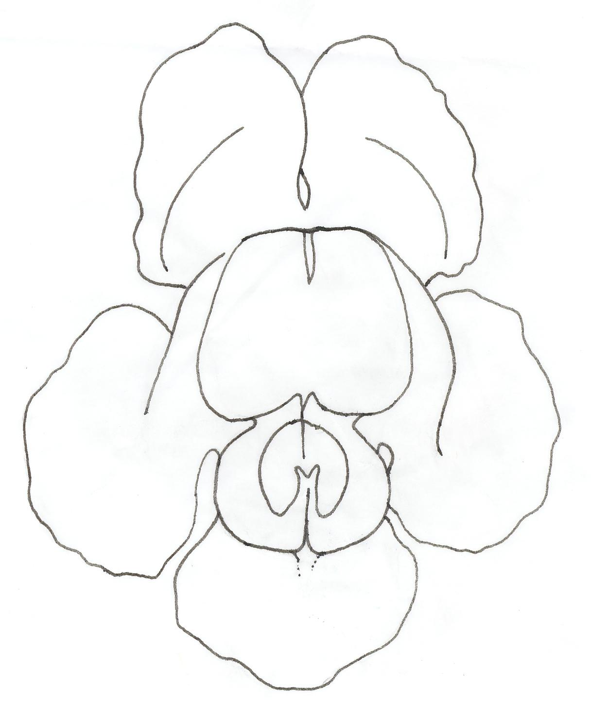
length

width

Ad. 10: Flower: reflexing of corolla lobes

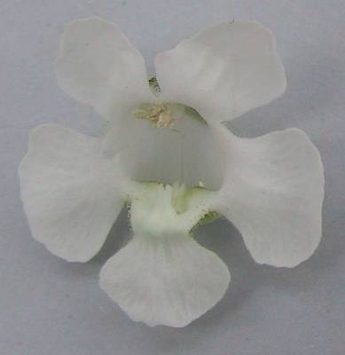 | 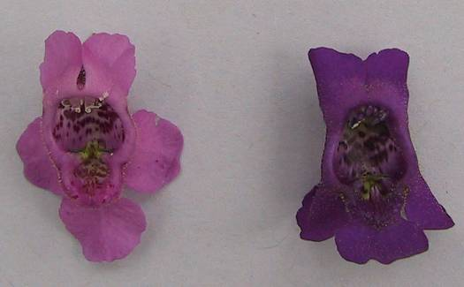
1 | 2 | 3
absent or weak | medium | strong

Ad. 17: Lower lip: undulation of margin

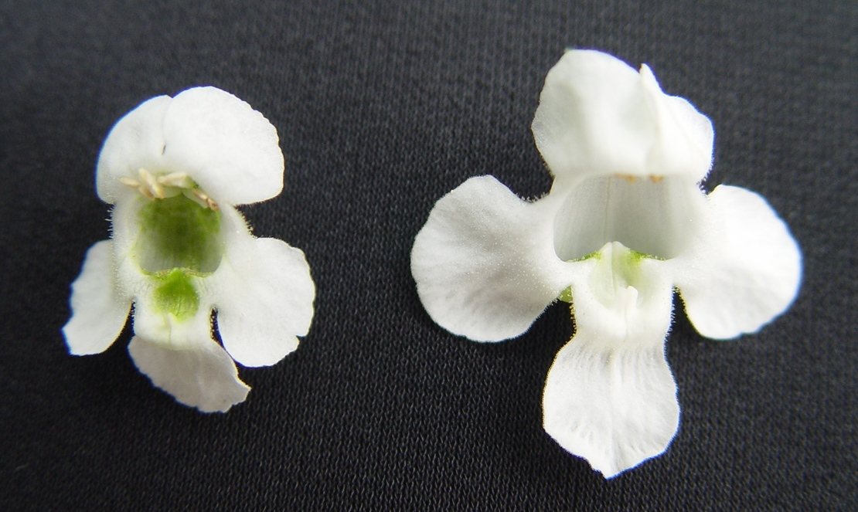 | 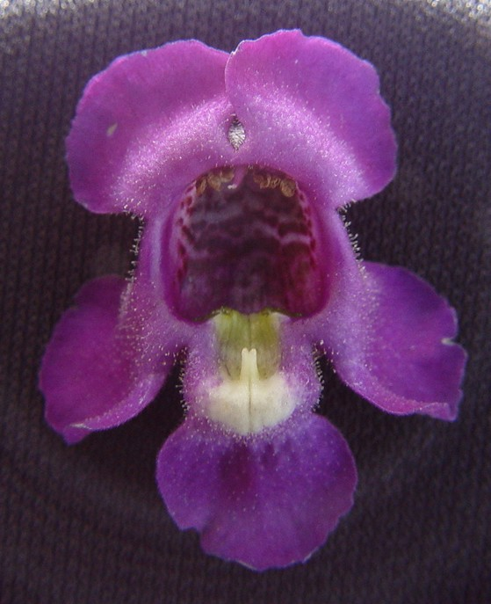
1 | 3
absent or very weak | weak
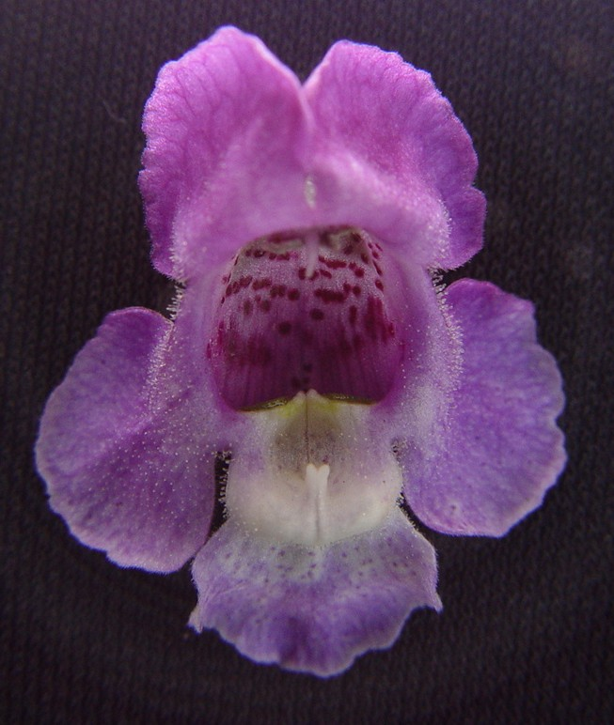 | 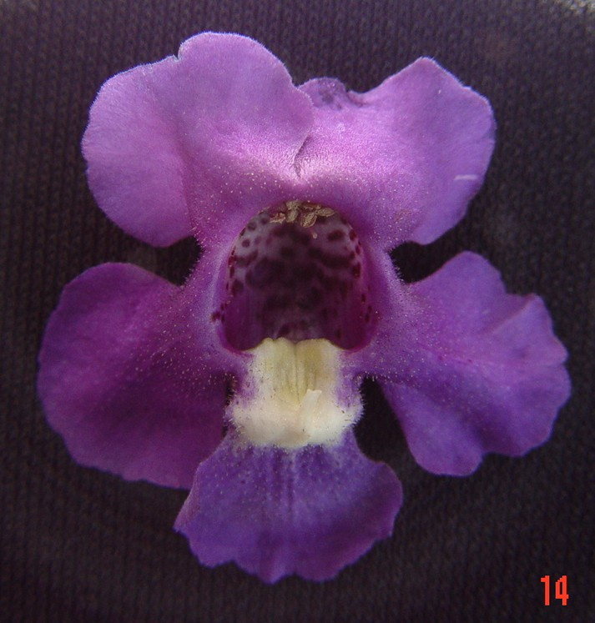
5 | 7
medium | strong

Ad. 18: Chamber: length
Ad. 19: Chamber: width
Ad. 20: Chamber: length in relation to width

width
length

Ad. 23: Chamber: density of markings

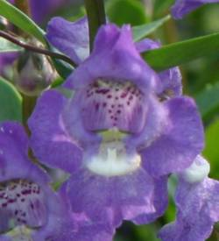 | 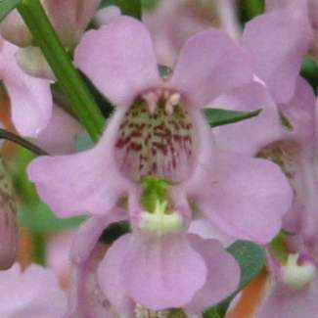 | 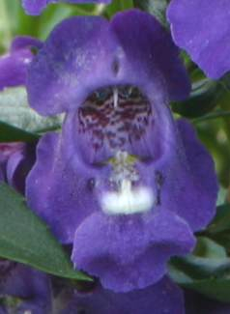
3 | 5 | 7
sparse | medium | dense

Ad. 24: Pouch: main colour

1 | 2
white | yellow green

 | 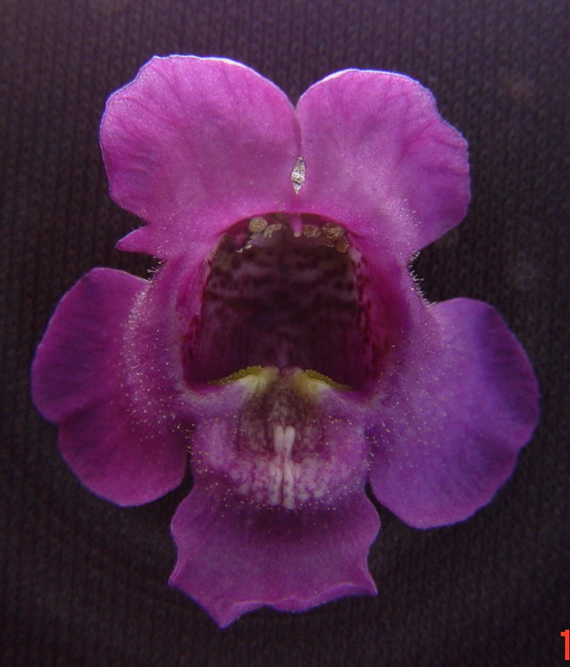
3 | 4
purple red | violet

Ad. 25: Nectary bulge: main color

 | 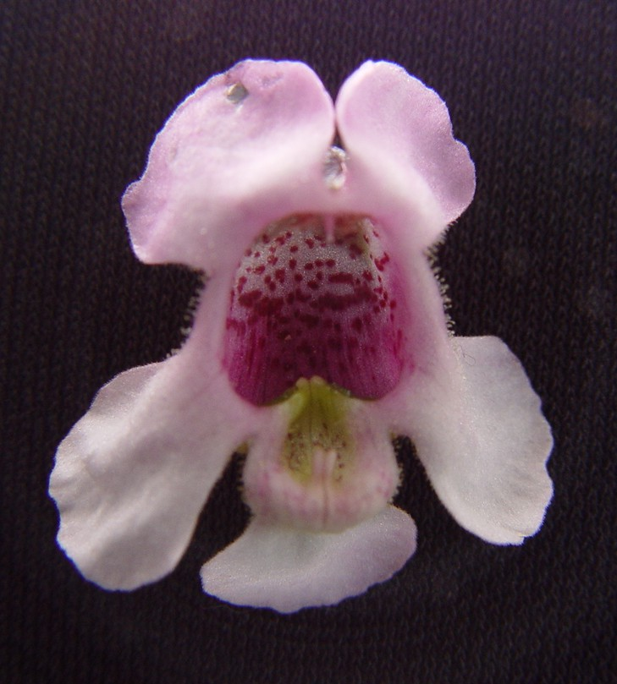
1 | 2 | 3
white | purple red | violet

Literature

Liberty Hyde Bailey Hortorium, 1976: Hortus Third, Macmillan Publishing Company.

Technical Questionnaire
TECHNICAL QUESTIONNAIRE |  |  |  | Page {x} of {y} |  | Reference Number:
 |  |  |  |  |  | Application date:
 |  |  |  |  |  | (not to be filled in by the applicant)
TECHNICAL QUESTIONNAIRE
to be completed in connection with an application for plant breeders’ rights

1. Subject of the Technical Questionnaire
1.1 Botanical name |  |  | Angelonia angustifolia Benth. |  |  |  |  |  | [ ]
Hybrid: please indicate the name(s) of species used in the crossing
1.2.1 Botanical name(s) |  |  |  |  |  |  |  |  | [ ]
1.2.2 Common name
2. Applicant
Name
Address
Telephone No.
Fax No.
E-mail address
Breeder (if different from applicant)
3. Proposed denomination and breeder’s reference
Proposed denomination
(if available)

Breeder’s reference
#4. Information on the breeding scheme and propagation of the variety

4.1 Breeding scheme

Variety resulting from:

4.1.1 Crossing

(a) controlled cross [ ]
(please state parent varieties)

(b) partially known cross [ ]
(please state known parent variety(ies))

(c) unknown cross [ ]

4.1.2 Mutation [ ]
(please state parent variety)

4.1.3 Discovery and development [ ]
(please state where and when discovered
and how developed)

4.1.4 Other [ ]
(please provide details)

4.2 Method of propagating the variety

4.2.1 Vegetative propagation

(a) cuttings [ ]

(b) in vitro propagation [ ]

(c) other (state method) [ ]

4.2.2 Seed [ ]

4.2.3 Other [ ]
(please provide details)

5. Characteristics of the variety to be indicated (the number in brackets refers to the corresponding characteristic in Test Guidelines; please mark the note which best corresponds).

 | Characteristics |  |  |  |  |  | Example Varieties |  |  | Note
5.1  (1) | Plant: growth habit
 | upright |  |  |  |  |  | Balangdepi, Balangimla |  |  | 1 [ ]
 | spreading |  |  |  |  |  | Balangbeke, Balangbawi |  |  | 2 [ ]
5.2  (11) | Corolla lobes: presence of stripes
 | absent |  |  |  |  |  | Balangimla |  |  | 1 [ ]
 | present |  |  |  |  |  | Balanglast |  |  | 9 [ ]
5.3 (i)  (12) | Only varieties with stripes absent: Upper lip: main color on corolla lobes
 | RHS Colour Chart (indicate reference number)
5.3 (ii)  (12) | Only varieties with stripes absent: Upper lip: main color on corolla lobes
 | white |  |  |  |  |  |  |  |  | 1 [ ]
 | pink |  |  |  |  |  |  |  |  | 2 [ ]
 | violet |  |  |  |  |  |  |  |  | 3 [ ]
 | Other color (indicate) … |  |  |  |  |  |  |  |  | 4 [ ]
5.4 (i)  (13) | Only varieties with stripes absent: Lower lip: main color on corolla lobes
 | RHS Colour Chart (indicate reference number)
5.4 (ii)  (13) | Only varieties with stripes absent: Lower lip: main color on corolla lobes
 | white |  |  |  |  |  |  |  |  | 1 [ ]
 | pink |  |  |  |  |  |  |  |  | 2 [ ]
 | violet |  |  |  |  |  |  |  |  | 3 [ ]
 | Other color (indicate) … |  |  |  |  |  |  |  |  | 4 [ ]
 | Characteristics |  |  |  |  |  | Example Varieties |  |  | Note
5.5 (i)  (14) | Only varieties with stripes present: Corolla lobes: ground color
 | RHS Colour Chart (indicate reference number)
5.5 (ii)  (14) | Only varieties with stripes present: Corolla lobes: ground color
 | white |  |  |  |  |  |  |  |  | 1 [ ]
 | other color (indicate) |  |  |  |  |  |  |  |  | 2 [ ]
5.6 (i)  (15) | Only varieties with stripes present: Corolla lobes: color of stripes
 | RHS Colour Chart (indicate reference number)
5.6 (ii)  (15) | Only varieties with stripes present: Corolla lobes: color of stripes
 | white |  |  |  |  |  |  |  |  | 1 [ ]
 | pink |  |  |  |  |  |  |  |  | 2 [ ]
 | violet |  |  |  |  |  |  |  |  | 3 [ ]
 | other color (indicate) |  |  |  |  |  |  |  |  | 4 [ ]
6. Similar varieties and differences from these varieties

Please use the following table and box for comments to provide information on how your candidate variety differs from the variety (or varieties) which, to the best of your knowledge, is (or are) most similar. This information may help the examination authority to conduct its examination of distinctness in a more efficient way.

Denomination(s) of variety(ies) similar to your candidate variety |  | Characteristic(s) in which your candidate variety differs from the similar variety(ies) |  |  | Describe the expression of the characteristic(s) for the similar variety(ies) |  |  | Describe the expression of the characteristic(s) for your candidate variety
Example |  | Plant: growth habit |  |  | upright |  |  | spreading
Comments:

#7. Additional information which may help in the examination of the variety

7.1 In addition to the information provided in sections 5 and 6, are there any additional characteristics which may help to distinguish the variety?

Yes [ ] No [ ]

(If yes, please provide details)

7.2 Are there any special conditions for growing the variety or conducting the examination?

Yes [ ] No [ ]

(If yes, please provide details)

7.3 Other information

A representative color photograph of the variety should accompany the Technical Questionnaire.

8. Authorization for release

(a) Does the variety require prior authorization for release under legislation concerning the protection of the environment, human and animal health?

Yes [ ] No [ ]

(b) Has such authorization been obtained?

Yes [ ] No [ ]

If the answer to (b) is yes, please attach a copy of the authorization.

9. Information on plant material to be examined or submitted for examination.

9.1 The expression of a characteristic or several characteristics of a variety may be affected by factors, such as pests and disease, chemical treatment (e.g. growth retardants or pesticides), effects of tissue culture, different rootstocks, scions taken from different growth phases of a tree, etc.

9.2 The plant material should not have undergone any treatment which would affect the expression of the characteristics of the variety, unless the competent authorities allow or request such treatment. If the plant material has undergone such treatment, full details of the treatment must be given. In this respect, please indicate below, to the best of your knowledge, if the plant material to be examined has been subjected to:

(a) Microorganisms (e.g. virus, bacteria, phytoplasma) Yes [ ] No [ ]

(b) Chemical treatment (e.g. growth retardant, pesticide) Yes [ ] No [ ]

(c) Tissue culture Yes [ ] No [ ]

(d) Other factors Yes [ ] No [ ]

Please provide details for where you have indicated “yes”.

……………………………………………………………

10. I hereby declare that, to the best of my knowledge, the information provided in this form is correct:

Applicant’s name

Signature Date

[End of document]

* These names were correct at the time of the introduction of these Test Guidelines but may be revised or updated. [Readers are advised to consult the UPOV Code, which can be found on the UPOV Website (www.upov.int), for the latest information.]
# Authorities may allow certain of this information to be provided in a confidential section of the Technical Questionnaire.
# Authorities may allow certain of this information to be provided in a confidential section of the Technical Questionnaire.

