 |  | E  TG/236/1  ORIGINAL: English  DATE: 2007-03-28
INTERNATIONAL UNION FOR THE PROTECTION OF NEW VARIETIES OF PLANTS
GENEVA

 | HUSK TOMATO  UPOV Code: PHYSA_IXO  Physalis ixocarpa Brot. | *

GUIDELINES

FOR THE CONDUCT OF TESTS

FOR DISTINCTNESS, UNIFORMITY AND STABILITY

Alternative Names:*

Botanical name | English | French | German | Spanish
Physalis ixocarpa Brot.,  Physalis philadelphica Lam | Husk Tomato | Alkékenge du Mexique, Coqueret, Physalis, Tomatillo, Tomate fraise | Mexikanische Blasenkirsche, Tomatillo | Miltomate, Tomatillo, Tomate de cáscara, Tomate de hoja, Tomate verde

The purpose of these guidelines (“Test Guidelines”) is to elaborate the principles contained in the General Introduction (document TG/1/3), and its associated TGP documents, into detailed practical guidance for the harmonized examination of distinctness, uniformity and stability (DUS) and, in particular, to identify appropriate characteristics for the examination of DUS and production of harmonized variety descriptions.

ASSOCIATED DOCUMENTS

These Test Guidelines should be read in conjunction with the General Introduction and its associated TGP documents.
TABLE OF CONTENTS PAGE

1. Subject of these Test Guidelines 3
2. Material Required 3
3. Method of Examination 3
3.1 Number of Growing Cycles 3
3.2 Testing Place 3
3.3 Conditions for Conducting the Examination 3
3.4 Test Design 4
3.5 Number of Plants / Parts of Plants to be Examined 4
3.6 Additional Tests 4
4. Assessment of Distinctness, Uniformity and Stability 4
4.1 Distinctness 4
4.2 Uniformity 5
4.3 Stability 5
5. Grouping of Varieties and Organization of the Growing Trial 5
6. Introduction to the Table of Characteristics 6
6.1 Categories of Characteristics 6
6.2 States of Expression and Corresponding Notes 6
6.3 Types of Expression 6
6.4 Example Varieties 6
6.5 Legend 7
7. Table of Characteristics/Tableau des caractères/Merkmalstabelle/Tabla de caracteres 8
8. Explanations on the Table of Characteristics 18
8.1 Explanations covering several characteristics 18
8.2 Explanations for individual characteristics 19
9. Literature 24
10. Technical Questionnaire 26

Subject of these Test Guidelines
These Test Guidelines apply to all varieties of Physalis ixocarpa Brot. ex Horm. (Syn: Physalis philadelphica Lam.).

Material Required
2.1 The competent authorities decide on the quantity and quality of the plant material required for testing the variety and when and where it is to be delivered. Applicants submitting material from a State other than that in which the testing takes place must ensure that all customs formalities and phytosanitary requirements are complied with.

2.2 The material is to be supplied in the form of seed.

2.3 The minimum quantity of plant material, to be supplied by the applicant, should be:

5 g or at least 2,500 seeds.

2.4 The seed should meet the minimum requirements for germination, species and analytical purity, health and moisture content, specified by the competent authority.

2.5 The plant material supplied should be visibly healthy, not lacking in vigor, nor affected by any important pest or disease.

2.6 The plant material should not have undergone any treatment which would affect the expression of the characteristics of the variety, unless the competent authorities allow or request such treatment. If it has been treated, full details of the treatment must be given.

Method of Examination

3.1 Number of Growing Cycles
The minimum duration of tests should normally be two independent growing cycles.

3.2 Testing Place
Tests are normally conducted at one place. In the case of tests conducted at more than one place, guidance is provided in TGP/9 “Examining Distinctness”.

3.3 Conditions for Conducting the Examination
3.3.1 The tests should be carried out under conditions ensuring satisfactory growth for the expression of the relevant characteristics of the variety and for the conduct of the examination.

3.3.2 The recommended method of observing the characteristic is indicated by the following key in the second column of the Table of Characteristics:

MG: single measurement of a group of plants or parts of plants
MS: measurement of a number of individual plants or parts of plants
VG: visual assessment by a single observation of a group of plants or parts of plants
VS: visual assessment by observation of individual plants or parts of plants

3.4 Test Design
3.4.1 Each test should be designed to result in a total of at least 60 plants which should be divided between at least 2 replicates.

3.4.2 The design of the tests should be such that plants or parts of plants may be removed for measurement or counting without prejudice to the observations which must be made up to the end of the growing cycle.

3.5 Number of Plants / Parts of Plants to be Examined
Unless otherwise indicated, all observations on single plants should be made on 30 plants or parts taken from each of 30 plants and any other observations made on all plants in the test.

3.6 Additional Tests
Additional tests, for examining relevant characteristics, may be established.

Assessment of Distinctness, Uniformity and Stability

4.1 Distinctness

4.1.1 General Recommendations

It is of particular importance for users of these Test Guidelines to consult the General Introduction prior to making decisions regarding distinctness. However, the following points are provided for elaboration or emphasis in these Test Guidelines.

4.1.2 Consistent Differences

The differences observed between varieties may be so clear that more than one growing cycle is not necessary. In addition, in some circumstances, the influence of the environment is not such that more than a single growing cycle is required to provide assurance that the differences observed between varieties are sufficiently consistent. One means of ensuring that a difference in a characteristic, observed in a growing trial, is sufficiently consistent is to examine the characteristic in at least two independent growing cycles.

4.1.3 Clear Differences

Determining whether a difference between two varieties is clear depends on many factors, and should consider, in particular, the type of expression of the characteristic being examined, i.e. whether it is expressed in a qualitative, quantitative, or pseudo-qualitative manner. Therefore, it is important that users of these Test Guidelines are familiar with the recommendations contained in the General Introduction prior to making decisions regarding distinctness.

4.2 Uniformity
4.2.1 It is of particular importance for users of these Test Guidelines to consult the General Introduction prior to making decisions regarding uniformity. However, the following points are provided for elaboration or emphasis in these Test Guidelines:

4.2.2 For the assessment of uniformity of cross-pollinated varieties, a population standard of 3% and an acceptance probability of at least 95% should be applied. In the case of a sample size of 60 plants, 4 off-types are allowed.

4.2.3 For the assessment of uniformity of hybrids, a population standard of 2% and an acceptance probability of at least 95% should be applied. In the case of a sample size of 60 plants, 3 off-types are allowed.

4.3 Stability
4.3.1 In practice, it is not usual to perform tests of stability that produce results as certain as those of the testing of distinctness and uniformity. However, experience has demonstrated that, for many types of variety, when a variety has been shown to be uniform, it can also be considered to be stable.

4.3.2 Where appropriate, or in cases of doubt, stability may be tested, either by growing a further generation, or by testing a new seed stock to ensure that it exhibits the same characteristics as those shown by the previous material supplied.

Grouping of Varieties and Organization of the Growing Trial
5.1 The selection of varieties of common knowledge to be grown in the trial with the candidate varieties and the way in which these varieties are divided into groups to facilitate the assessment of distinctness are aided by the use of grouping characteristics.

5.2 Grouping characteristics are those in which the documented states of expression, even where produced at different locations, can be used, either individually or in combination with other such characteristics: (a) to select varieties of common knowledge that can be excluded from the growing trial used for examination of distinctness; and (b) to organize the growing trial so that similar varieties are grouped together.

5.3 The following have been agreed as useful grouping characteristics:

(a) Plant: growth habit (characteristic 2)
(b) Stem: length of internodes (characteristic 4)
(c) Stem: anthocyanin coloration of internodes (characteristic 5)
(d) Fruit: size (characteristic 19)
(e) Fruit: main color (at harvest maturity) (characteristic 27)
(f) Calyx: anthocyanin coloration (characteristic 37)
(g) Calyx: intensity of anthocyanin coloration (characteristic 38)
(h) Peduncle: length (characteristic 39)
(i) Peduncle: thickness at fruit end (characteristic 40)
(j) Fruit: number of seeds (characteristic 43)

5.4 Guidance for the use of grouping characteristics, in the process of examining distinctness, is provided through the General Introduction.

Introduction to the Table of Characteristics

6.1 Categories of Characteristics
6.1.1 Standard Test Guidelines Characteristics

Standard Test Guidelines characteristics are those which are approved by UPOV for examination of DUS and from which members of the Union can select those suitable for their particular circumstances.

6.1.2 Asterisked Characteristics

Asterisked characteristics (denoted by *) are those included in the Test Guidelines which are important for the international harmonization of variety descriptions and should always be examined for DUS and included in the variety description by all members of the Union, except when the state of expression of a preceding characteristic or regional environmental conditions render this inappropriate.

6.2 States of Expression and Corresponding Notes
States of expression are given for each characteristic to define the characteristic and to harmonize descriptions. Each state of expression is allocated a corresponding numerical note for ease of recording of data and for the production and exchange of the description.

6.3 Types of Expression
An explanation of the types of expression of characteristics (qualitative, quantitative and pseudo-qualitative) is provided in the General Introduction.

6.4 Example Varieties
Where appropriate, example varieties are provided to clarify the states of expression of each characteristic.

6.5 Legend
(*) Asterisked characteristic – see Chapter 6.1.2

QL: Qualitative characteristic – see Chapter 6.3
QN: Quantitative characteristic– see Chapter 6.3
PQ: Pseudo-qualitative characteristic – see Chapter 6.3

MG, MS, VG, VS: See Chapter 3.3.2

(a) to (d) See Explanations on the Table of Characteristics in Chapter 8.1

(+) See Explanations on the Table of Characteristics in Chapter 8.2

Table of Characteristics/Tableau des caractères/Merkmalstabelle/Tabla de caracteres
 |  | English | français | Deutsch | español | Example Varieties/  Exemples/  Beispielssorten/  Variedades ejemplo | Note/  Nota
1.  (+) | VG | Seedling: anthocyanin coloration of hypocotyl | Plantule : pigmentation anthocyanique des hypocotyles | Keimpflanze: Anthocyanfärbung des Hypokotyls | Plántula: pigmentación antociánica del hipocótilo
QL |  | absent | absente | fehlend | ausente | Rendidora Precoz | 1
 |  | present | présente | vorhanden | presente | Morada R | 9
2.  (*)  (+) | VG | Plant: growth habit | Plante : port | Pflanze: Wuchsform | Planta: porte
QN | (a) | upright | dressé | aufrecht | erecto | Tamazula SM3 | 1
 |  | semi-upright | demi-dressé | halbaufrecht | semi-erecto | Diamante | 3
 |  | prostrate | étalé | liegend | postrado | Milpero Tetela | 5
3. | MS/MG | Stem: height at first branching | Tige : hauteur à la première ramification | Stengel: Höhe der ersten Verzweigung | Tallo: altura a la primera ramificación
QN | (a) | low | faible | niedrig | baja | Salamanca | 3
 |  | medium | moyenne | mittel | intermedia | Tamazula SM3 | 5
 |  | high | élevée | hoch | alta | Puebla SM3 | 7
4.  (*) | MS/MG | Stem: length of internodes | Tige : longueur des entre-nœuds | Stengel: Länge der Internodien | Tallo: longitud de entrenudos
QN | (a) | short | courts | kurz | corto | Salamanca | 3
 |  | medium | moyens | mittel | intermedio | Diamante | 5
 |  | long | longs | lang | largo | Tecozautla 04 | 7
5.  (*) | VG | Stem: anthocyanin coloration of internodes | Tige : pigmentation anthocyanique des entre-nœuds | Stengel: Anthocyanfärbung der Internodien | Tallo: pigmentación antociánica en los entrenudos
QL | (c) | absent | absente | fehlend | ausente | Rendidora Precoz | 1
 |  | present | présente | vorhanden | presente | Morada R | 9
6. | VG | Stem: intensity of anthocyanin coloration of internodes | Tige : intensité de la pigmentation anthocyanique des entre-nœuds | Stengel: Intensität der Anthocyan-färbung der Internodien | Tallo: intensidad de pigmentación antociánica en los entrenudos
QN | (c) | weak | faible | gering | débil | Tecozautla 04 | 3
 |  | medium | moyenne | mittel | media | Milpero Tetela | 5
 |  | strong | forte | stark | fuerte | Morada R | 7
7. | VG | Stem: pubescence of internodes | Tige : pubescence des entre-nœuds | Stengel: Behaarung der Internodien | Tallo: pubescencia de los entrenudos
QL | (c) | absent | absente | fehlend | ausente | Rendidora Precoz | 1
 |  | present | présente | vorhanden | presente | Milpero Tetela | 9
8.  (+) | VG | Leaf blade: shape | Limbe : forme | Blattspreite: Form | Hoja: forma
QN | (c) | narrow elliptic | elliptique étroit | schmal elliptisch | elíptica estrecha |  | 1
 |  | medium elliptic | elliptique moyen | mittel elliptisch | elíptica media | CHF1 Chapingo | 2
 |  | broad elliptic | elliptique large | breit elliptisch | elíptica ancha |  | 3
9. | MS | Leaf blade: length | Limbe : longueur | Blattspreite: Länge | Hoja: longitud
QN | (c) | short | court | kurz | corta | Milpero Tetela | 3
 |  | medium | moyen | mittel | mediana | Diamante | 5
 |  | long | long | lang | larga | Tecozautla 04 | 7
10. | MS | Leaf blade: width | Limbe : largeur | Blattspreite: Breite | Hoja: anchura
QN | (c) | narrow | étroit | schmal | estrecha | Rendidora Precoz | 3
 |  | medium | moyen | mittel | media | Diamante | 5
 |  | broad | large | breit | ancha | Manzano Tepetlixpa | 7
11.  (+) | VG | Leaf blade: dentation of margin | Limbe : dentelure du bord | Blattspreite: Zähnung des Randes | Hoja: dentado del margen
QN | (c) | absent or weak | nulle ou faible | fehlend oder gering | ausente o débil | Rendidora Precoz | 1
 |  | medium | moyenne | mittel | media | Yema de Huevo | 2
 |  | strong | forte | stark | fuerte | Tecozautla 04 | 3
12. | VG | Leaf blade: color | Limbe : couleur | Blattspreite: Farbe | Hoja: color
PQ | (c) | yellowish green | vert jaunâtre | gelblichgrün | verde amarillento | Yema de Huevo | 1
 |  | green | vert | grün | verde | Diamante | 2
 |  | purplish green | vert violacé | purpurgrün | verde violáceo | Tamazula SM3 | 3
13. | VG | Leaf blade: intensity of green color | Limbe : intensité de la couleur verte | Blattspreite: Intensität der Grünfärbung | Hoja: intensidad del color verde
QN | (c) | weak | claire | gering | débil | Salamanca | 3
 |  | medium | moyenne | mittel | media | Puebla SM3 | 5
 |  | strong | foncée | stark | fuerte | Morada R | 7
14.  (+) | VG | Petiole: attitude | Pétiole : port | Blattstiel: Haltung | Pecíolo: porte
QN | (c) | semi-erect | demi-dressé | halbaufrecht | semi-erecto | Yema de Huevo | 1
 |  | intermediate | intermédiaire | intermediär | intermedio | Salamanca | 2
 |  | drooping | retombant | hängend | colgante | Tecozautla 04 | 3
15. | MS | Petiole: length | Pétiole : longueur | Blattstiel: Länge | Pecíolo: longitud
QN | (c) | short | court | kurz | corto | Rendidora Precoz | 3
 |  | medium | moyen | mittel | medio | Puebla SM3 | 5
 |  | long | long | lang | largo | Manzano Tepetlixpa | 7
16. | VS | Flower: attitude of pedicel | Fleur : port du pédoncule | Blüte: Haltung des Blütenstiels | Flor: porte del pedicelo
QN | (b) | erect | dressé | aufrecht | erecto |  | 1
 |  | intermediate | intermédiaire | intermediär | intermedio |  | 3
 |  | drooping | retombant | hängend | colgante |  | 5
17. | VG/MS | Flower: diameter | Fleur : diamètre | Blüte: Durchmesser | Flor: diámetro
QN | (b) | small | petit | klein | pequeño | Milpero Tetela | 3
 |  | medium | moyen | mittel | medio | Manzano Tepetlixpa | 5
 |  | large | grand | groß | grande | Yema de Huevo | 7
18. | VG | Flower: number of anthers | Fleur : nombre d’anthères | Blüte: Anzahl Antheren | Flor: número de anteras
QL | (b) | five | cinq | fünf | cinco | Tamazula SM3 | 1
 |  | more than five | plus de cinq | mehr als fünf | más de cinco | Puebla SM3 | 2
19.  (*) | VG | Fruit: size | Fruit : taille | Frucht: Größe | Fruto: tamaño
QN | (c) | small | petit | klein | pequeño | Milpero Tetela | 3
 |  | medium | moyen | mittel | mediano | Tamazula SM3 | 5
 |  | large | grand | groß | grande | Diamante | 7
 |  | very large | très grand | sehr groß | muy grande | Tecozautla 04 | 9
20.  (*)  (+) | MS | Fruit: length | Fruit : longueur | Frucht: Länge | Fruto: longitud
QN | (c) | short | court | kurz | corta | Milpero Tetela | 3
 |  | medium | moyen | mittel | media | CHF1 Chapingo | 5
 |  | long | long | lang | larga | Tecozautla 04 | 7
21.  (*)  (+) | MS | Fruit: diameter | Fruit : diamètre | Frucht: Durchmesser | Fruto: diámetro
QN | (c) | narrow | étroit | schmal | estrecho | Milpero Tetela | 3
 |  | medium | moyen | mittel | medio | CHF1 Chapingo | 5
 |  | broad | large | breit | ancho | Tecozautla 04 | 7
22. | MS | Fruit: ratio length/diameter | Fruit : rapport longueur/diamètre | Frucht: Verhältnis Länge/Breite | Fruto: relación longitud/diámetro
QN | (c) | small | petit | klein | pequeña | Diamante | 3
 |  | medium | moyen | mittel | media | Milpero Tetela | 5
 |  | large | grand | groß | grande | Salamanca | 7
23.  (+) | VG | Fruit: shape in longitudinal section | Fruit : forme en section longitudinale | Frucht: Form im Längsschnitt | Fruto: forma en sección longitudinal
PQ | (c) | oblate | aplati | breitrund | aplanada |  | 1
 |  | circular | circulaire | kreisförmig | circular |  | 2
 |  | cordate | cordiforme | herzförmig | cordiforme |  | 3
 |  | triangular | triangulaire | dreieckig | triangular |  | 4
24.  (+) | VG | Fruit: shape in cross section | Fruit : forme en section transversale | Frucht: Form im Querschnitt | Fruto: forma en sección transversal
PQ | (c) | elliptic | elliptique | elliptisch | elíptica |  | 1
 |  | circular | circulaire | kreisförmig | circular | CHF1 Chapingo | 2
 |  | angular | anguleux | winklig | angular |  | 3
25.  (+) | VG | Fruit: depth of stalk cavity | Fruit : profondeur de la cavité du pédoncule | Frucht: Tiefe der Stielhöhle | Fruto: profundidad de la cavidad peduncular
QN | (c) | absent or very shallow | nulle ou très peu profonde | fehlend oder sehr flach | ausente o muy poco profunda |  | 1
 |  | shallow | peu profonde | flach | poco profunda |  | 3
 |  | medium | moyenne | mittel | media |  | 5
 |  | deep | profonde | tief | profunda |  | 7
26.  (+) | VS | Fruit: shape of apex | Fruit : forme du sommet | Frucht: Form der Spitze | Fruto: forma del ápice
PQ | (c) | pointed | pointu | zugespitzt | puntiaguda |  | 1
 |  | rounded | arrondi | abgerundet | redondeada | Milpero Tetela | 2
 |  | depressed | déprimé | eingesenkt | hendida |  | 3
27.  (*) | VG | Fruit: main color (at harvest maturity) | Fruit : couleur principale (à maturité de récolte) | Frucht: Hauptfarbe (zur Erntereife) | Fruto: color principal (en la madurez para la cosecha)
PQ | (c) | white | blanc | weiß | blanco | Mutante | 1
 |  | green | vert | grün | verde | Rendidora Precoz | 2
 |  | yellow | jaune | gelb | amarillo | Manzano Tepetlixpa | 3
 |  | orange | orange | orange | anaranjado | Yema de Huevo | 4
 |  | purple | pourpre | purpurn | púrpura | Tamazula SM3 | 5
28.  (+) | VG | Fruit: intensity of main color (at harvest maturity) | Fruit : intensité de la couleur principale (à maturité de récolte) | Frucht: Intensität der Hauptfarbe (zur Erntereife) | Fruto: intensidad del color (en la madurez para la cosecha)
QN | (c) | light | claire | hell | claro |  | 1
 |  | intermediate | intermédiaire | mittel | medio |  | 2
 |  | dark | foncée | dunkel | oscuro |  | 3
29.  (*) | VG | Fruit: main color (at physiological maturity) | Fruit : couleur principale (à maturité physiologique) | Frucht: Hauptfarbe (zur physiologischen Reife) | Fruto: color principal (en la madurez fisiológica)
PQ | (d) | white | blanc | weiß | blanco | Mutante | 1
 |  | green | vert | grün | verde | Rendidora Precoz | 2
 |  | yellow | jaune | gelb | amarillo | Manzano Tepetlixpa | 3
 |  | orange | orange | orange | anaranjado | Yema de Huevo | 4
 |  | purple | pourpre | purpurn | púrpura | Tamazula SM3 | 5
30.  (+) | VG | Fruit: intensity of main color (at physiological maturity) | Fruit : intensité de la couleur principale (à maturité physiologique) | Frucht: Intensität der Hauptfarbe (zur physiologischen Reife) | Fruto: intensidad del color principal (en la madurez fisiológica)
QN | (d) | light | claire | hell | débil |  | 1
 |  | intermediate | intermédiaire | mittel | media |  | 2
 |  | dark | foncée | dunkel | fuerte |  | 3
31. | VG | Fruit: color of flesh | Fruit : couleur de la chair | Frucht: Farbe des Fleisches | Fruto: color de la pulpa
PQ | (d) | white | blanc | weiß | blanco | Mutante | 1
 |  | yellow | jaune | gelb | amarillo | Manzano Tepetlixpa | 2
 |  | greenish yellow | jaune verdâtre | grünlichgelb | amarillo verdoso | CHF1 Chapingo | 3
 |  | green | vert | grün | verde | Puebla SM3 | 4
 |  | purplish green | vert violacé | purpurgrün | verde morado | Tamazula SM3 | 5
 |  | purple | pourpre | purpurn | púrpura | Morada R | 6
32. | MS | Fruit: predominant number of locules | Fruit : nombre prédominant de loges | Frucht: vorwiegende Anzahl Kernkammern | Fruto: número predominante de lóculos
QN | (d) | two | deux | zwei | dos |  | 1
 |  | three | trois | drei | tres |  | 2
 |  | four | quatre | vier | cuatro |  | 3
 |  | five | cinq | fünf | cinco |  | 4
 |  | more than five | plus de cinq | mehr als fünf | más de cinco |  | 5
33. | VS | Fruit: adherence of calyx | Fruit : adhérence du calice | Frucht: Anhaften des Kelches | Fruto: adherencia del cáliz
QN | (d) | weak | faible | gering | débil | Puebla SM3 | 3
 |  | medium | moyenne | mittel | media | Diamante | 5
 |  | strong | forte | stark | fuerte | CHF1 Chapingo | 7
34.  (+) | VS | Fruit: enclosure of calyx | Fruit : position du calice | Frucht: Umhüllung des Kelches | Fruto: cobertura del cáliz
QN | (d) | fully enclosed | complètement fermé | vollständig umhüllt | completamente cerrada | CHF1 Chapingo | 1
 |  | slightly open | faiblement ouvert | etwas offen | ligeramente abierta | Tecozautla 04 | 2
 |  | widely open | largement ouvert | weit offen | muy abierta | Puebla SM3 | 3
35. | VG | Calyx: pubescence | Calice : pubescence | Kelch: Behaarung | Cáliz: pubescencia
QL | (c) | absent | absentes | fehlend | ausente | Rendidora Precoz | 1
 |  | present | présentes | vorhanden | presente | Salamanca | 9
36.  (+) | VG | Calyx: ribbing | Calice : nervures | Kelch: Rippung | Cáliz: acostillado
QL | (c) | absent | absentes | fehlend | ausente | CHF1 Chapingo | 1
 |  | present | présentes | vorhanden | presente | Puebla SM3 | 9
37.  (*) | VG | Calyx: anthocyanin coloration | Calice : pigmentation anthocyanique | Kelch: Anthocyanfärbung | Cáliz: pigmentación antociánica
QL | (d) | absent | absente | fehlend | ausente | CHF1 Chapingo | 1
 |  | present | présente | vorhanden | presente | Tamazula SM3 | 9
38.  (*) | VG | Calyx: intensity of anthocyanin coloration | Calice : intensité de la pigmentation anthocyanique | Kelch: Intensität der Anthocyanfärbung | Cáliz: intensidad de la pigmentación antociánica
QN | (d) | very weak | très faible | sehr gering | muy débil |  | 1
 |  | weak | faible | gering | débil | Manzano Tepetlixpa | 3
 |  | medium | moyenne | mittel | media | Salamanca | 5
 |  | strong | forte | stark | fuerte | Morada R | 7
 |  | very strong | très forte | sehr stark | muy fuerte | Tamazula SM3 | 9
39.  (*) | MS | Peduncle: length | Pédoncule : longueur | Blütenstiel: Länge | Pedúnculo: longitud
QN | (c) | short | court | kurz | corto | Milpero Tetela | 3
 |  | medium | moyen | mittel | medio | Diamante | 5
 |  | long | long | lang | largo | Puebla SM3 | 7
40.  (*) | MS | Peduncle: thickness at fruit end | Pédoncule : épaisseur à l’extrémité du fruit | Blütenstiel: Dicke am Fruchtende | Pedúnculo: grosor en el extremo proximal
QN | (c) | thin | fin | dünn | delgado | Milpero Tetela | 3
 |  | medium | moyen | mittel | intermedio | Diamante | 5
 |  | thick | épais | dick | grueso | Tecozautla 04 | 7
41.  (+) | VS | Fruit: firmness | Fruit : fermeté | Frucht: Festigkeit | Fruto: firmeza
QN | (c) | soft | mou | weich | blanda | Rendidora Precoz | 3
 |  | medium | moyen | mittel | mediana | Diamante | 5
 |  | firm | ferme | fest | firme | Tamazula SM3 | 7
42.  (+) | MG | Fruit: density of flesh (ratio weight/volume) | Fruit : densité de la chair (rapport poids/volume) | Frucht: Dichte des Fleisches (Verhältnis Gewicht/Volumen) | Fruto: densidad de la pulpa (relación peso/volumen)
QN | (c) | low | faible | gering | baja | Milpero Tetela | 3
 |  | medium | moyenne | mittel | media | Diamante | 5
 |  | high | forte | hoch | alta | Yema de Huevo | 7
43.  (*) | MS | Fruit: number of seeds | Fruit : nombre de graines | Frucht: Anzahl Samen | Fruto: número de semillas
QN | (d) | few | petit | gering | pocas | Milpero Tetela | 3
 |  | medium | moyen | mittel | medio | Manzano Tepetlixpa | 5
 |  | many | grand | groß | muchas | Puebla SM3 | 7
44. | VG | Seed: color | Graine : couleur | Samen: Farbe | Semilla: color
QL | (d) | yellow | jaune | gelb | amarillo | Puebla SM3 | 1
 |  | brown yellow | jaune brunâtre | braungelb | amarillo pardo | Rendidora Precoz | 2
45. | VG | Seed: size | Graine : taille | Samen: Größe | Semilla: tamaño
QN | (d) | small | petite | klein | pequeño | Tamazula SM3 | 3
 |  | medium | moyenne | mittel | medio | Yema de Huevo | 5
 |  | large | grande | groß | grande | Tecozautla 04 | 7
46.  (+) | MG | Time of flowering | Époque de floraison | Zeitpunkt der Blüte | Tiempo a floración
QN |  | early | précoce | früh | precoz | CHF1 Chapingo | 3
 |  | medium | moyenne | mittel | media | Diamante | 5
 |  | late | tardive | spät | tardía | Puebla SM3 | 7
47.  (+) | MG | Time of harvest maturity | Époque de maturité de récolte | Zeitpunkt der Erntereife | Fruto: Época dea madurez comercial
QN |  | early | précoce | früh | precoz | Yema de Huevo | 3
 |  | medium | moyenne | mittel | media | Tecozautla 04 | 5
 |  | late | tardive | spät | tardía | Salamanca | 7
48.  (+) | MG | Time of physiological maturity | Époque de maturité physiologique | Zeitpunkt der physiologischen Reife | Fruto: época de madurez fisiológica
QN |  | early | précoce | früh | precoz | CHF1 Chapingo | 3
 |  | medium | moyenne | mittel | media | Tamazula SM3 | 5
 |  | late | tardive | spät | tardía | Cerro Gordo | 7
49.  (+) | MG | Shelf life | Durée de conservation | Haltbarkeit | Vida útil
QN |  | short | courte | kurz | corta | Manzano Tepetlixpa | 3
 |  | medium | moyenne | mittel | intermedia | Tecozautla 04 | 5
 |  | long | longue | lang | larga | Tamazula SM3 | 7

Explanations on the Table of Characteristics

8.1 Explanations covering several characteristics
Characteristics containing the following key in the second column of the Table of Characteristics should be examined as indicated below:

(a) Characteristics which should be examined when flowering begins at the fifth node of the four principal branches.
(b) Characteristics which should be examined at flowering (see Ad. 46). For flower measurements, take at least one of the first three nodes (see Fig. 1).
(c) Characteristics which should be examined at harvest maturity (see Ad. 47). For fruit observations, take at least one of the first three nodes (see Fig. 1).
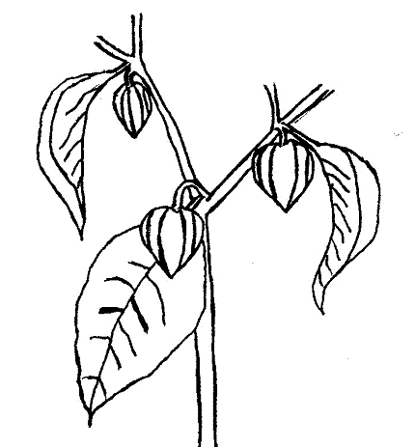
(d) Characteristics which should be examined at physiological maturity
(see Ad. 48). For fruit observations, take at least one of the first three nodes (see Fig. 1).

Figure 1. First three nodes of a plant.

8.2 Explanations for individual characteristics

Ad. 1: Seedling: anthocyanin coloration of hypocotyl

This characteristic refers to the plant immediately before the development of the first true leaf.

Ad. 2: Plant: growth habit
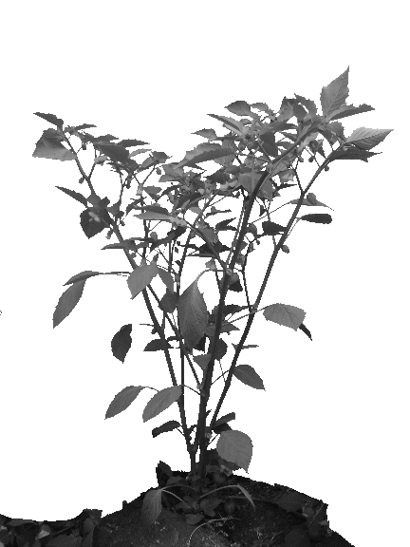
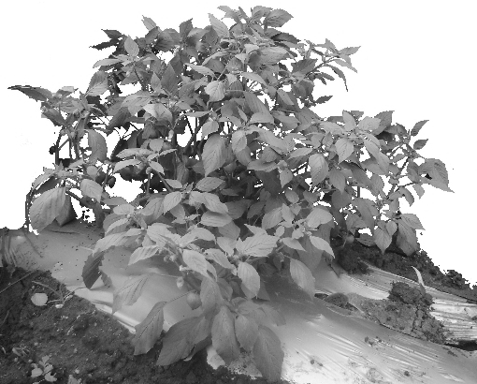
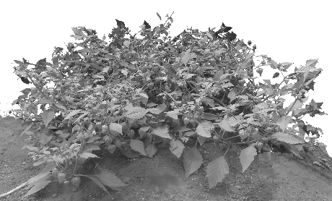
3
semi-upright
1
upright
5
prostrate

3 postrate

Ad. 8: Leaf blade: shape

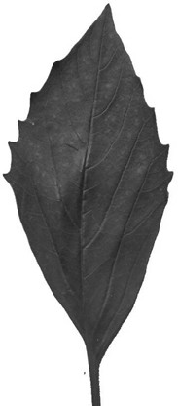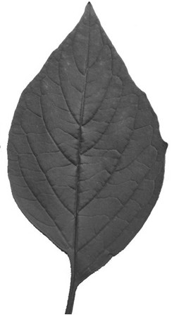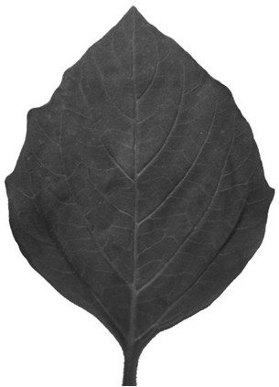
1
narrow elliptic
2
medium elliptic
3
broad elliptic

Ad. 11: Leaf blade: dentation of margin

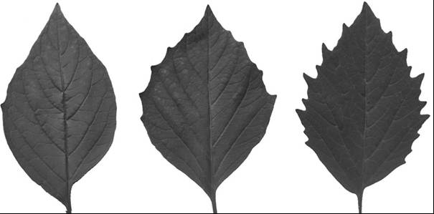
1
absent or weak
2
medium
3
strong

Ad. 14: Petiole: attitude

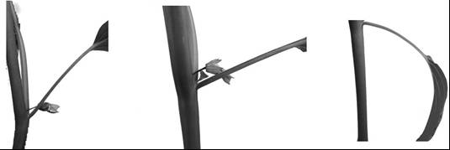
1
semi-erect
2
intermediate
3
drooping

Ad. 20: Fruit: length
Ad. 21: Fruit: diameter
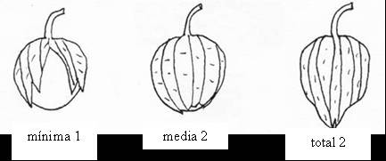
Fruit length

Fruit diameter

Ad. 23: Fruit: shape in longitudinal section
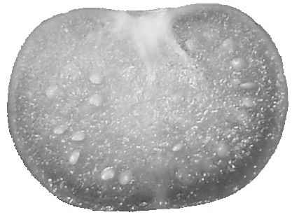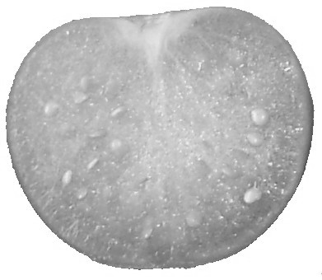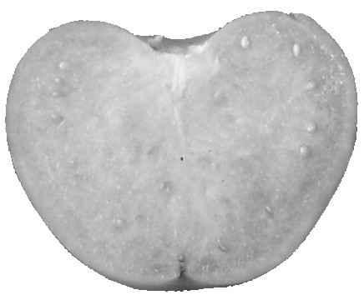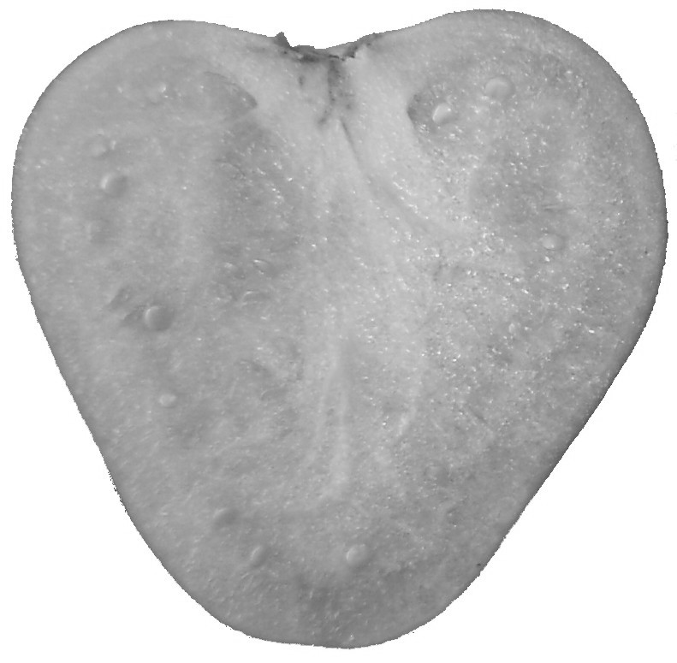
1
oblate
2
circular
3
cordate
4
triangular

Ad. 24: Fruit: shape in cross section
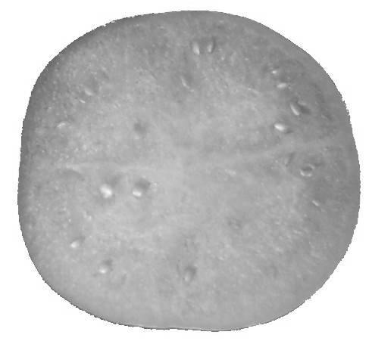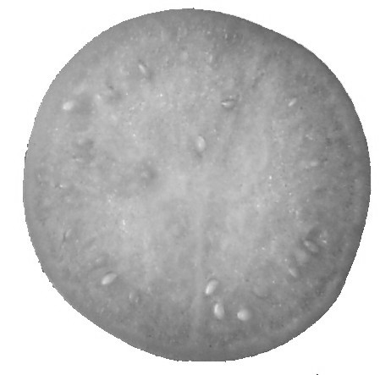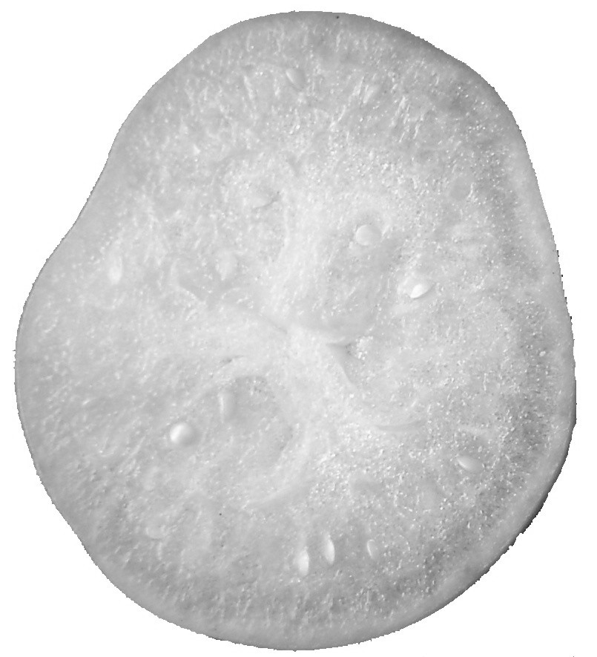
1
elliptic
2
circular
3
angular

Ad. 25: Fruit: depth of stalk cavity

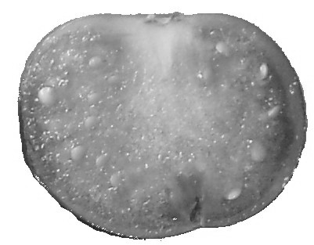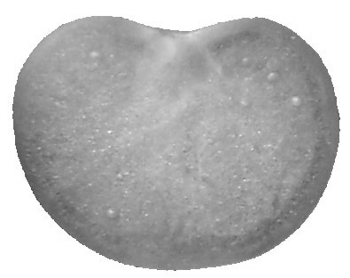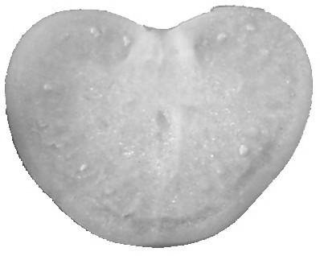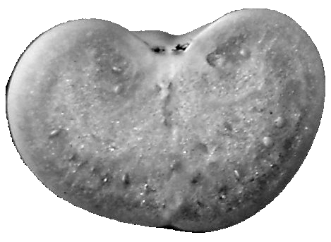
1
absent or very shallow
3
shallow
5
medium
7
deep

Ad. 26: Fruit: shape of apex

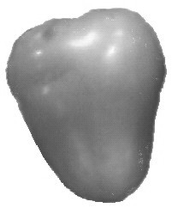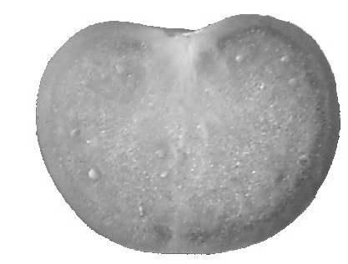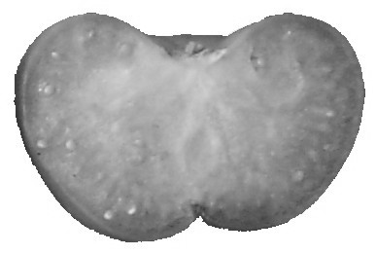
1
pointed
2
rounded
3
depressed

Ad. 28: Fruit: intensity of main color (at harvest maturity)

The intensity of color in each example variety of characteristic 27 should be considered as the intermediate state of expression for each color.

Ad. 30: Fruit: intensity of main color (at physiological maturity)

The intensity of color in each example variety of characteristic 29 should be considered as the intermediate state of expression for each color.

Ad. 34: Fruit: enclosure of calyx

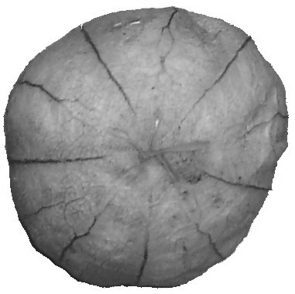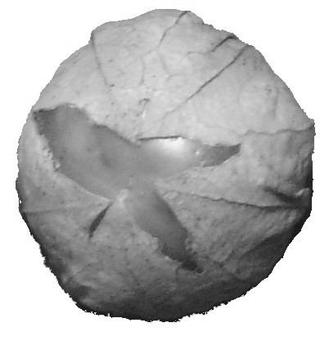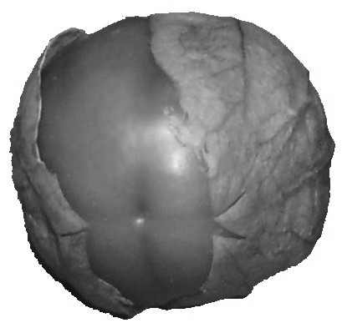
1
fully enclosed
2
slightly open
3
widely open

Ad. 36: Calyx: ribbing

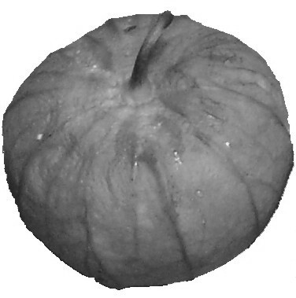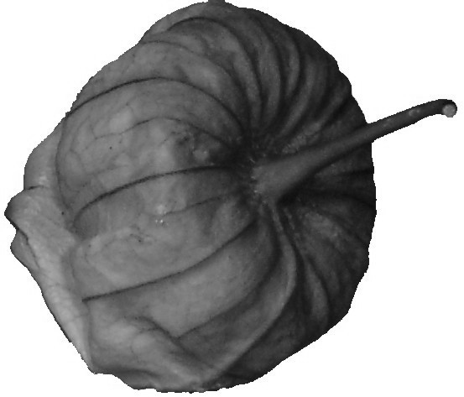
1
absent
9
present

Ad. 41: Fruit: firmness

This characteristic should be evaluated by comparing and contrasting the firmness of the candidate variety against the example varieties, using the index finger and the thumb.

Ad. 42: Fruit: density of flesh (ratio weight/volume)

This characteristic should be evaluated by weighing three 10-fruit samples from each replication and measuring their volume by water displacement. The ratio weight/volume is calculated by division.

Ad. 46: Time of flowering

This is the time at which half of the plants have at least one open flower.

Ad. 47: Time of harvest maturity

The time of harvest maturity is when the fruit is fully developed.

Ad. 48: Time of physiological maturity

The time of physiological maturity is when the seed color changes from white to another color.

Ad. 49: Shelf life

The test begins at harvest maturity. One fruit from each plant in each replication and environment is harvested and the 10 fruits from each replication are put in a polyethylene bag. The bags need to be stored inside. The classification is done by comparing and contrasting the candidate variety against the example varieties, verifying the shelf-life of each variety.

Literature
Ayala P., J. P., A. Peña L., J. Mulato B., 1992: Caracterización de germoplasma de tomate de cáscara (Physalis ixocarpa Brot.) en Chapingo. México, MX, Revista Chapingo 79/80: 128-137.

Bukasov, S.M., 1963: Las plantas cultivadas de México, Guatemala y Colombia. IICA. Zona Andina. Publicación Miscelánea 20: 1-16.

D’Arci, W.G., 1979: The classification of the Solanaceae. In: Hawkes, J.G., Lester, R.N., Skeiding, A.D. (eds.). The biology and taxonomy of the Solanaceae. Academis Press. London, pp. 3-47.

Harris, J.G., Harris, M.W., 2000: Plant identification terminology: an illustrated glossary. 2nd edition. Spring Lake Publishing, 206 pp.

Hernández X., E. 1978: Exploración etnobotánica para la obtención de plasma germinal para México. In: T. Cervantes S. (ed.). Recursos genéticos disponibles a México. Sociedad Mexicana de Fitogenética, A.C. Chapingo, MX, pp. 3-12.

Hernández, F., 1946: Historia de las Plantas de la Nueva España. Instituto de Biología. UNAM. México. Tomo III. pp. 699-714.

López, M., Santiaguillo, J.F., Peña, A., Cuevas, J.A., Sahún, J., 1994: Evaluación de 60 colectas de tomate de cáscara (Physalis ixocarpa Brot.) en Chapingo, México. Revista Chapingo 77: 75-79.

Menzel, Y. M., 1951: The Cytotaxonomy and Genetics of Physalis. Proc. Am. Philos. Soc. 95(2): 132-183.

Montalvo H., L., 1998: Caracterización molecular y morfológica de tomate de cáscara. Tesis de Maestría en Ciencias en Horticultura. Universidad Autónoma Chapingo. Chapingo, MX, 111 pp.

Montes H., S., 1994. Etnobotánica del tomate de cáscara (Physalis philadelphica Lam.). Revista Geografía Agrícoa 20: 163-172.

Montes H., S., y Aguirre R., J.R., 1992: Tomate de cáscara (Physalis philadelphica). In: Hernández B., J.E., León, J. (eds.). Cultivos marginales: otra perspectiva. FAO-ONU. Roma, IT, pp. 115-120.

Moreno, N. P., 1984: Glosario botánico ilustrado. CECSA. 300 pp.

Pandey, K.K., 1957: Genetics of self incompatibility in Physalis ixocarpa Brot: a new system. Am. J. Bot. 44: 879-887.

Patil, S.R., 1967: Accessory chromosomes in Physalis ixocarpa. Department of Biology. University of Colorado. Boulder, Colorado, US, Experientia 23(10): 862.

Peña L., A., Santiaguillo J.F., H, 1999: Variabilidad genética de tomate de cáscara en México. Boletín Técnico #2. Departamento de Fitotecnia. Universidad Autónoma Chapingo. Chapingo, MX, 26 pp.
Peña L., A., Ponce J.J., V., Sánchez F., C., Montalvo D., H., 2005: Evaluación de variedades de tomate de cáscara (Physalis ixocarpa Brot.) en invernadero y campo abierto. Revista Chapingo Serie Horticultura (Enviado).

Santiaguillo H., J.F., Peña A., L., Montalvo D., H., 2000: El cultivo del tomate milpero en Villa Purificación, Jal. Boletín Técnico #3. Departamento de Fitotecnia. Universidad Autónoma Chapingo. Chapingo, MX, 31 pp.

Santiaguillo H., J.F., López R., M., Peña A., L., Cuevas J.A., S., Sahún J., C., 1994: Distribución, colecta y conservación de germoplasma de tomate de cáscara (Physalis ixocarpa Brot.). Revista Chapingo Serie Horticultura, 2: 125-129.

Vargas P., O., Martínez M., D., Dávila P., A., 2003: La familia Solanaceae en Jalisco – el género Physalis. Universidad de Guadalajara. Guadalajara, Jal., MX, 127 pp.

Waterfall, V.T., 1967: Physalis in Mexico, Central America and the West Indies. Am. J. Bot. 69(778): 83-130.

Technical Questionnaire
TECHNICAL QUESTIONNAIRE |  |  |  | Page {x} of {y} |  | Reference Number:
 |  |  |  |  |  | Application date:
 |  |  |  |  |  | (not to be filled in by the applicant)
TECHNICAL QUESTIONNAIRE
to be completed in connection with an application for plant breeders’ rights

1. Subject of the Technical Questionnaire
1.1 Botanical name |  |  | Physalis ixocarpa Brot.
1.2 Common Name |  |  | Husk Tomato
2. Applicant
Name
Address
Telephone No.
Fax No.
E-mail address
Breeder (if different from applicant)
3. Proposed denomination and breeder’s reference
Proposed denomination
(if available)

Breeder’s reference
#4. Information on the breeding scheme and propagation of the variety

4.1 Breeding scheme

Variety resulting from:

4.1.1 Crossing

(a) controlled cross [ ]
(please state parent varieties)
(b) partially known cross [ ]
(please state known parent variety(ies))
(c) unknown cross [ ]

4.1.2 Mutation [ ]
(please state parent variety)

4.1.3 Discovery and development [ ]
(please state where and when discovered and
how developed)

4.1.4 Other [ ]
(please provide details)

4.2 Method of propagating the variety

4.2.1 Seed-propagated varieties

(a) Self-pollination [ ]
(b) Cross-pollination [ ]
(c) Hybrid [ ]
(d) Other [ ]
(please provide details)

4.2.2 Other [ ]
(please provide details)

5. Characteristics of the variety to be indicated (the number in brackets refers to the corresponding characteristic in Test Guidelines; please mark the note which best corresponds).

 | Characteristics |  |  |  |  |  | Example Varieties |  |  | Note
5.1  (2) | Plant: growth habit
 | upright |  |  |  |  |  | Tamazula SM3 |  |  | 1[ ]
 | semi-upright |  |  |  |  |  | Diamante |  |  | 3[ ]
 | prostrate |  |  |  |  |  | Milpero Tetela |  |  | 5[ ]
5.2  (4) | Stem: length of internodes
 | short |  |  |  |  |  | Salamanca |  |  | 3[ ]
 | medium |  |  |  |  |  | Diamante |  |  | 5[ ]
 | long |  |  |  |  |  | Tecozautla 04 |  |  | 7[ ]
5.3  (5) | Stem: anthocyanin coloration of internodes
 | absent |  |  |  |  |  | Rendidora Precoz |  |  | 1[ ]
 | present |  |  |  |  |  | Morada R |  |  | 9[ ]
5.4  (19) | Fruit: size
 | small |  |  |  |  |  | Milpero Tetela |  |  | 3[ ]
 | medium |  |  |  |  |  | Tamazula SM3 |  |  | 5[ ]
 | large |  |  |  |  |  | Diamante |  |  | 7[ ]
 | very large |  |  |  |  |  | Tecozautla 04 |  |  | 9[ ]
5.5  (27) | Fruit: main color (at harvest maturity)
 | white |  |  |  |  |  | Mutante |  |  | 1[ ]
 | green |  |  |  |  |  | Rendidora Precoz |  |  | 2[ ]
 | yellow |  |  |  |  |  | Manzano Tepetlixpa |  |  | 3[ ]
 | orange |  |  |  |  |  | Yema de Huevo |  |  | 4[ ]
 | purple |  |  |  |  |  | Tamazula SM3 |  |  | 5[ ]
 | Characteristics |  |  |  |  |  | Example Varieties |  |  | Note
5.6  (37) | Calyx: anthocyanin coloration
 | absent |  |  |  |  |  | CHF1 Chapingo |  |  | 1[ ]
 | present |  |  |  |  |  | Tamazula SM3 |  |  | 9[ ]
5.7  (38) | Calyx: intensity of anthocyanin coloration
 | very weak |  |  |  |  |  |  |  |  | 1[ ]
 | weak |  |  |  |  |  | Manzano Tepetlixpa |  |  | 3[ ]
 | medium |  |  |  |  |  | Salamanca |  |  | 5[ ]
 | strong |  |  |  |  |  | Morada R |  |  | 7[ ]
 | very strong |  |  |  |  |  | Tamazula SM3 |  |  | 9[ ]
5.8  (39) | Peduncle: length
 | short |  |  |  |  |  | Milpero Tetela |  |  | 3[ ]
 | medium |  |  |  |  |  | Diamante |  |  | 5[ ]
 | long |  |  |  |  |  | Puebla SM3 |  |  | 7[ ]
5.9  (40) | Peduncle: thickness at fruit end
 | thin |  |  |  |  |  | Milpero Tetela |  |  | 3[ ]
 | medium |  |  |  |  |  | Diamante |  |  | 5[ ]
 | thick |  |  |  |  |  | Tecozantla 04 |  |  | 7[ ]
5.10  (43) | Fruit: number of seeds
 | few |  |  |  |  |  | Milpero Tetela |  |  | 3[ ]
 | medium |  |  |  |  |  | Manzano Tepetlixpa |  |  | 5[ ]
 | many |  |  |  |  |  | Puebla SM3 |  |  | 7[ ]
6. Similar varieties and differences from these varieties

Please use the following table and box for comments to provide information on how your candidate variety differs from the variety (or varieties) which, to the best of your knowledge, is (or are) most similar. This information may help the examination authority to conduct its examination of distinctness in a more efficient way.

Denomination(s) of variety(ies) similar to your candidate variety |  | Characteristic(s) in which your candidate variety differs from the similar variety(ies) |  |  | Describe the expression of the characteristic(s) for the similar variety(ies) |  |  | Describe the expression of the characteristic(s) for your candidate variety
Example |  | Fruit: main color (at physiological maturity) |  |  | yellow |  |  | orange
Comments:

#7. Additional information which may help in the examination of the variety

7.1 In addition to the information provided in sections 5 and 6, are there any additional characteristics which may help to distinguish the variety?

Yes [ ] No [ ]

(If yes, please provide details)

7.2 Are there any special conditions for growing the variety or conducting the examination?

Yes [ ] No [ ]

(If yes, please provide details)

7.3 Other information

A representative color photograph of the fruit of the variety should accompany the Technical Questionnaire.

8. Authorization for release

(a) Does the variety require prior authorization for release under legislation concerning the protection of the environment, human and animal health?

Yes [ ] No [ ]

(b) Has such authorization been obtained?

Yes [ ] No [ ]

If the answer to (b) is yes, please attach a copy of the authorization.

9. Information on plant material to be examined or submitted for examination.

9.1 The expression of a characteristic or several characteristics of a variety may be affected by factors, such as pests and disease, chemical treatment (e.g. growth retardants or pesticides), effects of tissue culture, different rootstocks, scions taken from different growth phases of a tree, etc.

9.2 The plant material should not have undergone any treatment which would affect the expression of the characteristics of the variety, unless the competent authorities allow or request such treatment. If the plant material has undergone such treatment, full details of the treatment must be given. In this respect, please indicate below, to the best of your knowledge, if the plant material to be examined has been subjected to:

(a) Microorganisms (e.g. virus, bacteria, phytoplasma) Yes [ ] No [ ]

(b) Chemical treatment (e.g. growth retardant, pesticide) Yes [ ] No [ ]

(c) Tissue culture Yes [ ] No [ ]

(d) Other factors Yes [ ] No [ ]

Please provide details of where you have indicated “yes”.

……………………………………………………………

10. I hereby declare that, to the best of my knowledge, the information provided in this form is correct:

Applicant’s name

Signature Date

[End of document]

* These names were correct at the time of the introduction of these Test Guidelines but may be revised or updated. [Readers are advised to consult the UPOV Code, which can be found on the UPOV Website (www.upov.int), for the latest information.]
# Authorities may allow certain of this information to be provided in a confidential section of the Technical Questionnaire.
# Authorities may allow certain of this information to be provided in a confidential section of the Technical Questionnaire.

