 |  | E  TG/234/1  ORIGINAL: English  DATE: 2007-03-28
INTERNATIONAL UNION FOR THE PROTECTION OF NEW VARIETIES OF PLANTS
GENEVA

 | BUTTERNUT, BUTTERNUT SQUASH, CHEESE PUMPKIN,  CHINA SQUASH, CUSHAW, GOLDEN CUSHAW,  MUSKY GOURD, PUMPKIN, WINTER CROOKNECK SQUASH  UPOV Code: CUCUR_MOS  Cucurbita moschata Duch. | *

GUIDELINES

FOR THE CONDUCT OF TESTS

FOR DISTINCTNESS, UNIFORMITY AND STABILITY

Alternative Names:*
Botanical name | English | French | German | Spanish
Cucurbita moschata Duch. | Butternut, Butternut Squash, Cheese Pumpkin,  China Squash, Cushaw, Golden Cushaw,  Musky Gourd, Pumpkin, Winter Crookneck Squash | Citrouille, Courge musquée, Courge noix de beurre | Moschuskürbis, Bisamkürbis | Ayote,  Calabaza de Castilla, Calabaza moscada, Calabaza pellejo, Chicamita, Lacayote, Sequaloa, Zapallo

The purpose of these guidelines (“Test Guidelines”) is to elaborate the principles contained in the General Introduction (document TG/1/3), and its associated TGP documents, into detailed practical guidance for the harmonized examination of distinctness, uniformity and stability (DUS) and, in particular, to identify appropriate characteristics for the examination of DUS and production of harmonized variety descriptions.

ASSOCIATED DOCUMENTS

These Test Guidelines should be read in conjunction with the General Introduction and its associated TGP documents.

Other associated UPOV documents: TG/155: Cucurbita maxima Duch. / Pumpkin / Giraumon, Potiron / Riesenkürbis / Calabaza, Zapallo
TG/119: Cucurbita pepo L. / Vegetable Marrow, Squash / Courgette / Gartenkürbis, Zucchini / Calabacín
TABLE OF CONTENTS PAGE

1. Subject of these Test Guidelines 3
2. Material Required 3
3. Method of Examination 3
3.1 Number of Growing Cycles 3
3.2 Testing Place 3
3.3 Conditions for Conducting the Examination 3
3.4 Test Design 4
3.5 Number of Plants / Parts of Plants to be Examined 4
3.6 Additional Tests 4
4. Assessment of Distinctness, Uniformity and Stability 4
4.1 Distinctness 4
4.2 Uniformity 5
4.3 Stability 5
5. Grouping of Varieties and Organization of the Growing Trial 5
6. Introduction to the Table of Characteristics 6
6.1 Categories of Characteristics 6
6.2 States of Expression and Corresponding Notes 6
6.3 Types of Expression 6
6.4 Example Varieties 6
6.5 Legend 7
7. Table of Characteristics/Tableau des caractères/Merkmalstabelle/Tabla de caracteres 8
8. Explanations on the Table of Characteristics 16
8.1 Explanations covering several characteristics 16
8.2 Explanations for individual characteristics 16
8.3 Synonyms of example varieties 18
9. Literature 19
10. Technical Questionnaire 20

Subject of these Test Guidelines
These Test Guidelines apply to all varieties of Cucurbita moschata Duch.

Material Required
2.1 The competent authorities decide on the quantity and quality of the plant material required for testing the variety and when and where it is to be delivered. Applicants submitting material from a State other than that in which the testing takes place must ensure that all customs formalities and phytosanitary requirements are complied with.

2.2 The material is to be supplied in the form of seed.

2.3 The minimum quantity of plant material, to be supplied by the applicant, should be:

200 g or 1,500 seeds.

The seed should meet the minimum requirements for germination, species and analytical purity, health and moisture content, specified by the competent authority. In cases where the seed is to be stored, the germination capacity should be as high as possible and should be stated by the applicant.

2.4 The plant material supplied should be visibly healthy, not lacking in vigor, nor affected by any important pest or disease.

2.5 The plant material should not have undergone any treatment which would affect the expression of the characteristics of the variety, unless the competent authorities allow or request such treatment. If it has been treated, full details of the treatment must be given.

Method of Examination

3.1 Number of Growing Cycles
The minimum duration of tests should normally be two independent growing cycles.

3.2 Testing Place
Tests are normally conducted at one place. In the case of tests conducted at more than one place, guidance is provided in TGP/9 “Examining Distinctness”.

3.3 Conditions for Conducting the Examination
3.3.1 The tests should be carried out under conditions ensuring satisfactory growth for the expression of the relevant characteristics of the variety and for the conduct of the examination.
3.3.2 The recommended method of observing the characteristic is indicated by the following key in the second column of the Table of Characteristics:

MG: single measurement of a group of plants or parts of plants
MS: measurement of a number of individual plants or parts of plants
VG: visual assessment by a single observation of a group of plants or parts of plants
VS: visual assessment by observation of individual plants or parts of plants

3.4 Test Design
3.4.1 Each test should be designed to result in a total of at least 20 plants, which should be divided between two or more replicates.

3.4.2 The design of the tests should be such that plants or parts of plants may be removed for measurement or counting without prejudice to the observations which must be made up to the end of the growing cycle.

3.5 Number of Plants / Parts of Plants to be Examined
Unless otherwise indicated, all observations on single plants should be made on 10 plants or parts taken from each of 10 plants and any other observations made on all plants in the test.

3.6 Additional Tests
Additional tests, for examining relevant characteristics, may be established.

Assessment of Distinctness, Uniformity and Stability

4.1 Distinctness

4.1.1 General Recommendations

It is of particular importance for users of these Test Guidelines to consult the General Introduction prior to making decisions regarding distinctness. However, the following points are provided for elaboration or emphasis in these Test Guidelines.

4.1.2 Consistent Differences

The differences observed between varieties may be so clear that more than one growing cycle is not necessary. In addition, in some circumstances, the influence of the environment is not such that more than a single growing cycle is required to provide assurance that the differences observed between varieties are sufficiently consistent. One means of ensuring that a difference in a characteristic, observed in a growing trial, is sufficiently consistent is to examine the characteristic in at least two independent growing cycles.
4.1.3 Clear Differences

Determining whether a difference between two varieties is clear depends on many factors, and should consider, in particular, the type of expression of the characteristic being examined, i.e. whether it is expressed in a qualitative, quantitative, or pseudo-qualitative manner. Therefore, it is important that users of these Test Guidelines are familiar with the recommendations contained in the General Introduction prior to making decisions regarding distinctness.

4.2 Uniformity
4.2.1 It is of particular importance for users of these Test Guidelines to consult the General Introduction prior to making decisions regarding uniformity. However, the following points are provided for elaboration or emphasis in these Test Guidelines:

4.2.2 The assessment of uniformity for cross-pollinated varieties should be according to the recommendations for cross-pollinated varieties in the General Introduction.

4.2.3 For the assessment of uniformity of hybrid varieties and inbred lines, a population standard of 1% and an acceptance probability of at least 95% should be applied. In the case of a sample size of 20 plants, 1 off-type is allowed.

4.3 Stability
4.3.1 In practice, it is not usual to perform tests of stability that produce results as certain as those of the testing of distinctness and uniformity. However, experience has demonstrated that, for many types of variety, when a variety has been shown to be uniform, it can also be considered to be stable.

4.3.2 Where appropriate, or in cases of doubt, stability may be tested, either by growing a further generation, or by testing a new seed stock to ensure that it exhibits the same characteristics as those shown by the previous material supplied.

Grouping of Varieties and Organization of the Growing Trial
5.1 The selection of varieties of common knowledge to be grown in the trial with the candidate varieties and the way in which these varieties are divided into groups to facilitate the assessment of distinctness are aided by the use of grouping characteristics.

5.2 Grouping characteristics are those in which the documented states of expression, even where produced at different locations, can be used, either individually or in combination with other such characteristics: (a) to select varieties of common knowledge that can be excluded from the growing trial used for examination of distinctness; and (b) to organize the growing trial so that similar varieties are grouped together.

5.3 The following have been agreed as useful grouping characteristics:

(a) Plant: length of main stem (characteristic 2)
(b) Fruit: length (characteristic 14)
(c) Fruit: diameter (characteristic 15)
(d) Fruit: shape in longitudinal section (characteristic 18)
(e) Fruit: grooves (characteristic 24)
(f) Fruit: main color of skin (characteristic 28)
(g) Fruit: warts (characteristic 31)

5.4 Guidance for the use of grouping characteristics, in the process of examining distinctness, is provided through the General Introduction.

Introduction to the Table of Characteristics

6.1 Categories of Characteristics
6.1.1 Standard Test Guidelines Characteristics

Standard Test Guidelines characteristics are those which are approved by UPOV for examination of DUS and from which members of the Union can select those suitable for their particular circumstances.

6.1.2 Asterisked Characteristics

Asterisked characteristics (denoted by *) are those included in the Test Guidelines which are important for the international harmonization of variety descriptions and should always be examined for DUS and included in the variety description by all members of the Union, except when the state of expression of a preceding characteristic or regional environmental conditions render this inappropriate.

6.2 States of Expression and Corresponding Notes
States of expression are given for each characteristic to define the characteristic and to harmonize descriptions. Each state of expression is allocated a corresponding numerical note for ease of recording of data and for the production and exchange of the description.

6.3 Types of Expression
An explanation of the types of expression of characteristics (qualitative, quantitative and pseudo-qualitative) is provided in the General Introduction.

6.4 Example Varieties
Where appropriate, example varieties are provided to clarify the states of expression of each characteristic. A table of synonyms of example varieties is provided in Chapter 8.3.

6.5 Legend
(*) Asterisked characteristic – see Chapter 6.1.2

QL: Qualitative characteristic – see Chapter 6.3
QN: Quantitative characteristic – see Chapter 6.3
PQ: Pseudo-qualitative characteristic – see Chapter 6.3

MG, MS, VG, VS: See Chapter 3.3.2

(a)-(c) See Explanations on the Table of Characteristics in Chapter 8.1

(+) See Explanations on the Table of Characteristics in Chapter 8.2

Table of Characteristics/Tableau des caractères/Merkmalstabelle/Tabla de caracteres
 |  | English | français | Deutsch | español | Example Varieties/  Exemples/  Beispielssorten/  Variedades ejemplo | Note/  Nota
1. | VG | Cotyledon: ratio width/length | Cotyledon : rapport largeur/longueur | Keimblatt: Verhältnis Breite/Länge | Cotiledón: relación anchura/longitud
QN |  | small | petit | klein | pequeña | Carre, Waltham | 3
 |  | medium | moyen | mittel | media | Sunset, Zenith | 5
 |  | large | grand | groß | grande |  | 7
2.  (*) | VG | Plant: length of main stem | Plante: longueur de la tige principale | Pflanze: Länge des Haupttriebs | Planta: longitud del tallo principal
QN | (a) | short | courte | kurz | corta |  | 3
 |  | medium | moyenne | mittel | media | Butterbush | 5
 |  | long | longue | lang | larga | Ponca, Nippon, Nugget, Sunset | 7
3. | VG | Leaf blade: size | Limbe: taille | Blattspreite: Größe | Limbo: tamaño
QN | (a) | small | petit | klein | pequeño | Futsu Kurokawa | 3
 |  | medium | moyen | mittel | medio | Muscade | 5
 |  | large | grand | groß | grande |  | 7
4.  (*)  (+) | VG | Leaf blade: margin | Limbe : bord | Blattspreite: Rand | Limbo: margen
QN | (a) | entire or very weakly incised | entier ou très faiblement incisé | ganzrandig oder sehr gering eingeschnitten | incisiones nulas o muy leves | Ponca | 1
 |  | weakly incised | faiblement incisé | gering eingeschnitten | incisiones leves | Longue de Nice | 2
 |  | moderately or strongly incised | moyennement ou fortement incisé | mäßig oder stark eingeschnitten | incisiones moderadas o profundas |  | 3
5. | VG | Leaf blade: intensity of green color of upper side | Limbe: intensité de la couleur verte de la face supérieure | Blattspreite: Intensität der Grünfärbung der Oberseite | Limbo: intensidad del color verde de la cara superior
QN | (a) | light | faible | hell | clara | Ponca | 3
 |  | medium | moyenne | mittel | media | Longue de Nice | 5
 |  | dark | forte | dunkel | oscura | Futsu Kurokawa | 7
6. | VG | Leaf blade: silver patches | Limbe: taches argentées | Blattspreite: Silberflecken | Limbo: manchas plateadas
QL | (a) | absent | absentes | fehlend | ausentes | Ponca | 1
 |  | present | présentes | vorhanden | presentes | Longue de Nice | 9
7. | VG | Petiole: length | Pétiole: longueur | Blattstiel: Länge | Pecíolo: longitud
QN |  | short | court | kurz | corta | Futsu Kurokawa | 3
 | (a) | medium | moyen | mittel | media | Ponca | 5
 |  | long | long | lang | larga | Longue de Nice | 7
8. | VG | Petiole: diameter | Pétiole: diamètre | Blattstiel: Durchmesser | Pecíolo: diámetro
QN | (a) | small | petit | klein | pequeño | Futsu Kurokawa | 3
 |  | medium | moyen | mittel | medio | Longue de Nice | 5
 |  | large | grand | groß | grande |  | 7
9. | VG | Female flower: length of sepal | Fleur femelle: longueur du sépale | Weibliche Blüte: Länge des Kelchblattes | Flor femenina: longitud del sépalo
QN |  | short | court | kurz | corto |  | 3
 |  | medium | moyen | mittel | medio | Sucrine du Berry | 5
 |  | long | long | lang | largo | Longue de Nice | 7
10. | VG | Male flower: length of sepal | Fleur mâle: longueur du sépale | Männliche Blüte: Länge des Kelchblattes | Flor masculina: longitud del sépalo
QN |  | short | court | kurz | corto | Futsu Kurokawa | 3
 |  | medium | moyen | mittel | medio | Sucrine du Berry | 5
 |  | long | long | lang | largo | Longue de Nice | 7
 |  | very long | très long | sehr lang | muy largo | Pleine de Naples | 9
11. | VG | Peduncle: length | Pédoncule: longueur | Blütenstiel: Länge | Pedúnculo: longitud
QN | (b) | short | court | kurz | corto | Ponca | 3
 |  | medium | moyen | mittel | medio | Futsu Kurokawa, Longue de Nice | 5
 |  | long | long | lang | largo |  | 7
12. | VG | Peduncle: diameter | Pédoncule: diamètre | Blütenstiel: Durchmesser | Pedúnculo: diámetro
QN | (b) | small | petit | klein | pequeño | Futsu Kurokawa | 3
 |  | medium | moyen | mittel | medio | Longue de Nice | 5
 |  | large | grand | groß | grande | Muscade | 7
13.  (*) | VG | Fruit: intensity of green color of skin | Fruit: intensité de la couleur verte de l’épiderme | Frucht: Intensität der Grünfärbung der Schale | Fruto: intensidad del color verde de la epidermis
QN | (b) | very light | très faible | sehr hell | muy claro |  | 1
 |  | light | faible | hell | claro | Ponca, Tancheese | 3
 |  | medium | moyenne | mittel | medio |  | 5
 |  | dark | foncée | dunkel | oscuro | Futsu Kurokawa | 7
14.  (*) | MG / VG | Fruit: length | Fruit: longueur | Frucht: Länge | Fruto: longitud
QN | (b) | very short | très court | sehr kurz | muy corto |  | 1
 |  | short | court | kurz | corto | Ponca | 3
 |  | medium | moyen | mittel | medio | Muscade | 5
 |  | long | long | lang | largo | Aegean Gold | 7
 |  | very long | très long | sehr lang | muy largo | Longue de Nice,  Trombolino d’Albenga | 9
15.  (*)  (+) | MG / VG | Fruit: diameter | Fruit: diamètre maximal | Frucht: Durchmesser | Fruto: diámetro
QN | (b) | small | petit | klein | pequeño | Ponca | 3
 |  | medium | moyen | mittel | medio | Pleine de Naples | 5
 |  | large | grand | groß | grande | Muscade | 7
16. | MG / VG | Fruit: ratio length/ diameter | Fruit: rapport longueur / diamètre maximal | Frucht: Verhältnis Länge/Durchmesser | Fruto: relación longitud/diámetro
QN | (b) | very small | très petit | sehr klein | muy pequeña | Muscade | 1
 |  | small | petit | klein | pequeña | Futsu Kurokawa | 3
 |  | medium | moyen | mittel | media |  | 5
 |  | large | grand | groß | grande | Ponca | 7
 |  | very large | très grand | sehr groß | muy grande | Longue de Nice | 9
17. (*) | VG | Fruit: position of broadest part | Fruit: position du diamètre maximum | Frucht: Position der breitesten Stelle | Fruto: posición del diámetro máximo
QN | (b) | toward stem end | du coté de la tige | zum Stielende hin | hacia la base |  | 1
 |  | at middle | au milieu | in der Mitte | en el medio | Muscade | 2
 |  | toward blossom end | du coté de l’apex | zum apikalen Teil hin | hacia el ápice | Longue de Nice | 3
18.  (*)  (+) | VG | Fruit: shape in longitudinal section | Fruit: forme en section longitudinale | Frucht: Form im Längsschnitt | Fruto: forma en sección longitudinal
PQ | (b) | transverse broad elliptic | elliptique transversale large | quer breit elliptisch | elíptica transversal ancha | Muscade | 1
 |  | transverse medium elliptic | elliptique transversale moyenne | mittel querelliptisch | elíptica transversal media | Tancheese, Nippon | 2
 |  | round | arrondi | rund | redonda | Buckskin | 3
 |  | ovate | ovoïde | eiförmig | oval |  | 4
 |  | quadrangular | quadrangulaire | viereckig | cuadrangular | Hayato | 5
 |  | trapezoidal | trapézoïde | trapezförmig | trapezoidal | Fagtoong | 6
 |  | pear shaped | piriforme | birnenförmig | periforme | Sucrine du Berry, Nugget | 7
 |  | club shaped | en massue | keulenförmig | claviforme | Longue de Nice, Trombolino d’Albenga | 8
 |  | cylindrical | cylindrique | zylindrisch | cilíndrica | Ponca | 9
19.  (*) | VG | Fruit: presence of neck | Fruit : présence de col | Frucht: Vorhandensein des Halses | Fruto: presencia de cuello
QN | (b) | absent or very weak | absent ou très faible | fehlend oder sehr gering | ausente o muy débil | Futsu Kurokawa, Sucrine du Berry | 1
 |  | weak | faible | gering | débil | Ultra butternut | 2
 |  | medium or strong | moyen ou fort | mittel oder stark | medio o fuerte | Trombolino | 3
20. |  | Fruit: length of neck | Fruit : longueur du col | Frucht: Länge des Halses | Fruto: longitud del cuello
QN | (b) | short | court | kurz | corto | Sucrine du Berry | 3
 |  | medium | moyen | mittel | medio | Ultra Butternut | 5
 |  | long | long | lang | largo | Longue de Nice, Trombolino | 7
21.  (*)  (+) | VG | Fruit: curving (longitudinal axis) | Fruit : courbure (axe longitudinal) | Frucht: Krümmung (Längsachse) | Fruto: curvatura (eje longitudinal)
QN | (b) | absent or very weak | absente ou très faible | fehlend oder sehr gering | ausente o muy débil |  | 1
 |  | weak | faible | gering | débil | Ponca | 3
 |  | medium | moyenne | mittel | media | Longue de Nice | 5
 |  | strong | forte | stark | fuerte |  | 7
 |  | very strong | très forte | sehr stark | muy fuerte | Trombolino d’Albenga | 9
22.  (*) (+) | VG | Fruit: profile at stem end | Fruit : profil à la base | Frucht: Profil am Stielende | Fruto: perfil en la base
QN | (b) | raised | en relief | vorgewölbt | protuberante | Trombolino d’Albenda | 1
 |  | flat | plan | flach | plano | Sucrine du Berry | 2
 |  | slightly depressed | légèrement creux | leicht eingesenkt | ligeramente deprimido | Tancheese | 3
 |  | moderately depressed | modérément déprimé | mäßig eingesenkt | moderadamente deprimido | Futsu Kurokawa | 4
 |  | strongly depressed | très creux | stark eingesenkt | fuertemente deprimido | Muscade | 5
23.  (*)  (+) | VG | Fruit: profile at blossom end | Fruit : profil au sommet | Frucht: Profil am apikalen Teil | Fruto: perfil en el ápice
QN | (b) | depressed | déprimé | eingesenkt | deprimido | Muscade | 1
 |  | flat | plan | flach | plano | Sucrine du Berry | 2
 |  | raised | protubérant | vorgewölbt | elevado | Trombolino d’Albenga | 3
24.  (*) | VG | Fruit: grooves | Fruit: cannelures | Frucht: Furchen | Fruto: surcos
QL | (b) | absent | absentes | fehlend | ausentes | Sucrine du Berry | 1
 |  | présent | présentes | vorhanden | presentes | Muscade | 9
25. | VG | Fruit: distance between grooves | Fruit : distance entre les cannelures | Frucht: Abstand zwischen den Furchen | Fruto: distancia entre los surcos
QN | (b) | small | petite | klein | corta | Futsu Kurokawa | 3
 |  | medium | moyenne | mittel | media | Tancheese | 5
 |  | large | grande | groß | larga | Muscade | 7
26. | VG | Fruit: depth of grooves | Fruit: profondeur des cannelures | Frucht: Tiefe der Furchen | Fruto: profundidad de los surcos
QN | (b) | shallow | peu profondes | flach | poco profunda | Tancheese | 3
 |  | medium | moyennement profondes | mittel | media | Futsu Kurokawa | 5
 |  | deep | profondes | tief | profunda | Muscade | 7
27. | VG | Fruit: marbling | Fruit : marbrure | Frucht: Marmorierung | Fruto: jaspeado
QN | (b) | absent or very weak | absent ou très faible | fehlend oder sehr gering | ausente o muy débil |  | 1
 |  | weak | faible | gering | débil |  | 3
 |  | medium | moyenne | mittel | medio |  | 5
 |  | strong | forte | stark | fuerte | Ponca | 7
28.  (*) | VG | Fruit: main color of skin | Fruit: couleur principale de l’épiderme | Frucht: Hauptfarbe der Schale | Fruto: color principal de la epidermis
PQ | (c) | green | verte | grün | verde |  | 1
 |  | cream | crème | cremefarben | crema | Sunset | 2
 |  | yellow | jaune | gelb | amarillo | Aegean Gold | 3
 |  | orange brown | orange marron | orangebraun | marrón naranja | Muscade, Ponca | 4
 |  | brown | marron | braun | marrón | Hyuga 14 | 5
29. | VG | Fruit: intensity of main color of skin | Fruit: intensité de la couleur principale de l’épiderme | Frucht: Intensität der Hauptfarbe der Schale | Fruto: intensidad del color principal de la epidermis
QN | (c) | light | claire | hell | claro |  | 3
 |  | medium | moyenne | mittel | medio |  | 5
 |  | dark | foncée | dunkel | oscuro |  | 7
30. | VG | Fruit: waxiness of skin | Fruit: pruine de l’épiderme | Frucht: Wachsschicht der Schale | Fruto: pruina de la epidermis
QL | (c) | absent | absente | fehlend | ausente | Tancheese | 1
 |  | present | présente | vorhanden | presente | Futsu Kurokawa, Muscade | 9
31.  (*) | VG | Fruit: warts | Fruit: verrues | Frucht: Warzen | Fruto: verrugas
QL | (c) | absent | absentes | fehlend | ausentes | Ponca | 1
 |  | present | présentes | vorhanden | presentes | Futsu Kurokawa | 9
32.  (*) | VG | Fruit: main color of flesh | Fruit : couleur principale de la chair | Frucht: Hauptfarbe des Fleisches | Fruto: color principal de la pulpa
PQ | (c) | yellow | jaune | gelb | amarillo |  | 1
 |  | yellowish orange | orange jaunâtre | gelblich-orange | anaranjado amarillento | Futsu Kurokawa | 2
 |  | orange | orange | orange | naranja | Ponca, Tancheese | 3
33.  (+) | VG | Fruit: thickness of flesh (at level of seed cavity) | Fruit : épaisseur de la chair (au niveau de la loge carpellaire) | Frucht: Dicke des Fleisches (auf der Höhe der Samenhöhle) | Fruto: espesor de la pulpa (al nivel de la cavidad seminal)
QN | (c) | thin | fine | dünn | delgado | Trombolino d’Albenga | 3
 |  | medium | moyenne | mittel | medio | Longue de Nice | 5
 |  | thick | épaisse | dick | grueso | Muscade | 7
34. | VG | Fruit: diameter of flower scar | Fruit : diamètre de la cicatrice florale | Frucht: Durchmesser der Blütennarbe | Fruto: diámetro de la cicatriz floral
QN | (c) | small | petit | klein | pequeño | Trombolino d’Albenga | 3
 |  | medium | moyen | mittel | medio | Longue de Nice | 5
 |  | large | grand | groß | grande | Tancheese | 7
35. (*) | VG | Seed: length | Graine: longueur | Samen: Länge | Semilla: longitud
QN | (c) | short | courte | kurz | corta | Nugget, Futsu Kurokawa | 3
 |  | medium | moyenne | mittel | media | Waltham, Tancheese | 5
 |  | long | longue | lang | larga | Pleine de Naples | 7
36.  (+) | VG | Seed: ratio width/length | Graine: ratio largeur/longueur | Samen: Verhältnis Breite/Länge | Semilla: relación anchura/longitud
QN | (c) | small | petit | klein | pequeña |  | 3
 |  | medium | moyen | mittel | media |  | 5
 |  | large | grand | groß | grande |  | 7
37. | VG | Seed: color of coat | Graine : couleur du tégument | Samen: Farbe der Schale | Semilla: color del tegumento
PQ | (c) | cream | crème | cremefarben | crema | Ponca | 1
 |  | yellow | jaune | gelb | amarillo | Nippon, Nugget | 2
 |  | brown | marron | braun | marrón | Longue de Nice | 3
 |  | bluish grey | gris bleuâtre | bläulich-grau | gris azulado | Sunset | 4

Explanations on the Table of Characteristics

8.1 Explanations covering several characteristics
Characteristics containing the following key in the second column of the Table of Characteristics should be examined as indicated below:

(a) Observations on the leaf which should be made on fully developed leaves, when the first fruit is fully developed.

(b) Observations which should be made on fully developed fruits before physiological maturity.

(c) Observations which should be made on fruits at physiological maturity.

8.2 Explanations for individual characteristics

Ad. 4: Leaf blade: margin

 |  | 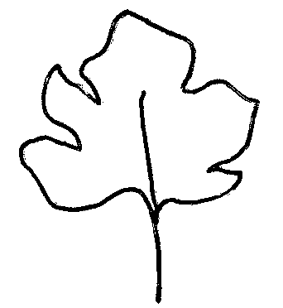
1 | 2 | 3
entire or very weakly incised | weakly incised | moderately or strongly incised

Ad. 15: Fruit: diameter

The diameter should be observed at the position of the broadest part.
Ad. 18: Fruit: shape in longitudinal section

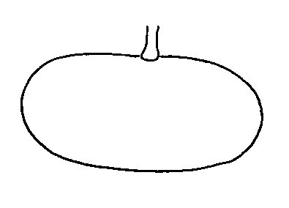 | 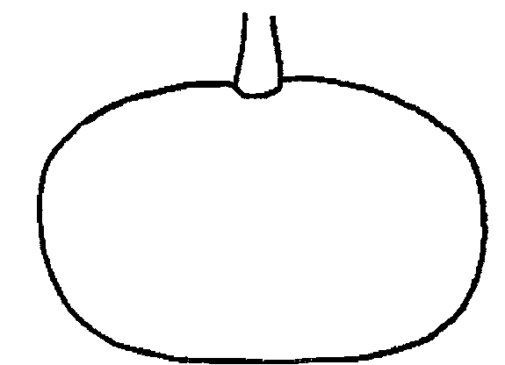 | 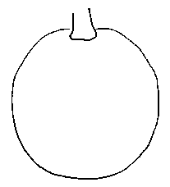 | 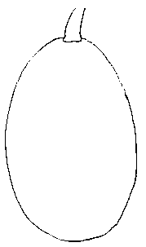
1 | 2 | 3 | 4
transverse broad elliptic | transverse medium elliptic | round | ovate

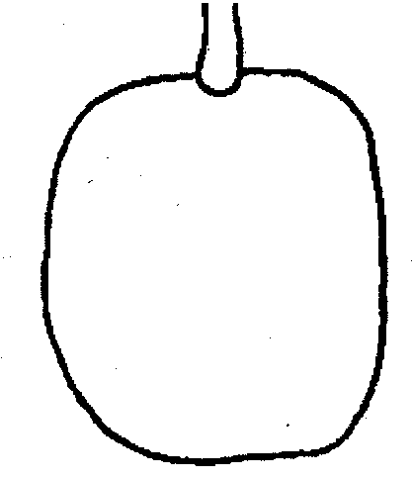 | 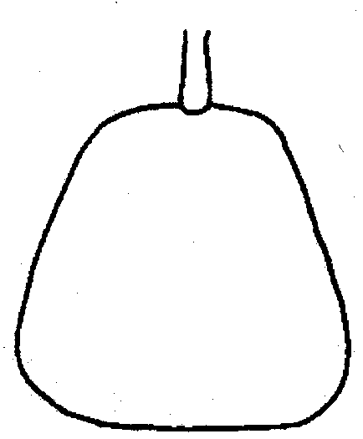 | 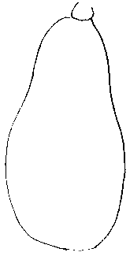 | 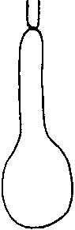 | 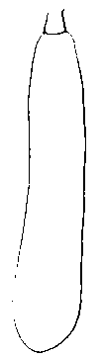
5 | 6 | 7 | 8 | 9
quadrangular | trapezoidal | pear shaped | club shaped | cylindrical

Ad. 21: Fruit: curving (longitudinal axis)

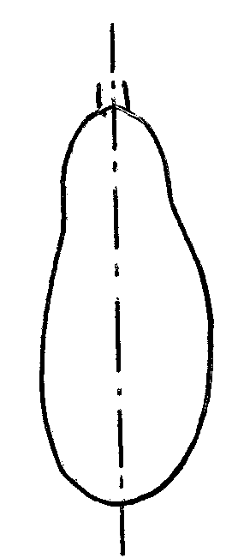 | 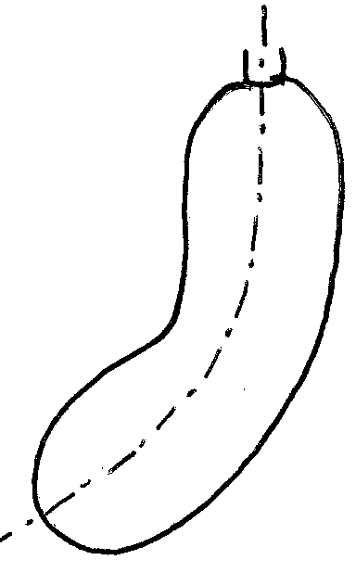 | 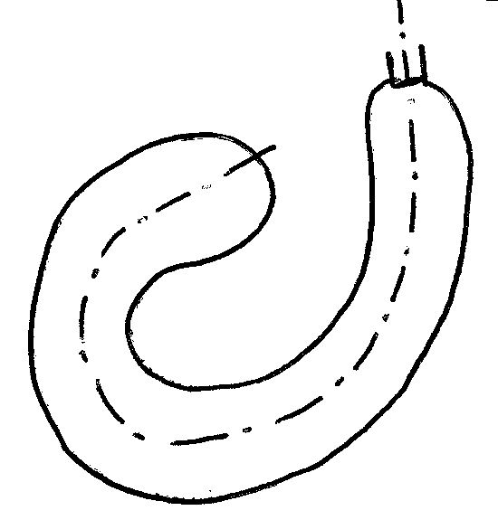
1 | 5 | 9
absent or very weak | medium | very strong

Ad. 22: Fruit: profile at stem end

 | 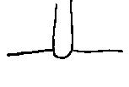 | 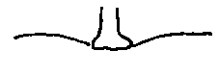 | 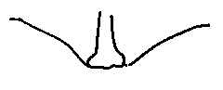 | 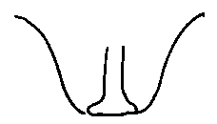
1 | 2 | 3 | 4 | 5
raised | flat | slightly depressed | moderately depressed | strongly depressed

Ad. 23: Fruit: profile at blossom end

 | 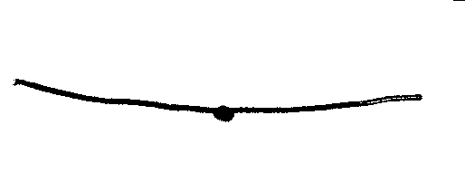 | 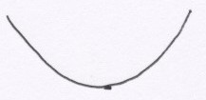
1 | 2 | 3
depressed | flat | raised

Ad. 33: Fruit thickness of flesh (at level of seed cavity)

Thickness should be measured at the widest part of the flesh, at the level of the seed cavity.
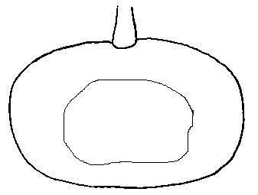 | 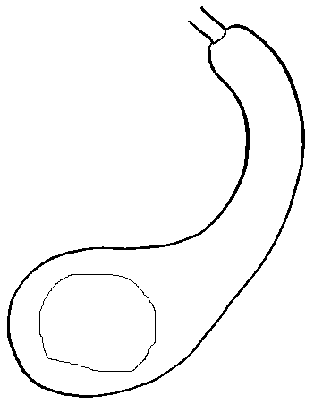

Ad. 36: Seed: ratio width / length

Ratio width / length |  | note
smaller than 0.5 | small | 3
close to 0.5 | medium | 5
higher than 0.5 | large | 7

8.3 Synonyms of example varieties
Example variety | Synonyms
Futsu Kurokawa | Futsu, Futsu black, Futsu black rinded

Literature
Brancucci, M., Bänziger, E., Das grosse Buch vom Kürbis. Midena & FONA Verlag GmbH, Aarau/Küttigen, Oldenburg, D, 173 pp.

Chaux, C., Foury, C., 1994: Productions légumières – Tome 3 Légumineuses Potagères Légumes fruits. Lavoisier TEC & DOC, Paris, FR, pp. 361-384.

Prades, J. B., Prades, N., Renaud, V., 1995: Le grand livre des Courges. Rustica Edition. Paris, FR, 183 pp.

Technical Questionnaire
TECHNICAL QUESTIONNAIRE |  |  |  | Page {x} of {y} |  |  | Reference Number:
 |  |  |  |  |  |  | Application date:
 |  |  |  |  |  |  | (not to be filled in by the applicant)
TECHNICAL QUESTIONNAIRE
to be completed in connection with an application for plant breeders’ rights

1. Subject of the Technical Questionnaire
1.1 Botanical name |  |  | Cucurbita moschata Duch.
2. Applicant
Name
Address
Telephone No.
Fax No.
E-mail address
Breeder (if different from applicant)
3. Proposed denomination and breeder’s reference
Proposed denomination
Breeder’s reference
(if available)

#4. Information on the breeding scheme and propagation of the variety

4.1 Breeding scheme

Variety resulting from:

4.1.1 Crossing

(a) controlled cross [ ]
(please state parent varieties)

(b) partially known cross [ ]
(please state known parent variety(ies))

(c) unknown cross [ ]

4.1.2 Mutation [ ]
(please state parent variety)

4.1.3 Discovery and development [ ]
(please state where and when discovered
and how developed)

4.1.4 Other [ ]
(please provide details)

4.2 Method of propagating the variety

4.2.1 Seed-propagated varieties

(a) Self-pollination [ ]

(b) Cross-pollination
(i) population [ ]
(ii) synthetic variety [ ]

(c) Hybrid [ ]

(d) Other [ ]
(please provide details)

4.2.2 Other [ ]

(please provide details)

5. Characteristics of the variety to be indicated (the number in brackets refers to the corresponding characteristic in Test Guidelines; please mark the note which best corresponds).

 | Characteristics |  |  |  |  |  |  | Example Varieties |  |  |  | Note
5.1  (2) | Plant: length of main stem
 | short |  |  |  |  |  |  |  |  |  |  | 3[ ]
 | medium |  |  |  |  |  |  | Butterbush |  |  |  | 5[ ]
 | long |  |  |  |  |  |  | Ponca, Nippon, Nugget, Sunset |  |  |  | 7[ ]
5.2  (14) | Fruit: length
 | very short |  |  |  |  |  |  |  |  |  |  | 1[ ]
 | short |  |  |  |  |  |  | Ponca |  |  |  | 3[ ]
 | medium |  |  |  |  |  |  | Muscade |  |  |  | 5[ ]
 | long |  |  |  |  |  |  | Aegean Gold |  |  |  | 7[ ]
 | very long |  |  |  |  |  |  | Longue de Nice,  Trombolino d’Albenga |  |  |  | 9[ ]
5.4 (15) | Fruit: diameter
 | small |  |  |  |  |  |  | Ponca |  |  |  | 3[ ]
 | medium |  |  |  |  |  |  | Pleine de Naples |  |  |  | 5[ ]
 | large |  |  |  |  |  |  | Muscade |  |  |  | 7[ ]
5.5 (18) | Fruit: shape in longitudinal section
 | transverse broad elliptic |  |  |  |  |  |  | Muscade |  |  |  | 1[ ]
 | transverse medium elliptic |  |  |  |  |  |  | Tancheese, Nippon |  |  |  | 2[ ]
 | round |  |  |  |  |  |  | Buckskin |  |  |  | 3[ ]
 | ovate |  |  |  |  |  |  |  |  |  |  | 4[ ]
 | quadrangular |  |  |  |  |  |  | Hayato |  |  |  | 5[ ]
 | trapezoidal |  |  |  |  |  |  | Fagtoong |  |  |  | 6[ ]
 | pear shaped |  |  |  |  |  |  | Sucrine du Berry, Nugget |  |  |  | 7[ ]
 | club shaped |  |  |  |  |  |  | Longue de Nice, Trombolino d’Albenga |  |  |  | 8[ ]
 | cylindrical |  |  |  |  |  |  | Ponca |  |  |  | 9[ ]
 | Characteristics |  |  |  |  |  |  | Example Varieties |  |  |  | Note
5.6  (21) | Fruit: curving (longitudinal axis)
 | absent or very weak |  |  |  |  |  |  |  |  |  |  | 1[ ]
 | weak |  |  |  |  |  |  | Ponca |  |  |  | 3[ ]
 | medium |  |  |  |  |  |  | Longue de Nice |  |  |  | 5[ ]
 | strong |  |  |  |  |  |  |  |  |  |  | 7[ ]
 | very strong |  |  |  |  |  |  | Trombolino d’Albenga |  |  |  | 9[ ]
5.7  (24) | Fruit: grooves
 | absent |  |  |  |  |  |  | Sucrine du Berry |  |  |  | 1[ ]
 | present |  |  |  |  |  |  | Muscade |  |  |  | 9[ ]
5.8  (28) | Fruit: main color of skin
 | green |  |  |  |  |  |  |  |  |  |  | 1[ ]
 | cream |  |  |  |  |  |  | Sunset |  |  |  | 2[ ]
 | yellow |  |  |  |  |  |  | Aegean Gold |  |  |  | 3[ ]
 | orange brown |  |  |  |  |  |  | Muscade, Ponca |  |  |  | 4[ ]
 | brown |  |  |  |  |  |  | Hyuga 14 |  |  |  | 5[ ]
5.9  (31) | Fruit: warts
 | absent |  |  |  |  |  |  | Ponca |  |  |  | 1[ ]
 | present |  |  |  |  |  |  | Futsu Kurokawa |  |  |  | 9[ ]
6. Similar varieties and differences from these varieties

Please use the following table and box for comments to provide information on how your candidate variety differs from the variety (or varieties) which, to the best of your knowledge, is (or are) most similar. This information may help the examination authority to conduct its examination of distinctness in a more efficient way.

Denomination(s) of variety(ies) similar to your candidate variety |  | Characteristic(s) in which your candidate variety differs from the similar variety(ies) |  |  | Describe the expression of the characteristic(s) for the similar variety(ies) |  |  |  |  | Describe the expression of the characteristic(s) for your candidate variety
Example |  | Fruit: main color of skin |  |  |  | yellow |  |  | orange brown
Comments:

#7. Additional information which may help in the examination of the variety

7.1 In addition to the information provided in sections 5 and 6, are there any additional characteristics which may help to distinguish the variety?

Yes [ ] No [ ]

(If yes, please provide details)

7.2 Are there any special conditions for growing the variety or conducting the examination?

Yes [ ] No [ ]

(If yes, please provide details)

7.3 Other information

A representative color photograph of the fruit of the variety should accompany the Technical Questionnaire.

8. Authorization for release

(a) Does the variety require prior authorization for release under legislation concerning the protection of the environment, human and animal health?

Yes [ ] No [ ]

(b) Has such authorization been obtained?

Yes [ ] No [ ]

If the answer to (b) is yes, please attach a copy of the authorization.

9. Information on plant material to be examined or submitted for examination.

9.1 The expression of a characteristic or several characteristics of a variety may be affected by factors, such as pests and disease, chemical treatment (e.g. growth retardants or pesticides), effects of tissue culture, different rootstocks, scions taken from different growth phases of a tree, etc.

9.2 The plant material should not have undergone any treatment which would affect the expression of the characteristics of the variety, unless the competent authorities allow or request such treatment. If the plant material has undergone such treatment, full details of the treatment must be given. In this respect, please indicate below, to the best of your knowledge, if the plant material to be examined has been subjected to:

(a) Microorganisms (e.g. virus, bacteria, phytoplasma) Yes [ ] No [ ]

(b) Chemical treatment (e.g. growth retardant, pesticide) Yes [ ] No [ ]

(c) Tissue culture Yes [ ] No [ ]

(d) Other factors Yes [ ] No [ ]

Please provide details for where you have indicated “yes”.

……………………………………………………………

10. I hereby declare that, to the best of my knowledge, the information provided in this form is correct:

Applicant’s name

Signature Date

[End of document]

* These names were correct at the time of the introduction of these Test Guidelines but may be revised or updated. [Readers are advised to consult the UPOV Code, which can be found on the UPOV Website (www.upov.int), for the latest information.]
# Authorities may allow certain of this information to be provided in a confidential section of the Technical Questionnaire.
# Authorities may allow certain of this information to be provided in a confidential section of the Technical Questionnaire.

