 |  | E  TG/225/1  ORIGINAL: English  DATE: 2005-04-06
INTERNATIONAL UNION FOR THE PROTECTION OF NEW VARIETIES OF PLANTS
GENEVA

 | WAXFLOWER  UPOV Code: CHMLC_  VECHM_  Chamelaucium Desf. and hybrids with Verticordia plumosa Desf. (Druce) | *

GUIDELINES

FOR THE CONDUCT OF TESTS

FOR DISTINCTNESS, UNIFORMITY AND STABILITY

Alternative Names:*
Botanical name | English | French | German | Spanish
Chamelaucium | Waxflower | Chamelaucium | Chamelaucium | Chamelaucium

The purpose of these guidelines (“Test Guidelines”) is to elaborate the principles contained in the General Introduction (document TG/1/3), and its associated TGP documents, into detailed practical guidance for the harmonized examination of distinctness, uniformity and stability (DUS) and, in particular, to identify appropriate characteristics for the examination of DUS and production of harmonized variety descriptions.

ASSOCIATED DOCUMENTS

These Test Guidelines should be read in conjunction with the General Introduction and its associated TGP documents.

TABLE OF CONTENTS PAGE

1. Subject of these Test Guidelines 3
2. Material Required 3
3. Method of Examination 3
3.1 Number of growing cycles 3
3.2 Testing Place 3
3.3 Conditions for Conducting the Examination 3
3.4 Test Design 4
3.5 Number of Plants / Parts of Plants to be Examined 4
3.6 Additional Tests 4
4. Assessment of Distinctness, Uniformity and Stability 4
4.1 Distinctness 4
4.2 Uniformity 5
4.3 Stability 5
5. Grouping of Varieties and Organization of the Growing Trial 5
6. Introduction to the Table of Characteristics 6
6.1 Categories of Characteristics 6
6.2 States of Expression and Corresponding Notes 6
6.3 Types of Expression 6
6.4 Example Varieties 6
6.5 Legend 7
7. Table of Characteristics/Tableau des caractères/Merkmalstabelle/Tabla de caracteres 8
8. Explanations on the Table of Characteristics 15
8.1 Explanations covering several characteristics 15
8.2 Explanations for individual characteristics 15
9. Literature 16
10. Technical Questionnaire 18

Subject of these Test Guidelines
These Test Guidelines apply to all varieties of Chamelaucium Desf. of the family Myrtaceae and their hybrids with Verticordia plumosa Desf. (Druce).

Material Required
2.1 The competent authorities decide on the quantity and quality of the plant material required for testing the variety and when and where it is to be delivered. Applicants submitting material from a State other than that in which the testing takes place must ensure that all customs formalities and phytosanitary requirements are complied with.

2.2 The material is to be supplied in the form of young plants.

2.3 The minimum quantity of plant material, to be supplied by the applicant, should be:
15 young plants

2.4 The plant material supplied should be visibly healthy, not lacking in vigor, nor affected by any important pest or disease.

2.5 The plant material should not have undergone any treatment which would affect the expression of the characteristics of the variety, unless the competent authorities allow or request such treatment. If it has been treated, full details of the treatment must be given.

Method of Examination

3.1 Number of growing cycles
The minimum duration of tests should normally be a single growing cycle.

3.2 Testing Place
Tests are normally conducted at one place. In the case of tests conducted at more than one place, guidance is provided in TGP/9 “Examining Distinctness”.

3.3 Conditions for Conducting the Examination
The tests should be carried out under conditions ensuring satisfactory growth for the expression of the relevant characteristics of the variety and for the conduct of the examination.

3.3.1 Observation of color by eye

Because daylight varies, color determinations made against a color chart should be made either in a suitable cabinet providing artificial daylight or in the middle of the day in a room without direct sunlight. The spectral distribution of the illuminant for artificial daylight should conform with the CIE Standard of Preferred Daylight D 6500 and should fall within the tolerances set out in the British Standard 950, Part I. These determinations should be made with the plant part placed against a white background.

3.4 Test Design
3.4.1 Each test should be designed to result in a total of at least 10 plants.

3.4.2 The design of the tests should be such that plants or parts of plants may be removed for measurement or counting without prejudice to the observations which must be made up to the end of the growing cycle.

3.5 Number of Plants / Parts of Plants to be Examined
Unless otherwise indicated, all observations should be made on 10 plants or parts taken from each of 10 plants.

3.6 Additional Tests
Additional tests, for examining relevant characteristics, may be established.

Assessment of Distinctness, Uniformity and Stability

4.1 Distinctness
4.1.1 General Recommendations

It is of particular importance for users of these Test Guidelines to consult the General Introduction prior to making decisions regarding distinctness. However, the following points are provided for elaboration or emphasis in these Test Guidelines.

4.1.2 Consistent Differences

The differences observed between varieties may be so clear that more than one growing cycle is not necessary. In addition, in some circumstances, the influence of the environment is not such that more than a single growing cycle is required to provide assurance that the differences observed between varieties are sufficiently consistent. One means of ensuring that a difference in a characteristic, observed in a growing trial, is sufficiently consistent is to examine the characteristic in at least two independent growing cycles.

4.1.3 Clear Differences

Determining whether a difference between two varieties is clear depends on many factors, and should consider, in particular, the type of expression of the characteristic being examined, i.e. whether it is expressed in a qualitative, quantitative, or pseudo-qualitative manner. Therefore, it is important that users of these Test Guidelines are familiar with the recommendations contained in the General Introduction prior to making decisions regarding distinctness.

4.2 Uniformity
4.2.1 It is of particular importance for users of these Test Guidelines to consult the General Introduction prior to making decisions regarding uniformity. However, the following points are provided for elaboration or emphasis in these Test Guidelines:

4.2.2 For the assessment of uniformity, a population standard of 1% and an acceptance probability of at least 95% should be applied. In the case of a sample size of 10 plants,
1 off-type is allowed.

4.3 Stability
4.3.1 In practice, it is not usual to perform tests of stability that produce results as certain as those of the testing of distinctness and uniformity. However, experience has demonstrated that, for many types of variety, when a variety has been shown to be uniform, it can also be considered to be stable.

4.3.2 Where appropriate, or in cases of doubt, stability may be tested, either by growing a further generation, or by testing a new plant stock to ensure that it exhibits the same characteristics as those shown by the previous material supplied.

Grouping of Varieties and Organization of the Growing Trial
5.1 The selection of varieties of common knowledge to be grown in the trial with the candidate varieties and the way in which these varieties are divided into groups to facilitate the assessment of distinctness is aided by the use of grouping characteristics.

5.2 Grouping characteristics are those in which the documented states of expression, even where produced at different locations, can be used, either individually or in combination with other such characteristics: (a) to select varieties of common knowledge that can be excluded from the growing trial used for examination of distinctness; and (b) to organize the growing trial so that similar varieties are grouped together.

5.3 The following have been agreed as useful grouping characteristics:

- Flower: type (characteristic 7)
- Flower: diameter (characteristic 8)
- Flower: main color of petals on day of opening (characteristic 13)

Gr. 1: white
Gr. 2: pink
Gr. 3: purple

- Flower: main color of petals 10-14 days after opening (characteristic 14)

Gr. 1: white
Gr. 2: pink
Gr. 3: purple

- Flower: main color of petals 4 weeks after opening (characteristic 15)

Gr. 1: white
Gr. 2: pink
Gr. 3: purple

- Sepal: incision of margin (characteristic 21)

5.4 Guidance for the use of grouping characteristics, in the process of examining distinctness, is provided through the General Introduction.

Introduction to the Table of Characteristics

6.1 Categories of Characteristics
6.1.1 Standard Test Guidelines Characteristics

Standard Test Guidelines characteristics are those which are approved by UPOV for examination of DUS and from which members of the Union can select those suitable for their particular circumstances.

6.1.2 Asterisked Characteristics

Asterisked characteristics (denoted by *) are those included in the Test Guidelines which are important for the international harmonization of variety descriptions and should always be examined for DUS and included in the variety description by all members of the Union, except when the state of expression of a preceding characteristic or regional environmental conditions render this inappropriate.

6.2 States of Expression and Corresponding Notes
States of expression are given for each characteristic to define the characteristic and to harmonize descriptions. Each state of expression is allocated a corresponding numerical note for ease of recording of data and for the production and exchange of the description.

6.3 Types of Expression
An explanation of the types of expression of characteristics (qualitative, quantitative and pseudo-qualitative) is provided in the General Introduction.

6.4 Example Varieties
Where appropriate, example varieties are provided to clarify the states of expression of each characteristic.

6.5 Legend
(*) Asterisked characteristic – see Chapter 6.1.2

QL: Qualitative characteristic – see Chapter 6.3
QN: Quantitative characteristic – see Chapter 6.3
PQ: Pseudo-qualitative characteristic – see Chapter 6.3

(a) – (c) See Explanations on the Table of Characteristics in Chapter 8.1

(+) See Explanations on the Table of Characteristics in Chapter 8.2

Table of Characteristics/Tableau des caractères/Merkmalstabelle/Tabla de caracteres
 |  | English | français | deutsch | español | Example Varieties/  Exemples/  Beispielssorten/  Variedades ejemplo | Note/  Nota
1. |  | Leaf: attitude in relation to stem | Feuille: disposition par rapport à la tige | Blatt: Stellung im Verhältnis zum Stiel | Hoja: porte en relación al tallo
QN | (a) | erect | dressée | aufrecht | erecto |  | 1
 |  | semi erect | demi-dressée | halbaufrecht | semierecto |  | 3
 |  | horizontal | horizontale | waagerecht | horizontal |  | 5
2. |  | Leaf: length | Feuille: longueur | Blatt: Länge | Hoja: longitud
QN | (a) | short | courte | kurz | corta | Pastel Gem | 3
 |  | medium | moyenne | mittel | media | Pristine | 5
 |  | long | longue | lang | larga | Alba, Purple Pride | 7
3.  (+) |  | Leaf: shape in cross section | Feuille: forme en section transversale | Blatt: Form im Querschnitt | Hoja: forma en sección transversal
PQ | (a) | flattened | aplatie | abgeflacht | aplanada |  | 1
 |  | triangular | triangulaire | dreieckig | triangular |  | 2
 |  | rounded | arrondie | abgerundet | redondeada |  | 3
4. |  | Flowering branch: angle of axillary shoot (5th node from distal end) | Rameau florifère: angle de la tige axillaire (cinquième noeud à partir de l’extrémité distale) | Blühender Zweig: Winkel des axillaren Triebs (5. Knoten vom distalen Teil) | Rama floral: ángulo del brote axilar (quinto nodo desde el extremo distal)
QN |  | small | petit | klein | pequeño | Jasper | 3
 |  | medium | moyen | mittel | medio | Eric John | 5
 |  | large | grand | groß | grande | Painted Lady | 7
5. |  | Flowering branch: location of flowers | Rameau florifère: position des fleurs | Blühender Zweig: Sitz der Blüten | Rama floral: posición de las flores
QL |  | axillary only | axillaire seulement | nur axillar | sólo axilar |  | 1
 |  | both axillary and terminal | axillaire et terminale | axillar und terminal | axilar y terminal |  | 2
 |  | terminal only | terminale seulement | terminal | sólo terminal |  | 3
6.  (+) |  | Flower bud: color of apex | Bouton floral: couleur de l’apex | Blütenknospe: Farbe der Spitze | Yema floral: color del ápice
PQ | (b) | white | blanc | weiß | blanco |  | 1
 |  | pink | rose | rosa | rosa |  | 2
 |  | purple | violet | purpurn | púrpura |  | 3
7.  (*) |  | Flower: type | Fleur: type | Blüte: Typ | Flor: tipo
QL | (c) | single | simple | einfach | sencillo |  | 1
 |  | double | double | gefüllt | doble | Champagne Pink, Dancing Queen | 2
8.  (*) |  | Flower: diameter | Fleur: diamètre | Blüte: Durchmesser | Flor: diámetro
QN | (c) | very small | très petit | sehr klein | muy pequeño | Moonflower | 1
 |  | small | petit | klein | pequeño | Lady Jennifer | 3
 |  | medium | moyen | mittel | medio | Mullering Brook,  White Spring | 5
 |  | large | grand | groß | grande | Niribi, Purple Pride | 7
9.  (+) |  | Flowering branch: angle in relation to axillary shoot (5th node from distal end) | Rameau florifère: angle par rapport à la tige axillaire (cinquième nœud à partir de l’extrémité distale) | Blühender Zweig: Winkel im Verhältnis zum axillaren Trieb (5. Knoten vom distalen Teil) | Rama floral: ángulo respecto del brote axilar (quinto nudo desde el extremo distal)
QN | (c) | free | libres | freistehend | separados |  | 1
 |  | intermediate | intermédiaires | intermediär | intermedios |  | 2
 |  | overlapping | chevauchants | überlappend | solapados |  | 3
10. |  | Flower: attitude of petals on day of opening | Fleur: disposition des pétales le jour de son épanouissement | Blüte: Haltung der Blütenblätter am Tag der Öffnung | Flor: porte de los pétalos el día en que se abre la flor
QN |  | erect | dressés | aufrecht | erecto |  | 1
 |  | semi erect | demi-dressés | halbaufrecht | semierecto |  | 3
 |  | horizontal | horizontaux | waagerecht | horizontal |  | 5
11. |  | Flower: attitude of petals 4 weeks after opening | Fleur: disposition des pétales 4 semaines après son épanouissement | Blüte: Stellung der Blütenblätter 4 Wochen nach der Öffnung | Flor: porte de los pétalos 4 semanas después de abrirse
QN |  | erect | dressés | aufrecht | erecto |  | 1
 |  | semi erect | demi-dressés | halbaufrecht | semierecto |  | 3
 |  | horizontal | horizontaux | waagerecht | horizontal |  | 5
12. |  | Flower: length of sepal in relation to length of petal | Fleur: longueur du sépale par rapport à la longueur du pétale | Blüte: Länge des Blütenblatts im Verhältnis zur Länge des Kelchblatts | Flor: longitud del sépalo en relación con la longitud del pétalo
QN | (c) | less than one third | moins d’un tiers | weniger als ein Drittel | menos de un tercio |  | 1
 |  | one third to two thirds | un à deux tiers | ein Drittel bis zwei Drittel | de uno a dos tercios |  | 2
 |  | greater than two thirds | plus de deux tiers | mehr als zwei Drittel | más de dos tercios |  | 3
13.  (*) |  | Flower: main color of petals on day of opening | Fleur: couleur principale des pétales le jour de son épanouissement | Blüte: Hauptfarbe der Blütenblätter am Tag der Öffnung | Flor: color principal de los pétalos el día en que se abre la flor
PQ |  | RHS Colour Chart (indicate reference number) | Code de couleurs RHS (indiquer le numéro de référence) | RHS-Farbkarte (Nummer angeben) | Carta de colores RHS (indíquese el número de referencia)
14.  (*) |  | Flower: main color of petals 10-14 days after opening | Fleur: couleur principale des pétales 10 à 14 jours après son épanouissement | Blüte: Hauptfarbe der Blütenblätter 10-14 Tage nach der Öffnung | Flor: color principal de los pétalos entre  10 y 14 días después de abrirse
PQ |  | RHS Colour Chart (indicate reference number) | Code de couleurs RHS (indiquer le numéro de référence) | RHS-Farbkarte (Nummer angeben) | Carta de colores RHS (indíquese número de referencia)
15.  (*) |  | Flower: main color of petals 4 weeks after opening | Fleur: couleur principale des pétales 4 semaines après son épanouissement | Blüte: Hauptfarbe der Blütenblätter 4 Wochen nach der Öffnung | Flor: color principal de los pétalos 4 semanas después de abrirse
PQ |  | RHS Colour Chart (indicate reference number) | Code de couleurs RHS (indiquer le numéro de référence) | RHS-Farbkarte (Nummer angeben) | Carta de colores RHS (indíquese número de referencia)
16. |  | Pedicel: length | Pédicelle: longueur | Blütenstiel: Länge | Pedicelo: longitud
QN | (c) | short | court | kurz | corta |  | 3
 |  | medium | moyen | mittel | media |  | 5
 |  | long | long | lang | larga |  | 7
17. |  | Hypanthium: conspicuousness of longitudinal furrowing | Hypanthe: netteté du sillon longitudinal | Hypanthium: Ausprägung der Längenfurchen | Hipanto: evidencia de surcos longitudinales
QN | (c) | absent to very weak | nulle à très faible | fehlend bis sehr gering | entre ausente y muy débil |  | 1
 | (d) | weak | faible | gering | débil |  | 3
 |  | medium | moyenne | mittel | media | Dancing Queen,  Jurien Brook | 5
 |  | strong | forte | stark | fuerte | Champagne Pink, Mullering Brook | 7
18. |  | Hypanthium: shape | Hypanthe: forme | Hypanthium: Form | Hipanto: forma
QL | (c) | cylindrical | cylindrique | zylindrisch | cilíndrica |  | 1
 | (d) | obconical | obconique | verkehrt kegelförmig | obcónica |  | 2
19. |  | Hypanthium: diameter at widest part | Hypanthe: diamètre dans sa partie la plus large | Hypanthium: Durchmesser am breitesten Teil | Hipanto: diámetro en su parte más ancha
QN | (c) | small | petit | klein | pequeño |  | 3
 | (d) | medium | moyen | mittel | medio | Purple Pride | 5
 |  | large | grand | groß | grande | Niribi | 7
20.  (+) |  | Hypanthium: main color at middle part | Hypanthe: couleur principale dans sa partie médiane | Hypanthium: Hauptfarbe im mittleren Teil | Hipanto: color principal en su parte media
PQ | (c) | yellow | jaune | gelb | amarillo |  | 1
 | (d) | green | vert | grün | verde |  | 2
 |  | brown | brun | braun | marrón |  | 3
21.  (*)  (+) |  | Sepal: incision of margin | Sépale: incision du bord | Kelchblatt: Randeinschnitte | Sépalo: incisión del borde
QL | (c) | absent | absente | fehlend | ausente | Denmark Pearl | 1
 |  | present | présente | vorhanden | presente | Eric John, Jasper | 9
22. | (c) | Petal: ratio length/width | Pétale: rapport longueur/largeur | Blütenblatt: Verhältnis Länge/Breite | Pétalo: relación longitud/anchura
QN |  | broader than long | plus large que long | breiter als lang | más ancho que largo |  | 1
 |  | as long as broad | aussi long que large | so lang wie breit | igual de largo que de ancho |  | 2
 |  | longer than broad | plus long que large | länger als breit | más largo que ancho |  | 3
23. | (c) | Petal: undulation of margin | Pétale: ondulation du bord | Blütenblatt: Randwellung | Pétalo: ondulación del margen
QN |  | absent or very weak | nulle ou très faible | fehlend oder sehr gering | ausente o muy débil | Elegance | 1
 |  | weak | faible | gering | débil |  | 3
 |  | medium | moyenne | mittel | media | Mullering Brook | 5
 |  | strong | forte | stark | fuerte |  | 7
24. | (d) | Stamen collar: color at opening of flower | Collerette de l’étamine: couleur à l’épanouissement de la fleur | Staubgefäßkrone: Farbe bei der Öffnung der Blüte | Collar de estambres: color en el momento en que se abre la flor
PQ |  | white | blanche | weiß | blanco |  | 1
 |  | pink | rose | rosa | rosa |  | 2
 |  | red | rouge | rot | rojo |  | 3
 |  | purple | violette | purpurn | púrpura |  | 4
25. | (d) | Stamen collar: color 10-14 days after opening of flower | Collerette de l’étamine: couleur 10 à 14 jours après l’épanouissement de la fleur | Staubgefäßkrone: Farbe 10-14 Tage nach Öffnung der Blüte | Collar de estambres: color entre 10 y 14 días después de abrirse la flor
PQ |  | white | blanche | weiß | blanco |  | 1
 |  | pink | rose | rosa | rosa |  | 2
 |  | red | rouge | rot | rojo |  | 3
 |  | purple | violette | purpurn | púrpura |  | 4
26. | (d) | Receptacle: color on day of opening of flower | Réceptacle: couleur le jour de l’épanouissement de la fleur | Blütenachse: Farbe am Tag der Öffnung der Blüte | Receptáculo: color el día en que se abre la flor
PQ |  | yellow green | vert jaune | gelbgrün | verde amarillento |  | 1
 |  | light green | vert clair | hellgrün | verde claro |  | 2
 |  | medium green | vert moyen | mittelgrün | verde medio |  | 3
 |  | dark green | vert foncé | dunkelgrün | verde oscuro |  | 4
 |  | red brown | brun rouge | rotbraun | marrón rojizo |  | 5
 |  | pink red | rouge rose | rosarot | rojo rosado |  | 6
27. | (d) | Receptacle: color 4 weeks after opening of flower | Réceptacle: couleur 4 semaines après l’épanouissement de la fleur | Blütenachse: Farbe 4 Wochen nach Öffnung der Blüte | Receptáculo: color 4 semanas después de abrirse la flor
PQ |  | yellow green | vert jaune | gelbgrün | verde amarillento |  | 1
 |  | light green | vert clair | hellgrün | verde claro |  | 2
 |  | medium green | vert moyen | mittelgrün | verde medio |  | 3
 |  | dark green | vert foncé | dunkelgrün | verde oscuro |  | 4
 |  | red brown | brun rouge | rotbraun | marrón rojizo |  | 5
28. | (c) | Style: color | Style: couleur | Griffel: Farbe | Estilo: color
PQ |  | white | blanc | weiß | blanco |  | 1
 |  | pink | rose | rosa | rosa |  | 2
 |  | red | rouge | rot | rojo |  | 3
 |  | purple | violet | purpurn | púrpura |  | 4
29. |  | Time of beginning of flowering | Époque de début de la floraison | Zeitpunkt des Blühbeginns | Época de inicio de la floración
QN |  | very early | très précoce | sehr früh | muy precoz | Blondie | 1
 |  | early | précoce | früh | precoz | Albany Pearl | 3
 |  | medium | intermédiaire | mittel | intermedia | Denmark Pearl, Madonna | 5
 |  | late | tardive | spät | tardía |  | 7

Explanations on the Table of Characteristics

8.1 Explanations covering several characteristics
Characteristics containing the following key in the second column of the Table of Characteristics should be examined as indicated below:

(a) observations on leaves should be made on fully developed, non-axillary leaves
- observations on the flower and flower parts which should be made 10-14 days after the flower has opened
- illustration of relevant parts of the flower

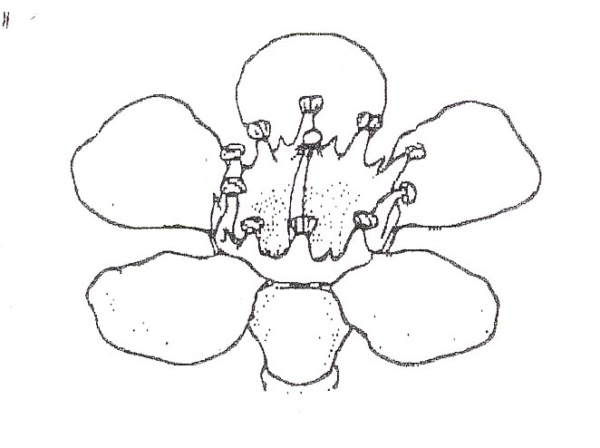
petal
hypanthium
stamen collar
upper surface of receptacle
style

8.2 Explanations for individual characteristics
Ad. 3: Leaf: shape in cross section

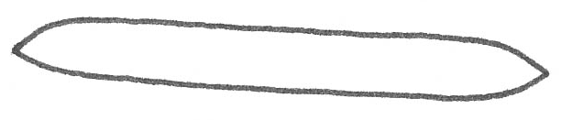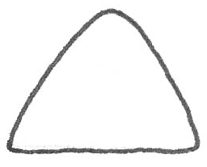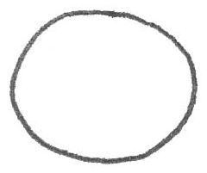
2
triangular
1
flattened
3
rounded

Ad. 6: Flower bud: color of apex

The color of apex should be observed when the flower bud is fully expanded, just prior to reflexing of the petals.

Ad. 9: Flowering branch: angle in relation to axillary shoot (5th node from distal end)

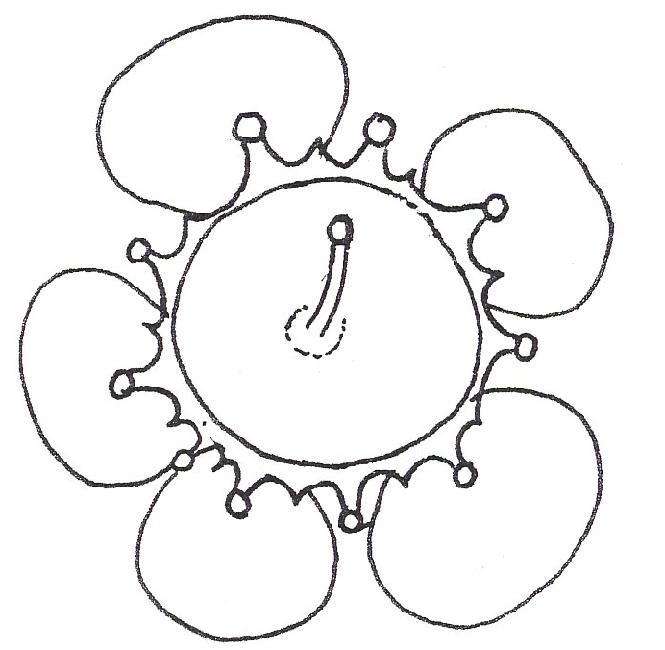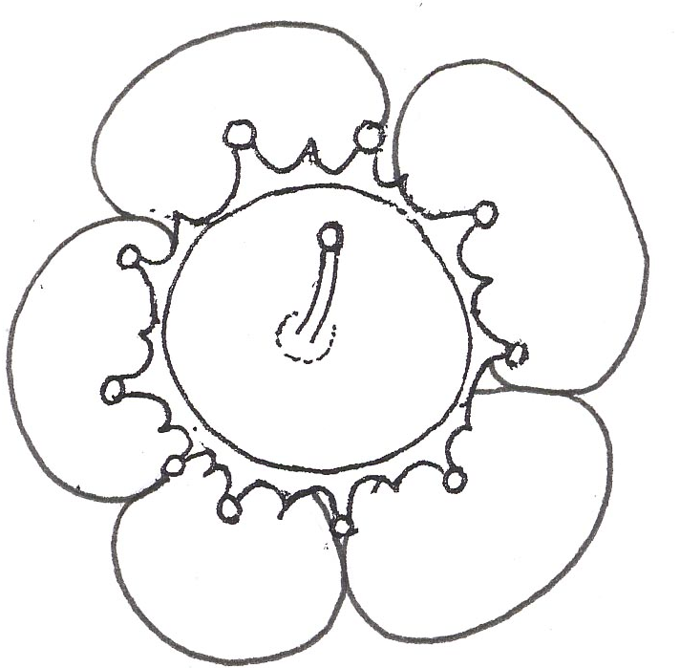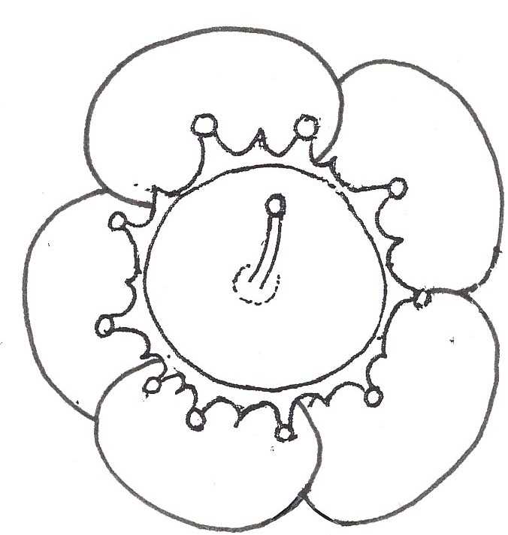
1
free
3
overlapping
2
intermediate

Ad. 20: Hypanthium: main color at middle part

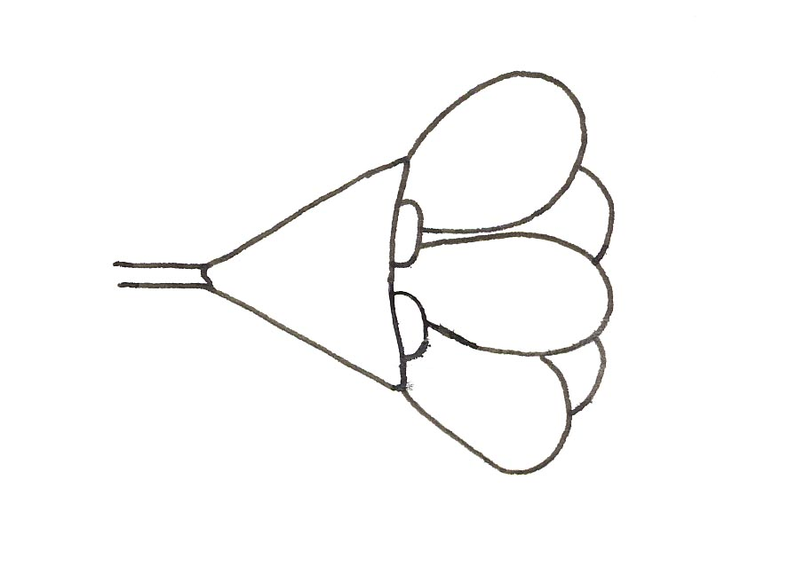
middle part of
hypanthium
sepal

Ad. 21: Sepal: incision of margin

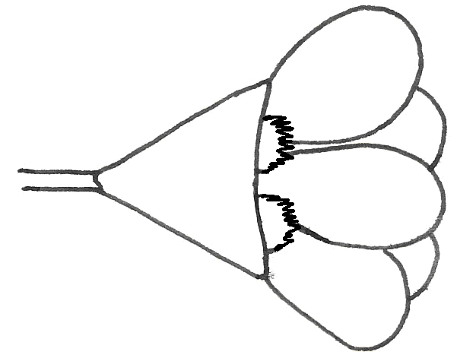
1
absent
9
present

Literature
Blackall, W.E. and Grieve, G.J. How to Know Western Australian Wildflowers Part IIIA.

Elliot, W.R. and Jones, D.L., 1989: Encyclopedia of Australian Plants Suitable for Cultivation Volume 3, Lothian Books.

Marchant, N.G., Wheeler, J.R., Rye, B.L., Bennett, E.M., Lander, N.S. and Macfarlane, T.D., 1987: Flora of the Perth Region Part One, Western Australian Herbarium, Department of Agriculture Western Australia.

Wrigley, J.W. and Fagg, M., 1988: Australian Native Plants Third Edition, Collins Publishers.

Technical Questionnaire
TECHNICAL QUESTIONNAIRE |  |  |  | Page {x} of {y} |  | Reference Number:
 |  |  |  |  |  | Application date:
 |  |  |  |  |  | (not to be filled in by the applicant)
TECHNICAL QUESTIONNAIRE
to be completed in connection with an application for plant breeders’ rights

1. Subject of the Technical Questionnaire
1.1.1 Botanical Name |  |  | Chamelaucium Desf.  (please indicate species)  ……………………………………………………….
1.1.2 Common Name |  |  | Waxflower
1.2.1 Botanical Name |  |  | Hybrids between Chamelaucium Desf. and Verticordia plumosa Desf. (Druce)  (please indicate species of Chamelaucium Desf.)  ……………………………………………………….
2. Applicant
Name
Address
Telephone No.
Fax No.
E-mail address
Breeder (if different from applicant)
3. Proposed denomination and breeder’s reference
Proposed denomination
(if available)
Breeder’s reference
#4. Information on the breeding scheme and propagation of the variety

4.1 Breeding scheme

Variety resulting from:

4.1.1 Crossing

(a) controlled cross [ ]
(please state parent varieties)
(b) partially known cross [ ]
(please state known parent variety(ies))
(c) unknown cross [ ]

4.1.2 Mutation [ ]
(please state parent variety)

4.1.3 Discovery and development [ ]
(please state where and when discovered and
how developed)

4.1.4 Other [ ]
(please provide details)

  - Method of propagating the variety

(a) cuttings [ ]
(b) divisions [ ]
(c) in vitro propagation [ ]
(d) other [ ]
(please provide details)

5. Characteristics of the variety to be indicated (the number in brackets refers to the corresponding characteristic in Test Guidelines; please mark the note which best corresponds).

 | Characteristics |  |  |  |  |  | Example Varieties |  |  | Note
5.1  (7) | Flower: type
 | single |  |  |  |  |  |  |  |  | 1[ ]
 | double |  |  |  |  |  | Champagne Pink,  Dancing Queen |  |  | 2[ ]
5.2  (8) | Flower: diameter
 | very small |  |  |  |  |  | Moonflower |  |  | 1[ ]
 | small |  |  |  |  |  | Lady Jennifer |  |  | 3[ ]
 | medium |  |  |  |  |  | Mullering Brook,  White Spring |  |  | 5[ ]
 | large |  |  |  |  |  | Niribi, Purple Pride |  |  | 7[ ]
5.3i  (13) | Flower: main color of petals on day of opening
RHS Colour Chart (indicate reference number)
...........................................................................................
5.3ii  (13) | Flower: main color of petals on day of opening
 | white |  |  |  |  |  |  |  |  | 1[ ]
 | pink |  |  |  |  |  |  |  |  | 2[ ]
 | purple |  |  |  |  |  |  |  |  | 3[ ]
5.4i  (14) | Flower: main color of petals 10-14 days after opening
RHS Colour Chart (indicate reference number)
...........................................................................................
5.4ii  (14) | Flower: main color of petals 10-14 days after opening
 | white |  |  |  |  |  |  |  |  | 1[ ]
 | pink |  |  |  |  |  |  |  |  | 2[ ]
 | purple |  |  |  |  |  |  |  |  | 3[ ]
 | Characteristics |  |  |  |  |  | Example Varieties |  |  | Note
5.5i  (15) | Flower: main color of petals 4 weeks after opening
RHS Colour Chart (indicate reference number)
...........................................................................................
5.5ii  (15) | Flower: main color of petals 4 weeks after opening
 | white |  |  |  |  |  |  |  |  | 1[ ]
 | pink |  |  |  |  |  |  |  |  | 2[ ]
 | purple |  |  |  |  |  |  |  |  | 3[ ]
5.6  (21) | Sepal: incision of margin
 | absent |  |  |  |  |  | Denmark Pearl |  |  | 1[ ]
 | present |  |  |  |  |  | Eric John, Jasper |  |  | 9[ ]
6. Similar varieties and differences from these varieties

Please use the following table and box for comments to provide information on how your candidate variety differs from the variety (or varieties) which, to the best of your knowledge, is (or are) most similar. This information may help the examination authority to conduct its examination of distinctness in a more efficient way.

Denomination(s) of variety(ies) similar to your candidate variety |  | Characteristic(s) in which your candidate variety differs from the similar variety(ies) |  |  | Describe the expression of the characteristic(s) for the similar variety(ies) |  |  | Describe the expression of the characteristic(s) for your candidate variety
Example |  | Flower: type |  |  | single |  |  | double
Comments:

#7. Additional information which may help in the examination of the variety

7.1 In addition to the information provided in Sections 5 and 6, are there any additional characteristics which may help to distinguish the variety?

Yes [ ] No [ ]

(If yes, please provide details)

7.2 Are there any special conditions for growing the variety or conducting the examination?

Yes [ ] No [ ]

(If yes, please provide details)

7.3 Other information

A representative color photograph of the variety should accompany the Technical Questionnaire.

8. Authorization for release

(a) Does the variety require prior authorization for release under legislation concerning the protection of the environment, human and animal health?

Yes [ ] No [ ]

(b) Has such authorization been obtained?

Yes [ ] No [ ]

If the answer to (b) is yes, please attach a copy of the authorization.

9. Information on plant material to be examined.

9.1 The expression of a characteristic or several characteristics of a variety may be affected by factors, such as pests and disease, chemical treatment (e.g. growth retardants or pesticides), effects of tissue culture, different rootstocks, scions taken from different growth phases of a tree, etc.

9.2 The plant material should not have undergone any treatment which would affect the expression of the characteristics of the variety, unless the competent authorities allow or request such treatment. If the plant material has undergone such treatment, full details of the treatment must be given. In this respect, please indicate below, to the best of your knowledge, if the plant material to be examined has been subjected to:

(a) Microorganisms (e.g. virus, bacteria, phytoplasma) Yes [ ] No [ ]

(b) Chemical treatment (e.g. growth retardant, pesticide) Yes [ ] No [ ]

(c) Tissue culture Yes [ ] No [ ]

(d) Other factors Yes [ ] No [ ]

Please provide details for where you have indicated “yes”.

……………………………………………………………

10. I hereby declare that, to the best of my knowledge, the information provided in this form is correct:

Applicant’s name

Signature Date

[End of document]

* These names were correct at the time of the introduction of these Test Guidelines but may be revised or updated. [Readers are advised to consult the UPOV Code, which can be found on the UPOV Website (www.upov.int), for the latest information.]
# Authorities may allow certain of this information to be provided in a confidential section of the Technical Questionnaire.
# Authorities may allow certain of this information to be provided in a confidential section of the Technical Questionnaire.

