 |  | E  TG/215/1 Rev.  ORIGINAL: English  DATE: 2007-03-28
INTERNATIONAL UNION FOR THE PROTECTION OF NEW VARIETIES OF PLANTS
GENEVA

 | CLEMATIS  UPOV Code: CLEMA  (Clematis L.) | *

GUIDELINES

FOR THE CONDUCT OF TESTS

FOR DISTINCTNESS, UNIFORMITY AND STABILITY

Alternative Names:*

Botanical name | English | French | German | Spanish
Clematis L. | Clematis | Clématite | Clematis, Waldrebe | Clemátide

The purpose of these guidelines (“Test Guidelines”) is to elaborate the principles contained in the General Introduction (document TG/1/3), and its associated TGP documents, into detailed practical guidance for the harmonized examination of distinctness, uniformity and stability (DUS) and, in particular, to identify appropriate characteristics for the examination of DUS and production of harmonized variety descriptions.

ASSOCIATED DOCUMENTS

These Test Guidelines should be read in conjunction with the General Introduction and its associated TGP documents.
TABLE OF CONTENTS PAGE

1. Subject of these Test Guidelines 3
2. Material Required 3
3. Method of Examination 3
3.1 Number of Growing Cycles 3
3.2 Testing Place 3
3.3 Conditions for Conducting the Examination 3
3.4 Test Design 4
3.5 Number of Plants / Parts of Plants to be Examined 4
3.6 Additional Tests 4
4. Assessment of Distinctness, Uniformity and Stability 4
4.1 Distinctness 4
4.2 Uniformity 4
4.3 Stability 5
5. Grouping of Varieties and Organization of the Growing Trial 5
6. Introduction to the Table of Characteristics 6
6.1 Categories of Characteristics 6
6.2 States of Expression and Corresponding Notes 6
6.3 Types of Expression 6
6.4 Example Varieties 6
6.5 Legend 6
7. Table of Characteristics/Tableau des caractères/Merkmalstabelle/Tabla de caracteres 7
8. Explanations on the Table of Characteristics 22
8.1 Explanations covering several characteristics 22
8.2 Explanations for individual characteristics 23
9. Literature 30
10. Technical Questionnaire 31

Subject of these Test Guidelines
These Test Guidelines apply to all varieties of Clematis L. of the family Ranunculaceae.

Material Required
2.1 The competent authorities decide on the quantity and quality of the plant material required for testing the variety and when and where it is to be delivered. Applicants submitting material from a State other than that in which the testing takes place must ensure that all customs formalities and phytosanitary requirements are complied with.

2.2 The material is to be supplied in the form of one-year old plants, not cut back, which have not previously flowered.

2.3 The minimum quantity of plant material, to be supplied by the applicant, should be:

8 plants.

2.4 The plant material supplied should be visibly healthy, not lacking in vigor, nor affected by any important pest or disease.

2.5 The plant material should not have undergone any treatment which would affect the expression of the characteristics of the variety, unless the competent authorities allow or request such treatment. If it has been treated, full details of the treatment must be given.

Method of Examination

3.1 Number of Growing Cycles
The minimum duration of tests should normally be a single growing cycle.

3.2 Testing Place
Tests are normally conducted at one place. In the case of tests conducted at more than one place, guidance is provided in TGP/9 “Examining Distinctness”.

3.3 Conditions for Conducting the Examination
3.3.1 The tests should be carried out under conditions ensuring satisfactory growth for the expression of the relevant characteristics of the variety and for the conduct of the examination.

3.3.2 Because daylight varies, color determinations made against a color chart should be made either in a suitable cabinet providing artificial daylight or in the middle of the day in a room without direct sunlight. The spectral distribution of the illuminant for artificial daylight should conform with the CIE Standard of Preferred Daylight D 6500 and should fall within the tolerances set out in the British Standard 950, Part I. These determinations should be made with the plant part placed against a white background.

3.4 Test Design
Each test should be designed to result in a total of at least 8 plants.

3.5 Number of Plants / Parts of Plants to be Examined
Unless otherwise indicated, all observations should be made on 8 plants or parts taken from each of 8 plants.

3.6 Additional Tests
Additional tests, for examining relevant characteristics, may be established.

Assessment of Distinctness, Uniformity and Stability

4.1 Distinctness
4.1.1 General Recommendations

It is of particular importance for users of these Test Guidelines to consult the General Introduction prior to making decisions regarding distinctness. However, the following points are provided for elaboration or emphasis in these Test Guidelines.

4.1.2 Consistent Differences

The differences observed between varieties may be so clear that more than one growing cycle is not necessary. In addition, in some circumstances, the influence of the environment is not such that more than a single growing cycle is required to provide assurance that the differences observed between varieties are sufficiently consistent. One means of ensuring that a difference in a characteristic, observed in a growing trial, is sufficiently consistent is to examine the characteristic in at least two independent growing cycles.

4.1.3 Clear Differences

Determining whether a difference between two varieties is clear depends on many factors, and should consider, in particular, the type of expression of the characteristic being examined, i.e. whether it is expressed in a qualitative, quantitative, or pseudo-qualitative manner. Therefore, it is important that users of these Test Guidelines are familiar with the recommendations contained in the General Introduction prior to making decisions regarding distinctness.

4.2 Uniformity
4.2.1 It is of particular importance for users of these Test Guidelines to consult the General Introduction prior to making decisions regarding uniformity. However, the following points are provided for elaboration or emphasis in these Test Guidelines:

4.2.2 For the assessment of uniformity, a population standard of 1% and an acceptance probability of at least 95% should be applied. In the case of a sample size of eight plants, one off-type is allowed.

4.3 Stability
4.3.1 In practice, it is not usual to perform tests of stability that produce results as certain as those of the testing of distinctness and uniformity. However, experience has demonstrated that, for many types of variety, when a variety has been shown to be uniform, it can also be considered to be stable.

4.3.2 Where appropriate, or in cases of doubt, stability may be tested, either by growing a further generation, or by testing a new plant stock to ensure that it exhibits the same characteristics as those shown by the previous material supplied.

Grouping of Varieties and Organization of the Growing Trial
5.1 The selection of varieties of common knowledge to be grown in the trial with the candidate varieties and the way in which these varieties are divided into groups to facilitate the assessment of distinctness are aided by the use of grouping characteristics.

5.2 Grouping characteristics are those in which the documented states of expression, even where produced at different locations, can be used, either individually or in combination with other such characteristics: (a) to select varieties of common knowledge that can be excluded from the growing trial used for examination of distinctness; and (b) to organize the growing trial so that similar varieties are grouped together.

5.3 The following have been agreed as useful grouping characteristics:

(a) Plant: type (characteristic 1)
- Leaf: type (characteristic 6)
(c) Flower: type (characteristic 22)
(d) Flower: diameter (characteristic 23)
(e) Sepal: number of colors of upper side (characteristic 37)
(f) Sepal: main color of upper side (characteristic 38) with the following groups:
Gr. 1: white
Gr. 2: yellow
Gr. 3: pink
Gr. 4: red
Gr. 5: purple
Gr. 6: violet
Gr. 7: blue
Gr. 8: green

5.4 Guidance for the use of grouping characteristics, in the process of examining distinctness, is provided through the General Introduction.

Introduction to the Table of Characteristics

6.1 Categories of Characteristics
6.1.1 Standard Test Guidelines Characteristics

Standard Test Guidelines characteristics are those which are approved by UPOV for examination of DUS and from which members of the Union can select those suitable for their particular circumstances.

6.1.2 Asterisked Characteristics

Asterisked characteristics (denoted by *) are those included in the Test Guidelines which are important for the international harmonization of variety descriptions and should always be examined for DUS and included in the variety description by all members of the Union, except when the state of expression of a preceding characteristic or regional environmental conditions render this inappropriate.

6.2 States of Expression and Corresponding Notes
States of expression are given for each characteristic to define the characteristic and to harmonize descriptions. Each state of expression is allocated a corresponding numerical note for ease of recording of data and for the production and exchange of the description.

6.3 Types of Expression
An explanation of the types of expression of characteristics (qualitative, quantitative and pseudo-qualitative) is provided in the General Introduction.

6.4 Example Varieties
Where appropriate, example varieties are provided to clarify the states of expression of each characteristic.

6.5 Legend
(*) Asterisked characteristic – see Chapter 6.1.2

QL: Qualitative characteristic – see Chapter 6.3
QN: Quantitative characteristic – see Chapter 6.3
PQ: Pseudo-qualitative characteristic – see Chapter 6.3

(a)–(e) See Explanations on the Table of Characteristics in Chapter 8.1

(+) See Explanations on the Table of Characteristics in Chapter 8.2

Table of Characteristics/Tableau des caractères/Merkmalstabelle/Tabla de caracteres
 |  |  |  |  |  |  | English |  |  |  |  |  |  | français |  |  |  | Deutsch |  |  |  | español |  |  |  |  | Example Varieties  Exemples  Beispielssorten  Variedades ejemplo |  |  |  | Note/  Nota
1.  (*) |  |  |  |  |  |  | Plant: type |  |  |  |  |  |  | Plante: type |  |  |  | Pflanze: Typ |  |  |  | Planta: tipo
QL |  |  |  |  |  |  | non-climbing |  |  |  |  |  |  | non grimpante |  |  |  | nicht kletternd |  |  |  | no trepadora |  |  |  |  | Evisix |  |  |  | 1
 |  |  |  |  |  |  | climbing |  |  |  |  |  |  | grimpante |  |  |  | kletternd |  |  |  | trepadora |  |  |  |  | Tetrarose |  |  |  | 2
2.  (*) |  |  |  |  |  |  | Non-climbing varieties only: Plant: growth habit |  |  |  |  |  |  | Variétés non grimpantes seulement: Plante: port |  |  |  | Nur nicht kletternde Sorten: Pflanze: Wuchsform |  |  |  | Sólo variedades no trepadoras: Planta: porte
QN |  |  |  |  |  |  | upright |  |  |  |  |  |  | dressé |  |  |  | aufrecht |  |  |  | erguido |  |  |  |  | Alblo |  |  |  | 1
 |  |  |  |  |  |  | semi-upright |  |  |  |  |  |  | demi-dressé |  |  |  | halbaufrecht |  |  |  | semierguido |  |  |  |  |  |  |  |  | 2
 |  |  |  |  |  |  | prostrate |  |  |  |  |  |  | étalé |  |  |  | liegend |  |  |  | postrado |  |  |  |  | Joe, Pixie, Syrena |  |  |  | 3
3.  (+) |  |  |  |  |  |  |  |  |  | Climbing varieties only: Plant: vigor |  |  |  | Variétés grimpantes seulement: Plante: vigueur |  |  |  | Nur kletternde Sorten: Pflanze: Wuchsstärke |  |  |  | Sólo variedades trepadoras: Planta: vigor
QN |  |  |  |  |  |  |  |  |  | weak |  |  |  | faible |  |  |  | gering |  |  |  | débil |  |  |  |  |  |  |  |  | 3
 |  |  |  |  |  |  |  |  |  | medium |  |  |  | moyenne |  |  |  | mittel |  |  |  | medio |  |  |  |  |  |  |  |  | 5
 |  |  |  |  |  |  |  |  |  | strong |  |  |  | forte |  |  |  | stark |  |  |  | fuerte |  |  |  |  |  |  |  |  | 7
4. |  |  |  |  |  | Young shoot: presence of pubescence |  |  |  |  |  | Jeune rameau: pubescence |  |  |  | Jungtrieb: Vorhandensein von Behaarung |  |  |  | Tallo joven: presencia de pubescencia
QL |  |  |  |  |  | absent |  |  |  |  |  | absente |  |  |  | fehlend |  |  |  | ausente |  |  |  |  |  |  |  |  | 1
 |  |  |  |  |  | present |  |  |  |  |  | présente |  |  |  | vorhanden |  |  |  | presente |  |  |  |  |  |  |  |  | 9
5. |  |  |  |  |  |  |  | Young shoot: density of pubescence |  |  |  |  |  | Jeune rameau: densité de la pubescence |  |  |  | Jungtrieb: Dichte der Behaarung |  |  |  | Tallo joven: densidad de la pubescencia
QN |  |  |  |  |  |  |  | sparse |  |  |  |  |  | éparse |  |  |  | locker |  |  |  | laxa |  |  |  |  |  |  |  |  | 3
 |  |  |  |  |  |  |  | medium |  |  |  |  |  | moyenne |  |  |  | mittel |  |  |  | media |  |  |  |  |  |  |  |  | 5
 |  |  |  |  |  |  |  | dense |  |  |  |  |  | dense |  |  |  | dicht |  |  |  | densa |  |  |  |  |  |  |  |  | 7
6.  (*)  (+) |  | (a) |  |  |  |  | Leaf: type |  |  |  |  |  | Feuille: type |  |  |  | Blatt: Typ |  |  |  | Hoja: tipo
QL |  |  |  |  |  |  | simple |  |  |  |  |  | simple |  |  |  | einfach |  |  |  | simple |  |  |  |  |  |  |  |  | 1
 |  |  |  |  |  |  | ternate |  |  |  |  |  | ternaire |  |  |  | dreizählig |  |  |  | ternada |  |  |  |  |  |  |  |  | 2
 |  |  |  |  |  |  | biternate |  |  |  |  |  | biternaire |  |  |  | doppelt dreizählig |  |  |  | biternada |  |  |  |  |  |  |  |  | 3
 |  |  |  |  |  |  | triternate |  |  |  |  |  | triternaire |  |  |  | dreifach dreizählig |  |  |  | triternada |  |  |  |  |  |  |  |  | 4
 |  |  |  |  |  |  | pinnate |  |  |  |  |  | pennée |  |  |  | gefiedert |  |  |  | pinnada |  |  |  |  |  |  |  |  | 5
 |  |  |  |  |  |  | bipinnate |  |  |  |  |  | bipennée |  |  |  | doppelt gefiedert |  |  |  | bipinnada |  |  |  |  |  |  |  |  | 6
 |  |  |  |  |  |  | tripinnate |  |  |  |  |  | tripennée |  |  |  | dreifach gefiedert |  |  |  | tripinnada |  |  |  |  |  |  |  |  | 7
7. |  |  |  |  | (a)  (b) |  |  |  |  |  | Leaf blade: length |  |  |  | Limbe: longueur |  |  |  | Blattspreite: Länge |  |  |  | Limbo: longitud
QN |  |  |  |  |  |  |  |  | short |  |  |  |  | court |  |  |  | kurz |  |  |  | corto |  |  |  |  |  |  |  |  | 3
 |  |  |  |  |  |  |  |  | medium |  |  |  |  | moyen |  |  |  | mittel |  |  |  | medio |  |  |  |  |  |  |  |  | 5
 |  |  |  |  |  |  |  |  | long |  |  |  |  | long |  |  |  | lang |  |  |  | largo |  |  |  |  |  |  |  |  | 7
8. |  |  |  | (a)  (b) |  |  |  |  | Leaf blade: width |  |  |  |  | Limbe: largeur |  |  |  | Blattspreite: Breite |  |  |  | Limbo: anchura
QN |  |  |  |  |  |  |  |  | narrow |  |  |  |  | étroit |  |  |  | schmal |  |  |  | estrecha |  |  |  |  |  |  |  |  | 3
 |  |  |  |  |  |  |  |  | medium |  |  |  |  | moyen |  |  |  | mittel |  |  |  | media |  |  |  |  |  |  |  |  | 5
 |  |  |  |  |  |  |  |  | broad |  |  |  |  | large |  |  |  | breit |  |  |  | ancha |  |  |  |  |  |  |  |  | 7
9.  (*)  (+) |  |  |  | (a)  (b) |  |  |  |  | Leaf blade: shape |  |  |  |  | Limbe: forme |  |  |  | Blattspreite: Form |  |  |  | Limbo: forma
PQ |  |  |  |  |  |  |  |  | lanceolate |  |  |  |  | lancéolée |  |  |  | lanzettlich |  |  |  | lanceolada |  |  |  |  |  |  |  |  | 1
 |  |  |  |  |  |  |  |  | ovate |  |  |  |  | ovale |  |  |  | eiförmig |  |  |  | oval |  |  |  |  |  |  |  |  | 2
 |  |  |  |  |  |  |  |  | elliptic |  |  |  |  | elliptique |  |  |  | elliptisch |  |  |  | elíptica |  |  |  |  |  |  |  |  | 3
 |  |  |  |  |  |  |  |  | obovate |  |  |  |  | obovale |  |  |  | verkehrt eiförmig |  |  |  | oboval |  |  |  |  |  |  |  |  | 4
 |  |  |  |  |  |  |  |  | rhombic |  |  |  |  | losangique |  |  |  | rautenförmig |  |  |  | rómbica |  |  |  |  |  |  |  |  | 5
 |  |  |  |  |  |  |  |  | cordate |  |  |  |  | cordiforme |  |  |  | herzförmig |  |  |  | cordiforme |  |  |  |  |  |  |  |  | 6
10.  (+) | (a)  (b) |  |  |  |  | Leaf blade: shape of apex |  |  |  |  |  | Limbe: forme du sommet |  |  |  | Blattspreite: Form der Spitze |  |  |  | Limbo: forma del ápice
PQ |  |  |  |  |  | acuminate |  |  |  |  |  | acuminée |  |  |  | zugespitzt |  |  |  | acuminada |  |  |  |  |  |  |  |  | 1
 |  |  |  |  |  | cuspidate |  |  |  |  |  | cuspidée |  |  |  | keilförmig |  |  |  | cuspidada |  |  |  |  |  |  |  |  | 2
 |  |  |  |  |  | acute |  |  |  |  |  | aiguë |  |  |  | spitz |  |  |  | aguda |  |  |  |  |  |  |  |  | 3
 |  |  |  |  |  | rounded |  |  |  |  |  | arrondie |  |  |  | abgerundet |  |  |  | redondeada |  |  |  |  |  |  |  |  | 4
11.  (+) |  |  |  |  | (a)  (b) |  |  |  |  | Leaf blade: shape of base |  |  |  | Limbe: forme de la base |  |  |  | Blattspreite: Form der Basis |  |  |  | Limbo: forma de la base
PQ |  |  |  |  |  |  |  |  |  | acute |  |  |  | aiguë |  |  |  | spitz |  |  |  | aguda |  |  |  |  |  |  |  |  | 1
 |  |  |  |  |  |  |  |  |  | obtuse |  |  |  | obtuse |  |  |  | stumpf |  |  |  | obtusa |  |  |  |  |  |  |  |  | 2
 |  |  |  |  |  |  |  |  |  | rounded |  |  |  | arrondie |  |  |  | abgerundet |  |  |  | redondeada |  |  |  |  |  |  |  |  | 3
 |  |  |  |  |  |  |  |  |  | cordate |  |  |  | cordée |  |  |  | herzförmig |  |  |  | cordiforme |  |  |  |  |  |  |  |  | 4
12.  (+) |  |  |  |  | (a)  (b) |  |  |  |  | Leaf blade: margin |  |  |  | Limbe: bord |  |  |  | Blattspreite: Rand |  |  |  | Limbo: borde
PQ |  |  |  |  |  |  |  |  |  | entire |  |  |  | entier |  |  |  | ganzrandig |  |  |  | entero |  |  |  |  |  |  |  |  | 1
 |  |  |  |  |  |  |  |  |  | sinuate |  |  |  | sinué |  |  |  | gebuchtet |  |  |  | sinuoso |  |  |  |  |  |  |  |  | 2
 |  |  |  |  |  |  |  |  |  | crenate |  |  |  | crénelé |  |  |  | gekerbt |  |  |  | crenado |  |  |  |  |  |  |  |  | 3
 |  |  |  |  |  |  |  |  |  | dentate |  |  |  | dentelé |  |  |  | gezähnt |  |  |  | dentado |  |  |  |  |  |  |  |  | 4
 |  |  |  |  |  |  |  |  |  | serrate |  |  |  | crénelé dentelé |  |  |  | gesägt |  |  |  | serrado |  |  |  |  |  |  |  |  | 5
13. |  |  |  |  | (a) |  |  |  |  | Leaf blade: lobing |  |  |  | Limbe: découpure |  |  |  | Blattspreite: Lappung |  |  |  | Limbo: lobulado
QL |  |  |  |  |  |  |  |  |  | absent |  |  |  | absente |  |  |  | fehlend |  |  |  | ausente |  |  |  |  | General Sikorski |  |  |  | 1
 |  |  |  |  |  |  |  |  |  | present |  |  |  | présente |  |  |  | vorhanden |  |  |  | presente |  |  |  |  | Syrena, Tetrarose |  |  |  | 9
14. |  |  |  |  | (a) |  |  |  |  | Lobed varieties only: Leaf blade: number of lobes |  |  |  | Variétés lobées seulement: Limbe: nombre de lobes |  |  |  | Nur gelappte Sorten: Blattspreite: Anzahl Lappen |  |  |  | Sólo variedades lobuladas: Limbo: número de lóbulos
PQ |  |  |  |  |  |  |  |  |  | two |  |  |  | deux |  |  |  | zwei |  |  |  | dos |  |  |  |  |  |  |  |  | 1
 |  |  |  |  |  |  |  |  |  | three or four |  |  |  | trois ou quatre |  |  |  | drei oder vier |  |  |  | tres o cuatro |  |  |  |  |  |  |  |  | 2
 |  |  |  |  |  |  |  |  |  | more than four |  |  |  | plus de quatre |  |  |  | mehr als vier |  |  |  | más de cuatro |  |  |  |  |  |  |  |  | 3
15.  (+) |  |  |  |  | (a) |  |  |  |  | Lobed varieties only: Leaf blade: depth of sinus between lobes |  |  |  | Variétés lobées seulement: Limbe: profondeur du sinus entre les lobes |  |  |  | Nur gelappte Sorten: Blattspreite: Tiefe der Buchten zwischen den Lappen |  |  |  | Sólo variedades lobuladas: Limbo: profundidad de los senos entre los lóbulos
QN |  |  |  |  |  |  |  |  |  | shallow |  |  |  | peu profond |  |  |  | flach |  |  |  | poco profunda |  |  |  |  |  |  |  |  | 3
 |  |  |  |  |  |  |  |  |  | medium |  |  |  | moyen |  |  |  | mittel |  |  |  | media |  |  |  |  |  |  |  |  | 5
 |  |  |  |  |  |  |  |  |  | deep |  |  |  | profond |  |  |  | tief |  |  |  | profunda |  |  |  |  |  |  |  |  | 7
16. |  |  |  |  | (a)  (b) |  |  |  |  | Leaf blade: main color of upper side |  |  |  | Limbe: couleur principale de la face supérieure |  |  |  | Blattspreite: Hauptfarbe der Oberseite |  |  |  | Limbo: color principal del haz
PQ |  |  |  |  |  |  |  |  |  | yellow green |  |  |  | vert jaune |  |  |  | gelbgrün |  |  |  | verde amarillento |  |  |  |  | Duchess of Edinburgh |  |  |  | 1
 |  |  |  |  |  |  |  |  |  | light green |  |  |  | vert clair |  |  |  | hellgrün |  |  |  | verde claro |  |  |  |  | Burford White |  |  |  | 2
 |  |  |  |  |  |  |  |  |  | medium green |  |  |  | vert moyen |  |  |  | mittelgrün |  |  |  | verde medio |  |  |  |  | Lady Northcliffe |  |  |  | 3
 |  |  |  |  |  |  |  |  |  | dark green |  |  |  | vert foncé |  |  |  | dunkelgrün |  |  |  | verde oscuro |  |  |  |  | Bowl of Beauty |  |  |  | 4
 |  |  |  |  |  |  |  |  |  | blue green |  |  |  | vert bleu |  |  |  | blaugrün |  |  |  | verde azulado |  |  |  |  | My Angel |  |  |  | 5
 |  |  |  |  |  |  |  |  |  | grey green |  |  |  | vert gris |  |  |  | graugrün |  |  |  | verde grisáceo |  |  |  |  | Tibetan Mix |  |  |  | 6
 |  |  |  |  |  |  |  |  |  | bronze |  |  |  | bronze |  |  |  | bronze |  |  |  | bronce |  |  |  |  | Mayleen |  |  |  | 7
17. |  |  |  |  | (a)  (b) |  |  |  |  | Leaf blade: variegation |  |  |  | Limbe: panachure |  |  |  | Blattspreite: Panaschierung |  |  |  | Limbo: variegación
QL |  |  |  |  |  |  |  |  |  | absent |  |  |  | absente |  |  |  | fehlend |  |  |  | ausente |  |  |  |  | Mrs George Jackman |  |  |  | 1
 |  |  |  |  |  |  |  |  |  | present |  |  |  | présente |  |  |  | vorhanden |  |  |  | presente |  |  |  |  | Gokanosho |  |  |  | 9
18. |  |  |  |  | (a)  (b) |  |  |  |  | Leaf blade: rugosity of upper surface |  |  |  | Limbe: rugosité de la surface supérieure |  |  |  | Blattspreite: Blasigkeit der Oberfläche |  |  |  | Limbo: rugosidad del haz
QN |  |  |  |  |  |  |  |  |  | absent or weak |  |  |  | absente ou faible |  |  |  | fehlend oder gering |  |  |  | ausente o débil |  |  |  |  |  |  |  |  | 1
 |  |  |  |  |  |  |  |  |  | moderate |  |  |  | modérée |  |  |  | mäßig |  |  |  | moderada |  |  |  |  |  |  |  |  | 2
 |  |  |  |  |  |  |  |  |  | strong |  |  |  | forte |  |  |  | stark |  |  |  | fuerte |  |  |  |  |  |  |  |  | 3
19.  (*) |  |  |  |  | (c) |  |  |  |  | Flowers: arrangement |  |  |  | Fleurs: disposition |  |  |  | Blüten: Anordnung |  |  |  | Flores: disposición
QL |  |  |  |  |  |  |  |  |  | solitary |  |  |  | isolées |  |  |  | einzeln |  |  |  | aislada |  |  |  |  | Black Prince, Evisix, Kugotia |  |  |  | 1
 |  |  |  |  |  |  |  |  |  | clustered |  |  |  | groupées |  |  |  | in Büscheln |  |  |  | en racimos |  |  |  |  | Apple Blossom |  |  |  | 2
20. |  |  |  |  | (c) |  |  |  |  | Flower: length of pedicel |  |  |  | Fleur: longueur du pédoncule |  |  |  | Blüte: Länge des Stiels |  |  |  | Flor: longitud del pedicelo
QN |  |  |  |  |  |  |  |  |  | short |  |  |  | court |  |  |  | kurz |  |  |  | corto |  |  |  |  |  |  |  |  | 3
 |  |  |  |  |  |  |  |  |  | medium |  |  |  | moyen |  |  |  | mittel |  |  |  | medio |  |  |  |  |  |  |  |  | 5
 |  |  |  |  |  |  |  |  |  | long |  |  |  | long |  |  |  | lang |  |  |  | largo |  |  |  |  |  |  |  |  | 7
21.  (+) |  |  |  |  | (c) |  |  |  |  | Flower: attitude |  |  |  | Fleur: port |  |  |  | Blüte: Haltung |  |  |  | Flor: Porte
QN |  |  |  |  |  |  |  |  |  | upwards |  |  |  | dressée |  |  |  | aufwärts |  |  |  | hacia arriba |  |  |  |  | Duchess of Albany |  |  |  | 1
 |  |  |  |  |  |  |  |  |  | outwards |  |  |  | horizontale |  |  |  | horizontal |  |  |  | hacia afuera |  |  |  |  |  |  |  |  | 2
 |  |  |  |  |  |  |  |  |  | downwards |  |  |  | retombante |  |  |  | abwärts |  |  |  | hacia abajo |  |  |  |  | Evisix |  |  |  | 3
22.  (*)  (+) |  |  |  |  | (c) |  |  |  |  | Flower: type |  |  |  | Fleur: type |  |  |  | Blüte: Typ |  |  |  | Flor: tipo
QN |  |  |  |  |  |  |  |  |  | single |  |  |  | simple |  |  |  | einfach |  |  |  | simple |  |  |  |  | Nelly Moser,  Perle d’Azur |  |  |  | 1
 |  |  |  |  |  |  |  |  |  | semi-double |  |  |  | semi-double |  |  |  | halbgefüllt |  |  |  | semidoble |  |  |  |  | Caroline Lloyd,  Marjorie |  |  |  | 2
 |  |  |  |  |  |  |  |  |  | double |  |  |  | double |  |  |  | gefüllt |  |  |  | doble |  |  |  |  | Kiri Te Kanawa,  Multi Blue |  |  |  | 3
23.  (*) |  |  |  |  | (c) |  |  |  |  | Flower: diameter |  |  |  | Fleur: diamètre |  |  |  | Blüte: Durchmesser |  |  |  | Flor: diámetro
QN |  |  |  |  |  |  |  |  |  | very small |  |  |  | très petit |  |  |  | sehr klein |  |  |  | muy pequeño |  |  |  |  | Marjorie |  |  |  | 1
 |  |  |  |  |  |  |  |  |  | small |  |  |  | petit |  |  |  | klein |  |  |  | pequeño |  |  |  |  | Little Nell |  |  |  | 3
 |  |  |  |  |  |  |  |  |  | medium |  |  |  | moyen |  |  |  | mittel |  |  |  | medio |  |  |  |  | Perle d’Azur |  |  |  | 5
 |  |  |  |  |  |  |  |  |  | large |  |  |  | grand |  |  |  | groß |  |  |  | grande |  |  |  |  | Evista |  |  |  | 7
 |  |  |  |  |  |  |  |  |  | very large |  |  |  | très grand |  |  |  | sehr groß |  |  |  | muy grande |  |  |  |  | Fairy Queen, Kacper |  |  |  | 9
24.  (*)  (+) |  |  |  |  | (c) |  |  |  |  | Only varieties with flower type: single or semi-double: Flower: shape |  |  |  | Seulement les variétés avec fleur: type: simple et semi-double: Fleur: forme |  |  |  | Nur Sorten mit Blüte: Typ: einfach oder halbgefüllt: Blüte: Form |  |  |  | Sólo variedades con flor: tipo: simple y semidoble: Flor: forma
PQ |  |  |  |  |  |  |  |  |  | tubular |  |  |  | tubulaire |  |  |  | röhrenförmig |  |  |  | tubular |  |  |  |  | Davidianna, Wyevale |  |  |  | 1
 |  |  |  |  |  |  |  |  |  | campanulate |  |  |  | campanulée |  |  |  | glockenförmig |  |  |  | acampanada |  |  |  |  | Étoile Rose |  |  |  | 2
 |  |  |  |  |  |  |  |  |  | urceolate |  |  |  | urcéolée |  |  |  | urnenförmig |  |  |  | u rceolada |  |  |  |  | Phil Mason |  |  |  | 3
 |  |  |  |  |  |  |  |  |  | rotate |  |  |  | arrondie |  |  |  | radförmig |  |  |  | rotácea |  |  |  |  | Lady Northcliffe,  Nelly Moser |  |  |  | 4
25.  (+) |  |  |  |  | (c) |  |  |  |  | Only varieties with flower shape: rotate: Flower: cross section in lateral view |  |  |  | Seulement les variétés avec fleur: forme: arrondie: Fleur: vue latérale de la section transversale |  |  |  | Nur Sorten mit Blüte: Form: radförmig: Blüte: Querschnitt in der Seitenansicht |  |  |  | Sólo variedades con flor: forma: rotácea: Flor: sección transversal en perspectiva lateral
QN |  |  |  |  |  |  |  |  |  | concave |  |  |  | concave |  |  |  | konkav |  |  |  | cóncava |  |  |  |  |  |  |  |  | 1
 |  |  |  |  |  |  |  |  |  | flat |  |  |  | plate |  |  |  | flach |  |  |  | plana |  |  |  |  | Henryi |  |  |  | 2
 |  |  |  |  |  |  |  |  |  | convex |  |  |  | convexe |  |  |  | konvex |  |  |  | convexa |  |  |  |  |  |  |  |  | 3
26.  (*) |  |  |  |  | (c)  (d)  (e) (f) |  |  |  |  | Only varieties with flower type: single or semi-double: Flower: number of sepals |  |  |  | Seulement les variétés à fleur: type: simple et semi-double: Fleur : nombre de sépales |  |  |  | Nur Sorten mit Blüte: Typ: einfach und halbgefüllt: Anzahl Kelchblätter |  |  |  | Sólo variedades con flor: tipo: simple y semidoble: Flor: número de sépalos
PQ |  |  |  |  |  |  |  |  |  | only four |  |  |  | seulement quatre |  |  |  | nur vier |  |  |  | sólo cuatro |  |  |  |  | Bill MacKenzie,  Perle d’Azur,  Tetrarose |  |  |  | 1
 |  |  |  |  |  |  |  |  |  | four to six |  |  |  | quatre à six |  |  |  | vier bis sechs |  |  |  | de cuatro a seis |  |  |  |  | Gipsy Queen,  Prince Charles |  |  |  | 2
 |  |  |  |  |  |  |  |  |  | only six |  |  |  | seulement six |  |  |  | nur sechs |  |  |  | sólo seis |  |  |  |  | Empress of India,  Frau Mikiko,  Ville de Lyon |  |  |  | 3
 |  |  |  |  |  |  |  |  |  | six to eight |  |  |  | six à huit |  |  |  | sechs bis acht |  |  |  | de seis a ocho |  |  |  |  | Dawn, Fireworks,  Haku Ookan |  |  |  | 4
 |  |  |  |  |  |  |  |  |  | only eight |  |  |  | seulement huit |  |  |  | nur acht |  |  |  | sólo ocho |  |  |  |  | Midnight,  Sandra Denny |  |  |  | 5
 |  |  |  |  |  |  |  |  |  | more than eight |  |  |  | plus de huit |  |  |  | mehr als acht |  |  |  | más de ocho |  |  |  |  | Mrs George Jackman |  |  |  | 6
27.  (+) |  |  |  |  | (c)  (d)  (e) |  |  |  |  | Only varieties with flower shape: rotate: Flower: arrangement of sepals |  |  |  | Seulement les variétés avec fleur: forme: arrondie: Fleur: disposition des sépales |  |  |  | Nur Sorten mit Blüte: Form: radförmig: Blüte: Anordnung der Kelchblätter |  |  |  | Sólo variedades con flor: forma: rotácea: Flor: disposición de los pétalos
QN |  |  |  |  |  |  |  |  |  | free |  |  |  | ouverts |  |  |  | freistehend |  |  |  | libre |  |  |  |  | Black Prince |  |  |  | 1
 |  |  |  |  |  |  |  |  |  | touching |  |  |  | tangents |  |  |  | sich berührend |  |  |  | tangentes |  |  |  |  | Iubileinyi-70 |  |  |  | 2
 |  |  |  |  |  |  |  |  |  | overlapping |  |  |  | chevauchants |  |  |  | überlappend |  |  |  | solapada |  |  |  |  | Horn of Plenty,  Ivan Olssen |  |  |  | 3
28. |  |  |  |  | (c) |  |  |  |  | Flower: fragrance |  |  |  | Fleur: parfum |  |  |  | Blüte: Duft |  |  |  | Flor: fragancia
QN |  |  |  |  |  |  |  |  |  | absent or very weak |  |  |  | absent ou très faible |  |  |  | fehlend oder sehr schwach |  |  |  | ausente o muy débil |  |  |  |  | Comtesse de Bouchard, Evijohill |  |  |  | 1
 |  |  |  |  |  |  |  |  |  | weak |  |  |  | faiblement présent |  |  |  | schwach vorhanden |  |  |  | débilmente presente |  |  |  |  | Freckles, Primrose Star |  |  |  | 2
 |  |  |  |  |  |  |  |  |  | strong |  |  |  | fortement présent |  |  |  | stark vorhanden |  |  |  | fuertemente presente |  |  |  |  | Fair Rosamond, Mayleen |  |  |  | 3
29. |  |  |  |  | (c)  (d)  (e) |  |  |  |  | Sepal: length |  |  |  | Sépale: longueur |  |  |  | Kelchblatt: Länge |  |  |  | Sépalo: longitud
QN |  |  |  |  |  |  |  |  |  | short |  |  |  | court |  |  |  | kurz |  |  |  | corta |  |  |  |  |  |  |  |  | 3
 |  |  |  |  |  |  |  |  |  | medium |  |  |  | moyen |  |  |  | mittel |  |  |  | media |  |  |  |  |  |  |  |  | 5
 |  |  |  |  |  |  |  |  |  | long |  |  |  | long |  |  |  | lang |  |  |  | larga |  |  |  |  |  |  |  |  | 7
30. |  |  |  |  | (c)  (d)  (e) |  |  |  |  | Sepal: width |  |  |  | Sépale: largeur |  |  |  | Kelchblatt: Breite |  |  |  | Sépalo: anchura
QN |  |  |  |  |  |  |  |  |  | narrow |  |  |  | étroit |  |  |  | schmal |  |  |  | estrecha |  |  |  |  |  |  |  |  | 3
 |  |  |  |  |  |  |  |  |  | medium |  |  |  | moyen |  |  |  | mittel |  |  |  | media |  |  |  |  |  |  |  |  | 5
 |  |  |  |  |  |  |  |  |  | broad |  |  |  | large |  |  |  | breit |  |  |  | ancha |  |  |  |  |  |  |  |  | 7
31.  (*) |  |  |  |  | (c)  (d)  (e) |  |  |  |  | Sepal: shape |  |  |  | Sépale: forme |  |  |  | Kelchblatt: Form |  |  |  | Sépalo: forma
PQ |  |  |  |  |  |  |  |  |  | ovate |  |  |  | ovale |  |  |  | eiförmig |  |  |  | oval |  |  |  |  | Scartho Gem |  |  |  | 1
 |  |  |  |  |  |  |  |  |  | lanceolate |  |  |  | lancéolé |  |  |  | lanzettlich |  |  |  | lanceolada |  |  |  |  |  |  |  |  | 2
 |  |  |  |  |  |  |  |  |  | elliptic |  |  |  | elliptique |  |  |  | elliptisch |  |  |  | elíptica |  |  |  |  | Daniel Deronda |  |  |  | 3
 |  |  |  |  |  |  |  |  |  | rhombic |  |  |  | losangique |  |  |  | rautenförmig |  |  |  | rómbica |  |  |  |  | Iubileinyi-70 |  |  |  | 4
 |  |  |  |  |  |  |  |  |  | obovate |  |  |  | obovale |  |  |  | verkehrt eiförmig |  |  |  | oboval |  |  |  |  | Prince Charles |  |  |  | 5
 |  |  |  |  |  |  |  |  |  | spatulate |  |  |  | spatulé |  |  |  | spatelförmig |  |  |  | espatulada |  |  |  |  | Teshio |  |  |  | 6
32.  (+) |  |  |  |  | (c)  (d)  (e) |  |  |  |  | Sepal: shape in  cross section |  |  |  | Sépale: forme en section transversale |  |  |  | Kelchblatt: Form im Querschnitt |  |  |  | Sépalo: forma en sección transversal
QN |  |  |  |  |  |  |  |  |  | concave |  |  |  | concave |  |  |  | konkav |  |  |  | cóncava |  |  |  |  |  |  |  |  | 1
 |  |  |  |  |  |  |  |  |  | flat |  |  |  | plat |  |  |  | flach |  |  |  | plana |  |  |  |  |  |  |  |  | 2
 |  |  |  |  |  |  |  |  |  | convex |  |  |  | convexe |  |  |  | konvex |  |  |  | convexa |  |  |  |  |  |  |  |  | 3
33.  (+) |  |  |  |  | (c)  (d)  (e) |  |  |  |  | Only varieties with flower shape: rotate: Sepal: curvature in longitudinal section |  |  |  | Seulement les variétés avec fleur: forme: arrondie: Sépale: courbure en section longitudinale |  |  |  | Nur Sorten mit Blüte: Form: radförmig: Kelchblatt: Biegung im Längsschnitt |  |  |  | Sólo variedades con flor: forma: rotácea: Sépalo: curvatura en sección longitudinal
QN |  |  |  |  |  |  |  |  |  | strongly incurved |  |  |  | fortement incurvée |  |  |  | stark aufgebogen |  |  |  | fuertemente incurvado |  |  |  |  |  |  |  |  | 1
 |  |  |  |  |  |  |  |  |  | moderately incurved |  |  |  | modérément incurvée |  |  |  | mäßig aufgebogen |  |  |  | moderadamente incurvado |  |  |  |  |  |  |  |  | 3
 |  |  |  |  |  |  |  |  |  | flat |  |  |  | plate |  |  |  | flach |  |  |  | plano |  |  |  |  |  |  |  |  | 5
 |  |  |  |  |  |  |  |  |  | moderately reflexed |  |  |  | modérément réfléchie |  |  |  | mäßig zurückgebogen |  |  |  | moderadamente reflexo |  |  |  |  |  |  |  |  | 7
 |  |  |  |  |  |  |  |  |  | strongly reflexed |  |  |  | fortement réfléchie |  |  |  | stark zurückgebogen |  |  |  | fuertemente reflexo |  |  |  |  |  |  |  |  | 9
34.  (+) |  |  |  |  | (c)  (d)  (e) |  |  |  |  | Only varieties with flower shape:  non-rotate: Sepal: reflexing of apex |  |  |  | Seulement les variétés avec fleur: forme: non arrondies: Sépale: courbure du sommet |  |  |  | Nur Sorten mit Blüte: Form:  nicht radförmig: Kelchblatt: Zurückbiegung der Spitze |  |  |  | Sólo variedades con flor: forma:  no rotácea: Sépalo: curvatura del ápice
QN |  |  |  |  |  |  |  |  |  | absent or very weak |  |  |  | absente ou très faible |  |  |  | fehlend oder sehr gering |  |  |  | ausente o muy débil |  | Henryi |  |  |  |  |  |  | 1
 |  |  |  |  |  |  |  |  |  | weak |  |  |  | faible |  |  |  | gering |  |  |  | débil |  |  |  |  |  |  |  |  | 3
 |  |  |  |  |  |  |  |  |  | medium |  |  |  | moyenne |  |  |  | mittel |  |  |  | media |  |  |  |  |  |  |  |  | 5
 |  |  |  |  |  |  |  |  |  | strong |  |  |  | forte |  |  |  | stark |  |  |  | fuerte |  | Pagoda |  |  |  |  |  |  | 7
 |  |  |  |  |  |  |  |  |  | very strong |  |  |  | très forte |  |  |  | sehr stark |  |  |  | muy fuerte |  |  |  |  |  |  |  |  | 9
35.  (+) |  |  |  |  | (c)  (d)  (e) |  |  |  |  | Sepal: shape of apex |  |  |  | Sépale: forme du sommet |  |  |  | Kelchblatt: Form der Spitze |  |  |  | Sépalo: forma del ápice
PQ |  |  |  |  |  |  |  |  |  | acuminate |  |  |  | acuminée |  |  |  | zugespitzt |  |  |  | acuminado |  | Belle of Woking |  |  |  |  |  |  | 1
 |  |  |  |  |  |  |  |  |  | cuspidate |  |  |  | cuspidée |  |  |  | keilförmig |  |  |  | cuspidado |  | Mrs Cholmondeley |  |  |  |  |  |  | 2
 |  |  |  |  |  |  |  |  |  | acute |  |  |  | aiguë |  |  |  | spitz |  |  |  | agudo |  | Helios |  |  |  |  |  |  | 3
 |  |  |  |  |  |  |  |  |  | obtuse |  |  |  | obtuse |  |  |  | stumpf |  |  |  | obtuso |  | Starlight |  |  |  |  |  |  | 4
 |  |  |  |  |  |  |  |  |  | retuse |  |  |  | échancrée |  |  |  | eingedrückt |  |  |  | retuso |  | Tetrarose |  |  |  |  |  |  | 5
36.  (+) |  |  |  |  | (c)  (d)  (e) |  |  |  |  | Sepal: shape of base |  |  |  | Sépale: forme de la base |  |  |  | Kelchblatt: Form der Basis |  |  |  | Sépalo: forma de la base
PQ |  |  |  |  |  |  |  |  |  | type 1 |  |  |  | type 1 |  |  |  | Typ 1 |  |  |  | tipo 1 |  |  |  |  |  |  |  |  | 1
 |  |  |  |  |  |  |  |  |  | type 2 |  |  |  | type 2 |  |  |  | Typ 2 |  |  |  | tipo 2 |  |  |  |  |  |  |  |  | 2
 |  |  |  |  |  |  |  |  |  | type 3 |  |  |  | type 3 |  |  |  | Typ 3 |  |  |  | tipo 3 |  |  |  |  |  |  |  |  | 3
37.  (*) |  |  |  |  | (c)  (d)  (e) |  |  |  |  | Sepal: number of colors of upper side |  |  |  | Sépale: nombre de couleurs sur la face supérieure |  |  |  | Kelchblatt: Anzahl Farben der Oberseite |  |  |  | Sépalo: número de colores de la cara superior
QL |  |  |  |  |  |  |  |  |  | one |  |  |  | une |  |  |  | eine |  |  |  | uno |  |  |  |  | Lady Northcliffe |  |  |  | 1
 |  |  |  |  |  |  |  |  |  | more than one |  |  |  | plusieurs |  |  |  | mehr als eine |  |  |  | más de uno |  |  |  |  | Evione, Nelly Moser |  |  |  | 2
38.  (*) |  |  |  |  | (c)  (d)  (e) |  |  |  |  | Sepal: main color of upper side |  |  |  | Sépale: couleur principale de la face supérieure |  |  |  | Kelchblatt: Hauptfarbe der Oberseite |  |  |  | Sépalo: color principal de la cara superior
PQ |  |  |  |  |  |  |  |  |  | RHS Colour Chart (indicate reference number) |  |  |  | Code RHS des couleurs (indiquer le numéro de référence) |  |  |  | RHS-Farbkarte (Nummer angeben) |  |  |  | Carta de colores RHS (indíquese el número de referencia)
39.  (*) |  |  |  |  | (c)  (d)  (e) |  |  |  |  | Only varieties with one color: Sepal: color distribution of upper side |  |  |  | Seulement les variétés à une couleur: Sépale: répartition de la couleur de la face supérieure |  |  |  | Nur einfarbige Sorten: Kelchblatt: Verteilung der Farbe der Oberseite |  |  |  | Sólo variedades con un color: Sépalo: distribución del color en la cara superior
QN |  |  |  |  |  |  |  |  |  | lighter towards middle |  |  |  | plus claire vers le milieu |  |  |  | heller zur Mitte |  |  |  | más claro hacia el medio |  |  |  |  | Ville de Lyon |  |  |  | 1
 |  |  |  |  |  |  |  |  |  | even |  |  |  | régulière |  |  |  | gleichmäßig |  |  |  | uniforme |  |  |  |  | Lady Northcliffe |  |  |  | 2
 |  |  |  |  |  |  |  |  |  | lighter towards margins |  |  |  | plus claire vers les bords |  |  |  | heller zu den Rändern |  |  |  | más claro hacia los bordes |  |  |  |  | Evione |  |  |  | 3
40.  (*) |  |  |  |  | (c)  (d)  (e) |  |  |  |  | Only varieties with more than one color: Sepal: secondary color of upper side |  |  |  | Seulement les variétés à plusieurs couleurs: Sépale: couleur secondaire de la face supérieure |  |  |  | Nur mehrfarbige Sorten: Kelchblatt: Sekundärfarbe der Oberseite |  |  |  | Sólo variedades con más de un color: Sépalo: color secundario de la cara superior
PQ |  |  |  |  |  |  |  |  |  | RHS Colour Chart (indicate reference number) |  |  |  | Code RHS des couleurs (indiquer le numéro de référence) |  |  |  | RHS-Farbkarte (Nummer angeben) |  |  |  | Carta de colores RHS (indíquese el número de referencia)
41.  (*)  (+) |  |  |  |  | (c)  (d)  (e) |  |  |  |  | Only varieties with more than one color: Sepal: distribution of secondary color on upper side |  |  |  | Seulement les variétés à plusieurs couleurs : Sépale: répartition de la couleur secondaire sur la face supérieure |  |  |  | Nur Sorten mit mehr als einer Farbe: Kelchblatt: Verteilung der Sekundärfarbe der Oberseite |  |  |  | Sólo variedades con más de un color: Sépalo: distribución del color secundario en la cara superior
PQ |  |  |  |  |  |  |  |  |  | edged |  |  |  | bordée |  |  |  | am Rand |  |  |  | ribeteado |  |  |  |  | Little Nell |  |  |  | 1
 |  |  |  |  |  |  |  |  |  | central bar |  |  |  | barre centrale |  |  |  | Mittelstreifen |  |  |  | raya central |  |  |  |  | Nelly Moser |  |  |  | 2
 |  |  |  |  |  |  |  |  |  | speckled |  |  |  | tachetée |  |  |  | gefleckt |  |  |  | manchado |  |  |  |  | Freckles |  |  |  | 3
 |  |  |  |  |  |  |  |  |  | along veins |  |  |  | le long des nervures |  |  |  | entlang der Adern |  |  |  | a lo largo de los nervios |  |  |  |  | Pagoda, Tango |  |  |  | 4
42.  (*) |  |  |  |  | (c)  (d)  (e) |  |  |  |  | Sepal: main color of lower side |  |  |  | Sépale: couleur principale de la face inférieure |  |  |  | Kelchblatt: Hauptfarbe der Unterseite |  |  |  | Sépalo: color principal de la cara inferior
PQ |  |  |  |  |  |  |  |  |  | RHS Colour Chart (indicate reference number) |  |  |  | Code RHS des couleurs (indiquer le numéro de référence) |  |  |  | RHS-Farbkarte (Nummer angeben) |  |  |  | Carta de colores RHS (indíquese el número de referencia)
43.  (*) |  |  |  |  | (c)  (d)  (e) |  |  |  |  | Only varieties with more than one color: Sepal: secondary color of lower side |  |  |  | Seulement les variétés à plusieurs couleurs: Sépale: couleur secondaire de la face inférieure |  |  |  | Nur Sorten mit mehr als einer Farbe: Kelchblatt: Sekundärfarbe der Unterseite |  |  |  | Sólo variedades con más de un color: Sépalo: color secundario de la cara inferior
PQ |  |  |  |  |  |  |  |  |  | RHS Colour Chart (indicate reference number) |  |  |  | Code RHS de couleurs (indiquer le numéro de référence) |  |  |  | RHS-Farbkarte (Nummer angeben) |  |  |  | Carta de colores RHS (indíquese el número de referencia)
44.  (*) |  |  |  |  | (c)  (d)  (e) |  |  |  |  | Sepal: undulation of margin |  |  |  | Sépale: ondulation du bord |  |  |  | Kelchblatt: Randwellung |  |  |  | Sépalo: ondulación del borde
QN |  |  |  |  |  |  |  |  |  | absent or very weak |  |  |  | absente ou très faible |  |  |  | fehlend oder sehr gering |  |  |  | ausente o muy débil |  |  |  |  | Barbara Jackman, Henryi |  |  |  | 1
 |  |  |  |  |  |  |  |  |  | weak |  |  |  | faible |  |  |  | gering |  |  |  | débil |  |  |  |  | Horn of Plenty |  |  |  | 3
 |  |  |  |  |  |  |  |  |  | medium |  |  |  | moyenne |  |  |  | mittel |  |  |  | media |  |  |  |  | Belle Nantaise, Corona |  |  |  | 5
 |  |  |  |  |  |  |  |  |  | strong |  |  |  | forte |  |  |  | stark |  |  |  | fuerte |  |  |  |  | Evirin, Lord Nevill |  |  |  | 7
 |  |  |  |  |  |  |  |  |  | very strong |  |  |  | très forte |  |  |  | sehr stark |  |  |  | muy fuerte |  |  |  |  | Katharina,  The First Lady |  |  |  | 9
45. |  |  |  |  | (c)  (d)  (e) |  |  |  |  | Sepal: twisting along longitudinal axis |  |  |  | Sépale: torsion autour de l’axe longitudinal |  |  |  | Kelchblatt: Verdrehung entlang der Längsachse |  |  |  | Sépalo: torsión a lo largo del eje longitudinal
QL |  |  |  |  |  |  |  |  |  | absent |  |  |  | absente |  |  |  | fehlend |  |  |  | ausente |  |  |  |  | Nelly Moser |  |  |  | 1
 |  |  |  |  |  |  |  |  |  | present |  |  |  | présente |  |  |  | vorhanden |  |  |  | presente |  |  |  |  | Evisix |  |  |  | 9
46. |  |  |  |  | (c)  (d)  (e) |  |  |  |  | Only varieties with twisting along longitudinal axis: Sepal: degree of twisting |  |  |  | Seulement les variétés avec torsion autour de l’axe longitudinal: Sépale: degré de torsion |  |  |  | Nur Sorten mit Verdrehung entlang der Längsachse: Kelchblatt: Grad der Verdrehung |  |  |  | Sólo variedades con torsión a lo largo del eje longitudinal: Sépalo: grado de torsión
QN |  |  |  |  |  |  |  |  |  | weak |  |  |  | faible |  |  |  | gering |  |  |  | débil |  |  |  |  |  |  |  |  | 3
 |  |  |  |  |  |  |  |  |  | medium |  |  |  | moyen |  |  |  | mittel |  |  |  | medio |  |  |  |  |  |  |  |  | 5
 |  |  |  |  |  |  |  |  |  | strong |  |  |  | fort |  |  |  | stark |  |  |  | fuerte |  |  |  |  |  |  |  |  | 7
47. |  |  |  |  | (c) (f) |  |  |  |  | Petaloid staminodes : presence |  |  |  | Staminodes pétaloïdes : présence |  |  |  | Petaloiden Staminodien: Vorhandensein |  |  |  | Estaminodios petaloides: presencia
QL |  |  |  |  |  |  |  |  |  | absent |  |  |  | absents |  |  |  | fehlend |  |  |  | ausentes |  |  |  |  | Bill MacKenzie,  Ville de Lyon |  |  |  | 1
 |  |  |  |  |  |  |  |  |  | present |  |  |  | présents |  |  |  | vorhanden |  |  |  | presentes |  |  |  |  | Lemon Bells, Sieboldii |  |  |  | 9
48. |  |  |  |  | (c) (f) |  |  |  |  | Petaloid staminodes: number |  |  |  | Staminodes pétaloïdes: nombre |  |  |  | Petaloide Staminodien: Anzahl |  |  |  | Estaminodios petaloides: número
QN |  |  |  |  |  |  |  |  |  | few |  |  |  | faible |  |  |  | gering |  |  |  | bajo |  |  |  |  |  |  |  |  | 3
 |  |  |  |  |  |  |  |  |  | medium |  |  |  | moyen |  |  |  | mittel |  |  |  | medio |  |  |  |  |  |  |  |  | 5
 |  |  |  |  |  |  |  |  |  | many |  |  |  | élevé |  |  |  | groß |  |  |  | alto |  |  |  |  |  |  |  |  | 7
49. |  |  |  |  | (c) (f) |  |  |  |  | Petaloid staminodes: main color of upper side |  |  |  | Staminodes pétaloïdes: couleur principale de la face supérieure |  |  |  | Petaloide Staminodien: Hauptfarbe der Oberseite |  |  |  | Estaminodios petaloides: color principal de la cara superior
PQ |  |  |  |  |  |  |  |  |  | greenish white |  |  |  | blanc-verdâtre |  |  |  | grünlichweiß |  |  |  | blanco verdoso |  |  |  |  | Plena |  |  |  | 1
 |  |  |  |  |  |  |  |  |  | green |  |  |  | verte |  |  |  | grün |  |  |  | verde |  |  |  |  |  |  |  |  | 2
 |  |  |  |  |  |  |  |  |  | yellow |  |  |  | jaune |  |  |  | gelb |  |  |  | amarillo |  |  |  |  |  |  |  |  | 3
 |  |  |  |  |  |  |  |  |  | orange |  |  |  | orange |  |  |  | orange |  |  |  | naranja |  |  |  |  |  |  |  |  | 4
 |  |  |  |  |  |  |  |  |  | pink |  |  |  | rose |  |  |  | rosa |  |  |  | rosa |  |  |  |  |  |  |  |  | 5
 |  |  |  |  |  |  |  |  |  | red |  |  |  | rouge |  |  |  | rot |  |  |  | rojo |  |  |  |  |  |  |  |  | 6
 |  |  |  |  |  |  |  |  |  | purple |  |  |  | pourpre |  |  |  | purpurn |  |  |  | púrpura |  |  |  |  | Sieboldii |  |  |  | 7
 |  |  |  |  |  |  |  |  |  | violet |  |  |  | violette |  |  |  | violett |  |  |  | violeta |  |  |  |  |  |  |  |  | 8
50. |  |  |  |  | (c)  (g) |  |  |  |  | Filament: color |  |  |  | Filament: couleur |  |  |  | Staubfaden: Farbe |  |  |  | Filamento: color
PQ |  |  |  |  |  |  |  |  |  | white |  |  |  | blanc |  |  |  | weiß |  |  |  | blanco |  | Poulala |  |  |  |  |  |  | 1
 |  |  |  |  |  |  |  |  |  | cream |  |  |  | crème |  |  |  | cremefarben |  |  |  | crema |  | Jan Pawell II |  |  |  |  |  |  | 2
 |  |  |  |  |  |  |  |  |  | yellow |  |  |  | jaune |  |  |  | gelb |  |  |  | amarillo |  |  |  |  |  |  |  |  | 3
 |  |  |  |  |  |  |  |  |  | greenish yellow |  |  |  | jaune-verdâtre |  |  |  | grünlichgelb |  |  |  | amarillo verdoso |  | Little Nell, Minuet |  |  |  |  |  |  | 4
 |  |  |  |  |  |  |  |  |  | green |  |  |  | vert |  |  |  | grün |  |  |  | verde |  | Pagoda |  |  |  |  |  |  | 5
 |  |  |  |  |  |  |  |  |  | pink |  |  |  | rose |  |  |  | rosa |  |  |  | rosa |  | Evione |  |  |  |  |  |  | 6
 |  |  |  |  |  |  |  |  |  | red |  |  |  | rouge |  |  |  | rot |  |  |  | rojo |  | Richard Pennell |  |  |  |  |  |  | 7
 |  |  |  |  |  |  |  |  |  | purple |  |  |  | pourpre |  |  |  | purpurn |  |  |  | púrpura |  | Tibetan Max |  |  |  |  |  |  | 8
 |  |  |  |  |  |  |  |  |  | brown purple |  |  |  | pourpre marron |  |  |  | braunpurpurn |  |  |  | púrpura marrón |  | Helios |  |  |  |  |  |  | 9
 |  |  |  |  |  |  |  |  |  | light violet |  |  |  | pourpre clair |  |  |  | hellviolett |  |  |  | violeta claro |  |  |  |  |  |  |  |  | 10
 |  |  |  |  |  |  |  |  |  | medium violet |  |  |  | violet moyen |  |  |  | mittelviolett |  |  |  | violeta medio |  | Shikoo |  |  |  |  |  |  | 11
 |  |  |  |  |  |  |  |  |  | brown |  |  |  | brun |  |  |  | braun |  |  |  | marrón |  |  |  |  |  |  |  |  | 12
51. |  |  |  |  | (c)  (g) |  |  |  |  | Anther: color |  |  |  | Anthères: couleur |  |  |  | Anthere: Farbe |  |  |  | Antera: color
PQ |  |  |  |  |  |  |  |  |  | white |  |  |  | blanches |  |  |  | weiß |  |  |  | blanco |  |  |  |  | Pink Minnie |  |  |  | 1
 |  |  |  |  |  |  |  |  |  | yellow green |  |  |  | vert-jaune |  |  |  | gelbgrün |  |  |  | amarillo verdoso |  |  |  |  |  |  |  |  | 2
 |  |  |  |  |  |  |  |  |  | cream |  |  |  | crème |  |  |  | cremefarben |  |  |  | crema |  |  |  |  | Gravetye Beauty, Pixie |  |  |  | 3
 |  |  |  |  |  |  |  |  |  | yellow |  |  |  | jaunes |  |  |  | gelb |  |  |  | amarillo |  |  |  |  | Evifive, Lasurstern |  |  |  | 4
 |  |  |  |  |  |  |  |  |  | pink |  |  |  | roses |  |  |  | rosa |  |  |  | rosa |  |  |  |  |  |  |  |  | 5
 |  |  |  |  |  |  |  |  |  | red |  |  |  | rouges |  |  |  | rot |  |  |  | rojo |  |  |  |  | Evirin, Fireworks |  |  |  | 6
 |  |  |  |  |  |  |  |  |  | reddish purple |  |  |  | pourpre-rougeâtre |  |  |  | rötlichpurpurn |  |  |  | púrpura rojizo |  |  |  |  | Fair Rosamond,  Marcel Moser |  |  |  | 7
 |  |  |  |  |  |  |  |  |  | purple |  |  |  | pourpres |  |  |  | purpurn |  |  |  | púrpura |  |  |  |  | Fantaziia, Ilka |  |  |  | 8
 |  |  |  |  |  |  |  |  |  | violet |  |  |  | violettes |  |  |  | violett |  |  |  | violeta |  |  |  |  |  |  |  |  | 9
 |  |  |  |  |  |  |  |  |  | brown |  |  |  | brunes |  |  |  | braun |  |  |  | marrón |  |  |  |  | Mrs Cholmondeley |  |  |  | 10
52. |  |  |  |  | (c)  (g) |  |  |  |  | Stigma: color |  |  |  | Stigmates: couleur |  |  |  | Narbe: Farbe |  |  |  | Estigma: color
PQ |  |  |  |  |  |  |  |  |  | white |  |  |  | blancs |  |  |  | weiß |  |  |  | blanco |  |  |  |  |  |  |  |  | 1
 |  |  |  |  |  |  |  |  |  | yellow |  |  |  | jaunes |  |  |  | gelb |  |  |  | amarillo verdoso |  |  |  |  |  |  |  |  | 2
 |  |  |  |  |  |  |  |  |  | pink |  |  |  | roses |  |  |  | rosa |  |  |  | rosa |  |  |  |  |  |  |  |  | 3
 |  |  |  |  |  |  |  |  |  | red |  |  |  | rouges |  |  |  | rot |  |  |  | rojo |  |  |  |  |  |  |  |  | 4
 |  |  |  |  |  |  |  |  |  | purple |  |  |  | pourpres |  |  |  | purpurn |  |  |  | púrpura |  |  |  |  |  |  |  |  | 5
 |  |  |  |  |  |  |  |  |  | brown |  |  |  | bruns |  |  |  | braun |  |  |  | marrón |  |  |  |  |  |  |  |  | 6
53. |  |  |  |  | (c)  (g) |  |  |  |  | Style: color |  |  |  | Style: couleur |  |  |  | Griffel: Farbe |  |  |  | Estilo: color
PQ |  |  |  |  |  |  |  |  |  | white |  |  |  | blanc |  |  |  | weiß |  |  |  | blanco |  |  |  |  |  |  |  |  | 1
 |  |  |  |  |  |  |  |  |  | yellow green |  |  |  | vert-jaune |  |  |  | gelbgrün |  |  |  | verde amarillento |  |  |  |  | Ania, Xerxes |  |  |  | 2
 |  |  |  |  |  |  |  |  |  | yellow |  |  |  | jaune |  |  |  | gelb |  |  |  | amarillo |  |  |  |  |  |  |  |  | 3
 |  |  |  |  |  |  |  |  |  | pink |  |  |  | rose |  |  |  | rosa |  |  |  | rosa |  |  |  |  |  |  |  |  | 4
 |  |  |  |  |  |  |  |  |  | purple |  |  |  | pourpre |  |  |  | purpurn |  |  |  | púrpura |  |  |  |  |  |  |  |  | 5
54.  (*) |  |  |  |  |  |  |  |  |  | Habit of flowering |  |  |  | Floraison |  |  |  | Blühverhalten |  |  |  | Tipo de floración
QL |  |  |  |  |  |  |  |  |  | only on previous year’s growth |  |  |  | seulement l’année qui précède l’année de croissance |  |  |  | nur am Vorjahrestrieb |  |  |  | sólo en la parte de la planta que creció el año anterior |  |  |  |  | Elizabeth |  |  |  | 1
 |  |  |  |  |  |  |  |  |  | on both previous year’s and current year’s growth |  |  |  | tant l’année de croissance que celle qui la précède |  |  |  | sowohl am Vorjahres- als auch am Jahrestrieb |  |  |  | en la parte de la planta que creció el año anterior y el año en curso |  |  |  |  | Haku Ookan, Kacper,  Nelly Moser |  |  |  | 2
 |  |  |  |  |  |  |  |  |  | only on current year’s growth |  |  |  | seulement l’année de croissance en cours |  |  |  | nur am Jahrestrieb |  |  |  | sólo en la parte de la planta que creció en el año en curso |  |  |  |  | Jackmanii |  |  |  | 3
55.  (*) |  |  |  |  |  |  |  |  |  | Time of beginning of flowering |  |  |  | Début de floraison |  |  |  | Zeitpunkt des Blühbeginns |  |  |  | Época del comienzo de la floración
QN |  |  |  |  |  |  |  |  |  | early |  |  |  | précoce |  |  |  | früh |  |  |  | temprana |  |  |  |  | Apple Blossom, Elizabeth |  |  |  | 3
 |  |  |  |  |  |  |  |  |  | medium |  |  |  | moyenne |  |  |  | mittel |  |  |  | media |  |  |  |  | Henryi, Titania |  |  |  | 5
 |  |  |  |  |  |  |  |  |  | late |  |  |  | tardive |  |  |  | spät |  |  |  | tardía |  |  |  |  | Jackmanii,  Jan Pawel II |  |  |  | 7

Explanations on the Table of Characteristics

8.1 Explanations covering several characteristics
Characteristics containing the following key in the second column of the Table of Characteristics should be examined as indicated below:

(a) All observations on the leaf should be made on mature leaves taken from the middle third of the current season’s shoots.
(b) For varieties with compound leaves, the leaf blade observations should be made on the basal leaflet of the first order.
(c) All observations on the flower should be made during the first flowering period of the season.
(d) Flowers of Clematis have no petals. However, the sepals are petal-like, as shown below. In some literature they are referred to as tepals, which is a term used when distinction between sepals and petals is not clear.
(e) For varieties with semi-double or double flowers, all observations on the sepals should be made on the first complete whorl of outer sepals.
(f) Staminodes are sterile non-functional and often antherless stamens. They are sometimes petal-like (petaloid) in form and color. Non-petaloid staminodes should be recorded in the same way as stamens.
(g) Identifiable stamens and pistils may not be present in some flowers, as one or both may be absent.

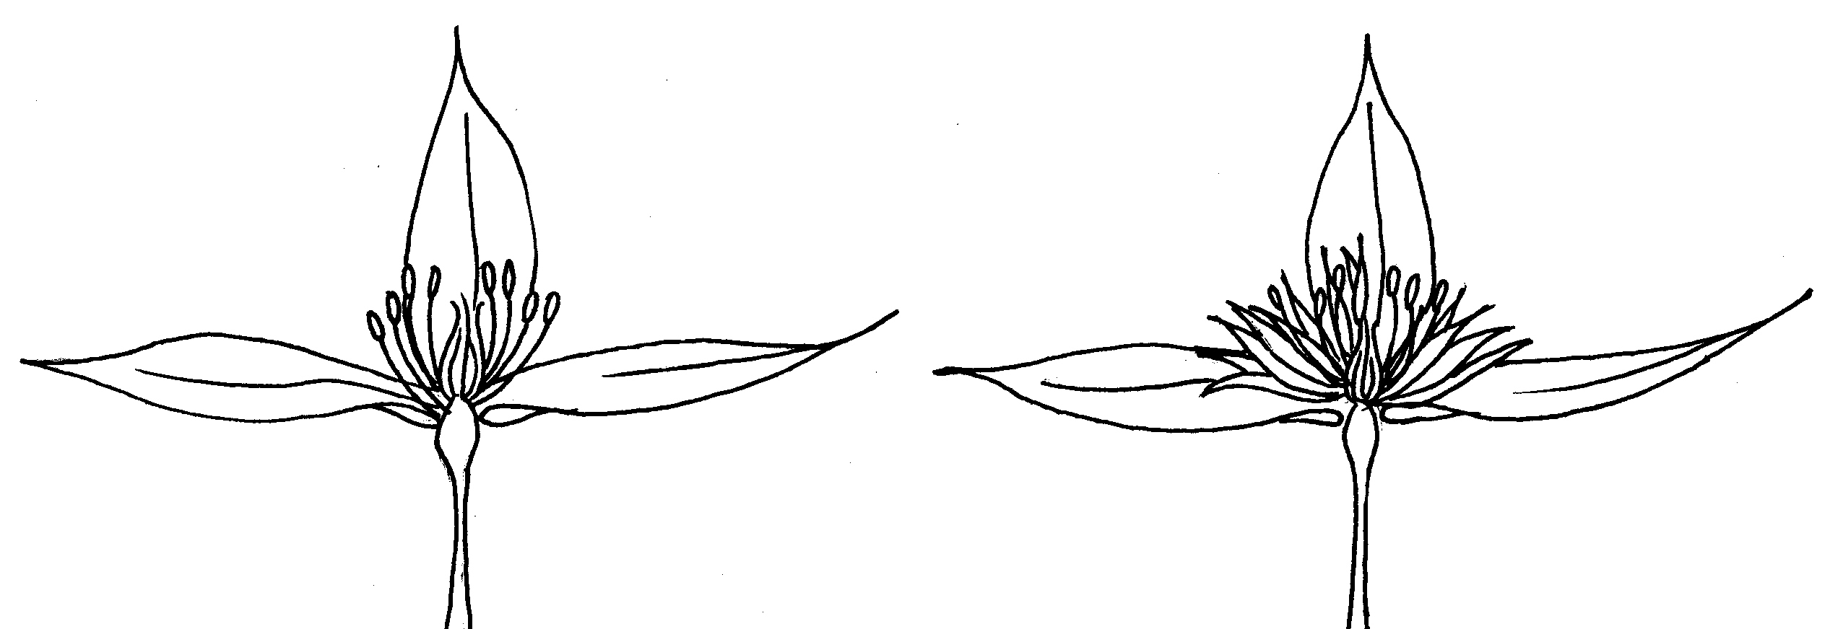
Anther
Filament
Petaloid
Staminode
Stigma
Style
Filament
Sepal
Sepal

Clematis flower with stamens | Clematis flower with stamens and petaloid staminodes

8.2 Explanations for individual characteristics

Ad. 3: Climbing varieties only: Plant: vigor

The plant vigor should be considered as the overall abundance of vegetative growth.

Ad. 6: Leaf: type

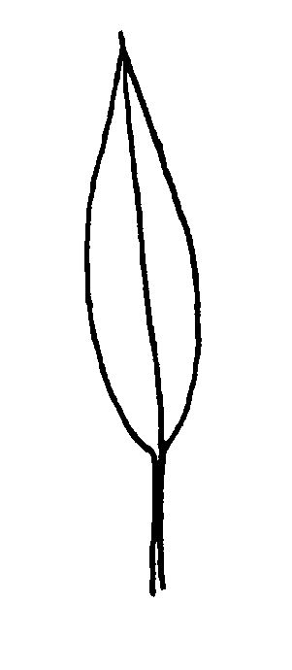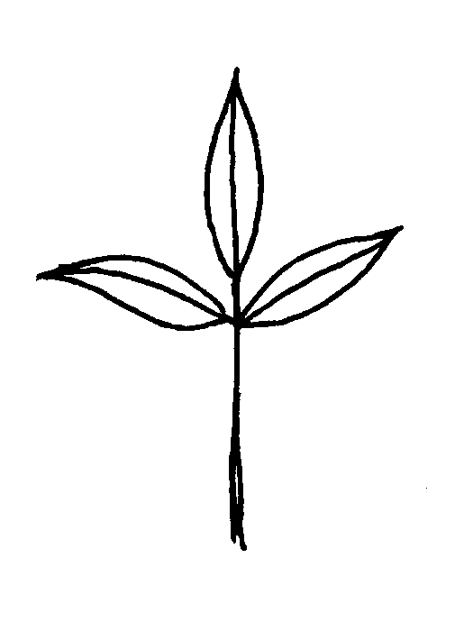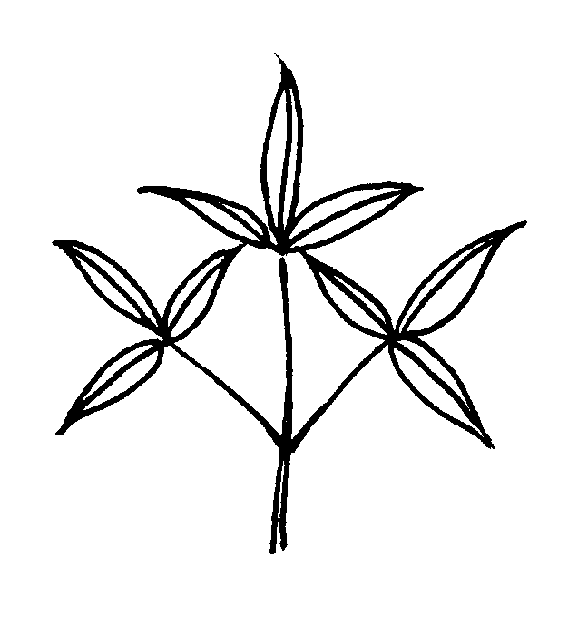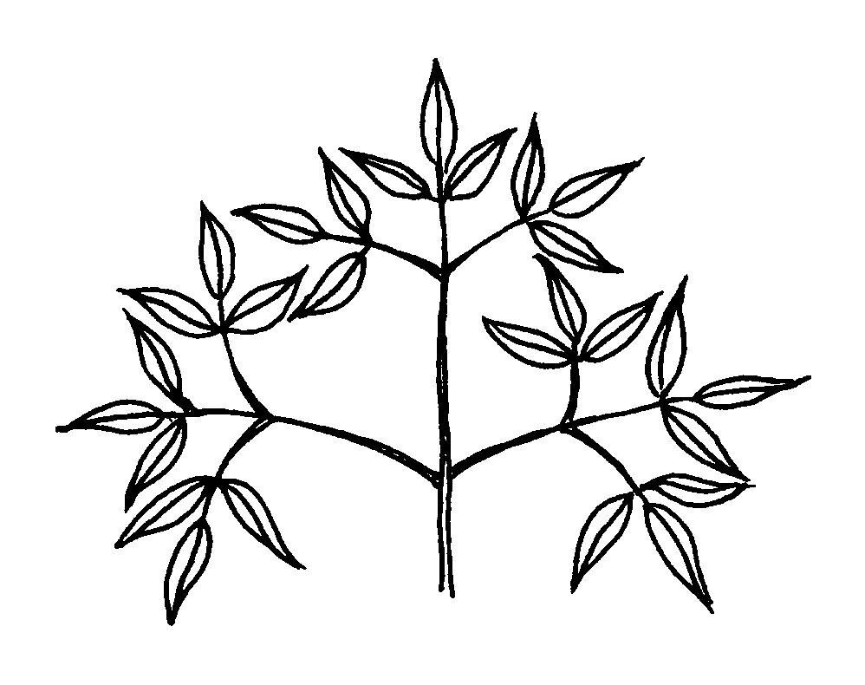

1 | 2 | 3 | 4
simple | ternate | biternate | triternate

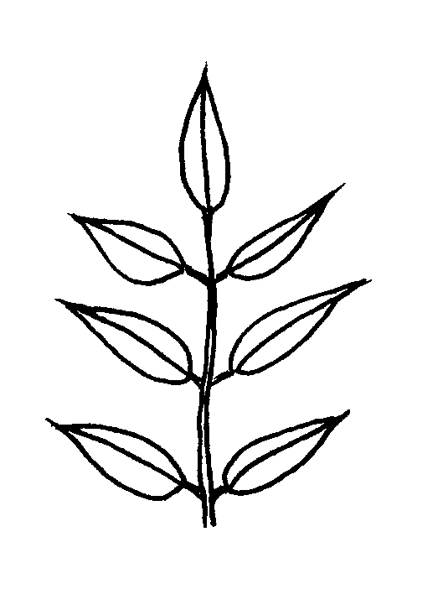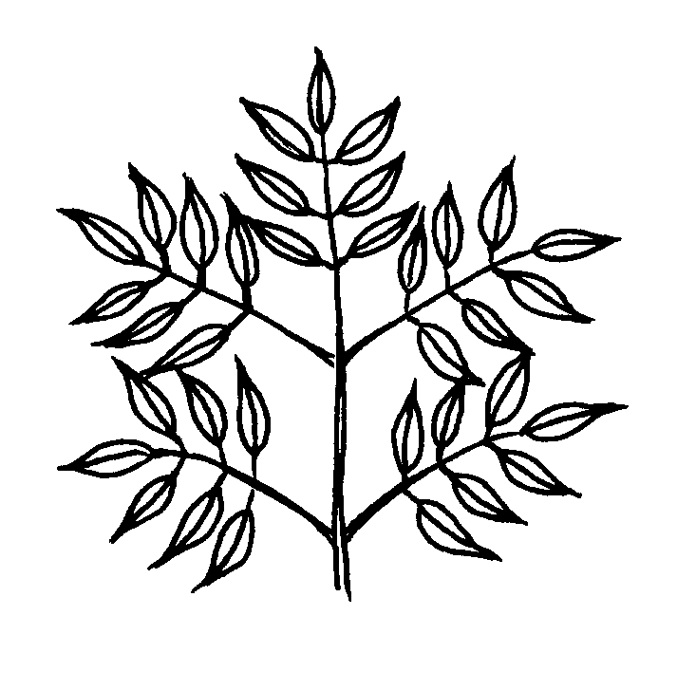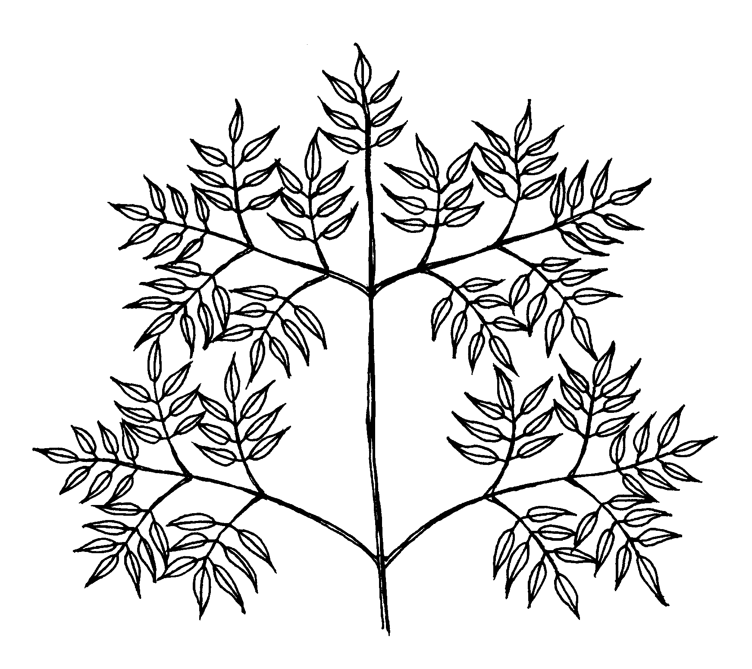

5 | 6 | 7
pinnate | bipinnate | tripinnate

Ad. 9: Leaf blade: shape

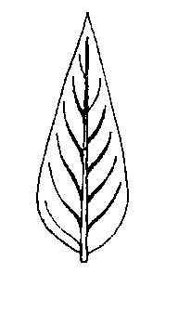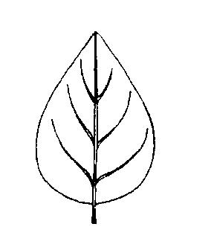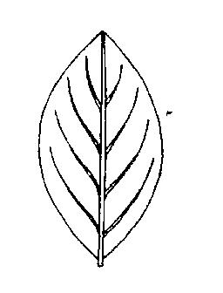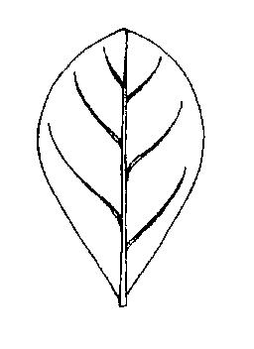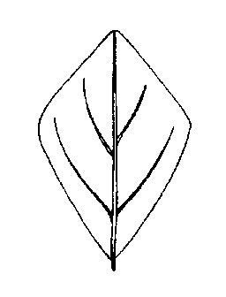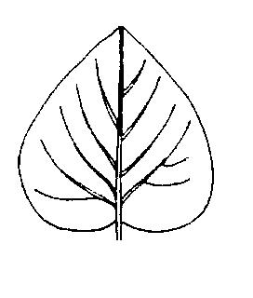

1 | 2 | 3 | 4 | 5 | 6
lanceolate | ovate | elliptic | obovate | rhombic | cordate

Ad. 10: Leaf blade: shape of apex

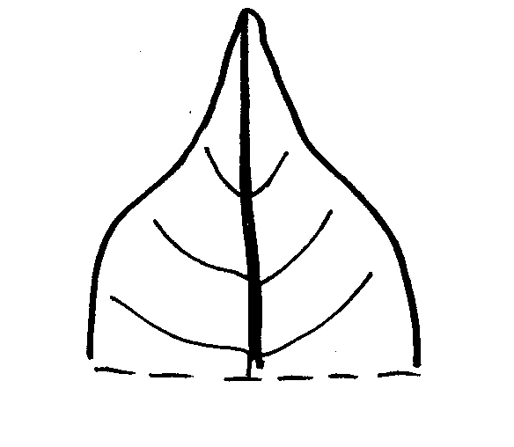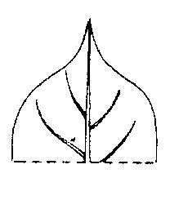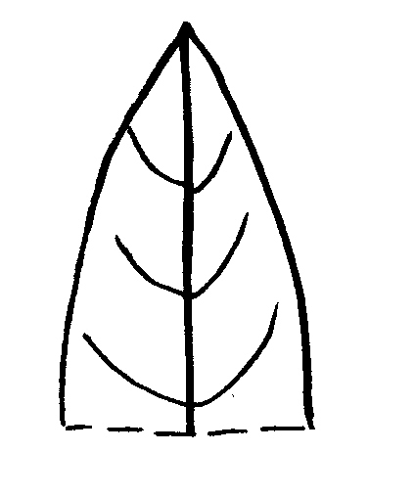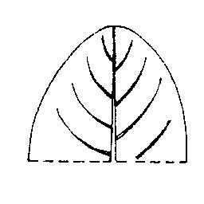

1 | 2 | 3 | 4
acuminate | cuspidate | acute | rounded

Ad.11: Leaf blade: shape of base

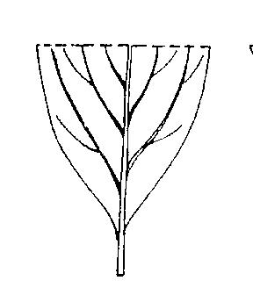 | 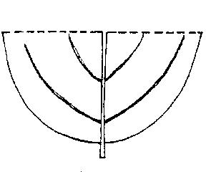 | 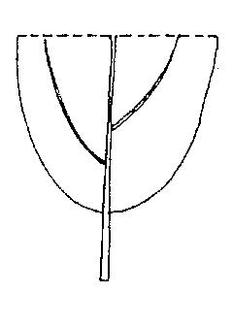 | 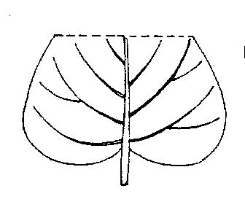
1 | 2 | 3 | 4
acute | obtuse | rounded | cordate

Ad. 12: Leaf blade: margin

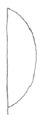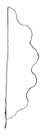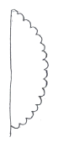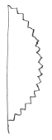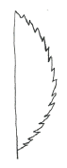

1 | 2 | 3 | 4 | 5
entire | sinuate | crenate | dentate | serrate

Ad. 15: Lobed varieties only: Leaf blade: depth of sinus between lobes

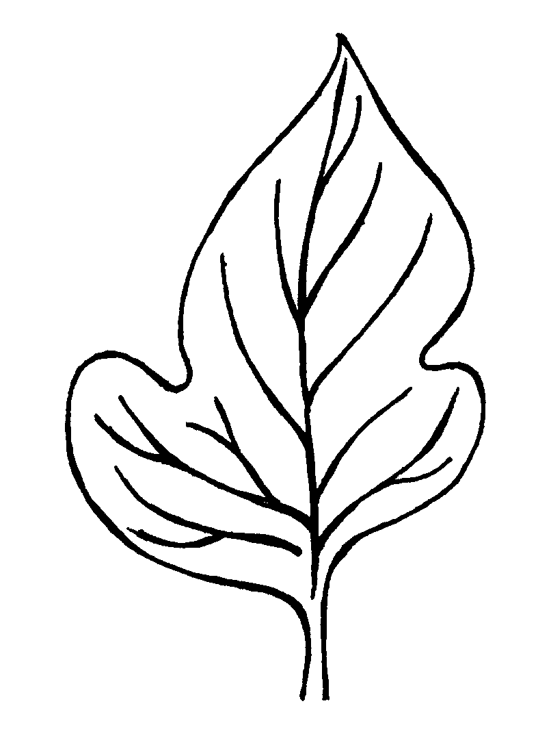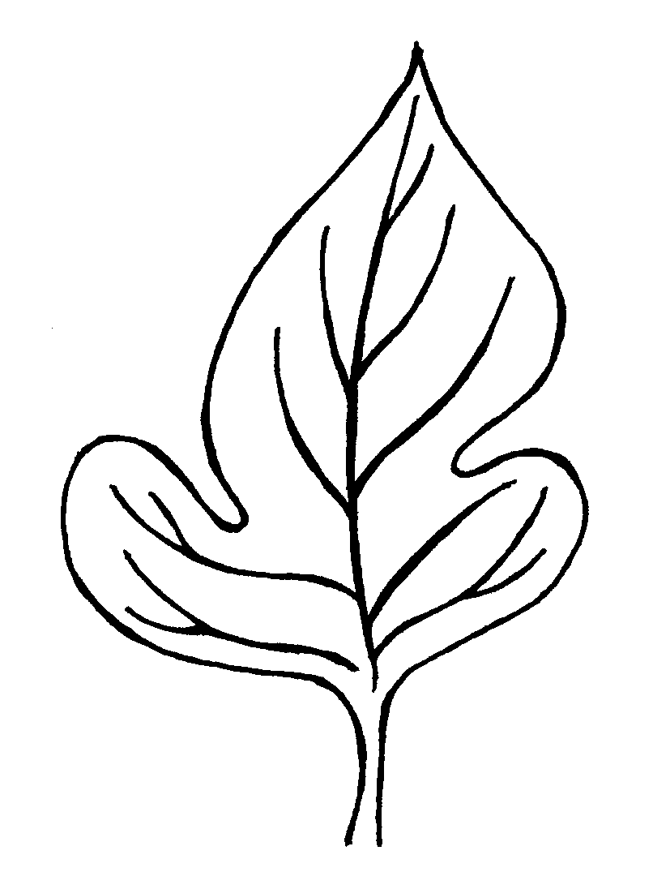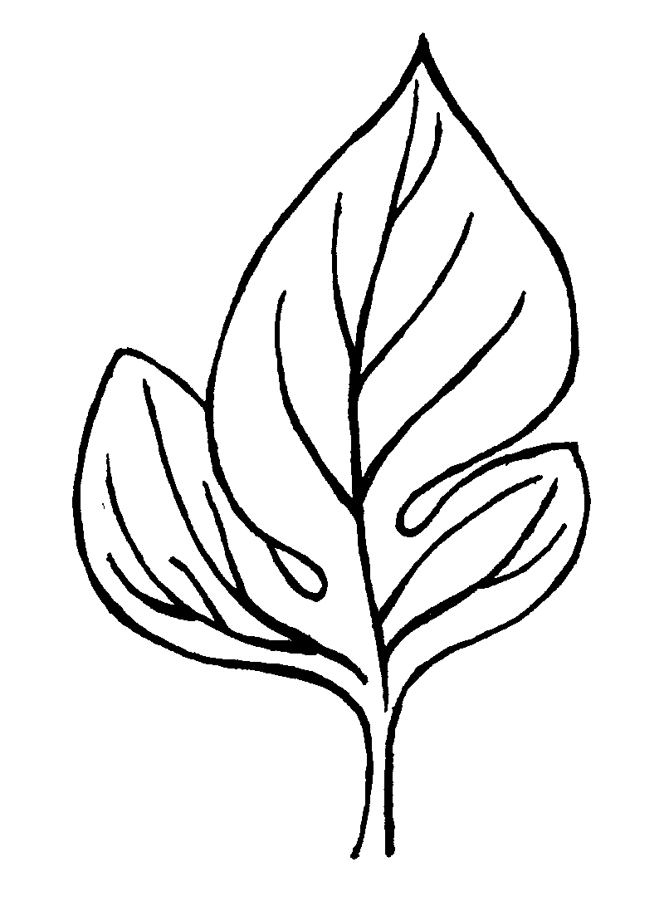

3 | 5 | 7
shallow | medium | deep

Ad. 21: Flower: attitude

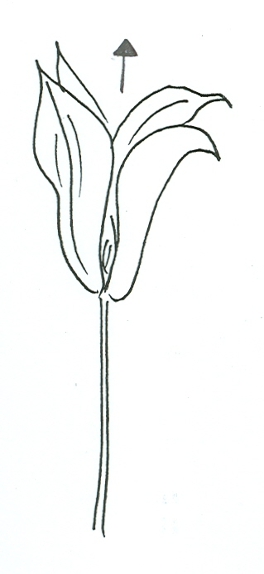 | 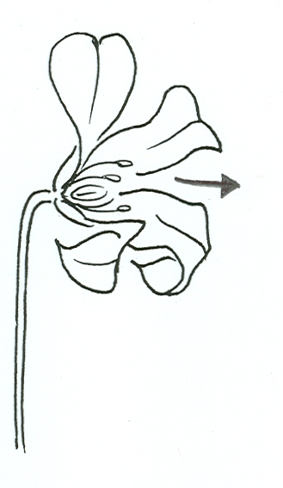 | 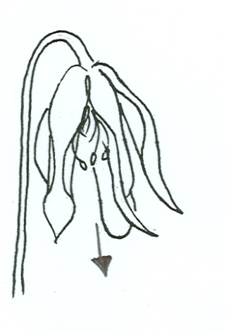
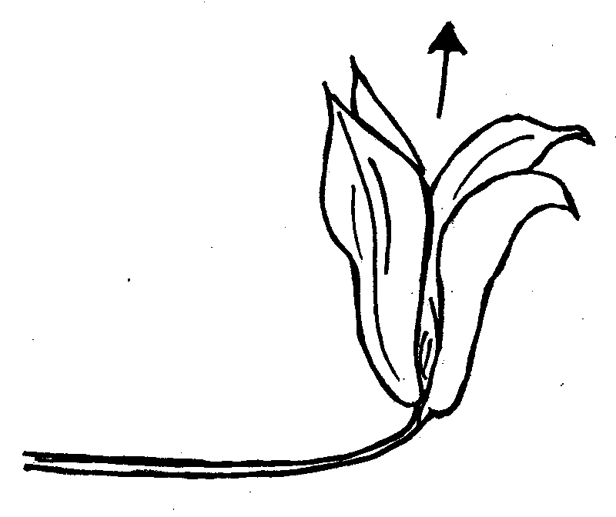 | 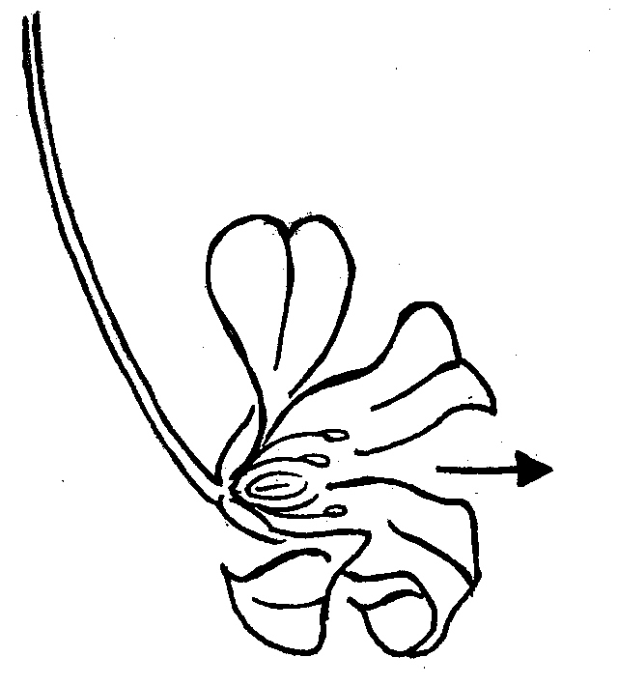 | 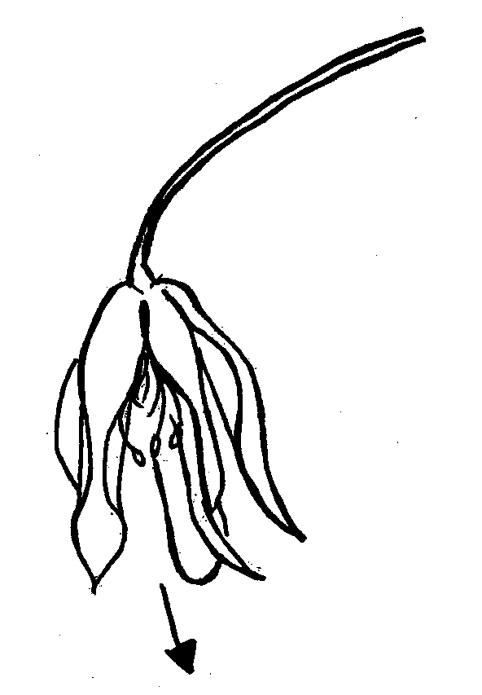
1 | 2 | 3
upwards | outwards | downwards

Ad. 22: Flower: type

Single: Flower which has one complete whorl of sepals
Semi-double: Flower which has one complete whorl of sepals plus one or two whorls that may be complete or incomplete
Double: Flower which has more than three whorls of sepals

Ad. 24: Only varieties with flower type: single or semi-double: Flower: shape

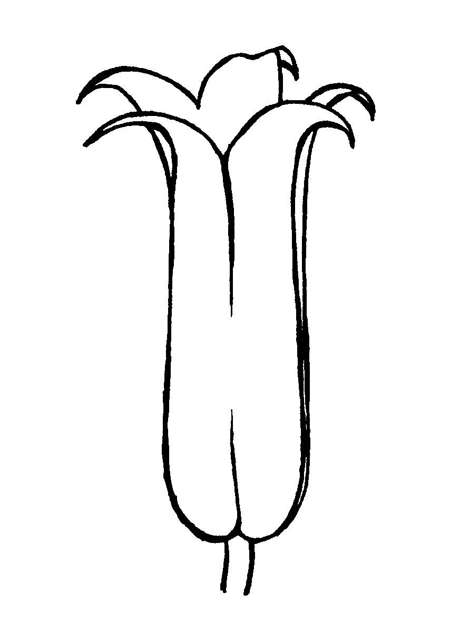 | 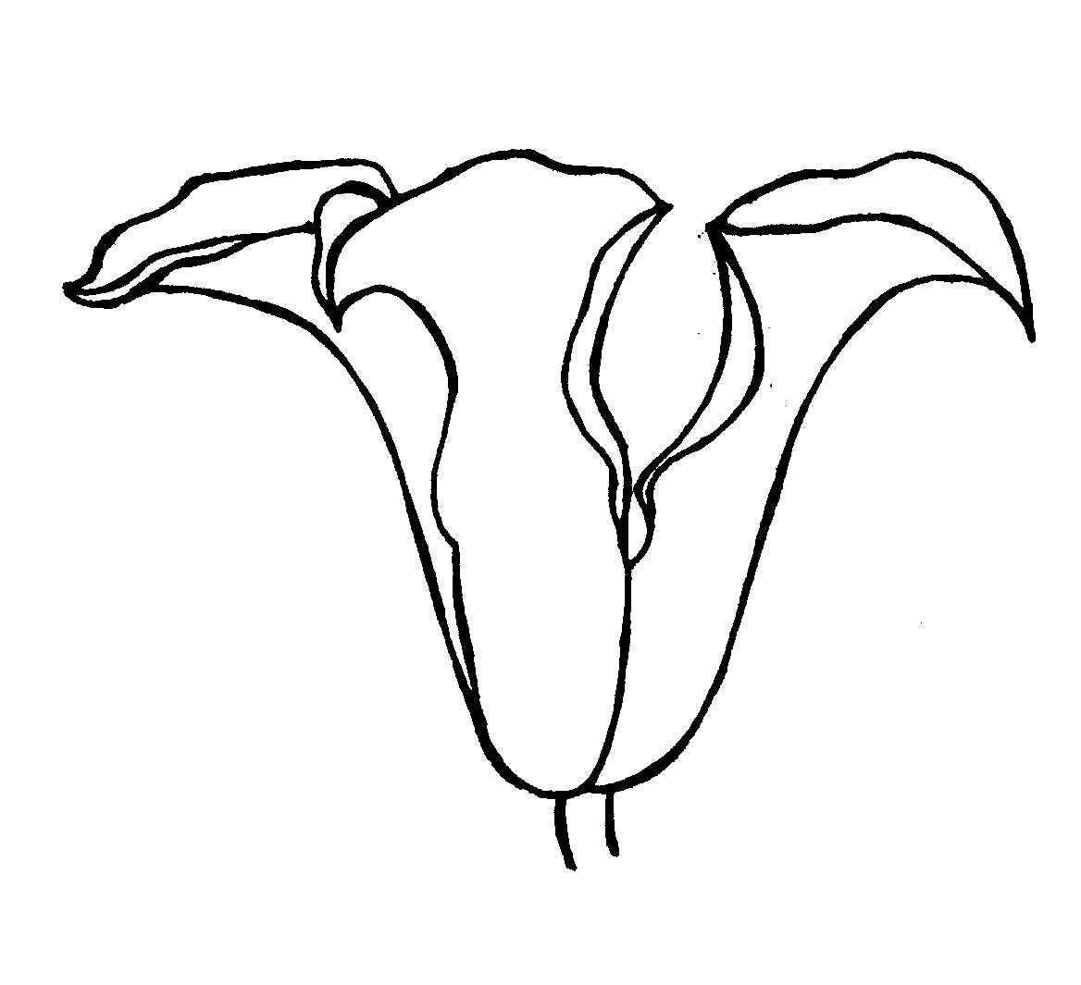 | 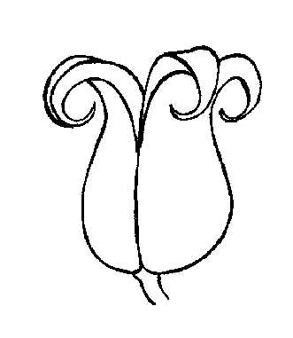 | 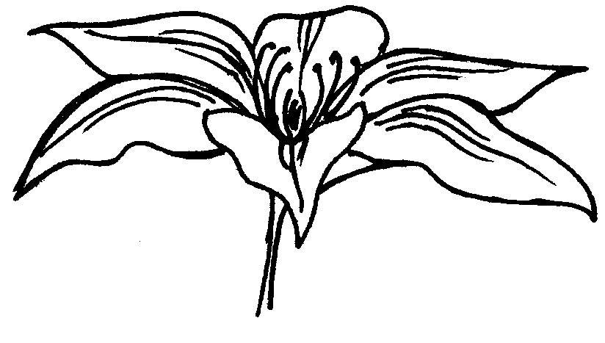
1 | 2 | 3 | 4
tubular | campanulate | urceolate | rotate
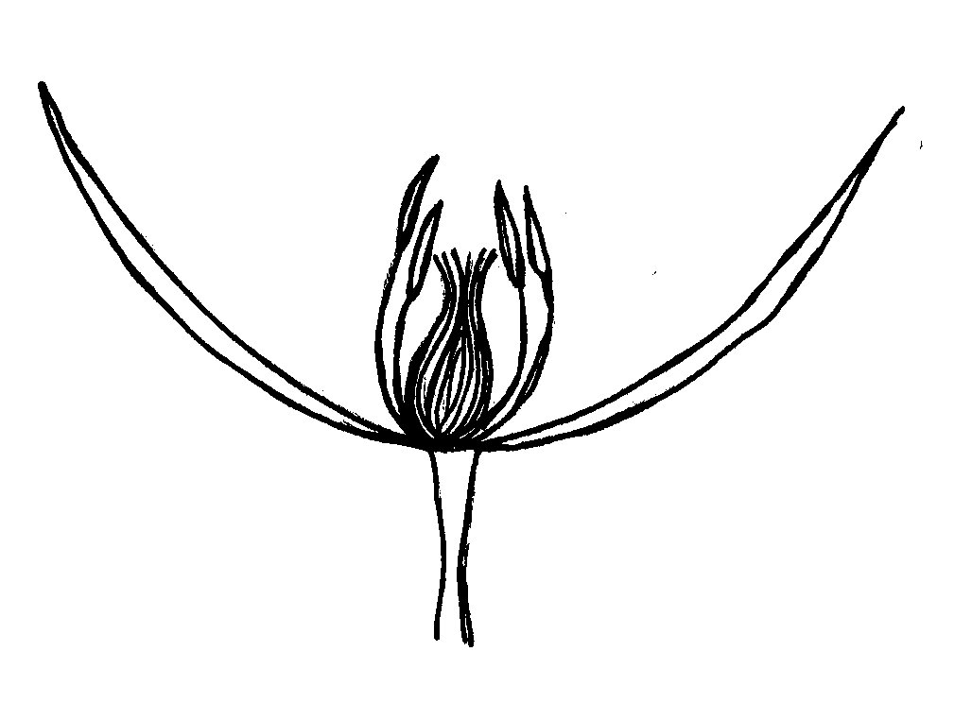
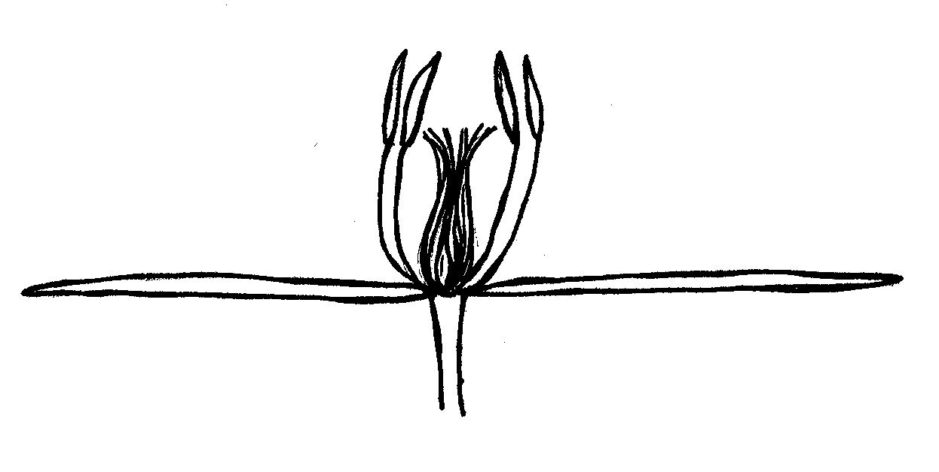
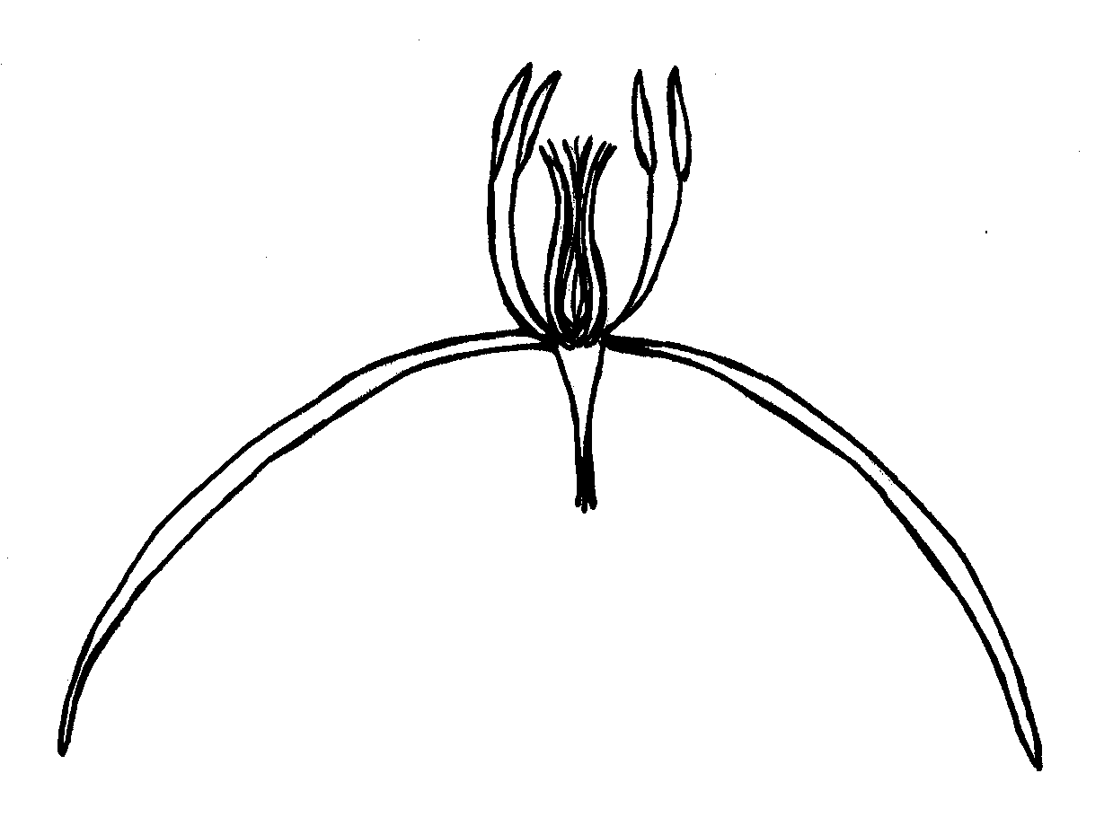
Ad. 25: Only varieties with flower shape: rotate: Flower: cross section in lateral view

1 | 2 | 3
concave | flat | convex

Ad. 27: Only varieties with flower shape: rotate: Flower: arrangement of sepals

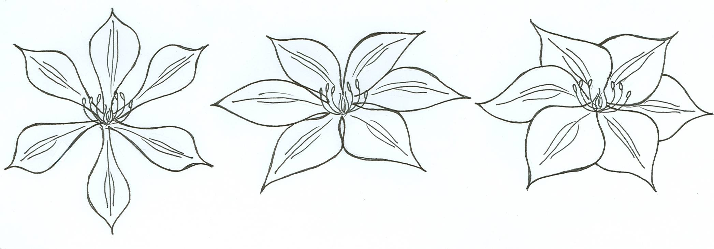
1 | 2 | 3
free | touching | overlapping

Ad. 32: Sepal: shape in cross section
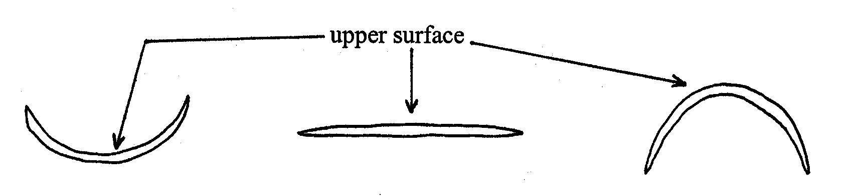

1 | 2 | 3
concave | flat | convex

Ad. 33: Only varieties with flower shape: rotate: Sepal: curvature in longitudinal section

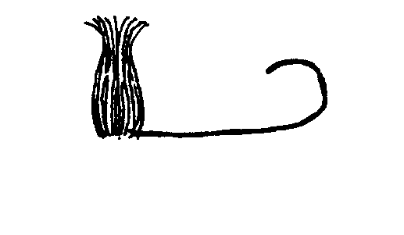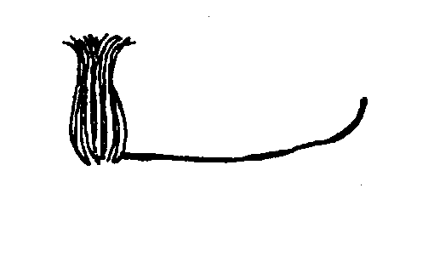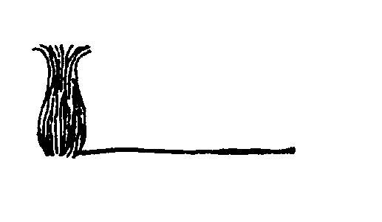

1 | 3 | 5
strongly incurved | moderately incurved | flat

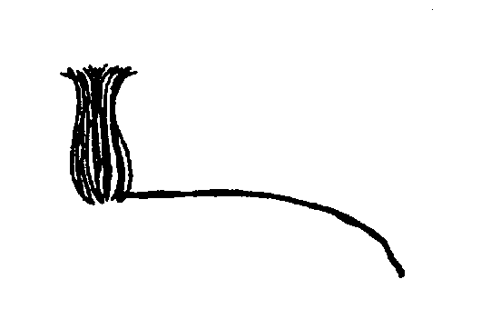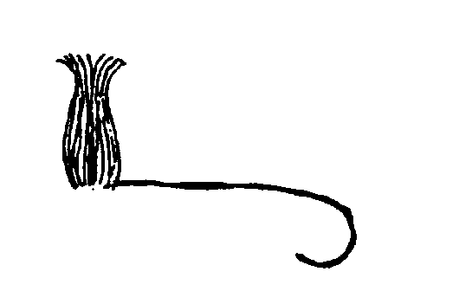
7 | 9
moderately reflexed | strongly reflexed

Ad. 34: Only varieties with flower shape: non rotate: Sepal: reflexing of apex

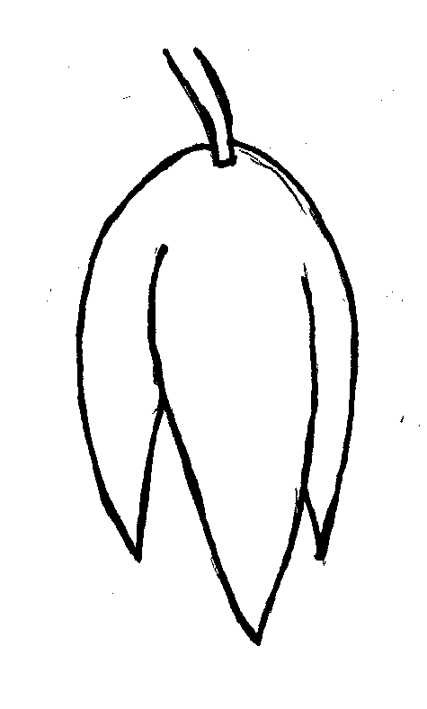
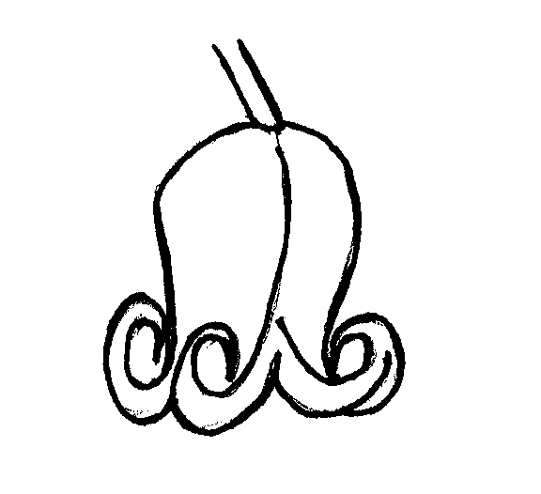
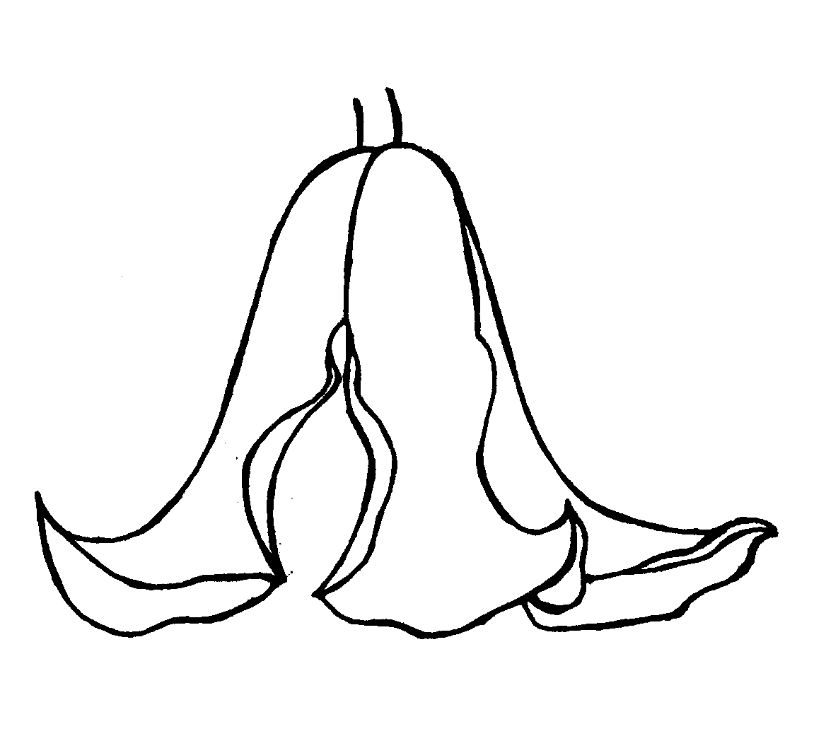
1 | 5 | 9
absent or very weak | medium | very strong

Ad. 35: Sepal: shape of apex

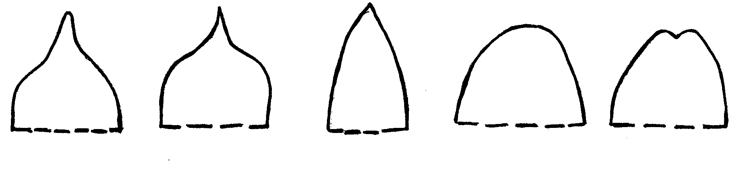
1 | 2 | 3 | 4 | 5
acuminate | cuspidate | acute | obtuse | retuse

Ad. 36: Sepal: shape of base

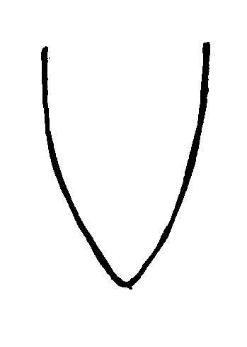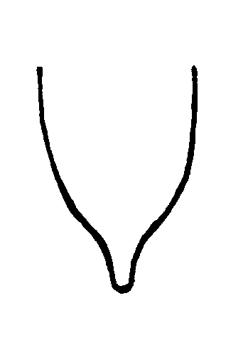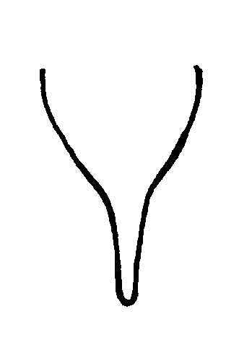

type 1 type 2 type 3

Ad. 41: Only varieties with more than one color: Sepal: distribution of secondary color on upper side

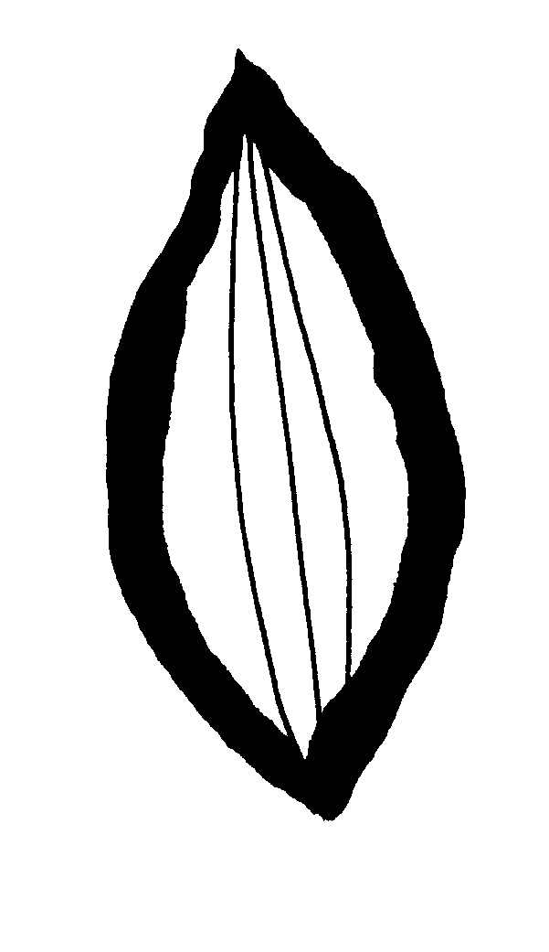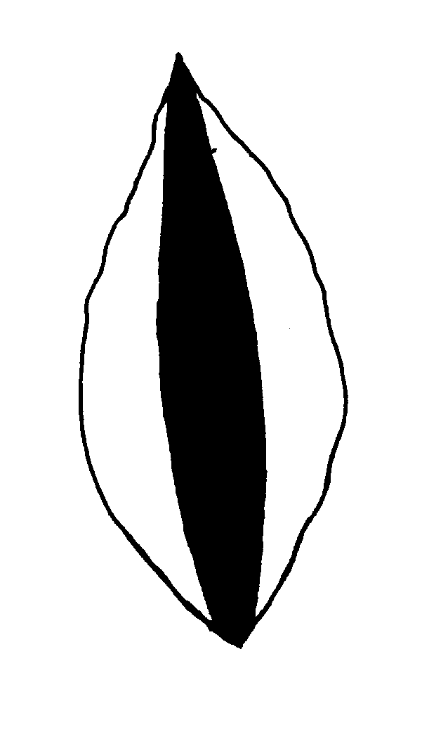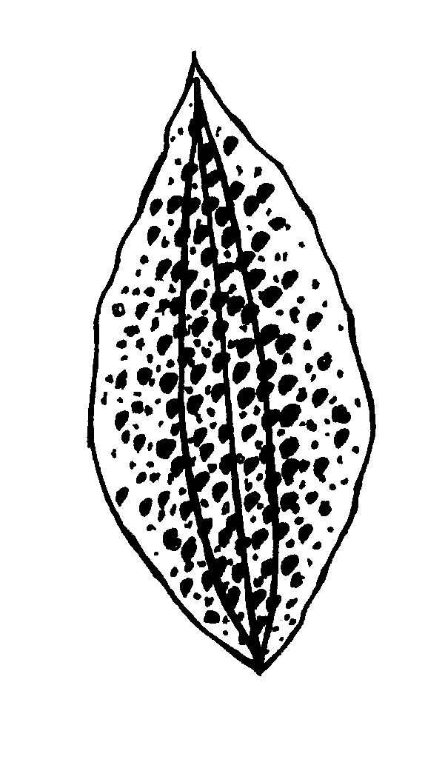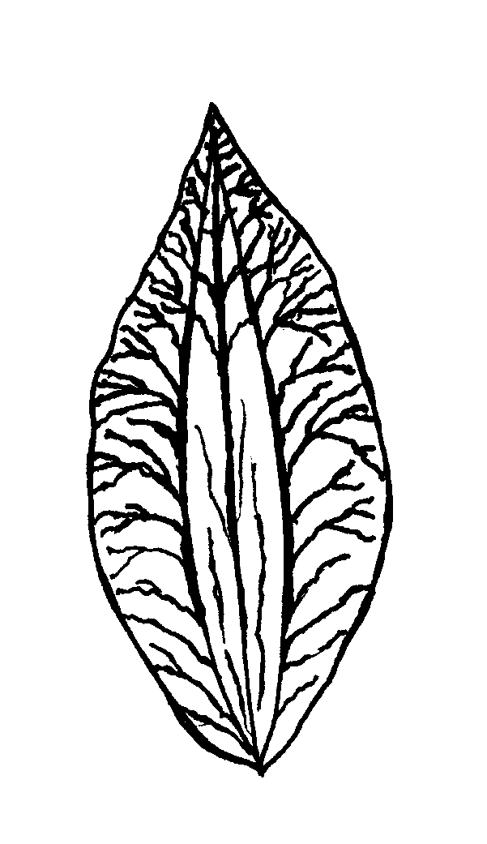
1 | 2 | 3 | 4
edged | central bar | speckled | along veins

Literature
Buczacki, S., 1998: Powojniki, ELIPSA, Warszawa, PL.

Evison, R., 1998: The Gardener’s Guide to Growing Clematis, David & Charles Publishers, Devon, GB.

Grey-Wilson, C., 2000: Clematis – the Genus, B.T. Batsford Ltd., London, GB.

Huxley, A. (ed.), Griffiths, M. (ed.), Levy, M. (ed.) 1999: The Royal Horticultural Society Dictionary of Gardening, McMillan Reference Ltd., London (Volume I, pp. 641-651), GB.

Johnson, M., 2001: The Genus Clematis, Magnus Johnsons Plantskola AB, Södertälje, SE.

Krüssmann, G. 1984: Manual of Cultivated Broad-Leaved Trees & Shrubs, Timber Press, Beaverton, Oregon (Volume I, pp. 339-353), US.

Sekowski, B., 1978: Powojniki, PWRiL, Warszawa, PL.

Toomey, M. and Leeds, E., 2001: An illustrated encyclopedia of Clematis, Timber Press, Portland, Oregon, US.

Technical Questionnaire
TECHNICAL QUESTIONNAIRE |  |  |  | Page {x} of {y} |  |  | Reference Number:
 |  |  |  |  |  |  | Application date:
 |  |  |  |  |  |  | (not to be filled in by the applicant)
TECHNICAL QUESTIONNAIRE
to be completed in connection with an application for plant breeders’ rights

1. Subject of the Technical Questionnaire
1.1 Botanical name |  |  | Clematis L.
1.2 Common name |  |  | Clematis
Species/Group (please complete)
2. Applicant
Name
Address
Telephone No.
Fax No.
E-mail address
Breeder (if different from applicant)
3. Proposed denomination and breeder’s reference
Proposed denomination
(if available)

Breeder’s reference
#4. Information on the breeding scheme and propagation of the variety

4.1 Breeding scheme

Variety resulting from:

4.1.1 Crossing

(a) controlled cross [ ]
(please state parent varieties)
(b) partially known cross [ ]
(please state known parent variety(ies))
(c) unknown cross [ ]

4.1.2 Mutation [ ]
(please state parent variety)

4.1.3 Discovery and development [ ]
(please state where and when discovered
and how developed)

4.1.4 Other [ ]
(please provide details)

4.2 Method of propagating the variety

(a) cuttings [ ]

(b) in vitro propagation [ ]

(c) seed [ ]

(d) other (specify method) [ ]

5. Characteristics of the variety to be indicated (the number in brackets refers to the corresponding characteristic in Test Guidelines; please mark the note which best corresponds).

 | Characteristics |  |  |  |  | Example Varieties |  |  |  | Note
5.1  (1) | Plant: type
 | non-climbing |  |  |  |  | Evisix |  |  |  | 1[ ]
 | climbing |  |  |  |  | Tetrarose |  |  |  | 2[ ]
5.2  (6) | Leaf: type
 | simple |  |  |  |  |  |  |  |  | 1[ ]
 | ternate |  |  |  |  |  |  |  |  | 2[ ]
 | biternate |  |  |  |  |  |  |  |  | 3[ ]
 | triternate |  |  |  |  |  |  |  |  | 4[ ]
 | pinnate |  |  |  |  |  |  |  |  | 5[ ]
 | bipinnate |  |  |  |  |  |  |  |  | 6[ ]
 | tripinnate |  |  |  |  |  |  |  |  | 7[ ]
5.3  (22) | Flower: type
 | single |  |  |  |  | Nelly Moser, Perle d’Azur |  |  |  | 1[ ]
 | semi-double |  |  |  |  | Caroline Lloyd, Marjorie |  |  |  | 2[ ]
 | double |  |  |  |  | Kiri Te Kanawa, Multi Blue |  |  |  | 3[ ]
5.4  (23) | Flower: diameter
 | very small |  |  |  |  | Marjorie |  |  |  | 1[ ]
 | small |  |  |  |  | Little Nell |  |  |  | 3[ ]
 | medium |  |  |  |  | Perle d’Azur |  |  |  | 5[ ]
 | large |  |  |  |  | Evista |  |  |  | 7[ ]
 | very large |  |  |  |  | Fairy Queen, Kacper |  |  |  | 9[ ]
 | Characteristics |  |  |  |  | Example Varieties |  |  |  | Note
5.5  (37) | Sepal: number of colors of upper side
 | one |  |  |  |  | Lady Northcliffe |  |  |  | 1[ ]
 | more than one |  |  |  |  | Evione, Nelly Moser |  |  |  | 2[ ]
5.6i  (38) | Sepal: main color of upper side
RHS Colour Chart (indicate reference number)
…………………………………………………
5.6ii  (38) | Sepal: main color of upper side
 | white |  |  |  |  |  |  |  |  | 1[ ]
 | yellow |  |  |  |  |  |  |  |  | 2[ ]
 | pink |  |  |  |  |  |  |  |  | 3[ ]
 | red |  |  |  |  |  |  |  |  | 4[ ]
 | purple |  |  |  |  |  |  |  |  | 5[ ]
 | violet |  |  |  |  |  |  |  |  | 6[ ]
 | blue |  |  |  |  |  |  |  |  | 7[ ]
 | green |  |  |  |  |  |  |  |  | 8[ ]
6. Similar varieties and differences from these varieties

Please use the table, and space provided for comments, below to provide information on how your candidate variety differs from the variety (or varieties) which, to the best of your knowledge, is (or are) most similar. This information may help the examination authority to conduct its examination of distinctness in a more efficient way.

Denomination(s) of variety(ies) similar to your candidate variety |  | Characteristic(s) in which your candidate variety differs from the similar variety(ies) |  |  | Describe the expression of the characteristic(s) for the similar variety(ies) |  |  | Describe the expression of the characteristic(s) for your candidate variety
Example |  | Flower: diameter |  |  | small |  |  | medium
Comments:

#7. Additional information which may help in the examination of the variety

7.1 In addition to the information provided in sections 5 and 6, are there any additional characteristics which may help to distinguish the variety?

Yes [ ] No [ ]

(If yes, please provide details)

7.2 Are there any special conditions for growing the variety or conducting the examination?

Yes [ ] No [ ]

(If yes, please provide details)

7.3 Other information

A representative color photograph of the variety should accompany the Technical Questionnaire.

8. Authorization for release

(a) Does the variety require prior authorization for release under legislation concerning the protection of the environment, human and animal health?

Yes [ ] No [ ]

(b) Has such authorization been obtained?

Yes [ ] No [ ]

If the answer to (b) is yes, please attach a copy of the authorization.

9. Information on plant material to be examined or submitted for examination.

9.1 The expression of a characteristic or several characteristics of a variety may be affected by factors, such as pests and disease, chemical treatment (e.g. growth retardants or pesticides), effects of tissue culture, different rootstocks, scions taken from different growth phases of a tree, etc.

9.2 The plant material should not have undergone any treatment which would affect the expression of the characteristics of the variety, unless the competent authorities allow or request such treatment. If the plant material has undergone such treatment, full details of the treatment must be given. In this respect, please indicate below, to the best of your knowledge, if the plant material to be examined has been subjected to:

(a) Microorganisms (e.g. virus, bacteria, phytoplasma) Yes [ ] No [ ]

(b) Chemical treatment (e.g. growth retardant, pesticide) Yes [ ] No [ ]

(c) Tissue culture Yes [ ] No [ ]

(d) Other factors Yes [ ] No [ ]

Please provide details for where you have indicated “yes”.

……………………………………………………………

10. I hereby declare that, to the best of my knowledge, the information provided in this form is correct:

Applicant’s name

Signature Date

[End of document]

* These names were correct at the time of the introduction of these Test Guidelines but may be revised or updated. [Readers are advised to consult the UPOV Code, which can be found on the UPOV Website (www.upov.int), for the latest information.]
# Authorities may allow certain of this information to be provided in a confidential section of the Technical Questionnaire.
# Authorities may allow certain of this information to be provided in a confidential section of the Technical Questionnaire.

