 |  | E  TG/213/2 Rev. Corr.  ORIGINAL: English  DATE: 2013-03-20 + 2019-10-29  + 2020-11-17
INTERNATIONAL UNION FOR THE PROTECTION OF NEW VARIETIES OF PLANTS
Geneva

 | PHALAENOPSIS  UPOV Code: PHALE  Phalaenopsis Blume | *

GUIDELINES

FOR THE CONDUCT OF TESTS

FOR DISTINCTNESS, UNIFORMITY AND STABILITY

Alternative Names:*

Botanical name | English | French | German | Spanish
Phalaenopsis Blume | Moth Orchid | Orchidée papillon | Phalaenopsis, Schmetterlingsorchidee | Phalaenopsis,  Orquídea Mariposa

The purpose of these guidelines (“Test Guidelines”) is to elaborate the principles contained in the General Introduction (document TG/1/3), and its associated TGP documents, into detailed practical guidance for the harmonized examination of distinctness, uniformity and stability (DUS) and, in particular, to identify appropriate characteristics for the examination of DUS and production of harmonized variety descriptions.

ASSOCIATED DOCUMENTS
These Test Guidelines should be read in conjunction with the General Introduction and its associated TGP documents.
TABLE OF CONTENTS PAGE

1. Subject of these Test Guidelines 3
2. Material Required 3
3. Method of Examination 3
3.1 Number of Growing Cycles 3
3.2 Testing Place 3
3.3 Conditions for Conducting the Examination 3
3.4 Test Design 3
3.5 Additional Tests 3
4. Assessment of Distinctness, Uniformity and Stability 4
4.1 Distinctness 4
4.2 Uniformity 5
4.3 Stability 5
5. Grouping of Varieties and Organization of the Growing Trial 5
6. Introduction to the Table of Characteristics 6
6.1 Categories of Characteristics 6
6.2 States of Expression and Corresponding Notes 6
6.3 Types of Expression 6
6.4 Example Varieties 7
6.5 Legend 7
7. Table of Characteristics/Tableau des caractères/Merkmalstabelle/Tabla de caracteres 8
8. Explanations on the Table of Characteristics 23
8.1 Explanations covering several characteristics 23
8.2 Explanations for individual characteristics 23
9. Literature 31
10. Technical Questionnaire 32

Subject of these Test Guidelines

These Test Guidelines apply to all varieties of Phalaenopsis Blume.

Material Required

2.1 The competent authorities decide on the quantity and quality of the plant material required for testing the variety and when and where it is to be delivered. Applicants submitting material from a State other than that in which the testing takes place must ensure that all customs formalities and phytosanitary requirements are complied with.

2.2 The material is to be supplied in the form of budded plants that have not previously flowered.

2.3 The minimum quantity of plant material, to be supplied by the applicant, should be:

9 plants.

2.4 The plant material supplied should be visibly healthy, not lacking in vigor, nor affected by any important pest or disease.

2.5 The plant material should not have undergone any treatment which would affect the expression of the characteristics of the variety, unless the competent authorities allow or request such treatment. If it has been treated, full details of the treatment must be given.

Method of Examination

3.1 Number of Growing Cycles

The minimum duration of tests should normally be a single growing cycle.

3.2 Testing Place

Tests are normally conducted at one place. In the case of tests conducted at more than one place, guidance is provided in TGP/9 “Examining Distinctness”.

3.3 Conditions for Conducting the Examination

3.3.1 The tests should be carried out under conditions ensuring satisfactory growth for the expression of the relevant characteristics of the variety and for the conduct of the examination.

3.3.2 Because daylight varies, color determinations made against a color chart should be made either in a suitable cabinet providing artificial daylight or in the middle of the day in a room without direct sunlight. The spectral distribution of the illuminant for artificial daylight should conform with the CIE Standard of Preferred Daylight D 6500 and should fall within the tolerances set out in the British Standard 950, Part I. These determinations should be made with the plant part placed against a white background. The color chart and version used should be specified in the variety description.

3.4 Test Design

3.4.1 Each test should be designed to result in a total of at least 9 plants.

3.4.2 The design of the tests should be such that plants or parts of plants may be removed for measurement or counting without prejudice to the observations which must be made up to the end of the growing cycle.

3.5 Additional Tests

Additional tests, for examining relevant characteristics, may be established.

Assessment of Distinctness, Uniformity and Stability

4.1 Distinctness

4.1.1 General Recommendations

It is of particular importance for users of these Test Guidelines to consult the General Introduction prior to making decisions regarding distinctness. However, the following points are provided for elaboration or emphasis in these Test Guidelines.

4.1.2 Consistent Differences

The differences observed between varieties may be so clear that more than one growing cycle is not necessary. In addition, in some circumstances, the influence of the environment is not such that more than a single growing cycle is required to provide assurance that the differences observed between varieties are sufficiently consistent. One means of ensuring that a difference in a characteristic, observed in a growing trial, is sufficiently consistent is to examine the characteristic in at least two independent growing cycles.

4.1.3 Clear Differences

Determining whether a difference between two varieties is clear depends on many factors, and should consider, in particular, the type of expression of the characteristic being examined, i.e. whether it is expressed in a qualitative, quantitative, or pseudo-qualitative manner. Therefore, it is important that users of these Test Guidelines are familiar with the recommendations contained in the General Introduction prior to making decisions regarding distinctness.

4.1.4 Number of Plants / Parts of Plants to be Examined

Unless otherwise indicated, for the purposes of distinctness, all observations on single plants should be made on 8 plants or parts taken from each of 8 plants and any other observations made on all plants in the test, disregarding any off-type plants.

4.1.5 Method of Observation

The recommended method of observing the characteristic for the purposes of distinctness is indicated by the following key in the second column of the Table of Characteristics (see document TGP/9 “Examining Distinctness”, Section 4 “Observation of characteristics”):

MG: single measurement of a group of plants or parts of plants
MS: measurement of a number of individual plants or parts of plants
VG: visual assessment by a single observation of a group of plants or parts of plants
VS: visual assessment by observation of individual plants or parts of plants

Type of observation: visual (V) or measurement (M)

“Visual” observation (V) is an observation made on the basis of the expert’s judgment. For the purposes of this document, “visual” observation refers to the sensory observations of the experts and, therefore, also includes smell, taste and touch. Visual observation includes observations where the expert uses reference points (e.g. diagrams, example varieties, side-by-side comparison) or non-linear charts (e.g. color charts). Measurement (M) is an objective observation against a calibrated, linear scale e.g. using a ruler, weighing scales, colorimeter, dates, counts, etc.

Type of record: for a group of plants (G) or for single, individual plants (S)

For the purposes of distinctness, observations may be recorded as a single record for a group of plants or parts of plants (G), or may be recorded as records for a number of single, individual plants or parts of plants (S). In most cases, “G” provides a single record per variety and it is not possible or necessary to apply statistical methods in a plant-by-plant analysis for the assessment of distinctness.

In cases where more than one method of observing the characteristic is indicated in the Table of Characteristics (e.g. VG/MG), guidance on selecting an appropriate method is provided in document TGP/9, Section 4.2.

4.2 Uniformity

4.2.1 It is of particular importance for users of these Test Guidelines to consult the General Introduction prior to making decisions regarding uniformity. However, the following points are provided for elaboration or emphasis in these Test Guidelines:

4.2.2 For the assessment of uniformity a population standard of 1% and an acceptance probability of at least 95% should be applied. In the case of a sample size of 9 plants, 1 off-type is allowed.

4.3 Stability

4.3.1 In practice, it is not usual to perform tests of stability that produce results as certain as those of the testing of distinctness and uniformity. However, experience has demonstrated that, for many types of variety, when a variety has been shown to be uniform, it can also be considered to be stable.

4.3.2 Where appropriate, or in cases of doubt, stability may be further examined by testing a new plant stock to ensure that it exhibits the same characteristics as those shown by the initial material supplied.

Grouping of Varieties and Organization of the Growing Trial

5.1 The selection of varieties of common knowledge to be grown in the trial with the candidate varieties and the way in which these varieties are divided into groups to facilitate the assessment of distinctness are aided by the use of grouping characteristics.

5.2 Grouping characteristics are those in which the documented states of expression, even where produced at different locations, can be used, either individually or in combination with other such characteristics: (a) to select varieties of common knowledge that can be excluded from the growing trial used for examination of distinctness; and (b) to organize the growing trial so that similar varieties are grouped together.

5.3 The following have been agreed as useful grouping characteristics:

- Plant: length (characteristic 1)
- Leaf: variegation (characteristic 10)
- Leaf: spots on upper side (characteristic 11)
- Flower: width in front view (characteristic 22)
- Petal: ground color of upper side (characteristic 58) with the following groups
Gr. 1: white
Gr. 2: yellow
Gr. 3: green
Gr. 4: orange
Gr. 5: red
Gr. 6: violet
Gr. 7: purple red
Gr. 8: purple
Gr. 9: brown
- Petal: over color (if present) (characteristic 59) with the following groups
Gr. 1: yellow
Gr. 2: green
Gr. 3: orange
Gr. 4: red
Gr. 5: violet
Gr. 6: purple red
Gr. 7: purple
Gr. 8: brown
- Petal: number of spots (characteristic 61)
- Petal: number of stripes (characteristic 64)
- Petal: density of netting (characterestic 66)

5.4 Guidance for the use of grouping characteristics, in the process of examining distinctness, is provided through the General Introduction and document TGP/9 “Examining Distinctness”.

Introduction to the Table of Characteristics

6.1 Categories of Characteristics

6.1.1 Standard Test Guidelines Characteristics

Standard Test Guidelines characteristics are those which are approved by UPOV for examination of DUS and from which members of the Union can select those suitable for their particular circumstances.

6.1.2 Asterisked Characteristics

Asterisked characteristics (denoted by *) are those included in the Test Guidelines which are important for the international harmonization of variety descriptions and should always be examined for DUS and included in the variety description by all members of the Union, except when the state of expression of a preceding characteristic or regional environmental conditions render this inappropriate.

6.2 States of Expression and Corresponding Notes

6.2.1 States of expression are given for each characteristic to define the characteristic and to harmonize descriptions. Each state of expression is allocated a corresponding numerical note for ease of recording of data and for the production and exchange of the description.

6.2.2 In the case of qualitative and pseudo-qualitative characteristics (see Chapter 6.3), all relevant states of expression are presented in the characteristic. However, in the case of quantitative characteristics with 5 or more states, an abbreviated scale may be used to minimize the size of the Table of Characteristics. For example, in the case of a quantitative characteristic with 9 states, the presentation of states of expression in the Test Guidelines may be abbreviated as follows:

State | Note
small | 3
medium | 5
large | 7

However, it should be noted that all of the following 9 states of expression exist to describe varieties and should be used as appropriate:

State | Note
very small | 1
very small to small | 2
small | 3
small to medium | 4
medium | 5
medium to large | 6
large | 7
large to very large | 8
very large | 9

6.2.3 Further explanation of the presentation of states of expression and notes is provided in document TGP/7 “Development of Test Guidelines”.

6.3 Types of Expression

An explanation of the types of expression of characteristics (qualitative, quantitative and pseudo-qualitative) is provided in the General Introduction.

6.4 Example Varieties

Where appropriate, example varieties are provided to clarify the states of expression of each characteristic.

6.5 Legend

(*) Asterisked characteristic – see Chapter 6.1.2

QL Qualitative characteristic – see Chapter 6.3
QN Quantitative characteristic – see Chapter 6.3
PQ Pseudo-qualitative characteristic – see Chapter 6.3

MG, MS, VG, VS – see Chapter 4.1.5

(a)-(c) See Explanations on the Table of Characteristics in Chapter 8.1

(+) See Explanations on the Table of Characteristics in Chapter 8.2.

Table of Characteristics/Tableau des caractères/Merkmalstabelle/Tabla de caracteres

 |  | English | français | deutsch | español | Example Varieties  Exemples  Beispielssorten  Variedades ejemplo | Note/  Nota
1.  (*)  (+) | VG/ MS | Plant: length | Plante : longueur | Pflanze: Länge | Planta: longitud
QN | (a) | short | courte | kurz | baja | Phalboezeq | 3
 |  | medium | moyenne | mittel | media | Phalpnizok, Red Eye | 5
 |  | long | longue | lang | larga | Figaro, Puccini | 7
2.  (*) | VG/ MS | Plant: number of inflorescences | Plante : nombre d’inflorescences | Pflanze: Anzahl Blütenstände | Planta: número de inflorescencias
QN | (a) | only one | une seulement | nur ein | sólo una | T-Rex | 1
 |  | one or two | une ou deux | ein oder zwei | una o dos |  | 2
 |  | only two | deux seulement | nur zwei | sólo dos | Mathilde | 3
 |  | two or three | deux ou trois | zwei oder drei | dos o tres |  | 4
 |  | only three | trois seulement | nur drei | sólo tres | SIO0020 | 5
 |  | more than three | plus de trois | mehr als drei | más de tres | Phalbuwak | 6
3. | VG/ MS | Leaf: length | Feuille : longueur | Blatt: Länge | Hoja: longitud
QN | (a) | short | courte | kurz | corta | Phalbexi, SOGO F1384,  Taida Black Leopard | 3
 | (b) | medium | moyenne | mittel | media | Puccini, Zhen Yu 5707 | 5
 |  | long | longue | lang | larga | Corneille | 7
4. | VG/ MS | Leaf: width | Feuille : largeur | Blatt: Breite | Hoja: anchura
QN | (a) | narrow | étroite | schmal | estrecha | SOGO Fairyland | 3
 | (b) | medium | moyenne | mittel | media | Mrs Brown, SOGO F-1442 | 5
 |  | broad | large | breit | ancha | Moonwalker | 7
5.  (+) | VG | Leaf: shape | Feuille : forme | Blatt: Form | Hoja: forma
QN | (a) | slightly elongated | légèrement allongée | leicht langgezogen | ligeramente alargada | SOGO F2006 | 1
 | (b) | moderately elongated | moyennement allongée | mäßig langgezogen | moderadamente alargada | Phalmache | 2
 |  | very elongated | très allongée | stark langgezogen | muy alargada |  | 3
6.  (+) | VG/ MS | Leaf: position of broadest part | Feuille : position de la partie la plus large | Blatt: Position der breitesten Stelle | Hoja: posición de la parte más ancha
QN | (a) | towards base | vers la base | zur Basis hin | hacia la base |  | 1
 | (b) | at middle | au milieu | in der Mitte | en el medio | Aïda | 2
 |  | towards apex | vers le sommet | zur Spitze hin | hacia el ápice | Lollypop, Trivium | 3
7.  (+) | VG | Leaf: shape of apex | Feuille : forme du sommet | Blatt: Form der Spitze | Hoja: forma del ápice
PQ | (a) | acute | aigu | spitz | agudo | SOGO Fairyland,  SOGO F-1016 | 1
 | (b) | obtuse | obtus | stumpf | obtuso | An Ching Green Apple,  Mrs Brown, | 2
 |  | emarginate | émarginé | eingekerbt | emarginado | Fire Fox,  Happy Sheena Kirara’ | 3
8. | VG/ MS | Leaf: symmetry of apex | Feuille : symétrie du sommet | Blatt: Symmetrie der Spitze | Hoja: simetría del ápice
QN | (a) | symmetric or slightly asymmetric | symétrique ou légèrement asymétrique | symmetrisch oder leicht asymmetrisch | simétrico o ligeramente asimétrico | Symphony | 1
 | (b) | moderately asymmetric | moyennement asymétrique | mäßig asymmetrisch | moderadamente asimétrico | SOGO Fairyland,  SOGO F-688 | 2
 |  | strongly asymmetric | fortement asymétrique | stark asymmetrisch | fuertemente asimétrico |  | 3
9. | VG/ MS | Leaf: attitude | Feuille : port | Blatt: Stellung | Hoja: porte
QN | (a) | semi-erect | demi-dressé | halbaufrecht | semierecta | Phalbnizok,  SOGO Yukidan‚v3’ | 3
 | (b) | horizontal | horizontal | waagerecht | horizontal | Pink Butterfly, Symphony | 5
 |  | semi-drooping | demi-retombant | halbüberhängend | semicolgante | Moonwalker, N16’,  Tai Lin Lady | 7
10.  (*) | VG | Leaf: variegation | Feuille : panachure | Blatt: Panaschierung | Hoja: variegación
QL | (a) | absent | absente | fehlend | ausente | Symphony | 1
 | (b) | present | présente | vorhanden | presente | SOGO F2806 | 9
11.  (*) | VG | Leaf: spots on upper side | Feuille : taches sur la face supérieure | Blatt: Flecken auf der Oberseite | Hoja: manchas en el haz
QL | (a) | absent | absentes | fehlend | ausentes | SOGO Fairyland,  Sunrise Beautiful Girl | 1
 | (b) | present | présentes | vorhanden | presentes | Phalnasxu, SOGO F-1320 | 9
12.  (+) | VG | Leaf: main color of upper side | Feuille: couleur principale de la face supérieure | Blatt: Hauptfarbe der Oberseite | Hoja: color principal del haz
PQ | (a) | yellowish green | vert jaunâtre | gelblichgrün | verde amarillento | Phalapek | 1
 | (b) | light green | vert clair | hellgrün | verde claro | King Car Hebe, Vivaldi | 2
 |  | medium green | vert moyen | mittelgrün | verde medio | Symphony, Torce N92 | 3
 |  | dark green | vert foncé | dunkelgrün | verde oscuro | Puccini | 4
13. | VG/ MS | Leaf: anthocyanin coloration of upper side | Feuille : pigmentation anthocyanique de la face supérieure | Blatt: Anthocyanfärbung der Oberseite | Hoja: pigmentación antociánica del haz
QN | (a) | absent or very weak | absente ou très faible | fehlend oder sehr gering | ausente o muy débil | Mrs Brown | 1
 | (b) | weak | faible | gering | débil | Phalcoqeo | 3
 |  | medium | moyenne | mittel | media | Memories | 5
 |  | strong | forte | stark | fuerte | Phalaguc | 7
 |  | very strong | tres forte | sehr stark | muy fuerte |  | 9
14.  (*)  (+) | VG | Inflorescence: type | Inflorescence : type | Blütenstand: Typ | Inflorescencia: tipo
QL | (a) | single flowered | à fleur simple | einfach | flor única |  | 1
 |  | raceme | grappe | traubenartig | racimo | Puccini | 2
 |  | panicle | panicule | rispenartig | panícula | SOGO Fairyland | 3
15.  (+) | VG/ MS | Inflorescence: length of flowering part | Inflorescence : longueur de la partie florale | Blütenstand: Länge des blühenden Teils | Inflorescencia: longitud de la parte en floración
QN | (a) | short | courte | kurz | corta | Mrs Brown | 3
 |  | medium | moyenne | mittel | media | Puccini | 5
 |  | long | longue | lang | larga | Pinnacle | 7
16. | VG/ MS | Excluding varieties with inflorescence type: single flowered: Inflorescence: number of flowers | Non compris les variétés avec inflorescence : type : à fleur simple : Inflorescence : nombre de fleurs | Ohne Sorten mit Blütenstand: Typ: einfach: Blütenstand: Anzahl Blüten | Excluidas las variedades con tipo de inflorescencia: flor única: Inflorescencia: número de flores
QN | (a) | few | petit | gering | bajo | Puccini | 3
 |  | medium | moyen | mittel | medio | Alabaster | 5
 |  | many | grand | groß | alto | SOGO Fairyland | 7
17. | VG/ MS | Peduncle: length | Pédoncule : longueur | Blütenstiel: Länge | Pedúnculo: longitud
QN | (a) | short | court | kurz | corto | SOGO F1567 | 3
 |  | medium | moyen | mittel | medio | Phaltulen, SOGO F-2451 | 5
 |  | long | long | lang | largo | Puccini | 7
18.  (+) | VG/ MS | Peduncle: thickness | Pédoncule : épaisseur | Blütenstiel: Dicke | Pedúnculo: grosor
QN | (a) | thin | fin | dünn | delgado | Phaladadel | 1
 |  | medium | moyen | mittel | medio | Moonwalker | 2
 |  | thick | épais | dick | grueso | Queen of Hearts | 3
19. | VG | Peduncle: anthocyanin coloration | Pédoncule : pigmentation anthocyanique | Blütenstiel: Anthocyanfärbung | Pedúnculo: pigmentación antociánica
QN | (a) | absent or weak | absente | fehlend oder gering | ausente o débil | Phaltulen | 1
 |  | medium | moyenne | mittel | media |  | 3
 |  | strong | présente | stark | fuerte | Mrs Brown | 5
20.  (+) | VG | Flower: shape in lateral view | Fleur : forme en vue latérale | Blüte: Form in Seitenansicht | Flor: forma en vista lateral
QN | (c) | concave | concave | konkav | cóncava | SOGO Fairyland | 1
 |  | flat | plate | flach | plana | Phalboezeq | 2
 |  | convex | convexe | konvex | convexa | Mrs Brown | 3
21.  (*)  (+) | VG/ MS | Flower: length in front view | Fleur : longueur en vue de face | Blüte: Länge in Frontansicht | Flor: longitud en vista frontal
QN | (c) | very short | très courte | sehr kurz | muy corta |  | 1
 |  | short | courte | kurz | corta | Mrs. Brown | 3
 |  | medium | moyen | mittel | media | Phaladadel | 5
 |  | long | longue | lang | larga | Phalbobol | 7
 |  | very long | très longue | sehr lang | muy larga | Cygnus Renaissance | 9
22.  (*)  (+) | VG/ MS | Flower: width in front view | Fleur : largeur en vue de face | Blüte: Breite in Frontansicht | Flor: anchura en vista frontal
QN | (c) | very narrow | très étroite | sehr schmal | muy estrecha |  | 1
 |  | narrow | étroite | schmal | estrecha | Mrs Brown | 3
 |  | medium | moyenne | mittel | media | Beauty Sheena Rin Rin | 5
 |  | broad | large | breit | ancha | Phaladadel | 7
 |  | very broad | très large | sehr breit | muy ancha | Cygnus Renaissance | 9
23.  (+) | VG/ MS | Flower: arrangement of petals | Fleur : disposition des pétales | Blüte: Anordnung der Blütenblätter | Flor: disposición de los pétalos
QN | (c) | free | libres | freistehend | separados | Fire Fox, SOGO Fairyland | 1
 |  | touching | tangents | sich berührend | en contacto | Paloma | 2
 |  | overlapping | chevauchants | überlappend | solapados | Halcyon,  Tai Lin Lady ‚N16’ | 3
24. | VG/ MS | Flower: fragrance | Fleur : parfum | Blüte: Duft | Flor: fragancia
QN | (c) | absent or weak | absent ou faible | fehlend oder gering | ausente o débil | Lih Jiang Diamond,  SOGO Fairyland | 1
 |  | moderate | modéré | mäßig | moderada |  | 2
 |  | strong | fort | stark | fuerte | Sun Passat | 3
25. | VG/ MS | Dorsal sepal: length | Sépale dorsal : longueur | Dorsales Kelchblatt: Länge | Sépalo dorsal: longitud
QN | (c) | short | court | kurz | corto | Green Star | 3
 |  | medium | moyen | mittel | medio | Ever Spring Prince ‚75’, Phaladadel | 5
 |  | long | long | lang | largo | Hawaiien Dream,  Torce N92 | 7
26. | VG/ MS | Dorsal sepal: width | Sépale dorsal : largeur | Dorsales Kelchblatt: Breite | Sépalo dorsal: anchura
QN | (c) | narrow | étroit | schmal | estrecho | Green Star | 3
 |  | medium | moyen | mittel | medio | Happy Days, SOGO F-977 | 5
 |  | broad | large | breit | ancho | Paloma, Red Rose | 7
27. | VG | Dorsal sepal: shape | Sépale dorsal : forme | Dorsales Kelchblatt: Form | Sépalo dorsal: forma
QN | (c) | moderately compressed | moyennement comprimé | mäßig zusammengedrückt | moderadamente comprimido | Starbust | 3
 |  | medium | moyen | mittel | medio | Taisuco Anna | 5
 |  | moderately elongated | moyennement allongé | mäßig langgezogen | moderadamente alargado | Phalciny | 7
28. | VG/ MS | Dorsal sepal: position of broadest part | Sépale dorsal : position de la partie la plus large | Dorsales Kelchblatt: Position der breitesten Stelle | Sépalo dorsal: posición de la parte más ancha
QN | (c) | towards base | vers la base | zur Basis hin | hacia la base | Heavenly | 1
 |  | at middle | au milieu | in der Mitte | en el medio | Phalbipxip | 2
 |  | towards apex | vers le sommet | zur Spitze hin | hacia el ápice | Santa Clara | 3
29.  (+) | VG/ MS | Dorsal sepal: curvature of longitudinal axis | Sépale dorsal : courbure de l’axe longitudinal | Dorsales Kelchblatt: Biegung der Längsachse | Sépalo dorsal: curvatura del eje longitudinal
QN | (c) | incurving | incurvé | aufgebogen | curvado hacia arriba | Cuckoo, SOGO F-1016 | 1
 |  | straight | droit | gerade | recto | Mrs Brown, SOGO F-728 | 2
 |  | recurving | retombant | zurückgebogen | curvado hacia abajo | Paloma, Red Rose | 3
30.  (+) | VG/ MS | Dorsal sepal: shape in cross section | Sépale dorsal : forme en section transversale | Dorsales Kelchblatt: Form im Querschnitt | Sépalo dorsal: forma en la sección transversal
QN | (c) | concave | concave | konkav | cóncavo | SOGO Fairyland,  SOGO F-1016 | 1
 |  | straight | droit | gerade | recto | Hawaiien Dream,  SOGO F-728 | 2
 |  | convex | convexe | konvex | convexo | Moonwalker, Red Rose | 3
31. | VG | Dorsal sepal: twisting | Sépale dorsal : torsion | Dorsales Kelchblatt: Drehung | Sépalo dorsal: torsión
QL | (c) | absent | absente | fehlend | ausente | Red Pearl,  SOGO Fairyland | 1
 |  | present | présente | vorhanden | presente |  | 9
32. | VG/ MS | Dorsal sepal: undulation of margin | Sépale dorsal : ondulation du bord | Dorsales Kelchblatt: Randwellung | Sépalo dorsal: ondulación del borde
QN | (c) | absent or weak | absente ou faible | fehlend oder gering | ausente o débil | Color Butterfly, Phaladadel | 1
 |  | moderate | modérée | mäßig | moderada | Miss Saigon | 2
 |  | strong | forte | stark | fuerte |  | 3
33.  (*)  (+) | VG | Dorsal sepal: ground color of upper side | Sépale dorsal : couleur de fond de la face supérieure | Dorsales Kelchblatt: Grundfarbe der Oberseite | Sépalo dorsal: color de fondo del haz
PQ | (c) | RHS Colour Chart (indicate reference number) | Code RHS des couleurs (indiquer le numéro de référence) | RHS-Farbkarte (Nummer angeben) | Carta de colores RHS (indíquese el número de referencia)
34.  (*)  (+) | VG | Dorsal sepal: over color (if present) | Sépale dorsal : couleur du lavis (si présent) | Dorsales Kelchblatt: Deckfarbe (falls vorhanden) | Sépalo dorsal: color superficial (de haberlo)
PQ | (c) | RHS Colour Chart (indicate reference number) | Code RHS des couleurs (indiquer le numéro de référence) | RHS-Farbkarte (Nummer angeben) | Carta de colores RHS (indíquese el número de referencia)
35.  (*) | VG/ MS | Dorsal sepal: number of spots | Sépale dorsal : nombre de taches | Dorsales Kelchblatt: Anzahl Flecken | Sépalo dorsal: número de manchas
QN | (c) | none | nul | keine | ninguno | Florina | 1
 |  | few | petit | gering | bajo | Paraheet | 3
 |  | medium | moyen | mittel | medio | Pebble Beach | 5
 |  | many | grand | groß | alto | PROV503GF | 7
36. | VG/ MS | Dorsal sepal: size of spots | Sépale dorsal : taille des taches | Dorsales Kelchblatt: Größe der Flecken | Sépalo dorsal: tamaño de las manchas
QN | (c) | small | petites | klein | pequeño | Phalelbe | 3
 |  | medium | moyennes | mittel | medio | Victory Song | 5
 |  | large | grandes | groß | grande | Troubadour | 7
37. | VG | Dorsal sepal: color of spots | Sépale dorsal : couleur des taches | Dorsales Kelchblatt: Farbe der Flecken | Sépalo dorsal: color de las manchas
PQ | (c) | RHS Colour Chart (indicate reference number) | Code RHS des couleurs (indiquer le numéro de référence) | RHS-Farbkarte (Nummer angeben) | Carta de colores RHS (indíquese el número de referencia)
38.  (*) | VG/ MS | Dorsal sepal: number of stripes | Sépale dorsal : nombre de stries | Dorsales Kelchblatt: Anzahl Streifen | Sépalo dorsal: número de rayas
QN | (c) | none | nul | keine | ninguno | Florina | 1
 |  | few | petit | gering | bajo |  | 3
 |  | medium | moyen | mittel | medio | Phalopixo | 5
 |  | many | grand | groß | alto | Taida Little Zebra | 7
39. | VG | Dorsal sepal: color of stripes | Sépale dorsal : couleur des stries | Dorsales Kelchblatt: Farbe der Streifen | Sépalo dorsal: color de las rayas
PQ | (c) | RHS Colour Chart (indicate reference number) | Code RHS des couleurs (indiquer le numéro de référence) | RHS-Farbkarte (Nummer angeben) | Carta de colores RHS (indíquese el número de referencia)
40.  (*) | VG/ MS | Dorsal sepal: density of netting | Sépale dorsal : densité de la réticulation | Dorsales Kelchblatt: Dichte des Netzes | Sépalo dorsal: densidad del reticulado
QN | (c) | none | nulle | fehlend | ninguna | Florina | 1
 |  | low | faible | gering | baja | Vallier | 3
 |  | medium | moyenne | mittel | media | Phalpnizok | 5
 |  | high | élevée | hoch | alta | Happy Days | 7
41. | VG | Dorsal sepal: color of netting | Sépale dorsal : couleur de la réticulation | Dorsales Kelchblatt: Farbe des Netzes | Sépalo dorsal: color del reticulado
PQ | (c) | RHS Colour Chart (indicate reference number) | Code RHS des couleurs (indiquer le numéro de référence) | RHS-Farbkarte (Nummer angeben) | Carta de colores RHS (indíquese el número de referencia)
42.  (+) | VG | Lateral sepal: ground color of upper side | Sépale latéral : couleur de fond de la face supérieure | Seitliches Kelchblatt: Grundfarbe der Oberseite | Sépalo lateral: color de fondo del haz
PQ | (c) | RHS Colour Chart (indicate reference number) | Code RHS des couleurs (indiquer le numéro de référence) | RHS-Farbkarte (Nummer angeben) | Carta de colores RHS (indíquese el número de referencia)
43.  (+) | VG | Lateral sepal: over color (if present) | Sépale latéral : couleur du lavis (si présent) | Seitliches Kelchblatt: Deckfarbe (falls vorhanden) | Sépalo lateral: color superficial (de haberlo)
PQ | (c) | RHS Colour Chart (indicate reference number) | Code RHS des couleurs (indiquer le numéro de référence) | RHS-Farbkarte (Nummer angeben) | Carta de colores RHS (indíquese el número de referencia)
44. | VG/ MS | Lateral sepal: number of spots | Sépale latéral : nombre de taches | Seitliches Kelchblatt: Anzahl Flecken | Sépalo lateral: número de manchas
QN | (c) | none | nul | keine | ninguno | Florina | 1
 |  | few | petit | gering | bajo | Pacific Point | 3
 |  | medium | moyen | mittel | medio | Feeling Groovy | 5
 |  | many | grand | groß | alto | Phalborbol | 7
45. | VG | Lateral sepal: color of spots | Sépale latéral : couleur des taches | Seitliches Kelchblatt: Farbe der Flecken | Sépalo lateral: color de las manchas
PQ | (c) | RHS Colour Chart (indicate reference number) | Code RHS des couleurs (indiquer le numéro de référence) | RHS-Farbkarte (Nummer angeben) | Carta de colores RHS (indíquese el número de referencia)
46. | VG/ MS | Lateral sepal: number of stripes | Sépale latéral : nombre de stries | Seitliches Kelchblatt: Anzahl Streifen | Sépalo lateral: número de rayas
QN | (c) | none | nul | keine | ninguno | Florina | 1
 |  | few | petit | gering | bajo | Phalbembu | 3
 |  | medium | moyen | mittel | medio | Phalalodu | 5
 |  | many | grand | groß | alto | Taida Little Zebra | 7
47. | VG | Lateral sepal: color of stripes | Sépale latéral : couleur des stries | Seitliches Kelchblatt: Farbe der Streifen | Sépalo lateral: color de las rayas
PQ | (c) | RHS Colour Chart (indicate reference number) | Code RHS des couleurs (indiquer le numéro de référence) | RHS-Farbkarte (Nummer angeben) | Carta de colores RHS (indíquese el número de referencia)
48. | VG/ MS | Lateral sepal: density of netting | Sépale latéral : densité de la réticulation | Seitliches Kelchblatt: Dichte des Netzes | Sépalo lateral: densidad del reticulado
QN | (c) | none | nulle | fehlend | ninguna | Florina | 1
 |  | low | faible | gering | baja |  | 3
 |  | medium | moyenne | mittel | media | 122530 | 5
 |  | high | élevée | hoch | alta | SIO0021 | 7
49. | VG | Lateral sepal: color of netting | Sépale latéral : couleur de la réticulation | Seitliches Kelchblatt: Farbe des Netzes | Sépalo lateral: color del reticulado
PQ | (c) | RHS Colour Chart (indicate reference number) | Code RHS des couleurs (indiquer le numéro de référence) | RHS-Farbkarte (Nummer angeben) | Carta de colores RHS (indíquese el número de referencia)
50.  (*) | VG/ MS | Petal: length | Pétale : longueur | Blütenblatt: Länge | Pétalo: longitud
QN | (c) | short | court | kurz | corto | Color Butterfly,  SOGO Fairyland | 3
 |  | medium | moyen | mittel | medio | Phaladadel | 5
 |  | long | long | lang | largo | Paloma | 7
51.  (*) | VG/ MS | Petal: width | Pétale : largeur | Blütenblatt: Breite | Pétalo: anchura
QN | (c) | narrow | étroit | schmal | estrecho | Mrs Brown, SOGO F-2451 | 3
 |  | medium | moyen | mittel | medio | Puccini, SOGO F-982 | 5
 |  | broad | large | breit | ancho | Paloma | 7
52. | VG | Petal: shape | Pétale : forme | Blütenblatt: Form | Pétalo: forma
QN | (c) | moderately compressed | modérément comprimé | mäßig zusammengedrückt | moderadamente comprimido | Asian Queen | 3
 |  | medium | moyen | mittel | medio | Phalucops | 5
 |  | moderately elongated | modérément allongé | mäßig langgezogen | moderadamente alargado | Phaljelow | 7
53.  (*) | VG/ MS | Petal: position of broadest part | Pétale : position de la partie la plus large | Blütenblatt: Position der breitesten Stelle | Pétalo: posición de la parte más ancha
QN | (b) | towards base | vers la base | zur Basis hin | hacia la base | Phalcamyl | 1
 |  | at middle | au milieu | in der Mitte | en el medio | Phalnasxu | 2
 |  | towards apex | vers le sommet | zur Spitze hin | hacia el ápice | Aïda | 3
54.  (+) | VG/ MS | Petal: curvature of longitudinal axis | Pétale : courbure de l’axe longitudinal | Blütenblatt: Biegung der Längsachse | Pétalo: curvatura del eje longitudinal
QN | (c) | incurving | incurvé | aufgebogen | curvado hacia arriba | SOGO Fairyland,  SOGO F-1016 | 1
 |  | straight | droit | gerade | recto | Mrs Brown, SOGO F-2451 | 2
 |  | recurving | retombant | zurückgebogen | curvado hacia abajo | Sun Passat | 3
55.  (+) | VG/ MS | Petal: shape in cross section | Pétale : forme en section transversale | Blütenblatt: Form im Querschnitt | Pétalo: forma en la sección transversal
QN | (c) | concave | concave | konkav | cóncavo | Figaro, SOGO F-1016 | 1
 |  | straight | droit | gerade | recto | Green Star, SOGO F-2451 | 2
 |  | convex | convexe | konvex | convexo | Puccini | 3
56. | VG | Petal: twisting | Pétale : torsion | Blütenblatt: Drehung | Pétalo: torsión
QL | (c) | absent | absente | fehlend | ausente | Mrs Brown | 1
 |  | present | présente | vorhanden | presente |  | 9
57. | VG/ MS | Petal: undulation of margin | Pétale : ondulation du bord | Blütenblatt: Randwellung | Pétalo: ondulación del borde
QN | (c) | absent or weak | absente ou faible | fehlend oder gering | ausente o débil | Phaladadel, SOGO F-1320 | 1
 |  | moderate | modérée | mäßig | moderada | Puccini | 2
 |  | strong | forte | stark | fuerte |  | 3
58.  (*)  (+) | VG | Petal: ground color of upper side | Pétale : couleur de fond de la face supérieure | Blütenblatt: Grundfarbe der Oberseite | Pétalo: color de fondo del haz
PQ | (c) | RHS Colour Chart (indicate reference number) | Code RHS des couleurs (indiquer le numéro de référence) | RHS-Farbkarte (Nummer angeben) | Carta de colores RHS (indíquese el número de referencia)
59.  (*)  (+) | VG | Petal: over color  (if present) | Pétale : couleur du lavis (si present) | Blütenblatt: Deckfarbe (falls vorhanden) | Pétalo: color superficial (de haberlo)
PQ | (c) | RHS Colour Chart (indicate reference number) | Code RHS des couleurs (indiquer le numéro de référence) | RHS-Farbkarte (Nummer angeben) | Carta de colores RHS (indíquese el número de referencia)
60.  (+) | VG/ MS | Petal: area of over color | Pétale : surface de la couleur du lavis | Blütenblatt: Fläche der Deckfarbe | Pétalo: extensión del color superficial
QN | (c) | small | petite | klein | pequeña | Fushengs Glad Lip Tenshi No Hoho | 3
 |  | medium | moyenne | mittel | media | Phalbiqam | 5
 |  | large | grande | groß | grande | Pink Honeysplash | 7
61.  (*) | VG/ MS | Petal: number of spots | Pétale : nombre de taches | Blütenblatt: Anzahl Flecken | Pétalo: número de manchas
QN | (c) | none | nul | keine | ninguno | Florina | 1
 |  | few | petit | gering | bajo | P 132 | 3
 |  | medium | moyen | mittel | medio |  | 5
 |  | many | grand | groß | alto | Phalborudo | 7
62. | VG/ MS | Petal: size of spots | Pétale : taille des taches | Blütenblatt: Größe der Flecken | Pétalo: tamaño de las manchas
QN | (c) | small | petites | klein | pequeño |  | 3
 |  | medium | moyennes | mittel | medio | Phaloqzu | 5
 |  | large | grandes | groß | grande | Troubadour | 7
63. | VG | Petal: color of spots | Pétale : couleur des taches | Blütenblatt: Farbe der Flecken | Pétalo: color de las manchas
PQ | (c) | RHS Colour Chart (indicate reference number) | Code RHS des couleurs (indiquer le numéro de référence) | RHS-Farbkarte (Nummer angeben) | Carta de colores RHS (indíquese el número de referencia)
64.  (*) | VG/ MS | Petal: number of stripes | Pétale : nombre de stries | Blütenblatt: Anzahl Streifen | Pétalo: número de rayas
QN | (c) | none | nul | keine | ninguno | Florina | 1
 |  | few | petit | gering | bajo |  | 3
 |  | medium | moyen | mittel | medio | Phaljelow | 5
 |  | many | grand | groß | alto | Firelight | 7
65. | VG | Petal: color of stripes | Pétale : couleur des stries | Blütenblatt: Farbe der Streifen | Pétalo: color de las rayas
PQ | (c) | RHS Colour Chart (indicate reference number) | Code RHS des couleurs (indiquer le numéro de référence) | RHS-Farbkarte (Nummer angeben) | Carta de colores RHS (indíquese el número de referencia)
66.  (*) | VG/ MS | Petal: density of netting | Pétale : densité de la réticulation | Blütenblatt: Dichte des Netzes | Pétalo: densidad del reticulado
QN | (c) | none | nulle | fehlend | ninguna | Florina | 1
 |  | low | faible | gering | baja | Vallier | 3
 |  | medium | moyenne | mittel | media | Phalpnizok | 5
 |  | high | élevée | hoch | alta | Happy Days | 7
67. | VG | Petal: color of netting | Pétale : couleur de la réticulation | Blütenblatt: Farbe des Netzes | Pétalo: color del reticulado
PQ | (c) | RHS Colour Chart (indicate reference number) | Code RHS des couleurs (indiquer le numéro de référence) | RHS-Farbkarte (Nummer angeben) | Carta de colores RHS (indíquese el número de referencia)
68.  (*)  (+) | VG | Lip: fusion of lateral lobes with apical lobe | Labelle : fusion des lobes latéraux avec le lobe apical | Lippe: Verwachsung von lateralen Lappen und apikalem Lappen | Labio: fusión de los lóbulos laterales con el lóbulo apical
QN | (c) | none | nullement fusionnés | fehlend | no fusionados | Phalorek | 1
 |  | slightly fused | légèrement fusionnés | leicht verwachsen | escasamente fusionados |  | 2
 |  | moderately fused | modérément fusionnés | mäßig verwachsen | medianamente fusionados | FL106P02 | 3
 |  | strongly fused | fortement fusionnés | stark verwachsen | ampliamente fusionados |  | 4
 |  | completely fused | complètement fusionnés | vollständig verwachsen | completamente fusionados | Yu Pin Fire Works | 5
69. | VG/ MS | Lip: length of apical lobe | Labelle : longueur du lobe apical | Lippe: Länge des apikalen Lappens | Labio: longitud del lóbulo apical
QN | (c) | short | court | kurz | corto | Mrs Brown | 3
 |  | medium | moyen | mittel | medio | Puccini, Red Rose | 5
 |  | long | long | lang | largo |  | 7
70. | VG/ MS | Lip: width of apical lobe | Labelle : largeur du lobe apical | Lippe: Breite des apikalen Lappens | Labio: anchura del lóbulo apical
QN | (c) | narrow | étroit | schmal | estrecho | Moonwalker | 3
 |  | medium | moyen | mittel | medio | Miss Saigon | 5
 |  | broad | large | breit | ancho | Phalmomen | 7
71.  (+) | VG | Lip: shape of apical lobe | Labelle : forme du lobe apical | Lippe: Form des apikalen Lappens | Labio: forma del lóbulo apical
PQ | (c) | triangular | triangulaire | dreieckig | triangular | Paloma | 1
 |  | ovate | ovale | eiförmig | ovado | Puccini | 2
 |  | trullate | trullé | rautenförmig | en forma de llana |  | 3
 |  | elliptic | elliptique | elliptisch | elíptico |  | 4
 |  | rhombic | losangique | rhombisch | rómbico | Green Star | 5
 |  | circular | circulaire | kreisförmig | circular | Phalnasxu | 6
 |  | obovate | obovale | verkehrt eiförmig | oboval | Nobby’s Amy | 7
 |  | obtrullate | losangique transverse | verkehrt rautenförmig | en forma de llana invertida | SOGO F-2451, Symphony | 8
 |  | obtriangular | obtriangulaire | verkehrt dreieckig | obtriangular | Hacyon | 9
72.  (*)  (+) | VG | Only varieties with Lip: fusion of lateral lobes with apical lobe: strongly or completely fused: Lip: extension of fused lobes | Seulement les variétés avec Labelle : fusion des lobes latéraux avec le lobe apical : fortement ou complètement fusionnés : Labelle : extension des lobes fusionnés | Nur Sorten mit Lippe: Verwachsung von lateralen Lappen und apikalem Lappen: stark oder vollständig verwachsen: Lippe: Verlängerung der verwachsenen Lappen | Solo variedades con Labio: fusión de los lóbulos laterales con el lóbulo apical: amplia o completamente fusionados: Labio: prolongación de los lóbulos fusionados
QN | (c) | absent or weak | nulle ou faible | fehlend oder gering | nula o leve | Yu Pin Fire Works | 1
 |  | moderate | modérée | mäßig | mediana | FL106Y01 | 2
 |  | strong | forte | stark | marcada | Yu Pin Eastern Island | 3
73.  (*) | VG | Lip: whiskers | Labelle : cirres | Lippe: Haare | Labio: patillas
QL | (c) | absent | absentes | fehlend | ausentes | Moonwalker,  SOGO F-1016 | 1
 |  | present | présentes | vorhanden | presentes | Phalmomen | 9
74. | VG/ MS | Lip: length of whiskers | Labelle : longueur des cirres | Lippe: Länge der Haare | Labio: longitud de las patillas
QN | (c) | short | courtes | kurz | cortas | Green Star, SOGO F-982 | 3
 |  | medium | moyennes | mittel | medias | Cuckoo, SOGO F-1302 | 5
 |  | long | longues | lang | largas | Jiang Firebird, Snow Tiger | 7
75.  (+) | VG/ MS | Lip: bump and ridge on apical lobe | Labelle : bosse et crête sur le lobe apical | Lippe: Höcker und Wulst am apikalen Seitenlappen | Labio: chichón y cresta en el lóbulo apical
QN | (c) | absent or small | absentes ou petites | fehlend oder klein | ausentes o pequeños | SOGO F1567, Torce N92 | 1
 |  | medium | moyennes | mittel | medios |  | 2
 |  | large | grandes | groß | grandes | Mrs Brown, SOGO F-1016 | 3
76.  (+) | VG | Lip: shape of lateral lobe | Labelle : forme du lobe latéral | Lippe: Form des lateralen Lappens | Labio: forma del lóbulo lateral
PQ | (c) | type I | type I | Typ I | tipo I | SOGO F-728 | 1
 |  | type II | type II | Typ II | tipo II | Amy Lee, LKV13509 | 2
 |  | type III | type III | Typ III | tipo III | Golden Jaquar | 3
 |  | type IV | type IV | Typ IV | tipo IV | Caroline | 4
 |  | type V | type V | Typ V | tipo V | SOGO Fairyland,  Torce N92 | 5
77.  (+) | VG/ MS | Lip: curvature of lateral lobe | Labelle : courbure du lobe latéral | Lippe: Biegung des lateralen Lappens | Labio: curvatura del lóbulo lateral
QN | (c) | weak | faible | gering | débil | SOGO Fairyland,  SOGO F-1016 | 1
 |  | medium | moyenne | mittel | media | Beaugard | 2
 |  | strong | forte | stark | fuerte | Snow Tiger | 3
78. | VG/ MS | Lip: size of lateral lobe relative to apical lobe | Labelle : taille du lobe latéral par rapport au lobe apical | Lippe: Größe des lateralen Lappens im Verhältnis zum apikalen Lappen | Labio: tamaño del lóbulo lateral en relación con el lóbulo apical
QN | (c) | much smaller | beaucoup plus petit | viel kleiner | mucho más pequeño |  | 1
 |  | smaller | plus petit | kleiner | más pequeño | Phaladadel | 3
 |  | equal | identique | gleich lang | del mismo tamaño | Puccini | 5
 |  | larger | plus grand | größer | más grande | Hawaiien Dream,  Ruey Hih Beauty | 7
 |  | much larger | beaucoup plus grand | viel größer | mucho más grande |  | 9
79.  (*)  (+) | VG | Apical lobe: ground color | Lobe apical : couleur de fond | Apikaler Lappen: Grundfarbe | Lóbulo apical: color de fondo
PQ | (c) | RHS Colour Chart (indicate reference number) | Code RHS des couleurs (indiquer le numéro de référence) | RHS-Farbkarte (Nummer angeben) | Carta de colores RHS (indíquese el número de referencia)
80.  (+) | VG | Apical lobe: over color (if present) | Lobe apical : couleur du lavis (si présent) | Apikaler Lappen: Deckfarbe (falls vorhanden) | Lóbulo apical: color superficial (de haberlo)
PQ | (c) | RHS Colour Chart (indicate reference number) | Code RHS des couleurs (indiquer le numéro de référence) | RHS-Farbkarte (Nummer angeben) | Carta de colores RHS (indíquese el número de referencia)
81.  (*) | VG/ MS | Apical lobe: number of spots | Lobe apical : nombre de taches | Apikaler Lappen: Anzahl Flecken | Lóbulo apical: número de manchas
QN | (c) | none | nul | keine | ninguno | SIO0037 | 1
 |  | few | petit | gering | bajo |  | 2
 |  | medium | moyen | mittel | medio | Margarita | 3
 |  | many | grand | groß | alto | PROV501GF | 4
82. | VG/ MS | Apical lobe: size of spots | Lobe apical : taille des taches | Apikaler Lappen: Größe der Flecken | Lóbulo apical: tamaño de las manchas
QN | (c) | small | petites | klein | pequeño | Phalelbe | 3
 |  | medium | moyennes | mittel | medio | PROV501GF | 5
 |  | large | grandes | groß | grande |  | 7
83. | VG | Apical lobe: color of spots | Lobe apical : couleur des taches | Apikaler Lappen: Farbe der Flecken | Lóbulo apical: color de las manchas
PQ | (c) | RHS Colour Chart (indicate reference number) | Code RHS des couleurs (indiquer le numéro de référence) | RHS-Farbkarte (Nummer angeben) | Carta de colores RHS (indíquese el número de referencia)
84.  (*) | VG/ MS | Apical lobe: number of stripes | Lobe apical : nombre de stries | Apikaler Lappen: Anzahl Streifen | Lóbulo apical: número de rayas
QN | (c) | none | nul | keine | ninguno | SIO0037 | 1
 |  | few | petit | gering | bajo | Taida Little Zebra | 2
 |  | medium | moyen | mittel | medio | Phalbipxip | 3
 |  | many | grand | groß | alto |  | 4
85. | VG | Apical lobe: color of stripes | Lobe apical : couleur des stries | Apikaler Lappen: Farbe der Streifen | Lóbulo apical: color de las rayas
PQ | (c) | RHS Colour Chart (indicate reference number) | Code RHS des couleurs (indiquer le numéro de référence) | RHS-Farbkarte (Nummer angeben) | Carta de colores RHS (indíquese el número de referencia)
86.  (*) | VG/ MS | Apical lobe: density of netting | Lobe apical : densité de la réticulation | Apikaler Lappen: Dichte des Netzes | Lóbulo apical: densidad del reticulado
QN | (c) | none | nulle | fehlend | ninguna |  | 1
 |  | low | basse | gering | baja | Lollypop | 2
 |  | medium | moyenne | mittel | media |  | 3
 |  | high | élevée | hoch | alta |  | 4
87. | VG | Apical lobe: color of netting | Lobe apical : couleur de la réticulation | Apikaler Lappen: Farbe des Netzes | Lóbulo apical: color del reticulado
PQ | (c) | RHS Colour Chart (indicate reference number) | Code RHS des couleurs (indiquer le numéro de référence) | RHS-Farbkarte (Nummer angeben) | Carta de colores RHS (indíquese el número de referencia)
88.  (*)  (+) | VG | Lateral lobe: ground color | Lobe latéral : couleur de fond | Lateraler Lappen: Grundfarbe | Lóbulo lateral: color de fondo
PQ | (c) | RHS Colour Chart (indicate reference number) | Code RHS des couleurs (indiquer le numéro de référence) | RHS-Farbkarte (Nummer angeben) | Carta de colores RHS (indíquese el número de referencia)
89.  (+) | VG | Lateral lobe: over color (if present) | Lobe latéral : couleur du lavis (si présent) | Lateraler Lappen: Deckfarbe (falls vorhanden) | Lóbulo lateral: color superficial (de haberlo)
PQ | (c) | RHS Colour Chart (indicate reference number) | Code RHS des couleurs (indiquer le numéro de référence) | RHS-Farbkarte (Nummer angeben) | Carta de colores RHS (indíquese el número de referencia)
90.  (*) | VG/ MS | Lateral lobe: number of spots | Lobe latéral : nombre de taches | Lateraler Lappen: Anzahl Flecken | Lóbulo lateral: número de manchas
QN | (c) | none | nul | keine | ninguno | Baby Seal | 1
 |  | few | petit | gering | bajo | Margarita | 2
 |  | medium | moyen | mittel | medio | PROV501GF | 3
 |  | many | grand | groß | alto | Phalborbol | 4
91. | VG | Lateral lobe: color of spots | Lobe latéral : couleur des taches | Lateraler Lappen: Farbe der Flecken | Lóbulo lateral: color de las manchas
PQ | (c) | RHS Colour Chart (indicate reference number) | Code RHS des couleurs (indiquer le numéro de référence) | RHS-Farbkarte (Nummer angeben) | Carta de colores RHS (indíquese el número de referencia)
92.  (*) | VG/ MS | Lateral lobe: number of stripes | Lobe latéral : nombre de stries | Lateraler Lappen: Anzahl Streifen | Lóbulo lateral: número de rayas
QN | (c) | none | nul | keine | ninguno | Good Times | 1
 |  | few | petit | gering | bajo | Sea Breeze | 2
 |  | medium | moyen | mittel | medio | Phalbapfoz | 3
 |  | many | grand | groß | alto |  | 4
93. | VG | Lateral lobe: color of stripes | Lobe latéral : couleur des stries | Lateraler Lappen: Farbe der Streifen | Lóbulo lateral: color de las rayas
PQ | (c) | RHS Colour Chart (indicate reference number) | Code RHS des couleurs (indiquer le numéro de référence) | RHS-Farbkarte (Nummer angeben) | Carta de colores RHS (indíquese el número de referencia)
94.  (*) | VG/ MS | Lateral lobe: density of netting | Lobe latéral : densité de la réticulation | Lateraler Lappen: Dichte des Netzes | Lóbulo lateral: densidad del reticulado
QN | (c) | none | nulle | fehlend | ninguna | PROVO005GF | 1
 |  | low | basse | gering | baja | SOGO F842 | 2
 |  | medium | moyenne | mittel | media | PROVO002GF | 3
 |  | high | élevée | hoch | alta | 121821 | 4
95. | VG | Lateral lobe: color of netting | Lobe latéral : couleur de la réticulation | Lateraler Lappen: Farbe des Netzes | Lóbulo lateral: color del reticulado
PQ | (c) | RHS Colour Chart (indicate reference number) | Code RHS des couleurs (indiquer le numéro de référence) | RHS-Farbkarte (Nummer angeben) | Carta de colores RHS (indíquese el número de referencia)
96.  (+) | VG/ MS | Lip: callus | Labelle : callus | Lippe: Kallus | Labio: callo
QN | (c) | flat or slightly raised | plat ou légèrement relevé | flach oder leicht vorgewölbt | plano o ligeramente prominente | Stage Girl | 1
 |  | moderately raised | moyennement relevé | mäßig vorgewölbt | moderadamente prominente | PROV507GF | 2
 |  | strongly raised | fortement relevé | stark vorgewölbt | muy prominente | Mrs Brown | 3
97. | VG/ MS | Callus: color | Callus : couleur | Kallus: Farbe | Callo: color
PQ | (c) | RHS Colour Chart (indicate reference number) | Code RHS des couleurs (indiquer le numéro de référence) | RHS-Farbkarte (Nummer angeben) | Carta de colores RHS (indíquese el número de referencia)
98. | VG | Callus: pubescence | Callus : pilosité | Kallus: Behaarung | Callo: pubescencia
QL | (c) | absent | absente | fehlend | ausente | Mrs Brown | 1
 |  | present | présente | vorhanden | presente | Zuma’s Pixie ‘Malibu’ | 9
99. | VG | Column: color | Colonne : couleur | Säule: Farbe | Columna: color
PQ | (c) | RHS Colour Chart (indicate reference number) | Code RHS des couleurs (indiquer le numéro de référence) | RHS-Farbkarte (Nummer angeben) | Carta de colores RHS (indíquese el número de referencia)

Explanations on the Table of Characteristics

8.1 Explanations covering several characteristics

Characteristics containing the following key in the second column of the Table of Characteristics should be examined as indicated below:

(a) Observations on the plant and the stem should be made when 50 % of flowers have opened on the first inflorescence.
(b) Observations on the leaves should be made on the largest fully expanded leaf.
(c) Observations on the flowers should be made on fully expanded flowers when 50 % of the flowers have opened.

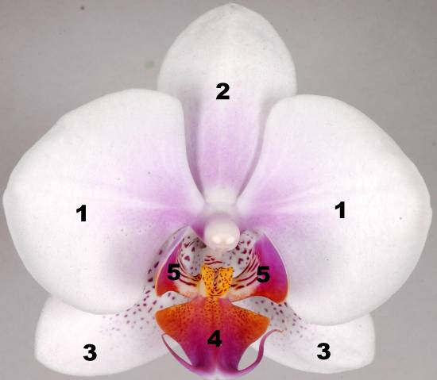
6

7

8
1: petal
2: dorsal sepal
3: lateral sepal
4: apical lobe
5: lateral lobe
6: column
7: callus
8: whiskers

8.2 Explanations for individual characteristics

Ad. 1: Plant: length

Plant length should be observed from soil level to the end of the plant including the flowers.

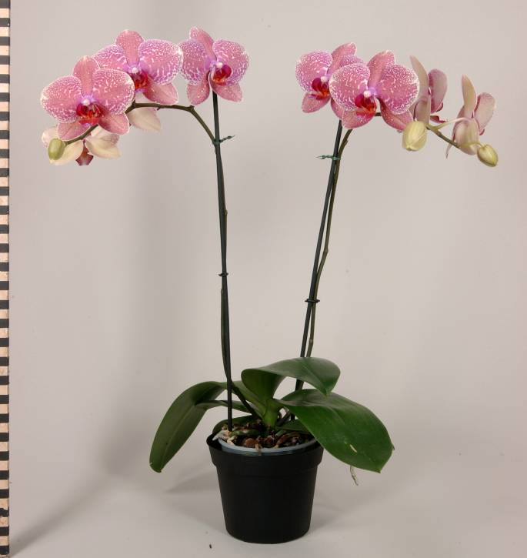
Plant: length
Ad. 5: Leaf: shape

1 | 2 | 3
slightly elongated | moderately elongated | very elongated

Ad. 6: Leaf: position of broadest part

1 | 2 | 3
towards base | at middle | towards apex

Ad. 7: Leaf: shape of apex

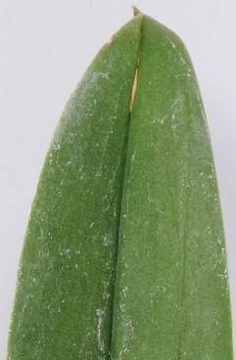 | 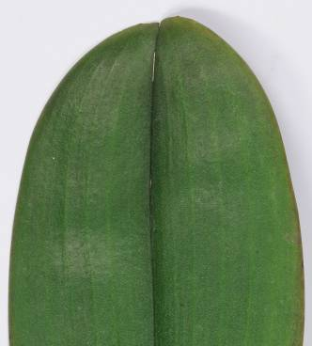 | 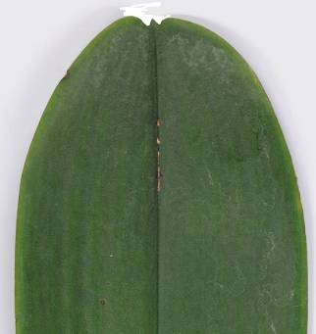
1 | 2 | 3
acute | obtuse | emarginate

Ad. 12: Leaf: main color of upper side

The main color is the color with the largest surface area. In cases where the areas of the main and secondary color are too similar to reliably decide which color has the largest area, the darker color is considered to be the main color.

Ad. 14: Inflorescence: type

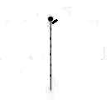 | 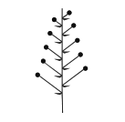 | 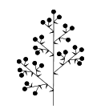
1 | 2 | 3
single flowered | raceme | panicle

Ad. 15: Inflorescence: length of flowering part

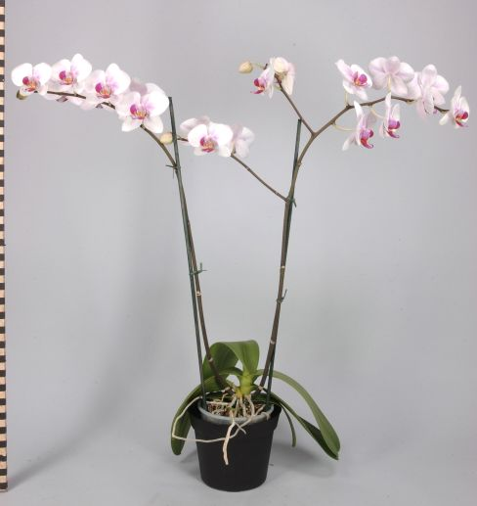
Inflorescence: length of flowering part

Ad. 18: Peduncle: thickness

The thickness of the peduncle must be observed at the centre part of the lower third of the peduncle.

Ad. 20: Flower: shape in lateral view

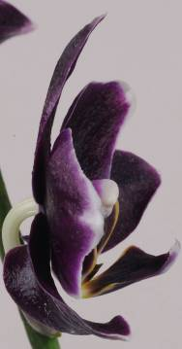 | 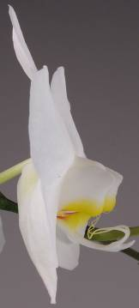 | 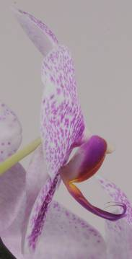
1 | 2 | 3
concave | flat | convex

Ad. 21: Flower: length in front view
Ad. 22: Flower: width in front view

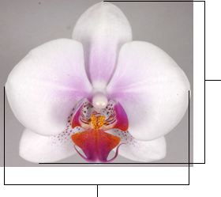
Flower: length
Flower: width

Ad. 23: Flower: arrangement of petals

1 | 2 | 3
free | touching | overlapping

Ad. 29: Dorsal sepal: curvature of longitudinal axis
Ad. 54: Petal: curvature of longitudinal axis

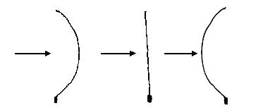
Front
Front
Front
1 | 2 | 3
incurving | straight | recurving

Ad. 30: Dorsal sepal: shape in cross section
Ad. 55: Petal: shape in cross section

 |  | 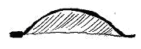
1 | 2 | 3
concave | straight | convex

Ad. 33: Dorsal sepal: ground color of upper side
Ad. 42: Lateral sepal: ground color of upper side
Ad. 58: Petal: ground color of upper side
Ad. 79: Apical lobe: ground color
Ad. 88: Lateral lobe: ground color

When a color on the upper side is the same as the color on the lower side this will be the ground color. The other colors on the upper side belong to the pattern.

Ad. 34: Dorsal sepal: over color (if present)
Ad. 43: Lateral sepal: over color (if present)
Ad. 59: Petal: over color (if present)
Ad. 80: Apical lobe: over color (if present)
Ad. 89: Lateral lobe: over color (if present)

In the case of a plant part which has a ground color upon which a second color such as a flush develops over time, the flush is considered the over color. The over color is not always the color occupying the smallest surface area of the plant part concerned.

Ad. 60: Petal: area of over color

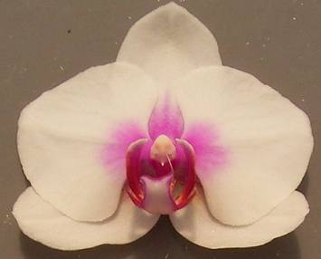 | 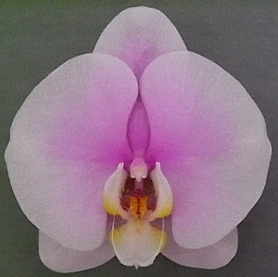 | 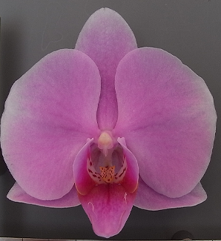
3 | 5 | 7
small | medium | large

Ad. 68: Lip: fusion of lateral lobes with apical lobe

1 – none
2 – slightly fused = fused up to quarter of length
3 – moderately fused = fused to half the length
4 – strongly fused = fused to three quarters of length and
5 – completely fused

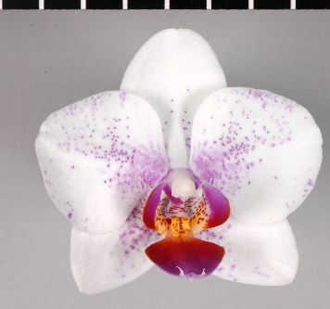 | 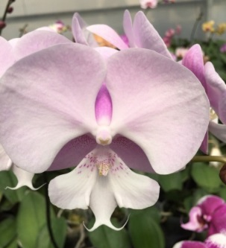 | 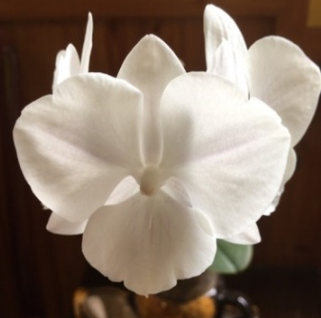
1 | 3 | 5
none | moderately fused | completely fused

Ad. 71: Lip: shape of apical lobe

 |  | ← broadest part →
 |  | (below middle) | at middle | (above middle)

broad (low) ← width (ratio length/width) → narrow (high)
broad (low) ← width (ratio length/width) → narrow (high) |  | 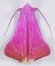  1  triangular | 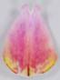  2  ovate | 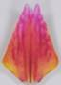  3  trullate | 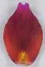  4  elliptic | 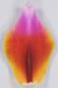  5  rhombic | 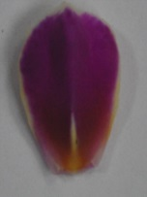  7  obovate | 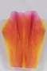  8  obtrullate | 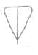  9  obtriangular
broad (low) ← width (ratio length/width) → narrow (high) |  |  |  |  | 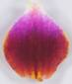  6  circular

Ad. 72: Only varieties with Lip: fusion of lateral lobes with apical lobe: strongly or completely fused: Lip: extension of fused lobes

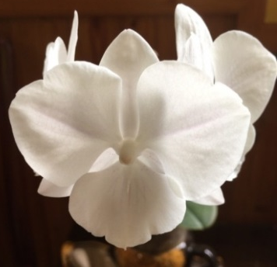 | 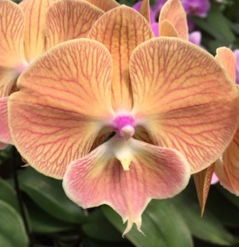 | 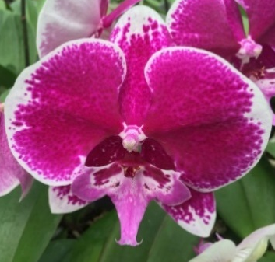
1 | 2 | 3
absent or weak | moderate | strong

Ad. 75: Lip: bump and ridge on apical lobe

1 | 2 | 3
absent or small | medium | large
Ad. 76: Lip: shape of lateral lobe

1 |  | 2 |  | 3
type I |  | type II |  | type III
 | 4 |  | 5
 | type IV |  | type V

Ad. 77: Lip: curvature of lateral lobe

1 | 2 | 3
weak | medium | strong

Ad. 96: Lip: callus

1 | 2 | 3
flat or slightly raised | moderately raised | strongly raised

Literature

Christenson, E, 2001: Phalaenopsis a Monograph, Timber Press, Portland Oregon

Dictionary of Gardening, The Royal Horticultural Society

Graebner, K, 1982: Freude an Orchideen, Verlag J. Berg, München, DE

Pridgeon, A, 1992: The illustrated Encyclopedia of Orchids, Kyodo Printing Pte Ltd, Singapore, SG

Schlechter, Dr R, 1915: Die Orchideen (Ihre Beschreibung, Kultur, und Züchtung), Verlagsbuchhandlung Paul Parey, Berlin, DE

Technical Questionnaire

TECHNICAL QUESTIONNAIRE |  |  |  | Page {x} of {y} |  | Reference Number:
 |  |  |  |  |  | Application date:
 |  |  |  |  |  | (not to be filled in by the applicant)
TECHNICAL QUESTIONNAIRE
to be completed in connection with an application for plant breeders’ rights

1. Subject of the Technical Questionnaire
1.1 Genus
1.1.1 Botanical name |  |  | Phalaenopsis Blume
1.1.2 Common name |  |  | Phalaenopsis
1.2 Species (please complete)
1.2.1 Botanical name
1.2.2 Common name
2. Applicant
Name
Address
Telephone No.
Fax No.
E-mail address
Breeder (if different from applicant)
3. Proposed denomination and breeder’s reference
Proposed denomination
(if available)

Breeder’s reference
#4. Information on the breeding scheme and propagation of the variety

4.1 Breeding scheme

Variety resulting from:

4.1.1 Crossing

(a) controlled cross [ ]
(please state parent varieties)

(…………………..……………..…) x (……………..…………………..…)
female parent male parent

(b) partially known cross [ ]
(please state known parent variety(ies))

(…………………..……………..…) x (……………..…………………..…)
female parent male parent

(c) unknown cross [ ]

4.1.2 Mutation [ ]
(please state parent variety)

4.1.3 Discovery and development [ ]
(please state where and when discovered and how developed)

4.1.4 Other [ ]
(please provide details)

4.2 Method of propagating the variety

4.2.1 Vegetative propagation

(a) cuttings [ ]

(b) in vitro propagation [ ]

(c) other (state method) [ ]

4.2.2 Other [ ]
(please provide details)

5. Characteristics of the variety to be indicated (the number in brackets refers to the corresponding characteristic in Test Guidelines; please mark the note which best corresponds).

 | Characteristics |  |  |  |  |  | Example Varieties |  |  | Note
5.1  (1) | Plant: length
 | very short |  |  |  |  |  |  |  |  | 1[ ]
 | very short to short |  |  |  |  |  |  |  |  | 2[ ]
 | short |  |  |  |  |  | Phalboezeq |  |  | 3[ ]
 | short to medium |  |  |  |  |  |  |  |  | 4[ ]
 | medium |  |  |  |  |  | Phalpnizok, Red Eye |  |  | 5[ ]
 | medium to long |  |  |  |  |  |  |  |  | 6[ ]
 | long |  |  |  |  |  | Figaro, Puccini |  |  | 7[ ]
 | long to very long |  |  |  |  |  |  |  |  | 8[ ]
 | very long |  |  |  |  |  |  |  |  | 9[ ]
5.2  (10) | Leaf: variegation
 | absent |  |  |  |  |  | Symphony |  |  | 1[ ]
 | present |  |  |  |  |  | SOGO F2806 |  |  | 9[ ]
5.3  (11) | Leaf: spots on upper side
 | absent |  |  |  |  |  | SOGO Fairyland,  Sunrise Beautiful Girl |  |  | 1[ ]
 | present |  |  |  |  |  | Phalnasxu, SOGO F-1320 |  |  | 9[ ]
5.4  (22) | Flower: width in front view
 | very narrow |  |  |  |  |  |  |  |  | 1[ ]
 | very narrow to narrow |  |  |  |  |  |  |  |  | 2[ ]
 | narrow |  |  |  |  |  | Mrs Brown |  |  | 3[ ]
 | narrow to medium |  |  |  |  |  |  |  |  | 4[ ]
 | medium |  |  |  |  |  | Beauty Sheena Rin Rin |  |  | 5[ ]
 | medium to broad |  |  |  |  |  |  |  |  | 6[ ]
 | broad |  |  |  |  |  | Phaladadel |  |  | 7[ ]
 | broad to very broad |  |  |  |  |  |  |  |  | 8[ ]
 | very broad |  |  |  |  |  | Cygnus Renaissance |  |  | 9[ ]
 | Characteristics |  |  |  |  |  | Example Varieties |  |  | Note
5.5  (58) | Petal: ground color of upper side
 | white |  |  |  |  |  |  |  |  | 1[ ]
 | yellow |  |  |  |  |  |  |  |  | 2[ ]
 | green |  |  |  |  |  |  |  |  | 3[ ]
 | orange |  |  |  |  |  |  |  |  | 4[ ]
 | red |  |  |  |  |  |  |  |  | 5[ ]
 | violet |  |  |  |  |  |  |  |  | 6[ ]
 | purple red |  |  |  |  |  |  |  |  | 7[ ]
 | purple |  |  |  |  |  |  |  |  | 8[ ]
 | brown |  |  |  |  |  |  |  |  | 9[ ]
5.6  (59) | Petal: over color (if present)
 | yellow |  |  |  |  |  |  |  |  | 1[ ]
 | green |  |  |  |  |  |  |  |  | 2[ ]
 | orange |  |  |  |  |  |  |  |  | 3[ ]
 | red |  |  |  |  |  |  |  |  | 4[ ]
 | violet |  |  |  |  |  |  |  |  | 5[ ]
 | purple red |  |  |  |  |  |  |  |  | 6[ ]
 | purple |  |  |  |  |  |  |  |  | 7[ ]
 | brown |  |  |  |  |  |  |  |  | 8[ ]
5.7  (61) | Petal: number of spots
 | none |  |  |  |  |  | Florina |  |  | 1[ ]
 | very few to few |  |  |  |  |  |  |  |  | 2[ ]
 | few |  |  |  |  |  | P 132 |  |  | 3[ ]
 | few to medium |  |  |  |  |  |  |  |  | 4[ ]
 | medium |  |  |  |  |  |  |  |  | 5[ ]
 | medium to many |  |  |  |  |  |  |  |  | 6[ ]
 | many |  |  |  |  |  | Phalborudo |  |  | 7[ ]
 | many to very many |  |  |  |  |  |  |  |  | 8[ ]
 | very many |  |  |  |  |  |  |  |  | 9[ ]
 | Characteristics |  |  |  |  |  | Example Varieties |  |  | Note
5.8  (64) | Petal: number of stripes
 | none |  |  |  |  |  | Florina |  |  | 1[ ]
 | very few to few |  |  |  |  |  |  |  |  | 2[ ]
 | few |  |  |  |  |  |  |  |  | 3[ ]
 | few to medium |  |  |  |  |  |  |  |  | 4[ ]
 | medium |  |  |  |  |  | Phaljelow |  |  | 5[ ]
 | medium to many |  |  |  |  |  |  |  |  | 6[ ]
 | many |  |  |  |  |  | Firelight |  |  | 7[ ]
 | many to very many |  |  |  |  |  |  |  |  | 8[ ]
 | very many |  |  |  |  |  |  |  |  | 9[ ]
5.9  (66) | Petal: density of netting
 | none |  |  |  |  |  | Florina |  |  | 1[ ]
 | very low to low |  |  |  |  |  |  |  |  | 2[ ]
 | low |  |  |  |  |  | Vallier |  |  | 3[ ]
 | low to medium |  |  |  |  |  |  |  |  | 4[ ]
 | medium |  |  |  |  |  | Phalpnizok |  |  | 5[ ]
 | medium to high |  |  |  |  |  |  |  |  | 6[ ]
 | high |  |  |  |  |  | Happy Days |  |  | 7[ ]
 | high to very high |  |  |  |  |  |  |  |  | 8[ ]
 | very high |  |  |  |  |  |  |  |  | 9[ ]
6. Similar varieties and differences from these varieties

Please use the following table and box for comments to provide information on how your candidate variety differs from the variety (or varieties) which, to the best of your knowledge, is (or are) most similar. This information may help the examination authority to conduct its examination of distinctness in a more efficient way.

Denomination(s) of variety(ies) similar to your candidate variety |  | Characteristic(s) in which your candidate variety differs from the similar variety(ies) |  |  | Describe the expression of the characteristic(s) for the similar variety(ies) |  |  | Describe the expression of the characteristic(s) for your candidate variety
Example |  | Leaf: length |  |  | short |  |  | long
Comments:

#7. Additional information which may help in the examination of the variety

7.1 In addition to the information provided in sections 5 and 6, are there any additional characteristics which may help to distinguish the variety?

Yes [ ] No [ ]

(If yes, please provide details)

7.2 Special conditions for the examination of the variety

7.2.1 Are there any special conditions for growing the variety or conducting the examination?

Yes [ ] No [ ]

7.2.2 If yes, please provide details:

7.3 Other information

A representative color image of the variety should accompany the Technical Questionnaire.

8. Authorization for release

(a) Does the variety require prior authorization for release under legislation concerning the protection of the environment, human and animal health?

Yes [ ] No [ ]

(b) Has such authorization been obtained?

Yes [ ] No [ ]

If the answer to (b) is yes, please attach a copy of the authorization.

9. Information on plant material to be examined or submitted for examination.

9.1 The expression of a characteristic or several characteristics of a variety may be affected by factors, such as pests and disease, chemical treatment (e.g. growth retardants or pesticides), effects of tissue culture, different rootstocks, scions taken from different growth phases of a tree, etc.

9.2 The plant material should not have undergone any treatment which would affect the expression of the characteristics of the variety, unless the competent authorities allow or request such treatment. If the plant material has undergone such treatment, full details of the treatment must be given. In this respect, please indicate below, to the best of your knowledge, if the plant material to be examined has been subjected to:

(a) Microorganisms (e.g. virus, bacteria, phytoplasma) Yes [ ] No [ ]

(b) Chemical treatment (e.g. growth retardant, pesticide) Yes [ ] No [ ]

(c) Tissue culture Yes [ ] No [ ]

(d) Other factors Yes [ ] No [ ]

Please provide details for where you have indicated “yes”.

……………………………………………………………

9.3 Has the plant material to be examined been tested for the presence of virus or other pathogens?

Yes [ ]
(please provide details as specified by the Authority)

No [ ]

10. I hereby declare that, to the best of my knowledge, the information provided in this form is correct:

Applicant’s name

Signature Date

[End of document]

* These names were correct at the time of the introduction of these Test Guidelines but may be revised or updated. [Readers are advised to consult the UPOV Code, which can be found on the UPOV Website (www.upov.int), for the latest information.]
# Authorities may allow certain of this information to be provided in a confidential section of the Technical Questionnaire.
# Authorities may allow certain of this information to be provided in a confidential section of the Technical Questionnaire.

