 |  | E  TG/208/1  ORIGINAL: English  DATE: April 9, 2003
INTERNATIONAL UNION FOR THE PROTECTION OF NEW VARIETIES OF PLANTS
GENEVA

 | CHERIMOYA  (Annona cherimola Mill.) | *

GUIDELINES

FOR THE CONDUCT OF TESTS

FOR DISTINCTNESS, UNIFORMITY AND STABILITY

Alternative Names:*

Latin | English | French | German | Spanish
Annona cherimola Mill. | Annona, Cherimoya, Custard Apple | Chérimolier | Cherimoya | Chirimoyo

ASSOCIATED DOCUMENTS

These guidelines should be read in conjunction with document TG/1/3, “General Introduction to the Examination of Distinctness, Uniformity and Stability and the Development of Harmonized Descriptions of New Varieties of Plants” (hereinafter referred to as the “General Introduction”) and its associated “TGP” documents.

TABLE OF CONTENTS PAGE

1. Subject of these Test Guidelines 3
2. Material Required 3
3. Method of Examination 3
3.1 Duration of Tests 3
3.2 Testing Place 3
3.3 Conditions for Conducting the Examination 3
3.4 Test Design 4
3.5 Number of Plants / Parts of Plants to be Examined 4
3.6 Additional Tests 4
4. Assessment of Distinctness, Uniformity and Stability 4
4.1 Distinctness 4
4.2 Uniformity 4
4.3 Stability 5
5. Grouping of Varieties and Organization of the Growing Trial 5
6. Introduction to the Table of Characteristics 5
6.1 Categories of Characteristics 5
6.2 States of Expression and Corresponding Notes 6
6.3 Types of Expression 6
6.4 Example Varieties 6
6.5 Legend 6
7. Table of Characteristics/Tableau des caractères/Merkmalstabelle/Tabla de caracteres 7
8. Explanations on the Table of Characteristics 17
8.1 Explanations covering several characteristics 17
8.2 Explanations for individual characteristics 18
9. Literature 21
10. Technical Questionnaire 22

Subject of these Test Guidelines
These Test Guidelines apply to all varieties of Annona cherimola Mill. and their hybrids.

Material Required
2.1 The competent authorities decide on the quantity and quality of the plant material required for testing the variety and when and where it is to be delivered. Applicants submitting material from a State other than that in which the testing takes place must ensure that all customs formalities and phytosanitary requirements are complied with.

2.2 The material is to be supplied in the form of one-year-old grafts on rootstocks of Annona cherimola Mill.

2.3 The minimum quantity of plant material, to be supplied by the applicant, should be:

eight plants.

2.4 The plant material supplied should be visibly healthy, not lacking in vigor, nor affected by any important pest or disease. It should preferably not be obtained from in vitro propagation. If it has been produced by in vitro propagation this fact has to be stated by the applicant.

2.5 The plant material should not have undergone any treatment which would affect the expression of the characteristics of the variety, unless the competent authorities allow or request such treatment. If it has been treated, full details of the treatment must be given.

Method of Examination

3.1 Duration of Tests
The minimum duration of tests should normally be two independent growing cycles. For the purposes of these Test Guidelines, a growing cycle refers to the fruiting cycle.

3.2 Testing Place
The tests should normally be conducted at one place. If any characteristics of the variety, which are relevant for the examination of DUS, cannot be seen at that place, the variety may be tested at an additional place.

3.3 Conditions for Conducting the Examination
The tests should be carried out under conditions ensuring satisfactory growth for the expression of the relevant characteristics of the variety and for the conduct of the examination. In particular, it is essential that the trees produce a satisfactory crop of fruit in each of the two growing cycles.

3.4 Test Design
3.4.1 Each test should be designed to result in a total of, at least 5 plants.

3.4.2 The design of the tests should be such that plants or parts of plants may be removed for measurement or counting without prejudice to the observations which must be made up to the end of the growing cycle.

3.5 Number of Plants / Parts of Plants to be Examined
Unless otherwise indicated, all observations determined by measuring or counting should be made on 5 plants or parts taken from each of 5 plants. In the case of plant parts, the number to be taken from each of the plants should be 2.

3.6 Additional Tests
Additional tests, for examining relevant characteristics, may be established.

Assessment of Distinctness, Uniformity and Stability

4.1 Distinctness
4.1.1 General Recommendations

It is of particular importance for users of these Test Guidelines to consult the General Introduction prior to making decisions regarding distinctness. However, the following points are provided for elaboration or emphasis in these Test Guidelines.

4.1.2 Consistent Differences

The minimum duration of tests recommended in section 3.1 reflects, in general, the need to ensure that any differences in a characteristic are sufficiently consistent.

4.1.3 Clear Differences

Determining whether a difference between two varieties is clear depends on many factors, and should consider, in particular, the type of expression of the characteristic being examined, i.e. whether it is expressed in a qualitative, quantitative, or pseudo-qualitative manner. Therefore, it is important that users of these Test Guidelines are familiar with the recommendations contained in the General Introduction prior to making decisions regarding distinctness.

4.2 Uniformity
4.2.1. It is of particular importance for users of these Test Guidelines to consult the General Introduction prior to making decisions regarding uniformity. However, the following points are provided for elaboration or emphasis in these Test Guidelines.

4.2.2 For the assessment of uniformity a population standard of 1% and an acceptance probability of at least 95% should be applied. In the case of a sample size of 5 plants no off-types are allowed.

4.3 Stability
4.3.1 In practice, it is not usual to perform tests of stability that produce results as certain as those of the testing of distinctness and uniformity. However, experience has demonstrated that, for many types of variety, when a variety has been shown to be uniform, it can also be considered to be stable.

4.3.2 Where appropriate, or in cases of doubt, stability may be tested, either by growing a further generation, or by testing a new plant stock to ensure that it exhibits the same characteristics as those shown by the previous material supplied.

Grouping of Varieties and Organization of the Growing Trial
5.1 The selection of varieties of common knowledge to be grown in the trial with the candidate varieties and the way in which these varieties are divided into groups to facilitate the assessment of distinctness is aided by the use of grouping characteristics.

5.2 Grouping characteristics are those in which the documented states of expression, even where produced at different locations, can be used, either individually or in combination with other such characteristics: (a) to select varieties of common knowledge that can be excluded from the growing trial used for examination of distinctness; and (b) to organize the growing trial so that similar varieties are grouped together.

5.3 The following have been agreed as useful grouping characteristics:

(a) Fruit: shape in lateral view (characteristic 29)
(b) Fruit: segmentation of surface (characteristic 33)
(c) Fruit: protuberances on surface (characteristic 34)

5.4 Guidance for the use of grouping characteristics, in the process of examining distinctness, is provided through the General Introduction.

Introduction to the Table of Characteristics

6.1 Categories of Characteristics
6.1.1 Standard Test Guidelines Characteristics

Standard Test Guidelines characteristics are those which are approved by UPOV for examination of DUS and from which members of the Union can select those suitable for their particular circumstances.

6.1.2 Asterisked Characteristics

Asterisked characteristics (denoted by *) are those included in the Test Guidelines which are important for the international harmonization of variety descriptions and should always be examined for DUS and included in the variety description by all members of the Union, except when the state of expression of a preceding characteristic or regional environmental conditions render this inappropriate.

6.2 States of Expression and Corresponding Notes
States of expression are given for each characteristic to define the characteristic and to harmonize descriptions. Each state of expression is allocated a corresponding numerical note for ease of recording of data and for the production and exchange of the description.

6.3 Types of Expression
An explanation of the types of expression of characteristics (qualitative, quantitative and pseudo-qualitative) is provided in the General Introduction.

6.4 Example Varieties
Where appropriate, example varieties are provided to clarify the states of expression of each characteristic.

6.5 Legend
(*) Asterisked characteristic – see Section 6.1.2

QL Qualitative characteristic – see Section 6.3
QN Quantitative characteristic – see Section 6.3
PQ Pseudo-Qualitative characteristic – see Section 6.3

(a)-(d) See Explanations on the Table of Characteristics in Chapter 8, Section 8.1

(+) See Explanations on the Table of Characteristics in Chapter 8, Section 8.2

Table of Characteristics/Tableau des caractères/Merkmalstabelle/Tabla de caracteres
 |  | English | français | deutsch | español | Example Varieties  Exemples  Beispielssorten  Variedades ejemplo | Note/  Nota
1. | (a) | Shoot: length of internode | Rameau: longueur de l’entre-nœud | Trieb: Länge des Internodiums | Rama: longitud del entrenudo
QN |  | short | court | kurz | corto | Big Sister, Villapark | 3
 |  | medium | moyen | mittel | medio | Bay Ott, Honey Hart | 5
 |  | long | long | lang | largo | Mariella, Pierce, White | 7
2. | (a) | Shoot: color | Rameau: couleur | Trieb: Farbe | Rama: color
PQ |  | greyish green | vert grisâtre | gräulichgrün | verde grisáceo | Big Sister, Chaffey | 1
 |  | grey | gris | grau | gris | Bay Ott, Honey Hart | 2
 |  | brown | brun | braun | marrón | African Pride, Fino de Jete | 3
3. | (a) | Shoot: pubescence | Rameau: pubescence | Trieb: Behaarung | Rama: pubescencia
QL |  | absent | absente | fehlend | ausente | African Pride, Gefner | 1
 |  | present | présente | vorhanden | presente | Bay Ott, Big Sister | 9
4. | (b) | Leaf blade: length | Limbe: longueur | Blattspreite: Länge | Limbo: longitud
QN |  | short | court | kurz | corto | African Pride, Gefner | 3
 |  | medium | moyen | mittel | medio | El Bumpo, Villapark | 5
 |  | long | long | lang | largo | Booth, Mariella | 7
5. | (b) | Leaf blade: width | Limbe: largeur | Blattspreite: Breite | Limbo: anchura
QN |  | narrow | étroit | schmal | estrecho | African Pride, Gefner | 3
 |  | medium | moyen | mittel | medio | El Bumpo, Villapark | 5
 |  | broad | large | breit | ancho | Booth, Mariella | 7
6. | (b) | Leaf blade: ratio length/width | Limbe: rapport longueur/largeur | Blattspreite: Verhältnis Länge/Breite | Limbo: relación longitud/anchura
QN |  | small | petit | klein | pequeña | African Pride, Gefner | 3
 |  | medium | moyen | mittel | media | El Bumpo, Villapark | 5
 |  | large | grand | groß | grande | Booth, Mariella | 7
7.  (*)  (+) | (b) | Leaf blade: shape | Limbe: forme | Blattspreite: Form | Limbo: forma
PQ |  | broad ovate | ovale large | breit eiförmig | oval ancha | Booth, Oakwood | 1
 |  | ovate | ovale | eiförmig | oval | Miguel, Ott, Pierce | 2
 |  | narrow ovate | ovale étroit | schmal eiförmig | oval estrecha | Big Sister, El Bumpo, Villapark | 3
 |  | lanceolate | lancéolé | lanzettlich | lanceolada | African Pride | 4
8. | (b) | Leaf blade: green color (upper side) | Limbe: couleur verte (face supérieure) | Blattspreite: Grünfärbung (Oberseite) | Limbo: color verde (haz)
QN |  | light | claire | hell | claro | Mariella, Oakwood | 3
 |  | medium | moyenne | mittel | medio | Bay Ott, Booth | 5
 |  | dark | foncée | dunkel | oscuro | Big Sister | 7
9. | (b) | Leaf blade: green color (lower side) | Limbe: couleur verte (face inférieure) | Blattspreite: Grünfärbung (Unterseite) | Limbo: color verde (envés)
QN |  | light | clair | hell | claro |  | 3
 |  | medium | moyen | mittel | medio |  | 5
 |  | dark | foncé | dunkel | oscuro | Bay Ott, Big Sister | 7
10. | (b) | Leaf blade: pubescence (upper side) | Limbe: pubescence (face supérieure) | Blattspreite: Behaarung (Oberseite) | Limbo: pubescencia (haz)
QL |  | absent | absente | fehlend | ausente | African Pride, Gefner | 1
 |  | present | présente | vorhanden | presente | Bay Ott, Big Sister | 9
11. | (b) | Leaf blade: pubescence (lower side) | Limbe: pubescence (face inférieure) | Blattspreite: Behaarung (Unterseite) | Limbo: pubescencia (envés)
QL |  | absent | absente | fehlend | ausente | African Pride, Gefner | 1
 |  | present | présente | vorhanden | presente | Bay Ott, Big sister | 9
12. | (b) | Leaf blade: undulation of margin | Limbe: ondulation du bord | Blattspreite: Randwellung | Limbo: ondulación del borde
QN |  | absent or very weak | nulle ou très faible | fehlend oder sehr gering | ausente o muy débil | African Pride | 1
 |  | weak | faible | gering | débil | Pierce | 3
 |  | medium | moyenne | mittel | media | White | 5
 |  | strong | forte | stark | fuerte | Big Sister | 7
13. | (b) | Petiole: length | Pétiole: longueur | Blattstiel: Länge | Pecíolo: longitud
QN |  | short | court | kurz | corto | Honey Hart | 3
 |  | medium | moyen | mittel | medio | Fino de Jete | 5
 |  | long | long | lang | largo | Big Sister | 7
14. | (b) | Petiole: thickness | Pétiole: épaisseur | Blattstiel: Dicke | Pecíolo: grosor
QN |  | thin | fin | dünn | delgado | Libby, Villapark | 3
 |  | medium | moyen | mittel | medio | Big Sister | 5
 |  | thick | épais | dick | grueso | Bays, Salmon | 7
15. | (c) | Flowering shoot: density of flowers | Rameau florifère: densité des fleurs | Blütentrieb: Dichte der Blüten | Rama floral: densidad de flores
QN |  | sparse | lâche | locker | laxa | Ott | 3
 |  | medium | moyenne | mittel | media | White | 5
 |  | dense | dense | dicht | densa | Big Sister | 7
16. | (c) | Petal: color | Pétale: couleur | Blütenblatt: Farbe | Pétalo: color
PQ |  | green | vert | grün | verde | African Pride, Gefner | 1
 |  | yellow | jaune | gelb | amarillo | Bay Ott, Big Sister | 2
 |  | light brown | brun clair | hellbraun | marrón claro | El Bumpo, Pierce | 3
17. | (c) | Petal: length | Pétale: longueur | Blütenblatt: Länge | Pétalo: longitud
QN |  | short | court | kurz | corto | Bays, Pink’s Mommoth, White | 3
 |  | medium | moyen | mittel | medio | Big Sister, El Bumpo, Sabor | 5
 |  | long | long | lang | largo | Libby, Villapark | 7
18. | (c) | Petal: width | Pétale: largeur | Blütenblatt: Breite | Pétalo: anchura
QN |  | narrow | étroit | schmal | estrecho | Honey Hart, White | 3
 |  | medium | moyen | mittel | medio | Campus, Mariella, Miguel, Pink’s Mommoth | 5
 |  | broad | large | breit | ancho | Libby, Villapark | 7
19. | (c) | Petal: ratio length/width | Pétale: rapport longueur/largeur | Blütenblatt: Verhältnis Länge/Breite | Pétalo: relación longitud/anchura
QN |  | small | petit | klein | pequeña | Honey Hart, White | 3
 |  | medium | moyen | mittel | media | Campus, Miguel | 5
 |  | large | grand | groß | grande | Libby, Villapark | 7
20. | (c) | Petal: thickness | Pétale: épaisseur | Blütenblatt: Dicke | Pétalo: grosor
QN |  | thin | fin | dünn | delgado | Bays, Campas, Fino de Jete | 3
 |  | medium | moyen | mittel | medio | Big Sister, Honey Hart | 5
 |  | thick | épais | dick | grueso | Libby, Sabor | 7
21. | (c) | Peduncle: length | Pédoncule: longueur | Blütenstiel: Länge | Pedúnculo: longitud
QN |  | short | court | kurz | corto | Campas, Chaffey | 3
 |  | medium | moyen | mittel | medio | African Pride, Pink’s Mommoth | 5
 |  | long | long | lang | largo | Booth, El Bumpo | 7
22. | (c) | Petal: twisting just before anthesis | Pétale: torsion juste avant l’anthèse | Blütenblatt: Drehung kurz vor dem Blühstadium | Pétalo: torsión inmediatamente antes de la antesis
QN |  | weak | faible | gering | débil | White | 3
 |  | medium | moyenne | mittel | media | Big Sister | 5
 |  | strong | forte | stark | fuerte | Villapark | 7
23. | (c) | Petal: curving | Pétale: courbure | Blütenblatt: Biegung | Pétalo: curvatura
QN |  | weak | faible | gering | débil | Booth, Pierce | 3
 |  | medium | moyenne | mittel | media | White | 5
 |  | strong | forte | stark | fuerte | Chaffey | 7
24. | (c) | Ovary: shape | Ovaire: forme | Fruchtknoten: Form | Ovario: forma
PQ |  | narrow cordate | cordée étroite | schmal herzförmig | cordiforme estrecha | Booth, Pierce, VillaPark | 1
 |  | cordate | cordée | herzförmig | cordiforme | Bays, Campas, Spain | 2
 |  | broad cordate | cordée large | breit herzförmig | cordiforme ancha | Chaffey | 3
25. | (c) | Ovary: length | Ovaire: longueur | Fruchtknoten: Länge | Ovario: longitud
QN |  | short | courte | kurz | corto | African Pride, Gefner | 3
 |  | medium | moyenne | mittel | medio | Chaffey | 5
 |  | long | longue | lang | largo | Big Sister | 7
26. | (c) | Ovary: width | Ovaire: largeur | Fruchtknoten: Breite | Ovario: anchura
QN |  | narrow | étroite | schmal | estrecho | African Pride, Gefner | 3
 |  | medium | moyenne | mittel | medio | Chaffey | 5
 |  | broad | large | breit | ancho | Booth | 7
27. | (d) | Fruit: length | Fruit: longueur | Frucht: Länge | Fruto: longitud
QN |  | short | court | kurz | corto | Chafey | 3
 |  | medium | moyen | mittel | medio | Bay Ott | 5
 |  | long | long | lang | largo | Big Sister | 7
28. | (d) | Fruit: diameter in cross section | Fruit: diamètre en section transversale | Frucht: Durchmesser im Querschnitt | Fruto: diámetro en sección transversal
QN |  | small | petit | klein | pequeño | Bay Ott, Bays | 3
 |  | medium | moyen | mittel | medio | Mariella, Pierce | 5
 |  | large | grand | groß | grande | Big Sister, Salmon | 7
29.  (*)  (+) | (d) | Fruit: shape in lateral view | Fruit: forme en vue latérale | Frucht: Form in der Seitenansicht | Fruto: forma en vista lateral
PQ |  | circular | circulaire | kreisförmig | circular | Bay Ott, Chaffey | 1
 |  | cordate | cordé | herzförmig | cordiforme | Bays, Honey Hart, Pierce, White | 2
 |  | conical | conique | kegelförmig | cónico | El Bumpo, Libby, Mariella, Villapark | 3
 |  | broad conical | conique large | breit kegelförmig | cónico ancho | Booth, Campas, Fino de Jete, Miguel, Ott | 4
 |  | trapezoidal | trapézoïdal | trapezförmig | trapezoidal | Big Sister | 5
30. | (d) | Fruit: glossiness of skin | Fruit: brillance de la peau | Frucht: Glanz der Schale | Fruto: brillo de la epidermis
QL |  | absent | absente | fehlend | ausente | Bays, Big Sister | 1
 |  | present | présente | vorhanden | presente | African Pride, Gefner | 9
31.  (*) | (d) | Fruit: color of skin | Fruit: couleur de la peau | Frucht: Farbe der Schale | Fruto: color de la epidermis
PQ |  | pale yellow green | vert-jaune pâle | blaß gelbgrün | verde amarillento pálido | Pierce | 1
 |  | pale green | vert pâle | blaßgrün | verde pálido | Bays, Big Sister, Libby | 2
 |  | greyish green | vert grisâtre | gräulichgrün | verde grisáceo | Sabor, Campas, Miguel | 3
32. | (d) | Fruit: thickness of rind | Fruit: épaisseur de l’écorce | Frucht: Dicke der Schale | Fruto: grosor de la corteza
QN |  | thin | fine | dünn | delgada | El Bumpo | 3
 |  | medium | moyenne | mittel | media | Big Sister | 5
 |  | thick | épaisse | dick | gruesa | Bay Ott | 7
33. (*)  (+) | (d) | Fruit: segmentation of surface | Fruit: segmentation de la surface | Frucht: Segmentierung der Oberfläche | Fruto: segmentación de la superficie
QL |  | reticulate | réticulée | netzartig | reticular | Booth, El Bumpo, Ott | 1
 |  | overlapping | chevauchante | überlappend | solapada | Bay Ott, Big Sister, Spain | 2
34. (*)  (+) | (d) | Fruit: protuberances on surface | Fruit: protubérances sur la surface | Frucht: Höcker an der Oberfläche | Fruto: protuberancias en la superficie
QN |  | absent or very small | nulle ou très petites | fehlend oder sehr klein | ausentes o muy pequeñas | Honey Hart, White | 1
 |  | small | petites | klein | pequeñas | Big Sister, Libby, Mariella, Villapark | 3
 |  | medium | moyennes | mittel | medias | El Bumpo, Oakwood | 5
 |  | large | grandes | groß | grandes | Miguel, Sabor | 7
35. | (d) | Fruit: color of flesh | Fruit: couleur de la chair | Frucht: Farbe des Fleisches | Fruto: color de la pulpa
PQ |  | white | blanche | weiß | blanco | Pierce | 1
 |  | cream | crème | cremefarben | crema | Villapark | 2
36. | (d) | Fruit: firmness of flesh | Fruit: fermeté de la chair | Frucht: Festigkeit des Fleisches | Fruto: firmeza de la pulpa
QN |  | soft | tendre | weich | blanda | El Bumpo, Miguel | 3
 |  | medium | moyenne | mittel | media | White | 5
 |  | firm | ferme | fest | firme | African Pride, Pink’s Mommoth | 7
37. | (d) | Fruit: amount of fiber | Fruit: quantité de fibres | Frucht: Menge der Fasern | Fruto: cantidad de fibra
QN |  | few | faible | gering | poca | African Pride, El Bumpo | 3
 |  | medium | moyen | mittel | media | Big Sister, Chaffey, Libby, Miguel | 5
 |  | many | nombreuses | groß | mucha | Bay Ott, Honey Hart, Mariella, White | 7
38. | (d) | Fruit: amount of stone cell | Fruit: quantité de sclérites | Frucht: Menge der Steinzellen | Fruto: cantidad de lóculo óseo
QN |  | few | peu | gering | pequeña | Bay Ott, Honey Hart, Miguel, White | 3
 |  | medium | assez nombreuses | mittel | media | Big Sister, Chaffey, Libby | 5
 |  | many | nombreuses | groß | alta | Booth, Campas, Ott, Sabor | 7
39. | (d) | Fruit: juiciness of flesh | Fruit: succulence de la chair | Frucht: Saftigkeit des Fleisches | Fruto: suculencia de la pulpa
QN |  | low | faible | gering | baja | Chaffey, Pierce | 3
 |  | medium | moyenne | mittel | media | Bay Ott, Big Sister, Honey Hart | 5
 |  | high | forte | stark | alta | Booth, El Bumpo, Mariella, Oakwood | 7
40. | (d) | Fruit: total soluble solids | Fruit: quantité de matières solubles | Frucht: Gehalt an löslicher Trockensubstanz | Fruto: contenido de sólidos solubles
QN |  | low | faible | niedrig | bajo | Pierce, Salmon | 3
 |  | medium | moyenne | mittel | medio | Big Sister, Libby, Mariella, Pink’s mommoth, Ott | 5
 |  | high | élevée | hoch | alto | Cumpas, Miguel, Sabor, White | 7
41. | (d) | Fruit: acidity | Fruit: acidité | Frucht: Säure | Fruto: acidez
QN |  | low | faible | gering | baja | Big Sister, Campas, Fino de Jete | 3
 |  | medium | moyenne | mittel | media | Booth, Miguel | 5
 |  | high | élevée | hoch | alta | Bays, El Bumpo | 7
42. | (d) | Fruit: aroma | Fruit: arôme | Frucht: Aroma | Fruto: aroma
QN |  | weak | faible | schwach | débil | Big Sister, Pierce | 3
 |  | medium | moyen | mittel | medio | Bay Ott, Bays, El Bumpo | 5
 |  | strong | fort | stark | fuerte | Booth, Honey Hart, Sabor, White | 7
43. | (d) | Fruit: number of seeds | Fruit: nombre de pépins | Frucht: Anzahl Samen | Fruto: número de semillas
QN |  | few | petit | gering | bajo | Salmon | 3
 |  | medium | moyen | mittel | medio | Fino de Jete | 5
 |  | many | grand | groß | alto | Big Sister | 7
44. |  | Seed: length | Pépin: longueur | Samen: Länge | Semilla: longitud
QN |  | short | court | kurz | corta | Oakwood, Pierce | 3
 |  | medium | moyen | mittel | media | Mariella | 5
 |  | long | long | lang | larga | Big Sister | 7
45. |  | Seed: width | Pépin: largeur | Samen: Breite | Semilla: anchura
QN |  | narrow | étroit | schmal | estrecha | African Pride, Gefner | 3
 |  | medium | moyen | mittel | media | Bay Ott, Honey Hart | 5
 |  | broad | large | breit | ancha | Chaffey, Mariella | 7
46. |  | Seed: ratio length/width | Pépin: rapport longueur/largeur | Samen: Verhältnis Länge/Breite | Semilla: relación entre la longitud y la anchura
QN |  | small | petit | klein | pequeña | Oakwood | 3
 |  | medium | moyen | mittel | media | El Bumpo | 5
 |  | large | grand | groß | grande | Bay Ott | 7
47. |  | Seed: glossiness | Pépin: brillance | Samen: Glanz | Semilla: brillo
QL |  | absent | absente | fehlend | ausente | Big Sister, White | 1
 |  | present | présente | vorhanden | presente | African Pride, Pink’s Mommoth, Spain | 9
48. |  | Seed: adherence to flesh | Pépin: adhérence à la chair | Samen: Anhaften am Fleisch | Semilla: adherencia a la pulpa
QN |  | weak | faible | gering | débil | Booth, Campus | 3
 |  | medium | moyenne | mittel | media | Big Sister, Chaffey | 5
 |  | strong | forte | stark | fuerte | Bay Ott, Bays | 7
49. |  | Time of harvest maturity | Époque de maturité de récolte | Zeitpunkt der Erntereife | Época de madurez para la cosecha
QN |  | early | précoce | früh | temprana | El Bumpo, White | 3
 |  | medium | moyenne | mittel | media | Pierce, Chaffey, Mariella | 5
 |  | late | tardive | spät | tardía | African Pride, Big Sister | 7

Explanations on the Table of Characteristics

8.1 Explanations covering several characteristics
Characteristics containing the following key in the second column of the Table of Characteristics should be examined as indicated below:

(a) Shoot: Observations on the old shoot should be made on the middle third of one-year-old shoots during the dormant season.

(b) Leaf: Observations on the leaf should be made on fully developed leaves from the middle third of a current season’s shoot.

(c) Flower: Observations on the flower should be made at the time of flowering when the petals are starting to separate.

(d) Fruit: Observations on the fruit should be made on fruits at the time of harvest maturity.

8.2 Explanations for individual characteristics

Ad. 7: Leaf blade: Shape

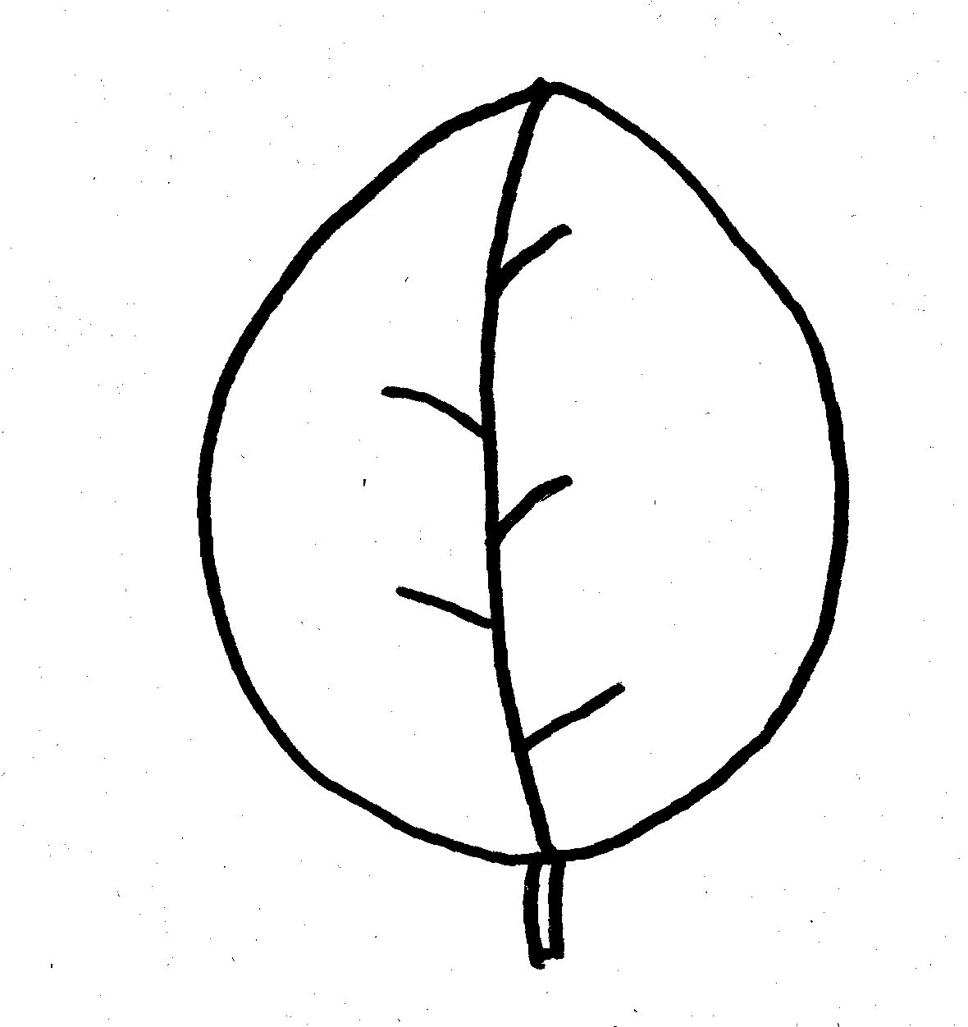 | 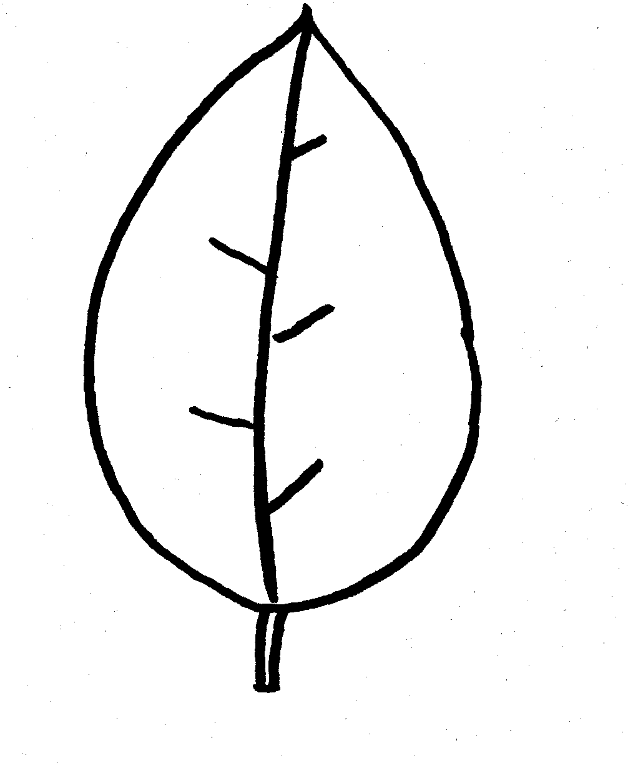
1 | 2
broad ovate | ovate

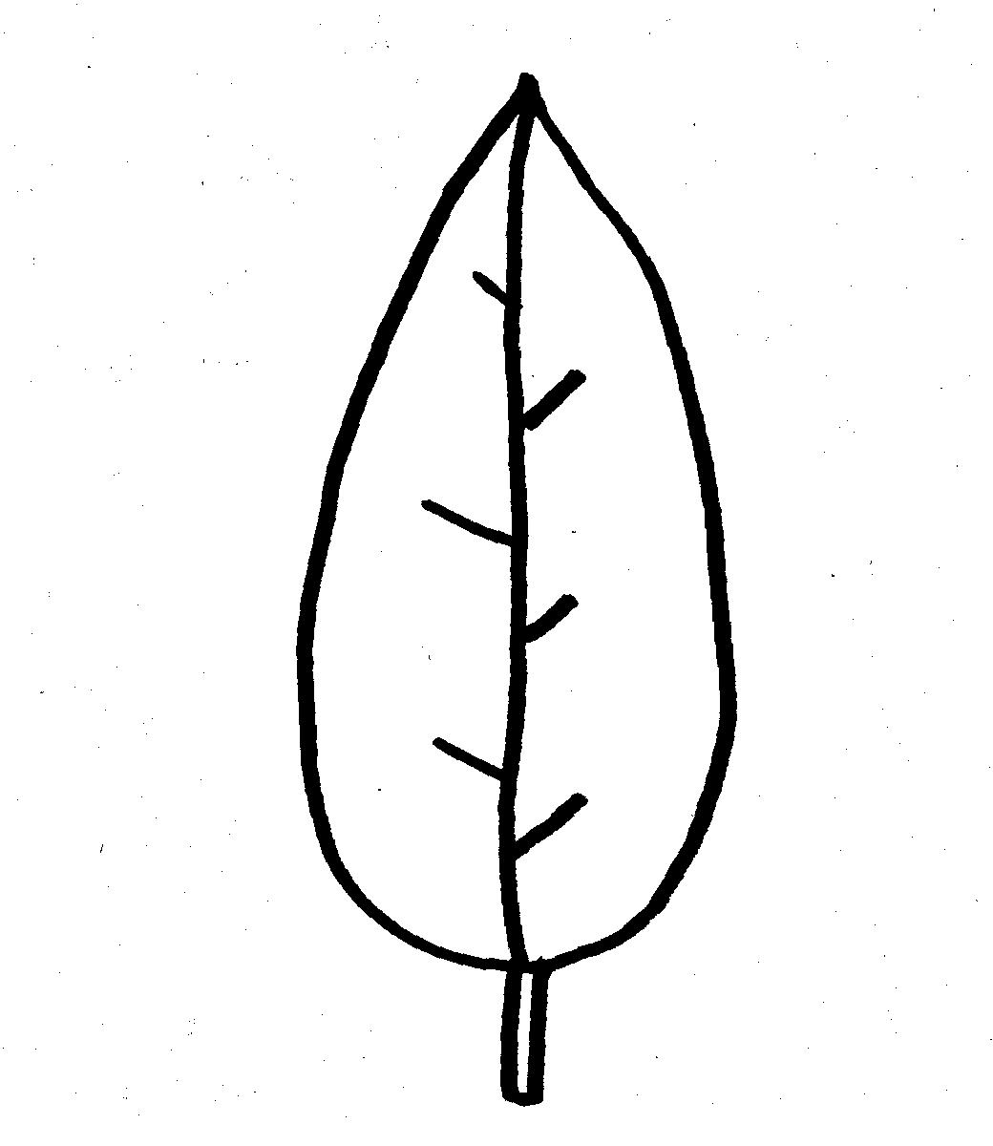 | 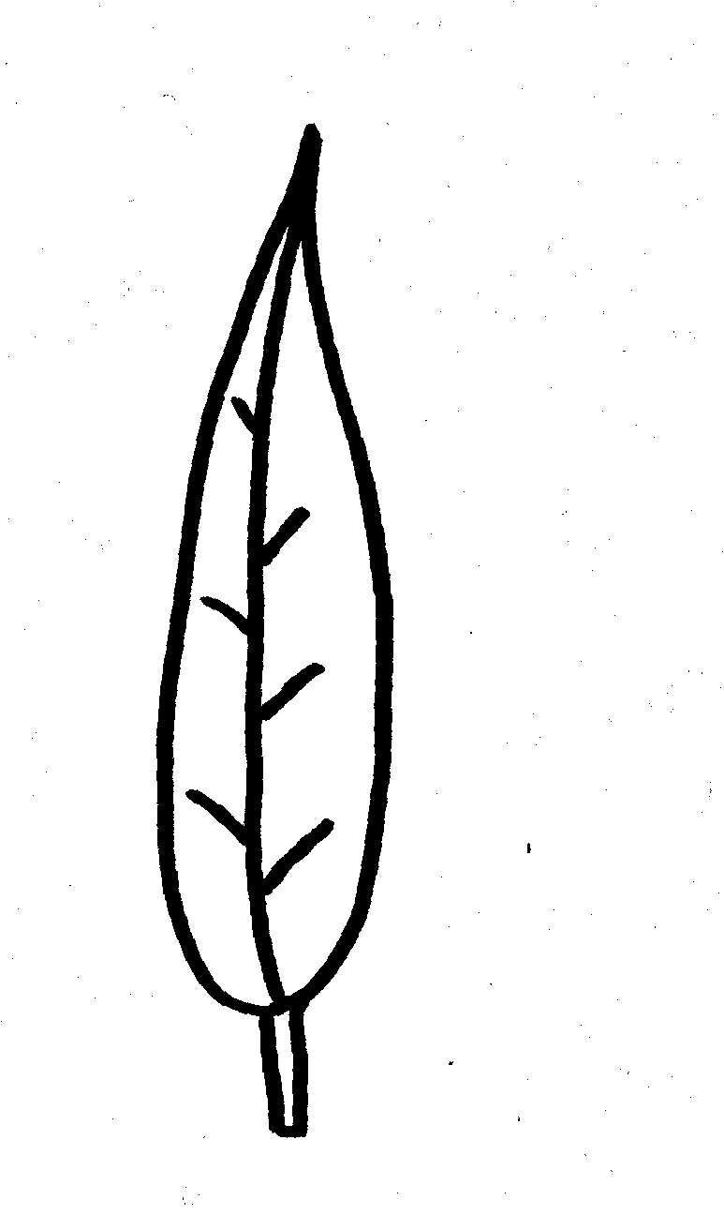
3 | 4
narrow ovate | lanceolate

Ad. 29: Fruit: shape in lateral view

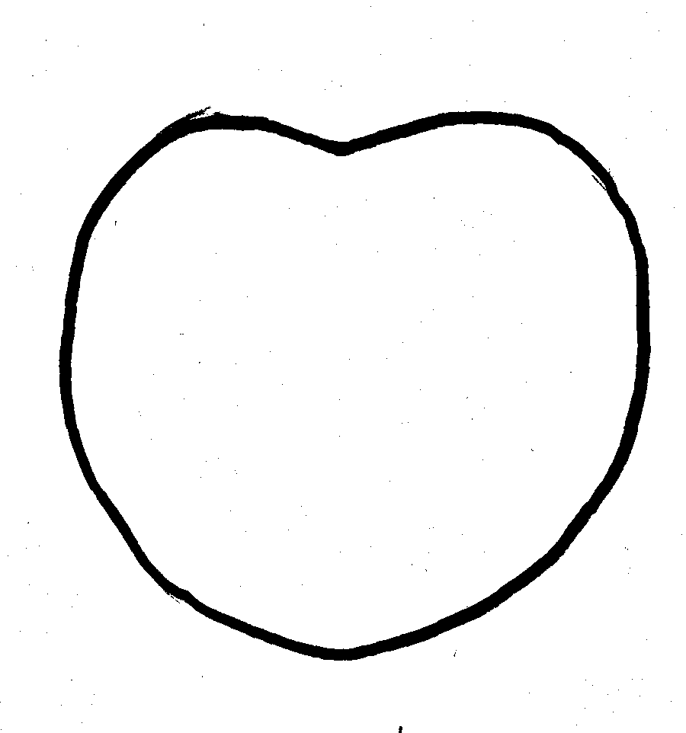 | 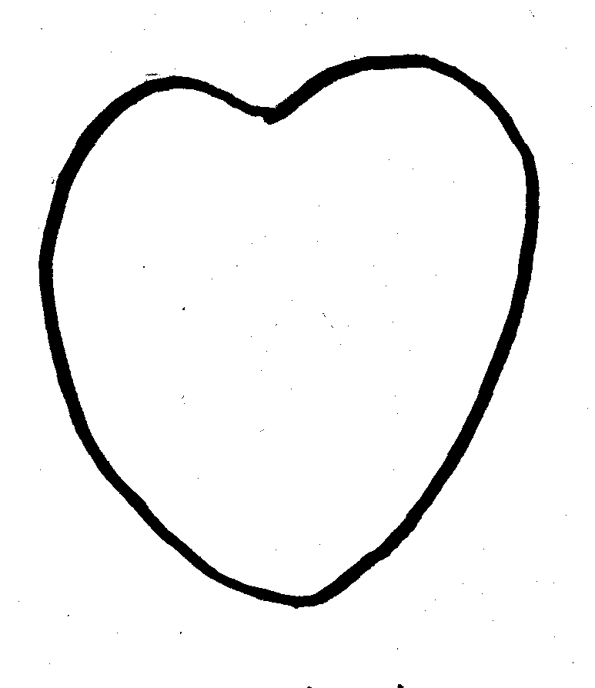 | 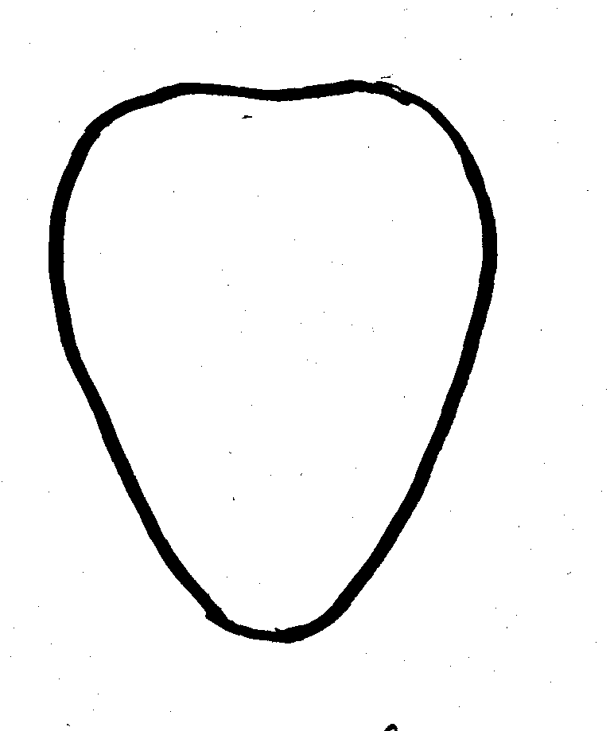
1 | 2 | 3
circular | cordate | conical

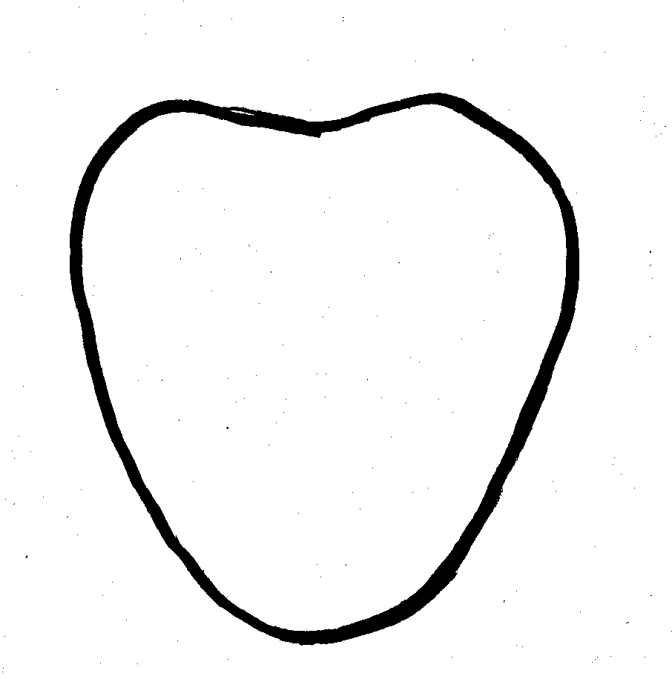 | 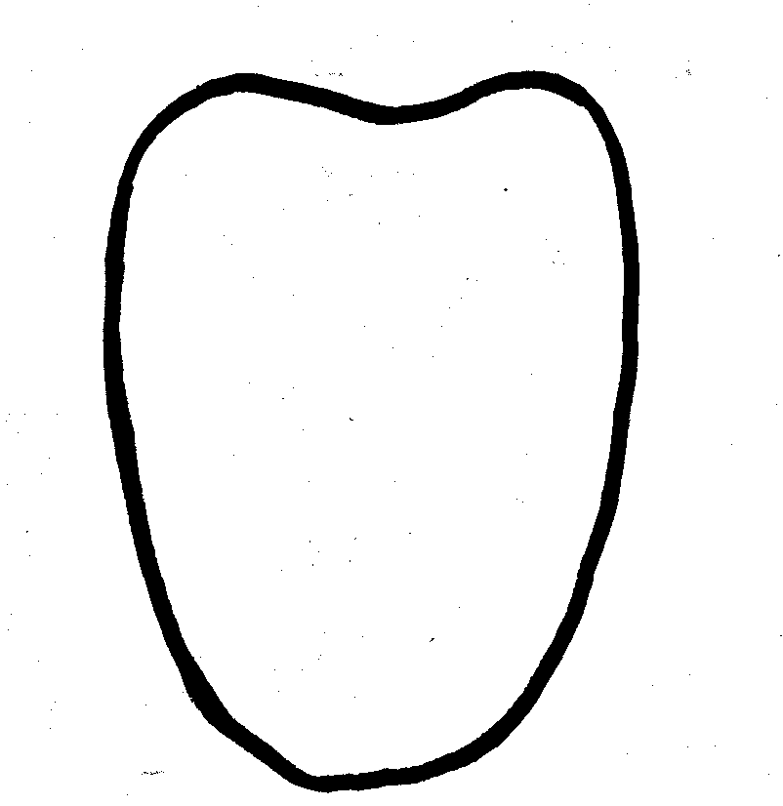
4 | 5
broad conical | trapezoidal

Ad. 33: Fruit: segmentation of surface

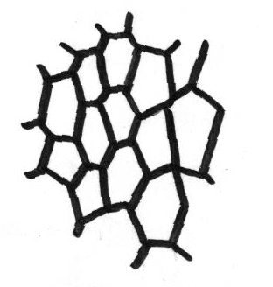 | 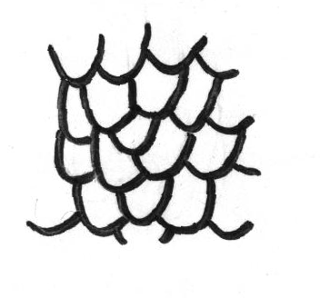
1 | 2
reticulate | overlapping

Ad. 34: Fruit: protuberance on surface

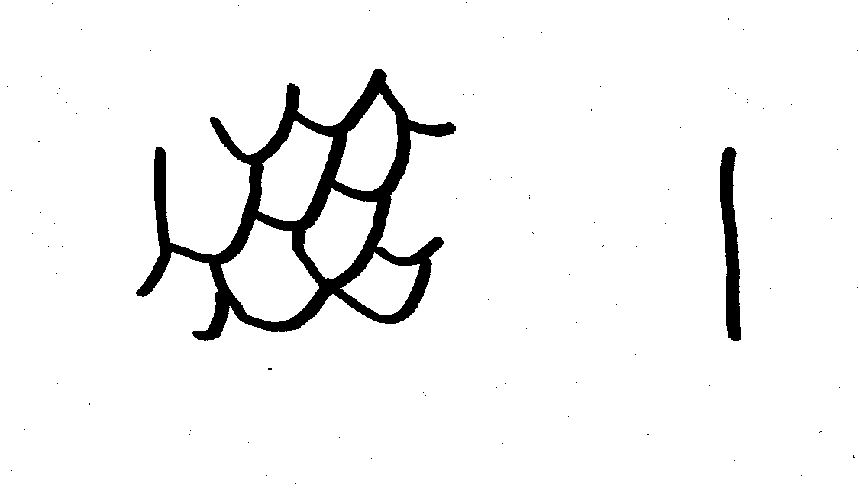 | 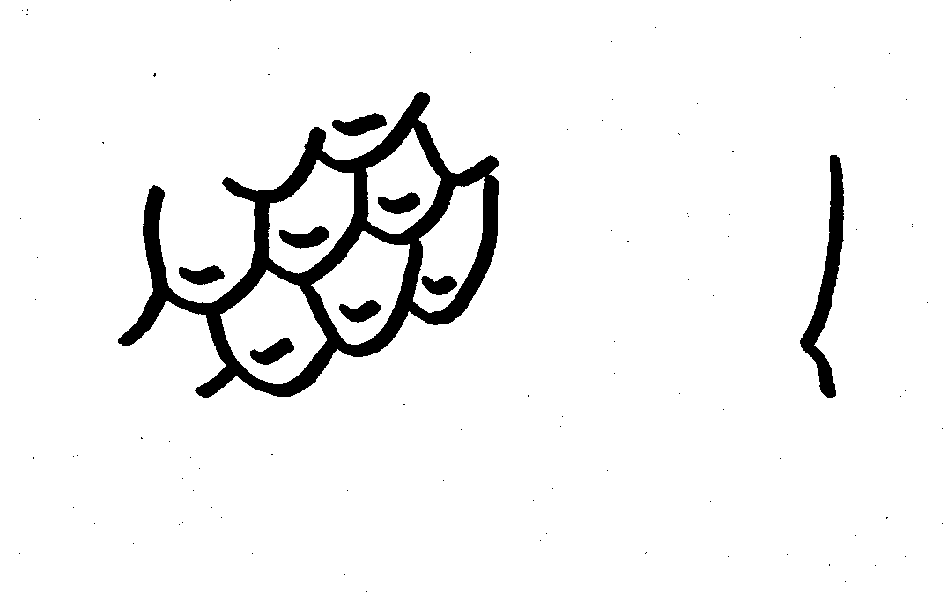
1 | 3
absent or very small | small

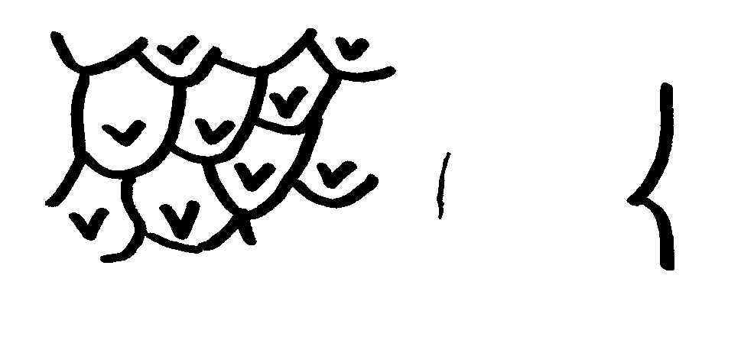 | 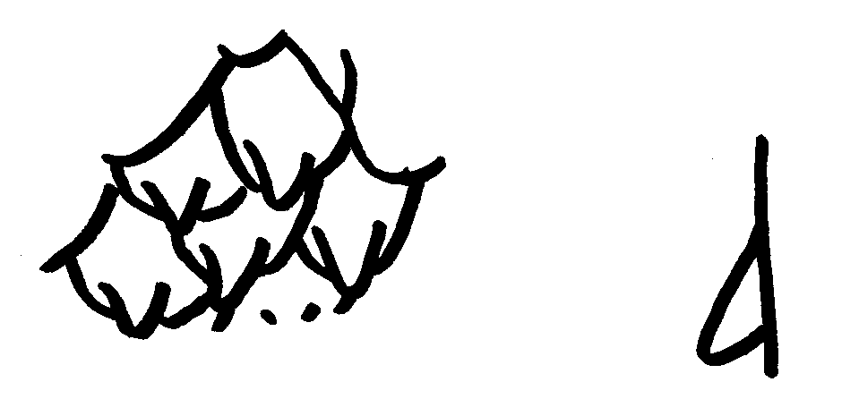
5 | 7
medium | large

Literature
Introductory fruit tree variety characteristic investigation enterprise report (1994), Japan Fruit Tree Seedling and Clonal Association.

Japanese National Test Guidelines for Cherimoya (2000).

Yamashita, S., (1995) Fruit of fascination - Cherimoya, Agriculture & Horticulture, Vol.70, No. 11, pp. 57-64.

Technical Questionnaire
TECHNICAL QUESTIONNAIRE |  |  |  | Page {x} of {y} |  |  | Reference Number:
 |  |  |  |  |  |  | Application date:
 |  |  |  |  |  |  | (not to be filled in by the applicant)
TECHNICAL QUESTIONNAIRE
to be completed in connection with an application for plant breeders’ rights

1. Subject of the Technical Questionnaire
1.1 Latin Name |  |  | Annona cherimola Mill.
1.2 Common Name |  |  | Cherimoya
2. Applicant
Name
Address
Telephone No.
Fax No.
E-mail address
Breeder (if different from applicant)
3. Proposed denomination and breeder’s reference
Proposed denomination
(if available)

Breeder’s reference
4. Information on the breeding scheme and propagation of the variety

4.1 Breeding Scheme

Variety resulting from:

4.1.1 Crossing

(a) controlled cross [ ]
(please state parent varieties)
(b) partially unknown cross [ ]
(please state known parent variety(ies))
(c) totally unknown cross [ ]

4.1.2 Mutation [ ]
(please state parent variety)

4.1.3 Discovery [ ]
(please state where, when and how developed)

4.1.4 Other [ ]
(please provide details)

4.2 Method of Propagating the Variety

4.2.1 Vegetative propagation

(a) in vitro propagation [ ]

(b) other (e.g. leaf cutting, hardwood cutting, layer) [ ]
(state method)

4.2.2 Other [ ]
(please provide details)

4.3 Virus status

4.3.1 The variety is free from all known viruses as follows: [ ]
(indicate from which viruses)

4.3.2 The plant material is virus tested: [ ]
(indicate against which viruses)

4.3.3 The virus status is unknown [ ]

5. Characteristics of the variety to be indicated (the number in brackets refers to the corresponding characteristic in Test Guidelines; please mark the note which best corresponds).

 | Characteristics |  |  |  |  | Example Varieties |  |  |  | Note
5.1  (29) | Fruit: shape in lateral view
 | circular |  |  |  |  | Bay Ott, Chaffey |  |  |  | 1[ ]
 | cordate |  |  |  |  | Bays, Honey Hart, Pierce, White |  |  |  | 2[ ]
 | conical |  |  |  |  | El Bumpo, Libby, Mariella, Villapark |  |  |  | 3[ ]
 | broad conical |  |  |  |  | Booth, Campas, Fino de Jete, Miguel, Ott |  |  |  | 4[ ]
 | trapezoidal |  |  |  |  | Big Sister |  |  |  | 5[ ]
5.2  (33) | Fruit: segmentation of surface
 | reticulate |  |  |  |  | Booth, El Bumpo, Ott |  |  |  | 1[ ]
 | overlapping |  |  |  |  | Bay Ott, Big Sister, Spain |  |  |  | 2[ ]
5.3  (34) | Fruit: protuberances on surface
 | absent or very small |  |  |  |  | Honey Hart, White |  |  |  | 1[ ]
 | small |  |  |  |  | Big Sister, Libby, Mariella, Villapark |  |  |  | 3[ ]
 | medium |  |  |  |  | El Bumpo, Oakwood |  |  |  | 5[ ]
 | large |  |  |  |  | Miguel, Sabor |  |  |  | 7[ ]
6. Similar varieties and differences from these varieties

Denomination(s) of variety(ies) similar to your candidate variety |  | Characteristic(s) in which your candidate variety differs from the similar variety(ies) |  |  | Describe the expression of the characteristic(s) for the similar variety(ies) |  |  | Describe the expression of the characteristic(s) for your candidate variety
(Example) |  | Fruit: shape in lateral view |  |  | conical |  |  | broad conical
Comments:
7. Additional information which may help in the examination of the variety

7.1 In addition to the information provided in sections 5 and 6, are there any additional characteristics which may help to distinguish the variety?

Yes [ ] No [ ]

(If yes, please provide details)

7.2 Special conditions for the examination of the variety

7.2.1 Are there any special conditions for growing the variety or conducting the examination?

Yes [ ] No [ ]

7.2.2 If yes, please give details:

7.3 Other information

A representative color photograph of the variety should accompany the Technical Questionnaire.

8. Authorization for release

(a) Does the variety require prior authorization for release under legislation concerning the protection of the environment, human and animal health?

Yes [ ] No [ ]

(b) Has such authorization been obtained?

Yes [ ] No [ ]

If the answer to (b) is yes, please attach a copy of the authorization.

9. I hereby declare that, to the best of my knowledge, the information provided in this form is correct:

Applicant’s name

Signature Date

[End of document]

* These names were correct at the time of the introduction of these Test Guidelines but may be revised or updated. [Readers are advised to consult the UPOV Code, which can be found on the UPOV Website (www.upov.int), for the latest information.]

