 |  | E  TG/206/1  ORIGINAL: English  DATE: April 9, 2003
INTERNATIONAL UNION FOR THE PROTECTION OF NEW VARIETIES OF PLANTS
GENEVA

 | BROAD BEAN  (Vicia faba L. var. major Harz) | *

GUIDELINES

FOR THE CONDUCT OF TESTS

FOR DISTINCTNESS, UNIFORMITY AND STABILITY

Alternative Names:*

Latin | English | French | German | Spanish
Vicia faba L. var. major Harz | Broad Bean | Fève | Dicke Bohne | Haba

ASSOCIATED DOCUMENTS

These guidelines should be read in conjunction with document TG/1/3, “General Introduction to the Examination of Distinctness, Uniformity and Stability and the Development of Harmonized Descriptions of New Varieties of Plants” (hereinafter referred to as the “General Introduction”) and its associated “TGP” documents.

TABLE OF CONTENTS PAGE

1. Subject of these TEST Guidelines 3
2. Material Required 3
3. Method of Examination 3
3.1 Duration of Tests 3
3.2 Testing Place 3
3.3 Conditions for Conducting the Examination 3
3.4 Test Design 4
3.5 Number of Plants / Parts of Plants to be Examined 4
3.6 Additional Tests 4
4. Assessment of Distinctness, Uniformity and Stability 4
4.1 Distinctness 4
4.2 Uniformity 4
4.3 Stability 5
5. Grouping of Varieties and Organization of the Growing Trial 5
6. Introduction to the Table of Characteristics 5
6.1 Categories of Characteristics 5
6.2 States of Expression and Corresponding Notes 6
6.3 Types of Expression 6
6.4 Example Varieties 6
6.5 Legend 6
7. Table of Characteristics 7
8. Explanations on the Table of Characteristics 15
8.1 Explanations covering several characteristics 15
8.2 Explanations for individual characteristics 15
8.3 Phenological growth stages and BBCH-identification keys of Vicia faba L. (Meier, 1997) 20
9. Literature 23
10. Technical Questionnaire 26

Subject of these Test Guidelines
These Test Guidelines apply to all varieties of Vicia faba L. var. major Harz.

Material Required
2.1 The competent authorities decide on the quantity and quality of the plant material required for testing the variety and when and where it is to be delivered. Applicants submitting material from a State other than that in which the testing takes place must ensure that all customs formalities and phytosanitary requirements are complied with.

2.2 The material is to be supplied in the form of seed.

2.3 The minimum quantity of plant material, to be supplied by the applicant, should be:

2 kg or at least 2000 seeds.

2.4 The seed should meet the minimum requirements for germination, species and analytical purity, health and moisture content, specified by the competent authority. In cases where the seed is to be stored, the germination capacity should be as high as possible and should be stated by the applicant.

2.5 The plant material supplied should be visibly healthy, not lacking in vigor, nor affected by any important pest or disease.

2.6 The plant material should not have undergone any treatment which would affect the expression of the characteristics of the variety, unless the competent authorities allow or request such treatment. If it has been treated, full details of the treatment must be given.

Method of Examination

3.1 Duration of Tests
The minimum duration of tests should normally be two independent growing cycles.

3.2 Testing Place
The tests should normally be conducted at one place. If any characteristics of the variety, which are relevant for the examination of DUS, cannot be seen at that place, the variety may be tested at an additional place.

3.3 Conditions for Conducting the Examination
The tests should be carried out under conditions ensuring satisfactory growth for the expression of the relevant characteristics of the variety and for the conduct of the examination.

3.4 Test Design
3.4.1 The design of the tests should be such that plants or parts of plants may be removed for measurement or counting without prejudice to the observations which must be made up to the end of the growing cycle.

3.4.2 Each test should be designed to result in a total of at least 160 plants, which should be divided between two or more replicates.

3.5 Number of Plants / Parts of Plants to be Examined
Unless otherwise indicated, all observations determined by measuring or counting should be made on 40 plants or parts taken from each of 40 plants.

3.6 Additional Tests
Additional tests, for examining relevant characteristics, may be established.

Assessment of Distinctness, Uniformity and Stability

4.1 Distinctness
4.1.1 General Recommendations

It is of particular importance for users of these Test Guidelines to consult the General Introduction prior to making decisions regarding distinctness. However, the following points are provided for elaboration or emphasis in these Test Guidelines.

4.1.2 Consistent Differences

The minimum duration of tests recommended in section 3.1 reflects, in general, the need to ensure that any differences in a characteristic are sufficiently consistent.

4.1.3 Clear Differences

Determining whether a difference between two varieties is clear depends on many factors, and should consider, in particular, the type of expression of the characteristic being examined, i.e. whether it is expressed in a qualitative, quantitative, or pseudo-qualitative manner. Therefore, it is important that users of these Test Guidelines are familiar with the recommendations contained in the General Introduction prior to making decisions regarding distinctness.

4.2 Uniformity
4.2.1 It is of particular importance for users of these Test Guidelines to consult the General Introduction prior to making decisions regarding uniformity. However, the following points are provided for elaboration or emphasis in these Test Guidelines.

4.2.2. The assessment of uniformity should be according to the recommendations for cross-pollinated varieties in the General Introduction.

4.3 Stability
4.3.1 In practice, it is not usual to perform tests of stability that produce results as certain as those of the testing of distinctness and uniformity. However, experience has demonstrated that, for many types of variety, when a variety has been shown to be uniform, it can also be considered to be stable.

4.3.2 Where appropriate, or in cases of doubt, stability may be tested, either by growing a further generation, or by testing a new seed or plant stock to ensure that it exhibits the same characteristics as those shown by the previous material supplied

Grouping of Varieties and Organization of the Growing Trial
5.1 The selection of varieties of common knowledge to be grown in the trial with the candidate varieties and the way in which these varieties are divided into groups to facilitate the assessment of distinctness is aided by the use of grouping characteristics.

5.2 Grouping characteristics are those in which the documented states of expression, even where produced at different locations, can be used, either individually or in combination with other such characteristics: (a) to select varieties of common knowledge that can be excluded from the growing trial used for examination of distinctness; and (b) to organize the growing trial so that similar varieties are grouped together.

5.3 The following have been agreed as useful grouping characteristics:

(a) Plant: growth type (characteristic 2);

(b) Wing: melanin spot (characteristic 16);

(c) Dry seed: color of testa (immediately after harvest) (characteristic 32).

5.4 Guidance for the use of grouping characteristics, in the process of examining distinctness, is provided through the General Introduction.

Introduction to the Table of Characteristics

6.1 Categories of Characteristics
6.1.1 Standard Test Guidelines Characteristics

Standard Test Guidelines characteristics are those which are approved by UPOV for examination of DUS and from which members of the Union can select those suitable for their particular circumstances.

6.1.2 Asterisked Characteristics

Asterisked characteristics (denoted by *) are those included in the Test Guidelines which are important for the international harmonization of variety descriptions and should always be examined for DUS and included in the variety description by all members of the Union, except when the state of expression of a preceding characteristic or regional environmental conditions render this inappropriate.

6.2 States of Expression and Corresponding Notes
States of expression are given for each characteristic to define the characteristic and to harmonize descriptions. Each state of expression is allocated a corresponding numerical note for ease of recording of data and for the production and exchange of the description.

6.3 Types of Expression
An explanation of the types of expression of characteristics (qualitative, quantitative and pseudo-qualitative) is provided in the General Introduction.

6.4 Example Varieties
Where appropriate, example varieties are provided to clarify the states of expression of each characteristic.

6.5 Legend
(*) Asterisked characteristic – see Section 6.1.2

(a)-(c) See Explanations on the Table of Characteristics in Chapter 8, Section 8.1

(+) See Explanations on the Table of Characteristics in Chapter 8, Section 8.2

¹⁾ The optimum stage of development for the assessment of each characteristic is indicated by a number in the second column. The stages of development denoted by each number are described under Chapter 8, Section 8.3.

Table of Characteristics/Tableau des caractères/Merkmalstabelle/Tabla de caracteres
 | Stage ¹⁾  Stade ¹⁾  Stadium ¹⁾  Estado ¹⁾ | English | français | deutsch | español | Example Varieties  Exemples  Beispielssorten  Variedades ejemplo | Note/  Nota
1.  (+) | 00 | Seed: tannin | Semence: tanin | Samen: Tannin | Semilla: tanino
 |  | absent | absent | fehlend | ausente | Driemaal Wit | 1
 |  | present | présent | vorhanden | presente | Trio | 9
2.  (*)  (+) | 65-67 | Plant: growth type | Plante: type de croissance | Pflanze: Wuchstyp | Planta: tipo de crecimiento
 |  | determinate | déterminée | begrenzt wachsend | determinado | Samson, Smerf | 1
 |  | indeterminate | indéterminée | unbegrenzt wachsend | indeterminado | Driemaal Wit | 2
3.  (*) | 60-69 | Plant: height | Plante: hauteur | Pflanze: Höhe | Planta: altura
 |  | very short | très basse | sehr niedrig | muy baja | The Sutton | 1
 |  | short | basse | niedrig | baja | Arbo, Reina Mora | 3
 |  | medium | moyenne | mittel | media | Aquadulce Claudia | 5
 |  | tall | haute | hoch | alta | Dreadnought | 7
 |  | very tall | très haute | sehr hoch | muy alta | Imperial White Windsor | 9
4.  (*) | 60-69 | Plant: number of stems (including tillers more than half the length of the main stem) | Plante: nombre de tiges (tiges dépassant la moitié de la longueur de la tige principale incluses) | Pflanze: Anzahl Triebe (einschließlich der Triebe mit mehr als der halben Länge des Haupttriebes) | Planta: número de tallos (incluidos los hijuelos cuya longitud sea superior a la mitad de la longitud del tallo principal)
 |  | few | faible | gering | bajo | The Sutton | 3
 |  | medium | moyen | mittel | medio | Albinette, Arbo | 5
 |  | many | élevé | groß | alto | Reina Blanca | 7
5. | 60-69 | Stem: number of nodes up to and including first flowering node | Tige: nombre de nœuds jusqu’au premier nœud florifère inclus | Trieb: Anzahl Knoten bis einschließlich des ersten blühenden Knotens | Tallo: número de nudos hasta el primer nudo floral incluido
 |  | few | faible | gering | bajo | Driemaal Wit, Metissa | 3
 |  | medium | moyen | mittel | medio | Futura | 5
 |  | many | élevé | groß | alto |  | 7
6. | 39-69 | Stem: anthocyanin coloration | Tige: pigmentation anthocyanique | Trieb: Anthocyan-färbung | Tallo: pigmentación antociánica
 |  | absent | absente | fehlend | ausente | Driemaal Wit, Metissa | 1
 |  | present | présente | vorhanden | presente | Futura | 9
7. | 39-69 | Foliage: greyish hue of green color | Feuillage: teinte grisâtre de la couleur verte | Laub: gräulicher Ton der Grünfärbung | Follaje: tono grisáceo del color verde
 | (a) | absent | absente | fehlend | ausente | Metissa | 1
 |  | present | présente | vorhanden | presente | Osnaweiss | 9
8. | 39-69 | Foliage: intensity of green color | Feuillage: intensité de la couleur verte | Laub: Intensität der Grünfärbung | Follaje: intensidad del color verde
 | (a) | light | claire | hell | claro | Driemaal Wit | 3
 |  | medium | moyenne | mittel | medio | Express, Futura | 5
 |  | dark | foncée | dunkel | oscuro |  | 7
9.  (*) | 62-65 | Leaflet: length (basal pair of leaflet at secondary node) | Foliole: longueur (paire basale de foliole au niveau du second nœud) | Fiederblatt: Länge (Basisfiederblattpaar am sekundären Nodium) | Folíolo: longitud (par de folíolos basales en nudos secundarios)
 | (b) | short | courte | kurz | corto | Metissa | 3
 |  | medium | moyenne | mittel | medio | Superaguadulce Tézier, Futura | 5
 |  | long | longue | lang | largo | Lange Hangers, Osnabrücker Markt | 7
10.  (*) | 62-65 | Leaflet width  (as for 9) | Foliole: largeur  (comme pour 9) | Fiederblatt: Breite (wie für 9) | Folíolo: anchura (como para 9)
 | (b) | narrow | étroite | schmal | estrecho | The Sutton | 3
 |  | medium | moyenne | mittel | medio | Optica | 5
 |  | broad | large | breit | ancho | Osnabrücker Markt | 7
11.  (*) | 62-65 | Leaflet: position of maximum width  (as for 9) | Foliole: position de la largeur maximale  (comme pour 9) | Fiederblatt: Position der maximalen Breite  (wie für 9) | Folíolo: punto de anchura máxima  (como para 9)
 | (b) | towards tip | vers le sommet | zur Spitze hin | hacia el ápice |  | 1
 |  | at middle | au milieu | in der Mitte | al medio |  | 2
 |  | towards base | vers la base | zur Basis hin | hacia la base |  | 3
12. | 70-78 | Leaflet: folding (along the main vein, terminal pair of leaflets) | Feuille: plissure (le long de la nervure principale, paire de folioles terminale) | Fiederblatt: Faltung (entlang der Mittelrippe, Endfiederpaar) | Folíolo: plegado (a lo largo del nervio principal, par de folíolos terminales)
 | (b) | weak | faible | gering | débil | Metissa | 3
 |  | medium | moyenne | mittel | medio |  | 5
 |  | strong | forte | stark | fuerte | Minica | 7
13.  (*) | 62-65 | Raceme: number of flowers | Racème: nombre de fleurs | Blütenstand: Anzahl Blüten | Racimo. número de flores
 | (b) | few | faible | gering | bajo | Aquadulce Claudia | 3
 |  | medium | moyen | mittel | medio |  | 5
 |  | many | élevé | groß | alto |  | 7
14.  (*) | 60 | Time of flowering (50% of the plants with at least one flower) | Époque de floraison (50% des plantes avec au moins une fleur) | Blühzeitpunkt (50% der Pflanzen zeigen wenigstens eine Blüte) | Época de floración (50% de las plantas con al menos una flor)
 |  | early | précoce | früh | temprana | Minica, Optica | 3
 |  | medium | moyenne | mittel | media | Futura | 5
 |  | late | tardive | spät | tardía | Osnabrücker Markt | 7
15.  (+) | 60-65 | Flower: length | Fleur: longueur | Blüte: Länge | Flor: longitud
 | (b) | short | courte | kurz | corta | Aquadulce Claudia, The Sutton | 3
 |  | medium | moyenne | mittel | media | Minica | 5
 |  | long | longue | lang | larga | Green Windsor | 7
16.  (*) | 60-65 | Wing: melanin spot | Aile: tache de mélanine | Flügel: Melaninfleck | Quilla: mancha de melanina
 |  | absent | absente | fehlend | ausente | Driemaal Wit, Metissa | 1
 |  | present | présente | vorhanden | presente | Futura, Trio | 9
17.  (*) | 60-65 | Wing: colour of melanin spot | Aile: couleur de la tache de mélanine | Flügel: Farbe des Melaninflecks | Quilla: color de la mancha de melanina
 |  | greenish yellow | jaune verdâtre | grünlichgelb | amarillo verdoso | Golda | 1
 |  | brown | brune | braun | marrón |  | 2
 |  | black | noire | schwarz | negro | Futura, Trio | 3
18. | 60-65 | Standard: melanin spot | Étendard: tache de mélanine | Fahne: Melaninfleck | Estandarte: mancha de melanina
 |  | absent | absente | fehlend | ausente | Driemaal Wit, Futura | 1
 |  | present | présente | vorhanden | presente | Felix | 9
19.  (*) | 60-65 | Standard: anthocyanin coloration | Étendard: pigmentation anthocyanique | Fahne: Anthocyanfärbung | Estandarte: pigmentación antociánica
 |  | absent | absente | fehlend | ausente | Driemaal Wit | 1
 |  | present | présente | vorhanden | presente |  | 9
20.  (+) | 60-65 | Standard: extent of anthocyanin coloration | Étendard: extension de la pigmentation anthocyanique | Fahne: Ausdehnung der Anthocyan-färbung | Estandarte: extensión de la pigmentación antociánica
 |  | small | faible | gering | pequeña | The Sutton, Osnabrücker Markt | 3
 |  | medium | moyenne | mittel | media |  | 5
 |  | large | forte | groß | grande |  | 7
21. | 70-78 | Truss: number of pods | Cyme: nombre de gousses | Fruchtstand: Anzahl Hülsen | Racimo: número de vainas
 |  | few | faible | gering | bajo | Aquadulce Claudia, Muchamiel | 3
 |  | medium | moyen | mittel | medio | Metissa | 5
 |  | many | élevé | groß | alto |  | 7
22.  (*) | 75-80 | Pod: attitude | Gousse: port | Hülse: Stellung | Vaina: porte
 | (a) | erect | dressé | aufrecht | erecto | Optica | 1
 | (b) | semi-erect | demi-dressé | halbaufrecht | semierecto | Statissa, The Sutton | 3
 |  | horizontal | horizontal | waagerecht | horizontal | Trio | 5
 |  | semi-pendulous | demi-retombant | halbhängend | semicolgante | Express | 7
 |  | pendulous | retombant | hängend | colgante | Lange Hangers, Futura | 9
23.  (*) | 80 | Pod: length (without beak) | Gousse: longueur (sans le bec) | Hülse: Länge (ohne Zahn) | Vaina: longitud (sin el pico)
 | (a) | very short | très courte | sehr kurz | muy corta | Arbo | 1
 | (b) | short | courte | kurz | corta | Green Windsor, Optica | 3
 |  | medium | moyenne | mittel | media | Driemaal Wit, Red Epicure | 5
 |  | long | longue | lang | larga | Dreadnought | 7
 |  | very long | très longue | sehr lang | muy larga | Hangdown Grünkernig | 9
24.  (*) | 80 | Pod: width (from suture to suture) | Gousse: largeur  (de suture à suture) | Hülse: Breite (von Naht zu Naht) | Vaina: anchura (de sutura a sutura)
 | (a) | narrow | étroite | schmal | estrecha | Felix, Minica | 3
 | (b) | medium | moyenne | mittel | media | Trio, Express | 5
 |  | broad | large | breit | ancha | Con Amore | 7
 |  | very broad | très large | sehr breit | muy ancha | Aquadulce Claudia | 9
25.  (+) | 80 | Pod: degree of curvature at green shell stage | Gousse: intensité de la courbure au stade vert | Hülse: Stärke der Krümmung im Grünhülsenstadium | Vaina: grado de curvatura en estado de vainas verdes
 | (b) | absent or very weak | nulle ou très faible | fehlend oder sehr gering | ausente o muy débil | Optica | 1
 |  | weak | faible | gering | débil | Metissa | 3
 |  | medium | moyenne | mittel | media | Witkiem | 5
 |  | strong | forte | stark | fuerte | Groene Hangers, Futura | 7
26. | 80 | Pod: intensity of green color | Gousse: intensité de la couleur verte | Hülse: Intensität der Grünfärbung | Vaina: intensidad del color verde
 | (a) | light | faible | hell | claro | Futura | 3
 | (b) | medium | moyenne | mittel | medio | Driemaal Wit | 5
 |  | dark | forte | dunkel | oscuro | Statissa | 7
27.  (*) | 80 | Pod: number of ovules (including seeds) | Gousse: nombre d’ovules (y compris les semences) | Hülse: Anzahl Samenanlagen (einschließlich Samen) | Vaina: número de óvulos (incluidas semillas)
 | (a) | few | faible | gering | bajo | White Windsor | 3
 | (b) | medium | moyen | mittel | medio | Aquadulce Claudia | 5
 |  | many | élevé | groß | alto | Imperial Green, Longpod | 7
28. | 80 | Pod: thickness of pod wall | Gousse: épaisseur de la cosse | Hülse: Dicke der Hülsenwand | Vaina: espesor de la pared
 | (a) | thin | fine | dünn | delgada | Statissa | 3
 | (b) | medium | moyenne | mittel | media |  | 5
 |  | thick | épaisse | dick | gruesa | Aquadulce Claudia, Futura | 7
29. | 99 | Dry seed: shape of median longitudinal section | Graine sèche: forme de la section longitudinale médiane | Trockenkorn: Form des medianen Längsschnitts | Grano seco: forma de la sección longitudinal media
 | (c) | narrow elliptic | elliptique étroite | schmal elliptisch | elíptica estrecha | Metissa | 1
 |  | elliptic | elliptique | elliptisch | elíptica |  | 2
 |  | broad elliptic | elliptique large | breit elliptisch | elíptica ancha | Futura | 3
30. | 99 | Dry seed: shape of cross section | Graine sèche: forme de la section transversale | Trockenkorn: Form des Querschnitts | Grano seco: forma de la sección transversal
 | (c) | narrow elliptic | elliptique étroite | schmal elliptisch | elíptica estrecha | Aquadulce Claudia, Futura | 1
 |  | elliptic | elliptique | elliptisch | elíptica |  | 2
 |  | broad elliptic | elliptique large | breit elliptisch | elíptica ancha |  | 3
31.  (*)  (+) | 99 | Dry seed: weight | Graine sèche: poids | Trockenkorn: Gewicht | Grano seco: peso
 | (c) | very low | très faible | sehr niedrig | muy bajo | Albinette, Minica | 1
 |  | low | faible | niedrig | bajo | Arbo, Felix | 3
 |  | medium | moyen | mittel | medio | The Sutton, Trio | 5
 |  | high | élevé | hoch | alto | Futura, Red Epicure | 7
 |  | very high | très élevé | sehr hoch | muy alto | White Windsor | 9
32.  (*) | 99 | Dry seed: color of testa (immediately after harvest) | Graine sèche: couleur du tégument (immédiatement après la récolte) | Trockenkorn: Farbe der Samenschale  (gleich nach der Ernte) | Grano seco: color de la testa (justo después de la cosecha)
 | (c) | beige | beige | beige | beige | Driemaal Wit, Trio | 1
 |  | green | vert | grün | verde | Green Windsor | 2
 |  | red | rouge | rot | rojo | Red Epicure | 3
 |  | violet | violet | violett | violeta | Reina Mora | 4
 |  | black | noir | schwarz | negro |  | 5
33.  (+) | 99 | Dry seed: black pigmentation of hilum | Graine sèche: pigmentation noire du hile | Trockenkorn: schwarze Pigmentierung des Nabels | Grano seco: coloración negra del hilo
 | (c) | absent | absente | fehlend | ausente | Driemaal Wit | 1
 |  | present | présente | vorhanden | presente | Aquadulce Claudia | 9
34. | 80 | Time of full development of pod (first fully developed pods) | Époque de développement complet de la gousse (premières gousses complètement développées) | Zeitpunkt der vollen Entwicklung der Hülse (erste vollentwickelte Hülsen) | Época de desarrollo completo de la vaina (primeras vainas completamente desarrolladas)
 |  | early | précoce | früh | temprana | Express | 3
 |  | medium | moyenne | mittel | media | Driemaal Wit | 5
 |  | late | tardive | spät | tardía | Imperial Green Longpod | 7

Explanations on the Table of Characteristics

8.1 Explanations covering several characteristics
Characteristics containing the following key in the second column of the Table of Characteristics should be examined as indicated below:

(a) Foliage and pod: Unless otherwise indicated, all observations on the foliage and pod should be made before green harvest maturity.

(b) Leaflet, raceme, flower, pod: All measurements of the leaflet, flower and pod should be made at the 2nd flowering node.

(c) Dry seed: All observation on the dry seed should be made on harvested dry seed.

8.2 Explanations for individual characteristics

Ad. 1: Seed: tannin

The tannin content of testa correlates with melanin spot on the flower wing. Maintaining both characteristics is necessary, as observations are made at very different stages and different times. The content of tannin should be tested by removing a piece of the testa from the seed and placing 1 or 2 drops of the test reagent upon its inner surface. A bright pink colour will develop within 1 or 2 minutes in the presence of tannins. (Reagents: A = 50% ethanol; B = 1% vanillin in concentrated HCl. A and B mixed 1:1 for use. For the purposes of this test, ‘concentrated’ is defined as within the range 33-37% weight by volume.)

Seeds that are yellowish grey immediately after harvest will turn brown after ageing if they contain tannin.

Ad. 2: Plant: growth type

Determinate growth type is characterized by a terminal inflorescence, whereas indeterminate growth type shows vegetative growth above the uppermost flowers.

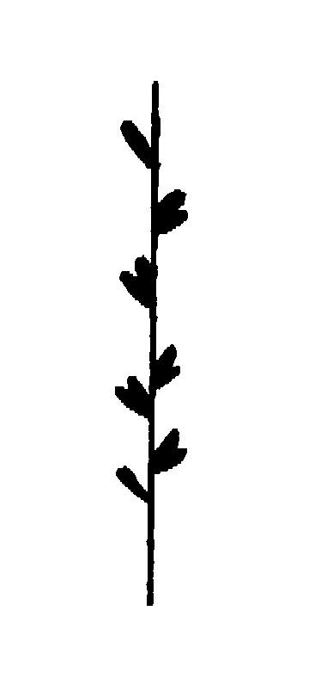
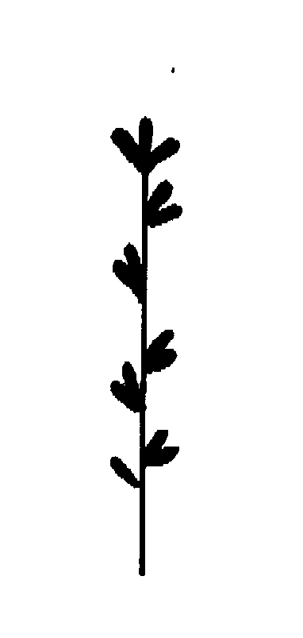
1 | 2
determinate | indeterminate

Ad. 15: Flower: length

Length

Ad. 20: Standard: extent of anthocyanin coloration

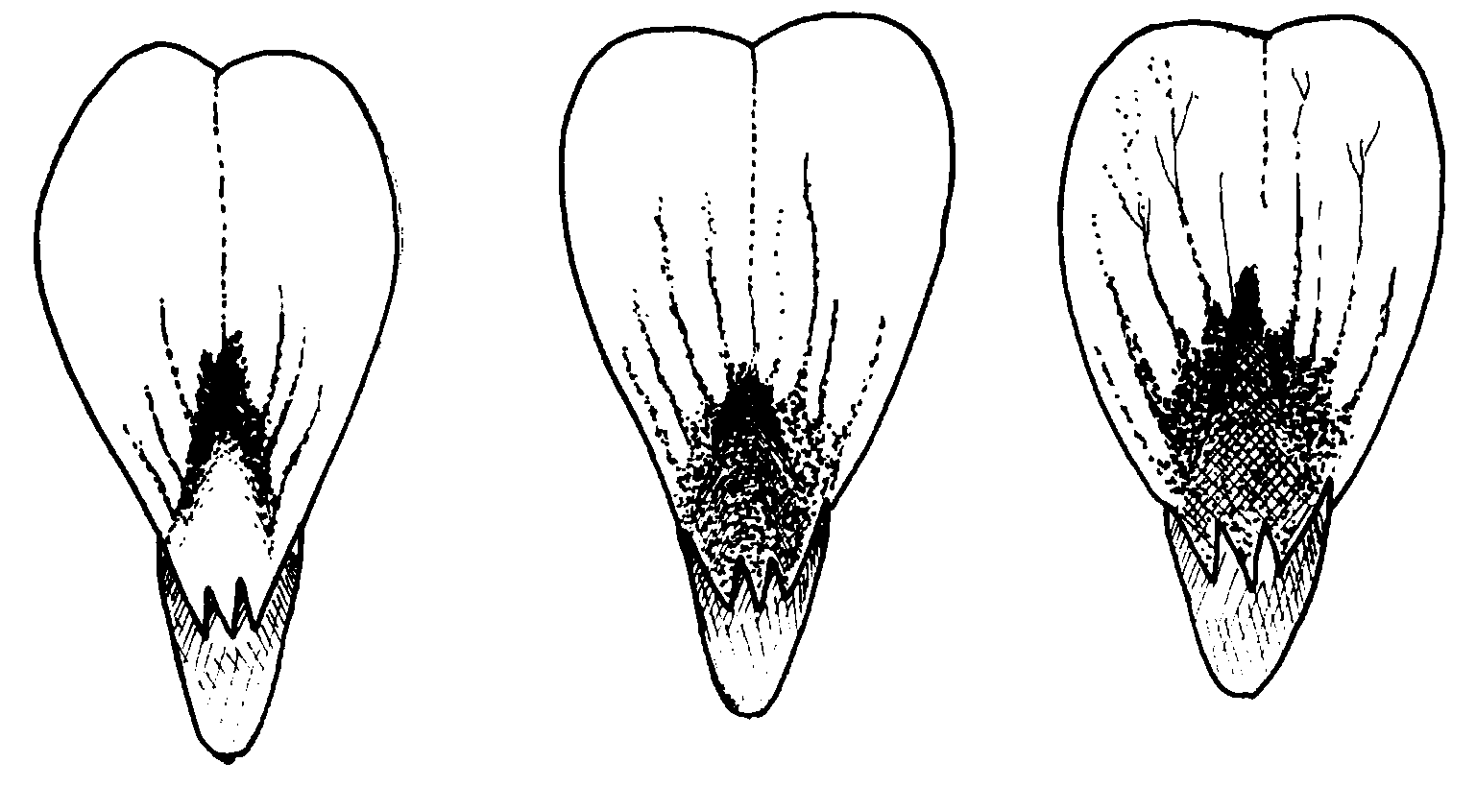
3 | 5 | 7
small | medium | large

The observation should be made on the inner side of the Standard.

Ad. 25: Pod: degree of curvature at green shell stage

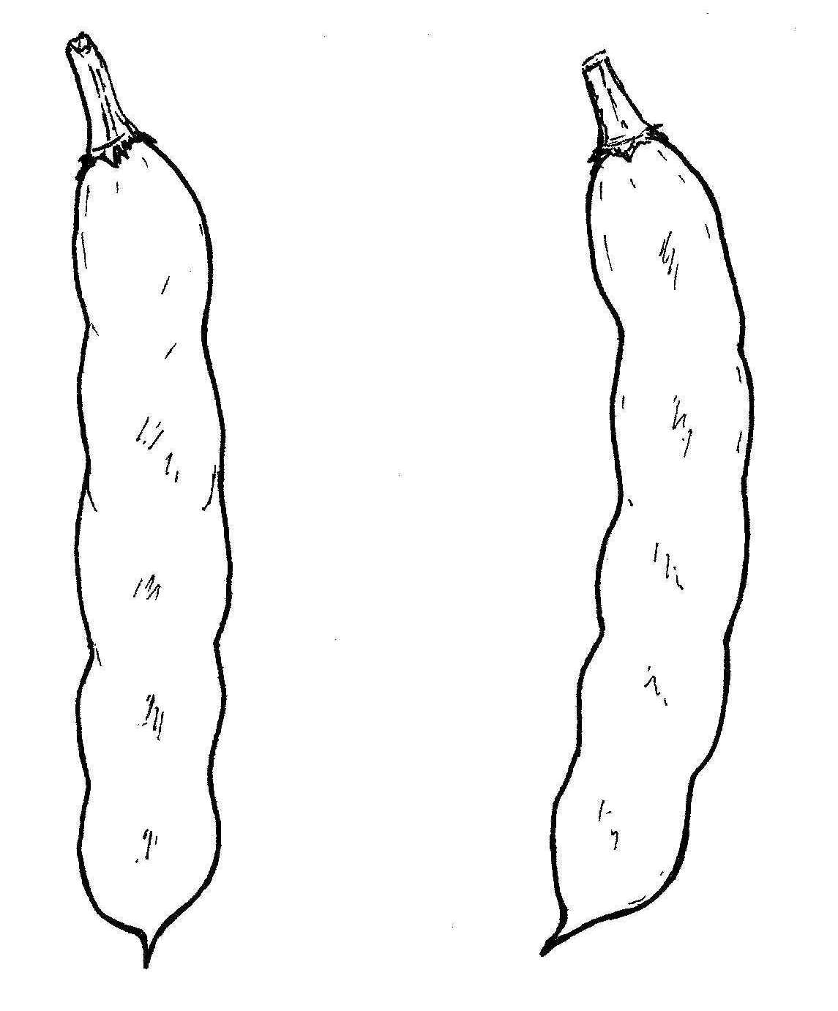
1 | 3
absent or very weak | weak

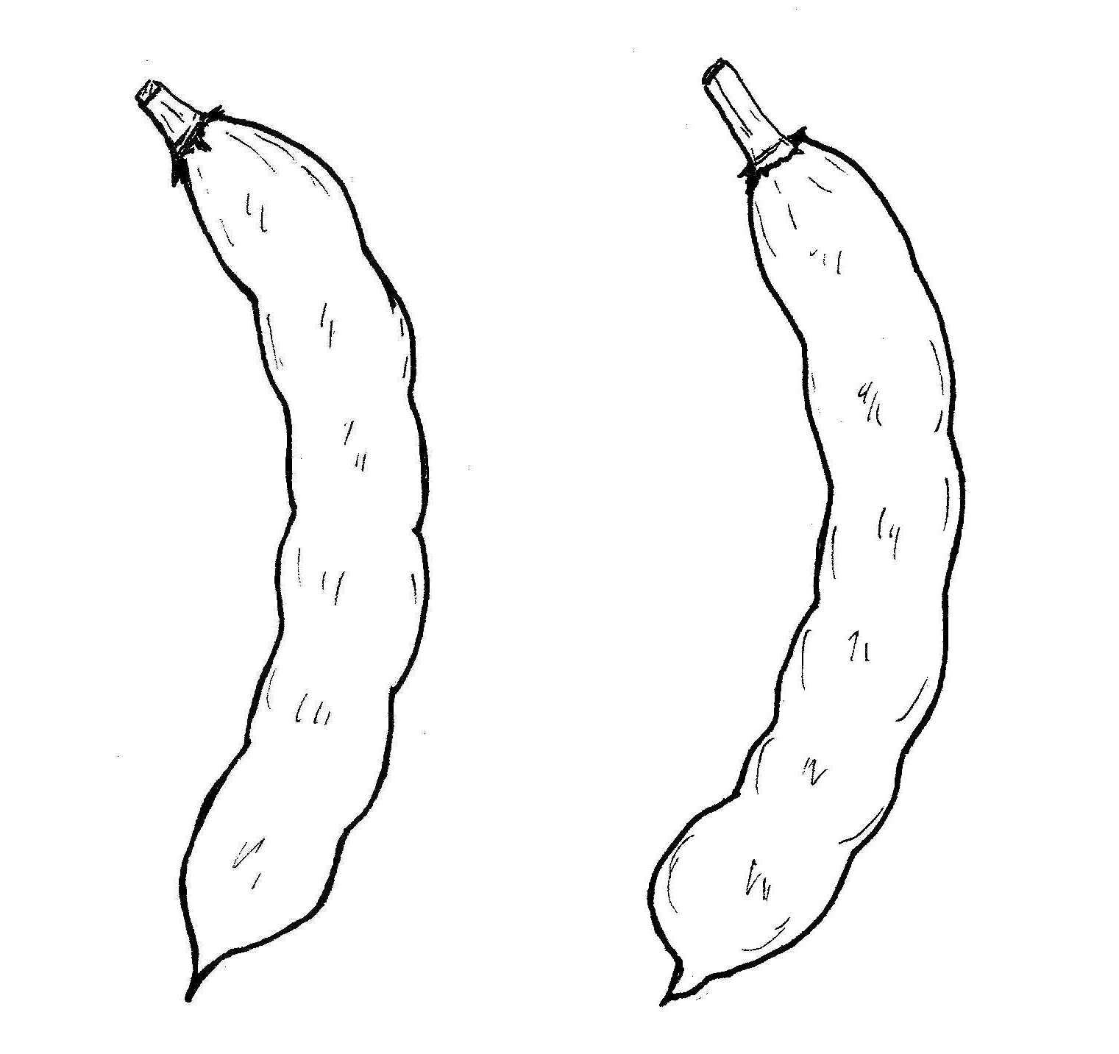
5 | 7
medium | strong

Ad. 31: Dry seed: weight

The dry seed weight should be measured by weighing the largest seed from the largest pod for each plant sampled.

Ad. 33: Dry seed: black pigmentation of hilum

Certain varieties, which by their genetic structure show segregation in respect of this characteristic, are admissable provided that the breeder is able to ensure stability. However, this characteristic cannot be used for establishing distinctness of varieties mentioned in the previous sentence. For varieties which show segregation, the characteristic should be described in the state “present” and the proportions of the two states of expression should, in each individual case, be included in the description.

8.3 Phenological growth stages and BBCH-identification keys of Vicia faba L.
(Meier, 1997)
Code | Description
Principal growth stage 0: Germination
00 | Dry seed
01 | Beginning of seed imbibition
02 | –
03 | Seed imbibition complete
04 | –
05 | Radicle emerged from seed
06 | –
07 | Shoot emerged from seed (plumule apparent)
08 | Shoot growing towards soil surface
09 | Emergence shoot emerges through soil surface
Principal growth stage 1: Leaf development 1
10 | Pair of scale leaves visible (may be eaten or lost)
11 | First leaf unfolded
12 | 2 leaves unfolded
13 | 3 leaves unfolded
1. | Stages continuous till …
19 | 9 or more leaves unfolded
Principal growth stage 2: Formation of side shoots
20 | No side shoots
21 | Beginning of side shoot development: first side shoot detectable
22 | 2 side shoots detectable
23 | 3 side shoots detectable
24 | 4 side shoots detectable
25 | 5 side shoots detectable
26 | 6 side shoots detectable
27 | 7 side shoots detectable
28 | 8 side shoots detectable
29 | End of side shoot development: 9 or more side shoots detectable
Principal growth stage 3: Stem elongation
30 | Beginning of stem elongation
31 | One visibly extended internode2
32 | 2 visibly extended internodes
33 | 3 visibly extended internodes
34 | 4 visibly extended internodes
35 | 5 visibly extended internodes
36 | 6 visibly extended internodes
37 | 7 visibly extended internodes
38 | 8 visibly extended internodes
39 | 9 or more visibly extended internodes
Principal growth stage 4: -----
Principal growth stage 5: Inflorescence emergence
50 | Flower buds present, still enclosed by leaves
51 | First flower buds visible outside leaves
52 | –
53 | –
54 | –
55 | First individual flower buds visible outside leaves but still closed
56 | –
57 | –
58 | –
59 | First petals visible, many individual flower buds, still closed
Principal growth stage 6: Flowering
60 | First flowers open
61 | Flowers open on first raceme
62 | –
63 | Flowers open 3 racemes per plant
64 | –
65 | Full flowering: flowers open on 5 racemes per plant
66 | –
67 | Flowering declining
68 | –
69 | End of flowering
Principal growth stage 7: Development of fruit
70 | First pods have reached final length (“flat pod”)
71 | 10% of pods have reached final length
72 | 20% of pods have reached final length
73 | 30% of pods have reached final length
74 | 40% of pods have reached final length
75 | 50% of pods have reached final length
76 | 60% of pods have reached final length
77 | 70% of pods have reached final length
78 | 80% of pods have reached final length
79 | Nearly all pods have reached final length
Principal growth stage 8: Ripening
80 | Beginning of ripening: seed green, filling pod cavity
81 | 10% of pods ripe, seeds dry and hard
82 | 20% of pods ripe, seeds dry and hard
83 | 30% of pods ripe and dark, seeds dry and hard
84 | 40% of pods ripe and dark, seeds dry and hard
85 | 50% of pods ripe and dark, seeds dry and hard
86 | 60% of pods ripe and dark, seeds dry and hard
87 | 70% of pods ripe and dark, seeds dry and hard
88 | 80% of pods ripe and dark, seeds dry and hard
89 | Fully ripe: nearly all pods dark, seeds dry and hard
Principal growth stage 9: Senescence
90 | –
91 | –
92 | –
93 | Stems begin to darken
94 | –
95 | 50% of stems brown or black
96 | –
97 | Plant dead and dry
98 | –
99 | Harvested product

Literature
Anon, 1995: Faba Bean Breeding. Grain Legumes. 8.

Anon, 1995: Field Bean Handbook. Processors and Growers Research Organisation, Peterborough.

Anon, 1990: Pea and bean pests, diseases and disorders. Processors and Growers Research Organisation, Peterborough.

Anon, 1990: Diseases of peas and beans. National Institute of Agricultural Botany. Cambridge.

Bould, A. and Crofton, G.R.A., 1987: Variation in the expression of hilum colour in field bean varieties in relation to seed certification standards. Seed Science and Technology, 15, 651-662.

Cabrera, A. and Martin, A., 1989: Genetics of tannin content and its relationship with flower and testa colours in Vicia faba. Journal of Agricultural Science, Cambridge. 113. 93-98.

Chapman, G.P., 1981: Genetic variation within Vicia faba. Aleppo: FABIS, ICARDA. 3, Supplement 1-12.

Cooke, R.J., Higgins, J., Morgan, A.G. and Evans, J.L., 1985: The use of a vanillin test for the detection of tannins in cultivars of Vicia faba L. J. Natn. Inst. Agric. Bot. 17. 139-143.

Crofton, G.R.A., 1996: A review of pollination and seed setting in Faba beans. Plant Varieties and Seeds 9, 29-36.

Duc, G., Brun, N., Merghem, R. and Jay, M., 1995: Genetic variation in tanning related characteristics in faba bean seeds (Vicia faba L.) and their relationship with seed coat colour. Plant Breeding, 114, 272 - 274.

Ebmeyer, E. and Stelling, D., 1994: Genetic structure of three open pollinated faba bean varieties (Vicia faba L.). Plant Breeding, 112, 17 - 23.

Erith, A.G. 1930: The inheritance of colour, size and form of seeds and flower colour in Vicia faba L.. Genetica, 12, 477-510.

Hebblethwaite, P.D. (Ed) 1983: The Faba Bean (Vicia faba L.): a basis for improvement. London. Butterworths. ISBN 0-408-10695-6.

Higgins, J., Evans, J.L., and Reed, P.J., 1981: Classification of Western European cultivars of Vicia faba L. Journ. Natn. Inst. Agric. Bot. 15. 3. 480-487.

Higgins, J. and Evans, J.L., 1983: Description of field bean cultivars (Vicia faba L. (partim.) Vicia faba L. Journ. Natn. Inst. Agric. Bot. 16. 273-277.

Higgins, J. and Evans, J.L., 1984: Standards employed in distinctness uniformity and stability tests for faba bean cultivars. In Systems for cytogenetic analysis in Vicia faba L. Ed. Chapman, G.P. and Tarawali, S.A.. Dordrecht, Martinus Nijhoff.

Higgins, J., Evans, J.L. and Law, J.R., 1988: A revised classification and descriptions of faba bean cultivars (Vicia faba L.). Plant Varieties and Seeds. 1. 27-35.

Higgins, J. and Sparks, T.H., 1989: A comparison of single-seed weight and 100-seed weight in faba bean varieties (Vicia faba L.). Plant Varieties and Seeds. 2. 193-200.

Kaznowski, L., 1923: Studja nad bobikiem (Vicia faba L., V. minor A.) Cz. I. Bobik Nadwislandski. Nadbitka z. Pamietnika panstw., Instytutu Naukowego Gospodarstwa Wiejskiego W Pulawach IV Pt A 50-85. (Polish with French summary).

Knott, C. M., 1990: A key for stages of development of the faba bean (Vicia faba). Ann. Appl. Biol. 116, 391-404.

Link, W., Ederer, W. Metz, P., Buiel, H. and Melchinger, A.E., 1994: Genotypic and environmental variation for degree of cross-fertilisation in faba bean. Crop Science, 34,
960 - 969.

Meier, U. (Editor), 1997. Growth Stages of Mono- and Dicotyledonous Plants. BBCH-Monograph, Blackwell Wissenschafts-Verlag Berlin-Wien (quadrilingual version: English, français, deutsch, español).

Mudzana, G., Pickett, A.A., Jarman, R.J., Cooke, R.J. and Keefe, P.D, 1995: Variety discrimination in faba beans (Vicia faba L.): an integrated approach. Plant Varieties and Seeds, 8, 135-145.

Muratova, V.S., 1931: Common Beans (Vicia faba L.). Bulletin of Applied Botany of Genetics and Plant Breeding. 50th supplement. pp 248-285. (English summary)

Picard, J., 1963: La coloration des téguments du grain chez la féverole (Vicia faba L.) Etude de l’hérédité des différentes colorations. Annales de l’Amélioration des Plantes, 13, 97-117.

Ricciardi, L., Filippetti, A., De Pace, C. and Marenzo, C.F. 1985: Inheritance of seed coat colour in Broad Bean (Vicia faba L.). Euphytica, 34, 43-51.

Sirks, M.J., 1931: Beiträge zu einer genotypischen Analyse der Ackerbone (Vicia faba L.) Genetica, 13, 210-631.

Sjodin, J., 1971: Induced morphological variation in Vica faba L. Hereditas. 67: 155 - 180.

Smartt, J. 1990: Grain Legumes: evolution and genetic resources. Cambridge University Press. ISBN 0-521-30797 X.

Summerfield, R.J. (Ed.), 1988: World Crops: Cool season food legumes. Proceedings of the International Food legume Research Conference on Pea, Lentil, Faba Bean and Chickpea. Spokane, Washington, USA 6-11 July 1986. Current Plant Science and Biotechnology in Agriculture. Kluwer Academic Publishers. ISBN 90-247-3641-2.

Summerfield, R.J. and Roberts, E.H. (Eds.), 1985: Grain Legume Crops. London, Collins.

Simmonds, N.W. and Smartt, J., 1995: Evolution of Crop Plants. Longman. ISBN 0-582-08643-4.

Thompson, R., 1981: Vicia faba: physiology and breeding. The Hague, Martinus Nijhoff.

Ward, S. and Chapman, G.P., 1986: Third conspectus of genetic variation within Vicia faba. FABIS, ICARDA.

Technical Questionnaire
TECHNICAL QUESTIONNAIRE |  |  |  | Page {x} of {y} |  |  | Reference Number:
 |  |  |  |  |  |  | Application date:
 |  |  |  |  |  |  | (not to be filled in by the applicant)
TECHNICAL QUESTIONNAIRE
to be completed in connection with an application for plant breeders’ rights

1. Subject of the Technical Questionnaire
1.1 Latin Name |  |  | Vicia faba L. var. major Harz
1.2 Common Name |  |  | Broad Bean
2. Applicant
Name
Address
Telephone No.
Fax No.
E-mail address
Breeder (if different from applicant)
3. Proposed denomination and breeder’s reference
Proposed denomination
(if available)

Breeder’s reference
4. Information on the breeding scheme and propagation of the variety

4.1 Breeding Scheme

Variety resulting from:

4.1.1 Crossing

(a) controlled cross [ ]
(please state parent varieties)
(b) partially unknown cross [ ]
(please state known parent variety(ies))
(c) totally unknown cross [ ]

4.1.2 Mutation [ ]
(please state parent variety)

4.1.3 Discovery [ ]
(please state where, when and how developed)

4.1.4 Other [ ]
(please provide details)

4.2 Method of Propagating the Variety

(a) Cross-pollination [ ]

(b) Other [ ]
(please provide details)

5. Characteristics of the variety to be indicated (the number in brackets refers to the corresponding characteristic in Test Guidelines; please mark the note which best corresponds).

 | Characteristics |  |  |  |  | Example Varieties |  |  |  | Note
5.1  (2) | Plant: growth type
 | determinate |  |  |  |  | Samson, Smerf |  |  |  | 1[ ]
 | indeterminate |  |  |  |  | Driemaal Wit |  |  |  | 2[ ]
5.2  (3) | Plant: height
 | very short |  |  |  |  | The Sutton |  |  |  | 1[ ]
 | short |  |  |  |  | Arbo, Reina Mora |  |  |  | 3[ ]
 | medium |  |  |  |  | Aquadulce Claudia |  |  |  | 5[ ]
 | tall |  |  |  |  | Dreadnought |  |  |  | 7[ ]
 | very tall |  |  |  |  | Imperial White Windsor |  |  |  | 9[ ]
5.3  (16) | Wing: melanin spot
 | absent |  |  |  |  | Driemaal Wit, Metissa |  |  |  | 1[ ]
 | present |  |  |  |  | Futura, Trio |  |  |  | 9[ ]
5.4  (23) | Pod: length (without beak)
 | very short |  |  |  |  | Arbo |  |  |  | 1[ ]
 | short |  |  |  |  | Green Windsor, Optica |  |  |  | 3[ ]
 | medium |  |  |  |  | Driemaal Wit, Red Epicure |  |  |  | 5[ ]
 | long |  |  |  |  | Dreadnought |  |  |  | 7[ ]
 | very long |  |  |  |  | Hangdown Grünkernig |  |  |  | 9[ ]
 | Characteristics |  |  |  |  | Example Varieties |  |  |  | Note
5.5  (31) | Dry seed: weight
 | very low |  |  |  |  | Albinette, Minica |  |  |  | 1[ ]
 | low |  |  |  |  | Arbo, Felix |  |  |  | 3[ ]
 | medium |  |  |  |  | The Sutton, Trio |  |  |  | 5[ ]
 | high |  |  |  |  | Futura, Red Epicure |  |  |  | 7[ ]
 | very high |  |  |  |  | White Windsor |  |  |  | 9[ ]
5.6  (32) | Dry seed: color of testa (immediately after harvest)
 | beige |  |  |  |  | Driemaal Wit, Trio |  |  |  | 1[ ]
 | green |  |  |  |  | Green Windsor |  |  |  | 2[ ]
 | red |  |  |  |  | Red Epicure |  |  |  | 3[ ]
 | violet |  |  |  |  | Reina Mora |  |  |  | 4[ ]
 | black |  |  |  |  |  |  |  |  | 5[ ]
6. Similar varieties and differences from these varieties

Denomination(s) of variety(ies) similar to your candidate variety |  | Characteristic(s) in which your candidate variety differs from the similar variety(ies) |  |  | Describe the expression of the characteristic(s) for the similar variety(ies) |  |  | Describe the expression of the characteristic(s) for your candidate variety
(Example) |  | Plant: height |  |  | medium |  |  | tall
7. Additional information which may help in the examination of the variety

7.1 In addition to the information provided in sections 5 and 6, are there any additional characteristics which may help to distinguish the variety?

Yes [ ] No [ ]

(If yes, please provide details)

7.2 Special conditions for the examination of the variety

7.2.1 Are there any special conditions for growing the variety or conducting the examination?

Yes [ ] No [ ]

7.2.2 If yes, please give details:

7.3 Other information

8. Authorization for release

(a) Does the variety require prior authorization for release under legislation concerning the protection of the environment, human and animal health?

Yes [ ] No [ ]

(b) Has such authorization been obtained?

Yes [ ] No [ ]

If the answer to (b) is yes, please attach a copy of the authorization.

9. I hereby declare that, to the best of my knowledge, the information provided in this form is correct:

Applicant’s name

Signature Date

[End of document]

* These names were correct at the time of the introduction of these Test Guidelines but may be revised or updated. [Readers are advised to consult the UPOV Code, which can be found on the UPOV Website (www.upov.int), for the latest information.]
1 Stem elongation may occur earlier than stage 19; in this case continue with the principal stage 3.
2 First internode extends from the scale leaf node to the first true leaf node.

