 |  | E  TG/200/2  ORIGINAL: English  DATE: 2016-03-16
INTERNATIONAL UNION FOR THE PROTECTION OF NEW VARIETIES OF PLANTS
Geneva

 | BASIL  UPOV Code: OCIMU_BAS  Ocimum basilicum L. | *

GUIDELINES
FOR THE CONDUCT OF TESTS
FOR DISTINCTNESS, UNIFORMITY AND STABILITY

Alternative Names:*

Botanical name | English | French | German | Spanish
Ocimum basilicum L. | Basil | Basilic | Basilikum | Albahaca

The purpose of these guidelines (“Test Guidelines”) is to elaborate the principles contained in the General Introduction (document TG/1/3), and its associated TGP documents, into detailed practical guidance for the harmonized examination of distinctness, uniformity and stability (DUS) and, in particular, to identify appropriate characteristics for the examination of DUS and production of harmonized variety descriptions.

ASSOCIATED DOCUMENTS
These Test Guidelines should be read in conjunction with the General Introduction and its associated TGP documents.
TABLE OF CONTENTS PAGE

1. Subject of these Test Guidelines 3
2. Material Required 3
3. Method of Examination 3
3.1 Number of Growing Cycles 3
3.2 Testing Place 3
3.3 Conditions for Conducting the Examination 3
3.4 Test Design 3
3.5 Additional Tests 3
4. Assessment of Distinctness, Uniformity and Stability 4
4.1 Distinctness 4
4.2 Uniformity 5
4.3 Stability 5
5. Grouping of Varieties and Organization of the Growing Trial 5
6. Introduction to the Table of Characteristics 5
6.1 Categories of Characteristics 5
6.2 States of Expression and Corresponding Notes 6
6.3 Types of Expression 6
6.4 Example Varieties 6
6.5 Legend 7
7. Table of Characteristics/Tableau des caractères/Merkmalstabelle/Tabla de caracteres 8
8. Explanations on the Table of Characteristics 12
8.1 Explanations covering several characteristics 12
8.2 Explanations for individual characteristics 13
9. Literature 17
10. Technical Questionnaire 18

Subject of these Test Guidelines

These Test Guidelines apply to all varieties of Ocimum basilicum L..

Material Required

2.1 The competent authorities decide on the quantity and quality of the plant material required for testing the variety and when and where it is to be delivered. Applicants submitting material from a State other than that in which the testing takes place must ensure that all customs formalities and phytosanitary requirements are complied with.

2.2 The material is to be supplied in the form of rooted young plants in case of vegetatively propagated varieties.

2.3 The minimum quantity of plant material, to be supplied by the applicant, should be:

for seed propagated varieties: 6 gr or at least 4000 seeds
for vegetatively propagated varieties: 40 young plants per growing cycle.

In the case of seed, the seed should meet the minimum requirements for germination, species and analytical purity, health and moisture content, specified by the competent authority.

2.4 The plant material supplied should be visibly healthy, not lacking in vigor, nor affected by any important pest or disease.

2.5 The plant material should not have undergone any treatment which would affect the expression of the characteristics of the variety, unless the competent authorities allow or request such treatment. If it has been treated, full details of the treatment must be given.

Method of Examination

3.1 Number of Growing Cycles

3.1.1 The minimum duration of tests should normally be two independent growing cycles.

3.1.2 The two independent growing cycles should be in the form of two separate plantings.

3.2 Testing Place

Tests are normally conducted at one place. In the case of tests conducted at more than one place, guidance is provided in TGP/9 “Examining Distinctness”.

3.3 Conditions for Conducting the Examination

The tests should be carried out under conditions ensuring satisfactory growth for the expression of the relevant characteristics of the variety and for the conduct of the examination.

3.4 Test Design

3.4.1 In case of seed-propagated varieties: Each test should be designed to result in a total of at least 40 plants which should be divided between at least 2 replicates.

3.4.2 In case of vegetatively propagated varieties: Each test should be designed to result in a total of at least 20 plants, which should be divided between 2 replicates.

3.5 Additional Tests

Additional tests, for examining relevant characteristics, may be established.

Assessment of Distinctness, Uniformity and Stability

4.1 Distinctness

4.1.1 General Recommendations

It is of particular importance for users of these Test Guidelines to consult the General Introduction prior to making decisions regarding distinctness. However, the following points are provided for elaboration or emphasis in these Test Guidelines.

4.1.2 Consistent Differences

The differences observed between varieties may be so clear that more than one growing cycle is not necessary. In addition, in some circumstances, the influence of the environment is not such that more than a single growing cycle is required to provide assurance that the differences observed between varieties are sufficiently consistent. One means of ensuring that a difference in a characteristic, observed in a growing trial, is sufficiently consistent is to examine the characteristic in at least two independent growing cycles.

4.1.3 Clear Differences

Determining whether a difference between two varieties is clear depends on many factors, and should consider, in particular, the type of expression of the characteristic being examined, i.e. whether it is expressed in a qualitative, quantitative, or pseudo-qualitative manner. Therefore, it is important that users of these Test Guidelines are familiar with the recommendations contained in the General Introduction prior to making decisions regarding distinctness.

4.1.4 Number of Plants / Parts of Plants to be Examined

Unless otherwise indicated, for the purposes of distinctness, all observations on single plants should be made on 10 plants or parts taken from each of 10 plants and any other observations made on all plants in the test, disregarding any off-type plants.

4.1.5 Method of Observation

The recommended method of observing the characteristic for the purposes of distinctness is indicated by the following key in the second column of the Table of Characteristics (see document TGP/9 “Examining Distinctness”, Section 4 “Observation of characteristics”):

MG: single measurement of a group of plants or parts of plants
MS: measurement of a number of individual plants or parts of plants
VG: visual assessment by a single observation of a group of plants or parts of plants
VS: visual assessment by observation of individual plants or parts of plants

Type of observation: visual (V) or measurement (M)

“Visual” observation (V) is an observation made on the basis of the expert’s judgment. For the purposes of this document, “visual” observation refers to the sensory observations of the experts and, therefore, also includes smell, taste and touch. Visual observation includes observations where the expert uses reference points (e.g. diagrams, example varieties, side-by-side comparison) or non-linear charts (e.g. color charts). Measurement (M) is an objective observation against a calibrated, linear scale e.g. using a ruler, weighing scales, colorimeter, dates, counts, etc.

Type of record: for a group of plants (G) or for single, individual plants (S)

For the purposes of distinctness, observations may be recorded as a single record for a group of plants or parts of plants (G), or may be recorded as records for a number of single, individual plants or parts of plants (S). In most cases, “G” provides a single record per variety and it is not possible or necessary to apply statistical methods in a plant-by-plant analysis for the assessment of distinctness.

In cases where more than one method of observing the characteristic is indicated in the Table of Characteristics (e.g. VG/MG), guidance on selecting an appropriate method is provided in document TGP/9, Section 4.2.

4.2 Uniformity

    - It is of particular importance for users of these Test Guidelines to consult the General Introduction prior to making decisions regarding uniformity. However, the following points are provided for elaboration or emphasis in these Test Guidelines:

4.2.2 The assessment of uniformity for cross-pollinated varieties should be according to the recommendations for cross-pollinated varieties in the General Introduction.

4.2.3 For the assessment of uniformity of vegetatively propagated varieties, a population standard of 1% and an acceptance probability of at least 95 % should be applied. In the case of a sample size of 20 plants, 1 off-type is allowed.

4.3 Stability

4.3.1 In practice, it is not usual to perform tests of stability that produce results as certain as those of the testing of distinctness and uniformity. However, experience has demonstrated that, for many types of variety, when a variety has been shown to be uniform, it can also be considered to be stable.

4.3.2 Where appropriate, or in cases of doubt, stability may be further examined by testing a new seed or plant stock to ensure that it exhibits the same characteristics as those shown by the initial material supplied.

Grouping of Varieties and Organization of the Growing Trial

5.1 The selection of varieties of common knowledge to be grown in the trial with the candidate varieties and the way in which these varieties are divided into groups to facilitate the assessment of distinctness are aided by the use of grouping characteristics.

5.2 Grouping characteristics are those in which the documented states of expression, even where produced at different locations, can be used, either individually or in combination with other such characteristics: (a) to select varieties of common knowledge that can be excluded from the growing trial used for examination of distinctness; and (b) to organize the growing trial so that similar varieties are grouped together.

5.3 The following have been agreed as useful grouping characteristics:

(a) Plant: growth habit (characteristic 1)
(b) Leaf blade: intensity of anthocyanin coloration (characteristic 7)
(c) Flower: color of corolla (characteristic 19)
(d) Only seed-propagated varieties: Beginning of flowering (characteristic 21)

5.4 Guidance for the use of grouping characteristics, in the process of examining distinctness, is provided through the General Introduction and document TGP/9 “Examining Distinctness”.

Introduction to the Table of Characteristics

6.1 Categories of Characteristics

6.1.1 Standard Test Guidelines Characteristics

Standard Test Guidelines characteristics are those which are approved by UPOV for examination of DUS and from which members of the Union can select those suitable for their particular circumstances.

6.1.2 Asterisked Characteristics

Asterisked characteristics (denoted by *) are those included in the Test Guidelines which are important for the international harmonization of variety descriptions and should always be examined for DUS and included in the variety description by all members of the Union, except when the state of expression of a preceding characteristic or regional environmental conditions render this inappropriate.

6.2 States of Expression and Corresponding Notes

6.2.1 States of expression are given for each characteristic to define the characteristic and to harmonize descriptions. Each state of expression is allocated a corresponding numerical note for ease of recording of data and for the production and exchange of the description.

6.2.2 In the case of qualitative and pseudo-qualitative characteristics (see Chapter 6.3), all relevant states of expression are presented in the characteristic. However, in the case of quantitative characteristics with 5 or more states, an abbreviated scale may be used to minimize the size of the Table of Characteristics. For example, in the case of a quantitative characteristic with 9 states, the presentation of states of expression in the Test Guidelines may be abbreviated as follows:

State | Note
small | 3
medium | 5
large | 7

However, it should be noted that all of the following 9 states of expression exist to describe varieties and should be used as appropriate:

State | Note
very small | 1
very small to small | 2
small | 3
small to medium | 4
medium | 5
medium to large | 6
large | 7
large to very large | 8
very large | 9

6.2.3 Further explanation of the presentation of states of expression and notes is provided in document TGP/7 “Development of Test Guidelines”.

6.3 Types of Expression

An explanation of the types of expression of characteristics (qualitative, quantitative and pseudo-qualitative) is provided in the General Introduction.

6.4 Example Varieties

Where appropriate, example varieties are provided to clarify the states of expression of each characteristic.

6.5 Legend

(*) Asterisked characteristic – see Chapter 6.1.2

QL Qualitative characteristic – see Chapter 6.3
QN Quantitative characteristic – see Chapter 6.3
PQ Pseudo-qualitative characteristic – see Chapter 6.3

MG, MS, VG, VS – see Chapter 4.1.5

(a)-(b) See Explanations on the Table of Characteristics in Chapter 8.1

(+) See Explanations on the Table of Characteristics in Chapter 8.2

Table of Characteristics/Tableau des caractères/Merkmalstabelle/Tabla de caracteres

 |  | English | français | deutsch | español | Example Varieties  Exemples  Beispielssorten  Variedades ejemplo | Note/  Nota
1  (*)  (+) | VG | Plant: growth habit | Plante: port | Pflanze: Wuchsform | Planta: hábito de crecimiento
PQ |  | upright | dressé | aufrecht | erguida | Grand vert | 1
 |  | upright to semi upright | dressé à demi-dressé | aufrecht bis halbaufrecht | erguida a semierguida |  | 2
 |  | semi upright | demi-dressé | halbaufrecht | semierguida | Fin vert nain compact | 3
2  (*)  (+) | VG | Plant: height | Plante: hauteur | Pflanze: Höhe | Planta: altura
QN |  | short | basse | niedrig | baja | Fin vert nain compact | 3
 |  | medium | moyenne | mittel | mediana | Marian | 5
 |  | tall | haute | hoch | alta | Bonazza, Grand vert | 7
3  (+) | VG | Stem: anthocyanin coloration | Tige: pigmentation anthocyanique | Trieb: Anthocyan-färbung | Tallo: pigmentación antociánica
QN |  | absent or very weak | nulle ou très faible | fehlend oder sehr gering | ausente o muy débil | Grand vert | 1
 |  | weak | faible | gering | débil | Magic White | 3
 |  | medium | moyenne | mittel | media | Pesto Perpetuo | 5
 |  | strong | forte | stark | fuerte | Ararat | 7
 |  | very strong | très forte | sehr stark | muy fuerte | Osmin, Rosie | 9
4  (*)  (+) | VG | Leaf blade: shape | Limbe: forme | Blattspreite: Form | Limbo: forma
PQ | (a) | broad ovate | ovale large | breit eiförmig | oval ancho | Géant Mammouth, Italian large leaf | 1
 |  | medium ovate | ovale moyenne | mittel eiförmig | oval medio | Baroness, Marian | 2
 |  | medium elliptic | elliptique moyenne | mittel elliptisch | elíptico medio | Ararat, Keskenylevelü, Magic White, Piccolino, Rudy | 3
 |  | narrow elliptic | elliptique étroite | schmal elliptisch | elíptico estrecho | Fin vert nain compact | 4
5 | VG/MS | Leaf blade: length | Limbe: longueur | Blattspreite: Länge | Limbo: longitud
QN | (a) | very short | très court | sehr kurz | muy corto | Fin vert nain compact | 1
 |  | short | court | kurz | corto | Pesto Perpetuo | 3
 |  | medium | moyen | mittel | medio | Baroness, Bonazza, Edwina , Osmin | 5
 |  | long | long | lang | largo | Basinova, Eowyn, Mammouth | 7
6 | VG/MS | Leaf blade: width | Limbe: largeur | Blattspreite: Breite | Limbo: anchura
QN | (a) | very narrow | très étroit | sehr schmal | muy estrecho | Fin vert nain compact | 1
 |  | narrow | étroit | schmal | estrecho | Keskenylevelü, Pesto Perpetuo, Piccolino | 3
 |  | medium | moyen | mittel | medio | Baroness, Bonazza | 5
 |  | broad | large | breit | ancho | Basinova | 7
7  (*) | VG | Leaf blade: intensity of anthocyanin coloration | Limbe: intensité de la pigmentation anthocyanique | Blattspreite: Intensität der Anthocyanfärbung | Limbo: intensidad de la pigmentación antociánica
QN | (a) | absent or very weak | nulle ou très faible | fehlend oder sehr gering | ausente o muy débil | Bonazza, Edwina, Grand vert | 1
 |  | weak | faible | gering | débil |  | 3
 |  | medium | moyenne | mittel | media | Ararat | 5
 |  | strong | forte | stark | fuerte | Osmin | 7
 |  | very strong | très forte | sehr stark | muy fuerte | Purple Ruffles | 9
8  (*)  (+) | VG | Leaf blade: distribution of anthocyanin coloration | Limbe: distribution de la pigmentation anthocyanique | Blattspreite: Verteilung der Anthocyanfärbung | Limbo: distribución de la pigmentación antociánica
PQ | (a) | mainly along veins | principalement le long des nervures | hauptsächlich entlang Adern | principalmente a lo largo de nervios | Feronia | 1
 |  | on basal part | sur la partie basale | am basalen Teil | en la parte basal | Wild Magic | 2
 |  | on basal and central part | sur la partie basale et la partie centrale | am basalen und mittleren Teil | en las partes basal y central | Lhasa | 3
 |  | throughout | partout | überall | en la totalidad | Osmin, Purple Ruffles, Rosie | 4
9  (*) | VG | Leaf blade: intensity of green color | Limbe: intensité de la couleur verte | Blattspreite: Intensität der Grünfärbung | Limbo: intensidad del color verde
QN | (a) | light | vert clair | hell | claro |  | 1
 |  | medium | vert moyen | mittel | medio | Baroness | 3
 |  | dark | vert foncé | dunkel | oscuro | Bajazzo, Gustosa | 5
10 | VG | Leaf blade: glossiness | Limbe: brillance | Blattspreite: Glanz | Limbo: brillo
QN | (a) | weak | faible | gering | débil | Magic White | 3
 |  | medium | moyenne | mittel | medio | Ararat, Bonazza, Osmin | 5
 |  | strong | forte | stark | fuerte | Edwina, Rudy | 7
11  (*) | VG | Leaf blade: blistering | Limbe: cloqûre | Blattspreite: Blasigkeit | Limbo: abullonado
QN | (a) | absent or very weak | nulle ou très faible | fehlend oder sehr gering | ausente o muy débil | Piccolino, Siam Queen | 1
 |  | weak | faible | gering | débil | Osmin | 3
 |  | medium | moyenne | mittel | medio | Baroness, Grand vert | 5
 |  | strong | forte | stark | fuerte | Basinova, Gustosa, Purple Ruffles | 7
12  (+) | VG | Leaf blade: profile in cross section | Limbe: profil en section transversale | Blattspreite: Profil im Querschnitt | Limbo: perfil en sección transversal
PQ | (a) | convex | convexe | konvex | convexo | Basinova, Edwina, Grand vert | 1
 |  | flat | plat | flach | plano | Osmin, Piccolino | 2
 |  | concave | concave | konkav | cóncavo |  | 3
 |  | v-shaped | en forme de V | v-förmig | en forma de V | Marian | 4
13  (*)  (+) | VG | Leaf blade: serration of margin | Limbe: dentelure du bord | Blattspreite: Randeinschnitte | Limbo: serrado del borde
QN | (a) | absent or very weak | absente ou très faible | fehlend oder sehr gering | ausente o muy débil | Piccolino | 1
 |  | weak | faible | gering | débil | Basinova, Bonazza | 3
 |  | medium | moyenne | mittel | medio | Ararat, Osmin, Rosie | 5
 |  | strong | forte | stark | fuerte | Serata | 7
 |  | very strong | très forte | sehr stark | muy fuerte | Purple Ruffles | 9
14 | VG | Leaf blade: undulation of margin | Limbe: ondulation du bord | Blattspreite: Randwellung | Limbo: ondulación del margen
QN | (a) | absent or very weak | absente ou très faible | fehlend oder sehr gering | ausente o muy débil | Basinova, Edwina, Grand vert, Marian, Piccolino | 1
 |  | weak | faible | gering | débil |  | 3
 |  | medium | moyenne | mittel | media | Serata | 5
 |  | strong | forte | stark | fuerte | Purple Ruffles | 7
15 | VG/MS | Petiole: length | Pétiole: longueur | Blattstiel: Länge | Pecíolo: longitud
QN | (a) | short | court | kurz | corto | Piccolino | 1
 |  | medium | moyen | mittel | medio | Bavires | 2
 |  | long | long | lang | largo | Mammolo | 3
16  (*)  (+) | VG/MS | Flowering stem: length | Tige florale: longueur | Blütentrieb: Länge | Tallo floral: longitud
QN | (b) | short | courte | kurz | corto | Piccolino | 3
 |  | medium | moyenne | mittel | medio | Osmin, Rudy | 5
 |  | long | longue | lang | largo | Bavires, Bonazza, Edwina | 7
17  (*)  (+) | VG/MS | Flowering stem: length of internodes | Tige florale: longueur des entre-nœuds | Blütentrieb: Länge der Internodien | Tallo floral: longitud de los entrenudos
QN | (b) | short | courte | kurz | cortos | Piccolino | 3
 |  | medium | moyenne | mittel | medios | Bavires, Bonazza, Grand vert, Gustosa, Osmin, Rosie | 5
 |  | long | longue | lang | largos |  | 7
18 | VG | Flower: hairiness of upper sepal | Fleur: pilosité du sépale supérieur | Blüte: Behaarung des oberen Kelchblatts | Flor: vellosidad del sépalo superior
QN | (b) | weak | faible | gering | débil | Grand vert | 1
 |  | medium | moyenne | mittel | media | Thailandais à petites feuilles | 2
 |  | strong | forte | stark | fuerte | Osmin | 3
19  (*) | VG | Flower: color of corolla | Fleur: couleur de la corolle | Blüte: Farbe der Krone | Flor: color de la corola
PQ |  | white | blanc | weiß | blanco | Bavires, Edwina, Grand vert, Marian, Pesto Perpetuo | 1
 |  | pink | rose | rosa | rosa | Red Arrow | 2
 |  | light violet | violet clair | hellviolett | violeta claro | Ararat, Rosie | 3
 |  | dark violet | violet foncé | dunkelviolett | violeta oscuro | Crimson, Osmin | 4
20  (*) | VG | Flower: color of style | Fleur: couleur du style | Blüte: Farbe des Griffels | Flor: color del estilo
PQ |  | white | blanc | weiß | blanco | Edwina, Marian, Piccolino | 1
 |  | light violet | violet clair | hellviolett | violeta claro | Magic White, Opal | 2
 |  | dark violet | violet foncé | dunkelviolett | violeta oscuro | Ararat, Rosie | 3
21  (*)  (+) | MG | Only seed-propagated varieties: Beginning of flowering | Variétés reproduites par voie sexuée seulement: Époque de début de la floraison | Nur bei samenvermehrten Sorten: Blühbeginn | Solo variedades propagadas por semilla: Comienzo de la floración
QN |  | very early | très précoce | sehr früh | muy temprano |  | 1
 |  | early | précoce | früh | temprano | Keskenylevelü, Piccolino | 3
 |  | medium | intermédiaire | mittel | intermedio | Grand vert, Mammolo, Marian | 5
 |  | late | tardive | spät | tardío |  | 7
 |  | very late | très tardive | sehr spät | muy tardío | Purple Ruffles | 9

Explanations on the Table of Characteristics

8.1 Explanations covering several characteristics

Characteristics containing the following key in the second column of the Table of Characteristics should be examined as indicated below:

(a) Observations should be made on fully developed outer leaves from the middle part of the plant.

(b)
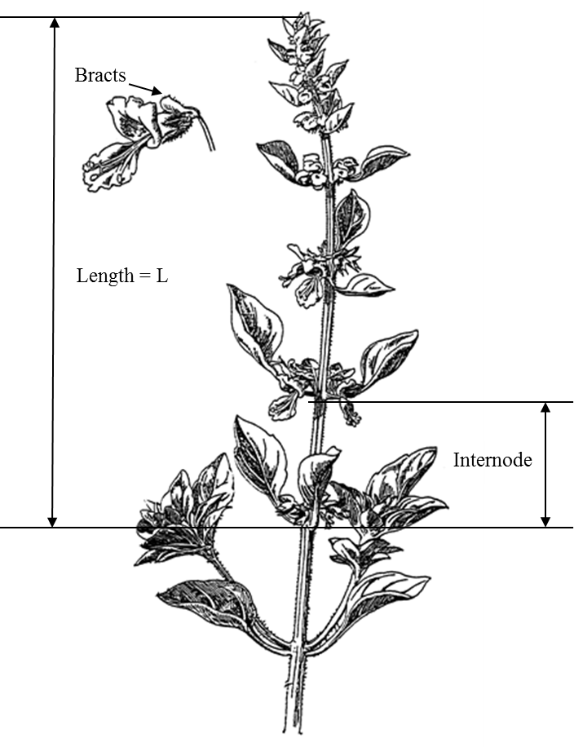
Upper sepal
Length
Internode

8.2 Explanations for individual characteristics

Ad. 1: Plant: growth habit

Observations should be done on fully developed plants before elongation of the flowering stems.

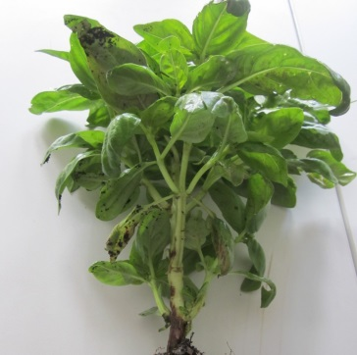 | 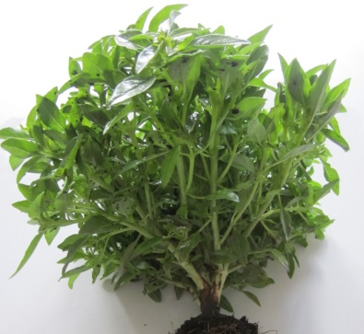
1 | 3
upright | semi upright

Ad. 2: Plant: height

The plant height should be observed on fully developed plants including the flowering stems.

Ad. 3: Stem: anthocyanin coloration

The anthocyanin coloration should be observed on the main stem of fully developed plants before elongation of the flowering stems.

Ad. 4: Leaf blade: shape

 |  | ← broadest part →
 |  | below middle | at middle
→ narrow (high) |  |  | 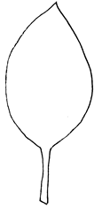  4  narrow elliptic
width (ratio length/width) |  | 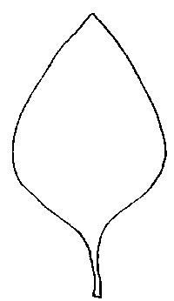  2  medium ovate | 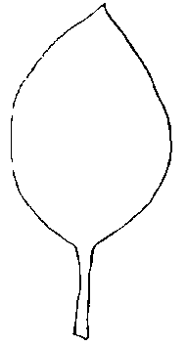  3  medium elliptic
broad (low)← |  | 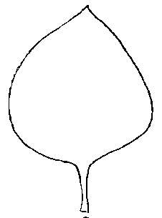  1  broad ovate

Ad. 8: Leaf blade: distribution of anthocyanin coloration

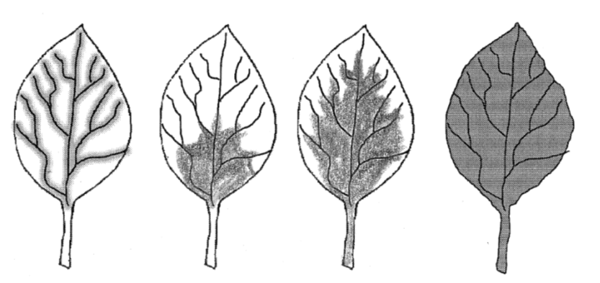
1 | 2 | 3 | 4
mainly along veins | on basal part | on basal and central part | throughout

Ad. 12: Leaf blade: profile in cross section

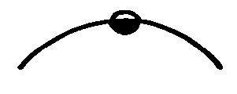 |  | 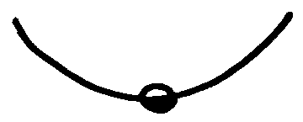 | 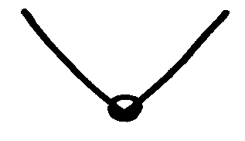
1 | 2 | 3 | 4
convex | flat | concave | v-shaped

Ad. 13: Leaf blade: serration of margin

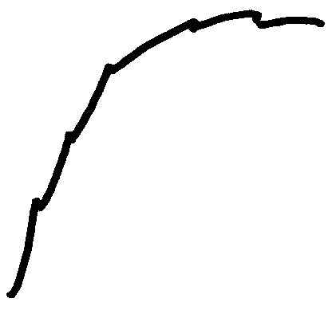 | 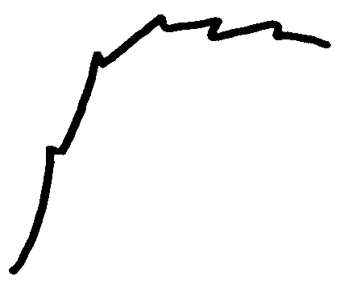 | 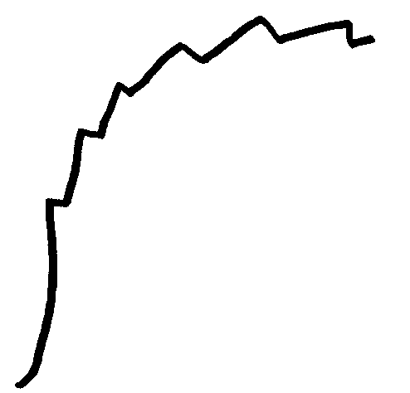
3 | 5 | 7
weak | medium | strong

Ad. 16: Flowering stem: length

The length is observed on the main flowering stem.

Ad. 17: Flowering stem: length of internodes

The length of the internodes is observed as an average of all internodes on the main flowering stem.

Ad. 21: Only seed-propagated varieties: Beginning of flowering

The time of beginning of flowering is when the first flower has fully opened on 10% of the plants.

Literature

Dachler M., Pelzmann H., 1999: Arznei- und Gewürzpflanzen, Österreichischer Agrarverlag, 2. Auflage, Klosterneuburg, AT.

Debaggio T., Belsinger S., 1942: Basil, An Herb Lover’s Guide. Ed. Interwave Press. 144p.

Heeger E.F., 1989: Handbuch des Arznei- und Gewürzpflanzenbaues, VEB Deutscher Landwirtschaftsverlag Berlin

Vilmorin Andrieux, 1989: Les plantes potagères, description et culture des principaux légumes des climats tempérés, Les édition 1900.

Vogel G., 1996: Handbuch des speziellen Gemüsebaues, Ulmer Verlag, Stuttgart, DE

Weymar, 1961: Buch der Lippenblütler und Rauhblattgewächse, Verlag Neumann Berlin und Radebeul, DE

Technical Questionnaire

TECHNICAL QUESTIONNAIRE |  |  |  | Page {x} of {y} |  | Reference Number:
 |  |  |  |  |  | Application date:
 |  |  |  |  |  | (not to be filled in by the applicant)
TECHNICAL QUESTIONNAIRE
to be completed in connection with an application for plant breeders’ rights

1. Subject of the Technical Questionnaire
1.1 Botanical name |  |  | Ocimum basilicum L.
1.2 Common name |  |  | Basil
2. Applicant
Name
Address
Telephone No.
Fax No.
E-mail address
Breeder (if different from
applicant)
3. Proposed denomination and breeder’s reference
Proposed denomination
(if available)
Breeder’s reference
#4. Information on the breeding scheme and propagation of the variety

4.1 Breeding scheme

Variety resulting from:

4.1.1 Crossing

(a) controlled cross [ ]
(please state parent varieties)

(…………………..…………………………) x (……………..…………..………………..…)
female parent male parent

(b) partially known cross [ ]
(please state known parent variety(ies))

(…………………..……………………....…) x (……………..………………..…………..…)
female parent male parent

(c) unknown cross [ ]
4.1.2 Mutation [ ]
(please state parent variety)

4.1.3 Discovery and development [ ]
(please state where and when discovered and how developed)

4.1.4 Other [ ]
(please provide details)

4.2 Method of propagating the variety

4.2.1 Seed-propagated varieties

(a) Cross-pollination
(b) Other [ ]
(please provide details)

4.2.2 Vegetatively propagated varieties

(a) Cuttings
(b) Other [ ]
(please provide details)

4.2.3 Other [ ]
(please provide details)

5. Characteristics of the variety to be indicated (the number in brackets refers to the corresponding characteristic in Test Guidelines; please mark the note which best corresponds).

 | Characteristics |  |  |  |  |  | Example Varieties |  |  |  | Note
5.1  (1) | Plant: growth habit
 | upright |  |  |  |  |  | Grand vert |  |  |  | 1[ ]
 | upright to semi upright |  |  |  |  |  |  |  |  |  | 2[ ]
 | semi upright |  |  |  |  |  | Fin vert nain compact |  |  |  | 3[ ]
5.2  (4) | Leaf blade: shape
 | broad ovate |  |  |  |  |  | Géant Mammouth, Italian large leaf |  |  |  | 1[ ]
 | medium ovate |  |  |  |  |  | Baroness, Marian |  |  |  | 2[ ]
 | medium elliptic |  |  |  |  |  | Ararat, Keskenylevelü, Magic White, Piccolino, Rudy |  |  |  | 3[ ]
 | narrow elliptic |  |  |  |  |  | Fin vert nain compact |  |  |  | 4[ ]
5.3  (7) | Leaf blade: intensity of anthocyanin coloration
 | absent or very weak |  |  |  |  |  | Bonazza, Edwina, Grand vert |  |  |  | 1[ ]
 | very weak |  |  |  |  |  |  |  |  |  | 2[ ]
 | weak |  |  |  |  |  |  |  |  |  | 3[ ]
 | weak to medium |  |  |  |  |  |  |  |  |  | 4[ ]
 | medium |  |  |  |  |  | Ararat |  |  |  | 5[ ]
 | medium to strong |  |  |  |  |  |  |  |  |  | 6[ ]
 | strong |  |  |  |  |  | Osmin |  |  |  | 7[ ]
 | strong to very strong |  |  |  |  |  |  |  |  |  | 8[ ]
 | very strong |  |  |  |  |  | Purple Ruffles |  |  |  | 9[ ]
5.4  (19) | Flower: color of corolla
 | white |  |  |  |  |  | Bavires, Edwina, Grand vert, Marian, Pesto Perpetuo |  |  |  | 1[ ]
 | pink |  |  |  |  |  | Red Arrow |  |  |  | 2[ ]
 | light violet |  |  |  |  |  | Ararat, Rosie |  |  |  | 3[ ]
 | dark violet |  |  |  |  |  | Crimson, Osmin |  |  |  | 4[ ]
 | Characteristics |  |  |  |  |  | Example Varieties |  |  |  | Note
5.5  (21) | Only seed-propagated varieties: Beginning of flowering
 | very early |  |  |  |  |  |  |  |  |  | 1[ ]
 | very early to early |  |  |  |  |  |  |  |  |  | 2[ ]
 | early |  |  |  |  |  | Keskenylevelü, Piccolino |  |  |  | 3[ ]
 | early to medium |  |  |  |  |  |  |  |  |  | 4[ ]
 | medium |  |  |  |  |  | Grand vert, Mammolo, Marian |  |  |  | 5[ ]
 | medium to late |  |  |  |  |  |  |  |  |  | 6[ ]
 | late |  |  |  |  |  |  |  |  |  | 7[ ]
 | late to very late |  |  |  |  |  |  |  |  |  | 8[ ]
 | very late |  |  |  |  |  | Purple Ruffles |  |  |  | 9[ ]
6. Similar varieties and differences from these varieties

Please use the following table and box for comments to provide information on how your candidate variety differs from the variety (or varieties) which, to the best of your knowledge, is (or are) most similar. This information may help the examination authority to conduct its examination of distinctness in a more efficient way.

Denomination(s) of variety(ies) similar to your candidate variety |  | Characteristic(s) in which your candidate variety differs from the similar variety(ies) |  |  | Describe the expression of the characteristic(s) for the similar variety(ies) |  |  | Describe the expression of the characteristic(s) for your candidate variety
Example |  | Leaf blade: length |  |  | long |  |  | medium
Comments:

#7. Additional information which may help in the examination of the variety

7.1 In addition to the information provided in sections 5 and 6, are there any additional characteristics which may help to distinguish the variety?

Yes [ ] No [ ]

(If yes, please provide details)

7.2 Are there any special conditions for growing the variety or conducting the examination?

Yes [ ] No [ ]

(If yes, please provide details)

7.3 Other information

8. Authorization for release

(a) Does the variety require prior authorization for release under legislation concerning the protection of the environment, human and animal health?

Yes [ ] No [ ]

(b) Has such authorization been obtained?

Yes [ ] No [ ]

If the answer to (b) is yes, please attach a copy of the authorization.

9. Information on plant material to be examined or submitted for examination

9.1 The expression of a characteristic or several characteristics of a variety may be affected by factors, such as pests and disease, chemical treatment (e.g. growth retardants or pesticides), effects of tissue culture, different rootstocks, scions taken from different growth phases of a tree, etc.

9.2 The plant material should not have undergone any treatment which would affect the expression of the characteristics of the variety, unless the competent authorities allow or request such treatment. If the plant material has undergone such treatment, full details of the treatment must be given. In this respect, please indicate below, to the best of your knowledge, if the plant material to be examined has been subjected to:

(a) Microorganisms (e.g. virus, bacteria, phytoplasma) Yes [ ] No [ ]

(b) Chemical treatment (e.g. growth retardant, pesticide) Yes [ ] No [ ]

(c) Tissue culture Yes [ ] No [ ]

(d) Other factors Yes [ ] No [ ]

Please provide details for where you have indicated “yes”.

9.3 Has the plant material to be examined been tested for the presence of virus or other pathogens?

Yes [ ]

(please provide details as specified by the Authority)

No [ ]

10. I hereby declare that, to the best of my knowledge, the information provided in this form is correct:

Applicant’s name

Signature Date

[End of document]

* These names were correct at the time of the introduction of these Test Guidelines but may be revised or updated. [Readers are advised to consult the UPOV Code, which can be found on the UPOV Website (www.upov.int), for the latest information.]
# #Authorities may allow certain of this information to be provided in a confidential section of the Technical Questionnaire.
# #Authorities may allow certain of this information to be provided in a confidential section of the Technical Questionnaire.

