 |  |  | E
 |  | 
  TG/197/2
  ORIGINAL: English
  DATE: 2021-10-26
INTERNATIONAL UNION FOR THE PROTECTION OF NEW VARIETIES OF PLANTS
 |  | Geneva
  EUSTOMA
  UPOV Code(s): EUSTO_GRA
  Eustoma exaltatum (L.) Salisb. ex G. Don subsp. russellianum (Hook.) Kartesz
  *
GUIDELINES
FOR THE CONDUCT OF TESTS
FOR DISTINCTNESS, UNIFORMITY AND STABILITY

Alternative names:*

Botanical name | English | French | German | Spanish
  Eustoma exaltatum (L.) Salisb. ex G. Don subsp. russellianum (Hook.) Kartesz, Bilamista grandiflora Raf., Eustoma grandiflorum (Raf.) Shinners, Eustoma russellianum (Hook.) G. Don, Lisianthius russellianus Hook.
  Eustoma, Lisianthus
  Eustoma, Lisianthus
  Eustoma, Lisianthus
  Eustoma, Lisiantus

 | The purpose of these guidelines (“Test Guidelines”) is to elaborate the principles contained in the General Introduction (document TG/1/3), and its associated TGP documents, into detailed practical guidance for the harmonized examination of distinctness, uniformity and stability (DUS) and, in particular, to identify appropriate characteristics for the examination of DUS and production of harmonized variety descriptions.
ASSOCIATED DOCUMENTS
These Test Guidelines should be read in conjunction with the General Introduction and its associated TGP documents.

TABLE OF CONTENTS | PAGE
1. | SUBJECT OF THESE TEST GUIDELINES.......................................................................................................... | 3
2. | MATERIAL REQUIRED......................................................................................................................................... | 3
3. | METHOD OF EXAMINATION................................................................................................................................ | 3
3.1 | Number of Growing Cycles........................................................................................................................ | 3
3.2 | Testing Place............................................................................................................................................. | 3
3.3 | Conditions for Conducting the Examination............................................................................................... | 3
3.4 | Test Design................................................................................................................................................ | 4
3.5 | Additional Tests......................................................................................................................................... | 4

4. | ASSESSMENT OF DISTINCTNESS, UNIFORMITY AND STABILITY................................................................. | 4
4.1 | Distinctness............................................................................................................................................... | 4
4.2 | Uniformity.................................................................................................................................................. | 5
4.3 | Stability...................................................................................................................................................... | 5

5. | GROUPING OF VARIETIES AND ORGANIZATION OF THE GROWING TRIAL................................................ | 6
6. | INTRODUCTION TO THE TABLE OF CHARACTERISTICS................................................................................ | 7
6.1 | Categories of Characteristics..................................................................................................................... | 7
6.2 | States of Expression and Corresponding Notes........................................................................................ | 7
6.3 | Types of Expression.................................................................................................................................. | 7
6.4 | Example Varieties...................................................................................................................................... | 7
6.5 | Legend....................................................................................................................................................... | 8

7. | TABLE OF CHARACTERISTICS/TABLEAU DES CARACTÈRES/MERKMALSTABELLE/TABLA DE CARACTERES...................................................................................................................................................... | 9
8. | EXPLANATIONS ON THE TABLE OF CHARACTERISTICS............................................................................... | 19
8.1 | Explanations covering several characteristics........................................................................................... | 19
 | Explanations for individual characteristics................................................................................................. | 19
  8.2

9. | LITERATURE......................................................................................................................................................... | 26
10 | TECHNICAL QUESTIONNAIRE............................................................................................................................ | 27

1. | Subject of these Test Guidelines
1.1
  These Test Guidelines apply to all varieties of Eustoma exaltatum (L.) Salisb. ex G. Don subsp. russellianum (Hook.) Kartesz.

1.2 | Guidance on the use of Test Guidelines for hybrids with other subspecies that are not explicitly covered by Test Guidelines is provided in document TGP/13 “Guidance for New Types and Species”.
2. | Material Required
2.1
  The competent authorities decide on the quantity and quality of the plant material required for testing the variety and when and where it is to be delivered. Applicants submitting material from a State other than that in which the testing takes place must ensure that all customs formalities and phytosanitary requirements are complied with.
2.2
  The material is to be supplied in the form of plants or seed.
2.3
  The minimum quantity of plant material, to be supplied by the applicant, should be:
vegetatively propagated varieties: 20 plants
seed-propagated varieties: a sufficient quantity of seed to produce 40 plants.

 | In the case of seed, the seed should meet the minimum requirements for germination, species and analytical purity, health and moisture content, specified by the competent authority. In cases where the seed is to be stored, the germination capacity should be as high as possible and should, be stated by the applicant.
2.4
  The plant material supplied should be visibly healthy, not lacking in vigor, nor affected by any important pest or disease.
2.5
  The plant material should not have undergone any treatment which would affect the expression of the characteristics of the variety, unless the competent authorities allow or request such treatment. If it has been treated, full details of the treatment must be given.

3. | Method of Examination
3.1 | Number of Growing Cycles
 | The minimum duration of tests should normally be a single growing cycle.
  3.1.1
 | The testing of a variety may be concluded when the competent authority can determine with certainty the outcome of the test.
  3.1.2
3.2 | Testing Place
 | Tests are normally conducted at one place. In the case of tests conducted at more than one place, guidance is provided in TGP/9 “Examining Distinctness”.
3.3 | Conditions for Conducting the Examination
 | The tests should be carried out under conditions ensuring satisfactory growth for the expression of the relevant characteristics of the variety and for the conduct of the examination.
  3.3.1

 | Because daylight varies, color determinations made against a color chart should be made either in a suitable cabinet providing artificial daylight or in the middle of the day in a room without direct sunlight. The spectral distribution of the illuminant for artificial daylight should conform with the CIE Standard of Preferred Daylight D 6500 and should fall within the tolerances set out in the British Standard 950, Part I. These determinations should be made with the plant part placed against a white background. The color chart and version used should be specified in the variety description.
  3.3.2

3.4 | Test Design
  3.4.1
  In the case of vegetatively propagated varieties, each test should be designed to result in a total of at least 20 plants.
  3.4.2
  In the case of seed-propagated varieties, each test should be designed to result in a total of at least 40 plants.

  3.4.3
  The design of the tests should be such that plants or parts of plants may be removed for measurement or counting without prejudice to the observations which must be made up to the end of the growing cycle.
3.5 | Additional Tests
 | Additional tests, for examining relevant characteristics, may be established.

4. | Assessment of Distinctness, Uniformity and Stability
4.1 | Distinctness
4.1.1 | General Recommendations
 | It is of particular importance for users of these Test Guidelines to consult the General Introduction prior to making decisions regarding distinctness. However, the following points are provided for elaboration or emphasis in these Test Guidelines.
4.1.2 | Consistent Differences
 | The differences observed between varieties may be so clear that more than one growing cycle is not necessary. In addition, in some circumstances, the influence of the environment is not such that more than a single growing cycle is required to provide assurance that the differences observed between varieties are sufficiently consistent. One means of ensuring that a difference in a characteristic, observed in a growing trial, is sufficiently consistent is to examine the characteristic in at least two independent growing cycles.
4.1.3 | Clear Differences
 | Determining whether a difference between two varieties is clear depends on many factors, and should consider, in particular, the type of expression of the characteristic being examined, i.e. whether it is expressed in a qualitative, quantitative, or pseudo-qualitative manner. Therefore, it is important that users of these Test Guidelines are familiar with the recommendations contained in the General Introduction prior to making decisions regarding distinctness.
4.1.4
  Number of Plants or Parts of Plants to be Examined
In the case of vegetatively propagated varieties, unless otherwise indicated, for the purposes of distinctness, all observations on single plants should be made on 10 plants or parts taken from each of 10 plants and any other observation made on all plants in the test, disregarding any off-type plants.

In the case of seed-propagated varieties, unless otherwise indicated, for the purposes of distinctness, all observations on single plants should be made on 20 plants or parts taken from each of 20 plants and any other observation made on all plants in the test, disregarding any off-type plants.

4.1.5 | Method of Observation
 | The recommended method of observing the characteristic for the purposes of distinctness is indicated by the following key in the Table of Characteristics (see document TGP/9 “Examining Distinctness”, Section 4 “Observation of characteristics”):
MG: single measurement of a group of plants or parts of plants
MS: measurement of a number of individual plants or parts of plants
VG: visual assessment by a single observation of a group of plants or parts of plants
VS: visual assessment by observation of individual plants or parts of plants

 | Type of observation: visual (V) or measurement (M)
 | “Visual” observation (V) is an observation made on the basis of the expert’s judgment. For the purposes of this document, “visual” observation refers to the sensory observations of the experts and, therefore, also includes smell, taste and touch. Visual observation includes observations where the expert uses reference points (e.g. diagrams, example varieties, side-by-side comparison) or non-linear charts (e.g. color charts). Measurement (M) is an objective observation against a calibrated, linear scale e.g. using a ruler, weighing scales, colorimeter, dates, counts, etc.
  Type of record: for a group of plants (G) or for single, individual plants (S)
  For the purposes of distinctness, observations may be recorded as a single record for a group of plants or parts of plants (G), or may be recorded as records for a number of single, individual plants or parts of plants (S). In most cases, “G” provides a single record per variety and it is not possible or necessary to apply statistical methods in a plant-by-plant analysis for the assessment of distinctness.
 | In cases where more than one method of observing the characteristic is indicated in the Table of Characteristics (e.g. VG/MG), guidance on selecting an appropriate method is provided in document TGP/9, Section 4.2.
4.2 | Uniformity
4.2.1 | It is of particular importance for users of these Test Guidelines to consult the General Introduction prior to making decisions regarding uniformity. However, the following points are provided for elaboration or emphasis in these Test Guidelines:
  4.2.2
  These Test Guidelines have been developed for the examination of vegetatively propagated and seed-propagated varieties. For varieties with other types of propagation, the recommendations in the General Introduction and document TGP/13 "Guidance for new types and species" Section 4.5 "Testing Uniformity" should be followed.
 | The assessment of uniformity for cross-pollinated varieties should be according to the recommendations for cross-pollinated varieties in the General Introduction.
  4.2.3
4.2.4 | The assessment of uniformity for hybrid varieties depends on the type of hybrid and should be according to the recommendations for hybrid varieties in the General Introduction.
4.2.5
  For the assessment of uniformity of vegetatively propagated varieties and self-pollinated varieties, a population standard of 1% and an acceptance probability of at least 95% should be applied. In the case of a sample size of 20 plants, 1 off-type is allowed. In the case of self-pollinated varieties of a sample size of 40 plants, 2 off-type are allowed.

4.3 | Stability
4.3.1 | In practice, it is not usual to perform tests of stability that produce results as certain as those of the testing of distinctness and uniformity. However, experience has demonstrated that, for many types of variety, when a variety has been shown to be uniform, it can also be considered to be stable.
4.3.2 | Where appropriate, or in cases of doubt, stability may be further examined by testing a new seed or plant stock to ensure that it exhibits the same characteristics as those shown by the initial material supplied.

5. | Grouping of Varieties and Organization of the Growing Trial
5.1 | The selection of varieties of common knowledge to be grown in the trial with the candidate varieties and the way in which these varieties are divided into groups to facilitate the assessment of distinctness are aided by the use of grouping characteristics.
5.2 | Grouping characteristics are those in which the documented states of expression, even where produced at different locations, can be used, either individually or in combination with other such characteristics: (a) to select varieties of common knowledge that can be excluded from the growing trial used for examination of distinctness; and (b) to organize the growing trial so that similar varieties are grouped together.
5.3 | The following have been agreed as useful grouping characteristics:
  (a)
  Plant: height (characteristic 1)
  (b)
  Flower: type (characteristic 14)
  (c)
  Flower: width (characteristic 18)
  (d)
  Petal: main color of inner side (characteristic 27) with the following groups:
  Gr. 1: white
  Gr. 2: light green
  Gr. 3: yellow
  Gr. 4: orange
  Gr. 5: pink
  Gr. 6: red
  Gr. 7: purple
  Gr. 8: blue purple
  (e)
  Petal: secondary color of inner side (characteristic 28) with the following groups:
  Gr. 1: none
  Gr. 2: white
  Gr. 3: light green
  Gr. 4: yellow
  Gr. 5: orange
  Gr. 6: pink
  Gr. 7: red
  Gr. 8: purple
  Gr. 9: blue purple
  (f)
  Petal: distribution of secondary color of inner side (characteristic 29)
  (g)
  Petal: color of base of inner side (characteristic 31)

5.4 | Guidance for the use of grouping characteristics, in the process of examining distinctness, is provided through the General Introduction and document TGP/9 “Examining Distinctness”.

6. | Introduction to the Table of Characteristics
6.1 | Categories of Characteristics
6.1.1 | Standard Test Guidelines Characteristics
 | Standard Test Guidelines characteristics are those which are approved by UPOV for examination of DUS and from which members of the Union can select those suitable for their particular circumstances.
6.1.2 | Asterisked Characteristics
 | Asterisked characteristics (denoted by *) are those included in the Test Guidelines which are important for the international harmonization of variety descriptions and should always be examined for DUS and included in the variety description by all members of the Union, except when the state of expression of a preceding characteristic or regional environmental conditions render this inappropriate.
6.2 | States of Expression and Corresponding Notes
6.2.1 | States of expression are given for each characteristic to define the characteristic and to harmonize descriptions. Each state of expression is allocated a corresponding numerical note for ease of recording of data and for the production and exchange of the description.
6.2.2 | All relevant states of expression are presented in the characteristic.
6.2.3 | Further explanation of the presentation of states of expression and notes is provided in document TGP/7 “Development of Test Guidelines”.
6.3 | Types of Expression
 | An explanation of the types of expression of characteristics (qualitative, quantitative and pseudo-qualitative) is provided in the General Introduction.
6.4 | Example Varieties
 | Where appropriate, example varieties are provided to clarify the states of expression of each characteristic.

6.5 | Legend
 |  | English |  | français |  | deutsch | español | Example Varieties  Exemples  Beispielssorten  Variedades ejemplo | Note/  Nota
  1
  2
  3
  4
  5
  6
  7
  Name of characteristics in English
  Nom du caractère en français
  Name des Merkmals auf Deutsch
  Nombre del carácter en español
  states of expression
  types d’expression
  Ausprägungsstufen
  tipos de expresión

1 | Characteristic number
2 | (*) | Asterisked characteristic | – see Chapter 6.1.2
3 | Type of expression
 | QL | Qualitative characteristic | – see Chapter 6.3
 | QN | Quantitative characteristic | – see Chapter 6.3
 | PQ | Pseudo-qualitative characteristic | – see Chapter 6.3
4 | Method of observation (and type of plot, if applicable)
 | MG, MS, VG, VS |  | – see Chapter 4.1.5
5
  (+)
  See Explanations on the Table of Characteristics in Chapter 8.2
6
  (a)-(c)
  See Explanations on the Table of Characteristics in Chapter 8.1
7
  Not applicable

7. | Table of Characteristics/Tableau des caractères/Merkmalstabelle/Tabla de caracteres

 |  | English |  | français |  | deutsch | español | Example Varieties  Exemples  Beispielssorten  Variedades ejemplo | Note/  Nota
1. | (*) | QN | MS/VG | (+)
  Plant: height
  Plante : hauteur
  Pflanze: Höhe
  Planta: altura
 |  | very short |  | très courte |  | sehr niedrig | muy baja |  | 1
 |  | very short to short |  | très courte à courte |  | sehr niedrig bis niedrig | muy baja a baja |  | 2
 |  | short |  | courte |  | niedrig | baja | Sase LIS02 | 3
 |  | short to medium |  | courte à moyenne |  | niedrig bis mittel | baja a media |  | 4
 |  | medium |  | moyenne |  | mittel | media | Momo Sen | 5
 |  | medium to tall |  | moyenne à haute |  | mittel bis hoch | media a alta |  | 6
 |  | tall |  | haute |  | hoch | alta | Mio Peach Chuchu | 7
 |  | tall to very tall |  | haute à très haute |  | hoch bis sehr hoch | alta a muy alta |  | 8
 |  | very tall |  | très haute |  | sehr hoch | muy alta |  | 9
2. |  | QN | MS/VG | (+)
  Plant: number of primary branches
  Plante : nombre de branches primaires
  Pflanze: Anzahl Hauptseitenzweige
  Planta: número de ramas primarias
 |  | very few |  | très petit |  | sehr gering | muy bajo |  | 1
 |  | very few to few |  | très petit à petit |  | sehr gering bis gering | muy bajo a bajo |  | 2
 |  | few |  | petit |  | gering | bajo | Shonai Cross Pink | 3
 |  | few to medium |  | petit à moyen |  | gering bis mittel | bajo a medio |  | 4
 |  | medium |  | moyen |  | mittel | medio | Exe Pink | 5
 |  | medium to many |  | moyen à grand |  | mittel bis hoch | medio a alto |  | 6
 |  | many |  | grand |  | hoch | alto | Illumypink | 7
 |  | many to very many |  | grand à très grand |  | hoch bis sehr hoch | alto a muy alto |  | 8
 |  | very many |  | très grand |  | sehr hoch | muy alto |  | 9
3. |  | PQ | VG | (+)
  Plant: position of primary branches
  Plante : position des branches primaires
  Pflanze: Position der Hauptseitenzweige
  Planta: posición de las ramas primarias
 |  | upper part only |  | partie supérieure seulement |  | nur oberer Teil | solo en la parte superior | Saga T2go | 1
 |  | upper and middle part |  | partie supérieure et médiane |  | oberer und mittlerer Teil | en la parte superior y en la central | Lilac Pink Thumb | 2
 |  | throughout |  | partout |  | überall | en la totalidad | Cherrybee | 3
4. |  | QN | MS/VG
  Stem: number of nodes
  Tige : nombre de nœuds
  Stängel: Anzahl Knoten
  Tallo: número de nudos
 |  | very few |  | très petit |  | sehr gering | muy bajo |  | 1
 |  | very few to few |  | très petit à petit |  | sehr gering bis gering | muy bajo a bajo |  | 2
 |  | few |  | petit |  | gering | bajo | Cherrybee 3go | 3
 |  | few to medium |  | petit à moyen |  | gering bis mittel | bajo a medio |  | 4
 |  | medium |  | moyen |  | mittel | medio | Momo Sen | 5
 |  | medium to many |  | moyen à grand |  | mittel bis hoch | medio a alto |  | 6
 |  | many |  | grand |  | hoch | alto | Shonai Cross White | 7
 |  | many to very many |  | grand à très grand |  | hoch bis sehr hoch | alto a muy alto |  | 8
 |  | very many |  | très grand |  | sehr hoch | muy alto |  | 9
5. | (*) | QN | MS/VG | (+) | (a)
  Leaf: length
  Feuille : longueur
  Blatt: Länge
  Hoja: longitud
 |  | very short |  | très courte |  | sehr kurz | muy corta |  | 1
 |  | very short to short |  | très courte à courte |  | sehr kurz bis kurz | muy corta a corta |  | 2
 |  | short |  | courte |  | kurz | corta | Diamond | 3
 |  | short to medium |  | courte à moyenne |  | kurz bis mittel | corta a media |  | 4
 |  | medium |  | moyenne |  | mittel | media | Momo Sen | 5
 |  | medium to long |  | moyenne à longue |  | mittel bis lang | media a larga |  | 6
 |  | long |  | longue |  | lang | larga | Sase LIS02 | 7
 |  | long to very long |  | longue à très longue |  | lang bis sehr lang | larga a muy larga |  | 8
 |  | very long |  | très longue |  | sehr lang | muy larga |  | 9
6. | (*) | QN | MS/VG | (+) | (a)
  Leaf: width
  Feuille : largeur
  Blatt: Breite
  Hoja: anchura
 |  | very narrow |  | très étroite |  | sehr schmal | muy estrecha |  | 1
 |  | very narrow to narrow |  | très étroite à étroite |  | sehr schmal bis schmal | muy estrecha a estrecha |  | 2
 |  | narrow |  | étroite |  | schmal | estrecha | Cherrybee 3go | 3
 |  | narrow to medium |  | étroite à moyenne |  | schmal bis mittel | estrecha a media |  | 4
 |  | medium |  | moyenne |  | mittel | media | Momo Sen | 5
 |  | medium to broad |  | moyenne à large |  | mittel bis breit | media a ancha |  | 6
 |  | broad |  | large |  | breit | ancha | Komachi White Dress | 7
 |  | broad to very broad |  | large à très large |  | breit bis sehr breit | ancha a muy ancha |  | 8
 |  | very broad |  | très large |  | sehr breit | muy ancha |  | 9
7. | (*) | QN | MS/VG | (+) | (a)
  Leaf: ratio length/width
  Feuille : rapport longueur/largeur
  Blatt: Verhältnis Länge/Breite
  Hoja: relación longitud/anchura
 |  | very low |  | très bas |  | sehr klein | muy baja |  | 1
 |  | very low to low |  | très bas à bas |  | sehr klein bis klein | muy baja a baja |  | 2
 |  | low |  | bas |  | klein | baja | Komachi White Dress | 3
 |  | low to medium |  | bas à moyen |  | klein bis mittel | baja a media |  | 4
 |  | medium |  | moyen |  | mittel | media | Momo Sen | 5
 |  | medium to high |  | moyen à élevé |  | mittel bis groß | media a alta |  | 6
 |  | high |  | élevé |  | groß | alta | Shonai Cross White | 7
 |  | high to very high |  | élevé à très élevé |  | groß bis sehr groß | alta a muy alta |  | 8
 |  | very high |  | très élevé |  | sehr groß | muy alta |  | 9
8. | (*) | QN | VG | (+) | (a)
  Leaf: glaucosity
  Feuille : glaucescence
  Blatt: Bereifung
  Hoja: glauescencia
 |  | absent or weak |  | nulle ou faible |  | fehlend oder gering | ausente o débil | Cherrybee | 1
 |  | medium |  | moyenne |  | mittel | media | Komachi Green Dress | 2
 |  | strong |  | forte |  | stark | fuerte | Momo Sen | 3
9. | (*) | QN | VG | (+) | (a)
  Leaf: intensity of green color
  Feuille : intensité de la couleur verte
  Blatt: Intensität der Grünfärbung
  Hoja: intensidad del color verde
 |  | light |  | claire |  | hell | clara | Saga T2go | 1
 |  | medium |  | moyenne |  | mittel | media | Momo Sen | 2
 |  | dark |  | foncée |  | dunkel | oscura | Lilac Pink Thumb | 3
10. |  | QN | MS/VG | (+)
  Pedicel: length
  Pédicelle : longueur
  Blütenstiel: Länge
  Pedicelo: longitud
 |  | very short |  | très courte |  | sehr kurz | muy corta |  | 1
 |  | very short to short |  | très courte à courte |  | sehr kurz bis kurz | muy corta a corta |  | 2
 |  | short |  | courte |  | kurz | corta | Lilac Pink Thumb | 3
 |  | short to medium |  | courte à moyenne |  | kurz bis mittel | corta a medio |  | 4
 |  | medium |  | moyenne |  | mittel | medio | Momo Sen | 5
 |  | medium to long |  | moyenne à longue |  | mittel bis lang | medio a larga |  | 6
 |  | long |  | longue |  | lang | larga | Diamond | 7
 |  | long to very long |  | longue à très longue |  | lang bis sehr lang | larga a muy larga |  | 8
 |  | very long |  | très longue |  | sehr lang | muy larga |  | 9
11. |  | QN | MS/VG | (+)
  Calyx: length
  Calice : longueur
  Kelch: Länge
  Cáliz: longitud
 |  | very short |  | très courte |  | sehr kurz | muy corta |  | 1
 |  | very short to short |  | très courte à courte |  | sehr kurz bis kurz | muy corta a corta |  | 2
 |  | short |  | courte |  | kurz | corta | Cherrybee | 3
 |  | short to medium |  | courte à moyenne |  | kurz bis mittel | corta a medio |  | 4
 |  | medium |  | moyenne |  | mittel | medio | Momo Sen | 5
 |  | medium to long |  | moyenne à longue |  | mittel bis lang | medio a larga |  | 6
 |  | long |  | longue |  | lang | larga | Asamiyae | 7
 |  | long to very long |  | longue à très longue |  | lang bis sehr lang | larga a muy larga |  | 8
 |  | very long |  | très longue |  | sehr lang | muy larga |  | 9
12. |  | QN | VG
  Calyx: anthocyanin coloration
  Calice : pigmentation anthocyanique
  Kelch: Anthocyanfärbung
  Cáliz: pigmentación antociánica
 |  | absent or weak |  | nulle ou faible |  | fehlend oder gering | ausente o débil | Light Blue Thumb | 1
 |  | medium |  | moyenne |  | mittel | media |  | 2
 |  | strong |  | forte |  | stark | fuerte | Cherrybee | 3
13. |  | QN | MS/VG
  Flower: number
  Fleur : nombre
  Blüte: Anzahl
  Flor: número
 |  | very few |  | très petit |  | sehr gering | muy bajo |  | 1
 |  | very few to few |  | très petit à petit |  | sehr gering bis gering | muy bajo a bajo |  | 2
 |  | few |  | petit |  | gering | bajo | Kirara Apricot 2 | 3
 |  | few to medium |  | petit à moyen |  | gering bis mittel | bajo a medio |  | 4
 |  | medium |  | moyen |  | mittel | medio | Momo Sen | 5
 |  | medium to many |  | moyen à grand |  | mittel bis hoch | medio a alto |  | 6
 |  | many |  | grand |  | hoch | alto | Mahoroba Peach | 7
 |  | many to very many |  | grand à très grand |  | hoch bis sehr hoch | alto a muy alto |  | 8
 |  | very many |  | très grand |  | sehr hoch | muy alto |  | 9
14. | (*) | QL | VG | (+)
  Flower: type
  Fleur : type
  Blüte: Typ
  Flor: tipo
 |  | single |  | simple |  | einfach | simple | Momo Sen | 1
 |  | double |  | double |  | gefüllt | doble | Piccorosa Pink Picotee | 2
15. | (*) | QN | MS/VG
  Only varieties with Flower: type: double: Flower: number of petals
  Seulement les variétés à Fleur : type : double : Fleur : nombre de pétales
  Nur Sorten mit Blüte: Typ: gefüllt: Blüte: Anzahl Blütenblätter
  Solo variedades con flor: tipo: doble: Flor: número de pétalos
 |  | very few |  | très petit |  | sehr gering | muy bajo |  | 1
 |  | very few to few |  | très petit à petit |  | sehr gering bis gering | muy bajo a bajo |  | 2
 |  | few |  | petit |  | gering | bajo | Komachi Green Dress | 3
 |  | few to medium |  | petit à moyen |  | gering bis mittel | bajo a medio |  | 4
 |  | medium |  | moyen |  | mittel | medio | Diamond | 5
 |  | medium to many |  | moyen à grand |  | mittel bis hoch | medio a alto |  | 6
 |  | many |  | grand |  | hoch | alto | Lination Pink Picotee | 7
 |  | many to very many |  | grand à très grand |  | hoch bis sehr hoch | alto a muy alto |  | 8
 |  | very many |  | très grand |  | sehr hoch | muy alto |  | 9
16. |  | PQ | VG | (+)
  Flower: shape
  Fleur : forme
  Blüte: Form
  Flor: forma
 |  | circular |  | circulaire |  | kreisförmig | circular | Chigusa | 1
 |  | pentagon |  | pentagone |  | fünfeckig | pentagonal | Azumanoshirabe | 2
 |  | star-shaped |  | étoile |  | sternförmig | estrellada | Shonai Cross White | 3
17. |  | QN | MS/VG | (+)
  Flower: height
  Fleur : hauteur
  Blüte: Höhe
  Flor: altura
 |  | very short |  | très courte |  | sehr niedrig | muy baja |  | 1
 |  | very short to short |  | très courte à courte |  | sehr niedrig bis niedrig | muy baja a baja |  | 2
 |  | short |  | courte |  | niedrig | baja | Chigusa | 3
 |  | short to medium |  | courte à moyenne |  | niedrig bis mittel | baja a media |  | 4
 |  | medium |  | moyenne |  | mittel | media | Momo Sen | 5
 |  | medium to tall |  | moyenne à haute |  | mittel bis hoch | media a alta |  | 6
 |  | tall |  | haute |  | hoch | alta |  | 7
 |  | tall to very tall |  | haute à très haute |  | hoch bis sehr hoch | alta a muy alta |  | 8
 |  | very tall |  | très haute |  | sehr hoch | muy alta |  | 9
18. | (*) | QN | MS/VG | (+)
  Flower: width
  Fleur : largeur
  Blüte: Breite
  Flor: anchura
 |  | very narrow |  | très étroite |  | sehr schmal | muy estrecha |  | 1
 |  | very narrow to narrow |  | très étroite à étroite |  | sehr schmal bis schmal | muy estrecha a estrecha |  | 2
 |  | narrow |  | étroite |  | schmal | estrecha | Chigusa | 3
 |  | narrow to medium |  | étroite à moyenne |  | schmal bis mittel | estrecha a media |  | 4
 |  | medium |  | moyenne |  | mittel | media | Momo Sen | 5
 |  | medium to broad |  | moyenne à large |  | mittel bis breit | media a ancha |  | 6
 |  | broad |  | large |  | breit | ancha | Rainbow White | 7
 |  | broad to very broad |  | large à très large |  | breit bis sehr breit | ancha a muy ancha |  | 8
 |  | very broad |  | très large |  | sehr breit | muy ancha |  | 9
19. |  | QN | MS/VG | (+)
  Flower: ratio height/width
  Fleur : rapport hauteur/largeur
  Blüte: Verhältnis Höhe/Breite
  Flor: relación altura/anchura
 |  | very low |  | très bas |  | sehr klein | muy baja |  | 1
 |  | very low to low |  | très bas à bas |  | sehr klein bis klein | muy baja a baja |  | 2
 |  | low |  | bas |  | klein | baja | Mahoroba Peach | 3
 |  | low to medium |  | bas à moyen |  | klein bis mittel | baja a media |  | 4
 |  | medium |  | moyen |  | mittel | media | Momo Sen | 5
 |  | medium to high |  | moyen à élevé |  | mittel bis groß | media a alta |  | 6
 |  | high |  | élevé |  | groß | alta | Shonai Cross White | 7
 |  | high to very high |  | élevé à très élevé |  | groß bis sehr groß | alta a muy alta |  | 8
 |  | very high |  | très élevé |  | sehr groß | muy alta |  | 9
20. | (*) | QN | MS/VG | (+) | (b)
  Petal: length
  Pétale : longueur
  Blütenblatt: Länge
  Pétalo: longitud
 |  | very short |  | très courte |  | sehr kurz | muy corta |  | 1
 |  | very short to short |  | très courte à courte |  | sehr kurz bis kurz | muy corta a corta |  | 2
 |  | short |  | courte |  | kurz | corta | Komachi White Dress | 3
 |  | short to medium |  | courte à moyenne |  | kurz bis mittel | corta a medio |  | 4
 |  | medium |  | moyenne |  | mittel | medio | Momo Sen | 5
 |  | medium to long |  | moyenne à longue |  | mittel bis lang | medio a larga |  | 6
 |  | long |  | longue |  | lang | larga | Suibijin | 7
 |  | long to very long |  | longue à très longue |  | lang bis sehr lang | larga a muy larga |  | 8
 |  | very long |  | très longue |  | sehr lang | muy larga |  | 9
21. | (*) | QN | MS/VG | (+) | (b)
  Petal: width
  Pétale : largeur
  Blütenblatt: Breite
  Pétalo: anchura
 |  | very narrow |  | très étroite |  | sehr schmal | muy estrecha |  | 1
 |  | very narrow to narrow |  | très étroite à étroite |  | sehr schmal bis schmal | muy estrecha a estrecha |  | 2
 |  | narrow |  | étroite |  | schmal | estrecha | Shonai Cross White | 3
 |  | narrow to medium |  | étroite à moyenne |  | schmal bis mittel | estrecha a media |  | 4
 |  | medium |  | moyenne |  | mittel | media | Momo Sen | 5
 |  | medium to broad |  | moyenne à large |  | mittel bis breit | media a ancha |  | 6
 |  | broad |  | large |  | breit | ancha | Suibijin | 7
 |  | broad to very broad |  | large à très large |  | breit bis sehr breit | ancha a muy ancha |  | 8
 |  | very broad |  | très large |  | sehr breit | muy ancha |  | 9
22. |  | PQ | VG | (+) | (b)
  Petal: shape
  Pétale : forme
  Blütenblatt: Form
  Pétalo: forma
 |  | elliptic |  | elliptique |  | elliptisch | elíptica | Shonai Cross Pink | 1
 |  | oblanceolate |  | oblancéolée |  | verkehrt lanzettlich | oblanceolada | Bouquet White | 2
 |  | obovate |  | obovale |  | verkehrt eiförmig | oboval | Momo Sen | 3
23. | (*) | PQ | VG | (+) | (b)
  Petal: shape of apex
  Pétale : forme de l’apex
  Blütenblatt: Form des Apex
  Pétalo: forma del ápice
 |  | acuminate |  | acuminée |  | zugespitzt | acuminada | Lination Pink Picotee | 1
 |  | obtuse |  | obtuse |  | stumpf | obtusa |  | 2
 |  | rounded |  | arrondie |  | abgerundet | redondeada | Momo Sen | 3
 |  | flat |  | plate |  | flach | plana | Komachi Green Dress | 4
 |  | retuse |  | rétuse |  | eingedrückt | retusa | Piccorosa Pink Picotee | 5
24. |  | QN | VG | (+) | (b)
  Petal: recurving of margin
  Pétale : recourbure du bord
  Blütenblatt: Zurückbiegung des Randes
  Pétalo: recurvado del borde
 |  | absent or very weak |  | nulle ou très faible |  | fehlend oder sehr gering | ausente o muy débil | Tokyo E1go | 1
 |  | weak |  | faible |  | gering | débil | Cute Green | 2
 |  | medium |  | moyenne |  | mittel | medio | Light Blue Thumb | 3
 |  | strong |  | forte |  | stark | fuerte | Momo Sen | 4
 |  | very strong |  | très forte |  | sehr stark | muy fuerte | Petit Snow | 5
25. | (*) | QN | VG | (+) | (b)
  Petal: undulation of margin
  Pétale : ondulation du bord
  Blütenblatt: Randwellung
  Pétalo: ondulación del borde
 |  | very weak |  | très faible |  | sehr gering | muy débil |  | 1
 |  | very weak to weak |  | très faible à faible |  | sehr gering bis gering | muy débil a débil |  | 2
 |  | weak |  | faible |  | gering | débil | Momo Sen | 3
 |  | weak to medium |  | faible à moyenne |  | gering bis mittel | débil a media |  | 4
 |  | medium |  | moyenne |  | mittel | media | Mio Peach Chuchu | 5
 |  | medium to strong |  | moyenne à forte |  | mittel bis stark | media a fuerte |  | 6
 |  | strong |  | forte |  | stark | fuerte | Mahoroba Peach | 7
 |  | strong to very strong |  | forte à très forte |  | stark bis sehr stark | fuerte a muy fuerte |  | 8
 |  | very strong |  | très forte |  | sehr stark | muy fuerte |  | 9
26. | (*) | QN | VG | (+) | (b)
  Petal: depth of incisions of margin
  Pétale : profondeur des incisions du bord
  Blütenblatt: Tiefe der Randeinschnitte
  Pétalo: profundidad de las incisiones del borde
 |  | absent or very shallow |  | absente ou très peu profonde |  | fehlend oder sehr flach | ausente o muy poco profunda | Momo Sen | 1
 |  | shallow |  | peu profonde |  | flach | poco profunda |  | 2
 |  | medium |  | moyenne |  | mittel | media | Mio Peach Chuchu | 3
 |  | deep |  | profonde |  | tief | profunda |  | 4
 |  | very deep |  | très profonde |  | sehr tief | muy profunda | Sase LIS02 | 5
27. | (*) | PQ | VG |  | (b), (c)
  Petal: main color of inner side
  Pétale : couleur principale de la face interne
  Blütenblatt: Hauptfarbe der Innenseite
  Pétalo: color principal de la cara interna
 |  | RHS Colour Chart (indicate reference number) |  | Code RHS des couleurs (indiquer le numéro de référence) |  | RHS-Farbkarte (Nummer angeben) | Carta de colores RHS (indíquese el número de referencia)
28. | (*) | PQ | VG |  | (b), (c)
  Petal: secondary color of inner side
  Pétale : couleur secondaire de la face interne
  Blütenblatt: Sekundärfarbe der Innenseite
  Pétalo: color secundario de la cara interna
 |  | RHS Colour Chart (indicate reference number) |  | Code RHS des couleurs (indiquer le numéro de référence) |  | RHS-Farbkarte (Nummer angeben) | Carta de colores RHS (indíquese el número de referencia)
29. | (*) | PQ | VG | (+) | (b), (c)
  Petal: distribution of secondary color of inner side
  Pétale : répartition de la couleur secondaire de la face interne
  Blütenblatt: Verteilung der Sekundärfarbe der Innenseite
  Pétalo: distribución del color secundario de la cara interna
 |  | none |  | aucune |  | keine | ausente |  | 1
 |  | at tip |  | à l’extrémité |  | an der Spitze | en la punta | Komachi Kiss | 2
 |  | margin |  | au bord |  | am Rand | en el borde | Piccorosa Pink Picotee | 3
 |  | central bar |  | barre centrale |  | Mittelstreifen | franja central |  | 4
 |  | distal half |  | moitié distale |  | distale Hälfte | en la mitad distal | Mahoroba Peach | 5
 |  | basal half |  | moitié basale |  | basale Hälfte | en la mitad basal | Cherrybee 2go | 6
 |  | throughout |  | partout |  | überall | en la totalidad |  | 7
30. | (*) | PQ | VG | (+) | (b), (c)
  Petal: pattern of secondary color of inner side
  Pétale : distribution de la couleur secondaire de la face interne
  Blütenblatt: Muster der Sekundärseite der Innenseite
  Pétalo: forma de disposición del color secundario de la cara interna
 |  | solid |  | uniforme |  | durchgefärbt | lisa | Piccorosa Pink Picotee | 1
 |  | flushed |  | diffuse |  | verschwommen | difusa | Mahoroba Peach | 2
 |  | irregular |  | irrégulière |  | unregelmäßig | irregular |  | 3
31. | (*) | PQ | VG | (+) | (b)
  Petal: color of base of inner side
  Pétale : couleur de la base de la face interne
  Blütenblatt: Farbe der Basis der Innenseite
  Pétalo: color de la base de la cara interna
 |  | green |  | vert |  | grün | verde | Chigusa | 1
 |  | violet |  | violet |  | violett | violeta | Momo Sen | 2
 |  | brown |  | brun |  | braun | marrón | Sase LIS02 | 3
32. | (*) | PQ | VG |  | (b), (c)
  Petal: main color of outer side
  Pétale : couleur principale de la face externe
  Blütenblatt: Hauptfarbe der Außenseite
  Pétalo: color principal de la cara externa
 |  | RHS Colour Chart (indicate reference number) |  | Code RHS des couleurs (indiquer le numéro de référence) |  | RHS-Farbkarte (Nummer angeben) | Carta de colores RHS (indíquese el número de referencia)
33. |  | QN | VG
  Style: anthocyanin coloration
  Style : pigmentation anthocyanique
  Griffel: Anthocyanfärbung
  Estilo: pigmentación antociánica
 |  | absent or weak |  | nulle ou faible |  | fehlend oder gering | ausente o débil | Momo Sen | 1
 |  | medium |  | moyenne |  | mittel | media |  | 2
 |  | strong |  | forte |  | stark | fuerte | Cherrybee 2go | 3
34. |  | QN | MG/VG | (+)
  Only seed-propagated varieties: Time of beginning of flowering
  Seulement les variétés reproduites par voie sexuée : Époque de début de floraison
  Nur samenvermehrte Sorten: Zeitpunkt des Blühbeginns
  Solo variedades propagadas mediante semillas: Época de inicio de la floración
 |  | very early |  | très précoce |  | sehr früh | muy temprana |  | 1
 |  | very early to early |  | très précoce à précoce |  | sehr früh bis früh | muy temprana a temprana |  | 2
 |  | early |  | précoce |  | früh | temprana | Cherrybee 3go | 3
 |  | early to medium |  | précoce à moyenne |  | früh bis mittel | temprana a media |  | 4
 |  | medium |  | moyenne |  | mittel | media | Mahoroba Yellow | 5
 |  | medium to late |  | moyenne à tardive |  | mittel bis spät | media a tardía |  | 6
 |  | late |  | tardive |  | spät | tardía | Saga T2go | 7
 |  | late to very late |  | tardive à très tardive |  | spät bis sehr spät | tardía a muy tardía |  | 8
 |  | very late |  | très tardive |  | sehr spät | muy tardía |  | 9

8. | Explanations on the Table of Characteristics
8.1 | Explanations covering several characteristics
  Unless otherwise indicated all characteristics should be observed at the time of full flowering.
 | Characteristics containing the following key in the Table of Characteristics should be examined as indicated below:
  (a)
  Observations should be made on fully developed leaves from the middle third of a stem.
  (b)
  Observations should be made on a petal from the outermost whorl.
  (c)
  The main color is the color with the largest area excluding the color at base. The secondary color is the color with the second largest area excluding the color at base. In cases where the areas of the main and secondary color are too similar to decide which color has the largest area, the darker color is considered to be the main color.

 | Explanations for individual characteristics
  8.2
Ad. 1: Plant: height

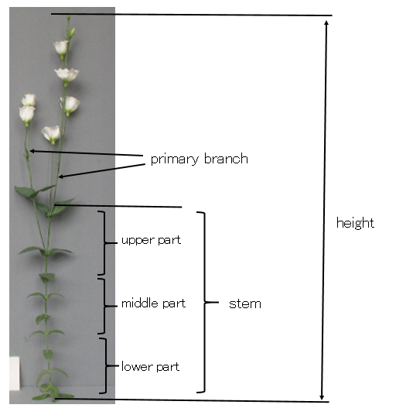
Primary branch
Height
Stem
upper part
middle part
lower part

Ad. 2: Plant: number of primary branches

See Ad. 1

Ad. 3: Plant: position of primary branches

See Ad. 1

Ad. 5: Leaf: length

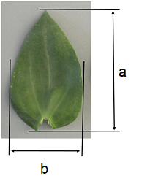 | a = Length  b = Width

Ad. 6: Leaf: width

See Ad. 5

Ad. 7: Leaf: ratio length/width

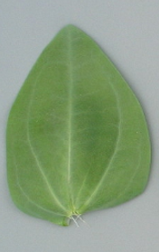 | 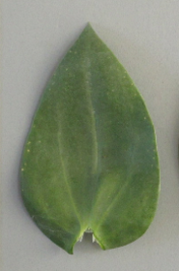 | 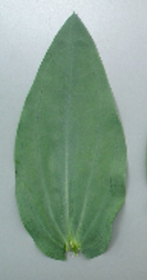
3 | 5 | 7
low | medium | high

Ad. 8: Leaf: glaucosity

Observations should be made on the upper side of the leaves.

Ad. 9: Leaf: intensity of green color

Observations should be made on the upper side of the leaf after removing the glaucosity.

Ad. 10: Pedicel: length

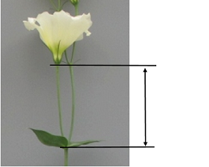

Ad. 11: Calyx: length

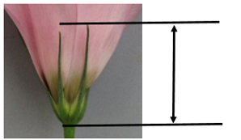

Ad. 14: Flower: type

Single varieties have only five petals.

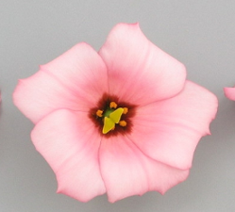 | 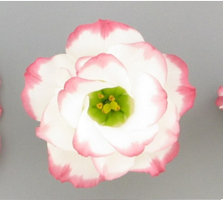
1 | 2
single | double

Ad. 16: Flower: shape

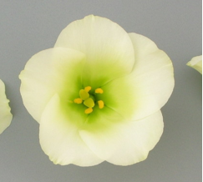 | 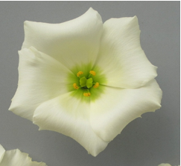 | 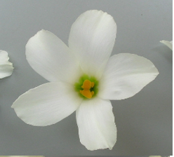
1 | 2 | 3
circular | pentagon | star-shaped

Ad. 17: Flower: height

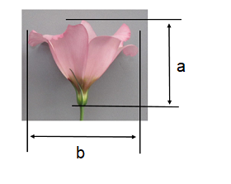 | a = Height  b = Width

Ad. 18: Flower: width

See Ad. 17

Ad. 19: Flower: ratio height/width

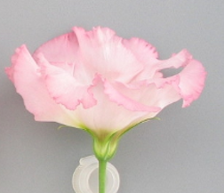 | 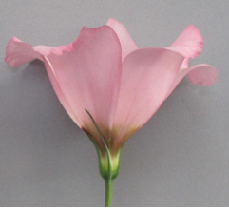 | 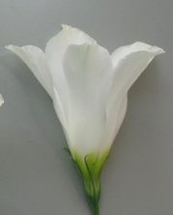
3 | 5 | 7
low | medium | high

Ad. 20: Petal: length

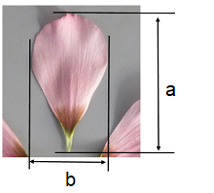 | a = Length  b = Width

Ad. 21: Petal: width

See Ad. 20

Ad. 22: Petal: shape

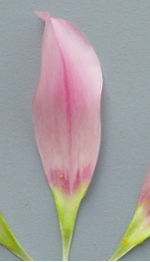 | 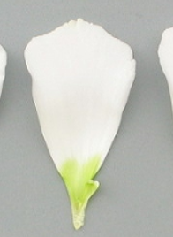 | 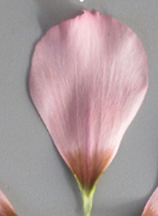
1 | 2 | 3
elliptic | oblanceolate | obovate

Ad. 23: Petal: shape of apex

 | 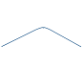 |  |  | 
1 | 2 | 3 | 4 | 5
acuminate | obtuse | rounded | flat | retuse

Ad. 24: Petal: recurving of margin

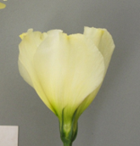 | 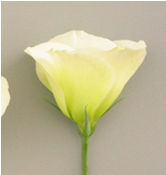 | 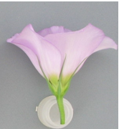 | 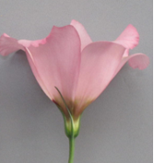 | 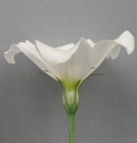
1 | 2 | 3 | 4 | 5
absent or very weak | weak | medium | strong | very strong

Ad. 25: Petal: undulation of margin

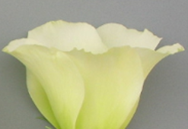 | 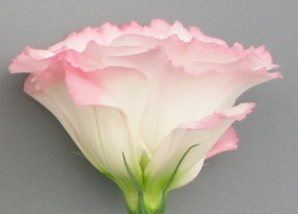 | 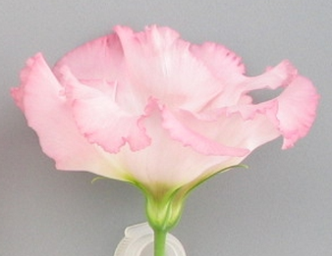
3 | 5 | 7
weak | medium | strong

Ad. 26: Petal: depth of incisions of margin

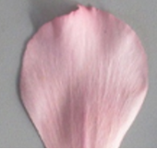 | 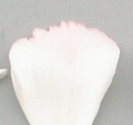 | 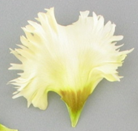
1 | 2 | 5
absent or very shallow | shallow | very deep

Ad. 29: Petal: distribution of secondary color of inner side

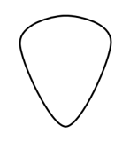 |  | 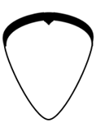 |  |  | 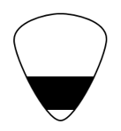 | 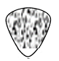
1 | 2 | 3 | 4 | 5 | 6 | 7
none | at tip | margin | central bar | distal half | basal half | throughout

Ad. 30: Petal: pattern of secondary color of inner side

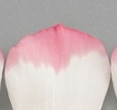 | 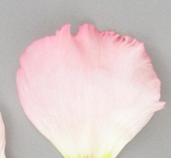 | 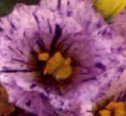
1 | 2 | 3
solid | flushed | irregular

Ad. 31: Petal: color of base of inner side

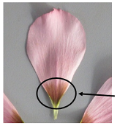

Ad. 34: Only seed -propagated varieties: Time of beginning of flowering

The time of beginning of flowering is reached when at least 50% of plants have at least one open flower.

9. | Literature

Kiyoshi Okawa, 1992: Eustoma (Torukogikyo) Seibundo-Shinkosha Co., Tokyo, JP.

10. | Technical Questionnaire

TECHNICAL QUESTIONNAIRE | Page {x} of {y} | Reference Number:

Application date:
(not to be filled in by the applicant)
TECHNICAL QUESTIONNAIRE
to be completed in connection with an application for plant breeders' rights

1. | Subject of the Technical Questionnaire
 |  | Botanical name
  1.1
  Eustoma exaltatum (L.) Salisb. ex G. Don subsp. russellianum (Hook.) Kartesz
 |  | Common name
  1.2
  Eustoma, Lisianthus

2. | Applicant
 | Name
 | Address
 | Telephone No.
 | Fax No.
 | E-mail address
 | Breeder (if different from
 | applicant)

3. | Proposed denomination and breeder's reference
 | Proposed denomination
 | (if available)
 | Breeder's reference

TECHNICAL QUESTIONNAIRE |  |  | Page {x} of {y} | Reference Number:
 | Information on the breeding scheme and propagation of the variety
  #4.
 | 4.1 | Breeding scheme
 | Variety resulting from:
  4.1.1
  Crossing
 |  | [ ]
  (a)
  controlled cross
(please state parent variety)

(…………………..……………..…) x (……………..…………………..…)

female parent male parent

 |  | [ ]
  (b)
  partially known cross
(please state known parent variety(ies))

(…………………..……………..…) x (……………..…………………..…)

female parent male parent

 |  | [ ]
  (c)
  unknown cross
 |  | [ ]
  4.1.2
  Mutation
  (please state parent variety)
 |  | [ ]
  4.1.3
  Discovery and development
  (please state where and when discovered and how developed)
 | Other  (Please provide details) | [ ]
  4.1.4

TECHNICAL QUESTIONNAIRE | Page {x} of {y} | Reference Number:

 | 4.2 | Method of propagating the variety
  4.2.1
  Seed-propagated varieties
 |  | [ ]
  (a)
  Self-pollination
 |  | [ ]
  (b)
  Cross-pollination
 |  | [ ]
  (c)
  Hybrid
 |  | [ ]
  (d)
  Other (please provide details)
  4.2.2
  Vegetative propagation
 |  | [ ]
  (a)
  Cuttings
 |  | [ ]
  (b)
  In vitro propagation
 |  | [ ]
  (c)
  Other (state method)
 | Other  (Please provide details) | [ ]
  4.2.3

TECHNICAL QUESTIONNAIRE | Page {x} of {y} | Reference Number:

5. | Characteristics of the variety to be indicated (the number in brackets refers to the corresponding characteristic in Test Guidelines; please mark the note which best corresponds).

 | Characteristics | Example Varieties | Note
  5.1
  (1)
  Plant: height
  very short
  1 [ ]
  very short to short
  2 [ ]
  short
  Sase LIS02
  3 [ ]
  short to medium
  4 [ ]
  medium
  Momo Sen
  5 [ ]
  medium to tall
  6 [ ]
  tall
  Mio Peach Chuchu
  7 [ ]
  tall to very tall
  8 [ ]
  very tall
  9 [ ]
  5.2
  (14)
  Flower: type
  single
  Momo Sen
  1 [ ]
  double
  Piccorosa Pink Picotee
  2 [ ]
  5.3
  (18)
  Flower: width
  very narrow
  1 [ ]
  very narrow to narrow
  2 [ ]
  narrow
  Chigusa
  3 [ ]
  narrow to medium
  4 [ ]
  medium
  Momo Sen
  5 [ ]
  medium to broad
  6 [ ]
  broad
  Rainbow White
  7 [ ]
  broad to very broad
  8 [ ]
  very broad
  9 [ ]
  5.4(i)
  (27)
  Petal: main color of inner side
  RHS Colour Chart (indicate reference number)
  5.4(ii)
  (27)
  Petal: main color of inner side
  white
  1 [ ]
  light green
  2 [ ]
  yellow
  3 [ ]
  orange
  4 [ ]
  pink
  5 [ ]
  red
  6 [ ]
  purple
  7 [ ]
  blue purple
  8 [ ]
  other (please indicate)
  [ ]

TECHNICAL QUESTIONNAIRE | Page {x} of {y} | Reference Number:

 | Characteristics | Example Varieties | Note
  5.5(i)
  (28)
  Petal: secondary color of inner side
  RHS Colour Chart (indicate reference number)
  5.5(ii)
  (28)
  Petal: secondary color of inner side
  none
  1 [ ]
  white
  2 [ ]
  light green
  3 [ ]
  yellow
  4 [ ]
  orange
  5 [ ]
  pink
  6 [ ]
  red
  7 [ ]
  purple
  8 [ ]
  blue prurple
  9 [ ]
  other (please indicate)
  [ ]
  5.6
  (29)
  Petal: distribution of secondary color of inner side
  none
  1 [ ]
  at tip
  Komachi Kiss
  2 [ ]
  margin
  Piccorosa Pink Picotee
  3 [ ]
  central bar
  4 [ ]
  distal half
  Mahoroba Peach
  5 [ ]
  basal half
  Cherrybee 2go
  6 [ ]
  throughout
  7 [ ]
  5.7
  (31)
  Petal: color of base of inner side
  green
  Chigusa
  1 [ ]
  violet
  Momo Sen
  2 [ ]
  brown
  Sase LIS02
  3 [ ]

TECHNICAL QUESTIONNAIRE | Page {x} of {y} | Reference Number:

6. | Similar varieties and differences from these varieties
Please use the following table and box for comments to provide information on how your candidate variety differs from the variety (or varieties) which, to the best of your knowledge, is (or are) most similar. This information may help the examination authority to conduct its examination of distinctness in a more efficient way.

  Denomination(s) of variety(ies) similar to your candidate variety
  Characteristic(s) in which your candidate variety differs from the similar variety(ies)
  Describe the expression of the characteristic(s) for the similar variety(ies)
  Describe the expression of the characteristic(s) for your candidate variety

Example
  Plant: height
  short
  medium

 | Comments:

TECHNICAL QUESTIONNAIRE | Page {x} of {y} | Reference Number:

 | Additional information which may help in the examination of the variety
  #7.
7.1 | In addition to the information provided in sections 5 and 6, are there any additional characteristics which may help to distinguish the variety?
 | Yes | [ ] | No | [ ]
 | (If yes, please provide details)
7.2 | Are there any special conditions for growing the variety or conducting the examination?
 | Yes | [ ] | No | [ ]
 | (If yes, please provide details)
7.3 | Other information
A representative color photograph of the variety displaying its main distinguishing feature(s), should accompany the Technical Questionnaire. The photograph will provide a visual illustration of the candidate variety which supplements the information provided in the Technical Questionnaire.
The key points to consider when taking a photograph of the candidate variety are:
• Indication of the date and geographic location
• Correct labeling (breeder’s reference)
• Good quality printed photograph (minimum 10 cm x 15 cm) and/or sufficient resolution electronic format version (minimum 960 x 1280 pixels)”
Further guidance on providing photographs with the Technical Questionnaire is available in document TGP/7 "Development of Test Guidelines", Guidance Note 35 (http://www.upov.int/tgp/en/).
[The link provided may be deleted by members of the Union when developing authorities’ own test guidelines.]

TECHNICAL QUESTIONNAIRE | Page {x} of {y} | Reference Number:

8. | Authorization for release
 | (a) | Does the variety require prior authorization for release under legislation concerning the protection of the environment, human and animal health?
 |  | Yes | [ ] | No | [ ]
 | (b) | Has such authorization been obtained?
 |  | Yes | [ ] | No | [ ]
 | If the answer to (b) is yes, please attach a copy of the authorization.

9. Information on plant material to be examined or submitted for examination

9.1 The expression of a characteristic or several characteristics of a variety may be affected by factors, such as pests and disease, chemical treatment (e.g. growth retardants or pesticides), effects of tissue culture, different rootstocks, scions taken from different growth phases of a tree, etc.
9.2 The plant material should not have undergone any treatment which would affect the expression of the characteristics of the variety, unless the competent authorities allow or request such treatment. If the plant material has undergone such treatment, full details of the treatment must be given. In this respect, please indicate below, to the best of your knowledge, if the plant material to be examined has been subjected to:

 | (a) | Microorganisms (e.g. virus, bacteria, phytoplasma) | Yes [ ] | No [ ]
 | (b) | Chemical treatment (e.g. growth retardant, pesticide) | Yes [ ] | No [ ]
 | (c) | Tissue culture | Yes [ ] | No [ ]
 | (d) | Other factors | Yes [ ] | No [ ]
 | Please provide details for where you have indicated “yes”.

10. | I hereby declare that, to the best of my knowledge, the information provided in this form is correct:
 | Applicant’s name
 | Signature |  | Date

[End of document]

