 |  | E  TG/196/2 Rev.  ORIGINAL: English  DATE: 2012-03-28
INTERNATIONAL UNION FOR THE PROTECTION OF NEW VARIETIES OF PLANTS
GENEVA

 | NEW GUINEA IMPATIENS  UPOV Code: IMPAT_NGH  Impatiens New Guinea Group | *

GUIDELINES

FOR THE CONDUCT OF TESTS

FOR DISTINCTNESS, UNIFORMITY AND STABILITY

Alternative Names:*

Botanical name | English | French | German | Spanish
Impatiens New Guinea Group | New Guinea Impatiens | Impatiente de Nouvelle-Guinée | Neuguinea-Impatiens | Impatiens de Nueva Guinea

The purpose of these guidelines (“Test Guidelines”) is to elaborate the principles contained in the General Introduction (document TG/1/3), and its associated TGP documents, into detailed practical guidance for the harmonized examination of distinctness, uniformity and stability (DUS) and, in particular, to identify appropriate characteristics for the examination of DUS and production of harmonized variety descriptions.

ASSOCIATED DOCUMENTS

These Test Guidelines should be read in conjunction with the General Introduction and its associated TGP documents.
TABLE OF CONTENTS PAGE

1. Subject of these Test Guidelines 3
2. Material Required 3
3. Method of Examination 3
3.1 Number of Growing Cycles 3
3.2 Testing Place 3
3.3 Conditions for Conducting the Examination 3
3.4 Test Design 4
3.5 Number of Plants / Parts of Plants to be Examined 4
3.6 Additional Tests 4
4. Assessment of Distinctness, Uniformity and Stability 4
4.1 Distinctness 4
4.2 Uniformity 5
4.3 Stability 5
5. Grouping of Varieties and Organization of the Growing Trial 5
6. Introduction to the Table of Characteristics 6
6.1 Categories of Characteristics 6
6.2 States of Expression and Corresponding Notes 6
6.3 Types of Expression 6
6.4 Example Varieties 6
6.5 Legend 6
7. Table of Characteristics/Tableau des caractères/Merkmalstabelle/Tabla de caracteres 7
8. Explanations on the Table of Characteristics 15
9. Literature 18
10. Technical Questionnaire 19

Subject of these Test Guidelines
These Test Guidelines apply to all varieties of the New Guinea Impatiens Group of the family Balsaminaceae.

Material Required
2.1 The competent authorities decide on the quantity and quality of the plant material required for testing the variety and when and where it is to be delivered. Applicants submitting material from a State other than that in which the testing takes place must ensure that all customs formalities and phytosanitary requirements are complied with.

2.2 The material is to be supplied in the form of rooted cuttings.

2.3 The minimum quantity of plant material, to be supplied by the applicant, should be:

20 rooted cuttings.

2.4 The plant material supplied should be visibly healthy, not lacking in vigor, nor affected by any important pest or disease.

2.5 The plant material should not have undergone any treatment which would affect the expression of the characteristics of the variety, unless the competent authorities allow or request such treatment. If it has been treated, full details of the treatment must be given.

Method of Examination

3.1 Number of Growing Cycles
The minimum duration of tests should normally be a single growing cycle.

3.2 Testing Place
Tests are normally conducted at one place. In the case of tests conducted at more than one place, guidance is provided in TGP/9 “Examining Distinctness”.

3.3 Conditions for Conducting the Examination
The tests should be carried out under conditions ensuring satisfactory growth for the expression of the relevant characteristics of the variety and for the conduct of the examination.

3.3.1 Observation of color by eye
Because daylight varies, color determinations made against a color chart should be made either in a suitable cabinet providing artificial daylight or in the middle of the day in a room without direct sunlight. The spectral distribution of the illuminant for artificial daylight should conform with the CIE Standard of Preferred Daylight D 6500 and should fall within the tolerances set out in the British Standard 950, Part I. These determinations should be made with the plant part placed against a white background.

3.4 Test Design
3.4.1 Each test should be designed to result in a total of at least 20 plants for vegetatively propagated varieties.

3.4.2 The design of the tests should be such that plants or parts of plants may be removed for measurement or counting without prejudice to the observations which must be made up to the end of the growing cycle.

3.5 Number of Plants / Parts of Plants to be Examined
Unless otherwise indicated, all observations should be made on 10 plants or parts taken from each of 10 plants.

3.6 Additional Tests
Additional tests, for examining relevant characteristics, may be established.

Assessment of Distinctness, Uniformity and Stability

4.1 Distinctness

4.1.1 General Recommendations

It is of particular importance for users of these Test Guidelines to consult the General Introduction prior to making decisions regarding distinctness. However, the following points are provided for elaboration or emphasis in these Test Guidelines.

4.1.2 Consistent Differences

The differences observed between varieties may be so clear that more than one growing cycle is not necessary. In addition, in some circumstances, the influence of the environment is not such that more than a single growing cycle is required to provide assurance that the differences observed between varieties are sufficiently consistent. One means of ensuring that a difference in a characteristic, observed in a growing trial, is sufficiently consistent is to examine the characteristic in at least two independent growing cycles.

4.1.3 Clear Differences

Determining whether a difference between two varieties is clear depends on many factors, and should consider, in particular, the type of expression of the characteristic being examined, i.e. whether it is expressed in a qualitative, quantitative, or pseudo-qualitative manner. Therefore, it is important that users of these Test Guidelines are familiar with the recommendations contained in the General Introduction prior to making decisions regarding distinctness.

4.2 Uniformity
4.2.1 It is of particular importance for users of these Test Guidelines to consult the General Introduction prior to making decisions regarding uniformity. However, the following points are provided for elaboration or emphasis in these Test Guidelines:

4.2.2 For the assessment of uniformity of vegetatively propagated varieties, a population standard of 1 % and an acceptance probability of at least 95 % should be applied. In the case of a sample size of 20 plants, 1 off-type is allowed.

4.3 Stability
4.3.1 In practice, it is not usual to perform tests of stability that produce results as certain as those of the testing of distinctness and uniformity. However, experience has demonstrated that, for many types of variety, when a variety has been shown to be uniform, it can also be considered to be stable.

4.3.2 Where appropriate, or in cases of doubt, stability may be tested, either by growing a further generation, or by testing a new plant stock to ensure that it exhibits the same characteristics as those shown by the previous material supplied.

Grouping of Varieties and Organization of the Growing Trial
5.1 The selection of varieties of common knowledge to be grown in the trial with the candidate varieties and the way in which these varieties are divided into groups to facilitate the assessment of distinctness are aided by the use of grouping characteristics.

5.2 Grouping characteristics are those in which the documented states of expression, even where produced at different locations, can be used, either individually or in combination with other such characteristics: (a) to select varieties of common knowledge that can be excluded from the growing trial used for examination of distinctness; and (b) to organize the growing trial so that similar varieties are grouped together.

5.3 The following have been agreed as useful grouping characteristics:

- Leaf blade: marking of upper side (characteristic 9);
- Flower: type (characteristic 17);
- Flower: number of colors (eye zone excluded) (characteristic 19);
- Flower: main color of upper side (characteristic 20) with the following groups:

Gr. 1: white
Gr. 2: orange pink
Gr. 3: orange red
Gr. 4: red
Gr. 5: bluish pink
Gr. 6: blue red
Gr. 7: purple red
Gr. 8: purple
Gr. 9: violet
Gr. 10: blue violet

5.4 Guidance for the use of grouping characteristics, in the process of examining distinctness, is provided through the General Introduction.

Introduction to the Table of Characteristics

6.1 Categories of Characteristics
6.1.1 Standard Test Guidelines Characteristics

Standard Test Guidelines characteristics are those which are approved by UPOV for examination of DUS and from which members of the Union can select those suitable for their particular circumstances.

6.1.2 Asterisked Characteristics

Asterisked characteristics (denoted by *) are those included in the Test Guidelines which are important for the international harmonization of variety descriptions and should always be examined for DUS and included in the variety description by all members of the Union, except when the state of expression of a preceding characteristic or regional environmental conditions render this inappropriate.

6.2 States of Expression and Corresponding Notes
States of expression are given for each characteristic to define the characteristic and to harmonize descriptions. Each state of expression is allocated a corresponding numerical note for ease of recording of data and for the production and exchange of the description.

6.3 Types of Expression
An explanation of the types of expression of characteristics (qualitative, quantitative and pseudo-qualitative) is provided in the General Introduction.

6.4 Example Varieties
Where appropriate, example varieties are provided to clarify the states of expression of each characteristic.

6.5 Legend
(*) Asterisked characteristic – see Chapter 6.1.2

QL: Qualitative characteristic – see Chapter 6.3
QN: Quantitative characteristic – see Chapter 6.3
PQ: Pseudo-qualitative characteristic – see Chapter 6.3

(+) See Explanations on the Table of Characteristics in Chapter 8

Table of Characteristics/Tableau des caractères/Merkmalstabelle/Tabla de caracteres
 | English | français | deutsch | español | Example Varieties  Exemples  Beispielssorten  Variedades ejemplo | Note/  Nota
1.  (*)  (+) | Plant: height of foliage | Plante: hauteur du feuillage | Pflanze: Höhe der Laubzone | Planta: altura del follaje
QN | short | bas | niedrig | bajo | Kijos | 3
 | medium | moyen | mittel | medio | Colombo | 5
 | tall | haut | hoch | alto | Firenze | 7
2.  (*) | Plant: width | Plante: largeur | Pflanze: Breite | Planta: anchura
QN | narrow | étroite | schmal | estrecha | Kimpgua | 3
 | medium | moyenne | mittel | media | Kitotoya | 5
 | broad | large | breit | ancha | Kibarbu | 7
3. | Shoot: anthocyanin coloration (on upper part of shoot) | Pousse: pigmentation anthocyanique (sur la partie supérieure d’une pousse) | Trieb: Anthocyanfärbung (am oberen Teil des Triebes) | Tallo: pigmentación antociánica (en la parte superior de un tallo)
QN | absent or very weak | absente ou très faible | fehlend oder sehr gering | ausente o muy débil | Vienna | 1
 | weak | faible | gering | débil | Duesweetres | 3
 | medium | moyenne | mittel | media | Firenze | 5
 | strong | forte | stark | fuerte | Kitotoya | 7
 | very strong | très forte | sehr stark | muy fuerte | Kimali | 9
4. | Petiole: length | Pétiole: longueur | Blattstiel: Länge | Pecíolo: longitud
QN | short | court | kurz | corto |  | 3
 | medium | moyen | mittel | medio |  | 5
 | long | long | lang | largo |  | 7
5. | Petiole: anthocyanin coloration on upper side | Pétiole: pigmentation anthocyanique de la partie supérieure | Blattstiel: Anthocyanfärbung auf der Oberseite | Pecíolo: pigmentación antociánica de la parte superior
QN | absent or very weak | absente ou très faible | fehlend oder sehr gering | ausente o muy débil | Kijos | 1
 | weak | faible | gering | débil | Ricky Gini | 3
 | medium | moyenne | mittel | media | Firenze | 5
 | strong | forte | stark | fuerte | Kinepor | 7
 | very strong | très forte | sehr stark | muy fuerte |  | 9
6.  (*) | Leaf blade: length | Limbe: longueur | Blattspreite: Länge | Limbo: longitud
QN | short | court | kurz | corto | Duesweetres | 3
 | medium | moyen | mittel | medio | Kitotoya | 5
 | long | long | lang | largo | Firenze | 7
7.  (*) | Leaf blade: width | Limbe: largeur | Blattspreite: Breite | Limbo: anchura
QN | narrow | étroit | schmal | estrecho | Kiluis | 3
 | medium | moyen | mittel | medio | Duesweetres | 5
 | broad | large | breit | ancho | Firenze | 7
8. | Leaf blade: length/width ratio | Limbe: rapport longueur/largeur | Blattspreite: Verhältnis Länge/Breite | Limbo: relación entre la longitud y la anchura
QN | small | petit | klein | pequeña | Kimpslav | 3
 | medium | moyen | mittel | media | Kitotoya | 5
 | large | grand | groß | grande | Kimaris | 7
9.  (*)  (+) | Leaf blade: marking of upper side | Limbe: ornementation de la face supérieure | Blattspreite: Zeichnung der Oberseite | Limbo: mancha del haz
QL | absent | absente | fehlend | ausente | Kitotoya | 1
 | present | présente | vorhanden | presente | Tempest | 9
10.  (*) | Varieties with marking only:  Leaf blade: color of marking of upper side | Seulement les variétés à ornementation:  Limbe: couleur de l’ornementation de la face supérieure | Nur Sorten mit Zeichnung:  Blattspreite: Farbe der Zeichnung der Oberseite | Sólo para variedades con mancha: Limbo: color de la mancha del haz
PQ | light yellow | jaune clair | hellgelb | amarillo claro | Solared | 1
 | medium yellow | jaune moyen | mittelgelb | amarillo medio | Red Planet | 2
 | yellow with red | jaune et rouge | gelb mit rot | amarillo y rojo | Tempest | 3
 | light green | vert clair | hellgrün | verde claro | Celsal | 4
11.  (*) | Leaf blade: anthocyanin coloration of upper side | Limbe: pigmentation anthocyanique de la face supérieure | Blattspreite: Anthocyanfärbung der Oberseite | Limbo: pigmentación antociánica del haz
QN | absent or very weak | absente ou très faible | fehlend oder sehr gering | ausente o muy débil | Ballet | 1
 | weak | faible | gering | débil | Kicarl | 3
 | medium | moyenne | mittel | media |  | 5
 | strong | forte | stark | fuerte |  | 7
 | very strong | très forte | sehr stark | muy fuerte | Vulcain | 9
12.  (*) | Leaf blade: color of lower side between veins | Limbe: couleur de la face inférieure entre les nervures | Blattspreite: Farbe der Unterseite zwischen den Adern | Limbo: color del envés entre los nervios
QL | green | verte | grün | verde | Kitotoya | 1
 | red | rouge | rot | rojo | Tempest | 2
13. | Varieties with red lower side only:  Leaf blade: intensity of red coloration on lower side between veins | Seulement les variétés dont la face inférieure est rouge:  Limbe: intensité de la pigmentation rouge sur la face inférieure entre les nervures | Nur Sorten mit roter Blattunterseite:  Blattspreite: Intensität der Rotfärbung der Unterseite zwischen den Adern | Sólo para variedades con envés rojo: Limbo: intensidad del color rojo en el envés entre los nervios
QN | weak | faible | gering | débil |  | 3
 | medium | moyenne | mittel | media |  | 5
 | strong | forte | stark | fuerte |  | 7
14.  (*) | Leaf blade: color of veins on lower side | Limbe: couleur des nervures sur la face inférieure | Blattspreite: Farbe der Adern auf der Unterseite | Limbo: color de los nervios en el envés
QL | green | vertes | grün | verde | Kijos | 1
 | red | rouges | rot | rojo | Kitotoya | 2
15. | Pedicel: length | Pédicelle: longueur | Blütenstiel: Länge | Pedicelo: longitud
QN | short | court | kurz | corto |  | 3
 | medium | moyen | mittel | medio |  | 5
 | long | long | lang | largo |  | 7
16. | Pedicel: anthocyanin coloration | Pédicelle: pigmentation anthocyanique | Blütenstiel: Anthocyanfärbung | Pedicelo: pigmentación antociánica
QN | absent or very weak | absente ou très faible | fehlend oder sehr gering | ausente o muy débil | Tempest | 1
 | weak | faible | gering | débil | Ricky Gini | 3
 | medium | moyenne | mittel | media | Firenze | 5
 | strong | forte | stark | fuerte | Kimpslav | 7
 | very strong | très forte | sehr stark | muy fuerte |  | 9
17.  (*) | Flower: type | Fleur: type | Blüte: Typ | Flor: tipo
QL | single | simple | einfach | simple | Kitotoya | 1
 | double | double | gefüllt | doble |  | 2
18.  (*)  (+) | Flower: width | Fleur: largeur | Blüte: Breite | Flor: anchura
QN | very narrow | très étroite | sehr schmal | muy estrecha | Kitol | 1
 | narrow | étroite | schmal | estrecha | Duesweetpur | 3
 | medium | moyenne | mittel | media | Kitotoya | 5
 | broad | large | breit | ancha | Kibetio | 7
 | very broad | très large | sehr breit | muy ancha | Kimpslav | 9
19.  (*) | Flower: number of colors (eye zone excluded) | Fleur: nombre de couleurs (zone de l’œil exclue) | Blüte: Anzahl Farben (Augenzone ausgenommen) | Flor: número de colores (excluida la zona del ojo)
QL | one | une | eine | uno | Kitotoya | 1
 | two | deux | zwei | dos | Kiluis | 2
 | three or more | trois ou plus | drei oder mehr | tres o más |  | 3
20.  (*) | Flower: main color of upper side | Fleur: couleur principale de la partie supérieure | Blüte: Hauptfarbe der Oberseite | Flor: color principal de la parte superior
PQ | RHS Colour Chart (indicate reference number) | Code RHS des couleurs (indiquer le numéro de référence) | RHS-Farbkarte (Nummer angeben) | Carta de colores RHS (indíquese el número de referencia)
21.  (*) | Varieties with bi- or multicolored flowers only: Flower: secondary color of upper side | Seulement les variétés à fleurs bicolores ou multicolores:  fleur: couleur secondaire de la partie supérieure | Nur Sorten mit zwei- oder mehrfarbigen Blüten: Blüte: Sekundärfarbe der Oberseite | Sólo para variedades con flores bicolores o multicolores: Flor: color secundario de la parte superior
PQ | RHS Colour Chart (indicate reference number) | Code RHS des couleurs (indiquer le numéro de référence) | RHS-Farbkarte (Nummer angeben) | Carta de colores RHS (indíquese el número de referencia)
22.  (*)  (+) | Varieties with bi- or multicolored flowers only: Flower: distribution of secondary color | Seulement les variétés à fleurs bicolores ou multicolores: fleur: distribution de la couleur secondaire | Nur Sorten mit zwei- oder mehrfarbigen Blüten:  Blüte: Verteilung der Sekundärfarbe | Sólo para variedades con flores bicolores o multicolores: Flor: distribución del color secundario
PQ | mainly on upper petal | surtout sur le pétale supérieur | hauptsächlich auf dem oberen Blütenblatt | principalmente en el pétalo superior | Vulcain | 1
 | on all petals around base | sur tous les pétales autour de la base | auf allen Blütenblättern um die Basis herum | en todos los pétalos alrededor de la base | Balcelisow | 2
 | on all petals along mid-rib | sur tous les pétales le long de la nervure centrale | auf allen Blütenblättern entlang der Mittelrippe | a lo largo del nervio central de todos los pétalos | Kiluis | 3
 | on all petals v-shaped at distal end | sur tous les pétales en V vers le sommet | auf allen Blütenblättern V-förmig am distalen Ende | en forma de “v” en el extremo distal de todos los pétalos | Danharpurcrown | 4
 | on all petals irregularly distributed | sur tous les pétales irrégulièrement répartie | auf allen Blütenblättern unregelmäßig verteilt | distribuido irregularmente en todos los pétalos | Fisnics Magpink | 5
 | mainly on lateral petals | surtout sur les pétales latéraux | hauptsächlich auf den seitlichen Blütenblättern | principalmente en los pétalos laterales |  | 6
 | on all petals as some longitudinal stripes and on upper petal as spot | sur tous les pétales en bandes longitudinales et sur le pétale supérieur en forme de tache | auf allen Blütenblättern als wenige Längsstreifen und auf dem oberen Blütenblatt als Fleck | algunas líneas longitudinales en todos los pétalos y un punto en el pétalo superior |  | 7
23.  (*)  (+) | Flower: eye zone | Fleur: zone de l’œil | Blüte: Augenzone | Flor: zona del ojo
QL | absent | Absente | fehlend | ausente | Kibetio | 1
 | present | Présente | vorhanden | presente | Kitotoya | 9
24.  (*) | Flower: size of eye zone | Fleur: taille de la zone de l’œil | Blüte: Größe der Augenzone | Flor: tamaño de la zona del ojo
QN | small | petite | klein | pequeña | Firenze | 3
 | medium | moyenne | mittel | media | Tempest | 5
 | large | grande | groß | grande | Kianton | 7
25. | Flower: main color of eye zone | Fleur: couleur principale de la zone de l’œil | Blüte: Hauptfarbe der Augenzone | Flor: color principal de la zona del ojo
PQ | RHS Colour Chart (indicate reference number) | Code RHS des couleurs (indiquer le numéro de référence) | RHS-Farbkarte (Nummer angeben) | Carta de colores RHS (indíquese el número de referencia)
26.  (+) | Varieties with single flowers only:  Upper petal: width | Seulement les variétés à fleurs simples: Pétale supérieur: largeur | Nur Sorten mit einfachen Blüten:  Oberes Blütenblatt: Breite | Sólo para variedades con flores simples: Pétalo superior: anchura
QN | narrow | étroit | schmal | estrecho | Kipaqui | 3
 | medium | moyen | mittel | medio | Kijos | 5
 | broad | large | breit | ancho | Kimali | 7
27.  (+) | Varieties with single flowers only:  Lateral petal: width | Seulement les variétés à fleurs simples: Pétale latéral: largeur | Nur Sorten mit einfachen Blüten:  Seitliches Blütenblatt: Breite | Sólo para variedades con flores simples: Pétalo lateral: anchura
QN | narrow | étroit | schmal | estrecho | Kitotoya | 3
 | medium | moyen | mittel | medio | Firenze | 5
 | broad | large | breit | ancho | Duesweetres | 7
28.  (+) | Varieties with single flowers only:  Lower petal: length | Seulement les variétés à fleurs simples: Pétale inférieur: longueur | Nur Sorten mit einfachen Blüten:  Unteres Blütenblatt: Länge | Sólo para variedades con flores simples: Pétalo inferior: longitud
QN | short | court | kurz | corto |  | 3
 | medium | moyen | mittel | medio |  | 5
 | long | long | lang | largo |  | 7
29.  (+) | Varieties with single flowers only:  Lower petal: depth of incision | Seulement les variétés à fleurs simples: Pétale inférieur: profondeur de l’incision | Nur Sorten mit einfachen Blüten:  Unteres Blütenblatt: Tiefe des Einschnitts | Sólo para variedades con flores simples: Pétalo inferior: profundidad de la incisión
QN | absent or very shallow | absente ou très peu profonde | fehlend oder sehr gering | ausente o muy poco profunda |  | 1
 | shallow | peu profonde | gering | poco profunda |  | 3
 | medium | moyenne | mittel | media |  | 5
 | deep | profonde | tief | profunda |  | 7
 | very deep | très profonde | sehr tief | muy profunda |  | 9
30.  (+) | Spur: degree of curvature | Éperon: degré de courbure | Sporn: Stärke der Krümmung | Espolón: grado de curvatura
QN | absent or very weak | nul ou très faible | fehlend oder sehr gering | ausente o muy débil |  | 1
 | weak | faible | gering | débil |  | 3
 | medium | moyen | mittel | media |  | 5
 | strong | fort | stark | fuerte |  | 7
 | very strong | très fort | sehr stark | muy fuerte |  | 9

Explanations on the Table of Characteristics
Ad. 1: Plant: height of foliage

The height of the foliage is the distance from the substrate surface to the highest point of the foliage.

Ad. 9: Leaf blade: marking of upper side
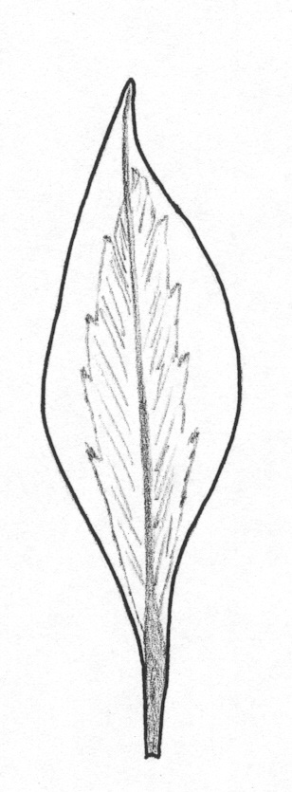
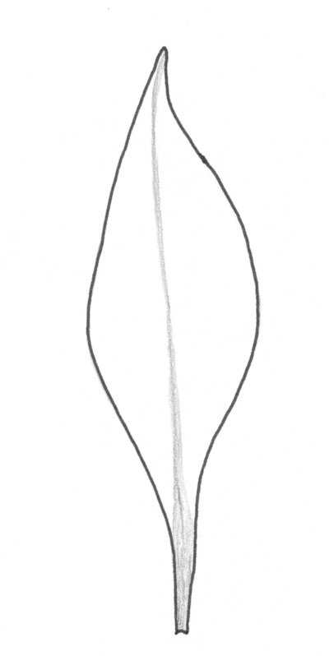
1 9
absent present

Ad. 18: Flower: width
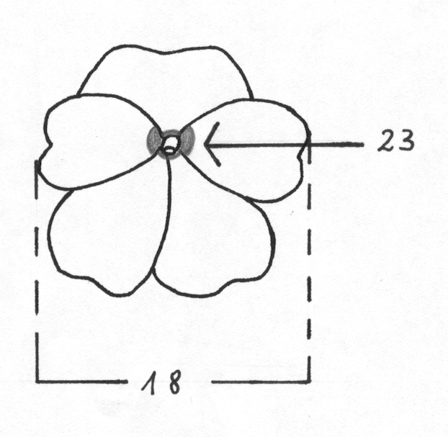
Ad. 23: Flower: eye zone
Ad. 22: Varieties with bi- or multicolored flowers only: Flower: distribution of secondary color
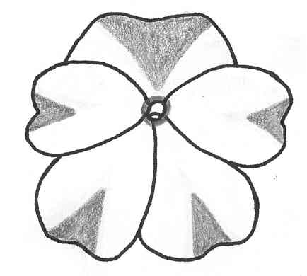
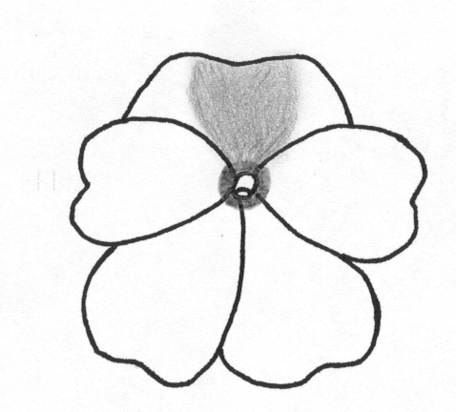
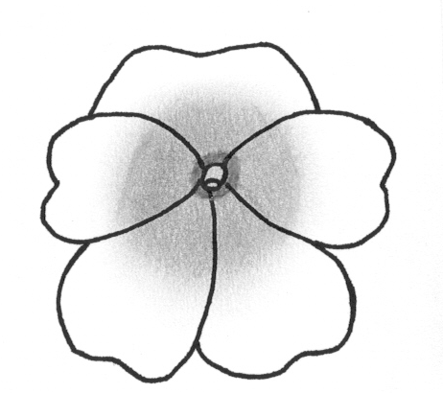
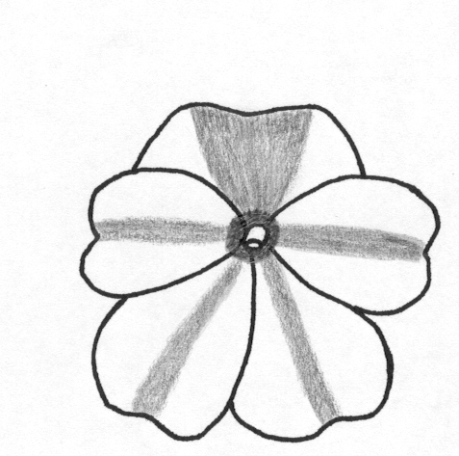

1 | 2 | 3 | 4
mainly on upper petal | on all petals around base | on all petals along mid-rib | on all petals  v-shaped at distal end

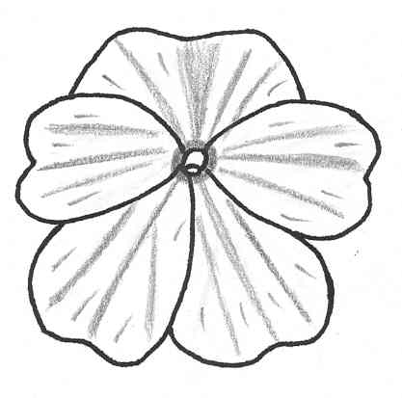 | 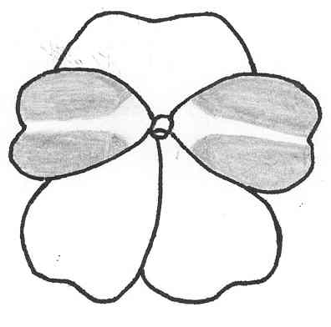 | 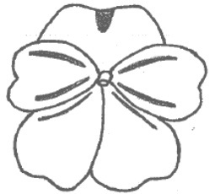
5 | 6 | 7
on all petals irregularly distributed | mainly on lateral petals | on all petals as some longitudinal stripes and on upper petal as spot

Ad. 26: Varieties with single flowers only: Upper petal: width
Ad. 27: Varieties with single flowers only: Lateral petal: width
Ad. 28: Varieties with single flowers only: Lower petal: length

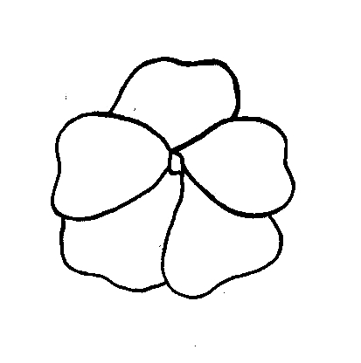
26
27
28

Ad. 29: Varieties with single flowers only: Lower petal: depth of incision
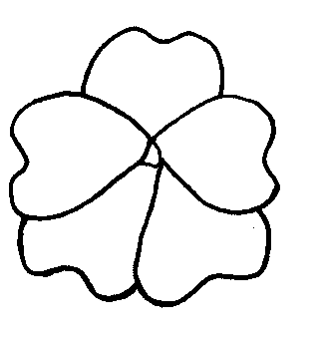
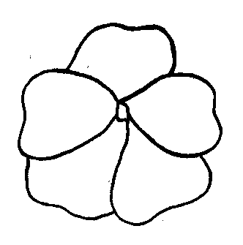
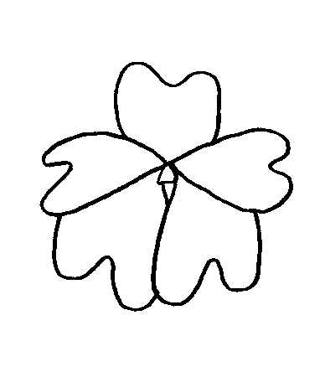
3 | 5 | 7
shallow | medium | deep

Ad. 30: Spur: degree of curvature
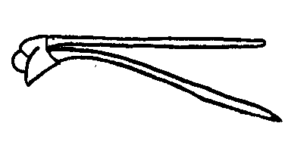
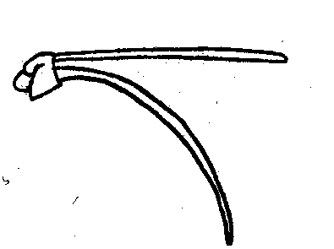
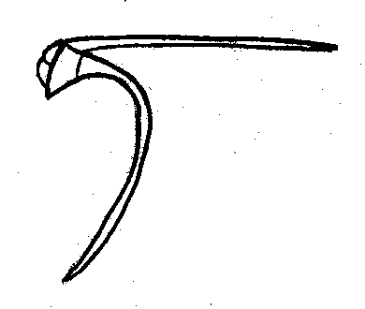

3 | 5 | 7
weak | medium | strong

Literature

Grey-Wilson, C., 1980: Impatiens of Africa, A. A. Balkema, Rotterdam.

Technical Questionnaire
TECHNICAL QUESTIONNAIRE |  |  |  | Page {x} of {y} |  | Reference Number:
 |  |  |  |  |  | Application date:
 |  |  |  |  |  | (not to be filled in by the applicant)
TECHNICAL QUESTIONNAIRE
to be completed in connection with an application for plant breeders’ rights

1. Subject of the Technical Questionnaire
1.1 Botanical name |  |  | Impatiens New Guinea Group
1.2 Common name |  |  | New Guinea Impatiens
2. Applicant
Name
Address
Telephone No.
Fax No.
E-mail address
Breeder (if different from applicant)
3. Proposed denomination and breeder’s reference
Proposed denomination
(if available)

Breeder’s reference
#4. Information on the breeding scheme and propagation of the variety

4.1 Breeding scheme

Variety resulting from:

4.1.1 Crossing

(a) controlled cross [ ]
(please state parent varieties)

(b) partially known cross [ ]
(please state known parent variety(ies))

(c) unknown cross [ ]

4.1.2 Mutation [ ]
(please state parent variety)

4.1.3 Discovery and development [ ]
(please state where and when discovered
and how developed)

4.1.4 Other [ ]
(please provide details)

4.2 Method of propagating the variety

4.2.1 Vegetative propagation

(a) cuttings [ ]

(b) in vitro propagation [ ]

(c) other (state method) [ ]

4.2.2 Other [ ]
(please provide details)

5. Characteristics of the variety to be indicated (the number in brackets refers to the corresponding characteristic in Test Guidelines; please mark the note which best corresponds).

 | Characteristics |  |  |  |  | Example Varieties |  |  | Note
5.1  (1) | Plant: height of foliage
 | short |  |  |  |  | Kijos |  |  | 3[ ]
 | medium |  |  |  |  | Colombo |  |  | 5[ ]
 | tall |  |  |  |  | Firenze |  |  | 7[ ]
5.2  (9) | Leaf blade: marking of upper side
 | absent |  |  |  |  | Kitotoya |  |  | 1[ ]
 | present |  |  |  |  | Tempest |  |  | 9[ ]
5.3  (11) | Leaf blade: anthocyanin coloration of upper side
 | absent or very weak |  |  |  |  | Ballet |  |  | 1[ ]
 | weak |  |  |  |  | Kicarl |  |  | 3[ ]
 | medium |  |  |  |  |  |  |  | 5[ ]
 | strong |  |  |  |  |  |  |  | 7[ ]
 | very strong |  |  |  |  | Vulcain |  |  | 9[ ]
5.4  (12) | Leaf blade: color of lower side between veins
 | green |  |  |  |  | Kitotoya |  |  | 1[ ]
 | red |  |  |  |  | Tempest |  |  | 2[ ]
5.5  (14) | Leaf blade: color of veins on lower side
 | green |  |  |  |  | Kijos |  |  | 1[ ]
 | red |  |  |  |  | Kitotoya |  |  | 2[ ]
 | Characteristics |  |  |  |  | Example Varieties |  |  | Note
5.6  (17) | Flower: type
 | single |  |  |  |  | Kitotoya |  |  | 1[ ]
 | double |  |  |  |  |  |  |  | 2[ ]
5.7  (18) | Flower: width
 | very narrow |  |  |  |  | Kitol |  |  | 1[ ]
 | narrow |  |  |  |  | Duesweetpur |  |  | 3[ ]
 | medium |  |  |  |  | Kitotoya |  |  | 5[ ]
 | broad |  |  |  |  | Kibetio |  |  | 7[ ]
 | very broad |  |  |  |  | Kimpslav |  |  | 9[ ]
5.8  (19) | Flower: number of colors (eye zone excluded)
 | one |  |  |  |  | Kitotoya |  |  | 1[ ]
 | two |  |  |  |  | Kiluis |  |  | 2[ ]
 | three or more |  |  |  |  |  |  |  | 3[ ]
5.9i  (20) | Flower: main color of upper side
RHS Colour Chart (indicate reference number)
………………………………………
5.9ii  (20) | Flower: main color of upper side
 | white |  |  |  |  |  |  |  | 1[ ]
 | orange pink |  |  |  |  |  |  |  | 2[ ]
 | orange red |  |  |  |  |  |  |  | 3[ ]
 | red |  |  |  |  |  |  |  | 4[ ]
 | bluish pink |  |  |  |  |  |  |  | 5[ ]
 | blue red |  |  |  |  |  |  |  | 6[ ]
 | purple red |  |  |  |  |  |  |  | 7[ ]
 | purple |  |  |  |  |  |  |  | 8[ ]
 | violet |  |  |  |  |  |  |  | 9[ ]
 | blue violet |  |  |  |  |  |  |  | 10[ ]
other color (indicate)
………………………………………
 | Characteristics |  |  |  |  | Example Varieties |  |  | Note
5.10i  (21) | Varieties with bi- or multicolored flowers only:  Flower: secondary color of upper side
RHS Colour Chart (indicate reference number)
………………………………………
5.10ii  (21) | Varieties with bi- or multicolored flowers only:  Flower: secondary color of upper side
 | white |  |  |  |  |  |  |  | 1[ ]
 | orange pink |  |  |  |  |  |  |  | 2[ ]
 | orange red |  |  |  |  |  |  |  | 3[ ]
 | red |  |  |  |  |  |  |  | 4[ ]
 | bluish pink |  |  |  |  |  |  |  | 5[ ]
 | blue red |  |  |  |  |  |  |  | 6[ ]
 | purple red |  |  |  |  |  |  |  | 7[ ]
 | purple |  |  |  |  |  |  |  | 8[ ]
 | violet |  |  |  |  |  |  |  | 9[ ]
 | blue violet |  |  |  |  |  |  |  | 10[ ]
other color (indicate)
………………………………………
6. Similar varieties and differences from these varieties

Please use the following table and box for comments to provide information on how your candidate variety differs from the variety (or varieties) which, to the best of your knowledge, is (or are) most similar. This information may help the examination authority to conduct its examination of distinctness in a more efficient way.

Denomination(s) of variety(ies) similar to your candidate variety |  | Characteristic(s) in which your candidate variety differs from the similar variety(ies) |  |  | Describe the expression of the characteristic(s) for the similar variety(ies) |  | Describe the expression of the characteristic(s) for your candidate variety
Example |  | Flower: main color of upper side |  |  | orange pink |  | orange red
Comments:

#7. Additional information which may help in the examination of the variety

7.1 In addition to the information provided in sections 5 and 6, are there any additional characteristics which may help to distinguish the variety?

Yes [ ] No [ ]

(If yes, please provide details)

7.2 Are there any special conditions for growing the variety or conducting the examination?

Yes [ ] No [ ]

(If yes, please provide details)

7.3 Other information

A representative color photograph of the variety should accompany the Technical Questionnaire.

8. Authorization for release

(a) Does the variety require prior authorization for release under legislation concerning the protection of the environment, human and animal health?

Yes [ ] No [ ]

(b) Has such authorization been obtained?

Yes [ ] No [ ]

If the answer to (b) is yes, please attach a copy of the authorization.

9. Information on plant material to be examined or submitted for examination.

9.1 The expression of a characteristic or several characteristics of a variety may be affected by factors, such as pests and disease, chemical treatment (e.g. growth retardants or pesticides), effects of tissue culture, different rootstocks, scions taken from different growth phases of a tree, etc.

9.2 The plant material should not have undergone any treatment which would affect the expression of the characteristics of the variety, unless the competent authorities allow or request such treatment. If the plant material has undergone such treatment, full details of the treatment must be given. In this respect, please indicate below, to the best of your knowledge, if the plant material to be examined has been subjected to:

(a) Microorganisms (e.g. virus, bacteria, phytoplasma) Yes [ ] No [ ]

(b) Chemical treatment (e.g. growth retardant, pesticide) Yes [ ] No [ ]

(c) Tissue culture Yes [ ] No [ ]

(d) Other factors Yes [ ] No [ ]

Please provide details for where you have indicated “yes”.

……………………………………………………………

10. I hereby declare that, to the best of my knowledge, the information provided in this form is correct:

Applicant’s name

Signature Date

[End of document]

* These names were correct at the time of the introduction of these Test Guidelines but may be revised or updated. [Readers are advised to consult the UPOV Code, which can be found on the UPOV Website (www.upov.int), for the latest information.]
# Authorities may allow certain of this information to be provided in a confidential section of the Technical Questionnaire.
# Authorities may allow certain of this information to be provided in a confidential section of the Technical Questionnaire.

