 |  | E  TG/195/1

INTERNATIONAL UNION FOR THE PROTECTION  OF NEW VARIETIES OF PLANTS | UNION INTERNATIONALE POUR LA PROTECTION  DES OBTENTIONS VÉGÉTALES | INTERNATIONALER VERBAND ZUM SCHUTZ VON PFLANZEN-ZÜCHTUNGEN | UNIÓN INTERNACIONAL PARA LA PROTECCIÓN  DE LAS OBTENCIONES VEGETALES

GUIDELINES

FOR THE CONDUCT OF TESTS

FOR DISTINCTNESS, UNIFORMITY AND STABILITY

TOBACCO

(Nicotiana tabacum L.)

GENEVA
2002

Copies of this document are available on request at the price of 10 Swiss francs each, including surface mail, from the Office of UPOV, 34, chemin des Colombettes, P.O. Box 18, 1211 Geneva 20, Switzerland

This document or parts of it may be reproduced, translated and published without obtaining the specific consent of UPOV, provided that the source is acknowledged.

* * * * * * *
E
TG/195/1
ORIGINAL: English
DATE : 2002-04-17

INTERNATIONAL UNION FOR THE PROTECTION  OF NEW VARIETIES OF PLANTS | UNION INTERNATIONALE POUR LA PROTECTION  DES OBTENTIONS VÉGÉTALES | INTERNATIONALER VERBAND ZUM SCHUTZ VON PFLANZEN-ZÜCHTUNGEN | UNIÓN INTERNACIONAL PARA LA PROTECCIÓN  DE LAS OBTENCIONES VEGETALES

GUIDELINES

FOR THE CONDUCT OF TESTS

FOR DISTINCTNESS, UNIFORMITY AND STABILITY

TOBACCO

(Nicotiana tabacum L.)

These Guidelines should be read in conjunction with document TG/1/2, which contains explanatory notes on the general principles on which the Guidelines have been established.

TABLE OF CONTENTS PAGE

I. Subject of these Guidelines 3

II. Material Required 3

III. Conduct of Tests 3

IV. Methods and Observations 3

V. Grouping of Varieties 4

VI. Characteristics and Symbols 4

VII. Table of Characteristics 6

VIII. Explanations on the Table of Characteristics 16

IX. Literature 24

X. Technical Questionnaire 25

ANNEX

I. Subject of these Test Guidelines

These Test Guidelines apply to all varieties of Nicotiana tabacum L.

II. Material Required

1. The competent authorities decide when, where and in what quantity and quality the plant material required for testing the variety is to be delivered. Applicants submitting material from a State other than that in which the testing takes place must make sure that all customs formalities are complied with. As a minimum, the following quantity of seed is recommended:

2 g.

The seed should meet the minimum requirements for germination, species and analytical purity, health and moisture content, specified by the competent authority. In cases where the seed is to be stored, the germination capacity should be as high as possible and should be stated by the applicant.

2. The seed must not have undergone any treatment unless the competent authorities allow or request such treatment. If it has been treated, full details of the treatment must be given.

III. Conduct of Tests

1. The minimum duration of tests should normally be two independent growing cycles.

2. The tests should normally be conducted at one place. If any important characteristics of the variety cannot be seen at that place, the variety may be tested at an additional place.

3. The tests should be carried out under conditions ensuring satisfactory growth for the expression of the relevant characteristics of the variety and for the conduct of the examination. The size of the plots should be such that plants or parts of plants may be removed for measurement and counting without prejudice to the observations which must be made up to the end of the growing period. Each test should be designed to result in a total of, at least 40 plants, which should be divided between two and more replicates. Separate plots for observation and for measuring should only be used if they have been subject to similar environmental conditions.

4. Additional tests may be established, especially with respect to the classification of tobacco.

IV. Methods and Observations

1. All observations for the assessment of distinctness and stability should be made on the plot as a whole. In the case of measured characteristics, observations should be made on at least 20 plants or parts taken from each of the 20 plants.

2. For the assessment of uniformity a population standard of 1% with an acceptance probability of at least 95% should be applied. In the case of a sample size of 40 plants, the maximum number of off types allowed would be 2.

3. All observations on the plant should be made after the beginning of flowering when the leaves in the middle third of the main stem are fully expanded.

4. All observations on the leaf should be made after the beginning of flowering on the largest fully-developed leaf in the middle third of the main stem, excluding the inflorescence.

5. All observations on flowers should be made on the main inflorescence on fully open flowers.

6. All observations on the inflorescence should be made on the main inflorescence at full flowering time.

7. Suckers are excluded from observations except for characteristics related to the suckers themselves.

V. Grouping of Varieties

1. The collection of varieties to be grown should be divided into groups to facilitate the assessment of distinctness. Characteristics which are suitable for grouping purposes are those which are known from experience not to vary, or to vary only slightly, within a variety. Their various states of expression should be fairly evenly distributed throughout the collection.

2. It is recommended that the competent authorities use the following characteristics for grouping varieties:

(a) Plant: height of main stem (including inflorescence) (characteristic 2);
(b) Plant: number of leaves (characteristic 4);
(c) Leaf: shape of blade (characteristic 14);
(d) Leaf: color of midrib on lower side (characteristic 22);
(e) Time of flowering (50% of plants with at least one corolla open) (characteristic 23);
(f) Flower: color of corolla (characteristic 29);
(g) Flower: development of stamens (characteristic 30).

VI. Characteristics and Symbols

1. To assess distinctness, uniformity and stability, the characteristics and their states as given in the Table of Characteristics should be used.

2. Where appropriate, example varieties are provided to clarify the states of expression of each characteristic. Two lists with different sets of example varieties are provided in the Annex to this Test Guidelines:

(a) A table containing example varieties provided by Greece;

(b) A table containing example varieties provided by Brazil. In this set of example varieties, for certain characteristics, different example varieties are indicated for Burley type and for Virginia Flue Cured type. Virginia Flue Cured type varieties are indicated by #.

3. Notes (numbers), for the purposes of electronic data processing, are given opposite the states of expression for each characteristic.

4. Legend

(*) Characteristics that should be used on all varieties in every growing period over which examinations are made and always be included in the variety descriptions, except when the state of expression of a preceding characteristic or regional environmental conditions render this impossible.

(+) See Explanations on the Table of Characteristics in Chapter VIII.

VII. Table of Characteristics/Tableau des caractères/Merkmalstabelle/Tabla de caracteres

See Annex for example varieties / Voir l’annexe pour des variétés exemples / Siehe Anlage für Beispielssorten / Véanse el Anexo para las variedades ejemplo.

 | English | français | deutsch | español | Example Varieties  Exemples  Beispielssorten  Variedades ejemplo | Note/  Nota
1.  (+) | Plant: shape | Plante: forme | Pflanze: Form | Planta: forma
 | conical | conique | kegelförmig | cónica |  | 1
 | cylindrical | cylindrique | zylindrisch | cilíndrica |  | 2
 | elliptical | elliptique | elliptisch | elipsoide |  | 3
 | inverted conical | conique inversée | verkehrt kegelförmig | de cono invertido |  | 4
2.  (*) | Plant: height of main stem (including inflorescence) | Plante: hauteur de la tige principale (y compris l’inflorescence) | Pflanze: Höhe des Haupttriebes (einschließlich Blütenstand) | Planta: altura del tallo principal (incluida la inflorescencia)
 | very short | très courte | sehr niedrig | muy corto |  | 1
 | short | courte | niedrig | corto |  | 3
 | medium | moyenne | mittel | mediano |  | 5
 | tall | haute | hoch | largo |  | 7
 | very tall | très haute | sehr hoch | muy largo |  | 9
3. | Plant: color of main stem | Plante: couleur de la tige principale | Pflanze: Farbe des Haupttriebes | Planta: color del tallo principal
 | white green | vert blanchâtre | weißgrün | verde blanquecino |  | 1
 | light green | vert clair | hellgrün | verde claro |  | 2
 | medium green | vert moyen | mittelgrün | verde medio |  | 3
 | dark green | vert foncé | dunkelgrün | verde oscuro |  | 4
4.  (*) | Plant: number of leaves | Plante: nombre de feuilles | Pflanze: Anzahl Blätter | Planta: número de hojas
 | very few | très petit | sehr gering | muy bajo |  | 1
 | few | petit | gering | bajo |  | 3
 | medium | moyen | mittel | medio |  | 5
 | many | grand | groß | alto |  | 7
 | very many | très grand | sehr groß | muy alto |  | 9
5. | Plant: tendency to produce suckers | Plante: tendance à drageonner | Pflanze: Neigung zur Bildung von Seitentrieben | Planta: tendencia a producir chupones
 | absent or very weak | absente ou très faible | fehlend oder sehr gering | ausente o muy débil |  | 1
 | weak | faible | gering | débil |  | 3
 | medium | moyenne | mittel | media |  | 5
 | strong | forte | stark | fuerte |  | 7
 | very strong | très forte | sehr stark | muy fuerte |  | 9
6.  (+) | Leaf: type | Feuille: type | Blatt: Typ | Hoja: tipo
 | sessile | sessile | ungestielt | sésil |  | 1
 | petiolate | pétiolée | gestielt | peciolada |  | 2
7.  (*)  (+) | Leaf: angle of insertion | Feuille: angle d’insertion | Blatt: Ansatzwinkel | Hoja: ángulo de inserción
 | very acute | très aigu | sehr spitz | muy agudo |  | 1
 | moderately acute | modérément aigu | mäßig spitz | moderadamente agudo |  | 2
 | right angle | droit | etwa rechtwinklig | ángulo recto |  | 3
8.  (*) | Leaf: length of blade (excluding auricles) | Feuille: longueur du limbe (à l’exclusion des oreillettes) | Blatt: Länge der Spreite (ohne Blattöhrchen) | Hoja: longitud del limbo (excluyendo las aurículas)
 | very short | très court | sehr kurz | muy corto |  | 1
 | short | court | kurz | corto |  | 3
 | medium | moyen | mittel | medio |  | 5
 | long | long | lang | largo |  | 7
 | very long | très long | sehr lang | muy largo |  | 9
9.  (*) | Leaf: width of blade | Feuille: largeur du limbe | Blatt: Breite der Spreite | Hoja: anchura del limbo
 | very narrow | très étroit | sehr schmal | muy estrecho |  | 1
 | narrow | étroit | schmal | estrecho |  | 3
 | medium | moyen | mittel | medio |  | 5
 | wide | large | breit | ancho |  | 7
 | very wide | très large | sehr breit | muy ancho |  | 9
10.  (*) | Leaf: ratio length/width of blade (excluding auricles) | Feuille : rapport longueur/largeur du limbe (à l’exclusion des oreillettes) | Blatt: Verhältnis Länge/Breite der Spreite (Blattöhrchen ausgenommen) | Hoja: proporción entre la longitud y la anchura del limbo (excluidas las aurículas)
 | very small | très petit | sehr klein | muy pequeño |  | 1
 | small | petit | klein | pequeño |  | 3
 | medium | moyen | mittel | medio |  | 5
 | large | grand | groß | grande |  | 7
 | very large | très grand | sehr groß | muy grande |  | 9
11.  (+) | Leaf: width of blade at basis (sessile types only) | Feuille: largeur du limbe à la base (seulement pour les variétés avec des feuilles de type sessile) | Blatt: Breite der Spreite an der Basis (nur ungestielte Typen) | Hoja: anchura de la base del limbo (sólo para tipos sésiles)
 | very narrow | très étroit | sehr schmal | muy estrecha |  | 1
 | narrow | étroit | schmal | estrecha |  | 3
 | medium | moyen | mittel | media |  | 5
 | broad | large | breit | ancha |  | 7
12. | Leaf: thickness of veins (excluding midrib) | Feuille: épaisseur des nervures (excepté nervure médiane) | Blatt: Dicke der Adern (ohne Mittelrippe) | Hoja: grosor de los nervios (excluida la nervadura central)
 | thin | fines | dünn | delgados |  | 3
 | medium | moyennes | mittel | medianos |  | 5
 | thick | épaisses | dick | gruesos |  | 7
13.  (+) | Leaf: angle of lateral veins to midrib | Feuille: angle des nervures latérales avec la nervure médiane | Blatt: Winkel zwischen Seitenadern und Mittelrippe | Hoja: ángulo de los nervios laterales con el nervio central
 | very acute | très aigu | sehr spitz | muy agudo |  | 1
 | moderately acute | moyennement aigu | mäßig spitz | moderadamente agudo |  | 2
 | right angle | droit | etwa rechtwinklig | ángulo recto |  | 3
14.  (*)  (+) | Leaf: shape of blade | Feuille: forme du limbe | Blatt: Form der Spreite | Hoja: forma del limbo
 | lanceolate | lancéolé | lanzettlich | lanceolada |  | 1
 | narrow elliptic | elliptique étroit | schmal elliptisch | elíptica estrecha |  | 2
 | broad elliptic | elliptique large | breit elliptisch | elíptica ancha |  | 3
 | ovate | ovale | eiförmig | oval |  | 4
 | obovate | obovale | verkehrt eiförmig | oboval |  | 5
 | cordate | cordé | herzförmig | cordiforme |  | 6
 | rounded | arrondi | rund | redondeada |  | 7
15.  (+) | Leaf: shape of tip | Feuille: forme du sommet | Blatt: Form der Spitze | Hoja: forma del ápice
 | obtuse | obtus | stumpf | obtuso |  | 1
 | slightly pointed | légèrement pointu | leicht spitz | ligeramente puntiagudo |  | 3
 | medium pointed | moyennement pointu | mäßig spitz | medianamente puntiagudo |  | 5
 | strongly pointed | fortement pointu | stark spitz | fuertemente puntiagudo |  | 7
 | very strongly pointed | très fortement pointu | sehr stark spitz | muy fuertemente puntiagudo |  | 9
16.  (+) | Leaf: shape in cross section | Feuille: forme en section transversale | Blatt: Form im Querschnitt | Hoja: forma en sección transversal
 | concave | concave | konkav | cóncava |  | 1
 | flat | plate | eben | plana |  | 2
 | convex | convexe | konvex | convexa |  | 3
17.  (+) | Leaf: longitudinal profile | Feuille: profil longitudinal | Blatt: Längsprofil | Hoja: perfil longitudinal
 | straight | droit | gerade | recto |  | 1
 | slightly recurved | légèrement incurvé | schwach gebogen | ligeramente recurvado |  | 3
 | moderately recurved | modérément incurvé | mäßig gebogen | moderadamente recurvado |  | 5
 | strongly recurved | fortement incurvé | stark gebogen | fuertemente recurvado |  | 7
18. | Leaf: blistering of blade | Feuille: cloqûre du limbe | Blatt: Blasigkeit der Spreite | Hoja: abullonado del limbo
 | absent or very weak | absente ou très faible | fehlend oder sehr gering | ausente o muy débil |  | 1
 | weak | faible | gering | débil |  | 3
 | medium | moyenne | mittel | medio |  | 5
 | strong | forte | stark | fuerte |  | 7
 | very strong | très forte | sehr stark | muy fuerte |  | 9
19. | Leaf: undulations of margin | Feuille: ondulations du bord | Blatt: Randwellungen | Hoja: ondulación del borde
 | absent or very weak | absentes ou très faibles | fehlend oder sehr gering | ausente o muy débil |  | 1
 | weak | faibles | gering | débil |  | 3
 | medium | moyennes | mittel | media |  | 5
 | strong | fortes | stark | fuerte |  | 7
20.  (+) | Leaf: development of auricles | Feuille : développement des oreillettes | Blatt: Entwicklung der Öhrchen | Hoja: desarrollo de las aurículas
 | absent or very weak | absentes ou très faibles | fehlend oder sehr schwach | ausentes o muy débiles |  | 1
 | weak | faibles | schwach | débiles |  | 3
 | medium | moyennes | mittel | medianas |  | 5
 | strong | fortes | stark | fuertes |  | 7
 | very strong | très fortes | sehr stark | muy fuertes |  | 9
21.  (*) | Leaf: color of blade | Feuille: couleur du limbe | Blatt: Farbe der Spreite | Hoja: color del limbo
 | yellow green | vert-jaune | gelbgrün | verde amarillento |  | 1
 | white green | vert-blanc | weißgrün | verde blanquecino |  | 2
 | light green | vert clair | hellgrün | verde claro |  | 3
 | medium green | vert moyen | mittelgrün | verde medio |  | 4
 | dark green | vert foncé | dunkelgrün | verde oscuro |  | 5
22.  (*) | Leaf: color of midrib on lower side | Feuille: couleur de la nervure médiane sur la face inférieure | Blatt: Farbe der Mittelrippe an der Unterseite | Hoja: color de la nervadura central del envés
 | whitish | blanchâtre | weißlich | blanquecina |  | 1
 | whitish green | vert blanchâtre | weißlichgrün | verde blanquecina |  | 2
 | green | verte | grün | verde |  | 3
23.  (*) | Time of flowering (50% of plants with at least one corolla open) | Époque de floraison (50% des plantes avec au moins une corolle ouverte) | Blühzeitpunkt (50% der Pflanzen zeigen wenigstens eine offene Krone) | Época de floración (50% de las plantas con al menos una corola abierta)
 | very early | très précoce | sehr früh | muy temprana |  | 1
 | early | précoce | früh | temprana |  | 3
 | medium | moyenne | mittel | media |  | 5
 | late | tardive | spät | tardía |  | 7
 | very late | très tardive | sehr spät | muy tardía |  | 9
24.  (*)  (+) | Flower: length (excluding peduncle) | Fleur: longueur (sans le pédoncule) | Blüte: Länge (ohne Blütenstiel) | Flor: longitud (excluido el pedúnculo)
 | short | courte | kurz | corta |  | 3
 | medium | moyenne | mittel | media |  | 5
 | long | longue | lang | larga |  | 7
25.  (+) | Flower: diameter of tube (just above calyx) | Fleur: diamètre du tube (juste au-dessus du calice) | Blüte: Durchmesser der Röhre (unmittelbar über dem Kelch) | Flor: diámetro del tubo (justo por encima del cáliz)
 | small | petit | klein | pequeño |  | 3
 | medium | moyen | mittel | mediano |  | 5
 | large | large | groß | grande |  | 7
26.  (+) | Flower: swelling of tube | Fleur: renflement du tube | Blüte: Verdickung der Röhre | Flor: engrosamiento del tubo
 | weak | faible | gering | débil |  | 3
 | medium | moyen | mittel | medio |  | 5
 | strong | fort | stark | fuerte |  | 7
27.  (+) | Flower: size of corolla | Fleur: taille de la corolle | Blüte: Größe der Krone | Flor: tamaño de la corola
 | small | petite | klein | pequeña |  | 3
 | medium | moyenne | mittel | mediana |  | 5
 | large | grande | groß | grande |  | 7
28.  (+) | Flower: expression of tips of corolla | Fleur: expression des pointes de la corolle | Blüte: Ausprägung der Kronenspitzen | Flor: expresión de los ápices de la corola
 | absent or very weak | absentes ou très faibles | fehlend oder sehr gering | ausentes o muy débiles |  | 1
 | weak | faibles | gering | débiles |  | 3
 | medium | moyennes | mittel | medianos |  | 5
 | strong | fortes | stark | fuertes |  | 7
 | very strong | très fortes | sehr stark | muy fuertes |  | 9
29.  (*) | Flower: color of corolla | Fleur: couleur de la corolle | Blüte: Farbe der Krone | Flor: color de la corola
 | white | blanche | weiß | blanco |  | 1
 | light pink | rose clair | hellrosa | rosa claro |  | 2
 | medium pink | rose moyen | mittelrosa | rosa medio |  | 3
 | dark pink | rose foncé | dunkelrosa | rosa fuerte |  | 4
 | red | rouge | rot | rojo |  | 5
30.  (*) | Flower: development of stamens | Fleur: développement des étamines | Blüte: Ausbildung von Staubblättern | Flor: desarrollo de los estambres
 | none or rudimentary | nul ou rudimentaire | keine oder rudimentär | ninguno o rudimentario |  | 1
 | full | complet | vollständig | pleno |  | 2
31.  (*) | Flower: length of pistil relative to stamens (varieties with fully developed stamens only) | Fleur: longueur du pistil par rapport aux étamines (seulement pour les variétés à développement complet des étamines) | Blüte: Länge des Stempels im Verhältnis zu den Staubblättern (nur Sorten mit vollentwickelten Staubblättern) | Flor: longitud del pistilo en relación con los estambres (sólo para variedades con estambres plenamente desarrollados)
 | shorter | plus court | kürzer | más corto |  | 1
 | same length | égal | gleich lang | de igual longitud |  | 2
 | longer | plus long | länger | más largo |  | 3
32.  (+) | Inflorescence: shape | Inflorescence: forme | Blütenstand: Form | Inflorescencia: forma
 | spherical | sphérique | kugelförmig | esférica |  | 1
 | flattened spherical | sphérique aplatie | abgeflacht kugelförmig | esférica aplanada |  | 2
 | inverted conical | conique inversée | verkehrt kegelförmig | de cono invertido |  | 3
 | double conical | conique double | doppelt kegelförmig | cónica doble |  | 4
33. | Inflorescence: position relative to upper leaves | Inflorescence: position par rapport aux feuilles supérieures | Blütenstand: Stellung im Verhältnis zu den oberen Blättern | Inflorescencia: posición en relación con las hojas superiores
 | among | au milieu | dazwischen | entre las hojas |  | 1
 | above | au-dessus | oberhalb | por encima |  | 2
34.  (+) | Inflorescence: compactness | Inflorescence: densité | Blütenstand:  Dichte | Inflorescencia: densidad
 | very loose | très lâche | sehr locker | muy laxa |  | 1
 | loose | lâche | locker | laxa |  | 3
 | medium | moyenne | mittel | media |  | 5
 | dense | dense | dicht | densa |  | 7
 | very dense | très dense | sehr dicht | muy densa |  | 9
35.  (+) | Fruit: form | Fruit: forme | Frucht: Form | Fruto: forma
 | rounded | arrondi | rundlich | redondeado |  | 1
 | intermediate | intermédiaire | intermediär | intermedio |  | 2
 | ovate | ovale | eiförmig | oval |  | 3

VIII. Explanations on the Table of Characteristics

Ad. 1: Plant: shape
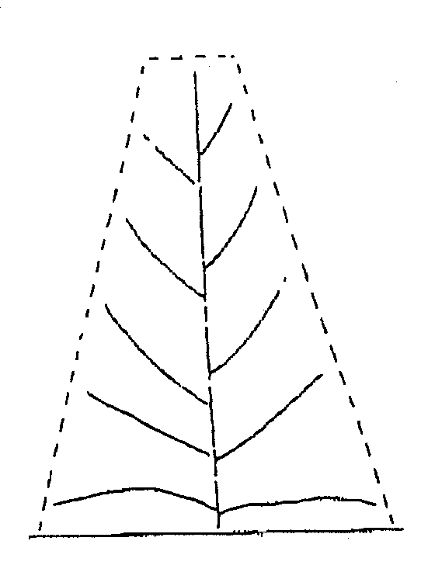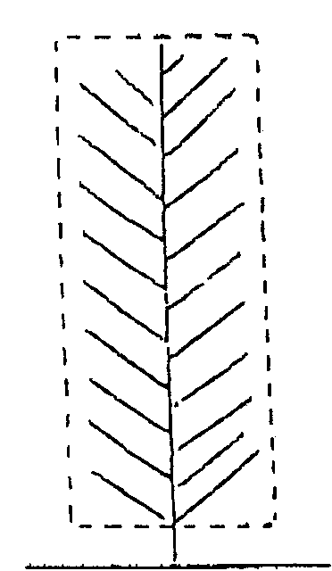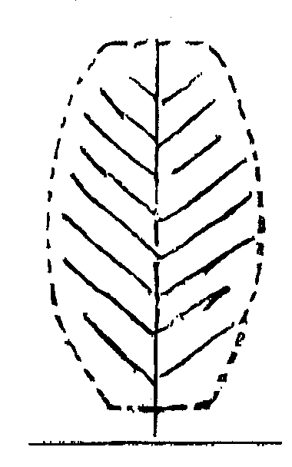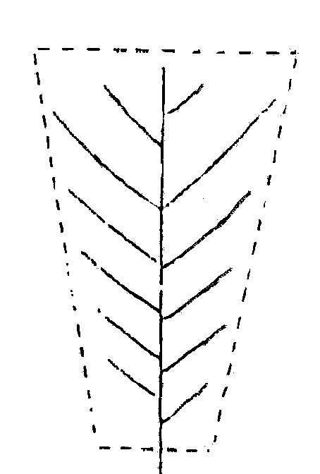

1 | 2 | 3 | 4
conical | cylindrical | elliptical | inverted conical

Ad. 6: Leaf: type
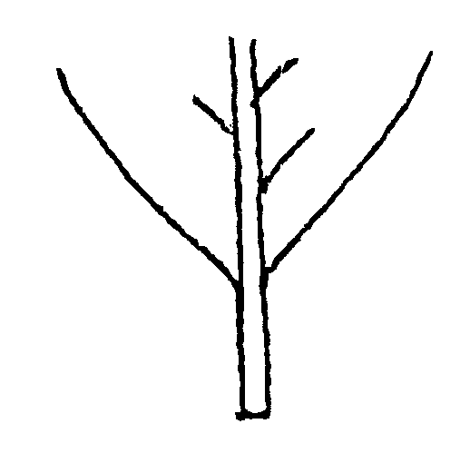
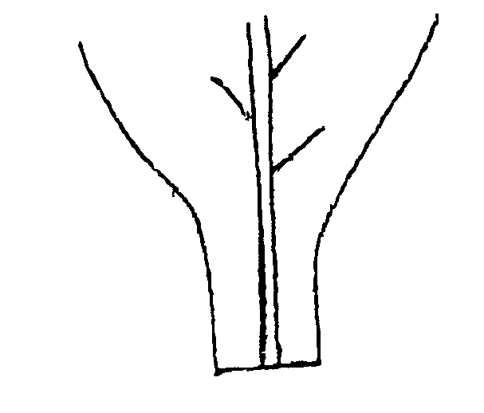
1 | 2
sessile | petiolate

Ad. 7: Leaf: angle of insertion
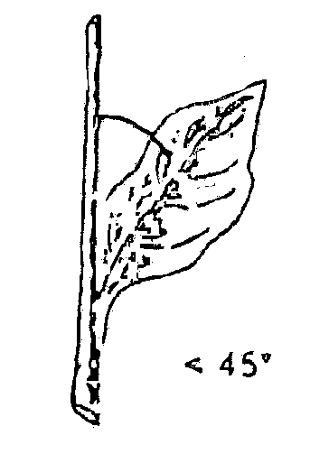
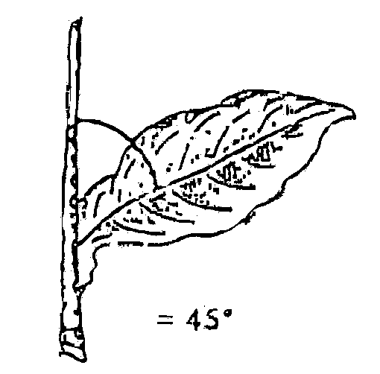
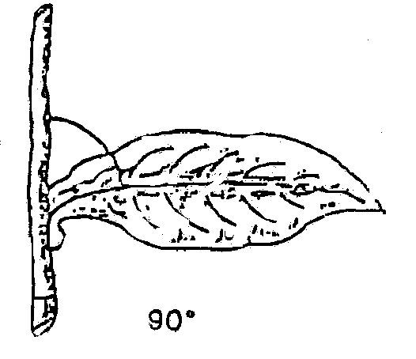

1 | 2 | 3
very acute | moderately acute | right angle
Ad. 11: Leaf: width of blade at basis (sessile types only)

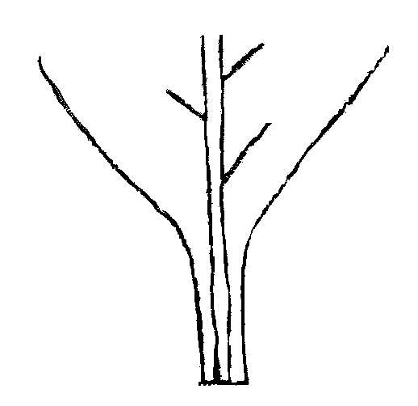
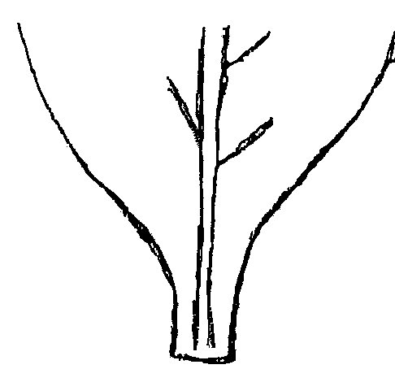
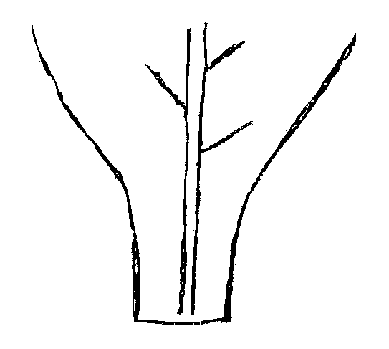

1 | 3 | 5
very narrow | narrow | medium

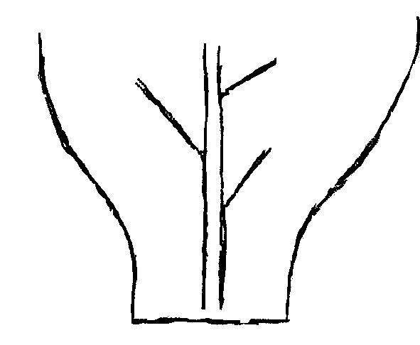

7
broad

Ad. 13: Leaf: angle of lateral veins to midrib

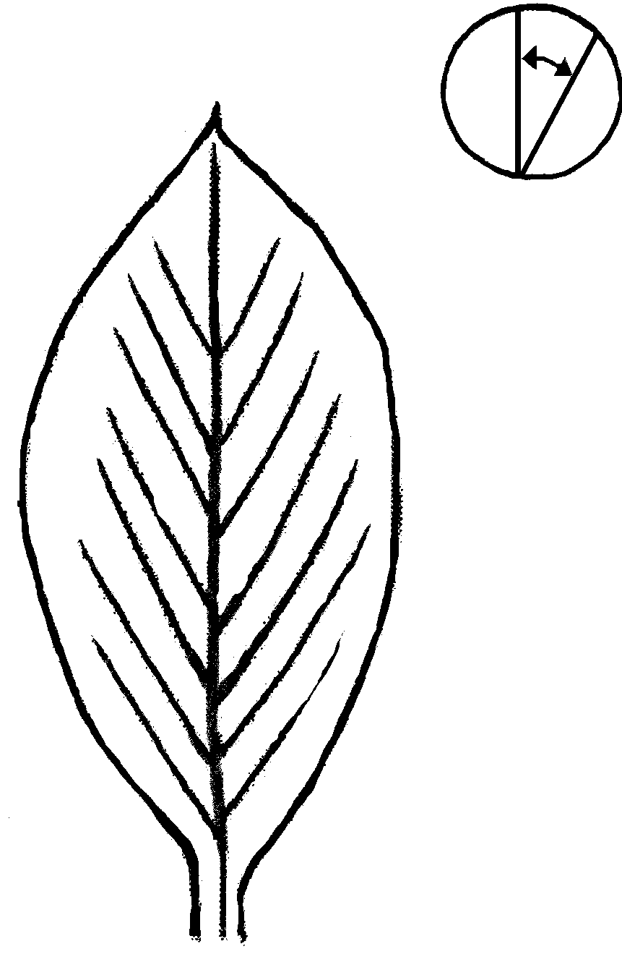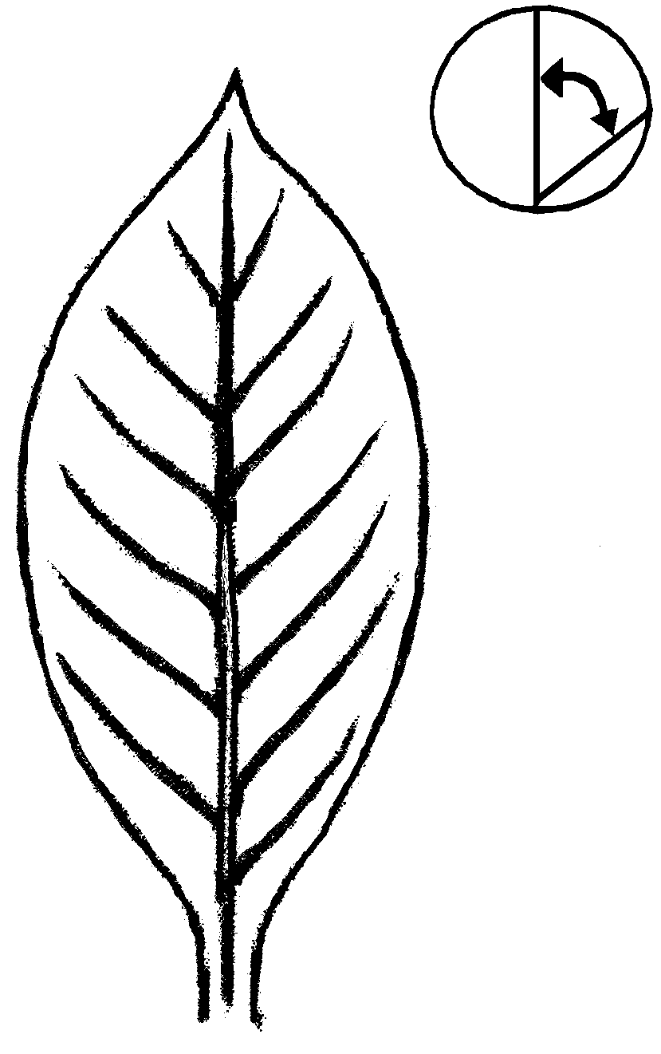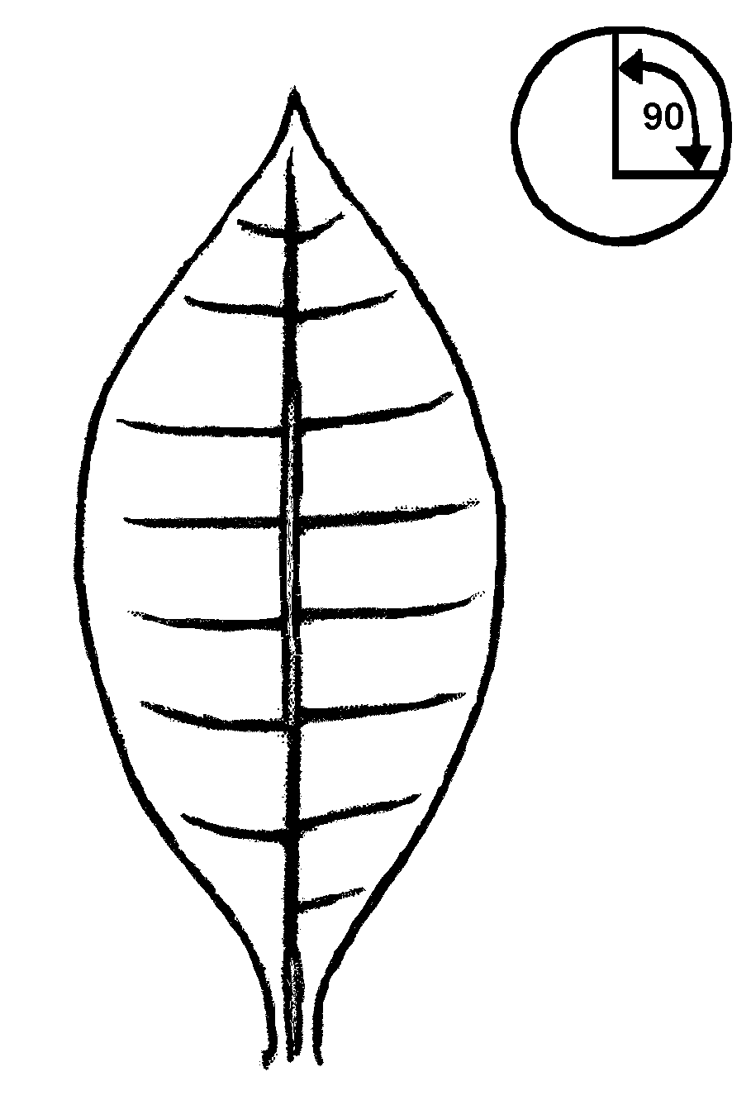
1 | 2 | 3
very acute | moderately acute | right angle
Ad. 14: Leaf: shape of blade
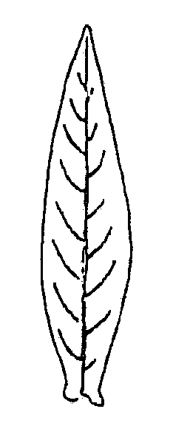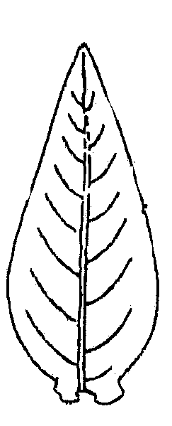
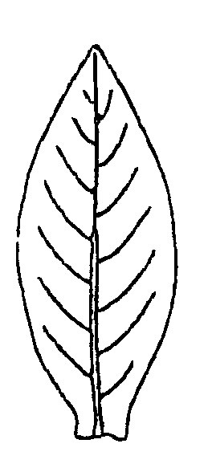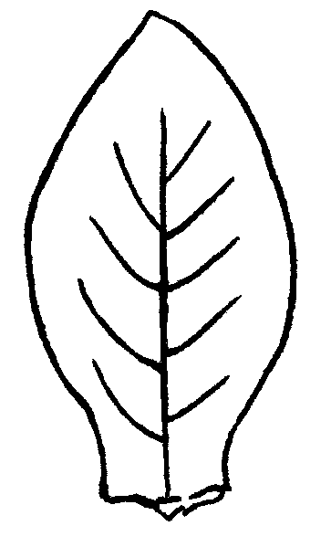
1 | 2 |  | 3 |  | 4
lanceolate | narrow elliptic |  | broad elliptic |  | ovate
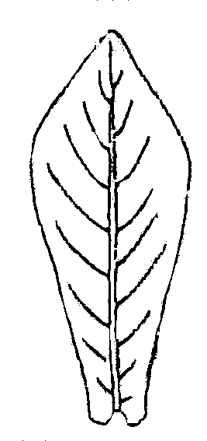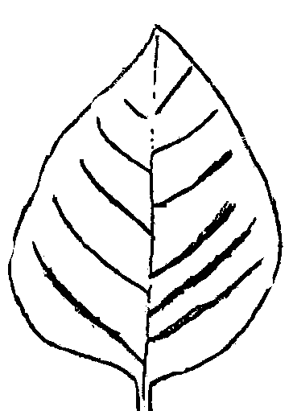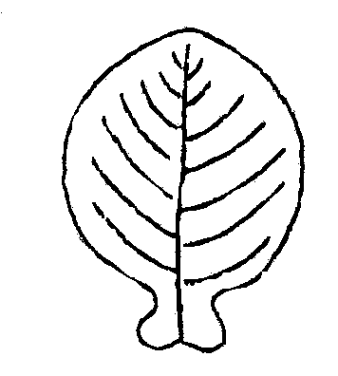5 |  | 6 |  | 7
obovate |  | cordate |  | rounded

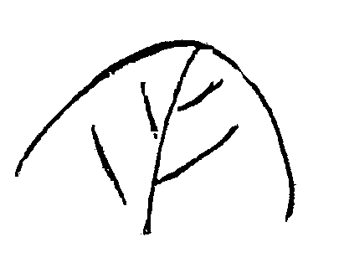
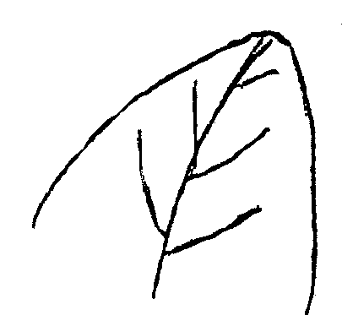
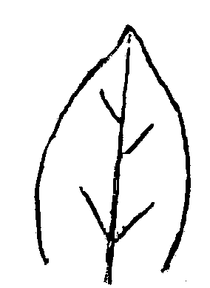
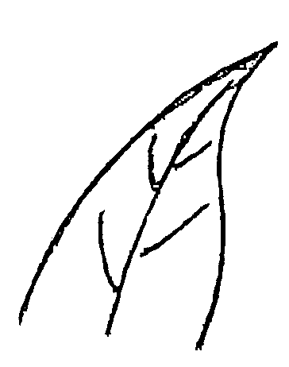
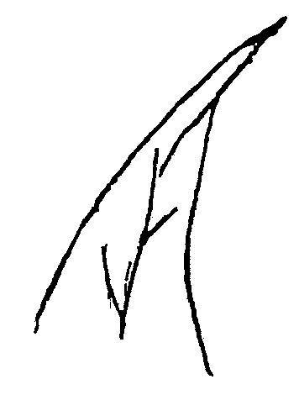
Ad. 15: Leaf: shape of tip

1 | 3 | 5 | 7 | 9
obtuse | slightly pointed | medium pointed | strongly pointed | very strongly pointed

Ad. 16: Leaf: shape in cross section

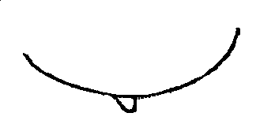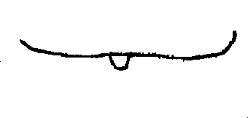
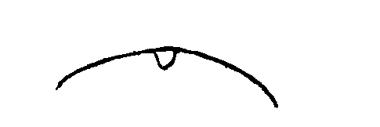
1 | 2 | 3
concave | flat | convex

Ad. 17: Leaf: longitudinal profile
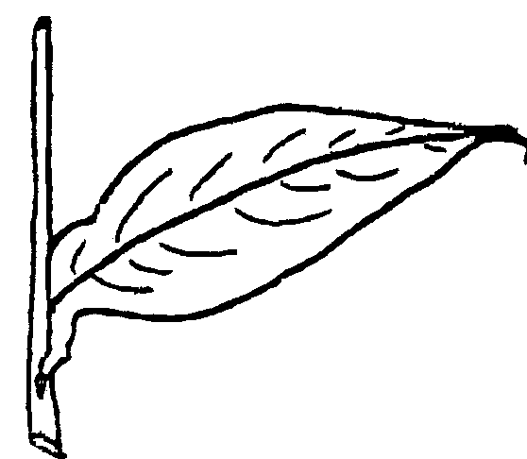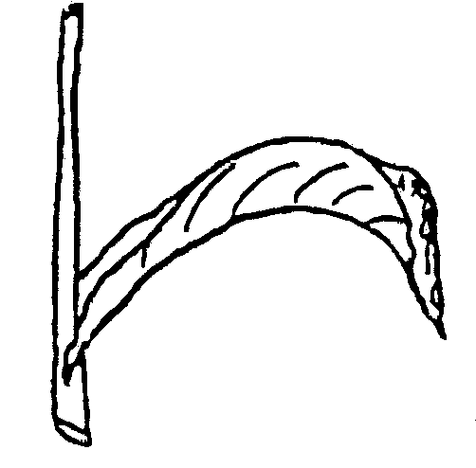

1 | 7
straight | strongly recurved

Ad. 20: Leaf: development of auricles
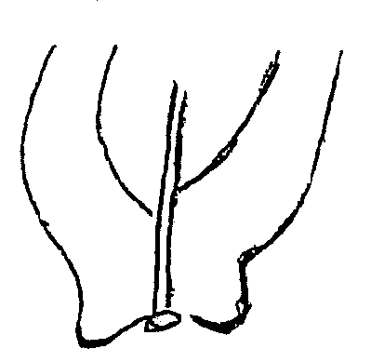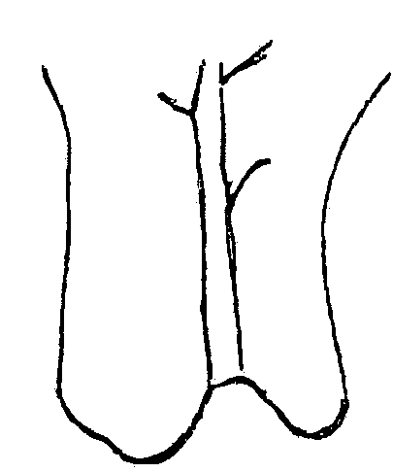
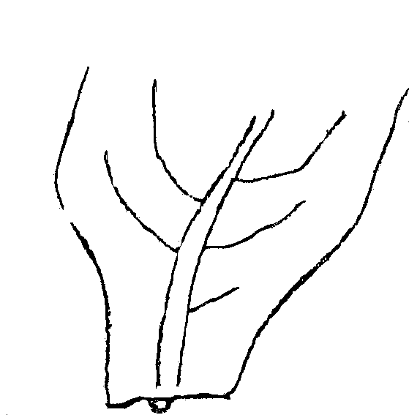
1 | 3 | 5
absent or very weak | weak | medium

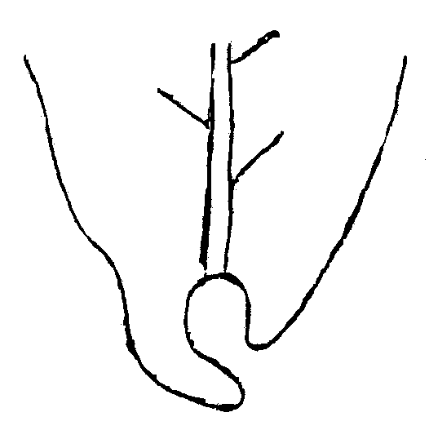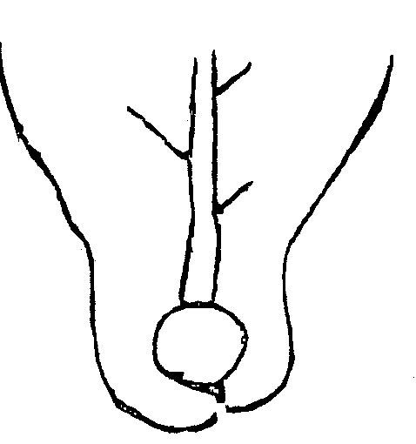
7 | 9
strong | very strong

Ad. 24, 25 and 26: Flower: length (excluding peduncle), diameter of tube (just above calyx) and swelling of tube

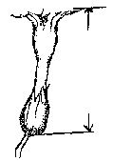
=
length
diameter
swelling

Ad. 27: Flower: size of corolla
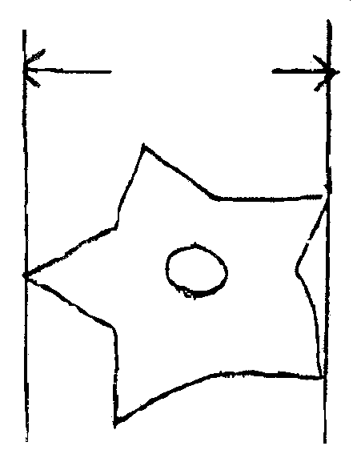

Ad. 28: Flower: expression of tips of corolla

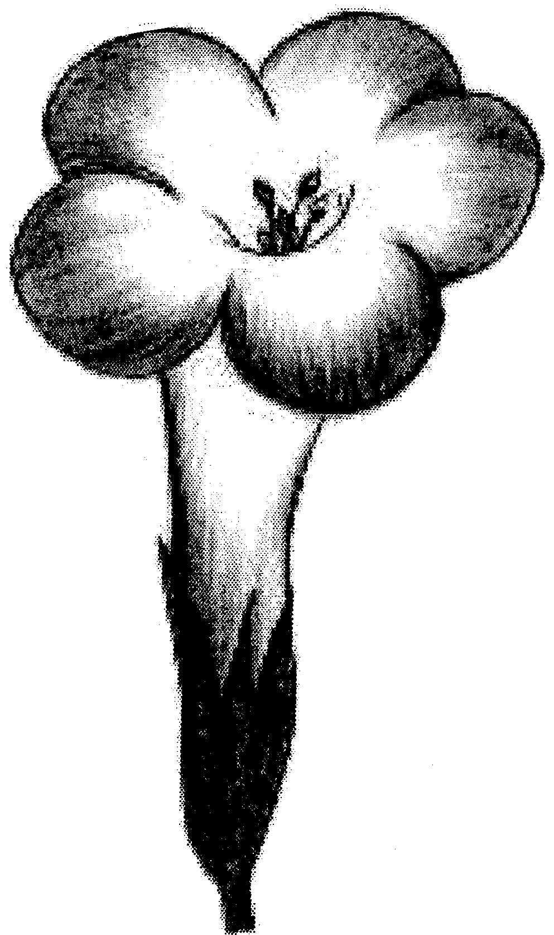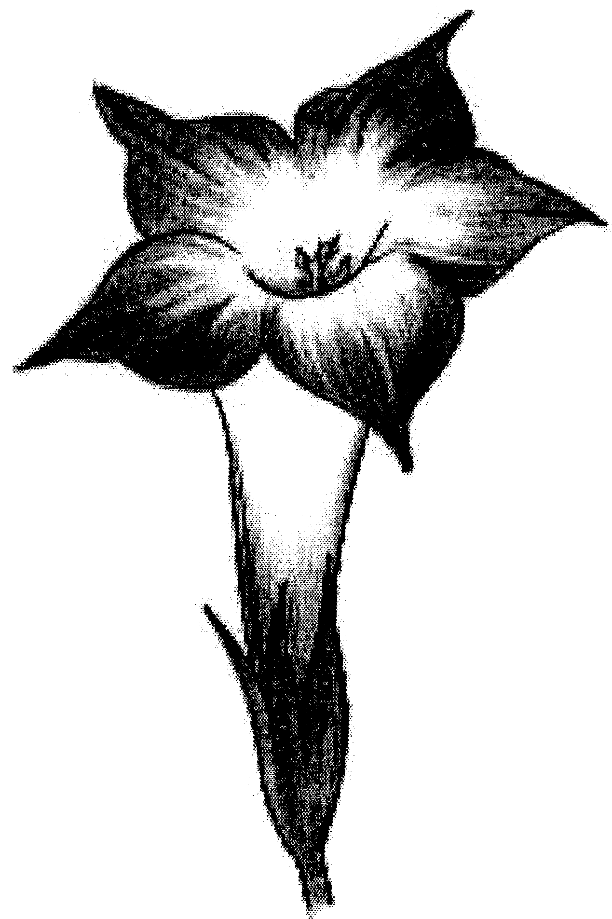
1 | 9
absent or very weak | very strong

Ad. 32: Inflorescence: shape

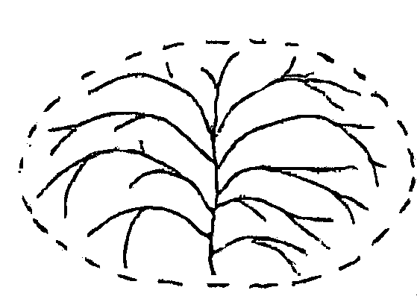
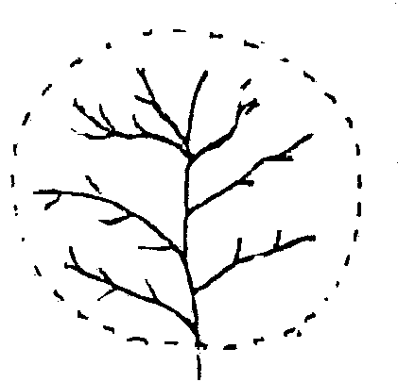

1 | 2
spherical | flattened spherical

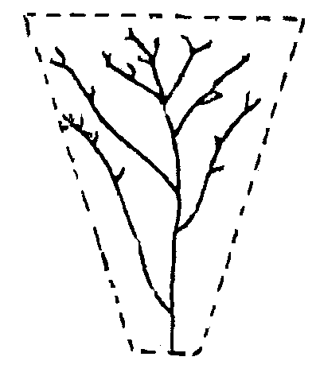
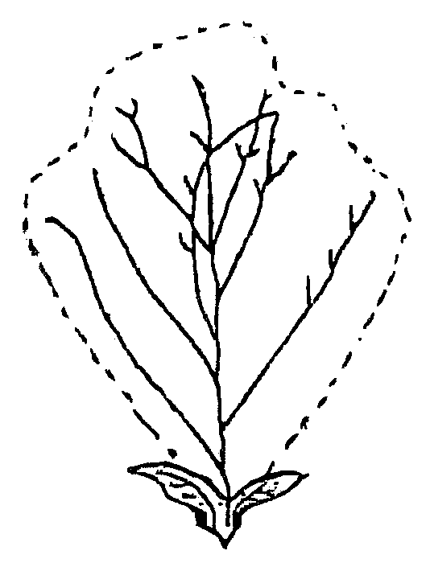

3 | 4
inverted conical | double conical

Ad. 34: Inflorescence: compactness
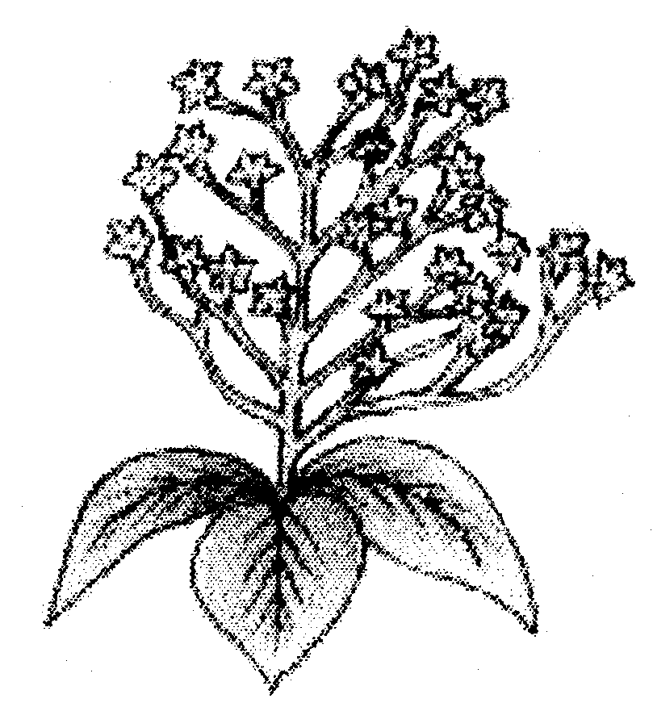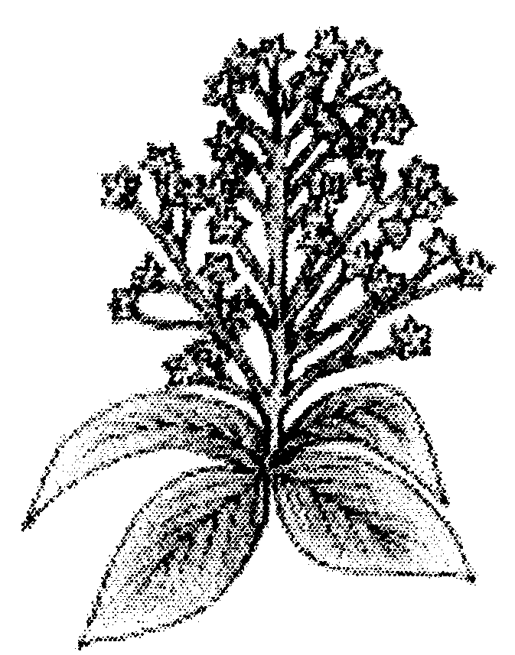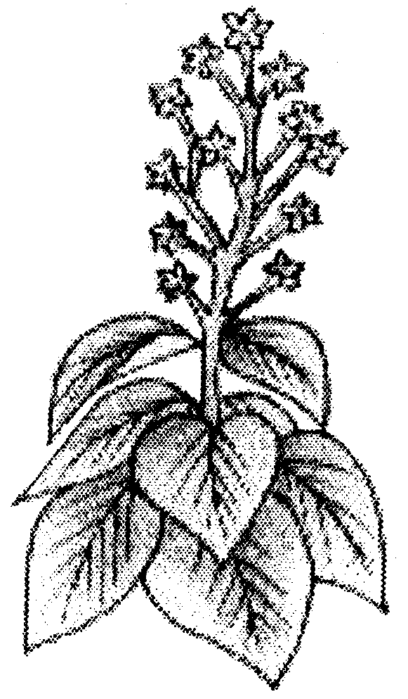

3 | 5 | 7
loose | medium | dense

Ad. 35: Fruit: form
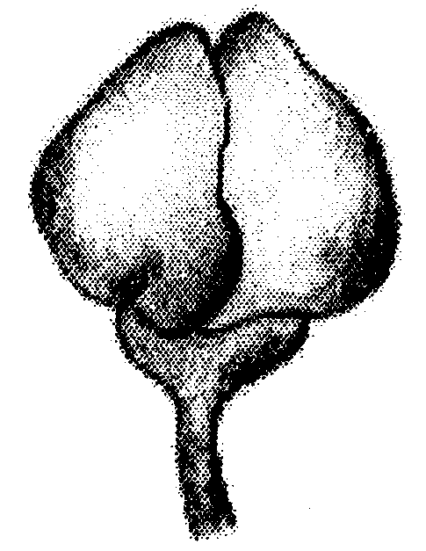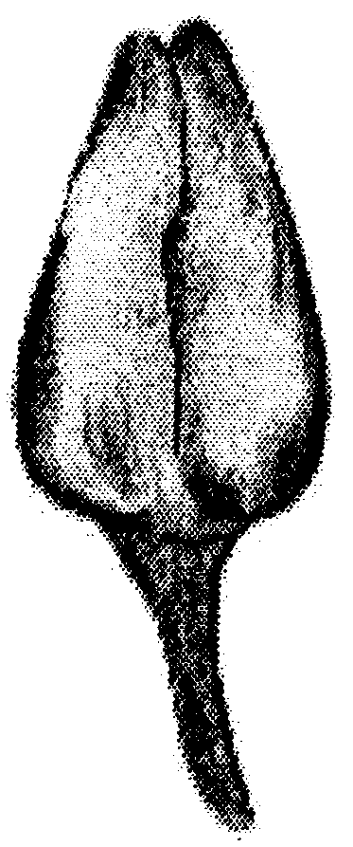

1 | 3
rounded | ovate
IX. Literature

No specific literature.
X. Technical Questionnaire

Reference Number
(not to be filled in by the applicant)

TECHNICAL QUESTIONNAIRE
to be completed in connection with an application for plant breeders’ rights

1. Species Nicotiana tabacum L.

TOBACCO

2. Applicant (Name and address)

3. Proposed denomination or breeder’s reference

4. Information on origin, maintenance and reproduction of the variety

4.1 Type of material

(a) inbred line
- male fertile line [ ]
- male sterile line [ ]
(b) male sterile single hybrid [ ]
(c) open pollinated variety [ ]
(d) other (please indicate) [ ]

……………………………………………………………………………..

4.2 Formula (hybrid varieties) – The information specified in chapters 5 and/to 7 must be provided, on separate sheets, for each component of the hybrid.

Single hybrid
- female parental line ………………………………………………...

- male parental line ………………………………………………..….

N.B. In the case of use of a male sterility system, indicate the name of the maintainer line of the female parental line

…………………………………………………………………………..

4.3 Genetic origin and breeding method

4.4 Other information

5. Characteristics of the variety to be indicated (the number in brackets refers to the corresponding characteristic in Test Guidelines; please mark the state of expression which best corresponds).

 | Characteristics |  |  | Note
5.1  (2) | Plant: height of main stem (including inflorescence)
 | very short |  |  | 1[ ]
 | short |  |  | 3[ ]
 | medium |  |  | 5[ ]
 | tall |  |  | 7[ ]
 | very tall |  |  | 9[ ]
5.2  (4) | Plant: number of leaves
 | very few |  |  | 1[ ]
 | few |  |  | 3[ ]
 | medium |  |  | 5[ ]
 | many |  |  | 7[ ]
 | very many |  |  | 9[ ]
5.3  (14) | Leaf: shape of blade
 | lanceolate |  |  | 1[ ]
 | narrow elliptic |  |  | 2[ ]
 | broad elliptic |  |  | 3[ ]
 | ovate |  |  | 4[ ]
 | obovate |  |  | 5[ ]
 | cordate |  |  | 6[ ]
 | rounded |  |  | 7[ ]

 | Characteristics |  |  | Note
5.4  (22) | Leaf: color of midrib on lower side
 | whitish |  |  | 1[ ]
 | whitish green |  |  | 2[ ]
 | green |  |  | 3[ ]
5.5  (23) | Time of flowering (50% of plants with at least one corolla open)
 | very early |  |  | 1[ ]
 | early |  |  | 3[ ]
 | medium |  |  | 5[ ]
 | late |  |  | 7[ ]
 | very late |  |  | 9[ ]
5.6  (29) | Flower: color of corolla
 | white |  |  | 1[ ]
 | light pink |  |  | 2[ ]
 | medium pink |  |  | 3[ ]
 | dark pink |  |  | 4[ ]
 | red |  |  | 5[ ]
5.7  (30) | Flower: development of stamens
 | none or rudimentary |  |  |  | 1[ ]
 | full |  |  |  | 2[ ]

6. Similar varieties and differences from these varieties

Denomination of similar variety | Characteristic in which the similar variety is different ^{o)} | State of expression of similar variety | State of expression of candidate variety
______________
^{o)} In the case of identical states of expressions of both varieties, please indicate the size of the difference.

7. Additional information which may help to distinguish the variety

7.1 Classification of tobacco varieties

flue cured [ ]

light air cured [ ]

dark air cured [ ]

sun cured [ ]

fire cured [ ]

other (please specify) [ ]

7.2 Resistance to pests and diseases

7.3 Special conditions for the evaluation of the variety

7.4 Other information

8. Authorization for release

(a) Does the variety require prior authorization for release under legislation concerning the protection of the environment, human and animal health?

Yes [ ] No [ ]

(b) Has such authorization been obtained?

Yes [ ] No [ ]

If the answer to that question is yes, please attach a copy of such an authorization.

[Annex follows]
ANNEX

EXAMPLE VARIETIES

TABLE OF CONTENTS PAGE

Part I Introduction …..................................................................... 2

Part II Table containing example varieties provided by Greece .... 3

Part III Table containing example varieties provided by Brazil ...... 4

Part I

Introduction

This Annex contains two lists of example varieties provided to clarify the states of expression of each characteristic.

For continuation see: http://www.upov.int/en/publications/tg-rom/tg195/tg_195_1.pdf

