 |  | E  TG/192/1  ORIGINAL: English  DATE: April 9, 2003
INTERNATIONAL UNION FOR THE PROTECTION OF NEW VARIETIES OF PLANTS
GENEVA

 | ORNAMENTAL APPLE  (Malus Mill.) | *

GUIDELINES

FOR THE CONDUCT OF TESTS

FOR DISTINCTNESS, UNIFORMITY AND STABILITY

Alternative Names:*

Latin | English | French | German | Spanish
Malus Mill. | Ornamental Apple | Pommier ornemental | Zierapfel | Manzano ornamental

ASSOCIATED DOCUMENTS

These guidelines should be read in conjunction with document TG/1/3, “General Introduction to the Examination of Distinctness, Uniformity and Stability and the Development of Harmonized Descriptions of New Varieties of Plants” (hereinafter referred to as the “General Introduction”) and its associated “TGP” documents.

TABLE OF CONTENTS PAGE

1. Subject of these Guidelines 3
2. Material Required 3
3. Method of Examination 3
3.1 Duration of Tests 3
3.2 Testing Place 3
3.3 Conditions for Conducting the Examination 3
3.4 Test Design 4
3.5 Number of Plants / Parts of Plants to be Examined 4
3.6 Additional Tests 4
4. Assessment of Distinctness, Uniformity and Stability 4
4.1 Distinctness 4
4.2 Uniformity 5
4.3 Stability 5
5. Grouping of Varieties and Organization of the Growing Trial 5
6. Introduction to the Table of Characteristics 6
6.1 Categories of Characteristics 6
6.2 States of Expression and Corresponding Notes 6
6.3 Types of Expression 6
6.4 Example Varieties 6
6.5 Legend 6
7. Table of Characteristics 7
8. Explanations on the Table of Characteristics 18
8.1 Explanations covering several characteristics 18
8.2 Explanations for individual characteristics 19
9. Literature 22
10. Technical Questionnaire 23

Subject of these Guidelines
These Test Guidelines apply to all varieties of ornamental apple, Malus Mill., of the family Rosaceae.

Material Required
2.1 The competent authorities decide on the quantity and quality of the plant material required for testing the variety and when and where it is to be delivered. Applicants submitting material from a State other than that in which the testing takes place must ensure that all customs formalities and phytosanitary requirements are complied with.

2.2 The material is to be supplied in the form of three-year-old trees grafted on a rootstock.

2.3 The minimum quantity of plant material, to be supplied by the applicant, should be:

5 trees.

2.4 The plant material supplied should be visibly healthy, not lacking in vigor, nor affected by any important pest or disease. The rootstock should be named when the plant material is supplied. The competent authorities may prescribe the rootstock on which the variety should be grafted.

2.5 The plant material should not have undergone any treatment which would affect the expression of the characteristics of the variety, unless the competent authorities allow or request such treatment. If it has been treated, full details of the treatment must be given.

Method of Examination

3.1 Duration of Tests
The minimum duration of tests should normally be two independent growing cycles. For the purposes of these Test Guidelines, a growing cycle refers to the fruiting cycle.

3.2 Testing Place
The tests should normally be conducted at one place. If any characteristics of the variety, which are relevant for the examination of DUS, cannot be seen at that place, the variety may be tested at an additional place.

3.3 Conditions for Conducting the Examination
3.3.1 The tests should be carried out under conditions ensuring satisfactory growth for the expression of the relevant characteristics of the variety and for the conduct of the examination. In particular, a satisfactory crop of fruit must be produced in at least two fruiting cycles.

3.3.2 Because daylight varies, color determinations made against a color chart should be made either in a suitable cabinet providing artificial daylight or in the middle of the day in a room without direct sunlight. The spectral distribution of the illuminant for artificial daylight should conform with the CIE Standard of Preferred Daylight D 6500 and should fall within the tolerances set out in the British Standard 950, Part I. These determinations should be made with the plant part placed against a white background.

3.4 Test Design
3.4.1 The design of the tests should be such that plants or parts of plants may be removed for measurement or counting without prejudice to the observations which must be made up to the end of the growing cycle.

3.4.2 Each test should be designed to result in a total of at least five trees.

3.5 Number of Plants / Parts of Plants to be Examined
Unless otherwise indicated, all observations should be made on 5 trees or plant parts taken from each of 5 trees. In the case of plant parts, the number to be taken from each of the trees should be 2.

3.6 Additional Tests
Additional tests, for examining relevant characteristics, may be established.

Assessment of Distinctness, Uniformity and Stability

4.1 Distinctness

4.1.1 General Recommendations

It is of particular importance for users of these Test Guidelines to consult the General Introduction prior to making decisions regarding distinctness. However, the following points are provided for elaboration or emphasis in these Test Guidelines.

4.1.2 Consistent Differences

The minimum duration of tests recommended in section 3.1 reflects, in general, the need to ensure that any differences in a characteristic are sufficiently consistent.

4.1.3 Clear Differences

Determining whether a difference between two varieties is clear depends on many factors, and should consider, in particular, the type of expression of the characteristic being examined, i.e. whether it is expressed in a qualitative, quantitative, or pseudo-qualitative manner. Therefore, it is important that users of these Test Guidelines are familiar with the recommendations contained in the General Introduction prior to making decisions regarding distinctness.

4.2 Uniformity
4.2.1 It is of particular importance for users of these Test Guidelines to consult the General Introduction prior to making decisions regarding uniformity. However, the following points are provided for elaboration or emphasis in these Test Guidelines:

4.2.2 For the assessment of uniformity a population standard of 1% and an acceptance probability of at least 95% should be applied. In the case of a sample size of 5 plants no off-types are allowed.

4.3 Stability
4.3.1 In practice, it is not usual to perform tests of stability that produce results as certain as those of the testing of distinctness and uniformity. However, experience has demonstrated that, for many types of variety, when a variety has been shown to be uniform, it can also be considered to be stable.

4.3.2 Where appropriate, or in cases of doubt, stability may be tested, either by growing a further generation, or by testing a new plant stock to ensure that it exhibits the same characteristics as those shown by the previous material supplied.

Grouping of Varieties and Organization of the Growing Trial
5.1 The selection of varieties of common knowledge to be grown in the trial with the candidate varieties and the way in which these varieties are divided into groups to facilitate the assessment of distinctness is aided by the use of grouping characteristics.

5.2 Grouping characteristics are those in which the documented states of expression, even where produced at different locations, can be used, either individually or in combination with other such characteristics: (a) to select varieties of common knowledge that can be excluded from the growing trial used for examination of distinctness; and (b) to organize the growing trial so that similar varieties are grouped together.

5.3 The following have been agreed as useful grouping characteristics:

(a) Flower: type (characteristic 6);
(b) Petal: color of marginal zone of inner side: white, light pink, dark pink, red, purple (characteristic 12);
(c) Expanding leaf: color of blade (characteristic 16);
(d) Fruit: size (characteristic 29);
(e) Fruit: predominant color (characteristic 35).

5.4 Guidance for the use of grouping characteristics, in the process of examining distinctness, is provided through the General Introduction.

Introduction to the Table of Characteristics

6.1 Categories of Characteristics
6.1.1 Standard Test Guidelines Characteristics

Standard Test Guidelines characteristics are those which are approved by UPOV for examination of DUS and from which members of the Union can select those suitable for their particular circumstances.

6.1.2 Asterisked Characteristics

Asterisked characteristics (denoted by *) are those included in the Test Guidelines which are important for the international harmonization of variety descriptions and should always be examined for DUS and included in the variety description by all members of the Union, except when the state of expression of a preceding characteristic or regional environmental conditions render this inappropriate.

6.2 States of Expression and Corresponding Notes
States of expression are given for each characteristic to define the characteristic and to harmonize descriptions. Each state of expression is allocated a corresponding numerical note for ease of recording of data and for the production and exchange of the description.

6.3 Types of Expression
An explanation of the types of expression of characteristics (qualitative, quantitative and pseudo-qualitative) is provided in the General Introduction.

6.4 Example Varieties
Where appropriate, example varieties are provided to clarify the states of expression of each characteristic.

6.5 Legend
(*) Asterisked characteristic – see Section 6.1.2

(a)–(c) See Explanations on the Table of Characteristics in Chapter 8, Section 8.1

(+) See Explanations on the Table of Characteristics in Chapter 8, Section 8.2

Table of Characteristics/Tableau des caractères/Merkmalstabelle/Tabla de caracteres
 |  | English | français | deutsch | español | Example Varieties  Exemples  Beispielssorten  Variedades ejemplo | Note/  Nota
1. |  | Tree: vigor | Arbre: vigueur | Baum: Wuchsstärke | Árbol: vigor
 |  | weak | faible | schwach | débil | Dorothea | 3
 |  | medium | moyenne | mittel | medio | Dolgo | 5
 |  | strong | forte | stark | fuerte | Jackii | 7
2.  (*)  (+) |  | Tree: habit | Arbre: port | Baum: Wuchsform | Árbol: porte
 |  | columnar | columnaire | säulenförmig | columnar | Maypole | 1
 |  | fastigiate | fastigé | sehr aufrecht | fastigiado | Laura | 2
 |  | upright | dressé | aufrecht | erecto | Van Eseltine | 3
 |  | spreading | divergent | breitwüchsig | rastrero | Red Glow | 4
 |  | drooping | retombant | überhängend | colgante | Elise Rathke | 5
 |  | weeping | pleureur | lang überhängend | llorón | Oekonomierat Echtermeyer | 6
3.  (+) |  | Shoot: color | Rameau: couleur | Trieb: Farbe | Brote: color
 |  | grey green | vert-gris | graugrün | verde grisáceo | Red Sentinel | 1
 |  | brown green | vert-brun | braungrün | verde pardo | Wintergold | 2
 |  | brown | brun | braun | marrón | Van Eseltine | 3
 |  | red brown | rouge-brun | rotbraun | marrón rojizo | Henry F. Dupont | 4
 |  | dark red | rouge foncé | dunkelrot | rojo oscuro | Evereste | 5
4. |  | Inflorescence: type | Inflorescence: type | Blütenstand: Typ | Inflorescencia: tipo
 |  | umbellate | ombelle | doldenförmig | umbelado | Golden Hornet | 1
 |  | corymbiform | corymbe | traubenförmig | corimbiforme | Charlottae | 2
5.  (*)  (+) |  | Unopened flower: color (balloon stage) | Fleur non épanouie: couleur (stade ballon) | Ungeöffnete Blüte: Farbe (Ballonstadium) | Flor cerrada: color (capullo)
 |  | white | blanc | weiß | blanco | Malus toringoides | 1
 |  | light pink | rose pâle | hellrosa | rosa claro | Charlottae | 2
 |  | medium pink | rose moyen | mittelrosa | rosa medio | Cowichan | 3
 |  | dark pink | rose foncé | dunkelrosa | rosa oscuro | Malus floribunda | 4
 |  | red | rouge | rot | rojo | Red Glow | 5
 |  | purple | pourpre | purpur | púrpura |  | 6
6.  (*) | (a) | Flower: type | Fleur: type | Blüte: Typ | Flor: tipo
 |  | single | simple | einfach | sencillo | Profusion | 1
 |  | semi-double | demi-double | halbgefüllt | semidoble | Malus x scheideckeri | 2
 |  | double | double | gefüllt | doble | Nieuwlandiana | 3
7.  (*) | (a) | Flower: diameter with petals pressed into horizontal position | Fleur: diamètre avec les pétales étalés dans un plan horizontal | Blüte: Durchmesser bei in waagerechte Position gedrückten Blütenblättern | Flor: diámetro con pétalos apretados en posición horizontal
 |  | small | petit | klein | pequeño | Wintergold | 3
 |  | medium | moyen | mittel | medio | Profusion | 5
 |  | large | grand | groß | grande | Montreal Beauty | 7
8.  (*) | (a) | Flower: shape | Fleur: forme | Blüte: Form | Flor: forma
 |  | flat | aplatie | flach | plana |  | 1
 |  | shallow cup | en coupe peu profonde | flach schüsselförmig | cáliz poco profundo | Courtarou | 2
 |  | deep cup | en coupe profonde | tief schüsselförmig | cáliz profundo | Van Eseltine | 3
9.  (*) | (a) | Petal: shape (excluding claw) | Pétale: forme (sans l’onglet) | Blütenblatt: Form (ohne Blattöhrchen) | Pétalo: forma  (excluyendo la uña)
 |  | oblong | oblong | rechteckig | oblonga | Charlottae | 1
 |  | narrow elliptic | elliptique étroite | schmal elliptisch | elíptica estrecha |  | 2
 |  | elliptic | elliptique | elliptisch | elíptica | Makamik | 3
 |  | broad elliptic | elliptique large | breit elliptisch | elíptica ancha | Wynema | 4
 |  | circular | arrondi | kreisförmig | circular | Veitchii | 5
 |  | narrow ovate | ovale étroit | schmal eiförmig | oval estrecha | Katherine | 6
 |  | ovate | ovale | eiförmig | oval | Profusion | 7
10.  (*) | (a) | Petals: relative position of margins | Pétales: position relative des bords | Blütenblätter: Relative Stellung der Ränder | Pétalos: posición relativa de los bordes
 |  | free | disjoints | freistehend | separada | Makamik | 1
 |  | touching | tangents | sich berührend | en contacto | John Downie | 2
 |  | overlapping | chevauchants | überlappend | solapada | Butterball | 3
11. | (a) | Petal: veins | Pétale: nervures | Blütenblatt: Adern | Pétalo: nervaduras
 |  | not prominent | non proéminentes | nicht ausgeprägt | no prominentes | John Downie | 1
 |  | prominent | proéminentes | ausgeprägt | prominentes | Almey | 2
12.  (*) | (a) | Petal: color of marginal zone of inner side | Pétale: couleur de la zone marginale de la face interne | Blütenblatt: Farbe der Randzone der Innenseite | Pétalo: color del borde de la cara interna
 |  | RHS-Colour Chart (indicate reference number) | Code RHS des couleurs- (indiquer le numéro de référence) | RHS-Farbkarte (Nummer angeben) | Carta de colores RHS (indíquese el número de referencia)
13.  (*) | (a) | Petal: color of middle zone of inner side (if different) | Pétale: couleur de la zone centrale de la face interne (si différente) | Blütenblatt: Farbe der mittleren Zone der Innenseite (wenn verschieden) | Pétalo: color de la zona media de la cara interna (si es distinto)
 |  | RHS-Colour Chart (indicate reference number) | Code RHS des couleurs- (indiquer le numéro de référence) | RHS-Farbkarte (Nummer angeben) | Carta de colores RHS (indíquese el número de referencia)
14.  (*) | (a) | Petal: color of basal zone of inner side (if different) | Pétale: couleur de la base de la face interne (si différente) | Blütenblatt: Farbe der basalen Zone der Innenseite (wenn verschieden) | Pétalo: color de la zona basal de la cara interna (si es distinto)
 |  | RHS-Colour Chart (indicate reference number) | Code RHS des couleurs- (indiquer le numéro de référence) | RHS-Farbkarte (Nummer angeben) | Carta de colores RHS (indíquese el número de referencia)
15.  (*) | (a) | Petal: color of outer side | Pétale: couleur de la face externe | Blütenblatt: Farbe der Außenseite | Pétalo: color de la cara externa
 |  | RHS-Colour Chart (indicate reference number) | Code RHS des couleurs- (indiquer le numéro de référence) | RHS-Farbkarte (Nummer angeben) | Carta de colores RHS (indíquese el número de referencia)
16.  (*) | (b) | Expanding leaf: color of blade | Feuille en cours de croissance: couleur du limbe | Sich entfaltendes Blatt: Farbe der Blattspreite | Hoja en crecimiento: color del limbo
 |  | green | vert | grün | verde | John Downie | 1
 |  | reddish green | vert rougeâtre | rötlichgrün | verde rojizo | Winter Gold | 2
 |  | red | rouge | rot | rojo |  | 3
 |  | reddish brown | brun rougeâtre | rötlichbraun | marrón rojizo | Laura | 4
 |  | bronze | bronze | bronze | bronce | Indian Magic | 5
 |  | purple | violet | purpur | púrpura | Royalty | 6
17. | (b) | Leaf blade: ratio length/width (from fourth to sixth fully expanded leaf) | Limbe: rapport longueur/largeur (de la quatrième à la sixième feuille complètement développée) | Blattspreite: Verhältnis Länge/Breite (vom vierten bis sechsten voll entwickelten Blatt) | Limbo: relación longitud/anchura (de cuatro a seis hojas completamente extendidas)
 |  | small | faible | klein | pequeño |  | 3
 |  | medium | moyen | mittel | medio |  | 5
 |  | large | élevé | groß | grande |  | 7
18.  (*) | (b) | Petiole: length | Pétiole: longueur | Blattstiel: Länge | Peciolo: longitud
 |  | short | court | kurz | corta |  | 3
 |  | medium | moyen | mittel | media |  | 5
 |  | long | long | lang | larga |  | 7
19.  (*) | (b) | Leaf blade: lobes | Limbe: lobes | Blattspreite: Lappung | Limbo: lóbulos
 |  | absent | absents | fehlend | ausentes | Dolgo | 1
 |  | sometimes present | parfois présents | manchmal vorhanden | presentes a veces | Wynema | 2
 |  | always present | toujours présents | immer vorhanden | siempre presentes | Nieuwlandiana | 3
20.  (*) | (b) | Leaf blade: incisions of margin | Limbe: incisions du bord | Blattspreite: Randeinschnitte | Limbo: incisiones del borde
 |  | crenate | crénelé | gekerbt | crenadas | Courtabri | 1
 |  | serrate | dentelé | gesägt | serradas | Scarlett | 2
21.  (*) | (b) | Leaf blade: glossiness of upper side | Limbe: brillance de la face supérieure | Blattspreite: Glanz der Oberseite | Limbo: brillo del haz
 |  | weak | faible | gering | ligero | Laura | 3
 |  | medium | moyenne | mittel | medio |  | 5
 |  | strong | forte | stark | fuerte | Scarlett | 7
22.  (*) | (b) | Leaf blade: green color of upper side | Limbe: couleur verte de la face supérieure | Blattspreite: Grünfärbung der Oberseite | Limbo: color verde del haz
 |  | light | claire | hell | claro | Red Jade | 3
 |  | medium | moyenne | mittel | medio |  | 5
 |  | dark | foncée | dunkel | oscuro | Red Jewel | 7
23.  (*) | (b) | Leaf blade: anthocyanin coloration of upper side | Limbe: pigmentation anthocyanique de la face supérieure | Blattspreite: Anthocyanfärbung der Oberseite | Limbo: pigmentación antociánica del haz
 |  | absent | absente | fehlend | ausente | Courtabri | 1
 |  | present | présente | vorhanden | presente | Royalty | 9
24.  (*) | (b) | Leaf blade: intensity of anthocyanin coloration of upper side | Limbe: intensité de la pigmentation anthocyanique de la face supérieure | Blattspreite: Intensität der Anthocyanfärbung der Oberseite | Limbo: intensidad de la pigmentación antociánica del haz
 |  | weak | faible | schwach | baja | Cowichan | 3
 |  | medium | moyenne | mittel | media | Baskatong | 5
 |  | strong | forte | stark | fuerte | Royalty | 7
25. | (b) | Leaf blade: main color just before leaf fall | Limbe: couleur principale juste avant la chute des feuilles | Blattspreite: Hauptfarbe unmittelbar vor Blattfall | Limbo: color principal antes de la caída de la hoja
 |  | yellow | jaune | gelb | amarillo | Malus sargentii | 1
 |  | orange | orange | orange | anaranjado | Scarlett | 2
 |  | red | rouge | rot | rojo | Rosseau | 3
 |  | brown | brun | braun | marrón | Royalty | 4
 |  | bronze | bronze | bronze | bronce |  | 5
 |  | purple | violet | purpur | púrpura |  | 6
26.  (*) | (b) | Leaf blade: length (from fourth to sixth fully expanded leaf) | Limbe: longueur (de la quatrième à la sixième feuille complètement développée) | Blattspreite: Länge (vom vierten bis sechsten voll entwickelten Blatt) | Limbo: longitud (de cuatro a seis hojas completamente extendidas)
 |  | short | court | kurz | corta | Malus floribunda | 3
 |  | medium | moyen | mittel | media | Lemoinei | 5
 |  | long | long | lang | larga | Simcoe | 7
27.  (*) | (b) | Leaf blade: width (from fourth to sixth fully expanded leaf) | Limbe: largeur (de la quatrième à la sixième feuille complètement développée) | Blattspreite: Breite (vom vierten bis sechsten voll entwickelten Blatt) | Limbo: anchura (de cuatro a seis hojas completamente extendidas)
 |  | narrow | étroit | schmal | estrecha | Hopa | 3
 |  | medium | moyen | mittel | media | John Downie | 5
 |  | broad | large | breit | ancha | Montreal Beauty | 7
28. |  | Tree: fruit setting | Arbre: quantité de fruits | Baum: Fruchtansatz | Árbol: canditad de frutos
 |  | none or very few | nulle ou très faible | keine oder sehr wenige | ninguno o muy pocos | Malus x atrosanguinea | 1
 |  | few | faible | wenige | pocos | Malus x magdeburgensis | 3
 |  | medium | moyenne | mittel | algunos | Makamik | 5
 |  | many | abondante | viele | muchos | John Downie | 7
 |  | very many | très abondante | sehr viele | muchísimos | Golden Hornet | 9
29.  (*) | (c) | Fruit: size | Fruit: taille | Frucht: Größe | Fruto: tamaño
 |  | very small | très petit | sehr klein | muy pequeño | Malus sargentii | 1
 |  | small | petit | klein | pequeño | Profusion | 3
 |  | medium | moyen | mittel | medio | John Downie | 5
 |  | large | gros | groß | grande | Wynema | 7
 |  | very large | très gros | sehr groß | muy grande | Niedzwetzkyana | 9
30.  (*)  (+) | (c) | Fruit: shape | Fruit: forme | Frucht: Form | Fruto: forma
 |  | globose | globuleuse | kugelförmig | globulosa | Winter Gold | 1
 |  | globose conical | conique globuleuse | kugel-kegelförmig | cónica globulosa | Scarlett | 2
 |  | broad globose conical | conique globuleuse large | breit kugel-kegelfömig | cónica globulosa ancha |  | 3
 |  | flat obloid | obloïde aplatie | abgeplattet | obloide plana | Malus x schiedeckeri | 4
 |  | obloid | obloïde | abgeplattet kugelförmig | obloide | Profusion | 5
 |  | conical | conique | kegelförmig | cónica | Eleyi | 6
 |  | narrow conical | conique étroite | schmal kegelförmig | cónica estrecha | John Downie | 7
 |  | truncate conical | conique tronquée | stumpf kegelförmig | cónica truncada | Malus x arnoldiana | 8
 |  | ellipsoid | ellipsoïde | ellipsoid | elipsoide | Malus baccata var. mandshurica | 9
 |  | ellipsoid conical (ovoid) | conique ellipsoïde (ovale) | ellipsoid kegelförmig (eiförmig) | elipsoide cónica | Dolgo | 10
 |  | oblong | oblongue | rechteckig | oblonga | Veitchii | 11
 |  | oblong conical | conique oblongue | rechteckig kegelförmig | oblonga cónica |  | 12
 |  | pyriform | piriforme | birnenförmig | piriforme | Malus toringoides | 13
31.  (*) | (c) | Fruit: calyx | Fruit: calice | Frucht: Kelch | Fruto: cáliz
 |  | absent | absent | fehlend | ausente | Scarlett | 1
 |  | sometimes present | parfois présent | manchmal vorhanden | presente a veces | Golden Hornet | 2
 |  | always present | toujours présent | immer vorhanden | siempre presente | John Downie | 3
32. | (c) | Fruit: length of stalk | Fruit: longueur du pédoncule | Frucht: Länge des Stiels | Fruto: longitud del pedúnculo
 |  | very short | très court | sehr kurz | muy corto | Redflesh | 1
 |  | short | court | kurz | corto | Strathmore | 3
 |  | medium | moyen | mittel | medio | John Downie | 5
 |  | long | long | lang | largo | Evereste | 7
 |  | very long | très long | sehr lang | muy largo | Aldenhamensis | 9
33. | (c) | Fruit: bloom of skin | Fruit: pruine de l’épiderme | Frucht: Bereifung der Schale | Fruto: pruina de la piel
 |  | absent | absente | fehlend | ausente | Courtabri | 1
 |  | weakly expressed | faible | schwach ausgeprägt | muy poca |  | 2
 |  | strongly expressed | forte | stark ausgeprägt | mucha | Dartmouth | 3
34. | (c) | Fruit: glossiness of skin | Fruit: brillance de la peau | Frucht: Glanz der Schale | Fruto: brillo de la piel
 |  | absent | absente | fehlend | ausente |  | 1
 |  | weakly expressed | faible | schwach ausgeprägt | muy poco |  | 2
 |  | strongly expressed | forte | stark ausgeprägt | mucho | Selkirk | 3
35.  (*) | (c) | Fruit: predominant color | Fruit: couleur dominante | Frucht: vorherrschende Farbe | Fruto: color predominante
 |  | whitish yellow | jaune blanchâtre | weißlichgelb | amarillo blanquecino |  | 1
 |  | yellow | jaune | gelb | amarillo | Golden Hornet | 2
 |  | whitish green | vert blanchâtre | weißlichgrün | verde blanquecino |  | 3
 |  | green yellow | jaune vert | grüngelb | amarillo verdoso | White Cascade | 4
 |  | medium green | vert moyen | mittelgrün | verde medio | Malus trilobata | 5
 |  | orange | orange | orange | anaranjado | Evereste | 6
 |  | light red | rouge clair | hellrot | rojo claro |  | 7
 |  | medium red | rouge moyen | mittelrot | rojo medio | Red Jade | 8
 |  | dark red | rouge foncé | dunkelrot | rojo oscuro | Profusion | 9
 |  | purple | violet | purpur | púrpura | Purple Prince | 10
 |  | brownish | brunâtre | bräunlich | parduzco |  | 11
36. | (c) | Fruit: color of flesh | Fruit: couleur de la chair | Frucht: Farbe des Fleisches | Fruto: color de la carne
 |  | white | blanche | weiß | blanco |  | 1
 |  | yellowish white | blanche jaunâtre | gelblichweiß | blanco amarillento | Elise Rathke | 2
 |  | yellowish | jaunâtre | gelblich | amarillento | Dolgo | 3
 |  | greenish | verdâtre | grünlich | verdoso | Charlottae | 4
 |  | pink | rose | rosa | rosa |  | 5
 |  | red | rouge | rot | rojo | Laura | 6
37.  (*) | (c) | Fruit: persistence | Fruit: persistance | Frucht: Haltbarkeit | Fruto: persistencia
 |  | very short | très courte | sehr kurz | muy corta | John Downie | 1
 |  | short | courte | kurz | corta | Dolgo | 3
 |  | medium | moyenne | mittel | media | Dorothea | 5
 |  | long | longue | lang | larga | Makamik | 7
 |  | very long | très longue | sehr lang | muy larga | Evereste | 9
38. |  | Time of beginning of flowering  (10% open flowers) | Époque de début de floraison  (10% des fleurs épanouies) | Zeitpunkt des Blühbeginns  (10% offene Blüten) | Inicio de la floración (10% de flores abiertas)
 |  | early | précoce | früh | precoz | Hopa | 3
 |  | medium | moyenne | mittel | media | Lemoinei | 5
 |  | late | tardive | spät | tardía | Wynema | 7

Explanations on the Table of Characteristics

8.1 Explanations covering several characteristics
Characteristics containing the following key in the second column of the Table of Characteristics should be examined as indicated below:

(a) All observations on the flower should be made at the start of anther dehiscence on second or third flowers with intact pedicel.

(b) Unless otherwise indicated all observations on the leaf should be made on mature leaves taken in summer from the middle third of a vigorous shoot of the current season on the outside of the tree.

(c) Unless otherwise indicated, for the observations on the fruit, 10 typical fruits should be selected. The terminal fruits should be excluded. The fruits should be examined before they are affected by any damage due to weather, birds etc.

8.2 Explanations for individual characteristics
Ad. 2: Tree: habit
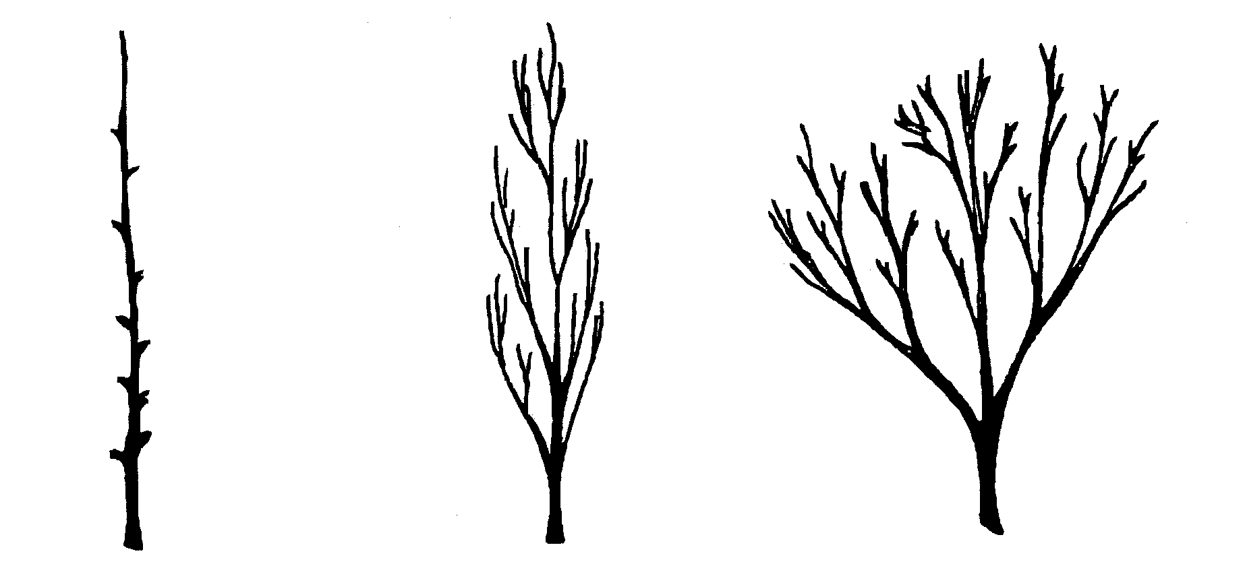

1 | 2 | 3
columnar | fastigiate | upright

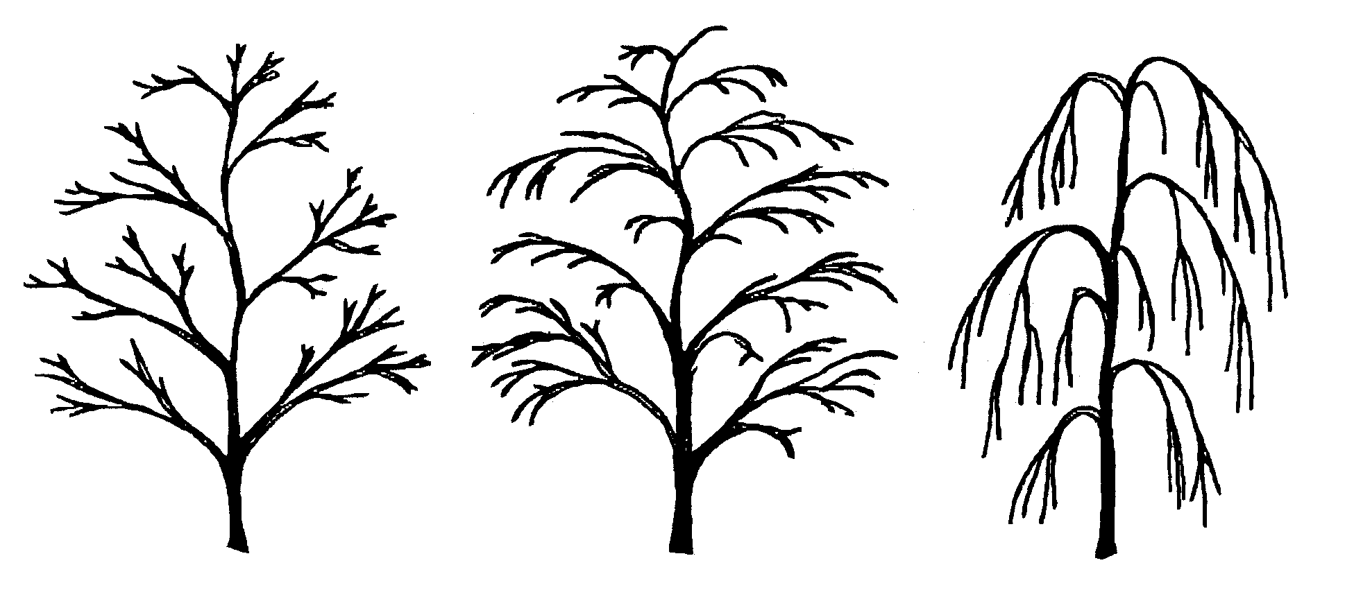
4 | 5 | 6
spreading | drooping | weeping

Ad. 3: Shoot: color

All observations on the current season’s shoot should be made on shoots from the outside of the tree in summer while the tree is still in active growth.

Ad. 5: Unopened flower: color (balloon stage)

All observations on the unopened flower should be made on the second or third flower bud when the terminal flower is opening.

Ad. 30: Fruit: shape

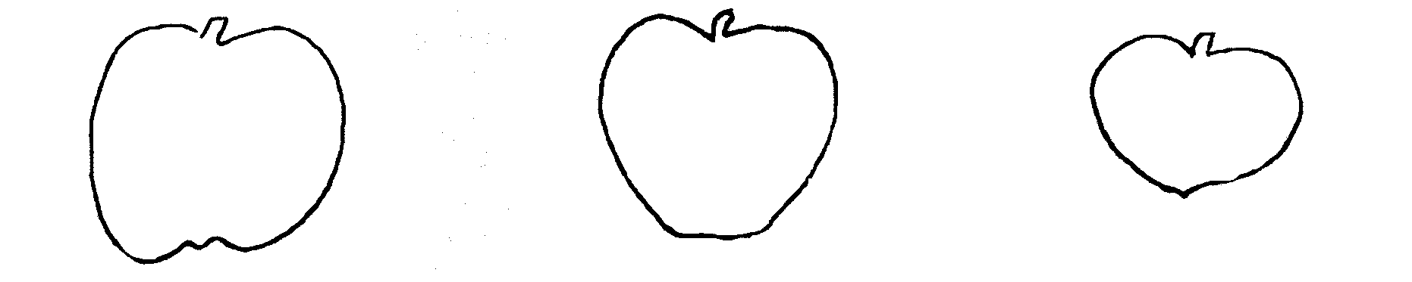
1 | 2 | 3
globose | globose conical | broad globose conical

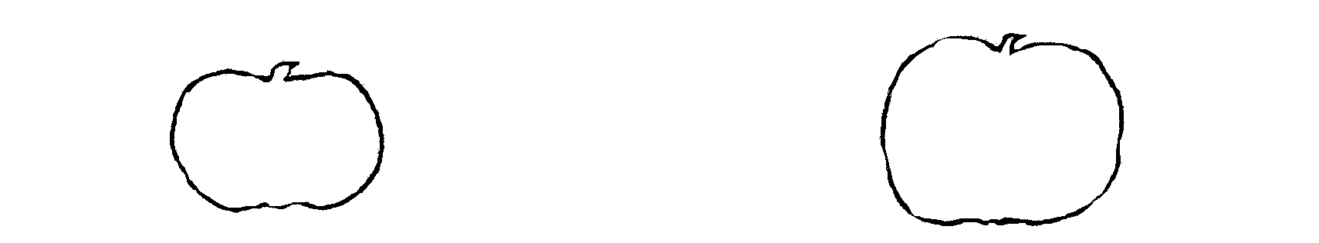
4 | 5
flat obloid | obloid

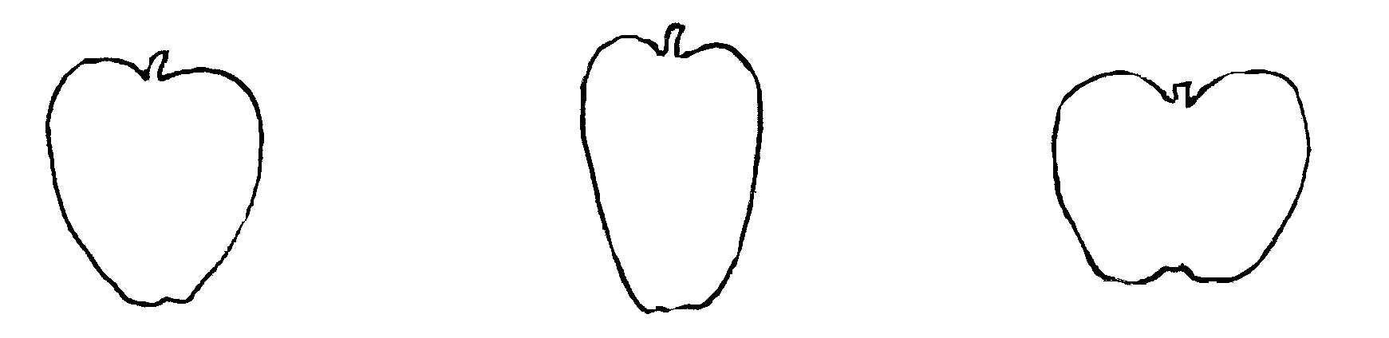
6 | 7 | 8
conical | narrow conical | truncate conical

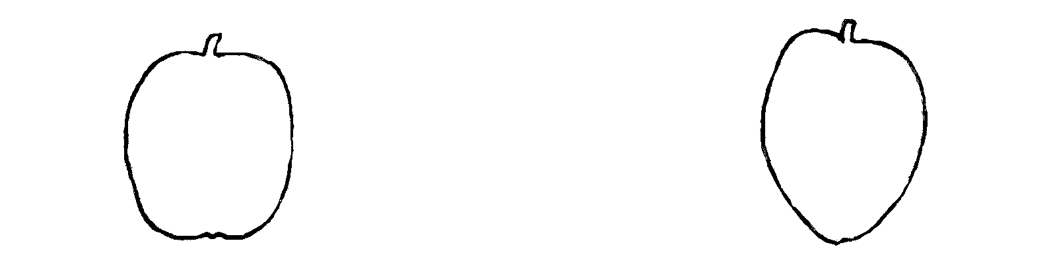
9 | 10
ellipsoid | ellipsoid conical (ovoid)
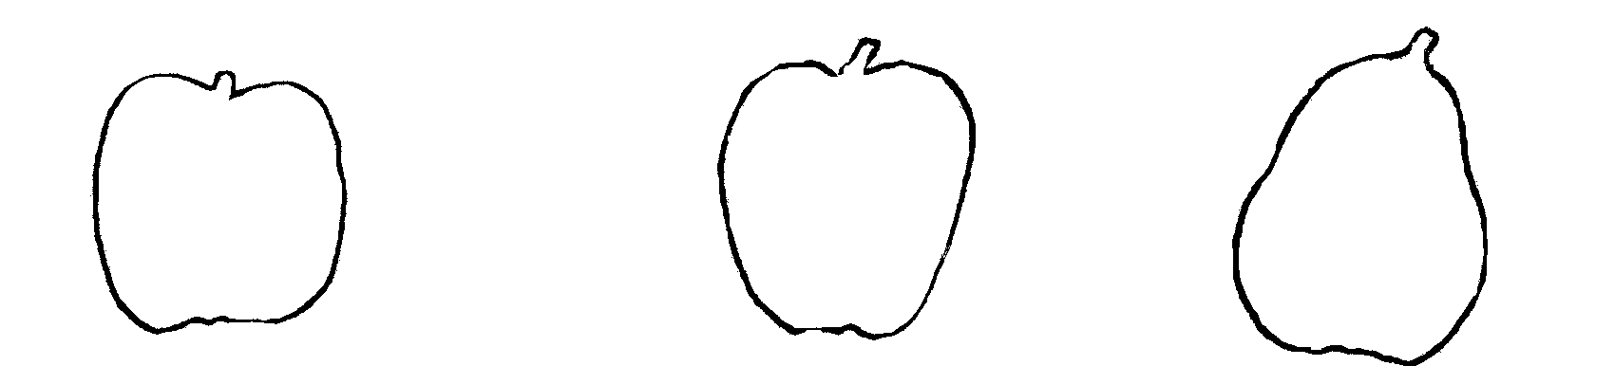

11 | 12 | 13
oblong | oblong conical | pyriform

Literature
Den Boer, Arie F.: 1959 “Ornamental Crab Apples”, American Association of Nurserymen, USA.

Bean, W.J.: “Trees and Shrubs Hardy in the British Isles”, John Murray, 1970-1980, 4 vols.

Fiala, Fr. John L.: 1994 “Flowering Crab Apples, the genus Malus” Timber Press, Portland, Oregon, USA, (273 pp.).

Grootendorst, Herman J.: 1964 “Malus - sierappels”, Dendroflora, NL (1964, 1: pp. 3-15).

Hillier Nurseries (Winchester) Ltd.: 1991 “The Hillier Manual of Trees and Shrubs”, David and Charles, Newton Abbott, Devon, UK (pp. 263-269).

Krussmann, G. : “Manual of Cultivated Broadleaved Trees and Shrubs”, 1984-1986, Batsford, London, 3 vols.

Royal Horticultural Society, London: “The New Royal Horticultural Society Dictionary of Gardening”, 1992, Macmillan Press Ltd, London, 4 vols.

Wyman, Donald E.: 1965 “Trees for American Gardens”, MacMillan, New York, USA (pp 293-319, 483-486).

Technical Questionnaire
TECHNICAL QUESTIONNAIRE |  |  |  | Page {x} of {y} |  |  | Reference Number:
 |  |  |  |  |  |  | Application date:
 |  |  |  |  |  |  | (not to be filled in by the applicant)
TECHNICAL QUESTIONNAIRE
to be completed in connection with an application for plant breeders’ rights

1. Subject of the Technical Questionnaire
1.1 Genus
1.1.1 Latin Name |  |  | Malus Mill.
1.1.2 Common Name |  |  | Ornamental apple
1.2 Species (please complete)
1.2.1 Latin Name
1.2.2 Common Name
2. Applicant
Name
Address
Telephone No.
Fax No.
E-mail address
Breeder (if different from applicant)
3. Proposed denomination and breeder’s reference
Proposed denomination
(if available)

Breeder’s reference
4. Information on the breeding scheme and propagation of the variety

4.1 Breeding Scheme

Variety resulting from:

4.1.1 Crossing

(a) controlled cross [ ]
(please state parent varieties)
(b) partially unknown cross [ ]
(please state known parent variety(ies))
(c) totally unknown cross [ ]

4.1.2 Mutation [ ]
(please state parent variety)

4.1.3 Discovery [ ]
(please state where, when and how developed)

4.1.4 Other [ ]
(please provide details)

4.2 Method of Propagating the Variety

(a) cuttings [ ]

(b) in vitro propagation [ ]

(c) other (state method) [ ]

5. Characteristics of the variety to be indicated (the number in brackets refers to the corresponding characteristic in Test Guidelines; please mark the note which best corresponds).

 | Characteristics |  |  |  |  | Example Varieties |  |  |  |  | Note
5.1  (6) | Flower: type
 | single |  |  |  |  | Profusion |  |  |  |  | 1[ ]
 | semi-double |  |  |  |  | Malus x scheideckeri |  |  |  |  | 2[ ]
 | double |  |  |  |  | Nieuwlandiana |  |  |  |  | 3[ ]
5.2i  (12) | Petal: color of marginal zone of inner side
 | RHS-Colour Chart (indicate reference number)
5.2ii  (12) | Petal: color of marginal zone of inner side
 | white |  |  |  |  |  |  |  |  |  | 1[ ]
 | light pink |  |  |  |  |  |  |  |  |  | 2[ ]
 | dark pink |  |  |  |  |  |  |  |  |  | 3[ ]
 | red |  |  |  |  |  |  |  |  |  | 4[ ]
 | purple |  |  |  |  |  |  |  |  |  | 5[ ]
5.3  (16) | Expanding leaf: color of blade
 | green |  |  |  |  | John Downie |  |  |  |  | 1[ ]
 | reddish green |  |  |  |  | Winter Gold |  |  |  |  | 2[ ]
 | red |  |  |  |  |  |  |  |  |  | 3[ ]
 | reddish brown |  |  |  |  | Laura |  |  |  |  | 4[ ]
 | bronze |  |  |  |  | Indian Magic |  |  |  |  | 5[ ]
 | purple |  |  |  |  | Royalty |  |  |  |  | 6[ ]
 | Characteristics |  |  |  |  | Example Varieties |  |  |  |  | Note
5.4  (29) | Fruit: size
 | very small |  |  |  |  | Malus sargentii |  |  |  |  | 1[ ]
 | small |  |  |  |  | Profusion |  |  |  |  | 3[ ]
 | medium |  |  |  |  | John Downie |  |  |  |  | 5[ ]
 | large |  |  |  |  | Wynema |  |  |  |  | 7[ ]
 | very large |  |  |  |  | Niedzwetzkyana |  |  |  |  | 9[ ]
5.5  (35) | Fruit: predominant color
 | whitish yellow |  |  |  |  |  |  |  |  |  | 1[ ]
 | yellow |  |  |  |  | Golden Hornet |  |  |  |  | 2[ ]
 | whitish green |  |  |  |  |  |  |  |  |  | 3[ ]
 | green yellow |  |  |  |  | White Cascade |  |  |  |  | 4[ ]
 | medium green |  |  |  |  | Malus trilobata |  |  |  |  | 5[ ]
 | orange |  |  |  |  | Evereste |  |  |  |  | 6[ ]
 | light red |  |  |  |  |  |  |  |  |  | 7[ ]
 | medium red |  |  |  |  | Red Jade |  |  |  |  | 8[ ]
 | dark red |  |  |  |  | Profusion |  |  |  |  | 9[ ]
 | purple |  |  |  |  | Purple Prince |  |  |  |  | 10[ ]
 | brownish |  |  |  |  |  |  |  |  |  | 11[ ]
6. Similar varieties and differences from these varieties

Denomination(s) of variety(ies) similar to your candidate variety |  | Characteristic(s) in which your candidate variety differs from the similar variety(ies) |  |  | Describe the expression of the characteristic(s) for the similar variety(ies) |  |  | Describe the expression of the characteristic(s) for your candidate variety
(Example) |  | Fruit: predominant color |  |  | light red |  |  | medium red
7. Additional information which may help in the examination of the variety

7.1 In addition to the information provided in sections 5 and 6, are there any additional characteristics which may help to distinguish the variety?

Yes [ ] No [ ]

(If yes, please provide details)

7.2 Special conditions for the examination of the variety

7.2.1 Are there any special conditions for growing the variety or conducting the examination?

Yes [ ] No [ ]

7.2.2 If yes, please give details:

7.3 Other information

8. Authorization for release

(a) Does the variety require prior authorization for release under legislation concerning the protection of the environment, human and animal health?

Yes [ ] No [ ]

(b) Has such authorization been obtained?

Yes [ ] No [ ]

If the answer to (b) is yes, please attach a copy of the authorization.

9. I hereby declare that, to the best of my knowledge, the information provided in this form is correct:

Applicant’s name

Signature Date

[End of document]

* These names were correct at the time of the introduction of these Test Guidelines but may be revised or updated. [Readers are advised to consult the UPOV Code, which can be found on the UPOV Website (www.upov.int), for the latest information.]

