 |  | E  TG/190/1

INTERNATIONAL UNION FOR THE PROTECTION  OF NEW VARIETIES OF PLANTS | UNION INTERNATIONALE POUR LA PROTECTION  DES OBTENTIONS VÉGÉTALES | INTERNATIONALER VERBAND ZUM SCHUTZ VON PFLANZEN-ZÜCHTUNGEN | UNIÓN INTERNACIONAL PARA LA PROTECCIÓN  DE LAS OBTENCIONES VEGETALES

GUIDELINES

FOR THE CONDUCT OF TESTS

FOR DISTINCTNESS, UNIFORMITY AND STABILITY

THYME

(Thymus vulgaris L.)

GENEVA
2002

Copies of this document are available on request at the price of 10 Swiss francs each, including surface mail, from the Office of UPOV, 34, chemin des Colombettes, P.O. Box 18, 1211 Geneva 20, Switzerland

This document or parts of it may be reproduced, translated and published without obtaining the specific consent of UPOV, provided that the source is acknowledged.

* * * * * * *
E
TG/190/1
ORIGINAL: English
DATE: 2002-04-17

INTERNATIONAL UNION FOR THE PROTECTION  OF NEW VARIETIES OF PLANTS | UNION INTERNATIONALE POUR LA PROTECTION  DES OBTENTIONS VÉGÉTALES | INTERNATIONALER VERBAND ZUM SCHUTZ VON PFLANZEN-ZÜCHTUNGEN | UNIÓN INTERNACIONAL PARA LA PROTECCIÓN  DE LAS OBTENCIONES VEGETALES

GUIDELINES

FOR THE CONDUCT OF TESTS

FOR DISTINCTNESS, UNIFORMITY AND STABILITY

THYME

(Thymus vulgaris L.)

These Guidelines should be read in conjunction with document TG/1/2, which contains explanatory notes on the general principles on which the Guidelines have been established.

TABLE OF CONTENTS PAGE

I. | Subject of these Guidelines | 3
II. | Material Required | 3
III. | Conduct of Tests | 3
IV. | Methods and Observations | 4
V. | Grouping of Varieties | 4
VI. | Characteristics and Symbols | 4
VII. | Table of Characteristics | 6
VIII. | Explanations on the Table of Characteristics | 12
IX. | Literature | 13
X. | Technical Questionnaire | 14

I. Subject of these Guidelines

These Test Guidelines apply to all varieties of Thymus vulgaris L. of the family Labiatae (Lamiaceae).

II. Material Required

1. The competent authorities decide when, where and in what quantity and quality the plant material required for testing the variety is to be delivered. Applicants submitting material from a State other than that in which the testing takes place must ensure that all customs formalities are complied with. As a minimum, the following quantity of material is recommended:

seed propagated varieties: 2 grams;
vegetatively propagated varieties: 20 rooted cuttings.

2. In the case of seed, the seed should meet the minimum requirements for germination, species and analytical purity, health and moisture content, specified by the competent authority. In cases where the seed is to be stored, the germination capacity should be as high as possible and should be stated by the applicant.

3. The material supplied should be visibly healthy, not lacking in vigor or affected by any important pests or diseases.

4. The plant material must not have undergone any treatment unless the competent authorities allow or request such treatment. If it has been treated, full details of the treatment must be given.

III. Conduct of Tests

- For seed propagated varieties, it is generally recommended that the growing trials are conducted over two independent growing cycles.

- For vegetatively propagated varieties, a test should normally be conducted in a single growing cycle (if necessary, after the year of establishment in open field). If distinctness and/or uniformity cannot be sufficiently examined in a single growing cycle, the test should be extended to a second growing cycle.

3. The test should normally be conducted at one place. If any important characteristics of the variety cannot be seen at that place, the variety may be tested at an additional place.

4. The tests should be carried out under conditions ensuring satisfactory growth for the expression of the relevant characteristics of the variety and for the conduct of the examination. The size of the plots should be such that plants or parts of plants may be removed for measurement and counting without prejudice to the observations which must be made up to the end of the growing cycle. For vegetatively propagated varieties, each test should be designed to result in a total of, at least 20 plants, which should be divided between two or more replicates. For seed propagated varietise, each test should be designed to result in a total of, at least 60 plants, which should be divided between two or more replicates. Separate plots for observation and measuring should only be used if they have been subject to similar environmental conditions.

5. Additional tests for special purposes may be established.

IV. Methods and Observations

1. All observations determined by measurement or counting should be made on 60 plants or parts taken from each of 60 plants for seed propagated varieties, and on 20 plants or parts taken from each of 20 plants for vegetatively propagated varieties.

2. For the assessment of uniformity for vegetatively propagated varieties, a population standard of 1% with an acceptance probability of at least 95% should be applied. In the case of a sample size of 20 plants, the maximum number of off-types allowed would be 1.

3. For the assessment of uniformity of seed propagated varieties, the recommendations in the General Introduction for cross-pollinated or hybrid varieties should be followed, as appropriate.

V. Grouping of Varieties

1. The collection of varieties to be grown should be divided into groups to facilitate the assessment of distinctness. Characteristics which are suitable for grouping purposes are those which are known from experience not to vary, or to vary only slightly, within a variety. Their various states of expression should be fairly evenly distributed throughout the collection.

2. It is recommended that the competent authorities use the following characteristics for grouping varieties:

(a) Leaf: variegation (characteristic 16);
(b) Leaf: main color (characteristic 17);
(c) Flower: color of petal (characteristic 20);
(d) Plant: male sterility (characteristic 25).

VI. Characteristics and Symbols

1. To assess distinctness, uniformity and stability, the characteristics and their states as given in the Table of Characteristics should be used.

2. Notes (numbers), for the purposes of electronic data processing, are given opposite the states of expression for each characteristic.

3. Legend:

(*) Characteristics that should be used on all varieties in every growing cycle over which examinations are made and always be included in the variety descriptions, except when the state of expression of a preceding characteristic or regional environmental conditions render this impossible.

(+) See Explanations on the Table of Characteristics in Chapter VIII.

VII. Table of characteristics/Tableau des caractères/Merkmalstabelle/Tabla de caracteres

 | English | français | deutsch | español | Example Varieties  Exemples  Beispielssorten  Variedades ejemplo | Note/  Nota
1.  (*) | Plant: growth habit | Plante: port | Pflanze: Wuchsform | Planta: porte
 | erect | dressé | aufrecht | erecto | Gambaru, Valdeyron | 1
 | semi erect | demi-dressé | halbaufrecht | semierecto | Allemand | 3
 | prostrate | horizontal | liegend | postrado | Heili, Savoie | 5
2.  (*) | Plant: height | Plante: hauteur | Pflanze: Höhe | Planta: altura
 | very short | très basse | sehr niedrig | muy baja |  | 1
 | short | basse | niedrig | baja | Savoie | 3
 | medium | moyenne | mittel | media | Heili, Passet | 5
 | tall | haute | hoch | alta | Valdeyron | 7
 | very tall | très haute | sehr hoch | muy alta | Gambaru, Ygor | 9
3.  (*) | Plant: diameter | Plante: diamètre | Pflanze: Durchmesser | Planta: diámetro
 | small | petit | gering | pequeño | 5.77 | 3
 | medium | moyen | mittel | medio | Escalin, Ygor | 5
 | large | grand | groß | grande | Gambaru | 7
4.  (*) | Foliage: density | Feuillage: densité | Laub: Dichte | Follaje: densidad
 | sparse | faible | locker | laxa | 1.52 | 3
 | medium | moyenne | mittel | media | Allemand, Passet | 5
 | dense | forte | dicht | densa | Pegase, Ygor | 7
5.  (*) | Stem: length | Tige: longueur | Stiel: Länge | Tallo: longitud
 | short | courte | kurz | corta | Pegase, Savoie | 3
 | medium | moyenne | mittel | media | Heili, Ygor | 5
 | long | longue | lang | larga | Gambaru, Passet | 7
6. | Stem: thickness | Tige: épaisseur | Stiel: Dicke | Tallo: espesor
 | thin | mince | dünn | delgado | Gambaru, Heili | 3
 | medium | moyenne | mittel | medio | Pegase | 5
 | thick | épaisse | dick | grueso | Passet | 7
7.  (*) | Stem: distribution of leaves | Tige: répartition des feuilles | Stiel: Verteilung der Blätter | Tallo: distribución de las hojas
 | only at base | seulement à la base | nur an der Basis | sólo en la base | Escalin, Passet | 1
 | only in middle | seulement au milieu | nur in der Mitte | sólo en la parte central | 2.40 | 2
 | only in upper part | seulement au sommet | nur am oberen Teil | sólo en la parte superior | Pegase, Ygor | 3
 | along whole stem | tout le long de la tige | am ganzen Stiel | a lo largo de todo el tallo | Gambaru, Valdeyron | 4
8.  (*) | Stem: position of flowering part | Tige: position des inflorescences | Stiel: Lage des blühenden Teils | Tallo: posición de la zona floral
 | at tip | au sommet | an der Spitze | en la parte superior | 1.44, 3.49 | 1
 | along upper quarter | le long du quart supérieur | am oberen Viertel | en el cuarto superior | Allemand, Escalin | 2
 | along upper half | le long de la moitié supérieure | an der oberen Hälfte | en la mitad superior | 1.52, Heili | 3
 | along upper two thirds | le long des 2/3 supérieurs | an den oberen zwei Dritteln | en los dos tercios superiores | Gambaru | 4
 | along whole stem | tout le long de la tige | am ganzen Stiel | en todo el tallo | Passet | 5
9. | Stem: density of flowers | Tige: densité des fleurs | Stiel: Dichte der Blüten | Tallo: densidad de las flores
 | sparse | faible | locker | laxa | Gambaru, Ygor | 3
 | medium | moyenne | mittel | media | Allemand, Escalin, Valdeyron | 5
 | dense | forte | dicht | densa |  | 7
10. | Stem: length of flowering part | Tige: longueur de la zone florifère | Stiel: Länge des blühenden Teils | Tallo: longitud de la zona floral
 | short | courte | kurz | corta | Allemand, Escalin, Valdeyron | 3
 | medium | moyenne | mittel | media | Gambaru, Pegase, Ygor | 5
 | long | longue | lang | larga | Passet | 7
11.  (*) | Leaf: shape | Feuille: forme | Blatt: Form | Hoja: forma
 | elliptic | elliptique | elliptisch | elíptica | 2.40 | 1
 | ovate | ovale | eiförmig | oval | Savoie, Ygor | 2
 | rhombic | rhomboïde | rautenförmig | romboica | Allemand, Gambaru | 3
12.  (*) | Leaf: length | Feuille: longueur | Blatt: Länge | Hoja: longitud
 | short | petite | kurz | corta | 7.56 | 3
 | medium | moyenne | mittel | media | Heili, Passet, Pegase | 5
 | long | grande | lang | larga | Allemand, Savoie | 7
13.  (*) | Leaf: width at basal part | Feuille: largeur à la partie basale | Blatt: Breite am basalen Teil | Hoja: anchura en la parte basal
 | narrow | petite | schmal | estrecha | 5.46.1 | 3
 | medium | moyenne | mittel | media | 3.49 | 5
 | broad | grande | breit | ancha | Passet, Savoie | 7
14. | Leaf: ratio length/width | Feuille: rapport longueur/largeur | Blatt: Verhältnis Länge/Breite | Hoja: relación entre la largura y la anchura
 | low | petit | gering | pequeña | 5.46.1 | 3
 | medium | moyen | mittel | media | 3.49 | 5
 | high | grand | groß | grande | Passet, Savoie | 7
15. | Leaf: prominence of veins on lower side | Feuille: proéminence des nervures sur la face inférieure | Blatt: Stärke der Adern an der Unterseite | Hoja: prominencia de los nervios en el envés
 | weak | faible | schwach | débil | Escalin, Valdeyron, Ygor | 3
 | medium | moyenne | mittel | media | Allemand, Heili | 5
 | strong | forte | stark | fuerte | 3.07, 4.77, Savoie | 7
16.  (*) | Leaf: variegation | Feuille: panachure | Blatt: Panachierung | Hoja: variegación
 | absent | absente | fehlend | ausente | Valdeyron | 1
 | present | presente | vorhanden | presente | Silver Posie | 9
17.  (*) | Leaf: main color | Feuille: couleur principale | Blatt: Hauptfarbe | Hoja: color principal
 | yellow green | vert-jaune | gelbgrün | verde amarillento |  | 1
 | green | verte | grün | verde | Allemand, Escalin | 2
 | blue green | vert-bleu | blaugrün | verde azulado | Passet, Ygor | 3
 | grey green | gris-vert | graugrün | verde grisáceo | Pegase, Valdeyron | 4
18.  (*) | Leaf: intensity of main color | Feuille: intensité de la couleur principale | Blatt: Intensität der Hauptfarbe | Hoja: intensidad del color principal
 | light | claire | hell | claro |  | 3
 | medium | moyenne | mittel | medio |  | 5
 | dark | foncée | dunkel | oscuro |  | 7
19.  (*) | Flower: size | Fleur: taille | Blüte: Größe | Flor: tamaño
 | small | petite | klein | pequeña | Luberon, Passet | 3
 | medium | moyenne | mittel | media | Allemand, Gambaru | 5
 | large | grande | groß | grande | Heili, Ygor, | 7
20.  (*) | Flower: color of petal | Fleur: couleur du pétale | Blüte: Farbe des Blütenblattes | Flor: color del pétalo
 | white or slightly pink | blanc ou légèrement rose | weiß oder leicht rosa | blanco o ligeramente rosado | Passet | 1
 | pink | rose | rosa | rosa | Escalin, Ygor | 2
 | light violet | mauve | hellviolett | violeta claro | 4.77 | 3
 | violet | violet | violett | violeta | Pegase, Valdeyron | 4
21.  (*) | Flower: length of style | Fleur: longueur du style | Blüte: Länge des Griffels | Flor: longitud del estilo
 | short | courte | kurz | corto |  | 3
 | medium | moyenne | mittel | medio | 3.07 | 5
 | long | longue | lang | largo | Gambaru, Escalin | 7
22. | Flower: main color of style | Fleur: couleur principale du style | Blüte: Hauptfarbe des Griffels | Flor: color principal del estilo
 | white | blanc | weiß | blanco |  | 1
 | pink | rose | rosa | rosa | Ygor | 2
 | light violet | mauve | hellviolett | violeta claro |  | 3
 | violet | violet | violett | violeta | Escalin, Gambaru, Luberon | 4
23. | Style: more intense colored zone | Style: zone plus intensément colorée | Griffel: intensiv gefärbte Zone | Estilo: zona de color más intenso
 | absent | absente | fehlend | ausente |  | 1
 | present | présente | vorhanden | presente |  | 9
24.  (*) | Time of beginning of flowering | Époque de début de floraison | Zeitpunkt des Blühbeginns | Fecha del inicio de la floración
 | very early | très précoce | sehr früh | muy precoz | 3.49, Ygor | 1
 | early | précoce | früh | precoz | Allemand, Valdeyron | 3
 | medium | moyenne | mittel | media | Luberon, Pegase | 5
 | late | tardive | spät | tardía | Gambaru, Passet | 7
 | very late | très tardive | sehr spät | muy tardía | Savoie | 9
25.  (*)  (+) | Plant: male sterility | Plante: stérilité mâle | Pflanze: männliche Sterilität | Planta: androesterilidad
 | absent | absente | fehlend | ausente | Heili, Ygor | 1
 | present | présente | vorhanden | presente | Escalin, Valdeyron | 9

VIII. Explanations on the Table of Characteristics

Ad. 25: Plant: male sterility

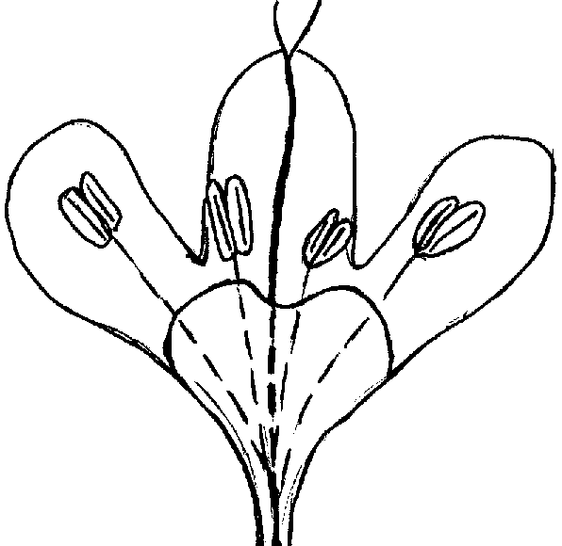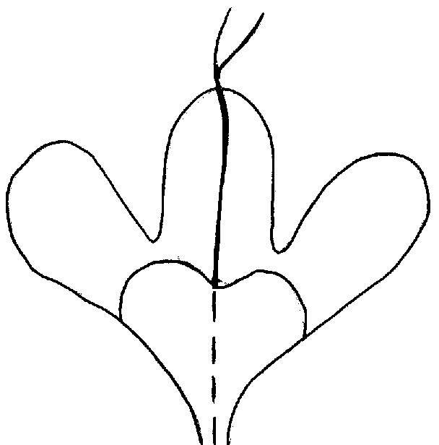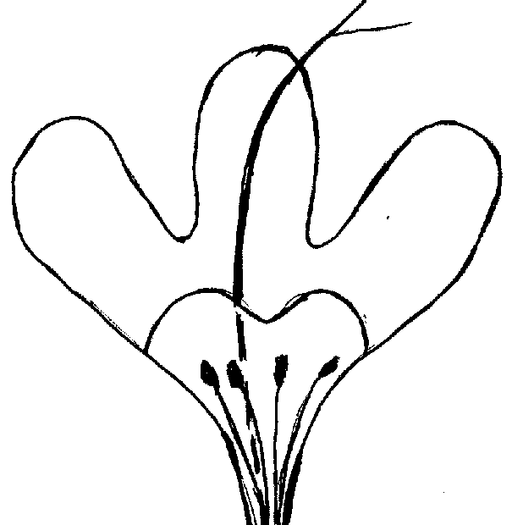
1  absent | 9  present
 |  | flower without stamen | flower with non-functional stamen

IX. Literature

Le Thym, pp 105 à 116, in Série synthèses Bibliographiques N°2, APRIA-CDUIPA Massy (91) France, 161 pp.

ELENA-ROSSELLO, J. A., 1979. Identification of a species-specific enzyme marker in Thymus L., The Journal of Heredity, 70: 147-149, 1979.

GUYON, J., 1975. La culture des plantes aromatiques et médicinales dans le département de la Drôme, Université Claude Bernard Lyon (69) France 139 pp.

PARVIZ, Maghami, 1979. Le Thym (pages 157 à 160) in Culture et cueillette de plantes médicinales, Hachette.

PASSET, J., 1979. La variabilité chimique chez le thym, ses manifestations, sa signification, parfums, cosmétiques, arômes, no. 29, juillet-août 1979.

RICHARD, H., 1974. Quelques épices et aromates et leurs huiles essentielles.

VERNET, P., 1977. Les variations de composition de l’essence de Thymus vulgaris L., mode de transmission héréditaire de trois terpènes (le thymol, le carvacrol et le linalol). Compte Rendu de l’Académie des Sciences de Paris, t. 284., Série D 1289.

VERNET, P., GOUYON Ph. Le polymorphisme chimique de Thymus vulgaris, parfums, cosmétiques, arômes. Novembre/décembre 1979.

VERNET, P., GUILLERM, J.L., GOUYON, Ph., 1977. Le polymorphisme chimique de Thymus vulgaris L. Répartition des formes chimiques avec certains facteurs écologiques, Oecol. Plant 1977, 12 (2), 159-179.

X. Technical Questionnaire

Reference Number
(not to be filled in by the applicant)

TECHNICAL QUESTIONNAIRE
to be completed in connection with an application for plant breeders’ rights

1. Species Thymus vulgaris L.

THYME

2. Applicant (name and address)

3. Proposed denomination or breeder’s reference

4. Information on origin, maintenance and reproduction of the variety

4.1 Origin

- Seedling (indicate parent varieties)

................................................................................................ [ ]

- Mutation (indicate parent variety)

................................................................................................ [ ]

- Discovery (indicate where and when)

................................................................................................ [ ]

- Other (specify)

................................................................................................ [ ]

  - Method of reproduction

- Seed [ ]

- Cuttings [ ]

- In vitro propagation [ ]

- Other (specify) [ ]

................................................................................................

4.3 Other information

5. Characteristics of the variety to be indicated (the number in brackets refers to the corresponding characteristic in Test Guidelines; please mark the state of expression which best corresponds).

 | Characteristics |  |  | Example Varieties |  | Note
5.1  (1) | Plant: growth habit
 | erect |  |  | Gambaru, Valdeyron |  | 1[ ]
 | semi erect |  |  | Allemand |  | 3[ ]
 | prostrate |  |  | Heili, Savoie |  | 5[ ]
5.2  (7) | Stem: distribution of leaves
 | only at base |  |  | Escalin, Passet |  | 1[ ]
 | only in middle |  |  | 2.40 |  | 2[ ]
 | only in upper part |  |  | Pegase, Ygor |  | 3[ ]
 | along whole stem |  |  | Gambaru, Valdeyron |  | 4[ ]
5.3  (8) | Stem: position of flowering part
 | at tip |  |  | 1.44, 3.49 |  | 1[ ]
 | along upper quarter |  |  | Allemand, Escalin |  | 2[ ]
 | along upper half |  |  | 1.52, Heili |  | 3[ ]
 | along upper two thirds |  |  | Gambaru |  | 4[ ]
 | along whole stem |  |  | Passet |  | 5[ ]
5.4  (16) | Leaf: variegation
 | absent |  |  | Valdeyron |  | 1[ ]
 | present |  |  | Silver Posie |  | 9[ ]
5.5  (17) | Leaf: main color
 | yellow green |  |  |  |  | 1[ ]
 | green |  |  | Allemand, Escalin |  | 2[ ]
 | blue green |  |  | Passet, Ygor |  | 3[ ]
 | grey green |  |  | Pegase, Valdeyron |  | 4[ ]
 | Characteristics |  |  | Example Varieties |  | Note
5.6  (18) | Leaf: intensity of main color
 | light |  |  |  |  | 3[ ]
 | medium |  |  |  |  | 5[ ]
 | dark |  |  |  |  | 7[ ]
5.7  (20) | Flower: color of petal
 | white or slightly pink |  |  | Passet |  | 1[ ]
 | pink |  |  | Escalin, Ygor |  | 2[ ]
 | light violet |  |  | 4.77 |  | 3[ ]
 | violet |  |  | Pegase, Valdeyron |  | 4[ ]
5.8  (25) | Plant: male sterility
 | absent |  |  | Heili, Ygor |  | 1[ ]
 | present |  |  | Escalin, Valdeyron |  | 9[ ]
6. Similar varieties and differences between these varieties

Denomination of similar variety |  | Characteristic in which the similar variety is different ^{o)} | State of expression of similar variety |  | State of expression of candidate variety
______________
^{o)} In the case of identical states of expressions of both varieties, please indicate the size of the difference.

- Additional information which may help to distinguish the variety

7.1 Resistance to pests and diseases

  - Special conditions for the examination of the variety

Main use

- ornamental [ ]

- culinary [ ]

- essential oil [ ]

- other (specify) [ ]

7.3 Other information

A representative color photo of the variety should be included in the Technical Questionnaire.

8. Authorization for release

(a) Does the variety require prior authorization for release under legislation concerning the protection of the environment, human and animal health?

Yes [ ] No [ ]

(b) Has such authorization been obtained?

Yes [ ] No [ ]

If the answer to that question is yes, please attach a copy of such an authorization.

[End of document]

