 |  | E  TG/189/1

INTERNATIONAL UNION FOR THE PROTECTION  OF NEW VARIETIES OF PLANTS | UNION INTERNATIONALE POUR LA PROTECTION  DES OBTENTIONS VÉGÉTALES | INTERNATIONALER VERBAND ZUM SCHUTZ VON PFLANZEN-ZÜCHTUNGEN | UNIÓN INTERNACIONAL PARA LA PROTECCIÓN  DE LAS OBTENCIONES VEGETALES

GUIDELINES

FOR THE CONDUCT OF TESTS

FOR DISTINCTNESS, UNIFORMITY AND STABILITY

PENTAS

(Pentas Benth.)

GENEVA
2002

Copies of this document are available on request at the price of 10 Swiss francs each, including surface mail, from the Office of UPOV, 34, chemin des Colombettes, P.O. Box 18, 1211 Geneva 20, Switzerland.

This document or parts of it may be reproduced, translated and published without obtaining the specific consent of UPOV, provided that the source is acknowledged.

* * * * * * *
E
TG/189/1
ORIGINAL: English
DATE: 2002-04-17

INTERNATIONAL UNION FOR THE PROTECTION  OF NEW VARIETIES OF PLANTS | UNION INTERNATIONALE POUR LA PROTECTION  DES OBTENTIONS VÉGÉTALES | INTERNATIONALER VERBAND ZUM SCHUTZ VON PFLANZEN-ZÜCHTUNGEN | UNIÓN INTERNACIONAL PARA LA PROTECCIÓN  DE LAS OBTENCIONES VEGETALES

GUIDELINES

FOR THE CONDUCT OF TESTS

FOR DISTINCTNESS, UNIFORMITY AND STABILITY

PENTAS

(Pentas Benth.)

These Guidelines should be read in conjunction with document TG/1/2, which contains explanatory notes on the general principles on which the Guidelines have been established.
TABLE OF CONTENTS PAGE

I. | Subject of these Guidelines ......................................................................... | 3
II. | Material Required ........................................................................................ | 3
III. | Conduct of Tests .......................................................................................... | 3
IV. | Methods and Observations........................................................................... | 4
V. | Grouping of Varieties .................................................................................. | 5
VI. | Characteristics and Symbols ........................................................................ | 5
VII. | Table of Characteristics ............................................................................... | 6
VIII. | Explanations on the Table of Characteristics .............................................. | 13
IX. | Literature ..................................................................................................... | 16
X. | Technical Questionnaire ............................................................................. | 17

I. Subject of these Guidelines

These Test Guidelines apply to all varieties of Pentas Benth. of the family Rubiaceae.

II. Material Required

1. The competent authorities decide when, where and in what quantity and quality the plant material required for testing the variety is to be delivered. Applicants submitting material from a State other than that in which the testing takes place must make sure that all customs formalities are complied with. As a minimum, the following quantity of material is recommended:

vegetatively propagated varieties: 25 rooted cuttings;

seed propagated varieties: 1 gram of seed,
germination capacity of at least 50%.

2. In the case of seed, the seed should meet the minimum requirements for germination, species and analytical purity, health and moisture content, specified by the competent authority. In cases where the seed is to be stored, the germination capacity should be as high as possible and should be stated by the applicant.

3. The plant material supplied should be visibly healthy, not lacking in vigor or affected by any important pests or diseases.

4. The plant material must not have undergone any treatment unless the competent authorities allow or request such treatment. If it has been treated, full details of the treatment must be given.

III. Conduct of Tests

1. The tests for vegetatively propagated varieties should normally be conducted over one growing cycle. If the examination cannot be completed in one growing cycle, the test should be extended for a second growing cycle.

2. The test for seed-propagated varieties should normally be conducted over two independent growing cycles.

3. The test should normally be conducted at one place. If any important characteristics of the variety cannot be seen at that place, the variety may be tested at an additional place.

4. The tests should be carried out under conditions ensuring satisfactory growth for the expression of the relevant characteristics of the variety and for the conduct of the examination.

Seed propagated varieties:

Sowing-time: January (Northern Hemisphere) is recommended for flowering in May

Growing medium: Well-drained; seeds should be covered with a very thin layer of sand, and with a thin layer of transparent PVC and cloth until germination

Temperature: Germination should occur after 2-3 weeks at a temperature of 18-20 ºC

Vegetatively propagated varieties:

Growing medium: Well-drained, fertile, with a high content of organic matter
or organic substrate

Temperature: Minimum of 17 ºC

The size of the plots should be such that plants or parts of plants may be removed for measurement and counting without prejudice to the observations which must be made up to the end of the growing cycle. For vegetatively propagated varieties, each test should be designed to result in a total of at least 25 plants. For seed propagated varieties, each test should be designed to result in a total of at least 100 plants. Separate plots for observation and for measuring should only be used if they have been subject to similar environmental conditions.

5. Additional tests for special purposes may be established.

IV. Methods and Observations

1. Unless otherwise indicated, all observations on vegetatively propagated varieties should be made on 10 plants or parts taken from each of 10 plants.

2. For the assessment of uniformity of vegetatively propagated varieties a population standard of 1% with an acceptance probability of at least 95% should be applied. In the case of a sample size of 25 plants, the maximum number of off-types allowed would be 1.

3. For the assessment of uniformity of seed propagated varieties, the recommendations in the General Introduction for cross-pollinated or hybrid varieties should be followed, as appropriate.

4. All observations on the flower should be made at full flowering.

5. Because daylight varies, color determinations made against a color chart should be made either in a suitable cabinet providing artificial daylight or in the middle of the day in a room without direct sunlight. The spectral distribution of the illuminant for artificial daylight should conform with the CIE Standard of Preferred Daylight D 6500 and should fall within the tolerance set out in British Standard 950, Part I. These determinations should be made with the plant part placed against a white background.

V. Grouping of Varieties

1. The collection of varieties to be grown should be divided into groups to facilitate the assessment of distinctness. Characteristics which are suitable for grouping purposes are those which are known from experience not to vary, or to vary only slightly, within a variety. Their various states of expression should be fairly evenly distributed throughout the collection.

2. It is recommended that the competent authorities use the following characteristics for grouping varieties:

(a) Plant: height (characteristic 2)
(b) Corolla lobe: main color on upper side (characteristic 26) with the following groups:

Gr. 1: white
Gr. 2: light pink
Gr. 3: pink
Gr. 4: red
Gr. 5: purple

VI. Characteristics and Symbols

1. To assess distinctness, uniformity and stability, the characteristics and their states as given in the Table of Characteristics should be used.

2. Notes (numbers), for the purposes of electronic data processing, are given opposite the states of expression for each characteristic.

3. Legend:

(*) Characteristics that should be used on all varieties in every growing cycle over which examinations are made, and always be included in the variety descriptions, except when the state of expression of a preceding characteristic or regional environmental conditions render this impossible.

(+) See Explanations on the Table of Characteristics in Chapter VIII.

VII. Table of Characteristics/Tableau des caractères/Merkmalstabelle/Tabla de caracteres

 | English | français | deutsch | español | Example Varieties  Exemples  Beispielssorten  Variedades ejemplo | Note/  Nota
1.  (*) | Plant: growth habit | Plante: port | Pflanze: Wuchsform | Planta: hábito de crecimiento
 | upright | dressé | aufrecht | erecto |  | 1
 | semi-upright | demi-dressé | halbaufrecht | semierecto |  | 2
 | spreading | étalé | breitwüchsig | rastrero | Mercur, Romance | 3
2.  (*) | Plant: height | Plante: hauteur | Pflanze: Höhe | Planta: altura
 | short | courte | niedrig | baja |  | 3
 | medium | moyenne | mittel | media |  | 5
 | tall | grande | hoch | alta | Festival, Partytime | 7
3.  (*) | Stem: length of internodes (in middle third) | Tige: longueur des entrenœuds (au tiers supérieur) | Haupttrieb: Länge der Internodien (im mittleren Drittel) | Tallo: longitud de los entrenudos (en el tercio medio)
 | short | courts | kurz | cortos |  | 3
 | medium | moyens | mittel | medios | Lola, Titan | 5
 | long | longs | lang | largos | Apollo, Venus | 7
4.  (*) | Stem: green color | Tige: couleur verte | Haupttrieb: Grünfärbung | Tallo: color verde
 | light | claire | hell | claro | Jupiter, Mercur, Saturn | 3
 | medium | moyenne | mittel | medio |  | 5
 | dark | foncée | dunkel | oscuro | Romance | 7
5.  (*) | Stem: anthocyanin coloration | Tige: pigmentation anthocyanique | Haupttrieb: Anthocyanfärbung | Tallo: pigmentación antociánica
 | absent | absente | fehlend | ausente | Saturn | 1
 | present | présente | vorhanden | presente | Jupiter, Lore | 9
6.  (*) | Leaf blade: length | Limbe: longueur | Blattspreite: Länge | Limbo: longitud
 | short | court | kurz | corto |  | 3
 | medium | moyen | mittel | medio | Lina, Pluto | 5
 | long | long | lang | largo | Festival, Lilac In, Saturn | 7
7.  (*) | Leaf blade: width | Limbe: largeur | Blattspreite: Breite | Limbo: anchura
 | narrow | étroit | schmal | estrecho | Lina | 3
 | medium | moyen | mittel | medio | Lilac In | 5
 | broad | large | breit | ancho | Jupiter | 7
8.  (*) | Leaf blade: shape | Limbe: forme | Blattspreite: Form | Limbo: forma
 | ovate | ovale | eiförmig | oval | Lilli | 1
 | elliptic | elliptique | elliptisch | elíptico | Comet, Lilac In,  Purple Rain | 2
 | obovate | obovale | verkehrt eiförmig | oboval |  | 3
9.  (*) | Leaf blade: green color of upper side | Limbe: couleur verte de la partie supérieure | Blattspreite: Grünfärbung der Oberseite | Limbo: color verde de la haz
 | light | claire | hell | claro |  | 3
 | medium | moyenne | mittel | medio | Galaxy | 5
 | dark | foncée | dunkel | oscuro | Romance, Saturn | 7
10.  (*) | Leaf blade: pubescence | Limbe: pilosité | Blattspreite: Behaarung | Limbo: pubescencia
 | sparse | faible | locker | rala | Mars, Pink In | 3
 | medium | moyenne | mittel | media | Festival, Partytime | 5
 | dense | forte | dicht | densa |  | 7
11. | Leaf blade: blistering | Limbe: cloqûre | Blattspreite: Blasigkeit | Limbo: abullonado
 | absent or very weak | nulle ou très faible | fehlend oder sehr gering | ausente o muy débil | Lina | 1
 | weak | faible | gering | débil | Lilac In, Partytime | 3
 | medium | moyenne | mittel | medio |  | 5
 | strong | forte | stark | fuerte |  | 7
 | very strong | très forte | sehr stark | muy fuerte |  | 9
12.  (*)  (+) | Inflorescence: maximum diameter | Inflorescence: diamètre maximal | Blütenstand: größter Durchmesser | Inflorescencia: diámetro máximo
 | small | petit | klein | pequeño |  | 3
 | medium | moyen | mittel | medio | Festival | 5
 | large | grand | groß | grande | Lilac In | 7
13.  (*)  (+) | Inflorescence: minimum diameter | Inflorescence: diamètre minimal | Blütenstand: kleinster Durchmesser | Inflorescencia: diámetro mínimo
 | small | petit | klein | pequeño |  | 3
 | medium | moyen | mittel | medio |  | 5
 | large | grand | groß | grande |  | 7
14.  (*)  (+) | Inflorescence: height | Inflorescence: hauteur | Blütenstand: Höhe | Inflorescencia: altura
 | low | basse | niedrig | baja |  | 3
 | medium | moyenne | mittel | media |  | 5
 | high | haute | hoch | alta |  | 7
15.  (*)  (+) | Inflorescence: shape of upper side | Inflorescence: forme de la face supérieure | Blütenstand: Form der Oberseite | Inflorescencia: forma de la cara superior
 | flat | plate | eben | plana |  | 1
 | rounded | arrondie | rundlich | redondeada | Galaxy, Pluto, Titan | 2
16.  (*) | Corolla: diameter | Corolle: diamètre | Krone: Durchmesser | Corola: diámetro
 | small | petit | klein | pequeño |  | 3
 | medium | moyen | mittel | medio | Lina, Lola | 5
 | large | grand | groß | grande |  | 7
17.  (*)  (+) | Corolla tube: length | Tube de la corolle: longueur | Kronenröhre: Länge | Tubo de la corola: longitud
 | short | court | kurz | corto | Red In | 3
 | medium | moyen | mittel | medio | Lola, Venus | 5
 | long | long | lang | largo |  | 7
18.  (*) | Corolla tube: color | Tube de la corolle: couleur | Kronenröhre: Farbe | Tubo de la corola: color
 | RHS Colour Chart (indicate reference number) | Code RHS des couleurs (préciser le numéro de référence) | RHS-Farbkarte (Nummer angeben) | Carta de colores RHS (indíquese el número de referencia)
19.  (*)  (+) | Corolla throat: color of distal part of hairs on inner side | Gorge de la corolle: couleur de la partie distale des poils de la face interne | Kronenschlund: Farbe des distalen Teils der Haare auf der Innenseite | Garganta de la corola: color de la parte distal de los pelos de la cara interior
 | whitish | blanchâtre | weißlich | blanquecino | Lilli, Lola, Saturn | 1
 | pink | rose | rosa | rosa |  | 2
 | red | rouge | rot | rojo |  | 3
 | red purple | rouge pourpre | rotpurpur | púrpura rojizo | Purple Rain | 4
 | blue purple | bleu pourpre | blaupurpur | púrpura azulado |  | 5
 | grey purple | gris pourpre | graupurpur | púrpura grisáceo | Romance | 6
20.  (*)  (+) | Corolla lobe: attitude | Lobe de la corolle: port | Kronzipfel: Haltung | Lóbulo de la corola: porte
 | semi-erect | demi-dressé | halbaufrecht | semierecto | Jupiter, Lola, Saturn | 1
 | horizontal | horizontal | waagerecht | horizontal | Festival, Partytime,  Purple Rain | 2
 | recurved | incurvé | zurückgeschlagen | recurvado |  | 3
21.  (*) | Corolla lobe: length | Lobe de la corolle: longueur | Kronzipfel: Länge | Lóbulo de la corola: longitud
 | short | court | kurz | corto | Comet | 3
 | medium | moyen | mittel | medio | Lina, Lola | 5
 | long | long | lang | largo |  | 7
22.  (*) | Corolla lobe: width | Lobe de la corolle: largeur | Kronzipfel: Breite | Lóbulo de la corola: anchura
 | narrow | étroit | schmal | estrecho |  | 3
 | medium | moyen | mittel | medio | Comet, Lina, Lola | 5
 | broad | large | breit | ancho |  | 7
23.  (*) | Corolla lobe: shape | Lobe de la corolle: forme | Kronzipfel: Form | Lóbulo de la corola: forma
 | ovate | ovale | eiförmig | oval | Lina, Lola, Lore | 1
 | elliptic | elliptique | elliptisch | elíptico |  | 2
 | obovate | obovale | verkehrt eiförmig | oboval |  | 3
24.  (*) | Corolla lobe: number of colors on upper side | Lobe de la corolle: nombre de couleurs sur la partie supérieure | Kronzipfel: Anzahl Farben der Oberseite | Lóbulo de la corola: número de colores en la cara superior
 | one | une | eine | uno | Festival, Jupiter, Mars | 1
 | more than one | plus d’une | mehr als eine | más de uno | Romance | 2
25.  (*)  (+) | Corolla lobe: main color on upper side | Lobe de la corolle: principale couleur sur la face supérieure | Kronzipfel: Hauptfarbe der Oberseite | Lóbulo de la corola: color principal en la cara superior
 | RHS Colour Chart (indicate reference number) | Code RHS des couleurs (préciser le numéro de référence) | RHS-Farbkarte (Nummer angeben) | Carta de colores RHS (indíquese el número de referencia)
26. | Varieties with more than one color on upper side: corolla lobe: secondary color | Variétés ayant plus d’une couleur sur la face supérieure: lobe de la corolle: couleur secondaire | Sorten mit mehr als einer Farbe an der Oberseite: Kronzipfel: Sekundärfarbe | Variedades con más de un color en la cara superior: lóbulo de la corola: color secundario
 | white | blanche | weiß | blanco |  | 1
 | pink | rose | rosa | rosa |  | 2
 | red | rouge | rot | rojo |  | 3
 | red purple | rouge pourpre | rotpurpur | púrpura rojizo |  | 4
 | blue purple | bleu violacé | blaupurpur | púrpura azulado | Romance | 5
27.  (*) | Varieties with more than one color on upper side: corolla lobe: distribution of secondary color | Variétés ayant plus d’une couleur sur la face supérieure: lobe de la corolle: répartition de la couleur secondaire | Sorten mit mehr als einer Farbe an der Oberseite: Kronzipfel: Verteilung der Sekundärfarbe | Variedades con más de un color en la cara superior: lóbulo de la corola: distribución del color secundario
 | at the tip | à l’extrémité | an der Spitze | en el ápice |  | 1
 | along margin | le long du bord | am Rand | a lo largo del margen | Romance | 2
 | splashed | maculée | fleckig | manchado |  | 3
 | eyed | mouchetée | augenförmig | moteado |  | 4
 | median stripe | strie médiane | Mittelstreifen | estría central |  | 5
28.  (*) | Anthers: level in relation to top of limb | Anthères: position par rapport au sommet du limbe | Antheren: Höhe im Verhältnis zum obersten Teil der Krone | Anteras: nivel en relación con la parte superior de la corona
 | above | au-dessus | oberhalb | por encima | Purple Rain | 1
 | same level | au même niveau | in gleicher Höhe | al mismo nivel | Apollo | 2
 | below | au-dessous | unterhalb | por debajo |  | 3
29. | Anther: color of pollen | Anthère: couleur du pollen | Anthere: Farbe des Pollens | Antera: color del polen
 | whitish | blanchâtre | weißlich | blanquecino |  | 1
 | yellowish | jaunâtre | gelblich | amarillento | Jupiter, Mars, Mercur | 2
 | greyish | grisâtre | gräulich | grisáceo | Purple Rain | 3
30.  (*) | Pistil: length of style | Pistil: longueur du style | Stempel: Länge des Griffels | Pistilo: longitud del estilo
 | short | court | kurz | corto | Purple Rain | 3
 | medium | moyen | mittel | medio | Lore, Venus | 5
 | long | long | lang | largo | Jupiter, Saturn | 7
31.  (*) | Stigma: size of lobes | Stigmate: taille des lobes | Narbe: Größe der Lappen | Estigma: tamaño de los lóbulos
 | small | petits | klein | pequeños | Comet | 3
 | medium | moyens | mittel | medios | Galaxy, Jupiter | 5
 | large | gros | groß | grandes |  | 7
32.  (*) | Stigma: color of lobes | Stigmate: couleur des lobes | Narbe: Farbe der Lappen | Estigma: color de los lóbulos
 | white | blancs | weiß | blanco | Romance | 1
 | yellow green | vert jaune | gelbgrün | verde amarillento | Galaxy, Purple Rain | 2
 | pink | roses | rosa | rosa | Lilli, Lola | 3
 | red | rouges | rot | rojo |  | 4
 | red purple | rouge pourpre | rotpurpur | púrpura rojizo | Lilo, Partytime | 5
 | blue purple | bleu pourpre | blaupurpur | púrpura azulado | Jupiter | 6
 | greyish | grisâtres | gräulich | grisaceo | Comet, Pluto | 7

VIII. Explanations on the Table of Characteristics

Ad. 12: Inflorescence: maximum diameter

Ad. 13: Inflorescence: minimum diameter

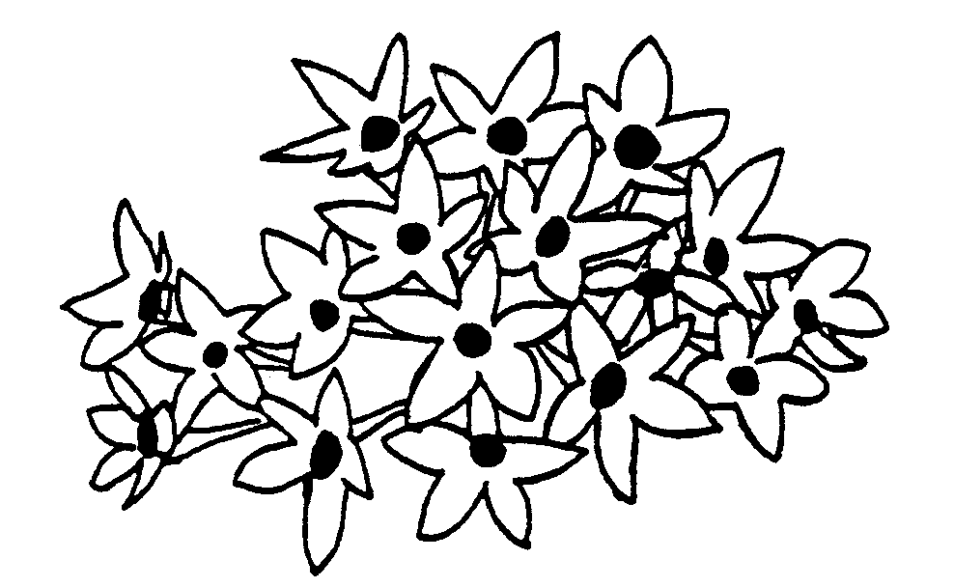

minimum
diameter

maximum diameter

Ad. 14: Inflorescence: height

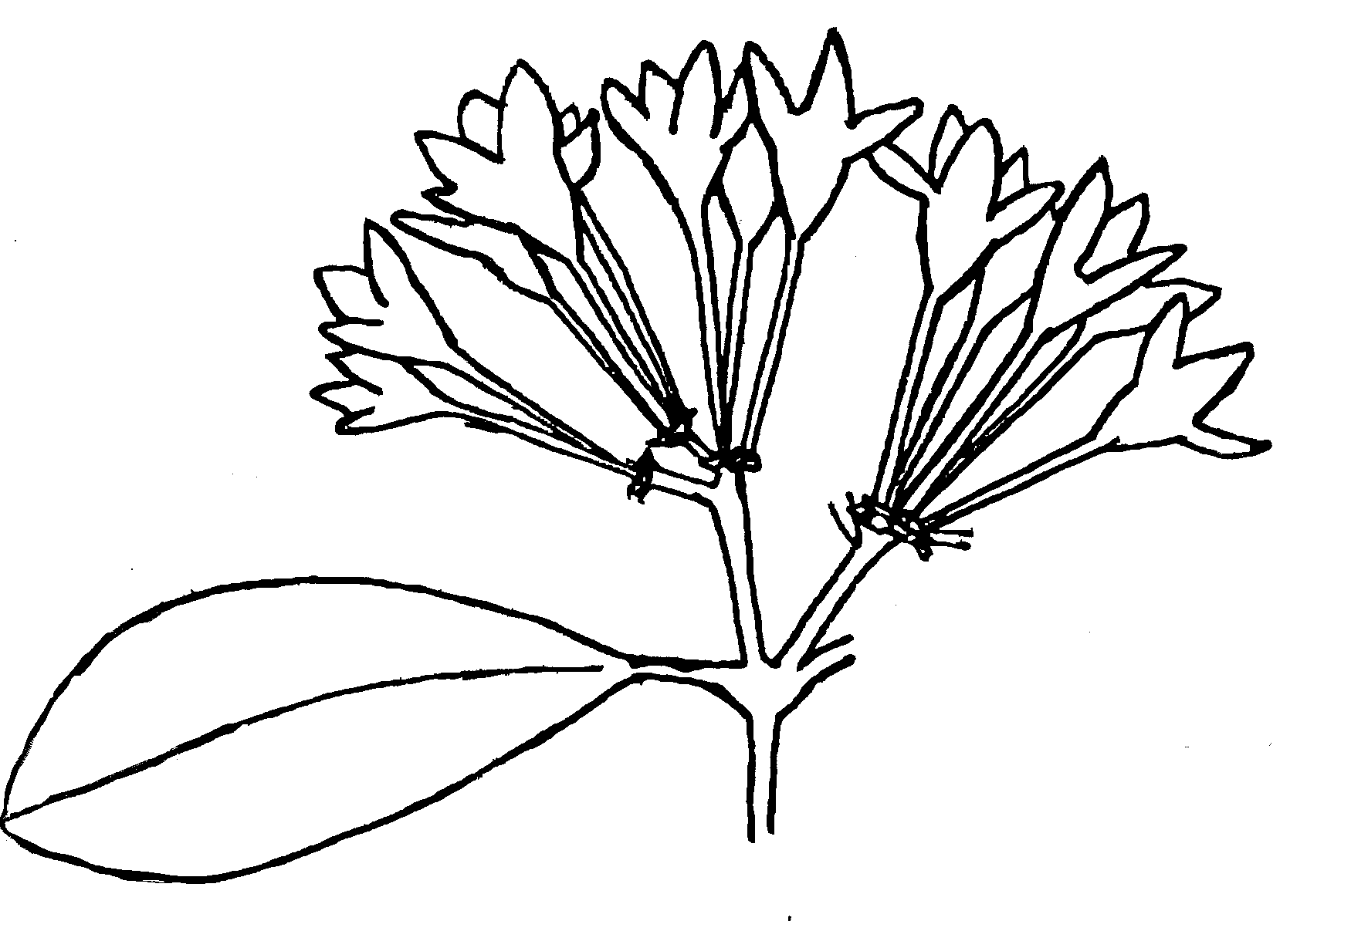

height

Ad. 15: Inflorescence: shape of upper side

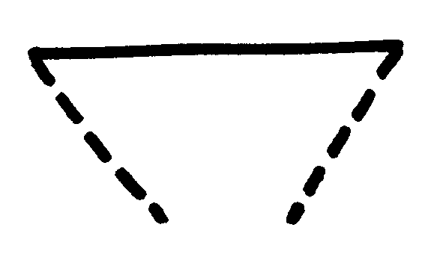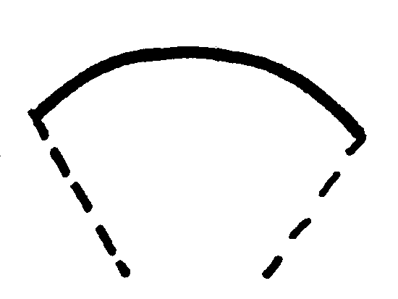
1 2
flat rounded

Ad. 17: Corolla tube: length

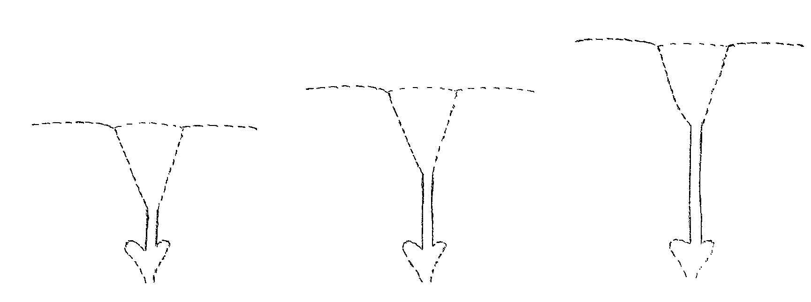

3 5 7
short medium long

Ad. 17 + 19: Corolla throat and corolla tube

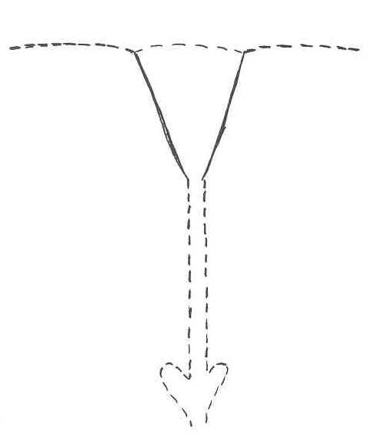 | 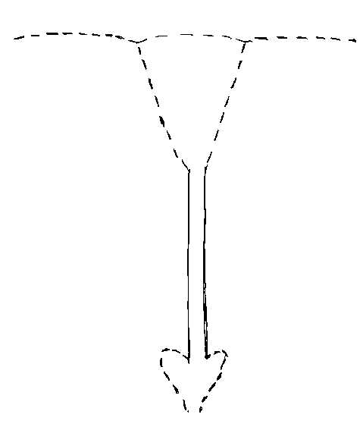
throat | tube

Ad. 20: Corolla lobe: attitude

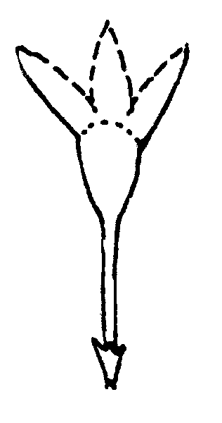 | 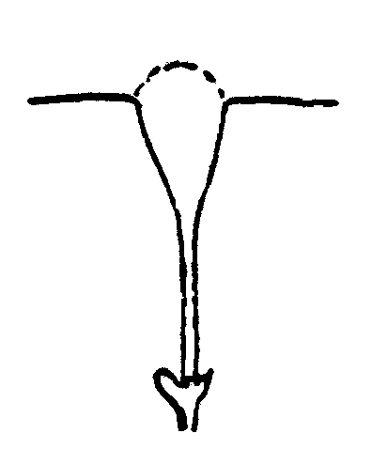 | 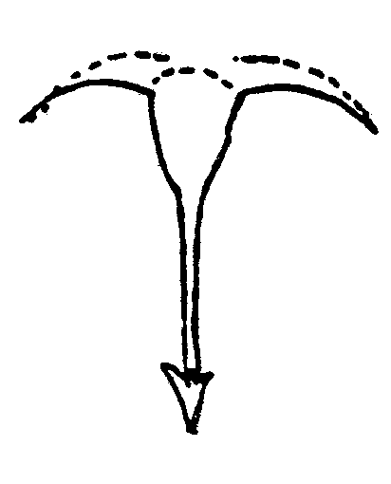
1 | 2 | 3
semi-erect | horizontal | recurved

Ad. 25: Corolla lobe: main color on upper side:

The main color of the flower is determined by the main color on the upper side of the inner tepals; the main color is the color which is present in the greatest area; in the case of bicolored or multicolored tepals where none of the colors is clearly predominant, the lightest color is considered to be the main color.

IX. Literature

Hortig A. M., Pentas lanceolata – Eine neue Beet-, Topf- und Schnittblume, Zierpflanzenbau Nr. 23-18.11.1993, pp. 1002-1004.

Papenhagen A., Sprau G., Neue Beetpflanze, wüchsig und erstaunlich witterungsfest, Gartenbörse und Gartenwelt, 1989, 2, 73-75.

Pearse H. L., Pentas, Pentas, Pentas, Farming in South Africa, Flowers and Ornamental Shrubs j., 10/1979.

Schwarz A., Dapper H., Pentas lanceolata, Biologie und Kultur einer wenig bekannten Zierpflanze, Zierpflanzenbau Nr. 25- 13. 12. 1989 , pp. 1012-1016.

X. Technical Questionnaire

Reference Number
(not to be filled in by the applicant)

TECHNICAL QUESTIONNAIRE
to be completed in connection with an application for plant breeders’ rights

1. Species Pentas Benth.

PENTAS

2. Applicant (Name and address)

3. Proposed denomination or breeder’s reference

4. Information on origin, maintenance and reproduction of the variety

4.1 Origin

- Seedling (indicate parent varieties)

................................................................................................ [ ]

- Mutation (indicate parent variety)

................................................................................................ [ ]

- Discovery (indicate where and when)

................................................................................................ [ ]

- Other (specify)

................................................................................................ [ ]

4.2 Method of reproduction

- cuttings [ ]

- in vitro propagation [ ]

- seed [ ]

- other (specify) [ ]

4.3 Other information

5. Characteristics of the variety to be indicated (the number in brackets refers to the corresponding characteristic in Test Guidelines; please mark the state of expression which best corresponds).

 | Characteristics |  |  | Example Varieties |  | Note
5.1i  (25) | Corolla lobe: main color on upper side
 | RHS Colour Chart (indicate reference number) |  |  | ……………………………..
5.1ii  (25) | Corolla lobe: main color on upper side
 | white |  |  | White In |  | 1[ ]
 | light pink |  |  | Pluto |  | 2[ ]
 | pink |  |  | Titan |  | 3[ ]
 | red |  |  | Partytime |  | 4[ ]
 | purple |  |  | Apollo |  | 5[ ]
6. Similar varieties and differences from these varieties

Denomination of similar variety |  | Characteristic in which the similar variety is different ^{o)} | State of expression of similar variety |  | State of expression of candidate variety
______________
^{o)} In the case of identical states of expressions of both varieties, please indicate the size of the difference.

7. Additional information which may help to distinguish the variety

7.1 Resistance to pest and diseases

7.2 Special conditions for the examination of the variety

Plant type:

– potplant type [ ]

– cutflower type [ ]

7.3 Other information

A representative color photo of the variety should be added to the Technical Questionnaire.

8. Authorization for release

(a) Does the variety require prior authorization for release under legislation concerning the protection of the environment, human and animal health?

Yes [ ] No [ ]

(b) Has such authorization been obtained?

Yes [ ] No [ ]

If the answer to that question is yes, please attach a copy of such an authorization.

[End of document]

