E
TG/187/2 Rev.
ORIGINAL: English
DATE: 2014-04-09 + 2021-10-26
INTERNATIONAL UNION FOR THE PROTECTION OF NEW VARIETIES OF PLANTS
Geneva

 | PRUNUS ROOTSTOCKS  UPOV Code: PRUNU  Prunus L. | *

GUIDELINES

FOR THE CONDUCT OF TESTS

FOR DISTINCTNESS, UNIFORMITY AND STABILITY

Alternative Names:*

Botanical name | English | French | German | Spanish
Prunus L. | Prunus Rootstocks | Porte-greffe de prunus | Prunus-Unterlagen | Portainjertos de prunus

The purpose of these guidelines (“Test Guidelines”) is to elaborate the principles contained in the General Introduction (document TG/1/3), and its associated TGP documents, into detailed practical guidance for the harmonized examination of distinctness, uniformity and stability (DUS) and, in particular, to identify appropriate characteristics for the examination of DUS and production of harmonized variety descriptions.

ASSOCIATED DOCUMENTS
These Test Guidelines should be read in conjunction with the General Introduction and its associated TGP documents.

Other associated UPOV documents: TG/35: Sweet Cherry
TG/41: European Plum
TG/53: Peach, Nectarine
TG/56: Almond
TG/70: Apricot
TG/84: Japanese Plum
TG/160: Mume (Japanese Apricot)
TABLE OF CONTENTS PAGE

1. Subject of these Test Guidelines 3
2. Material Required 3
3. Method of Examination 3
3.1 Number of Growing Cycles 3
3.2 Testing Place 3
3.3 Conditions for Conducting the Examination 3
3.4 Test Design 3
3.5 Additional Tests 3
4. Assessment of Distinctness, Uniformity and Stability 4
4.1 Distinctness 4
4.2 Uniformity 5
4.3 Stability 5
5. Grouping of Varieties and Organization of the Growing Trial 5
6. Introduction to the Table of Characteristics 6
6.1 Categories of Characteristics 6
6.2 States of Expression and Corresponding Notes 6
6.3 Types of Expression 6
6.4 Example Varieties 6
6.5 Legend 7
7. Table of Characteristics/Tableau des caractères/Merkmalstabelle/Tabla de caracteres 8
8. Explanations on the Table of Characteristics 14
8.1 Explanations covering several characteristics 14
8.2 Explanations for individual characteristics 14
8.3 Explanations on the Example Varieties 19
9. Literature 21
10. Technical Questionnaire 22

Subject of these Test Guidelines

1.1 These Test Guidelines apply to all varieties used as rootstocks of all species of Prunus L.

1.2 If characteristics of the flower, the fruit or the seed are necessary to examine the varieties, the Test Guidelines for Almond (TG/56), Apricot (TG/70), Sweet Cherry (TG/35), European Plum (TG/41), Japanese Plum (TG/84), Mume (Japanese Apricot) (TG/160) or Peach, Nectarine (TG/53) should be used for those characteristics, as appropriate.

Material Required

2.1 The competent authorities decide on the quantity and quality of the plant material required for testing the variety and when and where it is to be delivered. Applicants submitting material from a State other than that in which the testing takes place must ensure that all customs formalities and phytosanitary requirements are complied with.

2.2 The material is to be supplied in the form of plants on their own roots, the method of propagation of which is to be specified.

2.3 The minimum quantity of plant material, to be supplied by the applicant, should be:

(a) 5 plants, for vegetatively propagated varieties, or
(b) 40 one-year-old plants or 40 two-year-old plants for seed propagated varieties, and/or sufficient seeds ready for germinating into 40 plants.

2.4 The plant material supplied should be visibly healthy, not lacking in vigor, nor affected by any important pest or disease.

2.5 The plant material should not have undergone any treatment which would affect the expression of the characteristics of the variety, unless the competent authorities allow or request such treatment. If it has been treated, full details of the treatment must be given.

Method of Examination

3.1 Number of Growing Cycles

The minimum duration of tests should normally be two independent growing cycles.

3.2 Testing Place

Tests are normally conducted at one place. In the case of tests conducted at more than one place, guidance is provided in TGP/9 “Examining Distinctness”.

3.3 Conditions for Conducting the Examination

The tests should be carried out under conditions ensuring satisfactory growth for the expression of the relevant characteristics of the variety and for the conduct of the examination.

3.4 Test Design

3.4.1 In the case of vegetatively propagated varieties, each test should be designed to result in a total of at least 5 plants.

3.4.2 In the case of seed propagated varieties, each test should be designed to result in a total of at least 10 plants.

3.5 Additional Tests

Additional tests, for examining relevant characteristics, may be established.

Assessment of Distinctness, Uniformity and Stability

4.1 Distinctness

4.1.1 General Recommendations

It is of particular importance for users of these Test Guidelines to consult the General Introduction prior to making decisions regarding distinctness. However, the following points are provided for elaboration or emphasis in these Test Guidelines.

4.1.2 Consistent Differences

The differences observed between varieties may be so clear that more than one growing cycle is not necessary. In addition, in some circumstances, the influence of the environment is not such that more than a single growing cycle is required to provide assurance that the differences observed between varieties are sufficiently consistent. One means of ensuring that a difference in a characteristic, observed in a growing trial, is sufficiently consistent is to examine the characteristic in at least two independent growing cycles.

4.1.3 Clear Differences

Determining whether a difference between two varieties is clear depends on many factors, and should consider, in particular, the type of expression of the characteristic being examined, i.e. whether it is expressed in a qualitative, quantitative, or pseudo-qualitative manner. Therefore, it is important that users of these Test Guidelines are familiar with the recommendations contained in the General Introduction prior to making decisions regarding distinctness.

4.1.4 Number of Plants / Parts of Plants to be Examined

4.1.4.1 In the case of vegetatively propagated varieties, unless otherwise indicated, for the purposes of distinctness, all observations on single plants should be made on 5 plants or parts taken from each of 5 plants and any other observations made on all plants in the test, disregarding any off-type plants.

4.1.4.2 In the case of seed propagated varieties, unless otherwise indicated, for the purposes of distinctness, all observations on single plants should be made on 10 plants or parts taken from each of 10 plants and any other observations made on all plants in the test, disregarding any off-type plants.

4.1.5 Method of Observation

The recommended method of observing the characteristic for the purposes of distinctness is indicated by the following key in the second column of the Table of Characteristics (see document TGP/9 “Examining Distinctness”, Section 4 “Observation of characteristics”):

MG: single measurement of a group of plants or parts of plants
MS: measurement of a number of individual plants or parts of plants
VG: visual assessment by a single observation of a group of plants or parts of plants
VS: visual assessment by observation of individual plants or parts of plants

Type of observation: visual (V) or measurement (M)

“Visual” observation (V) is an observation made on the basis of the expert’s judgment. For the purposes of this document, “visual” observation refers to the sensory observations of the experts and, therefore, also includes smell, taste and touch. Visual observation includes observations where the expert uses reference points (e.g. diagrams, example varieties, side-by-side comparison) or non-linear charts (e.g. color charts). Measurement (M) is an objective observation against a calibrated, linear scale e.g. using a ruler, weighing scales, colorimeter, dates, counts, etc.

Type of record: for a group of plants (G) or for single, individual plants (S)

For the purposes of distinctness, observations may be recorded as a single record for a group of plants or parts of plants (G), or may be recorded as records for a number of single, individual plants or parts of plants (S). In most cases, “G” provides a single record per variety and it is not possible or necessary to apply statistical methods in a plant-by-plant analysis for the assessment of distinctness.

In cases where more than one method of observing the characteristic is indicated in the Table of Characteristics (e.g. VG/MG), guidance on selecting an appropriate method is provided in document TGP/9, Section 4.2.

4.2 Uniformity

4.2.1 It is of particular importance for users of these Test Guidelines to consult the General Introduction prior to making decisions regarding uniformity. However, the following points are provided for elaboration or emphasis in these Test Guidelines:

4.2.2 In the case of vegetatively propagated varieties, for the assessment of uniformity, a population standard of 1% and an acceptance probability of at least 95% should be applied. In the case of a sample size of 5 plants, no off-type is allowed.

4.2.3 In the case of seed propagated varieties, for the assessment of uniformity, a population standard of 1% and an acceptance probability of at least 95% should be applied. In case of a sample size of 10 plants, 1 off-type is allowed.

4.3 Stability

4.3.1 In practice, it is not usual to perform tests of stability that produce results as certain as those of the testing of distinctness and uniformity. However, experience has demonstrated that, for many types of variety, when a variety has been shown to be uniform, it can also be considered to be stable.

4.3.2 Where appropriate, or in cases of doubt, stability may be further examined by testing a new plant stock to ensure that it exhibits the same characteristics as those shown by the initial material supplied.

Grouping of Varieties and Organization of the Growing Trial

5.1 The selection of varieties of common knowledge to be grown in the trial with the candidate varieties and the way in which these varieties are divided into groups to facilitate the assessment of distinctness are aided by the use of grouping characteristics.

5.2 Grouping characteristics are those in which the documented states of expression, even where produced at different locations, can be used, either individually or in combination with other such characteristics: (a) to select varieties of common knowledge that can be excluded from the growing trial used for examination of distinctness; and (b) to organize the growing trial so that similar varieties are grouped together.

5.3 The following have been agreed as useful grouping characteristics:

(a) Plant: vigor (characteristic 1)
(b) Leaf blade: length (characteristic 15)
(c) Leaf blade: shape (characteristic 18)
(d) Leaf blade: color of upper side (characteristic 22)
(e) Leaf blade: incisions of margin (characteristic 25)

5.4 Guidance for the use of grouping characteristics, in the process of examining distinctness, is provided through the General Introduction and document TGP/9 “Examining Distinctness”.

Introduction to the Table of Characteristics

6.1 Categories of Characteristics

6.1.1 Standard Test Guidelines Characteristics

Standard Test Guidelines characteristics are those which are approved by UPOV for examination of DUS and from which members of the Union can select those suitable for their particular circumstances.

6.1.2 Asterisked Characteristics

Asterisked characteristics (denoted by *) are those included in the Test Guidelines which are important for the international harmonization of variety descriptions and should always be examined for DUS and included in the variety description by all members of the Union, except when the state of expression of a preceding characteristic or regional environmental conditions render this inappropriate.

6.2 States of Expression and Corresponding Notes

6.2.1 States of expression are given for each characteristic to define the characteristic and to harmonize descriptions. Each state of expression is allocated a corresponding numerical note for ease of recording of data and for the production and exchange of the description.

6.2.2 In the case of qualitative and pseudo-qualitative characteristics (see Chapter 6.3), all relevant states of expression are presented in the characteristic. However, in the case of quantitative characteristics with 5 or more states, an abbreviated scale may be used to minimize the size of the Table of Characteristics. For example, in the case of a quantitative characteristic with 9 states, the presentation of states of expression in the Test Guidelines may be abbreviated as follows:

State | Note
small | 3
medium | 5
large | 7

However, it should be noted that all of the following 9 states of expression exist to describe varieties and should be used as appropriate:

State | Note
very small | 1
very small to small | 2
small | 3
small to medium | 4
medium | 5
medium to large | 6
large | 7
large to very large | 8
very large | 9

6.2.3 Further explanation of the presentation of states of expression and notes is provided in document TGP/7 “Development of Test Guidelines”.

6.3 Types of Expression

An explanation of the types of expression of characteristics (qualitative, quantitative and pseudo-qualitative) is provided in the General Introduction.

6.4 Example Varieties

Where appropriate, example varieties are provided to clarify the states of expression of each characteristic (see explanations on the example varieties under Chapter 8.3).

6.5 Legend

(*) Asterisked characteristic – see Chapter 6.1.2

QL Qualitative characteristic – see Chapter 6.3
QN Quantitative characteristic – see Chapter 6.3
PQ Pseudo-qualitative characteristic – see Chapter 6.3

MG, MS, VG, VS – see Chapter 4.1.5

(a)-(c) See Explanations on the Table of Characteristics in Chapter 8.1
(+) See Explanations on the Table of Characteristics in Chapter 8.2.

Table of Characteristics/Tableau des caractères/Merkmalstabelle/Tabla de caracteres

 |  | English | français | deutsch | español | Example Varieties  Exemples  Beispielssorten  Variedades ejemplo | Note/  Nota
(*)  (+) | VG | Plant: vigor | Plante : vigueur | Pflanze: Wuchsstärke | Planta: vigor
QN | (a) | weak | faible | gering | débil | Edabriz, Ferlenain, Pumiselekt | 1
 |  | medium | moyenne | mittel | medio | Brokforest, GF 305,  GM 61/1, Rubira, Ute | 3
 |  | strong | forte | stark | fuerte | Alkavo, Hamyra, MF 12/1 | 5
(*)  (+) | VG | Plant: habit | Plante : port | Pflanze: Wuchsform | Planta: porte
QN | (a) | upright | dressé | aufrecht | erguido | Colt, Prudom | 1
 |  | spreading | étalé | breitwüchsig | abierto | Gisela 5 | 3
 |  | drooping | retombant | hängend | colgante | Prunus besseyi | 5
(+) | VG | Plant: branching | Plante : ramification | Pflanze: Verzweigung | Planta: ramificación
QN | (a) | weak | faible | gering | débil | Ferciana, MF 12/1 | 1
 |  | medium | moyenne | mittel | media | Pixy | 3
 |  | strong | forte | stark | fuerte | Gisela 5, Myruni | 5
(+) | VG | One-year-old shoot: thickness | Rameau d’un an : épaisseur | Einjähriger Trieb: Dicke | Rama de un año: grosor
QN | (a) | thin | fin | dünn | delgada | Edabriz, Gisela 5, Hamyra | 1
 |  | medium | moyen | mittel | media | Colt, GF 655-2, Pixy | 3
 |  | thick | épais | dick | gruesa | Brooks-60, MF 12/1 | 5
(+) | VG/MS | One-year-old shoot: length of internode | Rameau d’un an : longueur de l’entre-nœud | Einjähriger Trieb: Internodienlänge | Rama de un año: longitud del entrenudo
QN | (a) | short | court | kurz | corto | Prudom, Pumiselekt, SL 64 | 1
 |  | medium | moyen | mittel | medio | Colt, VVA 1 | 3
 |  | long | long | lang | largo | MF 12/1 | 5
(+) | VG | One-year-old shoot: pubescence | Rameau d’un an : pubescence | Einjähriger Trieb: Behaarung | Rama de un año: pubescencia
QL | (a) | absent | absente | fehlend | ausente | Pixy, Pumiselekt | 1
 |  | present | présente | vorhanden | presente | SL 64, Ute, VVA 1 | 9
(+) | VG | One-year-old shoot: number of lenticels | Rameau d’un an : nombre de lenticelles | Einjähriger Trieb: Anzahl Lentizellen | Rama de un año: número de lenticelas
QN | (a) | few | petit | gering | pequeño | Colt, Fereley | 1
 |  | medium | moyen | mittel | medio | Gisela 4, Pixy | 2
 |  | many | grand | groß | grande | SL 64, Ute | 3
(+) | VG | One-year-old shoot: anthocyanin coloration of apex | Rameau d’un an : pigmentation anthocyanique du sommet | Einjähriger Trieb: Anthocyanfärbung der Spitze | Rama de un año: pigmentación antociánica del ápice
QN | (a) | absent or very weak | absente ou très faible | fehlend oder sehr gering | ausente o muy débil | MF 12/1 | 1
 |  | weak | faible | gering | débil | Fereley | 2
 |  | medium | moyenne | mittel | media | Pixy | 3
 |  | strong | forte | stark | fuerte | Hamyra | 4
 |  | very strong | très forte | sehr stark | muy fuerte | Citation, Ferciana,  Rubira | 5
(+) | VG | One-year-old shoot: position of vegetative bud in relation to shoot | Rameau d’un an : position du bourgeon végétatif par rapport au rameau | Einjähriger Trieb: Stellung der vegetativen Knospe im Verhältnis zum Trieb | Rama de un año: posición de la yema vegetativa con relación a la rama
QN | (a) | adpressed | appliquée | anliegend | adpresa | Hamyra | 1
 |  | slightly held out | légèrement divergente | leicht abstehend | ligeramente divergente | Gisela 5 | 2
 |  | markedly held out | fortement divergente | deutlich abstehend | fuertemente divergente | MF 12/1 | 3
 | VG | One-year-old shoot:  size of vegetative bud | Rameau d’un an : taille du bourgeon végétatif | Einjähriger Trieb: Größe der vegetativen Knospe | Rama de un año: tamaño de la yema vegetativa
QN | (a) | small | petit | klein | pequeña | Hamyra, SL 64 | 1
 |  | medium | moyen | mittel | media | MF 12/1 | 3
 |  | large | grand | groß | grande | Piku 1 | 5
(*)  (+) | VG | One-year-old shoot: shape of apex of vegetative bud | Rameau d’un an : forme du sommet du bourgeon végétatif | Einjähriger Trieb: Form der Spitze der vegetativen Knospe | Rama de un año: forma del ápice de la yema vegetativa
PQ | (a) | acute | pointu | spitz | agudo | Hamyra, Pixy | 1
 |  | obtuse | obtus | stumpf | obtuso | Gisela 5 | 2
 |  | rounded | arrondi | abgerundet | redondeado | MF 12/1, Pumiselekt | 3
(+) | VG | One-year-old shoot: size of vegetative bud support | Rameau d’un an : taille du support du bourgeon végétatif | Einjähriger Trieb: Größe des Wulstes der vegetativen Knospe | Rama de un año: tamaño del soporte de la yema vegetativa
QN | (a) | small | petit | klein | pequeño | Hamyra | 1
 |  | medium | moyen | mittel | medio | MF 12/1 | 2
 |  | large | grand | groß | grande |  | 3
(*)  (+) | VG | One-year-old shoot: feathering | Rameau d’un an : anticipés | Einjähriger Trieb: Seitentriebbildung | Rama de un año: ramificación secundaria
QN |  | weak | peu nombreux | gering | débil | Felinem, Hamyra,  Mayor, Pumiselekt | 1
 |  | medium | moyennement nombreux | mittel | media | Adafuel, Ute | 3
 |  | strong | très nombreux | stark | fuerte | GF 677 | 5
(+) | VG | Young shoot: anthocyanin coloration of young leaf | Jeune rameau : pigmentation anthocyanique de la jeune feuille | Junger Trieb: Anthocyanfärbung des jungen Blattes | Rama joven: pigmentación antociánica de la hoja joven
QN | (c) | absent or weak | absente ou faible | fehlend oder gering | ausente o débil | Edabriz, Fereley | 1
 |  | medium | moyenne | mittel | media | GF 655-2, Hamyra,  MF 12/1 | 3
 |  | strong | forte | stark | fuerte | Colt, Ute | 5
(*) | VG/MS | Leaf blade: length | Limbe : longueur | Blattspreite: Länge | Limbo: longitud
QN | (b) | very short | très court | sehr kurz | muy corto | Myrobalan B | 1
 |  | short | court | kurz | corto | Edabriz, Weito T6 | 3
 |  | medium | moyen | mittel | medio | Piku 1 | 5
 |  | long | long | lang | largo | MF 12/1 | 7
 |  | very long | très long | sehr lang | muy largo | GF 677 | 9
 | VG/MS | Leaf blade: width | Limbe : largeur | Blattspreite: Breite | Limbo: anchura
QN | (b) | very narrow | très étroit | sehr schmal | muy estrecho | GF 677 | 1
 |  | narrow | étroit | schmal | estrecho | Myrobalan B | 3
 |  | medium | moyen | mittel | medio | Fereley, Weito T6 | 5
 |  | broad | large | breit | ancho | Brooks-60, MF 12/1 | 7
 |  | very broad | très large | sehr breit | muy ancho | Colt | 9
(+) | VG/MS | Leaf blade: ratio length/width | Limbe : rapport longueur/largeur | Blattspreite: Verhältnis Länge/Breite | Limbo: relación longitud/anchura
QN | (b) | very small | très petit | sehr klein | muy pequeña | GF 8-1, GM 61/1, Prudom | 1
 |  | small | petit | klein | pequeña | Gisela 5 | 3
 |  | medium | moyen | mittel | media | MF 12/1, Pixy | 5
 |  | large | grand | groß | grande | Piku 3, Pumiselekt | 7
 |  | very large | très grand | sehr groß | muy grande | GF 677 | 9
(*)  (+) | VG | Leaf blade: shape | Limbe : forme | Blattspreite: Form | Limbo: forma
PQ | (b) | broad ovate | ovale large | breit eiförmig | oval ancho | Edabriz, Gisela 5 | 1
 |  | medium ovate | ovale moyen | mittel eiförmig | oval medio | Greenpac | 2
 |  | circular | arrondi | kreisförmig | circular | Adara, Hamyra, Prudom, SL 64 | 3
 |  | medium elliptic | elliptique moyen | mittel elliptisch | elíptico medio | Colt, Fereley, Pixy | 4
 |  | narrow elliptic | elliptique étroit | schmal elliptisch | elíptico estrecho | GF 677, Pumiselekt | 5
 |  | obovate | obovale | verkehrt eiförmig | oboval | Weiroot 158 | 6
(+) | VG | Leaf blade: angle at apex | Limbe : angle du sommet | Blattspreite: Winkel an der Spitze | Limbo: ángulo del ápice
QN | (b) | acute | pointu | spitz | agudo | GF 677, Pixy, Pumiselekt | 1
 |  | right-angled | droit | rechtwinkling | recto | Edabriz | 2
 |  | obtuse | obtus | stumpf | obtuso | Colt, Fereley | 3
(*)  (+) | VG | Leaf blade: length of tip | Limbe : longueur de la pointe | Blattspreite: Länge der aufgesetzten Spitze | Limbo: longitud de la punta
QN | (b) | short | courte | kurz | corta | Fereley | 1
 |  | medium | moyenne | mittel | media | GM 61/1 | 3
 |  | long | longue | lang | larga | Colt, Ferlenain | 5
(*)  (+) | VG | Leaf blade: shape of base | Limbe : forme de la base | Blattspreite: Form der Basis | Limbo: forma de la base
PQ | (b) | acute | pointue | spitz | aguda | Colt, Hamyra, Pumiselekt | 1
 |  | obtuse | obtuse | stumpf | obtusa | MF 12/1, Ferlenain | 2
 |  | truncate | tronquée | gerade | truncada | GF 655-2, SL 64 | 3
(*) | VG | Leaf blade: color of upper side | Limbe : couleur de la face supérieure | Blattspreite: Farbe der Oberseite | Limbo: color del haz
PQ | (b) | medium green | vert moyen | mittelgrün | verde medio | Gisela 5, Hamyra, Pixy, Pumiselekt | 1
 |  | dark green | vert foncé | dunkelgrün | verde oscuro | Colt | 2
 |  | red | rouge | rot | rojo | Citation | 3
 |  | reddish brown | brun rougeâtre | rötlichbraun | marrón rojizo | Rubira | 4
 | VG | Leaf blade: glossiness of upper side | Limbe : brillance de la face supérieure | Blattspreite: Glanz der Oberseite | Limbo: brillo del haz
QN | (b) | absent or weak | absente ou faible | fehlend oder gering | ausente o débil | Hamyra, Weito T 6 | 1
 |  | medium | moyenne | mittel | medio | Fereley, Gisela 5 | 2
 |  | strong | forte | stark | fuerte | Colt, Ute | 3
 | VG | Leaf blade: pubescence of lower side at distal part | Limbe : pubescence de la face inférieure dans la partie distale | Blattspreite: Behaarung der Unterseite am distalen Teil | Limbo: pubescencia del envés en la parte distal
QN | (b) | absent or weak | absente ou faible | fehlend oder gering | ausente o débil | Hamyra | 1
 |  | medium | moyenne | mittel | media | Pixy | 2
 |  | strong | forte | stark | fuerte | Weito T 6 | 3
(*)  (+) | VG | Leaf blade: incisions of margin | Limbe : incisions du bord | Blattspreite: Randeinschnitte | Limbo: incisiones del margen
QL | (b) | crenate | crénelées | gekerbt | crenadas | Pixy | 1
 |  | crenate and serrate | crénelées et dentelées | gekerbt und gesägt | crenadas y serradas | Adesoto, GF 1869 | 2
 |  | serrate | dentelées | gesägt | serradas | Gisela 5, Hamyra, VVA 1, Wangenheim | 3
 | VG | Leaf blade: depth of incisions of margin | Limbe : profondeur des incisions du bord | Blattspreite: Tiefe der Randeinschnitte | Limbo: profundidad de las incisiones del borde
QN | (b) | very shallow | très peu profondes | sehr flach | muy poco profundas |  | 1
 |  | shallow | peu profondes | flach | poco profundas | Edabriz, Pumiselekt | 2
 |  | medium | moyennes | mittel | medias | Piku 3 | 3
 |  | deep | profondes | tief | profundas | Colt | 4
(*) | VG/MS | Petiole: length | Pétiole : longueur | Blattstiel: Länge | Pecíolo: longitud
QN | (b) | short | court | kurz | corto | Piku 3 | 3
 |  | medium | moyen | mittel | medio | Pixy | 5
 |  | long | long | lang | largo |  | 7
 | VG | Petiole: pubescence on upper side | Pétiole : pubescence sur la face supérieure | Blattstiel: Behaarung der Oberseite | Pecíolo: pubescencia en la parte superior
QN | (b) | absent or very sparse | absente ou très éparse | fehlend oder sehr locker | ausente o muy escasa | Colt, Hamyra, Pumiselekt | 1
 |  | sparse | éparse | locker | escasa | Hamyra | 2
 |  | dense | dense | dicht | densa | Ute, Weito T 6 | 3
(+) | VG | Petiole: depth of groove | Pétiole : profondeur du sillon | Blattstiel: Tiefe der Rinne | Pecíolo: profundidad de la acanaladura
QN | (b) | shallow | peu profond | flach | poco profunda | GF 8-1, MF 12/1 | 1
 |  | medium | moyen | mittel | media | Gisela 5, Prudom | 2
 |  | deep | profond | tief | profunda | Myrobalan B | 3
 | VG/MS | Leaf blade: length relative to petiole length | Limbe : longueur par rapport à la longueur du pétiole | Blattspreite: Länge im Verhältnis zur Länge des Blattstiels | Limbo: longitud con relación a la longitud del pecíolo
QN | (b) | short | court | kurz | corto | Hamyra, Piku 1, Pumiselekt | 1
 |  | medium | moyen | mittel | medio | Colt | 3
 |  | long | long | lang | largo | Fereley, GF 677,  Weito T 6 | 5
 | VG/MS | Leaf: length of stipule | Feuille : longueur du stipule | Blatt: Länge des Nebenblatts | Hoja: longitud de la estípula
QN | (b) | very short | très courte | sehr kurz | muy corta | Weito T 6 | 1
 |  | medium | moyenne | mittel | media | Gisela 5, Pixy | 3
 |  | very long | très longue | sehr lang | muy larga | MF 12/1 | 5
(*) | VG | Leaf: presence of nectaries | Feuille : présence de nectaires | Blatt: Vorhandensein von Nektarien | Hoja: presencia de nectarios
QL | (b) | absent | nulle | fehlend | ausentes | Ferlenain | 1
 |  | present | présentes | vorhanden | presentes | GF 677, Pixy, St. Julien A, Weito T 6 | 9
 | VG | Leaf: predominant number of nectaries | Feuille : nombre le plus fréquent de nectaires | Blatt: vorwiegende Anzahl Nektarien | Hoja: número predominante de nectarios
QN | (b) | one | un | eins | uno | Hamyra, Weiroot 158 | 1
 |  | two | deux | zwei | dos | Gisela 5, Pixy | 2
 |  | more than two | plus de deux | mehr als zwei | más de dos | Weito T 6 | 3
 | VG | Leaf: position of nectaries | Feuille : position des nectaires | Blatt: Stellung der Nektarien | Hoja: posición de los nectarios
QN | (b) | predominantly on base of blade | essentiellement à la base du limbe | vorwiegend an der Basis der Spreite | predominantemente en la base del limbo | Gisela 5 | 1
 |  | equally distributed on base of blade and petiole | autant à la base du limbe que sur le pétiole | gleichermaßen verteilt an der Basis der Spreite und am Blattstiel | distribuidos por igual en la base del limbo y en el pecíolo | Colt, GF 655-2, Prudom | 2
 |  | predominantly on petiole | essentiellement sur le pétiole | vorwiegend am Blattstiel | predominantemente en el pecíolo | MF 12/1 | 3
(*) | VG | Nectary: color | Nectaire : couleur | Nektarie: Farbe | Nectario: color
PQ | (b) | green | vert | grün | verde | Pixy | 1
 |  | yellow | jaune | gelb | amarillo | Weito T 6 | 2
 |  | red | rouge | rot | rojo | GF 8-1, Weiroot 158 | 3
 |  | violet | violet | violett | violeta | Colt | 4
(*) | VG | Nectary: shape | Nectaire : forme | Nektarie: Form | Nectario: forma
QL | (b) | circular | arrondi | kreisförmig | circular | GF 655-2, Gisela 5,  Prudom | 1
 |  | reniform | réniforme | nierenförmig | reniforme | Colt, Pumiselekt | 2

Explanations on the Table of Characteristics

8.1 Explanations covering several characteristics

Characteristics containing the following key in the second column of the Table of Characteristics should be examined as indicated below:

(a) Observations on the plant should be made in the dormant season.
(b) Observations on the leaf should be made at the stage of fully developed leaves on the upper third of typical one-year-old shoots.
(c) Observations on the young shoot should be made on the upper third of the one-year-old shoot during rapid growth.

8.2 Explanations for individual characteristics

Ad. 1: Plant: vigor

The vigor of the plant should be considered as the overall abundance of vegetative growth.

Ad. 2: Plant: habit

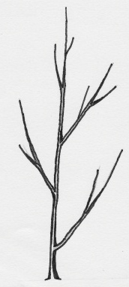 | 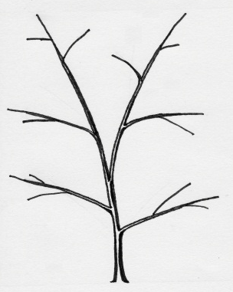 | 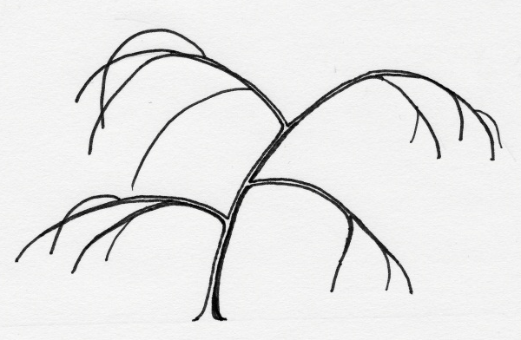
1 | 3 | 5
upright | spreading | drooping

Ad. 3: Plant: branching

Modern Prunus Rootstock varieties are mostly propagated by in-vitro propagation. This type of propagation may affect, in particular, the expression of the respective variety in this characteristic. Special attention should be given to this aspect when establishing distinctness.

Ad. 4: One-year-old shoot: thickness
Ad. 5: One-year-old shoot: length of internode
Ad. 7: One-year-old shoot: number of lenticels

To be observed at the middle third of the shoot.

Ad. 6: One-year-old shoot: pubescence

Should be assessed at the upper third of the shoot.

Ad. 8: One-year-old shoot: anthocyanin coloration of apex

Should be assessed on the sunny side of the shoot.

Ad. 9: One-year-old shoot: position of vegetative bud in relation to shoot

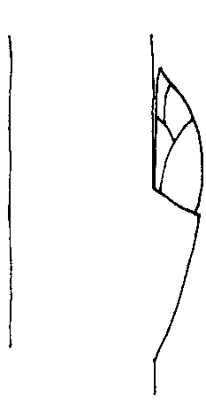 | 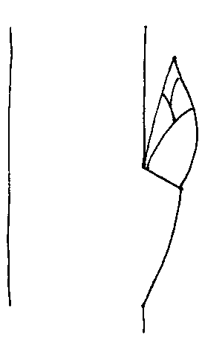 | 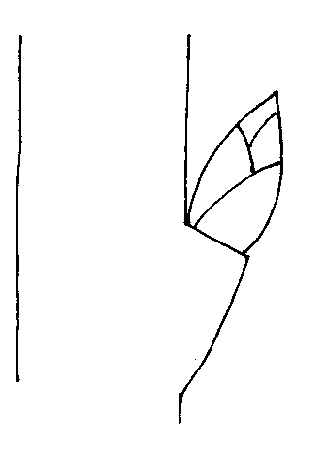
1 | 2 | 3
adpressed | slightly held out | markedly held out

Ad. 11: One-year-old shoot: shape of apex of vegetative bud

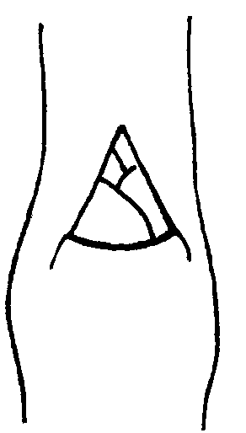 | 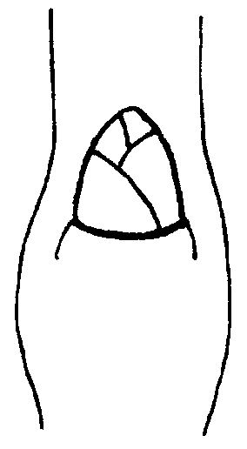 | 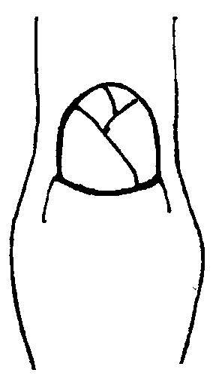
1 | 2 | 3
acute | obtuse | rounded

Ad. 12: One-year-old shoot: size of vegetative bud support

 | 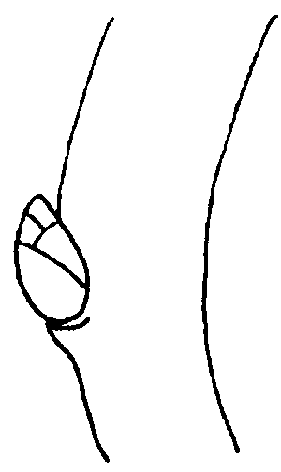 | 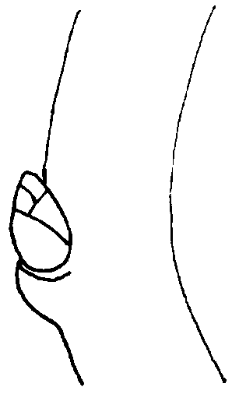
1 | 2 | 3
small | medium | large

Ad. 13: One-year-old shoot: feathering

Feathering is the presence of secondary shoots on current year shoots. Should be assessed at the end of summer.

Ad. 14: Young shoot: anthocyanin coloration of young leaf

Should be assessed during rapid growth.

Ad. 17: Leaf blade: ratio length/width
Ad. 18: Leaf blade: shape

 |  | ← broadest part →
 |  | below middle | at middle | above middle
broad (low) width (ratio length/width) narrow (high) |  | 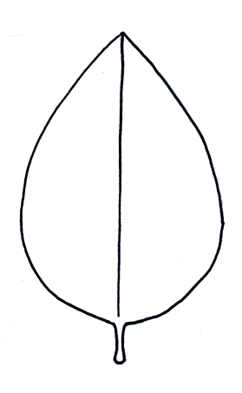  2  medium ovate | 5  narrow elliptic
 |  | 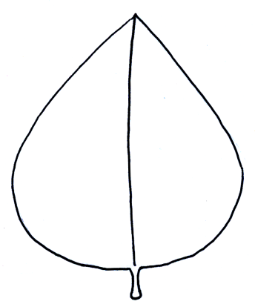  1  broad ovate | 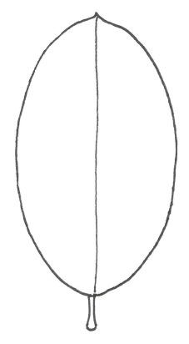  4  medium elliptic | 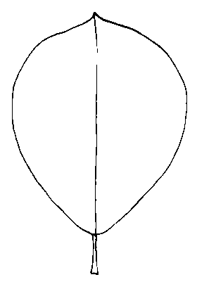  6  obovate
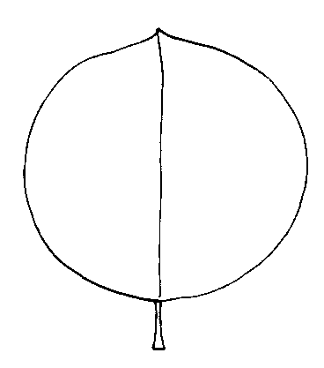
3
circular
Ad. 19: Leaf blade: angle at apex

Should be assessed excluding the tip.

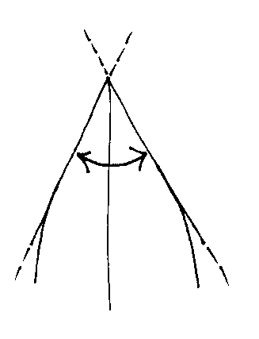 | 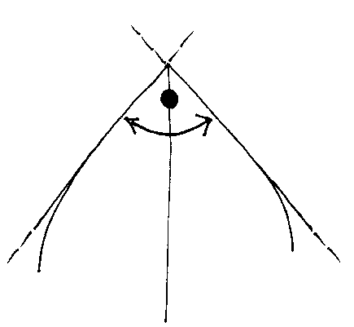
1 | 2 | 3
acute | right-angled | obtuse

Ad. 20: Leaf blade: length of tip

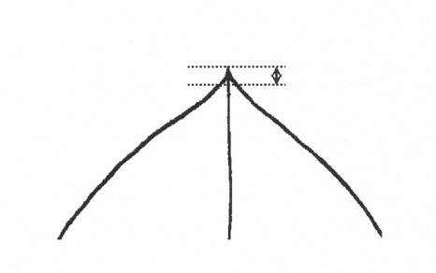 | 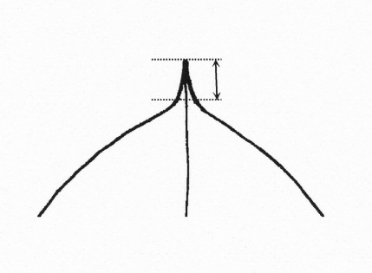
1 | 3 | 5
short | medium | long

Ad. 21: Leaf blade: shape of base

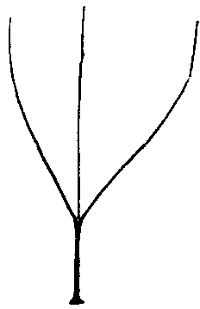 | 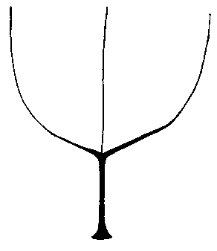 | 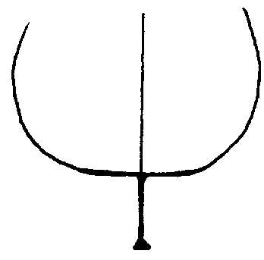
1 | 2 | 3
acute | obtuse | truncate

Ad. 25: Leaf blade: incisions of margin

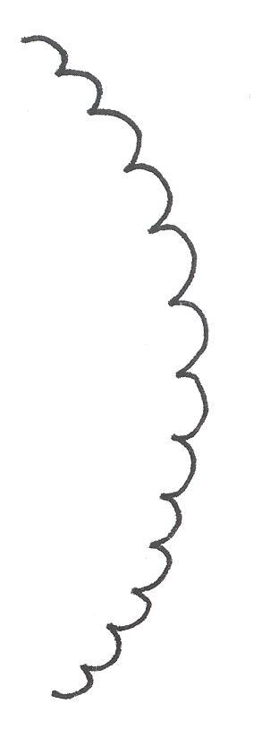 | 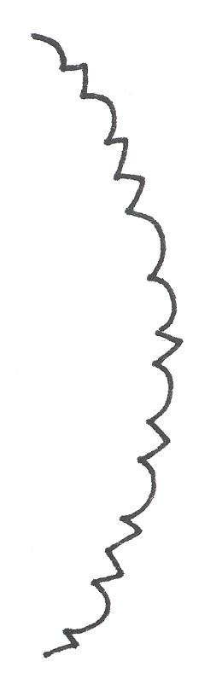 | 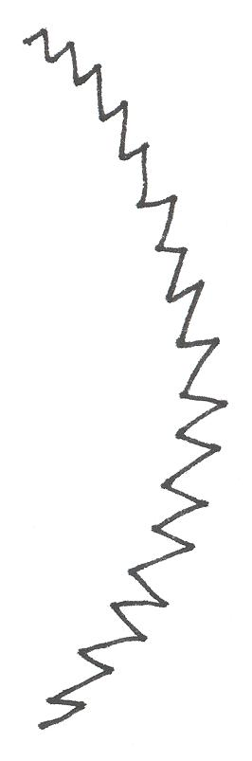
1 | 2 | 3
crenate | crenate and serrate | serrate

Ad. 29: Petiole: depth of groove

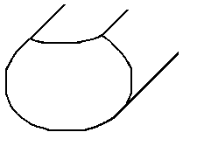 | 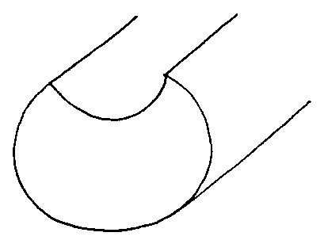 | 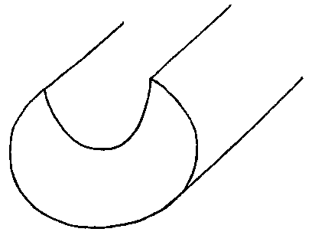
1 | 2 | 3
shallow | medium | deep

8.3 Explanations on the Example Varieties

Example var. | Use * | Species
Adafuel | PL | Prunus dulcis (Mill.) D.A. Webb x P. persica (L.) Batsch.
Adara | PL | Prunus cerasifera Ehrh., open pollinated
Adesoto | PL | Prunus domestica L. ssp. insititia (L.) Schneid
Alkavo | C | (syn. Altenweddinger Kaukasische Vogelkirsche) Prunus avium (L.) L.
Brokforest | C | (syn. M x M14) Prunus mahaleb L. x P. avium (L.) L.
Brooks-60 | C | (syn. Broksec, M x M60) Prunus mahaleb L. x P. avium (L.) L.
Citation | AP, PE | Prunus domestica L. x P. persica (L.) Batsch.
Colt | C | Prunus avium (L.) L. x P. pseudocerasus Lindl.
Edabriz | C | Prunus cerasus L.
Felinem | PL | Prunus persica (L.) Batsch. x P. dulcis (Mill.) D.A. Webb
Ferciana | PL | (Prunus cerasifera Ehrh. x P. salicina Lindl.) x (P. domestica L. x P. persica (L.) Batsch.)
Fereley | PL | (Prunus salicina Lindl. x P. cerasifera Ehrh.) x P. spinosa L.
Ferlenain | PL | Prunus besseyi L.H. Bailey x P. cerasifera Ehrh.
GF 8-1 | PL | Prunus marianna ined.
GF 305 | PE | Prunus persica (L.) Batsch.
GF 655-2 | PL | Prunus domestica L. ssp. insititia (L.) Schneid.
GF 677 | PL | Prunus persica (L.) Batsch. x P. dulcis (Mill.) D.A. Webb
GF 1869 | PL | Prunus domestica (L.) x P. persica (L.) Batsch.
Gisela 4 | C | (syn. 473/10) Prunus avium (L.) L. x P. fruticosa Pall.
Gisela 5 | C | (syn. 148/2) Prunus cerasus L. x P. canescens Bois
GM 61/1 | C | Prunus dawyckensis Sealy
Greenpac | AL, PE | [Prunus persica (L.) Batsch x P. davidiana (L.) Batsch.] x [P. dulcis (Mill.) D.A.Webb x P. persica]
Hamyra | PL | Prunus cerasifera Ehrh.
Mayor | PE, PL | Prunus persica (L.) Batsch. x P. dulcis (Mill.) D.A. Webb
MF 12/1 | C | Prunus avium (L.) L.
Myrobalan B | PL | Prunus cerasifera Ehrh.
Myruni | PL | Prunus cerasifera Ehrh.
Piku 1 | C | (syn. Pi-Ku 4,20) Prunus avium (L.) L. x (P. canescens Bois x P. tomentosa Thunb. ex Murr.)
Piku 3 | C | (syn. Pi-Ku 4,83) Prunus. pseudocerasus Lindl. x (P. canescens Bois x P. incisa Thunb. ex Murr.)
Pixy | PL | Prunus domestica L. ssp. insititia (L.) Schneid.
Prudom | PL | Prunus domestica L. ssp. domestica
Prunus besseyi | PL | Prunus besseyi L.H. Bailey
Pumiselekt | AP, PE | Prunus pumila L.
Rubira | PE | Prunus persica (L.) Batsch.
SL 64 | C | (syn. ‘Saint Lucie 64’) Prunus mahaleb L.
St. Julien A | PL | Prunus domestica L. ssp. insititia (L.) Schneid.
Ute | PL | Prunus domestica L. ssp. domestica
VVA 1 | PL | Prunus cerasifera Ehrh. x P. tomentosa Thunb.
Wangenheim | PL | Prunus domestica L. ssp. domestica
Weiroot 158 | C | Prunus cerasus L.
Weito T 6 | C, PL | Prunus tomentosa Thunb. ex Murr.

*
AL: for use as rootstock for almond varieties
AP: for use as rootstock for apricot varieties
C: for use as rootstock for cherry varieties
PE: for use as rootstock for peach varieties
PL: for use as rootstock for plum varieties

Literature

Anonymous, 1997: The Brooks and Olmo Register of Fruit & Nut Varieties. ASHS Press, 3rd edition. Alexandria VA, US, 744 p..

De Haas, P.G., 1976: Die Unterlagen- und Baumformen des Kern- und Steinobstes. Stuttgart: Ulmer Verlag. DE.

Friedrich, G., 1993: Handbuch des Obstbaus. Radebeul: Neumann Verlag. DE.

Kester, D. E., C. Grasselly, 1987: Almond rootstocks, in: Roy C. Rom and Robert F. Carlson: Rootstocks for Fruit Crops. J. Wiley and Sons, pp. 265-293.

Layne, R. E. C., 1987: Peach rootstocks, in: Roy C. Rom and Robert F. Carlson: Rootstocks for Fruit Crops. J. Wiley and Sons, pp. 185-216.

Maurer, E., 1939: Die Unterlagen der Obstgehölze. Berlin: Parey Verlag. DE.

Okie, W. R., 1987: Plum rootstocks, in: Roy C. Rom and Robert F. Carlson: Rootstocks for Fruit Crops. J. Wiley and Sons, pp. 321-360.

Perry, R. L., 1987: Cherry rootstocks, in: Roy C. Rom and Robert F. Carlson: Rootstocks for Fruit Crops. J. Wiley and Sons, pp. 217-264.

Raynaud, P. C., Audergon, J.M., 1987: Apricot rootstocks, in: Roy C. Rom and Robert F. Carlson: Rootstocks for Fruit Crops. J. Wiley and Sons, pp. 295-320.

Salesses, G., Grasselly, C., Renaud, R., Claverie, J., 1992: Les porte greffe des espèces fruitières à noyau du genre Prunus. “Amélioration des espèces végétales cultivées. Objectifs et critères de sélection”, pp. 768, A. Gallais, H. Bannerot I.N.R.A. Paris, FR, pp. 605-619.

Wertheim, S.J., 1998: Rootstock Guide. Publication no. 25, Fruit Research Station Wilhelminadorp, NL.

Technical Questionnaire

TECHNICAL QUESTIONNAIRE |  |  |  | Page {x} of {y} |  |  | Reference Number:
 |  |  |  |  |  |  | Application date:
 |  |  |  |  |  |  | (not to be filled in by the applicant)
TECHNICAL QUESTIONNAIRE
to be completed in connection with an application for plant breeders’ rights

1. Subject of the Technical Questionnaire
1.1 Botanical name |  |  | Prunus L.
1.2 Common name |  |  | Prunus Rootstock
1.3 Species

1.3.1  1.3.2  1.3.3  1.3.4  1.3.5  1.3.6 6 [ ]  1.3.7  1.3.8  1.3.9  1.3.10  1.3.11 |  |  | P. armeniaca L. [ ]  P. avium (L.) L. [ ]  P. cerasifera Ehrh. [ ]  P. cerasus L. [ ]  P. domestica L. [ ]  P. dulcis (Mill.) D.A. Webb (P. amygdalus Batsch) [ ]  P. mahaleb L. [ ]  P. persica (L.) Batsch [ ]  P. salicina Lindl. [ ]  other species (please specify) [ ]  interspecific hybrid (please specify) [ ]
2. Applicant
Name
Address
Telephone No.
Fax No.
E-mail address
Breeder (if different from applicant)
3. Proposed denomination and breeder’s reference
Proposed denomination
(if available)

Breeder’s reference
#4. Information on the breeding scheme and propagation of the variety

4.1 Breeding scheme

Variety resulting from:

4.1.1 Crossing

(a) controlled cross [ ]
(please state parent varieties)

(…………………..……………..…) x (……………..…………………..…)
female parent male parent

(b) partially known cross [ ]
(please state known parent variety(ies))

(…………………..……………..…) x (……………..…………………..…)
female parent male parent

(c) unknown cross [ ]

4.1.2 Mutation [ ]
(please state parent variety)

4.1.3 Discovery and development [ ]
(please state where and when discovered and how developed)

4.1.4 Other [ ]
(please provide details)

4.2 Method of propagating the variety

4.2.1 Vegetative propagation

(a) cuttings [ ]

(b) in vitro propagation [ ]

(c) other (state method) [ ]

4.2.2 Seed [ ]

4.2.3 Other [ ]
(please provide details)

5. Characteristics of the variety to be indicated (the number in brackets refers to the corresponding characteristic in Test Guidelines; please mark the note which best corresponds).

 | Characteristics |  |  |  |  | Example Varieties |  |  |  | Note
5.1  (1) | Plant: vigor
 | weak |  |  |  |  | Edabriz, Ferlenain, Pumiselekt |  |  |  | 1[ ]
 | weak to medium |  |  |  |  |  |  |  |  | 2[ ]
 | medium |  |  |  |  | Brokforest, GF 305, GM 61/1, Rubira, Ute |  |  |  | 3[ ]
 | medium to strong |  |  |  |  |  |  |  |  | 4[ ]
 | strong |  |  |  |  | Alkavo, Hamyra, MF 12/1 |  |  |  | 5[ ]
5.2  (2) | Plant: habit
 | upright |  |  |  |  | Colt, Prudom |  |  |  | 1[ ]
 | upright to spreading |  |  |  |  |  |  |  |  | 2[ ]
 | spreading |  |  |  |  | Gisela 5 |  |  |  | 3[ ]
 | spreading to drooping |  |  |  |  |  |  |  |  | 4[ ]
 | drooping |  |  |  |  | Prunus besseyi |  |  |  | 5[ ]
5.3  (4) | One-year-old shoot: thickness
 | thin |  |  |  |  | Edabriz, Gisela 5, Hamyra |  |  |  | 1[ ]
 | thin to medium |  |  |  |  |  |  |  |  | 2[ ]
 | medium |  |  |  |  | Colt, GF 655-2, Pixy |  |  |  | 3[ ]
 | medium to thick |  |  |  |  |  |  |  |  | 4[ ]
 | thick |  |  |  |  | Brooks-60, MF 12/1 |  |  |  | 5[ ]
5.4  (15) | Leaf blade: length
 | very short |  |  |  |  | Myrobalan B |  |  |  | 1[ ]
 | very short to short |  |  |  |  |  |  |  |  | 2[ ]
 | short |  |  |  |  | Edabriz, Weito T 6 |  |  |  | 3[ ]
 | short to medium |  |  |  |  |  |  |  |  | 4[ ]
 | medium |  |  |  |  | Piku 1 |  |  |  | 5[ ]
 | medium to long |  |  |  |  |  |  |  |  | 6[ ]
 | long |  |  |  |  | MF 12/1 |  |  |  | 7[ ]
 | long to very long |  |  |  |  |  |  |  |  | 8[ ]
 | very long |  |  |  |  | GF 677 |  |  |  | 9[ ]
 | Characteristics |  |  |  |  | Example Varieties |  |  |  | Note
5.5  (16) | Leaf blade: width
 | very narrow |  |  |  |  | GF 677 |  |  |  | 1[ ]
 | very narrow to narrow |  |  |  |  |  |  |  |  | 2[ ]
 | narrow |  |  |  |  | Myrobalan B |  |  |  | 3[ ]
 | narrow to medium |  |  |  |  |  |  |  |  | 4[ ]
 | medium |  |  |  |  | Fereley, Weito T6 |  |  |  | 5[ ]
 | medium to broad |  |  |  |  |  |  |  |  | 6[ ]
 | broad |  |  |  |  | Brooks-60, MF 12/1 |  |  |  | 7[ ]
 | broad to very broad |  |  |  |  |  |  |  |  | 8[ ]
 | very broad |  |  |  |  | Colt |  |  |  | 9[ ]
5.6  (18) | Leaf blade: shape
 | broad ovate |  |  |  |  | Edabriz, Gisela 5 |  |  |  | 1[ ]
 | medium ovate |  |  |  |  | Greenpac |  |  |  | 2[ ]
 | circular |  |  |  |  | Adara, Hamyra, Prudom, SL 64 |  |  |  | 3[ ]
 | medium elliptic |  |  |  |  | Colt, Fereley, Pixy |  |  |  | 4[ ]
 | narrow elliptic |  |  |  |  | GF 677, Pumiselekt |  |  |  | 5[ ]
 | obovate |  |  |  |  | Weiroot 158 |  |  |  | 6[ ]
5.7  (22) | Leaf blade: color of upper side
 | medium green |  |  |  |  | Gisela 5, Hamyra, Pixy, Pumiselekt |  |  |  | 1[ ]
 | dark green |  |  |  |  | Colt |  |  |  | 2[ ]
 | red |  |  |  |  | Citation |  |  |  | 3[ ]
 | reddish brown |  |  |  |  | Rubira |  |  |  | 4[ ]
5.8  (25) | Leaf blade: incisions of margin
 | crenate |  |  |  |  | Pixy |  |  |  | 1[ ]
 | crenate and serrate |  |  |  |  | Adesoto, GF 1869 |  |  |  | 2[ ]
 | serrate |  |  |  |  | Gisela 5, Hamyra, VVA 1, Wangenheim |  |  |  | 3[ ]
5.9  (32) | Leaf: presence of nectaries
 | absent |  |  |  |  | Ferlenain |  |  |  | 1[ ]
 | present |  |  |  |  | GF 677, Pixy, St. Julien A, Weito T 6 |  |  |  | 9[ ]
6. Similar varieties and differences from these varieties

Please use the following table and box for comments to provide information on how your candidate variety differs from the variety (or varieties) which, to the best of your knowledge, is (or are) most similar. This information may help the examination authority to conduct its examination of distinctness in a more efficient way.

Denomination(s) of variety(ies) similar to your candidate variety |  | Characteristic(s) in which your candidate variety differs from the similar variety(ies) |  |  | Describe the expression of the characteristic(s) for the similar variety(ies) |  |  | Describe the expression of the characteristic(s) for your candidate variety
Example |  | One-year-old shoot: pubescence |  |  | absent |  |  | present
Comments:

#7. Additional information which may help in the examination of the variety

7.1 In addition to the information provided in sections 5 and 6, are there any additional characteristics which may help to distinguish the variety?

Yes [ ] No [ ]

(If yes, please provide details)

7.2 Are there any special conditions for growing the variety or conducting the examination?

Yes [ ] No [ ]

(If yes, please provide details)

7.3 Other information

Please provide information on the use of the variety:

AL: for use as rootstock for almond varieties [ ]
AP: for use as rootstock for apricot varieties [ ]
C: for use as rootstock for cherry varieties [ ]
PE: for use as rootstock for peach varieties [ ]
PL: for use as rootstock for plum varieties [ ]

A representative color image of the variety should accompany the Technical Questionnaire.

8. Authorization for release

(a) Does the variety require prior authorization for release under legislation concerning the protection of the environment, human and animal health?

Yes [ ] No [ ]

(b) Has such authorization been obtained?

Yes [ ] No [ ]

If the answer to (b) is yes, please attach a copy of the authorization.

9. Information on plant material to be examined or submitted for examination.

9.1 The expression of a characteristic or several characteristics of a variety may be affected by factors, such as pests and disease, chemical treatment (e.g. growth retardants or pesticides), effects of tissue culture, different rootstocks, scions taken from different growth phases of a tree, etc.

9.2 The plant material should not have undergone any treatment which would affect the expression of the characteristics of the variety, unless the competent authorities allow or request such treatment. If the plant material has undergone such treatment, full details of the treatment must be given. In this respect, please indicate below, to the best of your knowledge, if the plant material to be examined has been subjected to:

(a) Microorganisms (e.g. virus, bacteria, phytoplasma) Yes [ ] No [ ]

(b) Chemical treatment (e.g. growth retardant, pesticide) Yes [ ] No [ ]

(c) Tissue culture Yes [ ] No [ ]

(d) Other factors Yes [ ] No [ ]

Please provide details for where you have indicated “yes”.

……………………………………………………………

9.3 Has the plant material to be examined been tested for the presence of virus or other pathogens?

Yes [ ]
(please provide details as specified by the Authority)

No [ ]

10. I hereby declare that, to the best of my knowledge, the information provided in this form is correct:

Applicant’s name

Signature Date

[End of document]

* These names were correct at the time of the introduction of these Test Guidelines but may be revised or updated. [Readers are advised to consult the UPOV Code, which can be found on the UPOV Website (www.upov.int), for the latest information.]
# Authorities may allow certain of this information to be provided in a confidential section of the Technical Questionnaire.
# Authorities may allow certain of this information to be provided in a confidential section of the Technical Questionnaire.

