 |  | E  TG/186/1  ORIGINAL: English  DATE: 2005-04-06
INTERNATIONAL UNION FOR THE PROTECTION OF NEW VARIETIES OF PLANTS
GENEVA

 | SUGARCANE  UPOV code: SACCH  (Saccharum L.) | *

GUIDELINES

FOR THE CONDUCT OF TESTS

FOR DISTINCTNESS, UNIFORMITY AND STABILITY

Alternative Names:*

Botanical name | English | French | German | Spanish
Saccharum L. | Sugarcane | Canne à sucre | Zuckerrohr | Caña de azúcar

The purpose of these guidelines (“Test Guidelines”) is to elaborate the principles contained in the General Introduction (document TG/1/3), and its associated TGP documents, into detailed practical guidance for the harmonized examination of distinctness, uniformity and stability (DUS) and, in particular, to identify appropriate characteristics for the examination of DUS and production of harmonized variety descriptions.

ASSOCIATED DOCUMENTS

These Test Guidelines should be read in conjunction with the General Introduction and its associated TGP documents.

TABLE OF CONTENTS PAGE

1. Subject of these Test Guidelines 3
2. Material Required 3
3. Method of Examination 3
3.1 Number of Growing Cycles 3
3.2 Testing Place 3
3.3 Conditions for Conducting the Examination 3
3.4 Test Design 4
3.5 Number of Plants / Parts of Plants to be Examined 4
3.6 Additional Tests 4
4. Assessment of Distinctness, Uniformity and Stability 4
4.1 Distinctness 4
4.2 Uniformity 5
4.3 Stability 5
5. Grouping of Varieties and Organization of the Growing Trial 5
6. Introduction to the Table of Characteristics 6
6.1 Categories of Characteristics 6
6.2 States of Expression and Corresponding Notes 6
6.3 Types of Expression 6
6.4 Example Varieties 6
6.5 Legend 7
7. Table of Characteristics/Tableau des
caractères/Merkmalstabelle/Tabla de caracteres 8
8. Explanations on the Table of Characteristics 21
8.1 Explanations covering several characteristics 21
8.2 Explanations for individual characteristics 21
9. Literature 29
10. Technical Questionnaire 30

Subject of these Test Guidelines
These Test Guidelines apply to all vegetatively propagated varieties of Saccharum L. of the family Gramineae (Poaceae).

Material Required
2.1 The competent authorities decide on the quantity and quality of the plant material required for testing the variety and when and where it is to be delivered. Applicants submitting material from a State other than that in which the testing takes place must ensure that all customs formalities and phytosanitary requirements are complied with.

2.2 The material is to be supplied from plants which are about 8 to 12 months old.

2.3 The minimum quantity of plant material, to be supplied by the applicant, should be:

12 segments of culm used for vegetative propagation of sugarcane
with 3 buds each, properly packaged to minimize damage to the buds.

2.4 The plant material supplied should be visibly healthy, not lacking in vigor, nor affected by any important pest or disease.

2.5 The plant material should not have undergone any treatment which would affect the expression of the characteristics of the variety, unless the competent authorities allow or request such treatment. If it has been treated, full details of the treatment must be given.

Method of Examination

3.1 Number of Growing Cycles
The minimum duration of tests should normally be a single growing cycle.

3.2 Testing Place
Tests are normally conducted at one place. In the case of tests conducted at more than one place, guidance is provided in TGP/9 “Examining Distinctness”.

3.3 Conditions for Conducting the Examination
3.3.1 The tests should be carried out under conditions ensuring satisfactory growth for the expression of the relevant characteristics of the variety and for the conduct of the examination.

3.3.2 All characteristics should be observed on plants aged between 10 to 12 months, in the first vegetative cycle of the crop (from planting to the first harvest).

3.3.3 The recommended method of observing the characteristic is indicated by the following key in the second column of the Table of Characteristics:

MS: measurement of a number of individual plants or parts of plants

3.4 Test Design
3.4.1 Each test should be designed to result in a total of at least 24 culms, all from different stools, which should be divided between two or more replicates. A stool is a cluster of culms (and their leaves) derived from a single segment of culm used for vegetative propagation of sugarcane. It also includes the underground position of the culms (rhizomes and roots) and is analogous to a single plant.

3.4.2 The design of the tests should be such that plants or parts of plants may be removed for measurement or counting without prejudice to the observations which must be made up to the end of the growing cycle.

3.5 Number of Plants / Parts of Plants to be Examined
3.5.1 Unless otherwise indicated, all observations for qualitative characteristics should be made on 6 culms or parts taken from 6 culms.

3.5.2 Unless otherwise indicated, all observations for quantitative characteristics should be made on 24 culms or parts taken from each of 24 culms.

3.5.3 Unless otherwise indicated, all observations on single culms should be made on 6 culms or parts taken from each of 6 culms.

3.6 Additional Tests
Additional tests, for examining relevant characteristics, may be established.

Assessment of Distinctness, Uniformity and Stability

4.1 Distinctness

4.1.1 General Recommendations

It is of particular importance for users of these Test Guidelines to consult the General Introduction prior to making decisions regarding distinctness. However, the following points are provided for elaboration or emphasis in these Test Guidelines.

4.1.2 Consistent Differences

The differences observed between varieties may be so clear that more than one growing cycle is not necessary. In addition, in some circumstances, the influence of the environment is not such that more than a single growing cycle is required to provide assurance that the differences observed between varieties are sufficiently consistent. One means of ensuring that a difference in a characteristic, observed in a growing trial, is sufficiently consistent is to examine the characteristic in at least two independent growing cycles.

4.1.3 Clear Differences

Determining whether a difference between two varieties is clear depends on many factors, and should consider, in particular, the type of expression of the characteristic being examined, i.e. whether it is expressed in a qualitative, quantitative, or pseudo-qualitative manner. Therefore, it is important that users of these Test Guidelines are familiar with the recommendations contained in the General Introduction prior to making decisions regarding distinctness.

4.2 Uniformity
4.2.1 It is of particular importance for users of these Test Guidelines to consult the General Introduction prior to making decisions regarding uniformity. However, the following points are provided for elaboration or emphasis in these Test Guidelines:

4.2.2 For the assessment of uniformity, a population standard of 1% and an acceptance probability of at least 95% should be applied. In the case of a sample size of 6 culms
1 off-type is allowed. In the case of a sample size of 24 culms, 1 off-type is allowed.

4.3 Stability
4.3.1 In practice, it is not usual to perform tests of stability that produce results as certain as those of the testing of distinctness and uniformity. However, experience has demonstrated that, for many types of variety, when a variety has been shown to be uniform, it can also be considered to be stable.

4.3.2 Where appropriate, or in cases of doubt, stability may be tested, either by growing a further generation, or by testing a new plant stock to ensure that it exhibits the same characteristics as those shown by the previous material supplied.

Grouping of Varieties and Organization of the Growing Trial
5.1 The selection of varieties of common knowledge to be grown in the trial with the candidate varieties and the way in which these varieties are divided into groups to facilitate the assessment of distinctness is aided by the use of grouping characteristics.

5.2 Grouping characteristics are those in which the documented states of expression, even where produced at different locations, can be used, either individually or in combination with other such characteristics: (a) to select varieties of common knowledge that can be excluded from the growing trial used for examination of distinctness; and (b) to organize the growing trial so that similar varieties are grouped together.

5.3 The following have been agreed as useful grouping characteristics:

(a) Internode: color where not exposed to sun (characteristic 13)
Gr. 1: yellow
Gr. 2: yellow green
Gr. 3: grey yellow
Gr. 4: grey orange
Gr. 5: grey red
Gr. 6: grey purple

(b) Node: shape of bud, excluding wings (characteristic 21)

5.4 Guidance for the use of grouping characteristics, in the process of examining distinctness, is provided through the General Introduction.

Introduction to the Table of Characteristics

6.1 Categories of Characteristics

6.1.1 Standard Test Guidelines Characteristics
Standard Test Guidelines characteristics are those which are approved by UPOV for examination of DUS and from which members of the Union can select those suitable for their particular circumstances.

6.1.2 Asterisked Characteristics
Asterisked characteristics (denoted by *) are those included in the Test Guidelines which are important for the international harmonization of variety descriptions and should always be examined for DUS and included in the variety description by all members of the Union, except when the state of expression of a preceding characteristic or regional environmental conditions render this inappropriate.

6.2 States of Expression and Corresponding Notes
States of expression are given for each characteristic to define the characteristic and to harmonize descriptions. Each state of expression is allocated a corresponding numerical note for ease of recording of data and for the production and exchange of the description.

6.3 Types of Expression
An explanation of the types of expression of characteristics (qualitative, quantitative and pseudo-qualitative) is provided in the General Introduction.

6.4 Example Varieties
Where appropriate, example varieties are provided to clarify the states of expression of each characteristic.

6.5 Legend
(*) Asterisked characteristic – see Chapter 6.1.2

MS: Measurement of a number of individual plants or parts of plants – see Chapter 3.3.1

(a)-(c) See Explanations on the Table of Characteristics in Chapter 8.1

(+) See Explanations on the Table of Characteristics in Chapter 8.2

Table of Characteristics/Tableau des caractères/Merkmalstabelle/Tabla de caracteres

 | English | français | deutsch | español | Example Varieties  Exemples  Beispielssorten  Variedades ejemplo | Note/  Nota
1. | Plant: stool growth habit | Plante: port de la souche | Pflanze: Wuchstyp der Mutterpflanze | Planta: porte de la cepa
 | erect | dressé | aufrecht | erecto | Q186, Q 121 | 1
 | semi-erect | demi-dressé | halbaufrecht | semierecto | Q96, RB72-454 | 3
 | intermediate | demi-dressé à demi-étalé | mittel | intermedio |  | 5
 | semi-prostrate | demi-étalé | halbliegend | semipostrado | H56-752 | 7
 | prostrate | étalé | liegend | postrado |  | 9
2.  (*)  (+) | Plant: adherence of leaf sheath | Plante: adhérence de la gaine de la feuille | Pflanze: Anhaften der Blattscheide | Planta: adherencia de la vaina de la hoja
 | weak | faible | gering | débil | H56-752, Q96 | 3
 | medium | moyenne | mittel | media | Q124, Q186 | 5
 | strong | forte | stark | fuerte | Q120, NC0 310, Q201 | 7
3. | Plant: tillering | Plante: tallage | Pflanze: Bestockung | Planta: macollaje
 | weak | faible | gering | débil | Q124 | 3
 | medium | moyen | mittel | medio | RB72-454 | 5
 | strong | fort | stark | fuerte | Q138 | 7
4. | Plant: number of suckers | Plante: nombre de drageons | Pflanze: Anzahl Stockausschlag | Planta: número de chupones
 | very few | très faible | sehr wenig | muy pocos | Q117, RB72-454 | 1
 | few | faible | wenig | pocos | Q121 | 3
 | medium | moyen | mittel | medios | BN81-1394 | 5
 | many | fort | viel | muchos |  | 7
5. | Plant: leaf canopy | Plante: feuillage | Pflanze: Blattlaub | Planta: follaje
 | very sparse | très clairsemé | sehr locker | muy abierto | RB72-454 | 1
 | sparse | clairsemé | locker | abierto | H56-752 | 3
 | medium | moyen | mittel | medio | Q96, Q115 | 5
 | dense | dense | dicht | denso |  | 7
6. | Plant: intensity of green color of leaf canopy | Plante: intensité de la couleur verte du feuillage | Pflanze: Intensität der Grünfärbung des Blattlaubs | Planta: intensidad del color verde del follaje
 | light | claire | hell | claro |  | 3
 | medium | moyenne | mittel | medio |  | 5
 | dark | foncée | dunkel | oscuro |  | 7
7.  (+) | Culm: height  (from the base to the base of the TVD leaf) | Tige de canne: hauteur (de la base à la base de la dernière feuille dont l’ochréa est visible) | Halm: Höhe (von der Basis bis zur Basis des TVD-Blatts) | Tallo: altura (desde la base hasta la base de la hoja TVD)
MS | short | courte | kurz | corta | Q117 | 3
 | medium | moyenne | mittel | mediana | Q124, Q138, Q170 | 5
 | long | longue | lang | larga | Q136, RB72-454 | 7
8.  (+)  MS | Internode: length on the bud side | Entre-nœud: longueur du côté  du bourgeon | Internodium: Länge an der Knospenseite | Entrenudo: longitud del lado de la yema
(a) | short | court | kurz | corto | Q117 | 3
 | medium | moyen | mittel | mediano | Q138, Q170 | 5
 | long | long | lang | largo | Q124 | 7
9.  (*)  (+)  MS | Internode: diameter  (as for 8) | Entre-nœud: diamètre  (comme pour 8) | Internodium: Durchmesser  (wie für 8) | Entrenudo: diámetro  (como para 8)
(a) | thin | petit | dünn | delgado | Q136 | 3
 | medium | moyen | mittel | medio | Q124, H56-752, Q170 | 5
 | thick | grand | dick | grueso | Q117 | 7
10.  (*)  (+) | Internode: shape | Entre-nœud: forme | Internodium: Form | Entrenudo: forma
(a) | cylindrical | cylindrique | zylindrisch | cilíndrico | Q169, RB72-454 | 1
 | tumescent | renflé | geschwollen | hinchado |  | 2
 | bobbin-shaped | en forme de bobine | spulenförmig | abobinado | H56-752 | 3
 | conoidal | conoïde | kegelförmig | conoidal |  | 4
 | obconoidal | obconique | verkehrt kegelförmig | conoidal invertido | H60-3802 | 5
 | concave-convex | concave-convexe | konkav-konvex | cóncavo-convexo | Q115 | 6
11.  (+) | Internode: cross-section | Entre-nœud: section transversale | Internodium: Querschnitt | Entrenudo: sección transversal
(a) | circular | circulaire | rund | circular | Q121, RB72-454 | 1
 | ovate | ovoïde | eiförmig | ovada | Q96, Q186, Q152 | 2
12.  (*)  (+) | Internode: color where exposed to sun | Entre-nœud: couleur du côté exposé au soleil | Internodium: Farbe an den der Sonne ausgesetzten Stellen | Entrenudo: color de la parte expuesta al sol
(a) | RHS Colour Chart (indicate reference number) | Code RHS des couleurs (indiquer le numéro de référence) | RHS-Farbkarte (Nummer angeben) | Carta de colores RHS (indíquese el número de referencia)
13.  (*)  (+) | Internode: color where not exposed to sun | Entre-nœud: couleur du côté non exposé au soleil | Internodium: Farbe an den der Sonne  nicht ausgesetzten Stellen | Entrenudo: color de la parte no expuesta al sol
(a) | RHS Colour Chart (indicate reference number) | Code RHS des couleurs (indiquer le numéro de référence) | RHS-Farbkarte (Nummer angeben) | Carta de colores RHS (indíquese el número de referencia)
14.  (+) | Internode: depth of growth crack | Entre-nœud: profondeur de la fente de croissance | Internodium: Tiefe des Wachstumsrisses | Entrenudo: profundidad de la rajadura de crecimiento
(a) | absent or very shallow | absente ou très peu profonde | fehlend oder sehr flach | ausente o muy poco profunda | RB72-454, H56-752 | 1
 | shallow | peu profonde | flach | poco profunda | Q124 | 3
 | medium | moyenne | mittel | media | Q121 | 5
 | deep | profonde | tief | profunda | Q179 | 7
15.  (*)  (+) | Internode: expression of zigzag alignment | Entre-nœud: expression de l’alignement en zigzag | Internodium: Ausprägung der Zickzackausrichtung | Entrenudo: expresión de la alineación en zig zag
(a) | absent or very weak | absente ou très faible | fehlend oder sehr gering | ausente o muy débil | Q124 | 1
 | weak | faible | gering | débil | Q135, Q152 | 3
 | moderate | moyenne | mittel | moderada | Q117 | 5
 | strong | forte | stark | fuerte | H56-752 | 7
16.  (+) | Internode: appearance (rind surface) | Entre-nœud: apparence (surface de l’écorce) | Internodium: Aussehen (Oberfläche der Schale) | Entrenudo: aspecto (superficie de la corteza)
(a) | smooth | lisse | glatt | lisa |  | 3
 | medium | moyenne | mittel | media |  | 5
 | rough (corky) | rugueuse (subéreuse) | rauh (korkartig) | rugosa (suberosa) |  | 7
17.  (+) | Internode: waxiness | Entre-nœud: pruine | Internodium: Wachsschicht | Entrenudo: cerosidad
(a) | absent or very weak | absente ou très faible | fehlend oder sehr gering | ausente o muy débil | Q179 | 1
 | weak | faible | gering | débil | Q138 | 3
 | medium | moyenne | mittel | media | Q121, RB72-454 | 5
 | strong | forte | stark | fuerte | H56-752, Q117 | 7
18.  (+) | Node: width of root band | Nœud: largeur de la zone radiculaire | Nodium: Breite der Wurzelzone | Nudo: anchura de la zona radicular
(a) | narrow | étroite | schmal | estrecha | Q121 | 3
 | medium | moyenne | mittel | mediana | Q124 | 5
 | broad | large | breit | ancha | H56-752 | 7
19.  (+) | Node: color of root band | Nœud: couleur de la zone radiculaire | Nodium: Farbe der Wurzelzone | Nudo: color de la zona radicular
(a) | RHS Colour Chart (indicate reference number) | Code RHS des couleurs (indiquer le numéro de référence) | RHS-Farbkarte (Nummer angeben) | Carta de colores RHS (indíquese el número de referencia)
20.  (+) | Node: wax ring | Nœud: zone cireuse | Nodium: Wachsring | Nudo: anillo ceroso
(a) | absent or very  narrow | absente ou très  étroite | fehlend oder sehr schmal | ausente o muy estrecho | Q179 | 1
 | narrow | étroite | schmal | estrecho |  | 3
 | medium | moyenne | mittel | mediano | Q113, Q96, RB72-454 | 5
 | wide | large | breit | ancho | Q115, Q138 | 7
 | very wide | très large | sehr breit | muy ancho |  | 9
21.  (*)  (+) | Node: shape of bud, excluding wings | Nœud: forme du bourgeon, à l’exclusion des ailes | Nodium: Form der Knospe, ohne Flügel | Nudo: forma de la yema, excluyendo las alas
(a) | triangular-pointed | triangulaire-pointue | dreieckig-spitz | triangular-puntiaguda | RB72-454 | 1
 | oval | ovale | elliptisch | oval | Q138 | 2
 | obovate | obovale | verkehrt eiförmig | trasovada |  | 3
 | pentagonal | pentagonale | fünfeckig | pentagonal |  | 4
 | rhomboid | rhomboïdale | rhomboid | romboide |  | 5
 | round | ronde | rund | redonda | Q179, Q124 | 6
 | ovate | ovoïde | eiförmig | ovada | Q170, Q115, Q186 | 7
 | rectangular | rectangulaire | rechteckig | rectangular |  | 8
 | beaked | becquée | schnabelförmig | en pico |  | 9
22.  (+) | Node: width of bud, excluding wings | Nœud: largeur du bourgeon, à l’exclusion des ailes | Nodium: Breite der Knospe, ohne Flügel | Nudo: anchura de la yema, excluyendo las alas
(a) | very narrow | très étroit | sehr schmal | muy estrecha |  | 1
 | narrow | étroit | schmal | estrecha | Q138 | 3
 | medium | moyen | mittel | mediana |  | 5
 | wide | large | breit | ancha | Q121, Q124 | 7
 | very wide | très large | sehr breit | muy ancha | Q136, H56-752 | 9
23.  (+) | Node: bud prominence (on second senescent leaf from the top) | Nœud: proéminence du bourgeon (sur la deuxième feuille sénescente à partir du sommet) | Nodium: Knospenausbildung (am zweiten alternden Blatt von oben) | Nudo: prominencia de la yema (en la segunda hoja senescente a partir de la parte superior)
(a) | very weak | très faible | sehr gering | muy débil | Q152 | 1
 | weak | faible | gering | débil | RB72-454 | 3
 | medium | moyenne | mittel | media | Q121, H56-752 | 5
 | strong | forte | stark | fuerte | Q136 | 7
24.  (+) | Node: depth of bud groove | Nœud: profondeur du sillon du bourgeon | Nodium: Tiefe der Knospenfurche | Nudo: profundidad del canal de la yema
(a) | absent or very shallow | absent ou très peu profond | fehlend oder sehr flach | ausente o muy poco profundo | Q121, Q186, Q117 | 1
 | shallow | peu profond | flach | poco profundo | RB72-454, Q170, Q138 | 3
 | medium | moyen | mittel | medio | Q179 | 5
 | deep | profond | tief | profundo |  | 7
25.  (+) | Node: length of bud groove | Nœud: longueur du sillon du bourgeon | Nodium: Länge der Knospenfurche | Nudo: longitud del canal de la yema
(a) | short | court | kurz | corta | Q121 | 3
 | medium | moyen | mittel | media | Q135, Q138 | 5
 | long | long | lang | larga | Q179, Q96, H56-752 | 7
26.  (+) | Node: position of bud tip in relation to growth ring | Nœud: position du sommet du bourgeon par rapport à l’anneau de croissance | Nodium: Stellung der Knospenspitze im Verhältnis zum Wachstumsring | Nudo: posición del ápice de la yema en relación con el anillo de crecimiento
(a) | clearly below | nettement en-dessous | deutlich unterhalb | claramente por debajo |  | 1
 | intermediate | intermédiaire | in der Mitte | intermedio | RB72-454, Q179 | 2
 | clearly above | nettement en-dessus | deutlich oberhalb | claramente por encima | Q121 | 3
27.  (+) | Node: pubescence on the bud | Nœud: pilosité sur le bourgeon | Nodium: Behaarung an der Knospe | Nudo: pubescencia en la yema
(a) | absent | absente | fehlend | ausente |  | 1
 | present | présente | vorhanden | presente |  | 9
28.  (+) | Node: position of the pubescence on the bud | Nœud: position des poils sur le bourgeon | Nodium: Lage der Behaarung an der Knospe | Nudo: posición de la pubescencia en la yema
(a) | basal | basale | an der Basis | basal |  | 1
 | apical | apicale | an der Spitze | apical |  | 2
 | lateral | latérale | seitlich | lateral |  | 3
29.  (+) | Node: bud cushion (space between base of bud and leaf scar) | Nœud: coussinet du bourgeon (espace entre la base du bourgeon et la cicatrice foliaire) | Nodium: Knospenwulst (Abstand zwischen der Knospenbasis und der Blattnarbe) | Nudo: cojín de la yema (espacio entre la base de la yema y la cicatriz foliar)
(a) | absent or very  narrow | absent ou très  étroit | fehlend oder sehr schmal | ausente o muy estrecho | Q121, Q186 | 1
 | narrow | étroit | schmal | estrecho | Q96 | 3
 | medium | moyen | mittel | mediano | RB72-454, Q181 | 5
 | wide | large | breit | ancho | Q170 | 7
30.  (+) | Node: width of bud wing | Nœud: largeur de l’aile du bourgeon | Nodium: Breite des Knospenflügels | Nudo: anchura del ala de la yema
(a) | narrow | étroite | schmal | estrecha | RB72-454 | 3
 | medium | moyenne | mittel | mediana | Q121 | 5
 | wide | large | breit | ancha | BN81-1394 | 7
31.  (+)  MS | Leaf sheath: length | Gaine de la feuille: longueur | Blattscheide: Länge | Vaina de la hoja: longitud
(b) | short | courte | kurz | corta | Q117 | 3
 | medium | moyenne | mittel | mediana | Q136, Q170 | 5
 | long | longue | lang | larga | Q121, Q124 | 7
32.  (+) | Leaf sheath: number of hairs (groups 57 and 60) | Gaine de la feuille: nombre de poils (groupes 57 et 60) | Blattscheide: Anzahl Haare (Gruppen 57 und 60) | Vaina de la hoja: número de pelos (grupos 57 y 60)
(b) | absent or very few | absent ou très petit | fehlend oder sehr gering | ausente o muy pocos | RB72-454, Q186 | 1
 | few | petit | gering | pocos | Q170 | 3
 | medium | moyen | mittel | medio | Q117, Q179 | 5
 | many | grand | groß | numerosos | Q124 | 7
 | very many | très grand | sehr groß | muy numerosos | Q169 | 9
33.  (+) | Leaf sheath: length of hairs (groups 57 and 60) | Gaine de la feuille: longueur des poils (groupes 57 et 60) | Blattscheide: Länge der Haare (Gruppen 57 und 60) | Vaina de la hoja: longitud de los pelos (grupos 57 y 60)
(b) | short | courts | kurz | cortos | Q186 | 3
 | medium | moyens | mittel | medianos | Q117, Q179, Q138 | 5
 | long | longs | lang | largos | Q121 | 7
34.  (+) | Leaf sheath: distribution of hairs | Gaine de la feuille: distribution des poils | Blattscheide: Verteilung der Haare | Vaina de la hoja: distribución de los pelos
(b) | only dorsal | uniquement dorsale | dorsal | únicamente dorsal | Q138, Q170 | 1
 | lateral and dorsal | latérale et dorsale | lateral und dorsal | lateral y dorsal |  | 2
35.  (+) | Leaf sheath: shape of ligule | Gaine de la feuille: forme de la ligule | Blattscheide: Form der Ligula | Vaina de la hoja: forma de la lígula
(b) | strap-shaped | en forme de bande | bandförmig | en forma de correa |  | 1
 | deltoid | deltoïde | deltaförmig | deltoide | H56-752, Q170 | 2
 | crescent-shaped | en forme de croissant | halbmondförmig | en forma de cuarto creciente | Q121, Q96, Q179 | 3
 | bow-shaped | en forme d’arceau | bogenförmig | arqueada |  | 4
 | asymmetrical, steeply sloping | asymétrique, fortement inclinée | asymmetrisch steil abfallend | asimétrica con una inclinación pronunciada |  | 5
 | assymmetrical, horizontal | asymétrique, horizontale | asymmetrisch waagerecht | asimétrica horizontal |  | 6
36.  (+) | Leaf sheath: ligule width | Gaine de la feuille: largeur de la ligule | Blattscheide: Breite der Ligula | Vaina de la hoja: anchura de la lígula
(b) | narrow | étroite | schmal | estrecha |  | 1
 | medium | moyenne | mittel | mediana | Q186, Q115, Q179 | 2
 | wide | large | breit | ancha | H56-752, Q170 | 3
37.  (+) | Leaf sheath: length of ligule hairs (group 61) | Gaine de la feuille: longueur des poils de la ligule (groupe 61) | Blattscheide: Länge der Ligulahaare  (Gruppe 61) | Vaina de la hoja: longitud de los pelos de la lígula (grupo 61)
(b) | short | courts | kurz | cortos | Q96, Q170, Q152 | 3
 | medium | moyens | mittel | medianos | RB72-454, Q179 | 5
 | long | longs | lang | largos | BN81-1394, Q124 | 7
38.  (+) | Leaf sheath: density of ligule hairs (group 61) | Gaine de la feuille: densité des poils de la ligule (groupe 61) | Blattscheide: Dichte der Ligulahaare  (Gruppe 61) | Vaina de la hoja: densidad de los pelos de la lígula (grupo 61)
(b) | absent or very sparse | nulle ou très lâche | fehlend oder sehr locker | ausente o muy laxa |  | 1
 | sparse | lâche | locker | laxa |  | 3
 | medium | moyenne | mittel | mediana | Q152 | 5
 | dense | dense | dicht | densa | Q121, RB72-454 | 7
 | very dense | très dense | sehr dicht | muy densa | Q179 | 9
39.  (+) | Leaf sheath: shape of underlapping auricle | Gaine de la feuille: forme de l’auricule sous-jacente | Blattscheide: Form des unterlappenden Blattöhrchens | Vaina de la hoja: forma de la aurícula subyacente
(b) | transitional | transitoire | durchgehend | transicional | Q121 | 1
 | deltoid | deltoïde | deltaförmig | deltoide | Q186 | 2
 | dentoid | en forme de dent | zahnförmig | dentoide |  | 3
 | unciform | unciforme | hakenförmig | unciforme |  | 4
 | calcarifom | en forme d’éperon | spornförmig | calcariforme |  | 5
 | lanceolate | lancéolée | lanzettlich | lanceolada | RB72-454, H56-752 | 6
 | falcate | falciforme | sichelförmig | falcada |  | 7
40.  (+) | Leaf sheath: size of underlapping auricle | Gaine de la feuille: taille de l’auricule sous-jacente | Blattscheide: Größe des unterlappenden Blattöhrchens | Vaina de la hoja: tamaño de la aurícula subyacente
(b) | small | petite | klein | pequeña | Q96 | 3
 | medium | moyenne | mittel | mediana | Q201 | 5
 | large | grande | groß | grande | Q135 | 7
41.  (+) | Leaf sheath: shape of overlapping auricle | Gaine de la feuille: forme de l’auricule de chevauchement | Blattscheide: Form des überlappenden Blattöhrchens | Vaina de la hoja: forma de la aurícula superpuesta
(b) | transitional | transitoire | durchgehend | transicional | Q121, Q152 | 1
 | deltoid | deltoïde | deltaförmig | deltoide | RB72-454, Q117 | 2
 | dentoid | en forme de dent | zahnförmig | dentoide |  | 3
 | unciform | unciforme | hakenförmig | unciforme |  | 4
 | calcariform | en forme d’éperon | spornförmig | calcariforme |  | 5
 | lanceolate | lancéolée | lanzettlich | lanceolada | Q138 | 6
 | falcate | falciforme | sichelförmig | falcada |  | 7
42.  (+) | Leaf sheath: size of overlapping auricle | Gaine de la feuille: taille de l’auricule de chevauchement | Blattscheide: Größe des überlappenden Blattöhrchens | Vaina de la hoja: tamaño de la aurícula superpuesta
(b) | small | petite | klein | pequeña |  | 3
 | medium | moyenne | mittel | mediana |  | 5
 | large | grande | groß | grande |  | 7
43.  (*)  (+) | Leaf sheath: color of dewlap | Gaine de la feuille: couleur de l’ochréa | Blattscheide: Farbe des Nackens | Vaina de la hoja: color del collar
(b) | RHS Colour Chart (indicate reference number) | code RHS des couleurs (indiquer le numéro de référence) | RHS-Farbkarte (Nummer angeben) | Carta de colores RHS (indíquese el número de referencia)
44. | Leaf blade: curvature | Limbe: courbure | Blattspreite: Biegung | Limbo de la hoja: curvado
(b) | straight | droit | gerade | recto | Q138 | 1
 | curved tips | sommets incurvés | gebogene Spitzen | ápices curvados | H56-752, Q115, Q124 | 2
 | arched | arqué | gebogen | arqueado |  | 3
 | curved at base | incurvé à la base | an der Basis gebogen | curvado a la base |  | 4
45.  (*)  MS | Leaf blade: width at the longitudinal mid-point | Limbe: largeur à mi-longueur | Blattspreite: Breite in der Mitte der Länge | Limbo de la hoja: anchura en el punto medio de la longitud
(b) | narrow | étroit | schmal | estrecho | Q113, Q186 | 3
 | medium | moyen | mittel | mediano | Q121, Q124 | 5
 | broad | large | breit | ancho | Q138, Q179 | 7
46.  MS | Leaf: midrib width (as for 46) | Feuille: largeur de la nervure principale (comme pour 46) | Blatt: Breite der Mittelrippe (wie für 46) | Hoja: anchura de la nervadura principal (como para 46)
(b) | very narrow | très étroite | sehr schmal | muy estrecha |  | 1
 | narrow | étroite | schmal | estrecha | Q121 | 3
 | medium | moyenne | mittel | mediana | Q124, Q170 | 5
 | wide | large | breit | ancha |  | 7
 | very wide | très large | sehr breit | muy ancha | Q138 | 9
47. | Leaf: ratio leaf blade width/midrib width | Feuille: rapport largeur du limbe/épaisseur de la nervure principale | Blatt: Verhältnis der Breite der Blattspreite/Breite der Mittelrippe | Hoja: relación entre la anchura del limbo de la hoja y la anchura de la nervadura principal
(b) | low | faible | niedrig | baja |  | 3
 | medium | moyen | mittel | media | Q124, H56-752 | 5
 | high | important | hoch | alta |  | 7
48.  (+)  MS | Leaf blade: length | Limbe: longueur | Blattspreite: Länge | Limbo de la hoja: longitud
(b) | short | court | kurz | corta | Q124 | 3
 | medium | moyen | mittel | mediana | Q136 | 5
 | long | long | lang | larga | Q170 | 7
49.  (+) | Leaf blade: pubescence on margin | Limbe: pilosité sur le bord | Blattspreite: Behaarung am Rand | Limbo de la hoja: pubescencia en el borde
(b) | absent or very sparse | absente ou très faible | fehlend oder sehr locker | ausente o muy rala | Q121, Q170, Q117 | 1
 | sparse | faible | locker | rala | H56-752 | 3
 | medium | moyenne | mittel | media | Q152 | 5
 | dense | forte | dicht | densa | Q169 | 7
50.  (+) | Leaf blade: serration of margin | Limbe: dentelure du bord | Blattspreite: Randzähnung | Limbo de la hoja: aserrado del borde
(b) | absent | absente | fehlend | ausente |  | 1
 | present | présente | vorhanden | presente | Q121, Q170, H56-752 | 9
51. | Cane top: length | Sommet de la canne: longueur | Rohrspitze: Länge | Parte superior de la caña: longitud
(c) | short | courte | kurz | corta |  | 3
 | medium | moyenne | mittel | mediana |  | 5
 | long | longue | lang | larga |  | 7
52. | Cane top: shape of cross-section | Sommet de la canne: forme de la section transversale | Rohrspitze: Form des Querschnitts | Parte superior de la caña: forma de la sección transversal
(c) | circular | circulaire | rund | circular |  | 1
 | ovate | ovoïde | eiförmig | ovada |  | 2
53. | Cane top: color | Sommet de la canne: couleur | Rohrspitze: Farbe | Parte superior de la caña: color
(c) | RHS Colour Chart (indicate reference number) | code RHS des couleurs (indiquer le numéro de référence) | RHS-Farbkarte (Nummer angeben) | Carta de colores RHS (indíquese el número de referencia)
54. | Cane top: waxiness | Sommet de la canne: pruine | Rohrspitze: Wachsschicht | Parte superior de la caña: cerosidad
(c) | absent or very weak | absente ou très faible | fehlend oder sehr gering | ausente o muy débil |  | 1
 | weak | faible | gering | débil |  | 3
 | medium | moyenne | mittel | media |  | 5
 | strong | forte | stark | fuerte |  | 7

Explanations on the Table of Characteristics

8.1 Explanations covering several characteristics
Characteristics containing the following key in the second column of the Table of Characteristics should be examined as indicated below:

(a) Observation on the node and internode to be made on the largest internode of a representative culm.

(b) Observation on the leaf blade and leaf sheath to be made on the top visible dewlap (TVD) leaf.

(c) The cane top is the region between the youngest exposed visible dewlap and the insertion of the fourth youngest fully extended leave (leaf + 4) in the culm.

8.2 Explanations for individual characteristics

Ad. 2: Plant: adherence of leaf sheath

To be observed on the lower half of the stool on the senescing leaves.

Ad. 7: Culm: height ((from the base to the base of the TVD leaf)

Based on measurements of 24 culms.
TVD leaf = top visible dewlap leaf = 1
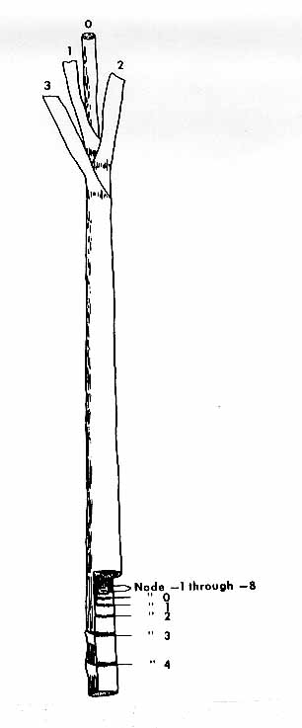
Culm: height

Ad. 8 to 17: Internode and 18 to 30: Node
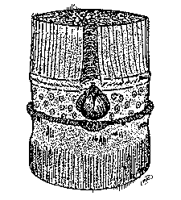
Bud groove (24)
Growth ring (26)
Root band (18, 19)
Wax ring (20)
Bud cushion (29)
Leaf scar (29)
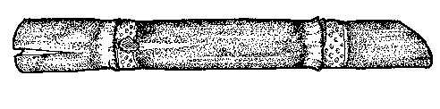
Internode (8 – 17)
Bud (21 - 30)
Wax ring (20)
Growth crack (14)
d = diameter

Bud side
At the central part of the internode on the axis going through the bud
(9)
Ad. 10: Internode shape
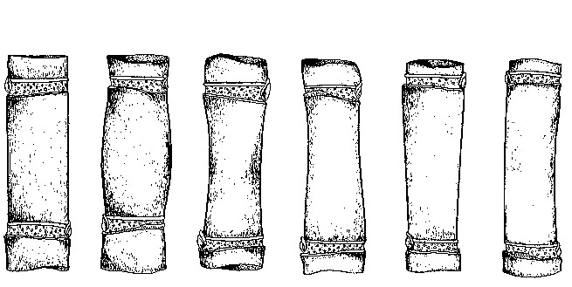1 | 2 | 3 | 4 | 5 | 6
cylindrical | tumescent | bobbin-shaped | conoidal | obconoidal | concave-convex

Ad. 12: Internode: color where exposed to sun

After three days of exposure to the sun on a culm on which the wax has been removed.

Ad. 13: Internode: color where not exposed to sun

On a culm protected from the sun, on which the wax has been removed.

Ad. 15: Internode: expression of zigzag alignment
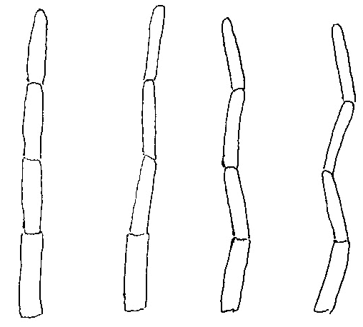

1 | 3 | 5 | 7
absent or very weak | weak | moderate | strong

Ad. 21: Node: shape of bud, excluding wings
wing
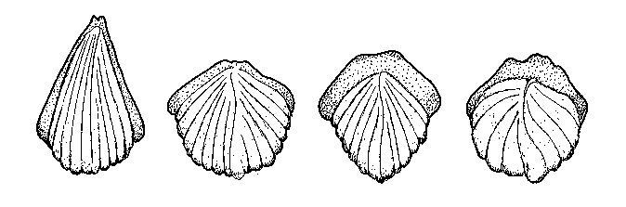

bud

1 | 2 | 3 | 4
triangular pointed | oval | obovate | pentagonal

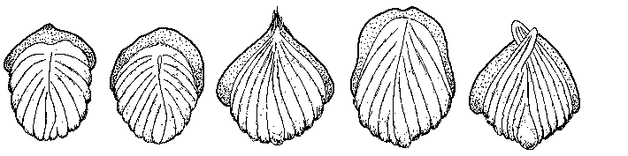

5 | 6 | 7 | 8 | 9
rhomboid | round | ovate | rectangular | beaked

Ad. 31: Leaf sheath: length

The leaf sheath is measured from the sheath base (point of attachment to the culm) to the dewlap (the junction between the leaf blade and the leaf sheath).
Ad. 31 to 43: Leaf sheath and Ad. 48 to 50: Leaf blade
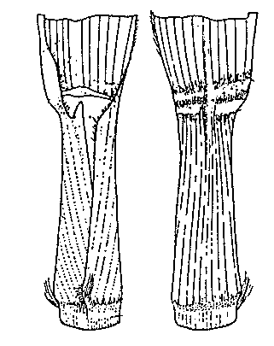
Frontal
Dorsal
Dewlap (43)
Dewlap (43)
Ligule (35 - 38)
Leaf blade (48 - 50)
Group 61 hairs (38)
Group 60 hairs (32, 33)

Underlapping auricle (39, 40)
Group 57 hairs
(32, 33)

Leaf sheath
(31 - 43)

Overlapping auricle (41, 42)

Ad. 32 and 33: Leaf sheath: number of hairs (32) (groups 57 and 60) and length of hairs (33) (groups 57 and 60)

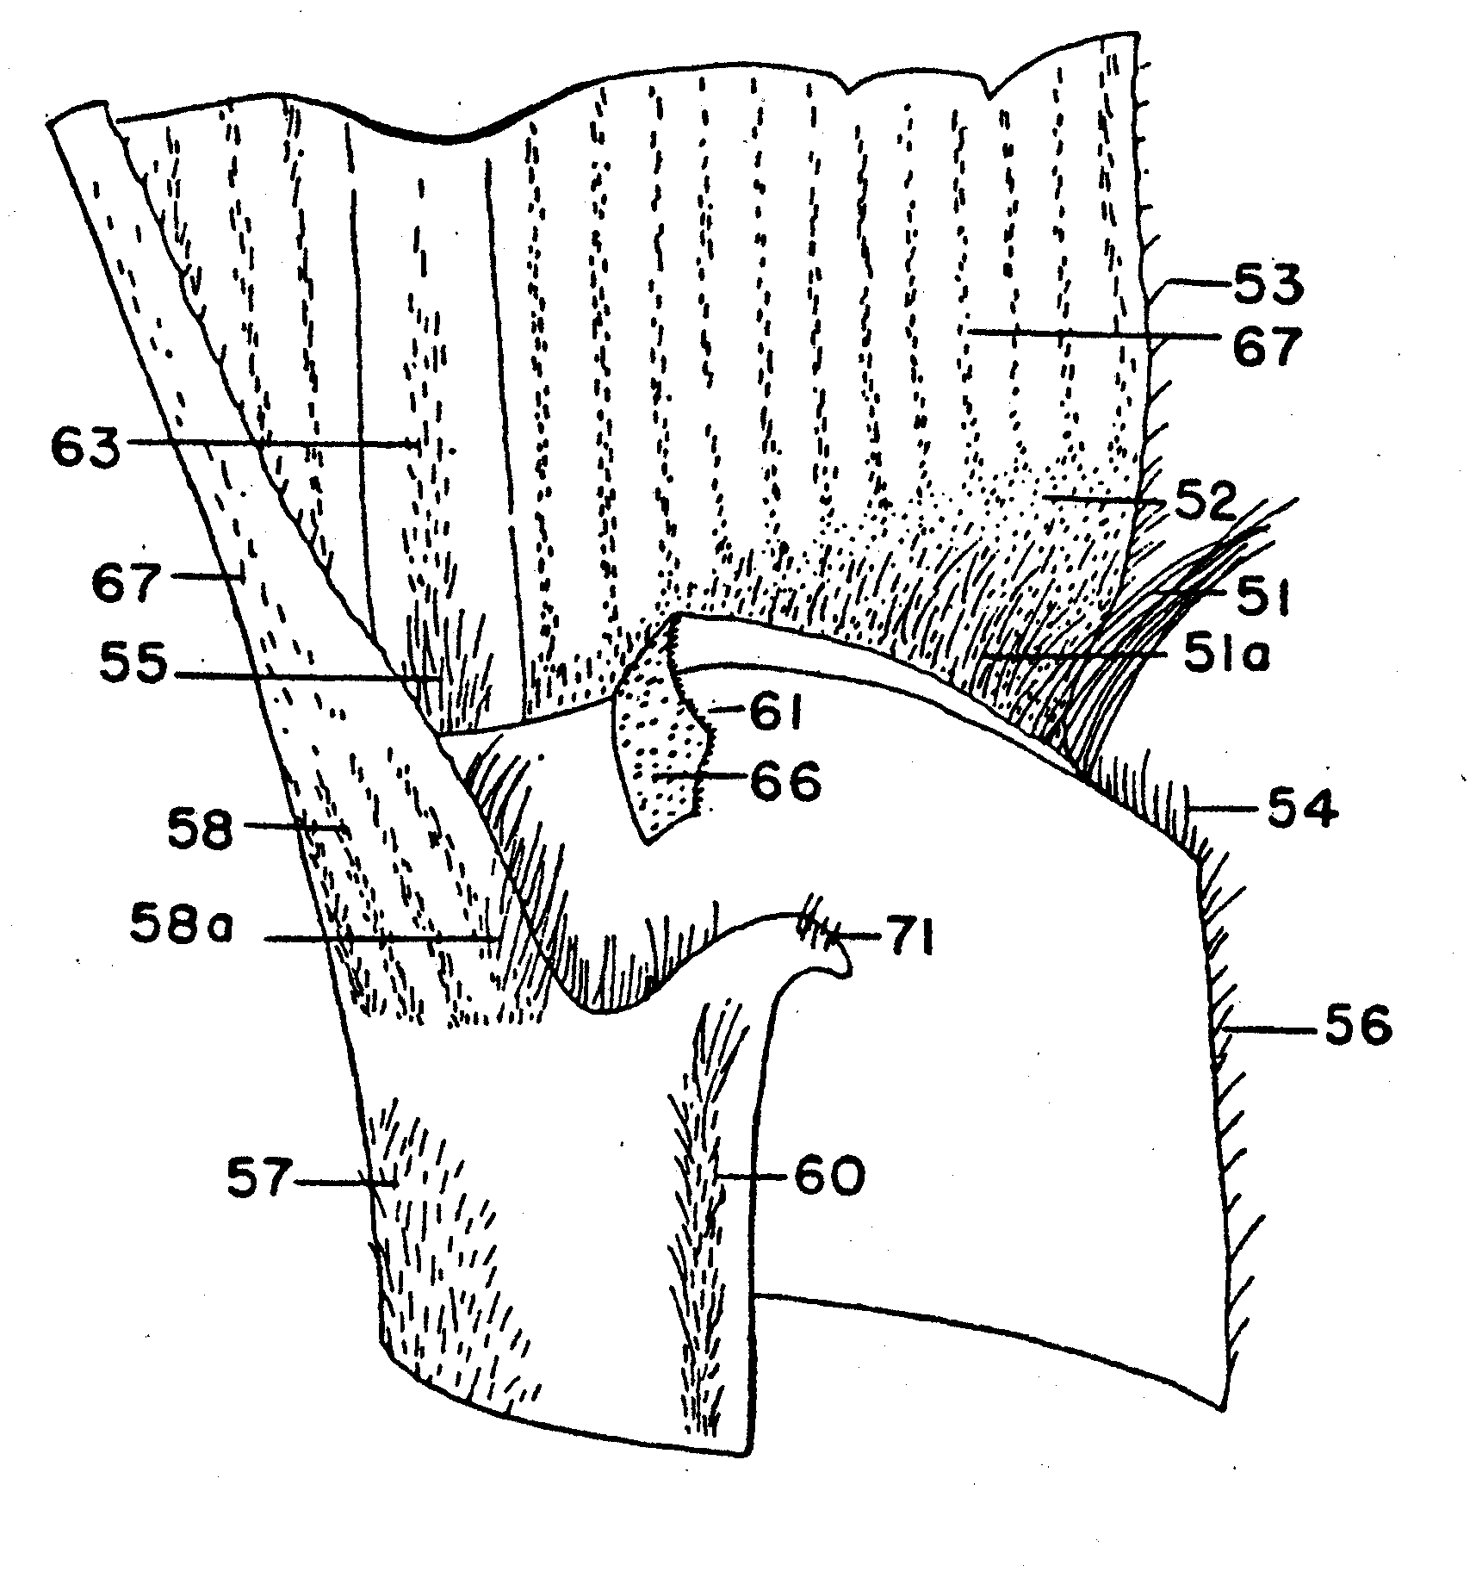

Ad. 35 and 36: Leaf sheath: shape of ligule (35) and ligule width (36)

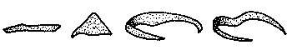

1 | 2 | 3 | 4
strap-shaped | deltoid | crescent-shaped | bow-shaped

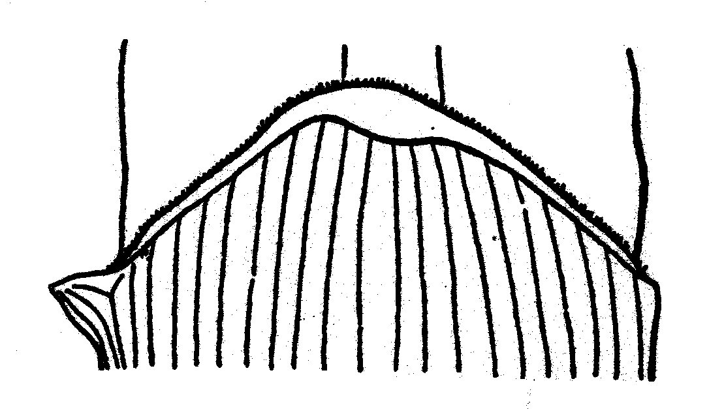
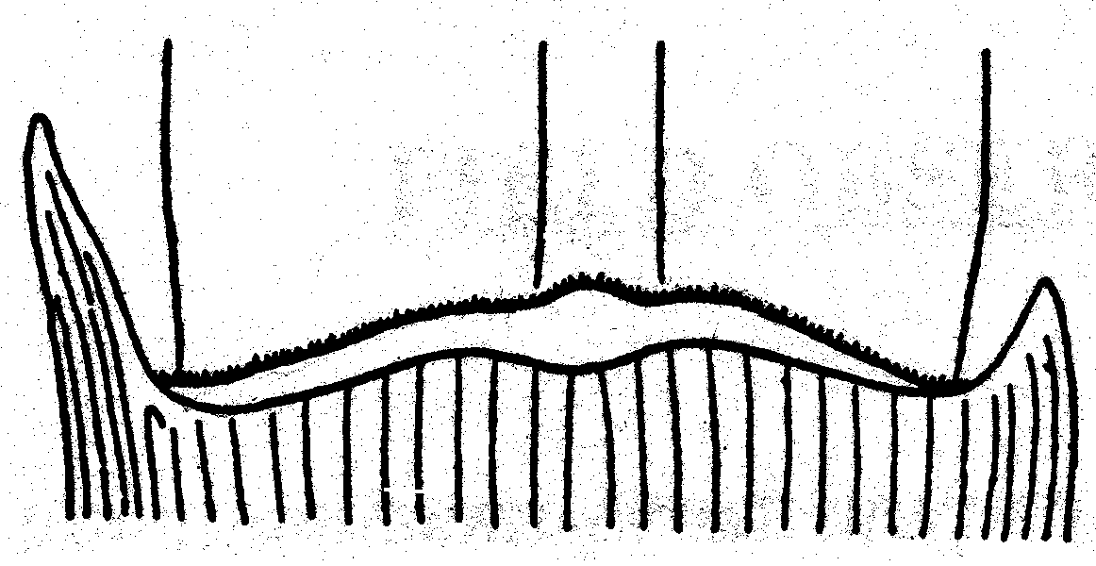

5 | 6
asymmetrical, | asymmetrical,
steeply sloping | horizontal

States strap-shaped (1) and deltoid (2) do not curl round the sheath.

Ligule width is the distance from the point of attachment at the junction of the leaf blade and the leaf sheath and the upper margin of the ligule at the widest point (middle of ligule).

narrow | < 3 mm
medium | 3 – 5 mm
wide | > 5 mm

Ad. 39 and 41: Leaf sheath: shape of auricle

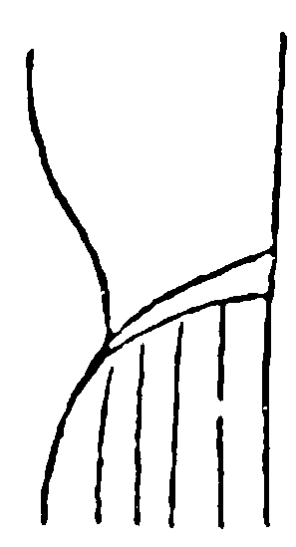
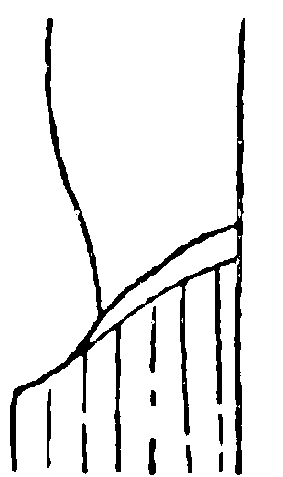
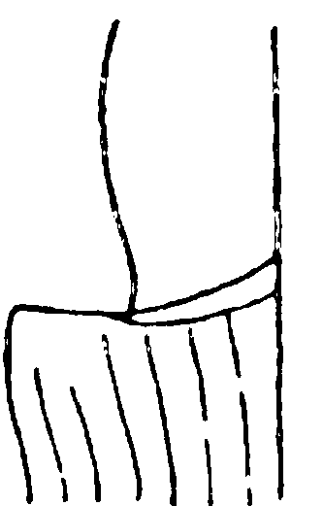
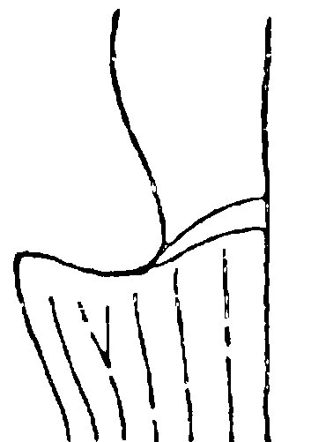

1 | 1 | 1 | 2
transitional | transitional | transitional | deltoid

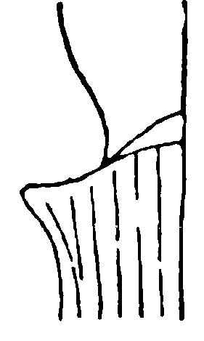
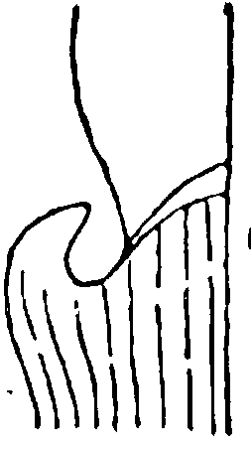
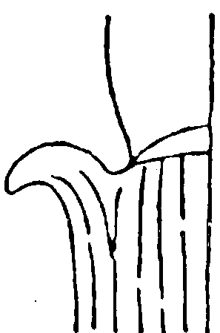
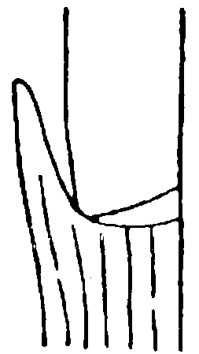
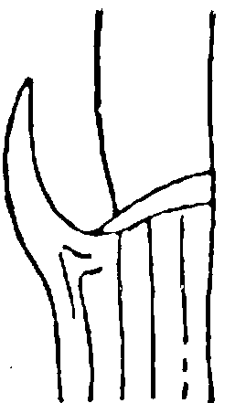

3 | 4 | 5 | 6 | 7
dentoid | unciform | calcariform | lanceolate | falcate

Literature
Artschwager, E., 1940: Journal of Agricultural Research, v. 60, n. 8, pp. 503-508.
Gallacher, D.J., 1994: Development of a minimum descriptor set for individuals of Saccharum spp. Hybrid germplasm. Thesis submitted for Ph.D., Department of Botany and Tropical Agriculture, James Cook University of North Queensland, AU.
Gallacher, D.J. and Berding, N. 1997: Purpose selection and application of descriptors for sugarcane germplasm. Aust. J. Agric. Res 48: 759-67.
Gallacher, D.J., 1997: Evaluation of sugarcane morphological descriptors using variance components analysis. Aust. J. Agric. Res 48: 769-73.
Gallacher, D.J., 1997: Optimised descriptors recommended for Australian sugarcane germplasm (Saccharum spp. hybrid) Aust. J. Agric. Res 48: 775-79.

Technical Questionnaire
TECHNICAL QUESTIONNAIRE |  |  |  | Page {x} of {y} |  | Reference Number:
 |  |  |  |  |  | Application date:
 |  |  |  |  |  | (not to be filled in by the applicant)
TECHNICAL QUESTIONNAIRE
to be completed in connection with an application for plant breeders’ rights

1. Subject of the Technical Questionnaire
1.1 Botanical name |  |  | Saccharum L.
1.2 Common name |  |  | Sugarcane
2. Applicant
Name
Address
Telephone No.
Fax No.
E-mail address
Breeder (if different from applicant)
3. Proposed denomination and breeder’s reference
Proposed denomination
(if available)

Breeder’s reference
#4. Information on the breeding scheme and propagation of the variety

4.1 Breeding scheme

Variety resulting from:

4.1.1 Crossing

(a) controlled cross [ ]
(please state parent varieties)
(b) partially known cross [ ]
(please state known parent variety(ies))
(c) unknown cross [ ]

4.1.2 Mutation [ ]
(please state parent variety)

4.1.3 Discovery and development [ ]
(please state where and when discovered
and how developed)

4.1.4 Other [ ]
(please provide details)

4.2 Method of propagating the variety

4.2.1 Vegetative propagation [ ]

4.2.2 Other [ ]
(please provide details)

5. Characteristics of the variety to be indicated (the number in brackets refers to the corresponding characteristic in Test Guidelines; please mark the note which best corresponds).

 | Characteristics |  |  |  |  |  | Example Varieties |  |  |  | Note
5.1  (2) | Plant: adherence of leaf sheath
 | weak |  |  |  |  |  | H56-752, Q96 |  |  |  | 3 [ ]
 | medium |  |  |  |  |  | Q124, Q186 |  |  |  | 5 [ ]
 | strong |  |  |  |  |  | Q120, NC₀ 310, Q201 |  |  |  | 7 [ ]
5.2  (10) | Internode: shape
 | cylindrical |  |  |  |  |  | Q169, RB72-454 |  |  |  | 1 [ ]
 | tumescent |  |  |  |  |  |  |  |  |  | 2 [ ]
 | bobbin-shaped |  |  |  |  |  | H56-752 |  |  |  | 3 [ ]
 | conoidal |  |  |  |  |  |  |  |  | 4 [ ]
 | obconoidal |  |  |  |  |  | H60-3802 |  |  |  | 5 [ ]
 | concave-convex |  |  |  |  |  | Q115 |  |  |  | 6 [ ]
5.3  (12) | Internode: color where exposed to sun
RHS Colour Chart (indicate reference number)
...........................................................................................................
5.4i  (13) | Internode: color where not exposed to sun
RHS Colour Chart (indicate reference number)
...........................................................................................................
 | Characteristics |  |  |  |  |  | Example Varieties |  |  |  | Note
5.4ii  (13) | Internode: color where not exposed to sun
 | yellow |  |  |  |  |  |  |  |  |  | 1 [ ]
 | yellow green |  |  |  |  |  |  |  |  |  | 2 [ ]
 | grey yellow |  |  |  |  |  |  |  |  |  | 3 [ ]
 | grey orange |  |  |  |  |  |  |  |  |  | 4 [ ]
 | grey red |  |  |  |  |  |  |  |  |  | 5 [ ]
 | grey purple |  |  |  |  |  |  |  |  |  | 6 [ ]
5.5  (15) | Internode: expression of zigzag alignment
 | absent or very weak |  |  |  |  |  | Q124 |  |  | 1 [ ]
 | weak |  |  |  |  |  | Q135, Q152 |  |  |  | 3 [ ]
 | moderate |  |  |  |  |  | Q117 |  |  |  | 5 [ ]
 | strong |  |  |  |  |  | H56-752 |  |  |  | 7 [ ]
5.6  (21) | Node: shape of bud, excluding wings
 | triangular-pointed |  |  |  |  |  | RB72-454 |  |  |  | 1 [ ]
 | oval |  |  |  |  |  | Q138 |  |  |  | 2 [ ]
 | obovate |  |  |  |  |  |  |  |  |  | 3 [ ]
 | pentagonal |  |  |  |  |  |  |  |  | 4 [ ]
 | rhomboid |  |  |  |  |  |  |  |  |  | 5 [ ]
 | round |  |  |  |  |  | Q179, Q124 |  |  |  | 6 [ ]
 | ovate |  |  |  |  |  | Q170, Q115, Q186 |  |  |  | 7 [ ]
 | rectangular |  |  |  |  |  |  |  |  |  | 8 [ ]
 | beaked |  |  |  |  |  |  |  |  |  | 9 [ ]
 | Characteristics |  |  |  |  |  | Example Varieties |  |  |  | Note
5.7  (43) | Leaf sheath: color of dewlap
RHS Colour Chart
(indicate reference number)
...........................................................................................................
5.8  (45) | Leaf blade: width at the longitudinal mid-point
 | narrow |  |  |  |  |  | Q113, Q186 |  |  |  | 3 [ ]
 | medium |  |  |  |  |  | Q121, Q124 |  |  |  | 5 [ ]
 | broad |  |  |  |  |  | Q138, Q179 |  |  |  | 7 [ ]
6. Similar varieties and differences from these varieties

Please use the table, and space provided for comments, below to provide information on how your candidate variety differs from the variety (or varieties) which, to the best of your knowledge, is (or are) most similar. This information may help the examination authority to conduct its examination of distinctness in a more efficient way.

Denomination(s) of variety(ies) similar to your candidate variety |  | Characteristic(s) in which your candidate variety differs from the similar variety(ies) |  |  | Describe the expression of the characteristic(s) for the similar variety(ies) |  |  | Describe the expression of the characteristic(s) for your candidate variety
Example |  | Internode: shape |  |  | cylindrical |  |  | tumescent
Comments:

#7. Additional information which may help in the examination of the variety

7.1 In addition to the information provided in sections 5 and 6, are there any additional characteristics which may help to distinguish the variety?

Yes [ ] No [ ]

(If yes, please provide details)

7.2 Are there any special conditions for growing the variety or conducting the examination?

Yes [ ] No [ ]

(If yes, please provide details)

7.3 Other information

8. Authorization for release

(a) Does the variety require prior authorization for release under legislation concerning the protection of the environment, human and animal health?

Yes [ ] No [ ]

(b) Has such authorization been obtained?

Yes [ ] No [ ]

If the answer to (b) is yes, please attach a copy of the authorization.

9. Information on plant material to be examined or submitted for examination

9.1 The expression of a characteristic or several characteristics of a variety may be affected by factors, such as pests and disease, chemical treatment (e.g. growth retardants or pesticides), effects of tissue culture, different rootstocks, scions taken from different growth phases of a tree, etc.

9.2 The plant material should not have undergone any treatment which would affect the expression of the characteristics of the variety, unless the competent authorities allow or request such treatment. If the plant material has undergone such treatment, full details of the treatment must be given. In this respect, please indicate below, to the best of your knowledge, if the plant material to be examined has been subjected to:

(a) Microorganisms (e.g. virus, bacteria, phytoplasma) Yes [ ] No [ ]

(b) Chemical treatment (e.g. growth retardant, pesticide) Yes [ ] No [ ]

(c) Tissue culture Yes [ ] No [ ]

(d) Other factors Yes [ ] No [ ]

Please provide details of where you have indicated “yes”:

……………………………………………………………

10. I hereby declare that, to the best of my knowledge, the information provided in this form is correct:

Applicant’s name

Signature Date

[End of document]

* These names were correct at the time of the introduction of these Test Guidelines but may be revised or updated. [Readers are advised to consult the UPOV Code, which can be found on the UPOV Website (www.upov.int), for the latest information.]
# Authorities may allow certain of this information to be provided in a confidential section of the Technical Questionnaire.
# Authorities may allow certain of this information to be provided in a confidential section of the Technical Questionnaire.

