 |  | E  TG/185/3

INTERNATIONAL UNION FOR THE PROTECTION  OF NEW VARIETIES OF PLANTS | UNION INTERNATIONALE POUR LA PROTECTION  DES OBTENTIONS VÉGÉTALES | INTERNATIONALER VERBAND ZUM SCHUTZ VON PFLANZEN-ZÜCHTUNGEN | UNIÓN INTERNACIONAL PARA LA PROTECCIÓN  DE LAS OBTENCIONES VEGETALES

GUIDELINES

FOR THE CONDUCT OF TESTS

FOR DISTINCTNESS, UNIFORMITY AND STABILITY

TURNIP RAPE

(Brassica rapa L. var. silvestris (Lam.) Briggs.)

GENEVA
2002

Copies of this document are available on request at the price of 10 Swiss francs each, including surface mail, from the Office of UPOV, 34, chemin des Colombettes, P.O. Box 18, 1211 Geneva 20, Switzerland

This document or parts of it may be reproduced, translated and published without obtaining the specific consent of UPOV, provided that the source is acknowledged.

* * * * * * *

E
TG/185/3
ORIGINAL: English
DATE: 2002-04-17

INTERNATIONAL UNION FOR THE PROTECTION  OF NEW VARIETIES OF PLANTS | UNION INTERNATIONALE POUR LA PROTECTION  DES OBTENTIONS VÉGÉTALES | INTERNATIONALER VERBAND ZUM SCHUTZ VON PFLANZEN-ZÜCHTUNGEN | UNIÓN INTERNACIONAL PARA LA PROTECCIÓN  DE LAS OBTENCIONES VEGETALES

GUIDELINES

FOR THE CONDUCT OF TESTS

FOR DISTINCTNESS, UNIFORMITY AND STABILITY

TURNIP RAPE

(Brassica rapa L. var. silvestris (Lam.) Briggs.)

These Guidelines should be read in conjunction with document TG/1/2, which contains explanatory notes on the general principles on which the Guidelines have been established.

TABLE OF CONTENTS PAGE

I. | Subject of these Guidelines | 3
II. | Material Required | 3
III. | Conduct of Tests | 3
IV. | Methods and Observations | 4
V. | Grouping of Varieties | 4
VI. | Characteristics and Symbols | 4
VII. | Table of Characteristics | 6
VIII. | Explanations on the Table of Characteristics | 12
IX. | Literature | 18
X. | Technical Questionnaire | 19

I. Subject of these Guidelines

These Test Guidelines apply to all varieties of Brassica rapa L. var. silvestris (Lam.) Briggs. excluding varieties with swollen root.

II. Material Required

1. The competent authorities decide when, where and in what quantity and quality the seed required for testing the variety is to be delivered. Applicants submitting material from a State other than that in which the testing takes place must ensure that all customs formalities are complied with. The minimum quantity of seed to be supplied by the applicant should be:

300 g.

In the case of hybrids and synthetic varieties a minimum of 100 g seed per component should also be supplied. The seed should meet the minimum requirements for germination, species and analytical purity, health and moisture content, specified by the competent authority. In cases where the seed is to be stored, the germination capacity should be as high as possible and should be stated by the applicant.

2. The plant material must not have undergone any treatment unless the competent authorities allow or request such treatment. If it has been treated, full details of the treatment must be given.

III. Conduct of Tests

1. The minimum duration of tests should normally be two independent growing cycles.

2. The tests should normally be conducted at one place. If any important characteristics of the variety cannot be seen at that place, the variety may be tested at an additional place.

3. The tests should be carried out under conditions ensuring satisfactory growth for the expression of the relevant characteristics of the variety and for the conduct of the examination. The distance between rows and between plants within the rows should be adjusted to enable observations on individual plants. The size of the plots should be such that plants or parts of the plants may be removed for measurement or counting without prejudice to the observations which must be made up to the end of the growing cycle. Each test should be designed to result in a total of at least 300 plants, which should be divided between two or more replicates. Separate plots for observation and for measuring should only be used if they have been subject to similar environmental conditions.

4. Additional tests for special purposes may be established.

IV. Methods and Observations

1. Unless otherwise indicated all observations on individual plants should be made on 60 plants or parts of each of the 60 plants.

2. All observations on a group of plants or parts of plants should be made on each plot as a whole.

3. For the assessment of uniformity of measured characteristics of any type of variety, the variability within the variety should not exceed the variability of comparable varieties already known. Interpretation of results should be made according to the rules for cross-pollinated species as laid down in the General Introduction.

4. For the assessment of uniformity on visually observed characteristics of parental lines a population standard of 2% with an acceptance probability of at least 95% should be applied. For the assessment of uniformity on visually observed characteristics of hybrid varieties a population standard of 10% with an acceptance probability of at least 95% should be applied.

5. Unless otherwise indicated, all observations on the foliage should be made on fully developed leaves in the rosette.

6. Unless otherwise indicated, all observations on siliquas should be made on the fully developed siliqua from the lower third on the main stem.

V. Grouping of Varieties

1. The collection of varieties to be grown should be divided into groups to facilitate the assessment of distinctness. Characters which are suitable for grouping purposes are those which are known from experience not to vary, or to vary only slightly, within the variety. Their various states of expression should be fairly evenly distributed throughout the collection.

2. It is recommended that the competent authorities use the following characteristics for grouping varieties:

- Ploidy (characteristic 2)
- Leaf: type (characteristic 8)
- Time of flowering (50% of plants with at least one open flower) (characteristic 16)

VI. Characteristics and Symbols

1. To assess distinctness, uniformity and stability, the characteristics and their states as given in the Table of Characteristics should be used.

2. Notes (numbers), for the purposes of electronic data processing, are given opposite the states of expression for each characteristic. For certain characteristics, different example varieties, separated by a semicolon, are indicated for spring turnip rape and winter turnip rape. Where winter varieties are indicated they follow the semicolon.

3. Legend:

(*) Characteristics that should be used on all varieties in every growing period over which the examinations are made and always be included in the variety descriptions, except when the state of expression of a preceding characteristics or regional environmental conditions render this impossible.

(+) See Explanations on the Table of Characteristics in Chapter VIII.

1) The optimum stage of development for the assessment of each characteristic is indicated by a number in the second column. The stages of development denoted by each number are described at the end of Chapter VIII.

Type of assessment:

MG: measurement of a group of plants or parts of plants
MS: measurement of a number of individual plants or parts of plants
VG: visual assessment by a single observation of a group of plants or parts of plants
VS: visual assessment by observation of individual plants or parts of plants
C: special test

VII. Table of Characteristics/Tableau des caractères/Merkmalstabelle/Tabla de caracteres

 | Stage ¹⁾  Stade ¹⁾  Stadium ¹⁾  Estado ¹⁾ | English | français | deutsch | español | Example Varieties  Exemples  Beispielssorten  Variedades ejemplo | Note/  Nota
1.  (+) | 00  C | Seed: erucic acid | Graine: acide érucique | Samen: Erucasäure | Semilla: ácido erúcico
 |  | absent | absent | fehlend | ausente | - ; Rex | 1
 |  | present | présent | vorhanden | presente | Nokonova; Perko PVH | 9
2.  (*) | 00  MS | Ploidy | Ploïdie | Ploidie | Ploidía
 |  | diploid | diploïde | diploid | diploide | Nokonova; Rex | 2
 |  | tetraploid | tétraploïde | tetraploid | tetraploide | - ; Perko PVH | 4
3.  (+) | 13  MS | Cotyledon:  length | Cotylédon:  longueur | Keimblatt:  Länge | Cotiledón: longitud
 |  | short | court | kurz | corto |  | 3
 |  | medium | moyen | mittel | medio | - ; Rex | 5
 |  | long | long | lang | largo | - ; Perko PVH | 7
4.  (+) | 13  MS | Cotyledon: width | Cotylédon: largeur | Keimblatt: Breite | Cotiledón: anchura
 |  | narrow | étroit | schmal | estrecho |  | 3
 |  | medium | moyen | mittel | medio |  | 5
 |  | broad | large | breit | ancho | - ; Perko PVH | 7
5. | 23-27  VG | Leaf: attitude | Feuille: port | Blatt: Stellung | Hoja: porte
 |  | erect | dressé | aufrecht | erecto | Hysyn 100; - | 1
 |  | semi-erect | demi-dressé | halbaufrecht | semierecto | Tobin; - | 3
 |  | horizontal | horizontal | waagerecht | horizontal | Clan; - | 5
6.  (+) | 23-27  VG | Leaf: reflexion of top | Feuille: enroulement du sommet | Blatt: Rollen der Spitze | Hoja: curvatura de la punta
 |  | weak | faible | gering | débil | Tobin; - | 3
 |  | medium | moyen | mittel | media | Skye; - | 5
 |  | strong | fort | stark | fuerte | Fortuna; - | 7
7.  (*) | 23-27  VG | Leaf: intensity of green color | Feuille: intensité de la couleur verte | Blatt: Intensität der Grünfärbung | Hoja: intensidad del color verde
 |  | light | claire | hell | claro | Clan; - | 3
 |  | medium | moyenne | mittel | medio | Tuli; - | 5
 |  | dark | foncée | dunkel | oscuro | Agena; - | 7
8.  (*)  (+) | 23-27  VS | Leaf: type | Feuille: type | Blatt: Typ | Hoja: tipo
 |  | entire | entière | ganzrandig | entera | - ; Chicon | 1
 |  | lobed | lobée | gelappt | lobulada | Kova; Perko PVH | 2
9.  (+) | 23-27  MS | For varieties with lobed leaves only: Leaf: number of lobes | Uniquement variétés à feuilles lobées: Feuille: nombre de lobes | Nur für Sorten mit gelappten Blättern: Blatt: Anzahl Lappen | Sólo para variedades de hoja lobulada: Hoja: número de lóbulos
 |  | few | faible | gering | bajo | Mull; - | 3
 |  | medium | moyen | mittel | medio | Skye; - | 5
 |  | many | élevé | groß | alto | Hymac; - | 7
10. | 23-27  VS | Leaf: undulation of margin | Feuille: ondulation du bord | Blatt: Randwellung | Hoja: ondulación del borde
 |  | weak | faible | gering | débil | Tobin; - | 3
 |  | medium | moyenne | mittel | media | Kova; - | 5
 |  | strong | forte | stark | fuerte | Harmoni; - | 7
11.  (+) | 23-27  VS | Leaf: dentation of margin | Feuille: denture du bord | Blatt: Randzähnung | Hoja: incisiones en el borde
 |  | weak | faible | gering | débiles |  | 3
 |  | medium | moyenne | mittel | medias |  | 5
 |  | strong | forte | stark | fuertes |  | 7
12.  (*)  (+) | 23-27  MS | Leaf: length (blade and petiole) | Feuille: longueur (limbe et pétiole) | Blatt: Länge (Blattspreite und Blattstiel) | Hoja: longitud (limbo y pecíolo)
 |  | short | courte | kurz | corta | Kulta | 3
 |  | medium | moyenne | mittel | media | Harmoni | 5
 |  | long | longue | lang | larga |  | 7
13.  (+) | 23-27  MS | Leaf: width (widest point) | Feuille: largeur (au point le plus large) | Blatt: Breite (an der breitesten Stelle) | Hoja: anchura (punto más ancho)
 |  | narrow | étroite | schmal | estrecha | Kulta | 3
 |  | medium | moyenne | mittel | media | Kova | 5
 |  | broad | large | breit | ancha |  | 7
14.  (*) | 61-62  VG | Tendency to form inflorescences in the year of sowing; winter types in spring sown trials | Tendance à former des inflorescences l’année du semis; variétés hivernales dans les essais semés au printemps | Neigung zur Bildung von Blütenständen im Aussaatjahr; Wintertypen bei Frühjahraussaat | Tendencia a formar inflorescencias el año de la siembra; variedades de invierno en los ensayos sembrados en primavera
 |  | weak | faible | gering | débil | - ; Triton | 3
 |  | medium | moyenne | mittel | media | - ; Rex | 5
 |  | strong | forte | stark | fuerte | - ; Primax | 7
15. | 61-62  VG | Tendency to form inflorescences in the year of sowing; spring types in late summer sown trials | Tendance à former des inflorescences l’année du semis; variétés printanières dans les essais semés tard en été | Neigung zur Bildung von Blütenständen im Aussaatjahr; Sommertypen bei Spätsommeraussaat | Tendencia a formar inflorescencias el año de la siembra; variedades de primavera en los ensayos sembrados al final del verano
 |  | weak | faible | gering | débil | Asko; | 3
 |  | medium | moyenne | mittel | media | Nokonova; | 5
 |  | strong | forte | stark | fuerte | Hymac; | 7
16.  (*) | 61-62  MG | Time of flowering (50% of plants with at least one open flower) | Époque de floraison (50% des plantes avec au moins une fleur épanouie) | Zeitpunkt der Blüte (50% der Pflanzen mit wenigstens einer geöffneten Blüte) | Época de floración (50% de las plantas con al menos una flor abierta)
 |  | very early | très précoce | sehr früh | muy temprana | Hymac; Primax | 1
 |  | early | précoce | früh | temprana | Agena; | 3
 |  | medium | moyenne | mittel | media | Kova; Rex | 5
 |  | late | tardive | spät | tardía | Munro; | 7
 |  | very late | très tardive | sehr spät | muy tardía | Nokonova; Triton | 9
17.  (*) | 62-63  VG | Flower: color of petal | Fleur: couleur des pétales | Blüte: Farbe des Blütenblatts | Flor: color de los pétalos
 |  | lemon yellow | jaune-citron | zitronengelb | amarillo limón | Kulta; Perko PVH | 1
 |  | orange yellow | jaune-orange | orangegelb | amarillo anaranjado |  | 2
18. | 62-63  MS | Flower: length of petal | Fleur: longueur des pétales | Blatt: Länge des Blütenblatts | Flor: longitud de los pétalos
 |  | short | courts | kurz | cortos |  | 3
 |  | medium | moyens | mittel | medios | Kulta | 5
 |  | long | longs | lang | largos |  | 7
19. | 62-63  MS | Flower: width of petal | Fleur: largeur des pétales | Blatt: Breite des Blütenblatts | Flor: anchura de los pétalos
 |  | narrow | étroits | schmal | estrechos |  | 3
 |  | medium | moyens | mittel | medios | Kulta | 5
 |  | broad | larges | breit | anchos |  | 7
20.  (*) | 62-63  VS | Flower: production of pollen | Fleur: production de pollen | Blüte: Pollenbildung | Flor: producción de polen
 |  | absent | absente | fehlend | ausente | MDA 1803 | 1
 |  | present | présente | vorhanden | presente | Kova | 9
21.  (*) | 75-89  MS | Plant: total length including side branches | Plante: longueur totale, branches latérales incluses | Pflanze: Gesamtlänge, einschließlich der Seitenzweige | Planta: longitud total incluidos los tallos laterales
 |  | short | courte | kurz | corta |  | 3
 |  | medium | moyenne | mittel | media | Kulta | 5
 |  | long | longue | lang | larga | Harmoni | 7
22.  (+) | 75-89  MS | Siliqua: length (between pedicel and beak) | Silique: longueur (entre pédoncule et bec) | Schote: Länge (zwischen Stiel und Spitze) | Silicua: longitud (entre el pedicelo y el rostro)
 |  | short | courte | kurz | corta |  | 3
 |  | medium | moyenne | mittel | media | Kulta | 5
 |  | long | longue | lang | larga | Harmoni | 7
23.  (+) | 75-89  MS | Siliqua: width (widest point) | Silique: largeur (au point le plus large) | Schote: Breite (an der breitesten Stelle) | Silicua: anchura (en su punto más ancho)
 |  | narrow | étroite | schmal | estrecha |  | 3
 |  | medium | moyenne | mittel | media |  | 5
 |  | broad | large | breit | ancha |  | 7
24.  (*)  (+) | 75-89  MS | Siliqua: length of beak | Silique: longueur du bec | Schote: Länge der Spitze | Silicua: longitud del rostro
 |  | short | court | kurz | corto |  | 3
 |  | medium | moyen | mittel | medio | Kulta | 5
 |  | long | long | lang | largo |  | 7
25.  (+) | 75-89  MS | Siliqua: length of pedicel | Silique: longueur du pédoncule | Schote: Länge des Stiels | Silicua: longitud del pedicelo
 |  | short | court | kurz | corto | MDA 1803; | 3
 |  | medium | moyen | mittel | medio | Kulta; | 5
 |  | long | long | lang | largo | Noko; | 7
26.  (+) | 00  VS | Seed: frequency of seeds with yellow coloration present | Graine: fréquence de graines qui ont une coloration jaune | Samen: Häufigkeit von Samen mit vorhandener Gelbfärbung | Semilla: frecuencia de semillas con presencia de pigmentación amarilla
 |  | nil or very low | nulle ou très faible | fehlend oder sehr gering | nula o muy baja |  | 1
 |  | low | faible | gering | baja |  | 3
 |  | medium | moyenne | mittel | media | Corlee; | 5
 |  | high | élevée | hoch | alta | Monsun; Triton | 7
 |  | very high | très élevée | sehr hoch | muy alta | Parkland; | 9

VIII. Explanations on the Table of Characteristics

Ad. 1: Seed: erucic acid

The erucic acid content should be observed on seed provided by the applicant. It should be expressed as a percentage by mass of methyl esters in accordance with the ISO standard in document 5508, paragraph 6.2.2.1. Seed containing 2% or less of erucic acid will be classified as “absent”.

Ad. 3 + 4: Cotyledon: length (3) and width (4)

The measurements should be taken in the glasshouse on cotyledons of 40 seedlings. If the two cotyledons differ in size, the biggest one should be measured. The length is defined as the distance between the inclination at the top of the cotyledon and the point where the width of the petiole is about 4 mm. The width of the cotyledon should be measured at the widest point of the cotyledons.

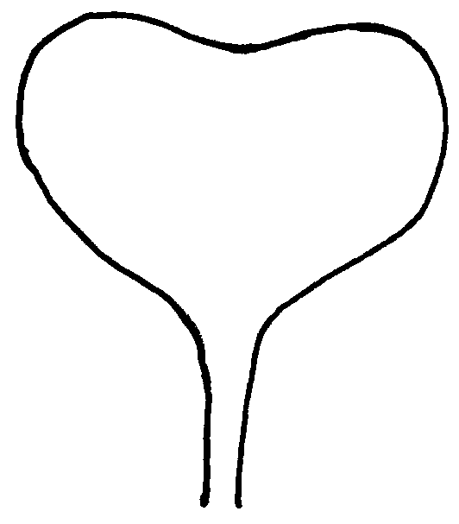
4 mm
3
4

Ad. 6: Leaf: reflexion of top

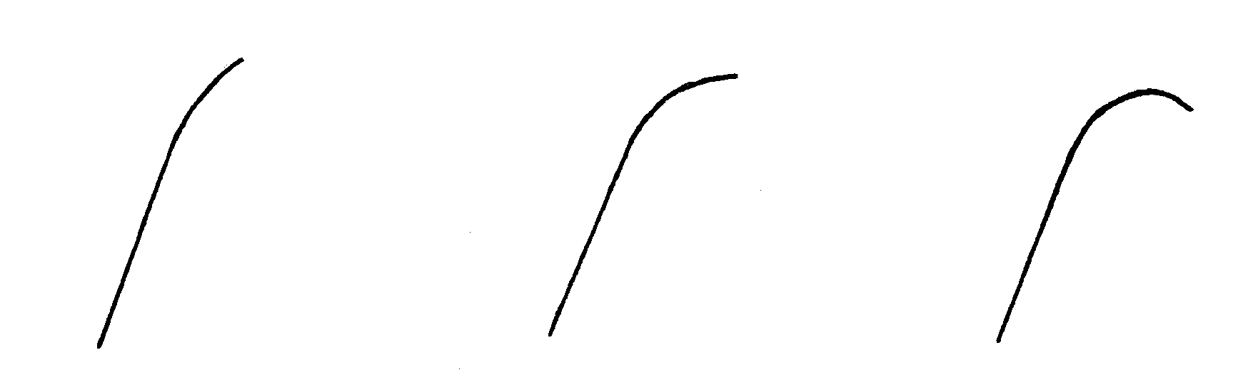
3 | 5 | 7
weak | medium | strong

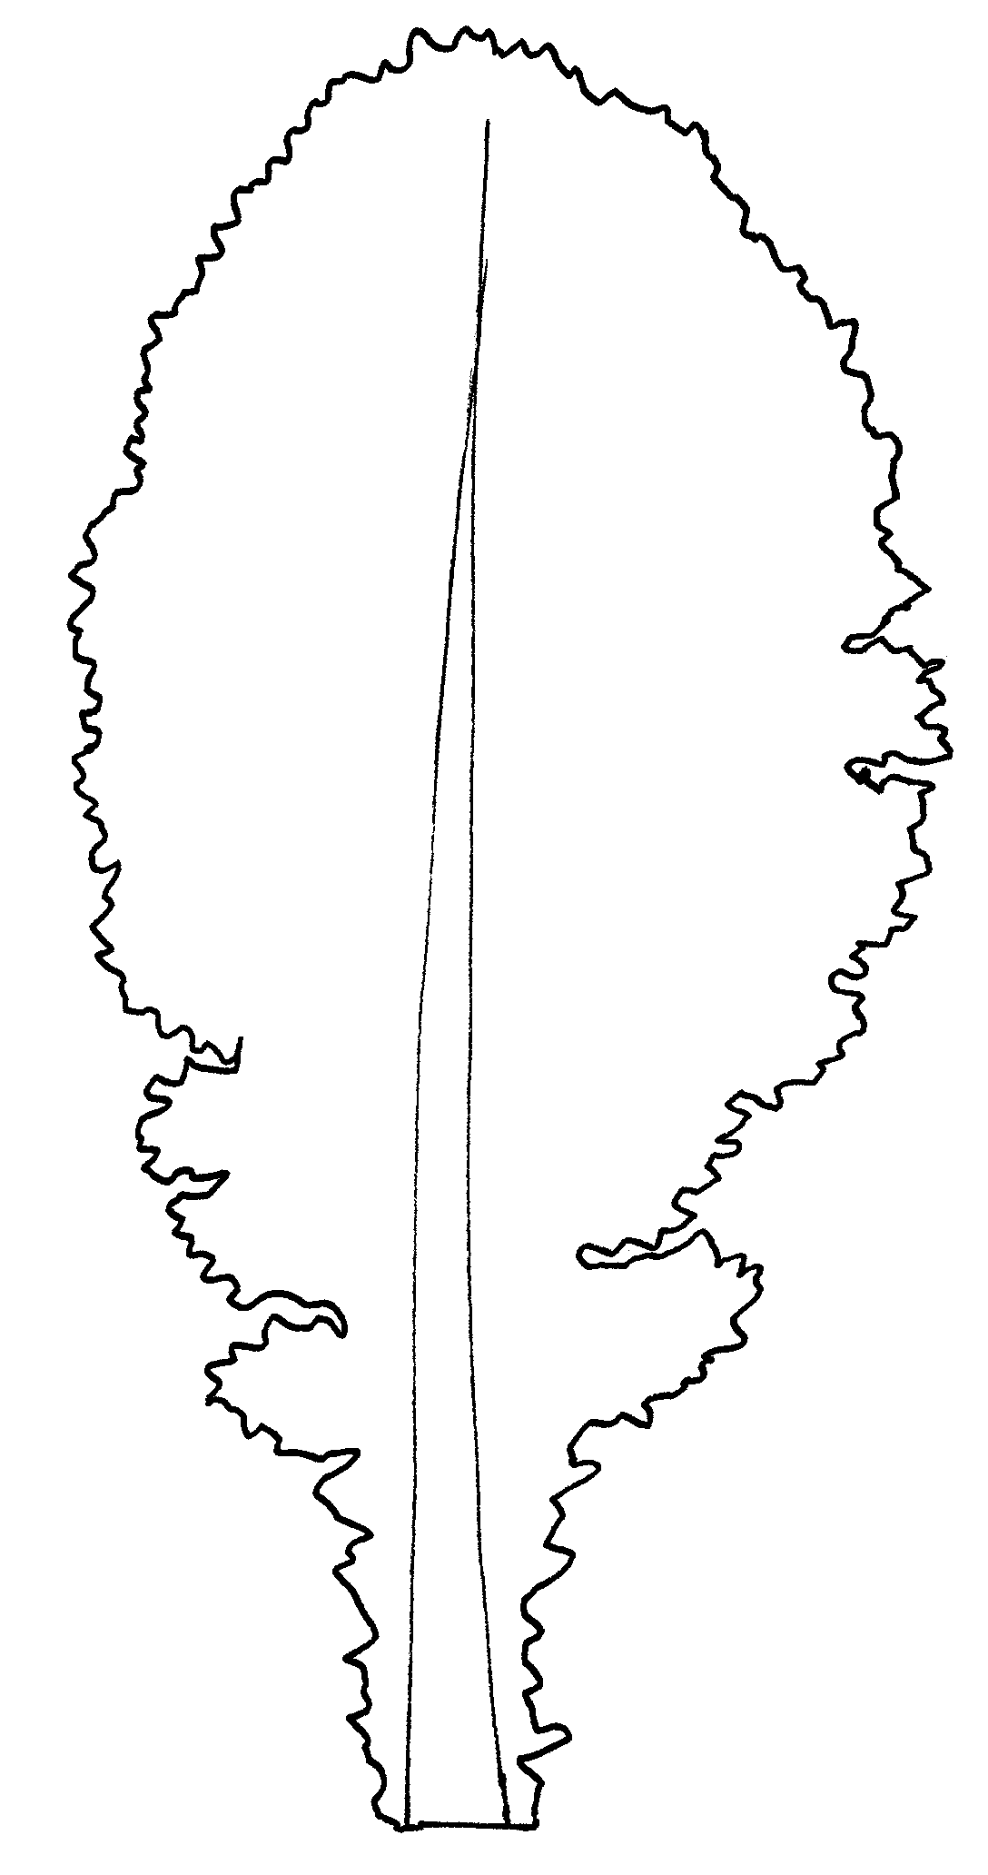
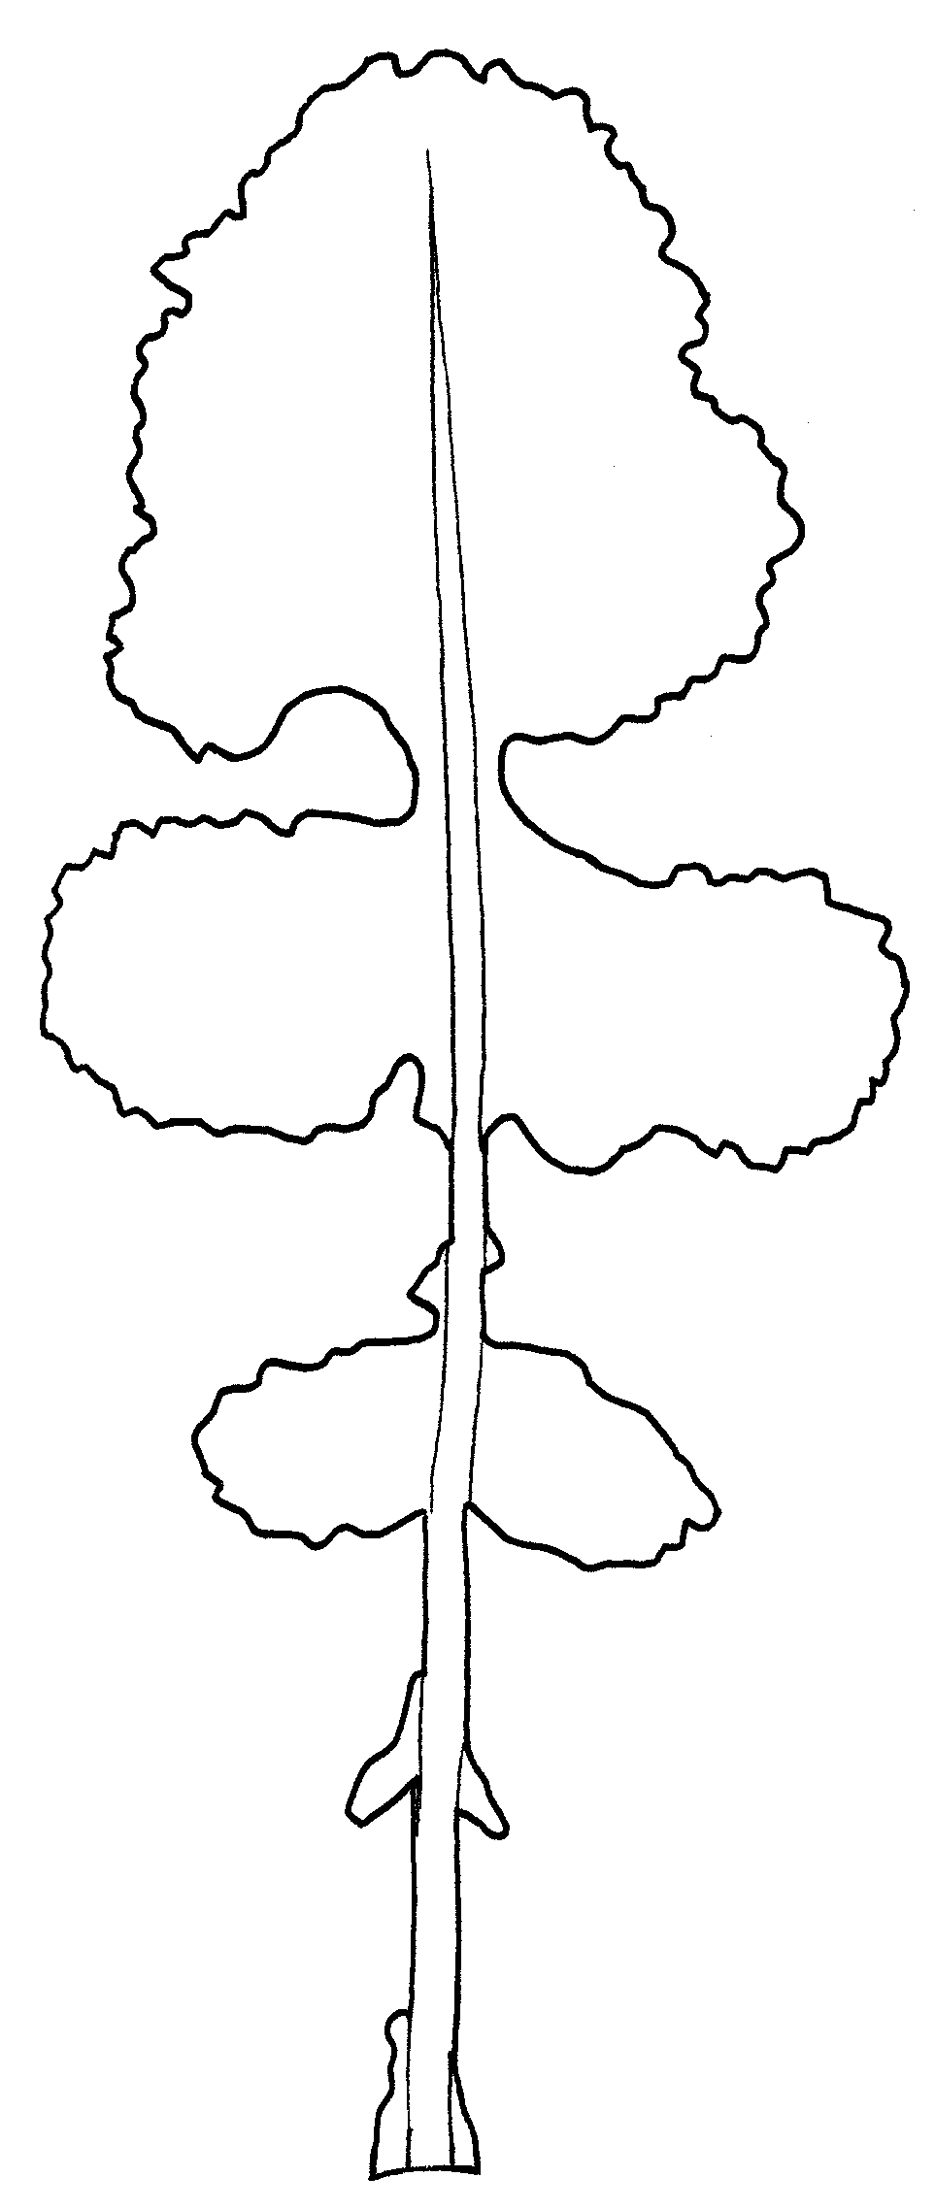
Ad. 8: Leaf: type
1
entire
2
lobed

Ad. 9: Leaf: number of lobes
1
2
3
4
5
6
7

Parts of the leaf blade are considered as lobes if their length is at least equivalent to the width of the leaf petiole at their point of attachment and if both notches of the blade have at least half the length of the lobe itself.

Ad. 11: Leaf: dentation

Part on which dentation should be recorded

Ad. 12 + 13: Leaf: length (blade and petiole) (12) and width (widest point) (13)

12
12
13
13

Ad. 22 to 25: Siliqua: length (between pedicel and beak) (22), width (widest point) (23), length of beak (24) and length of pedicel (25)

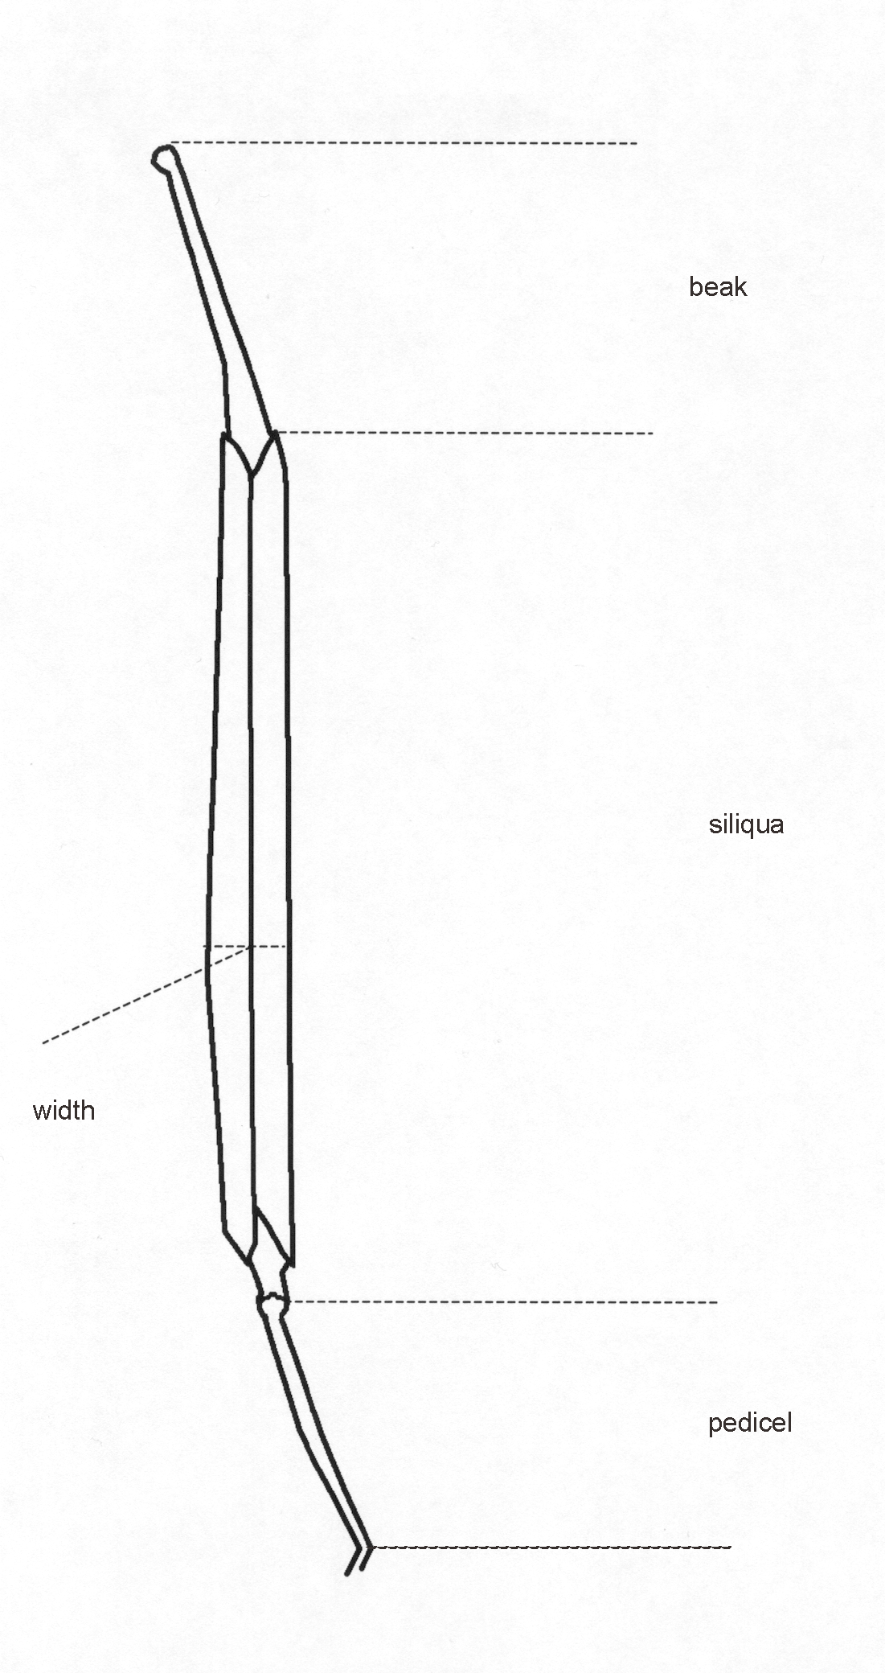

Ad. 26: Seed: frequency of seeds with yellow coloration present

Seed of the submitted sample should be mixed and sampled using appropriate methods.

A minimum sample size of 500 seeds, divided from the bulk into at least 2 replicates, is recommended. Immature (greenish colored) or infected seeds should be removed from the sample before counting. Seeds with any yellow coloration on the testa are counted as present and represented as the frequency occurring in the sample.

Visual assessment of the bulk sample will not give an accurate assessment of the frequency of seeds with yellow coloration. Entirely yellow seeds will have a greater influence on the bulk sample colour than seeds which are partially yellow.

Frequency of yellow seeds:

1 < 10% 4 30-39% 7 60-69%
2 10-19% 5 40-49% 8 70-79%
3 20-29% 6 50-59% 9 > 80%

KEY FOR THE GROWTH STAGES
according to Berkenkamp, 1973

KEY | GENERAL DESCRIPTION
0 | Germination
00 | Dry seed
10 | Seedling growth
11 | Appearance of cotyledons
13 | Cotyledons expanded
15 | 1 leaf-stage
17 | 2 leaf-stage
19 | 3 leaf-stage
20 | Rosette
21 | 4 leaf-stage
22 | 5 leaf-stage
23 | 6 leaf-stage
24 | 7 leaf-stage
25 | 8 leaf-stage
26 | 9-11 leaf-stage
27 | 12 or more leaves are completely developed
30 | Stem elongation
31 | Distance between cotyledons and vegetation point is more than 5 cm
35 | Distance between cotyledons and vegetation point is more than 15 cm
39 | Distance between cotyledons and vegetation point is more than 25 cm
50 | Bud formation
51 | Terminal bud is present, not raised above leaves
53 | Terminal bud is raised above level of leaves
57 | Pedicels are elongating
59 | Buds are yellowing
60 | Flower
61 | First open bud on terminal raceme
62 | Few buds are open on terminal raceme
64 | Full flower, lower siliques are elongating
65 | Lower siliques are starting to fill, less than 5% of buds are not yet open
67 | Seeds in lower siliques are enlarging, all buds are open
70 | Siliqua
71 | Seeds in lower siliques are in full size translucent
75 | Seeds in lower siliques are green, opaque
79 | All seeds of siliques on terminal raceme are dark
80 | Maturation
81 | Seeds in lower siliques on terminal raceme show brown areas
85 | Seeds in upper siliques show brown areas
89 | Brown siliques are brittle, stems are dry
IX. Literature

Aoba, T., 1970: “Inheritance of seed coat color in turnip.” Jap. Journ. Breeding 20 (3): 173-197.

Baltjes, H.J., Klein Geltink, D.J.A., Nienhuis, K.H. and Luesink, B., 1985: “Linking distinctness and description of varieties.” Journal National Institute Agricultural Botany. 17. p. 9-19.

Berkenkamp, B., 1973: “A growth-stage key for rape.” Can. Journal Plant Sci. 55:413.

Harper, F.R., 1973: “A key to standardize the description of growth stages in turnip rape, Brassica campestris.”. Can. Plant Dis. Surv. 53 (2): 93-95.

Kajanus, B., 1913: “Ueber die Vererbungsweise gewisser Merkmale der Beta- und Brassica-Ruben. II Brassica”, Zeitschrift fur Pflanzenzuchtung, Band I (4): 419-466.

Kimber, D.S., and McGregor, D.I. (Eds), 1995: “Brassica Oilseeds: Production and Utilisation.” CAB International. Wallingford.

Klein Geltink, D.J.A., 1983: “Inheritance of leaf shape in turnip (Brassica rapa L. partim) and rape (Brassica napus L.).” Euphytica 32 (2): 361-365.

Mohammad, A. and Sikka, S.M., 1937: “Breeding investigations in some of the oleiferous Brassicas of the Punjab.” Ind. Journ. Agric. Sci. VII (VI): 849 - 861.

Mohammad, A., Sikka S.M. and Aziz, M.A., 1942: “Inheritance of seed colour in some oleiferous Brassicae”. Ind. Journ. of Genetics & Plant Breeding 2: 112 - 127.

Scarisbrick, D.H. and Ferguson, A.J. (Eds.), 1995: “New Horizons for Oilseed Rape.” Semundo Limited. Cambridge.

Schutte, E., Steinberger, J. und Meier. U., 1982: “Entwicklungsstadien des Rapses”. Merkblatt der Biologischen Bundesanstalt fur Land- und Forstwirtschaft. Nr. 27/7.

Stringham, G.R., 1980: “Inheritance of seed color in turnip rape” . Can. Journ. Plant Sci. 60: 331 - 335.
X. Technical Questionnaire

Reference Number
(not to be filled in by the applicant)

TECHNICAL QUESTIONNAIRE
to be completed in connection with an application for plant breeders’ rights

1. Species Brassica rapa L. var.silvestris (Lam.) Briggs.

TURNIP RAPE

- Spring type [ ]

- Winter type [ ]

2. Applicant (Name and address)

3. Proposed denomination or breeder’s reference

4. Information on origin, maintenance and reproduction of the variety

4.1 Type of material

- inbred line
- male sterile line [ ]
- male fertile line [ ]
- hybrid
- male sterile hybrid [ ]
- male fertile hybrid [ ]
- open-pollinated variety [ ]
- synthetic variety [ ]
- other (please indicate)
..................................................................................................................

4.2 Formula (if applicable, for each component in separate sheets, the information according to the following Chapters 5 to 7 to be added)

Single hybrid

- Denomination or breeder’s reference
of female parental line .......................................
- Denomination or breeder’s reference
of male parental line .......................................

Three-way hybrid

Denomination or breeder’s reference of:

- single hybrid used .......................................
- female parental line of the single hybrid .......................................
- male parental line of the single hybrid .......................................
- female parent of the three-way hybrid .......................................
- male parental line of the three-way hybrid .......................................

NB: In case of use of male sterility system, indicate the name of the maintainer line of the female parental line
......................................

In case of use of self-incompatibility system, indicate, if applicable, the name of the
self-compatible lines
.......................................

4.3 Genetic origin and breeding method

4.4 Other information

5. Characteristics of the variety to be indicated (the number in brackets refers to the corresponding characteristic in Test Guidelines; please mark the state of expression which best corresponds).

 | Characteristics | Example Varieties  (Spring variety; Winter variety) | Note
5.1  (2) | Ploidy
 | diploid | Nokonova; Rex | 2[ ]
 | tetraploid | - ; Perko PVH | 4[ ]
5.2  (8) | Leaf: type
 | entire | - ; Chicon | 1[ ]
 | lobed | Kove; Perko PVH | 2[ ]
5.3  (16) | Time of flowering (50% of plants with at least one open flower)
 | very early | Hymac; Primax | 1[ ]
 | early | Agena; | 3[ ]
 | medium | Kova; Rex | 5[ ]
 | late | Munro; | 7[ ]
 | very late | Nokonova; Triton | 9[ ]

 | Characteristics |  |  | Example Varieties  (Spring variety; Winter variety) |  | Note
5.4  (17) | Flower: color of petal
 | lemon yellow |  |  | Kulta; Perko PVH |  | 1[ ]
 | orange yellow |  |  |  |  | 2[ ]
5.5  (21) | Plant: total length including side branches
 | short |  |  |  |  | 3[ ]
 | medium |  |  | Kulta |  | 5[ ]
 | long |  |  | Harmoni |  | 7[ ]
6. Similar varieties and differences from these varieties

Denomination of similar variety |  | Characteristic in which the similar variety is different ^{o)} | State of expression of similar variety |  | State of expression of candidate variety
______________
^{o)} In the case of identical states of expressions of both varieties, please indicate the size of the difference.

7. Additional information which may help to distinguish the variety

7.1 Resistance to pests and diseases

7.2 Special conditions for the examination of the variety

7.3 Main use

- seed [ ]
- forage [ ]
- other use (specify) [ ]

7.4 Other information

8. Authorization for release

- Does the variety require prior authorization for release under legislation concerning the protection of the environment, human and animal health?

Yes [ ] No [ ]

- Has such authorization been obtained?

Yes [ ] No [ ]

If the answer to that question is yes, please attach a copy of such an authorization.

[End of document]

