 |  | E  TG/178/3

INTERNATIONAL UNION FOR THE PROTECTION  OF NEW VARIETIES OF PLANTS | UNION INTERNATIONALE POUR LA PROTECTION  DES OBTENTIONS VÉGÉTALES | INTERNATIONALER VERBAND ZUM SCHUTZ VON PFLANZEN-ZÜCHTUNGEN | UNIÓN INTERNACIONAL PARA LA PROTECCIÓN  DE LAS OBTENCIONES VEGETALES

GUIDELINES

FOR THE CONDUCT OF TESTS

FOR DISTINCTNESS, UNIFORMITY AND STABILITY

FODDER RADISH

(Raphanus sativus L. var. oleiformis Pers.)

GENEVA
2001

Copies of this document are available on request at the price of 10 Swiss francs each, including surface mail, from the Office of UPOV, 34, chemin des Colombettes, P.O. Box 18, 1211 Geneva 20, Switzerland

This document or parts of it may be reproduced, translated and published without obtaining the specific consent of UPOV, provided that the source is acknowledged.

* * * * * * *
TG/178/3
ORIGINAL: English
DATE: 2001-04-04

INTERNATIONAL UNION FOR THE PROTECTION  OF NEW VARIETIES OF PLANTS | UNION INTERNATIONALE POUR LA PROTECTION  DES OBTENTIONS VÉGÉTALES | INTERNATIONALER VERBAND ZUM SCHUTZ VON PFLANZEN-ZÜCHTUNGEN | UNIÓN INTERNACIONAL PARA LA PROTECCIÓN  DE LAS OBTENCIONES VEGETALES

GUIDELINES

FOR THE CONDUCT OF TESTS

FOR DISTINCTNESS, UNIFORMITY AND STABILITY

FODDER RADISH

(Raphanus sativus L. var. oleiformis Pers.)

These Guidelines should be read in conjunction with document TG/1/2, which contains explanatory notes on the general principles on which the Guidelines have been established.

TABLE OF CONTENTS PAGE

I. | Subject of these Guidelines ......................................................................... | 3
II. | Material Required ........................................................................................ | 3
III. | Conduct of Tests .......................................................................................... | 3
IV. | Methods and Observations........................................................................... | 3
V. | Grouping of Varieties .................................................................................. | 4
VI. | Characteristics and Symbols ........................................................................ | 4
VII. | Table of Characteristics ............................................................................... | 6
VIII. | Explanations on the Table of Characteristics .............................................. | 11
IX. | Literature ..................................................................................................... | 17
X. | Technical Questionnaire ............................................................................. | 18
I. Subject of these Guidelines

These Test Guidelines apply to all varieties of Raphanus sativus L. var. oleiformis Pers.

II. Material Required

1. The competent authorities decide when, where and in what quantity and quality the plant material required for testing the variety is to be delivered. Applicants submitting material from a State other than that in which the testing takes place must make sure that all customs formalities are complied with. The minimum quantity of seed to be supplied by the applicant in one or several samples should be:

1000 g

The seed should at least meet the minimum requirements for germination capacity, moisture content and purity for marketing certified seed in the country in which the application is made. The germination capacity should be as high as possible.

2. The plant material must not have undergone any treatment unless the competent authorities allow or request such treatment. If it has been treated, full details of the treatment must be given.

III. Conduct of Tests

1. The minimum duration of tests should normally be two independent growing cycles.

2. The tests should normally be conducted at one place. If any important characteristics of the variety cannot be seen at that place, the variety may be tested at an additional place.

3. The tests should be carried out under conditions ensuring normal growth. The distance between rows and between plants within the rows should be adjusted to enable observations on individual plants. The size of the plots should be such that plants or parts of plants may be removed for measurement and counting without prejudice to the observations which must be made up to the end of the growing period. Each test should include a total of 300 plants which should be divided between three or more replicates. In addition each test should include a replicate of minimum 300 plants for the characteristics assessed by observation of a group of plants.

4. Additional tests for special purposes may be established.

IV. Methods and Observations

1. Unless otherwise stated, all observations determined by measurement or counting should be made on 60 plants or parts taken from each of 60 plants.

2. For the assessment of uniformity

- unless otherwise stated, all observations determined by measurements should be made on 60 plants or part of plants (MS)

- all visual observations of a number of individual plants or parts of plants should be made on 100 plants (VS)

- all single observations of a group of plants or parts of plants should be made on the total plot of minimum 300 plants (VG).

The variability within the variety should not exceed the variability of comparable varieties already known.

3. Interpretation of results should be made according to the rules for cross-pollinated varieties as stated in the General Introduction to the Test Guidelines.

V. Grouping of Varieties

1. The collection of varieties to be grown should be divided into groups to facilitate the assessment of distinctness. Characteristics which are suitable for grouping purposes are those which are known from experience not to vary, or to vary only slightly, within a variety. Their various states of expression should be fairly evenly distributed throughout the collection.

2. It is recommended that the competent authorities use the following characteristics for grouping varieties:

(a) Ploidy (characteristic 1)
(b) Time of flowering (characteristic 12)
(c) Flower: color of petals (characteristic 14)

VI. Characteristics and Symbols

1. To assess distinctness, uniformity and stability, the characteristics and their states as given in the Table of Characteristics should be used.

2. Notes (numbers), for the purposes of electronic data processing, are given opposite the states of expression for each characteristic.

3. Legend:

(*) Characteristics that should be used on all varieties in every growing period over which examinations are made and always be included in the variety descriptions, except when the state of expression of a preceding characteristic or regional environmental conditions render this impossible.

(+) See Explanations on the Table of Characteristics in Chapter VIII.

1) The optimum stage of development for the assessment of each characteristic is indicated by a number in the second column. The stages of development denoted by each number are described at the end of Chapter VIII.

MS: actual measurement

VG: visual assessment by a single observation of a group of plants or parts of plants

VS: visual assessment by observations of a number of individual plants or parts of plants.

VII. Table of Characteristics/Tableau des caractères/Merkmalstabelle/Tabla de caracteres

 | Stage ¹⁾  Stade ¹⁾  Stadium ¹⁾  Estadio ¹⁾ | English | français | deutsch | español |  | Example Varieties  Exemples  Beispielssorten  Variedades ejemplo | Note/  Nota
1.  (*)  (+) | 05 | Ploidy | Ploïdie | Ploidie | Ploidía
 |  | diploid | diploïde | diploid | diploide |  | Pegletta | 2
 |  | tetraploid | tétraploïde | tetraploid | tetraploide |  | Romulus | 4
2.  (+) | 11  MS | Cotyledon: length | Cotylédon: longueur | Keimblatt: Länge | Cotiledón: longitud
 |  | short | court | kurz | corta |  |  | 3
 |  | medium | moyen | mittel | media |  | Siletina | 5
 |  | long | long | lang | larga |  | Mira | 7
3.  (+) | 11  MS | Cotyledon: width | Cotylédon: largeur | Keimblatt: Breite | Cotiledón: anchura
 |  | narrow | étroit | schmal | estrecha |  |  | 3
 |  | medium | moyen | mittel | media |  | Siletina | 5
 |  | broad | large | breit | ancha |  | Iris | 7
4.  (*) | 19-30  VG | Leaf: intensity of green color | Feuille: intensité de la couleur verte | Blatt: Intensität der Grünfärbung | Hoja: intensidad del color verde
 |  | light | claire | hell | clara |  |  | 3
 |  | medium | moyenne | mittel | media |  | Diabolo | 5
 |  | dark | foncée | dunkel | oscura |  | Mator | 7
5.  (*)  (+) | 19-30  VS | Leaf: lobes | Feuille: lobes | Blatt: Lappen | Hoja: lóbulos
 |  | absent | absents | fehlend | ausentes |  |  | 1
 |  | present | présents | vorhanden | presentes |  | Pegletta | 9
6.  (*)  (+) | 19-30  MS | Leaf: number of lobes (fully developed leaf) | Feuille: nombre  de lobes (feuille complètement développée) | Blatt: Anzahl Lappen (vollständig entwickeltes Blatt) | Hoja: número de lóbulos (hoja completamente desarrollada)
 |  | few | faible | gering | bajo | Colonel |  | 3
 |  | medium | moyen | mittel | medio | Nemex |  | 5
 |  | many | grand | groß | alto | Regresso |  | 7
7.  (+) | 19-30  VG | Leaf: dentation of margin | Feuille: dentelure du bord | Blatt: Zähnung des Randes | Hoja: dentado del borde
 |  | weak | faible | gering | débil | Pecari |  | 3
 |  | medium | moyenne | mittel | medio | Resal |  | 5
 |  | strong | forte | stark | fuerte | Kwatro |  | 7
8.  (*)  (+) | 19-30  MS | Leaf: length (blade and petiole) | Feuille: longueur (limbe et pétiole) | Blatt: Länge (Spreite und Stiel) | Hoja: longitud (limbo y pecíolo)
 |  | short | courte | kurz | corta | Tempo |  | 3
 |  | medium | moyenne | mittel | media | Resal |  | 5
 |  | long | longue | lang | larga | Toro |  | 7
9.  (*)  (+) | 19-30  MS | Leaf: width (widest point) | Feuille: largeur  (au point le plus large) | Blatt: Breite (an breitester Stelle) | Hoja: anchura (en el punto más ancho)
 |  | narrow | étroite | schmal | estrecha | Tempo |  | 3
 |  | medium | moyenne | mittel | media | Resal |  | 5
 |  | broad | large | breit | ancha | Slobolt |  | 7
10.  (+) | 19-30  MS | Leaf: length of petiole | Feuille: longueur du pétiole | Blatt: Länge des Stieles | Hoja: longitud del peciolo
 |  | short | court | kurz | corta | Tempo |  | 3
 |  | medium | moyen | mittel | media | Resal |  | 5
 |  | long | long | lang | larga |  |  | 7
11.  (+) | 52  VG | Plant: height at emergence of flower buds | Plante: hauteur à l’apparition des boutons floraux | Pflanze: Höhe beim Erscheinen der Blütenknospen | Planta: altura en la época de aparición de los botones florales
 |  | low | basse | niedrig | baja |  | Colonel | 3
 |  | medium | moyenne | mittel | media |  | Toro | 5
 |  | tall | haute | hoch | alta |  | Siletta Nova | 7
12.  (*)  (+) | 60  MS | Time of flowering | Époque de floraison | Zeitpunkt der Blüte | Época de la floración
 |  | very early | très précoce | sehr früh | muy precoz |  | Iris | 1
 |  | early | précoce | früh | precoz |  | Siletina | 3
 |  | medium | moyenne | mittel | medio |  | Trick | 5
 |  | late | tardive | spät | tardía |  | Nemex | 7
 |  | very late | très tardive | sehr spät | muy tardía |  | Ultimo | 9
13.  (+) | 65  VG | Plant: height at flowering | Plante: hauteur à floraison | Pflanze: Höhe zur Zeit der Blüte | Planta: altura en floración
 |  | low | basse | niedrig | baja |  | Tempo | 3
 |  | medium | moyenne | mittel | media |  | Resal | 5
 |  | tall | haute | hoch | alta |  | Siletta Nova | 7
14.  (*)  (+) | 65  VS | Flower: color of petals | Fleur: couleur des pétales | Blüte: Farbe der Blütenblätter | Flor: color de los pétalos
 |  | white | blancs | weiß | blanco |  | Ultimo | 1
 |  | violet | violets | violett | violeta |  | Radical, Toro | 2
 |  | reddish | rougeâtres | rötlich | rojizo |  | Mator | 3
 |  | yellow | jaunes | gelb | amarillo |  |  | 4
15.  (*) | 89  MS | Plant: total length | Plante: longueur totale | Pflanze: Gesamtlänge | Planta: longitud total
 |  | very short | très courte | sehr kurz | muy corta |  | Mator | 1
 |  | short | courte | kurz | corta |  | Toro | 3
 |  | medium | moyenne | mittel | media |  | Adagio | 5
 |  | long | longue | lang | larga |  | Siletta Nova | 7
 |  | very long | très longue | sehr lang | muy larga |  |  | 9
16.  (*)  (+) | 89  MS | Siliqua: length (between peduncle and beak) | Silique: longueur (entre pédoncule et bec) | Schote: Länge (zwischen Stiel und Spitze) | Silicua: longitud (entre pedúnculo y rostro)
 |  | short | courte | kurz | corta |  | Tempo | 3
 |  | medium | moyenne | mittel | media |  | Pegletta | 5
 |  | long | longue | lang | larga |  | Ultimo | 7
17.  (+) | 89  MS | Siliqua: length of beak | Silique: longueur du bec | Schote: Länge der Spitze | Silicua: longitud del rostro
 |  | short | court | kurz | corta |  | Tempo | 3
 |  | medium | moyen | mittel | media |  | Siletina | 5
 |  | long | long | lang | larga |  | Toro | 7
18.  (+) | 89  MS | Siliqua: width | Silique: largeur | Schote: Breite | Silicua: anchura
 |  | narrow | étroite | schmal | estrecha |  | Radical | 3
 |  | medium | moyenne | mittel | media |  | Toro | 5
 |  | broad | large | breit | ancha |  | Pegletta | 7
19.  (+) | 89  MS | Siliqua: length of peduncle | Silique: longueur du pédoncule | Schote: Länge des Stieles | Silicua: longitud del pedúnculo
 |  | short | court | kurz | corta |  | Nemex | 3
 |  | medium | moyen | mittel | media |  | Mator | 5
 |  | long | long | lang | larga |  | Toro | 7
20.  (+) | 89  MS | Siliqua: number of seeds | Silique: nombre de grains | Schote: Anzahl Samen | Silicua: número de semillas
 |  | low | faible | gering | bajo |  | Romulus | 3
 |  | medium | moyen | mittel | medio |  | Pegletta | 5
 |  | high | élevé | groß | alto |  |  | 7
21. | 89  MS | Seed: thousand seed weight | Semence: poids de mille grains | Samen: Tausendkorngewicht | Semilla: peso de mil semillas
 |  | very low | très petit | sehr niedrig | muy pequeño |  |  | 1
 |  | low | petit | niedrig | pequeño |  | Siletina | 3
 |  | medium | moyen | mittel | medio |  | Adagio | 5
 |  | high | grand | hoch | grande |  |  | 7
 |  | very high | très grand | sehr hoch | muy grande |  | Romulus | 9
22.  (+) | VG | Tendency to form inflorescences in year of sowing for late summer sown trials | Tendance à former des inflorescences l’année du semis dans un essai semé tard en été | Neigung zur Bildung von Blütenständen im Aussaatjahr bei Spätsommeraussaat | Tendencia a formar inflores-cencias el año de siembra en los ensayos sembrados al final del verano
 |  | absent or very weak | nulle ou très faible | fehlend oder sehr gering | ausente o muy débil |  | Ultimo | 1
 |  | weak | faible | gering | débil |  | Resal | 3
 |  | medium | moyenne | mittel | media |  | Romulus | 5
 |  | strong | forte | stark | fuerte |  | Peglatta | 7
 |  | very strong | très forte | sehr stark | muy fuerte |  | Iris | 9
23.  (*)  (+) | VS | Root: color | Racine: couleur | Rübe: Farbe | Raíz: color
 |  | white | blanche | weiß | blanco |  | Nemex | 1
 |  | red | rouge | rot | rojo |  | Mator | 2
 |  | violet | violette | violett | violeta |  |  | 3
 |  | blackish brown | brun noirâtre | schwärzlich braun | marrón negrusco |  |  | 4

VIII. Explanations on the Table of Characteristics

Ad. 1: Ploidy

Ploidy should be assessed on at least 100 seedlings.

Ad. 2 + 3: Cotyledon: length (2) and width (3)

The measurements should be taken in the glasshouse. If the two cotyledons differ in size, the bigger one should be measured. The length is defined as distance between the inclination at top of the cotelydon and the point where the width of the petiole is about 4 mm. The width of the cotyledon should be measured at the widest point of the cotyledons.

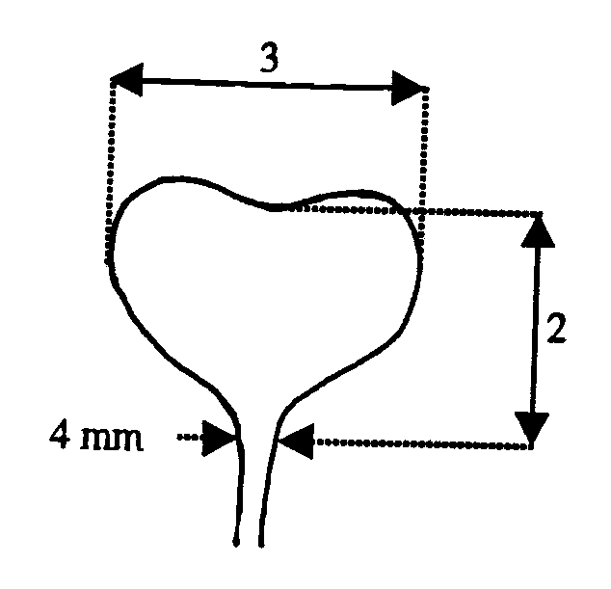

Ad. 5 + 6: Leaf: presence (5) and number of lobes (6)

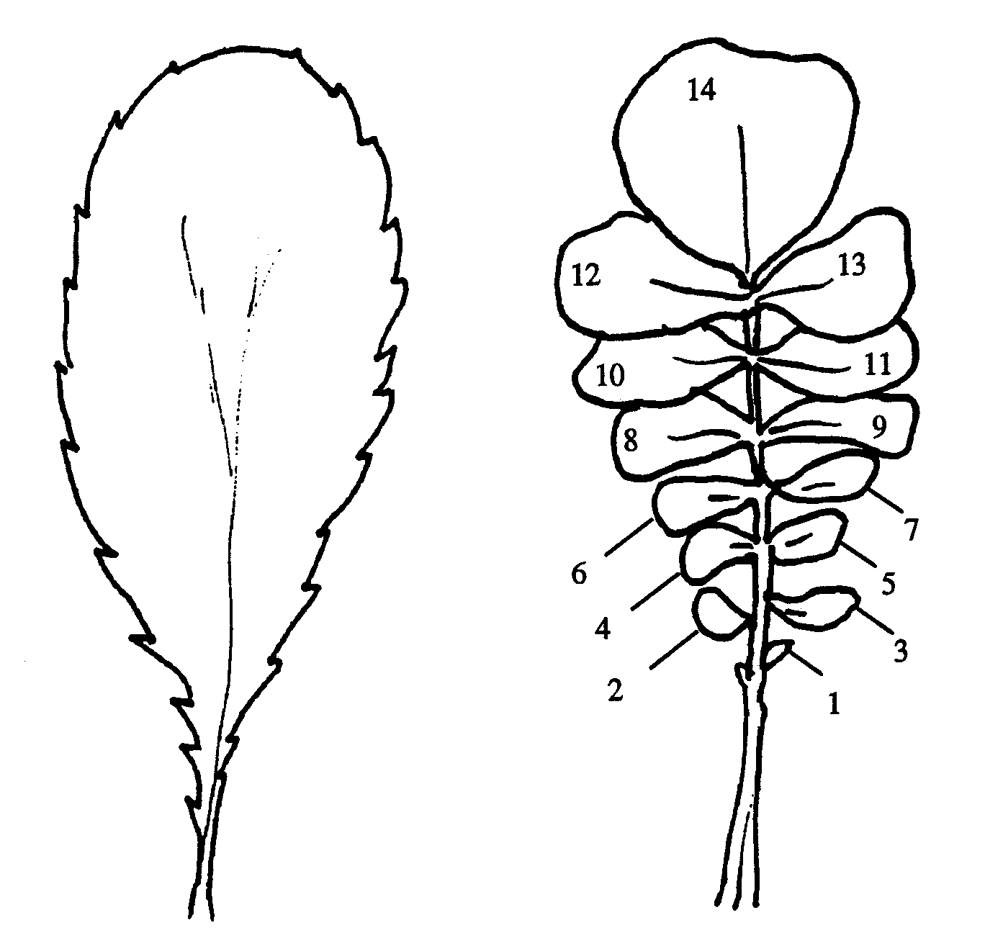
Absence or presence of lobing should be observed on the whole plant at rosette stage. Parts of the leaf blade are considered as lobes if their length is at least equivalent to the width of the leaf petiole at their point of attachment and if the upper notch of the blade has at least half the length of the lobe itself.

1 | 2
absent | present

Ad. 7 – 10: Leaf: dentation (7), length (8), width (9), length of petiole (10)

7 = part on which the dentation should be recorded (characteristic 7)
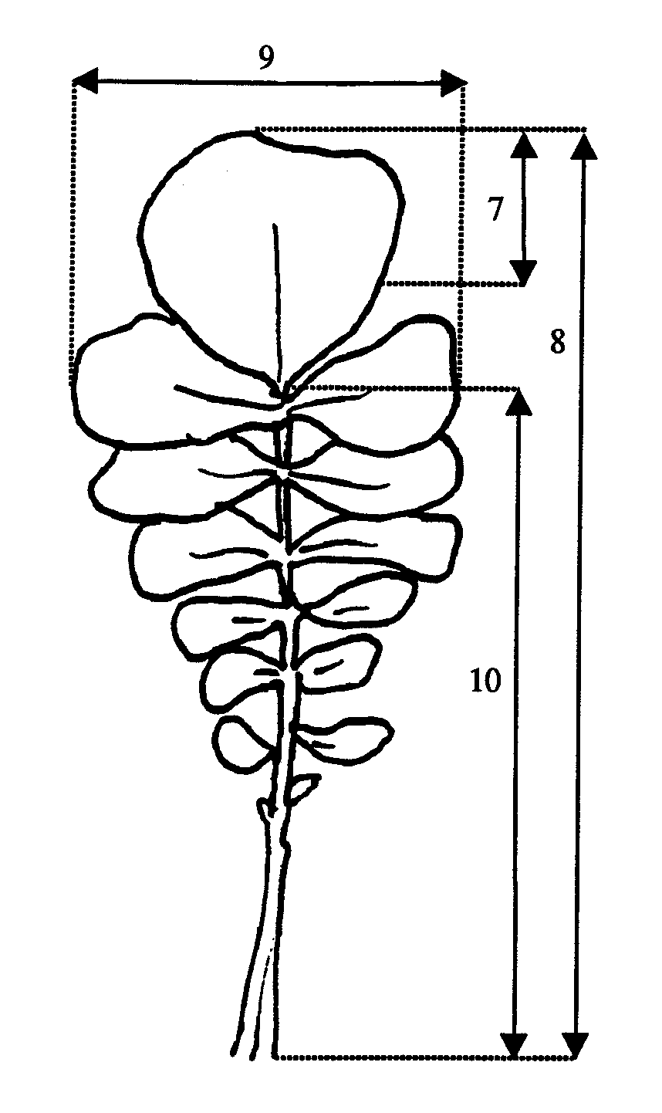

Ad 11: Plant: height at emergence of flower buds

The height of the plants should be assessed when 50% of the plants have reached stage 52.

Ad 12: Time of flowering

The observation should be done at least three times per week and more frequently if there is any need to do so. The date should be calculated – if necessary by interpolation – at which 50% of plants show at least one open flower.

Ad. 13: Plant: height at flowering

The height of the plants should be assessed when all normally developed plants have opened at least one flower.
Ad. 14: Flower: color of petals

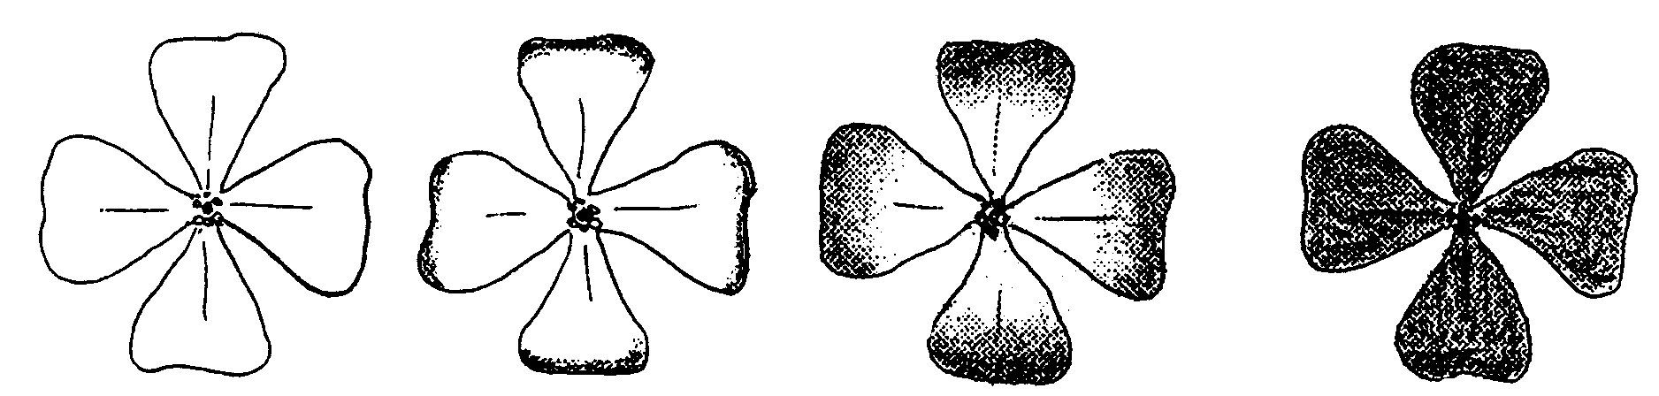
The violet and reddish color should be observed independent of its extension on the petal.

white or yellow violet or reddish

For varieties which show a segregation of plants with violet petals and white petals or with reddish petals and white petals the proportions of the states of expression should be recorded. A segregation of plants with three different colors is not tolerated.

Ad. 16-20: Siliqua

All observations on the siliqua should be recorded in the midpart of the inflorescence of the main stem or top branch.

Ad. 22: Tendency to form inflorescence in year of sowing for late summer sown trials

In a separate sowing the observation of the growth stage should be made in autumn, when the development stagnates.

Ad. 23: Root: color

In a separate sowing in late summer with half the density of the normal plots the color of skin should be recorded when the development in autumn stagnates.

The color is observed independent of its extension on the root and its intensity, immediately after lifting of the roots.
Phenological growth stages according to the BBCH-identification keys of oilseed rape
(Meier, 1997)

Code | Description
Principal growth stage 0: Germination
00 | Dry seed
01 | Beginning of seed imbibition
03 | Seed imbibition complete
05 | Radicle emerged from seed
07 | Hypocotyl with cotyledons emerged from seed
08 | Hypocotyl with cotyledons growing towards soil surface
09 | Emergence: cotyledons emergence through
Principal growth stage 1: Leaf development
10 | Cotyledons completely unfolded
11 | First leaf unfolded
12 | 2 leaves unfolded
13 | 3 leaves unfolded
14 | 4 leaves unfolded
15 | 5 leaves unfolded
16 | 6 leaves unfolded
17 | 7 leaves unfolded
18 | 8 leaves unfolded
19 | 9 or more leaves unfolded
Principal growth stage 2: Formation of side shoots
20 | No side shoots
21 | Beginning of side shoot de development: first side shoot detectable
22 | 2 side shoots detectable
23 | 3 side shoots detectable
24 | 4 side shoots detectable
25 | 5 side shoots detectable
26 | 6 side shoots detectable
27 | 7 side shoots detectable
28 | 8 side shoots detectable
29 | End of side shoot development: 9 or more side shoots detectable
Principal growth stage 3: Stem elongation
30 | Beginning of stem elongation: no internodes (“rosette”)
31 | 1 visibly extended internodes
32 | 2 visibly extended internodes
33 | 3 visibly extended internodes
34 | 4 visibly extended internodes
35 | 5 visibly extended internodes
36 | 6 visibly extended internodes
37 | 7 visibly extended internodes
38 | 8 visibly extended internodes
39 | 9 or more visibly extended internodes
Principal growth stage 4: --

Code | Description
Principal growth stage 5: Inflorescence emergence
50 | Flower buds present, still enclosed by leaves
51 | Flower buds visible from above (“green bud”)
52 | Flower buds free, level with the youngest leaves
53 | Flower buds raised above the youngest leaves
55 | Individual flower buds (main inflorescence) visible but still closed
57 | Individual flower buds (secondary inflorescences) visible but still closed
59 | First petals visible, flower buds still closed (“colored bud”)
Principal growth stage 6: Flowering
60 | First flowers open
61 | 10% of flowers on main raceme open, main raceme elongating
62 | 20% of flowers on main raceme open
63 | 30% of flowers on main raceme open
64 | 40% of flowers on main raceme open
65 | Full flowering 50% flowers on main raceme open, older petals falling
67 | Flowering declining: majority of petals fallen
69 | End of flowering
Principal growth stage 7: Development of fruit
71 | 10% of pods have reached final size
72 | 20% of pods have reached final size
73 | 30% of pods have reached final size
74 | 40% of pods have reached final size
75 | 50% of pods have reached final size
76 | 60% of pods have reached final size
77 | 70% of pods have reached final size
78 | 80% of pods have reached final size
79 | Nearly all pods have reached final size
Principal growth stage 8: Ripening
80 | Beginning of ripening: seed green, filling pod cavity
81 | 10% of pods ripe, seeds dark and hard
82 | 20% of pods ripe, seeds dark and hard
83 | 30% of pods ripe, seeds dark and hard
84 | 40% of pods ripe, seeds dark and hard
85 | 50% of pods ripe, seeds dark and hard
86 | 60% of pods ripe, seeds dark and hard
87 | 70% of pods ripe, seeds dark and hard
88 | 80% of pods ripe, seeds dark and hard
89 | Fully ripe: nearly all pods ripe, seeds dark and hard

IX. Literature

Growth stages of mono- and dicotyledonous plants: BBCH-Monograph. Federal Biological Research Centre of Agriculture and Forestry (ed.) Ed. by Uwe Meier.-Berlin; Wien [u.a.]: Blackwell Wiss.-Verl., 1997.

X. Technical Questionnaire

Reference Number
(not to be filled in by the applicant)

TECHNICAL QUESTIONNAIRE
to be completed in connection with an application for plant breeders’ rights

1. Species Raphanus sativus L. var. oleiformis Pers.

FODDER RADISH

2. Applicant (Name and address)

3. Proposed denomination or breeder’s reference

4. Information on origin, maintenance and reproduction of the variety

4.2 Other information

5. Characteristics of the variety to be indicated (the number in brackets refers to the corresponding characteristic in Test Guidelines; please mark the state of expression which best corresponds).

 | Characteristics |  |  |  | Example Varieties |  | Note
5.1  (1) |  |  | Ploidy
 |  |  | diploid | Pegletta |  | 2[ ]
 |  |  | tetraploid | Romulus |  | 4[ ]
5.2  (12) |  |  | Time of flowering
 |  | very early |  |  | Iris |  | 1[ ]
 |  | early |  |  | Siletina |  | 3[ ]
 |  | medium |  |  | Trick |  | 5[ ]
 |  | late |  |  | Nemex |  | 7[ ]
 |  | very late |  |  | Ultimo |  | 9[ ]
5.3  (14) |  | Flower: color of petals
 |  | white |  |  | Ultimo |  | 1[ ]
 |  | violet |  |  | Radical, Toro |  | 2[ ]
 |  | reddish |  |  | Mator |  | 3[ ]
 |  | yellow |  |  |  |  | 4[ ]

 | Characteristics |  |  |  | Example Varieties |  | Note
5.4  (15) |  | Plant: total length
 |  | very short |  |  | Mator |  | 1[ ]
 |  | short |  |  | Toro |  | 3[ ]
 |  | medium |  |  | Adagio |  | 5[ ]
 |  | long |  |  | Siletta Nova |  | 7[ ]
 |  | very long |  |  |  |  | 9[ ]
5.5  (23) |  | Root: color
 |  | white |  |  | Nemex |  | 1[ ]
 |  | red |  |  | Mator |  | 2[ ]
 |  | violet |  |  |  |  | 3[ ]
 |  | blackish brown |  |  |  |  | 4[ ]
6. Similar varieties and differences from these varieties

Denomination of similar variety |  |  | Characteristic in which the similar variety is different ^{o)} | State of expression of similar variety |  | State of expression of candidate variety
______________
^{o)} In the case of identical states of expressions of both varieties, please indicate the size of the difference.

7. Additional information which may help to distinguish the variety

7.1 Resistance to pests and diseases

7.2 Special conditions for the examination of the variety

7.3 Other information

- Authorization for release
(a) Does the variety require prior authorization for release under legislation concerning the protection of the environment, human and animal health?
yes [ ] no [ ]
(b) Has such authorization been obtained?
yes [ ] no [ ]
If the answer to that question is yes, please attach a copy of such an authorization.

[End of document]

