 |  | E  TG/177/3

INTERNATIONAL UNION FOR THE PROTECTION  OF NEW VARIETIES OF PLANTS | UNION INTERNATIONALE POUR LA PROTECTION  DES OBTENTIONS VÉGÉTALES | INTERNATIONALER VERBAND ZUM SCHUTZ VON PFLANZEN-ZÜCHTUNGEN | UNIÓN INTERNACIONAL PARA LA PROTECCIÓN  DE LAS OBTENCIONES VEGETALES

GUIDELINES

FOR THE CONDUCT OF TESTS

FOR DISTINCTNESS, UNIFORMITY AND STABILITY

ZANTEDESCHIA

(Zantedeschia Spreng.)

GENEVA
2001

Copies of this document are available on request at the price of 10 Swiss francs each, including surface mail, from the Office of UPOV, 34, chemin des Colombettes, P.O. Box 18, 1211 Geneva 20, Switzerland

This document or parts of it may be reproduced, translated and published without obtaining the specific consent of UPOV, provided that the source is acknowledged.

* * * * * * *
TG/177/3
ORIGINAL: English
DATE: 2001-04-04

INTERNATIONAL UNION FOR THE PROTECTION  OF NEW VARIETIES OF PLANTS | UNION INTERNATIONALE POUR LA PROTECTION  DES OBTENTIONS VÉGÉTALES | INTERNATIONALER VERBAND ZUM SCHUTZ VON PFLANZEN-ZÜCHTUNGEN | UNIÓN INTERNACIONAL PARA LA PROTECCIÓN  DE LAS OBTENCIONES VEGETALES

GUIDELINES

FOR THE CONDUCT OF TESTS

FOR DISTINCTNESS, UNIFORMITY AND STABILITY

ZANTEDESCHIA

(Zantedeschia Spreng.)

These Guidelines should be read in conjunction with document TG/1/2, which contains explanatory notes on the general principles on which the Guidelines have been established.

TABLE OF CONTENTS PAGE

I. Subject of these Guidelines 3

II. Material Required 3

III. Conduct of Tests 3

IV. Methods and Observations 4

V. Grouping of Varieties 4

VI. Characteristics and Symbols 5

VII. Table of Characteristics 6

VIII. Explanations on the Table of Characteristics 17

IX. Literature 19

X. Technical Questionnaire 20

I. Subject of these Guidelines

These Test Guidelines apply to all vegetatively propagated varieties of Zantedeschia Spreng. of the family Araceae.

II. Material Required

1. The competent authorities decide when, where and in what quantity and quality the plant material required for testing the variety is to be delivered. Applicants submitting material from a State other than that in which the testing takes place must make sure that all customs formalities are complied with. As a minimum, the following quantity of plant material is recommended:

20 tubers/rhizomes of flowering size or
20 young plants.

2. The plant material supplied should be visibly healthy, not lacking in vigor or affected by any important pests or diseases.

3. The plant material must not have undergone any treatment, especially not with gibberellic acid. If the competent authorities allow or request some other treatment, full details of the treatment must be given.

III. Conduct of Tests

1. A test should normally be conducted for one growing period. If distinctness and/or uniformity cannot be sufficiently established in one growing period, the test should be extended for a second growing period.

2. The tests should normally be conducted at one place. If any important characteristics of the variety cannot be seen at that place, the variety may be tested at an additional place.

3. The tests should be carried out under the following growing conditions:

Temperature: Preferably between 15 – 25ºC.

Planting time: March (Northern Hemisphere), August to
October (Southern Hemisphere).

Substrate: Very well-drained substrate rich in humus.

Fertilization: Not too much nitrogen for deciduous varieties. Trace elements may be added.

Irrigation: Deciduous varieties: keep moist but not wet.
Zantedeschia aethiopica: prefers more water.

Air humidity: Deciduous varieties prefer less humidity than
Zantedeschia aethiopica.

Shading: Without shading or with 40 % shade cloth, depending on local conditions.

The size of the plots should be such that plants or parts of plants may be removed for measurement and counting without prejudice to the observations which must be made up to the end of the growing period. Each test should include a total of 20 plants. Separate plots for observation and for measuring can only be used if they have been subject to similar environmental conditions.

4. Additional tests for special purposes may be established.

IV. Methods and Observations

1 All observations determined by measurement or counting should be made on 10 plants or parts taken from each of 10 plants.

2. For the assessment of uniformity a population standard of 1% and an acceptance probability of at least 95% should be applied. In the case of a sample size of 20 plants, the maximum number of off-types allowed would be 1.

3. All observations should be made on plants that have flowers of maximum size, during the peak flowering time.

- All observations on the leaf should be made on fully developed leaves from flowering shoots. The width of the leaf blade should be measured at the broadest part, which would sometimes include the lobes.

5. Unless otherwise indicated, all observations on the flower should be made at the beginning of anther dehiscence.

6. All observations on the fading, intensifying and greening of the flower color with age should be made two to three weeks after pollen shed.

7. Because daylight varies, color determinations made against a color chart should be made either in a suitable cabinet providing artificial daylight or in the middle of the day in a room without direct sunlight. The spectral distribution of the illuminant for artificial daylight should conform with the CIE Standard of Preferred Daylight D 6500 and should fall within the tolerances set out in British Standard 950, Part I. These determinations should be made with the plant part placed against a white background.

V. Grouping of Varieties

1. The collection of varieties to be grown should be divided into groups to facilitate the assessment of distinctness. Characteristics which are suitable for grouping purposes are those which are known from experience not to vary, or to vary only slightly, within a variety. Their various states of expression should be fairly evenly distributed throughout the collection.

2. It is recommended that the competent authorities use the following characteristics for grouping varieties:

- Plant: type (characteristic 1)
- Leaf blade: spots on upper side (characteristic 15)
- Spathe: natural length (viewed from above) (characteristic 23)
- Spathe: natural width (viewed from above) (characteristic 24)
- Spathe: main color of inner side (excluding throat spot color, if present)
(characteristic 27) with the following groups:
Gr. 1: white
Gr. 2: cream
Gr. 3: yellow
Gr. 4: yellow brown
Gr. 5: yellow orange
Gr. 6: orange
Gr. 7: orange red
Gr. 8: red
Gr. 9: purple red
Gr. 10: pink
Gr. 11: red pink
Gr. 12: purple
- Spathe: presence of throat spot (characteristic 31)

VI. Characteristics and Symbols

1. To assess distinctness, uniformity and stability, the characteristics and their states as given in the Table of Characteristics should be used.

2. Notes (numbers), for the purposes of electronic data processing, are given opposite the states of expression for each characteristic.

3. Legend:

(*) Characteristics that should be used on all varieties in every growing period over which examinations are made and always be included in the variety descriptions, except when the state of expression of a preceding characteristic or regional environmental conditions render this impossible.

(+) See Explanations on the Table of Characteristics in Chapter VIII.

 | English | français | deutsch | español | Example Varieties  Exemples  Beispielssorten  Variedades ejemplo | Note/  Nota
1.  (*) | Plant: type | Type de plante | Pflanze: Typ | Planta: tipo
 | deciduous | caduque | laubabwerfend | caducifolia |  | 1
 | semi-deciduous | semi-caduque | halblaubabwerfend | semicaducifolia |  | 2
 | evergreen | toujours verte | immergrün | de hoja perenne |  | 3
2.  (*) | Plant: height | Plante: hauteur | Pflanze: Höhe | Planta: altura
 | short | basse | niedrig | baja | Hope Cross | 3
 | medium | moyenne | mittel | media | Black Magic | 5
 | tall | haute | hoch | alta | Green Tip | 7
3. | Deciduous varieties only: Plant: total number of shoots | Variétés caduques seulement: plante: nombre total de pousses | Nur laubabwerfende Sorten: Pflanze: Anzahl Triebe | Variedades caducifolias únicamente: planta: número total de tallos
 | few | petit | gering | bajo | Pink Persuasion | 3
 | medium | moyen | mittel | medio | Inspiration | 5
 | many | grand | groß | alto | Celeste | 7
4.  (*) | Young shoot: color | Jeune pousse: couleur | Junger Trieb: Farbe | Tallo joven: color
 | yellow green | vert-jaune | gelbgrün | verde amarillento | Black Magic | 1
 | green | verte | grün | verde | Pink Persuasion | 2
 | red purple | violet-rouge | rotpurpur | rojo púrpura |  | 3
5. | Petiole: length | Pétiole: longueur | Blattstiel: Länge | Peciolo: longitud
 | short | courte | kurz | corta | Hope Cross | 3
 | medium | moyenne | mittel | media | Pink Persuasion | 5
 | long | longue | lang | larga | Green Tip | 7
6.  (*) | Petiole: color of lower part | Pétiole: couleur de la partie inférieure | Blattstiel: Farbe des unteren Teils | Peciolo: color de la parte inferior
 | yellow green | vert-jaune | gelbgrün | verde amarillento | Schwarzwalder | 1
 | light green | vert clair | hellgrün | verde claro | Heidi | 2
 | medium green | vert moyen | mittelgrün | verde medio | Inspiration | 3
 | dark green | vert foncé | dunkelgrün | verde oscuro | Majestic Red | 4
 | brown red | rouge-brun | braunrot | marrón rojizo | Black Magic | 5
 | purple | violet-pourpre | purpur | púrpura |  | 6
7. | Leaf blade: attitude | Limbe: port | Blattspreite: Haltung | Limbo: porte
 | erect | dressé | aufrecht | erecto |  | 1
 | semi-erect | demi-dressé | halbaufrecht | semierecto |  | 2
 | horizontal | horizontal | waagerecht | horizontal |  | 3
8.  (*) | Leaf blade: length (excluding lobes) | Limbe: longueur (à l’exclusion des lobes) | Blattspreite: Länge (ohne Lappen) | Limbo: longitud (excluidos los lóbulos)
 | very short | très court | sehr kurz | muy corto |  | 1
 | short | court | kurz | corto | Goldilocks | 3
 | medium | moyen | mittel | medio | Majestic Red | 5
 | long | long | lang | largo | Schwarzwalder | 7
 | very long | très long | sehr lang | muy largo | Green Tip | 9
9.  (*) | Leaf blade: width | Limbe: largeur | Blattspreite: Breite | Limbo: anchura
 | narrow | étroit | schmal | estrecho | Celeste | 1
 | narrow to medium | étroit à moyen | schmal bis mittel | estrecho a medio | Inspiration | 3
 | medium | moyen | mittel | medio | Majestic Red | 5
 | medium to broad | moyen à large | mittel bis breit | medio a ancho | Cameo | 7
 | broad | large | breit | ancho | Green Tip | 9
10.  (*) | Leaf blade: position of broadest part | Limbe: position de la partie la plus large | Blattspreite: Position des breitesten Teils | Limbo: posición de la parte más ancha
 | in middle | au centre | in der Mitte | en la mitad |  | 1
 | slightly below middle | légèrement en dessous du milieu | etwas unterhalb der Mitte | ligeramente por debajo de la mitad | Celeste | 2
 | far below middle | bien en dessous du milieu | weit unterhalb der Mitte | claramente por debajo de la mitad | Black Magic | 3
11.  (*) | Leaf blade: lobes | Limbe: lobes | Blattspreite: Lappen | Límbo: lóbulos
 | absent | absents | fehlend | ausentes | Hope Cross | 1
 | present | présents | vorhanden | presentes | Black Magic | 9
12.  (+) | Leaf blade: length of lobe | Limbe: longueur du lobe | Blattspreite: Länge der Lappen | Limbo: longitud del lóbulo
 | short | court | kurz | corto | Pink Persuasion | 3
 | medium | moyen | mittel | medio | Black Magic | 5
 | long | long | lang | largo | Green Tip | 7
13. | Leaf blade: shape at apex (excluding caudate tip) | Limbe: forme au sommet (à l’exclusion du sommet en forme de queue) | Blattspreite: Form an der Spitze (ohne langgezogene Spitze) | Limbo: forma del ápice (excluida la punta caudada)
 | acute | aiguë | spitz | aguda | Celeste | 1
 | right-angled | parallélépipédique | rechteckig | en ángulo recto | Red Soxs | 2
 | obtuse | obtuse | stumpf | obtusa | Green Tip | 3
14.  (*) | Leaf blade: intensity of green color of upper side | Limbe: intensité de la couleur verte sur la partie supérieure | Blattspreite: Intensität der grünen Farbe der Oberseite | Limbo: intensidad del color verde del haz
 | light | claire | hell | clara | Black Magic | 3
 | medium | moyenne | mittel | media | Hope Cross | 5
 | dark | foncée | dunkel | oscura | Red Soxs | 7
15.  (*) | Leaf blade: spots on upper side | Limbe: taches sur la partie supérieure | Blattspreite: Flecken auf der Oberseite | Limbo: manchas en el haz
 | absent | absentes | fehlend | ausentes | Hope Cross | 1
 | present | présentes | vorhanden | presentes | Majestic Red | 9
16. | Leaf blade: size of spots on upper side | Limbe: taille des taches sur la partie supérieure | Blattspreite: Größe der Flecken auf der Oberseite | Limbo: tamaño de las manchas del haz
 | small | petites | klein | pequeño | Inspiration | 3
 | medium | moyennes | mittel | medio | Majestic Red | 5
 | large | grandes | groß | grande | Black Magic | 7
17.  (*) | Leaf blade: number of spots on upper side | Limbe: nombre de taches sur la partie supérieure | Blattspreite: Anzahl der Flecken auf der Oberseite | Limbo: número de manchas en el haz
 | very few | très peu nombreuses | sehr gering | muy bajo | Aries | 1
 | few | peu nombreuses | gering | bajo | Pixie | 3
 | medium | moyennement nombreuses | mittel | medio | Majestic Red | 5
 | many | nombreuses | groß | alto | Black Magic | 7
 | very many | très nombreuses | sehr groß | muy alto |  | 9
18. | Leaf blade: undulation of margin | Limbe: ondulation du bord | Blattspreite: Randwellung | Limbo: ondulación del borde
 | absent or very weakly expressed | absente ou faiblement exprimée | fehlend oder sehr schwach ausgeprägt | ausente o expresada muy débilmente |  | 1
 | weakly expressed | faiblement exprimée | schwach ausgeprägt | expresada débilmente | Black Magic | 2
 | strongly expressed | fortement exprimée | stark ausgeprägt | expresada fuertemente | Inspiration | 3
19. | Scape: thickness | Pédoncule: épaisseur | Schaft: Dicke | Escapo: grosor
 | thin | mince | dünn | delgado | Scarlet Pimpernel | 3
 | medium | moyen | mittel | medio | Black Magic | 5
 | thick | épais | dick | grueso | Red Soxs | 7
20. | Scape: red coloration | Pédoncule: coloration rouge | Schaft: Rotfärbung | Escapo: coloración roja
 | absent or very weak | nulle ou très faible | fehlend oder sehr gering | ausente o muy débil | Majestic Red | 1
 | weak | faible | gering | débil |  | 3
 | medium | moyenne | mittel | media | Black Magic | 5
 | strong | forte | stark | fuerte | Cameo | 7
 | very strong | très forte | sehr stark | muy fuerte |  | 9
21. | Scape: mottling at basal part | Pédoncule: marbrures sur la partie basale | Schaft: Marmorierung am basalen Teil | Escapo: jaspeado de la parte basal
 | absent or very weakly expressed | absentes ou très faiblement exprimées | fehlend oder sehr schwach ausgeprägt | ausente o expresado muy débilmente | Red Soxs | 1
 | weakly expressed | faiblement exprimées | schwach ausgeprägt | expresado débilmente | Black Magic | 2
 | strongly expressed | fortement exprimées | stark ausgeprägt | expresado fuertemente | Sensation | 3
22.  (*)  (+) | Spathe: natural height | Spathe: hauteur naturelle | Spatha: natürliche Höhe | Espata: altura
 | low | basse | niedrig | baja | Scarlet Pimpernel | 1
 | low to medium | basse à moyenne | niedrig bis mittel | baja a media | Hope Cross | 3
 | medium | moyenne | mittel | media | Black Magic | 5
 | medium to high | moyenne à haute | mittel bis hoch | media a alta | Majestic Red | 7
 | high | haute | hoch | alta | Green Tip | 9
23.  (*)  (+) | Spathe: natural length (viewed from above) | Spathe: longueur naturelle (vue d’en haut) | Spatha: natürliche Länge (von oben betrachtet) | Espata: longitud (vista desde arriba)
 | short | courte | kurz | corta | Celeste | 1
 | short to medium | courte à moyenne | kurz bis mittel | corta a media | Pink Persuasion | 3
 | medium | moyenne | mittel | media | Schwarzwalder | 5
 | medium to long | moyenne à longue | mittel bis lang | media a larga |  | 7
 | long | longue | lang | larga | Green Tip | 9
24.  (*)  (+) | Spathe: natural width (viewed from above) | Spathe: largeur naturelle (vue d’en haut) | Spatha: natürliche Breite (von oben betrachtet) | Espata: anchura vista desde arriba
 | narrow | étroite | schmal | estrecha | Schwarzwalder | 1
 | narrow to medium | étroite à moyenne | schmal bis mittel | estrecha a media | Inspiration | 3
 | medium | moyenne | mittel | media | Pink Persuasion | 5
 | medium to broad | moyenne à large | mittel bis breit | media a ancha |  | 7
 | broad | large | breit | ancha |  | 9
25.  (+) | Spathe: height of overlapping part | Spathe: hauteur de la partie recouvrante | Spatha: Höhe des überlappenden Teils | Espata: altura de la parte superpuesta
 | low | basse | niedrig | baja | Green Tip | 3
 | medium | moyenne | mittel | media | Majestic Red | 5
 | high | haute | hoch | alta | Cameo | 7
26. | Spathe: natural shape of distal part (excluding caudate tip) | Spathe: forme naturelle de la partie distale (à l’exclusion du sommet en forme de queue) | Spatha: natürliche Form des oberen Endes (ohne langgezogene Spitze) | Espata: forma natural de la parte distal (excluida la punta caudada)
 | acute | pointue | spitz | aguda | Inspiration | 1
 | obtuse | obtuse | stumpf | obtusa | Black Magic | 2
 | rounded | arrondie | abgerundet | redondeada | Green Tip | 3
27.  (*) | Spathe: main color of inner side (excluding throat spot color, if present) | Spathe: couleur principale de la face interne (à l’exclusion de couleur de la tache sur la gorge, si présente) | Spatha: Hauptfarbe der Innenseite (ohne Farbe des Schlundflecks, wenn vorhanden) | Espata: color principal de la cara interna (excluido el color de la mancha de la garganta, de estar presente)
 | RHS Colour Chart  (indicate reference number) | RHS des couleurs (indiquer le numéro de référence) | RHS-Farbkarte (Nummer angeben) | Carta de colores RHS (indicar número de referencia)
28.  (*) | Spathe: secondary color of inner side (excluding the throat spot color) | Spathe: couleur secondaire de la face interne (à l’exclusion de couleur de la tache sur la gorge) | Spatha: Sekundärfarbe der Innenseite (ohne Farbe des Schlundflecks) | Espata: color secundario de la cara interna (excluido el color de la mancha de la garganta)
 | dark green | vert foncé | dunkelgrün | verde oscuro |  | 1
 | red orange | orange-rouge | rotorange | naranja rojizo |  | 2
 | red | rouge | rot | rojo |  | 3
 | orange pink | rose orangé | orangerosa | rosa anaranjado |  | 4
 | pink | rose | rosa | rosa |  | 5
 | red pink | rose-rouge | rotrosa | rosa rojizo |  | 6
 | purple pink | rose-violet | purpurrosa | rosa púrpura |  | 7
 | blue pink | rose-bleu | blaurosa | rosa azulado |  | 8
 | red purple | violet-rouge | rotpurpur | púrpura rojizo |  | 9
 | dark red purple | violet-rouge foncé | dunkelrotpurpur | púrpura rojizo oscuro |  | 10
29. | Spathe: gradual color change from base to apex (inner side, excluding varieties with throat spot) | Spathe : changement graduel de couleur de la base au sommet (face interne, à l’exclusion des variétés ayant une tache sur la gorge) | Spatha: allmähliche Veränderung der Farbe von der Basis zur Spitze (Innenseite, ohne Sorten mit Schlundfleck) | Espata: Cambio gradual de color de la base al ápice (cara interna, excluidas las variedades con mancha en la garganta)
 | strongly shading off | fortement dégradé | stark abschattiert | fuertemente atenuado | Pixie | 1
 | weakly shading off | faiblement dégradé | schwach abschattiert | débilmente atenuado | Inspiration | 2
 | no change or very little | aucun changement ou très peu | keine oder sehr geringe Veränderung | sin cambios o cambios muy leves | Celeste, Schwarzwalder | 3
 | weakly intensifying | faiblement intensifié | sich schwach intensivierend | intensificándose débilmente | Elmaro | 4
 | strongly intensifying | fortement intensifié | sich stark intensivierend | intensificándose fuertemente | Red Soxs | 5
30. | Spathe: size of un-changed color area at base (as for 29) | Spathe: taille de la zone qui n’a pas changé de couleur (comme pour 29) | Spatha: Größe des Bereichs der unveränderten Farbe an der Basis (wie für 29) | Espata: tamaño de la zona de color inalterado de la base (como para 29)
 | small | petite | klein | pequeño | Scarlet Pimpernel | 3
 | medium | moyenne | mittel | medio | Inspiration | 5
 | large | grande | groß | grande | Dominique | 7
31.  (*) | Spathe: presence of throat spot | Spathe: présence d’une tache sur la gorge | Spatha: Vorhandensein des Schlundflecks | Espata: presencia de mancha en la garganta
 | absent | absente | fehlend | ausente | Inspiration | 1
 | present | présente | vorhanden | presente | Black Magic | 9
32. | Spathe: size of throat spot | Spathe: taille de la tache sur la gorge | Spatha: Größe des Schlundflecks | Espata: tamaño de la mancha de la garganta
 | small | petite | klein | pequeño | Treasure | 3
 | medium | moyenne | mittel | mediano | Cameo | 5
 | large | grande | groß | grande |  | 7
33.  (*) | Spathe: color of throat spot | Spathe: couleur de la tache sur la gorge | Spatha: Farbe des Schlundflecks | Espata: color de la mancha de la garganta
 | pink | rose | rosa | rosa |  | 1
 | purple | violette | purpur | púrpura |  | 2
34. | Spathe: main color of outer side | Spathe: couleur principale de la face externe | Spatha: Hauptfarbe der Außenseite | Espata: color principal de la cara externa
 | white | blanche | weiß | blanco | Green Tip | 1
 | greenish white | blanc verdâtre | grünlich weiß | blanco verdoso | Green Goddess | 2
 | light yellow | jaune clair | hellgelb | amarillo claro | Pink Persuasion | 3
 | medium yellow | jaune moyen | mittelgelb | amarillo medio | Black Magic | 4
 | yellow orange | jaune-orange | gelborange | naranja amarillento | Fandango | 5
 | red orange | rouge orangé | rotorange | naranja rojizo | Treasure | 6
 | yellow red | jaune-rouge | gelbrot | rojo amarillento | Sensation | 7
 | red pink | rose-rouge | rotrosa | rosa rojizo | Aries | 8
 | purple pink | rose-violet | purpurrosa | rosa púrpura | Hope Cross | 9
 | red purple | violet-rouge | rotpurpur | púrpura rojizo | Majestic Red | 10
 | brown purple | violet-brun | braunpurpur | púrpura marrón | Scarlet Pimpernel | 11
 | purple | violette | purpur | púrpura | Schwarzwalder | 12
35. | Spathe: recurving of margin | Spathe: courbure du bord | Spatha: Zurückbiegung des Randes | Espata: curvatura del borde
 | weak | faiblement recourbé | gering | débil | Black Magic | 3
 | medium | moyennement recourbé | mittel | media | Inspiration | 5
 | strong | fortement recourbé | stark | fuerte | Aries | 7
36. (*) | Spadix: length | Spadice: longueur | Kolben: Länge | Espádice: longitud
 | short | court | kurz | corto | Cameo | 3
 | medium | moyen | mittel | medio | Pink Persuasion | 5
 | long | long | lang | largo |  | 7
37. | Spadix: width at middle of male part | Spadice: largeur au centre de la partie mâle | Kolben: Breite in der Mitte des männlichen Teils | Espádice: anchura del medio de la parte masculina
 | narrow | étroite | schmal | estrecha | Black Magic | 3
 | medium | moyenne | mittel | media | Sensation | 5
 | broad | large | breit | ancha | Majestic Red | 7
38. | Spadix: main color just before pollen shed | Spadice: couleur principale juste avant la libération du pollen | Kolben: Hauptfarbe kurz vor dem Pollenstäuben | Espádice: color principal justo antes de la emisión del polen
 | white | blanche | weiß | blanco |  | 1
 | yellow green | vert-jaune | gelbgrün | verde amarillento |  | 2
 | light yellow | jaune clair | hellgelb | amarillo claro | Cameo | 3
 | medium yellow | jaune moyen | mittelgelb | amarillo medio | Pink Persuasion | 4
 | yellow orange | orange-jaune | gelborange | naranja amarillento | Majestic Red | 5
 | orange brown | brun orangé | orangebraun | marrón anaranjado | Elmaro | 6
 | orange red | rouge orangé | orangerot | rojo anaranjado |  | 7
 | pink | rose | rosa | rosa | Green Tip | 8
 | purple red | rouge-violet | purpurrot | rojo púrpura | Schwarzwalder | 9
 | purple | violette | purpur | púrpura |  | 10
39. | Degree of fading of flower color with age | Degré de décoloration de la fleur avec l’âge | Stärke des Verblassens der Blütenfarbe mit dem Alter | Grado de decoloración de la flor con el tiempo
 | absent or very weakly expressed | nulle ou très faiblement exprimée | fehlend oder sehr schwach ausgeprägt | ausente o expresado muy débilmente | Schwarzwalder | 1
 | weakly expressed | faiblement exprimée | schwach ausgeprägt | expresado débilmente | Hope Cross | 2
 | strongly expressed | fortement exprimée | stark ausgeprägt | expresado fuertemente | Sensation | 3
40. | Color change with age | Changement de couleur avec l’âge | Veränderung der Farbe mit dem Alter | Cambio de color con el tiempo
 | strongly fading | fortement délavé | stark verblassend | fuertemente atenuado | Sensation | 1
 | weakly fading | faiblement délavé aucun | schwach verblassend | débilmente atenuado | Hope Cross | 2
 | no change or very little | changement ou très peu | keine oder sehr geringe Veränderung | sin cambios o cambios muy leves | Dominique, Schwarzwalder | 3
 | weakly intensifying | faiblement intensifié | sich schwach intensivierend | intensificándose débilmente | Pixie | 4
 | strongly intensifying | fortement intensifié | sich stark intensivierend | intensificándose fuertemente | Inspiration | 5

VIII. Explanations on the Table of Characteristics

Ad. 12: Leaf blade: length of lobe
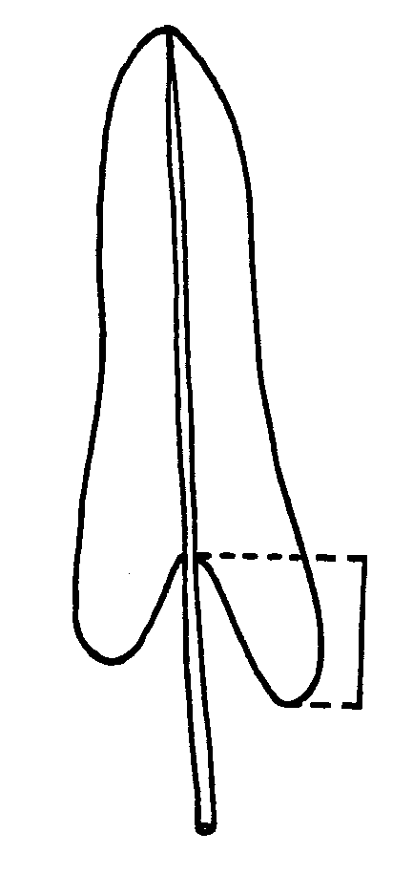

Ad. 22: Spathe: natural height

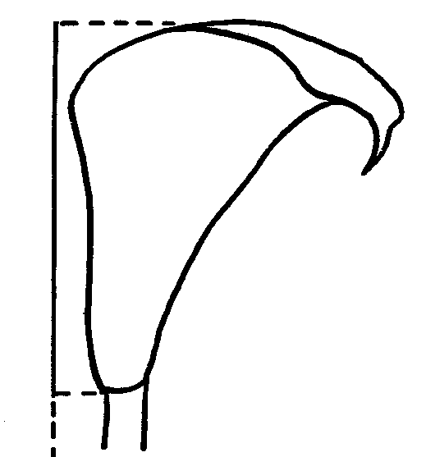
Ad. 23 and 24: Spathe: natural length (viewed from above) (23) and natural width (viewed from above) (24)
24
23
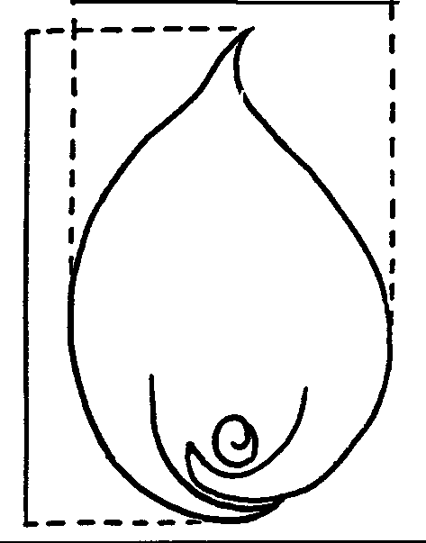

Ad. 25: Spathe: height of overlapping part
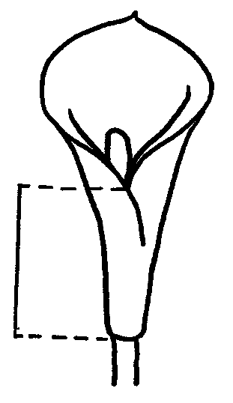
IX. Literature

Batten, Auriol, 1988: “Flowers of Southern Africa”, Southern Book Publishers (Pty) Ltd., Johannesburg, 3pp.

Letty, Cythna, 1973: “The Genus Zantedeschia”, Bothalia 11, 1 & 2, pp 5 - 26.

Singh, Y.; Van Wyk, A.E.; Baijnath, H., 1996: “Taxonomic notes on the genus Zantedeschia Spreng. (Araceae) in Southern Africa”, S. Afr. J. Bot. 62(6), pp 321-324.

Still, S.M., 1980: “Manual of Herbaceous Ornamental Plants”, STIPES Publishing Company, Illinois, pp 716-717.

Tija, B.O., 1989: Zantedeschia in Handbook of Flowering (Halevy, A.H. ed.) Volume VI, CRC Press, Boca Raton, pp 697-702.

X. Technical Questionnaire

Reference Number
(not to be filled in by the applicant)
TECHNICAL QUESTIONNAIRE
to be completed in connection with an application for plant breeders’ rights

1.1 1.1 Genus: Zantedeschia Spreng.
ZANTEDESCHIA

1.2 Species: .......................................
(indicate species)

2. Applicant (Name and address)

3. Proposed denomination or breeder’s reference

4. Information on origin, maintenance and reproduction of the variety
4.1 Origin
(a) Seedling (indicate parent varieties) | [ ]
(b) Mutation (indicate parent variety) | [ ]
(c) Discovery (indicate where and when) | [ ]
4.2 Method of reproduction  (a) in vitro  ……………………………………………………………...  (b) Tuber  ……………………………………………………………...  (c) Other (specify)  ……………………………………………………………...  4.3 Other information | [ ]  [ ]  [ ]

5. Characteristics of the variety to be indicated (the number in brackets refers to the corresponding characteristic in Test Guidelines; please mark the state of expression which best corresponds).

 |  | Characteristics |  | Example Varieties |  | Note
5.1  (1) |  | Plant: type
 |  | deciduous |  |  |  | 1[ ]
 |  | semi-deciduous |  |  |  | 2[ ]
 |  | evergreen |  |  |  | 3[ ]
5.2  (15) | Leaf blade: spots on upper side
 | absent |  | Hope Cross |  | 1[ ]
 | present |  | Majestic Red |  | 9[ ]
5.3  (23) | Spathe: natural length (viewed from above)
 | short |  | Celeste |  | 1[ ]
 | short to medium |  | Pink Persuasion |  | 3[ ]
 | medium |  | Schwarzwalder |  | 5[ ]
 | medium to long |  |  |  | 7[ ]
 | long |  | Green Tip |  | 9[ ]
5.4  (24) | Spathe: natural width (viewed from above)
 | narrow |  | Schwarzwalder |  | 1[ ]
 | narrow to medium |  | Inspiration |  | 3[ ]
 | medium |  | Pink Persuasion |  | 5[ ]
 | medium to broad |  |  |  | 7[ ]
 | broad |  |  |  | 9[ ]

 |  | Characteristics |  | Example Varieties |  | Note
5.5i  (27) | Spathe: main color of inner side (excluding throat spot color,  if present)
RHS Colour Chart (indicate reference number)
…………………………………………………
5.5ii  (27) | Spathe: main color of inner side (excluding throat spot color, if present)
 | white |  |  |  | 1[ ]
 | cream |  |  |  | 2[ ]
 | yellow |  |  |  | 3[ ]
 | yellow brown |  |  |  | 4[ ]
 | yellow orange |  |  |  | 5[ ]
 | orange |  |  |  | 6[ ]
 | orange red |  |  |  | 7[ ]
 | red |  |  |  | 8[ ]
 | purple red |  |  |  | 9[ ]
 | pink |  |  |  | 10[ ]
 | red pink |  |  |  | 11[ ]
 | purple |  |  |  | 12[ ]
5.6  (31) | Spathe: presence of throat spot
 | absent |  | Inspiration |  | 1[ ]
 | present |  | Black Magic |  | 9[ ]

6. Similar varieties and differences from these varieties

Denomination of  similar variety | Characteristic in which the similar variety is different^{o)} | State of expression of similar variety | State of expression of candidate variety
________________
^{o)} In the case of identical states of expression of both varieties, please indicate the size of the difference.

7. Additional information which may help to distinguish the variety
7.1 Resistance to pests and diseases
7.2 Special conditions for the examination of the variety
(a) Conditions for planting
- to be covered completely with soil |  |  | [ ]
- to be partly uncovered |  |  | [ ]
(b) Other conditions

7.3 Use of the variety  (a) garden  (b) cut flower  (c) pot plant | [ ]  [ ]  [ ]
7.4 Other information

A representative color photo of the variety should be included in the Technical Questionnaire

8. Authorization for release

(a) Does the variety require prior authorization for release under legislation concerning the protection of the environment, human and animal health?

Yes [ ] No [ ]

(b) Has such authorization been obtained?

Yes [ ] No [ ]

If the answer to that question is yes, please attach a copy of such an authorization.

[End of document]

