 |  | E
 | 
  TG/168/4
  ORIGINAL: English
  DATE: 2023-08-31
INTERNATIONAL UNION FOR THE PROTECTION OF NEW VARIETIES OF PLANTS
 | Geneva
  STATICE
  UPOV Code(s): LIMON; GONIO; PSYLL
  Limonium Mill.;
  Goniolimon Boiss.;
  Psylliostachys (Jaub. & Spach) Nevski
  *
GUIDELINES
FOR THE CONDUCT OF TESTS
FOR DISTINCTNESS, UNIFORMITY AND STABILITY

Alternative names:*

Botanical name | English | French | German | Spanish
  Limonium Mill.
  Statice
  Limonium, Statice
  Statice
  Statice
Goniolimon Boiss.

Psylliostachys (Jaub. & Spach) Nevski

The purpose of these guidelines (“Test Guidelines”) is to elaborate the principles contained in the General Introduction (document TG/1/3), and its associated TGP documents, into detailed practical guidance for the harmonized examination of distinctness, uniformity and stability (DUS) and, in particular, to identify appropriate characteristics for the examination of DUS and production of harmonized variety descriptions.

ASSOCIATED DOCUMENTS
These Test Guidelines should be read in conjunction with the General Introduction and its associated TGP documents.

TABLE OF CONTENTS | PAGE
1. | SUBJECT OF THESE TEST GUIDELINES.......................................................................................................... | 3
2. | MATERIAL REQUIRED......................................................................................................................................... | 3
3. | METHOD OF EXAMINATION................................................................................................................................ | 3
3.1 | Number of Growing Cycles........................................................................................................................ | 3
3.2 | Testing Place............................................................................................................................................. | 3
3.3 | Conditions for Conducting the Examination............................................................................................... | 3
3.4 | Test Design................................................................................................................................................ | 3
3.5 | Additional Tests......................................................................................................................................... | 3

4. | ASSESSMENT OF DISTINCTNESS, UNIFORMITY AND STABILITY................................................................. | 4
4.1 | Distinctness............................................................................................................................................... | 4
4.2 | Uniformity.................................................................................................................................................. | 5
4.3 | Stability...................................................................................................................................................... | 5

5. | GROUPING OF VARIETIES AND ORGANIZATION OF THE GROWING TRIAL................................................ | 5
6. | INTRODUCTION TO THE TABLE OF CHARACTERISTICS................................................................................ | 6
6.1 | Categories of Characteristics..................................................................................................................... | 6
6.2 | States of Expression and Corresponding Notes........................................................................................ | 6
6.3 | Types of Expression.................................................................................................................................. | 6
6.4 | Example Varieties...................................................................................................................................... | 6
6.5 | Legend....................................................................................................................................................... | 7

7. | TABLE OF CHARACTERISTICS/TABLEAU DES CARACTÈRES/MERKMALSTABELLE/TABLA DE CARACTERES...................................................................................................................................................... | 8
8. | EXPLANATIONS ON THE TABLE OF CHARACTERISTICS............................................................................... | 19
8.1 | Explanations covering several characteristics........................................................................................... | 19
 | Explanations for individual characteristics................................................................................................. | 19
  8.2

9. | LITERATURE......................................................................................................................................................... | 27
10. | TECHNICAL QUESTIONNAIRE............................................................................................................................ | 28

1. | Subject of these Test Guidelines
  These Test Guidelines apply to all varieties of Limonium Mill., Goniolimon Boiss. and Psylliostachys (Jaub. & Spach) Nevski.

2. | Material Required
2.1
  The competent authorities decide on the quantity and quality of the plant material required for testing the variety and when and where it is to be delivered. Applicants submitting material from a State other than that in which the testing takes place must ensure that all customs formalities and phytosanitary requirements are complied with.
2.2
  The material is to be supplied in the form of young plants.
2.3
  The minimum quantity of plant material, to be supplied by the applicant, should be:
  20 plants
2.4
  The plant material supplied should be visibly healthy, not lacking in vigor, nor affected by any important pest or disease.
2.5
  The plant material should not have undergone any treatment which would affect the expression of the characteristics of the variety, unless the competent authorities allow or request such treatment. If it has been treated, full details of the treatment must be given.

3. | Method of Examination
3.1 | Number of Growing Cycles
 | The minimum duration of tests should normally be a single growing cycle.
  3.1.1
 | The testing of a variety may be concluded when the competent authority can determine with certainty the outcome of the test.
  3.1.2
3.2 | Testing Place
 | Tests are normally conducted at one place. In the case of tests conducted at more than one place, guidance is provided in TGP/9 “Examining Distinctness”.
3.3 | Conditions for Conducting the Examination
 | The tests should be carried out under conditions ensuring satisfactory growth for the expression of the relevant characteristics of the variety and for the conduct of the examination.

3.4 | Test Design
  Each test should be designed to result in a total of at least 20 plants.
3.5 | Additional Tests
 | Additional tests, for examining relevant characteristics, may be established.

4. | Assessment of Distinctness, Uniformity and Stability
4.1 | Distinctness
4.1.1 | General Recommendations
 | It is of particular importance for users of these Test Guidelines to consult the General Introduction prior to making decisions regarding distinctness. However, the following points are provided for elaboration or emphasis in these Test Guidelines.

4.1.2 | Consistent Differences
 | The differences observed between varieties may be so clear that more than one growing cycle is not necessary. In addition, in some circumstances, the influence of the environment is not such that more than a single growing cycle is required to provide assurance that the differences observed between varieties are sufficiently consistent. One means of ensuring that a difference in a characteristic, observed in a growing trial, is sufficiently consistent is to examine the characteristic in at least two independent growing cycles.
4.1.3 | Clear Differences
 | Determining whether a difference between two varieties is clear depends on many factors, and should consider, in particular, the type of expression of the characteristic being examined, i.e. whether it is expressed in a qualitative, quantitative, or pseudo-qualitative manner. Therefore, it is important that users of these Test Guidelines are familiar with the recommendations contained in the General Introduction prior to making decisions regarding distinctness.
4.1.4
  Number of Plants or Parts of Plants to be Examined
  Unless otherwise indicated, for the purposes of distinctness, all observations on single plants should be made on 10 plants or parts of plants taken from each of 10 plants and any other observations made on all plants in the test, disregarding any off-type plants.
4.1.5 | Method of Observation
 | The recommended method of observing the characteristic for the purposes of distinctness is indicated by the following key in the Table of Characteristics (see document TGP/9 “Examining Distinctness”, Section 4 “Observation of characteristics”):
MG: single measurement of a group of plants or parts of plants
MS: measurement of a number of individual plants or parts of plants
VG: visual assessment by a single observation of a group of plants or parts of plants
VS: visual assessment by observation of individual plants or parts of plants

 | Type of observation: visual (V) or measurement (M)

 | “Visual” observation (V) is an observation made on the basis of the expert’s judgment. For the purposes of this document, “visual” observation refers to the sensory observations of the experts and, therefore, also includes smell, taste and touch. Visual observation includes observations where the expert uses reference points (e.g. diagrams, example varieties, side-by-side comparison) or non-linear charts (e.g. color charts). Measurement (M) is an objective observation against a calibrated, linear scale e.g. using a ruler, weighing scales, colorimeter, dates, counts, etc.
  Type of record: for a group of plants (G) or for single, individual plants (S)
  For the purposes of distinctness, observations may be recorded as a single record for a group of plants or parts of plants (G), or may be recorded as records for a number of single, individual plants or parts of plants (S). In most cases, “G” provides a single record per variety and it is not possible or necessary to apply statistical methods in a plant-by-plant analysis for the assessment of distinctness.
 | In cases where more than one method of observing the characteristic is indicated in the Table of Characteristics (e.g. VG/MG), guidance on selecting an appropriate method is provided in document TGP/9, Section 4.2.
4.2 | Uniformity
4.2.1 | It is of particular importance for users of these Test Guidelines to consult the General Introduction prior to making decisions regarding uniformity. However, the following points are provided for elaboration or emphasis in these Test Guidelines:
  4.2.2
  These Test Guidelines have been developed for the examination of vegetatively propagated varieties. For varieties with other types of propagation, the recommendations in the General Introduction and document TGP/13 "Guidance for new types and species" Section 4.5 "Testing Uniformity" should be followed.
4.2.3
  For the assessment of uniformity of vegetatively propagated varieties, a population standard of 1% and an acceptance probability of at least 95% should be applied. In the case of a sample size of 20 plants, 1 off-type is allowed.
4.3 | Stability
4.3.1 | In practice, it is not usual to perform tests of stability that produce results as certain as those of the testing of distinctness and uniformity. However, experience has demonstrated that, for many types of variety, when a variety has been shown to be uniform, it can also be considered to be stable.
4.3.2 | Where appropriate, or in cases of doubt, stability may be further examined by testing a new plant stock to ensure that it exhibits the same characteristics as those shown by the initial material supplied.

5. | Grouping of Varieties and Organization of the Growing Trial
5.1 | The selection of varieties of common knowledge to be grown in the trial with the candidate varieties and the way in which these varieties are divided into groups to facilitate the assessment of distinctness are aided by the use of grouping characteristics.
5.2 | Grouping characteristics are those in which the documented states of expression, even where produced at different locations, can be used, either individually or in combination with other such characteristics: (a) to select varieties of common knowledge that can be excluded from the growing trial used for examination of distinctness; and (b) to organize the growing trial so that similar varieties are grouped together.
5.3 | The following have been agreed as useful grouping characteristics:
  (a)
  Leaf: shape of blade (characteristic 4)
  (b)
  Inflorescence: type (characteristic 19)
  (c)
  Calyx: length (characteristic 23)
  (d)
  Calyx: main color (characteristic 26) with the following groups:
  Gr. 1: white
  Gr. 2: yellow
  Gr. 3: pink
  Gr. 4: red
  Gr. 5: purple red
  Gr. 6: violet
  Gr. 7: blue
  (e)
  Corolla: color (characteristic 33) with the following groups:
  Gr. 1: white
  Gr. 2: yellow
  Gr. 3: pink
  Gr. 4: violet
  Gr. 5: blue

5.4 | Guidance for the use of grouping characteristics, in the process of examining distinctness, is provided through the General Introduction and document TGP/9 “Examining Distinctness”.

6. | Introduction to the Table of Characteristics
6.1 | Categories of Characteristics
6.1.1 | Standard Test Guidelines Characteristics
 | Standard Test Guidelines characteristics are those which are approved by UPOV for examination of DUS and from which members of the Union can select those suitable for their particular circumstances.
6.1.2 | Asterisked Characteristics

 | Asterisked characteristics (denoted by *) are those included in the Test Guidelines which are important for the international harmonization of variety descriptions and should always be examined for DUS and included in the variety description by all members of the Union, except when the state of expression of a preceding characteristic or regional environmental conditions render this inappropriate.
6.2 | States of Expression and Corresponding Notes
6.2.1 | States of expression are given for each characteristic to define the characteristic and to harmonize descriptions. Each state of expression is allocated a corresponding numerical note for ease of recording of data and for the production and exchange of the description.
6.2.2 | All relevant states of expression are presented in the characteristic.
6.2.3 | Further explanation of the presentation of states of expression and notes is provided in document TGP/7 “Development of Test Guidelines”.
6.3 | Types of Expression
 | An explanation of the types of expression of characteristics (qualitative, quantitative and pseudo-qualitative) is provided in the General Introduction.
6.4 | Example Varieties
 | Where appropriate, example varieties are provided to clarify the states of expression of each characteristic.

6.5 | Legend
 |  | English |  | français |  | deutsch | español | Example Varieties  Exemples  Beispielssorten  Variedades ejemplo | Note/  Nota
  1
  2
  3
  4
  5
  6
  7
  Name of characteristics in English
  Nom du caractère en français
  Name des Merkmals auf Deutsch
  Nombre del carácter en español
  states of expression
  types d’expression
  Ausprägungsstufen
  tipos de expresión

1 | Characteristic number
2 | (*) | Asterisked characteristic | – see Chapter 6.1.2
3 | Type of expression
 | QL | Qualitative characteristic | – see Chapter 6.3
 | QN | Quantitative characteristic | – see Chapter 6.3
 | PQ | Pseudo-qualitative characteristic | – see Chapter 6.3
4 | Method of observation (and type of plot, if applicable)
 | MG, MS, VG, VS |  | – see Chapter 4.1.5
5
  (+)
  See Explanations on the Table of Characteristics in Chapter 8.2
6
  (a)-(b)
  See Explanations on the Table of Characteristics in Chapter 8.1
7
  Not applicable

7. | Table of Characteristics/Tableau des caractères/Merkmalstabelle/Tabla de caracteres

 |  | English |  | français |  | deutsch | español | Example Varieties  Exemples  Beispielssorten  Variedades ejemplo | Note/  Nota
1. | (*) | QN | MG/MS/VG | (+)
  Plant: height
  Plante : hauteur
  Pflanze: Höhe
  Planta: altura
 |  | very short |  | très courte |  | sehr niedrig | muy baja |  | 1
 |  | very short to short |  | très courte à courte |  | sehr niedrig bis niedrig | muy baja a baja |  | 2
 |  | short |  | courte |  | niedrig | baja | Zastapolar | 3
 |  | short to medium |  | courte à moyenne |  | niedrig bis mittel | baja a media |  | 4
 |  | medium |  | moyenne |  | mittel | media | Flamingo | 5
 |  | medium to tall |  | moyenne à haute |  | mittel bis hoch | media a alta |  | 6
 |  | tall |  | haute |  | hoch | alta | Nuno Joy | 7
 |  | tall to very tall |  | haute à très haute |  | hoch bis sehr hoch | alta a muy alta |  | 8
 |  | very tall |  | très haute |  | sehr hoch | muy alta |  | 9
2. | (*) | QN | MG/MS/VG | (+) | (a)
  Leaf: length
  Feuille : longueur
  Blatt: Länge
  Hoja: longitud
 |  | very short |  | très courte |  | sehr kurz | muy corta | Zalimsal | 1
 |  | very short to short |  | très courte à courte |  | sehr kurz bis kurz | muy corta a corta |  | 2
 |  | short |  | courte |  | kurz | corta | Zastafro | 3
 |  | short to medium |  | courte à moyenne |  | kurz bis mittel | corta a media |  | 4
 |  | medium |  | moyenne |  | mittel | media | Flamingo | 5
 |  | medium to long |  | moyenne à longue |  | mittel bis lang | media a larga |  | 6
 |  | long |  | longue |  | lang | larga | Nuno Joy | 7
 |  | long to very long |  | longue à très longue |  | lang bis sehr lang | larga a muy larga |  | 8
 |  | very long |  | très longue |  | sehr lang | muy larga |  | 9
3. | (*) | QN | MG/MS/VG | (+) | (a)
  Leaf: width
  Feuille : largeur
  Blatt: Breite
  Hoja: anchura
 |  | very narrow |  | très étroite |  | sehr schmal | muy estrecha |  | 1
 |  | very narrow to narrow |  | très étroite à étroite |  | sehr schmal bis schmal | muy estrecha a estrecha |  | 2
 |  | narrow |  | étroite |  | schmal | estrecha | Hildiaange | 3
 |  | narrow to medium |  | étroite à moyenne |  | schmal bis mittel | estrecha a media |  | 4
 |  | medium |  | moyenne |  | mittel | media | Hilalarizo | 5
 |  | medium to broad |  | moyenne à large |  | mittel bis breit | media a ancha |  | 6
 |  | broad |  | large |  | breit | ancha | Sinzii Blueish | 7
 |  | broad to very broad |  | large à très large |  | breit bis sehr breit | ancha a muy ancha |  | 8
 |  | very broad |  | très large |  | sehr breit | muy ancha |  | 9
4. | (*) | PQ | VG | (+) | (a)
  Leaf: shape of blade
  Feuille : forme du limbe
  Blatt: Form der Spreite
  Hoja: forma del limbo
 |  | elliptic |  | elliptique |  | elliptisch | elíptica | BALL452013 | 1
 |  | broad ovate to deltoid |  | ovale large à deltoïde |  | breit eiförmig bis dreieckig | oval ancha a deltoide | Zalimsal | 2
 |  | narrow obovate |  | obovale étroite |  | schmal verkehrt eiförmig | oboval estrecha | Hildiaange | 3
 |  | medium obovate |  | obovale moyenne |  | mittel verkehrt eiförmig | oboval media | Sinzii Blueish | 4
5. | (*) | QN | VG |  | (a)
  Leaf: intensity of green color
  Feuille : intensité de la couleur verte
  Blatt: Intensität der Grünfärbung
  Hoja: intensidad del color verde
 |  | very light |  | très claire |  | sehr hell | muy clara |  | 1
 |  | very light tot light |  | très claire à claire |  | sehr hell bis hell | muy clara a clara |  | 2
 |  | light |  | claire |  | hell | clara | Sinzii Lavenderish | 3
 |  | light to medium |  | claire à moyenne |  | hell bis mittel | clara a media |  | 4
 |  | medium |  | moyenne |  | mittel | media | Hilalkansa | 5
 |  | medium to dark |  | moyenne à foncée |  | mittel bis dunkel | media a oscura |  | 6
 |  | dark |  | foncée |  | dunkel | oscura | Hildiaange | 7
 |  | dark to very dark |  | foncée à très foncée |  | dunkel bis sehr dunkel | oscura a muy oscura |  | 8
 |  | very dark |  | très foncée |  | sehr dunkel | muy oscura |  | 9
6. |  | QN | VG |  | (a)
  Leaf: glossiness
  Feuille : brillance
  Blatt: Glanz
  Hoja: brillo
 |  | absent or very weak |  | absente ou très faible |  | fehlend oder sehr gering | ausente o muy débil |  | 1
 |  | very weak |  | très faible à faible |  | sehr gering | muy débil |  | 2
 |  | weak |  | faible |  | gering | débil | Sinzii Lavenderish | 3
 |  | weak to medium |  | faible à moyenne |  | gering bis mittel | débil a medio |  | 4
 |  | medium |  | moyenne |  | mittel | medio | DLISAOSHPI | 5
 |  | medium to strong |  | moyenne à forte |  | mittel bis stark | medio a fuerte |  | 6
 |  | strong |  | forte |  | stark | fuerte | DLIMPUDBLU | 7
 |  | strong to very strong |  | forte à très forte |  | stark bis sehr stark | fuerte a muy fuerte |  | 8
 |  | very strong |  | très forte |  | sehr stark | muy fuerte |  | 9
7. |  | QN | VG |  | (a)
  Leaf: density of hairs on upper side
  Feuille : densité de la pilosité sur la face supérieure
  Blatt: Dichte der Behaarung der Oberseite
  Hoja: densidad de la pilosidad en el haz
 |  | absent or very sparse |  | absente ou très lâche |  | fehlend oder sehr locker | ausente o muy laxa | Flamingo | 1
 |  | sparse |  | lâche |  | locker | laxa | Zastasky | 2
 |  | medium |  | moyenne |  | mittel | media | Sinzii Silverish | 3
 |  | dense |  | dense |  | dicht | densa |  | 4
 |  | very dense |  | très dense |  | sehr dicht | muy densa |  | 5
8. |  | QN | VG |  | (a)
  Leaf: density of hairs on margin
  Feuille : densité de la pilosité du bord
  Blatt: Dichte der Behaarung des Randes
  Hoja: densidad de la pilosidad del borde
 |  | absent or very sparse |  | absente ou très lâche |  | fehlend oder sehr locker | ausente o muy laxa | Flamingo | 1
 |  | sparse |  | lâche |  | locker | laxa | Zastafro | 2
 |  | medium |  | moyenne |  | mittel | media | Sinzii Blueish | 3
 |  | dense |  | dense |  | dicht | densa | Zastasky | 4
 |  | very dense |  | très dense |  | sehr dicht | muy densa |  | 5
9. |  | QN | VG |  | (a)
  Leaf: undulation of margin
  Feuille : ondulation du bord
  Blatt: Randwellung
  Hoja: ondulación del borde
 |  | absent or very weak |  | absente ou très faible |  | fehlend oder sehr gering | ausente o muy débil | Sinzii Silverish | 1
 |  | very weak to weak |  | très faible à faible |  | sehr gering bis gering | muy débil a débil |  | 2
 |  | weak |  | faible |  | gering | débil | Sinzii Lavenderish | 3
 |  | weak to medium |  | faible à moyenne |  | gering bis mittel | débil a media |  | 4
 |  | medium |  | moyenne |  | mittel | media | Zastasky | 5
 |  | medium to strong |  | moyenne à forte |  | mittel bis stark | media a fuerte |  | 6
 |  | strong |  | forte |  | stark | fuerte | Sinzii Blueish | 7
 |  | strong to very strong |  | forte à très forte |  | stark bis sehr stark | fuerte a muy fuerte |  | 8
 |  | very strong |  | très forte |  | sehr stark | muy fuerte |  | 9
10. | (*) | QN | VG |  | (a)
  Leaf: lobing
  Feuille : découpure
  Blatt: Lappung
  Hoja: lobulado
 |  | absent or very weak |  | absente ou très faible |  | fehlend oder sehr gering | ausente o muy débil | Flamingo | 1
 |  | very weak to weak |  | très faible à faible |  | sehr gering bis gering | muy débil a débil |  | 2
 |  | weak |  | faible |  | gering | débil | Sinzii Lavenderish | 3
 |  | weak to medium |  | faible à moyenne |  | gering bis mittel | débil a medio |  | 4
 |  | medium |  | moyenne |  | mittel | medio |  | 5
 |  | medium to strong |  | moyenne à forte |  | mittel bis stark | medio a fuerte |  | 6
 |  | strong |  | forte |  | stark | fuerte | Zastasky | 7
 |  | strong to very strong |  | forte à très forte |  | stark bis sehr stark | fuerte a muy fuerte |  | 8
 |  | very strong |  | très forte |  | sehr stark | muy fuerte |  | 9
11. |  | QN | VG |  | (a)
  Petiole: intensity of anthocyanin coloration
  Pétiole : intensité de la pigmentation anthocyanique
  Blattstiel: Intensität der Anthocyanfärbung
  Peciolo: intensidad de la pigmentación antociánica
 |  | absent or very weak |  | absente ou très faible |  | fehlend oder sehr gering | ausente o muy débil | Zastasky | 1
 |  | very weak to weak |  | très faible à faible |  | sehr gering bis gering | muy débil a débil |  | 2
 |  | weak |  | faible |  | gering | débil | Sinzii Blueish | 3
 |  | weak to medium |  | faible à moyenne |  | gering bis mittel | débil a media |  | 4
 |  | medium |  | moyenne |  | mittel | media | Hildiaanouch | 5
 |  | medium to strong |  | moyenne à forte |  | mittel bis stark | media a fuerte |  | 6
 |  | strong |  | forte |  | stark | fuerte | Elisajoy | 7
 |  | strong to very strong |  | forte à très forte |  | stark bis sehr stark | fuerte a muy fuerte |  | 8
 |  | very strong |  | très forte |  | sehr stark | muy fuerte |  | 9
12. |  | QN | MG/MS/VG |  | (b)
  Plant: number of inflorescences
  Plante : nombre d'inflorescences
  Pflanze: Anzahl Blütenstände
  Planta: número de inflorescencias
 |  | very few |  | très petit |  | sehr gering | muy bajo |  | 1
 |  | very few to few |  | très petit à petit |  | sehr gering bis gering | muy bajo a bajo |  | 2
 |  | few |  | petit |  | gering | bajo | Zastashin | 3
 |  | few to medium |  | petit à moyen |  | gering bis mittel | bajo a medio |  | 4
 |  | medium |  | moyen |  | mittel | medio | Sinzii Silverish | 5
 |  | medium to many |  | moyen à élevé |  | mittel bis groß | medio a alto |  | 6
 |  | many |  | élevé |  | groß | alto | Flamingo | 7
 |  | many to very many |  | élevé à très élevé |  | groß bis sehr groß | alto a muy alto |  | 8
 |  | very many |  | très élevé |  | sehr groß | muy alto |  | 9
13. | (*) | QN | MG/MS/VG | (+) | (b)
  Peduncle: length
  Pédoncule : longueur
  Blütenstandsstiel: Länge
  Pedúnculo: longitud
 |  | very short |  | très courte |  | sehr kurz | muy corta |  | 1
 |  | very short to short |  | très courte à courte |  | sehr kurz bis kurz | muy corta a corta |  | 2
 |  | short |  | courte |  | kurz | corta | Zalimsal | 3
 |  | short to medium |  | courte à moyenne |  | kurz bis mittel | corta a media |  | 4
 |  | medium |  | moyenne |  | mittel | media | Flamingo | 5
 |  | medium to strong |  | moyenne à forte |  | mittel bis stark | media a larga |  | 6
 |  | long |  | longue |  | lang | larga |  | 7
 |  | long to very long |  | longue à très longue |  | lang bis sehr lang | larga a muy larga |  | 8
 |  | very long |  | très longue |  | sehr lang | muy larga |  | 9
14. |  | QN | MG/MS/VG | (+) | (b)
  Peduncle: thickness
  Pédoncule : épaisseur
  Blütenstandsstiel: Dicke
  Pedúnculo: grosor
 |  | very thin |  | très mince |  | sehr dünn | muy delgado |  | 1
 |  | thin |  | mince |  | dünn | delgado |  | 2
 |  | medium |  | moyenne |  | mittel | medio | Sinzii Lavenderish | 3
 |  | thick |  | épaisse |  | dick | grueso |  | 4
 |  | very thick |  | très épaisse |  | sehr dick | muy grueso |  | 5
15. |  | QN | VG |  | (b)
  Peduncle: density of hairs
  Pédoncule : densité de la pilosité
  Blütenstandsstiel: Dichte der Behaarung
  Pedúnculo: densidad de la pilosidad
 |  | absent or very sparse |  | absente ou très lâche |  | fehlend oder sehr locker | ausente o muy laxa | Sinzii Lavenderish | 1
 |  | sparse |  | lâche |  | locker | laxa | Zastashin | 2
 |  | medium |  | moyenne |  | mittel | media |  | 3
 |  | dense |  | dense |  | dicht | densa |  | 4
 |  | very dense |  | très dense |  | sehr dicht | muy densa |  | 5
16. | (*) | QN | MG/MS/VG | (+) | (b)
  Peduncle: width of wing
  Pédoncule : largeur de l'aile
  Blütenstandsstiel: Breite des Flügels
  Pedúnculo: anchura del ala
 |  | absent or very narrow |  | absente ou très étroite |  | fehlend oder sehr schmal | ausente o muy estrecha | Flamingo | 1
 |  | narrow |  | étroite |  | schmal | estrecha | Zastasky | 2
 |  | medium |  | moyenne |  | mittel | media | Zastafro | 3
 |  | broad |  | large |  | breit | ancha | Sinzii Blueish | 4
 |  | very broad |  | très large |  | sehr breit | muy ancha |  | 5
17. |  | QN | VG |  | (b)
  Peduncle: undulation of margin of wing
  Pédoncule : ondulation du bord de l'aile
  Blütenstandsstiel: Randwellung des Flügels
  Pedúnculo: ondulación del borde del ala
 |  | absent or very weak |  | absent ou très faible |  | fehlend oder sehr gering | ausente o muy débil | Fulimmalte | 1
 |  | very weak to weak |  | très faible à faible |  | sehr gering bis gering | muy débil a débil |  | 2
 |  | weak |  | faible |  | gering | débil |  | 3
 |  | weak to medium |  | faible à moyenne |  | gering bis mittel | débil a media |  | 4
 |  | medium |  | moyenne |  | mittel | media |  | 5
 |  | medium to strong |  | moyenne à forte |  | mittel bis stark | media a fuerte |  | 6
 |  | strong |  | forte |  | stark | fuerte | Zastasky | 7
 |  | strong to very strong |  | forte à très forte |  | stark bis sehr stark | fuerte a muy fuerte |  | 8
 |  | very strong |  | très forte |  | sehr stark | muy fuerte |  | 9
18. |  | QN | MG/MS/VG | (+) | (b)
  Inflorescence: length of stipules at first branch
  Inflorescence : longueur des stipules au premier rameau
  Blütenstand: Länge der Nebenblätter am ersten Zweig
  Inflorescencia: longitud de las estípulas en la primera rama
 |  | absent or very short |  | absente ou très courte |  | fehlend oder sehr kurz | ausente o muy corta | Hildiaange | 1
 |  | very short to short |  | très courte à courte |  | sehr kurz bis kurz | muy corta a corta |  | 2
 |  | short |  | courte |  | kurz | corta | Flamingo | 3
 |  | short to medium |  | courte à moyenne |  | kurz bis mittel | corta a media |  | 4
 |  | medium |  | moyenne |  | mittel | media |  | 5
 |  | medium to long |  | moyenne à longue |  | mittel bis lang | media a larga |  | 6
 |  | long |  | longue |  | lang | larga | Sinzii Lavenderish | 7
 |  | long to very long |  | longue à très longue |  | lang bis sehr lang | larga a muy larga |  | 8
 |  | very long |  | très longue |  | sehr lang | muy larga | Sinzii Blueish | 9
19. | (*) | PQ | VG | (+)
  Inflorescence: type
  Inflorescence : type
  Blütenstand: Typ
  Inflorescencia: tipo
 |  | type I |  | type I |  | Typ I | tipo I | Hilalkansa | 1
 |  | type II |  | type II |  | Typ II | tipo II | Zastasky | 2
 |  | type III |  | type III |  | Typ III | tipo III |  | 3
 |  | type IV |  | type IV |  | Typ IV | tipo IV | Zalimred | 4
 |  | type V |  | type V |  | Typ V | tipo V |  | 5
 |  | type VI |  | type VI |  | Typ VI | tipo VI |  | 6
20. |  | QN | MS/VG | (+) | (b)
  Inflorescence: degree of ramification
  Inflorescence : degré de ramification
  Blütenstand: Stärke der Verzweigung
  Inflorescencia: grado de ramificación
 |  | very weak |  | très faible |  | sehr gering | muy débil |  | 1
 |  | very weak to weak |  | très faible à faible |  | sehr gering bis gering | muy débil a débil |  | 2
 |  | weak |  | faible |  | gering | débil | Zastosella | 3
 |  | weak to medium |  | faible à moyen |  | gering bis mittel | débil a medio |  | 4
 |  | medium |  | moyen |  | mittel | medio | Sinzii Blueish | 5
 |  | medium to strong |  | moyen à fort |  | mittel bis stark | medio a fuerte |  | 6
 |  | strong |  | fort |  | stark | fuerte | Hildiaange | 7
 |  | strong to very strong |  | fort à très fort |  | stark bis sehr stark | fuerte a muy fuerte |  | 8
 |  | very strong |  | très fort |  | sehr stark | muy fuerte |  | 9
21. | (*) | QN | VG |  | (b)
  Inflorescence: attitude of lateral branches
  Inflorescence : port des branches latérales
  Blütenstand: Haltung der Seitentriebe
  Inflorescencia: porte de las ramas laterales
 |  | erect |  | dressé |  | aufrecht | erecto |  | 1
 |  | erect to semi-erect |  | dressé à demi-dressé |  | aufrecht bis halbaufrecht | erecto a semierecto |  | 2
 |  | semi-erect |  | demi-dressé |  | halbaufrecht | semierecto |  | 3
 |  | semi-erect to horizontal |  | demi-dressé à horizontal |  | halbaufrecht bis waagerecht | semierecto a horizontal |  | 4
 |  | horizontal |  | horizontal |  | waagerecht | horizontal |  | 5
22. | (*) | QN | MG/VG |  | (b)
  Inflorescence: number of flowers
  Inflorescence : nombre de fleurs
  Blütenstand: Anzahl Blüten
  Inflorescencia: número de flores
 |  | very few |  | très petit |  | sehr gering | muy bajo |  | 1
 |  | very few to few |  | très petit à petit |  | sehr gering bis gering | muy bajo a bajo |  | 2
 |  | few |  | petit |  | gering | bajo |  | 3
 |  | few to medium |  | petit à moyen |  | gering bis mittel | bajo a medio |  | 4
 |  | medium |  | moyen |  | mittel | medio | Hilalkansa | 5
 |  | medium to many |  | moyen à élevé |  | mittel bis groß | medio a alto |  | 6
 |  | many |  | élevé |  | groß | alto | BALL452013 | 7
 |  | many to very many |  | élevé à très élevé |  | groß bis sehr groß | alto a muy alto |  | 8
 |  | very many |  | très élevé |  | sehr groß | muy alto |  | 9
23. |  | QN | MG/MS/VG | (+)
  Calyx: length
  Calice : longueur
  Kelch: Länge
  Cáliz: longitud
 |  | very short |  | très courte |  | sehr kurz | muy corta |  | 1
 |  | very short to short |  | très courte à courte |  | sehr kurz bis kurz | muy corta a corta |  | 2
 |  | short |  | courte |  | kurz | corta |  | 3
 |  | short to medium |  | courte à moyenne |  | kurz bis mittel | corta a media |  | 4
 |  | medium |  | moyenne |  | mittel | media | Hilsinpipp | 5
 |  | medium to long |  | moyenne à longue |  | mittel bis lang | media a larga |  | 6
 |  | long |  | longue |  | lang | larga | Zastafro | 7
 |  | long to very long |  | longue à très longue |  | lang bis sehr lang | larga a muy larga |  | 8
 |  | very long |  | très longue |  | sehr lang | muy larga |  | 9
24. | (*) | QN | MG/MS/VG | (+)
  Calyx: diameter
  Calice : diamètre
  Kelch: Durchmesser
  Cáliz: diámetro
 |  | very small |  | très petit |  | sehr klein | muy pequeño |  | 1
 |  | small |  | petit |  | klein | pequeño | BALL452013 | 2
 |  | medium |  | moyen |  | mittel | medio | Sinzii Blueish | 3
 |  | large |  | grand |  | groß | grande |  | 4
 |  | very large |  | très grand |  | sehr groß | muy grande |  | 5
25. | (*) | PQ | VG | (+)
  Calyx: shape
  Calice : forme
  Kelch: Form
  Cáliz: forma
 |  | campanulate |  | campanulée |  | glockenförmig | acampanada | DLISAOSHPI | 1
 |  | funnel shaped |  | en entonnoir |  | trichterförmig | en forma de embudo | Zastasky | 2
 |  | open campanulate |  | campanulée ouverte |  | offen glockenförmig | acampanada abierta |  | 3
26. | (*) | PQ | VG
  Calyx: main color
  Calice : couleur principale
  Kelch: Hauptfarbe
  Cáliz: color principal
 |  | RHS Colour Chart (indicate reference number) |  | Code RHS des couleurs (indiquer le numéro de référence) |  | RHS-Farbkarte (Nummer angeben) | Carta de colores RHS (indíquese el número de referencia)
27. |  | PQ | VG | (+)
  Calyx: color of ribs
  Calice : couleur des nervures
  Kelch: Farbe der Rippen
  Cáliz: color de las costillas
 |  | white |  | blanc |  | weiß | blanco |  | 1
 |  | yellow |  | jaune |  | gelb | amarillo |  | 2
 |  | blue |  | bleu |  | blau | azul |  | 3
 |  | violet |  | violet |  | violett | violeta |  | 4
 |  | pink |  | rose |  | rosa | rosa |  | 5
 |  | purple red |  | rouge-pourpre |  | purpurrot | rojo púrpura |  | 6
 |  | red |  | rouge |  | rot | rojo |  | 7
28. |  | QL | VG | (+)
  Corolla: type
  Corolle : type
  Krone: Typ
  Corola: tipo
 |  | single |  | simple |  | einfach | simple |  | 1
 |  | double |  | double |  | gefüllt | doble |  | 2
29. |  | QN | MG/VG
  Corolla: length in relation to calyx
  Corolle : longueur par rapport au calice
  Krone: Länge im Verhältnis zum Kelch
  Corola: longitud en relación con el cáliz
 |  | not clearly visible |  | pas clairement visible |  | nicht deutlich sichtbar | no se ve claramente |  | 1
 |  | similar or shorter |  | même longueur ou plus courte |  | gleich lang oder kürzer | similar o más corta |  | 2
 |  | slightly longer |  | légèrement plus longue |  | etwas länger | ligeramente más larga |  | 3
 |  | one and half times longer |  | une fois et demie plus longue |  | eineinhalbmal so lang | una vez y media más larga |  | 4
 |  | twice as long |  | deux fois plus longue |  | doppelt so lang | dos veces más larga |  | 5
 |  | three times or more longer |  | trois fois plus longue ou plus |  | dreimal so lang oder noch länger | tres veces o más largo |  | 6
30. |  | QN | MG/MS/VG | (+)
  Corolla: diameter
  Corolle : diamètre
  Krone: Durchmesser
  Corola: diámetro
 |  | very small |  | très petit |  | sehr klein | muy pequeño |  | 1
 |  | very small to small |  | très petit à petit |  | sehr klein bis klein | muy pequeño a pequeño |  | 2
 |  | small |  | petit |  | klein | pequeño |  | 3
 |  | small to medium |  | petit à moyen |  | klein bis mittel | pequeño a medio |  | 4
 |  | medium |  | moyen |  | mittel | medio |  | 5
 |  | medium to large |  | moyen à grand |  | mittel bis groß | medio a grande |  | 6
 |  | large |  | grand |  | groß | grande |  | 7
 |  | large to very large |  | grand à très grand |  | groß bis sehr groß | grande a muy grande |  | 8
 |  | very large |  | très grand |  | sehr groß | muy grande |  | 9
31. |  | PQ | VG | (+)
  Corolla: arrangement of lobes
  Corolle : disposition des lobes
  Krone: Anordnung der Lappen
  Corola: disposición de los lóbulos
 |  | free |  | libre |  | freistehend | libre |  | 1
 |  | touching |  | tangente |  | sich berührend | en contacto |  | 2
 |  | overlapping |  | chevauchante |  | überlappend | solapada |  | 3
32. |  | QL | VG
  Corolla: incision of the apex of lobes
  Corolle : incision de l'apex des lobes
  Krone: Einschnitt am Apex der Lappen
  Corola: incisión del ápice de los lóbulos
 |  | absent |  | absente |  | fehlend | ausente |  | 1
 |  | present |  | présente |  | vorhanden | presente |  | 9
33. | (*) | PQ | VG
  Corolla: color
  Corolle : couleur
  Krone: Farbe
  Corola: color
 |  | RHS Colour Chart (indicate reference number) |  | Code RHS des couleurs (indiquer le numéro de référence) |  | RHS-Farbkarte (Nummer angeben) | Carta de colores RHS (indíquese el número de referencia)
34. |  | PQ | VG
  Flower: position of stigma relative to anthers
  Fleur : position du stigmate par rapport aux anthères
  Blüte: Position der Narbe im Verhältnis zu den Antheren
  Flor: posición del estigma en relación a las anteras
 |  | above |  | au-dessus |  | oberhalb | por encima | Flamingo | 1
 |  | same level |  | au même niveau |  | auf gleicher Höhe | al mismo nivel | DLISAOSHPI | 2
 |  | below |  | au-dessous |  | unterhalb | por debajo | Zastasky | 3
 |  | no stigma or anthers present |  | absence de stigmate ou d'anthères |  | keine Narbe oder Antheren vorhanden | sin estigma ni anteras presentes |  | 4
35. |  | QL | VG | (+)
  Stigma: type
  Stigmate : type
  Narbe: Typ
  Estigma: tipo
 |  | cob type |  | en forme d’épi de maïs |  | kolbenförmig | en forme de espiga de maíz | Sinzii Lavenderish | 1
 |  | papillate type |  | papillifère |  | papillisartig | en forma de mariposa | Zastasky | 2
 |  | capitate type |  | capité |  | kopfförmig | en forma de cabeza |  | 3
36. |  | QN | VG
  Flower: fragrance
  Fleur : parfum
  Blüte: Duft
  Flor: fragancia
 |  | absent or weak |  | absent ou faible |  | fehlend oder gering | ausente o débil | Zastasky | 1
 |  | medium |  | moyen |  | mittel | media | Hildiaange | 2
 |  | strong |  | fort |  | stark | fuerte |  | 3
37. | (*) | QN | MG/MS/VG | (+)
  Time of beginning of flowering
  Epoque du début de floraison
  Zeitpunkt des Blühbeginns
  Época de inicio de la floración
 |  | very early |  | très précoce |  | sehr früh | muy temprana |  | 1
 |  | very early to early |  | très précoce à précoce |  | sehr früh bis früh | muy temprana a temprana |  | 2
 |  | early |  | précoce |  | früh | temprana | Zastasky | 3
 |  | early to medium |  | précoce à moyenne |  | früh bis mittel | temprana a media |  | 4
 |  | medium |  | moyenne |  | mittel | media |  | 5
 |  | medium to late |  | moyenne à tardive |  | mittel bis spät | media a tardía |  | 6
 |  | late |  | tardive |  | spät | tardía | DLISAOSHPI | 7
 |  | late to very late |  | tardive à très tardive |  | spät bis sehr spät | tardía a muy tardía |  | 8
 |  | very late |  | très tardive |  | sehr spät | muy tardía |  | 9

8. | Explanations on the Table of Characteristics
8.1 | Explanations covering several characteristics
  Unless otherwise indicated, observations should be made at the time of full flowering.
 | Characteristics containing the following key in the Table of Characteristics should be examined as indicated below:
  (a)
  Observations should be made on fully developed leaves from the middle third of the rosette.
 | Observations should be made on the plant at its maximum height (the first inflorescences often are shorter than the later ones)
  (b)

 | Explanations for individual characteristics
  8.2
Ad. 1: Plant: height

Observations should be made from the base of the plant to the top of the inflorescence. The tallest stems should be ignored and the average stem height observed. Note: the first inflorescence can be shorter than the inflorescences formed later.

Ad. 2: Leaf: length

Observations should be made from the base to the top of the leaf, including the petiole.
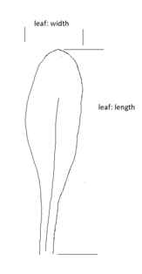
Leaf: width
Leaf: length

Ad. 3: Leaf: width

Observations should be made at the broadest part of the leaf, at a right angle to the mid-vein.

See Ad. 2

Ad. 4: Leaf: shape of blade

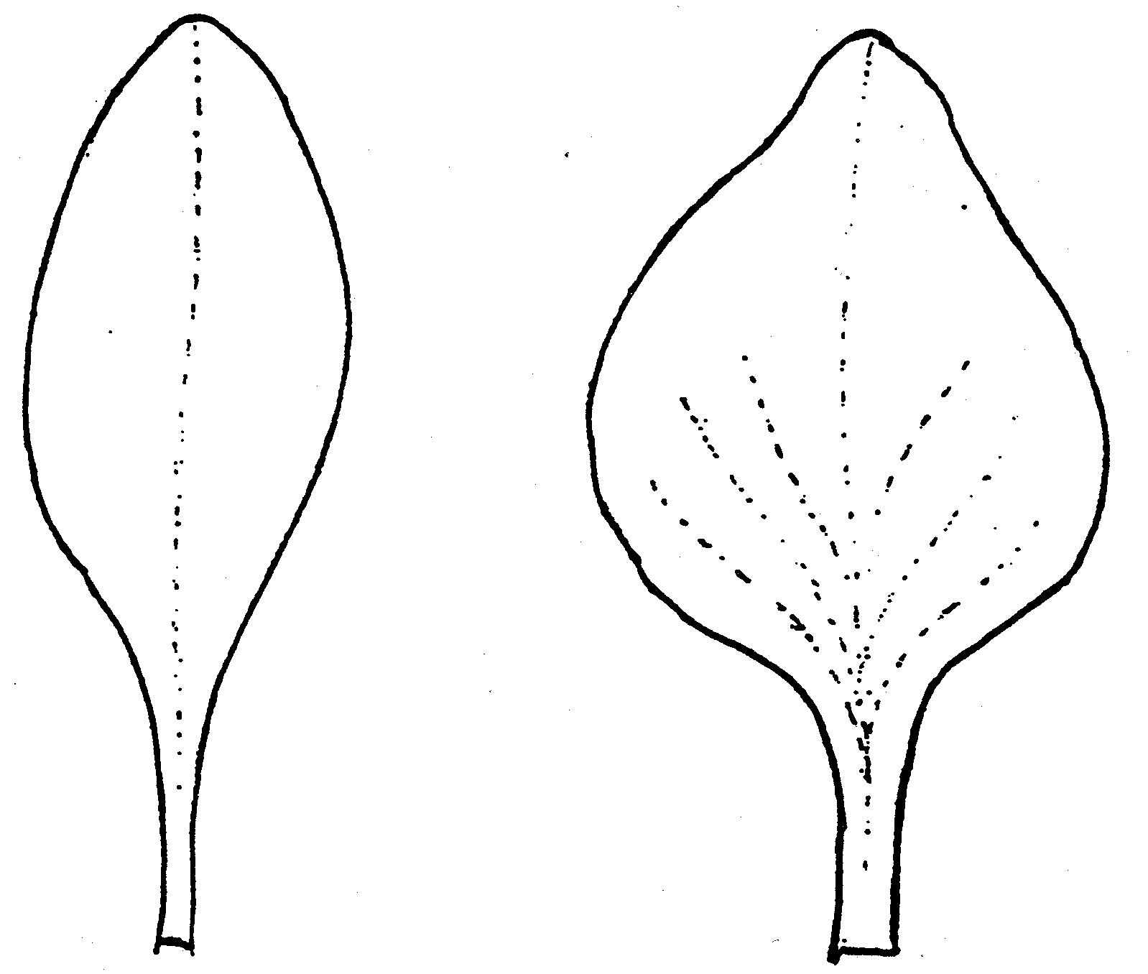 |  | 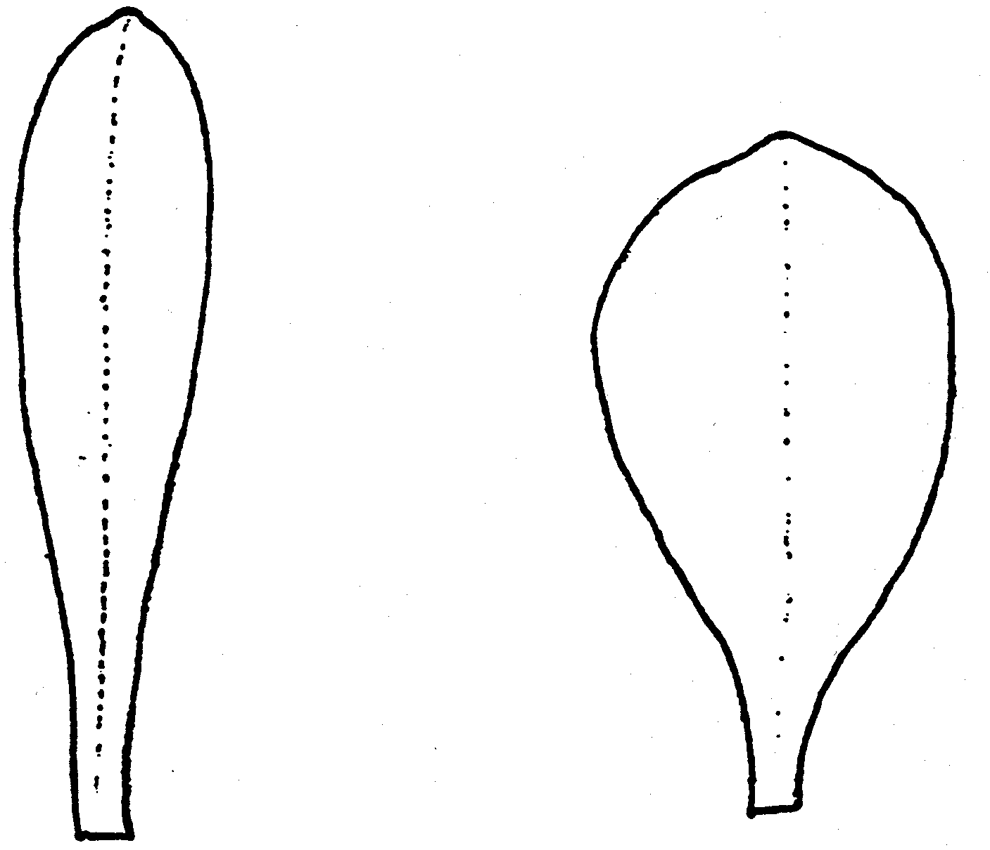
1 | 2 | 3 | 4
elliptic | broad ovate to deltoid | narrow obovate | medium obovate

Ad. 13: Peduncle: length

Observations should be made from the base of the plant to the first branch of the inflorescence.

Ad. 14: Peduncle: thickness

Observations should be made in the middle third of the peduncle, excluding wings.

Ad. 16: Peduncle: width of wing

Observations should be made in the middle third of the peduncle.

Ad. 18: Inflorescence: length of stipules at first branch

Observations should be made on the first branch from the base of the largest stipule to its tip.

Ad. 19: Inflorescence: type

Type I:
Stem not winged. Inflorescence clearly asymmetric and flattened at the top, racemose or cymose corymb, with semi-erect to horizontal branches. Flowers pointing upwards, sessile or with very short peduncle.

Type II:
Stem winged. Inflorescence more or less flattened at the top, cymose corymb or panicle, with semi-erect to erect branches. Flowers clustered at the end of branchlets, pointing upwards, sessile or with very short peduncle.

Type III:
Stem winged. Inflorescence open and irregular, racemose corymb, with semi-erect to horizontal branches.

Type IV:
Stem not winged. Inflorescence open, racemose or cymose corymb, with semi-erect to horizontal branches, sometimes more or less pending. Flowers pointing upwards, with short to long peduncle.

Type V:
Stem not winged. Inflorescence clearly longer than wide, open raceme, with semi-erect to horizontal branches. Flowers pointing upwards.

Type VI:
Stem not winged. Inflorescence branched and consisting of slender cylindrical spikes. Flowers sessile, arranged along the axis of the inflorescence.

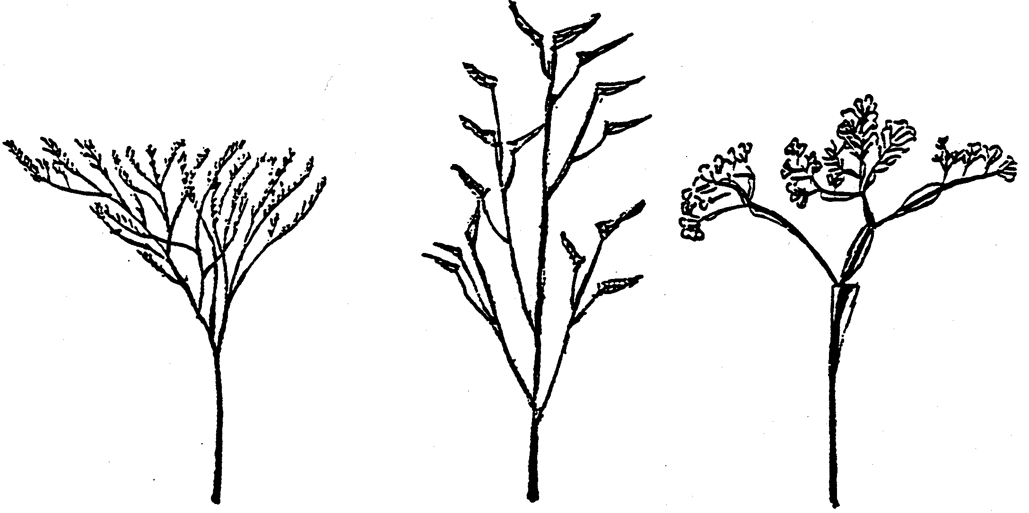

1 | 2 | 3
type I | type II | type III

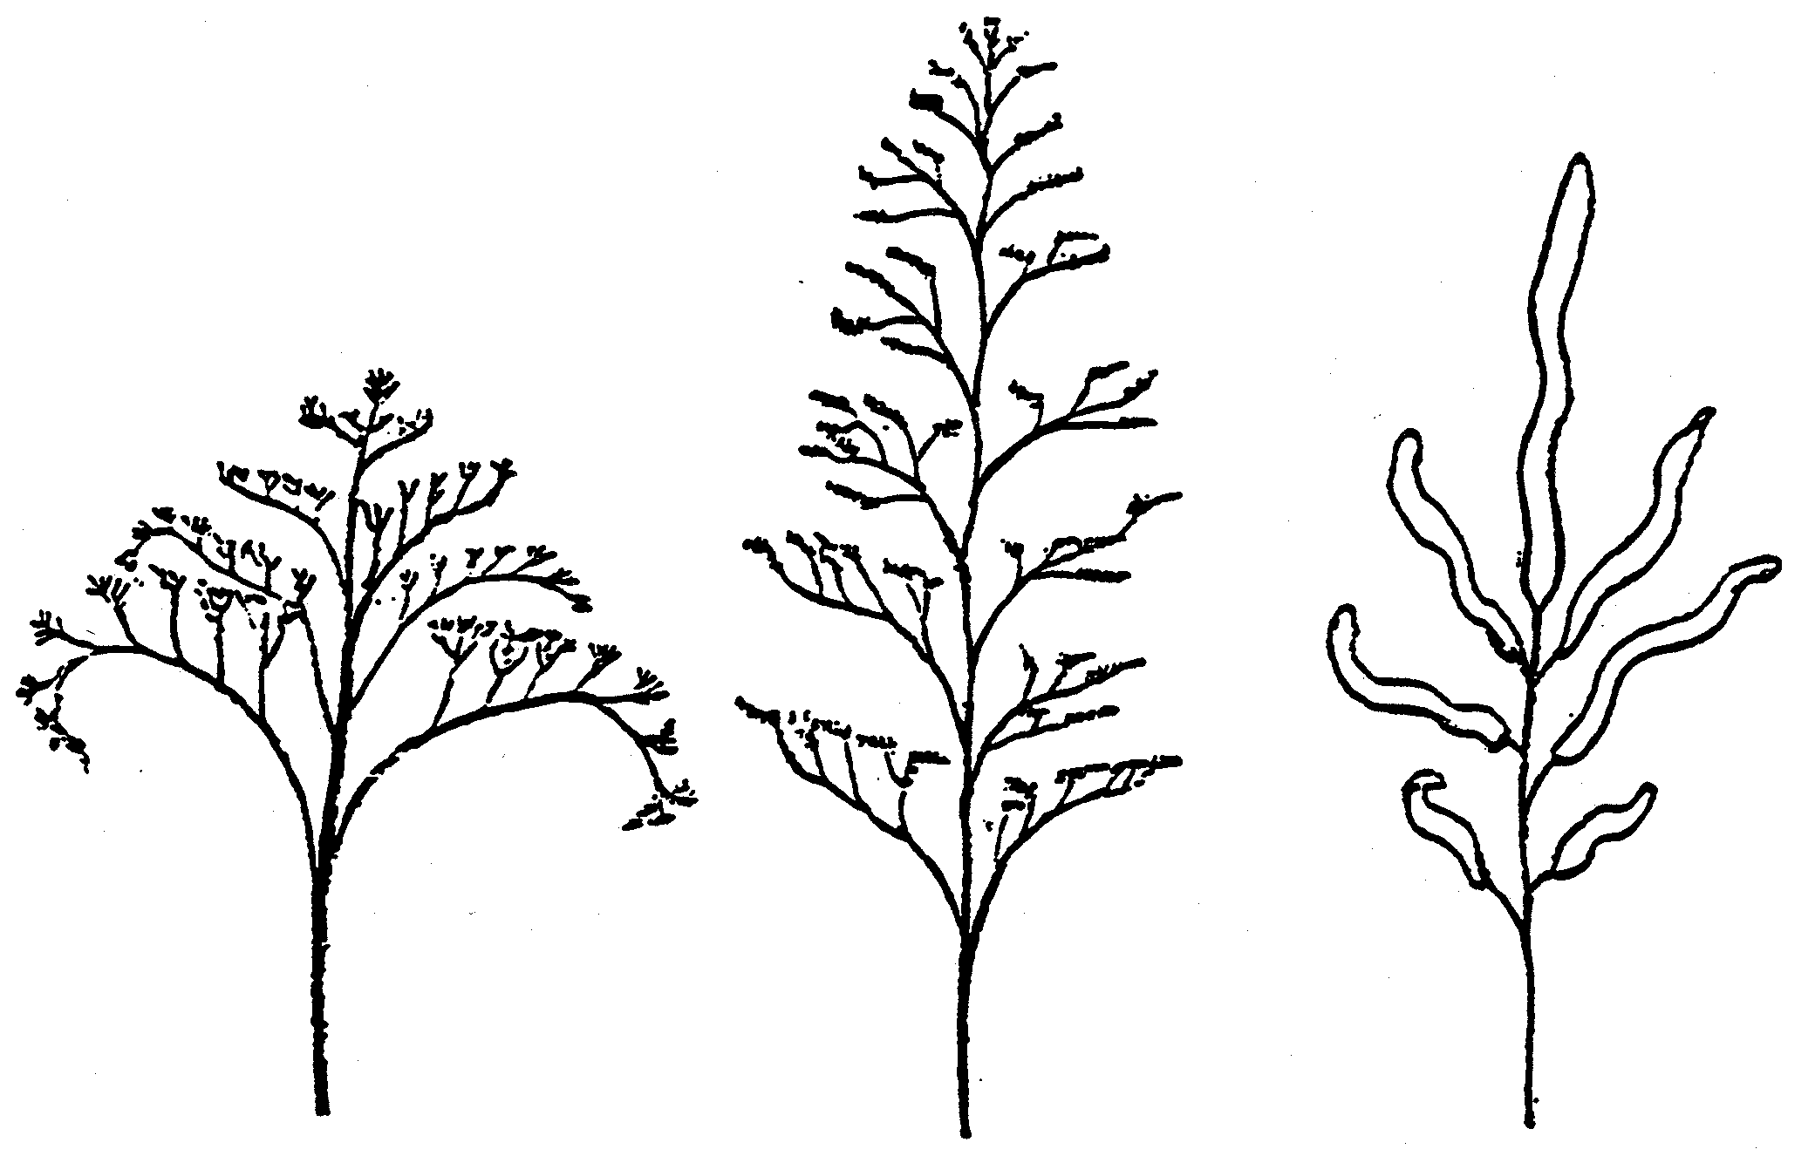

4 | 5 | 6
type IV | type V | type VI

Ad. 20: Inflorescence: degree of ramification

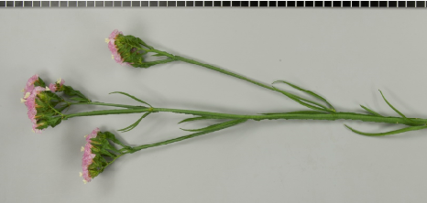 | 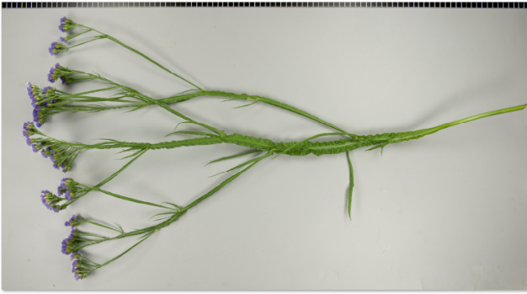 | 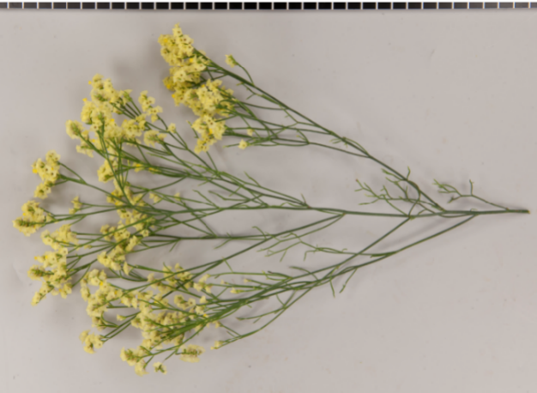
3 | 5 | 7
weak | medium | strong

Ad. 23: Calyx: length
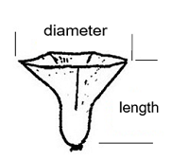
Diameter
Length

Ad. 24: Calyx: diameter

See Ad. 23

Ad. 25: Calyx: shape

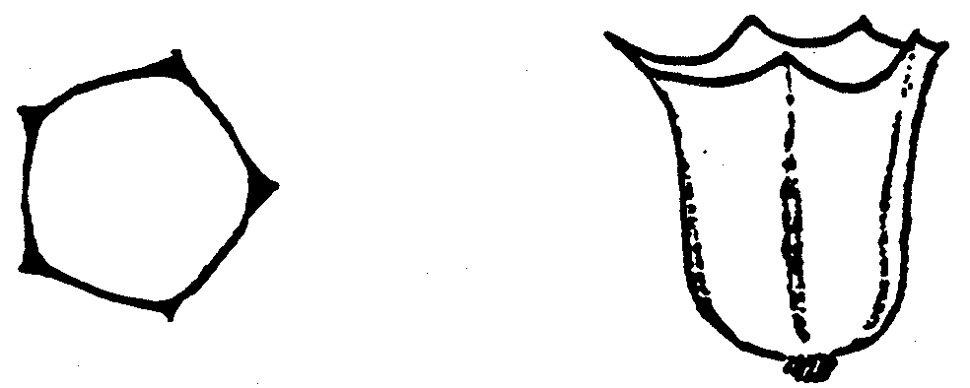

1
campanulate

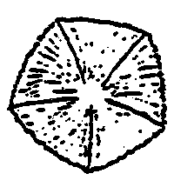 | 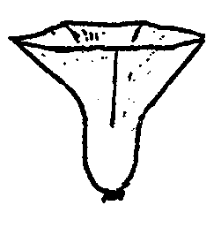
2
funnel shaped

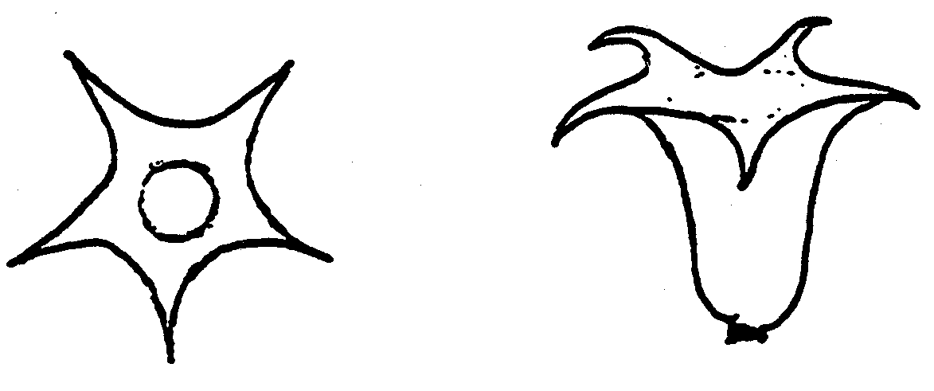
3
open campanulate

Ad. 27: Calyx: color of ribs

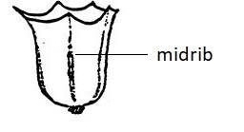
Rib

Ad. 28: Corolla: type

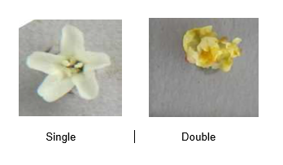
1 | 2
single | double

Ad. 30: Corolla: diameter

The largest diameter should be observed.

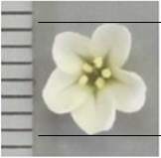

Ad. 31: Corolla: arrangement of lobes

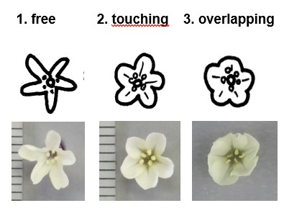
1 | 2 | 3
free | touching | overlapping

Ad. 35: Stigma: type

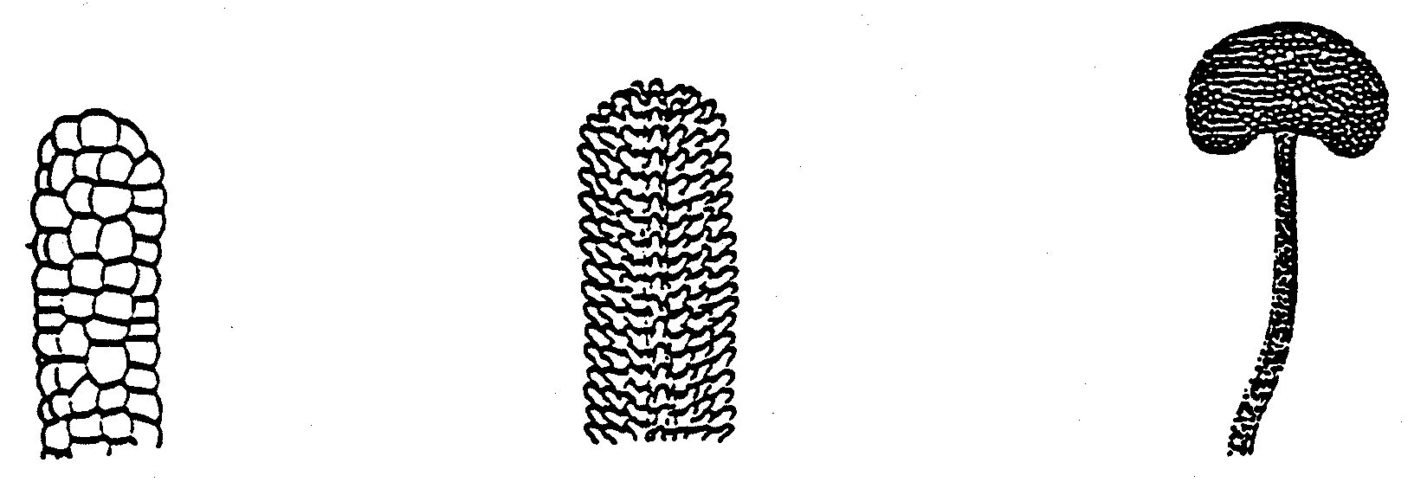
1 | 2 | 3
cob type | papillate type | capitate type

To be observed on top of stigma (assessed under a microscope).

Ad. 37: Time of beginning of flowering

The time of beginning of flowering is reached when 30% of inflorescences have open flowers.

9. | Literature

Anonymous, 1960: Limonium Mill. In: Pareys Blumengärtnerei, 2. Band, Ed. F. Encke; Parey, Berlin and Hamburg, DE, pp. 339-342

Anonymous, 1972: Limonium Miller. In: Flora Europaea Vol. 3, Ed. Tutin, Heywood, a.o.; Cambridge Univ. Press, GB, pp. 38-50

Anonymous, 1977: Limonium. In: Dictionary of Gardening Vol. 2 (2nd ed.), Ed. Chittenden; Clarendon Press, Oxford, GB, pp. 1179-1181

Armitage, A.M. & Laushman, 2008: Limonium. In: Specialty Cut Flowers; Varsity Press/Timber Press, Portland, Oregon, US, pp. 106-114 and 209-214

Boom, B. K., 1970: Statice & Limonium. In: Flora der gekweekte kruidachtige gewassen; Veeman, Wageningen, NL, pp. 202-203

Griffiths, M., (Ed.), 1994: Index of Garden Plants. Royal Hort. Soc., GB, pp. 674-676

Morgan, E., Funnell, K., 2018: Limonium. Ornamental Crops, 513–527. doi:10.1007/978-3-319-90698-0_21

10. | Technical Questionnaire

TECHNICAL QUESTIONNAIRE | Page {x} of {y} | Reference Number:

Application date:
(not to be filled in by the applicant)
TECHNICAL QUESTIONNAIRE
to be completed in connection with an application for plant breeders' rights

1. | Subject of the Technical Questionnaire
 |  | Botanical name
  1.1.1
  Limonium Mill.
  [ ]
 |  | Common name
  1.1.2
  Statice
  1.1.3
  Species (please indicate):
 |  | Botanical name
  1.2.1
  Goniolimon Boiss.
  [ ]
 |  | Common name
  1.2.2
  1.2.3
  Species (please indicate):
 |  | Botanical name
  1.3.1
  Psylliostachys (Jaub. & Spach) Nevski
  [ ]
 |  | Common name
  1.3.2
  1.3.3
  Species (please indicate):

TECHNICAL QUESTIONNAIRE | Page {x} of {y} | Reference Number:

2. | Applicant
 | Name
 | Address
 | Telephone No.
 | Fax No.
 | E-mail address
 | Breeder (if different from
 | applicant)

3. | Proposed denomination and breeder's reference
 | Proposed denomination
 | (if available)
 | Breeder's reference

TECHNICAL QUESTIONNAIRE |  |  | Page {x} of {y} | Reference Number:
 | Information on the breeding scheme and propagation of the variety
  #4.
 | 4.1 | Breeding scheme
 | Variety resulting from:
  4.1.1
  Crossing
 |  | [ ]
  (a)
  controlled cross
(please state parent variety)

(…………………..……………..…) x (……………..…………………..…)

female parent male parent

 |  | [ ]
  (b)
  partially known cross
(please state known parent variety(ies))

(…………………..……………..…) x (……………..…………………..…)

female parent male parent

 |  | [ ]
  (c)
  unknown cross
 |  | [ ]
  4.1.2
  Mutation
  (please state parent variety)
 |  | [ ]
  4.1.3
  Discovery and development
  (please state where and when discovered and how developed)
 | Other  (Please provide details) | [ ]
  4.1.4

TECHNICAL QUESTIONNAIRE | Page {x} of {y} | Reference Number:

 | 4.2 | Method of propagating the variety
 |  | [ ]
  4.2.1
  Seed-propagated varieties
  4.2.2
  Vegetative propagation
 |  | [ ]
  (a)
  Cuttings
 |  | [ ]
  (b)
  In vitro propagation
 |  | [ ]
  (c)
  Other (state method)
 | Other  (Please provide details) | [ ]
  4.2.3

TECHNICAL QUESTIONNAIRE | Page {x} of {y} | Reference Number:

5. | Characteristics of the variety to be indicated (the number in brackets refers to the corresponding characteristic in Test Guidelines; please mark the note which best corresponds).

 | Characteristics | Example Varieties | Note
  5.1
  (1)
  Plant: height
  very short
  1 [ ]
  very short to short
  2 [ ]
  short
  Zastapolar
  3 [ ]
  short to medium
  4 [ ]
  medium
  Flamingo
  5 [ ]
  medium to tall
  6 [ ]
  tall
  Nuno Joy
  7 [ ]
  tall to very tall
  8 [ ]
  very tall
  9 [ ]
  5.2
  (4)
  Leaf: shape of blade
  elliptic
  BALL452013
  1 [ ]
  broad ovate to deltoid
  Zalimsal
  2 [ ]
  narrow obovate
  Hildiaange
  3 [ ]
  medium obovate
  Sinzii Blueish
  4 [ ]
  5.3
  (19)
  Inflorescence: type
  type I
  Hilalkansa
  1 [ ]
  type II
  Zastasky
  2 [ ]
  type III
  3 [ ]
  type IV
  Zalimred
  4 [ ]
  type V
  5 [ ]
  type VI
  6 [ ]

TECHNICAL QUESTIONNAIRE | Page {x} of {y} | Reference Number:

 | Characteristics | Example Varieties | Note
  5.4(i)
  (26)
  Calyx: main color
  RHS Colour Chart (indicate reference number)
  5.4(ii)
  (26)
  Calyx: main color
  white
  1 [ ]
  yellow
  2 [ ]
  pink
  3 [ ]
  red
  4 [ ]
  purple red
  5 [ ]
  violet
  6 [ ]
  blue
  7 [ ]
  other (please indicate)
  [ ]
  5.5(i)
  (33)
  Corolla: color
  RHS Colour Chart (indicate reference number)
  5.5(ii)
  (33)
  Corolla: color
  white
  1 [ ]
  yellow
  2 [ ]
  pink
  3 [ ]
  violet
  4 [ ]
  blue
  5 [ ]
  other (please indicate)
  [ ]

TECHNICAL QUESTIONNAIRE | Page {x} of {y} | Reference Number:

6. | Similar varieties and differences from these varieties
Please use the following table and box for comments to provide information on how your candidate variety differs from the variety (or varieties) which, to the best of your knowledge, is (or are) most similar. This information may help the examination authority to conduct its examination of distinctness in a more efficient way.

  Denomination(s) of variety(ies) similar to your candidate variety
  Characteristic(s) in which your candidate variety differs from the similar variety(ies)
  Describe the expression of the characteristic(s) for the similar variety(ies)
  Describe the expression of the characteristic(s) for your candidate variety

Example
  Inflorescence: number of flowers
  few
  many

 | Comments:

TECHNICAL QUESTIONNAIRE | Page {x} of {y} | Reference Number:

 | Additional information which may help in the examination of the variety
  #7.
7.1 | In addition to the information provided in sections 5 and 6, are there any additional characteristics which may help to distinguish the variety?
 | Yes | [ ] | No | [ ]
 | (If yes, please provide details)
7.2 | Are there any special conditions for growing the variety or conducting the examination?
 | Yes | [ ] | No | [ ]
 | (If yes, please provide details)
7.3 | Other information
A representative color photograph of the variety displaying its main distinguishing feature(s), should accompany the Technical Questionnaire. The photograph will provide a visual illustration of the candidate variety which supplements the information provided in the Technical Questionnaire.
The key points to consider when taking a photograph of the candidate variety are:
• Indication of the date and geographic location
• Correct labeling (breeder’s reference)
• Good quality printed photograph (minimum 10 cm x 15 cm) and/or sufficient resolution electronic format version (minimum 960 x 1280 pixels)”
Further guidance on providing photographs with the Technical Questionnaire is available in document TGP/7 "Development of Test Guidelines", Guidance Note 35 (http://www.upov.int/tgp/en/).
[The link provided may be deleted by members of the Union when developing authorities’ own test guidelines.]
- Resistance to pests and diseases

- Growth type
- annual [ ]
- perennial [ ]

- Cold treatement
- not required [ ]
- required [ ]

TECHNICAL QUESTIONNAIRE | Page {x} of {y} | Reference Number:

8. | Authorization for release
 | (a) | Does the variety require prior authorization for release under legislation concerning the protection of the environment, human and animal health?
 |  | Yes | [ ] | No | [ ]
 | (b) | Has such authorization been obtained?
 |  | Yes | [ ] | No | [ ]
 | If the answer to (b) is yes, please attach a copy of the authorization.

9. Information on plant material to be examined or submitted for examination

9.1 The expression of a characteristic or several characteristics of a variety may be affected by factors, such as pests and disease, chemical treatment (e.g. growth retardants or pesticides), effects of tissue culture, different rootstocks, scions taken from different growth phases of a tree, etc.
9.2 The plant material should not have undergone any treatment which would affect the expression of the characteristics of the variety, unless the competent authorities allow or request such treatment. If the plant material has undergone such treatment, full details of the treatment must be given. In this respect, please indicate below, to the best of your knowledge, if the plant material to be examined has been subjected to:

 | (a) | Microorganisms (e.g. virus, bacteria, phytoplasma) | Yes [ ] | No [ ]
 | (b) | Chemical treatment (e.g. growth retardant, pesticide) | Yes [ ] | No [ ]
 | (c) | Tissue culture | Yes [ ] | No [ ]
 | (d) | Other factors | Yes [ ] | No [ ]
 | Please provide details for where you have indicated “yes”.

10. | I hereby declare that, to the best of my knowledge, the information provided in this form is correct:
 | Applicant’s name
 | Signature |  | Date

[End of document]

