 |  | E  TG/167/3

INTERNATIONAL UNION FOR THE PROTECTION  OF NEW VARIETIES OF PLANTS | UNION INTERNATIONALE POUR LA PROTECTION  DES OBTENTIONS VÉGÉTALES | INTERNATIONALER VERBAND ZUM SCHUTZ VON PFLANZEN-ZÜCHTUNGEN | UNIÓN INTERNACIONAL PARA LA PROTECCIÓN  DE LAS OBTENCIONES VEGETALES

GUIDELINES

FOR THE CONDUCT OF TESTS

FOR DISTINCTNESS, UNIFORMITY AND STABILITY

OKRA

(Abelmoschus esculentus
(L.) Moench.)

GENEVA
1999

Copies of this document are available on request at the price of 10 Swiss francs each, including surface mail, from the Office of UPOV, 34, chemin des Colombettes, P.O. Box 18, 1211 Geneva 20, Switzerland

This document or parts of it may be reproduced, translated and published without obtaining the specific consent of UPOV, provided that the source is acknowledged.

* * * * * * *
TG/167/3
ORIGINAL: English
DATE: 1999-03-24

INTERNATIONAL UNION FOR THE PROTECTION  OF NEW VARIETIES OF PLANTS | UNION INTERNATIONALE POUR LA PROTECTION  DES OBTENTIONS VÉGÉTALES | INTERNATIONALER VERBAND ZUM SCHUTZ VON PFLANZEN-ZÜCHTUNGEN | UNIÓN INTERNACIONAL PARA LA PROTECCIÓN  DE LAS OBTENCIONES VEGETALES

GUIDELINES

FOR THE CONDUCT OF TESTS

FOR DISTINCTNESS, UNIFORMITY AND STABILITY

OKRA

(Abelmoschus esculentus
(L.) Moench.)

These Guidelines should be read in conjunction with document TG/1/2, which contains explanatory notes on the general principles on which the Guidelines have been established.

TABLE OF CONTENTS PAGE

I. | Subject of these Guidelines ......................................................................... | 3
II. | Material Required ........................................................................................ | 3
III. | Conduct of Tests .......................................................................................... | 3
IV. | Methods and Observations........................................................................... | 3
V. | Grouping of Varieties .................................................................................. | 4
VI. | Characteristics and Symbols ........................................................................ | 4
VII. | Table of Characteristics ............................................................................... | 5
VIII. | Explanations on the Table of Characteristics .............................................. | 10
IX. | Literature ..................................................................................................... | 12
X. | Technical Questionnaire ............................................................................. | 13

I. Subject of these Guidelines

These Test Guidelines apply to all varieties of Abelmoschus eschlentus (L.) Moench.

II. Material Required

1 The competent authorities decide when, where and in what quantity and quality the plant material required for testing the variety is to be delivered. Applicants submitting material from a State other than that in which the testing takes place must make sure that all customs formalities are complied with. The minimum quantity of plant material to be supplied by the applicant in one or several samples should be:

200 g.

The seed should at least meet the minimum requirements for germination capacity, moisture content and purity for marketing seed in the country in which the application is made. The germination capacity of the seed should be as high as possible.

2. The plant material must not have undergone any treatment unless the competent authorities allow or request such treatment. If it has been treated, full details of the treatment must be given.

III. Conduct of Tests

1. The minimum duration of tests should normally be two similar growing periods.

2. The tests should normally be conducted at one place. If any important characteristics of the variety cannot be seen at that place, the variety may be tested at an additional place.

3. The tests should be carried out under conditions ensuring normal growth. The size of the plots should be such that plants or parts of plants may be removed for measurement and counting without prejudice to the observations which must be made up to the end of the growing period. Each test should include a total of 40 plants which should be divided between two or more replicates. Separate plots for observation and for measuring can only be used if they have been subject to similar environmental conditions.

4. Additional tests for special purposes may be established.

IV. Methods and Observations

1. Unless otherwise indicated, all observations determined by measurement, weighting or counting should be made on 20 plants or parts taken from each of the 20 plants.

2. For the assessment of uniformity a population standard of 1 % with an acceptance probability of at least 95% should be applied. In the case of a sample size of 40 plants the maximum number of off-types allowed would be 2.
3. Unless otherwise indicated, all observations on the fruit should be made on the young fruit at the time of commercial harvest.

4. All observations on the stem, the leaf blade and the petiole should be made on the 10th to 15th nodes of the main stem.

V. Grouping of Varieties

1. The collection of varieties to be grown should be divided into groups to facilitate the assessment of distinctness. Characteristics which are suitable for grouping purposes are those which are known from experience not to vary, or to vary only slightly, within a variety. Their various states of expression should be fairly evenly distributed throughout the collection.

2. It is recommended that the competent authorities use the following characteristics for grouping varieties:

- Plant: degree of branching (characteristic 1)
- Stem: color (characteristic 4)
- Leaf blade: depth of lobing (characteristic 8)
- Fruit: color (characteristic 15)
- Fruit: number of locules (characteristic 21)

VI. Characteristics and Symbols

1. To assess distinctness, uniformity and stability, the characteristics and their states as given in the Table of Characteristics should be used.

2. Notes (numbers), for the purposes of electronic data processing, are given opposite the states of expression for each characteristic.

3. Legend:

(*) Characteristics that should be used on all varieties in every growing period over which the examinations are made and always be included in the variety descriptions, except when the state of expression of a preceding characteristic or regional environmental conditions render this impossible.

(+) See Explanations on the Table of Characteristics in Chapter VIII.
VII. Table of Characteristics/Tableau des caractères/Merkmalstabelle/Tabla de caracteres

 | English | Français | Deutsch | Español | Example Varieties  Exemples  Beispielssorten  Variedades ejemplo |  | Note/  Nota
1.  (+)  (*) | Plant: degree of branching | Plante: degré de ramification | Pflanze: Stärke der Verzweigung | Planta: grado de ramificación
 | weak | faible | gering | débil |  |  | 3
 | medium | moyen | mittel | media | Tokyo-gokaku |  | 5
 | strong | fort | stark | fuerte | Emerarudo |  | 7
2. | Plant: height | Plante: hauteur | Pflanze: Höhe | Planta: altura
 | short | courte | niedrig | corta | Tokyo-gokaku |  | 3
 | medium | moyenne | mittel | media | Ryokusei |  | 5
 | tall | haute | hoch | alta |  |  | 7
3. | Stem: diameter | Tige: diamètre | Stengel: Durchmesser | Tallo: diámetro
 | small | petit | klein | pequeño | Gurin-sta |  | 3
 | medium | moyen | mittel | medio |  |  | 5
 | large | grand | groß | grande | Yaeyama |  | 7
4.  (*) | Stem: color | Tige: couleur | Stengel: Farbe | Tallo: color
 | green | vert | grün | verde | Dwarf green, Log Pod, Tokyo-gokaku |  | 1
 | red | rouge | rot | rojo | Aka-okura, Burgundy |  | 2
5. | Stem: intensity of color | Tige: intensité de la couleur | Stengel: Intensität der Farbe | Tallo: intensidad del color
 | light | claire | hell | claro |  | 3
 | medium | moyenne | mittel | medio |  | 5
 | dark | foncée | dunkel | oscuro |  | 7
6. | Stem: number of nodes (up to and including the first flowering node) | Tige: nombre de nœuds (jusqu’au premier nœud florifère, inclus) | Stengel: Anzahl Nodien (bis einschließlich erster Blüte) | Tallo: número de nudos (hasta el primer nudo floral inclusive)
 | few | petit | gering | bajo | Tokyo-gokaku | 3
 | medium | moyen | mittel | medio |  | 5
 | many | grand | groß | alto | Yaeyama | 7
7. | Leaf blade: size | Limbe: taille | Blattspreite: Größe | Limbo: tamaño
 | small | petit | klein | pequeño |  | 3
 | medium | moyen | mittel | medio | Tokyo-gokaku | 5
 | large | grand | groß | grande | Surimu-okura | 7
8.  (+)  (*) | Leaf blade: depth of lobing | Limbe: profondeur de la découpure | Blattspreite: Tiefe der Lappeneinschnitte | Limbo: profundidad de los incisiones de los lóbulos
 | shallow | peu profonde | flach | poco profunda | Tokyo-gokaku | 3
 | medium | moyenne | mittel | media | Ryokusei | 5
 | deep | profonde | tief | profunda | Emerarudo | 7
9. | Leaf blade: dentation of margin | Limbe: dentelure du bord | Blattspreite: Zähnung des Randes | Limbo: dentado del borde
 | weak | faible | gering | débil |  | 3
 | medium | moyenne | mittel | medio |  | 5
 | strong | forte | stark | fuerte |  | 7
10.  (*) | Leaf blade: color  between veins | Limbe: couleur  entres les nervures | Blattspreite: Farbe der Interkostalfelder | Limbo: color  entre los nervios
 | green | vert | grün | verde | Tokyo-gokaku | 1
 | red | rouge | rot | rojo | Aka-okura | 2
11. | Leaf blade: intensity of color  between veins | Limbe: intensité de la couleur  entre les nervures | Blattspreite: Intensität der Farbe der Interkostalfelder | Limbo: intensidad del color entre los nervios
 | light | claire | hell | claro |  | 3
 | medium | moyenne | mittel | medio |  | 5
 | dark | foncée | dunkel | oscuro |  | 7
12. | Petiole: length | Pétiole: longueur | Blattstiel: Länge | Peciolo: longitud
 | short | court | kurz | corto |  | 3
 | medium | moyen | mittel | medio | Tokyo-gokaku | 5
 | long | long | lang | largo | Yaeyama | 7
13. | Petiole: diameter | Pétiole: diamètre | Blattstiel: Durchmesser | Peciolo: diámetro
 | small | petit | klein | pequeño |  | 3
 | medium | moyen | mittel | medio | Horidei | 5
 | large | grand | groß | grande | Surimu-okura | 7
14. | Flower: size | Fleur: taille | Blüte: Größe | Flor: tamaño
 | small | petite | klein | pequeño | Emerarudo | 3
 | medium | moyenne | mittel | medio |  | 5
 | large | grande | groß | grande | Surimu-okura | 7
15.  (*) | Fruit: color | Fruit: couleur | Frucht: Farbe | Fruto: color
 | green | vert | grün | verde | Tokyo-gokaku | 1
 | red | rouge | rot | rojo | Aka-okura, Burgundy | 2
16. | Fruit: intensity of color | Fruit: intensité de la couleur | Frucht: Intensität der Farbe | Fruto: intensidad del color
 | light | claire | hell | claro |  | 3
 | medium | moyenne | mittel | medio |  | 5
 | dark | foncée | dunkel | oscuro |  | 7
17. | Fruit: diameter of young fruit (at mid length) | Fruit: diamètre du fruit jeune (au milieu de la longueur) | Frucht: Durchmesser der jungen Frucht (in der Mitte der Länge) | Fruto: diámetro del fruto joven (a mitad de la longitud)
 | small | petit | klein | pequeño | Emerarudo | 3
 | medium | moyen | mittel | media | Tokyo-gokaku | 5
 | large | grand | groß | grande | Yaeyama | 7
18.  (+)  (*) | Fruit: surface between ridges | Fruit: surface entre arêtes | Frucht: Oberfläche zwischen den Rippen | Fruto: superficie entre aristas
 | concave | concave | konkav | cóncava | Tokyo-gokaku | 3
 | flat | plane | flach | plana |  | 5
 | convex | convexe | konvex | convexa | Emerarudo | 7
19.  (+) | Fruit: constriction of basal part | Fruit: constriction de la partie basale | Frucht: Einschnürung des basalen Teiles | Fruto: constricción de la parte basal
 | absent or very weakly expressed | absente ou très faiblement exprimée | fehlend oder sehr gering ausgeprägt | ausente o muy débilmente expresado |  | 1
 | weakly expressed | faiblement exprimée | gering ausgeprägt | débilmente expresado | Emerarudo | 2
 | strongly expressed | fortement exprimée | stark ausgeprägt | fuertemente expresado | Yaeyama | 3
20.  (+) | Fruit: shape of apex | Fruit: forme du sommet | Frucht: Form der Spitze | Fruto: forma del ápice
 | narrow acute | aigu étroit | schmal spitz | agudo estrecho | Emerarudo | 1
 | acute | aigu | spitz | agudo | Tokyo-gokaku | 2
 | broad acute | aigu large | breit spitz | agudo ancho | Yaeyama | 3
21.  (*) | Fruit: number of locules | Fruit: nombre de loges | Frucht: Anzahl Kammern | Fruto: número de lóculos
 | five | cinq | fünf | cinco | Tokyo-gokaku | 1
 | more than five | plus de cinq | mehr als fünf | más de cinco | Yaeyama | 2
22. | Fruit: thickness of carpel | Fruit: grosseur du carpelle | Frucht: Dicke des Karpells | Fruto: grosor del cárpelo
 | thin | mince | dünn | delgado |  | 3
 | medium | moyen | mittel | medio | Tokyo-gokaku | 5
 | thick | gros | dick | grueso | Emerarudo | 7
23.  (+) | Fruit: length of mature fruit | Fruit: longueur du fruit mature | Frucht: Länge der reifen Frucht | Fruto: longitud del fruto maduro
 | short | court | kurz | corto | Gurin-sta | 3
 | medium | moyen | mittel | medio | Tokyo-gokaku | 5
 | long | long | lang | largo | Emerarudo | 7
24. | Fruit: diameter of mature fruit  (as for 17) | Fruit: diamètre du fruit mature (comme pour 17) | Frucht: Durchmesser der reifen Frucht (wie unter 17) | Fruto: diámetro del fruto maduro (como para 17)
 | small | petit | klein | pequeño | Emerarudo | 3
 | medium | moyen | mittel | media |  | 5
 | large | grand | groß | grande | Yaeyama | 7
25. | Time of flowering | Époque de la floraison | Zeitpunkt der Blüte | Época de floración
 | early | précoce | früh | temprana |  | 3
 | medium | moyenne | mittel | media |  | 5
 | late | tardive | spät | tardía |  | 7
26. | Time of commercial harvest | Époque de la récolte commerciale | Zeitpunkt der gewerbsmäßigen Ernte | Época de cosecha comercial
 | early | précoce | früh | temprana |  | 3
 | medium | moyenne | mittel | media | Tokyo-gokaku | 5
 | late | tardive | spät | tardía | Yaeyama | 7

VIII. Explanations on the Table of Characteristics

Ad. 1: Plant: degree of branching

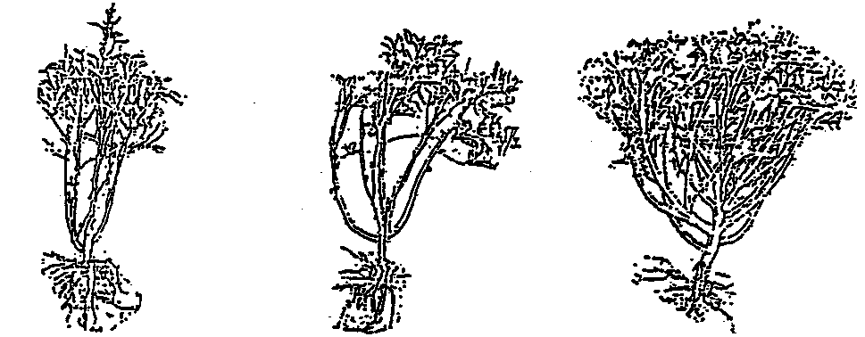

3 | 5 | 7
weak | medium | strong

Ad. 8: Leaf blade: depth of lobing

3 | 5 | 7
shallow | medium | deep

Ad. 18: Fruit: surface between ridges

ridge
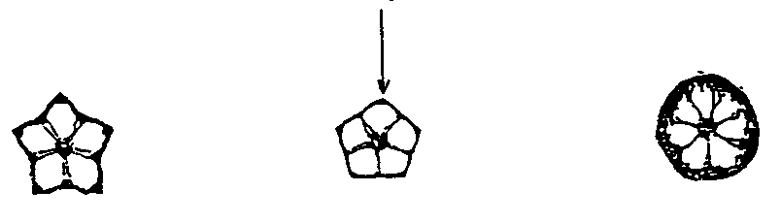
3 | 5 | 7
concave | flat | convex

Ad. 19: Fruit: construction of basal part

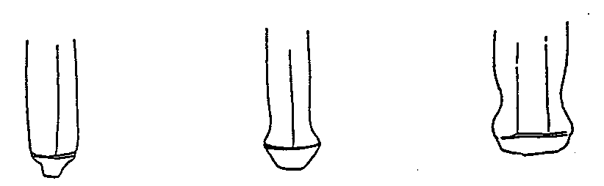

1 | 2 | 3
absent or very weakly  expressed | weakly expressed | strongly expressed

Ad. 20: Fruit: shape of apex

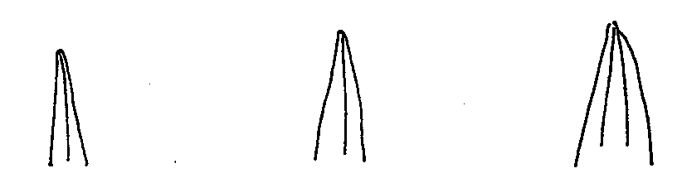

1 | 2 | 3
narrow acute | acute | broad acute

Ad. 23: Fruit: length of mature fruit

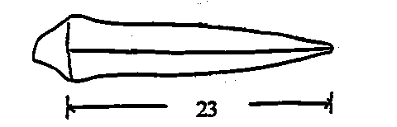

IX. Literature

Ashizawa, M., 1980: “Okra,” Yasaiengei-dai-jiten, p 961-965, Yokendo, Tokyo.

Phillips, R. et al., 1993: “Okra,” Vegetables, p 62-63, Pan Books Ltd.

Sumita, A., 1998: “Okra,” Nogyogijutu-taikei; Vegetable Vol. 11, p 77-90, Yokendo, Tokyo.

X. Technical Questionnaire

Reference Number
(not to be filled in by the applicant)

TECHNICAL QUESTIONNAIRE
to be completed in connection with an application for plant breeders’ rights

1. Species Abelmoschus esculentus (L). Moench.

OKRA

2. Applicant (Name and address)

3. Proposed denomination or breeder’s reference

4. Information on origin, maintenance and reproduction of the variety

4.1 Origin
- Seedling (indicate parent varieties) [ ]
………………………………………………………………..
- Mutation (indicate parent varieties) [ ]
………………………………………………………………..
- Discovery (indicate where and when) [ ]
………………………………………………………………..

4.2 Other information

5. Characteristics of the variety to be indicated (the number in brackets refers to the corresponding characteristic in Test Guidelines; please mark the state of expression which best corresponds).

 |  | Characteristics |  |  | Example Varieties |  |  | Note
5.1  (1) | Plant: degree of branching
 |  | weak |  |  |  |  |  | 3[ ]
 |  | medium |  |  | Tokyo-gokaku |  |  | 5[ ]
 |  | strong |  |  | Emerarudo |  |  | 7[ ]
5.2  (4) |  | Stem: color
 |  | green |  |  | Dwarf green, Log Pod, Tokyo-gokaku |  |  | 1[ ]
 |  | red |  |  | Aka-okura, Burgundy |  |  | 2[ ]
5.3  (8) |  | Leaf blade: depth of lobing
 |  | shallow |  |  | Tokyo-gokaku |  |  | 3[ ]
 |  | medium |  |  | Ryokusei |  |  | 5[ ]
 |  | deep |  |  | Emerarudo |  |  | 7[ ]
5.4  (15) |  |  | Fruit: color
 |  |  | green |  |  | Tokyo-gokaku |  |  | 1[ ]
 |  | red |  |  | Aka-okura, Burgundy |  |  | 2[ ]
5.5  (21) |  | Fruit: number of locules
 |  | five |  |  | Tokyo-gokaku |  |  | 1[ ]
 |  | more than five |  |  | Yaeyama |  |  | 2[ ]

6. Similar varieties and differences between these varieties

Denomination of similar variety | Characteristic in which the similar variety is different ^{o)} | State of expression of similar variety | State of expression of candidate variety
____________
⁰⁾ In the case of identical states of expressions of both varieties, please indicate the size of the difference.

7. Additional information which may help to distinguish the variety

7.1 Resistance to pests and diseases

7.2 Special conditions for the examination of the variety

7.3 Other information

8. Authorization for release

- Does the variety require prior authorization for release under legislation concerning the protection of the environment, human and animal health?
Yes [ ] No [ ]

- Has such authorization been obtained?

Yes [ ] No [ ]

If the answer to that question is yes, please attach a copy of such an authorization.

[End of document]

