 |  | E  TG/164/3

INTERNATIONAL UNION FOR THE PROTECTION  OF NEW VARIETIES OF PLANTS | UNION INTERNATIONALE POUR LA PROTECTION  DES OBTENTIONS VÉGÉTALES | INTERNATIONALER VERBAND ZUM SCHUTZ VON PFLANZEN-ZÜCHTUNGEN | UNIÓN INTERNACIONAL PARA LA PROTECCIÓN  DE LAS OBTENCIONES VEGETALES

GUIDELINES

FOR THE CONDUCT OF TESTS

FOR DISTINCTNESS, UNIFORMITY AND STABILITY

CYMBIDIUM

(Cymbidium Sw.)

GENEVA
1999

Copies of this document are available on request at the price of 10 Swiss francs each, including surface mail, from the Office of UPOV, 34, chemin des Colombettes, P.O. Box 18, 1211 Geneva 20, Switzerland

This document or parts of it may be reproduced, translated and published without obtaining the specific consent of UPOV, provided that the source is acknowledged.

* * * * * * *
TG/164/3
ORIGINAL: English
DATE: 1999-03-24

INTERNATIONAL UNION FOR THE PROTECTION  OF NEW VARIETIES OF PLANTS | UNION INTERNATIONALE POUR LA PROTECTION  DES OBTENTIONS VÉGÉTALES | INTERNATIONALER VERBAND ZUM SCHUTZ VON PFLANZEN-ZÜCHTUNGEN | UNIÓN INTERNACIONAL PARA LA PROTECCIÓN  DE LAS OBTENCIONES VEGETALES

GUIDELINES

FOR THE CONDUCT OF TESTS

FOR DISTINCTNESS, UNIFORMITY AND STABILITY

CYMBIDIUM

(Cymbidium Sw.)

These Guidelines should be read in conjunction with document TG/1/2, which contains explanatory notes on the general principles on which the Guidelines have been established.

TABLE OF CONTENTS PAGE

I. Subject of these Guidelines ........................................................................... 3

II. Material Required ........................................................................................ 3

III. Conduct of Tests .......................................................................................... 3

IV. Methods and Observations............................................................................ 3

V. Grouping of Varieties ................................................................................... 4

VI. Characteristics and Symbols ........................................................................ 5

VII. Table of Characteristics ............................................................................... 6

VIII. Explanations on the Table of Characteristics .............................................. 29

IX. Literature ..................................................................................................... 35

X. Technical Questionnaire ............................................................................. 36

I. Subject of these Guidelines

These Test Guidelines apply to all vegetatively propagated varieties of Cymbidium Sw. of the family Orchidaceae.

II. Material Required

1. The competent authorities decide when, where and in what quantity and quality the plant material required for testing the variety is to be delivered. Applicants submitting material from a State other than that in which the testing takes place must make sure that all customs formalities are complied with. As a minimum, the following quantity of plant material is recommended:

15 Plants, 2 to 3 years old, with at least two pseudobulbs

2. The plant material supplied should be visibly healthy, not lacking in vigor or affected by any important pests or diseases.

3. The plant material must not have undergone any treatment unless the competent authorities allow or request such treatment. If it has been treated, full details of the treatment must be given.

III. Conduct of Tests

1. A test should normally be conducted for one growing period. If distinctness and/or uniformity cannot be sufficiently established in one growing period, the test should be extended for a second growing period.

2. The tests should normally be conducted at one place. If any important characteristics of the variety cannot be seen at that place, the variety may be tested at an additional place.

3. The tests should be carried out in the greenhouse under conditions ensuring normal growth for the species concerned. The size of the plots should be such that plants or parts of plants may be removed for measurement and counting without prejudice to the observations which must be made up to the end of the growing period. Each test should include a total of 10 plants. Separate plots for observation and for measuring can only be used if they have been subject to similar environmental conditions.

4. Additional tests for special purposes may be established.

IV. Methods and Observations

1. All observations should be made on 10 plants or parts taken from each of 10 plants.

2. For the assessment of uniformity a population standard of 1% and an acceptance probability of at least 95% should be applied. In the case of a sample size of 10 plants, the maximum number of off-types allowed would be 1.

3. All observations on the pseudobulb should be made on the flowering pseudobulb.

4. All observations on the leaf should be made on the longest leaf of a flowering pseudobulb.

5. All observations on the inflorescence and the flower should be made at the time when 50% of the flowers on the inflorescence have opened, on the most recently fully opened flower on the inflorescence before fading of color.

6. All observations on the length and width of the flower and parts of the flower should be made on the unextended organ.

7. All observations on the color of the sepal, the petal and the lip should be made on the inner side.

8. All observations on the color of the column should be made on the outer side.

9. Because daylight varies, color determinations made against a color chart should be made either in a suitable cabinet providing artificial daylight or in the middle of the day in a room without direct sunlight. The spectral distribution of the illuminant for artificial daylight should conform with the CIE Standard of Preferred Daylight D 6,500 and should fall within the tolerances set out in British Standard 950, Part I. These determinations should be made with the plant part placed against a white background.

V. Grouping of Varieties

1. The collection of varieties to be grown should be divided into groups to facilitate the assessment of distinctness. The grouping should in the first instance be made according to the species. In addition, characteristics which are suitable for grouping purposes are those which are known from experience not to vary, or to vary only slightly, within a variety. Their various states of expression should be fairly evenly distributed throughout the collection.

2. It is recommended that the competent authorities use the following characteristics for grouping varieties:

- Plant: size (characteristic 1)
- Inflorescence: number of flowers ( characteristic 20)
- Peduncle: attitude (characteristic 24 )
- Flower: general impression of petals and sepals (characteristic 28)
- Flower: length (characteristic 29)
- Flower: width (characteristic 30)
- Flowering time (characteristic 100)
- Flower: predominant color (Technical Questionnaire 5.8)
VI. Characteristics and Symbols

1. To assess distinctness, uniformity and stability, the characteristics and their states as given in the Table of Characteristics should be used.

2. Notes (numbers), for the purposes of electronic data processing, are given opposite the states of expression for each characteristic.

3. So far only few varieties exist; therefore mainly species and only few example varieties are indicated in the Table of Characteristics. All variety denominations are preceded by group names (GREX). The variety denominations are always placed in quotation marks. Denominations of further example varieties will be indicated as soon as more varieties become available.

4. Legend:

(*) Characteristics that should be used on all varieties in every growing period over which examinations are made and always be included in the variety descriptions, except when the state of expression of a preceding characteristic or regional environmental conditions render this impossible.

(+) See Explanations on the Table of Characteristics in Chapter VIII.

VII. Table of Characteristics/Tableau des caractères/Merkmalstabelle/Tabla de caracteres

 | English | français | deutsch | español | Example Varieties  Exemples  Beispielssorten  Variedades ejemplo | Note/  Nota
1.  (*) | Plant: size | Plante: taille | Pflanze: Größe | Planta: tamaño
 | small | petite | klein | pequeño |  | 3
 | medium | moyenne | mittel | medio | Lucky Rainbow “Sainte Lapine” | 5
 | large | grande | groß | grande |  | 7
2.  (*) | Plant: height of tip of longest leaf relative to soil level | Plante: hauteur du sommet de la feuille la plus longue par rapport au niveau du sol | Pflanze: Höhe der Spitze des längsten Blattes im Verhältnis zur Substratoberfläche | Planta: altura de la punta de la hoja más larga respecto del nivel del suelo
 | far above | fortement au-dessous | weit oberhalb | muy por encima |  | 1
 | slightly above | faiblement au-dessous | etwas oberhalb | ligeramente por encima | Lucky Rainbow “Sainte Lapine” | 3
 | same level | au même niveau | auf gleicher Höhe | al mismo nivel |  | 5
 | slightly below | faiblement au-dessus | leicht unterhalb | ligeramente por debajo |  | 7
 | far below | fortement au-dessus | weit unterhalb | muy por debajo |  | 9
3.  (*)  (+) | Plant: angle of longitudinal axis with line from base to highest point of curvature | Plante: angle entre l’axe longitudinal et la ligne joignant la base da la plante au point le plus haut de la courbe | Pflanze: Winkel zwischen der Längsachse und der Linie, die von der Basis bis zum höchsten Punkt der Kurve des Blattes gezogen wird | Planta: ángulo del eje longitudinal con la línea de la base de la planta al punto más alto de curvatura
 | very small | très petit | sehr klein | muy pequeño |  | 1
 | small | petit | klein | pequeño |  | 3
 | medium | moyen | mittel | medio |  | 5
 | large | grand | groß | grande |  | 7
 | very large | très grand | sehr groß | muy grande |  | 9

 | English | français | deutsch | español | Example Varieties  Exemples  Beispielssorten  Variedades ejemplo | Note/  Nota
4.  (*)  (+) | Plant: angle of longitudinal axis with line from base to tip of longest leaf | Plante: angle entre l’axe longitudinal et la ligne joignant la base de la plante au sommet de la feuille la plus longue | Pflanze: Winkel zwischen der Längsachse und der Linie, die von der Basis bis zur Spitze des längsten Blattes gezogen wird | Planta: ángulo del eje longitudinal con la línea de la base de la planta al extremo de la hoja más larga
 | very small | très petit | sehr klein | muy pequeño |  | 1
 | small | petit | klein | pequeño |  | 3
 | medium | moyen | mittel | medio |  | 5
 | large | grand | groß | grande |  | 7
 | very large | très grand | sehr groß | muy grande |  | 9
5.  (*) | Pseudobulb: size | Pseudobulbe: taille | Pseudobulbe: Größe | Pseudobulbo: tamaño
 | very small | très petit | sehr klein | muy pequeño |  | 1
 | small | petit | klein | pequeño |  | 3
 | medium | moyen | mittel | medio | Half Moon “Banana Boat” | 5
 | large | gros | groß | grande |  | 7
6.  (+) | Pseudobulb: shape in longitudinal section | Pseudobulbe: forme en section longitudinale | Pseudobulbe: Form im Längsschnitt | Pseudobulbo: forma en sección longitudinal
 | oblong | oblongue | rechteckig | oblonga |  | 1
 | elliptic | elliptique | elliptisch | elíptica |  | 2
 | circular | circulaire | kreisförmig | circular | Sweet Love “Catilo” | 3
 | ovate | ovale | eiförmig | oval | Lucky Rainbow “Sainte Lapine” | 4

 | English |  | français |  | deutsch |  | español |  | Example Varieties  Exemples  Beispielssorten  Variedades ejemplo |  | Note/  Nota
7. | Pseudobulb: shape in cross section |  | Pseudobulbe: forme en section transversale |  | Pseudobulbe: Form im Querschnitt |  | Pseudobulbo: forma en sección transversal
 | elliptic |  | elliptique |  | elliptisch |  | elíptica |  | Lucky Rainbow “Sainte Lapine” |  | 1
 |  | circular |  | circulaire |  | kreisförmig |  | circular |  | Lucky Rainbow “Lapine Lily” | 2
8.  (*) |  | Plant: number of leaves |  | Plante: nombre de feuilles |  | Pflanze: Anzahl Blätter |  | Planta: número de hojas
 |  | few |  | peu nombreuses |  | gering |  | bajo |  |  | 3
 |  | medium |  | moyennes |  | mittel |  | medio |  |  | 5
 |  | many |  | nombreuses |  | groß |  | alto |  |  | 7
9.  (*) |  | Leaf: length |  | Feuille: longueur |  | Blatt: Länge |  | Hoja: longitud
 |  | short |  | courte |  | kurz |  | corta |  |  | 3
 |  | medium |  | moyenne |  | mittel |  | media |  | Lucky Rainbow “Sainte Lapine” | 5
 |  | long |  | longue |  | lang |  | larga |  |  | 7
10.  (*) |  | Leaf: width |  | Feuille: largeur |  | Blatt: Breite |  | Hoja: anchura
 |  | narrow |  | étroite |  | schmal |  | estrecha |  |  | 3
 |  | medium |  | moyenne |  | mittel |  | media |  |  | 5
 |  | broad |  | large |  | breit |  | ancha |  |  | 7
11. |  | Leaf: thickness |  | Feuille: épaisseur |  | Blatt: Dicke |  | Hoja: grosor
 |  | thin |  | mince |  | dünn |  | delgado |  |  | 3
 |  | medium |  | moyenne |  | mittel |  | medio |  | Lucky Rainbow “Sainte Lapine” | 5
 |  | thick |  | épaisse |  | dick |  | grueso |  |  | 7

 | English |  | français |  | deutsch |  | español |  | Example Varieties  Exemples  Beispielssorten  Variedades ejemplo |  | Note/  Nota
12.  (*)  (+) |  | Leaf: shape |  | Feuille: forme |  | Blatt: Form |  | Hoja: forma
 |  | narrow lanceolate |  | lancéolée étroite |  | schmal lanzettlich |  | estrecha lanceolada |  |  | 1
 |  | linear |  | linéaire |  | linear |  | lineal |  | Lucky Rainbow “Sainte Lapine” | 2
 |  | oblanceolate |  | oblancéolée |  | verkehrt lanzettlich |  | oblanceolada |  | Lucky Rainbow “Lapine Smile” | 3
 |  | spatulate |  | spatulée |  | spatelförmig |  | espatulada |  |  | 4
13.  (+) |  | Leaf: shape of apex |  | Feuille: forme de l’apex |  | Blatt: Form der Spitze |  | Hoja: forma del ápice
 |  | acute |  | aigu |  | spitz |  | agudo |  |  | 1
 |  | obtuse |  | obtus |  | stumpf |  | obtuso |  |  | 2
 |  | emarginate |  | émarginé |  | eingesenkt |  | emarginado |  |  | 3
14.  (+) |  | Leaf: symmetry of apex |  | Feuille: symétrie de l’apex |  | Blatt: Symmetrie der Spitze |  | Hoja: simetría del ápice
 |  | asymmetric |  | asymétrique |  | asymmetrisch |  | asimétrico |  |  | 1
 |  | symmetric |  | symétrique |  | symmetrisch |  | simétrico |  |  | 2
15. |  | Leaf: shape in cross section |  | Feuille: forme en section transversale |  | Blatt: Form im Querschnitt |  | Hoja: forma en sección transversal
 |  | straight |  | droite |  | gerade |  | recta |  | Lucky Rainbow “Lapine Lily” | 1
 |  | concave |  | concave |  | konkav |  | cóncava |  |  | 2
16. |  | Leaf: twisting |  | Feuille: torsion |  | Blatt: Drehung |  | Hoja: torsión
 |  | absent or very weak |  | absente ou très faible |  | fehlend oder sehr gering |  | ausente o muy débil |  | Sweet Love “Catilo” | 1
 |  | weak |  | faible |  | gering |  | débil |  |  | 3
 |  | medium |  | moyenne |  | mittel |  | media |  | Lucky Rainbow “Sainte Lapine” | 5
 |  | strong |  | forte |  | stark |  | fuerte |  |  | 7
 |  | very strong |  | très forte |  | sehr stark |  | muy fuerte |  | Great Flower “Hige” | 9

 | English |  | français |  | deutsch |  | español |  | Example Varieties  Exemples  Beispielssorten  Variedades ejemplo |  | Note/  Nota
17. |  | Leaf: green color |  | Feuille: couleur verte |  | Blatt: Grünfärbung |  | Hoja: color verde
 |  | light |  | claire |  | hell |  | claro |  |  | 3
 |  | medium |  | moyenne |  | mittel |  | medio |  |  | 5
 |  | dark |  | foncée |  | dunkel |  | oscuro |  |  | 7
18. |  | Leaf sheath: anthocyanin coloration |  | Gaine de la feuille: pigmentation anthocyanique |  | Blattscheide: Anthocyanfärbung |  | Vaina de la hoja: pigmentación antociánica
 |  | absent |  | absente |  | fehlend |  | ausente |  |  | 1
 |  | present |  | présente |  | vorhanden |  | presente |  |  | 9
19.  (*) |  | Inflorescence: type |  | Inflorescence: type |  | Blütenstand: Typ |  | Inflorescencia: tipo
 |  | solitary |  | isolée |  | einzeln |  | solitaria |  |  | 1
 |  | raceme |  | en grappe |  | Traube |  | en racimo |  |  | 2
20.  (*) |  | Varieties with raceme only: Inflorescence: number of flowers |  | Seulement variétés avec inflorescences en grappes: Inflorescence: nombre de fleurs |  | Nur Sorten mit Trauben: Blütenstand: Anzahl Blüten |  | Sólo variedades con racimo: Inflorescencia: número de flores
 |  | few |  | peu nombreuses |  | gering |  | bajo |  |  | 3
 |  | medium |  | moyennement nombreuses |  | mittel |  | medio |  | Sweet Love “Catilo” | 5
 |  | many |  | nombreuses |  | groß |  | alto |  |  | 7
21.  (*) |  | Peduncle: length |  | Pédoncule: longueur |  | Blumenstiel: Länge |  | Pedúnculo: longitud
 |  | short |  | court |  | kurz |  | corta |  |  | 3
 |  | medium |  | moyen |  | mittel |  | media |  | Lucky Rainbow “Sainte Lapine” | 5
 |  | long |  | long |  | lang |  | larga |  |  | 7

 | English |  | français |  | deutsch |  | español |  | Example Varieties  Exemples  Beispielssorten  Variedades ejemplo |  | Note/  Nota
22.  (*) |  | Peduncle: thickness |  | Pédoncule: épaisseur |  | Blumenstiel: Dicke |  | Pedúnculo: grosor
 |  | thin |  | mince |  | dünn |  | delgado |  |  | 3
 |  | medium |  | moyen |  | mittel |  | medio |  | Lucky Rainbow “Sainte Lapine” | 5
 |  | thick |  | épais |  | dick |  | grueso |  |  | 7
23. |  | Peduncle: rigidity |  | Pédoncule: rigidité |  | Blumenstiel: Festigkeit |  | Pedúnculo: rigidez
 |  | weak |  | faible |  | gering |  | débil |  |  | 3
 |  | medium |  | moyenne |  | mittel |  | media |  | Lucky Rainbow “Sainte Lapine” | 5
 |  | strong |  | forte |  | hoch |  | fuerte |  | Sweet Love “Catilo” | 7
24.  (*) |  | Peduncle: attitude |  | Pédoncule: port |  | Blumenstiel: Haltung |  | Pedúnculo: porte
 |  | erect |  | dressé |  | aufrecht |  | erecto |  | Half Moon “Banana Boat | 1
 |  | semi-erect |  | demi-dressé |  | halbaufrecht |  | semierecto |  | Lucky Rainbow “Sainte Lapine” | 3
 |  | horizontal |  | horizontal |  | waagerecht |  | horizontal |  |  | 5
 |  | semi-pendulous |  | demi-retombant |  | halbhängend |  | semicolgante |  |  | 7
 |  | pendulous |  | retombant |  | hängend |  | colgante |  |  | 9
25.  (*) |  | Peduncle: anthocyanin coloration |  | Pédoncule: pigmentation anthocyanique |  | Blumenstiel: Anthocyanfärbung |  | Pedúnculo: pigmentación antociánica
 |  | absent |  | absente |  | fehlend |  | ausente |  |  | 1
 |  | present |  | présente |  | vorhanden |  | presente |  |  | 9

 | English |  | français |  | deutsch |  | español |  | Example Varieties  Exemples  Beispielssorten  Variedades ejemplo |  | Note/  Nota
26. |  | Peduncle: size of bract |  | Pédoncule: taille  des bractées |  | Blumenstiel: Größe der Hüllblätter |  | Pedúnculo: tamaño de la bráctea
 |  | small |  | petites |  | klein |  | pequeño |  |  | 3
 |  | medium |  | moyennes |  | mittel |  | medio |  | Lucky Rainbow “Sainte Lapine” | 5
 |  | large |  | grandes |  | groß |  | grande |  |  | 7
27.  (*) |  | Flower: type |  | Fleur: type |  | Blume: Typ |  | Flor: tipo
 |  | single |  | simple |  | einfach |  | simple |  |  | 1
 |  | semi-double |  | demi-double |  | halbgefüllt |  | semidoble |  |  | 2
 |  | double |  | double |  | gefüllt |  | doble |  |  | 3
28.  (*) |  | Flower: general impression of petals and sepals |  | Fleur: impression générale des pétales et sépales |  | Blüte: allgemeiner Eindruck der Petalen und Sepalen |  | Flor: aspecto general de los pétalos y los sépalos
 |  | all incurved |  | toutes incurvées |  | alle eingebogen |  | todos encorvados |  | Lucky Rainbow “Sainte Lapine” | 1
 |  | some incurved, some spreading |  | quelques-unes incurvées, quelques autres étalées |  | einige eingebogen, andere gespreizt |  | algunos encorvados, algunos extendidos |  | Great Flower “Hige” | 2
 |  | all spreading |  | toutes étalées |  | alle gespreizt |  | todos extendidos |  | Fire Starter “Perfect Rouge” | 3
 |  | some spreading, some reflexed |  | quelques-unes étalées, quelques autres réfléchies |  | einige gespreizt, andere zurückgebogen |  | algunos extendidos, algunos cóncavos |  |  | 4
 |  | all reflexed |  | toutes réfléchies |  | alle zurückgebogen |  | todos cóncavos |  |  | 5
 |  | some incurved, some reflexed |  | quelques-unes incurvées, quelques autres réfléchies |  | einige eingebogen, andere zurückgebogen |  | algunos encorvados, algunos cóncavos |  |  | 6

 | English |  | français |  | deutsch |  | español |  | Example Varieties  Exemples  Beispielssorten  Variedades ejemplo |  | Note/  Nota
29.  (*)  (+) |  | Flower: length |  | Fleur: longueur |  | Blüte: Länge |  | Flor: longitud
 |  | short |  | courte |  | kurz |  | corta |  | Lucky Rainbow “Sainte Lapine” | 3
 |  | medium |  | moyenne |  | mittel |  | media |  |  | 5
 |  | long |  | longue |  | lang |  | larga |  |  | 7
30.  (*)  (+) |  | Flower: width |  | Fleur: largeur |  | Blüte: Breite |  | Flor: anchura
 |  | narrow |  | étroite |  | schmal |  | estrecha |  | Lucky Rainbow “Sainte Lapine” | 3
 |  | medium |  | moyenne |  | mittel |  | media |  | Fire Starter “Perfect Rouge” | 5
 |  | broad |  | large |  | breit |  | ancha |  |  | 7
31. |  | Flower: fragrance |  | Fleur: parfum |  | Blüte: Duft |  | Flor: fragancia
 |  | absent or very weakly expressed |  | nul ou très faiblement exprimé |  | fehlend oder sehr schwach ausgeprägt |  | ausente o expresada muy débilmente |  |  | 1
 |  | weakly expressed |  | faiblement exprimé |  | schwach ausgeprägt |  | expresada débilmente |  |  | 2
 |  | strongly expressed |  | fortement exprimé |  | stark ausgeprägt |  | expresada fuertemente |  |  | 3
32.  (*) |  | Dorsal sepal: length |  | Sépale dorsal: longueur |  | Dorsale Sepale: Länge |  | Sépalo dorsal: longitud
 |  | short |  | court |  | kurz |  | corta |  | Green Sour “Fresh” | 3
 |  | medium |  | moyen |  | mittel |  | media |  | Fire Starter “Perfect Rouge” | 5
 |  | long |  | long |  | lang |  | larga |  |  | 7
33.  (*) |  | Dorsal sepal: width |  | Sépale dorsal: largeur |  | Dorsale Sepale: Breite |  | Sépalo dorsal: anchura
 |  | narrow |  | étroit |  | schmal |  | estrecha |  |  | 3
 |  | medium |  | moyen |  | mittel |  | media |  | Fire Starter “Perfect Rouge” | 5
 |  | broad |  | large |  | breit |  | ancha |  |  | 7

 | English |  | français |  | deutsch |  | español |  | Example Varieties  Exemples  Beispielssorten  Variedades ejemplo |  | Note/  Nota
34.  (*)  (+) |  | Dorsal sepal: shape |  | Sépale dorsal: forme |  | Dorsale Sepale: Form |  | Sépalo dorsal: forma
 |  | lanceolate |  | lancéolé |  | lanzettlich |  | lanceolada |  |  | 1
 |  | linear |  | linéaire |  | linear |  | lineal |  |  | 2
 |  | oblong |  | oblong |  | rechteckig |  | oblonga |  | Fire Starter “Perfect Rouge” | 3
 |  | elliptic |  | elliptique |  | elliptisch |  | elíptica |  | Sweet Love “Catilo” | 4
 |  | obovate |  | obovale |  | verkehrt eiförmig |  | oboval |  |  | 5
35.  (*)  (+) |  | Dorsal sepal: curvature of longitudinal axis |  | Sépale dorsal: courbure de l’axe longitudinal |  | Dorsale Sepale: Biegung der Längsachse |  | Sépalo dorsal: curvatura del eje longitudinal
 |  | incurved with reflexed apex |  | incurvé avec sommet réfléchi |  | einwärts gebogen mit zurückgebogener Spitze |  | encorvada con ápice cóncavo |  |  | 1
 |  | strongly incurved |  | fortement incurvé |  | stark einwärts gebogen |  | fuertemente encorvada |  |  | 2
 |  | slightly incurved |  | faiblement incurvé |  | schwach einwärts gebogen |  | ligeramente encorvada |  | Lucky Rainbow “Sainte Lapine” | 3
 |  | straight |  | droit |  | gerade |  | recta |  | Lucky Rainbow “Lapine Smile” | 4
 |  | slightly reflexed |  | faiblement réfléchi |  | schwach zurückgebogen |  | ligeramente cóncava |  |  | 5
 |  | strongly reflexed |  | fortement réfléchi |  | stark zurückgebogen |  | fuertemente cóncava |  |  | 6
 |  | reflexed with incurved apex |  | réfléchi avec sommet incurvé |  | zurückgebogen mit einwärts gebogener Spitze |  | cóncava con ápice encorvado |  |  | 7
36.  (+) |  | Dorsal sepal: shape of apex |  | Sépale dorsal: forme du sommet |  | Dorsale Sepale: Form der Spitze |  | Sépalo dorsal: forma del ápice
 |  | narrow acute |  | aigu étroit |  | schmalspitz |  | aguda estrecha |  |  | 1
 |  | acute |  | aigu |  | spitz |  | aguda |  | Lucky Rainbow “Sainte Lapine” | 2
 |  | obtuse |  | obtus |  | stumpf |  | obtusa |  |  | 3
 |  | truncate |  | tronqué |  | abgestumpft |  | truncada |  |  | 4
 |  | emarginate |  | émarginé |  | eingesenkt |  | emarginada |  |  | 5
 | English |  | français |  | deutsch |  | español |  | Example Varieties  Exemples  Beispielssorten  Variedades ejemplo |  | Note/  Nota
37.  (*) |  | Dorsal sepal: recurvature of margin |  | Sépale dorsal: recourbure du bord |  | Dorsale Sepale: Zurückbiegung des Randes |  | Sépalo dorsal: recurvatura del borde
 |  | absent or very weak |  | nulle ou très faible |  | fehlend oder sehr gering |  | ausente o muy débil |  | Lucky Rainbow “Sainte Lapine” | 1
 |  | weak |  | faible |  | gering |  | débil |  |  | 3
 |  | medium |  | moyenne |  | mittel |  | media |  |  | 5
 |  | strong |  | forte |  | stark |  | fuerte |  |  | 7
 |  | very strong |  | très forte |  | sehr stark |  | muy fuerte |  |  | 9
38.  (*) |  | Dorsal sepal: undulation of margin |  | Sépale dorsal: ondulation du bord |  | Dorsale Sepale: Wellung des Randes |  | Sépalo dorsal: ondulación del borde
 |  | absent or very weak |  | nulle ou très faible |  | fehlend oder sehr gering |  | ausente o muy débil |  |  | 1
 |  | weak |  | faible |  | gering |  | débil |  |  | 3
 |  | medium |  | moyenne |  | mittel |  | media |  |  | 5
 |  | strong |  | forte |  | stark |  | fuerte |  |  | 7
 |  | very strong |  | très forte |  | sehr stark |  | muy fuerte |  |  | 9
39.  (*) |  | Lateral sepal: length |  | Sépale latéral: longueur |  | Seitliche Sepale: Länge |  | Sépalo lateral: longitud
 |  | short |  | court |  | kurz |  | corta |  | Green Sour “Fresh” | 3
 |  | medium |  | moyen |  | mittel |  | media |  | Lucky Rainbow “Lapine Smile” | 5
 |  | long |  | long |  | lang |  | larga |  |  | 7
40.  (*) |  | Lateral sepal: width |  | Sépale latéral: largeur |  | Seitliche Sepale: Breite |  | Sépalo lateral: anchura
 |  | narrow |  | étroit |  | schmal |  | estrecha |  |  | 3
 |  | medium |  | moyen |  | mittel |  | media |  | Lucky Rainbow “Lapine Smile” | 5
 |  | broad |  | large |  | breit |  | ancha |  | Lucky Rainbow “Sainte Lapine” | 7

 | English |  | français |  | deutsch |  | español |  | Example Varieties  Exemples  Beispielssorten  Variedades ejemplo |  | Note/  Nota
41.  (*)  (+) |  | Lateral sepal: shape |  | Sépale latéral: forme |  | Seitliche Sepale: Form |  | Sépalo lateral: forma
 |  | lanceolate |  | lancéolé |  | lanzettlich |  | lanceolada |  |  | 1
 |  | linear |  | linéaire |  | linear |  | lineal |  | Half Moon “Banana Boat” | 2
 |  | oblong |  | oblong |  | rechteckig |  | oblonga |  |  | 3
 |  | elliptic |  | elliptique |  | elliptisch |  | elíptica |  |  | 4
 |  | obovate |  | obovale |  | verkehrt eiförmig |  | oboval |  | Lucky Rainbow “Sainte Lapine” | 5
42.  (*)  (+) |  | Lateral sepal: curvature of longitudinal axis |  | Sépale latéral: courbure de l’axe longitudinal |  | Seitliche Sepale: Biegung der Längsachse |  | Sépalo lateral: curvatura del eje longitudinal
 |  | incurved with reflexed apex |  | incurvé avec sommet réfléchi |  | einwärts gebogen mit zurückgebogener Spitze |  | encorvada con ápice cóncavo |  |  | 1
 |  | strongly incurved |  | fortement incurvé |  | stark einwärts gebogen |  | fuertemente encorvada |  |  | 2
 |  | slightly incurved |  | faiblement incurvé |  | schwach einwärts gebogen |  | ligeramente encorvada |  | Lucky Rainbow “Sainte Lapine” | 3
 |  | straight |  | droit |  | gerade |  | recta |  | Lucky Rainbow “Lapine Lily” | 4
 |  | slightly reflexed |  | faiblement réfléchi |  | schwach zurückgebogen |  | ligeramente cóncava |  |  | 5
 |  | strongly reflexed |  | fortement réfléchi |  | stark zurückgebogen |  | fuertemente cóncava |  |  | 6
 |  | reflexed with incurved apex |  | réfléchi avec sommet incurvé |  | zurückgebogen mit einwärts gebogener Spitze |  | cóncava con ápice encorvado |  |  | 7
43.  (+) |  | Lateral sepal: shape of apex |  | Sépale latéral: forme du sommet |  | Seitliche Sepale: Form der Spitze |  | Sépalo lateral: forma del ápice
 |  | narrow acute |  | aigu étroit |  | schmalspitz |  | aguda estrecha |  |  | 1
 |  | acute |  | aigu |  | spitz |  | aguda |  | Fire Starter “Perfect Rouge” | 2
 |  | obtuse |  | obtus |  | stumpf |  | obtusa |  |  | 3
 |  | truncate |  | tronqué |  | abgestumpft |  | truncada |  |  | 4
 |  | emarginate |  | émarginé |  | eingesenkt |  | emarginada |  |  | 5
 | English |  | français |  | deutsch |  | español |  | Example Varieties  Exemples  Beispielssorten  Variedades ejemplo |  | Note/  Nota
44.  (*) |  | Lateral sepal: recurvature of margin |  | Sépale latéral: recourbure du bord |  | Seitliche Sepale: Zurückbiegung des Randes |  | Sépalo lateral: recurvatura del borde
 |  | absent or very weak |  | nulle ou très faible |  | fehlend oder sehr gering |  | ausente o muy débil |  | Lucky Rainbow “Sainte Lapine” | 1
 |  | weak |  | faible |  | gering |  | débil |  |  | 3
 |  | medium |  | moyenne |  | mittel |  | media |  | Lucky Rainbow “Lapine Smile” | 5
 |  | strong |  | forte |  | stark |  | fuerte |  |  | 7
 |  | very strong |  | très forte |  | sehr stark |  | muy fuerte |  |  | 9
45.  (*) |  | Lateral sepal: undulation of margin |  | Sépale latéral: ondulation du bord |  | Seitliche Sepale: Wellung des Randes |  | Sépalo lateral: ondulación del borde
 |  | absent or very weak |  | nulle ou très faible |  | fehlend oder sehr gering |  | ausente o muy débil |  |  | 1
 |  | weak |  | faible |  | gering |  | débil |  |  | 3
 |  | medium |  | moyenne |  | mittel |  | media |  | Great Flower “Hige” | 5
 |  | strong |  | forte |  | stark |  | fuerte |  |  | 7
 |  | very strong |  | très forte |  | sehr stark |  | muy fuerte |  |  | 9
46.  (*) |  | Sepal: number of colors |  | Sépale: nombre de couleurs |  | Sepale: Anzahl Farben |  | Sépalo: número de colores
 |  | one |  | une |  | eine |  | uno |  |  | 1
 |  | two |  | deux |  | zwei |  | dos |  |  | 2
 |  | three |  | trois |  | drei |  | tres |  |  | 3
 |  | more than three |  | plus de trois |  | mehr als drei |  | más de tres |  |  | 4
47.  (*) |  | Sepal: color of middle part |  | Sépale: couleur de la partie centrale |  | Sepale: Farbe des Mittelteiles |  | Sépalo: color de la parte central
 |  | RHS Colour Chart (indicate reference number) |  | Code RHS des couleurs (indiquer le numéro de référence) |  | RHS-Farbkarte (Nummer angeben). |  | Carta de colores RHS (indicar número de referencia)

 | English |  | français |  | deutsch |  | español |  | Example Varieties  Exemples  Beispielssorten  Variedades ejemplo |  | Note/  Nota
48.  (*) |  | Sepal: border between color zones |  | Sépale: limite entre les zones de la couleur |  | Sepale: Übergang zwischen den Farbzonen |  | Sépalo: limite entre los colores
 |  | abrupt |  | nette |  | plötzlich |  | abrupto |  |  | 1
 |  | gradual |  | floue |  | allmählich |  | gradual |  |  | 2
49.  (*) |  | Sepal: color of margin |  | Sépale: couleur du bord |  | Sepale: Farbe des Randes |  | Sépalo: color del borde
 |  | RHS Colour Chart (indicate reference number) |  | Code RHS des couleurs (indiquer le numéro de référence) |  | RHS-Farbkarte (Nummer angeben) |  | Carta de colores RHS (indicar número de referencia)
50.  (*) |  | Sepal: spots |  | Sépale: taches |  | Sepale: Flecken |  | Sépalo: manchas
 |  | absent |  | absentes |  | fehlend |  | ausentes |  |  | 1
 |  | present |  | présentes |  | vorhanden |  | presentes |  |  | 9
51. |  | Sepal: size of spots |  | Sépale: taille des taches |  | Sepale: Größe der Flecken |  | Sépalo: tamaño de las machas
 |  | small |  | petites |  | klein |  | pequeño |  |  | 3
 |  | medium |  | moyennes |  | mittel |  | medio |  |  | 5
 |  | large |  | grandes |  | groß |  | grande |  |  | 7
52. |  | Sepal: color of spots |  | Sépale: couleur des taches |  | Sepale: Farbe der Flecken |  | Sépalo: color de las manchas
 |  | RHS Colour Chart (indicate reference number) |  | Code RHS des couleurs (indiquer le numéro de référence) |  | RHS-Farbkarte (Nummer angeben) |  | Carta de colores RHS (indicar número de referencia)
53.  (*)  (+) |  | Sepal: cuneate area (differently colored) |  | Sépale: zone cunéiforme (avec couleur différente) |  | Sepale: keilförmige Zone (mit unterschiedlicher Farbe) |  | Sépalo: zona cuneiforme (de color diferente)
 |  | absent |  | absente |  | fehlend |  | ausente |  |  | 1
 |  | present |  | présente |  | vorhanden |  | presente |  |  | 9

 | English |  | français |  | deutsch |  | español |  | Example Varieties  Exemples  Beispielssorten  Variedades ejemplo |  | Note/  Nota
54. |  | Sepal: color of cuneate area  (as for 53) |  | Sépale: couleur de la zone cunéiforme (comme pour 53) |  | Sepale: Farbe der keilförmigen Zone (wie unter 53) |  | Sépalo: color de la zona cuneiforme (como en 53)
 |  | RHS Colour Chart (indicate reference number) |  | Code RHS des couleurs (indiquer le numéro de référence) |  | RHS-Farbkarte (Nummer angeben) |  | Carta de colores RHS (indicar número de referencia)
55.  (*) |  | Sepal: stripes |  | Sépale: stries |  | Sepale: Streifen |  | Sépalo: estrías
 |  | absent |  | absentes |  | fehlend |  | ausentes |  |  | 1
 |  | present |  | présentes |  | vorhanden |  | presentes |  |  | 9
56. |  | Sepal: color of stripes |  | Sépale: couleur des stries |  | Sepale: Farbe der Streifen |  | Sépalo: color de las estrías
 |  | RHS Colour Chart (indicate reference number) |  | Code RHS des couleurs (indiquer le numéro de référence) |  | RHS-Farbkarte (Nummer angeben) |  | Carta de colores RHS (indicar número de referencia)
57.  (*) |  | Petal: length |  | Pétale: longueur |  | Petale: Länge |  | Pétalo: longitud
 |  | short |  | court |  | kurz |  | corta |  |  | 3
 |  | medium |  | moyen |  | mittel |  | media |  | Fire Starter “Perfect Rouge” | 5
 |  | long |  | long |  | lang |  | larga |  |  | 7
58.  (*) |  | Petal: width |  | Pétale: largeur |  | Petale: Breite |  | Pétalo: anchura
 |  | narrow |  | étroit |  | schmal |  | estrecha |  |  | 3
 |  | medium |  | moyen |  | mittel |  | media |  | Lucky Rainbow “Sainte Lapine” | 5
 |  | broad |  | large |  | breit |  | ancha |  | Excel Amour “Look” | 7

 | English |  | français |  | deutsch |  | español |  | Example Varieties  Exemples  Beispielssorten  Variedades ejemplo |  | Note/  Nota
59.  (*)  (+) |  | Petal: shape |  | Pétale: forme |  | Petale: Form |  | Pétalo: forma
 |  | linear |  | linéaire |  | linear |  | lineal |  |  | 1
 |  | oblong |  | oblong |  | rechteckig |  | oblonga |  | Sweet Love “Catilo” | 2
 |  | elliptic |  | elliptique |  | elliptisch |  | elíptica |  |  | 3
 |  | rhombic |  | losangique |  | rhombisch |  | rómbica |  |  | 4
 |  | obovate |  | obovale |  | verkehrt eiförmig |  | oboval |  | Lucky Rainbow “Sainte Lapine” | 5
 |  | spatulate |  | spatulé |  | spatelförmig |  | espatulada |  |  | 6
60.  (*)  (+) |  | Petal: curvature of longitudinal axis |  | Pétale: courbure de l’axe longitudinal |  | Petale: Biegung der Längsachse |  | Pétalo: curvatura del eje longitudinal
 |  | incurved with reflexed apex |  | incurvé avec sommet réfléchi |  | einwärts gebogen mit zurückgebogener Spitze |  | encorvada con ápice cóncavo |  |  | 1
 |  | strongly incurved |  | fortement incurvé |  | stark einwärts gebogen |  | fuertemente encorvada |  |  | 2
 |  | slightly incurved |  | faiblement incurvé |  | schwach einwärts gebogen |  | ligeramente encorvada |  | Lucky Rainbow “Sainte Lapine” | 3
 |  | straight |  | droit |  | gerade |  | recta |  | Lucky Rainbow “Lapine Lily” | 4
 |  | slightly reflexed |  | faiblement réfléchi |  | schwach zurückgebogen |  | ligeramente cóncava |  |  | 5
 |  | strongly reflexed |  | fortement réfléchi |  | stark zurückgebogen |  | fuertemente cóncava |  |  | 6
 |  | reflexed with incurved apex |  | réfléchi avec sommet incurvé |  | zurückgebogen mit einwärts gebogener Spitze |  | cóncava con ápice encorvado |  |  | 7

 | English |  | français |  | deutsch |  | español |  | Example Varieties  Exemples  Beispielssorten  Variedades ejemplo |  | Note/  Nota
61.  (+) |  | Petal: shape of apex |  | Pétale: forme du sommet |  | Petale: Form der Spitze |  | Pétalo: forma del ápice
 |  | narrow acute |  | aigu étroit |  | schmalspitz |  | aguda estrecha |  |  | 1
 |  | acute |  | aigu |  | spitz |  | aguda |  |  | 2
 |  | obtuse |  | obtus |  | stumpf |  | obtusa |  |  | 3
 |  | truncate |  | tronqué |  | abgestumpft |  | truncada |  |  | 4
 |  | emarginate |  | émarginé |  | eingesenkt |  | emarginada |  |  | 5
62.  (*) |  | Petal: recurvature of margin |  | Pétale: recourbure du bord |  | Petale: Zurückbiegung des Randes |  | Pétalo: recurvatura del borde
 |  | absent or very weak |  | nulle ou très faible |  | fehlend oder sehr gering |  | ausente o muy débil |  |  | 1
 |  | weak |  | faible |  | gering |  | débil |  |  | 3
 |  | medium |  | moyenne |  | mittel |  | media |  |  | 5
 |  | strong |  | forte |  | stark |  | fuerte |  |  | 7
 |  | very strong |  | très forte |  | sehr stark |  | muy fuerte |  |  | 9
63.  (*) |  | Petal: undulation of margin |  | Pétale: ondulation du bord |  | Petale: Wellung des Randes |  | Pétalo: ondulación del borde
 |  | absent or very weak |  | nulle ou très faible |  | fehlend oder sehr gering |  | ausente o muy débil |  |  | 1
 |  | weak |  | faible |  | gering |  | débil |  |  | 3
 |  | medium |  | moyenne |  | mittel |  | media |  | Half Moon “Banana Boat” | 5
 |  | strong |  | forte |  | stark |  | fuerte |  |  | 7
 |  | very strong |  | très forte |  | sehr stark |  | muy fuerte |  |  | 9
64.  (*) |  | Petal: number of colors |  | Pétale: nombre de couleurs |  | Petale: Anzahl Farben |  | Pétalo: número de colores
 |  | one |  | une |  | eine |  | uno |  |  | 1
 |  | two |  | deux |  | zwei |  | dos |  |  | 2
 |  | three |  | trois |  | drei |  | tres |  |  | 3
 |  | more than three |  | plus de trois |  | mehr als drei |  | más de tres |  |  | 4
 | English |  | français |  | deutsch |  | español |  | Example Varieties  Exemples  Beispielssorten  Variedades ejemplo |  | Note/  Nota
65.  (*) |  | Petal: color of middle part |  | Pétale: couleur de la partie centrale |  | Petale: Farbe des Mittelteiles |  | Pétalo: color de la parte central
 |  | RHS Colour Chart (indicate reference number) |  | Code RHS des couleurs (indiquer le numéro de référence) |  | RHS-Farbkarte (Nummer angeben) |  | Carta de colores RHS (indicar número de referencia)
66.  (*) |  | Petal: border between color zones |  | Pétale: limite entre les zones de la couleur |  | Petale: Übergang zwischen den Farbzonen |  | Pétalo: limite entre los colores
 |  | abrupt |  | nette |  | plötzlich |  | abrupto |  |  | 1
 |  | gradual |  | floue |  | allmählich |  | progresivo |  |  | 2
67.  (*) |  | Petal: color of margin |  | Pétale: couleur du bord |  | Petale: Farbe des Randes |  | Pétalo: color del borde
 |  | RHS Colour Chart (indicate reference number) |  | Code RHS des couleurs (indiquer le numéro de référence) |  | RHS-Farbkarte (Nummer angeben) |  | Carta de colores RHS (indicar número de referencia)
68.  (*) |  | Petal: spots |  | Pétale: taches |  | Petale: Flecken |  | Pétalo: manchas
 |  | absent |  | absentes |  | fehlend |  | ausentes |  |  | 1
 |  | present |  | présentes |  | vorhanden |  | presentes |  |  | 9
69. |  | Petal: size of spots |  | Pétale: taille des taches |  | Petale: Größe der Flecken |  | Pétalo: tamaño de las manchas
 |  | small |  | petites |  | klein |  | pequeño |  |  | 3
 |  | medium |  | moyennes |  | mittel |  | medio |  |  | 5
 |  | large |  | grandes |  | groß |  | grande |  |  | 7
70. |  | Petal: color of spots |  | Pétale: couleur des taches |  | Petale: Farbe der Flecken |  | Pétalo: color de las manchas
 |  | RHS Colour Chart (indicate reference number) |  | Code RHS des couleurs (indiquer le numéro de référence) |  | RHS-Farbkarte (Nummer angeben) |  | Carta de colores RHS (indicar número de referencia)

 | English |  | français |  | deutsch |  | español |  | Example Varieties  Exemples  Beispielssorten  Variedades ejemplo |  | Note/  Nota
71.  (*)  (+) |  | Petal: cuneate area  (differently colored) |  | Pétale: zone cunéiforme (avec couleur différente) |  | Petale: keilförmige Zone (mit unterschiedlicher Farbe) |  | Pétalo: zona cuneiforme (de color diferente)
 |  | absent |  | absente |  | fehlend |  | ausente |  |  | 1
 |  | present |  | présente |  | vorhanden |  | presente |  |  | 9
72. |  | Petal: color of cuneate area  (as for 71) |  | Pétale: couleur de la zone cunéiforme (comme pour 71) |  | Petale: Farbe der keilförmigen Zone (wie unter 71) |  | Pétalo: color de la zona cuneiforme (como en 71)
 |  | RHS Colour Chart (indicate reference number) |  | Code RHS des couleurs (indiquer le numéro de référence) |  | RHS-Farbkarte (Nummer angeben) |  | Carta de colores RHS (indicar número de referencia)
73.  (*) |  | Petal: stripes |  | Pétale: stries |  | Petale: Streifen |  | Pétalo: estrías
 |  | absent |  | absentes |  | fehlend |  | ausentes |  |  | 1
 |  | present |  | présentes |  | vorhanden |  | presentes |  |  | 9
74. |  | Petal: color of stripes |  | Pétale: couleur des stries |  | Petale: Farbe der Streifen |  | Pétalo: color de las estrías
 |  | RHS Colour Chart (indicate reference number) |  | Code RHS des couleurs (indiquer le numéro de référence) |  | RHS-Farbkarte (Nummer angeben) |  | Carta de colores RHS (indicar número de referencia)
75.  (*) |  | Lip: length |  | Labelle: longueur |  | Lippe: Länge |  | Labelo: longitud
 |  | short |  | court |  | kurz |  | corta |  |  | 3
 |  | medium |  | moyen |  | mittel |  | media |  | Lucky Rainbow “Lapine Smile” | 5
 |  | long |  | long |  | lang |  | larga |  |  | 7

 | English |  | français |  | deutsch |  | español |  | Example Varieties  Exemples  Beispielssorten  Variedades ejemplo |  | Note/  Nota
76.  (*) |  | Lip: width |  | Labelle: largeur |  | Lippe: Breite |  | Labelo: anchura
 |  | narrow |  | étroit |  | schmal |  | estrecha |  |  | 3
 |  | medium |  | moyen |  | mittel |  | media |  | Lucky Rainbow “Sainte Lapine” | 5
 |  | broad |  | large |  | breit |  | ancha |  | Excel “Amour Look” | 7
77.  (*)  (+) |  | Lip: shape |  | Labelle: forme |  | Lippe: Form |  | Labelo: forma
 |  | narrow triangular |  | triangulaire étroite |  | schmal dreieckig |  | triangular estrecha |  |  | 1
 |  | triangular |  | triangulaire |  | dreieckig |  | triangular |  | Lucky Rainbow “Sainte Lapine” | 2
 |  | trapezium |  | trapézoïdale |  | trapezförmig |  | trapezoidal |  |  | 3
 |  | circular |  | circulaire |  | kreisförmig |  | circular |  | Great Flower “Hige” | 4
 |  | oblate |  | aplatie |  | abgeflacht |  | achatada |  | Excel Amour “Look” | 5
 |  | spatulate |  | spatulée |  | spatelförmig |  | espatulada |  |  | 6
78.  (*)  (+) |  | Lip: shape in longitudinal section |  | Labelle: forme en section longitudinale |  | Lippe: Form im Längsschnitt |  | Labelo: forma en sección longitudinal
 |  | incurved with reflexed apex |  | incurvé avec sommet réfléchi |  | einwärts gebogen mit zurückgebogener Spitze |  | encorvada con ápice cóncavo |  |  | 1
 |  | strongly incurved |  | fortement incurvé |  | stark einwärts gebogen |  | fuertemente encorvada |  |  | 2
 |  | slightly incurved |  | faiblement incurvé |  | schwach einwärts gebogen |  | ligeramente encorvada |  | Great Flower “Hige” | 3
 |  | straight |  | droit |  | gerade |  | recta |  |  | 4
 |  | slightly reflexed |  | faiblement réfléchi |  | schwach zurückgebogen |  | ligeramente cóncava |  | Lucky Rainbow “Sainte Lapine” | 5
 |  | strongly reflexed |  | fortement réfléchi |  | stark zurückgebogen |  | fuertemente cóncava |  |  | 6
 |  | reflexed with incurved apex |  | réfléchi avec sommet incurvé |  | zurückgebogen mit einwärts gebogener Spitze |  | cóncava con ápice encorvado |  |  | 7
 | English |  | français |  | deutsch |  | español |  | Example Varieties  Exemples  Beispielssorten  Variedades ejemplo |  | Note/  Nota
79. |  | Lip: lobing of apex |  | Labelle: lobes |  | Lippe: Lappung |  | Labelo: lobulado del ápice
 |  | absent |  | absents |  | fehlend |  | ausente |  |  | 1
 |  | present |  | présents |  | vorhanden |  | presente |  |  | 9
80.  (*) |  | Lip: recurvature of margin |  | Labelle: recourbure du bord |  | Lippe: Zurückbiegung des Randes |  | Labelo: recurvatura del borde
 |  | absent or very weak |  | nulle ou très faible |  | fehlend oder sehr gering |  | ausente o muy débil |  |  | 1
 |  | weak |  | faible |  | gering |  | débil |  |  | 3
 |  | medium |  | moyenne |  | mittel |  | media |  |  | 5
 |  | strong |  | forte |  | stark |  | fuerte |  |  | 7
 |  | very strong |  | très forte |  | sehr stark |  | muy fuerte |  |  | 9
81.  (*) |  | Lip: undulation of margin |  | Labelle: ondulation du bord |  | Lippe: Wellung des Randes |  | Labelo: ondulación del borde
 |  | absent or very weak |  | nulle ou très faible |  | fehlend oder sehr gering |  | ausente o muy débil |  |  | 1
 |  | weak |  | faible |  | gering |  | débil |  |  | 3
 |  | medium |  | moyenne |  | mittel |  | media |  | Lucky Rainbow “Sainte Lapine” | 5
 |  | strong |  | forte |  | stark |  | fuerte |  |  | 7
 |  | very strong |  | très forte |  | sehr stark |  | muy fuerte |  |  | 9
82.  (*) |  | Lip: number of colors |  | Labelle: nombre de couleurs |  | Lippe: Anzahl Farben |  | Labelo: número de colores
 |  | one |  | une |  | eine |  | uno |  |  | 1
 |  | two |  | deux |  | zwei |  | dos |  |  | 2
 |  | three |  | trois |  | drei |  | tres |  |  | 3
 |  | more than three |  | plus de trois |  | mehr als drei |  | más de tres |  |  | 4

 | English |  | français |  | deutsch |  | español |  | Example Varieties  Exemples  Beispielssorten  Variedades ejemplo |  | Note/  Nota
83.  (*) |  | Lip: color of middle part |  | Labelle: couleur de la partie centrale |  | Lippe: Farbe des Mittelteiles |  | Labelo: color de la parte central
 |  | RHS Colour Chart (indicate reference number) |  | Code RHS des couleurs (indiquer le numéro de référence) |  | RHS-Farbkarte (Nummer angeben) |  | Carta de colores RHS (indicar número de referencia)
84.  (*) |  | Lip: border between color zones |  | Labelle: limite entre les zones de la couleur |  | Lippe: Übergang zwischen den Farbzonen |  | Labelo: limite entre los colores
 |  | abrupt |  | nette |  | plötzlich |  | abrupto |  |  | 1
 |  | gradual |  | floue |  | allmählich |  | progresivo |  |  | 2
85.  (*) |  | Lip: color of margin |  | Labelle: couleur du bord |  | Lippe: Farbe des Randes |  | Labelo: color del borde
 |  | RHS Colour Chart (indicate reference number) |  | Code RHS des couleurs (indiquer le numéro de référence) |  | RHS-Farbkarte (Nummer angeben) |  | Carta de colores RHS (indicar número de referencia)
86.  (*) |  | Lip: spots |  | Labelle: taches |  | Lippe: Flecken |  | Labelo: manchas
 |  | absent |  | absentes |  | fehlend |  | ausentes |  |  | 1
 |  | present |  | présentes |  | vorhanden |  | presentes |  |  | 9
87. |  | Lip: size of spots |  | Labelle: taille des taches |  | Lippe: Größe der Flecken |  | Labelo: tamaño de las manchas
 |  | small |  | petites |  | klein |  | pequeño |  |  | 3
 |  | medium |  | moyennes |  | mittel |  | medio |  |  | 5
 |  | large |  | grandes |  | groß |  | grande |  |  | 7
88. |  | Lip: color of spots |  | Labelle: couleur des taches |  | Lippe: Farbe der Flecken |  | Labelo: color de las manchas
 |  | RHS Colour Chart (indicate reference number) |  | Code RHS des couleurs (indiquer le numéro de référence |  | RHS-Farbkarte (Nummer angeben) |  | Carta de colores RHS (indicar número de referencia)

 | English |  | français |  | deutsch |  | español |  | Example Varieties  Exemples  Beispielssorten  Variedades ejemplo |  | Note/  Nota
89.  (*)  (+) |  | Lip: cuneate area  (differently colored) |  | Labelle: zone cunéiforme (avec couleur différente) |  | Lippe: keilförmige Zone (mit unterschiedlicher Farbe) |  | Labelo: zona cuneiforme (de color diferente)
 |  | absent |  | absente |  | fehlend |  | ausente |  |  | 1
 |  | present |  | présente |  | vorhanden |  | presente |  |  | 9
90. |  | Lip: color of cuneate area  (as for 89) |  | Labelle: couleur de la zone cunéiforme (comme pour 89) |  | Lippe: Farbe der keilförmigen Zone (wie unter 89) |  | Labelo: color de la zona cuneiforme (como en 89)
 |  | RHS Colour Chart (indicate reference number) |  | Code RHS des couleurs (indiquer le numéro de référence) |  | RHS-Farbkarte (Nummer angeben) |  | Carta de colores RHS (indicar número de referencia)
91.  (*) |  | Lip: stripes |  | Labelle: stries |  | Lippe: Streifen |  | Labelo: estrías
 |  | absent |  | absentes |  | fehlend |  | ausentes |  |  | 1
 |  | present |  | présentes |  | vorhanden |  | presentes |  |  | 9
92. |  | Lip: color of stripes |  | Labelle: couleur des stries |  | Lippe: Farbe der Streifen |  | Labelo: color de las estrías
 |  | RHS Colour Chart (indicate reference number) |  | Code RHS des couleurs (indiquer le numéro de référence) |  | RHS-Farbkarte (Nummer angeben) |  | Carta de colores RHS (indicar número de referencia)
93.  (*) |  | Column: color of middle part |  | Colonnette: couleur de la partie centrale |  | Säule: Farbe des Mittelteiles |  | Columnilla: color de la parte central
 |  | RHS Colour Chart (indicate reference number) |  | Code RHS des couleurs (indiquer le numéro de référence) |  | RHS-Farbkarte (Nummer angeben) |  | Carta de colores RHS (indicar número de referencia)
94.  (*) |  | Column: color of tip |  | Colonnette: couleur du sommet |  | Säule: Farbe der Spitze |  | Columnilla: color de la punta
 |  | RHS Colour Chart (indicate reference number) |  | Code RHS des couleurs (indiquer le numéro de référence) |  | RHS-Farbkarte (Nummer angeben) |  | Carta de colores RHS (indicar número de referencia)

 | English |  | français |  | deutsch |  | español |  | Example Varieties  Exemples  Beispielssorten  Variedades ejemplo |  | Note/  Nota
95.  (*) |  | Column: border between color zones |  | Colonnette: limite entre les zones de la couleur |  | Säule: Übergang zwischen den Farbzonen |  | Columnilla: limite entre los colores
 |  | abrupt |  | nette |  | plötzlich |  | abrupto |  |  | 1
 |  | gradual |  | floue |  | allmählich |  | progresivo |  |  | 2
96.  (*) |  | Column: spots |  | Colonnette: taches |  | Säule: Flecken |  | Columnilla: manchas
 |  | absent |  | absentes |  | fehlend |  | ausentes |  |  | 1
 |  | present |  | présentes |  | vorhanden |  | presentes |  |  | 9
97. |  | Column: size of spots |  | Colonnette: taille des taches |  | Säule: Größe der Flecken |  | Columnilla: tamaño de las manchas
 |  | small |  | petites |  | klein |  | pequeño |  |  | 3
 |  | medium |  | moyennes |  | mittel |  | medio |  |  | 5
 |  | large |  | grandes |  | groß |  | grande |  |  | 7
98. |  | Column: color of spots |  | Colonnette: couleur des taches |  | Säule: Farbe der Flecken |  | Columnilla: color de las manchas
 |  | RHS Color Chart (indicate reference number) |  | Code RHS des couleurs (indiquer le numéro de référence) |  | RHS-Farbkarte (Nummer angeben) |  | Carta de colores RHS (indicar número de referencia)
99.  (*) |  | Column: color of anther cap |  | Colonnette: couleur du chapeau de l’anthère |  | Säule: Farbe der Antherenkappe |  | Columnilla: color de la caliptra de la antera
 |  | RHS Color Chart (indicate reference number) |  | Code RHS des couleurs (indiquer le numéro de référence) |  | RHS-Farbkarte (Nummer angeben) |  | Carta de colores RHS (indicar número de referencia)
100.  (*) |  | Flowering time |  | Époque de floraison |  | Zeitpunkt der Blüte |  | Época de floración
 |  | autumn |  | automne |  | Herbst |  | otoño |  | Green Sour “Fresh” | 1
 |  | early winter |  | début hiver |  | früher Winter |  | comienzo del invierno |  |  | 2
 |  | middle of winter |  | plein hiver |  | mitten im Winter |  | pleno invierno |  | Lucky Rainbow “Sainte Lapine” | 3
 |  | spring |  | printemps |  | Frühjahr |  | primavera |  | Shellpearl “Parnasse” | 4
 |  | perpetual |  | permanente |  | ganzjährig |  | perpetua |  |  | 5

VIII. Explanation on the Table of Characteristics

Ad. 3 and 4: Plant: angle of longitudinal axis with line from base to highest point of curvature (3) and with line from base to tip of longest leaf (4)

base → | 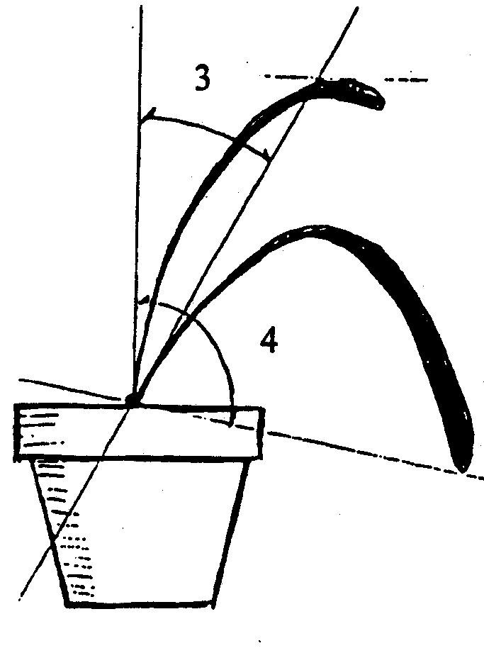 | highest point  longest leaf

Ad. 6: Pseudobulb: shape in longitudinal section

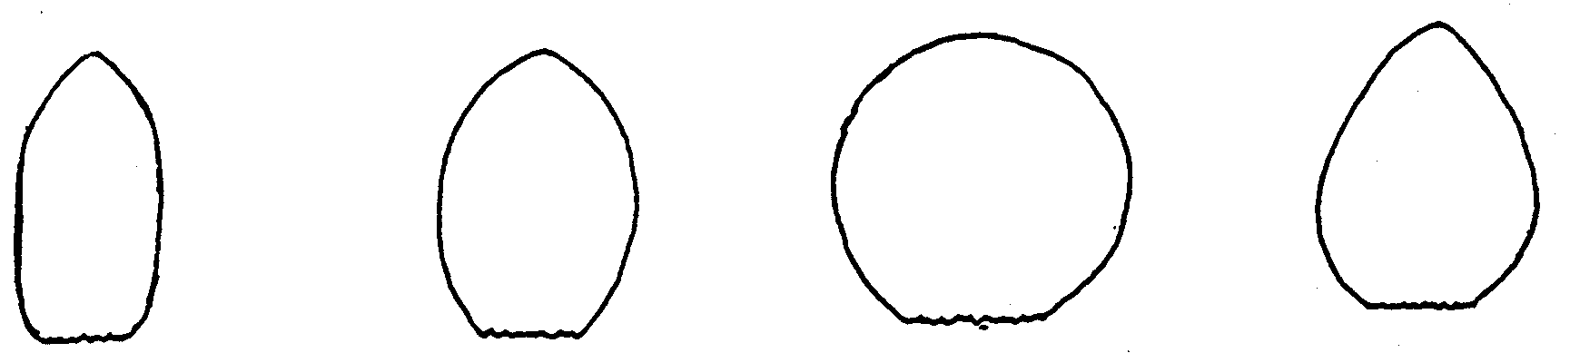

1 | 2 | 3 | 4
oblong | elliptic | circular | ovate

Ad. 12: Leaf: shape

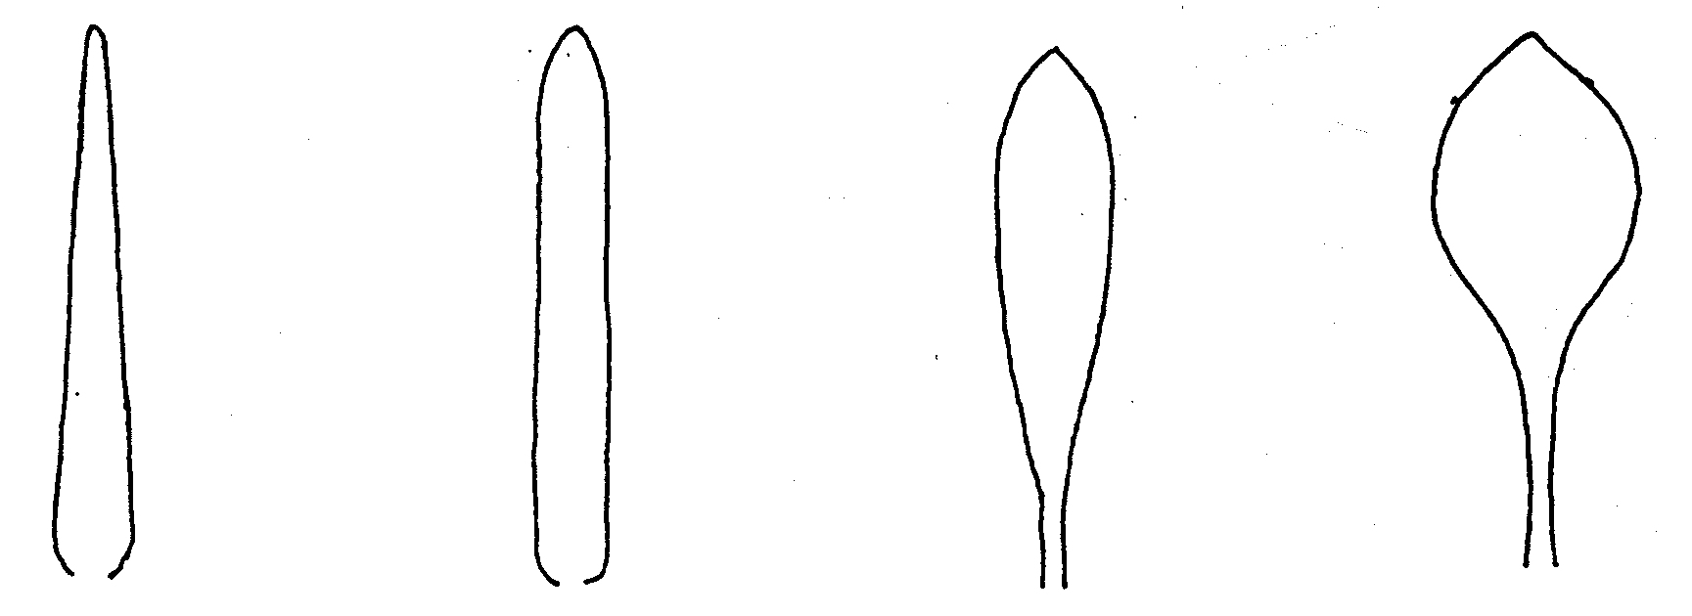
1 | 2 | 3 | 4
narrow lanceolate | linear | oblanceolate | spatulate

Ad. 13 and 14: Leaf: shape (13) and symmetry (14) of apex

asymmetric | 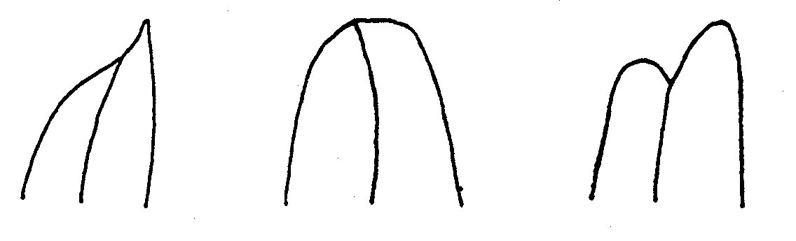
1 2 3
acute obtuse emarginate

symmetric | 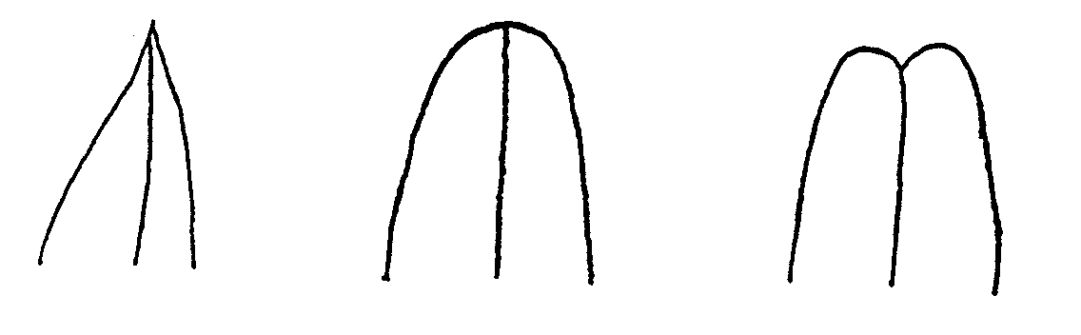
Ad. 29 and 30: Flower: length (29) and width (30)

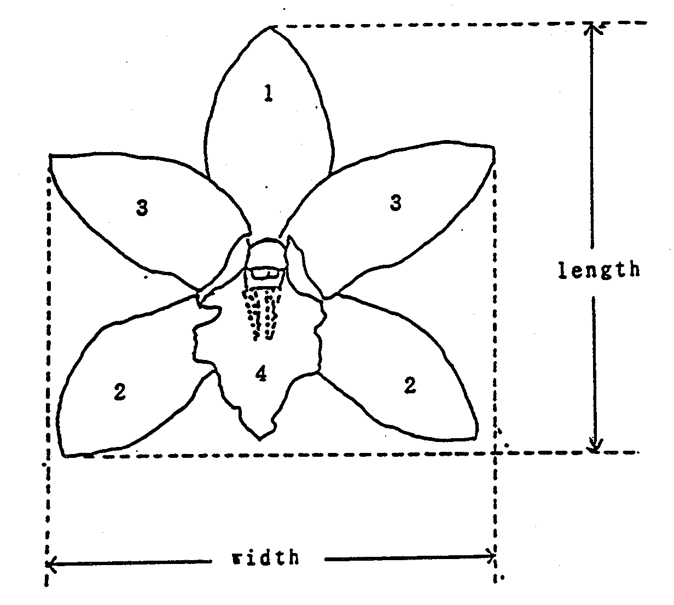 | 1: Dorsal sepal  2: Lateral sepal  3: Petal  4: Lip

Ad. 34 and 41: Dorsal (34) and lateral (41) sepal: shape

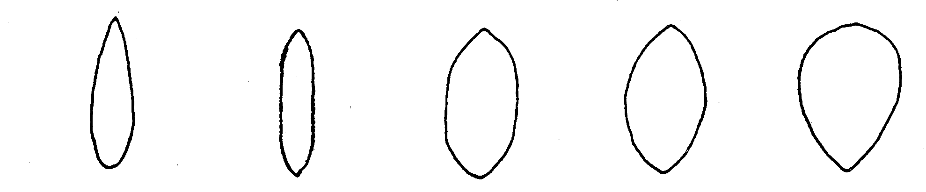
1 | 2 | 3 | 4 | 5
lanceolate | linear | oblong | elliptic | obovate

Ad. 36, 43, 61: Dorsal (36) and lateral (43) sepal and petal (61): shape of apex

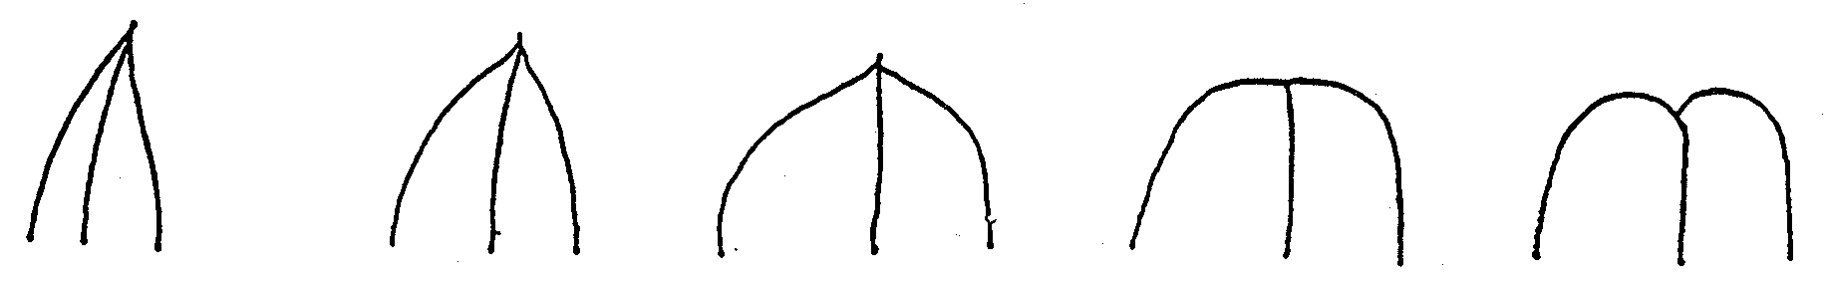

1 | 2 | 3 | 4 | 5
narrow acute | acute | obtuse | truncate | emarginate
Ad. 35, 42 and 60: Dorsal (35) and lateral (42) sepal and petal (60): curvature of longitudinal
axis

inner  side → | 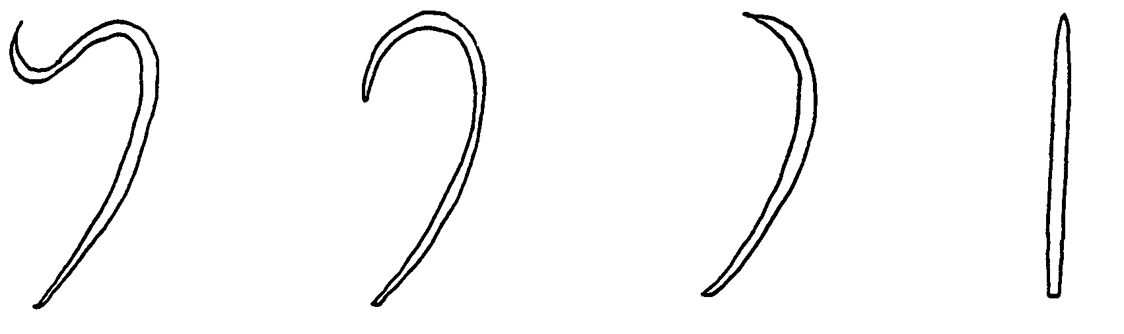

 | 1 | 2 | 3 | 4
 | incurved with | strongly | slightly | straight
 | reflexed apex | incurved | incurved

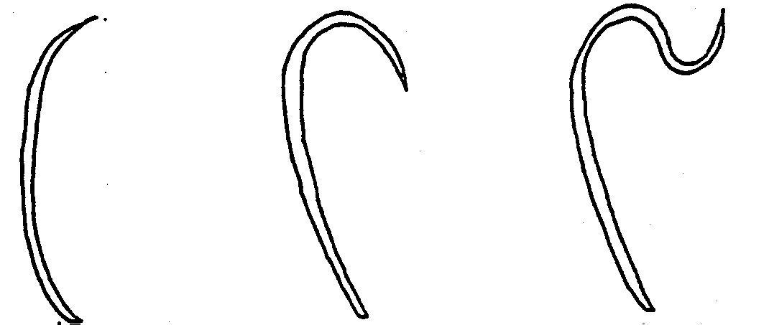

5 6 7
slightly strongly reflexed with
reflexed reflexed incurved apex

Ad. 53 and 71: Sepal (53) and petal (71): cuneate area (differently colored)

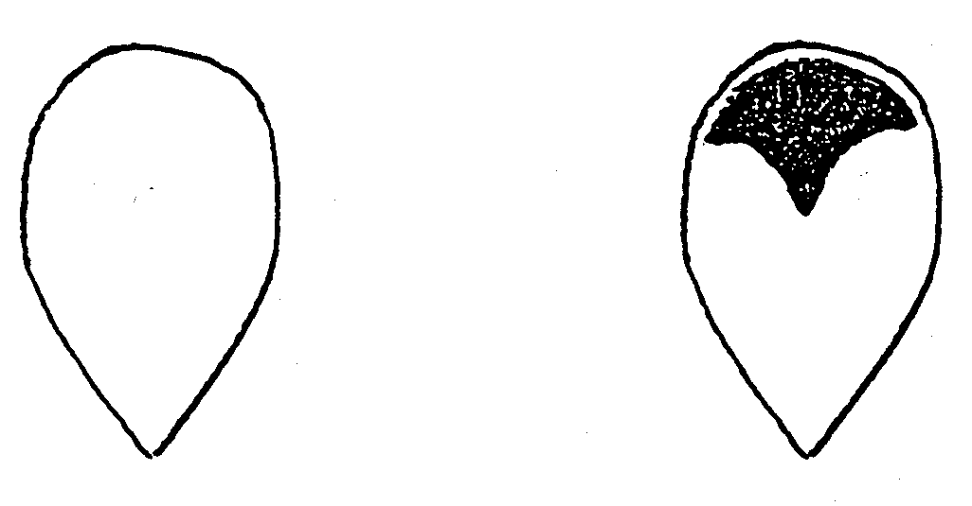
1 | 9
absent | present

Ad. 59: Petal: shape

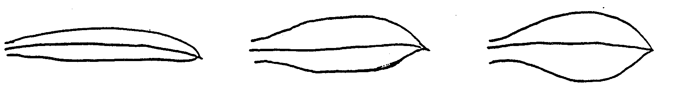

1 | 2 | 3
linear | oblong | elliptic

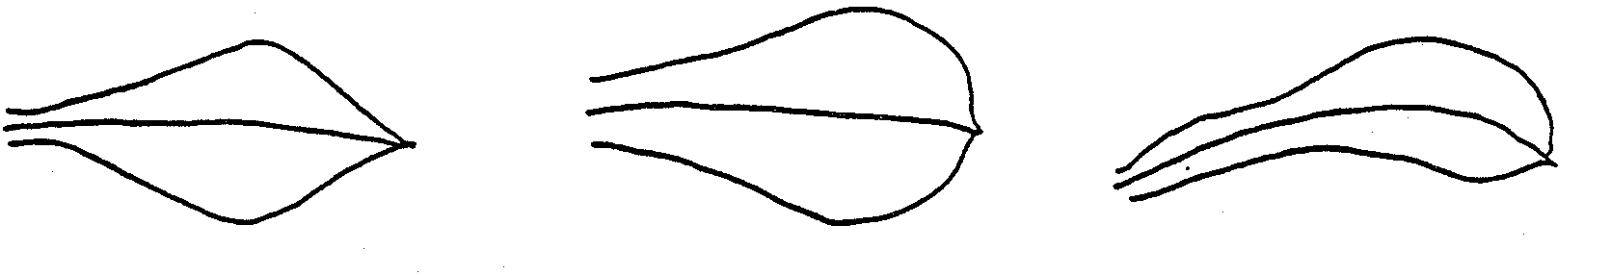

4 | 5 | 6
rhombic | obovate | spatulate

Ad. 77: Lip: shape

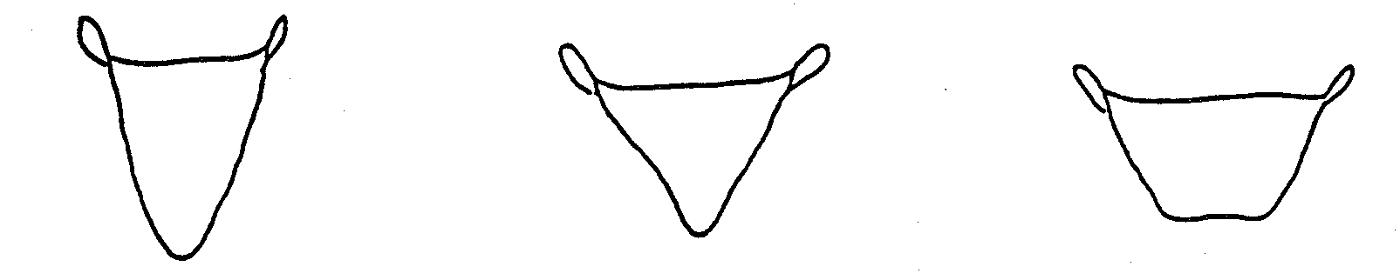

1 | 3 | 4
narrow triangular | triangular | trapezium

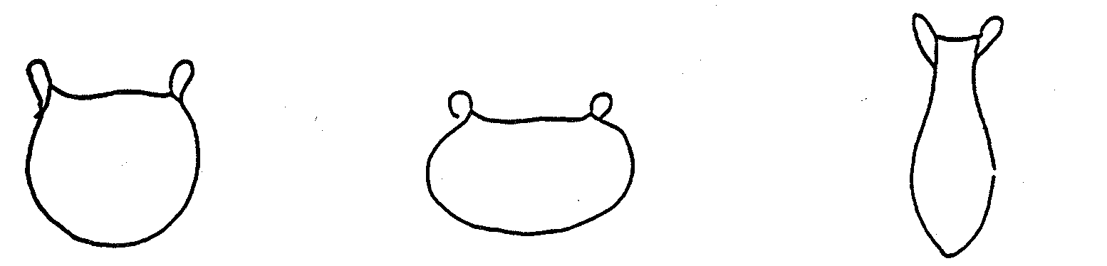

4 | 5 | 6
circular | oblate | spatulate

Ad. 78: Lip: shape in longitudinal section

inner side | 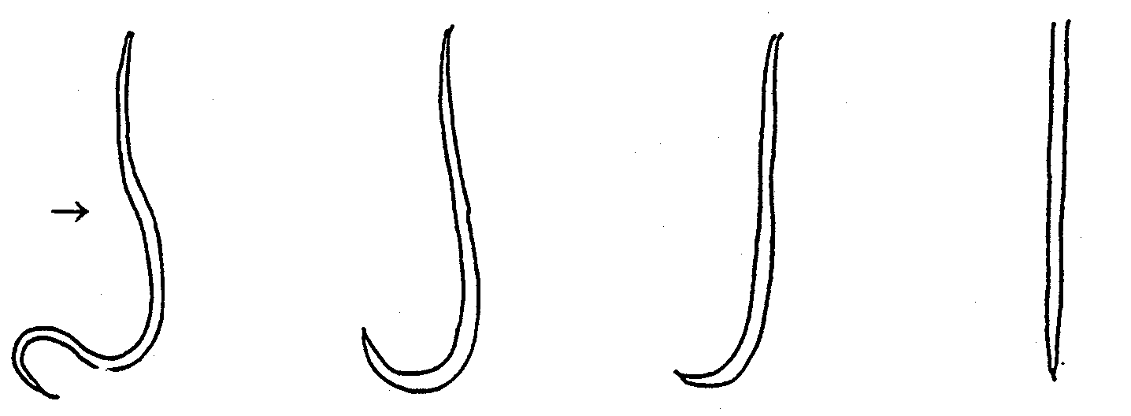

 | 1 | 2 | 3 | 4
 | incurved with  reflexed apex | strongly  incurved | slighly  incurved | straight

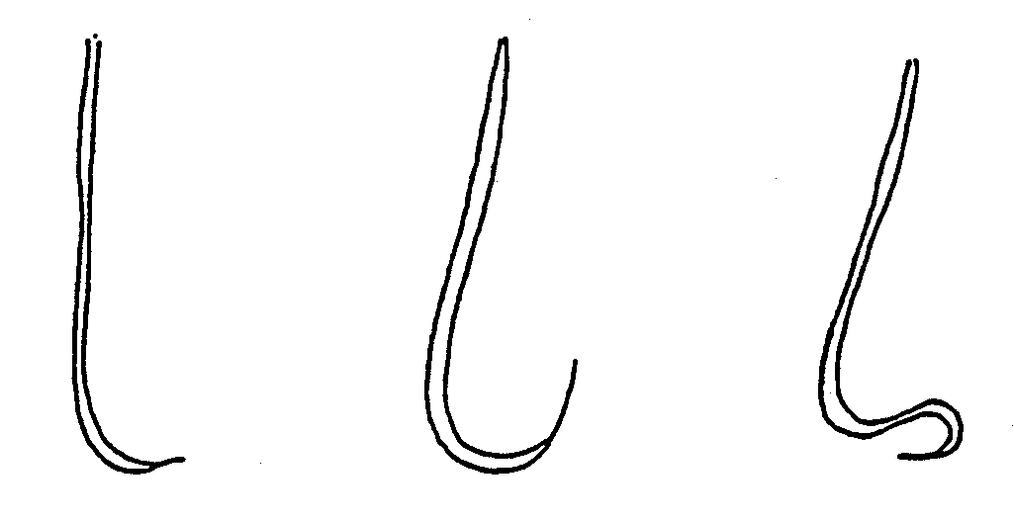
 | 5 | 6 | 7
 | slighly  reflexed | strongly  reflexed | reflexed with incurved apex

Ad. 89: Lip: cuneate area (differently colored)

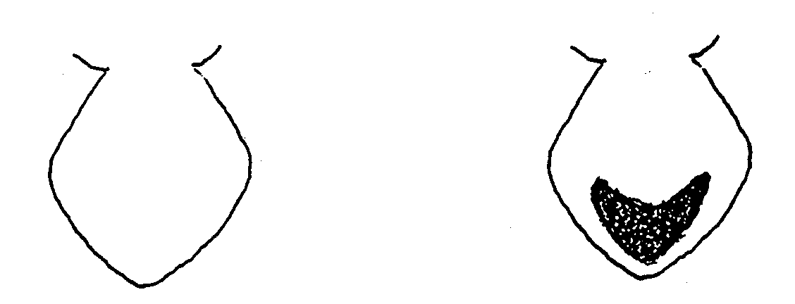

 | 1 | 9
 | absent | present

IX. Literature

K. Karasawa, 1994: “Orchid Atlas,” Vol. 6 Cymbidium and Lycaste, Orchid Atlas Publishing Society, c/o Yasaka Syobo, Inc., Tokyo, Japan

Encyclopedia of Horticulture, pp. 218-230, Seibun-Do Shinkosha, Tokyo, Japan (Japanese)

Greatwood, J., Hunt, P. F., Gribb, P. J. and Steward, J. (eds), 1993: (4th edition): The handbook on orchid nomenclature and registration. The International Orchid Commission, London, United Kingdom

X. Technical Questionnaire

Reference Number
(not to be filled in by the applicant)

TECHNICAL QUESTIONNAIRE
to be completed in connection with an application for plant breeders’ rights

1.1 Genus Cymbidium Sw.

CYMBIDIUM

1.2 Species ...................................................................
(indicate species)

2. Applicant (Name and address)

3. Proposed denomination or breeder’s reference

4. Information on origin, release, maintenance and reproduction of the variety

4.1 Origin

- Seedling (indicate parent varieties)

................................................................................................ [ ]

- Mutation (indicate parent variety)

................................................................................................ [ ]

- Discovery (indicate where and when)

................................................................................................ [ ]

- Other (specify)

................................................................................................ [ ]

4.2 Method of reproduction

- cuttings [ ]

- in vitro propagation [ ]

- other (please specify) [ ]

................................................................................................

4.3 Other information

5. Characteristics of the variety to be indicated (the number in brackets refers to the corresponding characteristic in Test Guidelines; please mark the state of expression which best corresponds).

 | Characteristics | Example Varieties |  |  | Note
5.1  (1) | Plant: size
 | small | C. goeringii |  |  | 3[ ]
 | medium | Lucky Rainbow “Saint Lapine” |  |  | 5[ ]
 | large |  |  | 7[ ]
5.2  (20) | Varieties with raceme only: Inflorescence: number of flowers
 | few |  |  | 3[ ]
 | medium |  | Sweet Love “Catilo” | 5[ ]
 | many |  |  | 7[ ]
5.3  (24) | Peduncle: attitude
 | erect |  | Half Moon “Banana Boat” | 1[ ]
 | semi-erect |  | Lucky Rainbow “Saint Lapine” | 3[ ]
 | horizontal |  |  | 5[ ]
 | semi-pendulous |  | Sarah Jean “Peach” | 7[ ]
 | pendulous |  | C. devonianum | 9[ ]
5. 4  (28) | Flower: general impression of petals and sepals
 | all incurved |  | Lucky Rainbow “Saint Lapine” | 1[ ]
 | some incurved, some spreading |  | Great Flower “Hige” | 2[ ]
 | all spreading |  | Fire Starter “Perfect Rouge” | 3[ ]
 | some spreading, some reflexed |  |  | 4[ ]
 | all reflexed |  |  | 5[ ]
 | some incurved, some reflexed |  |  | 6[ ]

 | Characteristics | Example Varieties |  |  |  | Note
5.5  (29) | Flower: length
 | short |  | C. goeringii |  | 3[ ]
 | medium |  | Lucky Rainbow “Saint Lapine” |  | 5[ ]
 | long |  |  |  | 7[ ]
5.6  (30) | Flower: width
 | narrow |  | Lucky Rainbow “Saint Lapine” |  | 3[ ]
 | medium |  | Fire Starter “Perfect Rouge” |  | 5[ ]
 | broad |  |  |  | 7[ ]
5.7  (100) | Flowering time
 | autumn |  | Green Sour “Fresh” |  | 1[ ]
 | early winter |  |  |  | 2[ ]
 | middle winter |  | Lucky Rainbow “Saint Lapine” | 3[ ]
 | spring |  | Shellpearl “Parnasse” | 4[ ]
 | perpetual |  |  | 5[ ]
5.8 | Flower: predominant color
 | white |  |  | 1[ ]
 | yellow |  |  | 2[ ]
 | green |  |  | 3[ ]
 | pink |  |  | 4[ ]
 | red |  |  | 5[ ]
 | purple |  |  | 6[ ]
 | reddish brown |  |  | 7[ ]
 | bicolored (indicate colors) .................................... |  |  | 8[ ]

6. Similar varieties and differences from these varieties

Denomination of similar variety | Characteristic in which the similar variety is different ^{o)} | State of expression of similar variety | State of expression of candidate variety
______________
^{o)} In the case of identical states of expressions of both varieties, please indicate the size of the difference.

7. Additional information which may help to distinguish the variety

7.1 Resistance to pests and diseases

7.2 Special conditions for the examination of the variety

- Conditions for planting

- Other conditions

7.3 Other information

A representative color photo of the variety should be added to the Technical Questionnaire.

8. Authorization for release

- Does the variety require prior authorization for release under legislation concerning the protection of the environment, human and animal health?
Yes [ ] No [ ] Yes [ ] No [ ]
- Has such authorization been obtained?

Yes [ ] No [ ]

If the answer to that question is yes, please attach a copy of such an authorization.

[End of document]

