 |  | E  TG/162/4 Rev.

INTERNATIONAL UNION FOR THE PROTECTION  OF NEW VARIETIES OF PLANTS | UNION INTERNATIONALE POUR LA PROTECTION  DES OBTENTIONS VÉGÉTALES | INTERNATIONALER VERBAND ZUM SCHUTZ VON PFLANZEN-ZÜCHTUNGEN | UNIÓN INTERNACIONAL PARA LA PROTECCIÓN  DE LAS OBTENCIONES VEGETALES

GUIDELINES

FOR THE CONDUCT OF TESTS

FOR DISTINCTNESS, UNIFORMITY AND STABILITY

GARLIC

(Allium sativum L.)

GENEVA
2001, 2022

Copies of this document are available on request at the price of 10 Swiss francs each, including surface mail, from the Office of UPOV, 34, chemin des Colombettes, P.O. Box 18, 1211 Geneva 20, Switzerland

This document or parts of it may be reproduced, translated and published without obtaining the specific consent of UPOV, provided that the source is acknowledged.

* * * * * * *
E
TG/162/4 Rev.
ORIGINAL: English
DATE: 2001-04-04 + 2022-10-25

INTERNATIONAL UNION FOR THE PROTECTION  OF NEW VARIETIES OF PLANTS | UNION INTERNATIONALE POUR LA PROTECTION  DES OBTENTIONS VÉGÉTALES | INTERNATIONALER VERBAND ZUM SCHUTZ VON PFLANZEN-ZÜCHTUNGEN | UNIÓN INTERNACIONAL PARA LA PROTECCIÓN  DE LAS OBTENCIONES VEGETALES

GUIDELINES

FOR THE CONDUCT OF TESTS

FOR DISTINCTNESS, UNIFORMITY AND STABILITY

GARLIC

(Allium sativum L.)

These Guidelines should be read in conjunction with document TG/1/2, which contains explanatory notes on the general principles on which the Guidelines have been established.

TABLE OF CONTENTS PAGE

I. | Subject of these Guidelines | 3
II. | Material Required | 3
III. | Conduct of Tests | 3
IV. | Methods and Observations | 4
V. | Grouping of Varieties | 4
VI. | Characteristics and Symbols | 5
VII. | Table of Characteristics | 6
VIII. | Explanations on the Table of Characteristics | 13
IX. | Literature | 17
X. | Technical Questionnaire | 18

I. Subject of these Guidelines

These Test Guidelines apply to all varieties of Allium sativum L.

II. Material Required

1. The competent authorities decide when, where and in what quantity and quality the seed required for testing the variety is to be delivered. Applicants submitting material from a State other than that in which the testing takes place must make sure that all customs formalities are complied with.

2. The material is to be supplied in the form of seed in the case of seed-propagated varieties, or in the form of bulbs in the case of vegetatively propagated varieties.

3. The minimum quantity of plant material, to be supplied by the applicant, should be:

Seed-propagated varieties: 15,000 seeds, or
Vegetatively propagated varieties: 60 bulbs

4. In the case of seed, the seed should meet the minimum requirements for germination, species and analytical purity, health and moisture content, specified by the competent authority.

5. In the case of bulbs, the plant material should at least meet the minimum requirements for sprouting capacity, moisture content and purity for marketing plant material in the country in which the application is made. It must be in good sanitary condition and free from virus, in particular from leek yellow stripe virus and onion yellow dwarf virus.

6. The plant material must not have undergone any treatment unless the competent authorities allow or request such treatment. If it has been treated, full details of the treatment must be given.

III. Conduct of Tests

1. The minimum duration of tests should normally be two independent growing cycles.

2. The tests should normally be conducted at one place. If any important characteristic of the variety cannot be seen at that place, the variety may be tested at an additional place.

3. The tests should be carried out under conditions ensuring normal growth. The size of the plots should be such that plants or parts of plants may be removed for measurement and counting without prejudice to the observations which must be made up to the end of the growing period. In the case of seed-propagated varieties, each test should be designed to result in a total of at least 200 plants divided between two or more replicates. In the case of vegetatively propagated varieties, each test should be designed to result in a total of at least 100 plants divided between two or more replicates. Separate plots for visual observation and for measuring can only be used if they have been subject to similar environmental conditions.

4. Because of the effect of conditions of storage of bulbs on the expression of characteristics, comparison of varieties should be made only on material which has been propagated and stored under the same temperature and humidity conditions (e.g. 15ºC to 18ºC).

5. Additional tests for special purposes may be established.

IV. Methods and Observations

1. Unless otherwise indicated, in the case of seed-propagated varieties, all observations on single plants should be made on 60 plants or parts taken from each of 60 plants. In the case of vegetatively propagated varieties, all observations on single plants should be made on 30 plants or parts taken from each of 30 plants.

2. The assessment of uniformity for cross-pollinated varieties should be according to the recommendations for cross pollinated varieties in the General Introduction.

3. The assessment of uniformity for hybrid varieties depends on the type of hybrid and should be according to the recommendations for hybrid varieties in the General Introduction.

4. For the assessment of uniformity of vegetatively propagated varieties, a population standard of 1% with an acceptance probability of at least 95% should be applied. In the case of a sample size of 100 plants, three off-types are allowed.

5. All observations on the leaf, foliage and flowering stem should be made before foliage fall-over.

6. All observations on the bulbs should be made on bulbs harvested in the trial.

V. Grouping of Varieties

1. The collection of varieties to be grown should be divided into groups to facilitate the assessment of distinctness. Characteristics which are suitable for grouping purposes are those which are known from experience not to vary, or to vary only slightly, within a variety. Their various states of expression should be fairly evenly distributed throughout the collection.

2. It is recommended that the competent authorities use the following characteristics for grouping varieties:

- Pseudostem: flowering stem (characteristic 10);
- Clove: color of scale (characteristic 29);
- Time of harvest maturity (characteristic 33);
- End of dormancy of clove in bulb (characteristic 34).

VI. Characteristics and Symbols

1. To assess distinctness, uniformity and stability, the characteristics and their states as given in the Table of Characteristics should be used.

2. Notes (numbers), for the purposes of electronic data processing, are given opposite the states of expression for each characteristic.

3. Legend:

(*) Characteristics that should be used on all varieties in every growing cycle over which the examinations are made and always be included in the variety descriptions, except when the state of expression of a preceding characteristic or regional environmental conditions render this impossible.

(+) See Explanations on the Table of Characteristics in Chapter VIII.

VII. Table of Characteristics/Tableau des caractères/Merkmalstabelle/Tabla de caracteres

 | English | français | deutsch | español | Example Varieties  Exemples  Beispielssorten  Variedades ejemplo | Note/  Nota
1.  (*) | Foliage: density | Feuillage: densité | Laub: Dichte | Follaje: densidad
1.  (*) | loose | lâche | locker | laxo | Ramses | 3
 | medium | moyen | mittel | medio | Printanor | 5
 | dense | dense | dicht | denso | Germidour | 7
2.  (*)  (+) | Foliage: attitude | Feuillage: port | Laub: Haltung | Follaje: porte
2.  (*)  (+) | erect | dressé | aufrecht | erecto | Jolimont | 1
 | erect to  semi-erect | dressé à  demi-dressé | aufrecht bis halbaufrecht | erecto a  semierecto | Printanor | 2
 | semi-erect | demi-dressé | halbaufrecht | semierecto | Jardinor | 3
3.  (*) | Leaf: green color | Feuille: couleur verte | Blatt: Grünfärbung | Hoja: color verde
3.  (*) | light | claire | hell | claro |  | 3
 | medium | moyenne | mittel | medio | Messidrome | 5
 | dark | foncée | dunkel | oscuro | Germidour | 7
4. | Leaf: waxiness | Feuille: pruine | Blatt: Wachsschicht | Hoja: cerosidad
 | absent or very weak | nulle ou très faible | fehlend oder sehr gering | ausente o muy débil |  | 1
 | weak | faible | gering | débil | Sprint | 3
 | medium | moyenne | mittel | media | Messidrome | 5
 | strong | forte | stark | fuerte | Germidour, Moratop | 7
 | very strong | très forte | sehr stark | muy fuerte | Gayant, Printanor | 9
5.  (*) | Leaf: length  (longest leaf) | Feuille: longueur  (feuille la plus longue) | Blatt: Länge  (längstes Blatt) | Hoja: longitud  (hoja más larga)
 | short | courte | kurz | corta | Jardinor | 3
 | medium | moyenne | mittel | media | Moraluz, Morasur | 5
 | long | longue | lang | larga | Sultop | 7
6.  (*) | Leaf: width  (as for 5) | Feuille: largeur  (comme pour 5) | Blatt: Breite  (wie unter 5) | Hoja: anchura  (como para 5)
 | narrow | étroite | schmal | estrecha | Ramses | 3
 | medium | moyenne | mittel | media | Printanor | 5
 | broad | large | breit | ancha | Germidour | 7
7.  (*) | Leaf: shape in cross section | Feuille: forme en section transversale | Blatt: Form im Querschnitt | Hoja: forma de la sección transversal
 | strongly concave | fortement concave | stark konkav | fuertemente cóncava |  | 1
 | slightly concave | légèrement concave | leicht konkav | ligeramente cóncava | Ramses | 2
 | flat | plane | flach | plana | Germidour | 3
8.  (*) | Pseudostem: intensity of anthocyanin coloration at base | Pseudotige: intensité de la pigmentation anthocyanique à la base | Pseudostamm: Intensität der Anthocyanfärbung an der Basis | Pseudotallo: intensidad de la pigmentación antociánica en la base
 | absent or very weak | absente ou très faible | fehlend oder sehr gering | ausente o muy débil | Printanor | 1
 | weak | faible | gering | débil | Messidrome | 3
 | medium | moyenne | mittel | media |  | 5
 | strong | forte | stark | fuerte | Germidour | 7
 | very strong | très forte | sehr stark | muy fuerte |  | 9
9.  (*) | Pseudostem: width of the base | Pseudotige: largeur de la base | Pseudostamm: Breite der Basis | Pseudotallo: anchura de la base
 | narrow | étroite | schmal | estrecha | Ramses | 3
 | medium | moyenne | mittel | media | Printanor | 5
 | broad | large | breit | ancha | Germidour | 7
10.  (*) | Pseudostem: flowering stem | Pseudotige: tige florifère | Pseudostamm: Blütenstandstiel | Pseudotallo: tallo floral
 | absent | absente | fehlend | ausente | Germidour | 1
 | present | présente | vorhanden | presente | Rose de Lautrec | 9
11.  (*)  (+) | Flowering stem: curvature | Tige florale:  courbure | Blütenstandstiel: Krümmung | Tallo floral:  curvatura
11.  (*)  (+) | absent | absente | fehlend | ausente | Morasur, Sultop | 1
 | present | présente | vorhanden | presente | Iberose | 9
12.  (*)  (+) | Flowering stem: length | Tige florale:  longueur | Blütenstandstiel: Länge | Tallo floral:  longitud
12.  (*)  (+) | short | courte | kurz | corto | Rose de Lautrec | 3
 | medium | moyenne | mittel | medio | Morasol | 5
 | long | longue | lang | largo | Sultop | 7
13.  (*)  (+) | Flowering stem: bulblets | Tige florale: bulbilles | Blütenstandstiel: Bulbillen | Tallo floral:  bulbillos
13.  (*)  (+) | absent | absentes | fehlend | ausentes | Rose de Lautrec | 1
 | present | présentes | vorhanden | presentes | Germidour | 9
14.  (*) | Bulb: size | Bulbe: taille | Zwiebel: Größe | Bulbo: tamaño
14.  (*) | small | petite | klein | pequeño | Fructidor | 3
 | medium | moyenne | mittel | mediano | Printanor | 5
 | large | grande | groß | grande | Messidrome | 7
15.  (*)  (+) | Bulb: shape in longitudinal section | Bulbe: forme en section longitudinale | Zwiebel: Form im Längsschnitt | Bulbo: forma en sección longitudinal
15.  (*)  (+) | transverse narrow elliptic | elliptique étroite transverse | quer schmal elliptisch | elíptica estrecha transversal | Sprint | 1
 | transverse broad elliptic | elliptique large transverse | quer breit elliptisch | elíptica ancha transversal | Germidour | 2
 | circular | arrondie | kreisförmig | circular | De Roumanie | 3
16. | Bulb: shape in cross section | Bulbe: forme en section transversale | Zwiebel: Form im Querschnitt | Bulbo: forma en sección transversal
 | elliptic | elliptique | elliptisch | elíptica | Fructidor | 1
 | circular | arrondie | kreisförmig | circular | Sprint | 2
17.  (+) | Bulb: position of cloves at tip of bulb | Bulbe: position des caïeux à l’extrémité supérieure du bulbe | Zwiebel: Position der Zehen an der Spitze der Zwiebel | Bulbo: posición de los dientes en el extremo del bulbo
 | inserted | insérée | im Hals | insertos | Sprint | 1
 | at same level | au même niveau | am Halsbeginn | al mismo nivel | Corail | 2
 | exerted | extérieure | unterhalb des Halses | exertos | Germidour | 3
18.  (*) | Bulb: position of root disc | Bulbe: position du plateau racinaire | Zwiebel: Position der Wurzelscheibe | Bulbo: posición del disco radicular
 | depressed | déprimée | eingesenkt | deprimido | Germidour | 1
 | flat | plane | flach | plano | Rose de Lautrec | 2
 | raised | en saillie | vorgewölbt | protuberante |  | 3
19.  (*)  (+) | Bulb: shape of base | Bulbe: forme de la base | Zwiebel: Form der Basis | Bulbo: forma de la base
19.  (*)  (+) | recessed | déprimée | eingebuchtet | deprimida | Germidour, Ramses | 1
 | flat | plate | flach | plana | Printanor | 2
 | rounded | arrondie | abgerundet | redonda | de Roumanie | 3
20. | Bulb: compactness of cloves | Bulbe: compacité des caïeux | Zwiebel: Dichte der Zehen | Bulbo: compacidad de los dientes
 | loose | faible | locker | laxo | Sprint | 3
 | medium | moyenne | mittel | medio | Germidour | 5
 | compact | forte | dicht | compacto | Printanor | 7
21.  (*) | Bulb: ground color of dry external scales | Bulbe: couleur de fond des tuniques externes sèches | Zwiebel: Grundfarbe der trockenen Außenschalen | Bulbo: color de fondo de las catáfilas externas
 | white | blanche | weiß | blanco | Printanor, Ramses | 1
 | yellowish white | blanc jaunâtre | gelblichweiß | blanco amarillento | Vigor Max, Vigor Supreme | 2
 | reddish white | blanc rougeâtre | rötlichweiß | blanco rojizo | Germidour | 3
22.  (*) | Bulb: anthocyanin stripes on dry external scales | Bulbe: striures anthocyaniques sur les tuniques externes sèches | Zwiebel: Anthocyanstreifen auf den trockenen Außenschalen | Bulbo: estrías antociánicas en las catáfilas externas
 | absent | absentes | fehlend | ausentes | Printanor, Ramses | 1
 | present | présentes | vorhanden | presentes | Germidour, Sprint | 9
23. | Bulb: skin adherence of dry external scales | Bulbe: adhérence des tuniques externes sèches | Zwiebel: Anhaften der trockenen Außenschalen | Bulbo: adherencia de las catáfilas externas
 | weak | faible | gering | débil | Sprint | 3
 | medium | moyenne | mittel | media | Messidrome | 5
 | strong | forte | stark | fuerte | Printanor, Gayant | 7
24. | Bulb: thickness of dry external scales | Bulbe: épaisseur des tuniques externes sèches | Zwiebel: Dicke der trockenen Außenschalen | Bulbo: espesor de las catáfilas externas
 | thin | minces | dünn | delgadas | Ramses | 3
 | medium | moyennes | mittel | medias | Morasur | 5
 | thick | épaisses | dick | gruesas | Jolimont | 7
25.  (*) | Bulb: number of cloves | Bulbe: nombre de caïeux | Zwiebel: Anzahl Zehen | Bulbo: número de dientes
 | few | petit | gering | bajo | Mondor | 3
 | medium | moyen | mittel | medio | Printanor | 5
 | many | grand | groß | alto | Ramses | 7
26.  (*)  (+) | Bulb: distribution of cloves | Bulbe: distribution des caïeux | Zwiebel: Verteilung der Zehen | Bulbo: distribución de los dientes
26.  (*)  (+) | radial | rayonnante | radial | radial | Rose de Lautrec, Sprint | 1
 | non-radial | non rayonnante | nicht radial | non radial | Blanc de Beaumont, Messidrome,  Rougeatre de Vendée | 2
27.  (*)  (+) | Bulb: external cloves | Bulbe: caïeux externes | Zwiebel: externe Zehen | Bulbo: dientes exteriores
27.  (*)  (+) | absent | absents | fehlend | ausentes | Sprint, Sultop | 1
 | present | présents | vorhanden | presentes | Blanc de Beaumont, Morasol | 9
28.  (*) | Clove: size | Caïeu: taille | Zehe: Größe | Diente: tamaño
28.  (*) | small | petite | klein | pequeño | Rose de Lautrec | 3
 | medium | moyenne | mittel | medio | Printanor | 5
 | large | grande | groß | grande | Germidour | 7
29.  (*) | Clove: color of scale | Caïeu: couleur de la tunique | Zehe: Schalenfarbe | Diente: color de la piel
 | white | blanche | weiß | blanco | Ramses | 1
 | cream | crème | cremefarben | crema | Messidrome | 2
 | pink | rose | rosa | rosa | Printanor | 3
 | purple | violette | purpur | violeta | Morasol, Sprint | 4
 | brown | brune | braun | marrón | Corail | 5
30.  (*) | Clove: intensity of color of scale | Caïeu: intensité de la couleur de la tunique | Zehe: Intensität der Schalenfarbe | Diente: intensidad del color de la piel
 | weak | faible | gering | débil | Printanor | 3
 | medium | moyenne | mittel | media | Ibérose, Sultop | 5
 | strong | forte | stark | fuerte | Morasol, Morasur, Moratop | 7
31.  (*) | Clove: anthocyanin stripes on scale | Caïeu: striures anthocyaniques de la tunique | Zehe: Anthocyanstreifen auf der Schale | Diente: estrías antociánicas en la piel
 | absent | absentes | fehlend | ausentes | Ramses | 1
 | present | présentes | vorhanden | presentes | Morasur | 9
32.  (*) | Clove: color of flesh | Caïeu: couleur de la chair | Zehe: Farbe des Fleisches | Diente: color de la pulpa
 | white | blanche | weiß | blanco | Printanor | 1
 | yellowish | jaunâtre | gelblich | amarillento | Germidour | 2
33.  (*) | Time of harvest maturity | Époque de maturité de récolte | Zeitpunkt der Erntereife | Época de madurez para la cosecha
 | very early | très précoce | sehr früh | muy temprana | Ramses | 1
 | early | précoce | früh | temprana | Sprint | 3
 | medium | moyenne | mittel | media | Germidour, Messidrome | 5
 | late | tardive | spät | tardía | Printanor | 7
 | very late | très tardive | sehr spät | muy tardía | Gayant | 9
34.  (*)  (+) | End of dormancy of clove in bulb | Levée de dormance des caïeux dans le bulbe | Ende der Keimruhe der Zehen in der Zwiebel | Final de la dormancia de los dientes en el bulbo
 | very early | très précoce | sehr früh | muy temprana | Ramses | 1
 | early | précoce | früh | temprana | Sprint | 3
 | medium | moyenne | mittel | media | Rose de Lautrec | 5
 | late | tardive | spät | tardía | Fructidor | 7
 | very late | très tardive | sehr spät | muy tardía | Gayant | 9

VIII. Explanations on the Table of Characteristics

Ad. 2: Foliage: attitude
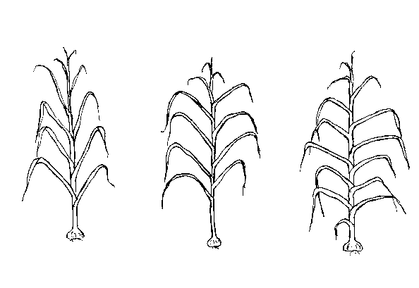  1  erect | 2  erect to semi-erect | 3  semi-erect

Ad. 11: Flowering stem: curvature


1  absent | 9  present

Ad. 12: Flowering stem: length
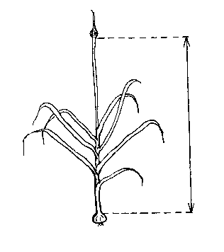

Ad. 13: Flowering stem: bulblets
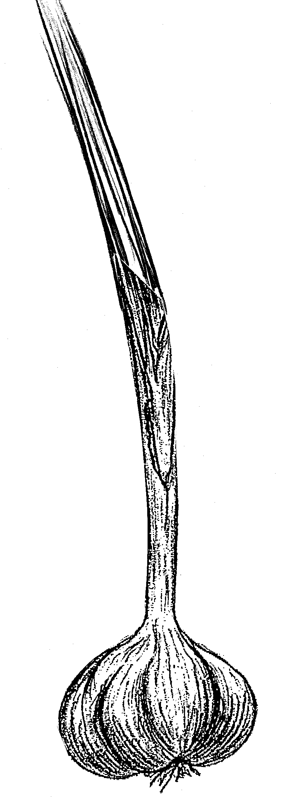
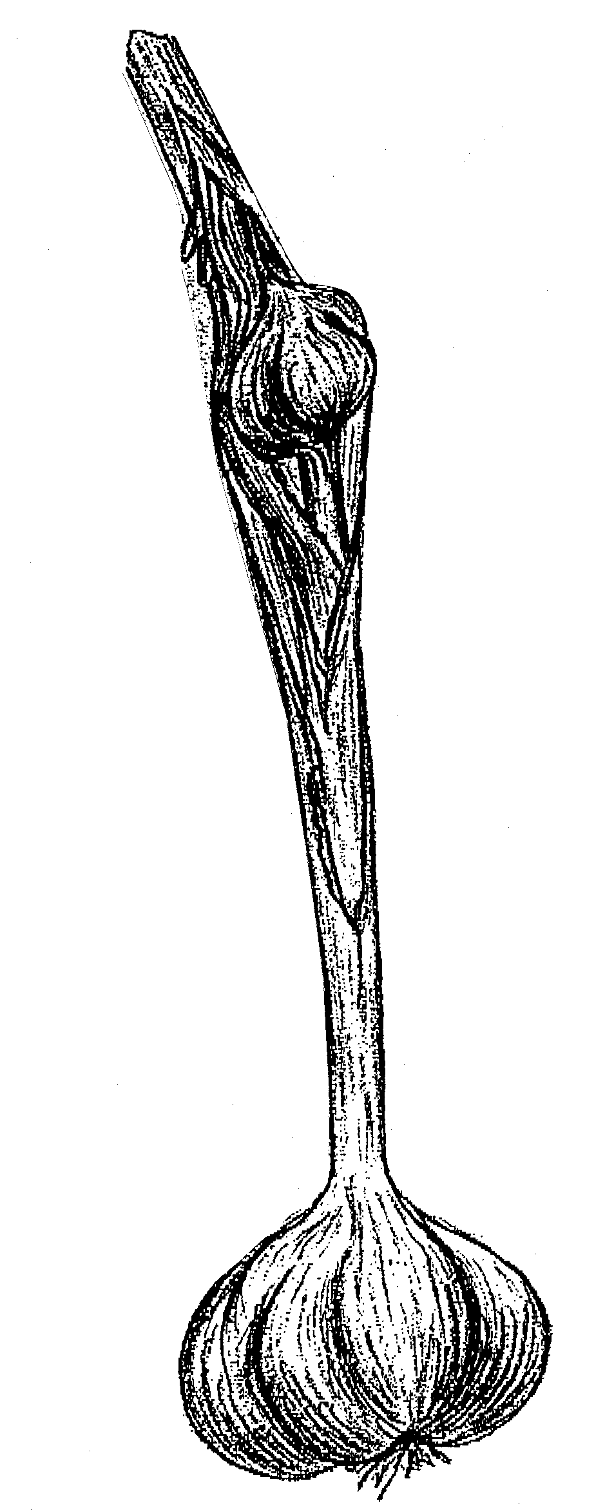

1 9
absent present
Ad. 15: Bulb: shape in longitudinal section

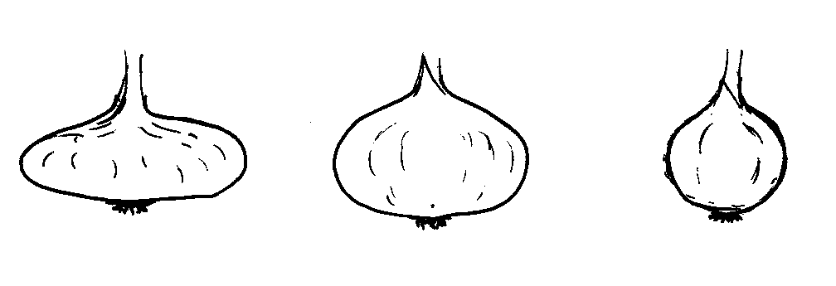

1  transverse narrow elliptic | 2  transverse broad elliptic | 3  circular

Ad. 17: Bulb: position of cloves at tip of bulb

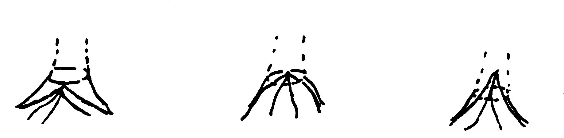
1  inserted | 2  at same level | 3  exerted

Ad. 19: Bulb: shape of base

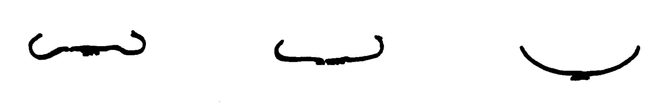

1  recessed | 2  flat | 3  rounded

Ad. 26: Bulb: distribution of cloves
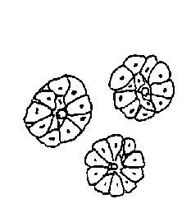
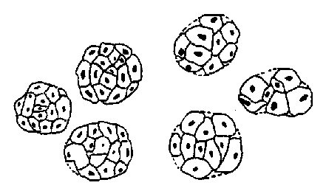

1  radial | 2  non-radial

Ad. 27: Bulb: external cloves

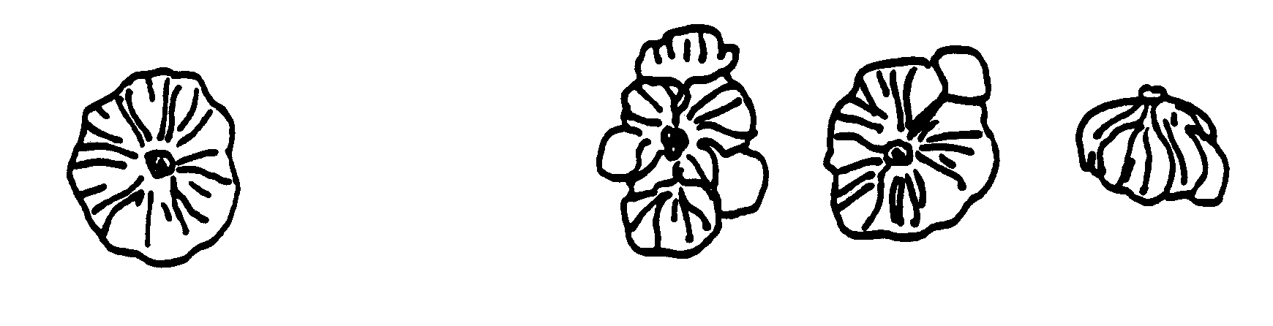
1  absent | 9  present

Ad. 34: End of dormancy of clove in bulb

After harvest, bulbs are stored in a room at an optimum temperature (20ºC to 25ºC) without being split into cloves. The end of dormancy is evaluated by observing the percentage of sprouted bulbs.

IX. Literature

Brand, R., “L’Ail, une semence à part dans les Allium”, La Lettre des Ressources Génétiques Végétales, nº 9, octobre 1996, pp. 11-16.

Messiaen, C.M., “6 La variabilité chez l’Ail”, La Lettre des Ressources Génétiques Végétales, nº 9, octobre 1996, pp. 7-10.

X. Technical Questionnaire

 |  |  |  |  | Reference Number
 |  |  |  |  | (not to be filled in by the applicant)
TECHNICAL QUESTIONNAIRE
to be completed in connection with an application for plant breeders’ rights

1. Species Allium sativum L.

GARLIC

2. Applicant (Name and address)

3. Proposed denomination or breeder’s reference

4. Information on origin, maintenance and reproduction of the variety

4.1 Breeding scheme

Variety resulting from:

4.1.1 Crossing

(a) controlled cross [ ]
(b) partially known cross [ ]
(c) unknown cross [ ]

4.1.2 Clone

- natural clone [ ]
- clone from in vitro culture [ ]
- clone from seedlings [ ]
- others (please indicate) [ ]

………………………………………………………………………

  - Mode of propagation

4.2.1 Seed propagated varieties

(a) parent line [ ]
(b) cross-pollinated [ ]
(c) hybrid
- seed propagated parents [ ]
- one vegetatively propagated and one seed propagated parent [ ]
- two vegetatively propagated parents [ ]
(d) other (please provide details) [ ]

………………………………………………………………………

4.2.2 Vegetatively propagated variety

(a) clone [ ]
(b) other (please indicate) [ ]
………………………………………………………………………..

4.3 Other information

5. Characteristics of the variety to be indicated (the number in brackets refers to the corresponding characteristic in Test Guidelines; please mark the state of expression which best corresponds).

 | Characteristics |  |  |  |  | Example Varieties |  | Note
5.1  (2) | Foliage: attitude
 | erect |  |  |  |  | Jolimont |  | 1[ ]
 | erect to semi-erect |  |  |  |  | Printanor |  | 2[ ]
 | semi-erect |  |  |  |  | Jardinor |  | 3[ ]
5.2  (3) | Leaf: green color
 | light |  |  |  |  |  |  | 3[ ]
 | medium |  |  |  |  | Messidrome |  | 5[ ]
 | dark |  |  |  |  | Germidour |  | 7[ ]
5.3  (10) | Pseudostem: flowering stem
 | absent |  |  |  |  | Germidour |  | 1[ ]
 | present |  |  |  |  | Rose de Lautrec |  | 9[ ]
5.4  (14) | Bulb: size
 | small |  |  |  |  | Fructidor |  | 3[ ]
 | medium |  |  |  |  | Printanor |  | 5[ ]
 | large |  |  |  |  | Messidrome |  | 7[ ]
5.5  (15) | Bulb: shape in longitudinal section
 | transverse narrow elliptic |  |  |  |  | Sprint |  | 1[ ]
 | transverse broad elliptic |  |  |  |  | Germidour |  | 2[ ]
 | circular |  |  |  |  | De Roumanie |  | 3[ ]
 | Characteristics |  |  |  |  | Example Varieties |  | Note
5.6  (21) | Bulb: ground color of dry external scales
 | white |  |  |  |  | Printanor, Ramses |  | 1[ ]
 | yellowish white |  |  |  |  | Vigor Max, Vigor Supreme |  | 2[ ]
 | reddish white |  |  |  |  | Germidour |  | 3[ ]
5.7  (27) | Bulb: external cloves
 | absent |  |  |  |  | Sprint, Sultop |  | 1[ ]
 | present |  |  |  |  | Blanc de Beaumont, Morasol |  | 9[ ]
5.8  (28) | Clove: size
 | small |  |  |  |  | Rose de Lautrec |  | 3[ ]
 | medium |  |  |  |  | Printanor |  | 5[ ]
 | large |  |  |  |  | Germidour |  | 7[ ]
5.9  (29) | Clove: color of scale
 | white |  |  |  |  | Ramses |  | 1[ ]
 | cream |  |  |  |  | Messidrome |  | 2[ ]
 | pink |  |  |  |  | Printanor |  | 3[ ]
 | purple |  |  |  |  | Morasol, Sprint |  | 4[ ]
 | brown |  |  |  |  | Corail |  | 5[ ]
5.10  (32) | Clove: color of flesh
 | white |  |  |  |  | Printanor |  | 1[ ]
 | yellowish |  |  |  |  | Germidour |  | 2[ ]
 | Characteristics |  |  |  |  | Example Varieties |  | Note
5.11  (33) | Time of harvest maturity
 | very early |  |  |  |  | Ramses |  | 1[ ]
 | early |  |  |  |  | Sprint |  | 3[ ]
 | medium |  |  |  |  | Germidour, Messidrome |  | 5[ ]
 | late |  |  |  |  | Printanor |  | 7[ ]
 | very late |  |  |  |  | Gayant |  | 9[ ]
5.12  (34) | End of dormancy of clove in bulb
 | very early |  |  |  |  | Ramses |  | 1[ ]
 | early |  |  |  |  | Sprint |  | 3[ ]
 | medium |  |  |  |  | Rose de Lautrec |  | 5[ ]
 | late |  |  |  |  | Fructidor |  | 7[ ]
 | very late |  |  |  |  | Gayant |  | 9[ ]
6. Similar varieties and differences between these varieties

Denomination of similar variety |  | Characteristic in which the similar variety is different ^{o)} |  | State of expression of similar variety |  |  | State of expression of candidate variety
______________
^{o)} In the case of identical states of expressions of both varieties, please indicate the size of the difference.

7. Additional information which may help to distinguish the variety

7.1 Resistance to pests and diseases

7.2 Special conditions for the examination of the variety

7.3 Type

Long-day type Autumn [ ]
Short-day type Spring [ ]

7.4 Other information

8. Authorization for release

- Does the variety require prior authorization for release under legislation concerning the protection of the environment, human and animal health?
Yes [ ] No [ ]

- Has such authorization been obtained?

Yes [ ] No [ ]

If the answer to that question is yes, please attach a copy of such an authorization.

[End of document]

