 |  | E  TG/155/4 Rev.  ORIGINAL: English  DATE: 2007-03-28 + 2009-04-01
INTERNATIONAL UNION FOR THE PROTECTION OF NEW VARIETIES OF PLANTS
GENEVA

 | PUMPKIN  UPOV Code: CUCUR_MAX  Cucurbita maxima Duch. | *

GUIDELINES

FOR THE CONDUCT OF TESTS

FOR DISTINCTNESS, UNIFORMITY AND STABILITY

Alternative Names:*
Botanical name | English | French | German | Spanish
Cucurbita maxima Duch. | Pumpkin | Giraumon, Potiron | Riesenkürbis | Calabaza, Zapallo

The purpose of these guidelines (“Test Guidelines”) is to elaborate the principles contained in the General Introduction (document TG/1/3), and its associated TGP documents, into detailed practical guidance for the harmonized examination of distinctness, uniformity and stability (DUS) and, in particular, to identify appropriate characteristics for the examination of DUS and production of harmonized variety descriptions.

ASSOCIATED DOCUMENTS
These Test Guidelines should be read in conjunction with the General Introduction and its associated TGP documents.

OTHER ASSOCIATED UPOV DOCUMENTS
TG/234: Cucurbita Moschata / Cucurbita pepo L. / Butternut, Butternut Squash, Cheese Pumpkin, China Squash, Cushaw, Golden Cushaw, Musky Gourd, Pumpkin, Winter Crookneck Squash / Citrouille, Courge musquée, Courge noix de beurre / Bisamkürbis, Moschuskürbis / Ayote, Calabaza de Castilla, Calabaza moscada, Calabaza pellejo, Chicamita, Lacayote, Sequaloa, Zapallo
TG/119: Cucurbita pepo L. / Vegetable Marrow, Squash / Courgette / Gartenkürbis, Zucchini / Calabacín

TABLE OF CONTENTS page

1. Subject of these Test Guidelines 3
2. Material Required 3
3. Method of Examination 3
3.1 Number of Growing Cycles 3
3.2 Testing Place 3
3.3 Conditions for Conducting the Examination 3
3.4 Test Design 4
3.5 Number of Plants / Parts of Plants to be Examined 4
3.6 Additional Tests 4
4. Assessment of Distinctness, Uniformity and Stability 4
4.1 Distinctness 4
4.2 Uniformity 5
4.3 Stability 5
5. Grouping of Varieties and Organization of the Growing Trial 5
6. Introduction to the Table of Characteristics 6
6.1 Categories of Characteristics 6
6.2 States of Expression and Corresponding Notes 6
6.3 Types of Expression 6
6.4 Example Varieties 6
6.5 Legend 7
7. Table of Characteristics/Tableau des caractères/Merkmalstabelle/Tabla de caracteres 8
8. Explanations on the Table of Characteristics 17
8.1 Explanations covering several characteristics 17
8.2 Explanations for individual characteristics 17
8.3 Synonyms of example varieties 20
9. Literature 21
10. Technical Questionnaire 22

Subject of these Test Guidelines
These Test Guidelines apply to all varieties of Cucurbita maxima Duch.

Material Required
2.1 The competent authorities decide on the quantity and quality of the plant material required for testing the variety and when and where it is to be delivered. Applicants submitting material from a State other than that in which the testing takes place must ensure that all customs formalities and phytosanitary requirements are complied with.

2.2 The material is to be supplied in the form of seed.

2.3 The minimum quantity of plant material, to be supplied by the applicant, should be:

200 g or 1,500 seeds.

The seed should meet the minimum requirements for germination, species and analytical purity, health and moisture content, specified by the competent authority. In cases where the seed is to be stored, the germination capacity should be as high as possible and should be stated by the applicant.

2.4 The plant material supplied should be visibly healthy, not lacking in vigor, nor affected by any important pest or disease.

2.5 The plant material should not have undergone any treatment which would affect the expression of the characteristics of the variety, unless the competent authorities allow or request such treatment. If it has been treated, full details of the treatment must be given.

Method of Examination

3.1 Number of Growing Cycles
The minimum duration of tests should normally be two independent growing cycles.

3.2 Testing Place
Tests are normally conducted at one place. In the case of tests conducted at more than one place, guidance is provided in TGP/9 “Examining Distinctness”.

3.3 Conditions for Conducting the Examination
3.3.1 The tests should be carried out under conditions ensuring satisfactory growth for the expression of the relevant characteristics of the variety and for the conduct of the examination.

3.3.2 The recommended method of observing the characteristic is indicated by the following key in the second column of the Table of Characteristics:

MG: single measurement of a group of plants or parts of plants
MS: measurement of a number of individual plants or parts of plants
VG: visual assessment by a single observation of a group of plants or parts of plants
VS: visual assessment by observation of individual plants or parts of plants.

3.4 Test Design
3.4.1 Each test should be designed to result in a total of at least 20 plants, which should be divided between two or more replicates.

3.4.2 The design of the tests should be such that plants or parts of plants may be removed for measurement or counting without prejudice to the observations which must be made up to the end of the growing cycle.

3.5 Number of Plants / Parts of Plants to be Examined
Unless otherwise indicated, all observations on single plants should be made on 10 plants or parts taken from each of 10 plants and any other observations made on all plants in the test.

3.6 Additional Tests
Additional tests, for examining relevant characteristics, may be established.

Assessment of Distinctness, Uniformity and Stability

4.1 Distinctness

4.1.1 General Recommendations
It is of particular importance for users of these Test Guidelines to consult the General Introduction prior to making decisions regarding distinctness. However, the following points are provided for elaboration or emphasis in these Test Guidelines.

4.1.2 Consistent Differences
The differences observed between varieties may be so clear that more than one growing cycle is not necessary. In addition, in some circumstances, the influence of the environment is not such that more than a single growing cycle is required to provide assurance that the differences observed between varieties are sufficiently consistent. One means of ensuring that a difference in a characteristic, observed in a growing trial, is sufficiently consistent is to examine the characteristic in at least two independent growing cycles.

4.1.3 Clear Differences
Determining whether a difference between two varieties is clear depends on many factors, and should consider, in particular, the type of expression of the characteristic being examined, i.e. whether it is expressed in a qualitative, quantitative, or pseudo-qualitative manner. Therefore, it is important that users of these Test Guidelines are familiar with the recommendations contained in the General Introduction prior to making decisions regarding distinctness.

4.2 Uniformity
4.2.1 It is of particular importance for users of these Test Guidelines to consult the General Introduction prior to making decisions regarding uniformity. However, the following points are provided for elaboration or emphasis in these Test Guidelines:

4.2.2 Cross-pollinated varieties

The assessment of uniformity for cross-pollinated varieties should be according to the recommendations for cross-pollinated varieties in the General Introduction.

4.2.3 Hybrid varieties, inbred lines

For the assessment of uniformity of hybrid varieties and inbred lines, a population standard of 1 % and an acceptance probability of at least 95 % should be applied. In the case of a sample size of 20 plants, 1 off-type is allowed.

4.3 Stability
4.3.1 In practice, it is not usual to perform tests of stability that produce results as certain as those of the testing of distinctness and uniformity. However, experience has demonstrated that, for many types of variety, when a variety has been shown to be uniform, it can also be considered to be stable.

4.3.2 Where appropriate, or in cases of doubt, stability may be tested, either by growing a further generation, or by testing a new seed stock to ensure that it exhibits the same characteristics as those shown by the previous material supplied.

Grouping of Varieties and Organization of the Growing Trial
5.1 The selection of varieties of common knowledge to be grown in the trial with the candidate varieties and the way in which these varieties are divided into groups to facilitate the assessment of distinctness are aided by the use of grouping characteristics.

5.2 Grouping characteristics are those in which the documented states of expression, even where produced at different locations, can be used, either individually or in combination with other such characteristics: (a) to select varieties of common knowledge that can be excluded from the growing trial used for examination of distinctness; and (b) to organize the growing trial so that similar varieties are grouped together.

5.3 The following have been agreed as useful grouping characteristics:
(a) Plant: length of main stem (characteristic 2)
(b) Fruit: length (characteristic 12)
(c) Fruit: diameter (characteristic 13)
(d) Fruit: shape (characteristic 15)
(e) Fruit: profile at blossom end (flower scar included) (characteristic 18)
(f) Fruit: number of colors of skin (characteristic 22)
(g) Fruit: main color of skin (characteristic 23)

5.4 Guidance for the use of grouping characteristics, in the process of examining distinctness, is provided through the General Introduction.

Introduction to the Table of Characteristics

6.1 Categories of Characteristics

6.1.1 Standard Test Guidelines Characteristics
Standard Test Guidelines characteristics are those which are approved by UPOV for examination of DUS and from which members of the Union can select those suitable for their particular circumstances.

6.1.2 Asterisked Characteristics
Asterisked characteristics (denoted by *) are those included in the Test Guidelines which are important for the international harmonization of variety descriptions and should always be examined for DUS and included in the variety description by all members of the Union, except when the state of expression of a preceding characteristic or regional environmental conditions render this inappropriate.

6.2 States of Expression and Corresponding Notes
States of expression are given for each characteristic to define the characteristic and to harmonize descriptions. Each state of expression is allocated a corresponding numerical note for ease of recording of data and for the production and exchange of the description.

6.3 Types of Expression
An explanation of the types of expression of characteristics (qualitative, quantitative and pseudo-qualitative) is provided in the General Introduction.

6.4 Example Varieties
Where appropriate, example varieties are provided to clarify the states of expression of each characteristic. A table of synonyms of example varieties is provided in Chapter 8.3.

6.5 Legend
(*) Asterisked characteristic – see Chapter 6.1.2

QL: Qualitative characteristic – see Chapter 6.3
QN: Quantitative characteristic – see Chapter 6.3
PQ: Pseudo-qualitative characteristic – see Chapter 6.3

MG, MS, VG, VS: See Chapter 3.3.2

(a)-(b) See Explanations on the Table of Characteristics in Chapter 8.1

(+) See Explanations on the Table of Characteristics in Chapter 8.2

Table of Characteristics/Tableau des caractères/Merkmalstabelle/Tabla de caracteres
 |  | English | français | Deutsch | español | Example Varieties/  Exemples/  Beispielssorten/  Variedades ejemplo | Note/  Nota
1 | VG | Seedling: shape of cotyledons | Plantule: forme des cotylédons | Jungpflanze: Form der Keimblätter | Plántula: forma del cotiledón
PQ |  | medium elliptic | elliptique moyen | mittel elliptisch | elíptica media | Uchiki Kuri | 1
 |  | broad elliptic | elliptique large | breit elliptisch | elíptica ancha | Bush Prince, Jaune Gros de Paris | 2
 |  | obovate | obovale | verkehrt eiförmig | oboval | Big Max, Pacifica | 3
2  (*) | VG | Plant: length of main stem | Plante: longueur de la tige principale | Pflanze: Länge des Haupttriebs | Planta: longitud del tallo principal
QN | (a) | very short | très courte | sehr kurz | muy corta | Golden Nugget | 1
 |  | short | courte | kurz | corta | Sweet Mama | 3
 |  | medium | moyenne | mittel | media |  | 5
 |  | long | longue | lang | larga | Jaune Gros de Paris | 7
 |  | very long | très longue | sehr lang | muy larga | Green Hubbard | 9
3 | VG | Leaf blade: size | Limbe: taille | Blattspreite: Größe | Limbo: tamaño
QN | (a) | very small | très petite | sehr klein | muy pequeño | Earli Dri-Crown, Royal Crown | 1
 |  | small | petite | klein | pequeño | Baby Blue, Bush Grey, Star 7025 | 3
 |  | medium | moyenne | mittel | medio | Delica, Marlborough Grey | 5
 |  | large | grande | groß | grande | Jaune Gros de Paris, Star 7020, Star 7024 | 7
 |  | very large | très grande | sehr groß | muy grande |  | 9
4  (+) | VG | Leaf blade: margin | Limbe: bord | Blattspreite: Rand | Limbo: margen
QN | (a) | entire or very weakly incised | entier ou très faiblement incisé | ganzrandig oder sehr gering eingeschnitten | entero o con incisiones muy leves | Platt White Boer | 1
 |  | weakly incised | faiblement incisé | gering eingeschnitten | con incisiones leves |  | 2
 |  | moderately incised | modérément incisé | mäßig eingeschnitten | con incisiones moderadas |  | 3
5  (*) | VG | Leaf blade: intensity of green color of upper side | Limbe: intensité de la couleur verte de la face supérieure | Blattspreite: Intensität der Grünfärbung der Oberseite | Limbo: intensidad del color verde del haz
QN | (a) | light | claire | hell | clara | Elza | 3
 |  | medium | moyenne | mittel | media | Delica, Jamboree, Royal Crown | 5
 |  | dark | foncée | dunkel | oscura | Japan Cup, Star 7020 | 7
6 | VG | Petiole: length | Pétiole: longueur | Blattstiel: Länge | Peciolo: longitud
QN | (a) | short | court | kurz | corta | Crown Prince, Doux d’Okkaïdo, Earli-Dri Crown | 3
 |  | medium | moyen | mittel | media | Bush Prince, Sweet Mama | 5
 |  | long | long | lang | larga | Star 7020, Uchiki Kuri | 7
7 | VG | Petiole: diameter (at base) | Pétiole: diamètre (à la base) | Blattstiel: Durchmesser (an der Basis) | Peciolo: diámetro (en la base)
QN | (a) | small | petit | klein | pequeño | Crown Prince, Maxi Prince, Uchiki Kuri | 3
 |  | medium | moyen | mittel | medio | Bush Prince, Delica | 5
 |  | large | grand | groß | grande | Gladiator, Star 7020 | 7
8 | VG | Female flower: length of sepal | Fleur femelle: longueur du sépale | Weibliche Blüte: Länge des Kelchblattes | Flor femenina: longitud del sépalo
QN |  | short | court | kurz | corta | Uchiki Kuri | 3
 |  | medium | moyen | mittel | media | Jaune Gros de Paris, Pacifica | 5
 |  | long | long | lang | larga | Crown Prince, Elza | 7
9 | VG | Male flower: length of sepal | Fleur mâle: longueur du sépale | Männliche Blüte: Länge des Kelchblattes | Flor masculina: longitud del sépalo
QN |  | short | courte | kurz | corta | Delica, Turks Turban | 3
 |  | medium | moyenne | mittel | media | Hubbard Blue | 5
 |  | long | longue | lang | larga | Big Moon | 7
10 | VG | Peduncle: length | Pédoncule: longueur | Blütenstiel: Länge | Pedúnculo: longitud
QN | (b) | short | court | kurz | corta |  | 3
 |  | medium | moyen | mittel | media |  | 5
 |  | long | long | lang | larga |  | 7
11 | VG | Peduncle: diameter | Pédoncule: diamètre | Blütenstiel: Durchmesser | Pedúnculo: diámetro
QN | (b) | small | petit | klein | pequeño |  | 3
 |  | medium | moyen | mittel | medio |  | 5
 |  | large | grand | groß | grande |  | 7
12  (*) | MG/ VG | Fruit: length | Fruit: longueur | Frucht: Länge | Fruto: longitud
QN | (b) | very short | très court | sehr kurz | muy corta | Golden Nugget | 1
 |  | short | court | kurz | corta | Uchiki Kuri | 3
 |  | medium | moyen | mittel | media | Golden Hubbard | 5
 |  | long | long | lang | larga | Big Moon | 7
 |  | very long | très long | sehr lang | muy larga | Banana Pink Jumbo | 9
13  (*)  (+) | MG/ VG | Fruit: diameter | Fruit: diamètre | Frucht: Durchmesser | Fruto: diámetro
QN | (b) | small | petit | klein | pequeño | Uchiki Kuri | 3
 |  | medium | moyen | mittel | medio |  | 5
 |  | large | grand | groß | grande | Big Max, Rouge vif d’Etampes | 7
 |  | very large | très grand | sehr groß | muy grande | Prizewinner | 9
14 | MG/ VG | Fruit: ratio length/ diameter | Fruit: rapport longueur/ diamètre | Frucht: Verhältnis Länge/Durchmesser | Fruto: relación longitud/ diámetro
QN | (b) | very small | très petit | sehr klein | muy pequeña |  | 1
 |  | small | petit | klein | pequeña |  | 3
 |  | medium | moyen | mittel | mediana |  | 5
 |  | large | grand | groß | grande |  | 7
 |  | very large | très grand | sehr groß | muy grande |  | 9
15  (*)  (+) | VG | Fruit: shape | Fruit: forme | Frucht: Form | Fruto: forma
PQ | (b) | heart shaped | cordiforme | herzförmig | acorazonada | Golden Delicious | 1
 |  | capped | en turban | turbanartig | en turbante | Giraumon Turban, Turks Turban | 2
 |  | transverse medium elliptic | elliptique transverse moyenne | quer mittel elliptisch | elíptica transversal media | Sweet Mama | 3
 |  | transverse broad elliptic | elliptique transverse large | quer breit elliptisch | elíptica transversal ancha | Jaune Gros de Paris, Mammouth | 4
 |  | circular | circulaire | rund | circular | Big Mama | 5
 |  | narrow elliptic | elliptique étroite | schmal elliptisch | elíptica estrecha | Banana | 6
 |  | medium elliptic | elliptique moyenne | mittel elliptisch | elíptica media | Banana Pink Jumbo | 7
 |  | rectangular | rectangulaire | rechteckig | rectangular |  | 8
 |  | trapezoid | trapézoïdale | trapezförmig | trapezoidal |  | 9
 |  | broad pear shaped | piriforme large | breit birnenförmig | piriforme ancha | Doux d’Okkaïdo, Green Baby | 10
 |  | narrow pear shaped | piriforme étroite | schmal birnenförmig | piriforme estrecha |  | 11
 |  | Hubbard type | Type Hubbard | Hubbard-Typ | Tipo Hubbard | Golden Hubbard, New England Blue Hubbard | 12
 |  | tri-lobed | trilobée | dreilappig | trilobulada | Tristar | 13
16  (*) | VG | Fruit: position of broadest part | Fruit: position de la partie la plus large | Frucht: Position der breitesten Stelle | Fruto: posición de la parte más ancha
QN | (b) | towards stem end | vers la base | zum Stielende hin | hacia la base | Golden Delicious | 1
 |  | at middle | au milieu | in der Mitte | en el medio | Rouge vif d’Etampes | 2
 |  | towards blossom end | vers le sommet | zum apikalen Teil hin | hacia el ápice | Golden Hubbard | 3
17 (*)  (+) | VG | Fruit: profile at stem end | Fruit: profil à la base | Frucht: Profil am Stielende | Fruto: perfil en la base
QN | (b) | raised | protubérant | vorgewölbt | elevado | Green Chicago Warted | 1
 |  | flat | plan | flach | plano | Delica | 2
 |  | slightly depressed | légèrement creux | leicht eingesenkt | ligeramente deprimido | Crown Prince | 3
 |  | moderately depressed | moyennement creux | mäßig eingesenkt | moderamente deprimido |  | 4
 |  | strongly depressed | très creux | stark eingesenkt | fuertemente deprimido | Tristar | 5
18  (*)  (+) | VG | Fruit: profile at blossom end (flower scar included) | Fruit: profil au sommet (cicatrice florale incluse) | Frucht: Profil am apikalen Teil (Blütennarbe eingeschlossen) | Fruto: perfil en el ápice (incluida la cicatriz floral)
QN | (b) | depressed | creux | eingesenkt | deprimido | Rouge vif d’Etampes | 1
 |  | flat | plan | flach | plano |  | 2
 |  | raised | protubérant | vorgewölbt | elevado | Hubbard Blue | 3
19  (*) | VG | Fruit: grooves | Fruit: cannelures | Frucht: Furchen | Fruto: surcos
QL | (b) | absent | absentes | fehlend | ausentes | Pacifica | 1
 |  | present | présentes | vorhanden | presentes | Marlborough Grey | 9
20 | VG | Fruit: distance between grooves | Fruit: distance entre les cannelures | Frucht: Abstand zwischen den Furchen | Fruto: distancia entre surcos
QN | (b) | small | faible | klein | corta |  | 3
 |  | medium | moyenne | mittel | media | Regal Early | 5
 |  | large | grande | groß | larga | Big Moon | 7
21 | VG | Fruit: depth of grooves | Fruit: profondeur des cannelures | Frucht: Tiefe der Furchen | Fruto: profundidad de los surcos
QN | (b) | shallow | peu profondes | flach | poco profunda |  | 3
 |  | medium | moyennement profondes | mittel | mediana |  | 5
 |  | deep | profondes | tief | profunda |  | 7
22  (*) | VG | Fruit: number of colors of skin | Fruit: nombre de couleurs de l’épiderme | Frucht: Anzahl Farben der Schale | Fruto: número de colores de la piel
PQ | (b) | one | une | eine | uno | Gladiator | 1
 |  | two color intensities (with clear borders) | deux intensités de couleur (avec des limites nettes) | zwei Farbintensitäten (mit deutlichen Rändern) | dos intensidades cromáticas (con límites definidos) | Giraumon Turban | 2
 |  | two color hues | deux teintes de couleur | zwei Farbtöne | dos tonos cromáticos | Delica | 3
 |  | more than two color hues or intensities (with clear borders) | plus de deux teintes ou intensités de couleur (avec des limites nettes) | mehr als zwei Farbtöne oder Farbintensitäten (mit deutlichen Rändern) | más de dos tonos o intensidades cromáticos (con límites definidos) | Turks Turban | 4
23  (*)  (+) | VG | Fruit: main color of skin | Fruit: couleur principale de l’épiderme | Frucht: Hauptfarbe der Schale | Fruto: color principal de la piel
PQ | (b) | white | blanc | weiß | blanco | Valenciano | 1
 |  | cream | crème | cremefarben | crema |  | 2
 |  | yellow | jaune | gelb | amarillo | Jaune Gros de Paris | 3
 |  | orange | orange | orange | naranja | Regal Early | 4
 |  | red | rouge | rot | rojo | Rouge vif d’Etampes | 5
 |  | pink | rose | rosa | rosa | Giraumon Turban | 6
 |  | green | vert | grün | verde | Delica, Pacifica | 7
 |  | grey green | gris vert | graugrün | verde grisáceo | Japan Cup, Star 7024 | 8
 |  | grey | gris | grau | gris | Baby Blue, Early Jarrah Grey, Hubbard Blue | 9
24  (+) | VG | Excluding varieties with main color of skin: cream or white: Fruit: intensity of main color of skin | Sauf les variétés dont la couleur principale de l’épiderme est blanc ou crème: Fruit: intensité de la couleur principale de l’épiderme | Ohne Sorten mit der Hauptfarbe der Schale: cremefarben oder weiß: Frucht: Intensität der Hauptfarbe der Schale | Excluidas las variedades cuyo color principal de la piel sea: crema o blanco: Fruto: intensidad del color principal de la
QN | (b) | light | claire | hell | clara |  | 3
 |  | medium | moyenne | mittel | media |  | 5
 |  | dark | foncée | dunkel | oscura |  | 7
25  (*)  (+) | VG | Only varieties with two or more color hues: Fruit: secondary color of skin | Seulement les variétés avec au moins deux teintes de couleur: Fruit: couleur secondaire de l’épiderme | Nur Sorten mit mindestens zwei Farbtönen: Frucht: Sekundärfarbe der Schale | Sólo variedades con al menos dos tonos cromáticos: Fruto: color secundario de la piel
PQ | (b) | white | blanc | weiß | blanco |  | 1
 |  | cream | crème | cremefarben | crema |  | 2
 |  | yellow | jaune | gelb | amarillo |  | 3
 |  | orange | orange | orange | naranja | Golden Hubbard | 4
 |  | red | rouge | rot | rojo |  | 5
 |  | pink | rose | rosa | rosa | Pink Jumbo Banana | 6
 |  | green | vert | grün | verde |  | 7
 |  | grey green | gris vert | graugrün | verde grisáceo |  | 8
 |  | grey | gris | grau | gris |  | 9
26  (*)  (+) | VG | Only varieties with two or more color hues: Fruit: intensity of secondary color of skin | Seulement les variétés avec au moins deux teintes de couleur: Fruit: intensité de la couleur secondaire de l’épiderme | Nur Sorten mit mindestens zwei Farbtönen: Frucht: Intensität der Sekundärfarbe der Schale | Sólo variedades con al menos dos tonos cromáticos: Fruto: intensidad del color secundario de la piel
QN |  | light | claire | hell | clara |  | 3
 |  | medium | moyenne | mittel | media |  | 5
 |  | dark | foncée | dunkel | oscura |  | 7
27  (*)  (+) | VG | Only varieties with two or more color hues or intensities: Fruit: distribution of secondary color of skin | Seulement les variétés avec au moins deux teintes ou intensités de couleur: Fruit: répartition de la couleur secondaire | Nur Sorten mit mindestens zwei Farbtönen oder Farbintensitäten: Frucht: Verteilung der Sekundärfarbe der Schale | Sólo variedades con al menos dos tonos o intensidades cromáticos: Fruto: distribución del color secundario de la piel
PQ | (b) | only patches | tâches uniquement | nur Flecke | únicamente en manchas | Atlantic Giant | 1
 |  | patches and stripes | tâches et rayures | Flecke und Streifen | en manchas y franjas | Delica | 2
 |  | only stripes | rayures uniquement | nur Streifen | únicamente en franjas | Turks Turban | 3
28 | VG | Fruit: texture of surface | Fruit: texture de la surface | Frucht: Textur der Oberfläche | Fruto: textura de la superficie
QL | (b) | smooth | lisse | glatt | lisa | Rouge vif d’Etampes, Uchiki Kuri | 1
 |  | rough | rugueuse | rauh | rugosa | Blue Hubbard, Delica | 2
 |  | warted | verruqueuse | warzig | verrugosa | Chicago Warted Hubbard | 3
 |  | bullate | gaufrée | blasig | abullonada | Marina di Chioggia | 4
29  (*)  (+) | VG | Fruit: cork formation | Fruit: formation de liège | Frucht: Korkbildung | Fruto: formación suberosa
PQ | (b) | absent or very sparse | absent ou très faible | fehlend oder sehr gering | ausente o muy débil | Rouge vif d’Etampes | 1
 |  | in dots | en points | in Punkten | en puntos | Jaune Gros de Paris | 2
 |  | netted | en filet | netzartig | reticular | Brodée Galeuse d’Eysine | 3
30 | VG | Fruit: thickness of cork | Fruit: épaisseur du liège | Frucht: Dicke des Korks | Fruto: espesor de la suberosidad
QN | (b) | thin | faible | dünn | fino | Jaune Gros de Paris | 3
 |  | medium | moyenne | mittel | medio |  | 5
 |  | thick | forte | dick | grueso | Brodée Galeuse d’Eysine | 7
31 | VG | Fruit: diameter of flower scar | Fruit: taille de la cicatrice florale | Frucht: Durchmesser der Blütennarbe | Fruto: diámetro de la cicatriz floral
QN | (b) | small | petite | klein | pequeño | Blue Hubbard, Pondorosa | 3
 |  | medium | moyenne | mittel | medio | Pacific King | 5
 |  | large | grande | groß | grande | Crown Prince, Turks Turban | 7
 |  | very large | très grande | sehr groß | muy grande |  | 9
32  (*) | VG | Fruit: main color of flesh | Fruit: couleur principale de la chair | Frucht: Hauptfarbe des Fleisches | Fruto: color principal de la pulpa
PQ | (b) | yellow | jaune | gelb | amarillo | Giraumon Turban, Pondorosa, Star 7024 | 1
 |  | orange | orange | orange | anaranjado | Jamboree | 2
 |  | reddish orange | orange rouge | orangerot | anaranjado rojizo | Rouge vif d’Etampes | 3
33  (*) | VG | Seed: size | Graine: taille | Samen: Größe | Semilla: tamaño
QN | (b) | small | petite | klein | pequeño | Chestnut Bush | 3
 |  | medium | moyenne | mittel | medio | Pink Jumbo Banana | 5
 |  | large | grande | groß | grande | Bleu de Hongrie | 7
34  (*) | VG | Seed: shape | Graine: forme | Samen: Form | Semilla: forma
QN | (b) | narrow elliptic | elliptique étroite | schmal elliptisch | elíptica estrecha | Plat White Boer | 1
 |  | medium elliptic | elliptique moyenne | mittel elliptisch | elíptica media | Chestnut Bush | 2
 |  | broad elliptic | elliptique large | breit elliptisch | elíptica ancha | Jarrahdale | 3
35  (*) | VG | Seed: color of coat | Graine: couleur du tégument | Samen: Farbe der Schale | Semilla: color del tegumento
PQ | (b) | white | blanc | weiß | blanco | Jaune Gros de Paris | 1
 |  | cream | crème | cremefarben | crema |  | 2
 |  | light brown | brun clair | hellbraun | marrón claro | Uchiki Kuri | 3

Explanations on the Table of Characteristics

8.1 Explanations covering several characteristics
Characteristics containing the following key in the second column of the Table of Characteristics should be examined as indicated below:

(a) Observations which should be made on fully developed leaves, when the first fruit is fully developed.

(b) Observations which should be made on fully developed fruit at maturity.

8.2 Explanations for individual characteristics
Ad. 4: Leaf blade: margin

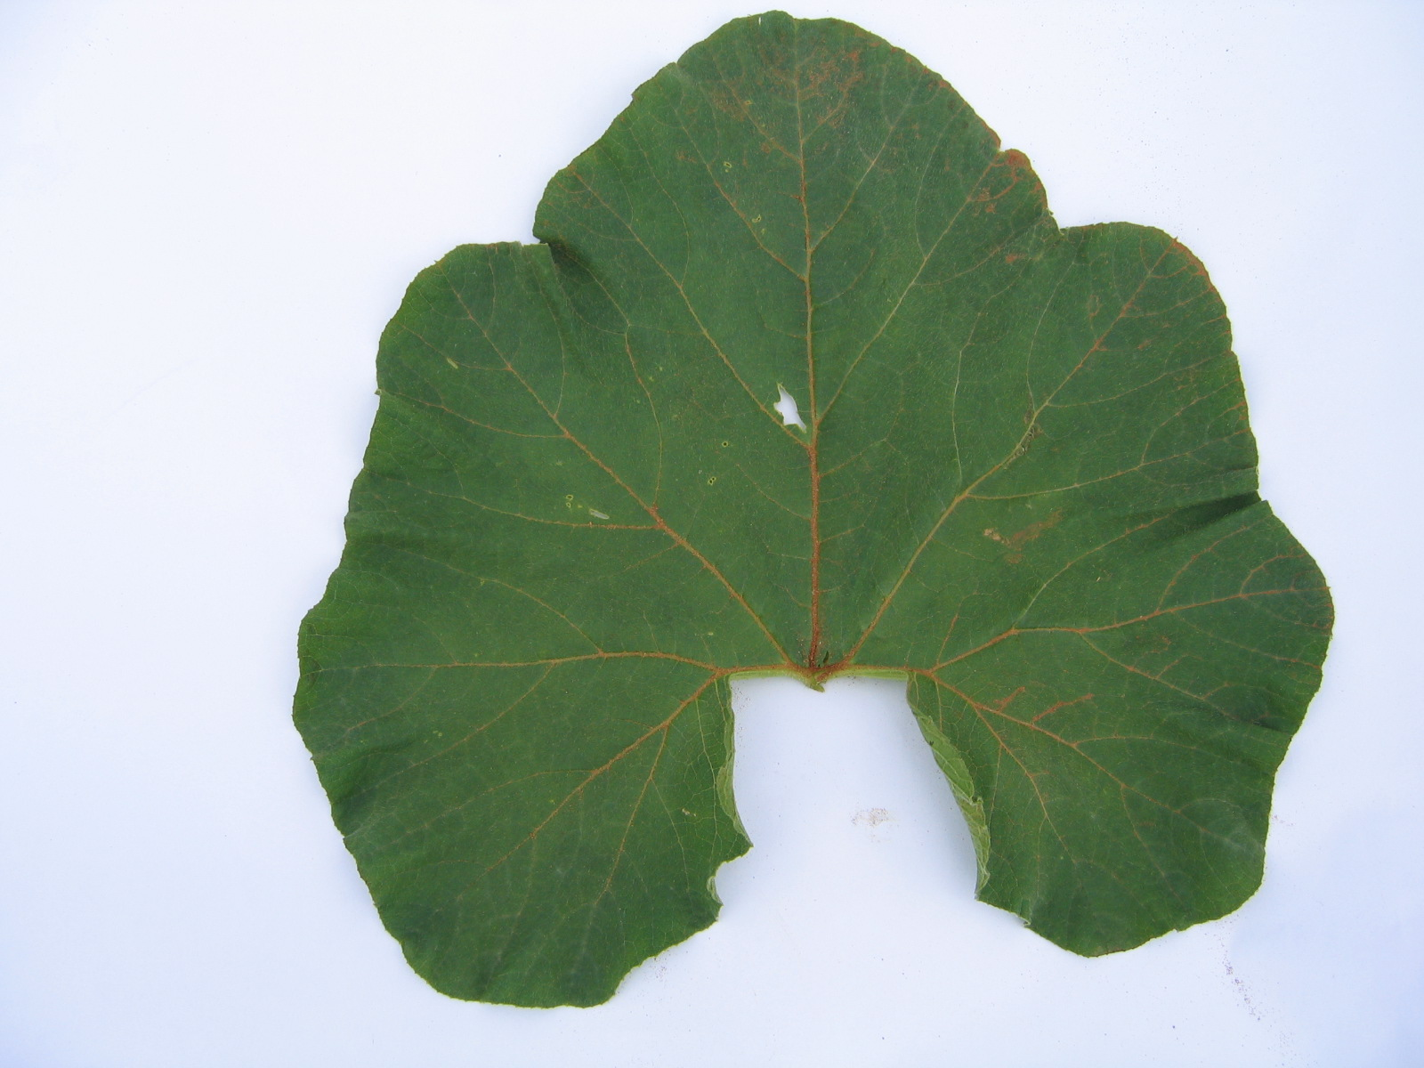 | 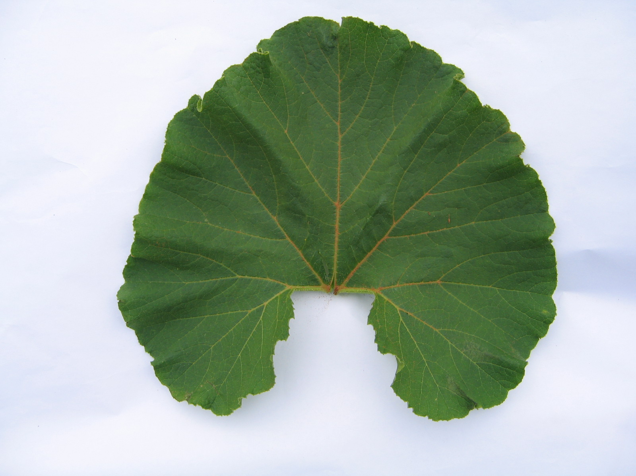 | 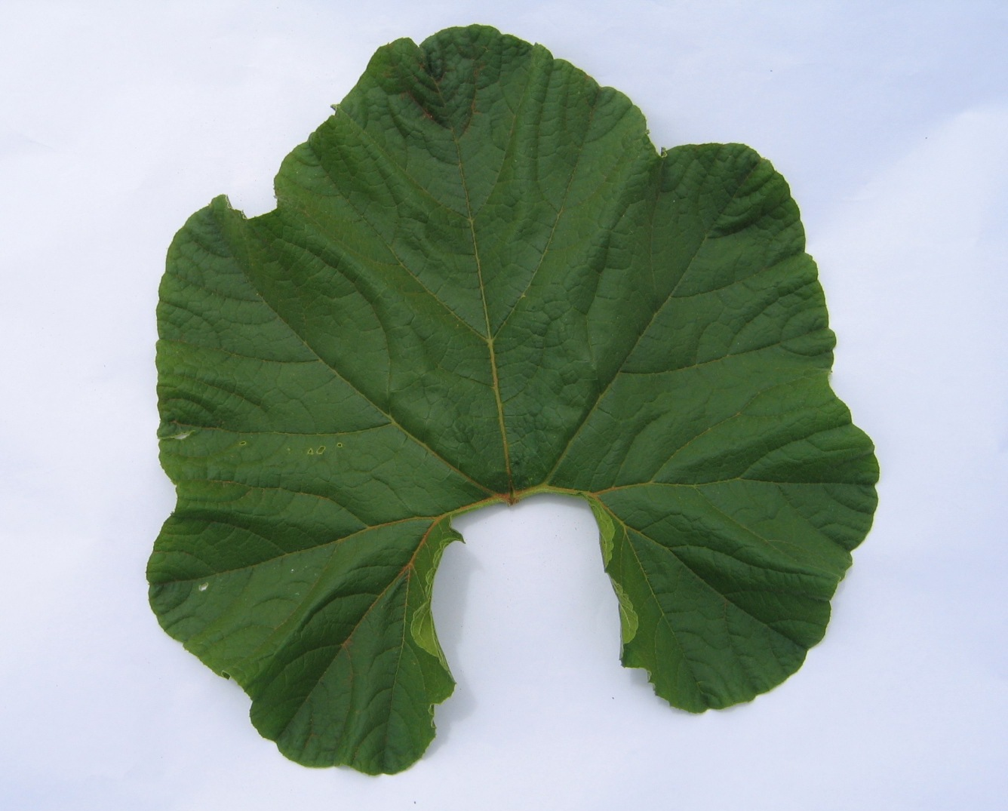
1 | 2 | 3
entire or very weakly incised | weakly incised | moderately incised

Ad. 13: Fruit: diameter

The diameter should be observed at the broadest part.

Ad. 15: Fruit: shape

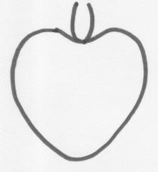 | 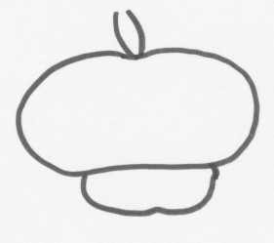 | 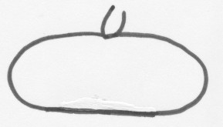 |  | 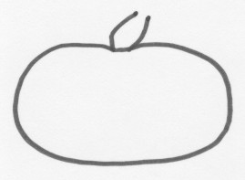
1 | 2 | 3 |  | 4
heart shaped | capped | transverse medium elliptic |  | transverse broad elliptic
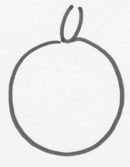 | 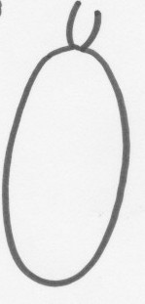 | 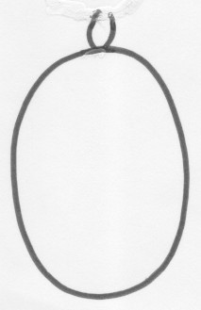 |  | 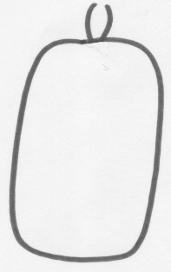
5 | 6 | 7 |  | 8
circular | narrow elliptic | medium elliptic |  | rectangular
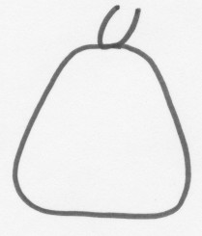 | 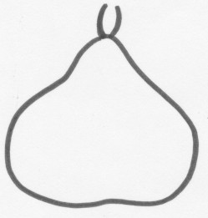 | 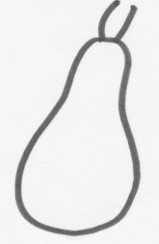
9 | 10 | 11
trapezoid | broad pear shaped | narrow pear shaped
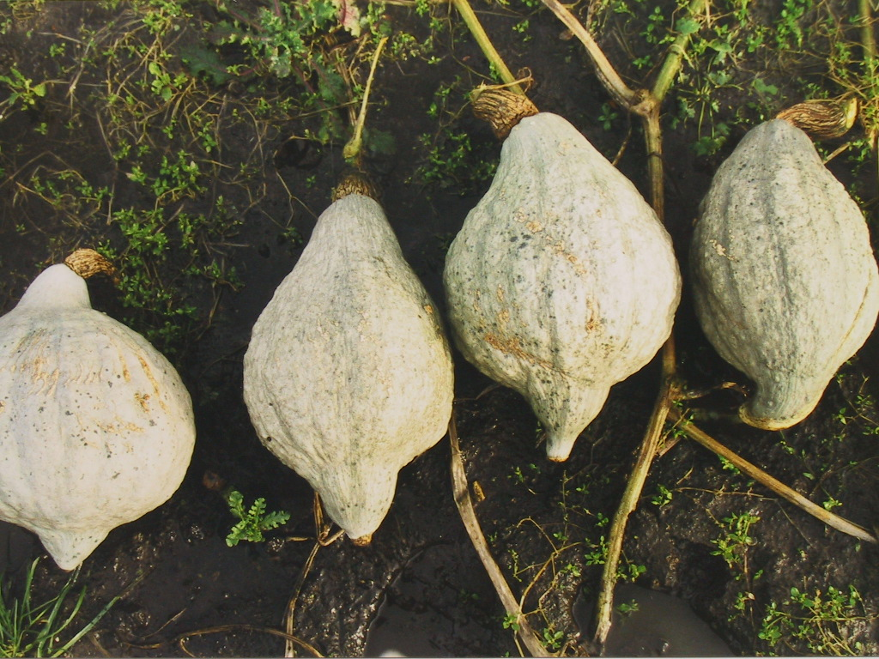 |  |  | 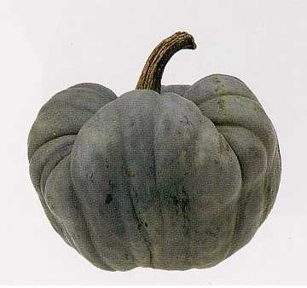
12 |  |  | 13
Hubbard type |  |  | tri-lobed

Ad. 17: Fruit: profile at stem end

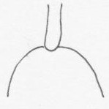 | 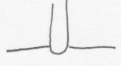 |  | 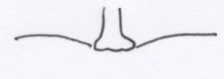
1 | 2 |  | 3
raised | flat |  | slightly depressed
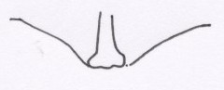 |  | 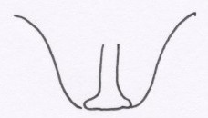
4 |  | 5
moderately depressed |  | strongly depressed

Ad. 18: Fruit: profile of blossom end (flower scar included)

 | 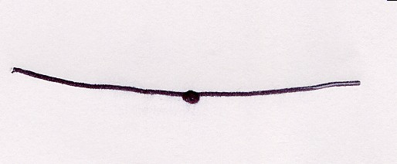 | 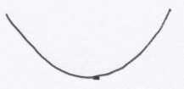
1 | 2 | 3
depressed | flat | raised

Ad. 23: Fruit: main color of skin
Ad. 24: Fruit: intensity of main color of skin (except for white and cream main color of skin)
Ad. 25: Only varieties with two or more color hues: Fruit: secondary color of skin
Ad. 26: Only varieties with two or more color hues: Fruit: intensity of secondary color of skin
Ad. 27: Only varieties with two or more color hues or intensities: Fruit: distribution of secondary color of skin

The main color is the color with the largest area over the whole fruit excluding the scar area. The secondary color is the color with the second largest area over the whole fruit excluding the scar area.

Ad. 29: Fruit: cork formation

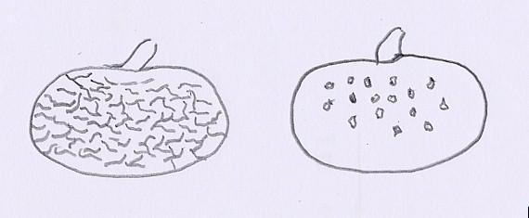
2 | 3
in dots | netted

8.3 Synonyms of example varieties
Example variety | Synonyms
Platt White Boer | Plat White Boer, Platt Wit Boer,  Blanche Platt White Boer, Flat White Boer

Literature
Chaux, C., Foury, C., 1994: Productions légumières – Tome 3 Légumineuses Potagères Légumes fruits. Lavoisier TEC & DOC, Paris, FR, pp. 361 - 384.

Prades, J. B., Prades, N., Renaud, V., 1995: Le grand livre des Courges. Rustica Edition. Paris, FR, 183 pp.

Brancucci, M., Bänziger, E., Das grosse Buch vom Kürbis. Midena & FONA Verlag GmbH, Aarau/Küttigen, Oldenburg, D, 173 pp.

Higgins, J., 1980: Species Identification of some Curcurbita Cultivars, J. Natn. Inst. Agric. Bot., 15, 281-287.

Tapley, William T., Enzie, Walter D., Van Eseltine, Glen P., 1937: The Vegetables of New York, Vol. 1, Part IV The Cucurbits, Albany, New York.

Whitaker, T.W., Bohn, G.W., 1950: The Taxonomy, Genetics, Production and Uses of the Cultivated Species of Curcurbita, Econ. Bot., 4, 52-81.

Whitaker, T.W., Davis, G.N., 1962: Curcurbits, Botany, Cultivation and Utilization, World Crop Books, London, New York.

Technical Questionnaire
TECHNICAL QUESTIONNAIRE |  |  |  |  | Page {x} of {y} |  | Reference Number:
 |  |  |  |  |  |  | Application date:
 |  |  |  |  |  |  | (not to be filled in by the applicant)
TECHNICAL QUESTIONNAIRE
to be completed in connection with an application for plant breeders’ rights

1. Subject of the Technical Questionnaire
1.1 Botanical name |  |  |  | Cucurbita maxima Duch.
1.2 Common name |  |  |  | Pumpkin
The applicant should check that the variety is of Cucurbita maxima Duch. and not another species of Cucurbita.
2. Applicant
Name
Address
Telephone No.
Fax No.
E-mail address
Breeder (if different
from applicant)
3. Proposed denomination and breeder’s reference
Proposed denomination
(if available)
Breeder’s reference
#4. Information on the breeding scheme and propagation of the variety

4.1 Breeding scheme

Variety resulting from:

4.1.1 Crossing

(a) controlled cross [ ]
(please state parent varieties)

(b) partially known cross [ ]
(please state known parent variety(ies))

(c) unknown cross [ ]

4.1.2 Mutation [ ]
(please state parent variety)

4.1.3 Discovery and development [ ]
(please state where and when discovered and how developed)

4.1.4 Other [ ]
(please provide details)

4.2 Method of propagating the variety

4.2.1 Seed-propagated varieties

(a) Cross-pollination [ ]

(b) Hybrid [ ]

(c) Other [ ]
(please provide details)

5. Characteristics of the variety to be indicated (the number in brackets refers to the corresponding characteristic in Test Guidelines; please mark the note which best corresponds).

 | Characteristics |  |  |  |  |  |  | Example Varieties |  | Note
5.1  (2) | Plant: length of main stem
 | very short |  |  |  |  |  |  | Golden Nugget |  | 1[…]
 | short |  |  |  |  |  |  | Sweet Mama |  | 3[…]
 | medium |  |  |  |  |  |  |  |  | 5[…]
 | long |  |  |  |  |  |  | Jaune Gros de Paris |  | 7[…]
 | very long |  |  |  |  |  |  | Green Hubbard |  | 9[…]
5.2  (12) | Fruit: length
 | very short |  |  |  |  |  |  | Golden Nugget |  | 1[…]
 | short |  |  |  |  |  |  | Uchiki Kuri |  | 3[…]
 | medium |  |  |  |  |  |  | Golden Hubbard |  | 5[…]
 | long |  |  |  |  |  |  | Big Moon |  | 7[…]
 | very long |  |  |  |  |  |  | Banana Pink Jumbo |  | 9[…]
5.3  (13) | Fruit: diameter
 | small |  |  |  |  |  |  | Uchiki Kuri |  | 3[…]
 | medium |  |  |  |  |  |  |  |  | 5[…]
 | large |  |  |  |  |  |  | Big Max, Rouge vif d’Etampes |  | 7[…]
 | very large |  |  |  |  |  |  | Prizewinner |  | 9[…]
 | Characteristics |  |  |  |  |  |  | Example Varieties |  | Note
5.4  (15) | Fruit: shape
 | heart shaped |  |  |  |  |  |  | Golden Delicious |  | 1[…]
 | capped |  |  |  |  |  |  | Giraumon Turban, Turks Turban |  | 2[…]
 | transverse medium elliptic |  |  |  |  |  |  | Sweet Mama |  | 3[…]
 | transverse broad elliptic |  |  |  |  |  |  | Jaune Gros de Paris, Mammouth |  | 4[…]
 | circular |  |  |  |  |  |  | Big Mama |  | 5[…]
 | narrow elliptic |  |  |  |  |  |  | Banana |  | 6[…]
 | medium elliptic |  |  |  |  |  |  | Banana Pink Jumbo |  | 7[…]
 | rectangular |  |  |  |  |  |  |  |  | 8[…]
 | trapezoid |  |  |  |  |  |  |  |  | 9[…]
 | broad pear shaped |  |  |  |  |  |  | Doux d’Okkaïdo, Green Baby |  | 10[…]
 | narrow pear shaped |  |  |  |  |  |  |  |  | 11[…]
 | Hubbard type |  |  |  |  |  |  | Golden Hubbard,  New England Blue Hubbard |  | 12[…]
 | tri-lobed |  |  |  |  |  |  | Tristar |  | 13[…]
5.5  (19) | Fruit: grooves
 | absent |  |  |  |  |  |  | Pacifica |  | 1[…]
 | present |  |  |  |  |  |  | Marlborough Grey |  | 9[…]
5.6  (22) | Fruit: number of colors of skin
 | one |  |  |  |  |  |  | Gladiator |  | 1[…]
 | two color intensities (with clear borders) |  |  |  |  |  |  | Giraumon Turban |  | 2[…]
 | two color hues |  |  |  |  |  |  | Delica |  | 3[…]
 | more than two color hues or intensities (with clear borders) |  |  |  |  |  |  | Turks Turban |  | 4[…]
 | Characteristics |  |  |  |  |  |  | Example Varieties |  | Note
5.7  (23) | Fruit: main color of skin
 | white |  |  |  |  |  |  | Valenciano |  | 1[…]
 | cream |  |  |  |  |  |  |  |  | 2[…]
 | yellow |  |  |  |  |  |  | Jaune Gros de Paris |  | 3[…]
 | orange |  |  |  |  |  |  | Regal Early |  | 4[…]
 | red |  |  |  |  |  |  | Rouge vif d’Etampes |  | 5[…]
 | pink |  |  |  |  |  |  | Giraumon Turban |  | 6[…]
 | green |  |  |  |  |  |  | Delica, Pacifica |  | 7[…]
 | grey green |  |  |  |  |  |  | Japan Cup, Star 7024 |  | 8[…]
 | grey |  |  |  |  |  |  | Baby Blue, Early Jarrah Grey, Hubbard Blue |  | 9[…]
6. Similar varieties and differences from these varieties
Please use the following table and box for comments to provide information on how your candidate variety differs from the variety (or varieties) which, to the best of your knowledge, is (or are) most similar. This information may help the examination authority to conduct its examination of distinctness in a more efficient way.

Denomination(s) of variety(ies) similar to your candidate variety |  | Characteristic(s) in which your candidate variety differs from the similar variety(ies) |  |  |  | Describe the expression of the characteristic(s) for the similar variety(ies) |  |  | Describe the expression of the characteristic(s) for your candidate variety
Example |  | Fruit: main color of skin |  |  |  | yellow |  |  | orange
Comments:

#7. Additional information which may help in the examination of the variety

7.1 In addition to the information provided in sections 5 and 6, are there any additional characteristics which may help to distinguish the variety?

Yes [ ] No [ ]

(If yes, please provide details)

7.2 Are there any special conditions for growing the variety or conducting the examination?

Yes [ ] No [ ]

(If yes, please provide details)

7.3 Other information

A representative color photograph of the fruit of the variety should accompany the Technical Questionnaire.

8. Authorization for release

(a) Does the variety require prior authorization for release under legislation concerning the protection of the environment, human and animal health?

Yes [ ] No [ ]

(b) Has such authorization been obtained?

Yes [ ] No [ ]

If the answer to (b) is yes, please attach a copy of the authorization.

9. Information on plant material to be examined or submitted for examination.

9.1 The expression of a characteristic or several characteristics of a variety may be affected by factors, such as pests and disease, chemical treatment (e.g. growth retardants or pesticides), effects of tissue culture, different rootstocks, scions taken from different growth phases of a tree, etc.

9.2 The plant material should not have undergone any treatment which would affect the expression of the characteristics of the variety, unless the competent authorities allow or request such treatment. If the plant material has undergone such treatment, full details of the treatment must be given. In this respect, please indicate below, to the best of your knowledge, if the plant material to be examined has been subjected to:

(a) Microorganisms (e.g. virus, bacteria, phytoplasma) Yes [ ] No [ ]

(b) Chemical treatment (e.g. growth retardant, pesticide) Yes [ ] No [ ]

(c) Tissue culture Yes [ ] No [ ]

(d) Other factors Yes [ ] No [ ]

Please provide details for where you have indicated “yes”.

……………………………………………………………

10. I hereby declare that, to the best of my knowledge, the information provided in this form is correct:

Applicant’s name

Signature Date

[End of document]

* These names were correct at the time of the introduction of these Test Guidelines but may be revised or updated. [Readers are advised to consult the UPOV Code, which can be found on the UPOV Website (www.upov.int), for the latest information.]
# Authorities may allow certain of this information to be provided in a confidential section of the Technical Questionnaire.
# Authorities may allow certain of this information to be provided in a confidential section of the Technical Questionnaire.

