 |  | E  TG/140/4 Corr.  ORIGINAL: English  DATE: 2007-03-28
INTERNATIONAL UNION FOR THE PROTECTION OF NEW VARIETIES OF PLANTS
GENEVA

 | POT AZALEA  UPOV Code: RHODD_SIM  (Rhododendron simsii Planch.) | *

GUIDELINES

FOR THE CONDUCT OF TESTS

FOR DISTINCTNESS, UNIFORMITY AND STABILITY

Alternative Names:*

Botanical name | English | French | German | Spanish
Rhododendron simsii Planch. | Pot Azalea | Azalée en pot | Topfazalee | Azalea de maceta

The purpose of these guidelines (“Test Guidelines”) is to elaborate the principles contained in the General Introduction (document TG/1/3), and its associated TGP documents, into detailed practical guidance for the harmonized examination of distinctness, uniformity and stability (DUS) and, in particular, to identify appropriate characteristics for the examination of DUS and production of harmonized variety descriptions.

ASSOCIATED DOCUMENTS

These Test Guidelines should be read in conjunction with the General Introduction and its associated TGP documents.

Other associated UPOV documents
TG/42: Rhododendron L. / Rhododendron / Rododendro
TABLE OF CONTENTS PAGE

1. Subject of these Test Guidelines 3
2. Material Required 3
3. Method of Examination 3
3.1 Number of Growing Cycles 3
3.2 Testing Place 3
3.3 Conditions for Conducting the Examination 3
3.4 Test Design 4
3.5 Number of Plants / Parts of Plants to be Examined 4
3.6 Additional Tests 4
4. Assessment of Distinctness, Uniformity and Stability 4
4.1 Distinctness 4
4.2 Uniformity 4
4.3 Stability 5
5. Grouping of Varieties and Organization of the Growing Trial 5
6. Introduction to the Table of Characteristics 6
6.1 Categories of Characteristics 6
6.2 States of Expression and Corresponding Notes 6
6.3 Types of Expression 6
6.4 Example Varieties 6
6.5 Legend 6
7. Table of Characteristics/Tableau des caractères/Merkmalstabelle/Tabla de caracteres 7
8. Explanations on the Table of Characteristics 14
8.1 Explanations covering several characteristics 14
8.2 Explanations for individual characteristics 14
9. Literature 16
10. Technical Questionnaire 17

Subject of these Test Guidelines
These Test Guidelines apply to all varieties of Rhododendron simsii Planch. which are normally grown as pot plants, as well as to hybrids between that species and other species of Rhododendron L.

Material Required
2.1 The competent authorities decide on the quantity and quality of the plant material required for testing the variety and when and where it is to be delivered. Applicants submitting material from a State other than that in which the testing takes place must ensure that all customs formalities and phytosanitary requirements are complied with.

2.2 The material is to be supplied in the form of potted plants, pinched twice.

2.3 The minimum quantity of plant material, to be supplied by the applicant, should be:

10 plants.

2.4 The plant material supplied should be visibly healthy, not lacking in vigor, nor affected by any important pest or disease.

2.5 The plant material should not have undergone any treatment which would affect the expression of the characteristics of the variety, unless the competent authorities allow or request such treatment. If it has been treated, full details of the treatment must be given.

Method of Examination

3.1 Number of Growing Cycles
The minimum duration of tests should normally be a single growing cycle.

3.2 Testing Place
Tests are normally conducted at one place. In the case of tests conducted at more than one place, guidance is provided in TGP/9 “Examining Distinctness”.

3.3 Conditions for Conducting the Examination
3.3.1 The tests should be carried out under conditions ensuring satisfactory growth for the expression of the relevant characteristics of the variety and for the conduct of the examination.

3.3.2 Because daylight varies, color determinations made against a color chart should be made either in a suitable cabinet providing artificial daylight or in the middle of the day in a room without direct sunlight. The spectral distribution of the illuminant for artificial daylight should conform with the CIE Standard of Preferred Daylight D 6500 and should fall within the tolerances set out in the British Standard 950, Part I. These determinations should be made with the plant part placed against a white background.

3.4 Test Design
3.4.1 Each test should be designed to result in a total of at least 10 plants.

3.4.2 The design of the tests should be such that plants or parts of plants may be removed for measurement or counting without prejudice to the observations which must be made up to the end of the growing cycle.

3.5 Number of Plants / Parts of Plants to be Examined
Unless otherwise indicated, all observations should be made on 10 plants or parts taken from each of 10 plants.

3.6 Additional Tests
Additional tests, for examining relevant characteristics, may be established.

Assessment of Distinctness, Uniformity and Stability

4.1 Distinctness
4.1.1 General Recommendations

It is of particular importance for users of these Test Guidelines to consult the General Introduction prior to making decisions regarding distinctness. However, the following points are provided for elaboration or emphasis in these Test Guidelines.

4.1.2 Consistent Differences

The differences observed between varieties may be so clear that more than one growing cycle is not necessary. In addition, in some circumstances, the influence of the environment is not such that more than a single growing cycle is required to provide assurance that the differences observed between varieties are sufficiently consistent. One means of ensuring that a difference in a characteristic, observed in a growing trial, is sufficiently consistent is to examine the characteristic in at least two independent growing cycles.

4.1.3 Clear Differences

Determining whether a difference between two varieties is clear depends on many factors, and should consider, in particular, the type of expression of the characteristic being examined, i.e. whether it is expressed in a qualitative, quantitative, or pseudo-qualitative manner. Therefore, it is important that users of these Test Guidelines are familiar with the recommendations contained in the General Introduction prior to making decisions regarding distinctness.

4.2 Uniformity
4.2.1 It is of particular importance for users of these Test Guidelines to consult the General Introduction prior to making decisions regarding uniformity. However, the following points are provided for elaboration or emphasis in these Test Guidelines.
4.2.2 For the assessment of uniformity a population standard of 2% and an acceptance probability of at least 95% should be applied. In the case of a sample size of 10 plants, 1 off-type is allowed.

4.3 Stability
4.3.1 In practice, it is not usual to perform tests of stability that produce results as certain as those of the testing of distinctness and uniformity. However, experience has demonstrated that, for many types of variety, when a variety has been shown to be uniform, it can also be considered to be stable.

4.3.2 Where appropriate, or in cases of doubt, stability may be tested, either by growing a further generation, or by testing a new plant stock to ensure that it exhibits the same characteristics as those shown by the previous material supplied.

Grouping of Varieties and Organization of the Growing Trial
5.1 The selection of varieties of common knowledge to be grown in the trial with the candidate varieties and the way in which these varieties are divided into groups to facilitate the assessment of distinctness are aided by the use of grouping characteristics.

5.2 Grouping characteristics are those in which the documented states of expression, even where produced at different locations, can be used, either individually or in combination with other such characteristics: (a) to select varieties of common knowledge that can be excluded from the growing trial used for examination of distinctness; and (b) to organize the growing trial so that similar varieties are grouped together.

5.3 The following have been agreed as useful grouping characteristics:

(a) Flower: type (characteristic 13)
(b) Corolla lobe: number of colors of inner side (markings excluded) (characteristic 16)
(c) Corolla lobe: color of middle of inner side (characteristic 18) with the following groups:
Gr. 1: white
Gr. 2: light pink
Gr. 3: medium pink
Gr. 4: dark pink
Gr. 5: orange red
Gr. 6: light red
Gr. 7: medium red
Gr. 8: purple
Gr. 9: violet

  - Guidance for the use of grouping characteristics, in the process of examining distinctness, is provided through the General Introduction.

Introduction to the Table of Characteristics

6.1 Categories of Characteristics
6.1.1 Standard Test Guidelines Characteristics

Standard Test Guidelines characteristics are those which are approved by UPOV for examination of DUS and from which members of the Union can select those suitable for their particular circumstances.

6.1.2 Asterisked Characteristics

Asterisked characteristics (denoted by *) are those included in the Test Guidelines which are important for the international harmonization of variety descriptions and should always be examined for DUS and included in the variety description by all members of the Union, except when the state of expression of a preceding characteristic or regional environmental conditions render this inappropriate.

6.2 States of Expression and Corresponding Notes
States of expression are given for each characteristic to define the characteristic and to harmonize descriptions. Each state of expression is allocated a corresponding numerical note for ease of recording of data and for the production and exchange of the description.

6.3 Types of Expression
An explanation of the types of expression of characteristics (qualitative, quantitative and pseudo-qualitative) is provided in the General Introduction.

6.4 Example Varieties
Where appropriate, example varieties are provided to clarify the states of expression of each characteristic.

6.5 Legend
(*) Asterisked characteristic – see Chapter 6.1.2

QL Qualitative characteristic – see Chapter 6.3
QN Quantitative characteristic – see Chapter 6.3
PQ Pseudo-Qualitative characteristic – see Chapter 6.3

(a)-(c) See Explanations on the Table of Characteristics in Chapter 8.1.
(+) See Explanations on the Table of Characteristics in Chapter 8.2.

Table of Characteristics/Tableau des caractères/Merkmalstabelle/Tabla de caracteres
 |  | English | français | Deutsch | español | Example Varieties/  Exemples/  Beispielssorten/  Variedades ejemplo | Note/  Nota
1. |  | Plant: growth habit | Plante : port | Pflanze: Wuchsform | Planta: porte
PQ |  | upright | dressé | aufrecht | erecto | Kirin, Rokoko | 1
 |  | broad bushy | buissonnant large | breit buschig | arbustivo ancho | Party Favour, Sayonara | 2
 |  | flat bushy | buissonnant plat | flach buschig | arbustivo plano | Coco, Taggi | 3
2.  (+) |  | Young leaf: color of upper side | Jeune feuille: couleur de la face supérieure | Junges Blatt: Farbe der Oberseite | Hoja joven: color del haz
PQ |  | yellow green | vert jaunâtre | gelbgrün | verde amarillento |  | 1
 |  | light green | vert clair | hellgrün | verde claro | Bertina | 2
 |  | medium green | vert moyen | mittelgrün | verde medio | Friedhelm Scherrer | 3
 |  | dark green | vert foncé | dunkelgrün | verde oscuro | Ostali, Rena | 4
 |  | red green | vert rougeâtre | rotgrün | verde rojizo |  | 5
 |  | blue green | vert bleuâtre | blaugrün | verde azulado |  | 6
3.  (*) |  | Mature leaf: length (including petiole) | Feuille adulte: longueur (y compris le pétiole) | Ausgewachsenes Blatt: Länge (einschließlich Stiel) | Hoja adulta: longitud (incluido el pecíolo)
QN | (a) | short | courte | kurz | corta | Ostali, Rosa Perle | 3
 |  | medium | moyenne | mittel | media | Super Sachsenstern | 5
 |  | long | longue | lang | larga | Aline, Poetry | 7
4.  (*) |  | Mature leaf: width | Feuille adulte: largeur | Ausgewachsenes Blatt: Breite | Hoja adulta: anchura
QN | (a) | narrow | étroite | schmal | estrecha | Barbara, Rosa Perle | 3
 |  | medium | moyenne | mittel | media | Desta 302 | 5
 |  | broad | large | breit | ancha | Coco, Luci | 7
5.  (*)  (+) |  | Mature leaf: shape | Feuille adulte: forme | Ausgewachsenes Blatt: Form | Hoja adulta: forma
PQ | (a) | elliptic | elliptique | elliptisch | elíptica | Poetry | 1
 |  | elliptic to obovate | elliptique à obovale | elliptisch bis verkehrt eiförmig | entre elíptica y oboval | Classic Rouge | 2
 |  | obovate | obovale | verkehrt eiförmig | oboval | Friedhelm Scherrer | 3
6.  (*) |  | Mature leaf: color of upper side | Feuille adulte: couleur de la face supérieure | Ausgewachsenes Blatt: Farbe der Oberseite | Hoja adulta: color del haz
PQ | (a) | light green | vert clair | hellgrün | verde claro | Kirin, St. Valentin | 1
 |  | medium green | vert moyen | mittelgrün | verde medio | Bertina, Rosa Perle | 2
 |  | dark green | vert foncé | dunkelgrün | verde oscuro | Désirée, Neapolis | 3
 |  | reddish green | vert rougeâtre | rötlichgrün | verde rojizo |  | 4
 |  | blue green | vert bleu | blaugrün | verde azulado | Birka, Ostalett | 5
7.  (*) |  | Mature leaf: color of lower side | Feuille adulte: couleur de la face inférieure | Ausgewachsenes Blatt: Farbe der Unterseite | Hoja adulta: color del envés
PQ | (a) | light green | vert clair | hellgrün | verde claro | Timo | 1
 |  | medium green | vert moyen | mittelgrün | verde medio | Coco, Luci | 2
 |  | dark green | vert foncé | dunkelgrün | verde oscuro | Ostaro | 3
 |  | blue green | vert bleu | blaugrün | verde azulado |  | 4
8. |  | Mature leaf: hairiness of upper side | Feuille adulte : pilosité de la face supérieure | Ausgewachsenes Blatt: Behaarung der Oberseite | Hoja adulta: vellosidad del haz
QN | (a) | absent or very weak | absente ou très faible | fehlend oder sehr gering | ausente o muy débil |  | 1
 |  | medium | moyenne | mittel | media |  | 3
 |  | strong | forte | stark | fuerte |  | 5
9.  (*) |  | Inflorescence: number of flowers | Inflorescence: nombre de fleurs | Blütenstand: Anzahl der Blüten | Inflorescencia: número de flores
QN |  | few | faible | gering | bajo | Ballerina, Tapestry | 3
 |  | medium | moyen | mittel | medio | Friedhelm Scherrer | 5
 |  | many | élevé | groß | alto | Anastasia | 7
10. |  | Pedicel: length | Pédicelle: longueur | Blütenstiel: Länge | Pedicelo: longitud
QN |  | short | court | kurz | corta | Promise | 3
 |  | medium | moyen | mittel | media | Désirée,  Friedhelm Scherrer | 5
 |  | long | long | lang | larga | Luci | 7
11.  (*) |  | Calyx: presence | Calice: présence | Kelch: Vorhandensein | Cáliz: presencia
QL |  | absent | absent | fehlend | ausente | Timeless, Violajana | 1
 |  | present | présent | vorhanden | presente | Anne,  Friedhelm Scherrer | 9
12.  (*) |  | Flower: diameter | Fleur: diamètre | Blüte: Durchmesser | Flor: diámetro
QN | (b) | small | petit | klein | pequeño | Neapolis, Rosa Perle | 3
 |  | medium | moyen | mittel | mediano | Friedhelm Scherrer, Sansibar | 5
 |  | large | grand | groß | grande | Knut Erwen, Spreeperle | 7
13.  (*)  (+) |  | Flower: type | Fleur: type | Blüte: Typ | Flor: tipo
QN | (b) | single | simple | einfach | simple | Ostali, Polarstern | 1
 |  | semi-double | semi double | halbgefüllt | semidoble | Judith, Luci | 2
 |  | double | double | gefüllt | doble | Ballerina, Ospo | 3
14.  (*)  (+) |  | Flower: shape | Fleur: forme | Blüte: Form | Flor: forma
PQ | (b) | wide funnel-shaped | en entonnoir très évasé | breite Trichterform | en forma de embudo ancho | Luci, Meggy | 1
 |  | open funnel-shaped | en entonnoir évasé | offene Trichterform | en forma de embudo abierto | Aline, Friedhelm Scherrer | 2
 |  | medium funnel-shaped | en entonnoir moyen | mittlere Trichterform | en forma de embudo medio | Maryke, Moard | 3
 |  | narrow funnel-campanulate | en entonnoir étroit et campanulée | schmale Trichter-Glockenform | embudo estrecho – acampanada | Kirin | 4
 |  | wide funnel-campanulate | en entonnoir très évasé et campanulée | breite Trichter-Glockenform | embudo ancho –acampanada | Prize | 5
 |  | medium campanulate | campanulée moyenne | mittlere Glockenform | acampanada media | Direkteur van Slyken | 6
15. |  | Flower: fragrance | Fleur: parfum | Blüte: Duft | Flor: fragancia
QN | (b) | absent or weak | absent ou faible | fehlend oder gering | ausente o débil | Miss Lulu | 1
 |  | medium | moyen | mittel | media | Cherish,  Prinses Mathilde | 2
 |  | strong | fort | stark | fuerte | Lara, Mistral | 3
16.  (*) |  | Corolla lobe: number of colors of inner side (markings excluded) | Lobe de la corolle : nombre de couleurs de la face interne (à l’exclusion des taches) | Kronzipfel: Anzahl Farben der Innenseite (ohne Zeichnung) | Lóbulo de la corola: número de colores de la cara interna (sin marcas)
QL | (c) | one | une | eine | uno |  | 1
 |  | two | deux | zwei | dos |  | 2
17.  (*) |  | Corolla lobe: color of margin of inner side | Lobe de la corolle: couleur du bord de la face interne | Kronzipfel: Farbe des Randes der Innenseite | Lóbulo de la corola: color del borde de la cara interna
PQ | (c) | RHS Colour Chart (indicate reference number) | RHS Colour Chart (indiquer le numéro de référence) | RHS-Farbkarte (Nummer angeben) | Carta de colores RHS (indíquese el número de referencia)
18.  (*) |  | Corolla lobe: color of middle of inner side | Lobe de la corolle: couleur de la partie moyenne de la face interne | Kronzipfel: Farbe der Mitte der Innenseite | Lóbulo de la corola: color del centro de la cara interna
PQ | (c) | RHS Colour Chart (indicate reference number) | RHS Colour Chart (indiquer le numéro de référence) | RHS-Farbkarte (Nummer angeben) | Carta de colores RHS (indíquese el número de referencia)
19. |  | Corolla lobe: color of margin of outer side | Lobe de la corolle: couleur du bord de la face externe | Kronzipfel: Farbe des Randes der Außenseite | Lóbulo de la corola: color del borde de la cara externa
PQ | (c) | RHS Colour Chart (indicate reference number) | RHS Colour Chart (indiquer le numéro de référence) | RHS-Farbkarte (Nummer angeben) | Carta de colores RHS (indíquese el número de referencia)
20. |  | Corolla lobe: color of middle of outer side | Lobe de la corolle: couleur de la partie moyenne de la face externe | Kronzipfel: Farbe der Mitte der Außenseite | Lóbulo de la corola: color del centro de la cara externa
PQ | (c) | RHS Colour Chart (indicate reference number) | RHS Colour Chart (indiquer le numéro de référence) | RHS-Farbkarte (Nummer angeben) | Carta de colores RHS (indíquese el número de referencia)
21.  (*) |  | Corolla lobe: undulation of margin | Lobe de la corolle: ondulation du bord | Kronzipfel: Randwellung | Lóbulo de la corola: ondulación del borde
QN | (c) | absent or very weak | nulle ou très faible | fehlend oder sehr gering | ausente o muy débil | Désirée, Jory | 1
 |  | weak | faible | gering | débil | Dinos, Luci | 3
 |  | medium | moyenne | mittel | media | Schneekönigin, Sylt | 5
 |  | strong | forte | stark | fuerte | Eleonore, Sister Jo | 7
 |  | very strong | très forte | sehr stark | muy fuerte | Meggy | 9
22.  (*) |  | Flower throat: conspicuousness of markings | Gorge de la fleur: netteté des taches | Blütenschlund: Ausprägung der Zeichnung | Garganta de la flor: presencia de marcas
QN |  | absent or very weak | nulle ou très faibles | fehlend oder sehr gering | ausente o muy baja | Charly, Georgentor, Janique | 1
 |  | weak | faibles | gering | baja | Otto, Paul Schultz | 3
 |  | medium | moyennes | mittel | media | Friedhelm Scherrer, Jura | 5
 |  | strong | fortes | stark | alta | Kassandra, Ostali | 7
 |  | very strong | très fortes | sehr stark | muy alta | Gloria, Kolibri | 9
23.  (*)  (+) |  | Flower throat: type of markings | George de la fleur: type de taches | Blütenschlund: Art der Zeichnung | Garganta de la flor: tipo de marcas
PQ |  | spots not touching each other | ponctuations ne se touchant pas l'une l'autre | Punkte nicht ineinander fließend | lunares que no están  en contacto entre sí | Anna Luka, Otto, Sayonara | 1
 |  | spots touching each other | ponctuations se touchant l'une l'autre | Punkte ineinander fließend | lunares en contacto entre sí | Friedhelm Scherrer, Ostali, Prinses Mathilde | 2
 |  | blotches surrounded by spots | taches entourées de ponctuation | Flecke umgeben von Punkten | manchas rodeadas por lunares | Rena | 3
24. |  | Flower throat: color of markings | Gorge de la fleur: couleur des taches | Blütenschlund: Farbe der Zeichnung | Garganta de la flor: color de las marcas
PQ |  | yellow green | jaune vert | gelbgrün | verde amarillento | Irish Lace | 1
 |  | red | rouge | rot | rojo | Miss Lulu | 2
 |  | brown red | brune rouge | braunrot | marrón rojizo | Anne, Royalty | 3
 |  | violet | violette | violett | violeta | Lavender Lace | 4
25.  (*) |  | Flower throat: color compared to color of middle of inner side of corolla lobe (excluding markings) | Gorge de la fleur: couleur par rapport à la couleur de la partie moyenne de la face supérieure du lobe de la corolle (sans taches) | Blütenschlund: Farbe im Vergleich zur Farbe der Mitte der Innenseite der Kronzipfel (ohne Zeichnung) | Garganta de la flor: color en relación con el color del centro de la cara interna del lóbulo de corola (sin marcas)
QN |  | lighter | plus claire | heller | más claro | Pharao, Ronja | 1
 |  | same color | de la même couleur | gleichfarbig | mismo color | Paradiso, Robijn | 2
 |  | darker | plus foncée | dunkler | más oscuro | Rika, Schumann | 3
26. |  | Anther: color | Anthère: couleur | Anthere: Farbe | Antera: color
PQ |  | yellow | jaune | gelb | amarillo | Mont Blanc, Reinhild | 1
 |  | light brown | brun clair | hellbraun | marrón claro |  | 2
 |  | dark brown | brun foncé | dunkelbraun | marrón oscuro | Miss Lulu | 3
 |  | purple | pourpre | purpurn | púrpura |  | 4
 |  | violet | violette | violett | violeta | Mont Ventoux, Ronja | 5
27.  (*)  (+) |  | Time of beginning of flowering | Époque du début de floraison | Zeitpunkt des Blühbeginns | Época de comienzo de la floración
QN |  | very early | très précoce | sehr früh | muy temprana | Helmut Vogel, Rena | 1
 |  | early | précoce | früh | temprana | Ambrosiana, Otto | 3
 |  | medium | moyenne | mittel | media | Friedhelm Scherrer, Spreeperle | 5
 |  | late | tardive | spät | tardía | Sachsenstern, Tamira | 7
 |  | very late | très tardive | sehr spät | muy tardía | van Straelen | 9

Explanations on the Table of Characteristics

8.1 Explanations covering several characteristics
The optimum stage of development for the assessment of the characteristics is when half of the flowers on each plant are fully open.

Characteristics containing the following key in the second column of the Table of Characteristics should be examined as indicated below:

- All observations on the mature leaf should be made on the second leaf below the flower bud at the time of opening of the flower bud.
- All observations on the flower should be made on a fully developed flower from a plant on which half of the flowers are fully open. The first fully developed flower should not be observed.
- All observations on the corolla lobes of varieties with semi-double or double flowers should be made on the outer whirl of the corolla lobes.

8.2 Explanations for individual characteristics
Ad. 2: Young leaf: color of upper side

Observations should be made on the fully developed leaf of the shoot grown after the last pinching.

Ad. 5: Mature leaf: shape
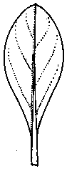
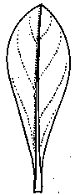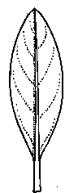
1 | 2 | 3
elliptic | elliptic to obovate | obovate

Ad. 13: Flower: type

A single flower has 5 corolla lobes only.
A semi-double flower has between 6 and 10 corolla lobes.
A double flower has more than 10 corolla lobes.

Ad. 14: Flower: shape

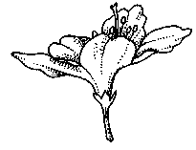 | 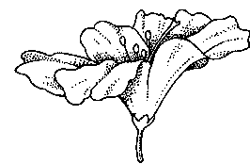 | 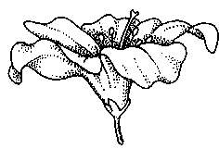
1 | 2 | 3
wide funnel-shaped | open funnel-shaped | medium funnel-shaped

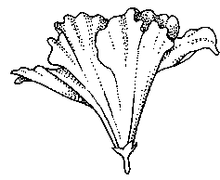 | 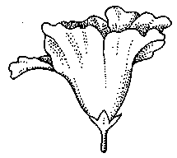 | 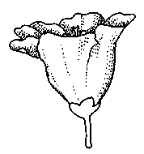
4 | 5 | 6
narrow funnel-campanulate | wide funnel-campanulate | medium campanulate

Ad. 23: Flower throat: type of markings

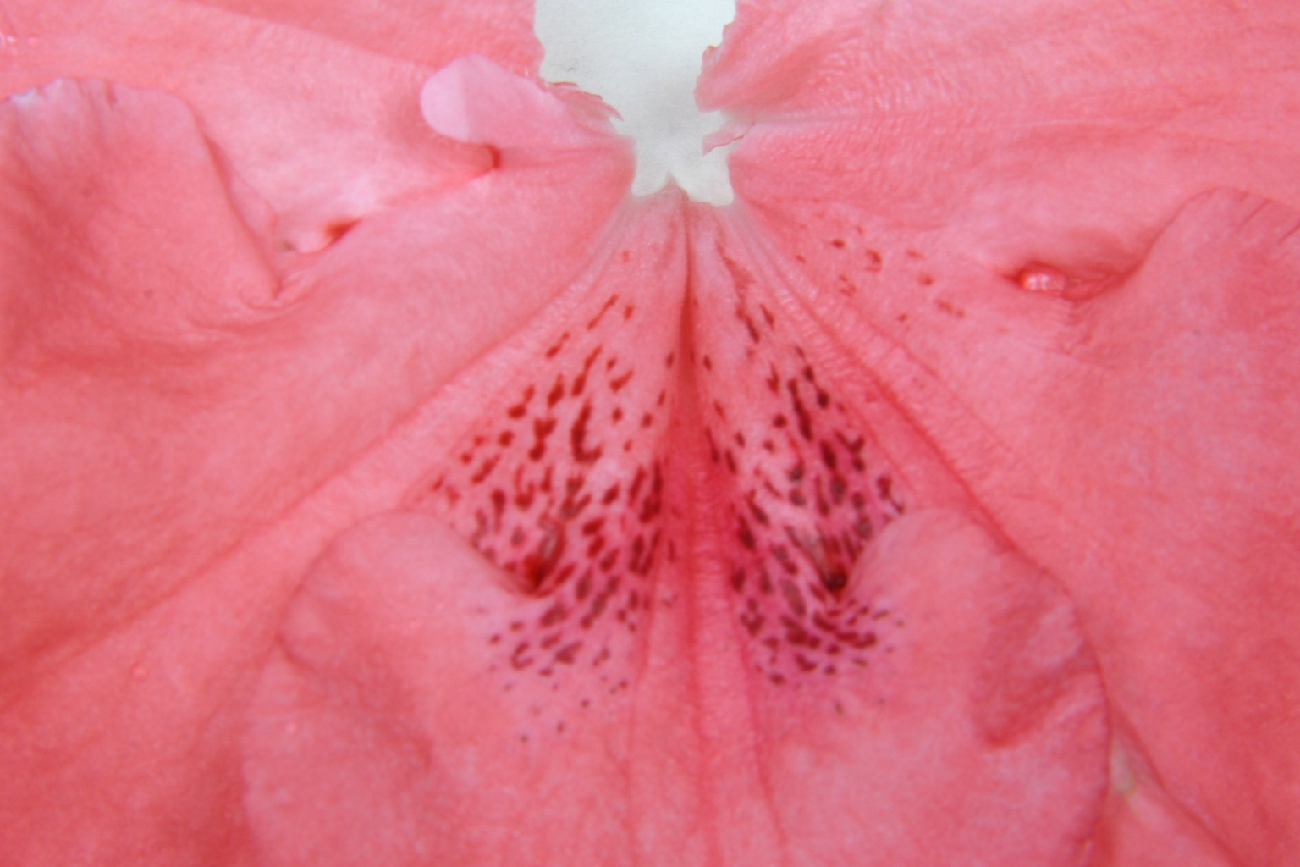
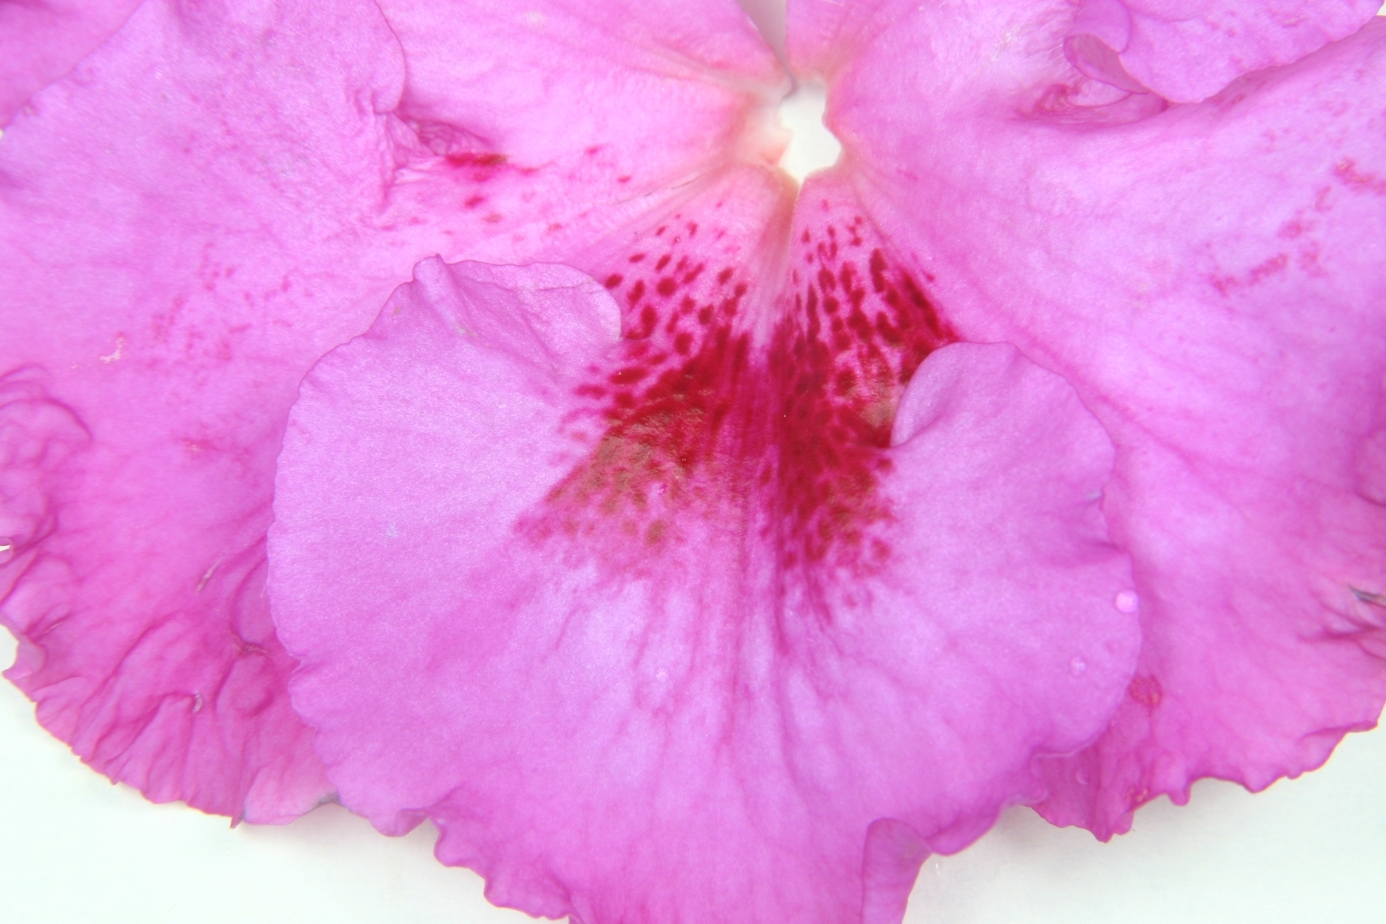
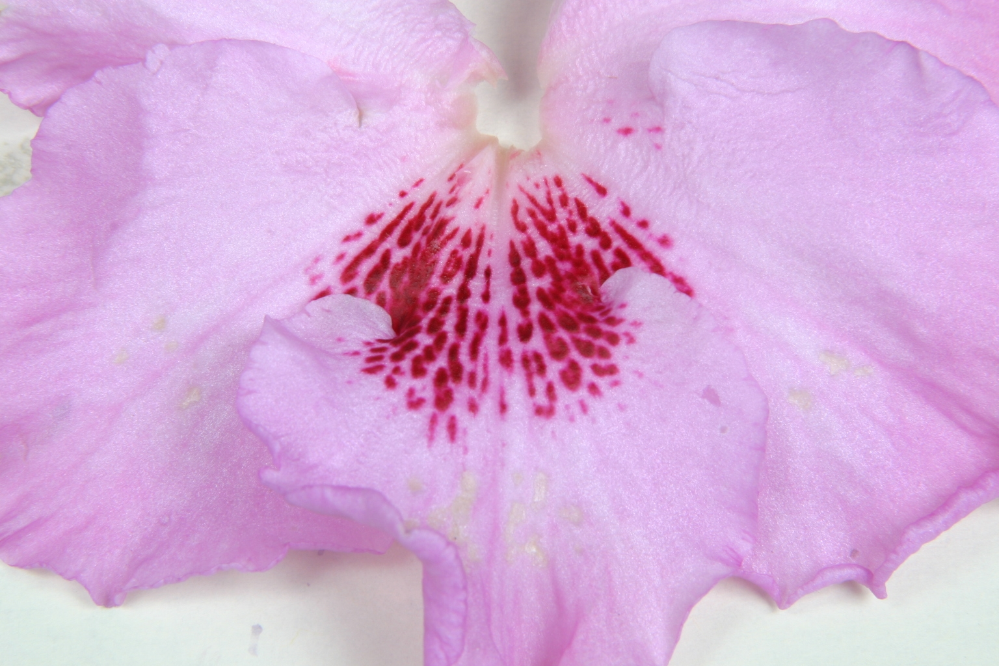

1 | 2 | 3
spots not touching each other | spots touching each other | blotches surrounded by spots

Ad. 27: Time of beginning of flowering

The time of beginning flowering is when 50% of the plants have at least one fully open flower.

Literature
Bundessortenamt, 2000: Beschreibende Sortenliste Topfazalee. 2. Auflage, Deutscher Landwirtschaftverlag, Hannover.

Struppek, G., 1983: Treibfibel, Wegweiser für die Treiberei von Topfazaleen. Lehr- und Versuchsanstalt Bad Zwischenahn.

Vogel, H., 1982: Azaleen, Eriken, Kamelien. Verlag Paul Parey, Berlin und Hamburg.

Technical Questionnaire
TECHNICAL QUESTIONNAIRE |  |  |  | Page {x} of {y} |  | Reference Number:
 |  |  |  |  |  | Application date:
 |  |  |  |  |  | (not to be filled in by the applicant)
TECHNICAL QUESTIONNAIRE
to be completed in connection with an application for plant breeders’ rights

1. Subject of the Technical Questionnaire
1.1.1 Botanical name |  |  | Rhododendron simsii Planch. |  |  |  |  | [ ]
1.1.2 Common name |  |  | Pot Azalea
Hybrid: please indicate name(s) of species used in the crossing
1.2.1 Botanical name
1.2.2 Common name
2. Applicant
Name
Address
Telephone No.
Fax No.
E-mail address
Breeder (if different from
applicant)
3. Proposed denomination and breeder’s reference
Proposed denomination
(if available)
Breeder’s reference
#4. Information on the breeding scheme and propagation of the variety

4.1 Breeding scheme

Variety resulting from:

4.1.1 Crossing
(a) controlled cross [ ]
(please state parent varieties)
(b) partially known cross [ ]
(please state known parent variety(ies))
(c) unknown cross [ ]

4.1.2 Mutation [ ]
(please state parent variety)

4.1.3 Discovery and development [ ]
(please state where and when discovered
and how developed)

4.1.4 Other [ ]
(please provide details)

4.2 Method of propagating the variety

4.2.1 Vegetative propagation

(a) cuttings [ ]
(b) in vitro propagation [ ]
(c) other (state method) [ ]

4.2.2 Seed [ ]

4.2.3 Other [ ]
(please provide details)

5. Characteristics of the variety to be indicated (the number in brackets refers to the corresponding characteristic in Test Guidelines; please mark the note which best corresponds).

 | Characteristics |  |  |  |  | Example Varieties |  |  | Note
5.1  (13) | Flower: type
 | single |  |  |  |  | Ostali, Polarstern |  |  | 1[ ]
 | semi-double |  |  |  |  | Judith, Luci |  |  | 2[ ]
 | double |  |  |  |  | Ballerina, Ospo |  |  | 3[ ]
5.2  (14) | Flower: shape
 | wide funnel-shaped |  |  |  |  | Luci, Meggy |  |  | 1[ ]
 | open funnel-shaped |  |  |  |  | Aline, Friedhelm Scherrer |  |  | 2[ ]
 | medium funnel-shaped |  |  |  |  | Maryke, Moard |  |  | 3[ ]
 | narrow funnel-campanulate |  |  |  |  | Kirin |  |  | 4[ ]
 | wide funnel-campanulate |  |  |  |  | Prize |  |  | 5[ ]
 | medium campanulate |  |  |  |  | Direkteur van Slyken |  |  | 6[ ]
5.3  (16) | Corolla lobe: number of colors of inner side (markings excluded)
 | one |  |  |  |  |  |  |  | 1[ ]
 | two |  |  |  |  |  |  |  | 2[ ]
5.4i  (17) | Corolla lobe: color of margin of inner side
RHS Colour Chart (indicate reference number)
...........................................................................
 | Characteristics |  |  |  |  | Example Varieties |  |  | Note
5.4ii  (17) | Corolla lobe: color of margin of inner side
 | white |  |  |  |  |  |  |  | 1[ ]
 | light pink |  |  |  |  |  |  |  | 2[ ]
 | medium pink |  |  |  |  |  |  |  | 3[ ]
 | dark pink |  |  |  |  |  |  |  | 4[ ]
 | orange red |  |  |  |  |  |  |  | 5[ ]
 | light red |  |  |  |  |  |  |  | 6[ ]
 | medium red |  |  |  |  |  |  |  | 7[ ]
 | purple |  |  |  |  |  |  |  | 8[ ]
 | violet |  |  |  |  |  |  |  | 9[ ]
 | other color (indicate) …………………………………… |  |  |  |  | .
5.5i  (18) | Corolla lobe: color of middle of inner side
RHS Colour Chart (indicate reference number)
...........................................................................
5.5ii  (18) | Corolla lobe: color of middle of inner side
 | white |  |  |  |  |  |  |  | 1[ ]
 | light pink |  |  |  |  |  |  |  | 2[ ]
 | medium pink |  |  |  |  |  |  |  | 3[ ]
 | dark pink |  |  |  |  |  |  |  | 4[ ]
 | orange red |  |  |  |  |  |  |  | 5[ ]
 | light red |  |  |  |  |  |  |  | 6[ ]
 | medium red |  |  |  |  |  |  |  | 7[ ]
 | purple |  |  |  |  |  |  |  | 8[ ]
 | violet |  |  |  |  |  |  |  | 9[ ]
 | other color (indicate) ...................................................... |  |  |  |  |  |  |  | 10[ ]
 | Characteristics |  |  |  |  | Example Varieties |  |  | Note
5.6  (22) | Flower throat: conspicuousness of markings
 | absent or very weak |  |  |  |  | Charly, Georgentor, Janique |  |  | 1[ ]
 | weak |  |  |  |  | Otto, Paul Schultz |  |  | 3[ ]
 | medium |  |  |  |  | Friedhelm Scherrer, Jura |  |  | 5[ ]
 | strong |  |  |  |  | Kassandra, Ostali |  |  | 7[ ]
 | very strong |  |  |  |  | Gloria, Kolibri |  |  | 9[ ]
5.7  (23) | Flower throat: type of markings
 | spots not touching each other |  |  |  |  | Anna Luka, Otto, Sayonara |  |  | 1[ ]
 | spots touching each other |  |  |  |  | Friedhelm Scherrer, Ostali,  Prinses Mathilde |  |  | 2[ ]
 | blotches surrounded by spots |  |  |  |  | Rena |  |  | 3[ ]
5.8  (27) | Time of beginning of flowering
 | very early |  |  |  |  | Helmut Vogel, Rena |  |  | 1[ ]
 | early |  |  |  |  | Ambrosiana, Otto |  |  | 3[ ]
 | medium |  |  |  |  | Friedhelm Scherrer, Spreeperle |  |  | 5[ ]
 | late |  |  |  |  | Sachsenstern, Tamira |  |  | 7[ ]
 | very late |  |  |  |  | van Straelen |  |  | 9[ ]
6. Similar varieties and differences from these varieties

Please use the following table and box for comments to provide information on how your candidate variety differs from the variety (or varieties) which, to the best of your knowledge, is (or are) most similar. This information may help the examination authority to conduct its examination of distinctness in a more efficient way.

Denomination(s) of variety(ies) similar to your candidate variety |  | Characteristic(s) in which your candidate variety differs from the similar variety(ies) |  |  | Describe the expression of the characteristic(s) for the similar variety(ies) |  | Describe the expression of the characteristic(s) for your candidate variety
(Example) |  | Corolla lobe: color of middle of inner side |  |  | white |  | light pink
#7. Additional information which may help in the examination of the variety

7.1 In addition to the information provided in sections 5 and 6, are there any additional characteristics which may help to distinguish the variety?

Yes [ ] No [ ]

(If yes, please provide details)

7.2 Are there any special conditions for growing the variety or conducting the examination?

Yes [ ] No [ ]

(If yes, please provide details)

7.3 Other information

A representative color photograph of the variety should accompany the Technical Questionnaire.

8. Authorization for release

(a) Does the variety require prior authorization for release under legislation concerning the protection of the environment, human and animal health?

Yes [ ] No [ ]

(b) Has such authorization been obtained?

Yes [ ] No [ ]

If the answer to (b) is yes, please attach a copy of the authorization.

9. Information on plant material to be examined or submitted for examination.

9.1 The expression of a characteristic or several characteristics of a variety may be affected by factors, such as pests and disease, chemical treatment (e.g. growth retardants or pesticides), effects of tissue culture, different rootstocks, scions taken from different growth phases of a tree, etc.

9.2 The plant material should not have undergone any treatment which would affect the expression of the characteristics of the variety, unless the competent authorities allow or request such treatment. If the plant material has undergone such treatment, full details of the treatment must be given. In this respect, please indicate below, to the best of your knowledge, if the plant material to be examined has been subjected to:

(a) Microorganisms (e.g. virus, bacteria, phytoplasma) Yes [ ] No [ ]

(b) Chemical treatment (e.g. growth retardant, pesticide) Yes [ ] No [ ]

(c) Tissue culture Yes [ ] No [ ]

(d) Other factors Yes [ ] No [ ]

Please provide details for where you have indicated “yes”.

……………………………………………………………

10. I hereby declare that, to the best of my knowledge, the information provided in this form is correct:

Applicant’s name

Signature Date

[End of document]

* These names were correct at the time of the introduction of these Test Guidelines but may be revised or updated. [Readers are advised to consult the UPOV Code, which can be found on the UPOV Website (www.upov.int), for the latest information.]
# Authorities may allow certain of this information to be provided in a confidential section of the Technical Questionnaire.
# Authorities may allow certain of this information to be provided in a confidential section of the Technical Questionnaire.

