 |  | E  TG/136/5  ORIGINAL: English  DATE: 2005-04-06
INTERNATIONAL UNION FOR THE PROTECTION OF NEW VARIETIES OF PLANTS
GENEVA

 | PARSLEY  UPOV code: PETRO_CRI  (Petroselinum crispum (Mill.) Nyman ex A.W. Hill) | *

GUIDELINES

FOR THE CONDUCT OF TESTS

FOR DISTINCTNESS, UNIFORMITY AND STABILITY

Alternative Names:*

Botanical name | English | French | German | Spanish
Petroselinum crispum (Mill.) Nyman ex A.W. Hill | Parsley | Persil | Petersilie | Perejil

The purpose of these guidelines (“Test Guidelines”) is to elaborate the principles contained in the General Introduction (document TG/1/3), and its associated TGP documents, into detailed practical guidance for the harmonized examination of distinctness, uniformity and stability (DUS) and, in particular, to identify appropriate characteristics for the examination of DUS and production of harmonized variety descriptions.

ASSOCIATED DOCUMENTS

These Test Guidelines should be read in conjunction with the General Introduction and its associated TGP documents.
TABLE OF CONTENTS PAGE

1. Subject of these Test Guidelines 3
2. Material Required 3
3. Method of Examination 3
3.1 Number of Growing Cycles 3
3.2 Testing Place 3
3.3 Conditions for Conducting the Examination 3
3.4 Test Design 4
3.5 Number of Plants / Parts of Plants to be Examined 4
3.6 Additional Tests 4
4. Assessment of Distinctness, Uniformity and Stability 4
4.1 Distinctness 4
4.2 Uniformity 5
4.3 Stability 5
5. Grouping of Varieties and Organization of the Growing Trial 5
6. Introduction to the Table of Characteristics 6
6.1 Categories of Characteristics 6
6.2 States of Expression and Corresponding Notes 6
6.3 Types of Expression 6
6.4 Example Varieties 6
6.5 Legend 7
7. Table of Characteristics/Tableau des caractères/Merkmalstabelle/Tabla de caracteres 8
8. Explanations on the Table of Characteristics 8
8.1 Explanations covering several characteristics 14
8.2 Explanations for individual characteristics 14
9. Literature 16
10. Technical Questionnaire 17

Subject of these Test Guidelines
These Test Guidelines apply to all varieties of Petroselinum crispum (Mill.) Nyman ex A.W. Hill.

Material Required
2.1 The competent authorities decide on the quantity and quality of the plant material required for testing the variety and when and where it is to be delivered. Applicants submitting material from a State other than that in which the testing takes place must ensure that all customs formalities and phytosanitary requirements are complied with.

2.2 The material is to be supplied in the form of seed.

2.3 The minimum quantity of plant material, to be supplied by the applicant, should be:

Leaf parsley: 20 g or 12,000 seeds;
Root parley: 50 g or 30,000 seeds.

2.4 The seed should meet the minimum requirements for germination, species and analytical purity, health and moisture content, specified by the competent authority.

2.5 The plant material supplied should be visibly healthy, not lacking in vigor, nor affected by any important pest or disease.

2.6 The plant material should not have undergone any treatment which would affect the expression of the characteristics of the variety, unless the competent authorities allow or request such treatment. If it has been treated, full details of the treatment must be given.

Method of Examination

3.1 Number of Growing Cycles
The minimum duration of tests should normally be two independent growing cycles

3.2 Testing Place
Tests are normally conducted at one place. In the case of tests conducted at more than one place, guidance is provided in TGP/9 “Examining Distinctness”.

3.3 Conditions for Conducting the Examination
The tests should be carried out under conditions ensuring satisfactory growth for the expression of the relevant characteristics of the variety and for the conduct of the examination.

3.3.1 The optimum stage of development for the assessment of each characteristic is indicated by a number in the second column of the Table of Characteristics. The stages of development denoted by each number are described at the end of Chapter 8.

3.3.2 The recommended method of observing the characteristic is indicated by the following key in the second column of the Table of Characteristics:

MG: single measurement of a group of plants or parts of plants
MS: measurement of a number of individual plants or parts of plants
VG: visual assessment by a single observation of a group of plants or parts of plants
VS: visual assessment by observation of individual plants or parts of plants

3.4 Test Design
3.4.1 Each test should be designed to result in a total of at least 160 plants in the case of root parsley and at least 60 plants in the case of leaf parsley, which should be divided in two or more replicates.

3.4.2 The design of the tests should be such that plants or parts of plants may be removed for measurement or counting without prejudice to the observations which must be made up to the end of the growing cycle.

3.5 Number of Plants / Parts of Plants to be Examined
Unless otherwise indicated, all observations on single plants should be made on 40 plants or parts taken from each of 40 plants and any other observations made on all plants in the test.

3.6 Additional Tests
Additional tests, for examining relevant characteristics, may be established.

Assessment of Distinctness, Uniformity and Stability

4.1 Distinctness

4.1.1 General Recommendations

It is of particular importance for users of these Test Guidelines to consult the General Introduction prior to making decisions regarding distinctness. However, the following points are provided for elaboration or emphasis in these Test Guidelines.

4.1.2 Consistent Differences

The differences observed between varieties may be so clear that more than one growing cycle is not necessary. In addition, in some circumstances, the influence of the environment is not such that more than a single growing cycle is required to provide assurance that the differences observed between varieties are sufficiently consistent. One means of ensuring that a difference in a characteristic, observed in a growing trial, is sufficiently consistent is to examine the characteristic in at least two independent growing cycles.

4.1.3 Clear Differences

Determining whether a difference between two varieties is clear depends on many factors, and should consider, in particular, the type of expression of the characteristic being examined, i.e. whether it is expressed in a qualitative, quantitative, or pseudo-qualitative manner. Therefore, it is important that users of these Test Guidelines are familiar with the recommendations contained in the General Introduction prior to making decisions regarding distinctness.

4.2 Uniformity
4.2.1 It is of particular importance for users of these Test Guidelines to consult the General Introduction prior to making decisions regarding uniformity. However, the following points are provided for elaboration or emphasis in these Test Guidelines:

4.2.2 The assessment of uniformity should be according to the recommendations for cross-pollinated varieties in the General Introduction.

4.3 Stability
4.3.1 In practice, it is not usual to perform tests of stability that produce results as certain as those of the testing of distinctness and uniformity. However, experience has demonstrated that, for many types of variety, when a variety has been shown to be uniform, it can also be considered to be stable.

4.3.2 Where appropriate, or in cases of doubt, stability may be tested, either by growing a further generation, or by testing a new seed stock to ensure that it exhibits the same characteristics as those shown by the previous material supplied.

Grouping of Varieties and Organization of the Growing Trial
5.1 The selection of varieties of common knowledge to be grown in the trial with the candidate varieties and the way in which these varieties are divided into groups to facilitate the assessment of distinctness are aided by the use of grouping characteristics.

5.2 Grouping characteristics are those in which the documented states of expression, even where produced at different locations, can be used, either individually or in combination with other such characteristics: (a) to select varieties of common knowledge that can be excluded from the growing trial used for examination of distinctness; and (b) to organize the growing trial so that similar varieties are grouped together.

5.3 The following have been agreed as useful grouping characteristics:

(a) Leaf blade: curling (characteristic 6)
(b) Root: thickening of main root (characteristic 20)

5.4 Guidance for the use of grouping characteristics, in the process of examining distinctness, is provided through the General Introduction.

Introduction to the Table of Characteristics

6.1 Categories of Characteristics
6.1.1 Standard Test Guidelines Characteristics

Standard Test Guidelines characteristics are those which are approved by UPOV for examination of DUS and from which members of the Union can select those suitable for their particular circumstances.

6.1.2 Asterisked Characteristics

Asterisked characteristics (denoted by *) are those included in the Test Guidelines which are important for the international harmonization of variety descriptions and should always be examined for DUS and included in the variety description by all members of the Union, except when the state of expression of a preceding characteristic or regional environmental conditions render this inappropriate.

6.2 States of Expression and Corresponding Notes
States of expression are given for each characteristic to define the characteristic and to harmonize descriptions. Each state of expression is allocated a corresponding numerical note for ease of recording of data and for the production and exchange of the description.

6.3 Types of Expression
An explanation of the types of expression of characteristics (qualitative, quantitative and pseudo-qualitative) is provided in the General Introduction.

6.4 Example Varieties
Where appropriate, example varieties are provided to clarify the states of expression of each characteristic.

6.5 Legend
(*) Asterisked characteristic – see Chapter 6.1.2

QL: Qualitative characteristic – see Chapter 6.3
QN: Quantitative characteristic – see Chapter 6.3
PQ: Pseudo-qualitative characteristic– see Chapter 6.3

MG: Single measurement of a group of plants or parts of plants – see Chapter 3.3.2
MS: Measurement of a number of individual plants or parts of plants – see Chapter 3.3.2
VG: Visual assessment by a single observation of a group of plants or parts of plants – see Chapter 3.3.2
VS: Visual assessment by observation of individual plants or parts of plants – see Chapter 3.3.2

(a)-(b) See Explanations on the Table of Characteristics in Chapter 8.1

(+) See Explanations on the Table of Characteristics in Chapter 8.2

Table of Characteristics/Tableau des caractères/Merkmalstabelle/Tabla de caracteres
 |  | English | français | deutsch | español | Example Varieties/  Exemples/  Beispielssorten/  Variedades ejemplo | Note/  Nota
1.  (*) | MS | Plant: height | Plante: hauteur | Pflanze: Höhe | Planta: altura
QN | (a) | short | basse | niedrig | baja | Petruschka | 3
 |  | medium | moyenne | mittel | media | Darki | 5
 |  | tall | haute | hoch | alta | Laura | 7
 |  | very tall | très haute | sehr hoch | muy alta | Gigante d'Italia | 9
2. | MS | Plant: width | Plante: largeur | Pflanze: Breite | Planta: anchura
QN | (a) | narrow | étroite | schmal | estrecha | Petruschka | 3
 |  | medium | moyenne | mittel | media |  | 5
 |  | broad | large | breit | ancha | Laura | 7
3.  (*) | VG | Plant: density of foliage | Plante: densité du feuillage | Pflanze: Dichte des Laubes | Planta: densidad del follaje
QN | (a) | loose | lâche | locker | laxa | Gigante d'Italia | 3
 |  | medium | moyenne | mittel | media | Vernusson | 5
 |  | dense | dense | dicht | densa |  | 7
 |  | very dense | très dense | sehr dicht | muy densa | Clivi | 9
4. | MS | Plant: number of leaves | Plante: nombre de feuilles | Pflanze: Anzahl Blätter | Planta: número de  hojas
QN | (a) | few | petit | gering | bajo | Bravour, Grüne Perle | 3
 |  | medium | moyen | mittel | medio | Darki, Lisette | 5
 |  | many | grand | groß | alto | Paravert | 7
 |  | very many | très grand | sehr groß | muy alto | Gigante d'Italia | 9
5. | VG | Leaf: attitude | Feuille: port | Blatt: Haltung | Hoja: porte
QN | (a) | erect | dressé | aufrecht | erecto | Thujade | 1
 |  | semi erect | demi-dressé | halbaufrecht | semierecto | Clivi | 3
 |  | prostrate | étalé | waagerecht | postrado |  | 5
6.  (*) | VG | Leaf blade: curling | Limbe: frisure | Blattspreite: Kräuselung | Limbo: rizado
QL | (a) | absent | absente | fehlend | ausente | Einfache Schnitt 2 | 1
 |  | present | présente | vorhanden | presente | Titan | 9
7.  (*)  (+) | VG | Leaf blade: intensity of curling | Limbe:  degré de frisure | Blattspreite: Stärke der Kräuselung | Limbo: grado de rizado
QN | (a) | weak | faible | gering | débil | Paravert | 3
 |  | medium | moyenne | mittel | medio | Opal | 5
 |  | strong | forte | stark | fuerte | Mooskrause 2 | 7
 |  | very strong | très forte | sehr stark | muy fuerte | Petruschka | 9
8. | VG | Only varieties with leaf blade curling: Plant: appearance of surface of canopy | Seulement variétés avec frisure du limbe: Plante: aspect du bouquet foliaire | Nur Sorten mit Blattspreitenkräuselung: Pflanze: Aussehen der Oberfläche des Laubes | Sólo variedades con rizado del limbo: Planta: aspecto de la cobertura foliar
QN | (a) | sparse | faible | locker | escaso | Frisé vert foncé | 3
 |  | medium | moyen | mittel | medio | Decora, Parus | 5
 |  | dense | fort | dicht | denso | Bravour | 7
9. | VG | Only varieties with leaf blade curling Leaf blade: upward reflexing of lobes | Seulement variétés avec frisure du limbe: Limbe: lobes réfléchis vers le haut | Nur Sorten mit Blattspreitenkräuselung: Blattspreite: nach oben gebogene Lappen | Sólo variedades con rizado del limbo: limbo: los lóbulos cóncavos hacia arriba
QL | (a) | absent | absents | fehlend | ausente | Clivi | 1
 |  | present | présents | vorhanden | presente | Titan, Vernusson | 9
10.  (*)  (+) | MS | Leaf blade: length | Limbe: longueur | Blattspreite: Länge | Limbo: longitud
QN | (a) | short | courte | kurz | corta | Grüne Perle | 3
 |  | medium | moyenne | mittel | media | Mooskrause 2 | 5
 |  | long | longue | lang | larga |  | 7
 |  | very long | très longue | sehr lang | muy larga | Einfache Schnitt 2 | 9
11.  (*)  (+) | MS | Leaf blade: width | Limbe: largeur | Blattspreite: Breite | Limbo: anchura
QN | (a) | narrow | étroite | schmal | estrecha |  | 3
 |  | medium | moyenne | mittel | media |  | 5
 |  | broad | large | breit | ancha | Darki | 7
12. | MS | Leaf blade: ratio length/width | Limbe: rapport longueur/largeur | Blattspreite: Verhältnis Länge/Breite | Limbo: relación longitud/anchura
QN | (a) | small | petit | klein | pequeña | Clivi | 3
 |  | medium | moyen | mittel | media | Frisé vert foncé | 5
 |  | large | grand | groß | grande | Darki | 7
13.  (*) | VG | Leaf blade: intensity of green color | Limbe: intensité de la couleur verte | Blattspreite: Intensität der Grünfärbung | Limbo: intensidad del color verde
QN | (a) | light | claire | hell | clara | Consort | 3
 |  | medium | moyenne | mittel | media | Clivi | 5
 |  | dark | foncée | dunkel | oscura | Opal | 7
14.  (+) | VG | Leaflet: shape | Foliole: forme | Blattfieder: Form | Folíolo: forma
QN | (a) | narrow  triangular | triangulaire étroite | schmal dreieckig | triangular estrecha | Gigante d'Italia | 3
 |  | medium triangular | triangulaire moyen | mittel dreieckig | triangular media | Thujade | 5
 |  | broad triangular | triangulaire large | breit dreieckig | triangular ancha | Clivi | 7
15.  (+) | VG | Leaf blade: distance between 1st and 2nd pair of leaflets | Limbe: distance entre la 1ère et la  2ème paire de folioles | Blattspreite: Abstand zwischen  1. und 2. Blattfiederpaar | Limbo: distancia entre el 1º y el 2º par de foliolos
QN | (a) | short | courte | kurz | corta | Clivi | 3
 |  | medium | moyenne | mittel | media | Grüne Perle | 5
 |  | long | longue | lang | larga | Thujade | 7
 |  | very long | très longue | sehr lang | muy larga | Festival | 9
16. | VG | Leaflet: undulation of margin | Foliole: ondulation du bord | Blattfieder: Wellung des Randes | Folíolo: ondulación del borde
QN | (a) | weak | faible | gering | débil |  | 3
 |  | medium | moyenne | mittel | media |  | 5
 |  | strong | forte | stark | fuerte |  | 7
17.  (+) | MS | Petiole: length | Pétiole: longueur | Blattstiel: Länge | Peciolo: longitud
QN | (a) | short | court | kurz | corta | Grüne Perle | 3
 |  | medium | moyen | mittel | media | Bravour, Clivi | 5
 |  | long | long | lang | larga |  | 7
18.  (+) | MS | Petiole: thickness | Pétiole: épaisseur | Blattstiel: Dicke | Peciolo: grosor
QN | (a) | thin | mince | dünn | fino | Laura | 3
 |  | medium | moyen | mittel | medio | Darki | 5
 |  | thick | épais | dick | grueso | Gigante d'Italia, Titan | 7
19.  (*) | VG | Petiole: anthocyanin coloration | Pétiole: pigmentation anthocyanique | Blattstiel: Anthocyanfärbung | Peciolo: pigmentación antocíanica
QN | (a) | absent or very weak | absente ou très faible | fehlend oder sehr gering | ausente o muy débil | Mooskrause 2 | 1
 |  | weak | faible | gering | débil |  | 3
 |  | medium | moyenne | Mittel | media |  | 5
 |  | strong | forte | stark | fuerte |  | 7
 |  | very strong | très forte | sehr stark | muy fuerte | Aromatico a costa rossa | 9
20.  (*) | VG | Root: thickening of main root | Racine: épaississement de la racine principale | Wurzel: Verdickung der Hauptwurzel | Raíz: engrosamiento de la raíz principal
QL | (b) | absent  (leaf parsley) | absent  (persil à feuilles) | fehlend  (Schnittpetersilie) | ausente  (perejil de hoja) | Mooskrause 2 | 1
 |  | present  (root parsley) | présente  (persil à grosse racine) | vorhanden  (Wurzelpetersilie) | presente  (perejil de raíz) | Halblange | 9
21.  (*) | MS | Only root parsley varieties:  Root: length | Seulement variétés de persil à grosse racine:  Racine: longueur | Nur Sorten von Wurzelpetersilie:  Wurzel: Länge | Sólo variedades de perejil de raíz:  raíz: longitud
QN | (b) | short | courte | kurz | corta | Korte | 3
 |  | medium | moyenne | mittel | media | Halblange | 5
 |  | long | longue | lang | larga | Lange | 7
22.  (*) | MS | Only root parsley varieties:  Root: width | Seulement variétés de persil à grosse racine:  Racine: largeur | Nur Sorten von Wurzelpetersilie:  Wurzel: Breite | Sólo variedades de perejil de raíz:  raíz: anchura
QN | (b) | narrow | étroite | schmal | estrecha | Lange | 3
 |  | medium | moyenne | mittel | media | Halblange | 5
 |  | broad | large | breit | ancha | Korte | 7
23.  (*) | MS | Only root parsley varieties:  Root: ratio length/width | Seulement variétés de persil à grosse racine:  Racine: rapport longueur/largeur | Nur Sorten von Wurzelpetersilie:  Wurzel: Verhältnis Länge/Breite | Sólo variedades de perejil de raíz:  raíz: relación longitud/anchura
QN | (b) | small | petit | klein | pequeña | Korte | 3
 |  | medium | moyen | mittel | media | Halblange | 5
 |  | large | grand | groß | grande | Lange | 7
24. | VG | Only root parsley varieties:  Root: branching | Seulement variétés de persil à grosse racine:  Racine: ramification | Nur Sorten von Wurzelpetersilie:  Wurzel: Verzweigung | Sólo variedades de perejil de raíz:  raíz: ramificación
QN | (b) | weak | faible | gering | débil |  | 3
 |  | medium | moyenne | mittel | media | Halblange | 5
 |  | strong | forte | stark | fuerte | Lange | 7

Explanations on the Table of Characteristics

8.1 Explanations covering several characteristics
Characteristics containing the following key in the second column of the Table of Characteristics should be examined as indicated below:

- Foliage and leaf: All observations on the foliage and the leaf should be made at the time of full development of the foliage. All observations should be made on the largest leaf.

- Root: All observations on the root should be made at root maturity.

8.2 Explanations for individual characteristics
Ad. 7 : Leaf blade: intensity of curling

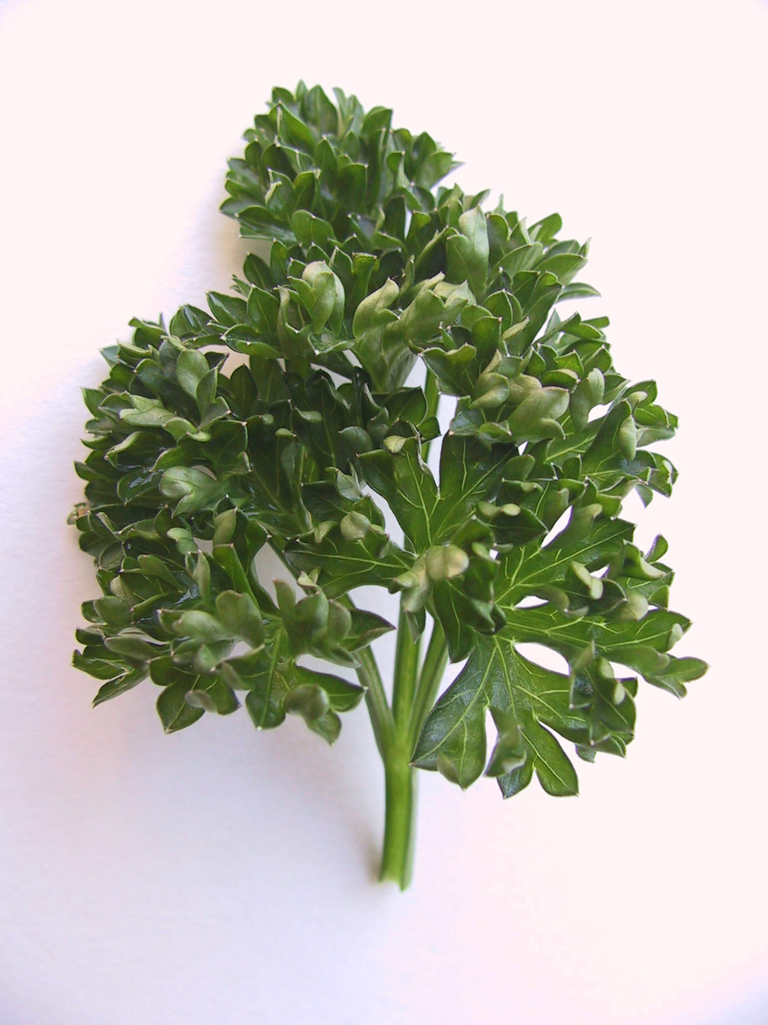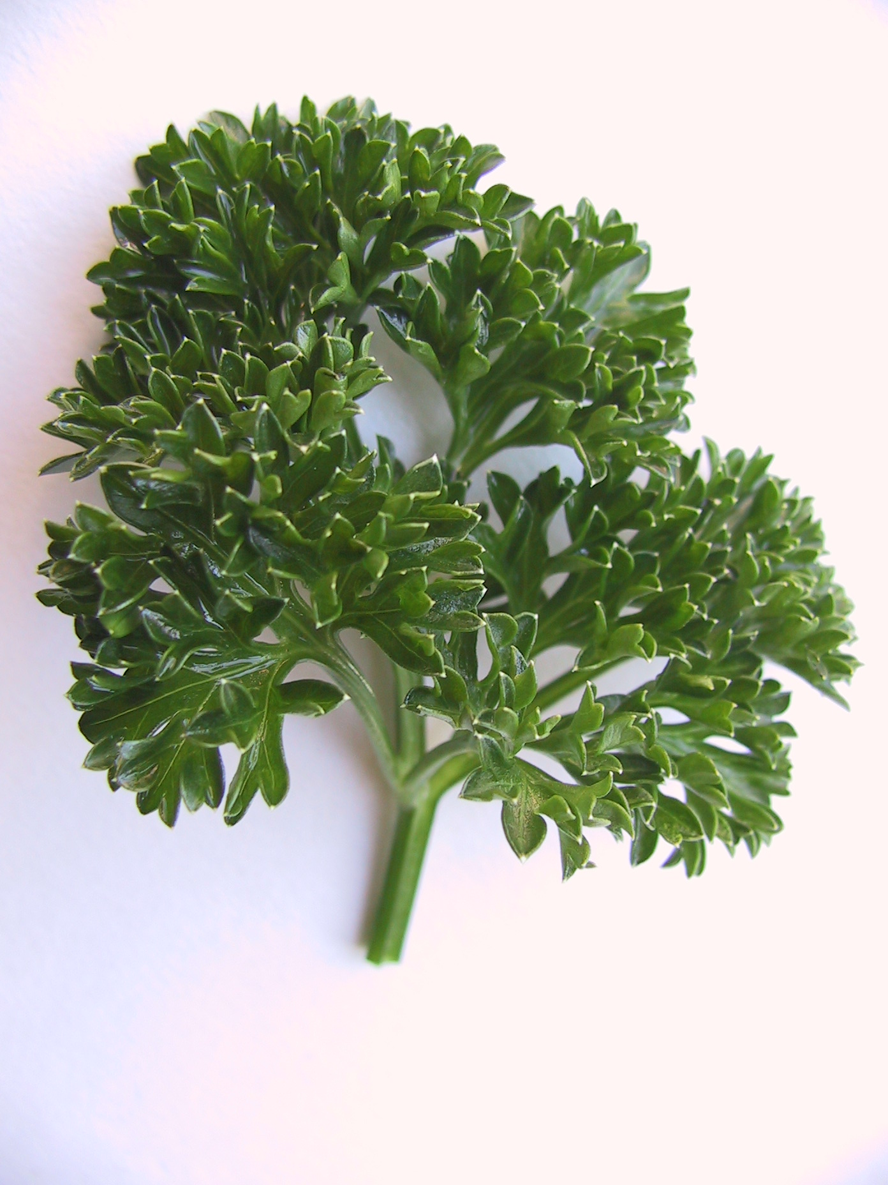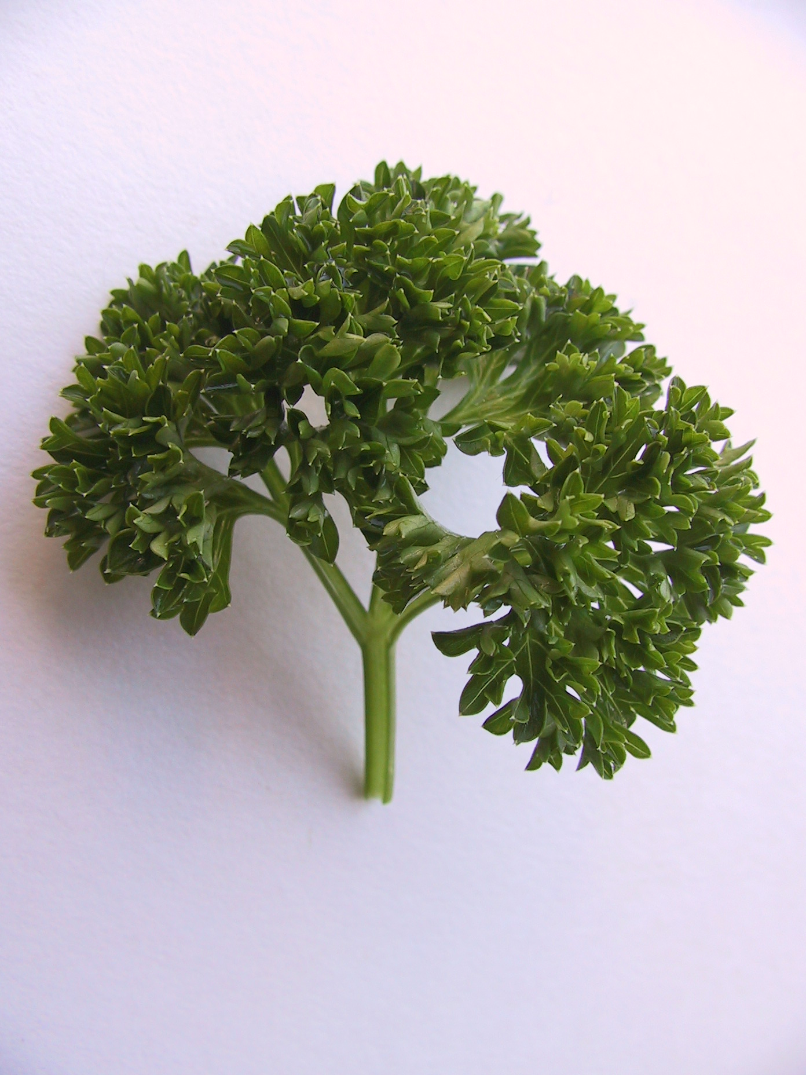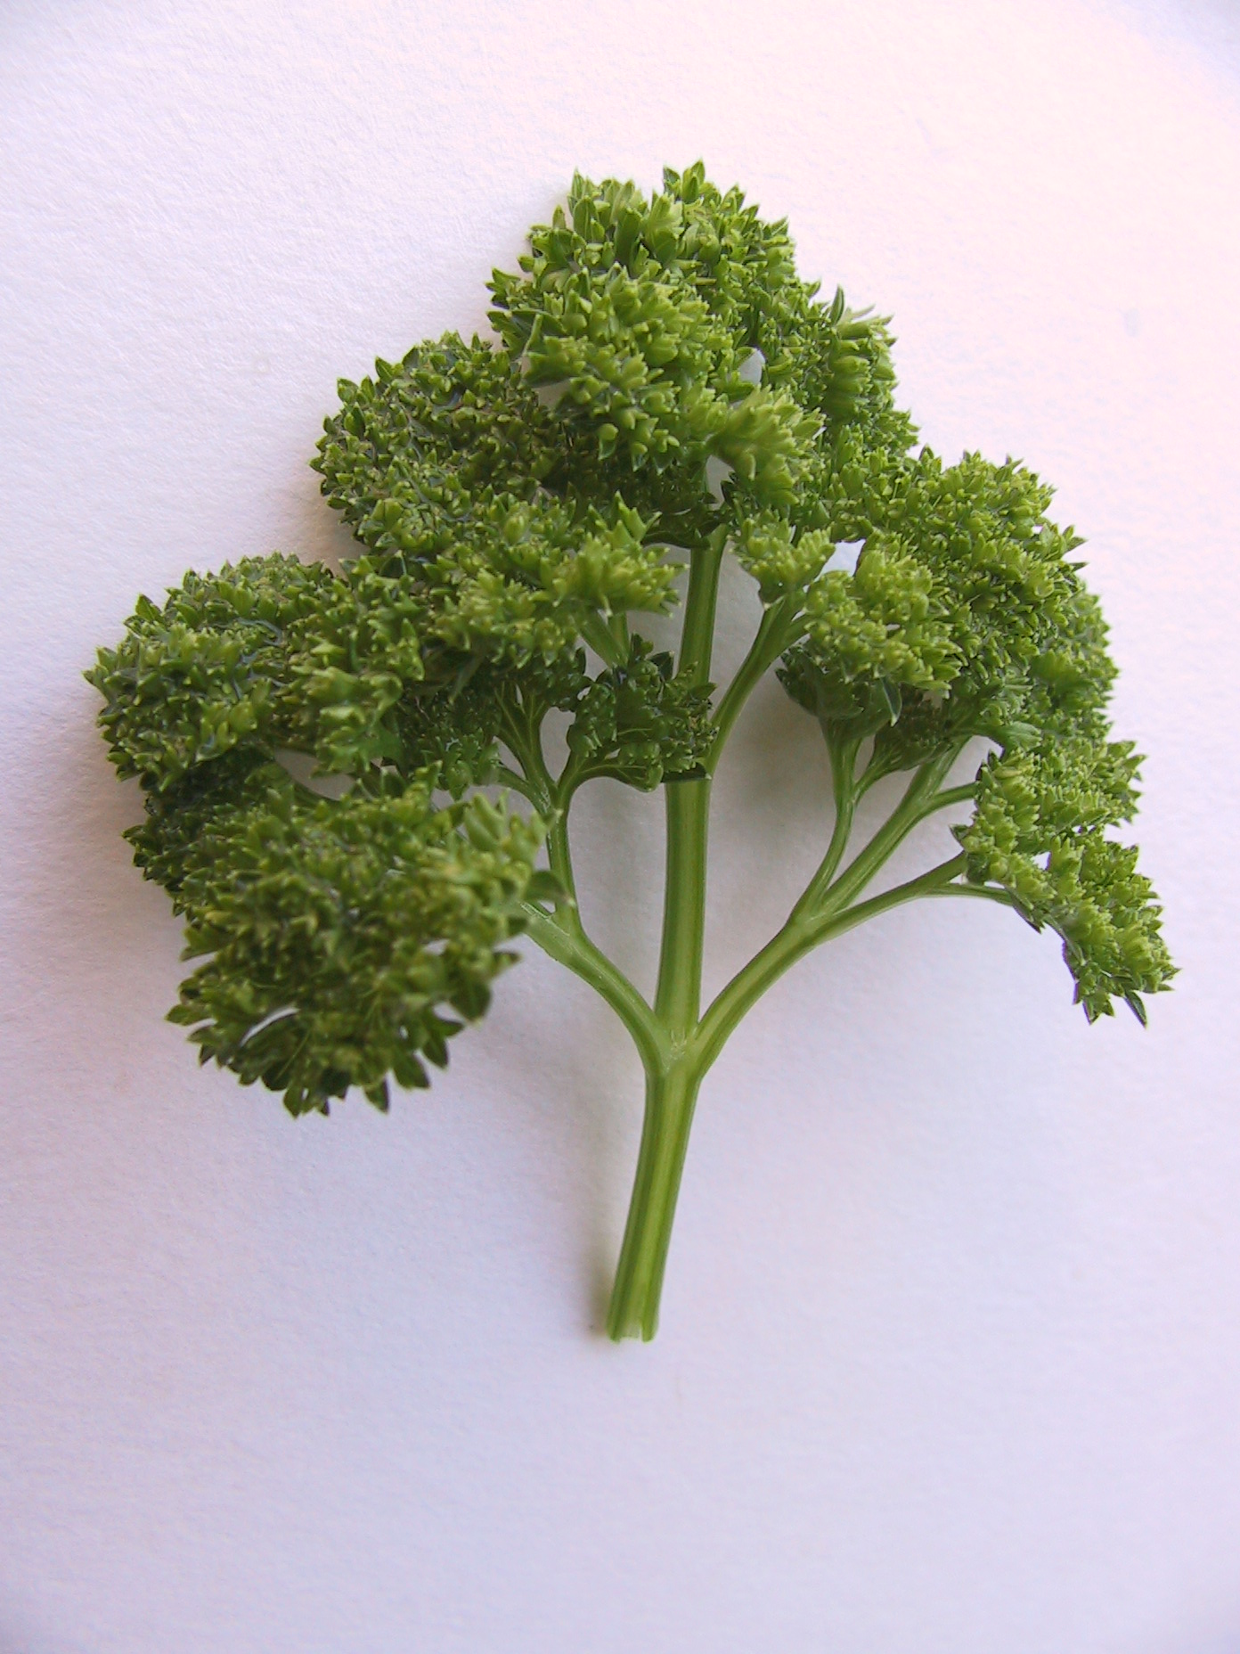

3 | 5 | 7 | 9
weak | medium | strong | very strong

Ad. 10: Leaf blade: length

17
10
11
18
15
Ad. 11: Leaf blade: width

Ad. 15. Leaf blade: distance
between 1st and 2nd pair of leaflets

Ad. 17: Petiole: length

Ad. 18: Petiole: thickness

Ad. 14: Leaflet: shape

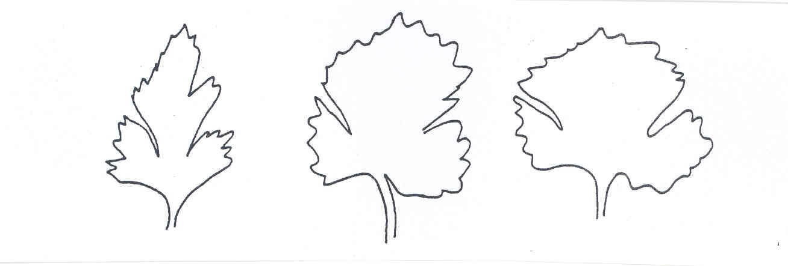  3 | 5 | 7
narrow triangular | medium triangular | broad triangular

Literature

Vogel, G., 1996: Handbuch des speziellen Gemüsebaues. Ulmer Verlag, Stuttgart,
pages 1009 - 1026

Technical Questionnaire
TECHNICAL QUESTIONNAIRE |  |  |  | Page {x} of {y} |  | Reference Number:
 |  |  |  |  |  | Application date:
 |  |  |  |  |  | (not to be filled in by the applicant)
TECHNICAL QUESTIONNAIRE
to be completed in connection with an application for plant breeders’ rights

1. Subject of the Technical Questionnaire
1.1 Botanical name |  |  | Petroselinum crispum (Mill). Nyman ex A.W. Hill
1.2 Common Name |  |  | Parsley
2. Applicant
Name
Address
Telephone No.
Fax No.
E-mail address
Breeder (if different from applicant)
3. Proposed denomination and breeder’s reference
Proposed denomination
(if available)

Breeder’s reference
#4. Information on the breeding scheme and propagation of the variety

4.1 Breeding scheme

Variety resulting from:

4.1.1 Crossing

(a) controlled cross [ ]
(please state parent varieties)
(b) partially known cross [ ]
(please state known parent variety(ies))
(c) unknown cross [ ]

4.1.2 Mutation [ ]
(please state parent variety)

4.1.3 Discovery and development [ ]
(please state where and when discovered and
how developed)

4.1.4 Other [ ]
(please provide details)

  - Method of propagating the variety

4.2.1 Seed-propagated varieties

(a) Cross-pollination [ ]

(b) Other [ ]
(please provide details)

4.2.2 Other [ ]
(please provide details)

5. Characteristics of the variety to be indicated (the number in brackets refers to the corresponding characteristic in Test Guidelines; please mark the note which best corresponds)

 | Characteristics |  |  |  |  |  | Example Varieties |  |  |  | Note
5.1  (1) | Plant: height
 | short |  |  |  |  |  | Petruschka |  |  | 3[ ]
 | medium |  |  |  |  |  | Darki |  |  | 5[ ]
 | tall |  |  |  |  |  | Laura |  |  | 7[ ]
 | very tall |  |  |  |  |  | Gigante d'Italia |  |  | 9[ ]
5.2  (6) | Leaf blade: curling
 | absent |  |  |  |  |  | Einfache Schnitt 2 |  |  | 1[ ]
 | present |  |  |  |  |  | Titan |  |  | 9[ ]
5.3  (13) | Leaf blade: intensity of green color
 | light |  |  |  |  |  | Consort |  |  | 3[ ]
 | medium |  |  |  |  |  | Clivi |  |  | 5[ ]
 | dark |  |  |  |  |  | Opal |  |  | 7[ ]
5.4  (20) | Root: thickening of main root
 | absent (leaf parsley) |  |  |  |  |  | Mooskrause 2 |  |  | 1[ ]
 | present (root parsley) |  |  |  |  |  | Halblange |  |  | 9[ ]
5.5  (21) | Only root parsley varieties:  Root: length
 | short |  |  |  |  |  | Korte |  |  | 3[ ]
 | medium |  |  |  |  |  | Halblange |  |  | 5[ ]
 | long |  |  |  |  |  | Lange |  |  | 7[ ]
 | Characteristics |  |  |  |  |  | Example Varieties |  |  |  | Note
5.5  (23) | Only root parsley varieties:  Root: ratio length/width
 | small |  |  |  |  |  | Korte |  |  | 3[ ]
 | medium |  |  |  |  |  | Halblange |  |  | 5[ ]
 | large |  |  |  |  |  | Lange |  |  | 7[ ]
6. Similar varieties and differences from these varieties

Please use the following table and box for comments to provide information on how your candidate variety differs from the variety (or varieties) which, to the best of your knowledge, is (or are) most similar. This information may help the examination authority to conduct its examination of distinctness in a more efficient way.

Denomination(s) of variety(ies) similar to your candidate variety |  | Characteristic(s) in which your candidate variety differs from the similar variety(ies) |  |  | Describe the expression of the characteristic(s) for the similar variety(ies) |  |  | Describe the expression of the characteristic(s) for your candidate variety
Example |  | Leaf blade: intensity of green color |  |  | light |  |  | medium
Comments:

#7. Additional information which may help in the examination of the variety

7.1 In addition to the information provided in sections 5 and 6, are there any additional characteristics which may help to distinguish the variety?

Yes [ ] No [ ]

(If yes, please provide details)

7.2 Are there any special conditions for growing the variety or conducting the examination?

Yes [ ] No [ ]

(If yes, please provide details)

7.3 Other information

8. Authorization for release

(a) Does the variety require prior authorization for release under legislation concerning the protection of the environment, human and animal health?

Yes [ ] No [ ]

(b) Has such authorization been obtained?

Yes [ ] No [ ]

If the answer to (b) is yes, please attach a copy of the authorization.

9. Information on plant material to be examined or submitted for examination.

9.1 The expression of a characteristic or several characteristics of a variety may be affected by factors, such as pests and disease, chemical treatment (e.g. growth retardants or pesticides), effects of tissue culture, different rootstocks, scions taken from different growth phases of a tree, etc.

9.2 The plant material should not have undergone any treatment which would affect the expression of the characteristics of the variety, unless the competent authorities allow or request such treatment. If the plant material has undergone such treatment, full details of the treatment must be given. In this respect, please indicate below, to the best of your knowledge, if the plant material to be examined has been subjected to:

(a) Microorganisms (e.g. virus, bacteria, phytoplasma) Yes [ ] No [ ]

(b) Chemical treatment (e.g. growth retardant, pesticide) Yes [ ] No [ ]

(c) Tissue culture Yes [ ] No [ ]

(d) Other factors Yes [ ] No [ ]

Please provide details of where you have indicated “yes”.

……………………………………………………………

10. I hereby declare that, to the best of my knowledge, the information provided in this form is correct:

Applicant’s name

Signature Date

[End of document]

* These names were correct at the time of the introduction of these Test Guidelines but may be revised or updated. [Readers are advised to consult the UPOV Code, which can be found on the UPOV Website (www.upov.int), for the latest information.]
# Authorities may allow certain of this information to be provided in a confidential section of the Technical Questionnaire.
# Authorities may allow certain of this information to be provided in a confidential section of the Technical Questionnaire.

