 |  | E
TG/133/5
ORIGINAL: English
DATE: 2020-12-17

INTERNATIONAL UNION FOR THE PROTECTION OF NEW VARIETIES OF PLANTS
 | Geneva
 | HYDRANGEA  UPOV Code(s): HYDRN  Hydrangea L. | *
GUIDELINES
FOR THE CONDUCT OF TESTS
FOR DISTINCTNESS, UNIFORMITY AND STABILITY

Alternative names:*

Botanical name | English | French | German | Spanish
Hydrangea L. | Hydrangea | Hortensia, Hydrangée | Hortensie | Hidrangea, Hortensia

The purpose of these guidelines (“Test Guidelines”) is to elaborate the principles contained in the General Introduction (document TG/1/3), and its associated TGP documents, into detailed practical guidance for the harmonized examination of distinctness, uniformity and stability (DUS) and, in particular, to identify appropriate characteristics for the examination of DUS and production of harmonized variety descriptions.
ASSOCIATED DOCUMENTS
These Test Guidelines should be read in conjunction with the General Introduction and its associated TGP documents.

TABLE OF CONTENTS | PAGE
1. | SUBJECT OF THESE TEST GUIDELINES.......................................................................................................... | 3
2. | MATERIAL REQUIRED......................................................................................................................................... | 3
3. | METHOD OF EXAMINATION................................................................................................................................ | 3
3.1 | Number of Growing Cycles........................................................................................................................ | 3
3.2 | Testing Place............................................................................................................................................. | 3
3.3 | Conditions for Conducting the Examination............................................................................................... | 3
3.4 | Test Design................................................................................................................................................ | 4
3.5 | Additional Tests......................................................................................................................................... | 4

4. | ASSESSMENT OF DISTINCTNESS, UNIFORMITY AND STABILITY................................................................. | 4
4.1 | Distinctness............................................................................................................................................... | 4
4.2 | Uniformity.................................................................................................................................................. | 5
4.3 | Stability...................................................................................................................................................... | 5

5. | GROUPING OF VARIETIES AND ORGANIZATION OF THE GROWING TRIAL................................................ | 6
6. | INTRODUCTION TO THE TABLE OF CHARACTERISTICS................................................................................ | 6
6.1 | Categories of Characteristics..................................................................................................................... | 6
6.2 | States of Expression and Corresponding Notes........................................................................................ | 6
6.3 | Types of Expression.................................................................................................................................. | 7
6.4 | Example Varieties...................................................................................................................................... | 7
6.5 | Legend....................................................................................................................................................... | 7

7. | TABLE OF CHARACTERISTICS/TABLEAU DES CARACTÈRES/MERKMALSTABELLE/TABLA DE CARACTERES...................................................................................................................................................... | 8
8. | EXPLANATIONS ON THE TABLE OF CHARACTERISTICS............................................................................... | 19
8.1 | Explanations covering several characteristics........................................................................................... | 19
8.2 | Explanations for individual characteristics................................................................................................. | 19

9. | LITERATURE......................................................................................................................................................... | 30
10. | TECHNICAL QUESTIONNAIRE............................................................................................................................ | 31

1. | Subject of these Test Guidelines
 | These Test Guidelines apply to all varieties of Hydrangea L.

2. | Material Required
2.1 | The competent authorities decide on the quantity and quality of the plant material required for testing the variety and when and where it is to be delivered. Applicants submitting material from a State other than that in which the testing takes place must ensure that all customs formalities and phytosanitary requirements are complied with.
2.2 | The material is to be supplied in the form of plants capable of expressing all characteristics in the first growing cycle.
2.3 | The minimum quantity of plant material, to be supplied by the applicant, should be:
 | 8 plants.
2.4 | The plant material supplied should be visibly healthy, not lacking in vigor, nor affected by any important pest or disease.
2.5 | The plant material should not have undergone any treatment which would affect the expression of the characteristics of the variety, unless the competent authorities allow or request such treatment. If it has been treated, full details of the treatment must be given.

3. | Method of Examination
3.1 | Number of Growing Cycles
3.1.1 | The minimum duration of tests should normally be a single growing cycle.
3.1.2 | The testing of a variety may be concluded when the competent authority can determine with certainty the outcome of the test.
3.2 | Testing Place
 | Tests are normally conducted at one place. In the case of tests conducted at more than one place, guidance is provided in TGP/9 “Examining Distinctness”.
3.3 | Conditions for Conducting the Examination
3.3.1 | The tests should be carried out under conditions ensuring satisfactory growth for the expression of the relevant characteristics of the variety and for the conduct of the examination.
3.3.2 | Because daylight varies, color determinations made against a color chart should be made either in a suitable cabinet providing artificial daylight or in the middle of the day in a room without direct sunlight. The spectral distribution of the illuminant for artificial daylight should conform with the CIE Standard of Preferred Daylight D 6500 and should fall within the tolerances set out in the British Standard 950, Part I. These determinations should be made with the plant part placed against a white background. The color chart and version used should be specified in the variety description.

3.4 | Test Design
3.4.1 | Each test should be designed to result in a total of at least 8 plants.
3.4.2 | The design of the tests should be such that plants or parts of plants may be removed for measurement or counting without prejudice to the observations which must be made up to the end of the growing cycle.
3.5 | Additional Tests
 | Additional tests, for examining relevant characteristics, may be established.

4. | Assessment of Distinctness, Uniformity and Stability
4.1 | Distinctness
4.1.1 | General Recommendations
 | It is of particular importance for users of these Test Guidelines to consult the General Introduction prior to making decisions regarding distinctness. However, the following points are provided for elaboration or emphasis in these Test Guidelines.
4.1.2 | Consistent Differences
 | The differences observed between varieties may be so clear that more than one growing cycle is not necessary. In addition, in some circumstances, the influence of the environment is not such that more than a single growing cycle is required to provide assurance that the differences observed between varieties are sufficiently consistent. One means of ensuring that a difference in a characteristic, observed in a growing trial, is sufficiently consistent is to examine the characteristic in at least two independent growing cycles.
4.1.3 | Clear Differences
 | Determining whether a difference between two varieties is clear depends on many factors, and should consider, in particular, the type of expression of the characteristic being examined, i.e. whether it is expressed in a qualitative, quantitative, or pseudo-qualitative manner. Therefore, it is important that users of these Test Guidelines are familiar with the recommendations contained in the General Introduction prior to making decisions regarding distinctness.
4.1.4 | Number of Plants or Parts of Plants to be Examined
 | Unless otherwise indicated, for the purposes of distinctness, all observations on single plants should be made on 7 plants or parts of plants taken from each of 7 plants and any other observations made on all plants in the test, disregarding any off-type plants.
4.1.5 | Method of Observation
 | The recommended method of observing the characteristic for the purposes of distinctness is indicated by the following key in the Table of Characteristics (see document TGP/9 “Examining Distinctness”, Section 4 “Observation of characteristics”):
MG: single measurement of a group of plants or parts of plants
MS: measurement of a number of individual plants or parts of plants
VG: visual assessment by a single observation of a group of plants or parts of plants
VS: visual assessment by observation of individual plants or parts of plants

 | Type of observation: visual (V) or measurement (M)
 | “Visual” observation (V) is an observation made on the basis of the expert’s judgment. For the purposes of this document, “visual” observation refers to the sensory observations of the experts and, therefore, also includes smell, taste and touch. Visual observation includes observations where the expert uses reference points (e.g. diagrams, example varieties, side-by-side comparison) or non-linear charts (e.g. color charts). Measurement (M) is an objective observation against a calibrated, linear scale e.g. using a ruler, weighing scales, colorimeter, dates, counts, etc.
 | Type of record: for a group of plants (G) or for single, individual plants (S)
 | For the purposes of distinctness, observations may be recorded as a single record for a group of plants or parts of plants (G), or may be recorded as records for a number of single, individual plants or parts of plants (S). In most cases, “G” provides a single record per variety and it is not possible or necessary to apply statistical methods in a plant-by-plant analysis for the assessment of distinctness.
 | In cases where more than one method of observing the characteristic is indicated in the Table of Characteristics (e.g. VG/MG), guidance on selecting an appropriate method is provided in document TGP/9, Section 4.2.
4.2 | Uniformity
4.2.1 | It is of particular importance for users of these Test Guidelines to consult the General Introduction prior to making decisions regarding uniformity. However, the following points are provided for elaboration or emphasis in these Test Guidelines:
4.2.2 | These Test Guidelines have been developed for the examination of vegetatively propagated varieties. For varieties with other types of propagation, the recommendations in the General Introduction and document TGP/13 "Guidance for new types and species" Section 4.5 "Testing Uniformity" should be followed.
4.2.3 | For the assessment of uniformity of vegetatively propagated varieties, a population standard of 1% and an acceptance probability of at least 95% should be applied. In the case of a sample size of 8 plants, 1 off-type is allowed.
4.3 | Stability
4.3.1 | In practice, it is not usual to perform tests of stability that produce results as certain as those of the testing of distinctness and uniformity. However, experience has demonstrated that, for many types of variety, when a variety has been shown to be uniform, it can also be considered to be stable.
4.3.2 | Where appropriate, or in cases of doubt, stability may be further examined by testing a new plant stock to ensure that it exhibits the same characteristics as those shown by the initial material supplied.

5. | Grouping of Varieties and Organization of the Growing Trial
5.1 | The selection of varieties of common knowledge to be grown in the trial with the candidate varieties and the way in which these varieties are divided into groups to facilitate the assessment of distinctness are aided by the use of grouping characteristics.
5.2 | Grouping characteristics are those in which the documented states of expression, even where produced at different locations, can be used, either individually or in combination with other such characteristics: (a) to select varieties of common knowledge that can be excluded from the growing trial used for examination of distinctness; and (b) to organize the growing trial so that similar varieties are grouped together.
5.3 | The following have been agreed as useful grouping characteristics:
(a) |  | Plant: type (characteristic 1)
(b) |  | Stem: fasciation (characteristic 5)
(c) |  | Stem: color (characteristic 6)
(d) |  | Leaf blade: intensity of anthocyanin coloration (characteristic 17)
(e) |  | Leaf blade: variegation (characteristic 19)
(f) |  | Leaf blade: main color (characteristic 20)
(g) |  | Inflorescence: shape (characteristic 26)
(h) |  | Inflorescence: conspicuousness of fertile flowers (characteristic 29)
(i) |  | Sterile flower: diameter of calyx (characteristic 32)
(j) |  | Sterile flower: number of sepals (characteristic 33)

 | (k) Sterile flower: main color of inner side of sepals (characteristic 42) with the following groups: Gr. 1: white Gr. 2: green Gr. 3: light pink Gr. 4: medium pink Gr. 5: dark pink Gr. 6: red
5.4 | Guidance for the use of grouping characteristics, in the process of examining distinctness, is provided through the General Introduction and document TGP/9 “Examining Distinctness”.

6. | Introduction to the Table of Characteristics
6.1 | Categories of Characteristics
6.1.1 | Standard Test Guidelines Characteristics
 | Standard Test Guidelines characteristics are those which are approved by UPOV for examination of DUS and from which members of the Union can select those suitable for their particular circumstances.
6.1.2 | Asterisked Characteristics
 | Asterisked characteristics (denoted by *) are those included in the Test Guidelines which are important for the international harmonization of variety descriptions and should always be examined for DUS and included in the variety description by all members of the Union, except when the state of expression of a preceding characteristic or regional environmental conditions render this inappropriate.
6.2 | States of Expression and Corresponding Notes
6.2.1 | States of expression are given for each characteristic to define the characteristic and to harmonize descriptions. Each state of expression is allocated a corresponding numerical note for ease of recording of data and for the production and exchange of the description.

6.2.2 | All relevant states of expression are presented in the characteristic.
6.2.3 | Further explanation of the presentation of states of expression and notes is provided in document TGP/7 “Development of Test Guidelines”.
6.3 | Types of Expression

 | An explanation of the types of expression of characteristics (qualitative, quantitative and pseudo-qualitative) is provided in the General Introduction.
6.4 | Example Varieties
 | Where appropriate, example varieties are provided to clarify the states of expression of each characteristic.
The example varieties given in the Table of Characteristics belong to the species indicated below:

(a) Hydrangea macrophylla (Thunb.) Ser. and Hydrangea serrata (Thunb.) Ser. var. serrata
(b) Hydrangea paniculata Siebold
(c) Hydrangea arborescens L.
(d) Hydrangea quercifolia W. Bartram
(e) Hydrangea petiolaris Siebold & Zucc.

6.5 | Legend
 |  | English |  | français |  | deutsch | español | Example Varieties  Exemples  Beispielssorten  Variedades ejemplo | Note/  Nota
1 | 2 | 3 | 4 | 5 | 6 | 7
 |  | Name of characteristics in English |  | Nom du caractère en français |  | Name des Merkmals auf Deutsch | Nombre del carácter en español
 |  | states of expression |  | types d’expression |  | Ausprägungsstufen | tipos de expresión

1 | Characteristic number
2 | (*) | Asterisked characteristic | – see Chapter 6.1.2
3 | Type of expression
 | QL | Qualitative characteristic | – see Chapter 6.3
 | QN | Quantitative characteristic | – see Chapter 6.3
 | PQ | Pseudo-qualitative characteristic | – see Chapter 6.3
4 | Method of observation (and type of plot, if applicable)
 | MG, MS, VG, VS |  | – see Chapter 4.1.5
5 | (+) | See Explanations on the Table of Characteristics in Chapter 8.2
6 | (a)-(d) | See Explanations on the Table of Characteristics in Chapter 8.1
7 | Not applicable

(a) - (e) Species of example varieties (see 6.4)

7. | Table of Characteristics/Tableau des caractères/Merkmalstabelle/Tabla de caracteres

 |  | English |  | français |  | deutsch | español | Example Varieties  Exemples  Beispielssorten  Variedades ejemplo | Note/  Nota
1. | (*) | QL | VG
 |  | Plant: type |  | Plante : type |  | Pflanze: Typ | Planta: tipo
 |  | climbing |  | grimpant |  | kletternd | trepadora | Silver Lining (e) | 1
 |  | non-climbing |  | non grimpant |  | nicht kletternd | no trepadora | Merveille (a) | 2
2. | (*) | QN | VG | (+)
 |  | Only varieties with Plant: type: non-climbing: Plant: growth habit |  | Uniquement les variétés de type non grimpant : Plante : port |  | Nur Sorten mit Pflanze: Typ: nicht kletternd: Pflanze: Wuchsform | Solo variedades con Planta: tipo: no trepadora: Planta: hábito de crecimiento
 |  | upright |  | dressé |  | aufrecht | erecto |  | 1
 |  | semi-upright |  | demi-dressé |  | halbaufrecht | semierecto |  | 2
 |  | spreading |  | étalé |  | breitwüchsig | extendido |  | 3
3. | (*) | QN | MG/MS/VG | (+)
 |  | Only varieties with Plant: type: non-climbing: Plant: height |  | Uniquement les variétés de type non grimpant : Plante : hauteur |  | Nur Sorten mit Pflanze: Typ: nicht kletternd: Pflanze: Höhe | Solo variedades con Planta: tipo: no trepadora: Planta: altura
 |  | very short |  | très courte |  | sehr niedrig | muy baja | BREG14 (b), NCHA8 (c), Saxtabrose (a) | 1
 |  | very short to short |  | très courte à courte |  | sehr niedrig bis niedrig | muy baja a baja |  | 2
 |  | short |  | courte |  | niedrig | baja | Dolprim (b),  HBA 2014903 (a), NCHA7 (c) | 3
 |  | short to medium |  | courte à moyenne |  | niedrig bis mittel | baja a media |  | 4
 |  | medium |  | moyenne |  | mittel | media | Bokraflame (b), Hortmasnodo (a),  NCHA3 (c) | 5
 |  | medium to tall |  | moyenne à haute |  | mittel bis hoch | media a alta |  | 6
 |  | tall |  | haute |  | hoch | alta | Bulk (b), HBA 215908 (a), NCHA4 (c) | 7
 |  | tall to very tall |  | haute à très haute |  | hoch bis sehr hoch | alta a muy alta |  | 8
 |  | very tall |  | très haute |  | sehr hoch | muy alta | Annabelle (c), Kazan (a), Mid Late Summer (b) | 9
4. |  | QN | VG
 |  | Only varieties with Plant: type: non-climbing: Plant: height in relation to width |  | Uniquement les variétés de type non grimpant : Plante : hauteur par rapport à la largeur |  | Nur Sorten mit Pflanze: Typ: nicht kletternd: Pflanze: Höhe im Verhältnis zur Breite | Solo variedades con Planta: tipo: no trepadora: Planta: altura en relación con la anchura
 |  | taller than broad |  | plus haute que large |  | höher als breit | más alta que ancha |  | 1
 |  | as tall as broad |  | aussi haute que large |  | gleich hoch wie breit | tan alta como ancha |  | 2
 |  | broader than tall |  | plus large que haute |  | breiter als hoch | más ancha que alta |  | 3
5. | (*) | QL | VG | (+) | (a)
 |  | Stem: fasciation |  | Tige : fasciation |  | Trieb: Verbänderung | Tallo: fasciación
 |  | absent |  | absente |  | fehlend | ausente | Merveille (a) | 1
 |  | present |  | présente |  | vorhanden | presente | Domotoi (a) | 9
6. | (*) | PQ | VG |  | (a)
 |  | Stem: color |  | Tige : couleur |  | Trieb: Farbe | Tallo: color
 |  | green |  | vert |  | grün | verde | Merveille (a) | 1
 |  | pink |  | rose |  | rosa | rosa | Mid Late Summer (b) | 2
 |  | red |  | rouge |  | rot | rojo | Wims Red (b) | 3
 |  | brown |  | brun |  | braun | marrón | Bokraflame (b) | 4
 |  | black |  | noir |  | schwarz | negro | Nigra (a) | 5
 |  | green and black |  | vert et noir |  | grün und schwarz | verde y negro | Napo (a) | 6
7. |  | QN | VG | (+) | (a)
 |  | Stem: number of lenticels |  | Tige : nombre de lenticelles |  | Trieb: Anzahl Lentizellen | Tallo: número de lenticelas
 |  | absent or few |  | absent ou petit |  | fehlend oder wenige | nulo o bajo | Blue Bird (a), Imola (a) | 1
 |  | few to medium |  | petit à moyen |  | wenige bis mittel | bajo a medio |  | 2
 |  | medium |  | moyen |  | mittel | medio | Merveille Sanguinea (a) | 3
 |  | medium to many |  | moyen à grand |  | mittel bis viele | medio a alto |  | 4
 |  | many |  | grand |  | viele | alto | Hobella (a) | 5
8. |  | QN | VG | (+) | (a)
 |  | Stem: size of lenticels |  | Tige : taille des lenticelles |  | Trieb: Größe der Lentizellen | Tallo: tamaño de las lenticelas
 |  | small |  | petite |  | klein | pequeño | Mrs Kumiko (a) | 1
 |  | medium |  | moyenne |  | mittel | medio | Bergfink (a) | 2
 |  | large |  | grande |  | groß | grande | Hokomac (a) | 3
9. |  | PQ | VG |  | (a)
 |  | Stem: color of lenticels |  | Tige : couleur des lenticelles |  | Trieb: Farbe der Lentizellen | Tallo: color de las lenticelas
 |  | whitish |  | blanchâtre |  | weißlich | blanquecino | Pink Diamond (a) | 1
 |  | reddish |  | rougeâtre |  | rötlich | rojizo | Leuchtfeuer (a) | 2
 |  | blackish |  | noirâtre |  | schwärzlich | negruzco | Merveille (a) | 3
10. | (*) | QN | MS/VG |  | (b)
 |  | Leaf blade: length |  | Limbe : longueur |  | Blattspreite: Länge | Limbo: longitud
 |  | very short |  | très courte |  | sehr kurz | muy corta |  | 1
 |  | very short to short |  | très courte à courte |  | sehr kurz bis kurz | muy corta a corta |  | 2
 |  | short |  | courte |  | kurz | corta | Hörnli (a) | 3
 |  | short to medium |  | courte à moyenne |  | kurz bis mittel | corta a media |  | 4
 |  | medium |  | moyenne |  | mittel | media | Rosita (a) | 5
 |  | medium to long |  | moyenne à longue |  | mittel bis lang | media a larga |  | 6
 |  | long |  | longue |  | lang | larga | Merveille (a) | 7
 |  | long to very long |  | longue à très longue |  | lang bis sehr lang | larga a muy larga |  | 8
 |  | very long |  | très longue |  | sehr lang | muy larga |  | 9
11. |  | QN | MS/VG |  | (b)
 |  | Leaf blade: width |  | Limbe : largeur |  | Blattspreite: Breite | Limbo: anchura
 |  | very narrow |  | très étroite |  | sehr schmal | muy estrecha |  | 1
 |  | very narrow to narrow |  | très étroite à étroite |  | sehr schmal bis schmal | muy estrecha a estrecha |  | 2
 |  | narrow |  | étroite |  | schmal | estrecha | Shichidanka (a) | 3
 |  | narrow to medium |  | étroite à moyenne |  | schmal bis mittel | estrecha a media |  | 4
 |  | medium |  | moyenne |  | mittel | media | Mrs Kumiko (a) | 5
 |  | medium to broad |  | moyenne à large |  | mittel bis breit | media a ancha |  | 6
 |  | broad |  | large |  | breit | ancha | Snowflake (d) | 7
 |  | broad to very broad |  | large à très large |  | breit bis sehr breit | ancha muy ancha |  | 8
 |  | very broad |  | très large |  | sehr breit | muy ancha |  | 9
12. | (*) | QL | VG | (+) | (b)
 |  | Leaf blade: lobing |  | Limbe : lobes |  | Blattspreite: Lappung | Limbo: lobulado
 |  | absent |  | absents |  | fehlend | ausente | Merveille (a) | 1
 |  | present |  | présents |  | vorhanden | presente | Harmony (d) | 9
13. | (*) | PQ | VG | (+) | (b)
 |  | Only varieties with Leaf blade: lobing: absent: Leaf blade: shape |  | Uniquement les variétés sans découpures des bords : Limbe : forme |  | Nur Sorten mit Blattspreite: Lappung: fehlend: Blattspreite: Form | Solo variedades con Limbo: lobulado: ausente: Limbo: forma
 |  | ovate |  | ovale |  | eiförmig | oval | Merveille (a) | 1
 |  | circular |  | circulaire |  | kreisförmig | circular | Rosita (a) | 2
 |  | elliptic |  | elliptique |  | elliptisch | elíptica | Blue Wave (a) | 3
 |  | obovate |  | obovale |  | verkehrt eiförmig | oboval | H213 (a), H213902 (a) | 4
14. |  | QN | VG | (+) | (b)
 |  | Leaf blade: length of tip |  | Limbe : longueur de la pointe |  | Blattspreite: Länge der Spitze | Limbo: longitud del ápice
 |  | absent or short |  | absente ou courte |  | fehlend oder kurz | ausente o corta | Chaperon Rouge (a) | 1
 |  | medium |  | moyenne |  | mittel | media | Mme E. Mouillère (a) | 2
 |  | long |  | longue |  | lang | larga | Hallasan (a) | 3
15. | (*) | PQ | VG | (+) | (b)
 |  | Leaf blade: shape of base |  | Limbe : forme de la base |  | Blattspreite: Form der Basis | Limbo: forma de la base
 |  | acute |  | pointue |  | spitz | aguda | Europa (a) | 1
 |  | obtuse |  | obtuse |  | stumpf | obtusa | Bosco (a), Hamburg (a) | 2
 |  | rounded |  | arrondie |  | abgerundet | redondeada | Rosabelle (a) | 3
 |  | cordate |  | cordiforme |  | herzförmig | cordada | Annabelle (c) | 4
16. |  | QN | VG | (+) | (b)
 |  | Leaf blade: depth of incisions on margin |  | Limbe : profondeur des incisions du bord |  | Blattspreite: Tiefe der Randeinschnitte | Limbo: profundidad de las incisiones del margen
 |  | absent or very shallow |  | absente ou très peu profonde |  | fehlend oder sehr flach | ausente o muy poco profunda | Bokraflame (b) | 1
 |  | shallow |  | peu profonde |  | flach | poco profunda | Perfrie (a) | 2
 |  | medium |  | moyenne |  | mittel | medianamente profunda | Hobergine (a) | 3
 |  | deep |  | profonde |  | tief | profunda | Fasan (a) | 4
 |  | very deep |  | très profonde |  | sehr tief | muy profunda | Paris (a) | 5
17. | (*) | QN | VG |  | (b)
 |  | Leaf blade: intensity of anthocyanin coloration |  | Limbe : intensité de la pigmentation anthocyanique |  | Blattspreite: Intensität der Anthocyanfärbung | Limbo: intensidad de la pigmentación antociánica
 |  | absent or very weak |  | nulle ou très faible |  | fehlend oder sehr gering | ausente o muy débil | Victoria (a) | 1
 |  | weak |  | faible |  | gering | débil | SICAMU2934 (a) | 2
 |  | medium |  | moyenne |  | mittel | media | Red Angel (a) | 3
 |  | strong |  | forte |  | stark | fuerte | Dark Angel (a) | 4
 |  | very strong |  | très forte |  | sehr stark | muy fuerte | Baroque Angel (a) | 5
18. |  | PQ | VG | (+) | (b)
 |  | Leaf blade: distribution of anthocyanin coloration |  | Limbe : distribution de la pigmentation anthocyanique |  | Blattspreite: Verteilung der Anthocyanfärbung | Limbo: distribución de la pigmentación antociánica
 |  | none |  | aucune |  | keine | ausente |  | 1
 |  | on margin |  | sur le bord |  | am Rand | en el borde |  | 2
 |  | throughout |  | partout |  | überall | en la totalidad |  | 3
19. | (*) | QL | VG |  | (b)
 |  | Leaf blade: variegation |  | Limbe : panachure |  | Blattspreite: Panaschierung | Limbo: variegación
 |  | absent |  | absente |  | fehlend | ausente | Merveille (a) | 1
 |  | present |  | présente |  | vorhanden | presente | Tricolor (a) | 9
20. | (*) | PQ | VG |  | (b), (c)
 |  | Leaf blade: main color |  | Limbe : couleur principale |  | Blattspreite: Hauptfarbe | Limbo: color principal
 |  | yellow |  | jaune |  | gelb | amarillo | Ogonba (a) | 1
 |  | light green |  | vert clair |  | hellgrün | verde claro | Mousseline (a) | 2
 |  | medium green |  | vert moyen |  | mittelgrün | verde medio | Hobergine (a) | 3
 |  | dark green |  | vert foncé |  | dunkelgrün | verde oscuro | Rosalba (a) | 4
21. | (*) | PQ | VG |  | (b), (c)
 |  | Leaf blade: secondary color |  | Limbe : couleur secondaire |  | Blattspreite: Sekundärfarbe | Limbo: color secundario
 |  | none |  | aucune |  | keine | ausente | Hobella (a) | 1
 |  | white |  | blanc |  | weiß | blanco | Variegata (a) | 2
 |  | yellow |  | jaune |  | gelb | amarillo | Lemon Wave (a) | 3
 |  | yellow green |  | vert-jaune |  | gelbgrün | verde amarillento | Golden Annabelle (c) | 4
22. |  | QN | VG |  | (b)
 |  | Leaf blade: glossiness |  | Limbe : brillance |  | Blattspreite: Glanz | Limbo: brillo
 |  | absent or weak |  | absente ou faible |  | fehlend oder gering | ausente o débil | Maman (a) | 1
 |  | medium |  | moyenne |  | mittel | media | Merveille (a) | 2
 |  | strong |  | forte |  | stark | fuerte | Ayesha (a) | 3
23. |  | QN | VG |  | (b)
 |  | Leaf blade: rugosity |  | Limbe : rugosité |  | Blattspreite: Blasigkeit | Limbo: rugosidad
 |  | absent or very weak |  | absente ou très faible |  | fehlend oder sehr gering | ausente o débil | Blue Bird (a),  Bokraflame (b) | 1
 |  | weak |  | faible |  | gering | débil | Red Red (a) | 2
 |  | medium |  | moyenne |  | mittel | media | La Marne (a) | 3
 |  | strong |  | forte |  | stark | fuerte | Paris (a) | 4
 |  | very strong |  | très forte |  | sehr stark | muy fuerte | Merveille Sanguinea (a) | 5
24. |  | QN | VG | (+) | (b)
 |  | Leaf blade: shape in cross-section |  | Limbe : forme en section transversale |  | Blattspreite: Form im Querschnitt | Limbo: forma en sección transversal
 |  | concave |  | concave |  | konkav | cóncava |  | 1
 |  | flat |  | plate |  | flach | plana |  | 2
 |  | convex |  | convexe |  | konvex | convexa |  | 3
25. | (*) | PQ | VG | (+) | (b)
 |  | Petiole: color |  | Pétiole : couleur |  | Blattstiel: Farbe | Pecíolo: color
 |  | green |  | vert |  | grün | verde | Paris (a) | 1
 |  | red |  | rouge |  | rot | rojo | Preziosa (a) | 2
 |  | greenish brown |  | brun verdâtre |  | grünlichbraun | marrón verdoso | Renba (b) | 3
 |  | black |  | noir |  | schwarz | negro | Horzu (a) | 4
26. | (*) | PQ | VG | (+) | (d)
 |  | Inflorescence: shape |  | Inflorescence : forme |  | Blütenstand: Form | Inflorescencia: forma
 |  | flattened |  | aplatie |  | abgeflacht | aplanada | Mousmée (a),  Sea Foam (a) | 1
 |  | flattened to globular |  | aplatie à globuleuse |  | abgeflacht bis kugelförmig | entre aplanada y globular | Wedding Gown (a) | 2
 |  | globular |  | globuleuse |  | kugelförmig | globular | Merveille (a) | 3
 |  | globular to conical |  | globuleuse à conique |  | kugelförmig bis kegelförmig | entre globular y cónica | Kolmamon (b) | 4
 |  | conical |  | conique |  | kegelförmig | cónica | Snowflake (d) | 5
27. |  | QN | MG/MS/VG | (+) | (d)
 |  | Inflorescence: height |  | Inflorescence : hauteur |  | Blütenstand: Höhe | Inflorescencia: altura
 |  | very short |  | très courte |  | sehr niedrig | muy baja |  | 1
 |  | very short to short |  | très courte à courte |  | sehr niedrig bis niedrig | muy baja a baja |  | 2
 |  | short |  | courte |  | niedrig | baja | Shichidanka (a) | 3
 |  | short to medium |  | courte à moyenne |  | niedrig bis mittel | baja a media |  | 4
 |  | medium |  | moyenne |  | mittel | media | Mrs Kumiko (a) | 5
 |  | medium to tall |  | moyenne à haute |  | mittel bis hoch | media a alta |  | 6
 |  | tall |  | haute |  | hoch | alta | Snowflake (d) | 7
 |  | tall to very tall |  | haute à très haute |  | hoch bis sehr hoch | alta a muy alta |  | 8
 |  | very tall |  | très haute |  | sehr hoch | muy alta |  | 9
28. |  | QN | MG/MS/VG | (+) | (d)
 |  | Inflorescence: width |  | Inflorescence : largeur |  | Blütenstand: Breite | Inflorescencia: anchura
 |  | very narrow |  | très étroite |  | sehr schmal | muy estrecha |  | 1
 |  | very narrow to narrow |  | très étroite à étroite |  | sehr schmal bis schmal | muy estrecha a estrecha |  | 2
 |  | narrow |  | étroite |  | schmal | estrecha | Hörnli (a) | 3
 |  | narrow to medium |  | étroite à moyenne |  | schmal bis mittel | estrecha a media |  | 4
 |  | medium |  | moyenne |  | mittel | media | Merveille (a) | 5
 |  | medium to broad |  | moyenne à large |  | mittel bis breit | media a ancha |  | 6
 |  | broad |  | large |  | breit | ancha | Maman (a) | 7
 |  | broad to very broad |  | large à très large |  | breit bis sehr breit | ancha muy ancha |  | 8
 |  | very broad |  | très large |  | sehr breit | muy ancha |  | 9
29. | (*) | QN | VG | (+) | (d)
 |  | Inflorescence: conspicuousness of fertile flowers |  | Inflorescence : netteté des fleurs fertiles |  | Blütenstand: Ausprägung der fertilen Blüten | Inflorescencia: visibilidad de las flores fértiles
 |  | absent or weak |  | absente ou faible |  | fehlend oder gering | no visible o poco visible | Merveille (a) | 1
 |  | medium |  | moyenne |  | mittel | medianamente visible | HOPE2069 (a) | 2
 |  | strong |  | forte |  | stark | muy visible | Mousmée (a),  Sea Foam (a) | 3
30. | (*) | PQ | VG | (+) | (d)
 |  | Only varieties with Inflorescence: conspicuousness of fertile flowers: medium and strong: Inflorescence: arrangement of sterile flowers |  | Uniquement les variétés dont la netteté des fleurs fertiles est moyenne et forte : Inflorescence : répartition des fleurs stériles |  | Nur Sorten mit Blütenstand: Ausprägung der fertilen Blüten: mittel und stark: Blütenstand: Anordnung der sterilen Blüten | Solo variedades con Inflorescencia: visibilidad de las flores fértiles: medianamente y muy visible: Inflorescencia: disposición de las flores estériles
 |  | in one whorl |  | en un verticille |  | in einem Quirl | en un verticilo | Tricolor (a) | 1
 |  | in two or more whorls |  | en deux verticilles ou plus |  | in zwei oder mehr Quirlen | en dos o más verticilos | Jogasaki (a) | 2
 |  | irregular |  | irrégulière |  | unregelmäßig | irregular | Veitchii (a) | 3
31. |  | QN | VG | (+) | (d)
 |  | Only varieties with Inflorescence: conspicuousness of fertile flowers: absent or weak: Inflorescence: density of sterile flowers |  | Uniquement les variétés dont la netteté des fleurs fertiles est absente ou faible : Inflorescence : densité des fleurs stériles |  | Nur Sorten mit Blütenstand: Ausprägung der fertilen Blüten: fehlend oder gering: Blütenstand: Dichte der sterilen Blüten | Solo variedades con Inflorescencia: visibilidad de las flores fértiles: no visible o poco visible: Inflorescencia: densidad de las flores estériles
 |  | sparse |  | lâche |  | locker | laxa |  | 1
 |  | sparse to medium |  | lâche à moyenne |  | locker bis mittel | laxa a media |  | 2
 |  | medium |  | moyenne |  | mittel | media |  | 3
 |  | medium to dense |  | moyenne à dense |  | mittel bis dicht | media a densa |  | 4
 |  | dense |  | dense |  | dicht | densa |  | 5
32. | (*) | QN | MG/MS | (+) | (d)
 |  | Sterile flower: diameter of calyx |  | Fleur stérile : diamètre du calice |  | Sterile Blüte: Durchmesser des Kelches | Flor estéril: diámetro del cáliz
 |  | very small |  | très petit |  | sehr klein | muy pequenõ |  | 1
 |  | very small to small |  | très petit à petit |  | sehr klein bis klein | muy pequenõ a pequenõ |  | 2
 |  | small |  | petit |  | klein | pequenõ | Ayesha (a) | 3
 |  | small to medium |  | petit à moyen |  | klein bis mittel | pequenõ a medio |  | 4
 |  | medium |  | moyen |  | mittel | medio | Hörnli (a), Mariesii (a) | 5
 |  | medium to large |  | moyen à grand |  | mittel bis groß | medio a grande |  | 6
 |  | large |  | grand |  | groß | grande | Alpenglühen (a) | 7
 |  | large to very large |  | grand à très grand |  | groß bis sehr groß | grande a muy grande |  | 8
 |  | very large |  | très grand |  | sehr groß | muy grande |  | 9
33. | (*) | PQ | MG |  | (d)
 |  | Sterile flower: number of sepals |  | Fleur stérile : nombre de sépales |  | Sterile Blüte: Anzahl Kelchblätter | Flor estéril: número de sépalos
 |  | 3 and 4 |  | 3 et 4 |  | 3 und 4 | 3 y 4 | Preziosa (a) | 1
 |  | only 4 |  | uniquement 4 |  | nur 4 | solo 4 | AB Green Shadow (a) | 2
 |  | 4 and 5 |  | 4 et 5 |  | 4 und 5 | 4 y 5 | HBADU (a) | 3
 |  | 5 and 6 |  | 5 et 6 |  | 5 und 6 | 5 y 6 | Horcos (a) | 4
 |  | 7 or more |  | 7 ou plus |  | 7 oder mehr | 7 o más | YOUMEFIVE (a) | 5
34. |  | QN | VG | (+) | (d)
 |  | Sterile flower: attitude of sepals |  | Fleur stérile : port des sépales |  | Sterile Blüte: Haltung der Kelchblätter | Flor estéril: porte de los sépalos
 |  | erect |  | dressé |  | aufrecht | erecto | Hokomarevo (a) | 1
 |  | semi-erect |  | demi-dressé |  | halbaufrecht | semierecto | Horgew (a) | 2
 |  | horizontal |  | horizontal |  | waagerecht | horizontal | Fasan (a) | 3
35. | (*) | PQ | VG | (+) | (d)
 |  | Sterile flower: shape of apex of sepals |  | Fleur stérile : forme du sommet des sépales |  | Sterile Blüte: Form der Spitze der Kelchblätter | Flor estéril: forma del ápice de los sépalos
 |  | pointed |  | pointue |  | spitz | puntiaguda | Horgew (a) | 1
 |  | rounded |  | arrondie |  | abgerundet | redondeada | Zebra (a) | 2
 |  | emarginate |  | émarginée |  | eingekerbt | emarginada | H213905 (a) | 3
36. |  | QN | VG |  | (d)
 |  | Sterile flower: rugosity of sepals |  | Fleur stérile : rugosité des sépales |  | Sterile Blüte: Blasigkeit der Kelchblätter | Flor estéril: rugosidad de los sépalos
 |  | absent or weak |  | absente ou faible |  | fehlend oder gering | ausente o débil | Schneeball (a) | 1
 |  | medium |  | moyenne |  | mittel | media | Hokomarevo (a) | 2
 |  | strong |  | forte |  | stark | fuerte | Hortmarhaso (a) | 3
37. |  | PQ | VG | (+) | (d)
 |  | Sterile flower: shape of sepals in cross-section |  | Fleur stérile : forme des sépales en section transversale |  | Sterile Blüte: Form der Kelchblätter im Querschnitt | Flor estéril: forma de los sépalos en sección transversal
 |  | flat |  | plate |  | flach | plana | Fasan (a) | 1
 |  | weakly concave |  | faiblement concave |  | leicht konkav | débilmente cóncava | Alpenglühen (a) | 2
 |  | strongly concave |  | fortement concave |  | stark konkav | muy cóncava | SICAMU4533 (a) | 3
38. | (*) | QN | VG | (+) | (d)
 |  | Only varieties with Sterile flower: number of sepals: 3 and 4 to 4 and 5: overlapping of sepals |  | Uniquement les variétés à fleur stérile avec 3 et 4 à 4 et 5 sépales : chevauchement des sépales |  | Nur Sorten mit steriler Blüte: Anzahl Kelchblätter: 3 und 4 bis 4 und 5: Überlappen der Kelchblätter | Solo variedades con Flor estéril: número de sépalos: 3 y 4 a 4 y 5: solapamiento de los sépalos
 |  | absent or very weak |  | absent ou très faible |  | fehlend oder sehr gering | ausente o muy débil | Hörnli (a) | 1
 |  | weak |  | faible |  | gering | débil | Mme Plumecoq (a) | 2
 |  | medium |  | moyen |  | mittel | medio | Bichon (a) | 3
 |  | strong |  | fort |  | stark | fuerte | Heinrich Seidel (a),  Mme Gilles Goujon (a) | 4
 |  | very strong |  | très fort |  | sehr stark | muy fuerte | Etoile Violette (a), Merveille Sanguinea (a) | 5
39. |  | QN | VG | (+) | (d)
 |  | Sterile flower: undulation of sepals |  | Fleur stérile : ondulation des sépales |  | Sterile Blüte: Wellung der Kelchblätter | Flor estéril: ondulación de los sépalos
 |  | absent or weak |  | absente ou faible |  | fehlend oder gering | ausente o débil | Dolfarf (a) | 1
 |  | medium |  | moyenne |  | mittel | media | Hortmacodre (a) | 2
 |  | strong |  | forte |  | stark | fuerte | HBAROYALC (a) | 3
40. | (*) | QN | VG | (+) | (d)
 |  | Sterile flower: incisions of margin of sepals |  | Fleur stérile : incisions du bord des sépales |  | Sterile Blüte: Randeinschnitte der Kelchblätter | Flor estéril: incisiones del margen de los sépalos
 |  | absent on all sepals |  | absentes de tous les sépales |  | fehlend an allen Kelchblättern | ausentes en todos los sépalos | Maman (a), Merveille (a) | 1
 |  | present on some sepals |  | présentes sur quelques sépales |  | vorhanden an einigen Kelchblättern | presentes en algunos sépalos | Gloria (a) | 2
 |  | present on all sepals |  | présentes sur tous les sépales |  | vorhanden an allen Kelchblättern | presentes en todos los sépalos | Europa (a) | 3
41. |  | QN | VG | (+) | (d)
 |  | Sterile flower: depth of incisions of margin of sepals |  | Fleur stérile : profondeur des incisions du bord des sépales |  | Sterile Blüte: Tiefe der Randeinschnitte der Kelchblätter | Flor estéril: profundidad de las incisiones del margen de los sépalos
 |  | shallow |  | peu profonde |  | flach | poco profunda | Constellation (a) | 1
 |  | medium |  | moyenne |  | mittel | medianamente profunda | Dolfarf (a) | 2
 |  | deep |  | profonde |  | tief | profunda | HBAROYALC (a) | 3
42. | (*) | PQ | VG |  | (c), (d)
 |  | Sterile flower: main color of inner side of sepals |  | Fleur stérile : couleur principale de la face interne des sépales |  | Sterile Blüte: Hauptfarbe der Innenseite der Kelchblätter | Flor estéril: color principal de la cara interna de los sépalos
 |  | RHS Colour Chart (indicate reference number) |  | Code RHS des couleurs (indiquer le numéro de référence) |  | RHS-Farbkarte (Nummer angeben) | Carta de colores RHS (indíquese el número de referencia)
43. | (*) | PQ | VG |  | (c), (d)
 |  | Sterile flower: secondary color of inner side of sepals |  | Fleur stérile : couleur secondaire de la face interne des sépales |  | Sterile Blüte: Sekundärfarbe der Innenseite der Kelchblätter | Flor estéril: color secundario de la cara interna de los sépalos
 |  | none |  | aucune |  | keine | ausente | Schneeball (a) | 1
 |  | white |  | blanc |  | weiß | blanco | Raberah (a) | 2
 |  | green |  | vert |  | grün | verde | MAK 20 (a) | 3
 |  | pink |  | rose |  | rosa | rosa | Sandra (a) | 4
 |  | red |  | rouge |  | rot | rojo | Ripple (a) | 5
 |  | violet |  | violet |  | violett | violeta |  | 6
 |  | brown |  | brun |  | braun | marrón | Ruby Tuesday (a) | 7
44. |  | PQ | VG | (+) | (d)
 |  | Sterile flower: distribution of secondary color of inner side of sepals |  | Fleur stérile : distribution de la couleur secondaire sur la face interne des sépales |  | Sterile Blüte: Verteilung der Sekundärfarbe der Innenseite der Kelchblätter | Flor estéril: distribución del color secundario de la cara interna de los sépalos
 |  | marginal zone |  | marginale |  | Randzone | en la zona del borde | Sandra (a) | 1
 |  | distal margin |  | bord distal |  | distaler Rand | en el borde distal | Ripple (a) | 2
 |  | in upper half |  | moitié supérieure |  | in der oberen Hälfte | en la mitad superior | AB Green Shadow (a) | 3
 |  | in lower half |  | moitié inférieure |  | in der unteren Hälfte | en la mitad inferior | Rosalba (a) | 4
 |  | throughout |  | partout |  | überall | en la totalidad |  | 5
45. |  | PQ | VG | (+) | (d)
 |  | Sterile flower: pattern of secondary color of inner side of sepals |  | Fleur stérile : répartition de la couleur secondaire sur la face interne des sépales |  | Sterile Blüte: Muster der Sekundärfarbe der Innenseite der Kelchblätter | Flor estéril: forma de disposición del color secundario de la cara interna de los sépalos
 |  | solid |  | uniforme |  | ganzflächig | uniforme | Hokomac (a) | 1
 |  | flush |  | surteinte |  | flächig | difusa | AB Green Shadow (a) | 2
 |  | irregular |  | irrégulière |  | unregelmäßig | irregular | Sweet fantasy (a) | 3
46. | (*) | PQ | VG |  | (d)
 |  | Only varieties with Fertile flower: conspiciousness: medium and strong: Fertile flower: color of petals |  | Uniquement les variétés dont la netteté des fleurs fertiles est moyenne ou forte : Fleur fertile : couleur des pétales |  | Nur Sorten mit fertiler Blüte: Ausprägung: mittel und stark: Fertile Blüte: Farbe der Blütenblätter | Solo variedades con Flor fértil: visibilidad: medianamente o muy visibles: Flor fértil: color de los pétalos
 |  | white |  | blanc |  | weiß | blanco | Rosalba (a) | 1
 |  | green |  | vert |  | grün | verde |  | 2
 |  | pink |  | rose |  | rosa | rosa | Tricolor (a) | 3
 |  | red |  | rouge |  | rot | rojo |  | 4
 |  | purple |  | pourpre |  | purpurn | púrpura | Lemon Wave (a) | 5
 |  | blue |  | bleu |  | blau | azul |  | 6
47. | (*) | PQ | VG | (+)
 |  | Only varieties with Inflorescence: shape: conical: Inflorescence: pink or red color at aging |  | Uniquement les variétés à inflorescence conique : Inflorescence : couleur rose ou rouge au vieillissement |  | Nur Sorten mit Blütenstand: Form: kegelförmig: Blütenstand: rosa oder rote Farbe beim Alterungsprozess | Solo variedades con Inflorescencia: forma: cónica: Inflorescencia: color rosa o rojo al envejecer
 |  | absent |  | absente |  | fehlend | ausente | Dolprim (b) | 1
 |  | on a part of inflorescence |  | sur une partie de l’inflorescence |  | an einem Teil des Blütenstands | en una parte de la inflorescencia | Renba (b), Renhy (b) | 2
 |  | on the entire inflorescence |  | sur l’ensemble de l’inflorescence |  | am ganzen Blütenstand | en toda la inflorescencia | Rendia (b) | 3

8. | Explanations on the Table of Characteristics
8.1 | Explanations covering several characteristics
 | Unless otherwise indicated, observations should be made at the time of full flowering.
 | Characteristics containing the following key in the Table of Characteristics should be examined as indicated below:
(a) | Observations should be made in the middle third of the stem before the opening of flowers.
(b) | Observations should be made on the upper side of leaves from the third node under the inflorescence before the opening of flowers.
(c) | The main color is the color with the largest surface area. In cases where the areas of the main and the secondary color are too similar to reliably decide which color has the largest area, the darker color is considered to be the main color.
(d) | Observations should be made on fully developed primary inflorescences.

8.2 | Explanations for individual characteristics
Ad. 2: Only varieties with Plant: type: non-climbing: Plant: growth habit

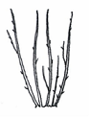 | 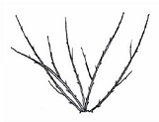 | 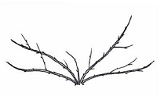
1 | 2 | 3
upright | semi-upright | spreading

Ad. 3: Only varieties with Plant: type: non-climbing: Plant: height

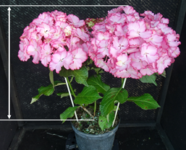

Ad. 5: Stem: fasciation

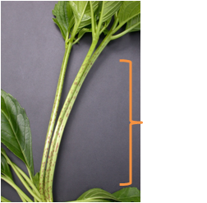

Ad. 7: Stem: number of lenticels

 | 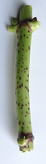 | 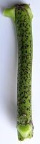
1 | 3 | 5
absent or few | medium | many

Ad. 8: Stem: size of lenticels

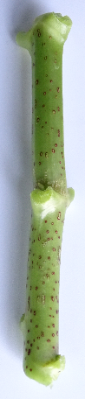 | 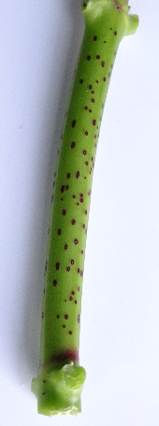 | 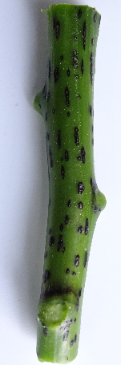
1 | 2 | 3
small | medium | large

Ad. 12: Leaf blade: lobing

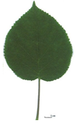 | 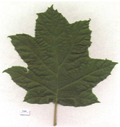
1 | 9
absent | present

Ad. 13: Only varieties with Leaf blade: lobing: absent: Leaf blade: shape

 |  | ← broadest part →
 |  | below middle | at middle | above middle
relative
width
narrow |  | 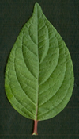  1  ovate | 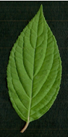  3  elliptic | 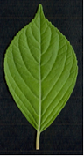  4  obovate
broad |  |  | 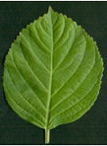  2  circular

Ad. 14: Leaf blade: length of tip

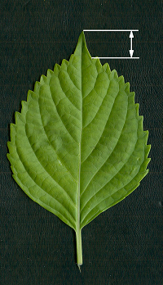

Ad. 15: Leaf blade: shape of base

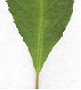 | 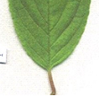 | 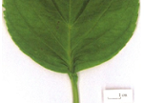 | 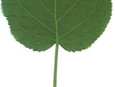
1 | 2 | 3 | 4
acute | obtuse | rounded | cordate

Ad. 16: Leaf blade: depth of incisions on margin

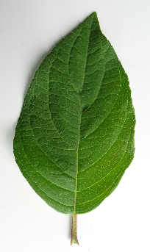 | 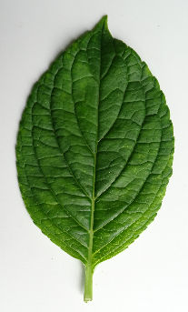 | 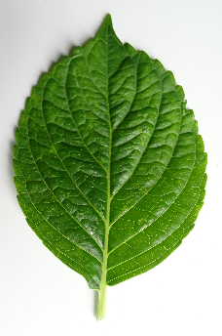 | 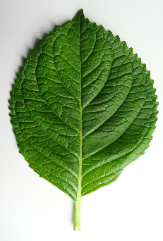 | 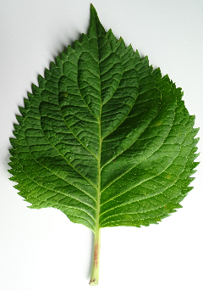
1 | 2 | 3 | 4 | 5
absent or very shallow | shallow | medium | deep | very deep

Ad. 18: Leaf blade: distribution of anthocyanin coloration

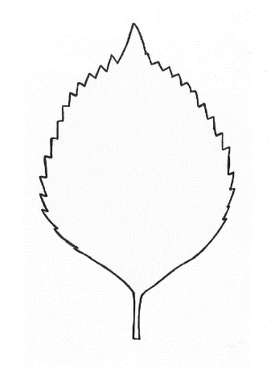 | 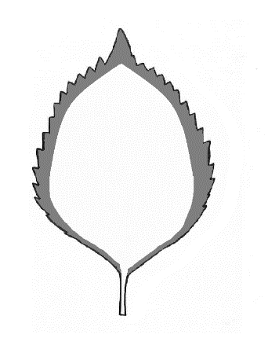 | 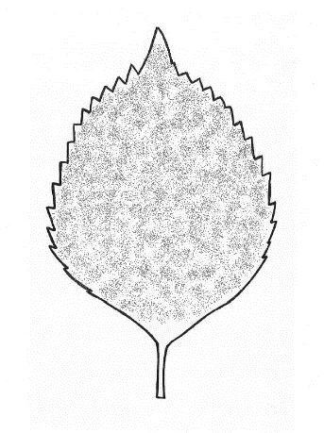
1 | 2 | 3
none | on margin | throughout

Ad. 24: Leaf blade: shape in cross-section

1 | 2 | 3
concave | flat | convex

Ad. 25: Petiole: color
Observations should be made on the middle third of the petiole on the lower side.

Ad. 26: Inflorescence: shape

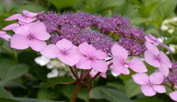 | 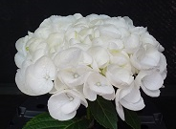 | 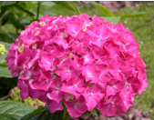
1 | 2 | 3
flattened | flattened to globular | globular

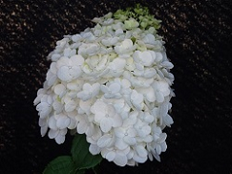 | 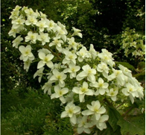
4 | 5
globular to conical | conical

Ad. 27: Inflorescence: height
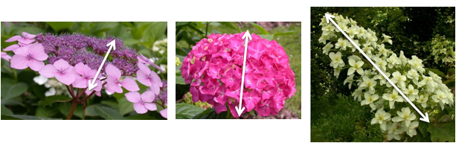

Ad. 28: Inflorescence: width

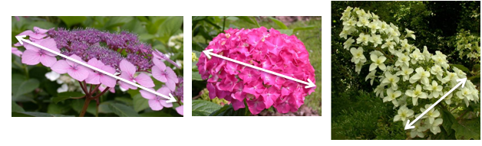

Ad. 29: Inflorescence: conspicuousness of fertile flowers

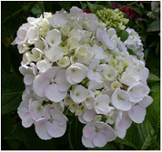 | 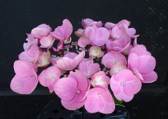 | 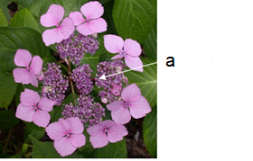
1 | 2 | 3
absent or weak | medium | strong

a = fertile flowers

Ad. 30: Only varieties with Inflorescence: conspicuousness of fertile flowers: medium and strong: Inflorescence: arrangement of sterile flowers

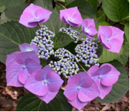 | 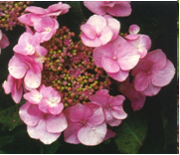 | 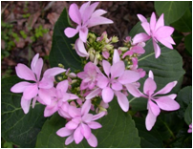
1 | 2 | 3
in one whorl | in two or more whorls | irregular

Ad. 31: Only varieties with Inflorescence: conspicuousness of fertile flowers: absent or weak: Inflorescence: density of sterile flowers

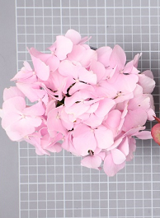 | 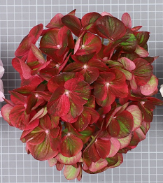 | 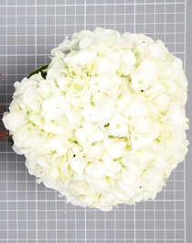
1 | 3 | 5
sparse | medium | dense

Ad. 32: Sterile flower: diameter of calyx

The observations should be made on the flattened sterile flower.
The diameter should be observed at the broadest part of the calyx.

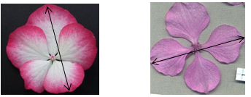

Ad. 34: Sterile flower: attitude of sepals

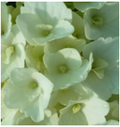 | 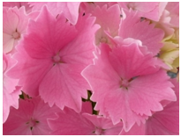 | 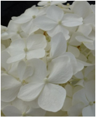
1 | 2 | 3
erect | semi-erect | horizontal

Ad. 35: Sterile flower: shape of apex of sepals

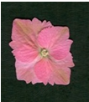 | 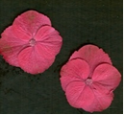 | 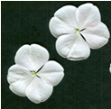
1 | 2 | 3
pointed | rounded | emarginate

Ad. 37: Sterile flower: shape of sepals in cross-section

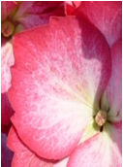 | 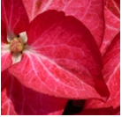 | 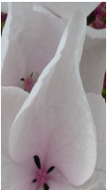
1 | 2 | 3
flat | weakly concave | strongly concave

Ad. 38: Only varieties with Sterile flower: number of sepals: 3 and 4 to 4 and 5: overlapping of sepals

For varieties with double sterile flowers observations should be made on the outermost row of sepals.

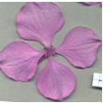 | 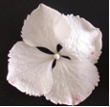 | 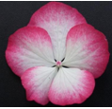 | 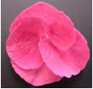 | 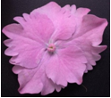
1 | 2 | 3 | 4 | 5
absent or very weak | weak | medium | strong | very strong

Ad. 39: Sterile flower: undulation of sepals

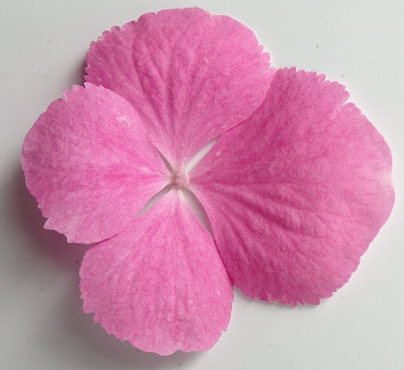 | 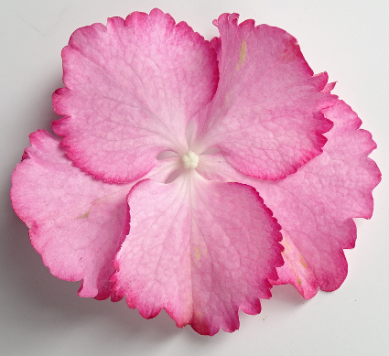 | 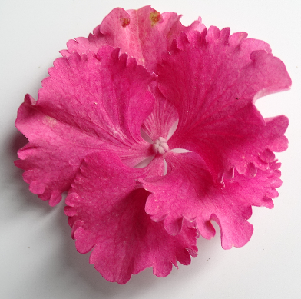
1 | 2 | 3
absent or weak | medium | strong

Ad. 40: Sterile flower: incisions of margin of sepals

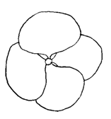 | 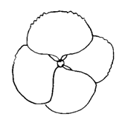 | 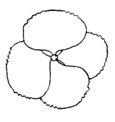
1 | 2 | 3
absent on all sepals | present on some sepals | present on all sepals

Ad. 41: Sterile flower: depth of incisions of margin of sepals

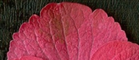 | 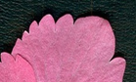 | 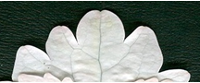
1 | 2 | 3
shallow | medium | deep

Ad. 44: Sterile flower: distribution of secondary color of inner side of sepals

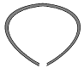 |  |  | 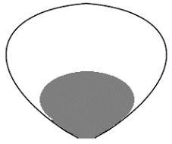
1 | 2 | 3 | 4 | 5
marginal zone | distal margin | in upper half | in lower half | throughout

Ad. 45: Sterile flower: pattern of secondary color of inner side of sepals

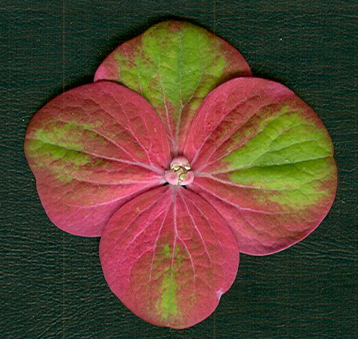 | 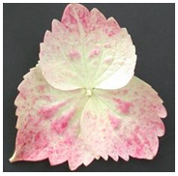 | 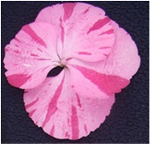
1 | 2 | 3
solid | flush | irregular

Ad. 47: Only varieties with Inflorescence: shape: conical: Inflorescence: pink or red color at aging

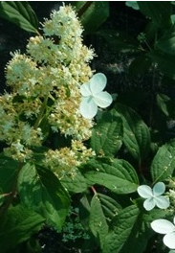 | 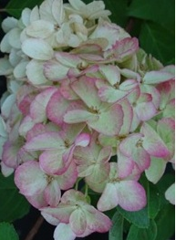 | 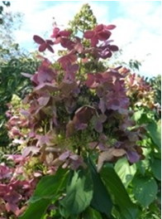
1 | 2 | 3
absent | on a part of inflorescence | on the entire inflorescence

9. | Literature

Bertrand H., Becue I., Relion D., 2007: INH, BRG. Ressources génétiques du genre Hydrangea L., collection nationale, texte et iconographie. Jan. Edition 2007, 245 pp.

Bertrand H., Relion D., Boulineau F., Chevalier C., Retailleau JM, 2004: INH-GEVES CD ROM. Description officielle des variétés d’Hydrangeas:105 variétés décrites (version 1) Nov. 2004.

BRG, INH, Bertrand H., 2007: Répertoire des ressources génétiques Hydrangea. Réseau Hydrangea 2006, Feb. edition.

Guerin V. Coord., 2002: Hydrangea: acquisitions nouvelles et applications. INRA Editions, 133 pp.

Haworth-Booth, M., 1984: The Hydrangeas. 5th Ed., Constable, London, GB, 217 pp.

Lawson-Hall T. & Rothera B. 1995: Hydrangeas a Gardeners’ Guide. Edition B.T. Batsford Ltd. London, GB, 160 pp.

Möhring, H.K., Kuhlen, H., Bosse, G., 1956: Die Hortensien. Verlag Dr. Rudolf Georgi, Aachen, DE, 238 pp.

Rehder, A., 1940: Manual of Cultivated Trees and Shrubs. 2nd Ed., Macmillan Company, New York, US, 996 pp.

Vidalie, H., 1986: Les productions florales. 4e éd., Edition J.B. Baillière, Paris, FR.

10. | Technical Questionnaire

TECHNICAL QUESTIONNAIRE | Page {x} of {y} | Reference Number:

Application date:
(not to be filled in by the applicant)
TECHNICAL QUESTIONNAIRE
to be completed in connection with an application for plant breeders' rights

1. | Subject of the Technical Questionnaire
 | 1.1 | Botanical name | Hydrangea L.
 | 1.2 | Common name | Hydrangea
 | 1.3 | Species (please indicate):

2. | Applicant
 | Name
 | Address
 | Telephone No.
 | Fax No.
 | E-mail address
 | Breeder (if different from
 | applicant)

3. | Proposed denomination and breeder's reference
 | Proposed denomination
 | (if available)
 | Breeder's reference

TECHNICAL QUESTIONNAIRE |  |  | Page {x} of {y} | Reference Number:
#4. | Information on the breeding scheme and propagation of the variety
 | 4.1 | Breeding scheme
 | Variety resulting from:
4.1.1 | Crossing
(a) | controlled cross | [ ]
(please state parent variety)

(…………………..……………..…) x (……………..…………………..…)

female parent male parent

(b) | partially known cross | [ ]
(please state known parent variety(ies))

(…………………..……………..…) x (……………..…………………..…)

female parent male parent

(c) | unknown cross | [ ]
4.1.2 | Mutation  (please state parent variety) | [ ]
4.1.3 | Discovery and development  (please state where and when discovered and how developed) | [ ]
4.1.4 | Other  (Please provide details) | [ ]

TECHNICAL QUESTIONNAIRE | Page {x} of {y} | Reference Number:

 | 4.2 | Method of propagating the variety
4.2.1 | Vegetative propagation
(a) | Cuttings | [ ]
(b) | Other (state method) | [ ]
4.2.2 | Other  (Please provide details) | [ ]

TECHNICAL QUESTIONNAIRE | Page {x} of {y} | Reference Number:

5. | Characteristics of the variety to be indicated (the number in brackets refers to the corresponding characteristic in Test Guidelines; please mark the note which best corresponds).
The example varieties given belong to the species indicated below:

(a) Hydrangea macrophylla (Thunb.) Ser. and Hydrangea serrata (Thunb.) Ser. var. serrata
(b) Hydrangea paniculata Siebold
(c) Hydrangea arborescens L.
(d) Hydrangea quercifolia W. Bartram
(e) Hydrangea petiolaris Siebold & Zucc.

 | Characteristics | Example Varieties | Note
5.1  (1) | Plant: type
 | climbing | Silver Lining (e) | 1 [ ]
 | non-climbing | Merveille (a) | 2 [ ]
5.2  (5) | Stem: fasciation
 | absent | Merveille (a) | 1 [ ]
 | present | Domotoi (a) | 9 [ ]
5.3  (6) | Stem: color
 | green | Merveille (a) | 1 [ ]
 | pink | Mid Late Summer (b) | 2 [ ]
 | red | Wims Red (b) | 3 [ ]
 | brown | Bokraflame (b) | 4 [ ]
 | black | Nigra (a) | 5 [ ]
 | green and black | Napo (a) | 6 [ ]
5.4  (17) | Leaf blade: intensity of anthocyanin coloration
 | absent or very weak | Victoria (a) | 1 [ ]
 | weak | SICAMU2934 (a) | 2 [ ]
 | medium | Red Angel (a) | 3 [ ]
 | strong | Dark Angel (a) | 4 [ ]
 | very strong | Baroque Angel (a) | 5 [ ]
5.5  (19) | Leaf blade: variegation
 | absent | Merveille (a) | 1 [ ]
 | present | Tricolor (a) | 9 [ ]
5.6  (20) | Leaf blade: main color
 | yellow | Ogonba (a) | 1 [ ]
 | light green | Mousseline (a) | 2 [ ]
 | medium green | Hobergine (a) | 3 [ ]
 | dark green | Rosalba (a) | 4 [ ]

 | TECHNICAL QUESTIONNAIRE Page {x} of {y} Reference Number:
 |  | Characteristics | Example Varieties | Note
5.7  (26) |  | Inflorescence: shape
 |  | flattened | Mousmée (a), Sea Foam (a) | 1 [ ]
 |  | flattened to globular | Wedding Gown (a) | 2 [ ]
 |  | globular | Merveille (a) | 3 [ ]
 |  | globular to conical | Kolmamon (b) | 4 [ ]
 |  | conical | Snowflake (d) | 5 [ ]
5.8  (29) |  | Inflorescence: conspicuousness of fertile flowers
 |  | absent or weak | Merveille (a) | 1 [ ]
 |  | medium | HOPE2069 (a) | 2 [ ]
 |  | strong | Mousmée (a), Sea Foam (a) | 3 [ ]
5.9  (30) |  | Only varieties with Inflorescence: conspicuousness of fertile flowers: medium and strong: Inflorescence: arrangement of sterile flowers
 |  | in one whorl | Tricolor (a) | 1 [ ]
 |  | in two or more whorls | Jogasaki (a) | 2 [ ]
 |  | irregular | Veitchii (a) | 3 [ ]
5.10  (32) |  | Sterile flower: diameter of calyx
 |  | very small |  | 1 [ ]
 |  | very small to small |  | 2 [ ]
 |  | small | Ayesha (a) | 3 [ ]
 |  | small to medium |  | 4 [ ]
 |  | medium | Hörnli (a), Mariesii (a) | 5 [ ]
 |  | medium to large |  | 6 [ ]
 |  | large | Alpenglühen (a) | 7 [ ]
 |  | large to very large |  | 8 [ ]
 |  | very large |  | 9 [ ]
5.11  (33) |  | Sterile flower: number of sepals
 |  | 3 and 4 | Preziosa (a) | 1 [ ]
 |  | only 4 | AB Green Shadow (a) | 2 [ ]
 |  | 4 and 5 | HBADU (a) | 3 [ ]
 |  | 5 and 6 | Horcos (a) | 4 [ ]
 |  | 7 or more | YOUMEFIVE (a) | 5 [ ]

 | TECHNICAL QUESTIONNAIRE Page {x} of {y} Reference Number:
 |  | Characteristics | Example Varieties | Note
5.12  (40) |  | Sterile flower: incisions of margin of sepals
 |  | absent on all sepals | Maman (a), Merveille (a) | 1 [ ]
 |  | present on some sepals | Gloria (a) | 2 [ ]
 |  | present on all sepals | Europa (a) | 3 [ ]
5.13(i)  (42) |  | Sterile flower: main color of inner side of sepals
 |  | RHS Colour Chart (indicate reference number)
5.13(ii)  (42) |  | Sterile flower: main color of inner side of sepals
 |  | white |  | 1 [ ]
 |  | green |  | 2 [ ]
 |  | light pink |  | 3 [ ]
 |  | medium pink |  | 4 [ ]
 |  | dark pink |  | 5 [ ]
 |  | red |  | 6 [ ]
 |  | other (please indicate) |  | 7 [ ]
5.14  (43) |  | Sterile flower: secondary color of inner side of sepals
 |  | none | Schneeball (a) | 1 [ ]
 |  | white | Raberah (a) | 2 [ ]
 |  | green | MAK 20 (a) | 3 [ ]
 |  | pink | Sandra (a) | 4 [ ]
 |  | red | Ripple (a) | 5 [ ]
 |  | violet |  | 6 [ ]
 |  | brown | Ruby Tuesday (a) | 7 [ ]
5.15  (47) |  | Only varieties with Inflorescence: shape: conical: Inflorescence: pink or red color at aging
 |  | absent | Dolprim (b) | 1 [ ]
 |  | on a part of inflorescence | Renba (b), Renhy (b) | 2 [ ]
 |  | on the entire inflorescence | Rendia (b) | 3 [ ]

TECHNICAL QUESTIONNAIRE | Page {x} of {y} | Reference Number:

6. | Similar varieties and differences from these varieties
Please use the following table and box for comments to provide information on how your candidate variety differs from the variety (or varieties) which, to the best of your knowledge, is (or are) most similar. This information may help the examination authority to conduct its examination of distinctness in a more efficient way.

Denomination(s) of variety(ies) similar to your candidate variety | Characteristic(s) in which your candidate variety differs from the similar variety(ies) | Describe the expression of the characteristic(s) for the similar variety(ies) | Describe the expression of the characteristic(s) for your candidate variety

Example | Sterile flower: number of  sepals | 3 and 4 | 5 and 6

 | Comments:

TECHNICAL QUESTIONNAIRE | Page {x} of {y} | Reference Number:

#7. | Additional information which may help in the examination of the variety
7.1 | In addition to the information provided in sections 5 and 6, are there any additional characteristics which may help to distinguish the variety?
 | Yes | [ ] | No | [ ]
 | (If yes, please provide details)
7.2 | Are there any special conditions for growing the variety or conducting the examination?
 | Yes | [ ] | No | [ ]
 | (If yes, please provide details)
7.3 | Other information
A representative color photograph of the variety displaying its main distinguishing feature(s), should accompany the Technical Questionnaire. The photograph will provide a visual illustration of the candidate variety which supplements the information provided in the Technical Questionnaire.
The key points to consider when taking a photograph of the candidate variety are:
• Indication of the date and geographic location
• Correct labeling (breeder’s reference)
• Good quality printed photograph (minimum 10 cm x 15 cm) and/or sufficient resolution electronic format version (minimum 960 x 1280 pixels)”
Further guidance on providing photographs with the Technical Questionnaire is available in document TGP/7 "Development of Test Guidelines", Guidance Note 35 (http://www.upov.int/tgp/en/).
[The link provided may be deleted by members of the Union when developing authorities’ own test guidelines.]

TECHNICAL QUESTIONNAIRE | Page {x} of {y} | Reference Number:

8. | Authorization for release
 | (a) | Does the variety require prior authorization for release under legislation concerning the protection of the environment, human and animal health?
 |  | Yes | [ ] | No | [ ]
 | (b) | Has such authorization been obtained?
 |  | Yes | [ ] | No | [ ]
 | If the answer to (b) is yes, please attach a copy of the authorization.

9. Information on plant material to be examined or submitted for examination

9.1 The expression of a characteristic or several characteristics of a variety may be affected by factors, such as pests and disease, chemical treatment (e.g. growth retardants or pesticides), effects of tissue culture, different rootstocks, scions taken from different growth phases of a tree, etc.
9.2 The plant material should not have undergone any treatment which would affect the expression of the characteristics of the variety, unless the competent authorities allow or request such treatment. If the plant material has undergone such treatment, full details of the treatment must be given. In this respect, please indicate below, to the best of your knowledge, if the plant material to be examined has been subjected to:

 | (a) | Microorganisms (e.g. virus, bacteria, phytoplasma) | Yes [ ] | No [ ]
 | (b) | Chemical treatment (e.g. growth retardant, pesticide) | Yes [ ] | No [ ]
 | (c) | Tissue culture | Yes [ ] | No [ ]
 | (d) | Other factors | Yes [ ] | No [ ]
 | Please provide details for where you have indicated “yes”.

10. | I hereby declare that, to the best of my knowledge, the information provided in this form is correct:
 | Applicant’s name
 | Signature |  | Date

[End of document]

