 |  | E  TG/133/4  ORIGINAL: English  DATE: 2010-03-24
INTERNATIONAL UNION FOR THE PROTECTION OF NEW VARIETIES OF PLANTS
GENEVA

 | HYDRANGEA  UPOV Code: HYDRN  Hydrangea L. | *

GUIDELINES

FOR THE CONDUCT OF TESTS

FOR DISTINCTNESS, UNIFORMITY AND STABILITY

Alternative Names:*

Botanical name | English | French | German | Spanish
Hydrangea L. | Hydrangea | Hortensia | Hortensie | Hortensia, Hidrangea

The purpose of these guidelines (“Test Guidelines”) is to elaborate the principles contained in the General Introduction (document TG/1/3), and its associated TGP documents, into detailed practical guidance for the harmonized examination of distinctness, uniformity and stability (DUS) and, in particular, to identify appropriate characteristics for the examination of DUS and production of harmonized variety descriptions.

ASSOCIATED DOCUMENTS

These Test Guidelines should be read in conjunction with the General Introduction and its associated TGP documents.
TABLE OF CONTENTS PAGE

1. Subject of these Test Guidelines 3
2. Material Required 3
3. Method of Examination 3
3.1 Number of Growing Cycles 3
3.2 Testing Place 3
3.3 Conditions for Conducting the Examination 3
3.4 Test Design 3
3.5 Number of Plants / Parts of Plants to be Examined 4
3.6 Additional Tests 4
4. Assessment of Distinctness, Uniformity and Stability 4
4.1 Distinctness 4
4.2 Uniformity 4
4.3 Stability 5
5. Grouping of Varieties and Organization of the Growing Trial 5
6. Introduction to the Table of Characteristics 5
6.1 Categories of Characteristics 5
6.2 States of Expression and Corresponding Notes 6
6.3 Types of Expression 6
6.4 Example Varieties 6
6.5 Legend 6
7. Table of Characteristics/Tableau des caractères/Merkmalstabelle/Tabla de caracteres 7
8. Explanations on the Table of Characteristics 14
9. Literature 22
10. Technical Questionnaire 23

Subject of these Test Guidelines
These Test Guidelines apply to all varieties of Hydrangea L.

Material Required
2.1 The competent authorities decide on the quantity and quality of the plant material required for testing the variety and when and where it is to be delivered. Applicants submitting material from a State other than that in which the testing takes place must ensure that all customs formalities and phytosanitary requirements are complied with.

2.2 The material is to be supplied in the form of rooted cuttings, taken from a mother plant grown in a medium that will not specifically affect the sepal color, capable of flowering and expressing all relevant characteristics of the variety during the first growing cycle.

2.3 The minimum quantity of plant material, to be supplied by the applicant, should be:

8 plants.

2.4 The plant material supplied should be visibly healthy, not lacking in vigor, nor affected by any important pest or disease.

2.5 The plant material should not have undergone any treatment which would affect the expression of the characteristics of the variety, unless the competent authorities allow or request such treatment. If it has been treated, full details of the treatment must be given.

Method of Examination

3.1 Number of Growing Cycles
The minimum duration of tests should normally be two independent growing cycles.

3.2 Testing Place
Tests are normally conducted at one place. In the case of tests conducted at more than one place, guidance is provided in TGP/9 “Examining Distinctness”.

3.3 Conditions for Conducting the Examination
The tests should be carried out under conditions ensuring satisfactory growth for the expression of the relevant characteristics of the variety and for the conduct of the examination. In particular, the plants should not be grown in a medium that will specifically affect the sepal color.

3.4 Test Design
3.4.1 Each test should be designed to result in a total of at least 8 plants.

3.4.2 The design of the tests should be such that plants or parts of plants may be removed for measurement or counting without prejudice to the observations which must be made up to the end of the growing cycle.

3.5 Number of Plants / Parts of Plants to be Examined
Unless otherwise indicated, all observations should be made on 8 plants or parts taken from each of 8 plants.

3.6 Additional Tests
Additional tests, for examining relevant characteristics, may be established.

Assessment of Distinctness, Uniformity and Stability

4.1 Distinctness

4.1.1 General Recommendations

It is of particular importance for users of these Test Guidelines to consult the General Introduction prior to making decisions regarding distinctness. However, the following points are provided for elaboration or emphasis in these Test Guidelines.

4.1.2 Consistent Differences

The differences observed between varieties may be so clear that more than one growing cycle is not necessary. In addition, in some circumstances, the influence of the environment is not such that more than a single growing cycle is required to provide assurance that the differences observed between varieties are sufficiently consistent. One means of ensuring that a difference in a characteristic, observed in a growing trial, is sufficiently consistent is to examine the characteristic in at least two independent growing cycles.

4.1.3 Clear Differences

Determining whether a difference between two varieties is clear depends on many factors, and should consider, in particular, the type of expression of the characteristic being examined, i.e. whether it is expressed in a qualitative, quantitative, or pseudo-qualitative manner. Therefore, it is important that users of these Test Guidelines are familiar with the recommendations contained in the General Introduction prior to making decisions regarding distinctness.

4.2 Uniformity
4.2.1 It is of particular importance for users of these Test Guidelines to consult the General Introduction prior to making decisions regarding uniformity. However, the following points are provided for elaboration or emphasis in these Test Guidelines:

4.2.2 For the assessment of uniformity, a population standard of 1% and an acceptance probability of at least 95% should be applied. In the case of a sample size of 8 plants, 1 off-type is allowed.

4.3 Stability
4.3.1 In practice, it is not usual to perform tests of stability that produce results as certain as those of the testing of distinctness and uniformity. However, experience has demonstrated that, for many types of variety, when a variety has been shown to be uniform, it can also be considered to be stable.

4.3.2 Where appropriate, or in cases of doubt, stability may be tested, either by growing a further generation, or by testing a new plant stock to ensure that it exhibits the same characteristics as those shown by the previous material supplied.

Grouping of Varieties and Organization of the Growing Trial
5.1 The selection of varieties of common knowledge to be grown in the trial with the candidate varieties and the way in which these varieties are divided into groups to facilitate the assessment of distinctness are aided by the use of grouping characteristics.

5.2 Grouping characteristics are those in which the documented states of expression, even where produced at different locations, can be used, either individually or in combination with other such characteristics: (a) to select varieties of common knowledge that can be excluded from the growing trial used for examination of distinctness; and (b) to organize the growing trial so that similar varieties are grouped together.

5.3 The following have been agreed as useful grouping characteristics:

- Stem: color (characteristic 5)
- Leaf blade: variegation (characteristic 15)
- Leaf blade: main color (characteristic 16)
- Inflorescence: shape (characteristic 20)
- Inflorescence: conspicuousness of fertile flowers (characteristic 23)
- Sterile flower: type (characteristic 26)
- Sterile flower: main color of sepal (characteristic 29) with the following groups:
Gr.1: white
Gr.2: light pink
Gr.3: dark pink
Gr.4: purple pink
Gr.5: red

5.4 Guidance for the use of grouping characteristics, in the process of examining distinctness, is provided through the General Introduction.

Introduction to the Table of Characteristics

6.1 Categories of Characteristics
6.1.1 Standard Test Guidelines Characteristics

Standard Test Guidelines characteristics are those which are approved by UPOV for examination of DUS and from which members of the Union can select those suitable for their particular circumstances.
6.1.2 Asterisked Characteristics

Asterisked characteristics (denoted by *) are those included in the Test Guidelines which are important for the international harmonization of variety descriptions and should always be examined for DUS and included in the variety description by all members of the Union, except when the state of expression of a preceding characteristic or regional environmental conditions render this inappropriate.

6.2 States of Expression and Corresponding Notes
States of expression are given for each characteristic to define the characteristic and to harmonize descriptions. Each state of expression is allocated a corresponding numerical note for ease of recording of data and for the production and exchange of the description.

6.3 Types of Expression
An explanation of the types of expression of characteristics (qualitative, quantitative and pseudo-qualitative) is provided in the General Introduction.

6.4 Example Varieties
Where appropriate, example varieties are provided to clarify the states of expression of each characteristic.

6.5 Legend
(*) Asterisked characteristic – see Chapter 6.1.2

QL: Qualitative characteristic – see Chapter 6.3
QN: Quantitative characteristic – see Chapter 6.3
PQ: Pseudo-qualitative characteristic – see Chapter 6.3

(+) See Explanations on the Table of Characteristics in Chapter 8.

Table of Characteristics/Tableau des caractères/Merkmalstabelle/Tabla de caracteres
 |  | English | français | deutsch | español | Example Varieties/  Exemples/  Beispielssorten/  Variedades ejemplo | Note/  Nota
1.  (*) |  | Plant: type | Plante : type | Pflanze: Typ | Planta: tipo
QL |  | climbing | grimpant | kletternd | trepadora | Nana Yakushimanum | 1
 |  | non-climbing | non grimpant | nicht kletternd | no trepadora | Merveille | 2
2.  (*) |  | Only varieties with plant type: non-climbing: Plant: growth habit | Uniquement les variétés de type non grimpant : Plante : port | Nur Sorten mit Pflanzentyp: nicht kletternd: Pflanze: Wuchsform | Sólo variedades con tipo de planta: no trepadora: Planta: hábito de crecimiento
PQ |  | upright | dressé | aufrecht | erecto | Merveille | 1
 |  | semi upright | demi dressé | halbaufrecht | semierecto |  | 2
 |  | spreading | étalé | breitwüchsig | extendido |  | 3
3.  (*)  (+) |  | Only varieties with plant type: non-climbing: Plant: natural height including inflorescence | Uniquement les variétés de type non grimpant : Plante : hauteur naturelle y compris l’inflorescence | Nur Sorten mit Pflanzentyp: nicht kletternd: Pflanze: natürliche Höhe einschließlich Blütenstand | Sólo variedades con tipo de planta: no trepadora: Planta: altura incluyendo la inflorescencia
QN |  | short | courte | niedrig | baja | Hörnli | 3
 |  | medium | moyenne | mittel | media | Merveille | 5
 |  | tall | haute | hoch | alta | Maman | 7
4.  (*)  (+) |  | Stem: fasciation | Tige : fasciation | Stiel: Verbänderung | Tallo: fasciación
QL |  | absent | absente | fehlend | ausente | Merveille | 1
 |  | present | présente | vorhanden | presente | Domotoi | 9
5.  (*) |  | Stem: color | Tige : couleur | Trieb: Farbe | Tallo: color
PQ |  | green | verte | grün | verde | Merveille | 1
 |  | brownish | brunâtre | bräunlich | amarronado |  | 2
 |  | purplish | pourpre | purpurn | purpúreo |  | 3
 |  | blackish | noirâtre | schwärzlich | negruzco | Nigra | 4
6. |  | Stem: lenticels  (in autumn) | Tige : lenticelles  (en automne) | Trieb: Lentizellen (im Herbst) | Tallo: lenticelas  (en otoño)
QN |  | absent or few | absentes ou peu nombreuses | fehlend oder wenige | ninguna o pocas | Zorro | 1
 |  | medium | moyennement nombreuses | mittel | media | Merveille | 2
 |  | many | nombreuses | viele | muchas |  | 3
7.  (*) |  | Stem: color of lenticels | Tige : couleur des lenticelles | Trieb: Farbe der Lentizellen | Tallo: color de las lenticelas
PQ |  | white | blanches | weiß | blanco | Pink Diamond | 1
 |  | red | rouges | rot | rojo | Leuchtfeuer | 2
 |  | black | noires | schwarz | negro | Merveille | 3
8.  (*) |  | Leaf blade: length | Limbe : longueur | Blattspreite: Länge | Limbo: longitud
QN |  | short | court | kurz | corta | Hörnli | 3
 |  | medium | moyen | mittel | media | Rosita | 5
 |  | long | long | lang | larga | Merveille | 7
9. |  | Leaf blade: width | Limbe : largeur | Blattspreite: Breite | Limbo: anchura
QN |  | narrow | étroit | schmal | estrecha | Shichidanka | 3
 |  | medium | moyen | mittel | media | Mrs Kumiko | 5
 |  | broad | large | breit | ancha | Snowflake | 7
10.  (*)  (+) |  | Leaf blade: lobing | Limbe : lobes | Blattspreite: Lappung | Limbo: lobulado
QL |  | absent | absents | fehlend | ausente | Merveille | 1
 |  | present | présents | vorhanden | presente | Harmony | 9
11.  (+) |  | Only varieties with leaf blade lobing: absent: Leaf blade: shape | Uniquement les variétés sans découpures des bords : Limbe : forme | Nur Sorten mit Lappung der Blattspreite: fehlend: Blattspreite: Form | Sólo variedades que no presentan limbo lobulado: Limbo: forma
PQ |  | ovate | ovale | eiförmig | oval | Merveille | 1
 |  | elliptic | elliptique | elliptisch | elíptica | Blue Ware | 2
 |  | circular | circulaire | kreisförmig | circular | Rosita | 3
12.  (*)  (+) |  | Leaf blade: length of tip | Limbe : longueur de la pointe | Blattspreite: Länge der Spitze | Limbo: longitud del ápice
QN |  | short | courte | kurz | corta | Chaperon rouge | 1
 |  | medium | moyenne | mittel | media | Mme E. Mouillère | 2
 |  | long | longue | lang | larga | Hallasan | 3
13.  (+) |  | Leaf blade: shape of base | Limbe : forme de la base | Blattspreite: Form der Basis | Limbo: forma de la base
PQ |  | acute | pointue | spitz | aguda | Europa | 1
 |  | obtuse | obtuse | stumpf | obtusa | Bosco, Hamburg | 2
 |  | rounded | arrondie | abgerundet | redondeada | Rosabelle | 3
 |  | cordate | cordiforme | herzförmig | cordada | Annabelle | 4
14. |  | Leaf blade: depth of incisions | Limbe : profondeur des incisions | Blattspreite: Tiefe der Einschnitte | Limbo: profundidad de las incisiones
QN |  | shallow | peu profondes | flach | poco profunda | King George | 3
 |  | medium | moyennes | mittel | media | Europa | 5
 |  | deep | profondes | tief | profunda | Altona | 7
15.  (*) |  | Leaf blade: variegation | Limbe : panachure | Blattspreite: Panaschierung | Limbo: variegación
QL |  | absent | absente | fehlend | ausente | Merveille | 1
 |  | present | présente | vorhanden | presente | Tricolor | 9
16.  (*)  (+) |  | Leaf blade: main color | Limbe : couleur principale | Blattspreite: Hauptfarbe | Limbo: color principal
PQ |  | yellow | jaune | gelb | amarillo | Ogonda | 1
 |  | light green | verte claire | hellgrün | verde claro | Mousseline | 2
 |  | medium green | verte moyenne | mittelgrün | verde medio | Hobergine | 3
 |  | dark green | verte foncée | dunkelgrün | verde oscuro | Rosalba | 4
 |  | purple | violette | purpurn | púrpura | Merveille Sanguinea | 5
17.  (*) |  | Leaf blade: secondary color | Limbe : couleur secondaire | Blattspreite: Sekundärfarbe | Limbo: color secundario
PQ |  | white only | seulement blanche | nur weiß | sólo blanco | Variegata | 1
 |  | white and yellow | blanche et jaune | weiß und gelb | blanco y amarillo | Tricolor | 2
 |  | yellow only | seulement jaune | nur gelb | sólo amarillo | Lemen wave | 3
18. |  | Leaf blade: glossiness of upper side | Feuille : brillance de la face supérieure | Blattspreite: Glanz der Oberseite | Limbo: brillo del haz
QN |  | absent or weak | absente ou faible | fehlend oder gering | ausente o débil | Maman | 1
 |  | moderate | modérée | mäßig | moderado | Merveille | 2
 |  | strong | forte | stark | fuerte | Ayesha, Joseph Banks | 3
19. |  | Leaf blade: blistering | Feuille : cloqûre | Blattspreite: Blasigkeit | Limbo: abullonado
QN |  | weak | faible | gering | débil | Mme Mouillère | 1
 |  | medium | moyenne | mittel | medio | Rosita | 2
 |  | strong | forte | stark | fuerte | Merveille | 3
20.  (*)  (+) |  | Inflorescence: shape | Inflorescence : forme | Blütenstand: Form | Inflorescencia: forma
PQ |  | flattened | aplatie | abgeflacht | aplanada | Mousmée, Sea Foam | 1
 |  | globular | globuleuse | kugelförmig | globulosa | Merveille | 2
 |  | conical | conique | kegelförmig | cónica | Snowflake | 3
21.  (+) |  | Inflorescence: height | Inflorescence : hauteur | Blütenstand: Höhe | Inflorescencia: altura
QN |  | short | courte | niedrig | baja | Shichidanka | 3
 |  | medium | moyenne | mittel | media | Mrs Kumiko | 5
 |  | tall | haute | hoch | alta | Snowflake | 7
22.  (+) |  | Inflorescence: diameter | Inflorescence : diamètre | Blütenstand: Durchmesser | Inflorescencia: diámetro
QN |  | small | petit | klein | pequeño | Hörnli | 3
 |  | medium | moyen | mittel | medio | Merveille | 5
 |  | large | grand | groß | grande | Maman | 7
23.  (*)  (+) |  | Inflorescence: conspicuousness of fertile flowers | Inflorescence : netteté des fleurs fertiles | Blütenstand: Ausprägung der fertilen Blüten | Inflorescencia: visibilidad de las flores fértiles
QN |  | inconspicuous or slightly conspicuous | peu nettes ou légèrement nettes | undeutlich oder etwas deutlich | invisibles o ligeramente visibles | Merveille | 1
 |  | moderately conspicuous | modérément nettes | mäßig deutlich | moderadamente visibles | Mucke | 2
 |  | very conspicuous | très nettes | sehr deutlich | muy visibles | Mousmée, Sea Foam | 3
24.  (+) |  | Only varieties with inflorescence shape: flattened: Inflorescence: arrangement of sterile flowers | Uniquement les variétés à forme d’inflorescence : aplatie : Inflorescence : répartition des fleurs stériles | Nur Sorten mit Blütenstand: Form: abgeflacht: Blütenstand: Anordnung der sterilen Blüten | Sólo variedades con forma de la inflorescencia: aplanada: Inflorescencia: disposición de las flores estériles
PQ |  | irregular | irrégulière | unregelmäßig | irregular | Vetchie | 1
 |  | in one whorl | en un verticille | in einem Quirl | en un verticilo | Tricolor | 2
 |  | in two or more whorls | en deux verticilles ou plus | in zwei oder mehr Quirlen | en dos o más verticilos | Jogasaki | 3
25.  (*)  (+) |  | Sterile flower: diameter of calyx | Fleur stérile : diamètre du calice | Sterile Blüte: Durchmesser des Kelches | Flor estéril: diámetro del cáliz
QN |  | small | petit | klein | pequeño | Ayesha | 3
 |  | medium | moyen | mittel | medio | Homli/Mariesi | 5
 |  | large | grand | groß | grande | Alpenglühen | 7
26.  (*)  (+) |  | Sterile flower: type | Fleur stérile : type | Sterile Blüte: Typ | Flor estéril: tipo
QL |  | single | simple | einfach | simple | Merveille | 1
 |  | double | double | gefüllt | doble | Amethyst, Izu-no-Hana | 2
27.  (+) |  | Sterile flower: degree of overlapping of sepals | Fleur stérile : degré de chevauchement des sépales | Sterile Blüte: Stärke des Überlappens der Kelchblätter | Flor estéril: grado de solapado de los sépalos
QN |  | absent or very weak | absent ou très faible | fehlend oder sehr gering | ausente o muy débil | Hörnli | 1
 |  | weak | faible | gering | débil | Madame Plumecoq | 2
 |  | medium | moyen | mittel | medio | Bichon | 3
 |  | strong | fort | stark | fuerte | Heinrich Siedel, Madame Gilles Goujon | 4
 |  | very strong | très fort | sehr stark | muy fuerte | Etoile Violette, Merveille Sanguinéa | 5
28.  (*)  (+) |  | Sterile flower: incisions of margin of sepal | Fleur stérile : incisions du bord du sépale | Sterile Blüte: Randeinschnitte des Kelchblattes | Flor estéril: incisiones del borde del sépalo
QN |  | absent on all sepals | absentes sur tous les sépales | fehlend an allen Kelchblättern | ausentes en todos los sépalos | Maman, Merveille | 1
 |  | present on some sepals | présentes sur quelques sépales | vorhanden an einigen Kelchblättern | presentes en algunos sépalos | Gloria | 2
 |  | present on all sepals | présentes sur tous les sépales | vorhanden an allen Kelchblättern | presentes en todos los sépalos | Europa | 3
29.  (*)  (+) |  | Sterile flower: main color of sepal | Fleur stérile : couleur principale du sépale | Sterile Blüte: Hauptfarbe des Kelchblattes | Flor estéril: color principal del sépalo
PQ | (b) | RHS Colour Chart (indicate reference number) | Code RHS des couleurs (indiquer le numéro de référence) | RHS-Farbkarte (Nummer angeben) | Carta de colores RHS (indíquese el número de referencia)
30.  (*)  (+) |  | Sterile flower: secondary color of sepal | Fleur stérile : couleur secondaire du sépale | Sterile Blüte: Sekundärfarbe des Kelchblattes | Flor estéril: color secundario del sépalo
 | (b) | absent | absente | fehlend | ausente |  | 1
 |  | white | blanche | weiß | blanco | Raberah | 2
 |  | pink | rose | rosa | rosa | Sandra | 3
 |  | red | rouge | rot | rojo | Ripple | 4
31. (*)  (+) |  | Sterile flower: distribution of secondary color of sepal | Fleur stérile :  répartition de la couleur secondaire du sépale | Sterile Blüte: Verteilung der Sekundärfarbe des Kelchblattes | Flor estéril: distribución del color secundario del sépalo
PQ |  | distal part | partie distale | distaler Teil | en la parte distal | Ripple | 1
 |  | marginal zone | marginale | Randzone | en el borde | Sandra | 2
 |  | diffuse | diffuse | diffus | difusa | Rosalba | 3
32. |  | Fertile flower: color of petals | Fleur fertile : couleur des pétales | Fertile Blüte: Farbe des Blütenblattes | Flor fértil: color de los pétalos
PQ |  | white | blancs | weiß | blanco | Rosalba | 1
 |  | pink | roses | rosa | rosa | Tricolor | 2
 |  | purple | violets | purpurn | púrpura | Lemen wave | 3
33.  (*)  (+) |  | Time of beginning of flowering | Époque de début de la floraison | Zeitpunkt des Blühbeginns | Época de inicio de la floración
QN |  | early | précoce | früh | temprana | Freudenstein | 3
 |  | medium | moyenne | mittel | media | Maman, Marveille | 5
 |  | late | tardive | spät | tardía | Europa, Hörnli, Magicien | 7

Explanations on the Table of Characteristics
Ad. 3: Only varieties with plant type: non-climbing: Plant: natural height including inflorescence

Plants should be examined during the flowering period.

Ad. 4: Stem: fasciation

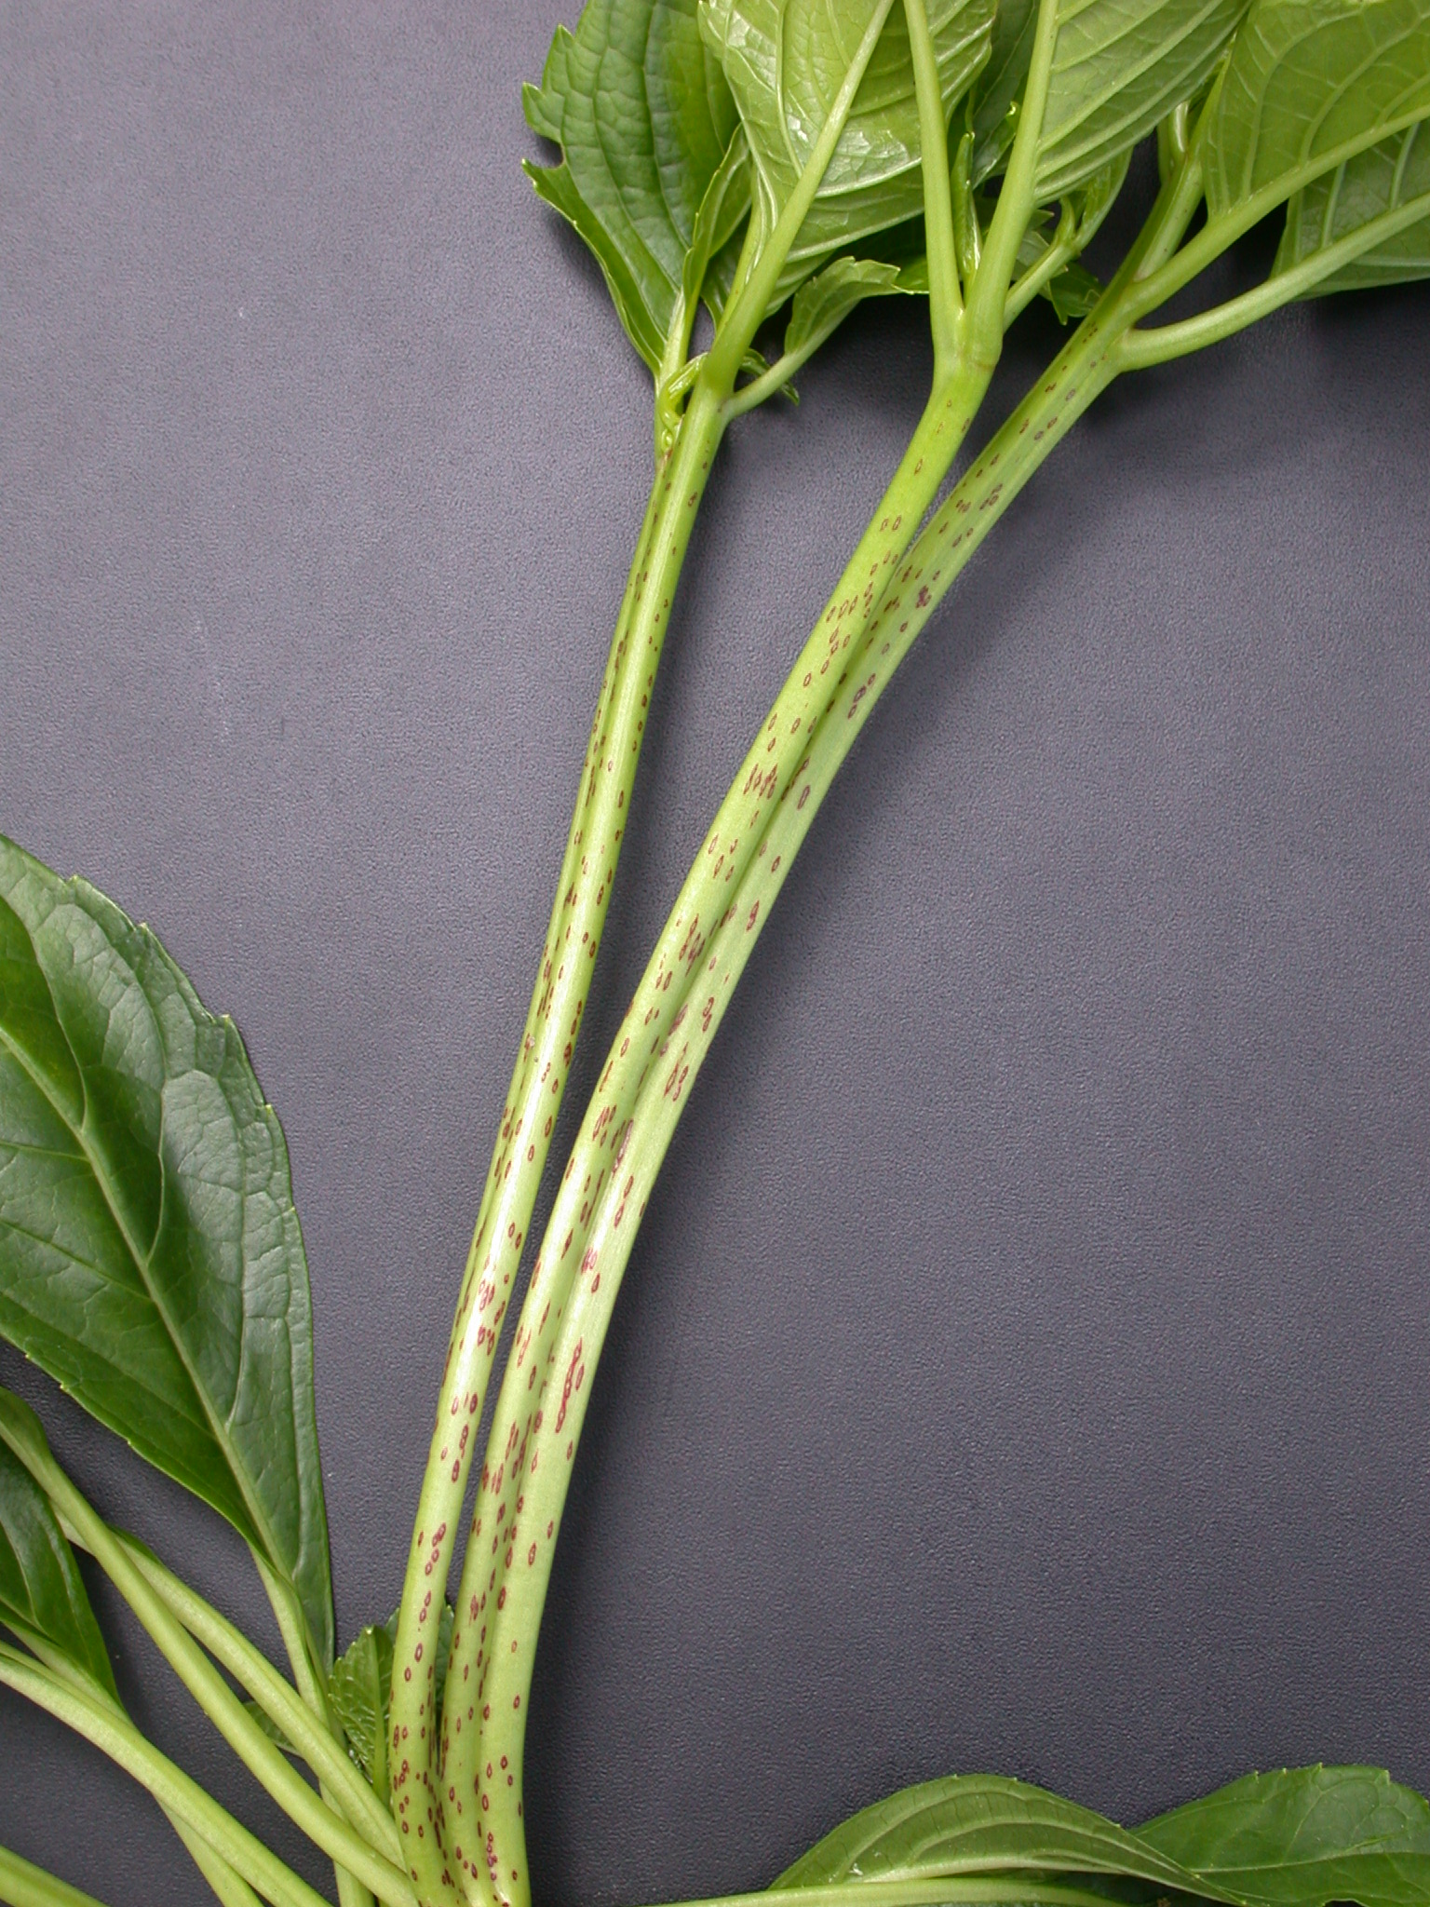
fasciation

Ad. 10: Leaf blade: lobing

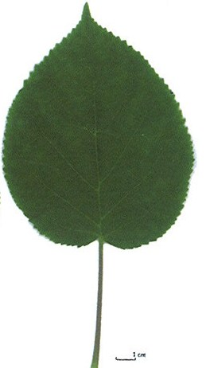 | 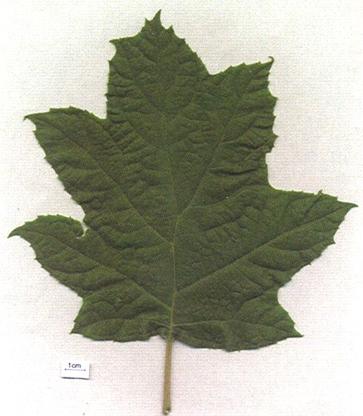
1 | 9
absent | present

Ad. 11: Only varieties with leaf blade lobing: absent: Leaf blade: shape

 |  | < position of broadest part >
 |  | below middle | at middle
< length/width ratio > | high | 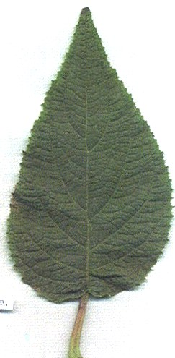  1  ovate | 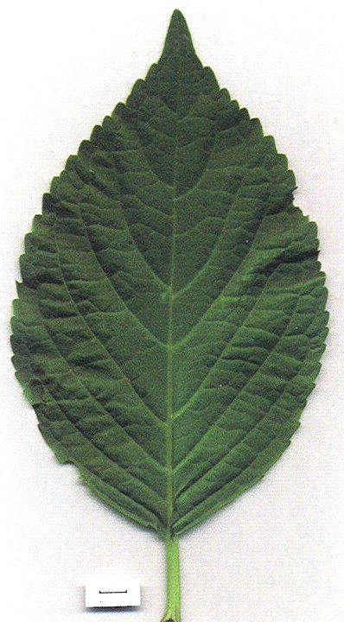  2  elliptic
< length/width ratio > | low |  | 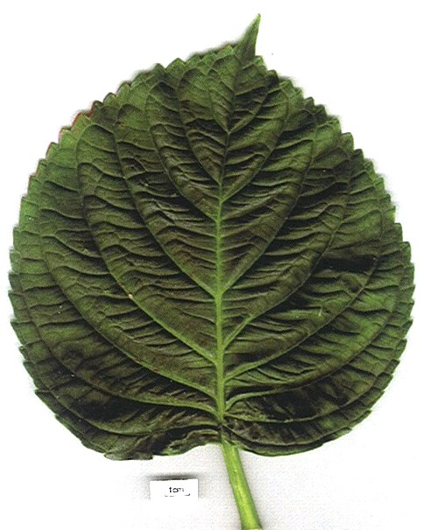  3  circular

Ad. 12: Leaf blade: length of tip

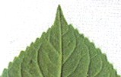 | 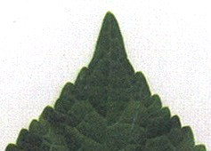 | 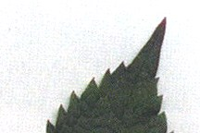
1 | 2 | 3
short | medium | long

Ad. 13: Leaf blade: shape of base

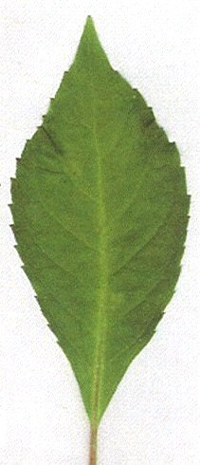 | 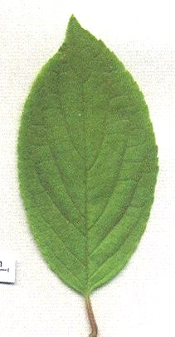 | 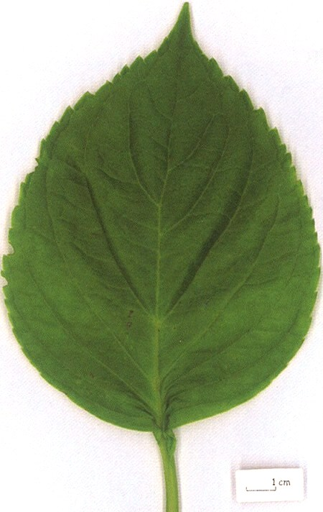 | 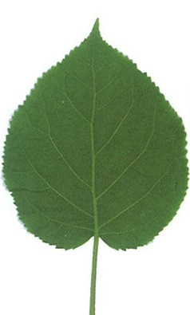
1 | 2 | 3 | 4
acute | obtuse | rounded | cordate

Ad. 16: Leaf blade: main color

The main color is the color with the largest surface area.

Ad. 20: Inflorescence: shape

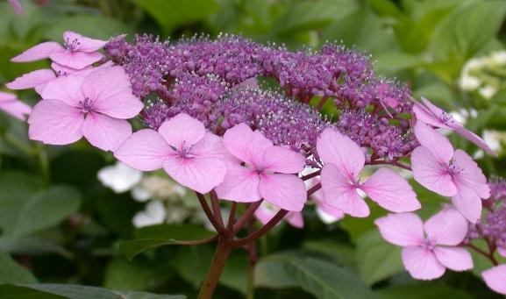 | 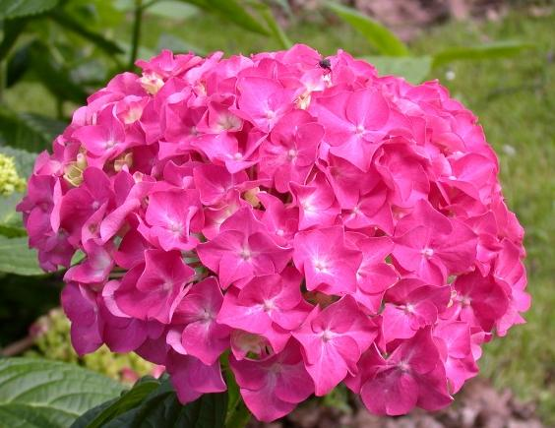 | 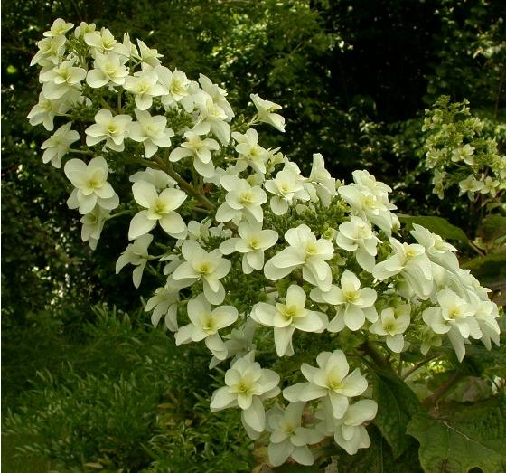
1 | 2 | 3
flattened | globular | conical

Ad. 21: Inflorescence: height

Ad. 22: Inflorescence: diameter

Ad. 23: Inflorescence: conspicuousness of fertile flowers

Fertile flowers tend to have a small inconspicuous calyx and sterile flowers have a large prominent calyx.

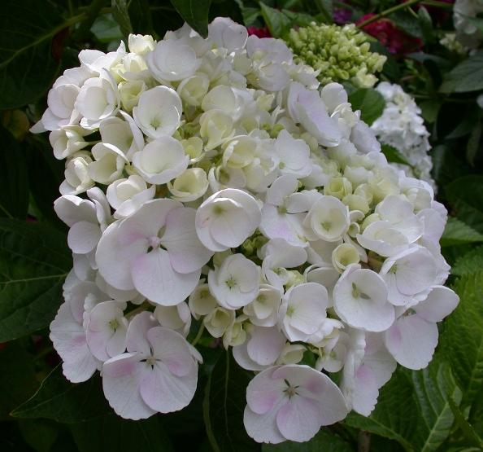  Fertile flowers | 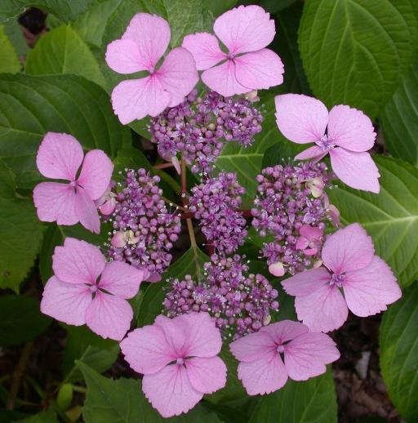
inconspicuous | very conspicuous

Ad. 24: Only varieties with flower head shape: flattened: Inflorescence: arrangement of sterile flowers

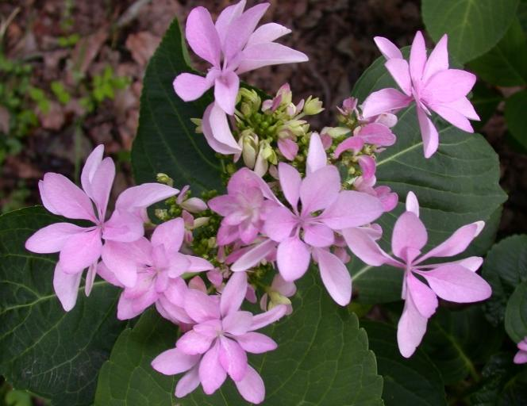 | 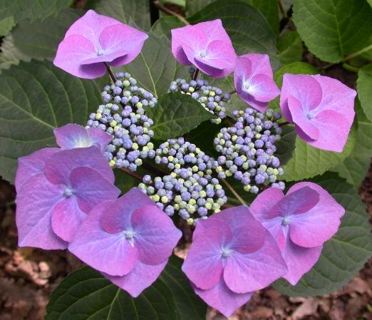 | 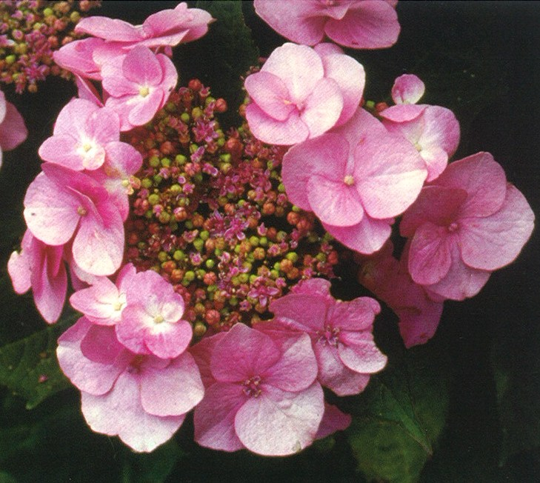
1 | 2 | 3
irregular | in one whorl | in two or more whorls

Ad. 25: Sterile flower: diameter of calyx

The diameter should be observed at the broadest part of the calyx.

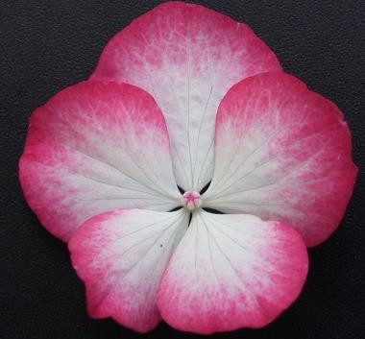

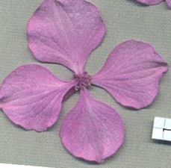

Ad. 26: Sterile flower: type

single: when the number of sepals is 3 to 6
double: when the number of sepals is > 6

Ad. 27: Sterile flower: degree of overlapping of sepals

 | 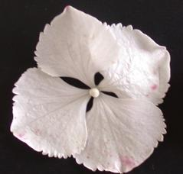 |  | 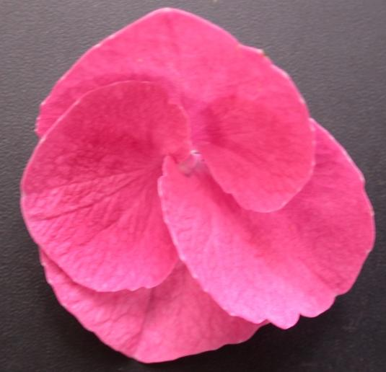 | 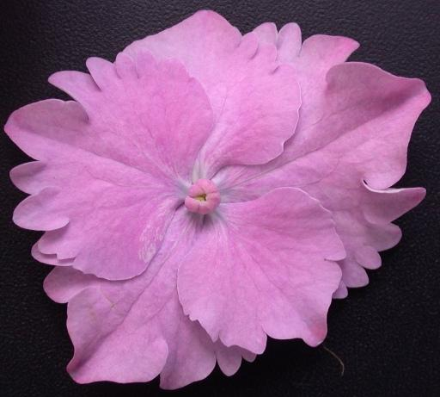
1 | 2 | 3 | 4 | 5
absent or very weak | weak | medium | strong | very strong

Ad. 28: Sterile flower: incisions of margin of sepal

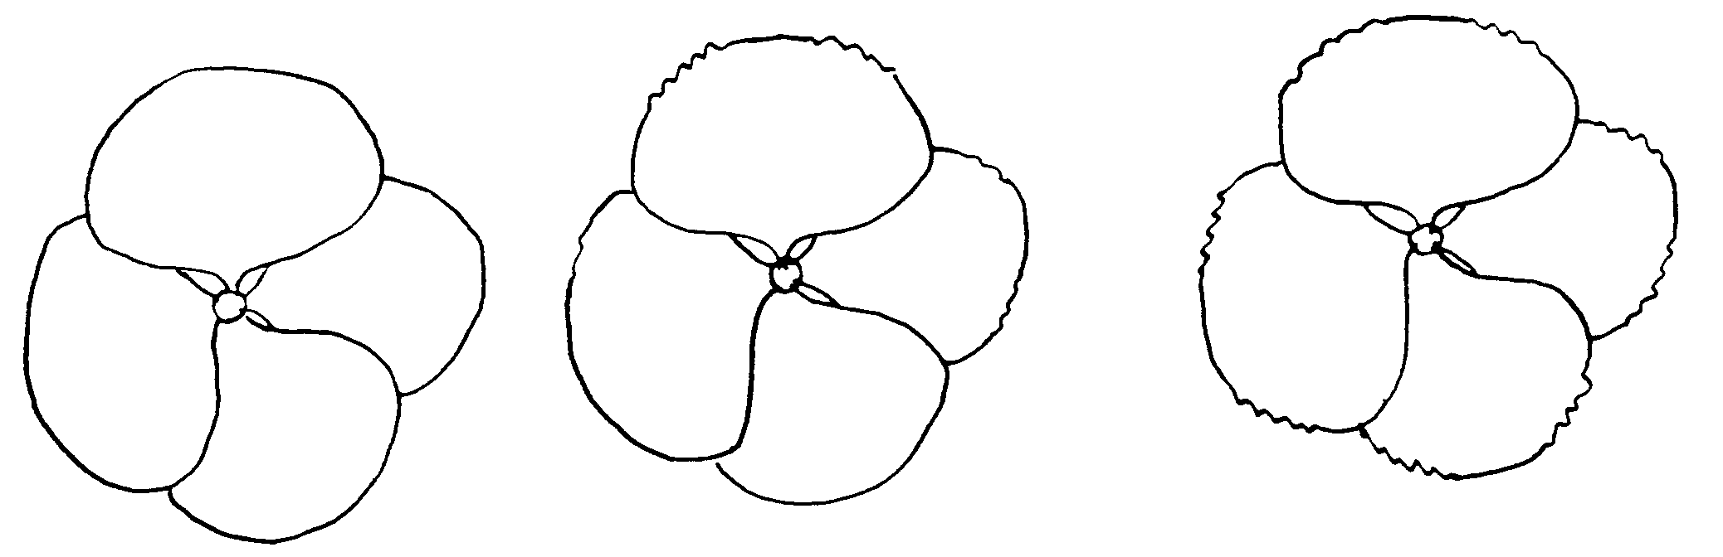
1 | 2 | 3
absent on all sepals | present on some sepals | present on all sepals

Ad. 29: Sterile flower: main color of sepal
Ad. 30: Sterile flower: secondary color of sepal

The color should be observed on plants grown in pots in a medium with pH higher than 5 and with no added aluminum or other metals that would affect the color. In other growing conditions the color could be different. The main color is the color with the largest surface area. The secondary color is the color with the second largest surface area.

Ad. 30: Sterile flower: secondary color of sepal

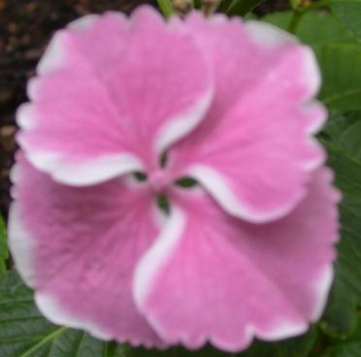 | 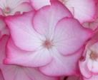
2 | 3 | 4
white | pink | red

Ad. 31: Sterile flower: distribution of secondary color of sepal

 | 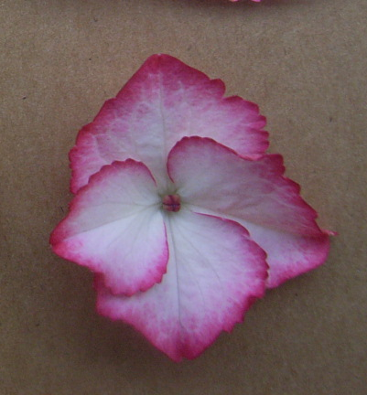 | 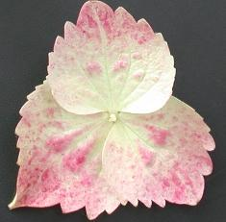
1 | 2 | 3
distal part | marginal zone | diffuse

Ad. 33: Time of beginning of flowering

The time of beginning of flowering is when one or more inflorescences have at least 90% colored sepals.

Literature
Bertrand H., Becue I., Relion D., 2007: INH, BRG. Ressources génétiques du genre Hydrangea L., collection nationale, texte et iconographie. Jan. Edition 2007, 245 pp.

Bertrand H., Relion D., Boulineau F., Chevalier C., Retailleau JM, 2004: INH-GEVES CD ROM. Description officielle des variétés d’Hydrangeas:105 variétés décrites (version 1) Nov. 2004.

BRG, INH, Bertrand H., 2007: Répertoire des ressources génétiques Hydrangea. Réseau Hydrangea 2006, Feb. edition.

Guerin V. Coord., 2002: Hydrangea: acquisitions nouvelles et applications. INRA Editions, 133 pp.

Haworth-Booth, M., 1984: The Hydrangeas. 5th Ed., Constable, London, GB, 217 pp.

Lawson-Hall T. & Rothera B. 1995: Hydrangeas a Gardeners’ Guide. Edition B.T. Batsford Ltd. London, GB, 160 pp.

Mohring, H.K., Kuhlen, H., Bosse, G., 1956: Die Hortensien. Verlag Dr. Rudolf Georgi, Aachen, DE, 238 pp.

Rehder, A., 1940: Manual of Cultivated Trees and Shrubs. 2nd Ed., Macmillan Company, New York, US, 996 pp.

Vidalie, H., 1986: Les productions florales. 4e éd., Edition J.B. Baillière, Paris, FR.

Technical Questionnaire
TECHNICAL QUESTIONNAIRE |  |  |  | Page {x} of {y} |  | Reference Number:
 |  |  |  |  |  | Application date:
 |  |  |  |  |  | (not to be filled in by the applicant)
TECHNICAL QUESTIONNAIRE
to be completed in connection with an application for plant breeders’ rights

1. Subject of the Technical Questionnaire
1.1 Genus
1.1.1 Botanical Name |  |  | Hydrangea L.
1.1.2 Common Name |  |  | Hydrangea
1.2 Species
2. Applicant
Name
Address
Telephone No.
Fax No.
E-mail address
Breeder (if different from applicant)
3. Proposed denomination and breeder’s reference
Proposed denomination
(if available)
Breeder’s reference
#4. Information on the breeding scheme and propagation of the variety

4.1 Breeding scheme

Variety resulting from:

4.1.1 Crossing

(a) controlled cross [ ]
(please state parent varieties)

(b) partially known cross [ ]
(please state known parent variety(ies))

(c) unknown cross [ ]

4.1.2 Mutation [ ]
(please state parent variety)

4.1.3 Discovery and development [ ]
(please state where and when discovered
and how developed)

4.1.4 Other [ ]
(please provide details)

4.2 Method of propagating the variety

4.2.1 Vegetative propagation

(a) cuttings [ ]
(b) in vitro propagation [ ]
(c) other (state method) [ ]

4.2.2 Seed [ ]

4.2.3 Other [ ]
(please provide details)

5. Characteristics of the variety to be indicated (the number in brackets refers to the corresponding characteristic in Test Guidelines; please mark the note which best corresponds).

 | Characteristics |  |  |  |  |  |  | Example Varieties |  |  | Note
5.1  (4) | Stem: fasciation
 | absent |  |  |  |  |  |  | Merveille |  |  | 1[ ]
 | present |  |  |  |  |  |  | Domotoi |  |  | 9[ ]
5.2  (5) | Stem: color
 | green |  |  |  |  |  |  | Merveille |  |  | 1[ ]
 | brownish |  |  |  |  |  |  |  |  |  | 2[ ]
 | purplish |  |  |  |  |  |  |  |  |  | 3[ ]
 | blackish |  |  |  |  |  |  | Nigra |  |  | 4[ ]
5.3  (16) | Leaf blade: main color
 | yellow |  |  |  |  |  |  | Ogonda |  |  | 1[ ]
 | light green |  |  |  |  |  |  | Mousseline |  |  | 2[ ]
 | medium green |  |  |  |  |  |  | Hobergine |  |  | 3[ ]
 | dark green |  |  |  |  |  |  | Rosalba |  |  | 4[ ]
 | purple |  |  |  |  |  |  | Merveille Sanguinea |  |  | 5[ ]
5.4  (20) | Inflorescence: shape
 | flattened |  |  |  |  |  |  | Mousmée, Sea Foam |  |  | 1[ ]
 | globular |  |  |  |  |  |  | Merveille |  |  | 2[ ]
 | conical |  |  |  |  |  |  | Snowflake |  |  | 3[ ]
5.5  (23) | Inflorescence: conspicuousness of fertile flowers
 | inconspicuous or slightly conspicuous |  |  |  |  |  |  | Merveille |  |  | 1[ ]
 | moderately conspicuous |  |  |  |  |  |  | Mucke |  |  | 2[ ]
 | very conspicuous |  |  |  |  |  |  | Mousmée, Sea Foam |  |  | 3[ ]
 | Characteristics |  |  |  |  |  | Example Varieties |  |  |  |  | Note
5.6  (26) | Sterile flower: type
 | single |  |  |  |  |  | Merveille |  |  |  | 1[ ]
 | double |  |  |  |  |  | Amethyst, Izu-no-Hana |  |  |  | 2[ ]
5.7(a)(i)  (29) | Sterile flower: main color of sepal  (plants continuously grown in non-bluing conditions)
 | RHS Colour Chart (indicate reference number)
5.7(a)(ii)  (29) | Sterile flower: main color of sepal  (plants continuously grown in non-bluing conditions)
 | white |  |  |  |  |  |  |  |  |  | 1[ ]
 | light pink |  |  |  |  |  |  |  |  |  | 2[ ]
 | dark pink |  |  |  |  |  |  |  |  |  | 3[ ]
 | purple pink |  |  |  |  |  |  |  |  |  | 4[ ]
 | red |  |  |  |  |  |  |  |  |  | 5[ ]
 | other |  |  |  |  |  |  |  |  |  | 6[ ]
5.7(b)(i)  (29) | Sterile flower: main color of sepal  (plants continuously grown in bluing conditions)
 | RHS Colour Chart (indicate reference number)
5.7(b)(ii)  (29) | Sterile flower: main color of sepal  (plants continuously grown in bluing conditions)
 | color (please complete) |  |  |  |  |  |  |  |  |  | [ ]
5.8  (30) | Sterile flower: secondary color of sepal
 | absent |  |  |  |  |  |  |  |  |  | 1[ ]
 | white |  |  |  |  |  | Raberah |  |  |  | 2[ ]
 | pink |  |  |  |  |  | Sandra |  |  |  | 3[ ]
 | red |  |  |  |  |  | Ripple |  |  |  | 4[ ]
6. Similar varieties and differences from these varieties

Please use the following table and box for comments to provide information on how your candidate variety differs from the variety (or varieties) which, to the best of your knowledge, is (or are) most similar. This information may help the examination authority to conduct its examination of distinctness in a more efficient way.

Denomination(s) of variety(ies) similar to your candidate variety |  | Characteristic(s) in which your candidate variety differs from the similar variety(ies) |  |  | Describe the expression of the characteristic(s) for the similar variety(ies) |  |  |  | Describe the expression of the characteristic(s) for your candidate variety
Example |  | Sterile flower: main color of sepal |  |  | light pink |  |  |  | dark pink
Comments:

#7. Additional information which may help in the examination of the variety

7.1 In addition to the information provided in sections 5 and 6, are there any additional characteristics which may help to distinguish the variety?

Yes [ ] No [ ]

(If yes, please provide details)

7.2 Are there any special conditions for growing the variety or conducting the examination?

Yes [ ] No [ ]

(If yes, please provide details)

7.3 A representative color photograph of the variety should accompany the Technical Questionnaire.

7.4 Use

(a) pot plant [ ]
(b) garden plant [ ]
(c) cut-flower [ ]
(d) other [ ]
(please provide details)

8. Authorization for release

(a) Does the variety require prior authorization for release under legislation concerning the protection of the environment, human and animal health?

Yes [ ] No [ ]

(b) Has such authorization been obtained?

Yes [ ] No [ ]

If the answer to (b) is yes, please attach a copy of the authorization.

9. Information on plant material to be examined or submitted for examination.

9.1 The expression of a characteristic or several characteristics of a variety may be affected by factors, such as pests and disease, chemical treatment (e.g. growth retardants or pesticides), effects of tissue culture, different rootstocks, scions taken from different growth phases of a tree, etc.

9.2 The plant material should not have undergone any treatment which would affect the expression of the characteristics of the variety, unless the competent authorities allow or request such treatment. If the plant material has undergone such treatment, full details of the treatment must be given. In this respect, please indicate below, to the best of your knowledge, if the plant material to be examined has been subjected to:

(a) Microorganisms (e.g. virus, bacteria, phytoplasma) Yes [ ] No [ ]

(b) Chemical treatment (e.g. growth retardant, pesticide) Yes [ ] No [ ]

(c) Tissue culture Yes [ ] No [ ]

(d) Other factors Yes [ ] No [ ]

Please provide details for where you have indicated “yes”.

……………………………………………………………

10. I hereby declare that, to the best of my knowledge, the information provided in this form is correct:

Applicant’s name

Signature Date

[End of document]

* These names were correct at the time of the introduction of these Test Guidelines but may be revised or updated. [Readers are advised to consult the UPOV Code, which can be found on the UPOV Website (www.upov.int), for the latest information.]
# Authorities may allow certain of this information to be provided in a confidential section of the Technical Questionnaire.
# Authorities may allow certain of this information to be provided in a confidential section of the Technical Questionnaire.

