 |  | E  TG/118/5 Corr.  ORIGINAL: English  DATE: 2013-03-20 + 2014-07-15
INTERNATIONAL UNION FOR THE PROTECTION OF NEW VARIETIES OF PLANTS
Geneva

 | ENDIVE  UPOV Code: CICHO_END  Cichorium endivia L. | *

GUIDELINES

FOR THE CONDUCT OF TESTS

FOR DISTINCTNESS, UNIFORMITY AND STABILITY

Alternative Names:*

Botanical name | English | French | German | Spanish
Cichorium endivia L. | Endive | Chicorée frisée,  Chicorée scarole | Endivie | Escarola

The purpose of these guidelines (“Test Guidelines”) is to elaborate the principles contained in the General Introduction (document TG/1/3), and its associated TGP documents, into detailed practical guidance for the harmonized examination of distinctness, uniformity and stability (DUS) and, in particular, to identify appropriate characteristics for the examination of DUS and production of harmonized variety descriptions.

ASSOCIATED DOCUMENTS
These Test Guidelines should be read in conjunction with the General Introduction and its associated TGP documents.
TABLE OF CONTENTS PAGE

1. Subject of these Test Guidelines 3
2. Material Required 3
3. Method of Examination 3
3.1 Number of Growing Cycles 3
3.2 Testing Place 3
3.3 Conditions for Conducting the Examination 3
3.4 Test Design 3
3.5 Additional Tests 3
4. Assessment of Distinctness, Uniformity and Stability 4
4.1 Distinctness 4
4.2 Uniformity 5
4.3 Stability 5
5. Grouping of Varieties and Organization of the Growing Trial 5
6. Introduction to the Table of Characteristics 7
6.1 Categories of Characteristics 7
6.2 States of Expression and Corresponding Notes 7
6.3 Types of Expression 7
6.4 Example Varieties 7
6.5 Legend 8
7. Table of Characteristics/Tableau des caractères/Merkmalstabelle/Tabla de caracteres 9
8. Explanations on the Table of Characteristics 15
8.1 Endive Growth Sub-Types (under Section 5.3) 15
D’été à cœur jaune 18
8.2 Explanations covering several characteristics 19
8.3 Explanation for individual characteristics 19
9. Literature 27
10. Technical Questionnaire 28

Subject of these Test Guidelines

These Test Guidelines apply to all varieties of Cichorium endivia L..

Material Required

2.1 The competent authorities decide on the quantity and quality of the plant material required for testing the variety and when and where it is to be delivered. Applicants submitting material from a State other than that in which the testing takes place must ensure that all customs formalities and phytosanitary requirements are complied with.

2.2 The material is to be supplied in the form of seed.

2.3 The minimum quantity of plant material, to be supplied by the applicant, should be:

20 g or 10,000 seeds.

The seed should meet the minimum requirements for germination, species and analytical purity, health and moisture content, specified by the competent authority. In cases where the seed is to be stored, the germination capacity should be as high as possible and should, be stated by the applicant.

2.4 The plant material supplied should be visibly healthy, not lacking in vigor, nor affected by any important pest or disease.

2.5 The plant material should not have undergone any treatment which would affect the expression of the characteristics of the variety, unless the competent authorities allow or request such treatment. If it has been treated, full details of the treatment must be given.

Method of Examination

3.1 Number of Growing Cycles

The minimum duration of tests should normally be two independent growing cycles.

3.2 Testing Place

Tests are normally conducted at one place. In the case of tests conducted at more than one place, guidance is provided in TGP/9 “Examining Distinctness”.

3.3 Conditions for Conducting the Examination

The tests should be carried out under conditions ensuring satisfactory growth for the expression of the relevant characteristics of the variety and for the conduct of the examination.

3.4 Test Design

3.4.1 Each test should be designed to result in a total of at least 60 plants, which should be divided between at least 2 replicates.

3.4.2 The design of the tests should be such that plants or parts of plants may be removed for measurement or counting without prejudice to the observations which must be made up to the end of the growing cycle.

3.5 Additional Tests

Additional tests, for examining relevant characteristics, may be established.

Assessment of Distinctness, Uniformity and Stability

4.1 Distinctness

4.1.1 General Recommendations

It is of particular importance for users of these Test Guidelines to consult the General Introduction prior to making decisions regarding distinctness. However, the following points are provided for elaboration or emphasis in these Test Guidelines.

4.1.2 Consistent Differences

The differences observed between varieties may be so clear that more than one growing cycle is not necessary. In addition, in some circumstances, the influence of the environment is not such that more than a single growing cycle is required to provide assurance that the differences observed between varieties are sufficiently consistent. One means of ensuring that a difference in a characteristic, observed in a growing trial, is sufficiently consistent is to examine the characteristic in at least two independent growing cycles.

4.1.3 Clear Differences

Determining whether a difference between two varieties is clear depends on many factors, and should consider, in particular, the type of expression of the characteristic being examined, i.e. whether it is expressed in a qualitative, quantitative, or pseudo-qualitative manner. Therefore, it is important that users of these Test Guidelines are familiar with the recommendations contained in the General Introduction prior to making decisions regarding distinctness.

4.1.4 Number of Plants / Parts of Plants to be Examined

Unless otherwise indicated, for the purposes of distinctness, all observations on single plants should be made on 20 plants or parts taken from each of 20 plants and any other observations made on all plants in the test, disregarding any off-type plants.

4.1.5 Method of Observation

The recommended method of observing the characteristic for the purposes of distinctness is indicated by the following key in the second column of the Table of Characteristics (see document TGP/9 “Examining Distinctness”, Section 4 “Observation of characteristics”):

MG: single measurement of a group of plants or parts of plants
MS: measurement of a number of individual plants or parts of plants
VG: visual assessment by a single observation of a group of plants or parts of plants
VS: visual assessment by observation of individual plants or parts of plants

Type of observation: visual (V) or measurement (M)

“Visual” observation (V) is an observation made on the basis of the expert’s judgment. For the purposes of this document, “visual” observation refers to the sensory observations of the experts and, therefore, also includes smell, taste and touch. Visual observation includes observations where the expert uses reference points (e.g. diagrams, example varieties, side-by-side comparison) or non-linear charts (e.g. color charts). Measurement (M) is an objective observation against a calibrated, linear scale e.g. using a ruler, weighing scales, colorimeter, dates, counts, etc.

Type of record: for a group of plants (G) or for single, individual plants (S)

For the purposes of distinctness, observations may be recorded as a single record for a group of plants or parts of plants (G), or may be recorded as records for a number of single, individual plants or parts of plants (S). In most cases, “G” provides a single record per variety and it is not possible or necessary to apply statistical methods in a plant-by-plant analysis for the assessment of distinctness.”

In cases where more than one method of observing the characteristic is indicated in the Table of Characteristics (e.g. VG/MG), guidance on selecting an appropriate method is provided in document TGP/9, Section 4.2.

4.2 Uniformity

4.2.1 It is of particular importance for users of these Test Guidelines to consult the General Introduction prior to making decisions regarding uniformity. However, the following points are provided for elaboration or emphasis in these Test Guidelines:

4.2.2 The assessment of uniformity should be according to the recommendations for cross-pollinated varieties in the General Introduction.

4.3 Stability

4.3.1 In practice, it is not usual to perform tests of stability that produce results as certain as those of the testing of distinctness and uniformity. However, experience has demonstrated that, for many types of variety, when a variety has been shown to be uniform, it can also be considered to be stable.

4.3.2 Where appropriate, or in cases of doubt, stability may be further examined by testing a new seed stock to ensure that it exhibits the same characteristics as those shown by the initial material supplied.

Grouping of Varieties and Organization of the Growing Trial

5.1 The selection of varieties of common knowledge to be grown in the trial with the candidate varieties and the way in which these varieties are divided into groups to facilitate the assessment of distinctness are aided by the use of grouping characteristics.

5.2 Grouping characteristics are those in which the documented states of expression, even where produced at different locations, can be used, either individually or in combination with other such characteristics: (a) to select varieties of common knowledge that can be excluded from the growing trial used for examination of distinctness; and (b) to organize the growing trial so that similar varieties are grouped together.

5.3 Firstly, the collection should be divided according to the growth types in Table 1.

In cases of doubt to which growth sub-type a variety belongs to, it should be tested in all relevant growth sub-types.

5.4 The following have been agreed as useful grouping characteristics:

(a) Leaf: color (characteristic 10)
(b) Flower: color (characteristic 25)
(c) Time of bolting (characteristic 27)

5.5 Guidance for the use of grouping characteristics, in the process of examining distinctness, is provided through the General Introduction and document TGP/9 “Examining Distinctness”.

Table 1

Plant : growth type | Growth  sub-type | Plant: diameter  (char. 1) | Plant : Shape of upper part in longitudinal section  (char 3.) | Plain type only: leaf depth of lobing  (char. 11) | Cut type only: Leaf: venation  (char. 12) | Cut type only: Leaf: length of lobes  (char. 13) | Plain type only: Leaf: creasing  (char. 17) | Cut type varieties only: Leaf: ratio length of part of leaf without lobes/total length of leaf  (char. 18) | Leaf: width of midrib at base  (char. 19)
Plain¹ | Grosse Bouclée 2 (Nummer Vijf 2) | medium (notes 5-7) | rounded | shallow  (notes 2-4) |  |  | medium  (notes 4-6) |  | medium  (notes 4-6)
Plain¹ | Breedblad Volhart Winter (A cœur plein) | medium (notes 4-6) | truncate | shallow  (notes 2-4) |  |  | strong  (notes 6-8) |  | broad  (notes 6-8)
Plain¹ | Géante maraichère | large (notes 5-8) | truncate | absent or very shallow  (note 1) |  |  | weak  (notes 1-3) |  | broad  (notes 6-8)
Plain¹ | Cornet | medium (notes 5-7) | pointed | absent or very shallow  (notes 1 or 2) |  |  | strong  (notes 5-7) |  | broad  (notes 6-8)
Plain¹ | Ambio | medium (notes 4-6) | truncate | deep (to parted)  (notes 7-9) |  |  | very strong (notes 8 or 9) |  | broad  (notes 6-8)
Cut² | Wallonne | very large (notes 7-9) | truncate |  | not flabellate | short  (notes 3 or 4) |  | medium  (notes 4-6) | broad  (notes 6-8)
Cut² | De Louviers | small (notes 1-5) | rounded |  | flabellate | long  (notes 7-9) |  | small  (notes 1-3) | very narrow  (notes 1-3)
Cut² | D’ été a cœur jaune | medium (notes 4-6) | rounded |  | semi flabellate | medium  (notes 4-6) |  | medium  (notes 4-6) | medium  (notes 4-6)

¹ The leaves of Plain growth types (C. endivia var. latifolia) are entire to almost parted, with an undulating and serrate to dentate margin;
² The leaves of Cut growth types (C. endivia var. crispa) are very deeply parted, with a crispate and dentate to laciniate margin.

The range of notes in the sub-type is indicated between brackets.

Section 8.1 provides illustrations for the growth sub-types.

Introduction to the Table of Characteristics

6.1 Categories of Characteristics

6.1.1 Standard Test Guidelines Characteristics

Standard Test Guidelines characteristics are those which are approved by UPOV for examination of DUS and from which members of the Union can select those suitable for their particular circumstances.

6.1.2 Asterisked Characteristics

Asterisked characteristics (denoted by *) are those included in the Test Guidelines which are important for the international harmonization of variety descriptions and should always be examined for DUS and included in the variety description by all members of the Union, except when the state of expression of a preceding characteristic or regional environmental conditions render this inappropriate.

6.2 States of Expression and Corresponding Notes

6.2.1 States of expression are given for each characteristic to define the characteristic and to harmonize descriptions. Each state of expression is allocated a corresponding numerical note for ease of recording of data and for the production and exchange of the description.

6.2.2 In the case of qualitative and pseudo-qualitative characteristics (see Chapter 6.3), all relevant states of expression are presented in the characteristic. However, in the case of quantitative characteristics with 5 or more states, an abbreviated scale may be used to minimize the size of the Table of Characteristics. For example, in the case of a quantitative characteristic with 9 states, the presentation of states of expression in the Test Guidelines may be abbreviated as follows:

State | Note
small | 3
medium | 5
large | 7

However, it should be noted that all of the following 9 states of expression exist to describe varieties and should be used as appropriate:

State | Note
very small | 1
very small to small | 2
small | 3
small to medium | 4
medium | 5
medium to large | 6
large | 7
large to very large | 8
very large | 9

6.2.3 Further explanation of the presentation of states of expression and notes is provided in document TGP/7 “Development of Test Guidelines”.

6.3 Types of Expression

An explanation of the types of expression of characteristics (qualitative, quantitative and pseudo-qualitative) is provided in the General Introduction.

6.4 Example Varieties

Where appropriate, example varieties are provided to clarify the states of expression of each characteristic.

6.5 Legend

(*) Asterisked characteristic – see Chapter 6.1.2

QL Qualitative characteristic – see Chapter 6.3
QN Quantitative characteristic – see Chapter 6.3
PQ Pseudo-qualitative characteristic – see Chapter 6.3

MG, MS, VG, VS – see Chapter 4.1.5

(a)-(d) See Explanations on the Table of Characteristics in Chapter 8.2.

(+) See Explanations on the Table of Characteristics in Chapter 8.3.

Table of Characteristics/Tableau des caractères/Merkmalstabelle/Tabla de caracteres

 |  | English | français | Deutsch | español | Example Varieties  Exemples  Beispielssorten  Variedades ejemplo | Note/  Nota
1.  (*) | VG | Plant: diameter | Plante : diamètre | Pflanze: Durchmesser | Planta: diámetro
QN | (a) | very small | très petit | sehr klein | muy pequeño | Belusa | 1
 |  | small | petit | klein | pequeño | De Louviers | 3
 |  | medium | moyen | mittel | medio | Blonde à cœur plein,  D’été à cœur jaune, Golda | 5
 |  | large | grand | groß | grande | Grosse Pancalière | 7
 |  | very large | très grand | sehr groß | muy grande | Superfiorentina, Wallonne | 9
2.  (+) | VG | Plant: growth habit | Plante : port | Pflanze: Wuchsform | Planta: porte
QN | (a) | upright | dressé | aufrecht | erecto | Gloire de l’Exposition | 1
 |  | semi-upright | demi-dressé | halbaufrecht | semierecto | Blonde à cœur plein,  D’été à cœur jaune | 2
 |  | horizontal | horizontal | waagerecht | horizontal | Argentée Mirabel, De Ruffec | 3
3.  (*)  (+) | VG | Plant: shape of upper part in longitudinal section | Plante : forme de la partie supérieure en section longitudinale | Pflanze: Form des oberen Teils im Längsschnitt | Planta: forma de la parte superior en sección longitudinal
PQ | (a) | truncate | tronquée | gerade | truncada | Aery, Gloire de l’Exposition | 1
 |  | rounded | arrondie | abgerunded | redondeada | Ameris, Dafne,  Grosse Bouclée 2 | 2
 |  | pointed | pointue | zugespitzt | puntiaguda | Cornet de la Loire | 3
4.  (+) | VG | Heart: tendency to bleach | Cœur : tendance au blanchissement | Herz: Neigung zum Bleichen | Cogollo: tendencia a la decoloración
QN | (a) | absent or weak | absente ou faible | fehlend oder gering | ausente o débil | Géante maraîchère | 1
 |  | moderate | modérée | mäßig | moderada | Amos, D’été à cœur jaune | 2
 |  | strong | forte | stark | fuerte | Starly | 3
5.  (+) | VG | Leaf: inflexing of upper part | Feuille : courbure de la partie supérieure | Blatt: Biegung des oberen Teils | Hoja: inflexión de la parte superior
QN | (b) | weak | faible | gering | débil | Cornet de la Loire | 1
 |  | medium | moyenne | mittel | media | Blonde à cœur plein | 2
 |  | strong | forte | stark | fuerte | D’hiver de Provence | 3
6. | VG | Leaf: length | Feuille : longueur | Blatt: Länge | Hoja: longitud
QN | (b) | very short | très courte | sehr kurz | muy corta | Nairobi | 1
 |  | short | courte | kurz | corta | Gloire de l’Exposition | 3
 |  | medium | moyenne | mittel | media | D’hiver de Provence,  Grosse Bouclée 2 | 5
 |  | long | longue | lang | larga | D’été à cœur jaune, Tebas | 7
 |  | very long | trés longue | sehr lang | muy larga | Atleta | 9
7. | VG | Plain type varieties only: Leaf: width | Variétés de type scarole seulement : Feuille : largeur | Nur ganzblättrige Sorten: Blatt: Breite | Sólo variedades de hojas anchas: Hoja: anchura
QN | (b) | narrow | étroite | schmal | estrecha | Pacos | 3
 |  | medium | moyenne | mittel | media | Grosse Bouclée 2 | 5
 |  | broad | large | breit | ancha | Géante maraîchère | 7
8. | VG | Cut type varieties only: Leaf: width | Variétés de type frisée seulement : Feuille : largeur | Nur krausblättrige Sorten: Blatt: Breite | Sólo variedades de hojas rizadas: Hoja: anchura
QN | (b) | narrow | étroite | schmal | estrecha | Wallonne | 3
 |  | medium | moyenne | mittel | media | Belusa,  D’hiver de Provence | 5
 |  | broad | large | breit | ancha | D’été à cœur jaune | 7
9.  (+) | VG | Plain type varieties only: Leaf: shape | Variétés de type scarole seulement : Feuille : forme | Nur ganzblättrige Sorten: Blatt: Form | Sólo variedades de hojas anchas: Hoja: forma
QN | (b) | narrow obovate | obovale étroite | schmal verkehrt eiförmig | obovado estrecha | Escariol grüner, Pacos | 1
 |  | medium obovate | obovale moyenne | mittel verkehrt eiförmig | obovado media | Andes | 3
 |  | broad obovate | obovale large | breit verkehrt eiförmig | obovado ancha | Diva, Géante maraîchère, Kalinka | 5
10.  (*) | VG | Leaf: color | Feuille : couleur | Blatt: Farbe | Hoja: color
PQ | (b) | light yellowish green | vert jaunâtre clair | hell gelblichgrün | verde amarillento claro | Belusa | 1
 |  | medium yellowish green | vert jaunâtre moyen | mittel gelblichgrün | verde amarillento medio | Blonde à cœur plein, Magaly, Tarquinis | 2
 |  | dark yellowish green | vert jaunâtre foncé | dunkel gelblichgrün | verde amarillento oscuro | Kampero | 3
 |  | very light green | vert très clair | sehr hellgrün | verde muy claro | Gloire de l’exposition, Systel | 4
 |  | light green | vert clair | hellgrün | verde claro | Cathie, Milady, Solera | 5
 |  | medium green | vert moyen | mittelgrün | verde medio | Géante Maraîchère, Nuance, Sally | 6
 |  | dark green | vert foncé | dunkelgrün | verde oscuro | Atleta, Minerva, Wallonne | 7
 |  | very dark green | vert très foncé | sehr dunkelgrün | verde muy oscuro | D’hiver de Provence, Isola | 8
 |  | light greyish green | vert grisâtre clair | hell gräulichgrün | verde grisáceo claro | Barundi, De Louviers, Lassie | 9
 |  | medium greyish green | vert grisâtre moyen | mittel gräulichgrün | verde grisáceo medio | Argentée Mirabel, Constance, Woodie | 10
 |  | dark greyish green | vert grisâtre foncé | dunkel gräulichgrün | verde grisáceo oscuro | De Namur, Snoopie | 11
11.  (+) | VG | Plain type varieties only: Leaf: depth of lobing | Variétés de type scarole seulement : Feuille : profondeur de la découpure | Nur ganzblättrige Sorten: Blatt: Tiefe der Lappung | Sólo variedades de hojas anchas: Hoja: profundidad del lobulado
QN | (b) | absent or very shallow | absente ou très peu profonde | fehlend oder sehr flach | ausente o muy poco profundo | Géante Mâraichère | 1
 |  | shallow | peu profonde | flach | poco profundo | Blonde à Coeur plein, Grosse Bouclée 2 | 3
 |  | medium | moyenne | mittel | medio | Maruschka | 5
 |  | deep | profonde | tief | profundo | Ambio | 7
 |  | very deep | très profonde | sehr tief | muy profundo | Friscaro | 9
12.  (+) | VG | Cut type varieties only: Leaf: venation | Variétés de type frisée seulement : Feuille : nervation | Nur krausblättrige Sorten: Blatt: Aderung | Sólo variedades de hojas rizadas: Hoja: nervadura
QN | (b) | not flabellate | non flabelliforme | nicht fächerförmig | no flabeliforme | Wallonne | 1
 |  | semi flabellate | semi-flabelliforme | halb-fächerförmig | semiflabeliforme | D’été à coeur jaune | 2
 |  | flabellate | flabelliforme | fächerförmig | flabeliforme | De Louviers,  Gloire de l’exposition | 3
13.  (+) | VG | Cut type varieties only: Leaf: length of lobes | Variétés de type frisée seulement : Feuille : longueur des lobes | Nur krausblättrige Sorten: Blatt: Länge der Lappen | Sólo variedades de hojas rizadas: Hoja: longitud de los lóbulos
QN | (b) | short | courts | kurz | cortos | Wallonne | 3
 |  | medium | moyens | mittel | medios | D’été à Coeur jaune | 5
 |  | long | longs | lang | largos | Trés fine Mâraichére | 7
 |  | very long | très longs | sehr lang | muy largos |  | 9
14.  (+) | VG | Plain type varieties only: Leaf: dentation of margin | Variétés de type scarole seulement : Feuille : denture du bord | Nur ganzblättrige Sorten: Blatt: Zähnung des Randes | Sólo variedades de hojas anchas: Hoja: dentado del borde
QN | (b) | absent or weak | absente ou faible | fehlend oder gering | ausente o débil | Grosse Bouclée 2 | 1
 |  | medium | moyenne | mittel | medio | Géante Mâraichère | 2
 |  | strong | forte | stark | fuerte | Cornet | 3
15.  (+) | VG | Cut type varieties only: Leaf: length of dentation of margin | Variétés de type frisée seulement : Feuille : longueur de la denture du bord | Nur krausblättrige Sorten: Blatt: Länge der Zähnung des Randes | Sólo variedades de hojas rizadas: Hoja: longitud del dentado del borde
QN | (b) | short | courte | kurz | corto | Atleta | 3
 |  | medium | moyenne | mittel | medio | Trés fine Mâraichére | 5
 |  | long | longue | lang | largo | Ruffec | 7
16.  (+) | VG | Plain type varieties only: Leaf: undulation of margin | Variétés de type scarole seulement : Feuille : ondulation du bord | Nur ganzblättrige Sorten: Blatt: Randwellung | Sólo variedades de hojas anchas: Hoja: ondulación del borde
QN | (b) | weak | faible | gering | débil | Ophely | 3
 |  | medium | moyenne | mittel | media | Grosse Bouclée 2 | 5
 |  | strong | forte | stark | fuerte | Gigance | 7
17. | VG | Plain type varieties only: Leaf: creasing | Variétés de type scarole seulement : Feuille : crispation | Nur ganzblättrige Sorten: Blatt: Faltung | Sólo variedades de hojas anchas: Hoja: crenado
QN | (b) | weak | faible | gering | débil | Géante Mâraichère | 3
 |  | medium | moyenne | mittel | medio | Grosse Bouclée 2 | 5
 |  | strong | forte | stark | fuerte | Blonde à cœur plein | 7
18.  (*)  (+) | VG | Cut type varieties only: Leaf: ratio length of part of leaf without lobes/total length of leaf | Variétés de type frisée seulement : Feuille : rapport longueur de la partie de la feuille sans lobes/longueur totale de la feuille | Nur krausblättrige Sorten: Blatt: Verhältnis Länge des Blattteils ohne Lappen/Gesamtlänge des Blattes | Sólo variedades de hojas rizadas: Hoja: relación entre la longitud de la parte de la hoja sin lóbulos y la longitud total de la hoja
QN | (b) | very low | très bas | sehr klein | muy baja | D’Olivet | 1
 |  | low | bas | klein | baja | De Louviers | 3
 |  | medium | moyen | mittel | media | Wallonne | 5
 |  | high | élevé | groß | alta |  | 7
 |  | very high | très élevé | sehr groß | muy alta | Toujours Blanche | 9
19.  (*) | VG | Leaf: width of midrib at base | Feuille : largeur de la nervure médiane à la base | Blatt: Breite der Mittelrippe an der Basis | Hoja: anchura del nervio central en la base
QN | (b) | very narrow | très étroite | sehr schmal | muy estrecho | Fresseta | 1
 |  | narrow | étroite | schmal | estrecho | Mercedes | 3
 |  | medium | moyenne | mittel | medio | D’été à cœur jaune,  Grosse Bouclée 2 | 5
 |  | broad | large | breit | ancho | Blonde à cœur plein, Wallonne | 7
20.  (*) | (b) | Cut type varieties only: Leaf: anthocyanin coloration at base | Variétés de type frisée seulement : Feuille : pigmentation anthocyanique de la nervure médiane à la base | Nur krausblättrige Sorten: Blatt: Anthocyanfärbung an der Basis | Sólo variedades de hojas rizadas: Hoja: pigmentación antociánica en la base
QN |  | absent or weak | nulle ou faible | fehlend oder gering | ausente o débil | D’été à cœur jaune | 1
 |  | medium | moyenne | mittel | media |  | 2
 |  | strong | forte | stark | fuerte | De Meaux | 3
21.  (+) | VG | Stem: height | Tige : hauteur | Stängel: Höhe | Tallo: altura
QN | (c) | short | courte | niedrig | bajo | De Louviers | 3
 |  | medium | moyenne | mittel | medio | D’été à cœur jaune | 5
 |  | tall | haute | hoch | alto | Cornet de la Loire,  D’Hiver de Provence | 7
22.  (+) | VG | Stem: fasciation | Tige : fasciation | Stängel: Verbänderung | Tallo: fasciación
QL | (c) | absent | absente | fehlend | ausente | Cornet d’Anjou,  D’Hiver de Provence,  De Ruffec | 1
 |  | present | présente | vorhanden | presente | Golda, Grosse Bouclée 2 | 9
23. | VG | Stem: attitude of branches | Tige : port des ramifications | Stängel: Stellung der Seitentriebe | Tallo: porte de las ramificaciones
QN | (c) | erect | dressé | aufrecht | erecto | Grosse Bouclée 2 | 1
 |  | semi-erect | demi-dressé | halbaufrecht | semierecto |  | 3
 |  | horizontal | horizontal | waagerecht | horizontal | Ariga | 5
24. | VG | Plain type varieties only: Stem: shape of stipules | Variétés de type scarole seulement : Tige : forme des stipules | Nur ganzblättrige Sorten: Stängel: Form der Nebenblätter | Sólo variedades de hojas anchas: Tallo: forma de las estípulas
QN | (c) | narrow elliptic | elliptique étroits | schmal elliptisch | elíptica estrecha |  | 1
 |  | broad elliptic | elliptiques larges | breit elliptisch | elíptica ancha | Blonde à cœur plein | 2
 |  | circular | arrondis | kreisförmig | circular | Solera | 3
25.  (*)  (+) | VG | Flower: color | Fleur : couleur | Blüte: Farbe | Flor: color
PQ |  | white | blanche | weiß | blanco | De Louviers,  Grosse pommant seule | 1
 |  | light pink | rose pâle | hellrosa | rosa claro | Lisuna | 2
 |  | dark pink | rose foncé | dunkelrosa | rosa oscuro | Ascari | 3
 |  | blue | bleue | blau | azul | Grosse Bouclée 2 | 4
 |  | violet blue | bleu violacé | violettblau | azul violeta | Alaska, Ariga, Sally, Wallonne | 5
26.  (+) | MG | Time of harvest maturity | Époque de maturité de récolte | Zeitpunkt der Erntereife | Época de madurez para la cosecha
QN |  | early | précoce | früh | temprana | Sally | 3
 |  | medium | moyenne | mittel | media |  | 5
 |  | late | tardive | spät | tardía | Wallonne | 7
 |  | very late | très tardive | sehr spät | muy tardía | Cornet d’Anjou | 9
27.  (*) | MG | Time of bolting | Époque de montaison | Zeitpunkt des Schossens | Época de espigado a flor
QN |  | very early | très précoce | sehr früh | muy temprana | Noveli | 1
 |  | early | précoce | früh | temprana | De Meaux,  Grosse pommant seule | 3
 |  | medium | moyenne | mittel | media | Sally | 5
 |  | late | tardive | spät | tardía | Blonde à cœur plein | 7
 |  | very late | très tardive | sehr spät | muy tardía | Excel | 9

Explanations on the Table of Characteristics

8.1 Endive Growth Sub-Types (under Section 5.3)

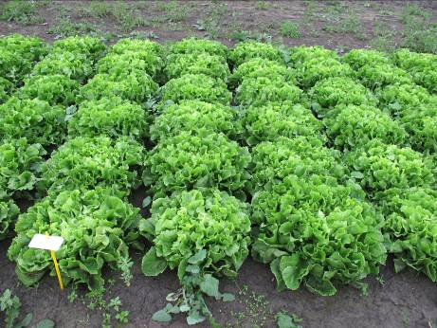
Grosse bouclée 2 (Nummer Vijf 2)

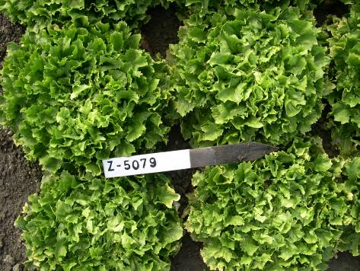
Breedblad Volhart Winter (A cœur plein)

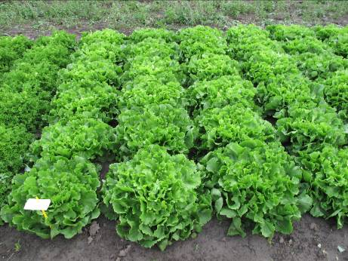
Géante maraichère

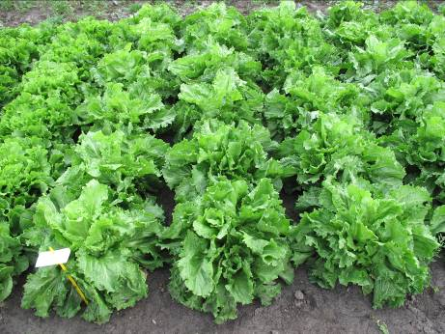
Cornet

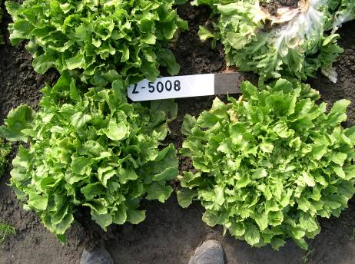
Ambio

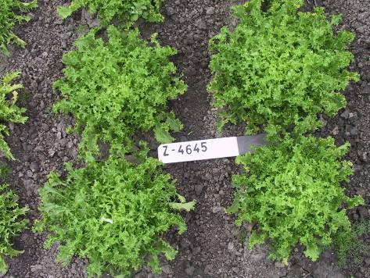
Wallonne

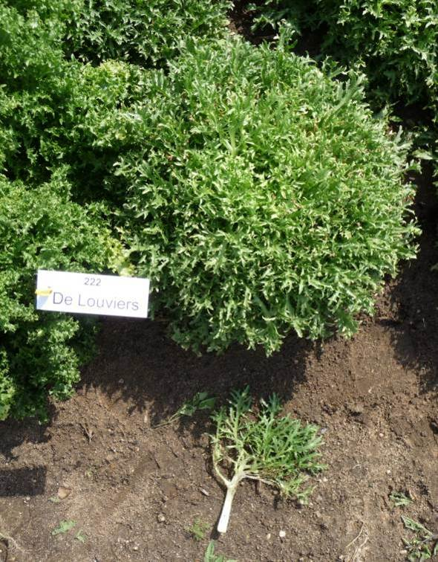
De Louviers

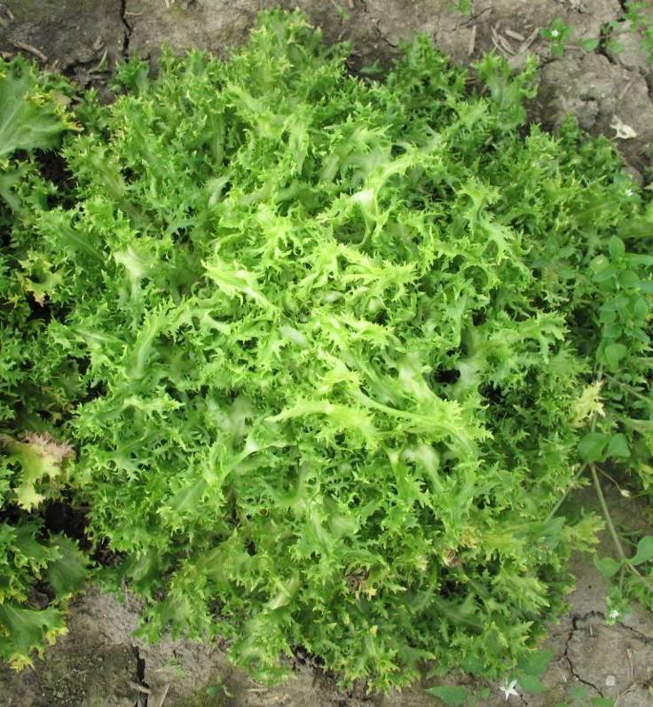

D’été à cœur jaune

8.2 Explanations covering several characteristics

Characteristics should be observed under natural conditions without forcing measures.

Characteristics containing the following key in the second column of the Table of Characteristics should be examined as indicated below:

(a) Plant: Observations on the plant should be made just before harvest maturity.

(b) Leaf: Observations on the leaf should be made just before harvest maturity on leaves excluding the outer and center leaves.

(c) Stem: Observations on the stem should be made on a flowering stem.

(d) Flower: The color should be observed on just opened flowers, because the color of the flowers changes with ageing.

8.3 Explanation for individual characteristics

Ad. 2: Plant: growth habit

1 | 2
upright | semi-upright
3
horizontal

Ad. 3: Plant: shape of upper part in longitudinal section

1 | 2
truncate | rounded
3
pointed

Ad. 4: Heart: tendency to bleach

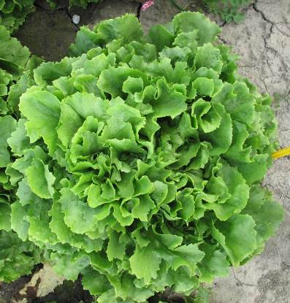 | 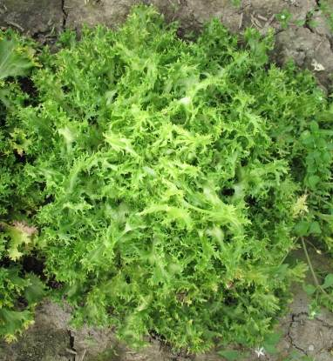 | 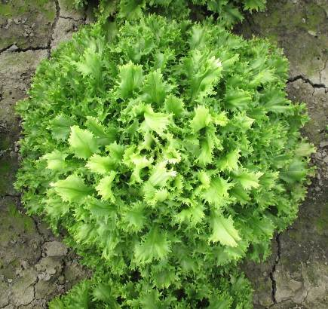
1 | 2 | 3
absent or weak | moderate | strong

Ad. 5: Leaf: inflexing of upper part

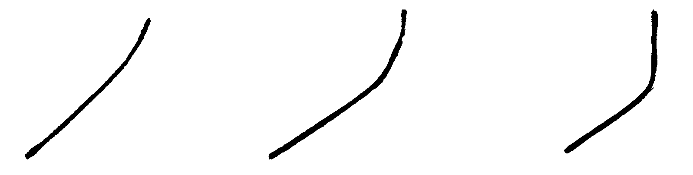

1 | 2 | 3
weak | medium | strong

Ad. 9: Plain type varieties only: Leaf: shape

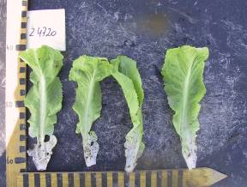 | 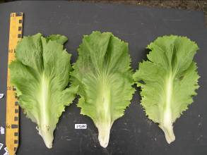 | 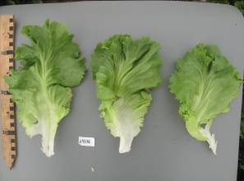
1 | 3 | 5
narrow obovate | medium obovate | broad obovate

Ad. 11: Plain type varieties only: Leaf: depth of lobing

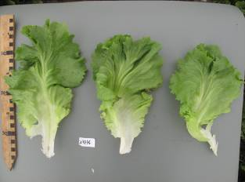 | 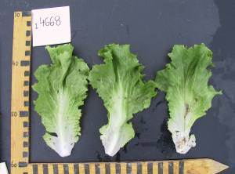 | 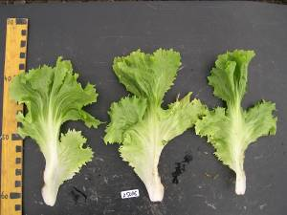 | 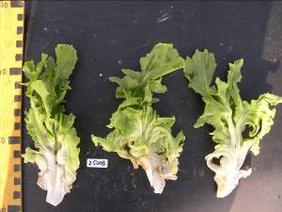
1 | 3 | 5 | 7
absent or very shallow | shallow | medium | deep

Ad. 12: Cut type varieties only: Leaf: venation

1 | 2 | 3
not flabellate | semi flabellate | flabellate

Ad. 13: Cut type varieties only: Leaf: length of lobes

The length of the lobes is to be observed from the attachment to the tip, following the curving of the lobes.
In this illustration the length of the lobe is indicated by a dotted line.

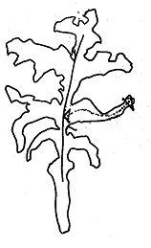

Ad. 14: Plain type varieties only: Leaf: dentation of margin

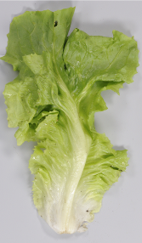 | 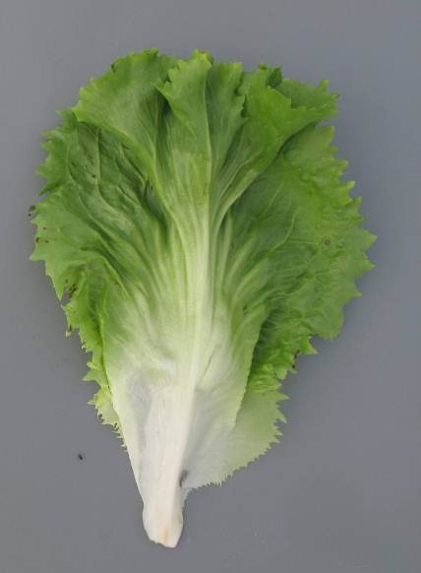 | 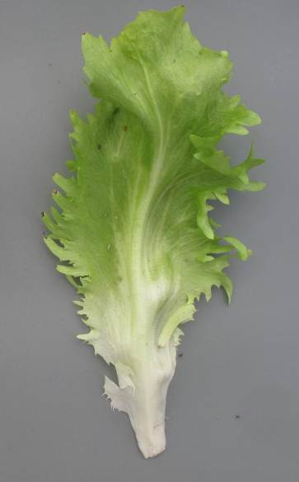
1 | 2 | 3
absent or weak | medium | strong

Ad. 15: Cut type varieties only: Leaf: length of dentation of margin

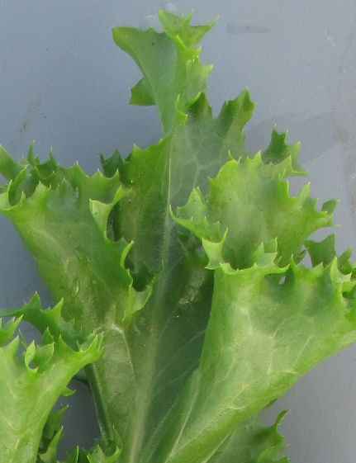 | 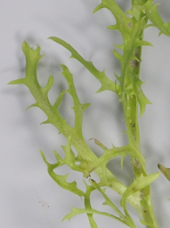 | 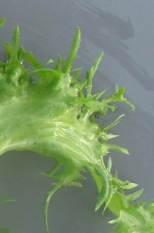
3 | 5 | 7
short | medium | long

Ad. 16: Plain type varieties only: Leaf: undulation of margin

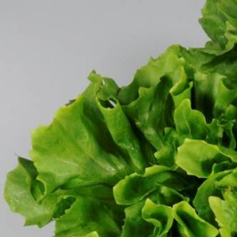 | 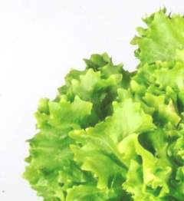
3 | 7
weak | strong

Ad. 18: Cut type varieties only: Leaf: ratio length of part of leaf without lobes/total length of leaf

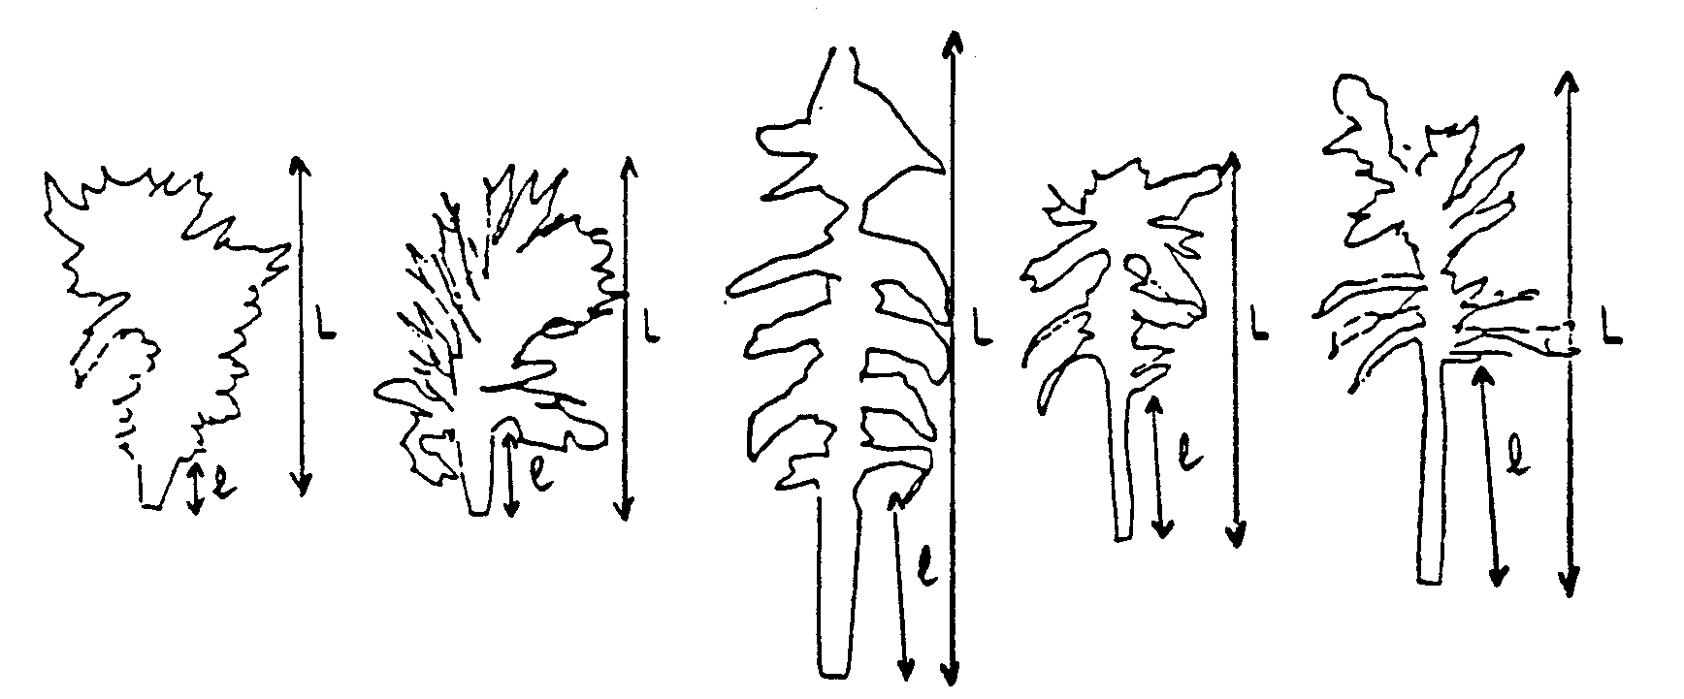
L = total length of leaf
l = length of part of leaf without lobes

1 | 3 | 5 | 7 | 9
very low | low | medium | high | very high

Ad. 21: Stem: height

To be observed for each variety individually when the first flowers are open.

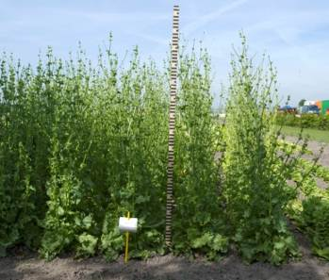

Ad. 22: Stem: fasciation

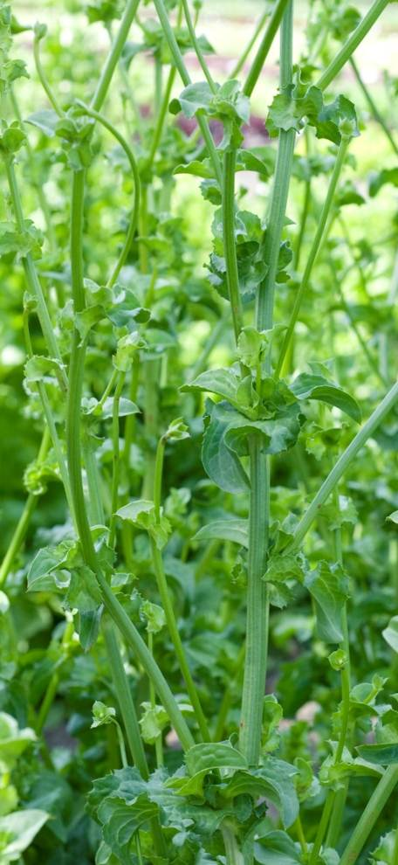 | 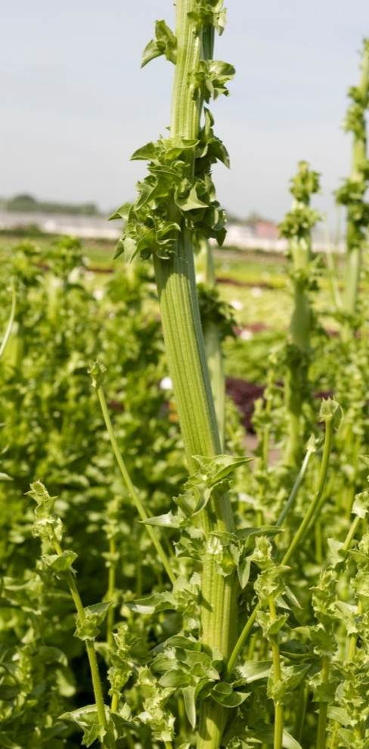
1 | 9
absent | present

Ad. 25: Flower: color

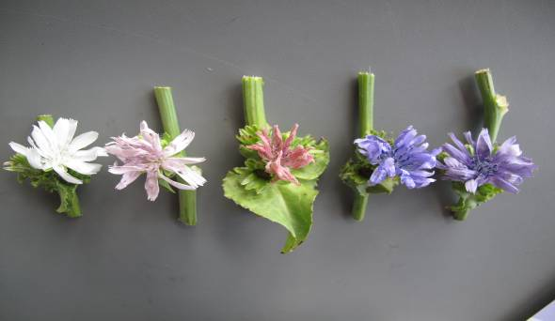
1 | 2 | 3 | 4 | 5
white | light pink | dark pink | blue | violet blue
 | RHS 75D | RHS 70D | RHS 97A | RHS 92B

The reference to the RHS Colour Chart is indicative.

Ad. 26: Time of harvest maturity

Harvest maturity is reached before the beginning of bolting. For those varieties that do not bolt, harvest maturity is when they have reached their full size.

Literature

No specific literature.

Technical Questionnaire

TECHNICAL QUESTIONNAIRE |  |  |  | Page {x} of {y} |  | Reference Number:
 |  |  |  |  |  | Application date:
 |  |  |  |  |  | (not to be filled in by the applicant)
TECHNICAL QUESTIONNAIRE
to be completed in connection with an application for plant breeders’ rights

1. Subject of the Technical Questionnaire
1.1 Botanical name |  |  | Cichorium endivia L.
1.2 Common name |  |  | Endive
2. Applicant
Name
Address
Telephone No.
Fax No.
E-mail address
Breeder (if different from applicant)
3. Proposed denomination and breeder’s reference
Proposed denomination
(if available)

Breeder’s reference
#4. Information on the breeding scheme and propagation of the variety

4.1 Method of propagating the variety

(a) Cross-pollination [ ]
(b) Other [ ]
(please provide details)

5. Characteristics of the variety to be indicated (the number in brackets refers to the corresponding characteristic in Test Guidelines; please mark the note which best corresponds).

 | Characteristics |  |  |  |  |  | Example Varieties |  |  | Note
5.1  (1) | Plant: diameter
 | very small |  |  |  |  |  | Belusa |  |  | 1[ ]
 | very small to small |  |  |  |  |  |  |  |  | 2[ ]
 | small |  |  |  |  |  | De Louviers |  |  | 3[ ]
 | small to medium |  |  |  |  |  |  |  |  | 4[ ]
 | medium |  |  |  |  |  | Blonde à cœur plein,  D’été à cœur jaune, Golda |  |  | 5[ ]
 | medium to large |  |  |  |  |  |  |  |  | 6[ ]
 | large |  |  |  |  |  | Grosse Pancalière |  |  | 7[ ]
 | large to very large |  |  |  |  |  |  |  |  | 8[ ]
 | very large |  |  |  |  |  | Superfiorentina, Wallonne |  |  | 9[ ]
5.2  (10) | Leaf: color
 | light yellowish green |  |  |  |  |  | Belusa |  |  | 1[ ]
 | medium yellowish green |  |  |  |  |  | Blonde à cœur plein, Magaly, Tarquinis |  |  | 2[ ]
 | dark yellowish green |  |  |  |  |  | Kampero |  |  | 3[ ]
 | very light green |  |  |  |  |  | Gloire de l’exposition, Systel |  |  | 4[ ]
 | light green |  |  |  |  |  | Cathie, Milady, Solera |  |  | 5[ ]
 | medium green |  |  |  |  |  | Géante Maraîchère, Nuance, Sally |  |  | 6[ ]
 | dark green |  |  |  |  |  | Atleta, Minerva, Wallonne |  |  | 7[ ]
 | very dark green |  |  |  |  |  | D’hiver de Provence, Isola |  |  | 8[ ]
 | light greyish green |  |  |  |  |  | Barundi, De Louviers, Lassie |  |  | 9[ ]
 | medium greyish green |  |  |  |  |  | Argentée Mirabel, Constance, Woodie |  |  | 10[ ]
 | dark greyish green |  |  |  |  |  | De Namur, Snoopie |  |  | 11[ ]
 | Characteristics |  |  |  |  |  | Example Varieties |  |  | Note
5.3  (25) | Flower: color
 | white |  |  |  |  |  | De Louviers, Grosse pommant seule |  |  | 1[ ]
 | light pink |  |  |  |  |  | Lisuna |  |  | 2[ ]
 | dark pink |  |  |  |  |  | Ascari |  |  | 3[ ]
 | blue |  |  |  |  |  | Grosse Bouclée 2 |  |  | 4[ ]
 | violet blue |  |  |  |  |  | Alaska, Ariga, Sally, Wallonne |  |  | 5[ ]
5.4  (27) | Time of bolting
 | very early |  |  |  |  |  | Noveli |  |  | 1[ ]
 | very early to early |  |  |  |  |  |  |  |  | 2[ ]
 | early |  |  |  |  |  | De Meaux, Grosse pommant seule |  |  | 3[ ]
 | early to medium |  |  |  |  |  |  |  |  | 4[ ]
 | medium |  |  |  |  |  | Sally |  |  | 5[ ]
 | medium to late |  |  |  |  |  |  |  |  | 6[ ]
 | late |  |  |  |  |  | Blonde à cœur plein |  |  | 7[ ]
 | late to very late |  |  |  |  |  |  |  |  | 8[ ]
 | very late |  |  |  |  |  | Excel |  |  | 9[ ]
6. Similar varieties and differences from these varieties

Please use the following table and box for comments to provide information on how your candidate variety differs from the variety (or varieties) which, to the best of your knowledge, is (or are) most similar. This information may help the examination authority to conduct its examination of distinctness in a more efficient way.

Denomination(s) of variety(ies) similar to your candidate variety |  | Characteristic(s) in which your candidate variety differs from the similar variety(ies) |  |  | Describe the expression of the characteristic(s) for the similar variety(ies) |  |  | Describe the expression of the characteristic(s) for your candidate variety
Example |  | Leaf: color |  |  | yellowish green |  |  | green
Comments:

#7. Additional information which may help in the examination of the variety

7.1 In addition to the information provided in sections 5.3 and 8.1, please provide information concerning: Growth type

Plain type (C. endivia var. latifolia) [ ]
Sub-type: Grosse bouclée 2 (Nummer Vijf 2) [ ]
Sub-type: Breedblad Volhart Winter (A cœur plein) [ ]
Sub-type: Géante maraichère [ ]
Sub-type: Cornet [ ]
Sub-type: Ambio [ ]

Cut type (C. endivia var. crispa) [ ]
Sub-type: Wallonne [ ]
Sub-type: De Louviers [ ]
Sub-type: D’été à cœur jaune [ ]

7.2 Are there any special conditions for growing the variety or conducting the examination?

Yes [ ] No [ ]

(If yes, please provide details)

7.3 Other information

8. Authorization for release

(a) Does the variety require prior authorization for release under legislation concerning the protection of the environment, human and animal health?

Yes [ ] No [ ]

(b) Has such authorization been obtained?

Yes [ ] No [ ]

If the answer to (b) is yes, please attach a copy of the authorization.

9. Information on plant material to be examined or submitted for examination.

9.1 The expression of a characteristic or several characteristics of a variety may be affected by factors, such as pests and disease, chemical treatment (e.g. growth retardants or pesticides), effects of tissue culture, different rootstocks, scions taken from different growth phases of a tree, etc.

9.2 The plant material should not have undergone any treatment which would affect the expression of the characteristics of the variety, unless the competent authorities allow or request such treatment. If the plant material has undergone such treatment, full details of the treatment must be given. In this respect, please indicate below, to the best of your knowledge, if the plant material to be examined has been subjected to:

(a) Microorganisms (e.g. virus, bacteria, phytoplasma) Yes [ ] No [ ]

(b) Chemical treatment (e.g. growth retardant, pesticide) Yes [ ] No [ ]

(c) Tissue culture Yes [ ] No [ ]

(d) Other factors Yes [ ] No [ ]

Please provide details for where you have indicated “yes”.

……………………………………………………………

10. I hereby declare that, to the best of my knowledge, the information provided in this form is correct:

Applicant’s name

Signature Date

[End of document]

* These names were correct at the time of the introduction of these Test Guidelines but may be revised or updated. [Readers are advised to consult the UPOV Code, which can be found on the UPOV Website (www.upov.int), for the latest information.]
# Authorities may allow certain of this information to be provided in a confidential section of the Technical Questionnaire.
# Authorities may allow certain of this information to be provided in a confidential section of the Technical Questionnaire.

