 |  | E  TG/97/4  ORIGINAL: English  DATE: 2006-04-05
INTERNATIONAL UNION FOR THE PROTECTION OF NEW VARIETIES OF PLANTS
GENEVA

 | AVOCADO  UPOV Code: PERSE_AME  Persea americana Mill. | *

GUIDELINES

FOR THE CONDUCT OF TESTS

FOR DISTINCTNESS, UNIFORMITY AND STABILITY

Alternative Names:*
Botanical name | English | French | German | Spanish
Persea americana Mill. | Avocado | Avocatier | Avocado | Aguacate, Palto

The purpose of these guidelines (“Test Guidelines”) is to elaborate the principles contained in the General Introduction (document TG/1/3), and its associated TGP documents, into detailed practical guidance for the harmonized examination of distinctness, uniformity and stability (DUS) and, in particular, to identify appropriate characteristics for the examination of DUS and production of harmonized variety descriptions.

ASSOCIATED DOCUMENTS
These Test Guidelines should be read in conjunction with the General Introduction and its associated TGP documents.
TABLE OF CONTENTS PAGE

1. Subject of these Test Guidelines 3
2. Material Required 3
3. Method of Examination 3
3.1 Number of Growing Cycles 3
3.2 Testing Place 3
3.3 Conditions for Conducting the Examination 3
3.4 Test Design 4
3.5 Number of Plants / Parts of Plants to be Examined 4
3.6 Additional Tests 4
4. Assessment of Distinctness, Uniformity and Stability 4
4.1 Distinctness 4
4.2 Uniformity 5
4.3 Stability 5
5. Grouping of Varieties and Organization of the Growing Trial 5
6. Introduction to the Table of Characteristics 6
6.1 Categories of Characteristics 6
6.2 States of Expression and Corresponding Notes 6
6.3 Types of Expression 6
6.4 Example Varieties 6
6.5 Legend 6
7. Table of Characteristics/Tableau des caractères/Merkmalstabelle/Tabla de caracteres 7
8. Explanations on the Table of Characteristics 23
8.1 Explanations covering several characteristics 23
8.2 Explanations for individual characteristics 24
9. Literature 33
10. Technical Questionnaire 34

Subject of these Test Guidelines
These Test Guidelines apply to all varieties of Persea americana Mill.

Material Required
2.1 The competent authorities decide on the quantity and quality of the plant material required for testing the variety and when and where it is to be delivered. Applicants submitting material from a State other than that in which the testing takes place must ensure that all customs formalities and phytosanitary requirements are complied with.

2.2 The material is to be supplied in the form of graft sticks.

2.3 The minimum quantity of plant material, to be supplied by the applicant, should be:

8 graft sticks, sufficient to produce 8 trees.

The rootstock to be used is specified by the competent authority.

2.4 The plant material supplied should be visibly healthy, not lacking in vigor, nor affected by any important pest or disease.

2.5 The plant material should not have undergone any treatment which would affect the expression of the characteristics of the variety, unless the competent authorities allow or request such treatment. If it has been treated, full details of the treatment must be given.

Method of Examination

3.1 Number of Growing Cycles
3.1.1 The minimum duration of tests should normally be two independent growing cycles.

3.1.2 The growing cycle is considered to be the period ranging from the beginning of active vegetative growth or flowering, continuing through active vegetative growth or flowering and fruit development and concluding with the harvesting of fruit.”

3.2 Testing Place
Tests are normally conducted at one place. In the case of tests conducted at more than one place, guidance is provided in TGP/9 “Examining Distinctness”.

3.3 Conditions for Conducting the Examination
The tests should be carried out under conditions ensuring satisfactory growth for the expression of the relevant characteristics of the variety and for the conduct of the examination. In particular, it is essential that the trees produce a satisfactory crop of fruit in each of the two growing cycles.”

3.4 Test Design
3.4.1 Each test should be designed to result in a total of at least five plants.

3.4.2 The design of the tests should be such that plants or parts of plants may be removed for measurement or counting without prejudice to the observations which must be made up to the end of the growing cycle.

3.5 Number of Plants / Parts of Plants to be Examined
Unless otherwise indicated, all observations should be made on 5 plants or parts taken from each of 5 plants. In the case of parts of plants, the number to be taken from each of the plants should be 2.

3.6 Additional Tests
Additional tests, for examining relevant characteristics, may be established.

Assessment of Distinctness, Uniformity and Stability

4.1 Distinctness
4.1.1 General Recommendations

It is of particular importance for users of these Test Guidelines to consult the General Introduction prior to making decisions regarding distinctness. However, the following points are provided for elaboration or emphasis in these Test Guidelines.

4.1.2 Consistent Differences

The differences observed between varieties may be so clear that more than one growing cycle is not necessary. In addition, in some circumstances, the influence of the environment is not such that more than a single growing cycle is required to provide assurance that the differences observed between varieties are sufficiently consistent. One means of ensuring that a difference in a characteristic, observed in a growing trial, is sufficiently consistent is to examine the characteristic in at least two independent growing cycles.

4.1.3 Clear Differences

Determining whether a difference between two varieties is clear depends on many factors, and should consider, in particular, the type of expression of the characteristic being examined, i.e. whether it is expressed in a qualitative, quantitative, or pseudo-qualitative manner. Therefore, it is important that users of these Test Guidelines are familiar with the recommendations contained in the General Introduction prior to making decisions regarding distinctness.

4.2 Uniformity
4.2.1 It is of particular importance for users of these Test Guidelines to consult the General Introduction prior to making decisions regarding uniformity. However, the following points are provided for elaboration or emphasis in these Test Guidelines:

4.2.2 For the assessment of uniformity, a population standard of 1% and an acceptance probability of at least 95 % should be applied. In the case of a sample size of 5 plants, no off-types are allowed.

4.3 Stability
4.3.1 In practice, it is not usual to perform tests of stability that produce results as certain as those of the testing of distinctness and uniformity. However, experience has demonstrated that, for many types of variety, when a variety has been shown to be uniform, it can also be considered to be stable.

4.3.2 Where appropriate, or in cases of doubt, stability may be tested, either by growing a further generation, or by testing a new seed or plant stock to ensure that it exhibits the same characteristics as those shown by the previous material supplied.

Grouping of Varieties and Organization of the Growing Trial
5.1 The selection of varieties of common knowledge to be grown in the trial with the candidate varieties and the way in which these varieties are divided into groups to facilitate the assessment of distinctness are aided by the use of grouping characteristics.

5.2 Grouping characteristics are those in which the documented states of expression, even where produced at different locations, can be used, either individually or in combination with other such characteristics: (a) to select varieties of common knowledge that can be excluded from the growing trial used for examination of distinctness; and (b) to organize the growing trial so that similar varieties are grouped together.

5.3 The following have been agreed as useful grouping characteristics:

(a) Leaf blade: anise aroma (characteristic 18);
(b) Ripe fruit: color (characteristic 49);
(c) Ripe fruit: thickness of skin (characteristic 50);
(d) Time of fruit maturity for harvesting (characteristic 67).

5.4 Guidance for the use of grouping characteristics, in the process of examining distinctness, is provided through the General Introduction.

Introduction to the Table of Characteristics

6.1 Categories of Characteristics
6.1.1 Standard Test Guidelines Characteristics

Standard Test Guidelines characteristics are those which are approved by UPOV for examination of DUS and from which members of the Union can select those suitable for their particular circumstances.

6.1.2 Asterisked Characteristics

Asterisked characteristics (denoted by *) are those included in the Test Guidelines which are important for the international harmonization of variety descriptions and should always be examined for DUS and included in the variety description by all members of the Union, except when the state of expression of a preceding characteristic or regional environmental conditions render this inappropriate.

6.2 States of Expression and Corresponding Notes
States of expression are given for each characteristic to define the characteristic and to harmonize descriptions. Each state of expression is allocated a corresponding numerical note for ease of recording of data and for the production and exchange of the description.

6.3 Types of Expression
An explanation of the types of expression of characteristics (qualitative, quantitative and pseudo-qualitative) is provided in the General Introduction.

6.4 Example Varieties
Where appropriate, example varieties are provided to clarify the states of expression of each characteristic.

6.5 Legend
(*) Asterisked characteristic – see Chapter 6.1.2

QL: Qualitative characteristic – see Chapter 6.3
QN: Quantitative characteristic – see Chapter 6.3
PQ: Pseudo-qualitative characteristic – see Chapter 6.3

(a)-(h) See Explanations on the Table of Characteristics in Chapter 8.1

(+) See Explanations on the Table of Characteristics in Chapter 8.2

Table of Characteristics/Tableau des caractères/Merkmalstabelle/Tabla de caracteres

 |  | English | français | deutsch | español | Example Varieties  Exemples  Beispielssorten  Variedades ejemplo | Note/  Nota
1.  (*)  (+) |  | Tree: growth habit | Arbre: port | Baum: Wuchsform | Árbol: porte
PQ |  | upright | dressé | aufrecht | erecto | Bacon, Zutano | 1
 |  | spreading | étalé | auseinanderfallend | abierto | Fuerte, Hass | 2
 |  | semi drooping | demi-retombant | halbhängend | semicolgante | Colín V-33 | 3
 |  | drooping | retombant | hängend | colgante |  | 4
2.  (*) |  | Young shoot: color | Jeune tige: couleur | Junger Trieb: Farbe | Brote joven: color
PQ | (a) | yellow green | vert jaune | gelbgrün | verde amarillento | Collinson | 1
 |  | green | verte | grün | verde | Benedict, G-22, Teague | 2
 |  | reddish | rougeâtre | rötlich | rojizo | Duke 6 | 3
3. |  | Young shoot: color of lenticels | Jeune tige: couleur des lenticelles | Junger Trieb: Farbe der Lentizellen | Brote joven: color de las lenticelas
PQ | (a) | yellow | jaunes | gelb | amarillo |  | 1
 |  | green | vertes | grün | verde | Collinson, G-22 | 2
 |  | red | rouges | rot | rojo | Benedict, Duke 6 | 3
 |  | purple | violettes | purpurn | púrpura |  | 4
4. |  | Young leaf: color of pubescence of petiole | Jeune feuille: couleur de la pilosité du pétiole | Junges Blatt: Farbe der Behaarung des Blattstiels | Hoja joven: color de la pubescencia del peciolo
PQ | (a) | white | blanche | weiß | blanco | Edranol | 1
 | (b) | yellow | jaune | gelb | amarillo | Duke 6 | 2
 |  | brown | brune | braun | marrón |  | 3
 |  | red brown | brun rouge | rotbraun | marrón rojizo | Fuerte | 4
5.  (+) |  | Shoot: length of internode | Tige: longueur de l’entre-nœud | Trieb: Länge des Internodiums | Brote: longitud del internodo
QN |  | short | court | kurz | corto | San Martín | 1
 |  | intermediate | intermédiaire | mittel | intermedio | Fuerte, Hass | 2
 |  | long | long | lang | largo |  | 3
6. |  | Leaf: attitude relative to shoot | Feuille: orientation par rapport à la tige | Blatt: Haltung im Verhältnis zum Trieb | Hoja: porte en relación con el brote
QN | (c) | upwards | vers le haut | aufwärts gerichtet | hacia arriba | G-6 | 1
 |  | outwards | perpendiculaire | abstehend | perpendicular | Hass | 2
 |  | downwards | vers le bas | abwärts gerichtet | hacia abajo |  | 3
7. |  | Leaf blade: length | Limbe: longueur | Blattspreite: Länge | Limbo: longitud
QN | (c) | very short | très court | sehr kurz | muy corto | San Martín | 1
 |  | short | court | kurz | corto | Fuchsia, Puebla, Topa Topa | 3
 |  | medium | moyen | mittel | medio | Choquette, Colín V-33, Fuerte | 5
 |  | long | long | lang | largo | Barker | 7
 |  | very long | très long | sehr lang | muy largo | Encinos | 9
8. |  | Leaf blade: width | Limbe: largeur | Blattspreite: Breite | Limbo: anchura
QN | (c) | very narrow | très étroit | sehr schmal | muy estrecho | Duke 7, San Martín | 1
 |  | narrow | étroit | schmal | estrecho | Hass, Thomas | 3
 |  | medium | moyen | mittel | medio | Choquette, Fuerte | 5
 |  | broad | large | breit | ancho | Monroe, Pollock | 7
 |  | very broad | très large | sehr breit | muy ancho | Encinos, G755c | 9
9. |  | Leaf blade: ratio length/width | Limbe: rapport longueur/largeur | Blattspreite: Verhältnis Länge/Breite | Limbo: relación longitud/anchura
QN | (c) | very small | très petit | sehr klein | muy pequeña | Santana | 1
 |  | small | petit | klein | pequeña | G755c | 3
 |  | medium | moyen | mittel | media | Choquette | 5
 |  | large | grand | groß | grande | Mike, Pinkerton | 7
 |  | very large | très grand | sehr groß | muy grande | Reed | 9
10.  (+) |  | Leaf blade: shape | Limbe: forme | Blattspreite: Form | Limbo: forma
PQ | (c) | lanceolate | lancéolé | lanzettlich | lanceolada | Collinson | 1
 |  | ovate | ovale | eiförmig | oval | Teague | 2
 |  | elliptic | elliptique | elliptisch | elíptica | Duke | 3
 |  | circular | circulaire | rund | circular | Santana | 4
 |  | obovate | obovale | verkehrt eiförmig | oboval | Dilly | 5
11.  (+) |  | Leaf blade: shape of apex | Limbe: forme du sommet | Blattspreite: Form der Spitze | Limbo: forma del ápice
PQ | (c) | acuminate | acuminé | zugespitzt | acuminada | Fuerte | 1
 |  | acute | pointu | spitz | aguda | Hass | 2
 |  | rounded | arrondi | abgerundet | redondeada | Santana | 3
12.  (+) |  | Leaf blade: twisting along whole length | Limbe: torsion sur toute la longueur | Blattspreite: Verdrehung auf der ganzen Länge | Limbo: torsión en toda la longitud
QL | (c) | absent | absente | fehlend | ausente | Fuerte | 1
 |  | present | présente | vorhanden | presente | Zutano | 9
13.  (+) |  | Leaf blade: twisting of apex | Limbe: torsion du sommet | Blattspreite: Verdrehung der Spitze | Limbo: torsión del ápice
QL | (c) | absent | absente | fehlend | ausente | Fuerte | 1
 |  | present | présente | vorhanden | presente | Collinson | 9
14.  (+) |  | Leaf blade: undulation of margin | Limbe: ondulation du bord | Blattspreite: Wellung des Randes | Limbo: ondulación del borde
QN | (c) | absent or very weak | nulle ou très faible | fehlend oder sehr gering | ausente o muy débil | Duke | 1
 |  | weak | faible | gering | débil | Frazer | 3
 |  | medium | moyenne | mittel | media | Ettinger | 5
 |  | strong | forte | stark | fuerte | Pinkerton | 7
 |  | very strong | très forte | sehr stark | muy fuerte | Arturo | 9
15. |  | Leaf blade: relief of venation on upper surface | Limbe: relief de la nervation sur la face supérieure | Blattspreite: Art der Aderung auf der Oberseite | Limbo: relieve de la nervadura en la parte superior
QN | (c) | sunken | en creux | eingesunken | hundido | G755c, Topa Topa | 1
 |  | level | plan | intermediär | plano | Duke 7, Fuerte | 2
 |  | raised | proéminente | vorgewölbt | protuberante | Edranol, Frazer, Teague | 3
16. |  | Leaf blade: number of secondary veins | Limbe: nombre de nervures secondaires | Blattspreite: Anzahl sekundärer Adern | Limbo: número de nervios secundarios
QN | (c) | few | petit | gering | bajo | Aguilar, Hass, Mike | 1
 |  | intermediate | intermédiaire | mittel | intermedio | Duke 7, Fuerte, Pinkerton | 2
 |  | many | grand | groß | elevado | Encinos, G755c | 3
17. |  | Leaf blade: density of pubescence on lower surface | Limbe: densité de la pilosité sur la face inférieure | Blattspreite: Dichte der Behaarung an der Unterseite | Limbo: densidad de la pubescencia en la parte inferior
QN | (b) | absent or sparse | absente ou éparse | fehlend oder locker | ausente o laxa | Hass | 1
 | (c) | medium | moyenne | mittel | media | Edranol | 2
 |  | dense | dense | dicht | alta | Duke | 3
18.  (*) |  | Leaf blade: anise aroma | Limbe: arôme anisé | Blattspreite: Anisaroma | Limbo: aroma de anís
QN | (c) | absent or weak | absent ou faible | fehlend oder gering | ausente o débil | Hass, Reed | 1
 |  | medium | moyen | mittel | medio | Duke 7 | 2
 |  | strong | fort | stark | fuerte | Thomas | 3
19. |  | Petiole: length | Pétiole: longueur | Blattstiel: Länge | Peciolo: longitud
QN | (c) | very short | très court | sehr kurz | muy corto | San Martín | 1
 |  | short | court | kurz | corto | Aguilar, Reed | 3
 |  | medium | moyen | mittel | medio | Frazer, G755c, Mike | 5
 |  | long | long | lang | largo | Encinos, Hass | 7
 |  | very long | très long | sehr lang | muy largo | Fuerte | 9
20.  (+) |  | Inflorescence: length of axis | Inflorescence: longueur de l’axe | Blütenstand: Länge der Achse | Inflorescencia: longitud del eje
QN | (d) | short | court | kurz | corto | Bacon | 3
 |  | medium | moyen | mittel | medio | Fuerte | 5
 |  | long | long | lang | largo | Pinkerton | 7
21. |  | Inflorescence: color of lenticels | Inflorescence: couleur des lenticelles | Blütenstand: Farbe der Lentizellen | Inflorescencia: color de las lenticelas
QL | (d) | green | vertes | grün | verde | Topa Topa | 1
 |  | red | rouges | rot | rojo | Teague | 2
22.  (+) |  | Inflorescence: flowering type | Inflorescence: type floral | Blütenstand: Blühtyp | Inflorescencia: tipo de floración
QL | (d) | type A | type A | Typ A | tipo A | Hass | 1
 |  | type B | type B | Typ B | tipo B | Colín V-33, Fuerte | 2
23.  (+) |  | Flower: nectary | Fleur: nectaire | Blüte: Nektarium | Flor: nectario
QL | (e) | sessile | sessile | ungestielt | sésil | Ettinger | 1
 |  | stalked | à pédoncules | gestielt | con pedúnculo | Fuerte | 2
24.  (+) |  | Flower: style | Fleur: style | Blüte: Griffel | Flor: estilo
QL | (e) | straight | droit | gerade | recto | Fuerte | 1
 |  | kinked | coudé | geknickt | acodado | Collinson | 2
25.  (+) |  | Flower: pollen | Fleur: pollen | Blüte: Pollen | Flor: polen
QL |  | absent | absent | fehlend | ausente | Collinson | 1
 |  | present | présent | vorhanden | presente | Aguilar, Fuerte, Hass | 9
26. |  | Sepal: pubescence of inner surface | Sépale: pilosité de la face interne | Kelchblatt: Behaarung an der Innenseite | Sépalo: pubescencia de la parte interna
QL | (b) | absent | absente | fehlend | ausente | Pollock | 1
 | (e) | present | présente | vorhanden | presente | Duke, Hass | 9
27. |  | Sepal: density of pubescence of inner surface | Sépale: densité de la pilosité de la face interne | Kelchblatt: Dichte der Behaarung der Innenseite | Sépalo: densidad de la pubescencia de la parte interna
QN | (b) | sparse | faible | locker | laxa | Hass | 3
 | (e) | medium | moyenne | mittel | media |  | 5
 |  | dense | forte | dicht | elevada | Duke | 7
28.  (*) |  | Mature fruit: length | Fruit à maturité de cueillette: longueur | Erntereife Frucht: Länge | Fruto maduro: longitud
QN | (f) | very short | très court | sehr kurz | muy corto | Mexicola, Northrup | 1
 |  | short | court | kurz | corto | Dickinson, Edranol, Fuerte | 3
 |  | medium | moyen | mittel | medio | Avis, Hellen | 5
 |  | long | long | lang | largo | Cellon's Hawaii Seedling | 7
 |  | very long | très long | sehr lang | muy largo | Lima Late, Telsen | 9
29.  (*) |  | Mature fruit: diameter | Fruit à maturité de cueillette: diamètre | Erntereife Frucht: Durchmesser | Fruto maduro: diámetro
QN | (f) | very small | très petit | sehr klein | muy pequeño | Mexicola, Northrup | 1
 |  | small | petit | klein | pequeño | Dickinson, Edranol, Fuerte | 3
 |  | medium | moyen | mittel | medio | Avis, Hellen | 5
 |  | large | gros | groß | grande | Cellon's Hawaii Seedling | 7
 |  | very large | très gros | sehr groß | muy grande | Lima Late, Telsen | 9
30.  (*) |  | Mature fruit: ratio length/diameter | Fruit à maturité de cueillette: rapport longueur/diamètre | Erntereife Frucht: Verhältnis Länge/ Durchmesser | Fruto maduro: relación longitud/diámetro
QN | (f) | very small | très petit | sehr klein | muy pequeña | Trapp | 1
 |  | small | petit | klein | pequeña | Monroe | 3
 |  | medium | moyen | mittel | media | Carlsbad, Lima Late, Topa Topa | 5
 |  | large | grand | groß | grande | #86 | 7
 |  | very large | très grand | sehr groß | muy grande | Telsen | 9
31.  (+) |  | Mature fruit: shape of stalk end | Fruit à maturité de cueillette: forme à l’extrémité pédonculaire | Erntereife Frucht: Form des Stielendes | Fruto maduro: forma del extremo peduncular
PQ | (f) | pointed | pointu | spitz | en punta | Dickinson, Frazer | 1
 |  | narrowly rounded | arrondi étroit | schmal abgerundet | redondeado estrecho | Carlsbad, Edranol, Sharwil | 2
 |  | broadly rounded | arrondi large | breit abgerundet | redondeado ancho | Esther, Hashimoto, Nimlioh | 3
 |  | truncate | tronqué | stumpf | truncada | Lamb Hass, Mayo, Puebla | 4
32.  (+) |  | Mature fruit: presence of neck | Fruit à maturité de cueillette: présence d’un collet | Erntereife Frucht: Vorhandensein eines Halses | Fruto maduro: cuello
QL | (f) | absent | absent | fehlend | ausente | Hashimoto, Hass, Lamat | 1
 |  | present | présent | vorhanden | presente | Akbal, Fuerte, Horshim | 9
33.  (+) |  | Mature fruit: presence of depression at stalk end | Fruit à maturité de cueillette: présence d’une dépression à l’extrémité pédonculaire | Erntereife Frucht: Vorhandensein einer Einsenkung am Stielende | Fruto maduro: depresión del extremo peduncular
QL | (f) | absent | absente | fehlend | ausente | Jim, Sharwil, Wurtz | 1
 |  | present | présente | vorhanden | presente | Maxima, Simmonds, Trapp | 9
34.  (+) |  | Mature fruit: diameter of stalk attachment | Fruit à maturité de cueillette: diamètre de la fixation pédonculaire | Erntereife Frucht: Durchmesser des Stielansatzes | Fruto maduro: diámetro de la inserción peduncular
QN | (f) | small | petit | klein | pequeño | Frazer | 3
 |  | medium | moyen | mittel | medio | Fuerte | 5
 |  | large | grand | groß | grande | Encinos | 7
35. |  | Mature fruit: position of stalk | Fruit à maturité de cueillette: position du pédoncule | Erntereife Frucht: Sitz des Stiels | Fruto maduro: posición del pedúnculo
QN | (f) | along axis | le long de l’axe | entlang der Achse | a lo largo del eje | G-22, Nabal, Simmonds | 1
 |  | slightly oblique | légèrement oblique | leicht seitlich | ligeramente oblicuo | Fuerte, Rincon | 2
 |  | strongly oblique | fortement oblique | stark seitlich | muy oblicuo | Hayes, Whitsell | 3
36.  (+) |  | Mature fruit: shape at stylar region | Fruit à maturité de cueillette: forme de la région stylaire | Erntereife Frucht: Form in der Griffelregion | Fruto maduro: forma de la parte en la que se encuentran los estilos
PQ | (f) | pointed | pointue | spitz | en punta | Lamat, Mexicola | 1
 |  | rounded | arrondie | abgerundet | redondeada |  | 2
 |  | flattened | aplatie | eben | aplanada | Dade, Stewart, Trapp | 3
 |  | slightly depressed | légèrement déprimée | leicht eingesenkt | ligeramente deprimida | Gordo, Irving, Nimlioh | 4
 |  | deeply depressed | profondément déprimée | tief eingesenkt | muy deprimida | Duke | 5
37. |  | Mature fruit: conspicuousness of lenticels | Fruit à maturité de cueillette: netteté des lenticelles | Erntereife Frucht: Ausprägung der Lentizellen | Fruto maduro: presencia de lenticelas
QN | (f) | inconspicuous or weak | peu nettes | undeutlich oder gering | imperceptible o débil | Topa Topa | 1
 |  | medium | moyennement nettes | mittel | media | Fuerte | 2
 |  | strong | très nettes | deutlich | elevada | Carlsbad, Stewart | 3
38. |  | Mature fruit: size of lenticels | Fruit à maturité de cueillette: taille des lenticelles | Erntereife Frucht: Größe der Lentizellen | Fruto maduro: tamaño de lenticelas
QN | (f) | small | petites | klein | pequeño | Rincon | 3
 |  | medium | moyennes | mittel | medio | Fuerte, Stewart | 5
 |  | large | grandes | groß | grande | Ettinger | 7
39. |  | Mature fruit: color of lenticels | Fruit à maturité de cueillette: couleur des lenticelles | Erntereife Frucht: Farbe der Lentizellen | Fruto maduro: color de las lenticelas
PQ | (f) | cream | crème | cremefarben | crema | Biscayne Seedling | 1
 |  | yellow | jaunes | gelb | amarillo | Fuerte | 2
 |  | light green | vert pâle | hellgrün | verde claro | Akbal | 3
 |  | brown | brunes | braun | marrón | Aycock Red 3, Carlsbad | 4
40. |  | Mature fruit: glossiness | Fruit à maturité de cueillette: brillance | Erntereife Frucht: Glanz | Fruto maduro: brillo
QN | (f) | absent or weak | absente ou faible | fehlend oder gering | ausente o débil | Fuerte, Horshim | 1
 |  | medium | moyenne | mittel | medio | Ettinger, Zutano | 2
 |  | strong | forte | stark | fuerte | Simmonds, Topa Topa | 3
41.  (*) |  | Mature fruit: surface | Fruit à maturité de cueillette: surface | Erntereife Frucht: Oberfläche | Fruto maduro: superficie
QN | (f) | very smooth | très lisse | sehr glatt | muy lisa | Duke, Simmonds, Topa Topa | 1
 |  | smooth | lisse | glatt | lisa | Bacon, Ettinger | 3
 |  | medium | moyenne | mittel | media | Alboyce, Fuerte, Horshim | 5
 |  | rough | rugueuse | rauh | rugosa | Hass, Whitsell | 7
 |  | very rough | très rugueuse | sehr rauh | muy rugosa | Dickinson | 9
42. |  | Mature fruit: persistence of perianth | Fruit à maturité de cueillette: persistance du périanthe | Erntereife Frucht: Ausdauern der Blütenhülle | Fruto maduro: persistencia del perianto
QN | (f) | absent or weak | absente ou faible | fehlend oder gering | ausente o débil | Hass | 1
 |  | medium | moyenne | mittel | media | Colín V-33, Lypps | 2
 |  | strong | forte | stark | fuerte | Irving, Jim | 3
43.  (+) |  | Pedicel: thickness compared to peduncle (at junction) | Pédicelle: épaisseur par rapport au pédoncule (à la jonction) | Fruchtstiel: Dicke im Verhältnis zum Stiel des Fruchtstandes  (an der Verbindungsstelle) | Pedicelo: grosor en comparación con el pedúnculo (en la intersección)
QL | (g) | same | même épaisseur | gleich | igual | Ettinger, Simmonds | 1
 |  | thicker | plus épais | dicker | mayor | Collinson, Dade | 2
44.  (*) |  | Pedicel: length | Pédicelle: longueur | Fruchtstiel: Länge | Pedicelo: longitud
QN | (g) | short | court | kurz | corto | Pollock | 3
 |  | medium | moyen | mittel | medio | Fuerte | 5
 |  | long | long | lang | largo | G-22, Hass | 7
45.  (*)  (+) |  | Pedicel: shape | Pédicelle: forme | Fruchtstiel: Form | Pedicelo: forma
QL | (g) | cylindrical | cylindrique | zylindrisch | cilíndrica | Horshim, Iriet, Teague | 1
 |  | conical | conique | kegelförmig | cónica | Dunedin, Edranol, Monroe | 2
46.  (*)  (+) |  | Pedicel: “nailhead” | Pédicelle: en forme de tête de clou | Fruchtstiel: „Nagelkopfform“ | Pedicelo: “cabeza de clavo”
QL | (g) | absent | absente | fehlend | ausente | Duke, Edranol, Wurtz | 1
 |  | present | présente | vorhanden | presente | Maxima, Pollock | 9
47. |  | Pedicel: color | Pédicelle: couleur | Fruchtstiel: Farbe | Pedicelo: color
PQ | (g) | yellow | jaune | gelb | amarillo | Aycock Red 3, Duke | 1
 |  | yellow green | vert jaune | gelbgrün | verde amarillento | Hass, Iriet | 2
 |  | green | vert | grün | verde | Alboyce, Lamat | 3
 |  | green brown | brun vert | grünbraun | marrón verdoso | Horshim | 4
 |  | reddish | rougeâtre | rötlich | rojizo | Wurtz | 5
48. |  | Pedicel: surface | Pédicelle: surface | Fruchtstiel: Oberfläche | Pedicelo: superficie
QL | (g) | smooth | lisse | glatt | lisa | Duke, Ferdyn, Topa Topa | 1
 |  | wrinkled | ridée | gerieft | arrugada | Edranol, Ettinger | 2
49.  (*) |  | Ripe fruit: color | Fruit à maturité de consommation: couleur | Reife Frucht: Farbe | Fruto maduro: color
PQ | (h) | yellow green | vert jaune | gelbgrün | verde amarillo | Melendez | 1
 |  | light green | vert clair | hellgrün | verde claro | Marsheline, Mayo | 2
 |  | medium green | vert moyen | mittelgrün | verde medio | Greengold, Rincon, Zutano | 3
 |  | dark green | vert foncé | dunkelgrün | verde oscuro | Ahaheim, Colín V-33, Edranol | 4
 |  | reddish | rougeâtre | rötlich | rojizo | Los Moros | 5
 |  | medium purple | violet moyen | mittelpurpurn | púrpura medio |  | 6
 |  | dark purple or black | violet foncé ou noir | dunkelpurpurn oder schwarz | púrpura oscuro o negro | Hass, Topa Topa | 7
50.  (*) |  | Ripe fruit: thickness of skin | Fruit à maturité de consommation: épaisseur de l’épiderme | Reife Frucht: Dicke der Schale | Fruto maduro: grosor de la piel
QN | (h) | very thin | très fin | sehr dünn | muy fina | Mexicola, Topa Topa | 1
 |  | moderately thin | modérément fin | mäßig dünn | moderadamente fina | Colín V-33, Fuerte | 3
 |  | medium | moyen | mittel | media | Edranol | 5
 |  | moderately thick | modérément épais | mäßig dick | moderadamente gruesa | Hass | 7
 |  | very thick | très épais | dick | muy gruesa | Dickinson | 9
51.  (+) |  | Ripe fruit: consistency of skin | Fruit à maturité de consommation: consistance de l’épiderme | Reife Frucht: Konsistenz der Schale | Fruto maduro: consistencia de la piel
QL | (h) | membranous | membraneux | membranartig | membranosa | Ettinger, Teague, Topa Topa | 1
 |  | leathery | coriace | lederartig | áspera | Edranol, Pollock, Santana | 2
 |  | corky | liégeux | korkartig | rugosa | G-22, Nabal | 3
52.  (+) |  | Ripe fruit: adherence of skin to flesh | Fruit à maturité de consommation: adhérence de l’épiderme à la chair | Reife Frucht: Anhaften der Schale am Fleisch | Fruto maduro: adherencia de la piel a la pulpa
QN | (h) | weak | faible | gering | débil | Edranol, Fuerte | 1
 |  | intermediate | intermédiaire | mittel | intermedia | Sharwil | 2
 |  | strong | forte | stark | fuerte | Ettinger, Nabal, Teague | 3
53. |  | Ripe fruit: main color of flesh | Fruit à maturité de consommation: couleur principale de la chair | Reife Frucht: Hauptfarbe des Fleisches | Fruto maduro: color principal de la pulpa
PQ | (h) | whitish | blanchâtre | weißlich | blanquecino | Hazzard | 1
 |  | cream | crème | cremefarben | crema | Bacon, Ettinger, Zutano | 2
 |  | yellow | jaune | gelb | amarillo | Hayes, Nabal | 3
 |  | light green | vert clair | hellgrün | verde claro | G-6, San Miguel | 4
54. |  | Ripe fruit: color of layer next to skin | Fruit à maturité de consommation: couleur de la zone proche de l’épiderme | Reife Frucht: Farbe der Fleischschicht nahe der Schale | Fruto maduro: color de la capa pegada a la piel
PQ | (h) | light green | vert clair | hellgrün | verde claro | Santana | 1
 |  | medium green | vert moyen | mittelgrün | verde medio | Hass, Sharwil, Sir Prize | 2
 |  | yellow green | vert jaune | gelbgrün | verde amarillento | Duke | 3
55. |  | Ripe fruit: width of layer next to skin | Fruit à maturité de consommation: largeur de la zone proche de l’épiderme | Reife Frucht: Breite der Fleischschicht nahe der Schale | Fruto maduro: anchura de la capa pegada a la piel
QN | (h) | narrow | étroite | schmal | estrecha | Duke, Santana | 3
 |  | medium | moyenne | mittel | media | Colín V-33, Fuerte, Santana | 5
 |  | broad | large | breit | ancha | Edranol, Reed, Whitsell | 7
56. |  | Ripe fruit: conspicuousness of fibers in flesh | Fruit à maturité de consommation: netteté des fibres dans la chair | Reife Frucht: Ausprägung der Fasern im Fleisch | Fruto maduro: presencia de fibras en la pulpa
QL | (h) | inconspicuous | peu nettes | undeutlich | imperceptibles | Fuerte, Santana | 1
 |  | conspicuous | nettes | deutlich | presentes | Edranol, Ettinger, Ryan | 2
57. |  | Ripe fruit: consistency of flesh | Fruit à maturité de consommation: consistance de la chair | Reife Frucht: Konsistenz des Fleisches | Fruto maduro: consistencia de la pulpa
PQ | (h) | watery | aqueuse | wäßrig | acuosa | Simmonds | 1
 |  | buttery | beurrée | buttrig | grasienta | Fuerte, Hass | 2
 |  | dry | sèche | trocken | seca | Fundación II | 3
 |  | granular | granuleuse | körnig | granulosa |  | 4
58. |  | Ripe fruit: anise aroma of flesh | Fruit à maturité de consommation: arôme anisé de la chair | Reife Frucht: Anisaroma des Fleisches | Fruto maduro: aroma de anís de la pulpa
QL | (h) | absent | absent | fehlend | ausente | Aguilar, Hass, Lamb Hass | 1
 |  | present | présent | vorhanden | presente | Mexicola | 9
59. |  | Ripe fruit: ratio fruit length/seed length | Fruit à maturité de consommation: rapport longueur du fruit/longueur du noyau | Reife Frucht: Verhältnis Länge der Frucht/Länge des Kerns | Fruto maduro: relación longitud del fruto/longitud de la semilla
QN | (h) | very small | très petit | sehr klein | muy pequeña | Toltec | 1
 |  | small | petit | klein | pequeña | Bacon, Ettinger | 3
 |  | medium | moyen | mittel | media | Hashimoto, Hass, Lamat | 5
 |  | large | grand | groß | grande | T181 | 7
 |  | very large | très grand | sehr groß | muy grande | Carlsbad | 9
60.  (+) |  | Seed: shape in longitudinal section (lateral view) | Noyau: forme en section longitudinale (vue latérale) | Kern: Form im Längsschnitt | Semilla: forma en sección longitudinal (vista lateral)
PQ | (h) | triangular | triangulaire | dreieckig | triangular | Simmonds, Telsen, Zutano | 1
 |  | ovate | ovale | eiförmig | oval | Anaheim, Colín V-33, Rincon | 2
 |  | elliptic | elliptique | elliptisch | elíptica | Jan Boyce, Lima Late, Topa Topa | 3
 |  | circular | circulaire | rund | circular | Lamat, Lamb Hass, Mayapan | 4
 |  | oblate | aplati | breitrund | achatada | Hayes, McDonald, Suardia | 5
 |  | depressed oblate | aplati déprimé | eingesenkt breitrund | achatada deprimida | Carlsbad, Nowels | 6
61. |  | Seed: shape in cross section | Noyau: forme en section transversale | Kern: Form im Querschnitt | Semilla: forma en sección transversal
QL | (h) | circular | circulaire | rund | circular | Fuerte | 1
 |  | elliptic | elliptique | elliptisch | elíptica | Ryan | 2
62. |  | Seed coat: adherence to flesh | Téguments: adhérence à la chair | Samenschale: Anhaften am Fleisch | Tegumento: adherencia a la pulpa
QN | (h) | absent or weak | nulle ou faible | fehlend oder gering | ausente o débil | Zutano | 1
 |  | medium | moyenne | mittel | media | Northrup, Topa Topa | 2
 |  | strong | forte | stark | fuerte | Colín V-33, Fuerte, Hass | 3
63. |  | Seed coat: adherence to cotyledon | Téguments: adhérence au cotylédon | Samenschale: Anhaften am Keimblatt | Tegumento: adherencia al cotiledón
QN | (h) | absent or weak | nulle ou faible | fehlend oder gering | ausente o débil | Akbal, Aycock Red #3, Hardee | 1
 |  | medium | moyenne | mittel | medio | Dade | 2
 |  | strong | forte | stark | fuerte | Hass, Fuerte | 3
64. |  | Seed coat: surface | Téguments: surface | Samenschale: Oberfläche | Tegumento: superficie
QN | (h) | smooth or slightly wrinkled | lisse ou légèrement ridée | glatt oder leicht gerieft | lisa o ligeramente arrugada | Hass | 1
 |  | moderately wrinkled | modérément ridée | mäßig gerieft | moderadamente arrugada | Lula | 2
 |  | strongly wrinkled | fortement ridée | stark gerieft | muy arrugada | Trapp | 3
65. |  | Cotyledon: surface | Cotylédon: surface | Keimblatt: Oberfläche | Cotiledón: superficie
QL | (h) | smooth | lisse | glatt | lisa | Bacon | 1
 |  | wrinkled | ridée | gerieft | arrugada | Collinson | 2
66. |  | Time of beginning of flowering | Époque du début de la floraison | Zeitpunkt des Blühbeginns | Época de inicio de la floración
QN |  | early | précoce | früh | precoz | Duke | 3
 |  | medium | moyenne | mittel | media | Fuerte | 5
 |  | late | tardive | spät | tardía | Hass | 7
67.  (*) |  | Time of fruit maturity for harvesting | Époque de maturité de cueillette des fruits | Zeitpunkt der Erntereife der Frucht | Época de madurez del fruto para la cosecha
QN | (f) | very early | très précoce | sehr früh | muy precoz | Topa Topa | 1
 |  | early | précoce | früh | precoz | Ettinger | 3
 |  | medium | moyenne | mittel | media | Fuerte | 5
 |  | late | tardive | spät | tardía | Hass, Ryan | 7
 |  | very late | très tardive | sehr spät | muy tardía | Reed | 9
68. |  | Seed multiple sprouting | Polyembryonie | Mehrkeimigkeit | Germinación múltiple de semillas
QL |  | absent | absente | fehlend | ausente | Hass | 1
 |  | present | présente | vorhanden | presente | Lula | 9

Explanations on the Table of Characteristics

8.1 Explanations covering several characteristics
Characteristics containing the following key in the second column of the Table of Characteristics should be examined as indicated below:

(a) Young shoot / Young leaf: All observations on the young shoot and young leaf should be made on the current season’s growth, during a period of active growth (flush).

(b) Pubescence: All observations on pubescence should be made with the aid of a magnifying glass.

(c) Leaf: Unless otherwise indicated, all observations on the leaf should be made on mature leaves from branches which are neither bearing fruit nor showing signs of new flush on the outside of the tree. They should be made in the middle third of the current season's growth.

(d) Inflorescence: All observations on the inflorescence should be made at the time of full flowering.

(e) Flower: All observations on the flower should be made during female opening. To determine the flowering type of a variety, the average night and day minimum temperatures should not be below 15 °C and 25 °C, respectively.

(f) Mature fruit: The mature fruit is defined as the fruit ready for harvesting.

(g) Pedicel: All observations on the pedicel should be made on mature fruits.

(h) Ripe fruit, seed, cotyledon: observations on the ripe fruit, seed and cotyledon which should be made when the fruit is ready for eating.

8.2 Explanations for individual characteristics
Ad. 1: Tree: growth habit

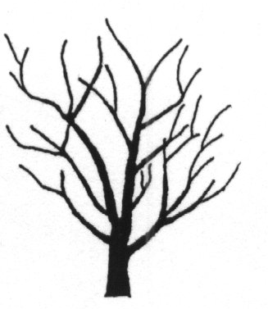 | 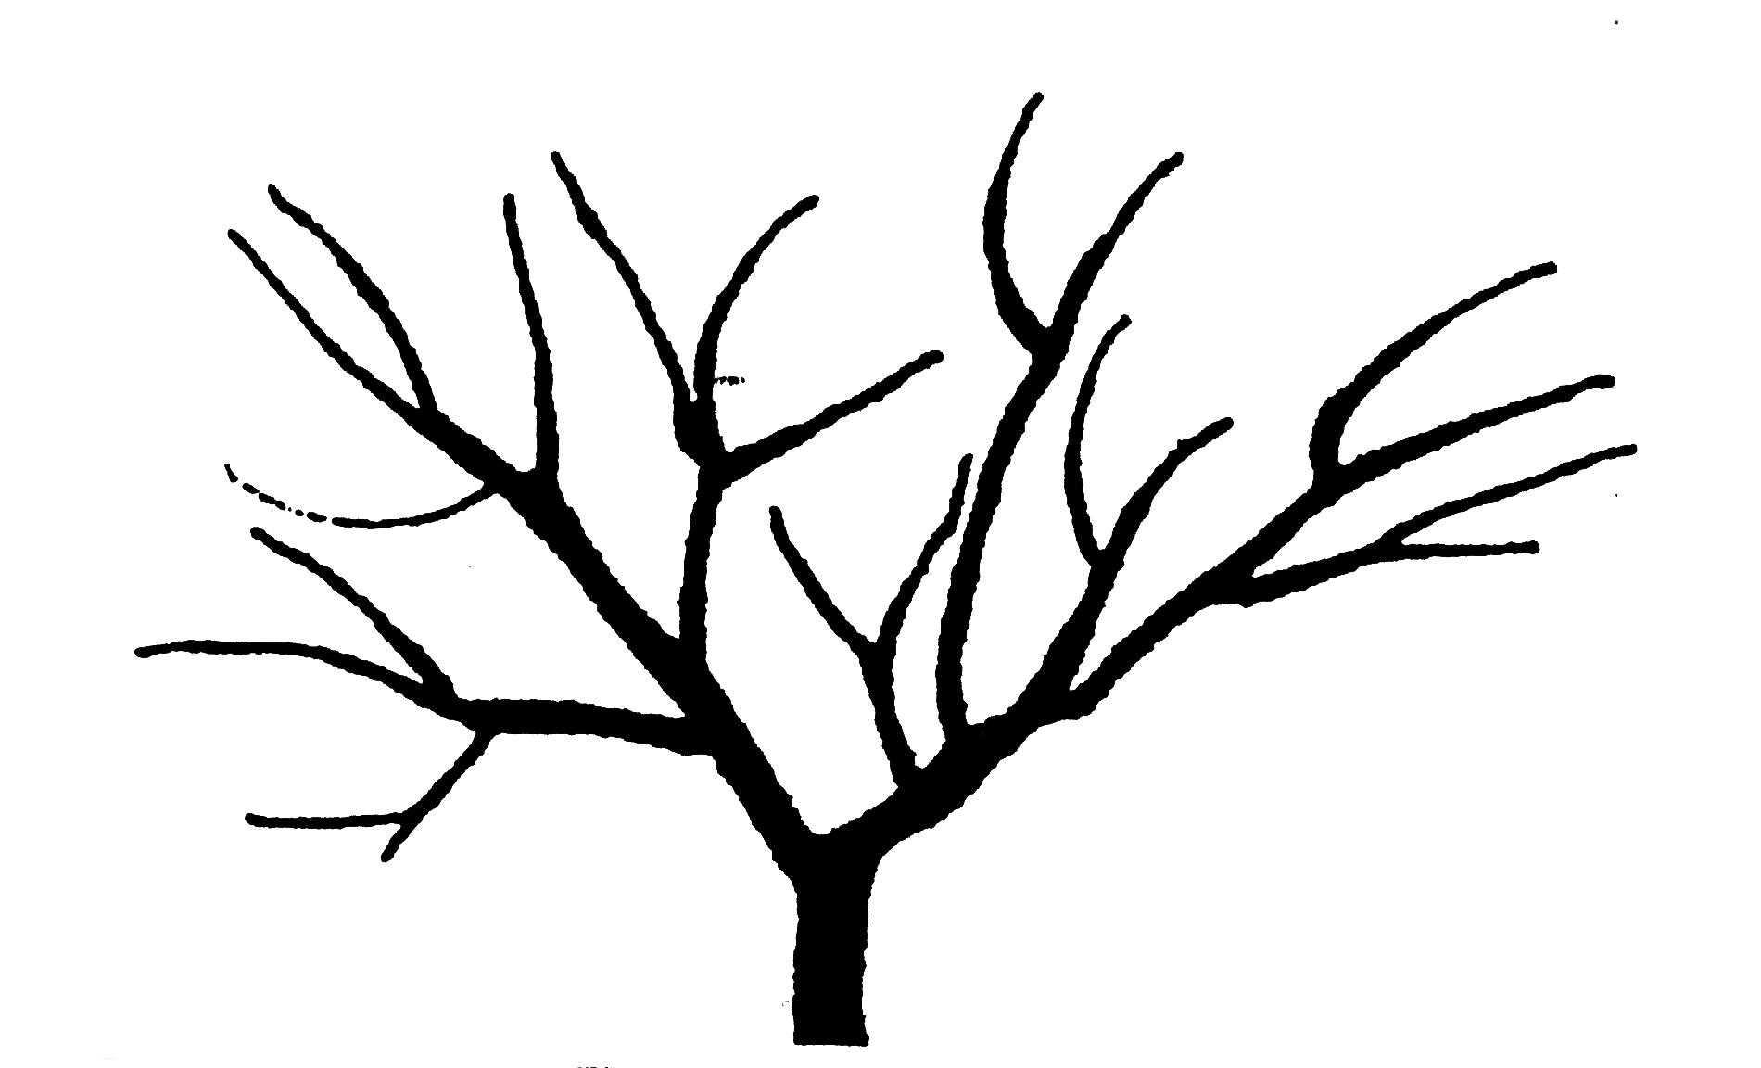 | 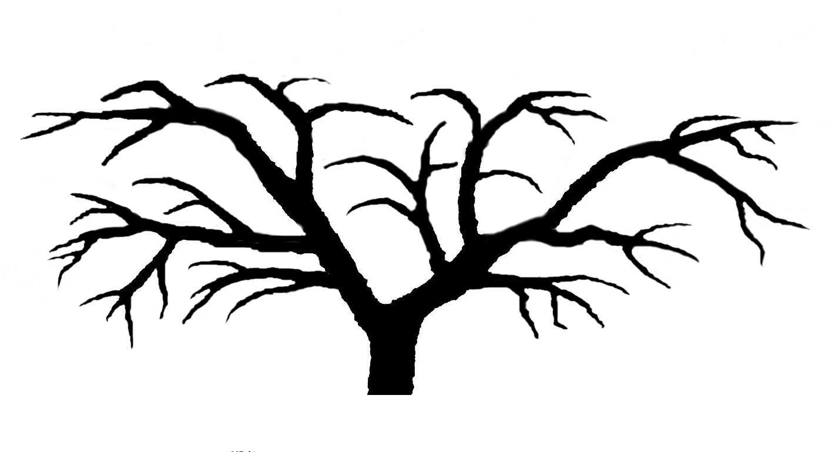 | 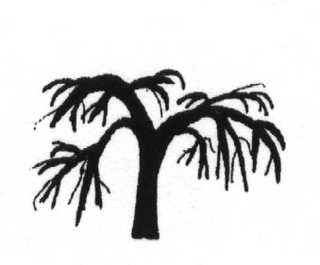
1 | 2 | 3 | 4
upright | spreading | semi drooping | drooping
Ad. 5: Shoot: length of internode

To be observed on the middle part of the shoot, after the current season’s growth has stopped.

Ad. 10: Leaf blade: shape

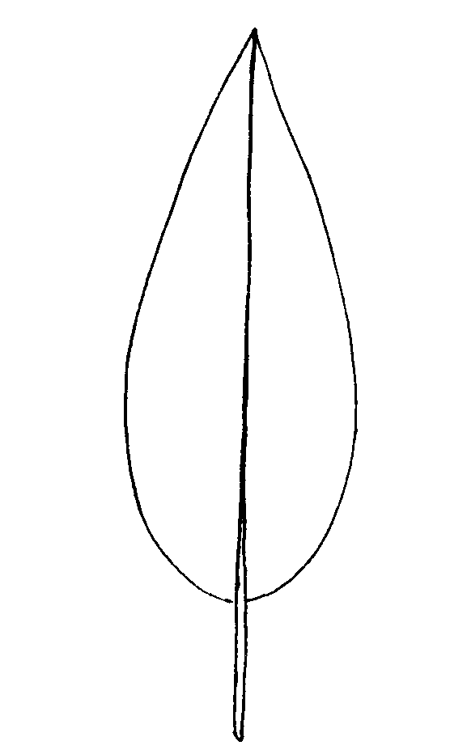 | 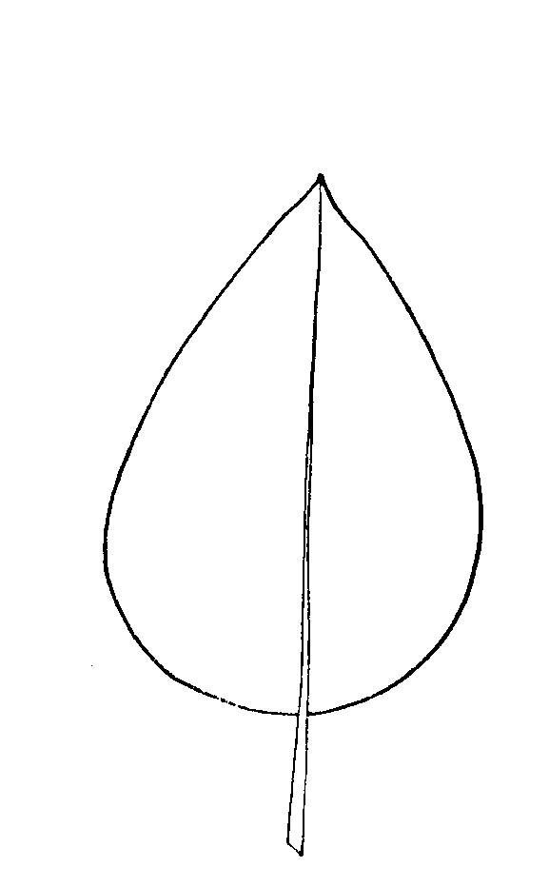 |  | 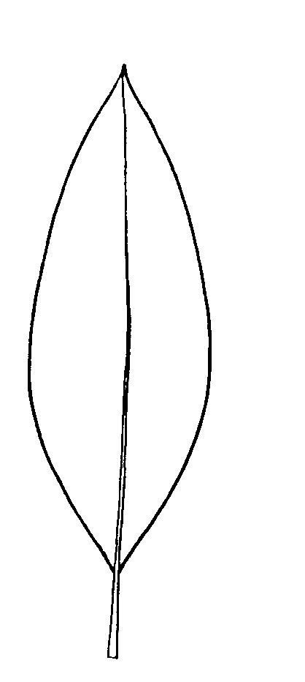
1 | 2 |  | 3
lanceolate | ovate |  | elliptic
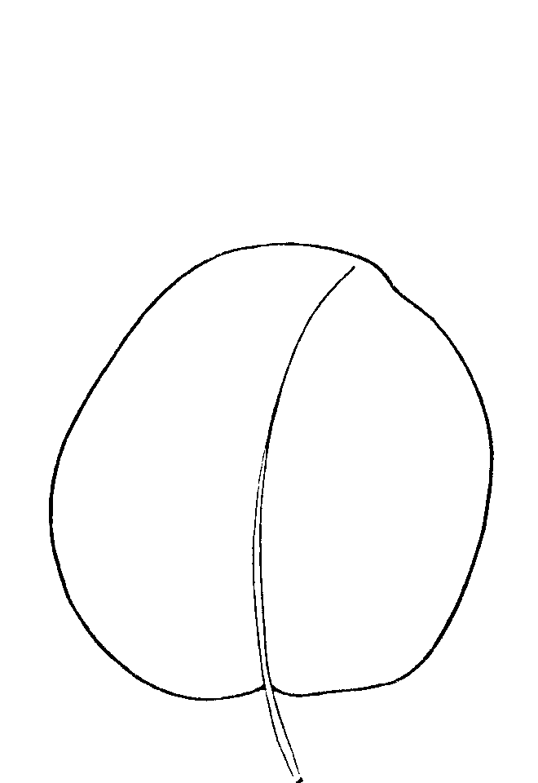 |  | 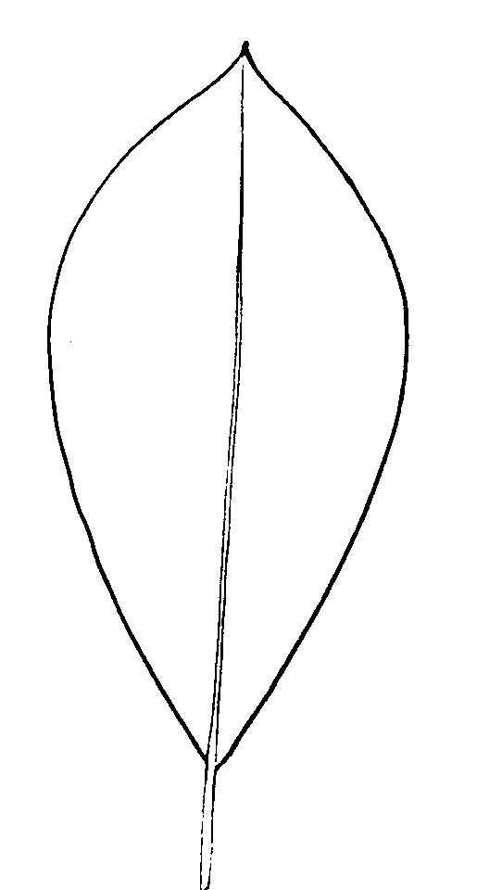
4 |  | 5
circular |  | obovate

Ad. 11: Leaf blade: shape of apex

 |  |  | 1
 |  |  | acuminate
 | 2 |  |  | 3
 | acute |  |  | rounded

Ad. 12: Leaf blade: twisting along whole length

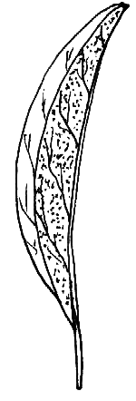 | 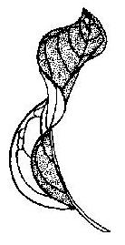
1 | 9
absent | present

Ad. 13: Leaf blade: twisting of apex
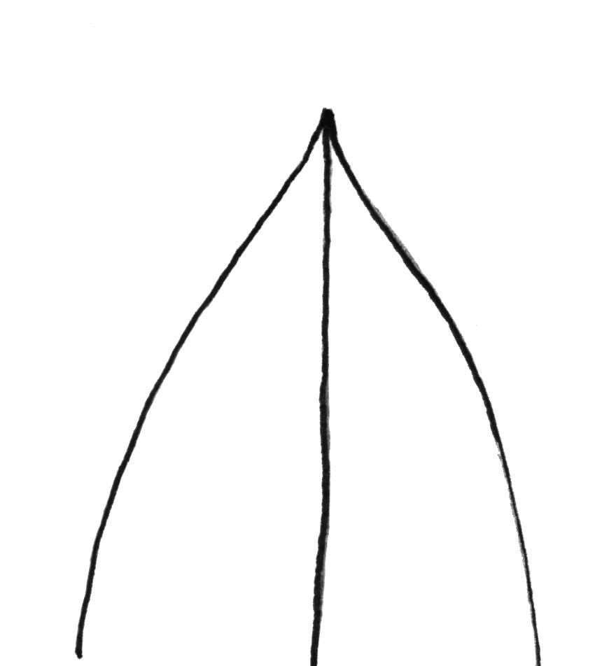 |  | 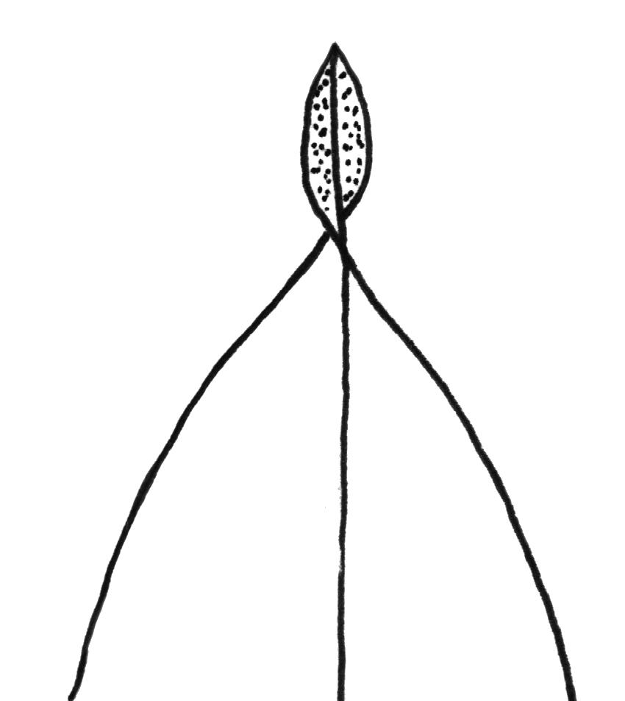
1 |  | 9
absent |  | present

Ad. 14: Leaf blade: undulation of margin

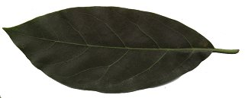

1 |  | 3
absent or very weak |  | weak
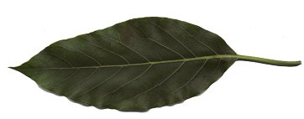
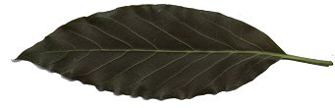

5 |  | 7
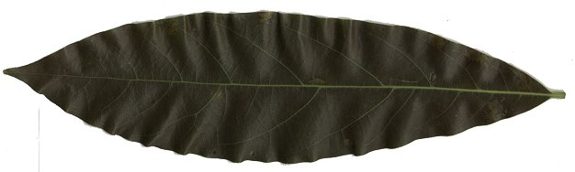  medium |  | strong

9
very strong

Ad. 20: Inflorescence: length of axis

3 | 5
short | medium

7
long

Ad. 22: Inflorescence: flowering type

A flower from inflorescence

Type |  | A | B
Day 1 | a.m. | open with female parts functional | closed
Day 1 | p.m. | closed | open with female parts functional
Day 2 | a.m. | closed | open with male parts functional
Day 2 | p.m. | open with male parts functional | closed

Observations should be carried out according to Ish-Am, G. and D. Eisikowitch. 1991: New insight into avocado flowering in relation to its pollination. California Avocado Society Yearbook 75: 125-137.

Ad. 23: Flower: nectary

1 |  | 2
sessile |  | stalked

Ad. 24: Flower: style

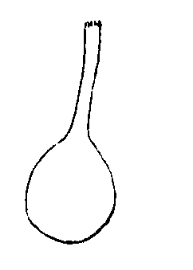 |  | 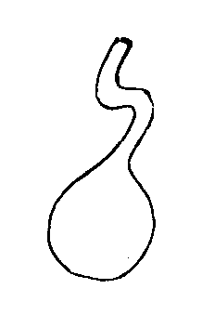
1 |  | 2
straight |  | kinked

Ad. 25: Flower: pollen

Observations on the pollen should be made at anther dehiscence of the male stage flower.

Ad. 31: Mature fruit: shape of stalk end

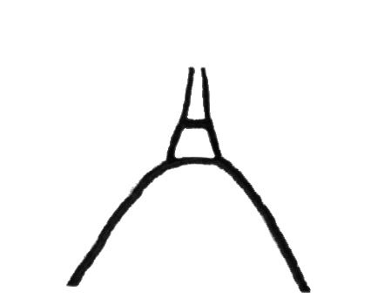 | 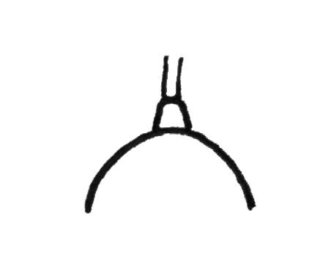 | 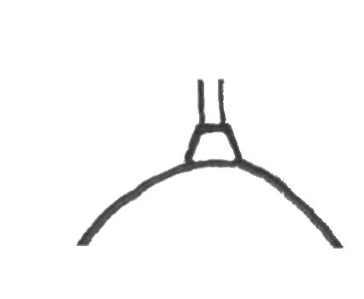 | 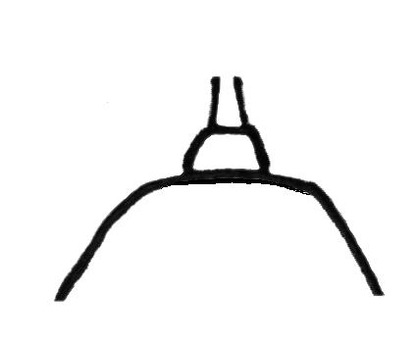
1 | 2 | 3 | 4
pointed | narrowly rounded | broadly rounded | truncate

Ad. 32: Mature fruit: presence of neck

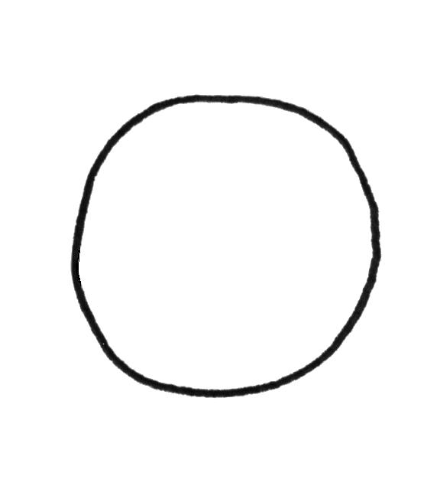 | 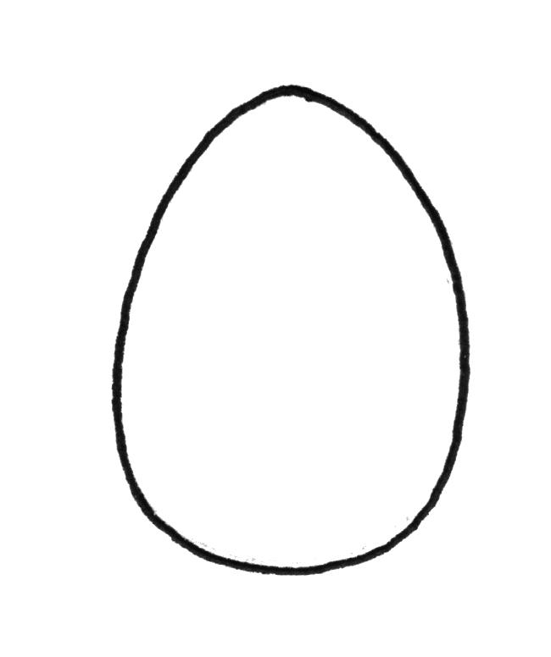 | 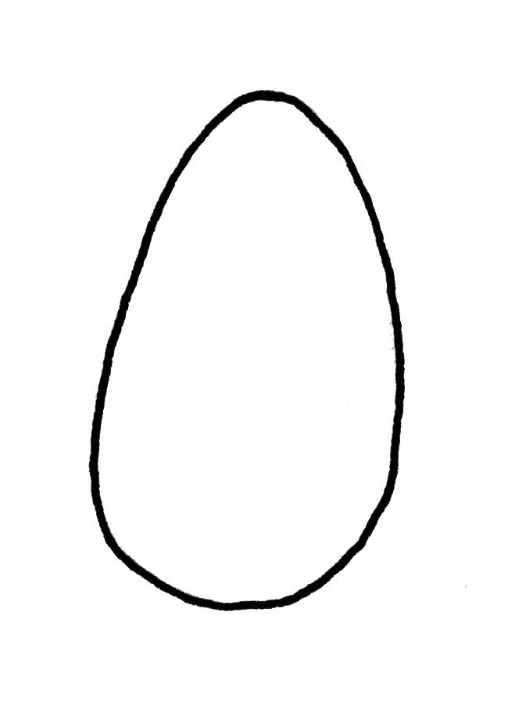 | 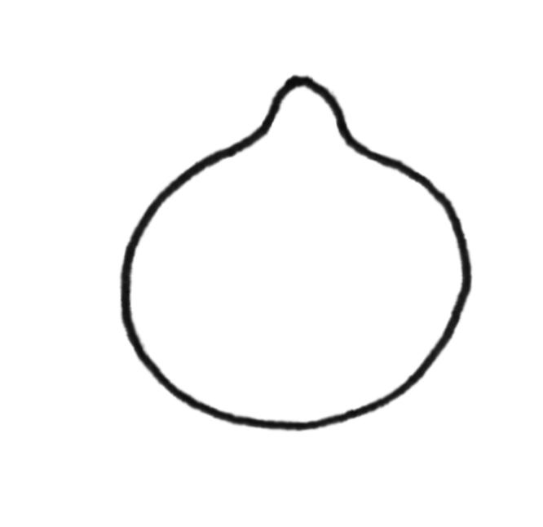 | 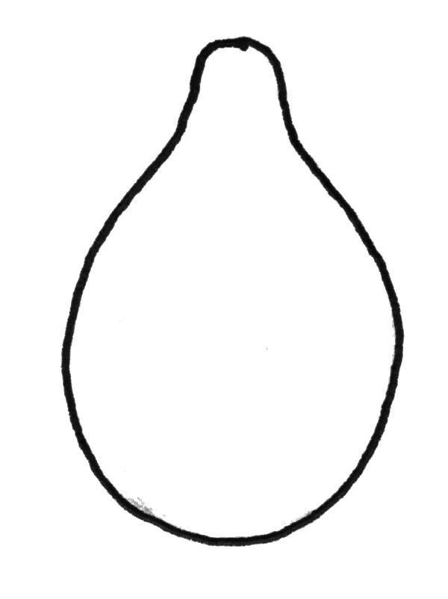 | 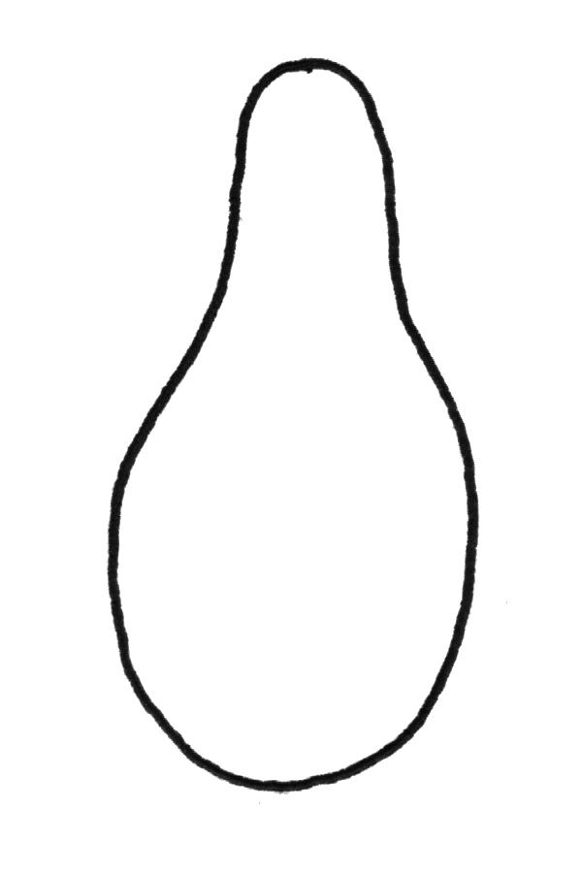
1 |  |  | 9
absent |  |  | present

Ad. 33: Mature fruit: presence of depression at stalk end

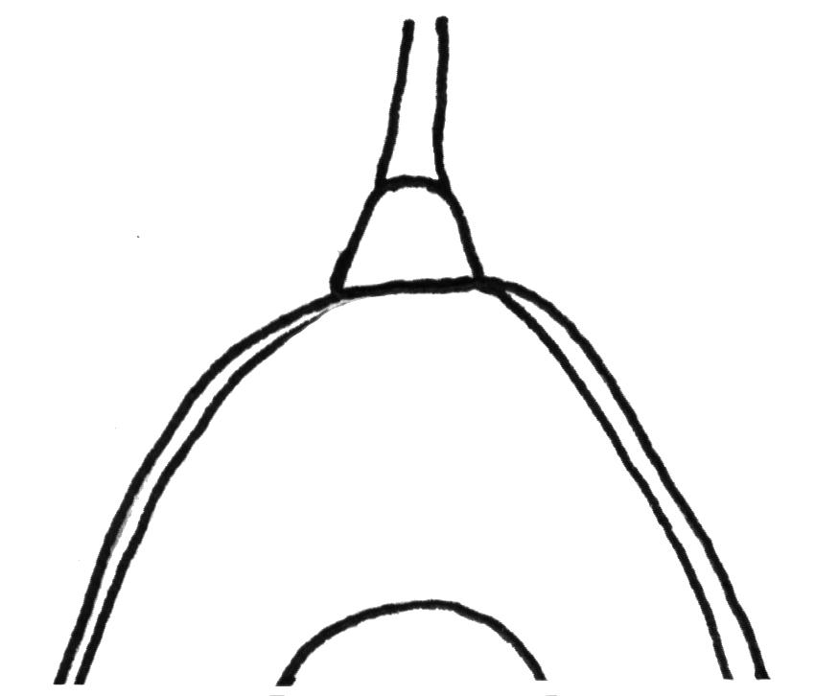 |  | 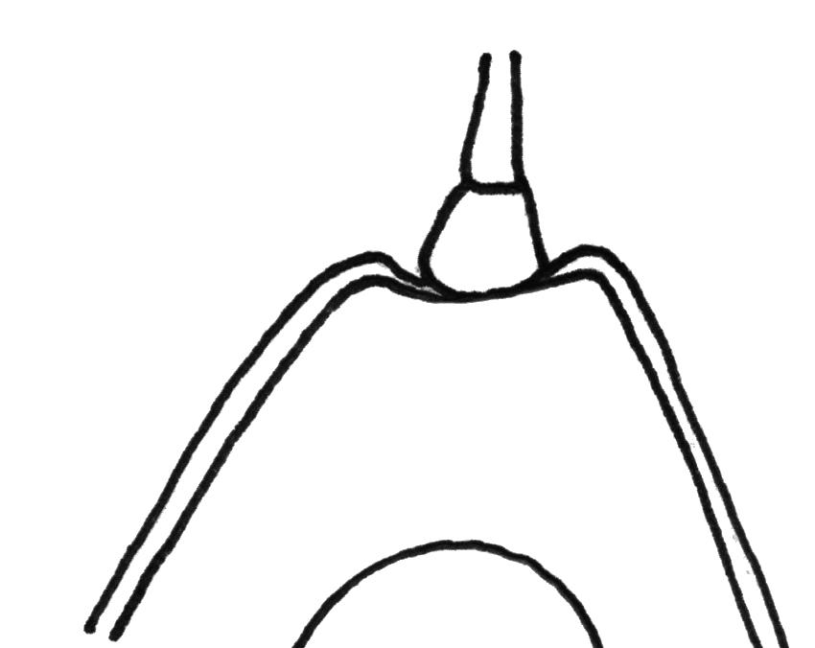
1 |  | 9
absent |  | present

Ad. 34: Mature fruit: diameter of stalk attachment

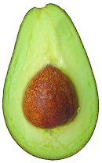
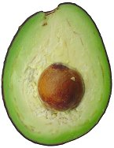
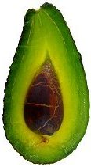

3 | 5 | 7
small | medium | large

Ad. 36: Mature fruit: shape at stylar region

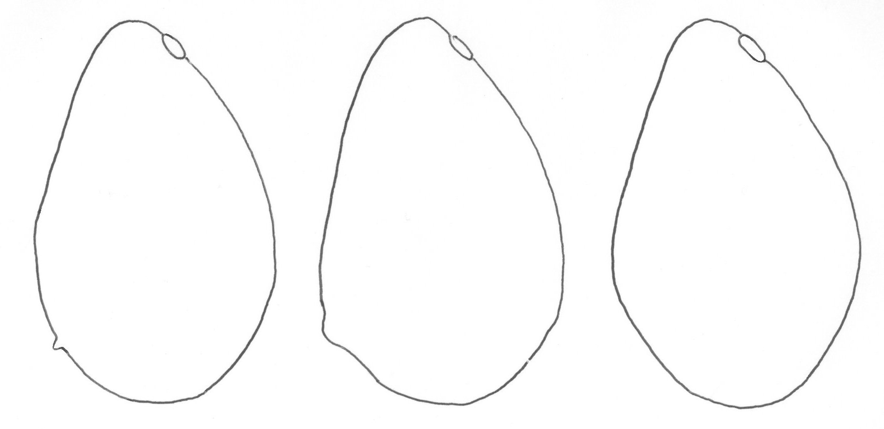
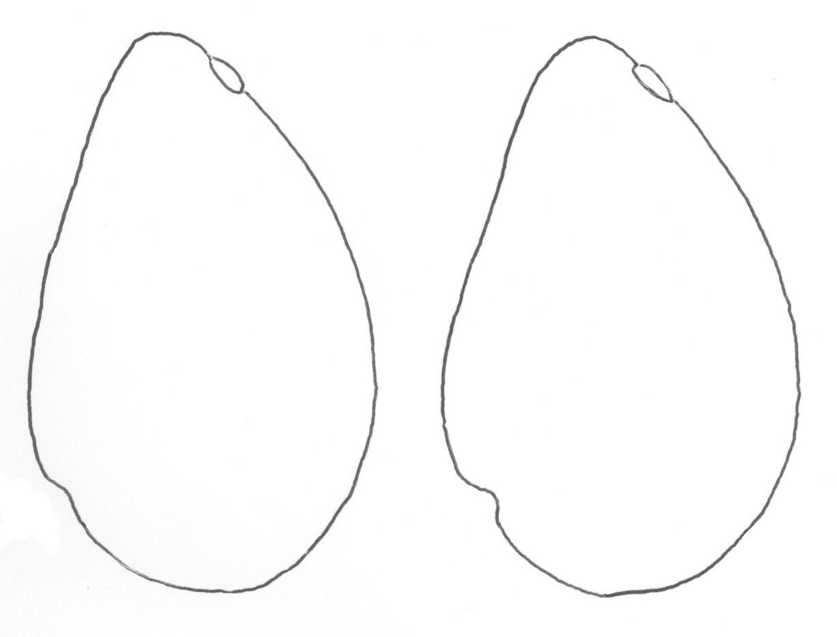

7

1 | 2 | 3 | 4 | 5
pointed | rounded | flattened | slightly depressed | deeply depressed

Ad. 43: Pedicel: thickness compared to peduncle (at junction)

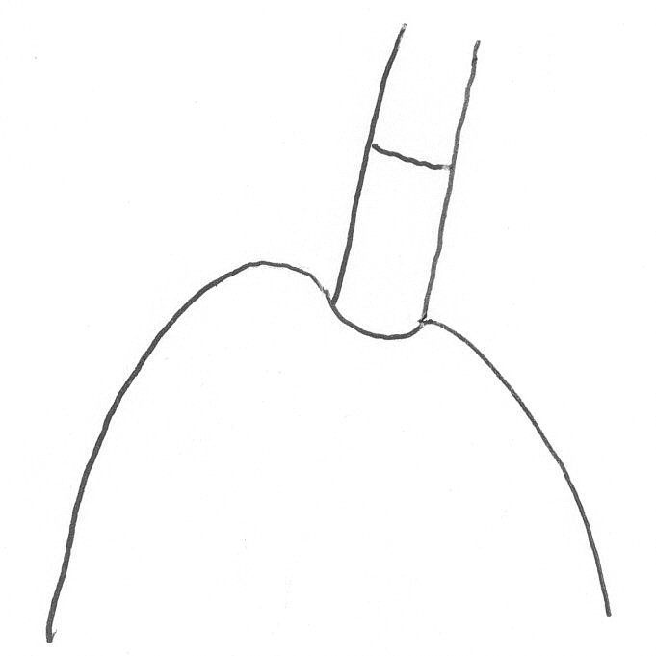
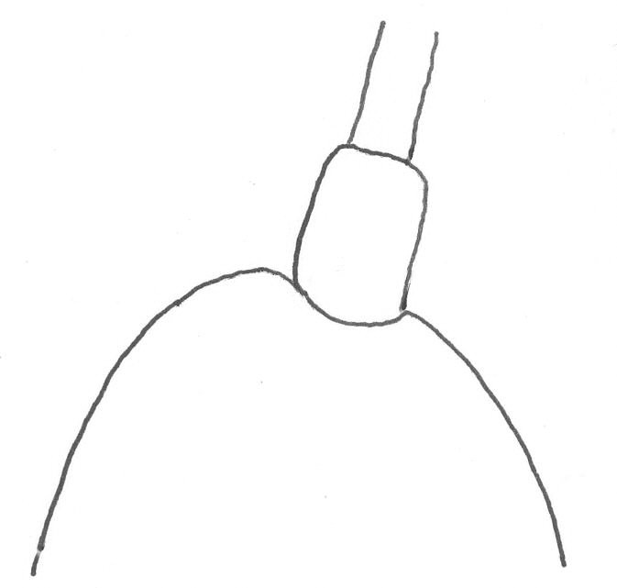

1 |  | 2
same |  | thicker

Ad. 45: Pedicel: shape

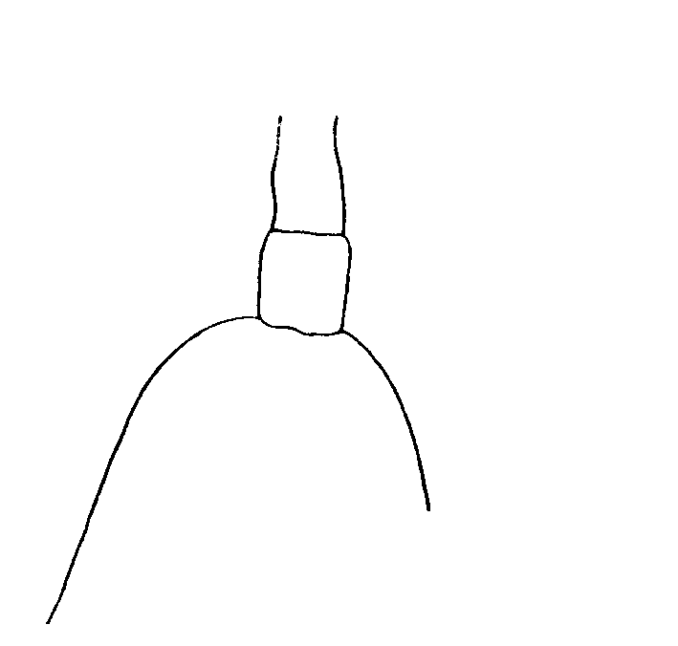 |  | 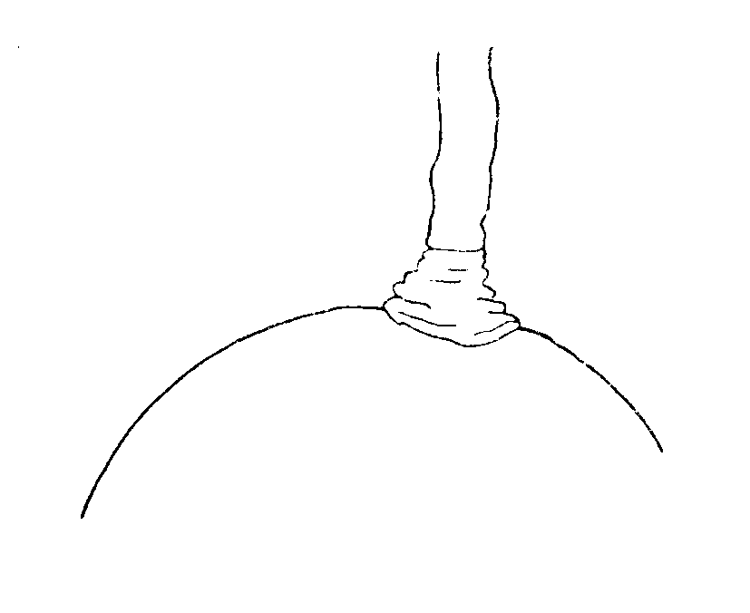
1 |  | 2
cylindrical |  | conical

Ad. 46: Pedicel: “nailhead”

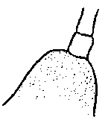 |  | 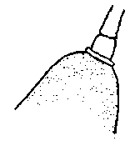
1 |  | 9
absent |  | present

Ad. 51: Ripe fruit: consistency of skin
Ad. 52: Ripe fruit: adherence of skin to flesh

Should be evaluated by peeling the ripe fruit with the aid of the fingers.

Ad. 60: Seed: shape in longitudinal section (lateral view)

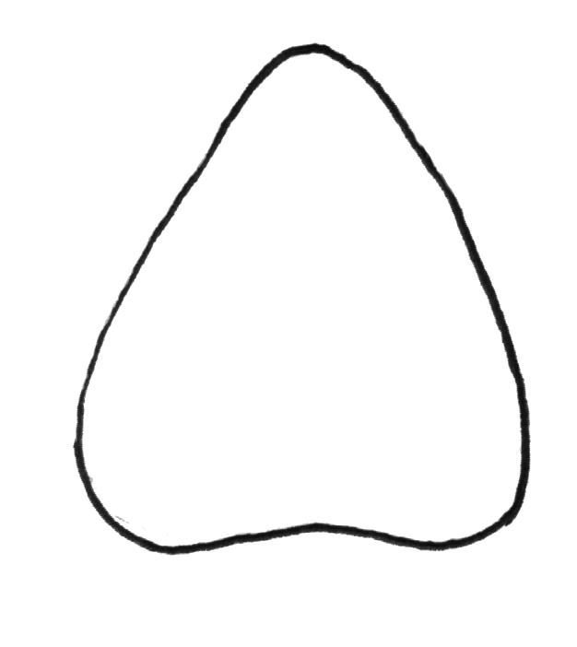 | 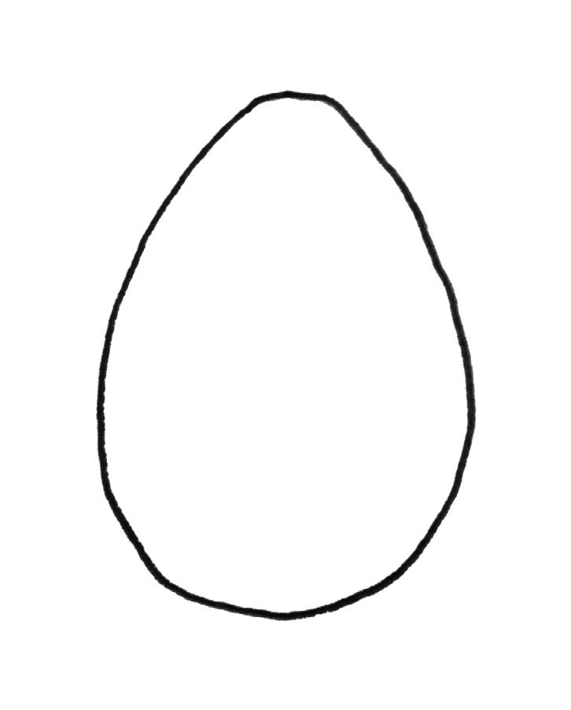 | 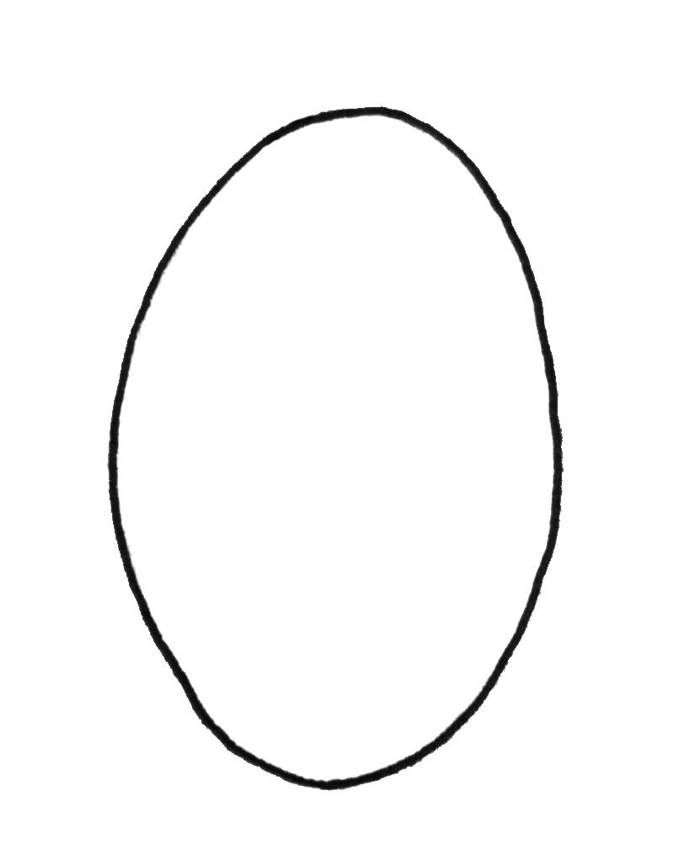
1 | 2 | 3
triangular | ovate | elliptic

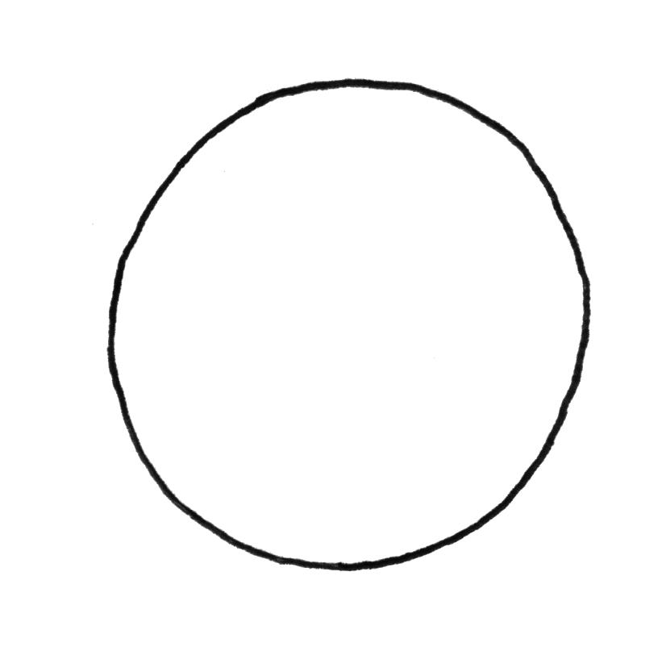 | 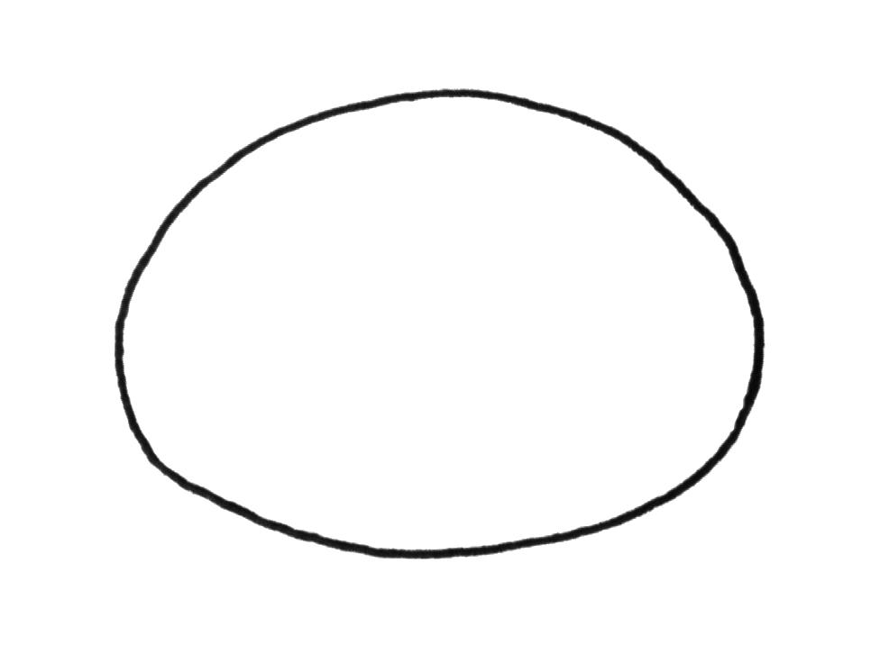 | 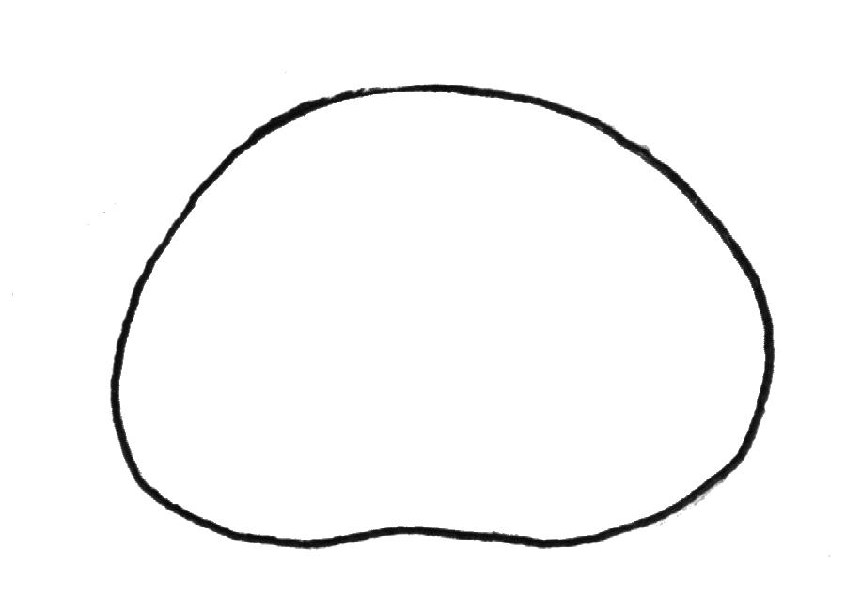
4 | 5 | 6
circular | oblate | depressed oblate

Literature
Avilán Rovira, L.; Avilán Rodríguez, L. A,. 1997: Sistema de Información de las fichas de variedades de aguacate del banco de germoplasma – CENIAP. Manual de Usuario y Disco. Fondo Nacional de Investigaciones Agropecuarias, Centro Nacional de Investigaciones Agropecuarias-IICA/CReA/PROCIANDINO/FRUTHEX. Serie D No. 34. Maracay, Venezuela. 19 p.

Barrientos-Priego, A. F.; Ben-Ya’acov, A. D.; de la Cruz-Torres, E.; López-López, L.; Bufler, G.; Borys, M. W., 1991: Descriptores para aguacate-Descriptors for avocado. Fundación Salvador Sánchez Colín-CICTAMEX, S. C. Coatepec Harinas, Estado de México. México 69 p.

IPGRI, 1995: Descriptors for Avocado (Persea americana Mill.). International Genetic Resources Institute (IPGRI-FAO). Rome, Italy. 52 p.

Ish-Am, G.; Eisikowitch, D., 1991: New insight into avocado flowering in relation to its pollination. California Avocado Society Yearbook 75: 125-137. (Can be downloaded at www.avocadosource.com)

Technical Questionnaire
TECHNICAL QUESTIONNAIRE |  |  |  | Page {x} of {y} |  | Reference Number:
 |  |  |  |  |  | Application date:
 |  |  |  |  |  | (not to be filled in by the applicant)
TECHNICAL QUESTIONNAIRE
to be completed in connection with an application for plant breeders’ rights

1. Subject of the Technical Questionnaire
1.1 Botanical Name |  |  | Persea americana Mill.
1.2 Common Name |  |  | Avocado
2. Applicant
Name
Address
Telephone No.
Fax No.
E-mail address
Breeder (if different from applicant)
3. Proposed denomination and breeder’s reference
Proposed denomination
(if available)

Breeder’s reference
#4. Information on the breeding scheme and propagation of the variety

4.1 Breeding scheme

Variety resulting from:

4.1.1 Crossing

(a) controlled cross [ ]
(please state parent varieties)
(b) partially known cross [ ]
(please state known parent variety(ies))
(c) unknown cross [ ]

4.1.2 Mutation [ ]
(please state parent variety)

4.1.3 Discovery and development [ ]
(please state where and when discovered and how developed)

4.1.4 Other [ ]
(please provide details)

4.2 Method of propagating the variety

4.2.1 Vegetative propagation

(a) grafting [ ]
(b) layering (clonal) [ ]
(c) other (state method) [ ]

4.2.2 Seed [ ]

4.2.3 Other [ ]
(please provide details)

5. Characteristics of the variety to be indicated (the number in brackets refers to the corresponding characteristic in Test Guidelines; please mark the note which best corresponds).
 | Characteristics |  |  |  |  |  | Example Varieties |  |  | Note
5.1  (2) | Young shoot: color
 | yellow green |  |  |  |  |  | Collinson |  |  | 1[ ]
 | green |  |  |  |  |  | Benedict, G-22, Teague |  |  | 2[ ]
 | reddish |  |  |  |  |  | Duke 6 |  |  | 3[ ]
5.2  (18) | Leaf blade: anise aroma
 | absent or weak |  |  |  |  |  | Hass, Reed |  |  | 1[ ]
 | medium |  |  |  |  |  | Duke 7 |  |  | 2[ ]
 | strong |  |  |  |  |  | Thomas |  |  | 3[ ]
5.3  (45) | Pedicel: shape
 | cylindrical |  |  |  |  |  | Horshim, Iriet, Teague |  |  | 1[ ]
 | conical |  |  |  |  |  | Dunedin, Edranol, Monroe |  |  | 2[ ]
5.4  (46) | Pedicel: “nailhead”
 | absent |  |  |  |  |  | Duke, Edranol, Wurtz |  |  | 1[ ]
 | present |  |  |  |  |  | Maxima, Pollock |  |  | 9[ ]
5.5  (49) | Ripe fruit: color
 | yellow green |  |  |  |  |  | Melendez |  |  | 1[ ]
 | light green |  |  |  |  |  | Marsheline, Mayo |  |  | 2[ ]
 | medium green |  |  |  |  |  | Greengold, Rincon, Zutano |  |  | 3[ ]
 | dark green |  |  |  |  |  | Ahaheim, Colín V-33, Edranol |  |  | 4[ ]
 | reddish |  |  |  |  |  | Los Moros |  |  | 5[ ]
 | medium purple |  |  |  |  |  |  |  |  | 6[ ]
 | dark purple or black |  |  |  |  |  | Hass, Topa Topa |  |  | 7[ ]
 | Characteristics |  |  |  |  |  | Example Varieties |  |  | Note
5.6  (50) | Ripe fruit: thickness of skin
 | very thin |  |  |  |  |  | Mexicola, Topa Topa |  |  | 1[ ]
 | moderately thin |  |  |  |  |  | Colín V-33, Fuerte |  |  | 3[ ]
 | medium |  |  |  |  |  | Edranol |  |  | 5[ ]
 | moderately thick |  |  |  |  |  | Hass |  |  | 7[ ]
 | very thick |  |  |  |  |  | Dickinson |  |  | 9[ ]
5.7  (67) | Time of fruit maturity for harvesting
 | very early |  |  |  |  |  | Topa Topa |  |  | 1[ ]
 | early |  |  |  |  |  | Ettinger |  |  | 3[ ]
 | medium |  |  |  |  |  | Fuerte |  |  | 5[ ]
 | late |  |  |  |  |  | Hass, Ryan |  |  | 7[ ]
 | very late |  |  |  |  |  | Reed |  |  | 9[ ]
6. Similar varieties and differences from these varieties

Please use the following table and box for comments to provide information on how your candidate variety differs from the variety (or varieties) which, to the best of your knowledge, is (or are) most similar. This information may help the examination authority to conduct its examination of distinctness in a more efficient way.
Denomination(s) of variety(ies) similar to your candidate variety |  | Characteristic(s) in which your candidate variety differs from the similar variety(ies) |  |  | Describe the expression of the characteristic(s) for the similar variety(ies) |  |  | Describe the expression of the characteristic(s) for your candidate variety
Example |  | Mature fruit: stalk cavity |  |  | e.g. note 1 |  |  | note 9
 |  |  |  |  | e.g. absent |  |  | present
Comments:

#7. Additional information which may help in the examination of the variety

7.1 In addition to the information provided in sections 5 and 6, are there any additional characteristics which may help to distinguish the variety?

Yes [ ] No [ ]
(If yes, please provide details)

7.2 Are there any special conditions for growing the variety or conducting the examination?

Yes [ ] No [ ]
(If yes, please provide details)

7.3 Other information

A representative color photograph of the variety should accompany the Technical Questionnaire.

8. Authorization for release

(a) Does the variety require prior authorization for release under legislation concerning the protection of the environment, human and animal health?

Yes [ ] No [ ]

(b) Has such authorization been obtained?

Yes [ ] No [ ]

If the answer to (b) is yes, please attach a copy of the authorization.

9. Information on plant material to be examined or submitted for examination.

9.1 The expression of a characteristic or several characteristics of a variety may be affected by factors, such as pests and disease, chemical treatment (e.g. growth retardants or pesticides), effects of tissue culture, different rootstocks, scions taken from different growth phases of a tree, etc.

9.2 The plant material should not have undergone any treatment which would affect the expression of the characteristics of the variety, unless the competent authorities allow or request such treatment. If the plant material has undergone such treatment, full details of the treatment must be given. In this respect, please indicate below, to the best of your knowledge, if the plant material to be examined has been subjected to:

(a) Microorganisms (e.g. virus, bacteria, phytoplasma) Yes [ ] No [ ]

(b) Chemical treatment (e.g. growth retardant, pesticide) Yes [ ] No [ ]

(c) Tissue culture Yes [ ] No [ ]

(d) Other factors Yes [ ] No [ ]

Please provide details for where you have indicated “yes”.

……………………………………………………………

10. I hereby declare that, to the best of my knowledge, the information provided in this form is correct:

Applicant’s name

Signature Date

[End of document]

* These names were correct at the time of the introduction of these Test Guidelines but may be revised or updated. [Readers are advised to consult the UPOV Code, which can be found on the UPOV Website (www.upov.int), for the latest information.]
# Authorities may allow certain of this information to be provided in a confidential section of the Technical Questionnaire.
# Authorities may allow certain of this information to be provided in a confidential section of the Technical Questionnaire.

