 |  | E  TG/92/4  ORIGINAL: English  DATE: 2004-03-31
INTERNATIONAL UNION FOR THE PROTECTION OF NEW VARIETIES OF PLANTS
GENEVA

 | PERSIMMON  (Diospyros kaki L.) | *

GUIDELINES

FOR THE CONDUCT OF TESTS

FOR DISTINCTNESS, UNIFORMITY AND STABILITY

Alternative Names:*

Latin | English | French | German | Spanish
Diospyros kaki L. | Persimmon | Plaqueminier | Kakipflaume | Caqui, Kaki

ASSOCIATED DOCUMENTS

These guidelines should be read in conjunction with document TG/1/3, “General Introduction to the Examination of Distinctness, Uniformity and Stability and the Development of Harmonized Descriptions of New Varieties of Plants” (hereinafter referred to as the “General Introduction”) and its associated “TGP” documents.
TABLE OF CONTENTS PAGE

1. Subject of these Test Guidelines 3
2. Material Required 3
3. Method of Examination 3
3.1 Duration of Tests 3
3.2 Testing Place 3
3.3 Conditions for Conducting the Examination 3
3.4 Test Design 3
3.5 Number of Plants / Parts of Plants to be Examined 4
3.6 Additional Tests 4
4. Assessment of Distinctness, Uniformity and Stability 4
4.1 Distinctness 4
4.2 Uniformity 4
4.3 Stability 5
5. Grouping of Varieties and Organization of the Growing Trial 5
6. Introduction to the Table of Characteristics 6
6.1 Categories of Characteristics 6
6.2 States of Expression and Corresponding Notes 6
6.3 Types of Expression 6
6.4 Example Varieties 6
6.5 Legend 6
7. Table of Characteristics/Tableau des caractères/Merkmalstabelle/Tabla de caracteres 7
8. Explanations on the Table of Characteristics 19
8.1 Explanations covering several characteristics 19
8.2 Explanations for individual characteristics 19
8.3 Classification of Persimmon 28
9. Literature 31
10. Technical Questionnaire 32

Subject of these Test Guidelines
These Test Guidelines apply to all varieties of Diospyros kaki L. and their hybrids.

Material Required
2.1 The competent authorities decide on the quantity and quality of the plant material required for testing the variety and when and where it is to be delivered. Applicants submitting material from a State other than that in which the testing takes place must ensure that all customs formalities and phytosanitary requirements are complied with.

2.2 The material is to be supplied in the form of one-year-old grafted plants on rootstocks of Diospyros kaki L. or Diospyros lotus L.

2.3 The minimum quantity of plant material, to be supplied by the applicant, should be:

5 plants.
2.4 The plant material supplied should be visibly healthy, not lacking in vigor, nor affected by any important pest or disease. It should preferably not be obtained from in vitro propagation. If it has been produced by in vitro propagation, this fact must be stated by the applicant.

2.5 The plant material should not have undergone any treatment, which would affect the expression of the characteristics of the variety, unless the competent authorities allow or request such treatment. If it has been treated, full details of the treatment must be given.

Method of Examination

3.1 Duration of Tests
The minimum duration of tests should normally be two independent growing cycles. For the purposes of these Test Guidelines, a growing cycle refers to the fruiting cycle.

3.2 Testing Place
The tests should normally be conducted at one place. If any characteristics of the variety, which are relevant for the examination of DUS, cannot be observed at that place, the variety may be tested at an additional place.

3.3 Conditions for Conducting the Examination
The tests should be carried out under conditions ensuring satisfactory growth for the expression of the relevant characteristics of the variety and for the conduct of the examination. In particular, it is essential that the trees produce a satisfactory crop of fruit in each of the two growing cycles.

3.4 Test Design
3.4.1 Each test should be designed to result in a total of at least 5 plants.

3.4.2 The design of the tests should be such that plants or parts of plants may be removed for measurement or counting without prejudice to the observations which must be made up to the end of the growing cycle.

3.5 Number of Plants / Parts of Plants to be Examined
Unless otherwise indicated, all observations determined by measuring or counting should be made on 5 plants or parts taken from each of 5 plants. In the case of parts of plants, the number to be taken from each of the plants should be 2.

3.6 Additional Tests
Additional tests, for examining relevant characteristics, may be established.

Assessment of Distinctness, Uniformity and Stability

4.1 Distinctness
4.1.1 General Recommendations

It is of particular importance for users of these Test Guidelines to consult the General Introduction prior to making decisions regarding distinctness. However, the following points are provided for elaboration or emphasis in these Test Guidelines.

4.1.2 Consistent Differences

The minimum duration of tests recommended in Section 3.1 reflects, in general, the need to ensure that any differences in a characteristic are sufficiently consistent.

4.1.3 Clear Differences

Determining whether a difference between two varieties is clear depends on many factors, and should consider, in particular, the type of expression of the characteristic being examined, i.e. whether it is expressed in a qualitative, quantitative, or pseudo-qualitative manner. Therefore, it is important that users of these Test Guidelines are familiar with the recommendations contained in the General Introduction prior to making decisions regarding distinctness.

4.2 Uniformity
4.2.1 It is of particular importance for users of these Test Guidelines to consult the General Introduction prior to making decisions regarding uniformity.

4.2.2 For the assessment of uniformity a population standard of 1% and an acceptance probability of at least 95% should be applied. In the case of a sample size of 5 plants, no off-types are allowed.

4.3 Stability
4.3.1 In practice, it is not usual to perform tests of stability that produce results as certain as those of the testing of distinctness and uniformity. However, experience has demonstrated that, for many types of variety, when a variety has been shown to be uniform, it can also be considered to be stable.

4.3.2 Where appropriate, or in cases of doubt, stability may be tested, either by growing a further generation, or by testing a new plant stock to ensure that it exhibits the same characteristics as those shown by the previous material supplied.

Grouping of Varieties and Organization of the Growing Trial
5.1 The selection of varieties of common knowledge to be grown in the trial with the candidate varieties and the way in which these varieties are divided into groups to facilitate the assessment of distinctness is aided by the use of grouping characteristics.

5.2 Grouping characteristics are those in which the documented states of expression, even where produced at different locations, can be used, either individually or in combination with other such characteristics: (a) to select varieties of common knowledge that can be excluded from the growing trial used for examination of distinctness; and (b) to organize the growing trial so that similar varieties are grouped together.

5.3 The following have been agreed as useful grouping characteristics:

(a) Fruit: general shape in lateral view (characteristic 21);
(b) Varieties with astringency always absent or sometimes present only: Fruit: color of skin (characteristic 37);
(c) Varieties with astringency always present only: Fruit: color of skin (characteristic 38);
(d) Varieties with astringency always absent or sometimes present only: Time of ripeness for eating (characteristic 48);
(e) Varieties with astringency always present only: Time of ripeness for eating (characteristic 49);
(f) Fruit: astringency (characteristic 50).

5.4 Guidance for the use of grouping characteristics, in the process of examining distinctness, is provided through the General Introduction.

Introduction to the Table of Characteristics

6.1 Categories of Characteristics
6.1.1 Standard Test Guidelines Characteristics

Standard Test Guidelines characteristics are those which are approved by UPOV for examination of DUS and from which members of the Union can select those suitable for their particular circumstances.

6.1.2 Asterisked Characteristics

Asterisked characteristics (denoted by *) are those included in the Test Guidelines which are important for the international harmonization of variety descriptions and should always be examined for DUS and included in the variety description by all members of the Union, except when the state of expression of a preceding characteristic or regional environmental conditions render this inappropriate.

6.2 States of Expression and Corresponding Notes
States of expression are given for each characteristic to define the characteristic and to harmonize descriptions. Each state of expression is allocated a corresponding numerical note for ease of recording of data and for the production and exchange of the description.

6.3 Types of Expression
An explanation of the types of expression of characteristics (qualitative, quantitative and pseudo-qualitative) is provided in the General Introduction.

6.4 Example Varieties
Where appropriate, example varieties are provided to clarify the states of expression of each characteristic.

6.5 Legend
(*) Asterisked characteristic – see Section 6.1.2

QL Qualitative characteristic – see Section 6.3
QN Quantitative characteristic – see Section 6.3
PQ Pseudo-qualitative characteristic – see Section 6.3

(a)-(d) See Explanations on the Table of Characteristics in Chapter 8, Section 8.1

(+) See Explanations on the Table of Characteristics in Chapter 8, Section 8.2

Table of Characteristics/Tableau des caractères/Merkmalstabelle/Tabla de caracteres
 |  | English | français | deutsch | español | Example Varieties  Exemples  Beispielssorten  Variedades ejemplo | Note/  Nota
1. | (a) | Tree: vigor | Arbre: vigueur | Baum: Wuchsstärke | Árbol: vigor
QN |  | weak | faible | gering | débil | Akagaki, Izu, Kurogaki | 3
 |  | medium | moyenne | mittel | medio | Shogatsu | 5
 |  | strong | forte | stark | fuerte | Hiratanenashi, Saijo | 7
2.  (*) | (a) | Tree: habit | Arbre: port | Baum: Wuchsform | Árbol: porte
PQ |  | upright | dressé | aufrecht | erecto | Saijo | 1
 |  | semi-upright | demi-dressé | halbaufrecht | semierecto | Hiratanenashi | 2
 |  | spreading | divergent | breitwüchsig | rastrero | Fuyu | 3
 |  | drooping | retombant | überhängend | colgante | Shakokushi | 4
3.  (*) | (a) | One-year-old shoot: length | Rameau d’un an: longueur | Einjähriger Trieb: Länge | Rama de un año: longitud
QN |  | short | court | kurz | corta | Izu | 3
 |  | medium | moyen | mittel | media | Suruga | 5
 |  | long | long | lang | larga | Fuyu | 7
4. | (a) | One-year-old shoot: thickness | Rameau d’un an: épaisseur | Einjähriger Trieb: Dicke | Rama de un año: grosor
QN |  | thin | fin | dünn | delgada | Gosho, Nishimurawase | 3
 |  | medium | moyen | mittel | media | Jiro | 5
 |  | thick | épais | dick | gruesa | Fuyu, Hiratanenashi | 7
5. | (a) | One-year-old shoot: length of internode | Rameau d’un an: longueur de l’entre-nœud | Einjähriger Trieb: Länge des Internodiums | Rama de un año: longitud del entrenudo
QN |  | short | court | kurz | corto | Nishimurawase | 3
 |  | medium | moyen | mittel | medio | Gosho | 5
 |  | long | long | lang | largo | Fuyu, Gionbo | 7
6. | (a) | One-year-old shoot: number of lenticels | Rameau d’un an: nombre de lenticelles | Einjähriger Trieb: Anzahl Lentizellen | Rama de un año: número de lenticelas
QN |  | few | petit | gering | bajo | Toyoka | 3
 |  | medium | moyen | mittel | medio | Fuyu, Hiratanenashi, Jiro | 5
 |  | many | grand | groß | alto | Amahyakume, Takura | 7
7. | (a) | One-year-old shoot: size of lenticels | Rameau d’un an: taille des lenticelles | Einjähriger Trieb: Größe der Lentizellen | Rama de un año: tamaño de las lenticelas
QN |  | small | petites | klein | pequeñas | Aizumishirazu, Yotsumizo | 3
 |  | medium | moyennes | mittel | medias | Fuyu, Saijo | 5
 |  | large | grandes | groß | grandes | Moriya, Takura | 7
8. | (a) | One-year-old shoot: shape of lenticels | Rameau d’un an: forme des lenticelles | Einjähriger Trieb: Form der Lentizellen | Rama de un año: forma de las lenticelas
PQ |  | elliptic | elliptiques | elliptisch | elípticas | Fuyu, Hiratanenashi, Jiro | 1
 |  | circular | circulaires | kreisförmig | circulares | Hanagosho, Nishimurawase | 2
 |  | oblong | oblongues | rechteckig | oblongas | Koshuhyakume | 3
9. | (a) | One-year-old shoot: color (sunny side) | Rameau d’un an: couleur (face ensoleillée) | Einjähriger Trieb: Farbe (Sonnenseite) | Rama de un año: color (en la cara soleada)
PQ |  | grey brown | brun gris | graubraun | marrón grisáceo | Sanja, Yotsumizo | 1
 |  | yellow brown | brun jaune | gelbbraun | marrón amarillento | Hiratanenashi | 2
 |  | brown | brun | braun | marrón | Atago | 3
 |  | red brown | brun rouge | rotbraun | marrón rojizo | Fuyu | 4
10.  (*)  (+) | (a) | One-year-old shoot: shape of bud in profile view | Rameau d’un an: forme du bourgeon vu de profil | Einjähriger Trieb: Form der Knospe in der Seitenansicht | Rama de un año: forma de la yema vista de perfil
PQ |  | triangular | triangulaire | dreieckig | triangular | Aizumishirazu, Fuyu | 1
 |  | broad ovate | ovale large | breit eiförmig | ovalada ancha | Jiro, Saijo | 2
 |  | circular | circulaire | kreisförmig | circular | Hiratanenashi | 3
11. | (b) | Leaf blade: length | Limbe: longueur | Blattspreite: Länge | Limbo: longitud
QN |  | short | court | kurz | corto | Hanagosho, Hiratanenashi | 3
 |  | medium | moyen | mittel | medio | Fuyu, Nishimurawase | 5
 |  | long | long | lang | largo | Aizumishirazu, Saijo | 7
12. | (b) | Leaf blade: width | Limbe: largeur | Blattspreite: Breite | Limbo: anchura
QN |  | narrow | étroit | schmal | estrecho | Eboshi | 3
 |  | medium | moyen | mittel | medio | Fuyu, Jiro | 5
 |  | broad | large | breit | ancho | Koshuhyakume | 7
13.  (*)  (+) | (b) | Leaf blade: shape | Limbe: forme | Blattspreite: Form | Limbo: forma
PQ |  | elliptic | elliptique | elliptisch | elíptica | Aizumishirazu, Fuyu | 1
 |  | ovate | ovale | eiförmig | oval | Hanagosho, Hiratanenashi | 2
 |  | obovate | obovale | verkehrt eiförmig | oboval | Shakokushi | 3
14.  (*)  (+) | (b) | Leaf blade: shape of base | Limbe: forme de la base | Blattspreite: Form der Basis | Limbo: forma de la base
PQ |  | narrow acute | aiguë étroite | schmalspitz | aguda estrecha | Eboshi | 1
 |  | broad acute | aiguë large | breitspitz | aguda ancha | Aizumishirazu | 2
 |  | obtuse | obtuse | stumpf | obtusa | Fuyu, Gosho | 3
 |  | rounded | arrondie | abgerundet | redondeada | Amahyakume, Suruga | 4
15.  (+) | (b) | Leaf blade: shape of apex | Limbe: forme du sommet | Blattspreite: Form der Spitze | Limbo: forma del ápice
PQ |  | acuminate | acuminé | mit aufgesetzter Spitze | acuminado | Aizumishirazu | 1
 |  | acute | aigu | spitz | agudo | Atago, Fuyu, Jiro, Saijo | 2
 |  | obtuse | obtus | stumpf | obtuso | Hiratanenashi, Suruga | 3
16. (*) | (a) | Tree: sex expression of flowers | Arbre: expression du sexe des fleurs | Baum: Geschlechtsausprägung der Blüten | Árbol: expresión del sexo de las flores
QL |  | female only | femelles seulement | nur weiblich | sólo femeninas | Fuyu, Hiratanenashi, Jiro | 1
 |  | female and male | femelles et mâles | weiblich und männlich | femeninas y masculinas | Hanagosho | 2
 |  | female, male and hermaphrodite | femelles, mâles et hermaphrodites | weiblich, männlich und zwittrig | femeninas, masculinas y hermafroditas | Kubogataobishi, Meotogaki | 3
17.  (*) | (c) | Female flower: diameter of corolla | Fleur femelle: diamètre de la corolle | Weibliche Blüte: Durchmesser der Krone | Flor femenina: diámetro de la corola
QN |  | small | petit | klein | pequeño | Kubo, Yotsumizo | 3
 |  | medium | moyen | mittel | medio | Aizumishirazu | 5
 |  | large | grand | groß | grande | Amahyakume, Koshuhyakume | 7
18.  (+) | (c) | Female flower: shape of calyx viewed from above | Fleur femelle: forme du calice vu de dessus | Weibliche Blüte: Form des Kelches von oben gesehen | Flor femenina: forma del cáliz visto desde arriba
PQ |  | circular | circulaire | kreisförmig | circular | Anzai | 1
 |  | rounded rhombic | losangique arrondi | abgerundet rautenförmig | rómbico redondeado | Izu | 2
 |  | rhombic | losangique | rautenförmig | rómbico | Aizumishirazu, Fuyu | 3
 |  | regular cruciform | cruciforme régulier | regelmäßig kreuzförmig | cruciforme regular | Hiratanenashi, Jiro | 4
 |  | irregular cruciform | cruciforme irrégulier | unregelmäßig kreuzförmig | cruciforme irregular | Oshorokaki | 5
19.  (*) | (c) | Female flower: number of corolla lobes | Fleur femelle: nombre de lobes de la corolle | Weibliche Blüte: Anzahl Kronzipfel | Flor femenina: número de lóbulos de la corola
QL |  | four | quatre | vier | cuatro | Koshuhyakume | 1
 |  | more than four | plus de quatre | mehr als vier | más de cuatro | Marcatelli | 2
20. (*) | (d) | Fruit: size | Fruit: taille | Frucht: Größe | Fruto: tamaño
QN |  | small | petit | klein | pequeño | Yotsumizo | 3
 |  | medium | moyen | mittel | medio | Hiratanenashi, Izu | 5
 |  | large | gros | groß | grande | Fuyu, Koshuhyakume | 7
21.  (*)  (+) | (d) | Fruit: general shape in lateral view | Fruit: forme générale en vue latérale | Frucht: allgemeine Form in der Seitenansicht | Fruto: forma general en vista lateral
PQ |  | narrow elliptic | elliptique étroit | schmal elliptisch | elíptico estrecho |  | 1
 |  | elliptic | elliptique | elliptisch | elíptico | Saijo | 2
 |  | circular | circulaire | kreisförmig | circular | Aizumishirazu, Amahyakume | 3
 |  | oblate | aplati | breitrund | achatado | Fuyu, Izu, Jiro | 4
 |  | transverse broad oblong | oblong transversal large | quer breit rechteckig | oblongo ancho transversal | Hiratanenashi | 5
 |  | ovate | ovale | eiförmig | oval | Atago, Yotsumizo | 6
 |  | broad ovate | ovale large | breit eiförmig | oval ancho | Koshuhyakume | 7
 |  | very broad ovate | ovale très large | sehr breit eiförmig | oval muy ancho | Hanagosho | 8
22.  (*)  (+) | (d) | Fruit: general shape in cross section | Fruit: forme générale en section transversale | Frucht: allgemeine Form im Querschnitt | Fruto: forma general en sección transversal
PQ |  | circular | circulaire | kreisförmig | circular | Aizumishirazu, Fuyu | 1
 |  | irregular rounded | arrondi irrégulier | unregelmäßig abgerundet | redondeado irregular | Nishimurawase | 2
 |  | square | quadrangulaire | quadratisch | cuadrado | Hiratanenashi, Jiro | 3
23.  (*)  (+) | (d) | Fruit: shape of apex in longitudinal section | Fruit: forme du sommet en section longitudinale | Frucht: Form der Spitze im Längsschnitt | Fruto: forma del ápice en sección longitudinal
PQ |  | acuminate | acuminé | mit aufgesetzter Spitze | acuminado | Hoshomaru | 1
 |  | obtuse | obtus | stumpf | obtuso |  | 2
 |  | rounded | arrondi | abgerundet | redondeado | Hanagosho, Nishimurawase | 3
 |  | truncate | tronqué | abgeflacht | truncado | Akagaki, Fuyu | 4
 |  | retuse | échancré | eingedrückt | retuso | Aizumishirazu, Zenjimaru | 5
24.  (+) | (d) | Fruit: grooving at apex | Fruit: cannelures au sommet | Frucht: Riefung an der Spitze | Fruto: acanalado del ápice
QN |  | absent or weak | absentes ou faibles | fehlend oder gering | ausente o débil | Saijo, Suruga | 1
 |  | moderate | modérées | mäßig | moderado | Atago, Hanagosho | 2
 |  | strong | importantes | stark | fuerte | Aizumishirazu | 3
25.  (+) | (d) | Fruit: shallow concentric cracking around apex | Fruit: craquelures concentriques superficielles autour du sommet | Frucht: flaches konzentrisches Platzen um die Spitze | Fruto: agrietamiento concéntrico superficial alrededor del ápice
QN |  | absent or weak | absentes ou faibles | fehlend oder gering | ausente o débil | Fuyu, Hiratanenashi, Jiro | 1
 |  | moderate | modérées | mäßig | moderado | Saijo | 2
 |  | strong | importantes | stark | fuerte | Dojohachiya, Ichidagaki | 3
26.  (+) | (d) | Fruit: cracking of apex | Fruit: craquelures du sommet | Frucht: Platzen der Spitze | Fruto: agrietamiento del ápice
QN |  | absent or weak | absentes ou faibles | fehlend oder gering | ausente o débil | Fuyu, Hiratanenashi, Saijo | 1
 |  | moderate | modérées | mäßig | moderado | Gosho, Hanagosho | 2
 |  | strong | importantes | stark | fuerte | Jiro, Okugosho | 3
27.  (+) | (d) | Fruit: longitudinal grooving | Fruit: cannelures longitudinales | Frucht: Längsriefung | Fruto: acanalado longitudinal
QN |  | absent to very shallow | absentes à  très superficielles | fehlend bis sehr flach | ausente a  muy superficial | Fuyu, Hiratanenashi | 1
 |  | shallow | superficielles | flach | superficial | Mizushima | 3
 |  | medium | moyennes | mittel | medio | Jiro | 5
 |  | deep | profondes | tief | profundo | Gionbo | 7
28. | (d) | Fruit: wrinkles at calyx end | Fruit: rides à l’œil | Frucht: Runzeln am Kelchende | Fruto: arrugas en el extremo del cáliz
QN |  | absent to very few | absentes à très rares | fehlend bis sehr wenige | ausentes a muy pocas | Fuyu, Hiratanenashi | 1
 |  | few | rares | wenige | pocas | Akagaki, Koshuhyakume | 3
 |  | medium | moyennes | mittel | medias | Jiro | 5
 |  | many | nombreuses | viele | muchas | Fujiwaragosho | 7
29.  (+) | (d) | Fruit: calyx attachment | Fruit: attache du calice | Frucht: Kelchansatz | Fruto: inserción del cáliz
QN |  | level | plate | eben | al mismo nivel | Saijo | 1
 |  | slightly depressed | légèrement creuse | leicht eingesenkt | ligeramente deprimido | Yotsumizo | 2
 |  | strongly depressed | très creuse | stark eingesenkt | fuertemente deprimido | Fuyu, Hiratanenashi, Izu, Jiro | 3
30.  (+) | (d) | Fruit: groove at calyx end | Fruit: cannelure à l’œil | Frucht: Furche am Kelchende | Fruto: acanaladura en el extremo del cáliz
QL |  | absent | absente | fehlend | ausente | Fuyu, Jiro | 1
 |  | present | présente | vorhanden | presente | Damopan, Fudegaki | 9
31. | (d) | Fruit: cracking at calyx end | Fruit: craquelures  à l’œil | Frucht: Platzen am Kelchende | Fruto: agrietamiento en el extremo del cáliz
QN |  | absent or weak | absentes ou faibles | fehlend oder gering | ausente o débil | Hiratanenashi, Zenjimaru | 1
 |  | moderate | modérées | mäßig | moderado | Fuyu | 2
 |  | strong | importantes | stark | fuerte | Hanagosho, Suruga | 3
32.  (+) | (d) | Fruit: calyx size compared with fruit diameter | Fruit: taille du calice par rapport au diamètre du fruit | Frucht: Größe des Kelches im Vergleich zum Durchmesser der Frucht | Fruto: tamaño del cáliz en relación con el diámetro del fruto
QN |  | small | petit | klein | pequeño | Naganogosho | 3
 |  | medium | moyen | mittel | medio | Atago, Fuyu, Hiratanenashi | 5
 |  | large | grand | groß | grande | Amahyakume, Dojohachiya | 7
33.  (*)  (+) | (d) | Fruit: attitude of calyx | Fruit: port  du calice | Frucht: Haltung des Kelches | Fruto: porte del cáliz
QN |  | erect | dressé | aufrecht | erecto | Aizumishirazu, Saijo | 1
 |  | semi-erect | demi-dressé | halbaufrecht | semierecto | Hiratanenashi, Jiro | 2
 |  | horizontal | horizontal | waagerecht | horizontal | Dojohachiya, Fuyu, Izu | 3
34.  (+) | (d) | Fruit: width of sepal | Fruit: largeur du sépale | Frucht: Breite des Kelchblattes | Fruto: anchura del sépalo
QN |  | narrow | étroit | schmal | estrecho | Kubo, Saijo | 3
 |  | medium | moyen | mittel | medio | Akagaki, Hanagosho | 5
 |  | broad | large | breit | ancho | Fuyu, Gosho, Jiro, Yotsumizo | 7
35. | (d) | Fruit: length of stalk | Fruit: longueur du pédoncule | Frucht: Länge des Stieles | Fruto: longitud del pedúnculo
QN |  | short | court | kurz | corto | Fuyu, Hanagosho, Jiro | 3
 |  | medium | moyen | mittel | medio | Hiratanenashi, Saijo | 5
 |  | long | long | lang | largo | Fudegaki, Zenjimaru | 7
36. | (d) | Fruit: thickness of stalk | Fruit: épaisseur du pédoncule | Frucht: Dicke des Stieles | Fruto: grosor del pedúnculo
QN |  | thin | fin | dünn | delgado | Saijo, Yotsumizo | 3
 |  | medium | moyen | mittel | medio | Nishimurawase | 5
 |  | thick | épais | dick | grueso | Fuyu, Jiro | 7
37.  (*)  (+) | (d) | Varieties with astringency always absent or sometimes present only: Fruit: color of skin | Variétés toujours ou parfois non astringentes seulement: Fruit: couleur de la peau | Nur nie oder manchmal adstringierende Sorten: Frucht: Farbe der Haut | Sólo variedades que son siempre o a veces no astringentes: Fruto: color de la epidermis
PQ |  | yellow orange | orange jaune | gelborange | naranja amarillento | Shogatsu | 1
 |  | orange | orange | orange | naranja | Hazegosho, Yamatogosho | 2
 |  | orange red | rouge orangé | orangerot | rojo anaranjado | Fuyu, Izu, Jiro, Nishimurawase | 3
 |  | dark purple | pourpre foncé | dunkelpurpurn | púrpura oscuro | Kurogaki | 4
38.  (*)  (+) | (d) | Varieties with astringency always present only: Fruit: color of skin | Variétés toujours astringentes seulement: Fruit: couleur de la peau | Nur immer adstringierende Sorten: Frucht: Farbe der Haut | Sólo variedades que son siempre astringentes: Fruto: color de la epidermis
PQ |  | yellow orange | orange jaune | gelborange | naranja amarillento | Gionbo, Saijo | 1
 |  | orange | orange | orange | naranja | Aizumishirazu, Hiratanenashi | 2
 |  | red orange | orange rouge | rotorange | naranja rojizo | Koshuhyakume | 3
39.  (*)  (+) | (d) | Varieties with astringency always absent or sometimes present only: Fruit: color of flesh | Variétés toujours ou parfois non astringentes seulement: Fruit: couleur de la chair | Nur nie oder manchmal adstringierende Sorten: Frucht: Farbe des Fleisches | Sólo variedades que son siempre o a veces no astringentes: Fruto: color de la pulpa
PQ |  | yellow | jaune | gelb | amarillo |  | 1
 |  | yellow orange | orange jaune | gelborange | naranja amarillento | Hana-fuyu | 2
 |  | orange | orange | orange | naranja | Fuyu, Jiro | 3
 |  | orange red | rouge orangé | orangerot | rojo anaranjado | Gosho, Izu, Suruga | 4
 |  | brown orange | orange brun | braunorange | naranja pardo | Tipo | 5
 |  | brown | brun | braun | marrón | Mercatelli | 6
40.  (*)  (+) | (d) | Varieties with astringency always present only: Fruit: color of flesh | Variétés toujours astringentes seulement: Fruit: couleur de la chair | Nur immer adstringierende Sorten: Frucht: Farbe des Fleisches | Sólo variedades que son siempre astringentes: Fruto: color de la pulpa
PQ |  | yellow | jaune | gelb | amarillo | Damopan | 1
 |  | orange yellow | jaune orangé | orangegelb | amarillo anaranjado | Aizumishirazu, Atago, Costata, Saijo | 2
 |  | orange | orange | orange | naranja | Cicopersicon, Farmacista-honorati, Triumph, Yokono | 3
 |  | red orange | orange rouge | rotorange | naranja rojizo | Tamamoto, Yotsumizo | 4
 |  | brown | brun | braun | marrón |  | 5
41.  (+) | (d) | Fruit: presence of brown specks in flesh | Fruit: présence de points bruns dans la chair | Frucht: Vorhandensein brauner Flecken im Fleisch | Fruto: presencia de manchas marrones en la pulpa
QL |  | always absent | toujours absents | immer fehlend | siempre ausentes | Atago, Saijo | 1
 |  | sometimes present | parfois présents | manchmal vorhanden | a veces presentes | Zenjimaru | 2
 |  | always present | toujours présents | immer vorhanden | siempre presentes | Fuyu, Jiro | 3
42. | (d) | Fruit: size of brown specks in flesh | Fruit: taille des points bruns dans la chair | Frucht: Größe der braunen Flecken im Fleisch | Fruto: tamaño de las manchas marrones en la pulpa
QN |  | small | petits | klein | pequeñas | Fuyu, Jiro | 3
 |  | medium | moyens | mittel | medias | Amahyakume, Shogatsu | 5
 |  | large | gros | groß | grandes | Nishimurawase, Zenjimaru | 7
43. |  | Seed: size | Pépin: taille | Samen: Größe | Semilla: tamaño
QN |  | small | petit | klein | pequeña | Gosho | 3
 |  | medium | moyen | mittel | media | Nishimurawase | 5
 |  | large | gros | groß | grande | Atago, Fuyu | 7
44.  (+) |  | Seed: shape in lateral view | Pépin: forme en vue latérale | Samen: Form in der Seitenansicht | Semilla: forma en vista lateral
PQ |  | narrow elliptic | elliptique étroite | schmal elliptisch | elíptica estrecha | Atago, Mercatelli, Saijo | 1
 |  | ovate | ovale | eiförmig | oval | Hanagosho, Yokono | 2
 |  | broad ovate | ovale large | breit eiförmig | oval ancha | Maekawajiro | 3
 |  | semi broad elliptic | semi-elliptique large | halb breitelliptisch | semi elíptica ancha |  | 4
 |  | semi oblate | semi-aplatie | halb breitrund | semi oblata | Fuyu | 5
45. |  | Seed: color | Pépin: couleur | Samen: Farbe | Semilla: color
PQ |  | green brown | brun gris | grünbraun | marrón verdoso | Saijo | 1
 |  | medium brown | brun moyen | mittelbraun | marrón medio | Aizumishirazu, Akagaki | 2
 |  | dark brown | brun foncé | dunkelbraun | marrón oscuro | Fuyu, Jiro | 3
46.  (*) |  | Time of flowering of female flower (80% open) | Époque de floraison de la fleur femelle (80% des fleurs épanouies) | Blühzeitpunkt der weiblichen Blüte (80% offen) | Época de floración de la flor femenina (80% de las flores abiertas)
QN |  | early | précoce | früh | temprana | Hiratanenashi, Nishimurawase | 3
 |  | medium | moyenne | mittel | media | Izu, Jiro | 5
 |  | late | tardive | spät | tardía | Fuyu, Gosho | 7
47. |  | Time of vegetative bud burst | Époque de débourrement | Zeitpunkt des Aufbruchs der vegetativen Knospe | Época de brotación de las yemas de madera
QN |  | early | précoce | früh | temprana | Hiratanenashi | 3
 |  | medium | moyenne | mittel | media | Koshuhyakume | 5
 |  | late | tardive | spät | tardía | Fuyu | 7
48.  (*)  (+) |  | Varieties with astringency always absent or sometimes present only: Time of ripeness for eating | Variétés toujours ou parfois non astringentes seulement: Époque de maturité pour la consommation | Nur nie oder manchmal adstringierende Sorten: Zeitpunkt der Genußreife | Sólo variedades que son siempre o a veces no astringentes: Época de madurez para el consumo
QN |  | early | précoce | früh | temprana | Izu, Nishimurawase | 3
 |  | medium | moyenne | mittel | media | Matsumotowase-fuyu, Mizushima | 5
 |  | late | tardive | spät | tardía | Amahyakume, Fuyu, Gosho | 7
49.  (*)  (+) |  | Varieties with astringency always present only: Time of ripeness for eating | Variétés toujours astringentes seulement: Époque de maturité pour la consommation | Nur immer adstringierende Sorten: Zeitpunkt der Genußreife | Sólo variedades que son siempre astringentes: Época de madurez para el consumo
QN |  | early | précoce | früh | temprana | Ichidagaki, Tonewase | 3
 |  | medium | moyenne | mittel | media | Hiratanenashi, Koshuhyakume | 5
 |  | late | tardive | spät | tardía | Aizumishirazu, Atago | 7
50.  (+) |  | Fruit: astringency | Fruit: astringence | Frucht: Adstringenz | Fruto: astringencia
QL |  | always absent | toujours absente | immer fehlend | siempre ausente | Fuyu, Gosho, Jiro | 1
 |  | sometimes present | parfois présente | manchmal vorhanden | a veces presente | Nishimurawase, Shogatsu | 2
 |  | always present | toujours présente | immer vorhanden | siempre presente | Aizumishirazu, Atago, Koshuhyakume, Saijo | 3

Explanations on the Table of Characteristics

8.1 Explanations covering several characteristics
Characteristics containing the following key in the second column of the Table of Characteristics should be examined as indicated below:

(a) Tree/One-year-old shoot: Observations on the tree and the one-year-old shoot should be made during the dormant season. Observations on the one-year-old shoot should be made on the middle third of the shoot.

(b) Leaf: Observations on the leaf should be made in summer on fully developed leaves from the middle third of a current season’s shoot.

(c) Flower: Observations on the flower should be made on fully developed flowers at full flowering.

(d) Fruit: Observations on the fruit should be made on fruits at the time of harvest maturity.

8.2 Explanations for individual characteristics
Ad. 10: One-year-old shoot: shape of bud in profile view

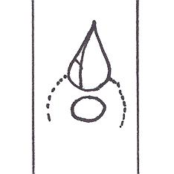 | 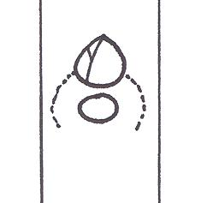 | 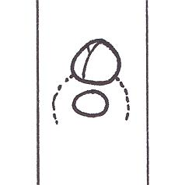
1 | 2 | 3
triangular | broad ovate | circular

Ad. 13: Leaf blade: shape

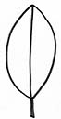 | 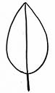 | 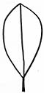
1 | 2 | 3
elliptic | ovate | obovate

Ad. 14: Leaf blade: shape of base

 | 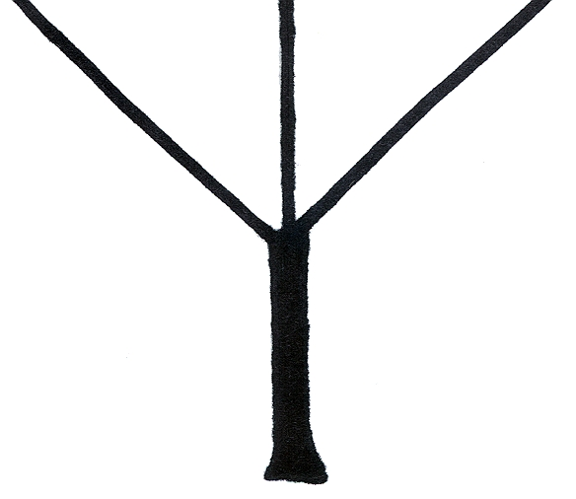 | 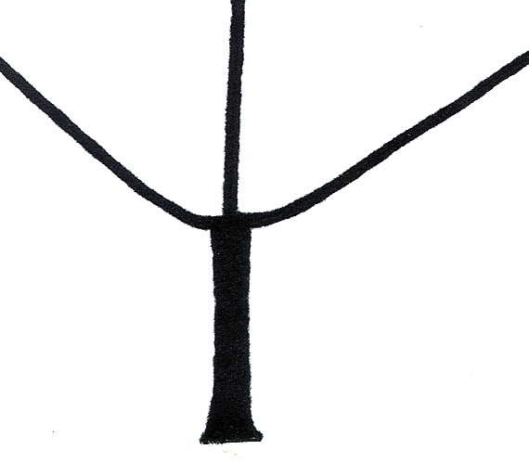 | 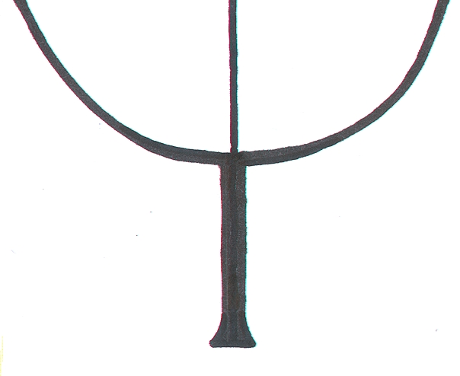
1  narrow acute | 2  broad acute | 3  obtuse | 4  rounded

Ad. 15: Leaf blade: shape of apex

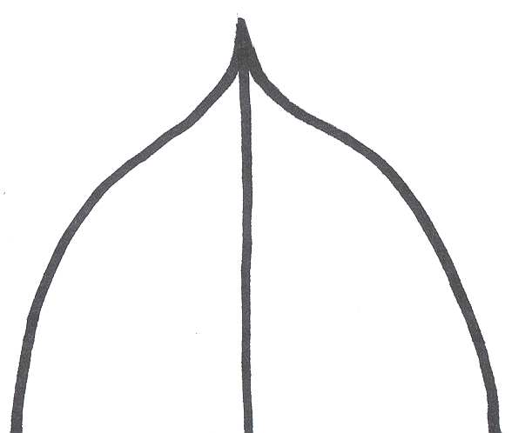 | 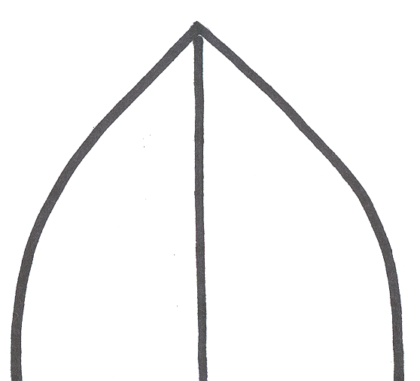 | 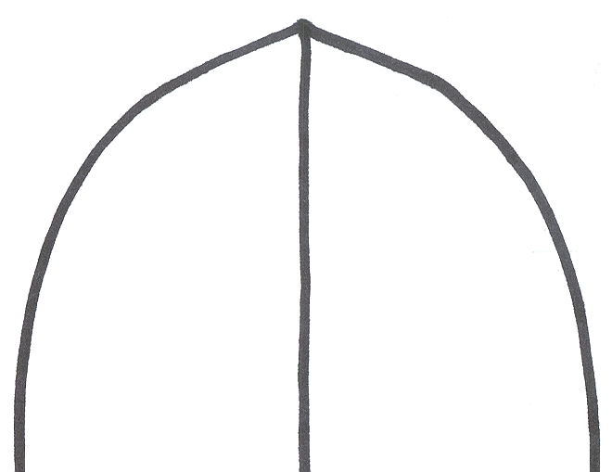
1  acuminate | 2  acute | 3  obtuse

Ad. 18: Female flower: shape of calyx viewed from above

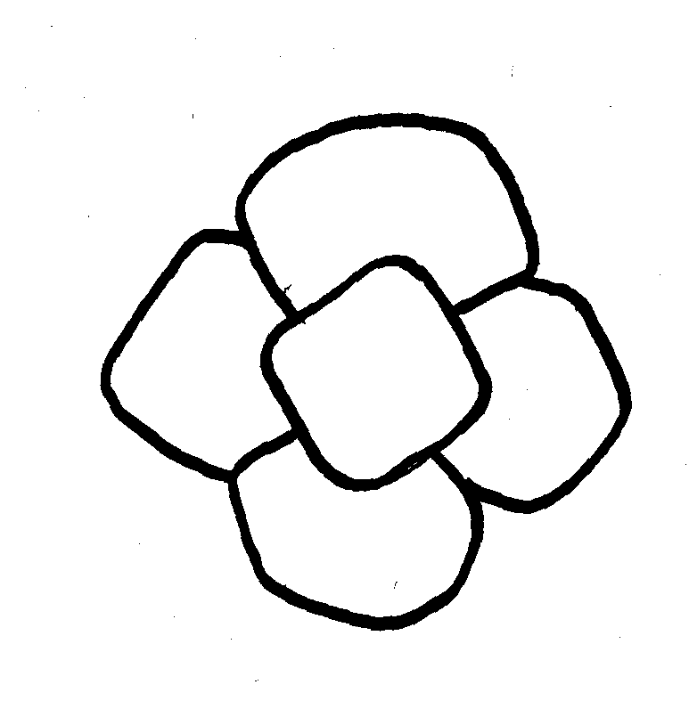 | 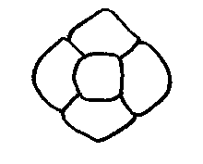 |  | 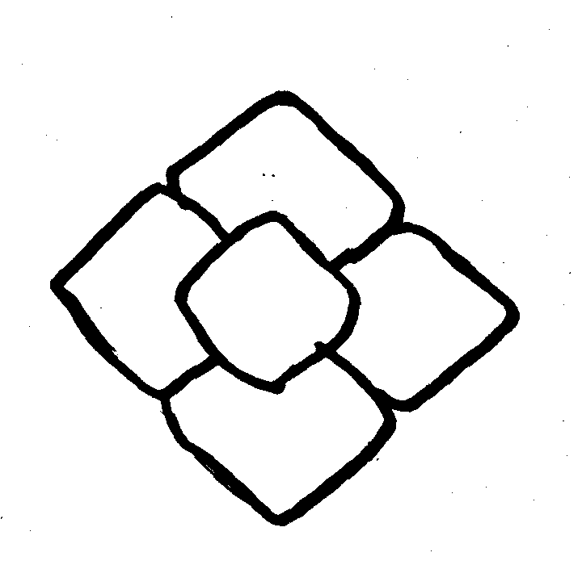
1 | 2 |  | 3
circular | rounded rhombic |  | rhombic
4 |  | 5
regular cruciform |  | irregular cruciform

Ad. 21: Fruit: general shape in lateral view

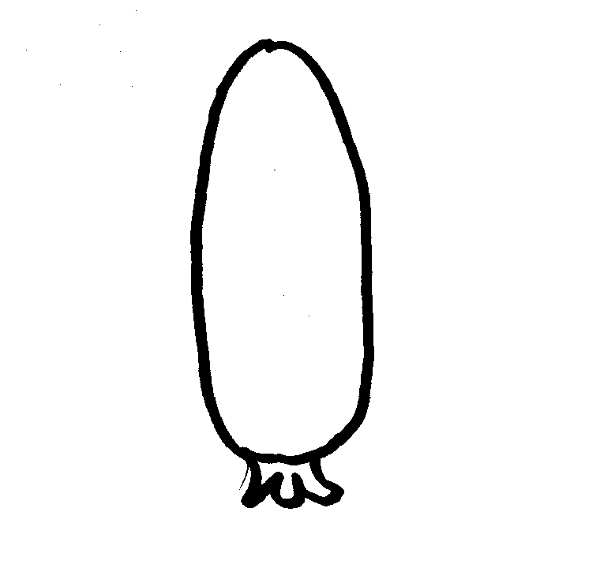 | 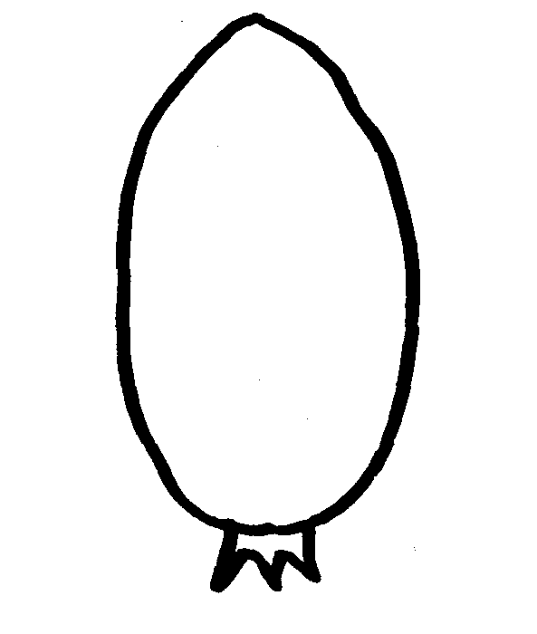 |  | 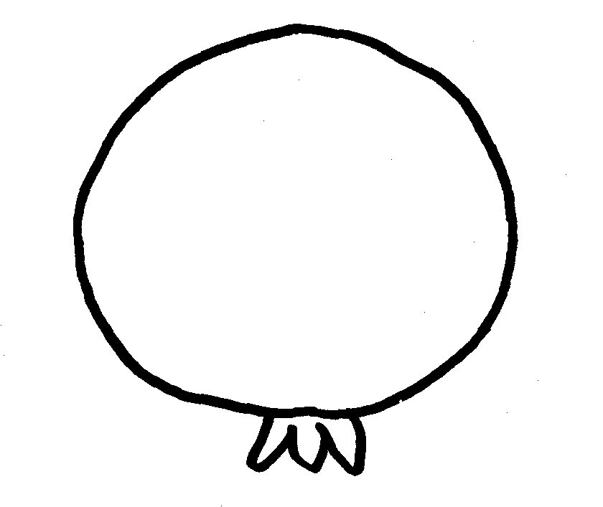
1 | 2 |  | 3
narrow elliptic | elliptic |  | circular
 |  |  | 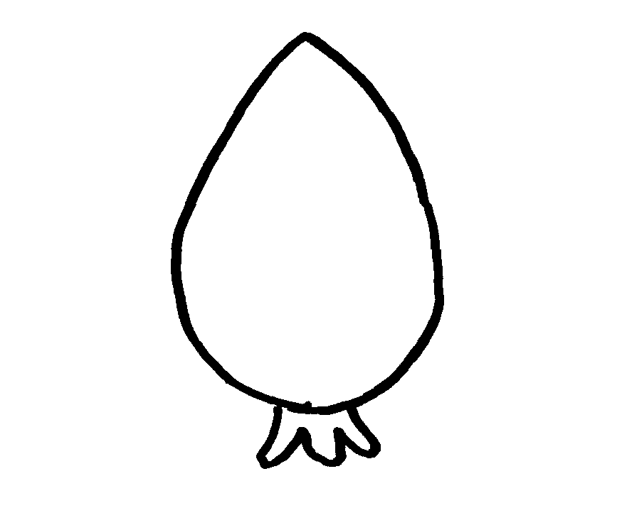
4 | 5 |  | 6
oblate | transverse broad oblong |  | ovate
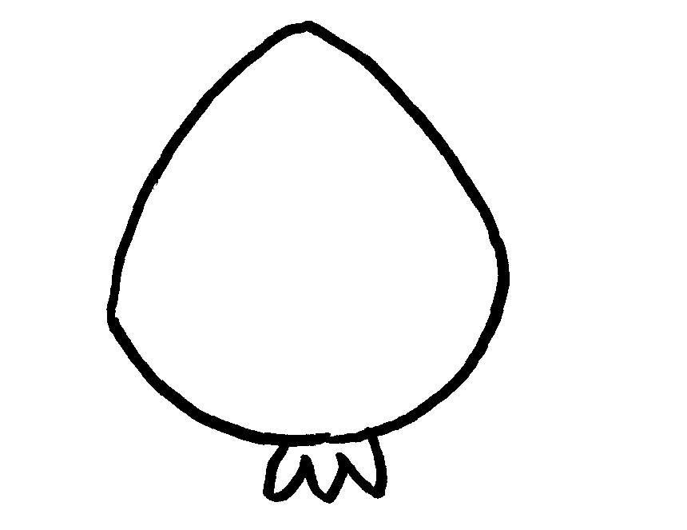 |  | 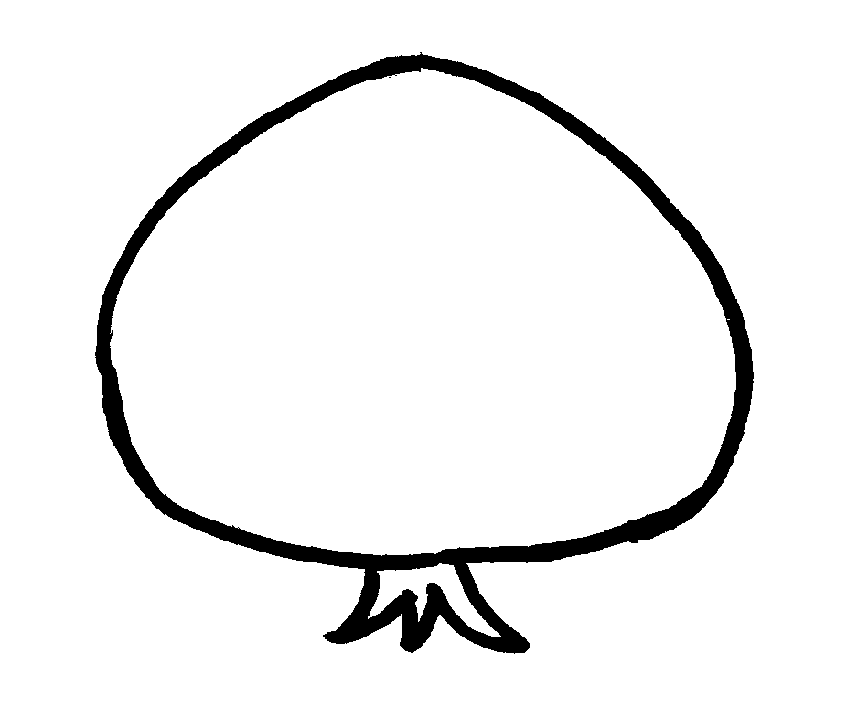
7 |  | 8
broad ovate |  | very broad ovate

Ad. 22: Fruit: general shape in cross section

 |  | 
1 | 2 | 3
circular | irregular rounded | square

Ad. 23: Fruit: shape of apex in longitudinal section

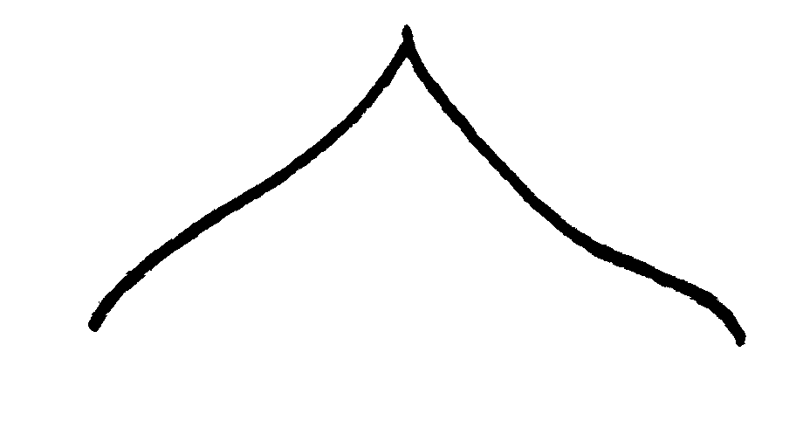 | 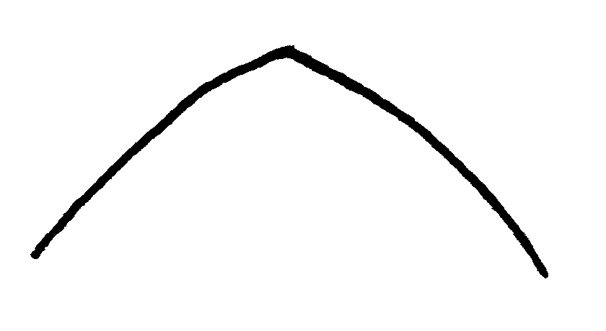 |  | 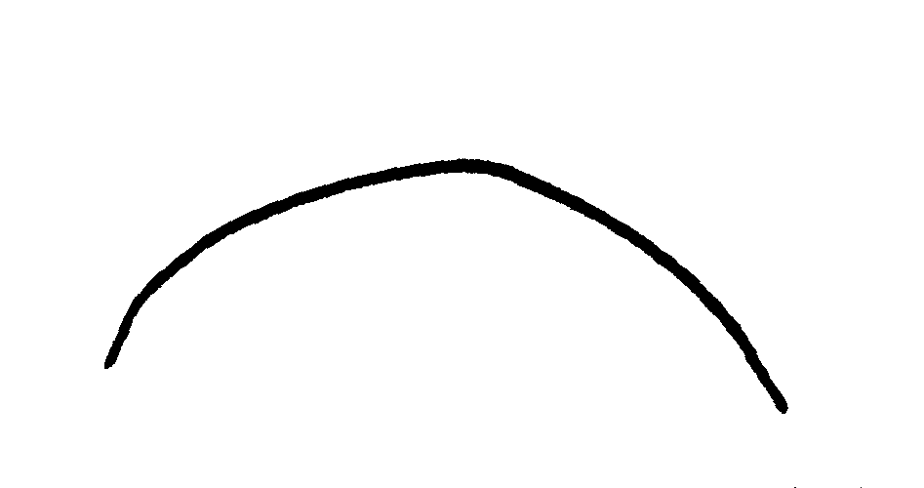
1 | 2 |  | 3
acuminate | obtuse |  | rounded
 |  | 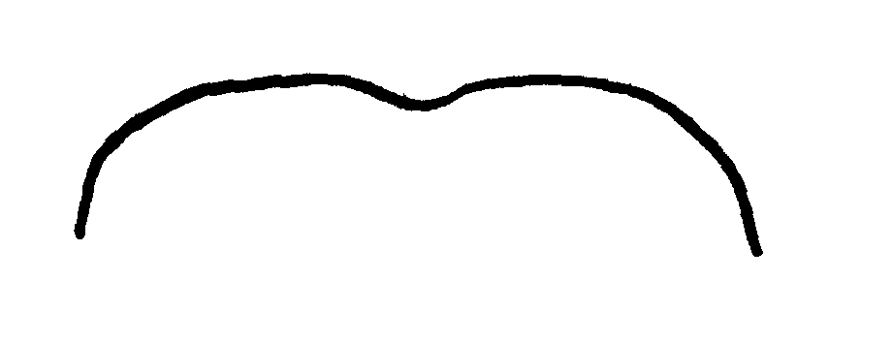
4 |  | 5
truncate |  | retuse

Ad. 24: Fruit: grooving at apex

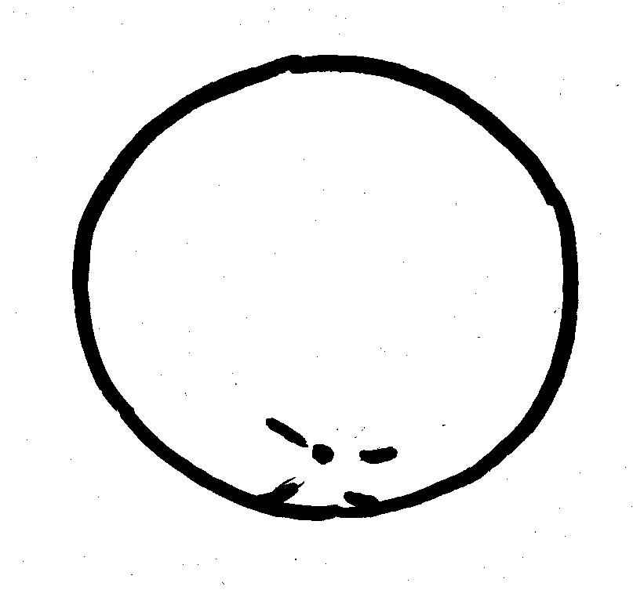 | 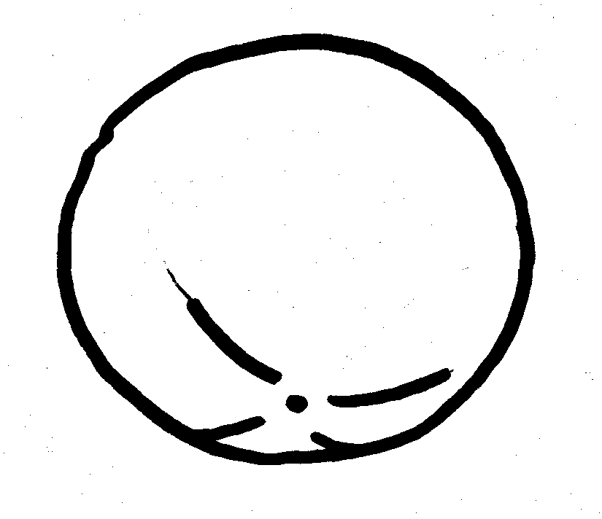 | 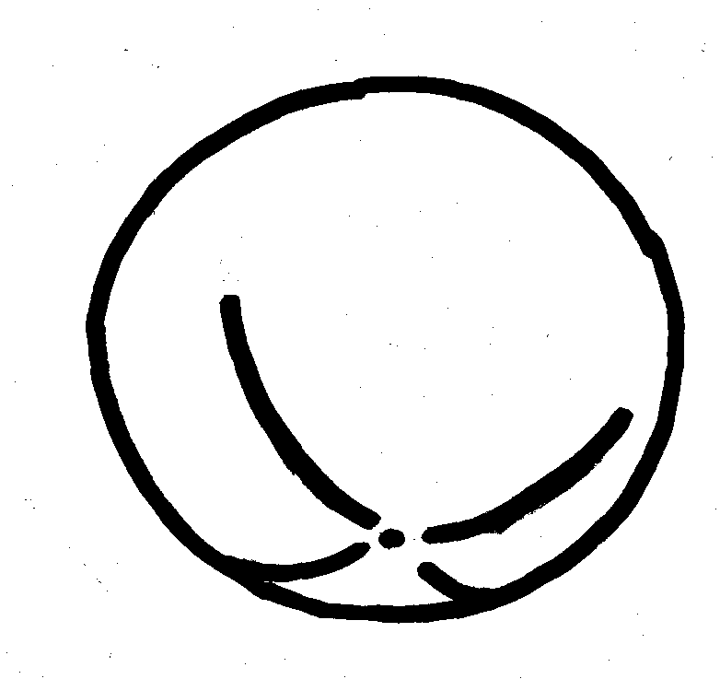
1 | 2 | 3
absent or weak | moderate | strong

Ad. 25: Fruit: shallow concentric cracking around apex

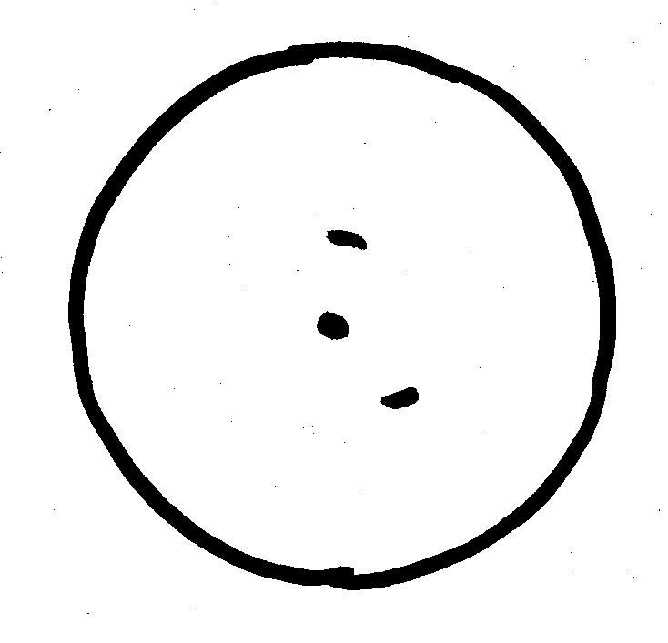 | 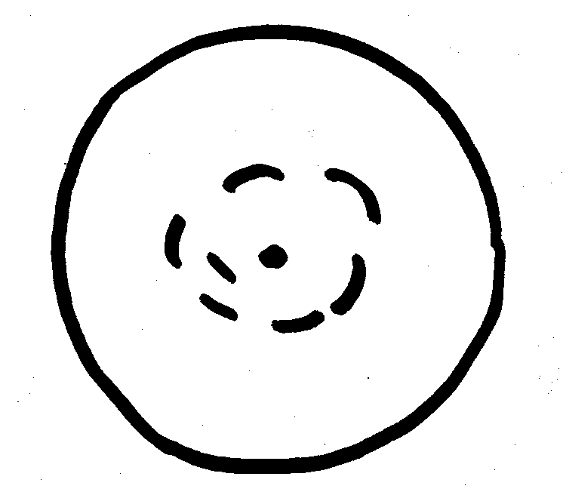 | 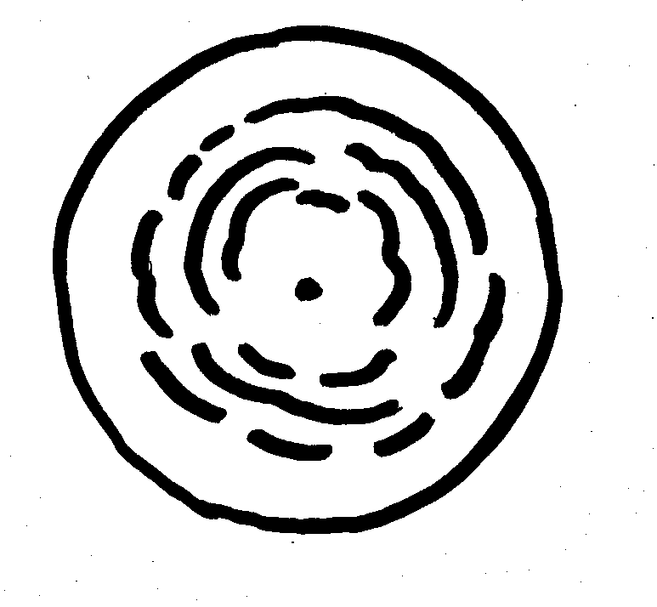
1 | 2 | 3
absent or weak | moderate | strong

Ad. 26: Fruit: cracking of apex

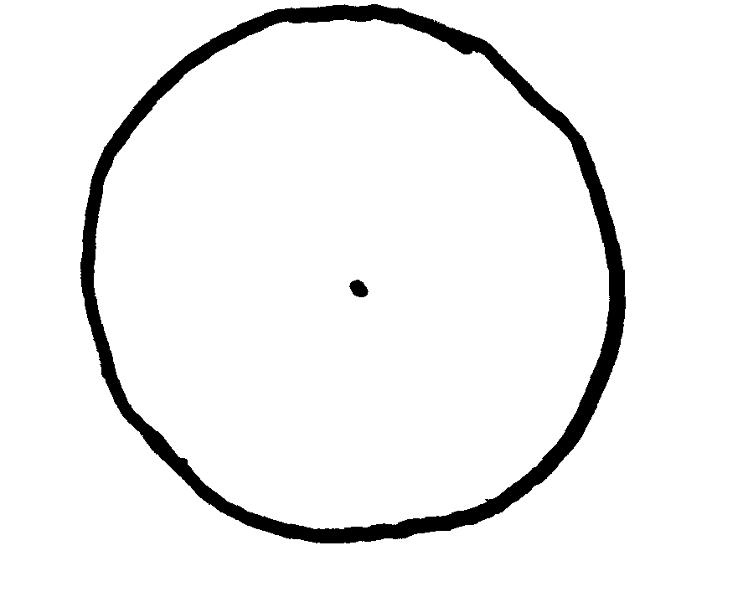 |  | 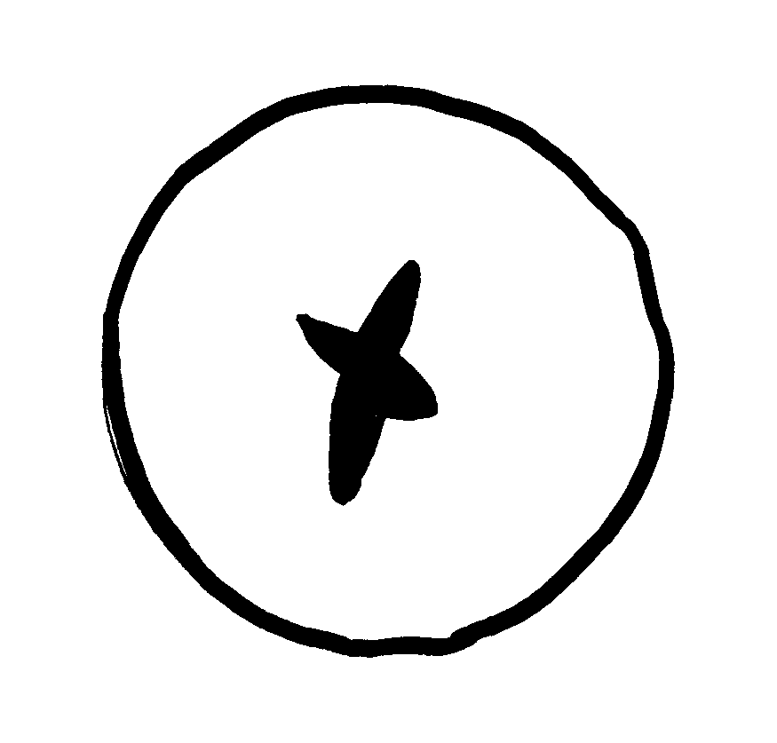
1 | 2 | 3
absent or weak | moderate | strong

Ad. 27: Fruit: longitudinal grooving

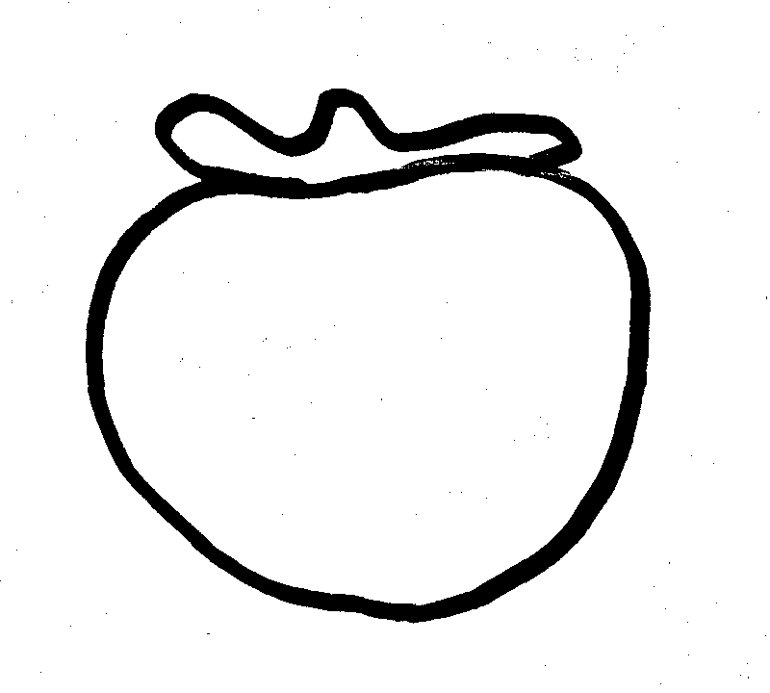 | 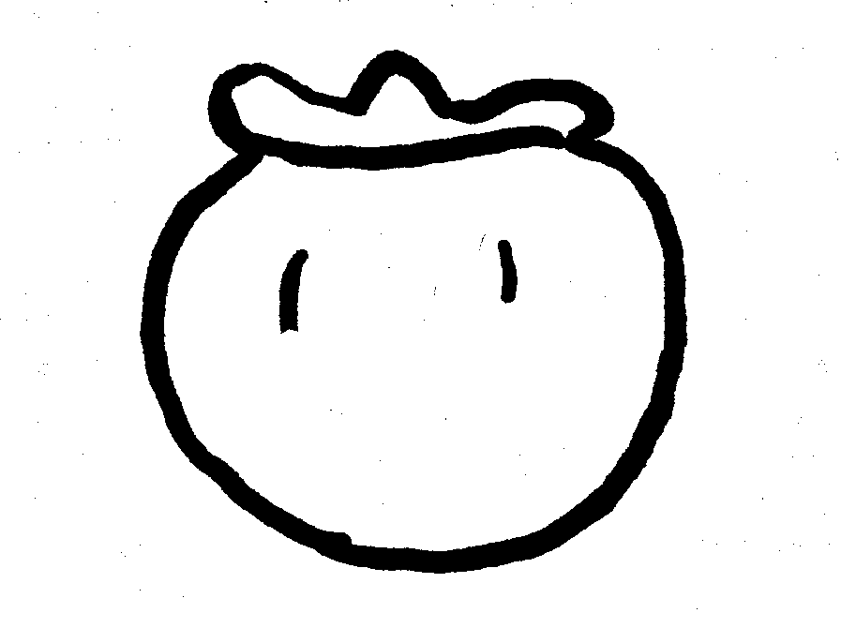
1 | 3
absent to very shallow | shallow
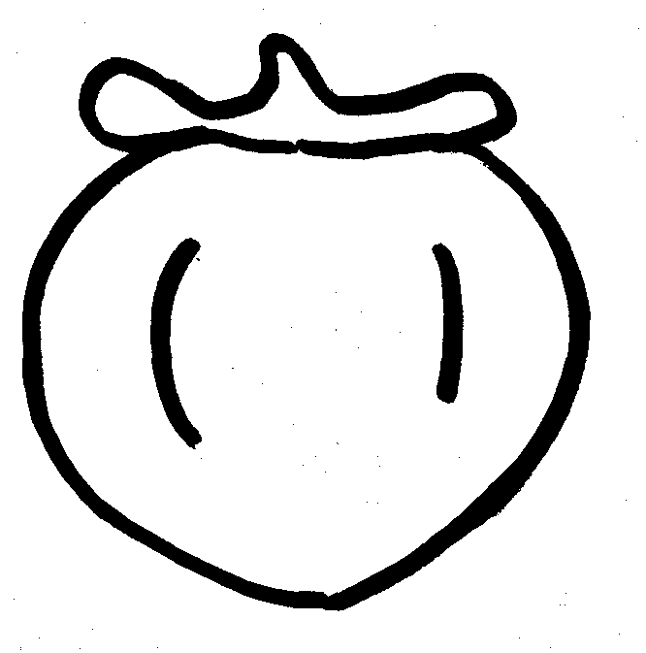 | 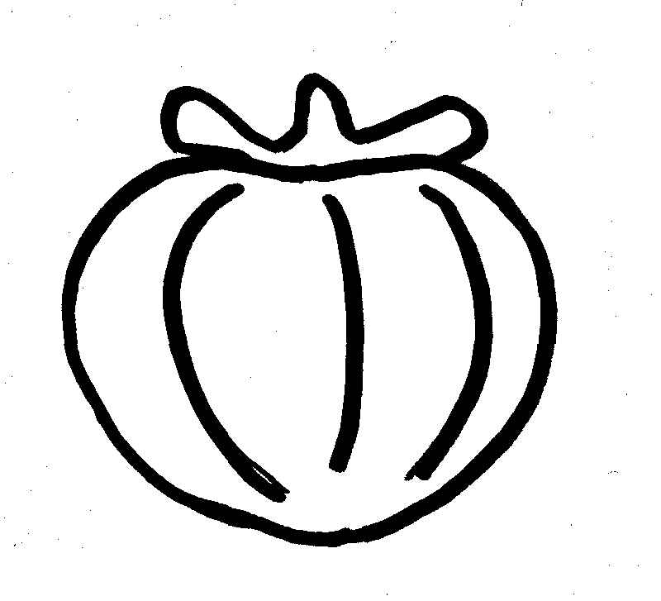
5 | 7
medium | deep

Ad. 29: Fruit: calyx attachment

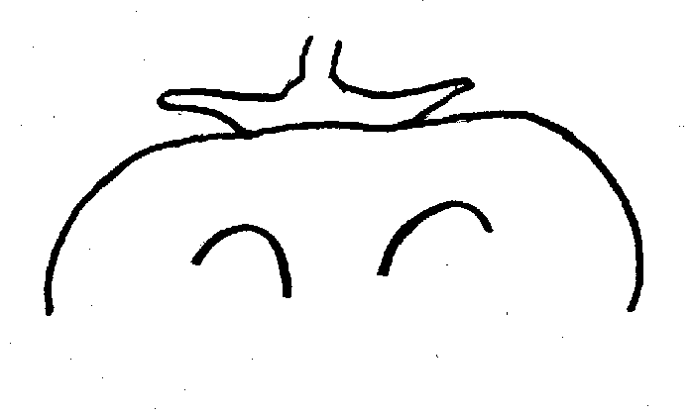 | 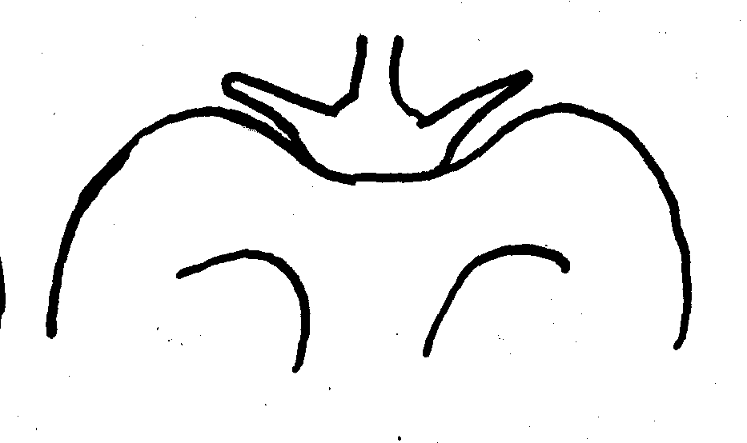 | 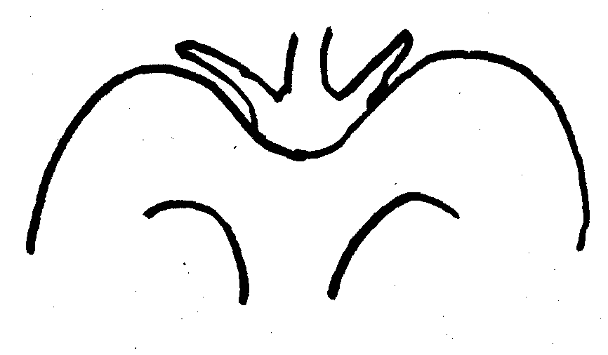
1 | 2 | 3
level | slightly depressed | strongly depressed

Ad. 30: Fruit: groove at calyx end

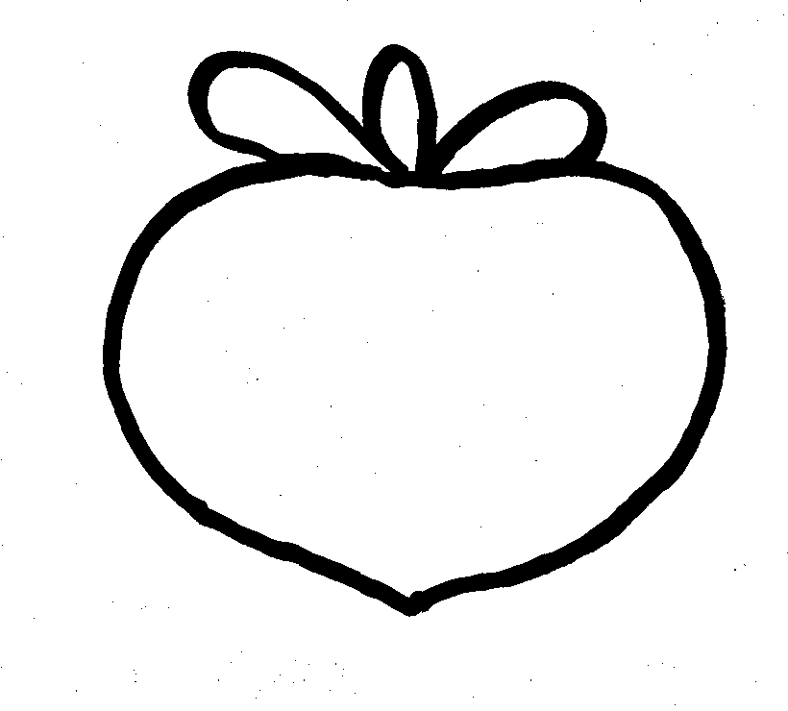 | 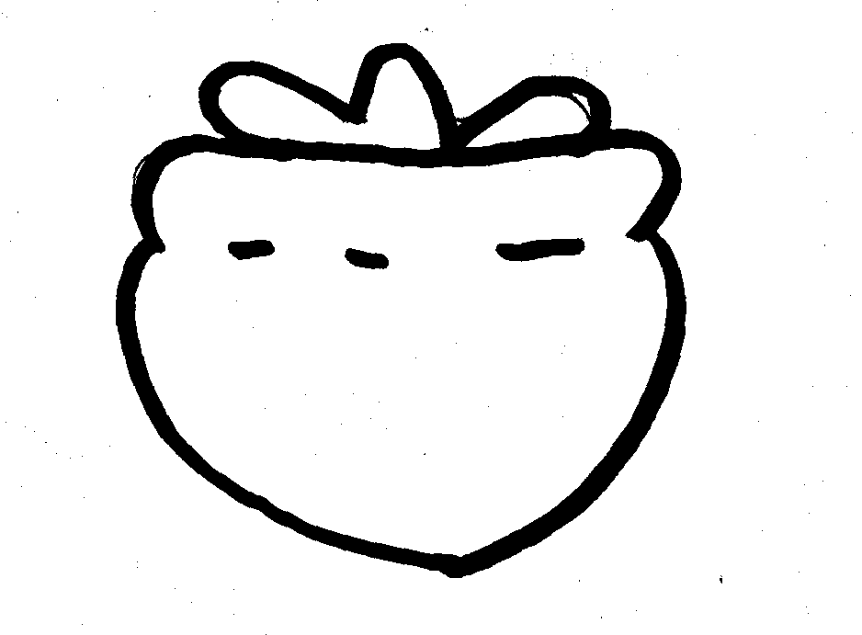
1 | 9
absent | present

Ad. 32: Fruit: calyx size compared with fruit diameter

 | 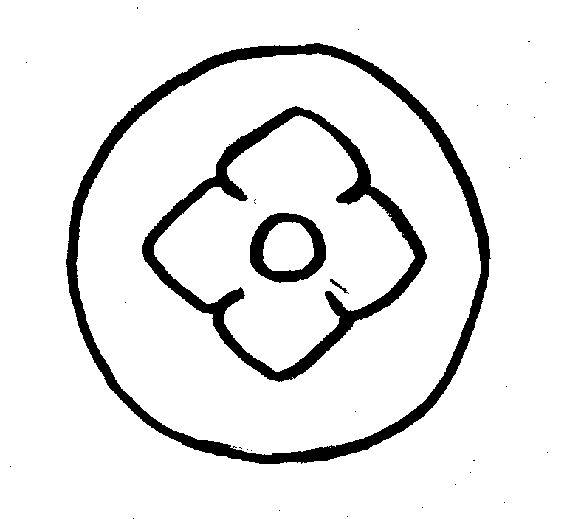 | 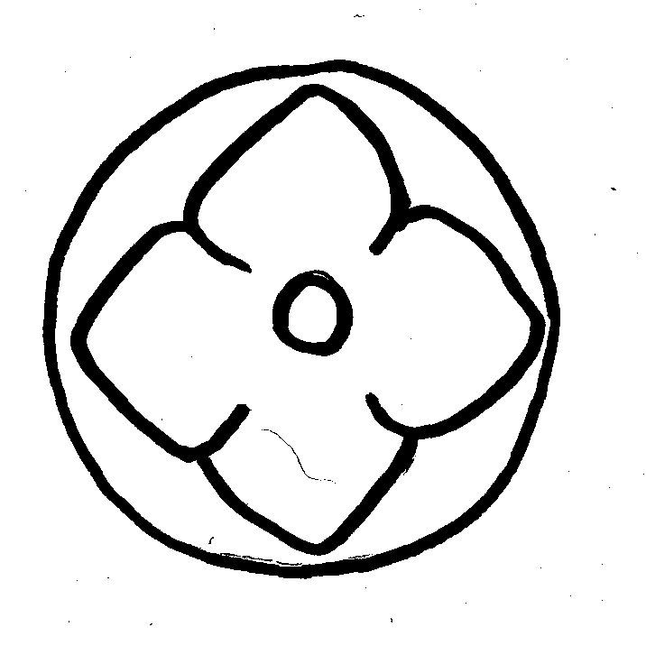
3 | 5 | 7
small | medium | large

Ad. 33: Fruit: attitude of calyx

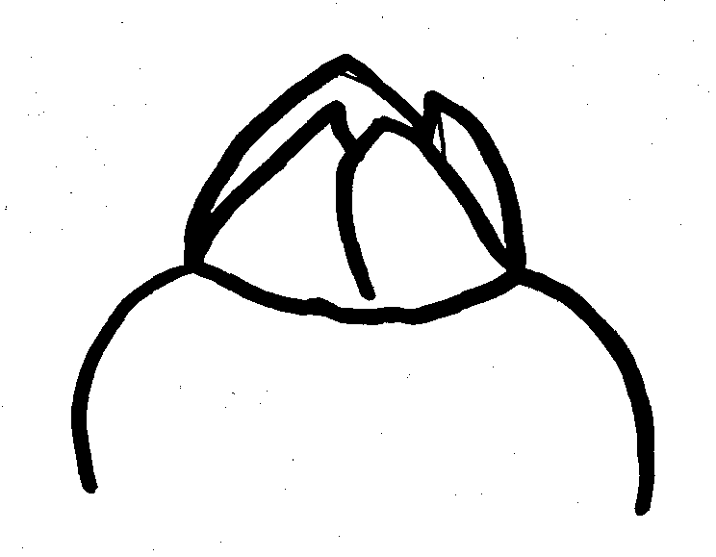 | 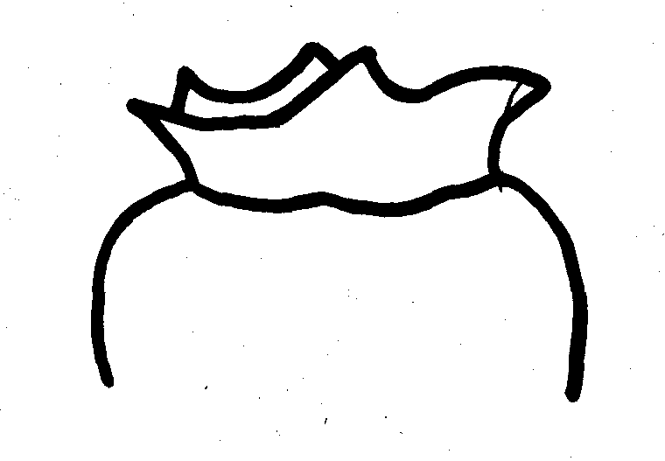 | 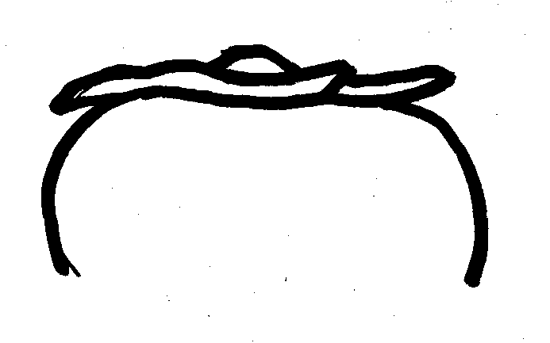
1 | 2 | 3
erect | semi-erect | horizontal

Ad. 34: Fruit: width of sepal

The width of sepal should be measured as the width of the broadest of the sepals.

Ad. 37; 39; 48: Varieties with astringency always absent or sometimes present only: Fruit: color of skin (37); Fruit: color of flesh (39); Time of ripeness for eating (48)

The time of ripeness for non-astringent varieties is reached when the flesh is still firm and the color of skin changes.

Ad. 38; 40; 49: Varieties with astringency always present only: Fruit: color of skin (38); Fruit: color of flesh (40); Time of ripeness for eating (49)

The time of ripeness for astringent varieties is reached when the flesh becomes soft after post harvest storage. The fruits should be stored at normal room temperature (about 15 ºC), without any chemical or other treatments.

Ad. 41: Fruit: presence of brown specks in flesh

For some varieties, the presence of brown specks in the flesh is pollination variant (state 2). For those varieties, the presence and number of seeds influence the presence of brown specks (see also 8.3 Classification of Persimmon).

Ad. 44: Seed: shape in lateral view

 |  |  | 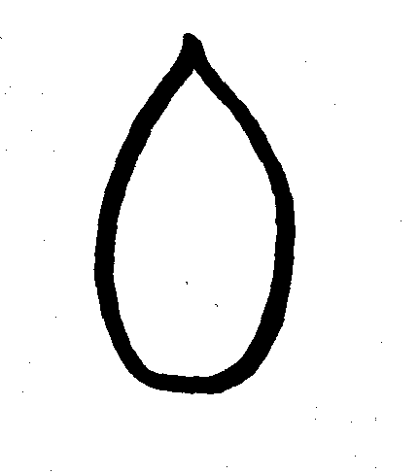 | 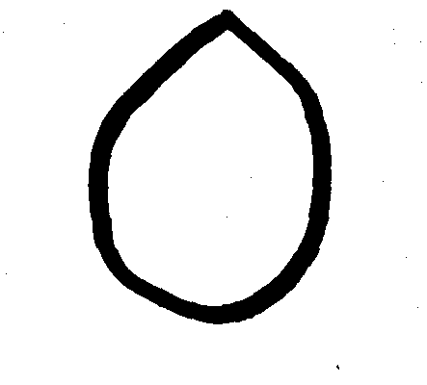
 | 1 |  | 2 | 3
 | narrow elliptic |  | ovate | broad ovate
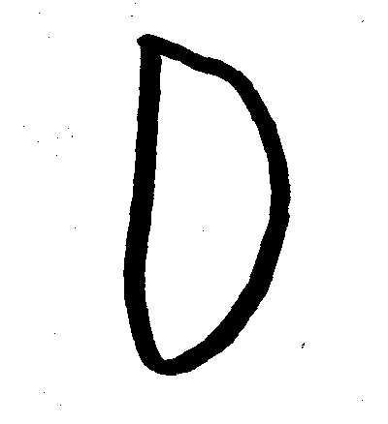 |  | 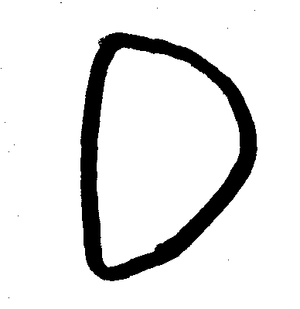
4 |  | 5
semi broad elliptic |  | semi oblate

Ad. 50: Fruit: astringency

For some varieties, astringency is not consistent (state 2). For those varieties, the presence and number of seeds determine astringency (see also 8.3 Classification of Persimmon).

8.3 Classification of Persimmon
Varieties of Persimmon can be classified into Pollination Constant (PC) and Pollination Variant (PV) types, as follow:

(A = Astringent; NA = Non-Astringent)

PC (Pollination Constant) varieties:

• are always astringent or always not astringent;

• have brown specks always present in the flesh or always absent.

PV (Pollination Variant) varieties:

• are always astringent or sometimes astringent (depending on the presence and number of seeds);

• sometimes have brown specks in the flesh (depending on the presence and number of seeds). PV Astringent (PVA) varieties only have brown specks around the seed. PV Non Astringent (PVNA) varieties have brown specks around the seed and sometimes these extend over a wide area of flesh (depending on the number of seeds).

This classification is explained in relation to the states of expression of certain characteristics in the Table of Characteristics in Table 1. Table 2 presents a classification on the basis of a combination of pollination types (PC/PV) and astringency types (A/NA). Table 3 presents the example varieties according to the classification provided in Table 2.

Table1: Classification of Persimmon Varieties in Relation to States of Expression for Characteristics 41 and 50

 | State 1  (always absent) | State 2  (sometimes present) | State 3  (always present)
Char. 41  Fruit: presence of brown speck | PCA | PVA  PVNA | PCNA
Char. 50  Fruit: astringency | PCNA | PVNA | PVA  PCA

Table 2: Classification of Persimmon Varieties on the Basis of a Combination of Pollination Types (PC/PV) and Astringency Types (A/NA)

Class | Cross-section | Features
PCNA | 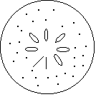 | Always non-astringent at maturity.  Always have small number of brown specks in flesh.
PCA | 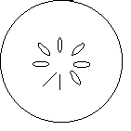 | Always astringent at maturity.  Never have brown specks in flesh.
PVNA | 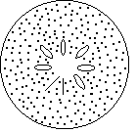 | Sometimes non-astringent at maturity.  Brown specks around seeds and sometimes over a wide area of flesh (the area depends on numbers of seeds).
PVA | 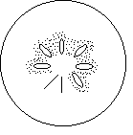 | Always astringent at maturity.  Brown specks around seeds.

Table 3: Classification of Example Varieties

Example Varieties | Type | Example Varieties | Type
Aizumishirazu | PVA | Meotogaki | PCA
Akagaki | PVNA | Marcatelli | PVNA
Akoumankaki | PVNA | Matsumotowase-fuyu | PCNA
Amahyakume | PVNA | Mercatelli | PVNA
Anzai | PVNA | Mikatanigosho | PVNA
Atago | PCA | Mizushima | PVNA
Costata | PCA | Moriya | PCA
Damopan | PCA | Naganogosho | PVNA
Dojohachiya | PCA | Nishimurawase | PVNA
Eboshi | PCA | Obishi | PVNA
Farmacista-honorati | PCA | Ogosho | PCNA
Fudegaki | PVNA | Okugosho | PCA
Fujiwaragosho | PCNA | Oshorokaki | PVNA
Fuyu | PCNA | Saijo | PCA
Gionbo | PCA | Sanja | PCA
Gosho | PCNA | Shakokushi | PCA
Hana–fuyu | PCNA | Shogatsu | PVNA
Hanagosho | PCNA | Square | PCA
Hazegosho | PCNA | Suruga | PCNA
Hiratanenashi | PVA | Takura | PCA
Hoshomaru | PVA | Tamamoto | PCA
Ichidagaki | PCA | Tonewase | PVA
Izu | PCNA | Tipo | PVNA
Jiro | PCNA | Toyoka | PVNA
Koshuhyakume | PVA | Tsurunohashi | PCA
Kubo | PVNA | Yamato | PCA
Kubogataobishi | PVNA | Yamatogosho | PCNA
Kurogaki | PVNA | Yokono | PCA
Lycopersicon | PCA | Yotsumizo | PCA
Maekawajiro | PCNA | Zenjimaru | PVNA

Literature
Bellini, E., Giannelli, G. (1982), New Directions in Growing Kaki, Informatore agrario, Vol. 38, No. 4, pp. 19,027-19,044.

Bellini, E. (1982), Monografia delle principali cultivar di kaki introdotte in Italia. Istituto di Coltivazione Arboree dell’Università Firenze.

Condit, I. J. (1919), The Kaki or Oriental Persimmon, USA, College of Agriculture, Agricultural Experiment Station, Bulletin No. 316, pp. 229-266, University of California Press.

Cultivation and Evaluation of Fruit Tree PGR (1996), Technical Assistance Activities for Genetic Resources Projects, ref. No. 9, pp. 57-68, Japan: Japan International Cooperation Agency (JICA).

Hume, H. H. (1914), A Kaki Classification, Journal of Heredity, 5, pp. 400-406.

Japanese National Test Guidelines for Persimmon (1979).

Kitagawa, H., Glucina, P. E. (1984), Persimmon Culture in New Zealand. Wellington, New Zealand, Science Information Publishing Center.

Kozaki, I., Ueno, I.et al. (1995), The Fruit in Japan (with English summary). Tokyo, Japan: Yokendo, 423 pp.

Nagamine, T., Takeda, H. (1999), The Descriptors for Characterization and Evaluation in Plant Genetic Resources, Vol. 1, pp. 370-375, Japan, National Institute of Agro biological Resources, MAFF.

Technical Questionnaire
TECHNICAL QUESTIONNAIRE |  |  |  | Page {x} of {y} |  |  | Reference Number:
 |  |  |  |  |  |  | Application date:
 |  |  |  |  |  |  | (not to be filled in by the applicant)
TECHNICAL QUESTIONNAIRE
to be completed in connection with an application for plant breeders’ rights

1. Subject of the Technical Questionnaire
1.1 Latin Name |  |  | Diospyros kaki L.
1.2 Common Name |  |  | Persimmon
2. Applicant
Name
Address
Telephone No.
Fax No.
E-mail address
Breeder (if different from applicant)
3. Proposed denomination and breeder’s reference
Proposed denomination
(if available)

Breeder’s reference
4. Information on the breeding scheme and propagation of the variety

4.1 Breeding scheme

Variety resulting from:

4.1.1 Crossing
(a) controlled cross [ ]
(please state parent varieties)
(b) partially unknown cross [ ]
(please state known parent variety(ies))
(c) unknown cross [ ]

4.1.2 Mutation [ ]
(please state parent variety)

4.1.3 Discovery and development [ ]
(please state where and when discovered
and how developed)

4.1.4 Other [ ]
(please provide details)

4.2 Method of propagating the variety

4.2.1 Vegetatively propagated varieties
(a) in vitro propagation [ ]
(b) other (e.g. leaf cutting, hardwood cutting, layer) [ ]
(state method)

4.2.2 Seed-propagated varieties [ ]

4.2.3 Other [ ]
(please provide details)

4.3 Virus status

4.3.1 The variety is free from all known viruses as follows: [ ]
(indicate from which viruses)

4.3.2 The plant material is virus tested: [ ]
(indicate against which viruses)

4.3.3 The virus status is unknown [ ]

5. Characteristics of the variety to be indicated (the number in brackets refers to the corresponding characteristic in Test Guidelines; please mark the note which best corresponds).

 | Characteristics |  |  |  |  | Example Varieties |  |  |  | Note
5.1  (21) | Fruit: general shape in lateral view
 | narrow elliptic |  |  |  |  |  |  |  |  | 1[ ]
 | elliptic |  |  |  |  | Saijo |  |  |  | 2[ ]
 | circular |  |  |  |  | Aizumishirazu, Amahyakume |  |  |  | 3[ ]
 | oblate |  |  |  |  | Fuyu, Izu, Jiro |  |  |  | 4[ ]
 | transverse broad oblong |  |  |  |  | Hiratanenashi |  |  |  | 5[ ]
 | ovate |  |  |  |  | Atago, Yotsumizo |  |  |  | 6[ ]
 | broad ovate |  |  |  |  | Koshuhyakume |  |  |  | 7[ ]
 | very broad ovate |  |  |  |  | Hanagosho |  |  |  | 8[ ]
5.2  (37) | Varieties with astringency always absent or sometimes present only: Fruit color of skin
 | yellow orange |  |  |  |  | Shogatsu |  |  |  | 1[ ]
 | orange |  |  |  |  | Hazegosho, Yamatogosho |  |  |  | 2[ ]
 | orange red |  |  |  |  | Fuyu, Izu, Jiro, Nishimurawase |  |  |  | 3[ ]
 | dark purple |  |  |  |  | Kurogaki |  |  |  | 4[ ]
5.3  (38) | Varieties with astringency always present only: Fruit color of skin
 | yellow orange |  |  |  |  | Gionbo, Saijo |  |  |  | 1[ ]
 | orange |  |  |  |  | Aizumishirazu, Hiratanenashi |  |  |  | 2[ ]
 | red orange |  |  |  |  | Koshuhyakume |  |  |  | 3[ ]
5.4  (48) | Varieties with astringency always absent or sometimes present only: Time of ripeness for eating
 | early |  |  |  |  | Izu, Nishimurawase |  |  |  | 3[ ]
 | medium |  |  |  |  | Matsumotowase-fuyu, Mizushima |  |  |  | 5[ ]
 | late |  |  |  |  | Amahyakume, Fuyu, Gosho |  |  |  | 7[ ]
 | Characteristics |  |  |  |  | Example Varieties |  |  |  | Note
5.5  (49) | Varieties with astringency always present only: Time of ripeness for eating
 | early |  |  |  |  | Ichidagaki, Tonewase |  |  |  | 3[ ]
 | medium |  |  |  |  | Hiratanenashi, Koshuhyakume |  |  |  | 5[ ]
 | late |  |  |  |  | Aizumishirazu, Atago |  |  |  | 7[ ]
6. Similar varieties and differences from these varieties

Please use the table, and space provided for comments, below to provide information on how your candidate variety differs from the variety (or varieties) which, to the best of your knowledge, is (or are) most similar. This information may help the examination authority to conduct its examination of distinctness in a more efficient way.

Denomination(s) of variety(ies) similar to your candidate variety |  | Characteristic(s) in which your candidate variety differs from the similar variety(ies) |  |  | Describe the expression of the characteristic(s) for the similar variety(ies) |  |  | Describe the expression of the characteristic(s) for your candidate variety
Example |  | Fruit: general shape in lateral view |  |  | elliptic |  |  | circular
Comments:

7. Additional information which may help in the examination of the variety

7.1 In addition to the information provided in sections 5 and 6, are there any additional characteristics which may help to distinguish the variety?

Yes [ ] No [ ]

(If yes, please provide details)

7.2 Special conditions for the examination of the variety

7.2.1 Are there any special conditions for growing the variety or conducting the examination?

Yes [ ] No [ ]

7.2.2 If yes, please give details:

7.3 Other information

A representative colour photograph of the variety should accompany the Technical Questionnaire

8. Authorization for release

(a) Does the variety require prior authorization for release under legislation concerning the protection of the environment, human and animal health?

Yes [ ] No [ ]

(b) Has such authorization been obtained?

Yes [ ] No [ ]

If the answer to (b) is yes, please attach a copy of the authorization.

9. Information on plant material to be examined.

9.1 The expression of a characteristic or several characteristics of a variety may be affected by factors, such as pests and disease, chemical treatment (e.g. growth retardants or pesticides), effects of tissue culture, different rootstocks, scions taken from different growth phases of a tree, etc.

9.2 The plant material should not have undergone any treatment which would affect the expression of the characteristics of the variety, unless the competent authorities allow or request such treatment. If the plant material has undergone such treatment, full details of the treatment must be given. In this respect, please indicate below, to the best of your knowledge, if the plant material to be examined has been subjected to:

(a) Microorganisms (e.g. virus, bacteria, phytoplasma) Yes [ ] No [ ]

(b) Chemical treatment (e.g. growth retardant or pesticide) Yes [ ] No [ ]

(c) Tissue culture Yes [ ] No [ ]

(d) Other factors Yes [ ] No [ ]

Please provide details of where you have indicated “yes”:

……………………………………………………………

10. I hereby declare that, to the best of my knowledge, the information provided in this form is correct:

Applicant’s name

Signature Date

[End of document]

* These names were correct at the time of the introduction of these Test Guidelines but may be revised or updated. [Readers are advised to consult the UPOV Code, which can be found on the UPOV Website (www.upov.int), for the latest information.]

