 |  | E
 | 
  TG/90/7
  ORIGINAL: English
  DATE: 2023-10-24
INTERNATIONAL UNION FOR THE PROTECTION OF NEW VARIETIES OF PLANTS
 | Geneva
  KALE
  UPOV Code(s): BRASS_OLE_COS; BRASS_OLE_GAM; BRASS_OLE_GAS; BRASS_OLE_GAV; BRASS_OLE_PAL
  Brassica oleracea L. var. costata DC.;
  Brassica oleracea L. var. medullosa Thell.; Brassica oleracea L. var. sabellica L.; Brassica oleracea L. var. viridis L.; Brassica oleracea L. var. palmifolia DC.
  *
GUIDELINES
FOR THE CONDUCT OF TESTS
FOR DISTINCTNESS, UNIFORMITY AND STABILITY

TG/90/7
Kale, 2023-10-24
2

Alternative names:*

Botanical name | English | French | German | Spanish
  Brassica oleracea L. var. costata DC., Brassica oleracea L. var. tronchuda L. H. Bailey
  Bedford cabbage, Braganza,
  Portugese cole, Portuguese kale, Seakale cabbage, Tronchuda cabbage, Tronchuda kale
  Chou tronchuda, Chou à grosses côtes, Chou portuguais
  Portugiesischer Kohl, Rippenkohl, Tronchudakohl
  Col asa de cántaro, Col de pezón grueso, Col tronchuda
  Brassica oleracea L. var. medullosa Thell.
  Marrow-stem kale
  Chou moëllier
  Futterkohl, Markstammkohl
  Col medular,
  Col de meollo
  Brassica oleracea L. var. sabellica L., Brassica oleracea L. var. acephala auct., Brassica oleracea L. var. selenisia L.
  Borecole, Curly kale, Dwarf Siberian kale, Kitchen kale,
  Scotch kale
  Chou frisé,
  Chou aigrette,
  Chou plume
  Braunkohl, Federkohl, Grünkohl, Krauskohl
  Berza rizada,
  Col crespa,
  Col rizada
  Brassica oleracea L. var. viridis L., Brassica oleracea L. var. acephala DC.
  Collards,
  Cow cabbage, Fodder kale,
  Galega kale, Kale, Spring-heading cabbage, Tall kale, Tree kale
  Chou à vaches, Chou fourrager, Chou cavalier,
  Chou collard
  Blattkohl, Blätterkohl, Futterkohl, Kuhkohl
  Berza,
  Berza gallega,
  Col forrajera
  Brassica oleracea L. var. palmifolia DC.
  Giant Jersey kale, Jersey kale,
  Palm kale,
  Palm-tree kale,
  Tree kale
  Chou palmier
  Palmkohl, Italienischer Kohl
  Col palmera

The purpose of these guidelines (“Test Guidelines”) is to elaborate the principles contained in the General Introduction (document TG/1/3), and its associated TGP documents, into detailed practical guidance for the harmonized examination of distinctness, uniformity and stability (DUS) and, in particular, to identify appropriate characteristics for the examination of DUS and production of harmonized variety descriptions.
ASSOCIATED DOCUMENTS
These Test Guidelines should be read in conjunction with the General Introduction and its associated TGP documents.

TABLE OF CONTENTS | PAGE
1. | SUBJECT OF THESE TEST GUIDELINES.......................................................................................................... | 4
2. | MATERIAL REQUIRED......................................................................................................................................... | 4
3. | METHOD OF EXAMINATION................................................................................................................................ | 4
3.1 | Number of Growing Cycles........................................................................................................................ | 4
3.2 | Testing Place............................................................................................................................................. | 4
3.3 | Conditions for Conducting the Examination............................................................................................... | 5
3.4 | Test Design................................................................................................................................................ | 5
3.5 | Additional Tests......................................................................................................................................... | 5

4. | ASSESSMENT OF DISTINCTNESS, UNIFORMITY AND STABILITY................................................................. | 5
4.1 | Distinctness............................................................................................................................................... | 5
4.2 | Uniformity.................................................................................................................................................. | 6
4.3 | Stability...................................................................................................................................................... | 7

5. | GROUPING OF VARIETIES AND ORGANIZATION OF THE GROWING TRIAL................................................ | 7
6. | INTRODUCTION TO THE TABLE OF CHARACTERISTICS................................................................................ | 7
6.1 | Categories of Characteristics..................................................................................................................... | 7
6.2 | States of Expression and Corresponding Notes........................................................................................ | 7
6.3 | Types of Expression.................................................................................................................................. | 8
6.4 | Example Varieties...................................................................................................................................... | 8
6.5 | Legend....................................................................................................................................................... | 8

7. | TABLE OF CHARACTERISTICS/TABLEAU DES CARACTÈRES/MERKMALSTABELLE/TABLA DE CARACTERES...................................................................................................................................................... | 9
8. | EXPLANATIONS ON THE TABLE OF CHARACTERISTICS............................................................................... | 17
8.1 | Explanations covering several characteristics........................................................................................... | 17
 | Explanations for individual characteristics................................................................................................. | 17
  8.2

9. | LITERATURE........................................................................................................................................................ | 27
10. | TECHNICAL QUESTIONNAIRE............................................................................................................................ | 28

1. | Subject of these Test Guidelines
1.1
  These Test Guidelines apply to all varieties of Brassica oleracea L. var. costata DC., Brassica oleracea L. var. medullosa Thell., Brassica oleracea L. var. sabellica L., Brassica oleracea L. var. viridis L. and Brassica oleracea L. var. palmifolia DC.
1.2
  Guidance on the use of Test Guidelines for interspecific hybrids that are not explicitly covered by Test Guidelines is provided in document TGP/13 “Guidance for New Types and Species”.

2. | Material Required
2.1
  The competent authorities decide on the quantity and quality of the plant material required for testing the variety and when and where it is to be delivered. Applicants submitting material from a State other than that in which the testing takes place must ensure that all customs formalities and phytosanitary requirements are complied with.
2.2
  The material is to be supplied in the form of seeds or young plants.
2.3
  The minimum quantity of plant material, to be supplied by the applicant, should be:
seed-propagated varieties: 20g or 5000 seeds
vegetatively propagated varieties: 30 young plants

 | In the case of seed, the seed should meet the minimum requirements for germination, species and analytical purity, health and moisture content, specified by the competent authority. In cases where the seed is to be stored, the germination capacity should be as high as possible and should, be stated by the applicant.
2.4
  The plant material supplied should be visibly healthy, not lacking in vigor, nor affected by any important pest or disease.
2.5
  The plant material should not have undergone any treatment which would affect the expression of the characteristics of the variety, unless the competent authorities allow or request such treatment. If it has been treated, full details of the treatment must be given.

3. | Method of Examination
3.1 | Number of Growing Cycles
 | The minimum duration of tests should normally be two independent growing cycles.
  3.1.1
 | The two independent growing cycles should be in the form of two separate plantings.
  3.1.2
 | The testing of a variety may be concluded when the competent authority can determine with certainty the outcome of the test.
  3.1.3

3.2 | Testing Place
 | Tests are normally conducted at one place. In the case of tests conducted at more than one place, guidance is provided in TGP/9 “Examining Distinctness”.
3.3 | Conditions for Conducting the Examination
 | The tests should be carried out under conditions ensuring satisfactory growth for the expression of the relevant characteristics of the variety and for the conduct of the examination.

3.4 | Test Design
  3.4.1
  In the case of seed-propagated varieties, each test should be designed to result in a total of at least 40 plants which should be divided between at least 2 replicates.
  3.4.2
  In the case of vegetatively propagated varieties, each test should be designed to result in a total of at least 20 plants which should be divided between at least 2 replicates.

  3.4.3
  The design of the tests should be such that plants or parts of plants may be removed for measurement or counting without prejudice to the observations which must be made up to the end of the growing cycle.
3.5 | Additional Tests
 | Additional tests, for examining relevant characteristics, may be established.

4. | Assessment of Distinctness, Uniformity and Stability
4.1 | Distinctness
4.1.1 | General Recommendations
 | It is of particular importance for users of these Test Guidelines to consult the General Introduction prior to making decisions regarding distinctness. However, the following points are provided for elaboration or emphasis in these Test Guidelines.
4.1.2 | Consistent Differences
 | The differences observed between varieties may be so clear that more than one growing cycle is not necessary. In addition, in some circumstances, the influence of the environment is not such that more than a single growing cycle is required to provide assurance that the differences observed between varieties are sufficiently consistent. One means of ensuring that a difference in a characteristic, observed in a growing trial, is sufficiently consistent is to examine the characteristic in at least two independent growing cycles.
4.1.3 | Clear Differences
 | Determining whether a difference between two varieties is clear depends on many factors, and should consider, in particular, the type of expression of the characteristic being examined, i.e. whether it is expressed in a qualitative, quantitative, or pseudo-qualitative manner. Therefore, it is important that users of these Test Guidelines are familiar with the recommendations contained in the General Introduction prior to making decisions regarding distinctness.
4.1.4
  Number of Plants or Parts of Plants to be Examined
In the case of seed-propagated varieties, unless otherwise indicated, for the purposes of distinctness, all observations on single plants should be made on 20 plants or parts taken from each of 20 plants and any other observation made on all plants in the test, disregarding any off-type plants.

In the case of vegetatively propagated varieties, unless otherwise indicated, for the purposes of distinctness, all observations on single plants should be made on 10 plants or parts taken from each of 10 plants and any other observation made on all plants in the test, disregarding any off-type plants.

4.1.5 | Method of Observation
 | The recommended method of observing the characteristic for the purposes of distinctness is indicated by the following key in the Table of Characteristics (see document TGP/9 “Examining Distinctness”, Section 4 “Observation of characteristics”):
MG: single measurement of a group of plants or parts of plants
MS: measurement of a number of individual plants or parts of plants
VG: visual assessment by a single observation of a group of plants or parts of plants
VS: visual assessment by observation of individual plants or parts of plants

 | Type of observation: visual (V) or measurement (M)
 | “Visual” observation (V) is an observation made on the basis of the expert’s judgment. For the purposes of this document, “visual” observation refers to the sensory observations of the experts and, therefore, also includes smell, taste and touch. Visual observation includes observations where the expert uses reference points (e.g. diagrams, example varieties, side-by-side comparison) or non-linear charts (e.g. color charts). Measurement (M) is an objective observation against a calibrated, linear scale e.g. using a ruler, weighing scales, colorimeter, dates, counts, etc.
  Type of record: for a group of plants (G) or for single, individual plants (S)
  For the purposes of distinctness, observations may be recorded as a single record for a group of plants or parts of plants (G), or may be recorded as records for a number of single, individual plants or parts of plants (S). In most cases, “G” provides a single record per variety and it is not possible or necessary to apply statistical methods in a plant-by-plant analysis for the assessment of distinctness.
 | In cases where more than one method of observing the characteristic is indicated in the Table of Characteristics (e.g. VG/MG), guidance on selecting an appropriate method is provided in document TGP/9, Section 4.2.
4.2 | Uniformity
4.2.1 | It is of particular importance for users of these Test Guidelines to consult the General Introduction prior to making decisions regarding uniformity. However, the following points are provided for elaboration or emphasis in these Test Guidelines:
  4.2.2
  These Test Guidelines have been developed for the examination of cross-pollinated, self-pollinated (inbred line), hybrid varieties and vegetatively propagated varieties. For varieties with other types of propagation, the recommendations in the General Introduction and document TGP/13 "Guidance for new types and species" Section 4.5 "Testing Uniformity" should be followed.
 | The assessment of uniformity for cross-pollinated varieties should be according to the recommendations for cross-pollinated varieties in the General Introduction.
  4.2.3
4.2.4
  For the assessment of uniformity of single cross hybrids and self-pollinated varieties (inbred lines), a population standard of 1% and an acceptance probability of at least 95% should be applied. In the case of a sample size of 40 plants, 2 off-types are allowed. In addition, for single cross hybrids, a population standard of 3% and an acceptance probability of at least 95% should be applied for inbred plants obviously resulting from the selfing of a parent line. In the case of a sample size of 40 plants, 3 inbred plants are allowed.
4.2.5
  For the assessment of uniformity of vegetatively propagated varieties, a population standard of 1% and an acceptance probability of at least 95% should be applied. In the case of a sample size of 20 plants, 1 off-type is allowed.

4.3 | Stability
4.3.1 | In practice, it is not usual to perform tests of stability that produce results as certain as those of the testing of distinctness and uniformity. However, experience has demonstrated that, for many types of variety, when a variety has been shown to be uniform, it can also be considered to be stable.
4.3.2 | Where appropriate, or in cases of doubt, stability may be further examined by testing a new seed or plant stock to ensure that it exhibits the same characteristics as those shown by the initial material supplied.

5. | Grouping of Varieties and Organization of the Growing Trial
5.1 | The selection of varieties of common knowledge to be grown in the trial with the candidate varieties and the way in which these varieties are divided into groups to facilitate the assessment of distinctness are aided by the use of grouping characteristics.
5.2 | Grouping characteristics are those in which the documented states of expression, even where produced at different locations, can be used, either individually or in combination with other such characteristics: (a) to select varieties of common knowledge that can be excluded from the growing trial used for examination of distinctness; and (b) to organize the growing trial so that similar varieties are grouped together.
5.3 | The following have been agreed as useful grouping characteristics:
  (a)
  Plant: position of growing point (characteristic 3)
  (b)
  Leaf: color (characteristic 9)
  (c)
  Leaf: variegation (characteristic 11)

5.4 | Guidance for the use of grouping characteristics, in the process of examining distinctness, is provided through the General Introduction and document TGP/9 “Examining Distinctness”.

6. | Introduction to the Table of Characteristics
6.1 | Categories of Characteristics
6.1.1 | Standard Test Guidelines Characteristics
 | Standard Test Guidelines characteristics are those which are approved by UPOV for examination of DUS and from which members of the Union can select those suitable for their particular circumstances.
6.1.2 | Asterisked Characteristics
 | Asterisked characteristics (denoted by *) are those included in the Test Guidelines which are important for the international harmonization of variety descriptions and should always be examined for DUS and included in the variety description by all members of the Union, except when the state of expression of a preceding characteristic or regional environmental conditions render this inappropriate.
6.2 | States of Expression and Corresponding Notes
6.2.1 | States of expression are given for each characteristic to define the characteristic and to harmonize descriptions. Each state of expression is allocated a corresponding numerical note for ease of recording of data and for the production and exchange of the description.
6.2.2 | All relevant states of expression are presented in the characteristic.
6.2.3 | Further explanation of the presentation of states of expression and notes is provided in document TGP/7 “Development of Test Guidelines”.

6.3 | Types of Expression
 | An explanation of the types of expression of characteristics (qualitative, quantitative and pseudo-qualitative) is provided in the General Introduction.
6.4 | Example Varieties
 | Where appropriate, example varieties are provided to clarify the states of expression of each characteristic.

6.5 | Legend
 |  | English |  | français |  | deutsch | español | Example Varieties  Exemples  Beispielssorten  Variedades ejemplo | Note/  Nota
  1
  2
  3
  4
  5
  6
  7
  Name of characteristics in English
  Nom du caractère en français
  Name des Merkmals auf Deutsch
  Nombre del carácter en español
  states of expression
  types d’expression
  Ausprägungsstufen
  tipos de expresión

1 | Characteristic number
2 | (*) | Asterisked characteristic | – see Chapter 6.1.2
3 | Type of expression
 | QL | Qualitative characteristic | – see Chapter 6.3
 | QN | Quantitative characteristic | – see Chapter 6.3
 | PQ | Pseudo-qualitative characteristic | – see Chapter 6.3
4 | Method of observation (and type of plot, if applicable)
 | MG, MS, VG, VS |  | – see Chapter 4.1.5
5
  (+)
  See Explanations on the Table of Characteristics in Chapter 8.2
6
  (a)-(d)
  See Explanations on the Table of Characteristics in Chapter 8.1
7
  Not applicable

7. | Table of Characteristics/Tableau des caractères/Merkmalstabelle/Tabla de caracteres

 |  | English |  | français |  | deutsch | español | Example Varieties  Exemples  Beispielssorten  Variedades ejemplo | Note/  Nota
1. | (*) | QN | MG/MS/VG | (+) | (a)
  Plant: height
  Plante : hauteur
  Pflanze: Höhe
  Planta: altura
 |  | very short |  | très basse |  | sehr niedrig | muy baja |  | 1
 |  | very short to short |  | très basse à basse |  | sehr niedrig bis niedrig | muy baja a baja |  | 2
 |  | short |  | basse |  | niedrig | baja | Lage Moskrul, Starbor | 3
 |  | short to medium |  | basse à moyenne |  | niedrig bis mittel | baja a media |  | 4
 |  | medium |  | moyenne |  | mittel | media | Darkibor, Marriot, Rossignol | 5
 |  | medium to tall |  | moyenne à haute |  | mittel bis hoch | media a alta |  | 6
 |  | tall |  | haute |  | hoch | alta | Esthe, Fizz,  Nero di Toscana, Redbor | 7
 |  | tall to very tall |  | haute à très haute |  | hoch bis sehr hoch | alta a muy alta |  | 8
 |  | very tall |  | très haute |  | sehr hoch | muy alta | Ostfriesische Palme | 9
2. |  | QN | MS/VG | (+) | (a)
  Plant: diameter
  Plante : diamètre
  Pflanze: Durchmesser
  Planta: diámetro
 |  | very small |  | très petit |  | sehr klein | muy pequeño |  | 1
 |  | very small to small |  | très petit à petit |  | sehr klein bis klein | muy pequeño a pequeño |  | 2
 |  | small |  | petit |  | klein | pequeño | Tintoreto | 3
 |  | small to medium |  | petit à moyen |  | klein bis mittel | pequeño a medio |  | 4
 |  | medium |  | moyen |  | mittel | medio | Darkibor,  Dwarf Green Curled | 5
 |  | medium to large |  | moyen à grand |  | mittel bis groß | medio a grande |  | 6
 |  | large |  | grand |  | groß | grande | Cottagers, Esthe,  Nero di Toscana | 7
 |  | large to very large |  | grand à très grand |  | groß bis sehr groß | grande a muy grande |  | 8
 |  | very large |  | très grand |  | sehr groß | muy grande |  | 9
3. | (*) | QN | VG | (+) | (a)
  Plant: position of growing point
  Plante : position du point végétatif
  Pflanze: Position des Vegetationspunkts
  Planta: posición del punto vegetativo
 |  | lower part |  | partie inférieure |  | im unteren Teil | parte inferior | Esthe, Fizz | 1
 |  | lower to middle part |  | partie inférieure à partie centrale |  | im unteren bis mittleren Teil | parte inferior a parte central | Halbhoher grüner krauser | 2
 |  | middle part |  | partie centrale |  | im mittleren Teil | parte central | Black Magic, Kobolt | 3
 |  | middle to upper part |  | partie centrale à partie supérieure |  | im mittleren bis oberen Teil | parte central a parte superior |  | 4
 |  | upper part |  | partie supérieure |  | im obereren Teil | parte superior | Dwarf Green Curled, Kadet, Westlandse Herfst | 5
4. |  | QN | MG/MS/VG | (+) | (a)
  Plant: number of leaves
  Plante : nombre de feuilles
  Pflanze: Anzahl Blätter
  Planta: número de hojas
 |  | few |  | petit |  | gering | bajo | Fizz, Pentland Brig | 1
 |  | few to medium |  | petit à moyen |  | gering bis mittel | bajo a medio |  | 2
 |  | medium |  | moyen |  | mittel | medio | Redbor,  Westlandse Herfst | 3
 |  | medium to many |  | moyen à élevé |  | mittel bis hoch | medio a alto |  | 4
 |  | many |  | élevé |  | hoch | alto | Esthe, Winnetou | 5
5. |  | QN | MG/MS/VG | (+) | (a)
  Stem: length
  Tige : longueur
  Stiel: Länge
  Tallo: longitud
 |  | very short |  | très courte |  | sehr kurz | muy corta |  | 1
 |  | very short to short |  | très courte à courte |  | sehr kurz bis kurz | muy corta a corta |  | 2
 |  | short |  | courte |  | kurz | corta | Rednex | 3
 |  | short to medium |  | courte à moyenne |  | kurz bis mittel | corta a media |  | 4
 |  | medium |  | moyenne |  | mittel | media | Dwarf Green Curled, Fizz | 5
 |  | medium to long |  | moyenne à longue |  | mittel bis lang | media a larga |  | 6
 |  | long |  | longue |  | lang | larga |  | 7
 |  | long to very long |  | longue à très longue |  | lang bis sehr lang | larga a muy larga |  | 8
 |  | very long |  | très longue |  | sehr lang | muy larga |  | 9
6. |  | QN | MS/VG | (+) | (a), (d)
  Stem: diameter
  Tige : diamètre
  Stiel: Durchmesser
  Tallo: diámetro
 |  | very small |  | très petit |  | sehr klein | muy pequeño |  | 1
 |  | very small to small |  | très petit à petit |  | sehr klein bis klein | muy pequeño a pequeño |  | 2
 |  | small |  | petit |  | klein | pequeño | Thousand Head | 3
 |  | small to medium |  | petit à moyen |  | klein bis mittel | pequeño a medio |  | 4
 |  | medium |  | moyen |  | mittel | medio | Goldeneye | 5
 |  | medium to large |  | moyen à grand |  | mittel bis groß | medio a grande |  | 6
 |  | large |  | grand |  | groß | grande | Camaro | 7
 |  | large to very large |  | grand à très grand |  | groß bis sehr groß | grande a muy grande |  | 8
 |  | very large |  | très grand |  | sehr groß | muy grande |  | 9
7. |  | QN | VG | (+) | (d)
  Stem: tendency to branch
  Tige : tendance à se ramifier
  Stiel: Neigung zur Verzweigung
  Tallo: tendencia a ramificar
 |  | weak |  | faible |  | gering | débil | Bombardier | 1
 |  | weak to medium |  | faible à moyenne |  | gering bis mittel | débil a media |  | 2
 |  | medium |  | moyenne |  | mittel | media | Thousand Head | 3
 |  | medium to strong |  | moyenne à forte |  | mittel bis stark | media a fuerte |  | 4
 |  | strong |  | forte |  | stark | fuerte | Anglian Gold | 5
8. | (*) | QN | VG | (+) | (a), (b)
  Leaf: attitude
  Feuille : port
  Blatt: Haltung
  Hoja: porte
 |  | erect |  | dressé |  | aufrecht | erecto | Esthe, Nero di Toscana | 1
 |  | erect to semi-erect |  | dressé à demi-dressé |  | aufrecht bis halbaufrecht | erecto a semierecto |  | 2
 |  | semi-erect |  | demi-dressé |  | halbaufrecht | semierecto | Cottagers, Redbor | 3
 |  | semi-erect to horizontal |  | demi-dressé à horizontal |  | halbaufrecht bis waagerecht | semierecto a horizontal |  | 4
 |  | horizontal |  | horizontal |  | waagerecht | horizontal | Marriot | 5
9. | (*) | PQ | VG |  | (a), (b)
  Leaf: color
  Feuille : couleur
  Blatt: Farbe
  Hoja: color
 |  | light green |  | vert clair |  | hellgrün | verde claro | Tintoreto | 1
 |  | medium green |  | vert moyen |  | mittelgrün | verde medio | Dwarf Green Curled, Esthe | 2
 |  | dark green |  | vert foncé |  | dunkelgrün | verde oscuro | Kapitan | 3
 |  | grey green |  | vert-gris |  | graugrün | verde grisáceo | Fizz | 4
 |  | blue green |  | vert-bleu |  | blaugrün | verde azulado | Black Magic,  Nero di Toscana | 5
 |  | reddish green |  | vert rougeâtre |  | rötlichgrün | verde rojizo | Redbor | 6
 |  | purple |  | pourpre |  | purpurn | púrpura | Rednex | 7
10. |  | QN | VG | (+) | (a), (b)
  Leaf: intensity of anthocyanin coloration of main vein
  Feuille : intensité de la pigmentation anthocyanique de la nervure principale
  Blatt: Intensität der Anthocyanfärbung der Mittelrippe
  Hoja: intensidad de la pigmentación antociánica del nervio principal
 |  | absent or very weak |  | absente ou très faible |  | fehlend oder sehr gering | ausente o muy débil | Darkibor,  Ostfriesische Palme | 1
 |  | weak |  | faible |  | gering | débil |  | 2
 |  | medium |  | moyenne |  | mittel | media | Midnight Sun | 3
 |  | strong |  | forte |  | stark | fuerte | Redbor, Rednex | 4
 |  | very strong |  | très forte |  | sehr stark | muy fuerte |  | 5
11. | (*) | QL | VG |  | (a), (b), (c)
  Leaf: variegation
  Feuille : panachure
  Blatt: Panaschierung
  Hoja: variegación
 |  | absent |  | absente |  | fehlend | ausente | Esthe | 1
 |  | present |  | présente |  | vorhanden | presente | Frost Byte, Purple Varie | 9
12. | (*) | QN | MS/VG | (+) | (a), (b)
  Leaf: number of lobes
  Feuille : nombre de lobes
  Blatt: Anzahl Lappen
  Hoja: número de lóbulos
 |  | absent or very few |  | absent ou très petit |  | fehlend oder sehr gering | ausente o muy bajo | Esthe, Nero di Toscana | 1
 |  | few |  | petit |  | gering | bajo | Cottagers | 2
 |  | medium |  | moyen |  | mittel | medio | Pentland Brig | 3
 |  | many |  | élevé |  | hoch | alto | Darkibor | 4
 |  | very many |  | très élevé |  | sehr hoch | muy alto | Lerchenzungen | 5
13. |  | QN | VG | (+) | (a), (d)
  Leaf: length of petiole wing
  Feuille : longueur de l'aile du pétiole
  Blatt: Länge des Blattstielflügels
  Hoja: longitud del ala del peciolo
 |  | absent or very short |  | absente ou très courte |  | fehlend oder sehr kurz | ausente o muy corta | Harrier | 1
 |  | very short to short |  | très courte à courte |  | sehr kurz bis kurz | muy corta a corta |  | 2
 |  | short |  | courte |  | kurz | corta | Coleor | 3
 |  | short to medium |  | courte à moyenne |  | kurz bis mittel | corta a media |  | 4
 |  | medium |  | moyenne |  | mittel | media | Camaro | 5
 |  | medium to long |  | moyenne à longue |  | mittel bis lang | media a larga |  | 6
 |  | long |  | longue |  | lang | larga | Grüner Angeliter | 7
 |  | long to very long |  | longue à très longue |  | lang bis sehr lang | larga a muy larga |  | 8
 |  | very long |  | très longue |  | sehr lang | muy larga | Pavla | 9
14. | (*) | QN | MS/VG | (+) | (a), (b), (c)
  Leaf blade: length
  Limbe : longueur
  Blattspreite: Länge
  Limbo: longitud
 |  | very short |  | très courte |  | sehr kurz | muy corta |  | 1
 |  | very short to short |  | très courte à courte |  | sehr kurz bis kurz | muy corta a corta |  | 2
 |  | short |  | courte |  | kurz | corta | Redbor,  Westlandse Herfst | 3
 |  | short to medium |  | courte à moyenne |  | kurz bis mittel | corta a media |  | 4
 |  | medium |  | moyenne |  | mittel | media | Esthe | 5
 |  | medium to long |  | moyenne à longue |  | mittel bis lang | media a larga |  | 6
 |  | long |  | longue |  | lang | larga | Nero di Toscana | 7
 |  | long to very long |  | longue à très longue |  | lang bis sehr lang | larga a muy larga |  | 8
 |  | very long |  | très longue |  | sehr lang | muy larga |  | 9
15. | (*) | QN | MS/VG | (+) | (a), (b), (c)
  Leaf blade: width
  Limbe : largeur
  Blattspreite: Breite
  Limbo: anchura
 |  | very narrow |  | très étroite |  | sehr schmal | muy estrecha |  | 1
 |  | very narrow to narrow |  | très étroite à étroite |  | sehr schmal bis schmal | muy estrecha a estrecha | Raven | 2
 |  | narrow |  | étroite |  | schmal | estrecha | Dwarf Green Curled, Redbor | 3
 |  | narrow to medium |  | étroite à moyenne |  | schmal bis mittel | estrecha a media |  | 4
 |  | medium |  | moyenne |  | mittel | media | Cottagers, Esthe, Fizz | 5
 |  | medium to broad |  | moyenne à large |  | mittel bis breit | media a ancha |  | 6
 |  | broad |  | large |  | breit | ancha | Beira | 7
 |  | broad to very broad |  | large à très large |  | breit bis sehr breit | ancha muy ancha |  | 8
 |  | very broad |  | très large |  | sehr breit | muy ancha |  | 9
16. | (*) | QN | MS/VG |  | (a), (b), (c)
  Leaf blade: length/width ratio
  Limbe : rapport longueur/largeur
  Blattspreite: Verhältnis Länge/Breite
  Limbo: relación longitud/anchura
 |  | very low |  | très bas |  | sehr klein | muy baja |  | 1
 |  | very low to low |  | très bas à bas |  | sehr klein bis klein | muy baja a baja | Marriot | 2
 |  | low |  | bas |  | klein | baja | Beira | 3
 |  | low to medium |  | bas à moyen |  | klein bis mittel | baja a media | Dauro | 4
 |  | medium |  | moyen |  | mittel | media | Esthe, Redbor, Tintoreto | 5
 |  | medium to high |  | moyen à élevé |  | mittel bis groß | media a alta | Fizz | 6
 |  | high |  | élevé |  | groß | alta |  | 7
 |  | high to very high |  | élevé à très élevé |  | groß bis sehr groß | alta a muy alta | Black Magic, Lerchenzungen | 8
 |  | very high |  | très élevé |  | sehr groß | muy alta | Nero di Toscana | 9
17. |  | QN | MS/VG | (+) | (a), (b)
  Leaf blade: number of incisions
  Limbe : nombre d'incisions
  Blattspreite: Anzahl Einschnitte
  Limbo: número de incisiones
 |  | absent or very few |  | absent ou très petit |  | fehlend oder sehr gering | ausente o muy bajo | Esthe, Nero di Toscana | 1
 |  | very few to few |  | très petit à petit |  | sehr gering bis gering | muy bajo a bajo |  | 2
 |  | few |  | petit |  | gering | bajo | Westlandse Herfst | 3
 |  | few to medium |  | petit à moyen |  | gering bis mittel | bajo a medio |  | 4
 |  | medium |  | moyen |  | mittel | medio | Fizz | 5
 |  | medium to many |  | moyen à élevé |  | mittel bis hoch | medio a alto |  | 6
 |  | many |  | élevé |  | hoch | alto |  | 7
 |  | many to very many |  | élevé à très élevé |  | hoch bis sehr hoch | alto a muy alto |  | 8
 |  | very many |  | très élevé |  | sehr hoch | muy alto |  | 9
18. |  | QN | VG | (+) | (a), (b)
  Leaf blade: depth of incisions
  Limbe : profondeur des incisions
  Blattspreite: Tiefe der Einschnitte
  Limbo: profundidad de las incisiones
 |  | absent or shallow |  | absente ou peu profonde |  | fehlend oder flach | ausente o poco profunda | Esthe, Nero di Toscana | 1
 |  | shallow to medium |  | peu profonde à moyenne |  | flach bis mittel | poco profunda a media |  | 2
 |  | medium |  | moyenne |  | mittel | media |  | 3
 |  | medium to deep |  | moyenne à profonde |  | mittel bis tief | media a profunda |  | 4
 |  | deep |  | profonde |  | tief | profunda | Fizz | 5
19. |  | QN | VG | (+) | (a), (b), (c)
  Leaf blade: curvature of midrib
  Limbe : courbure de la nervure médiane
  Blattspreite: Biegung der Mittelrippe
  Limbo: curvatura del nervio central
 |  | incurved |  | incurvée |  | aufgebogen | incurvada |  | 1
 |  | straight |  | droite |  | gerade | recta | Midnight Sun | 2
 |  | slightly recurved |  | légèrement recourbée |  | leicht gebogen | ligeramente recurvada | Esthe, Kadet, Lerchenzungen | 3
 |  | moderately recurved |  | modérément recourbée |  | mäßig gebogen | moderadamente recurvada | Westlandse Winter | 4
 |  | strongly recurved |  | fortement recourbée |  | stark gebogen | fuertemente recurvada | Westlandse Herfst | 5
 |  | very strongly recurved |  | très fortement recourbée |  | sehr stark gebogen | muy fuertemente recurvada |  | 6
20. |  | QN | VG | (+) | (a), (b), (c)
  Leaf blade: blistering
  Limbe : cloqûre
  Blattspreite: Blasigkeit
  Limbo: abullonado
 |  | absent or very weak |  | absente ou très faible |  | fehlend oder sehr gering | ausente o muy débil |  | 1
 |  | very weak to weak |  | très faible à faible |  | sehr gering bis gering | muy débil a débil |  | 2
 |  | weak |  | faible |  | gering | débil | Esthe | 3
 |  | weak to medium |  | faible à moyenne |  | gering bis mittel | débil a medio |  | 4
 |  | medium |  | moyenne |  | mittel | medio | Fizz | 5
 |  | medium to strong |  | moyenne à forte |  | mittel bis stark | medio a fuerte |  | 6
 |  | strong |  | forte |  | stark | fuerte | Black Magic,  Nero di Toscana | 7
 |  | strong to very strong |  | forte à très forte |  | stark bis sehr stark | fuerte a muy fuerte |  | 8
 |  | very strong |  | très forte |  | sehr stark | muy fuerte |  | 9
21. |  | QN | VG | (+) | (a), (b), (c)
  Leaf blade: folding in cross section
  Limbe : pliure en section transversale
  Blattspreite: Faltung im Querschnitt
  Limbo: plegado en sección transversal
 |  | absent or very weak |  | absente ou très faible |  | fehlend oder sehr gering | ausente o muy débil |  | 1
 |  | weak |  | faible |  | gering | débil | Rossignol, Tintoreto | 2
 |  | medium |  | moyenne |  | mittel | medio | Dwarf Green Curled, Redbor | 3
 |  | strong |  | forte |  | stark | fuerte | Lerchenzungen | 4
 |  | very strong |  | très forte |  | sehr stark | muy fuerte |  | 5
22. |  | QN | VG | (+) | (a), (b), (c)
  Leaf blade: twisting
  Limbe : torsion
  Blattspreite: Drehung
  Limbo: torsión
 |  | absent or very weak |  | absente ou très faible |  | fehlend oder sehr gering | ausente o muy débil | Black Magic,  Nero di Toscana | 1
 |  | weak |  | faible |  | gering | débil | Esthe | 2
 |  | medium |  | moyenne |  | mittel | media | Cottagers | 3
 |  | strong |  | forte |  | stark | fuerte |  | 4
 |  | very strong |  | très forte |  | sehr stark | muy fuerte |  | 5
23. |  | QN | VG | (+) | (a), (b), (c)
  Leaf blade: undulation of margin
  Limbe : ondulation du bord
  Blattspreite: Randwellung
  Limbo: ondulación del margen
 |  | absent or very weak |  | absente ou très faible |  | fehlend oder sehr gering | ausente o muy débil | Cottagers, Esthe | 1
 |  | weak |  | faible |  | gering | débil | Pentland Brig | 2
 |  | medium |  | moyenne |  | mittel | media | Redbor | 3
 |  | strong |  | forte |  | stark | fuerte | Dwarf Green Curled | 4
 |  | very strong |  | très forte |  | sehr stark | muy fuerte | Westlandse Herfst | 5
24. |  | QN | VG | (+) | (a), (b), (c)
  Only for varieties with Leaf blade: undulation of margin: absent or very weak to weak: Leaf blade: recurvature of margin
  Seulement pour les variétés avec Limbe : ondulation du bord : absente ou très faible : Limbe : recourbure du bord
  Nur für Sorten mit Blattspreite: Randwellung: fehlend oder sehr gering bis gering: Blattspreite: Randbiegung
  Solo variedades con Limbo: ondulación del margen: ausente o muy débil a débil: Limbo: curvatura del margen
 |  | absent or weak |  | absente ou faible |  | fehlend oder gering | ausente o débil | Esthe, Midnight Sun | 1
 |  | medium |  | moyenne |  | mittel | media | Rossignol | 2
 |  | strong |  | forte |  | stark | fuerte | Black Magic,  Nero di Toscana | 3
25. |  | QN | MS/VG | (+) | (a), (b)
  Petiole: length
  Pétiole : longueur
  Blattstiel: Länge
  Peciolo: longitud
 |  | absent or very short |  | absente ou très courte |  | fehlend oder sehr kurz | ausente o muy corta | Nero di Toscana | 1
 |  | short |  | courte |  | kurz | corta | Rossignol, Tintoreto | 2
 |  | medium |  | moyenne |  | mittel | media | Halbhoher grüner krauser, Redbor | 3
 |  | long |  | longue |  | lang | larga |  | 4
 |  | very long |  | très longue |  | sehr lang | muy larga | Cottagers, Fizz | 5
26. |  | QN | MS/VG | (+) | (a), (b)
  Petiole: width
  Pétiole : largeur
  Blattstiel: Breite
  Peciolo: anchura
 |  | very narrow |  | très étroite |  | sehr schmal | muy estrecha |  | 1
 |  | narrow |  | étroite |  | schmal | estrecha | Darkibor,  Westlandse Herfst | 2
 |  | medium |  | moyenne |  | mittel | media | Cottagers, Esthe, Halbhoher grüner krauser, Kobolt | 3
 |  | broad |  | large |  | breit | ancha | Marriot | 4
 |  | very broad |  | très large |  | sehr breit | muy ancha | Dauro | 5
27. |  | PQ | VG | (+) | (a)
  Young leaf: color
  Jeune feuille : couleur
  Junges Blatt: Farbe
  Hoja joven: color
 |  | yellow green |  | vert-jaune |  | gelbgrün | verde amarillento | Esthe, Tintoreto | 1
 |  | green |  | vert |  | grün | verde | Dwarf Green Curled | 2
 |  | grey green |  | vert-gris |  | graugrün | verde grisáceo | Lerchenzungen | 3
 |  | blue green |  | vert-bleu |  | blaugrün | verde azulado | Black Magic,  Nero di Toscana | 4
 |  | red purple |  | pourpre-rouge |  | rotpurpurn | púrpura rojizo | Redbor, Rednex | 5
28. |  | QL | MS/VS | (+)
  Male sterility
  Stérilité mâle
  Männliche Sterilität
  Androesterilidad
 |  | absent |  | absente |  | fehlend | ausente | Esthe, Westlandse Herfst | 1
 |  | present |  | présente |  | vorhanden | presente | Winnetou | 9

8. | Explanations on the Table of Characteristics
8.1 | Explanations covering several characteristics
 | Characteristics containing the following key in the Table of Characteristics should be examined as indicated below:
  (a)
  Observations should be made on plants 3 to 5 months after sowing.
  (b)
  Observations should be made on fully developed leaves.
  (c)
  The leaf blade does not include the independent lateral lobes at the lower half of the leaf.
  (d)
  Characteristics which should be observed on fodder types only (Brassica oleracea L. var. viridis L., Brassica oleracea L. var. medullosa Thell.).

 | Explanations for individual characteristics
  8.2
Ad. 1: Plant: height
Plant: diameter
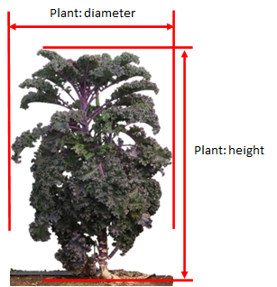
Plant: height

Ad. 2: Plant: diameter

See Ad. 1

Ad. 3: Plant: position of growing point

Observations of the growing point position should be made in relation to the top of the plant.
growing point
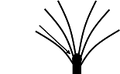  growing point | growing point  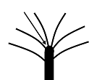 | 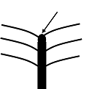
1 | 3 | 5
lower part | middle part | upper part

Ad. 4: Plant: number of leaves

Observations should be made on the number of leaves more than 10 cm in length.

Ad. 5: Stem: length

Observations should be made from ground level to the growing point.

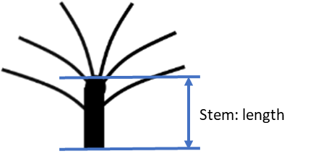
Stem: length

Ad. 6: Stem: diameter

Observations should be made at the widest point.

Ad. 7: Stem: tendency to branch

Observations should be made after bolting but before flowering. It should be assessed as number of branching nodes along the main stem.

Ad. 8: Leaf: attitude

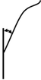 | 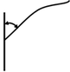 | 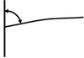
1 | 3 | 5
erect | semi-erect | horizontal

Ad. 10: Leaf: intensity of anthocyanin coloration of main vein

Observations should be made on the lower side of the leaf.

Ad. 12: Leaf: number of lobes

Parts of the leaf are considered to be lobes if:
1. They have a minimum length of 1 cm and
2. When folded back to the midrib as shown in Figs 1 and 2, the folded tissue meets the midrib
3. Their length is at least equivalent to the width of the leaf petiole at their point of attachment

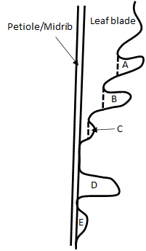  Petiole/Midrib  Leaf blade | 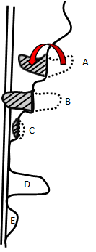
Figure 1 Figure 2

A is not a lobe as it does not meet the midrib when folded
B is a lobe as it meets the midrib when folded
C is too small to be a lobe as it is less than 1 cm in length and does not meet the midrib when folded
D is a lobe as the length is longer than the width of the leaf petiole at the point of attachment
E is not a lobe as the length is shorter than the width of the leaf petiole at the point of attachment

Ad. 13: Leaf: length of petiole wing

Parts of the leaf are considered to be wings if:
1. They attach to the petiole at the base
2. Their length is most equivalent to the width of the petiole at the point of attachment.
Where the lamina is entire and continuous and is attached to the base of the petiole then the petiole wing is assessed as note 9.

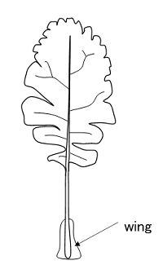
Wing

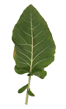 | 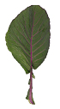 | 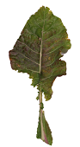 | 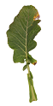 | 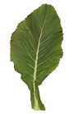
1 | 3 | 5 | 7 | 9
absent or very short | short | medium | long | very long

Ad. 14: Leaf blade: length
Leaf blade: width
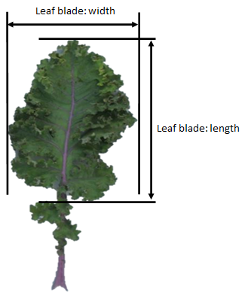
Leaf blade: length

Ad. 15: Leaf blade: width

See Ad. 14

Ad. 17: Leaf blade: number of incisions

Observations should be made on the upper third of the unfolded leaf blade.

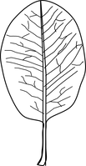 | 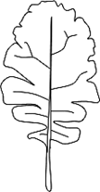 | 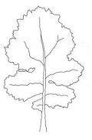 | 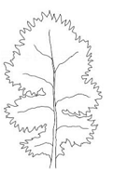
1 | 3 | 5 | 7
absent or very few | few | medium | many

Ad. 18: Leaf blade: depth of incisions

Observations should be made on the upper third of the unfolded leaf blade.

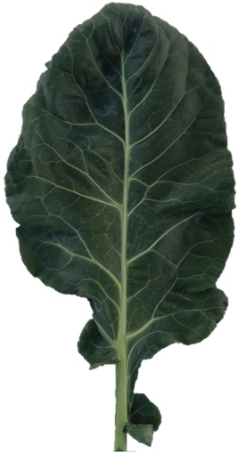 | 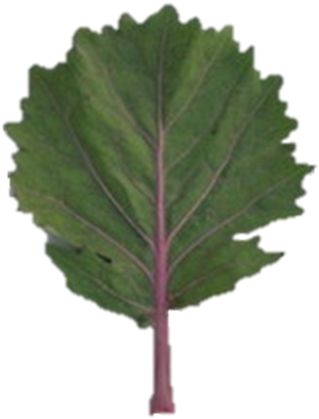 | 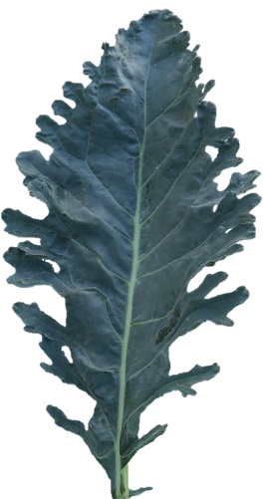
1  absent or shallow | 3  medium | 5  deep

Ad. 19: Leaf blade: curvature of midrib

Observations should be made on the overall shape, not one section of the leaf blade. For example, if almost all of the midrib is straight but the apical part of the midrib is strongly recurved then it should be assessed as straight.

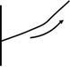 | 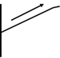 | 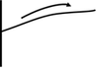
1 | 2 | 3
incurved | straight | slightly recurved

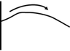 | 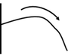 | 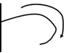
4 | 5 | 6
moderately recurved | strongly recurved | very strongly recurved

Ad. 20: Leaf blade: blistering

Blistering is the difference in height of the surface of the leaf between the veins.

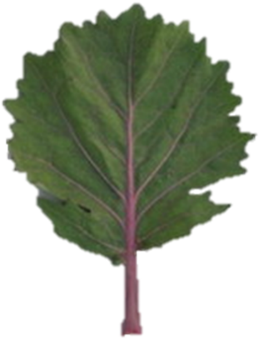 | 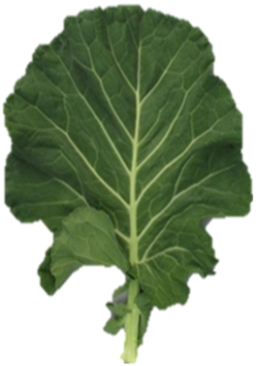 | 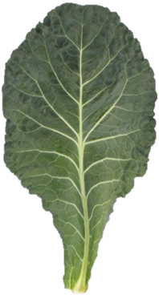 | 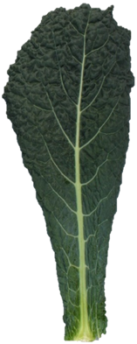
1 | 3 | 5 | 7
absent or very weak | weak | medium | strong

Ad. 21: Leaf blade: folding in cross section

Observations should be made at the middle third of the leaf blade.

 |  | 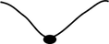
1 | 2 | 3
absent or very weak | weak | medium

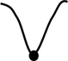 | 
4 | 5
strong | very strong

Ad. 22: Leaf blade: twisting

Observations should be made on the whole leaf.

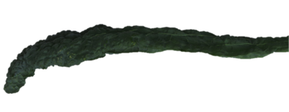 | 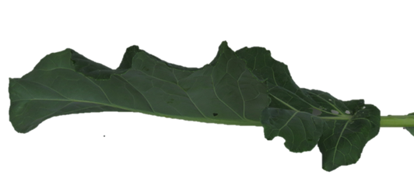
1 | 2
absent or very weak | weak

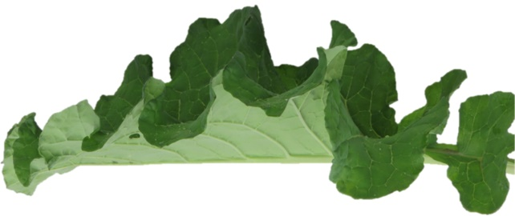 | 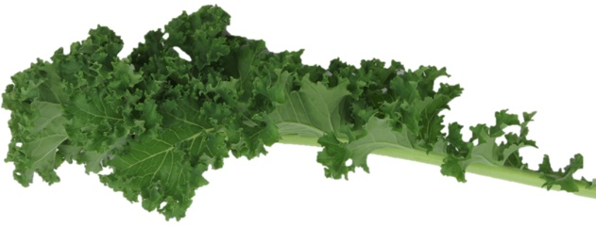
3 | 4
medium | strong

Ad. 23: Leaf blade: undulation of margin

Observations should be made on the small undulations of the margin of the leaf blade.

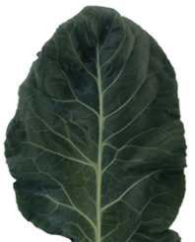 | 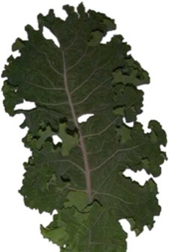 | 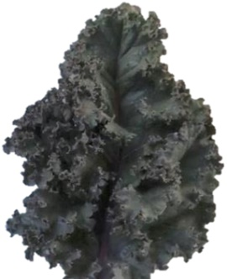 | 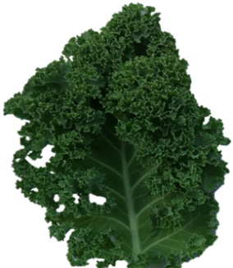 | 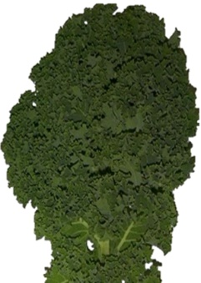
1 | 2 | 3 | 4 | 5
absent or very weak | weak | medium | strong | very strong

Ad. 24: Only for varieties with Leaf blade: undulation of margin: absent or very weak to weak: Leaf blade: recurvature of margin

Observations should be made at the middle third of the leaf blade.

 |  | 
1 | 2 | 3
absent or weak | medium | strong

Ad. 25: Petiole: length

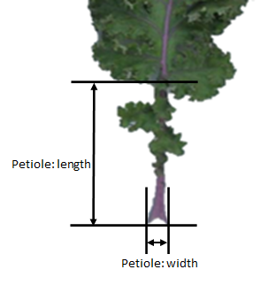
Petiole: width

Ad. 26: Petiole: width

See Ad. 25

Observations should be made at the base of petiole.

Ad. 27: Young leaf: color

Observations should be made on immature leaves at the apex of the plant.

Petiole: length

Ad. 28: Male sterility

To be tested in a field trial and/or in a DNA marker test.

In the case of a field trial, the type of observation is VS. In the case of a DNA marker test, the type of observation is MS.

Field trial:

Observations should be made on fully opened flowers. Tapping or shaking the flowering stem will release pollen, which, if present, can be observed on dark colored paper or card. The absence of pollen production is an indication of male sterility. The presence of pollen production is an indication of male fertility.

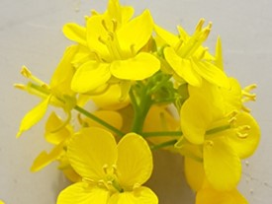 | 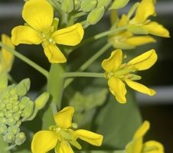
male fertile (pollen present) | male sterile (pollen absent)

DNA marker test:

If the cytoplasmic male sterility (CMS) marker is absent, the variety is expected to have male fertile flowers. If the CMS marker is present, the variety is expected to have male sterile flowers.

In cases where the DNA marker test result does not confirm the declaration in the TQ, a field trial should be performed to observe whether the variety has male fertile or male sterile flowers due to another mechanism.

9. | Literature

Akihiro Y., 2004: Yasai-engei-daihyakka 20. Shadanhojin Nousan-gyoson-bunkakyokai. Tokyo, JP. pp. 97 to 101

IBPGR, 1990: Descriptors of Brassica and Raphanus. International Board for Plant Genetic Resources. Rome, IT.

Kaloo, G. and Bergh, B.O., 1993: Genetic Improvement of Vegetable Crops, 11 Kale. Pergamon Press. New York, US. pp. 187 to 190

Langer, R.H.M., and Hill, G.D., 1982: Agricultural Plants 8, Cruciferae. Cambridge University Press. Cambridge, GB. pp. 165 to 183

Lustinec, J., 1988: Biotechnology in Agriculture and Forestry 6. Ed. Y.P.S. Bajaj. Springer-Verlag Berlin, DE. pp. 530 to 547

Nieuwhof, M., 1969: Cole Crops. Botany, Cultivation and Utilisation. Leonard Hill. London, GB.

Tsukamoto, Y., 1994: The Grand Dictionary of Horticulture Volume 1. The Shogakukan Ltd. Tokyo, JP. pp. 829 to 830

Tsunoda, S., Hinata, K. and Gomez-Campo, C., 1980: Brassica Crops and Wild Allies. Biology and Breeding Japan Scientific Press. Tokyo, JP. pp163 to 167

10. | Technical Questionnaire

TECHNICAL QUESTIONNAIRE | Page {x} of {y} | Reference Number:

Application date:
(not to be filled in by the applicant)
TECHNICAL QUESTIONNAIRE
to be completed in connection with an application for plant breeders' rights

1. | Subject of the Technical Questionnaire
 |  | Botanical name
  1.1.1
  Brassica oleracea L. var. costata DC.
  [ ]
 |  | Common name
  1.1.2
  Bedford cabbage, Braganza, Portugese cole, Portuguese kale, Seakale cabbage, Tronchuda cabbage, Tronchuda kale
 |  | Botanical name
  1.2.1
  Brassica oleracea L. var. medullosa Thell.
  [ ]
 |  | Common name
  1.2.2
  Marrow-stem kale
 |  | Botanical name
  1.3.1
  Brassica oleracea L. var. sabellica L.
  [ ]
 |  | Common name
  1.3.2
  Borecole, Curly kale, Dwarf Siberian kale, Kitchen kale, Scotch kale
 |  | Botanical name
  1.4.1
  Brassica oleracea L. var. viridis L.
  [ ]
 |  | Common name
  1.4.2
  Collards, Cow cabbage, Fodder kale, Galega kale, Kale, Spring-heading cabbage, Tall kale, Tree kale
 |  | Botanical name
  1.5.1
  Brassica oleracea L. var. palmifolia DC.
  [ ]

 |  | Common name
  1.5.2
  Giant Jersey kale, Jersey kale, Palm kale, Palm-tree kale, Tree kale

TECHNICAL QUESTIONNAIRE | Page {x} of {y} | Reference Number:

2. | Applicant
 | Name
 | Address
 | Telephone No.
 | Fax No.
 | E-mail address
 | Breeder (if different from
 | applicant)

3. | Proposed denomination and breeder's reference
 | Proposed denomination
 | (if available)
 | Breeder's reference

TECHNICAL QUESTIONNAIRE |  |  | Page {x} of {y} | Reference Number:
 | Information on the breeding scheme and propagation of the variety
  #4.
 | 4.1 | Breeding scheme
 | Variety resulting from:
  4.1.1
  Crossing
 |  | [ ]
  (a)
  controlled cross
 |  | [ ]
  (b)
  partially known cross
 |  | [ ]
  (c)
  unknown cross
 |  | [ ]
  4.1.2
  Mutation
  (please state parent variety)
 |  | [ ]
  4.1.3
  Discovery and development
  (please state where and when discovered and how developed)
 | Other  (Please provide details) | [ ]
  4.1.4

TECHNICAL QUESTIONNAIRE | Page {x} of {y} | Reference Number:

 | 4.2 | Method of propagating the variety
  4.2.1
  Seed-propagated varieties
 |  | [ ]
  (a)
  Cross-pollination
 |  | [ ]
  (i)
  Population
 |  | [ ]
  (b)
  Hybrid
 |  | [ ]
  (i)
  Single hybrid
 |  | [ ]
  (c)
  Other (please provide details)
  4.2.2
  Vegetative propagation
 |  | [ ]
  (a)
  Cuttings
 |  | [ ]
  (b)
  Other (state method)
 | Other  (Please provide details) | [ ]
  4.2.3

TECHNICAL QUESTIONNAIRE | Page {x} of {y} | Reference Number:

5. | Characteristics of the variety to be indicated (the number in brackets refers to the corresponding characteristic in Test Guidelines; please mark the note which best corresponds).

 | Characteristics | Example Varieties | Note
  5.1
  (1)
  Plant: height
  very short
  1 [ ]
  very short to short
  2 [ ]
  short
  Lage Moskrul, Starbor
  3 [ ]
  short to medium
  4 [ ]
  medium
  Darkibor, Marriot, Rossignol
  5 [ ]
  medium to tall
  6 [ ]
  tall
  Esthe, Fizz, Nero di Toscana, Redbor
  7 [ ]
  tall to very tall
  8 [ ]
  very tall
  Ostfriesische Palme
  9 [ ]
  5.2
  (3)
  Plant: position of growing point
  lower part
  Esthe, Fizz
  1 [ ]
  lower to middle part
  Halbhoher grüner krauser
  2 [ ]
  middle part
  Black Magic, Kobolt
  3 [ ]
  middle to upper part
  4 [ ]
  upper part
  Dwarf Green Curled, Kadet,
  Westlandse Herfst
  5 [ ]
  5.3
  (8)
  Leaf: attitude
  erect
  Esthe, Nero di Toscana
  1 [ ]
  erect to semi-erect
  2 [ ]
  semi-erect
  Cottagers, Redbor
  3 [ ]
  semi-erect to horizontal
  4 [ ]
  horizontal
  Marriot
  5 [ ]
  5.4
  (9)
  Leaf: color
  light green
  Tintoreto
  1 [ ]
  medium green
  Dwarf Green Curled, Esthe
  2 [ ]
  dark green
  Kapitan
  3 [ ]
  grey green
  Fizz
  4 [ ]
  blue green
  Black Magic, Nero di Toscana
  5 [ ]
  reddish green
  Redbor
  6 [ ]
  purple
  Rednex
  7 [ ]

TECHNICAL QUESTIONNAIRE | Page {x} of {y} | Reference Number:

 | Characteristics | Example Varieties | Note
  5.5
  (11)
  Leaf: variegation
  absent
  Esthe
  1 [ ]
  present
  Frost Byte, Purple Varie
  9 [ ]
  5.6
  (14)
  Leaf blade: length
  very short
  1 [ ]
  very short to short
  2 [ ]
  short
  Redbor, Westlandse Herfst
  3 [ ]
  short to medium
  4 [ ]
  medium
  Esthe
  5 [ ]
  medium to long
  6 [ ]
  long
  Nero di Toscana
  7 [ ]
  long to very long
  8 [ ]
  very long
  9 [ ]
  5.7
  (15)
  Leaf blade: width
  very narrow
  1 [ ]
  very narrow to narrow
  Raven
  2 [ ]
  narrow
  Dwarf Green Curled, Redbor
  3 [ ]
  narrow to medium
  4 [ ]
  medium
  Cottagers, Esthe, Fizz
  5 [ ]
  medium to broad
  6 [ ]
  broad
  Beira
  7 [ ]
  broad to very broad
  8 [ ]
  very broad
  9 [ ]
  5.8
  (16)
  Leaf blade: length/width ratio
  very low
  1 [ ]
  very low to low
  Marriot
  2 [ ]
  low
  Beira
  3 [ ]
  low to medium
  Dauro
  4 [ ]
  medium
  Esthe, Redbor, Tintoreto
  5 [ ]
  medium to high
  Fizz
  6 [ ]
  high
  7 [ ]
  high to very high
  Black Magic, Lerchenzungen
  8 [ ]
  very high
  Nero di Toscana
  9 [ ]

TECHNICAL QUESTIONNAIRE | Page {x} of {y} | Reference Number:

 | Characteristics | Example Varieties | Note
  5.9
  (18)
  Leaf blade: depth of incisions
  absent or shallow
  Esthe, Nero di Toscana
  1 [ ]
  shallow to medium
  2 [ ]
  medium
  3 [ ]
  medium to deep
  4 [ ]
  deep
  Fizz
  5 [ ]
  5.10
  (23)
  Leaf blade: undulation of margin
  absent or very weak
  Cottagers, Esthe
  1 [ ]
  weak
  Pentland Brig
  2 [ ]
  medium
  Redbor
  3 [ ]
  strong
  Dwarf Green Curled
  4 [ ]
  very strong
  Westlandse Herfst
  5 [ ]
  5.11
  (28)
  Male sterility
  absent
  Esthe, Westlandse Herfst
  1 [ ]
  present
  Winnetou
  9 [ ]

TECHNICAL QUESTIONNAIRE | Page {x} of {y} | Reference Number:

6. | Similar varieties and differences from these varieties
Please use the following table and box for comments to provide information on how your candidate variety differs from the variety (or varieties) which, to the best of your knowledge, is (or are) most similar. This information may help the examination authority to conduct its examination of distinctness in a more efficient way.

  Denomination(s) of variety(ies) similar to your candidate variety
  Characteristic(s) in which your candidate variety differs from the similar variety(ies)
  Describe the expression of the characteristic(s) for the similar variety(ies)
  Describe the expression of the characteristic(s) for your candidate variety

Example
  Stem: length
  medium
  short

 | Comments:

TECHNICAL QUESTIONNAIRE | Page {x} of {y} | Reference Number:

 | Additional information which may help in the examination of the variety
  #7.
7.1 | In addition to the information provided in sections 5 and 6, are there any additional characteristics which may help to distinguish the variety?
 | Yes | [ ] | No | [ ]
 | (If yes, please provide details)
7.2 | Are there any special conditions for growing the variety or conducting the examination?
 | Yes | [ ] | No | [ ]
 | (If yes, please provide details)
7.3 | Other information

TECHNICAL QUESTIONNAIRE | Page {x} of {y} | Reference Number:

8. | Authorization for release
 | (a) | Does the variety require prior authorization for release under legislation concerning the protection of the environment, human and animal health?
 |  | Yes | [ ] | No | [ ]
 | (b) | Has such authorization been obtained?
 |  | Yes | [ ] | No | [ ]
 | If the answer to (b) is yes, please attach a copy of the authorization.

9. Information on plant material to be examined or submitted for examination

9.1 The expression of a characteristic or several characteristics of a variety may be affected by factors, such as pests and disease, chemical treatment (e.g. growth retardants or pesticides), effects of tissue culture, different rootstocks, scions taken from different growth phases of a tree, etc.
9.2 The plant material should not have undergone any treatment which would affect the expression of the characteristics of the variety, unless the competent authorities allow or request such treatment. If the plant material has undergone such treatment, full details of the treatment must be given. In this respect, please indicate below, to the best of your knowledge, if the plant material to be examined has been subjected to:

 | (a) | Microorganisms (e.g. virus, bacteria, phytoplasma) | Yes [ ] | No [ ]
 | (b) | Chemical treatment (e.g. growth retardant, pesticide) | Yes [ ] | No [ ]
 | (c) | Tissue culture | Yes [ ] | No [ ]
 | (d) | Other factors | Yes [ ] | No [ ]
 | Please provide details for where you have indicated “yes”.

10. | I hereby declare that, to the best of my knowledge, the information provided in this form is correct:
 | Applicant’s name
 | Signature |  | Date

[End of document]

The description of the method to test male sterility for Brassica (CMS marker) is covered by a trade secret. The owner of the trade secret, Syngenta Seeds B.V., has given its consent for the use of the CMS marker solely for the purposes of examination of Distinctness, Uniformity and Stability (DUS) and for the development of variety descriptions by UPOV and authorities of UPOV members. Syngenta Seeds B.V. declares that neither UPOV, nor authorities of UPOV members that use the CMS marker for the above purposes will be held accountable for possible (mis)use of the CMS marker by third parties. Please contact Naktuinbouw, Netherlands, to obtain the method and information on the CMS marker for the purposes mentioned above.

